Ontological Diversity in Gaming Disorder Measurement:
A Nationally Representative Registered Report

[Stage 2, v1]

Veli-Matti Karhulahti¹*,
Jukka Vahlo^{1,2},
Marcel Martončik³,
Matti Munukka¹,
Raine Koskimaa¹,
Mikaela von Bonsdorff^{1, 4}

1 University of Jyväskylä, Jyväskylä, Finland
2 University of Turku, Turku, Finland
3 University of Prešov, Prešov, Slovakia
3 Institute of Social Sciences, CSPS SAS, Slovakia
4 Folkhälsan Research Center, Helsinki, Finland
* Corresponding author, vmmkar@utu.fi

Author Note
Stage 2 review round 1.0, 23.5.2022. This paper has not been peer reviewed.
Word count: 7747 (including abstract, captions, and references)
Appendix 0: Gaming disorder and internet gaming disorder criteria symptoms
Appendix 1: Pilot
Appendix 2: Research questions and hypotheses
Code, Data, and other Materials: The data are stored and made available for scientific reuse in the Finnish Social Science Data Archive (FSD). The code and other relevant materials are stored in the OSF: https://osf.io/6fqm5/
Funding: The work was supported by the Finnish Work Environment Fund (200349), Academy of Finland (312397), and the Slovak Research and Development Agency under the Contract no. APVV-18-0140.
Abstract
Gaming-related health problems have been researched since the 1980s with numerous different “ontologies” as reference systems, from self-assessed “game addiction” to “pathological gambling” (in the DSM-IV), “internet gaming disorder” (in the 3rd section of the DSM-5) and most recently “gaming disorder” (in the ICD-11). Our goal was to investigate how screening instruments that derive from different ontologies differ in identifying associated problem groups. By using four central screening instruments, each representing a different ontological basis, we hypothesized differences and similarities in prevalence, overlap, and health. A nationally representative (N=8217) sample of Finnish participants was collected. The validated screening instruments produced significantly different prevalence rates (from 0.4% to 6.9%) and the binomial probabilities of group overlap ranged from poor (0.419) to good (0.919). Expectedly, the problem groups had lower mental health than the general population, yet exploratory analyses implied equivalent or significantly higher physical health. We also found strong exploratory evidence for mischievous responding to complicate the measurement of gaming problems. Considering that several major differences were confirmed between the four gaming problem constructs, we recommend researchers to clearly define their construct of interest, i.e., whether they are studying the ICD-11 based official mental disorder, the DSM-5 proposed “internet gaming disorder,” or other gaming problems—especially in future meta-analyses.
Introduction

A lot of scientific effort has recently been invested in studying the relationship between technology use and wellbeing. A key theme in this research are the suggested mental disorders related to technology use, which outside diagnostic manuals are often discussed as “addictions”, such as “social media addiction”. At the time of writing, one technology-related disorder has received approval from the World Health Organization (WHO): in 2019, “gaming disorder” was confirmed to be included in the International Classification of Diseases (ICD-11) as a disorder due to addictive behaviors. Unlike the WHO, the American Psychiatric Association (APA) decided not to include such disorders for diagnosis in their Diagnostic and Statistical Manual of Mental Disorders (DSM-5), because the literature “suffers from a lack of a standard definition from which to derive prevalence data [and] understanding of the natural histories of cases” (APA 2013, p. 796). “Internet gaming disorder” was listed in the third section of DSM-5 as needing more research.
Despite “gaming disorder” now being part of the ICD-11, the problems addressed by the APA—how to identify and epidemiologically measure those with clinically significant problems—remain debated. Henceforth, we use gaming-related health problems (GRHPs) as a reference to all constructs (“videogame addiction”, “gaming disorder”, etc.) that relate to adverse mental, physical, and social aspects of gaming. A recent review of English GRHP screening instruments found 32 unique scales (King et al. 2020), and the scholars concluded five of them—including GAS7 (Game Addiction Scale: Lemmens et al. 2009) and IGDT10 (Internet Gaming Disorder Test: Király et al. 2017)—to have high evidential support. A later review found the prevalence rates of these five instruments to range from less than 1% to more than 14% in different age groups (Stevens et al. 2020). Despite scholars’ continuous attempts to make sophisticated epidemiological estimations, the fundamental problem remains unsolved: with at least 32 English screening tools that derive from diverse ontological grounds, what varies may not only be the prevalence rates, but also the GRHP constructs that are being measured (Appendix 0). For instance, GAS7 is based on the definition of pathological gambling in the DSM-IV (seven symptoms four of which must be present), whereas IGDT10 is based on “internet gaming disorder” in the DSM-5 (nine symptoms five of which must be present). After “gaming disorder” was confirmed to be included in the ICD-11, new instruments now rely on the WHO’s ontology: three novel criteria that must all be met for establishing a diagnosis. Taken together, these differences reflect two dimensions of ontological diversity:

- What criteria define the disorder? E.g., the DSM-5 and the ICD-11 list different criteria.
- How criteria define the disorder? E.g., the DSM-5 disorder is diagnosable when some criteria are met, but the ICD-11 demands meeting all criteria.

Previous research has found many participants who express GRHP symptoms based on the DSM-5 not to have general health problems (Colder Carras & Kardefelt-Winther 2018), whereas some scholars further distinguish between the degrees to which criteria, symptoms, and health problems manifest (Myrseth & Notelaers 2018). Such investigations imply that it could be useful to distinguish more than one (not necessarily diagnostic) GRHP constructs. Accordingly, our research question is:

RQ: How do screening instruments that derive from different ontological understandings differ in identifying GRHP groups?

The research question is investigated from three perspectives—prevalence, overlap, and health—which form three sub research questions.

RQ-A: How do GRHP screening instruments that derive from separate ontological understandings differ in their prevalence rates (how many)?
RQ-B: How do GRHP screening instruments that derive from separate ontological understandings differ in who they identify (what characteristics)?
RQ-C: How do GRHP screening instruments that derive from separate ontological understandings differ in the health of their identified groups (how healthy)?

To formulate informed hypotheses, we carried out a pilot (N=1000) by using four central GRHP screening instruments with separate ontological foundations.

Game Addiction Scale (GAS7) (Lemmens et al. 2009)
- based on pathological gambling, as defined in the DSM-IV.
Internet Gaming Disorder Test (IGDT10) (Király et al. 2017)
- based on “internet gaming disorder”, as defined in the DSM-5.
Gaming Disorder Test (GDT) (Pontes et al. 2019)
- based on “gaming disorder”, as defined in the ICD-11.
Problem Gaming Test (THL1) (Salonen & Raisamo 2015)
- based on Self-assessed gaming problems.

Whereas all the above instruments measure GRHPs, the discrepancies in the above-cited literature imply that the construct(s) being measured might not be a single entity, but plural. Although our methods cannot investigate the clinical or etiological nature of these potentially multiple constructs, we can seek evidence for the multiplicity of the measured construct(s). Thus, we use “constructs” as references to those latent entities, which are shared by the (expectedly) different four groups identified by each of the four instruments, respectively. Accordingly, our study pursued evidence for an improved conceptual organization of what the ICD-11 and many scholars today refer to as a single construct, “gaming disorder”.
The current epidemiological and historical understandings of “gaming disorder” are based on a long lineage of research throughout which multiple GRHPs have been treated as one and the same construct. In practice, studies on the literal “gaming disorder” (by the ICD-11) draw from the literature on “internet gaming disorder” (in the DSM-5), which in turn was built on studies of “gaming addiction” (pathological gambling in the DSM-IV) and others, such as “problem gaming”, that vary in their ontology by each study and research team. Sound evidence for this issue are the epidemiological reviews, which systematically mix gambling-based (DSM-IV), internet-based (DSM-5), general (ICD-11), and other ontologically diverse findings of GRHPs (e.g., Stevens et al. 2020). If we find evidence for our four ontologically diverse instruments to be similar in how they operate, this supports the single-construct idea of “gaming disorder” (which may manifest in many ways, Figure 1). If the instruments differ in how they operate, this indicates that efforts should be directed toward assessing the clinical (ir)relevance of multiple constructs (Figure 2).
Next, we introduce our hypotheses, which are specified in the Methods section. Based on the recurring findings that show prevalence rates of GRHPs to vary along with the instruments (e.g., Stevens et al. 2020), we expected our ontologically distinct instruments to produce meaningfully different prevalence rates (Appendix 1).

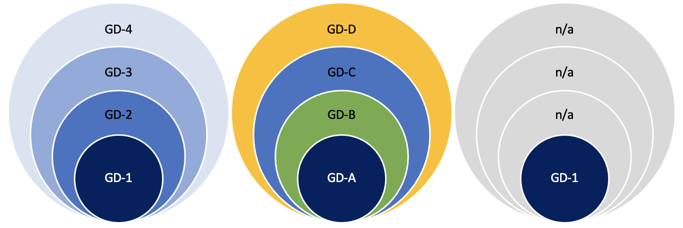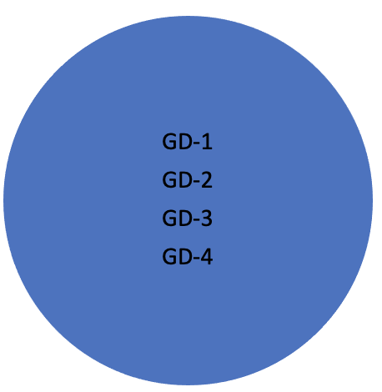
Figure 1. Four exemplary scenarios where our GRHP screening instruments identify overlapping groups. On the left: an example scenario where four screening instruments identify four different sized groups and they all capture the same construct on different severity levels (e.g. GD-1: severe problems, GD-4: mild problems). Left middle: an example scenario where four screening instruments identify four different sized groups and they all capture different domains of the construct (e.g., GD-A: mental health problems, GD-B: physical health problems, GD-C: social health problems, GD-D: other problems). Right middle: an example scenario where four screening instruments identify four different sized groups of which one involves GRHPs (e.g., GD-1: mixed health problems, other identified groups not related health problems). On the right: an example perfect scenario where four screening instruments identify one and the same group. The examples are not exhaustive, and the identified groups need not overlap.

Primary hypotheses, high confidence.
H1: We expect the ICD-11 and DSM-5 based GRHP prevalence rates to be meaningfully lower than the DSM-IV and Self-assessment based prevalence rates.
H1a: We expect the ICD-11 based prevalence rate to be meaningfully lower than the DSM-IV based prevalence rate.
H1b: We expect the ICD-11 based prevalence rate to be meaningfully lower than the Self-assessment based prevalence rate.
H1c: We expect the DSM-5 based prevalence rate to be meaningfully lower than the DSM-IV based prevalence rate.
H1d: We expect the DSM-5 based prevalence rate to be meaningfully lower than the Self-assessment based prevalence rate.

The prevalence rate tells us how many people are identified, but it tells little about overlap—who are identified. In practice, two identical prevalence rates could identify two entirely different groups of people. For instance, Starcevic and colleagues (2020) assessed 100 individuals who sought treatment for GRHPs and found 36 met both “gaming disorder” and “internet gaming disorder” criteria, whereas additionally 25 met only the latter. Likewise, Ko and colleagues (2020) carried out diagnostic interviews with 69 individuals who met the “internet gaming disorder” criteria and found 44 of them also met the “gaming disorder” criteria (cf. Figure 1). We did not find clinical studies between “game addiction” (DSM-IV pathological gambling based) and the later “internet gaming disorder” (DSM-5) and “gaming disorder” (ICD-11), however, our pilot data indicated that the latter two also meet the DSM-IV based criteria. We hence expect our three related instruments to identify similarly overlapping groups. The overlap of Self-assessment based problems is reported exploratively.

Secondary hypotheses, medium confidence.
H2: We expect ICD-11, DSM-5, and DSM-IV based GRHPs to overlap. Those who meet the ICD-11 criteria also meet the DSM-5 criteria, and both above additionally meet the DSM-IV based criteria.
H2a: Those who meet the ICD-11 criteria also meet the DSM-5 criteria.
H2b: Those who meet the ICD-11 and DSM-5 criteria also meet the DSM-IV based criteria.

Finally, we are interested in whether some groups are healthier than others. Because “gaming disorder” is conceptualized as a mental disorder, we expect those identified by related screening tools to have lower mental health scores than the general population. Previous findings also imply similar patterns regarding physical health (Puolitaival et al., 2020). Due to the small prevalence rates acquired in our pilot study (Appendix 1), we expect not to have sufficient power to compare health in ICD-11 and DSM-5 based constructs at Stage 2. Thus, we set a hypothesis on the other two constructs alone. As our pilot gave mixed evidence on the health of those with Self-assessed gaming problems, we set competing H0s.

Tertiary hypotheses, mild confidence.
H3: We expect those with DSM-IV and Self-assessment based GRHPs to have (equally) lower health in comparison to the general population.
H3a: We expect those with DSM-IV based GRHPs to have meaningfully lower mental or physical health in comparison to the general population.
H3b/H0: We expect those who Self-assess that they have gaming problems to have meaningfully lower mental or physical health in comparison to the general population.
H3c/H0: We expect the mental and physical health of those with DSM-IV and Self-assessment based GRHPs to be meaningfully different.

Methods

This study received a positive appraisal from the Human Sciences and Ethics Committee of University of Jyväskylä in 2021. The research was carried out according to the Finnish National Board on Research Integrity guidelines and the Helsinki Declaration with its later amendments.

Design
We planned to collect a Finnish survey sample (N=8000) by using the services of a company specialized in surveys (Bilendi, Appendix 1). The sample was planned to be representative of the Finnish population by gender and region (four regions in Finland) between ages 16 and 65.
H1. Among adolescents, GRHPs have been found to be more common than in older groups (e.g., Stevens et al. 2020). Due to the sample including individuals younger than 18, we expected our adult pilot data prevalence rates to be lower. We had no reason to believe this to notably influence the ratios between the prevalence rates of the four instruments. We expected the differences between the prevalence rates to cohere with those in the pilot (Table 1 in Appendix 1) so that the proportions identified by ICD-11 and the DSM-5 based instruments are meaningfully smaller than those identified by DSM-IV and Self-assessment based instruments (H1a–d). To test the hypotheses, we used an interval-based method, as described in Dienes (2021) (see Neyman & Pearson 1933). We set the H0 critical region (null corroboration) to the lower bound of 95% CI in the smallest obtained prevalence rate and the H1 acceptance region twice above the upper bound of 95% CI in that prevalence rate. The range between these intervals represents an inconclusive region of doubt. If the 95% confidence intervals of the H1a–d effects (differences between prevalence rates) overlap mainly with the H0 or the H1 interval, the hypotheses are corroborated, respectively. If the 95% confidence intervals of the effects (differences between prevalence rates) overlap mainly with the region of doubt, neither H0 nor H1 will be corroborated. H1a–d corroborations support the position that ICD-11 and DSM-5 based constructs differ from DSM-IV and Self-assessment based gaming problem constructs in terms of prevalence. Due to lacking pilot support for ICD-11 and DSM-5 prevalence differences, we did not set a hypothesis regarding them but report that exploratively. If H0 is corroborated one or more times, this supports the position that the DSM-IV and/or Self-assessment based gaming problem constructs are similar to ICD-11 and/or DSM-5 based ones, prevalence-wise.
H2. From previous clinical studies, we found only ICD-11 and DSM-5 based GRHPs analyzed comparatively. These studies found 60% (Starcevic et al. 2020) and 64% (Ko et al. 2020) of “internet gaming disorder” (DSM-5) patients also meeting the “gaming disorder” (ICD-11) criteria, and all the latter meeting all the former. Our pilot found no overlap between the individuals in the ICD-11 and DSM-5 criteria meeting groups. The conflict could be explained by our pilot sample size (Figure A in Appendix 1). It is also known that the content differences between the available screening instruments are large (Karhulahti et al. 2021), thus some of these discrepancies could be explained by the properties of GDT and IGDT10 scales. We thus followed the clinical literature in our hypotheses, in addition to which we expected both the ICD-11 and DSM-5 criteria meeting groups to meet the DSM-IV based cutoff, based on the pilot data: P(DSM-5|ICD-11)≈1 and P(DSM-5+ICD-11|DSM-IV)≈1. Because mischievous responding, among similar biases, is a known problem in survey research, we controlled Type 2 error. In gaming research, Przybylski (2016) found mischievous responding alone to account for up to 2.27% of respondents, indicating that among those who meet ICD-11 criteria (N=8000x0.2≈16), a false response is not unlikely to occur. Therefore, we allowed variation by the lower bound of the binomial probability 50% confidence interval for the conditional probability P=1 (n=16/16; 0.917, 1). This control allows, for example, one ICD-11 criteria meeting respondent to not meet the DSM-5 criteria without undermining the hypothesis (in the example of ICD-11=16; 0.917, 1). If the obtained sample of ICD-11 criteria meeting group meets P(ICD-11|DSM-5)>0.917, we consider H2a corroborated and this as evidence for the ICD-11 and DSM-5 based constructs to overlap. For null testing, we set the binomial probability confidence interval at 95% for the conditional probability P=1 (n=16/16; 0.794, 1). If the sample of GDT criteria meeting participants meets P(ICD-11|DSM-5)<0.794, we consider H0 corroborated and this as evidence for the ICD-11 and DSM-5 based constructs to be different by overlap. We repeat the process with the same logic regarding ICD-11–DSM-IV and DSM-5–DSM-IV (H2b). Empirical support for overlap can mean that the constructs consist of similar health problems (of different degree), different kinds of health problems, or no health problems (Figure 1). Empirical support for lacking overlap can mean that the constructs are partially or entirely different (Figure 2).

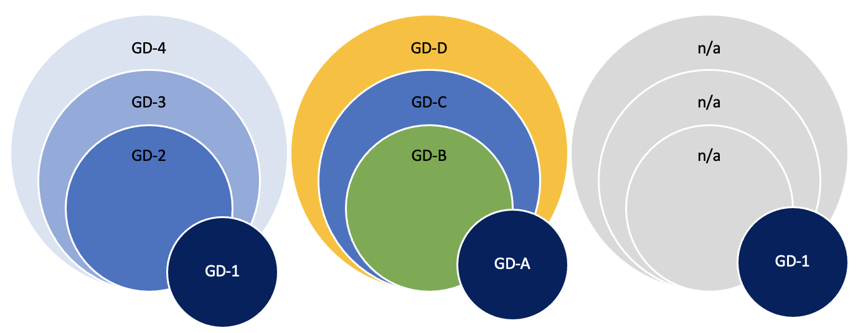
Figure 2. Three exemplary scenarios where one screening instrument identifies a group with marginal overlap.

H3. We planned to apply PROMIS Global Physical Health (GPH-2) and Global Mental Health (GMH-2) scales for investigating health (Hays et al. 2017). The United States based reference values for physical health are 42–50 (good) and 35–41 (fair); for mental health the values are 40–48 (good) and 28–40 (fair) (PROMIS 2021; Hays et al. 2015). When measured with GPH-2 in the pilot, the Finnish working population had mean value 44.2 whereas the value for the individuals meeting DSM-IV based criteria was 42.5. With GMH-2, the values were 47.0 for the general working population and 44.5 for the DSM-IV based criteria meeting group. A one-way analysis of variance (ANOVA) test showed that there was a statistically significant difference between both physical health (F[1, 998]=4.66, p<0.05, Cohen’s d=0.23, 95% CI [.14, .33]) and mental health (F[1,998]=8.53, p<0.01, Cohen’s d=0.32, 95% CI [.22, .41]). Even small effects can be relevant if adverse health scenarios prolong over multiple years (Funder & Ozer 2019). Hence, we set our smallest effect size of interest to d=0.22 (the lowest 95% CI in the pilot; clear change in reference value). If either the mental or physical health of the DSM-IV and Self-assessment based groups is significantly (d≥0.22 at alpha 0.025) lower than that of the general population, we consider H3a/H3b corroborated. If corroborated, we consider that as theoretical evidence for the Self-assessment or DSM-IV based constructs linking to lower health. If neither mental nor physical effects are significant or below d=.22, we consider H3a/H3b not supported and continue with equivalence testing (Lakens 2017) to assess null support. As we did not find strong pilot evidence for H3c (Appendix 1), we set H0 as a competing hypothesis. In H3c, we assess the difference between the DSM-IV and Self-assessment groups. A significant effect (d≥0.22 at alpha 0.025) is interpreted as support for the multiplicity of constructs health-wise. H0 is a competing hypothesis, and its corroboration is interpreted as evidence for construct similarity, health-wise.

Sampling
The data were collected with Bilendi, i.e. respondents were invited remotely from the company’s 2.2M panel of participants (Appendix 1). Ultimately, we recruited 8217 Finnish respondents as nationally representative of gender (women=4130, men=4070), region (East=797, South=3662, West=2831, North=927), and age (M=48.60, SD=18.18). We included two control questions (Oppenheimer et al. 2009) in the survey and Bilendi removed those responses that failed both (i.e., not included in N=8217). Additionally, participants who reported not having played videogames within the past six months did not fill out GRHP instruments, and they were considered not having GRHPs. The order of the screening instruments was randomized.
H1. Our sample size calculation for the estimated prevalence rates was based on precision rather than power (see Rothman & Greenland, 2018). We calculated the required sample size of 7668 participants based on the 95% confidence interval around the point estimate 0.2, which corresponds with the smallest prevalence rate in the pilot (GDT). Thus, N=8000 was a rational target sample size for precise prevalence analysis and comparison.
H2. Sample size derived from H1.
H3. The sample size requirement for H3a–b was based on power analysis for the Welch t-test (one-sided). For the desired power level of 0.9, alpha set to 0.025 (using multiple comparison correction), and the expected sizes of the groups (GAS7=712; 8.9%; THL1=1104; 13.8%) when the target sample size is N=8000, we would have had power to reliably detect d=0.127 and d=0.105, respectively. This meets our smallest effect size of interest (d=0.22). We only make inferences based on the effects that are reliably detectable by the identified groups. The sample for H3c derives from sensitivity analysis for the Welch t-test (two-sided). Based on the 95% confidence intervals of the above prevalence, sensitivity analysis with the desired power level of 0.9 and alpha set to 0.025 showed that we would be able to reliably detect d=0.185 or d=0.155, respectively. The code of is available at: https://osf.io/6fqm5/

Analysis plan
H1. We planned to calculate the prevalence rates with 95% confidence intervals for each of the four instruments. As the ontology of each diagnostic manual is linked to their recommended cutoffs (second dimension in Introduction), we follow their recommendations (Appendix 1). We apply the method described by Dienes: “If the CI lies mainly in the H0 interval and the remaining minority only in the grey interval, one could accept H0; similarly, if the CI lies mainly in the H1 interval and the remaining minority only in the grey interval, accept H1; otherwise more data are needed” (2021, p. 9). We set the H0 interval (null corroboration region) to the lower bound of 95% CI in the smallest obtained prevalence rate and the H1 interval (alternative acceptance region) twice above the upper bound of 95% CI in that prevalence rate. Because assessing what “endorsement” of items means is not straightforward (Connolly et al. 2021), we report Self-assessment (THL1) exploratively by using different endorsement criteria.
H2. The results regarding cutoff overlap are presented descriptively based on the above analyses. For H2, we test group overlap against conditional probability P>0.917. The null is tested against conditional probability P<0.714.
H3a–b. We compare the means of mental (GMH-2) and physical (GPH-2) health between the DSM-IV based group and the rest of the sample (one-tailed Welch t-test). This is repeated with Self-assessment. Because mental and physical health are measured separately, we carry out the test twice with a corresponding alpha level 0.025 (multiple comparison correction). Equivalence testing is carried out using the TOSTtwo function for an independent t-test (TOSTER package). Exploratively, we repeat the analyses with two general population groups: gaming and non-gaming. We set our equivalence bounds by the same smallest effect size of interest (d=0.22). We follow the above in H3c and use THL1 cutoff 2/4 in concordance with GAS7 wording (“sometimes”).

Results

H1. The prevalence rates (N=8217) with 95% confidence intervals are presented in Table 1.

Gaming disorder construct | Prevalence rate | 95% CI
[THL1 (2/4, problems at least “sometimes”) | 12.6% | 11.9, 13.3]
‍THL1 (3/4, problems ”often” or “almost always”) | 2.2% | 1.9, 2.6
DSM-IV based (GAS7) | 6.9% | 6.4, 7.5
DSM-5 based (IGDT10) | 0.9% | 0.7, 1.1
ICD-11 based (GDT) | 0.4% | 0.3, 0.5
Difference in prevalence rates | 95% CI of difference
ICD-11 vs DSM-IV | (5.97, 7.10)
‍ICD-11 vs THL1 (3/4) | (1.52, 2.21)
[ICD-11 vs THL1 (2/4) | (11.50, 12.96)]
[DSM-5 vs THL1 (2/4) | (10.96, 12.45)]
‍DSM-5 vs THL1 (3/4) | (.96, 1.72)
DSM-5 vs DSM-IV | (5.43, 6.60)

Table 1. Prevalence rates and differences between them. Exploratory differences in square brackets.

For all H1a–d, we set null regions to the lower 95% CI bound of the smallest prevalence rate (0.3), and the acceptance region twice as high as the higher 95% CI bound (2 x 0.5 = 1.0). All four hypotheses were corroborated (Figure 3). We conclude that each of the four GRHP construct comparisons imply difference in terms of prevalence.
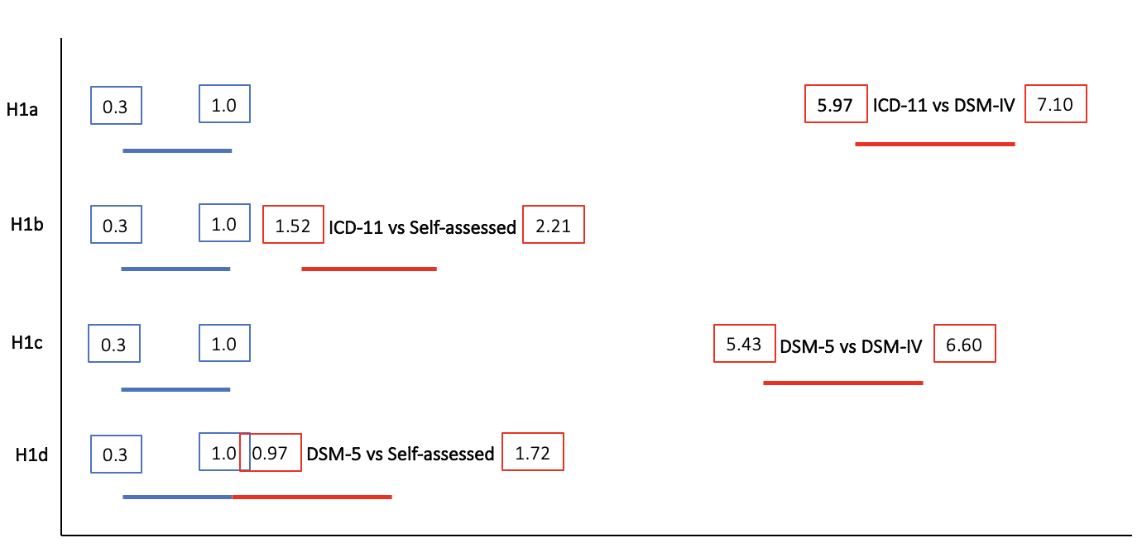
Figure 3. Null regions (blue) against the effects of compared constructs (red) in H1.

H2. To test construct overlap, we calculated binomial probabilities for the groups (Table 2). We set the null to binomial probability 0.794 and the acceptance binomial probability to 0.917. In H2a, the null was supported (DSM-5|ICD-11). In H2b, the first part was undecided (ICD-11|DSM-IV), and in the second, alternative hypothesis corroborated (DSM-5|DSM-IV).

GRHP construct groups | Overlap | Binomial probability | 95% CI
ICD-11 (n=31) and DSM-5 (n=74) | 13 | 0.419 | 0.264, 0.592
ICD-11 (n=31) and DSM-IV (n=568) | 27 | 0.871 | 0.711, 0.949
DSM-5 (n=74) and DSM-IV (n=568) | 68 | 0.919 | 0.834, 0.962
[THL1 (3/4) (n=184) and DSM-IV (n=568) | 133 | 0.723 | 0.654, 0.782]
[THL1 (3/4) (n=184) and DSM-5 (n=74) | 45 | 0.608 | 0.494, 0.711]
[THL1 (3/4) (n=184) and ICD-11 (n=31) | 21 | 0.677 | 0.501, 0.814]

Table 2. Binomial probabilities for overlap. Exploratory probabilities in square brackets.

H3. We set competing alternative and null hypotheses regarding the lower health of DSM-IV and Self-assessment based groups, in comparison to the general population.
- In H3a, the DSM-IV group (M=43.65, SD=8.76) had lower mental health than the general population (M=46.98, SD=8.00), t(639.27)=8.812, p< .001, d=0.40, 95% CI (.30, .49). This exceeded our smallest effect size of interest, corroborating the alternative hypothesis.
  - We did not find a significant difference in physical health between the DSM-IV group (M=3.07, SD=1.15) and the general population (M=3.05, SD=0.998), t(632.34)=-0.42, p= .67, d=-.02, 95% CI (-.11, .06). Equivalence testing revealed that the effect is statistically equivalent, as both p values in two one-sided tests were lower than 0.05, t(632.05)=4.37, p<.01.
- In H3b, the Self-assessed problems group (M=45.01, SD=8.04) had lower mental health than the general population (M=47.0, SD=8.08), t(1354.2)=7.48, p<.001, d=0.25, 95% CI (.18, .31). Again, this effect size corroborated the alternative hypothesis.
  - We did not find a significant difference in physical health between the Self-assessed problems group (M=3.04, SD=1.06) and the general population (M=3.05, SD=1.01), t(1314)=.49, p=.62, d=.02, 95% CI (-.05, .08). Equivalence testing revealed that the effect was statistically equivalent, as both p values in two one-sided tests were below 0.05, t(1320.62)=-6.22, p< .01.
- In H3c, the Self-assessed problems group (M=45.53, SD=7.65) had higher mental health than the DSM-IV group (M=43.02, SD=8.93), t(308.06)=3.68, p<.001, d=0.30, 95% CI (.14, .48). This result was reached when excluding participants who met both cutoffs. When not doing so (i.e., some participants belonged to both groups), the Self-assessed problems group (M=45.01, SD=8.04) still had higher mental health than the DSM-IV group (M=43.65, SD=8.76), t(1085.1)=3.06, p=.002, d=0.16, 95% CI (.06, .26), but the effect did not meet our smallest effect size of interest. We continued with equivalence testing, which revealed that the effect was not statistically equivalent because the larger p value was higher than 0.05, t(1084.9)=-1.10, p=.135.
  - We did not find a significant difference in physical health between the Self-assessed problems group (M=3.00, SD=.99) and the DSM-IV group (M=3.00, SD=1.08), t(1314)=-.04, p=.97, d< .01, 95% CI (-.16, .15). The effect was statistically equivalent; both p values were lower than 0.05, t(323.22)=+-2.72, p< .01. This result was reached when excluding participants who met both cutoffs. Similar results were reached when not doing so: the effect was statistically equivalent, as both p values were lower than 0.05, t(1088.83)=3.65, p< .01.

Exploratory analyses

As some of the results were unexpected, we were curious if mischievous responding could explain some of them. The survey included two control items, and those who failed both were not included in the final dataset. Thus, we decided to investigate exploratively how many respondents who report having GRHPs failed the first control item (“Please select often as a response to this question. This is a control question, which is used to verify that you are not a robot”). The results show that the more problems people report, the more they also fail the control test (Table 3). For instance, the four response options in THL1 illustrate how control failures increase from 0.1% and 2.3% to 12.8% and, finally, all the way to 22.7%. Although this might reflect the poor attention skills of respondents who have GRHPs, we believe the phenomenon to be better explained by mischievous responding. Confirmatory research is needed to properly explore the issue.

GRHP construct groups | Failed first control
‍THL1 (4/4, problems “almost always”) | 22.7 %
DSM-5 based (IGDT10)  THL1 (3/4, problems “often”) | 13.5 %  12.8 %
ICD-11 based (GDT)  DSM-IV (GAS7)  THL1 (2/4, problems “sometimes”)  THL1 (1/4, problems “never”) | 9.6 %  8.1 %  2.3 %  0.1 %

Table 3. Participants who failed the first control question but passed the second one (and were included).

The rest of our exploratory analyses are reported in Table 4. Post hoc power for the exploratory analyses is reported by power curve, which is part of the Supplement.

Exploratory analyses related to H3a
 | M | SD | M |  | SD | t | df | p | d | 95% CI
 | General gaming population (n=5459) |  | DSM-IV  (n=568)
GMH-2 (T-scores) | 46.9 | 7.91 | 43.6 |  | 8.76 | 8.58 | 666.75 | < .01 | .39 | [.30, .49]
GPH-1 | 3.07 | .99 | 3.07 |  | 1.15 | .03 | 658.25 | .98 | < .01 | [-.09, .09]
Equivalence test result: equivalent, t(657.79) = -4.717, p = 0.00000146
 | General non-gaming population (n=2190) |  | DSM-IV  (n=568)
GMH-2 (T scores) | 47.1 | 8.23 | 43.6 |  | 8.76 | 8.52 | 845.03 | < .01 | .41 | [.32, .51]
GPH-1 | 3.00 | 1.01 | 3.07 |  | 1.15 | -1.46 | 809.35 | .15 | -.07 | [-.17, .03]
Equivalence test result: equivalent, t(808.18) = 3.180, p = 0.000764
 | General population (n=8143) |  | DSM-5  (n=74)
GMH-2 (T scores) | 46.80 | 8.08 | 45.40 | 9.89 |  | 1.18 | 73.89 | .12 | .15 | [-.09, .43]
Equivalence test result: non-equivalent, t(73.89) = -0.509, p = 0.306
GPH-1 | 3.05 | 1.01 | 3.45 | 1.27 |  | -2.67 | 73.83 | < .01 | -.35 | [-.63, -.1]
 | General gaming population (n=5953) |  | DSM-5  (n=74)
GMH-2 (T scores) | 46.60 | 8.02 | 45.40 | 9.89 |  | 1.07 | 74.20 | .14 | .14 | [-.12, .40]
Equivalence test result: non-equivalent, t(74.2) = -0.676, p = 0.250
GPH-1 | 3.07 | 1.00 | 3.45 | 1.27 |  | -2.54 | 74.13 | .01 | -.33 | [-.61, -.07]
 | General non-gaming population (n=2190) |  | DSM-5  (n=74)
GMH-2 (T scores) | 47.1 | 8.23 | 45.4 | 9.89 |  | 1.48 | 76.45 | .07 | .19 | [-.07, .45]
Equivalence test result: non-equivalent, t(76.45) = -0.259, p = 0.398
GPH-1 | 3.00 | 1.01 | 3.45 | 1.27 |  | -3.01 | 76.1 | < .01 | -.39 | [-.65, -.13]
 | General population (n=8186) |  | ICD-11  (n=31)
GMH-2 (T scores) | 46.8 | 8.08 | 41.9 | 10.3 |  | 2.63 | 30.14 | < .01 | .53 | [.13, .96]
GPH-1 | 3.05 | 1.01 | 3.03 | 1.30 |  | .09 | 30.14 | .93 | .02 | [-.40, .41]
Equivalence test result: non-equivalent, t(30.14) = -1.010, p = 0.160
 | General gaming population (n=5996) |  | ICD-11  (n=31)
GMH-2 (T scores) | 46.6 | 8.03 | 41.9 | 10.3 |  | 2.56 | 30.19 | < .01 | .52 | [.13, .98]
GPH-1 | 3.07 | 1.01 | 3.03 | 1.30 |  | .18 | 30.19 | .86 | .04 | [-.37, .43]
Equivalence test result: non-equivalent, t(30.19) = -0.924, p = 0.181
 | General non-gaming population (n=2190) |  | ICD-11  (n=31)
GMH-2 (T scores) | 47.1 | 8.23 | 41.9 | 10.3 |  | 2.81 | 30.54 | < .01 | .56 | [.15, 1.02]
GPH-1 | 3.00 | 1.01 | 3.03 | 1.30 |  | -.16 | 30.51 | .88 | -.03 | [-.47, .38]
Equivalence test result: non-equivalent, t(30.51) = 0.964, p = 0.171
Exploratory analyses related to H3b
 | M | SD | M | SD |  | t | df | p | d | 95% CI
 | General gaming population (n=4991) |  | Self-assessed, at least “sometimes” (n=1036)
GMH-2 (T scores) | 47.00 | 8.01 | 45.00 | 8.04 |  | 7.11 | 1492.2 | < .01 | .24 | [.18, .31]
GPH-1 | 3.08 | 1.00 | 3.04 | 1.06 |  | 1.21 | 1437.2 | .23 | .04 | [-.03, .11]
Equivalence test result: equivalent, t(1439.09) = -5.200, p = 0.000000114
 | General non-gaming population (n=2190) |  | Self-assessed, at least “sometimes” (n=1036)
GMH-2 (T scores) | 47.1 | 8.23 | 45.0 | 8.04 |  | 6.91 | 2074.5 | < .01 | .26 | [.19, .33]
GPH-1 | 3.0 | 1.01 | 3.04 | 1.06 |  | -1.07 | 1941.5 | .28 | -.04 | [-.12, .04]
Equivalence test result: equivalent, t(1945.29) = 4.769, p = 0.000000996
 | General population (n=8033) |  | Self-assessed, at least “often” (n=184)
GMH-2 (T scores) | 46.8 | 8.08 | 46.1 | 8.77 |  | .95 | 190.18 | .17 | .07 | [-.08, .22]
Equivalence test result: non-equivalent, t(190.18) = -1.769, p = 0.0392
GPH-1 | 3.04 | 1.00 | 3.53 | 1.16 |  | -5.67 | 189.27 | < .01 | -.45 | [-.62, -.29]
 | General gaming population (n=5843) |  | Self-assessed, at least “often” (n=184)
GMH-2 (T scores) | 46.6 | 8.02 | 46.1 | 8.77 |  | .75 | 192.76 | .23 | .06 | [-.09, .22]
Equivalence test result: equivalent, t(192.76) = -2.059, p = 0.0204
GPH-1 | 3.06 | 1.00 | 3.53 | 1.16 |  | -5.46 | 191.59 | < .01 | -.44 | [-.59, -.28]
 | General non-gaming population (n=2190) |  | Self-assessed, at least “often” (n=184)
GMH-2 (T scores) | 47.1 | 8.23 | 46.1 | 8.77 |  | 1.45 | 210.96 | .07 | .11 | [-.03, -.27]
Equivalence test result: not equivalent, t(210.99) = -1.300, p = 0.0975
GPH-1 | 3.00 | 1.01 | 3.53 | 1.16 |  | -6.07 | 206.82 | < .01 | -.49 | [-.67, -.33]
Exploratory analyses related to H3c
 | M | SD | M | SD |  | t | df | p | d | 95% CI
 | Self-assessed, at least “often” (n=51) |  | DSM-IV  (n=435) |  |  | Note: 82 participants met both cut-offs. In this comparison, they have been excluded.
GMH-2 (T scores) | 47.1 | 8.06 | 43.0 | 8.57 |  | 3.42 | 64.02 | < .01 | .49 | [.21, .80]
GPH-1 | 3.45 | 0.945 | 2.92 | 1.07 |  | 3.73 | 66.15 | < .01 | .52 | [.24, .81]
 | Self-assessed, at least “often” (n=184) |  | DSM-IV  (n=568) |  |  | Note: 82 participants met both cut-offs. In this comparison, they have been included.
GMH-2 (T scores) | 46.1 | 8.77 | 43.6 | 8.76 |  | 3.36 | 309.75 | < .01 | .29 | [.11, .45]
GPH-1 | 3.53 | 1.16 | 3.07 | 1.15 |  | 4.68 | 306.53 | < .01 | .40 | [.22, .58]

Table 4. All exploratory analyses.

The exploratory analyses regarding the mental health of gaming and non-gaming populations did not yield any meaningful differences. On the other hand, while we did find the ICD-11 based group having significantly lower mental health than the general population, we could not find this effect in the DSM-5 based group. This implies a construct difference in terms of mental health, but confirmatory research is needed to corroborate it. Following the above, we did not find meaningful differences in physical health between the ICD-11 based group and the general population; however, both the DSM-5 based group and the Self-assessed problems (at least “often”) group reported significantly higher physical health than the general population. These surprising exploratory findings naturally call for confirmatory research as well.

Discussion

Our findings generally support the idea that multiple ontologically different constructs, which have been used synonymously as a reference to “gaming-related health problems” (or addiction), are distinct also in practice. In other words, ICD-11 based, DSM-5 based, DSM-IV based, and Self-assessment based measures for GRHPs seem to identify different groups of people, which implies that different problems (or other different constructs) are being measured, to different degrees. Some constructs also had similarities, which we discuss below.

The first hypotheses (H1) brought confirmatory evidence for prevalence differences in all four comparisons. The prevalence rates ranged from 0.4% (ICD-11) to 6.9% (DSM-IV), which means that one validated scale provided an estimate that is more than 17 times larger than another validated scale. On the other hand, no less than 12.6% of the participants Self-assessed having problems with gaming at least “sometimes.” Evidently, many people have some problems with gaming sometimes, but this should not be confused with the prevalence of related mental disorders. It remains for future studies, with clinically validated scales, to assess what the prevalence rates for gaming disorder (as a mental disorder) are.

We did not hypothesize about the prevalence difference between ICD-11 (0.4%) and DSM-5 (0.9%), but the second hypothesis (H2) yielded counterevidence against the ICD-11 and DSM-5 based constructs being similar: more than half of the ICD-11 group did not meet the DSM-5 criteria. On the other hand, a significant proportion of the DSM-5 group also met the DSM-IV based criteria, which implies a difference in degree rather than kind (Figure 4).

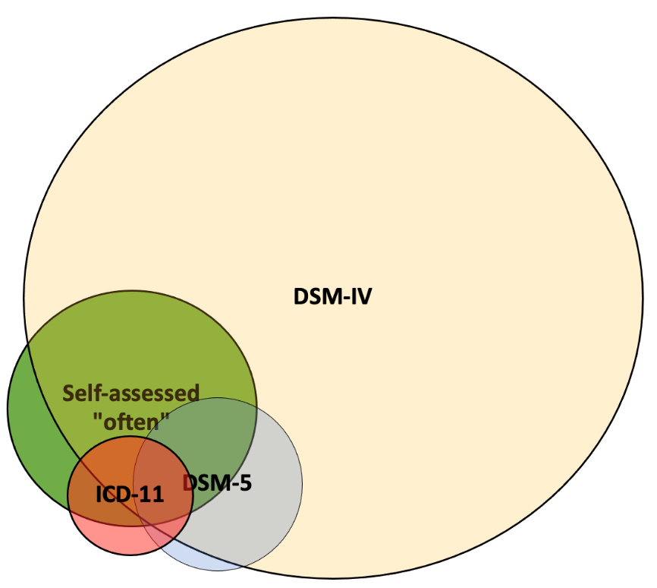
Figure 4. A model of the prevalence rate and overlap of all measured constructs.

Finally, our hypotheses regarding health (H3) were generally supported, i.e. both DSM-IV and Self-assessment based problem groups had meaningfully lower mental health levels than the general population. We also found a significant difference between the two constructs, but the effect was not large enough to be meaningful. Our interpretation is that the constructs are distinct health-wise in relation to the general population, but the data do not allow us to make claims regarding meaningful differences or equivalence between them. The findings regarding physical health were both different and similar: the DSM-IV group and those who Self-assess having problems (at least) “often” had equivalent physical health with the general population and each other; namely, the two constructs were similar in this respect, but also similar with the general population.

In this study, we chose to use the officially suggested instrument cutoffs for analysis. Such cutoffs generally represent the diagnostic relevance in individual cases, and thus allowed us to compare the prevalence, overlap, and health of the identified groups as proxies for constructs like “gaming disorder” (ICD-11) and “internet gaming disorder” (DSM-5). We did not, however, investigate other aspects, such as the dimensions across measured symptoms and problems (see Regier et al. 2004; Kessler et al. 2004) or alternative cutoffs by sensitivity (except for both “sometimes” and “often” with THL1). To chart further ontological differences and similarities between constructs and/or instruments, it would be possible to compare, for instance, instrument-specific factor structures or item-based network models (e.g., Adamkovič et al. 2022; Liu et al. 2022). Researchers could also explore the standardization of cutoffs (de Beurs et al. 2021); however, due to the major differences between ontological systems, such as monothetic and polythetic premises, this could compromise the core criteria by which different constructs define themselves. As our data is open for secondary analysis, anyone willing to pursue the above avenues is encouraged to do so.

Taken together, our findings add to the rapidly accumulating literature on the fuzziness of technology use constructs. For instance, Davidson and colleagues (2022) recently compared measures such as those of smartphone addiction, social networking addiction, and internet gaming disorder, and found them all to be reducible to a single component (despite claims to measure various diverse constructs). Although the design of our study was the opposite (investigating differences and similarities within one assumed construct), we further corroborate the fuzziness hypothesis: significant differences manifest from multiple perspectives between constructs that all measure addictive gaming behaviors. In sum, while the current technology use scales of different constructs seem unable to distinguish themselves from others, the scales of addictive gaming behaviors—standardly studied as a single construct—seem unable to identify mutual groups with shared problems. Presently, the field appears incapable of managing both, construct differences and similarities.

Limitations

Because of the incidence reported in Footnote 2, we could not carry out confirmatory analyses regarding physical health, and we had to settle with an exploratory single-item measure. That said, the item is a direct self-assessment of physical health, and we have no reasons to expect different results with the full physical health (PROMIS) scale. As to more in-depth research on physical health and gaming, we rather look forward to other methods, such as actual physical health tests, which can yield more accurate information. Related to the above, the war in Ukraine may also have affected the respondents at the time of survey. Nevertheless, because our design was comparative between related constructs, the potential effects applied to all constructs, and thus were unlikely to undermine the findings. Finally, we highlight that our study was limited to four instruments, i.e., one per each construct. Different instruments are likely to represent the same constructs in different ways, due to which possible future replications and other similar studies may consider adding new instruments. On the other hand, researchers might do better by investing their resources in explorative designs that map out the different types of problems and their unique contexts rather than continuing with the existing instruments, which seem to measure multiple unknown constructs (and/or construct dimensions).

Conclusions

Historically, gaming-related health problems have been studied through constructs such as “game addiction”, “internet gaming disorder,” and most recently, “gaming disorder.” Many of them derive from different ontological foundations that range from various diagnostic manuals and theories to simple self-assessment. In the present study, our goal was to investigate their differences, which were hypothesized due to different ontological foundations: ICD-11, DSM-5, and DSM-IV, and Self-assessment. Our findings lead us to conclude two things. First, we confirm that the constructs seem to be associated with lowered mental health. Second, we confirm that there do not seem to be many other similarities between the constructs, i.e., despite their mutual capacity to predict lowered mental health, they were found to be significantly different in terms of prevalence and/or overlap. Ultimately, we recommend researchers who are working with gaming-related health problems to

- clearly define their construct of interest, i.e., whether they are researching gaming disorder (as a mental disorder), problems related to gaming, or some other construct.
- seek good evidence for construct validity, i.e., whether the instruments being used accurately measure the construct of interests, or something else.

Being able to give strong answers to both a and b will significantly improve research quality, enable the development of useful meta-analyses, and allow researchers to communicate with each other without the risk of confusing related yet different constructs.

References

Aalto, A. M., Elovainio, M., Kivimäki, M., Uutela, A., & Pirkola, S. (2012). The Beck Depression Inventory and General Health Questionnaire as measures of depression in the general population: a validation study using the Composite International Diagnostic Interview as the gold standard. Psychiatry research, 197(1-2), 163-171.
Adamkovič, M., Martončik, M., Karhulahti, V. & Ropovik, I. (2022). Network Structures of Internet Gaming Disorder and Gaming Disorder: Symptom Operationalization Causes Variation. Preprint. https://psyarxiv.com/g3jpt/
APA (American Psychiatric Association) 2013. Diagnostic and Statistical Manual of Mental Disorders. 5th edition. APA.
Carras, M. C., & Kardefelt-Winther, D. (2018). When addiction symptoms and life problems diverge: A latent class analysis of problematic gaming in a representative multinational sample of European adolescents. European child & adolescent psychiatry, 27(4), 513-525.
Connolly, T., Atherton, G., Cross, L., & Kaye, L. K. (2021). The Wild West of measurement: Exploring problematic technology use cut off scores and their relation to psychosocial and behavioural outcomes in adolescence. Computers in Human Behavior, 125, e106965.
Davidson, B. I., Shaw, H., & Ellis, D. A. (2022). Fuzzy constructs in technology usage scales. Computers in Human Behavior, 107206.
de Beurs, E., Boehnke, J. R., & Fried, E. (2021) Common measures or common metrics? A plea to harmonize measurement results. Preprint. https://psyarxiv.com/m4qzb/
Dienes, Z. (2020). Obtaining evidence for no effect. Collabra: Psychology (in press). Preprint: https://doi.org/10.31234/osf.io/yc7s5
Funder, D. C., & Ozer, D. J. (2019). Evaluating effect size in psychological research: Sense and nonsense. Advances in Methods and Practices in Psychological Science, 2(2), 156-168.
Hays, R. D., Spritzer, K. L., Thompson, W. W., & Cella, D. (2015). US general population estimate for “excellent” to “poor” self-rated health item. Journal of General Internal Medicine, 30(10), 1511-1516.
Hays, R. D., Schalet, B. D., Spritzer, K. L., & Cella, D. (2017). Two-item PROMIS® global physical and mental health scales. Journal of patient-reported outcomes, 1(1), 1-5.
Karhulahti, V., Martončik, M., & Adamkovic, M. (2021). Measuring Internet Gaming Disorder and Gaming Disorder: Qualitative Content Validity Analysis of Validated Scales. Assessment.
Kessler RC, Merikangas KR, Berglund P et al. (2004) For DSM-V, it’s the “disorder threshold”, stupid—reply. Archives of General Psychiatry, 61 (10): 1051–1052. https://doi.org/10.1001/archpsyc.61.10.1051-b
King, D. L., Chamberlain, S. R., Carragher, N., Billieux, J., Stein, D., Mueller, K., … Delfabbro, P. H. (2020). Screening and assessment tools for gaming disorder: A comprehensive systematic review. Clinical Psychology Review, 77, 101831. Doi:10.1016/j.cpr.2020.101831
Király, O., Sleczka, P., Pontes, H. M., Urbán, R., Griffiths, M. D., & Demetrovics, Z. (2017). Validation of the Ten-Item Internet Gaming Disorder Test (IGDT-10) and evaluation of the nine DSM-5 internet gaming disorder criteria. Addictive Behaviors, 64, 253–260.
Ko, C. H., Lin, H. C., Lin, P. C., & Yen, J. Y. (2020). Validity, functional impairment and complications related to Internet gaming disorder in the DSM-5 and gaming disorder in the ICD-11. Australian & New Zealand Journal of Psychiatry, 54(7), 707-718.
Kujanpää, T., Ylisaukko-Oja, T., Jokelainen, J., Hirsikangas, S., Kanste, O., Kyngäs, H., & Timonen, M. (2014). Prevalence of anxiety disorders among Finnish primary care high utilizers and validation of Finnish translation of GAD-7 and GAD-2 screening tools. Scandinavian journal of primary health care, 32(2), 78–83.
Lakens, D. (2017). Equivalence tests: A practical primer for t tests, correlations, and meta-analyses. Social psychological and personality science, 8(4), 355-362.
Lemmens, J. S., Valkenburg, P. M., & Peter, J. (2009). Development and validation of a game addiction scale for adolescents. Media psychology, 12(1), 77-95.
Liu, D., Lemmens, J., Hong, X., Li, B., Hao, J., & Yue, Y. (2022). A network analysis of internet gaming disorder symptoms. Psychiatry Research, 311, 114507.
Myrseth, H., & Notelaers, G. (2018). A latent class approach for classifying the problem and disordered gamers in a group of adolescence. Frontiers in psychology, 9, 2273.
Neyman, J. & Pearson, E. (1933). The testing of statistical hypotheses in relation to probabilities a priori. Mathematical Proceedings of the Cambridge Philosophical Society, 29(04), 492–510.
Oppenheimer, D. M., Meyvis, T., & Davidenko, N. (2009). Instructional manipulation checks: Detecting satisficing to increase statistical power. Journal of experimental social psychology, 45(4), 867-872.
Pontes, H. M., Schivinski, B., Sindermann, C., Li, M., Becker, B., Zhou, M., & Montag, C. (2019). Measurement and conceptualization of gaming disorder according to the World Health Organization framework: The development of the Gaming Disorder Test. International Journal of Mental Health and Addiction.
PROMIS (2021) PROMIS® Reference Populations. Official instrument website. https://www.healthmeasures.net/score-and-interpret/interpret-scores/promis/reference-populations
Przybylski, A. K. (2016). Mischievous responding in Internet gaming disorder research. PeerJ, 4, e2401.
Puolitaival, T., Sieppi, M., Pyky, R., Enwald, H., Korpelainen, R., & Nurkkala, M. (2020). Health behaviours associated with video gaming in adolescent men: a cross-sectional population-based MOPO study. BMC public health, 20(1), 1-8.
Regier, D. A., Narrow, W. E., & Rae, D. S. (2004). For DSM-V, It’s the “Disorder Threshold,” Stupid. Archives of General Psychiatry, 61 (10), 1051–1051. https://doi.org/10.1001/archpsyc.61.10.1051-a
Rothman, K. J., & Greenland, S. (2018). Planning Study Size Based on Precision Rather Than Power. Epidemiology, 29(5), 599–603.
Salonen, A. & Raisamo, S. (2015) Suomalaisten rahapelaaminen 2015: Rahapelaaminen, rahapeliongelmat ja rahapelaamiseen liittyvät asenteet ja mielipiteet 15-74-vuotiailla. Helsinki: THL.
Starcevic, V., Choi, T. Y., Kim, T. H., Yoo, S. K., Bae, S., Choi, B. S., & Han, D. H. (2020). Internet gaming disorder and gaming disorder in the context of seeking and not seeking treatment for video-gaming. Journal of psychiatric research, 129, 31-39.
Stevens, M. W., Dorstyn, D., Delfabbro, P. H., & King, D. L. (2020). Global prevalence of gaming disorder: A systematic review and meta-analysis. Australian & New Zealand Journal of Psychiatry, 0004867420962851.
THL (2021) National PROMIS Centre. Finnish Institute for Health and Welfare. https://thl.fi/fi/web/toimintakyky/toimintakyvyn-arviointi/kansallinen-promis-keskus

Acknowledgements
The work was supported by the Finnish Work Environment Fund (200349), Academy of Finland (312397), and the Slovak Research and Development Agency under the Contract no. APVV-18-0140. We thank Niko Männikko for sharing the Finnish translations of GAS7 and IGDT10 scales and Sari Castrén for assistance with other scales.

Author contributions
Conceptualization: VMK, JV, RK, MB. Data curation: JV, VMK. Formal analysis: JV, MMA, MMU, MB. Funding Acquisition: VMK, JV, MMU, RK, MB. Investigation: VMK, JV, MMU, RK, MB. Methodology: VMK, JV, MMA, MMU, MB. Project administration: VMK. Resources: VMK, RK. Software: JV, MMA, MMU, MB. Supervision: N/A. Validation: VMK, MMU, MB. Visualization: VMK. Writing original draft: VMK. Writing review & editing: VMK, JV, MMA, MMU, RK, MB.

Competing interests
VMK is one of the PCI Registered Reports recommenders. JV is a CSO in Kinrate Analytics, which provides personalized game recommendations.

Appendix 0

“Gaming disorder”, as constructed in the ICD-11 (2022):

Gaming disorder is characterised by a pattern of persistent or recurrent gaming behaviour (‘digital gaming’ or ‘video-gaming’), which may be online (i.e., over the internet) or offline, manifested by: 1. impaired control over gaming (e.g., onset, frequency, intensity, duration, termination, context); 2. increasing priority given to gaming to the extent that gaming takes precedence over other life interests and daily activities; and 3. continuation or escalation of gaming despite the occurrence of negative consequences. The pattern of gaming behaviour may be continuous or episodic and recurrent. The pattern of gaming behaviour results in marked distress or significant impairment in personal, family, social, educational, occupational, or other important areas of functioning. The gaming behaviour and other features are normally evident over a period of at least 12 months in order for a diagnosis to be assigned, although the required duration may be shortened if all diagnostic requirements are met and symptoms are severe.

“Internet gaming disorder”, as constructed in the DSM-5 (2013, p. 795):

Persistent and recurrent use of the Internet to engage in games, often with other players, leading to clinically significant impairment or distress as indicated by five (or more) of the following in a 12-month period:

1. Preoccupation with internet games. The individual thinks about previous gaming activity or anticipates playing the next game. Internet gaming becomes the dominant activity in daily life.
2. Withdrawal symptoms when internet gaming is taken away. These symptoms are typically described as irritability, anxiety, or sadness, but there are no physical signs of pharmacological withdrawal.
3. Tolerance The need to spend increasing amounts of time engaged in internet games.
4. Unsuccessful attempts to control the participation in internet games
5. Loss of interests in previous hobbies and entertainment as a result of, and with the exception of, internet games
6. Continued excessive use of internet games despite knowledge of psychosocial problems
7. Has deceived family members, therapists, or others regarding the amount of internet gaming.
8. Use of internet games to escape or relieve a negative mood. For example, feelings of helplessness, guilt, anxiety.
9. Has jeopardized or lost a significant relationship, job, or educational or career opportunity because of participation in internet games

“Pathological gambling”, as constructed in the DSM-IV (1994 p. 618):

- A preoccupation with gambling (e.g., preoccupation with reliving past gambling experiences, handicapping or thinking of ways to get money with which to gamble)
- A need to gamble with increasing amounts of money in order to achieve the desired level of excitement
- Repeated, unsuccessful efforts to control, cut back or stop gambling
- Feels restless or irritable when attempting to cut down or stop gambling (withdrawal symptoms)
- Uses gambling as a way of escaping from problems or of relieving a dysphoric mood (e.g., feelings of hopelessness, guilt, anxiety and depression)
- After losing money gambling, often returns another day to get even (“chasing” one’s losses)
- Lies to family members, therapist or others to conceal the extent of one’s involvement with gambling
- Has committed illegal acts such as forgery, fraud, theft or embezzlement to finance gambling
- Has jeopardized or lost a significant relationship, job or educational or career opportunity because of gambling
- Relies on others to provide money to relieve a desperate financial situation caused by gambling

Appendix 1

To be able to set informed expectations for our hypotheses, we acquired pilot data (N=1000) by using the recruitment services of the company Bilendi (a company specialized in recruiting survey samples). Data collection took three days—the company estimated that our upcoming N=8000 might take up to a month to collect—and the participants were incentivized by the company with soft currency points, which can be transformed into material reward items. The participants filled out the survey remotely by using digital devices (computer, tablet, smartphone). The respondents were Finnish adults, and the pilot sample was nationally representative of the working population of Finland by age (M=41.6, SD=12.2), region (equal distribution between four Finnish regions) and gender (men n=521). The respondents filled in the previously described four screening instruments (also others, see later). The Finnish translations of the first two instruments have been found reliable (GAS7: Männikkö et al. 2015; IGDT10: Männikkö et al. 2019), and the Self-assessed GRHP instrument (THL1) was originally developed in Finnish language by the ministry operated Finnish Institute for Health and Welfare. Because GDT is a new instrument and does not have validation studies of its translated versions yet, we (back) translated it with the help of an English-Finnish linguist and carried out convergent validation tests for the translated version (Supplement). The translated GDT had composite reliability (CR) of 0.90 and average variance extracted (AVE) value of 0.69, both of which exceeded their required levels (CR>0.70, AVE >0.50). Hence, the tests supported convergent validity for the translated GDT (see Fornell and Larcker, 1981).
For GDT, which is a 4-item instrument with a five-point scale (“Never”, “Rarely”, “Sometimes”, “Often”, “Very Often”), we use a monothetic cutoff to identify those who answer “Often” or “Very Often” to all items (cutoff=4/4 according to ICD ontology). For IGDT10, which is a 10-item instrument with a three-point scale (“Never”, “Sometimes”, “Often”), we use a polythetic cutoff to identify those who answer “Often” to at least five items (the last two items are combined to give one point, cutoff=5/9 according to DSM ontology). For GAS7, which is a 7-item instrument with a five-point scale (“Never”, “Rarely”, Sometimes”, “Often”, “Very Often”), we use a polythetic cutoff to identify those who answer “Sometimes” to at least four items (cutoff=4/7 according to DSM ontology). For THL1, which is a 1-item instrument with a four-point scale (from “Never”, Sometimes”, Often”, “Almost Always”), we report both previously applied (Karhulahti & Koskimaa 2019; Salonen & Raisamo 2015) cutoffs to identify those who self-assess problems at least “Sometimes” and “Often” (cutoff=1/1). The prevalence rates of GRHPs according to each instrument are presented in Table 1.

ONTOLOGICAL BASIS | ICD-11  gaming disorder | DSM-5  internet gaming disorder | DSM-IV  pathological gambling | Self-assessed
instrument | GDT | IGDT10 | GAS7 | THL1
prevalence | 0.2 %, n=2  95% CI (0.05–0.79) | 0.6 %, n=6  95% CI (0.24–1.33) | 8.9 %, n=89  95% CI (7.28–10.83) | - %, n=24  95% CI (1.61–3.56)
Table 1. Prevalence rates in the pilot. These rates were calculated with Stata/SE 16.1. We did a verifying analysis with IBM SPSS Statistics 26, which was identical except for GAS7 having 91 participants in the group. After additional calculations with R that produced the original results, we concluded this higher prevalence for GAS7 in the SPSS being associated with a software flaw. Other analyses were also replicated with SPSS (no discrepancies). Note: the explorative THL1 is presented here by its higher cutoff (3/4), while the lower cutoff (2/4) had a prevalence of n=138 (13.8; 95% CI [11.80–16.07]).

Related to our H2, we analyzed the overlap between the above four groups. Even though almost all individuals who met the cutoff by GDT and IGDT10 also met the cutoff by GAS7, none of those who met the GDT cutoff met the IGDT10 cutoff. The overlap is presented in Figure A.

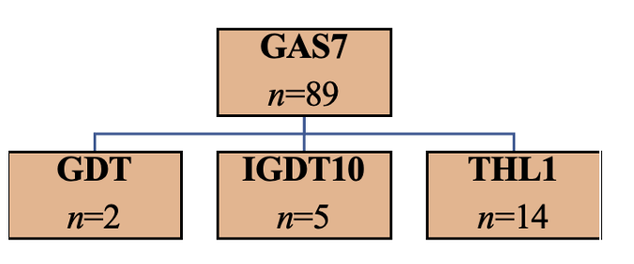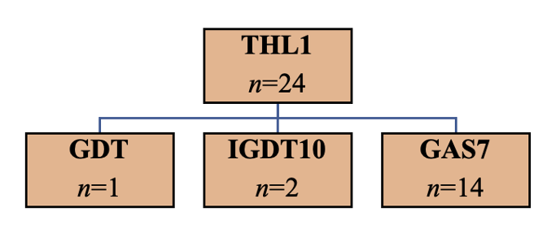
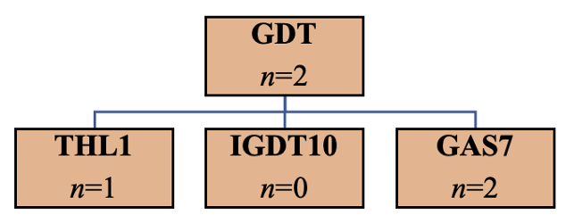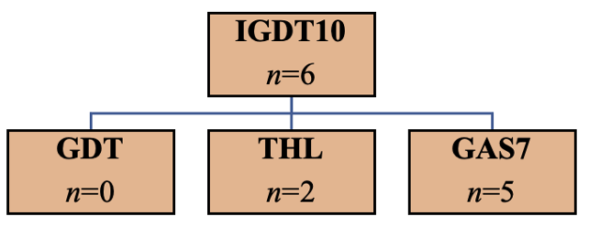
Figure A. The groups identified by each of the four instruments in the pilot. We present only the higher cutoff (3/4) for THL1.

For H3, the data provided us with estimates for mental and physical health differences. The respondents filled out GPH-2 and GMH-2 scales (Hays et al. 2017), which have been localized and tested by the collaboration of the National Institute for Health and Welfare and PROMIS Health Organization (THL 2021). Because the Finnish translation does not have published validation studies yet, we tested their internal consistencies (existing Stata code https://www.stata.com/manuals13/mvalpha.pdf). The coefficient alpha for GMH-2 was good (0.78) and for GPH-2 slightly below (0.66). Spearman-Brown produced the same results. Due to the instruments having only two items, and the translations having been done carefully with a professional linguist, we considered the instruments valid for use in this study.
The sample size allowed us to compare the GAS7 criteria meeting group (n=89) mental and physical health with the general population. In terms of both mental and physical health, the general population had slightly higher mean values than the individuals identified by GAS7 (see reference values in the Methods section). A one-way analysis of variance (existing State code https://www.stata.com/manuals13/mvalpha.pdf) test showed that there was a statistically significant difference between both physical health (F[1, 998]=4.66, p<0.05, Cohen’s d=0.23 (95% CI [0.14, 0.33)] and mental health (F[1,998]=8.53, p<0.01, Cohen’s d=0.32, 95% CI [0.22, 0.41]). When identifying a group by the lower THL1 cutoff 2/4 (n=138), the effects were smaller (lower physical health p=0.09, d=0.13, 95% CI [0.30, -0.05]; lower mental health p=0.04, d=0.16, 95% CI [0.34, -0.02]) and the CIs crossed both null and our smallest effect size of interest. To seek clarifying support, we accessed and analyzed a recently opened nationally representative dataset (N=3994), shared by the Finnish Health Institute (THL & Salonen 2021). The data were collected for gambling research, but it also included modified GAS7 (timespan changed from 6 months to 12 months and “gaming” replaced by “digital gaming”), the original THL1, and Mental Health Inventory 5 (Berwick et al. 1991). We found both GAS7 (p=.015, d=0.37, 95% CI [0.14, 2.26) and THL1 (cutoff 2/4; p=.000, d=0.52, 95% CI [0.35, 0.65]) to correlate with lower mental health scores. This supported our H3a, but provided mixed evidence for H3b/c. Therefore, we decided to set competing H0 hypotheses for the latter.
We use these pilot data to specify outcome expectations for our hypotheses in the analysis plan section. Materials are available here: https://osf.io/6fqm5/
The final survey will also measure gambling problems (Salonen & Raisamo 2015; translation from Gebeuer et al. 2010), perceived loneliness (Tilvis et al. 2000), work ability (WAI short version; Ilmarinen 2007), and work recovery (Mauno et al. 2017), which we will use exploratively. The results will not be reported in this registered report. Table 2 summarizes all measures.

Construct | Measure | Details
Gaming-related health problems
Gaming addiction | Gaming addiction scale (GAS7), Lemmens et al. (2009). | 7-item measure on scale 1–5, polythetic cutoff 4/7 by score 3/5
Internet gaming disorder | Internet Gaming Disorder Test (IGDT10), Király et al. (2017). | 10-item measure on scale 1–3, polythetic cutoff 5/9 by score 3/3
Gaming disorder | Gaming disorder test (GDT), Pontes et al. (2019). | 4-item measure on scale 1–5, monothetic cutoff 4/4 by score 4/5
Self-assessed problem gaming | Problem gaming test (THL1), Salonen & Raisamo (2015). | 1-item measure on scale 1–4, cutoff by score ¾
General health
General Mental Health | PROMIS General Mental Health (GMH-2), Hays et al. (2017). | In US national standards, less than 28 = poor, more than 56 = excellent
General Physical Health | PROMIS General Physical Health (GPH-2), Hays et al. (2017) | In US national standards, less than 35 = poor, more than 58 = excellent
Additional measures (not used in this registered report)
Work ability | Work ability index short form (WAI), Ilmarinen (2007) | 1-item measure on scale 0–10
Work recovery | Work recovery question (WR), Mauno et al. (2017) | 1-item measure on scale 1–5
Perceived loneliness | Perceived loneliness (PL), Tilvis et al. (2000) | 1-item measure on scale 1–3
Pathological gambling | BBDS, Salonen & Raisamo (2015) from Gebauer et al. (2010) | 3-item measure on scale 1–2, polythetic cutoff 1/3 by score 2/2
Measures added after Stage 1 (not used in this registered report)
Anxiety | General anxiety disorder scale 2 (GAD-2) (Spitzer et al. 2006), Finnish validation (Kujanpää et al. 2014) | 2-item measure on scale 1–4
Bullying | “The following question concerns bullying (e.g., at school, work, or home). Please choose the response that best corresponds to your experience. In my life, I have been bullied in ways that have significantly reduced my physical or mental health.” | 1-item measure with a 5-point Likert response scale.
Depression | Beck Depression Inventory (BDI), Finnish validation (Aalto et al. 2012) | 6-item measure on scale 1–5
Item about the effect of Ukraine on mental health | “To what degree has the war in Ukraine and the related crisis negatively affected your mental health?” | 1-item measure on scale 1–5
Table 2. All measures. Additionally, those who reported not having played games at all were given several brief items about why they do not play.

References

Aalto, A. M., Elovainio, M., Kivimäki, M., Uutela, A., & Pirkola, S. (2012). The Beck Depression Inventory and General Health Questionnaire as measures of depression in the general population: a validation study using the Composite International Diagnostic Interview as the gold standard. Psychiatry research, 197(1-2), 163-171.
Berwick, D. M., Murphy, J. M., Goldman, P. A., Ware Jr, J. E., Barsky, A. J., & Weinstein, M. C. (1991). Per- formance of a five-item mental health screening test. Medical care, 169–176.
Fornell, C., & Larcker, D. F. (1981). Evaluating structural equation models with unobservable variables and measurement error. Journal of Marketing Research, 18(1), 39–50. https://doi.org/10.2307/3151312.
Gebauer L, LaBrie R, Shaffer HJ. Optimizing DSM-IV-TR Classification accuracy: A brief Biosocial Screen for Detecting Current gambling Disorders Among Gamblers in the General Household Population. The Canadian Journal of Psychiatry 2010; 55(2): 82-90.
Hays, R. D., Schalet, B. D., Spritzer, K. L., & Cella, D. (2017). Two-item PROMIS® global physical and mental health scales. Journal of patient-reported outcomes, 1(1), 1-5.
Ilmarinen, J. (2007). The work ability index (WAI). Occupational medicine, 57(2), 160-160.
Karhulahti, V. M., & Koskimaa, R. (2019). On the Prevalence of Addicted or Problematic Gaming in Finland. Addictive behaviors reports, 10, 100225.
Kujanpää, T., Ylisaukko-Oja, T., Jokelainen, J., Hirsikangas, S., Kanste, O., Kyngäs, H., & Timonen, M. (2014). Prevalence of anxiety disorders among Finnish primary care high utilizers and validation of Finnish translation of GAD-7 and GAD-2 screening tools. Scandinavian journal of primary health care, 32(2), 78-83.
Mauno, S., Hirvonen, R., & Kiuru, N. (2018). Children’s life satisfaction: The roles of mothers’ work engagement and recovery from work. Journal of Happiness Studies, 19(5), 1373-1393.
Männikkö, N., Billieux, J., & Kääriäinen, M. (2015). Problematic digital gaming behavior and its relation to the psychological, social and physical health of Finnish adolescents and young adults. Journal of behavioral addictions, 4(4), 281-288.
Männikkö, N., Ruotsalainen, H., Tolvanen, A., & Kääriäinen, M. (2019). Psychometric properties of the Internet Gaming Disorder Test (IGDT‐10) and problematic gaming behavior among Finnish vocational school students. Scandinavian journal of psychology, 60(3), 252-260.
Salonen, A. & Raisamo, S. (2015) Suomalaisten rahapelaaminen 2015: Rahapelaaminen, rahapeliongelmat ja rahapelaamiseen liittyvät asenteet ja mielipiteet 15-74-vuotiailla. Helsinki: THL.
Spitzer, R. L., Kroenke, K., Williams, J. B., & Löwe, B. (2006). A brief measure for assessing generalized anxiety disorder: the GAD-7. Archives of internal medicine, 166(10), 1092-1097.
THL (2021) National PROMIS Centre. Finnish Institute for Health and Welfare. https://thl.fi/fi/web/toimintakyky/toimintakyvyn-arviointi/kansallinen-promis-keskus
THL & Salonen, Anne (National Health Institute): Rahapelitutkimus 2019 [electronic data]. Version 1.0 (2021-04-27). Finnish Social Science Data Archive. http://urn.fi/urn:nbn:fi:fsd:T- FSD3522
Tilvis, R., Pitkälä, K., Jolkkonen, J., & Strandberg, T. (2000). Feelings of loneliness and 10-year cognitive decline in the aged population. Lancet, 356, 77-78.

Appendix 2

RQ | H | Sampling | Analysis | Rationale | Interpretation | Theory
A | 1a  1b  1c  1d | Nationally representative N=8000, which corresponds with the precision required to assess prevalence for 0.2 (n=7668). This prevalence is the lowest one found in our pilot (for GDT). | We calculate prevalence rates and 95% confidence intervals with recommended cutoffs for the screening instruments. We apply the method described by Dienes: “If the CI lies mainly in the H0 interval and the remaining minority only in the grey interval, one could accept H0; similarly, if the CI lies mainly in the H1 interval and the remaining minority only in the grey interval, accept H1; otherwise more data are needed” (2021, p. 9). | All instruments have a different ontological basis. Significant differences between prevalence rate proportions would be some evidence for these ontological bases representing different constructs. No difference would be evidence for these ontological bases representing the same construct. | In each hypotheses, we set the H0 interval to the lower bound of the smallest obtained prevalence rate and the H1 interval to x2 of its upper bound. If the confidence intervals of the differences between compared prevalence rates fall mainly to the H1 area, we consider H1a–d corroborated. Null will be corroborated by the confidence intervals falling mainly to the H0 area. If the confidence interval falls mainly in the grey area between, none of the hypotheses are corroborated. | H1 (if all sub hypotheses are corroborated) would support the position that the DSM-IV and/or Self-assessment based “gaming disorder” constructs are different from those of ICD-11 and/or DSM-5, prevalence-wise. H0 (if all sub hypotheses are refuted) would support the similarity of the constructs, respectively. Both types of evidence would be theoretically meaningful. In case of mixed findings, we do not draw full theoretical implications for H1 or H0.
B | 2a | N/A | We test P(DSM-5|ICD-11)≈1 and P(DSM-5+GDT|DSM-IV)≈1. To control Type 2 error, we allow variation by the lower bound of the binomial probability 50% confidence interval for the conditional probability P=1 (at n=16/16; 0.917, 1). For possible null testing, we set the binomial probability confidence interval at 95% for the conditional probability P=1 (n=16/16; 0.794, 1). | All instruments have a different ontological basis, but previous literature has shown 100% of those who meet ICD-11 based criteria to also meet DSM-5 criteria. We thus expect the ICD-11 criteria meeting group to also meet the DSM-5 cutoff. To control Type 2 error, we allow variation based on the 50% confidence interval of P=1 (at n=16/16; 0.917, 1). | If the obtained sample of ICD-11 identified participants meets P(ICD-11|DSM-5)>0.917, we consider H2a corroborated and this as evidence for the ICD-11 and DSM-5 based constructs to be similar by overlap. If the obtained sample of GDT-identified participants meets P(ICD-11|DSM-5)<0.794,  we consider this as evidence for the ICD-11 and DSM-5 based constructs to be different by overlap. | If both H2a and H2b are corroborated, this would be evidence for all ICD-11, DSM-5, and DSM-IV based constructs to overlap. If H2a and H2b are not corroborated, this will be evidence for construct differences (three possible differences: ICD-11 vs DSM-5, ICD-11 vs DSM-IV, DSM-5 vs DSM-IV). Similarities support the singular “gaming disorder” construct and differences support the multiplicity thereof. In case of mixed findings, we do not draw full theoretical implications for H2 or H0.
B | 2b |  |  | Our pilot indicates both ICD-11 and DSM-5 based groups to also meet DSM-IV criteria. We thus expect the ICD-11 and DSM-5 criteria meeting groups to also belong to the DSM-IV criteria meeting group (in the same way as above). | [Same as above, with GDT, IGDT10, GAS7]
C | 3a | The sample size is based on a power analysis for the Welch t-test (one-sided). We expect that the size of the effect between the DSM-IV group and the rest of the sample will be approximately d=0.22–0.41 with GPH-2 and GMH-2. For the desired power level of 0.9, alpha set to 0.0125, and the expected sizes of the DSM-IV group (n=712 / 8.9%) and self-assessment group (n=192 / 2.4%) when the target sample size is N=8000, we have power to reliably detect d=0.138 and d=0.257, respectively. Although the latter does not meet our lowest effect size of interest (d=0.22), we have reason to believe that our prevalence rates will be higher. If the self-assessment criteria meeting group will be smaller than the one needed to detect the observed effect, we will not make inferences in H3b unless the upper bound of the effect’s confidence interval does not exceeds our smallest effect size of interest (which would support uninteresting effect). | We compare the means of mental and physical health, measured by GPH-2 and GMH-2, between the DSM_IV group and the rest of the sample (two-tailed ANOVA). This is repeated with self-assessment criteria. We carry out the Welch t-test twice with a corresponding alpha level 0.025 (multiple comparison correction). In case of nonsignificant results, we continue with equivalence testing (as below). | Based on pilot data, we expect the DSM-IV criteria meeting group to have lower general mental health than the remaining sample. Previous evidence and our pilot indicate the same for physical health, and we expect this, too. | If either the mental or physical health of the DSM-IV based criteria meeting groups are significantly (d≥0.22 at alpha 0.025) lower than those of the rest of the sample, we consider H3a corroborated. A nonsignificant or below d=0.22 effect will not corroborate the H3a. | If corroborated, we consider that as evidence for the THL1 (self-assessed) or GAS7 (DSM-IV pathological gambling based) criteria meeting groups to have lowered mental and/or physical health (no causal interpretations). This would support the two instruments to measure one or more constructs, which are distinct health-wise in relation to the general population. Equivalence, in turn, would support equal health levels between those with “gaming disorder” in the two respective ontological domains and the general population.
C | 3b |  |  | [Same as above with mixed evidence for THL1] | Same as above with THL1, where equivalence testing can support the null.]
C | 3c | N/A | We use the TOSTER::TOSTone.raw() function from the TOSTER package. First, we will compute raw means (m_{diff1}, m_{diff2}) and standard deviations (sd_{diff1}, sd_{diff2}) for both effects (differences between groups based on the GAS7 and THL1 classification). In TOSTER::TOSTone.raw() function m = 0, sd = (sd_{diff1}, sd_{diff2})/2 and mu = m_{diff1} – m_{diff2}. Lower and upper equivalence bound will be +- 0.2 sd. If we do not find equivalence, we move to test significance both ways. | Based on pilot data, both equivalence and difference are possible. We set two competing hypotheses. | We test significance between the health levels of the two groups and consider d≥0.22 (at alpha 0.025) evidence for difference. | Corroborated H0 would weakly support self-assessed “gaming disorder” and DSM-IV based “gaming disorder” to represent the same or similar construct health-wise. If we find a difference, this would some evidence for the multiplicity regarding the two constructs health-wise. Fully corroborated H3/H0 would require all sub hypotheses to be corroborated.

RQ: How do screening instruments that derive from different ontological understandings differ in identifying GRHP groups?

RQ-A: How do GRHP screening instruments that derive from separate ontological understandings differ in their prevalence rates (how many)?
RQ-B: How do GRHP screening instruments that derive from separate ontological understandings differ in who they identify (what characteristics)?
RQ-C: How do GRHP screening instruments that derive from separate ontological understandings differ in the health of their identified groups (how healthy)?

H1: We expect the ICD-11 and DSM-5 based GRHP prevalence rates to be meaningfully lower than the DSM-IV and Self-assessment based prevalence rates.

H1a: We expect the ICD-11 based prevalence rate to be meaningfully lower than the DSM-IV based prevalence rate.
H1b: We expect the ICD-11 based prevalence rate to be meaningfully lower than the Self-assessment based prevalence rate.
H1c: We expect the DSM-5 based prevalence rate to be meaningfully lower than the DSM-IV based prevalence rate.
H1d: We expect the DSM-5 based prevalence rate to be meaningfully lower than the Self-assessment based prevalence rate.

H2: We expect ICD-11, DSM-5, and DSM-IV, based GRHPs to overlap. Those who meet the ICD-11 criteria also meet the DSM-5 criteria, and both above additionally meet the DSM-IV based criteria.

H2a: Those who meet the ICD-11 criteria also meet the DSM-5 criteria.
H2b: Those who meet the ICD-11 and DSM-5 criteria also meet the DSM-IV based criteria.

H3: We expect those with DSM-IV and Self-assessment based GRHPs to have (equally) lower health in comparison to the general population.

H3a: We expect those with DSM-IV based GRHPs to have meaningfully lower mental or physical health in comparison to the general population.
H3b/H0: We expect those who Self-assess that they have gaming problems to have meaningfully lower mental or physical health in comparison to the general population.
H3c/H0: We expect the mental and physical health of those with DSM-IV and Self-assessment based GRHPs to be meaningfully different.

All the applied instruments are self-assessment survey tools, but only one (THL1) asks the respondent to directly Self-assess their gaming problems.
As we were about to initiate data collection, the war in Ukraine started. Russia threated to use nuclear weapons, and in Finland (where our participants are), for the first time in history, the support for joining NATO (North Atlantic Treaty Organization) outnumbered opponents. Although the past two years under COVID-19 had hardly been “normal,” the acute possibility of World War III implied that the mental health of our participants was not what it had been a bit earlier. The project schedule did not allow postponing data collection, but as an extra control measure, our team agreed to enlarge the survey with two additional measures: anxiety (validated Finnish translation of GAD-2: Kujanpää et al. 2014) and depression (validated Finnish translation of BDI-6: Aalto et al. 2012). To add further means for assessing the effects of the drastic world events, we included a single item that asks the participants to self-report the negative mental health impact of the war in Ukraine. As a byproduct of these last-minute changes and several extra test iterations, a mistake occurred in our team and an erroneous GPH-2 item—PROMIS Global Health item #09 instead of #06, which is very similar in wording—ended up being included in the final survey. We noticed this soon after the data had been collected and immediately contacted the recommender who, after discussing with the managing board, advised us to proceed without confirmatory GPH-2 analysis in H3. We thus report physical health exploratively in this section with only one GPH-2 item (“GPH-1”).

