Does ‘virtuality’ affect the role of prior expectations in perception and action? Comparing predictive grip and lifting forces in real and virtual environments

David Harris¹, Tom Arthur¹, Gavin Buckingham¹

1. School of Public Health and Sport Sciences, Medical School, University of Exeter, Exeter, EX1 2LU, UK.

Author note – Correspondence concerning this article should be addressed to Dr David Harris, School of Public Health and Sport Sciences, Medical School, University of Exeter, St Luke’s Campus, Exeter, EX1 2LU. Contact: D.J.Harris@exeter.ac.uk
Conflict of interest – The authors declare no conflicts of interest.
Availability of data, material and code – All relevant data and code is available online from: https://osf.io/3zhna/
Funding – This work was supported a Leverhulme Early Career Fellowship awarded to DH.

Abstract
Recent theories in cognitive science propose that prior expectations strongly influence how individuals perceive the world and control their actions. This influence is particularly relevant in novel sensory environments, such as virtual reality (VR). This registered report outlines a study examining the impact of VR on prediction-related sensory perception and motor control during object lifting. We aim to test two competing hypotheses: the Low-Precision Priors (LPP) hypothesis suggests reduced influence of prior expectations in VR due to the novelty and uncertainty of the context, while the High-Precision Priors (HPP) hypothesis posits increased reliance on predictions relative to current sensory information due to sensory uncertainty. We will employ weight illusion tasks (the size-weight and material-weight illusions) to isolate the effects of expectations on perception and action to test whether VR alters the influence of prior expectations on weight perception and fingertip forces. This research addresses crucial questions about how virtual environments impact predictive sensorimotor control and has implications for applications of VR technologies to training and rehabilitation.
Does ‘virtuality’ affect the role of prior expectations in perception and action? Comparing predictive grip and lifting forces in real and virtual environments

Introduction
A collection of theories in cognitive science have argued that people’s perceptions of the world are heavily shaped by their prior expectations or beliefs (Bar, 2007; Clark, 2013; de Lange et al., 2018; Helmholtz, 1860; Hohwy, 2013). Actively generating predictions about sensations helps an observer interpret incoming information, make sense of noisy sensory inputs, and subsequently control their actions (Henderson, 2017; Wolpert & Flanagan, 2001). Advances in technology mean that the human sensorimotor system is, however, increasingly being placed in novel and ambiguous sensory environments. One salient example of comes in the form of engagement with computer-generated environments such as immersive virtual reality, where existing action models and predictions may not apply (Harris et al., 2019; Yarossi et al., 2021). In the present work, we will examine whether placing people in a virtual environment impacts prediction-related sensory perception and motor control during object lifting.
Virtual reality (VR) refers to a collection of technologies that simulate physical reality, allowing the user to interact with a computer-generated environment in a reasonably naturalistic fashion (Burdea & Coiffet, 2003; Slater, 2009). VR is being rapidly adopted for a diverse range of purposes including rehabilitation, robotic teleoperation, psychological experimentation, workplace training, and entertainment. Yet, the perceptual consequences of perceiving, moving, and learning in VR are poorly understood. For instance, there are concerns that impoverished haptic and visual information may fundamentally alter perception and action in VR (Bingham et al., 2001; Brock et al., 2023; Harris et al., 2019; Rzepka et al., 2022; Wijeyaratnam et al., 2019). For instance, the quality of visual feedback (e.g., tracking and visualization of hands) can be limited, and may vary between virtual environments. This is likely to have implications for the online control of goal-directed movements (Desmurget et al., 1998). Furthermore, a disrupted mode of action control in VR could impair any subsequent transfer of learning back to the real-world and undermine many applications of VR, including psychological experimentation (Harris et al., 2020).
In addition to providing unusual sensory information, virtual worlds are (often overtly) not beholden to the laws of the physical environment, which may also affect the way people make predictions about sensory input, causal regularities in the world, and their own action capabilities (Yarossi et al., 2021). It is well established that internal predictive models inform sensorimotor functions and the processing of sensory input (Clark, 2013; Friston, 2010; Körding & Wolpert, 2004). For instance, decades of studies into the famous ‘size-weight illusion’ have shown that lifelong learning that larger objects tend to be heavier than smaller objects influences both the fingertip forces when lifting objects and the experience of how heavy they feel (Buckingham, 2014; Flanagan & Beltzner, 2000). These priors are said to be represented probabilistically, such that more certain (i.e., precise) beliefs will have a greater impact on perception, while weaker beliefs will be more easily overridden (Knill & Pouget, 2004; Yu & Dayan, 2005). Priors are malleable and context specific, making them highly sensitive to the surrounding environment (Trapp & Bar, 2015). Hence a belief that the current context is new, unknown, or unpredictable can have cascading effects on the balance between top-down predictions and bottom-up sensations (Behrens et al., 2007). In this work, we will examine how immersion in virtual environments might impact this balance during the simple daily task of object lifting.
Although VR technologies seek to accurately substitute real sensory inputs for artificially generated ones, individuals wearing VR headsets usually retain a sense that the world in which they are immersed is not real (Stoffregen et al., 2003). Yarossi and colleagues propose that the brain interprets VR as a novel sensorimotor context, due to the presence of sensory conflicts, such as visual-vestibular mismatch from head tracking errors or optic flow lags (Yarossi et al., 2021). Yarossi et al. point to context-specific learning effects (e.g., context-dependent memory; Smith & Vela, 2001) and context-dependent motor adaptation (Shadmehr et al., 2010; Welch & Ting, 2014) to argue that VR may be treated as a novel context. There is preliminary evidence that this novel context may alter the balance between top-down expectations and bottom-up sensory information during motor learning. For instance, larger aftereffects in a prism adaptation task have been observed for VR compared to prism goggles (Ramos et al., 2019) and aftereffects from learning perturbed reaches persist in VR despite an explicit learning strategy, where aftereffects would not be expected (Anglin et al., 2017). Both results are indicative of reduced precision afforded to predictions, relative to current sensory inputs. So, while predictions about the normal regularities of the world might indeed be a feature of how people behave in VR, an increased sense of environmental novelty and/or uncertainty could weaken their impact on perceptual-motor processes relative to incoming sensory information. We refer to this as the low-precision priors (LPP) hypothesis.
An alternative proposition is that people might instead rely more heavily on predictions in VR. According to Bayesian accounts of perception, the relative influence of different information sources is scaled according to their perceived reliability or precision (Knill & Pouget, 2004). Virtual environments – where sensory inputs may be missing, unrealistic, or uncertain (Harris et al., 2019) – might, therefore, induce a reweighting of information where people assign reduced precision to sensations and rely more heavily on prior knowledge. A study by Rzepka et al. (2022) reported that participants relied heavily on the familiar dimensions of objects when asked to judge their size in VR, regardless of the availability of binocular cues to size and distance. This effect diverged from physical reality, where participants instead relied more on presented size in binocular conditions, suggesting that prior knowledge about the typical size of objects was prioritised in VR. We refer to this as the high-precision priors (HPP) hypothesis. In Figure 1 we illustrate these hypotheses via changes in the precision of the prior distribution but shifts towards (HPP) or away from (LPP) the prior could equally be driven by changes in the weighting of sensory inputs. Hence we are concerned with the relative balance between the two. Our primary aim with this research is to test these competing predictions and establish whether VR induces a greater, lesser, or similar reliance on prior expectations than shown in ‘real-world’ physical environments. Our focus here is to compare physical reality with a virtual environment that is very closely matched in terms of the visual and haptic information available, such that any differences are most likely attributable to ‘virtuality’ rather than critical differences in available information. It is worth noting, however, that virtual environments differ greatly in the nature of the visual and haptic information, which will itself affect the way information sources are weighted in perception and action.
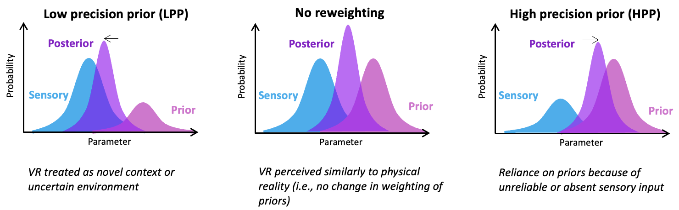
Figure 1 – Illustration of our three hypotheses about perception in VR. The left panel illustrates a downweighting of the perceived precision of the prior, and therefore relative increase in influence of sensory input. The right panel illustrates a downweighting of sensory input and corresponding relative increase in the strength of the prior. In the context of the SWI, if the LPP hypothesis is correct we will observe a smaller influence of object size on fingertip forces and a reduced illusion. If the HPP hypothesis is correct, we will observe a larger influence of object size on fingertip forces and a greater perceptual illusion. The middle panel illustrates a balanced weighting of prior expectations and incoming sensations to represent the absence of any reweighting in VR.

It may also be important to consider the moderating role that presence in VR could have on the balance between predictions and sensory input. Slater describes how creating a sense of presence – the subjective experience of actually being inside the virtual environment – can induce users to behave as if the virtual world were real (Meehan et al., 2002; Slater et al., 2006). Consequently, the degree to which the VR world is believed to be ‘real’ may influence whether it is treated as a new and uncertain context, or an extension of reality. Indeed, a previous study has shown that the magnitude of the SWI may be stronger for more immersive virtual presentation conditions (Heineken & Schulte, 2007). Further support comes from the finding that the realism of a virtual hand during a VR reaching task moderates the strength of prediction error signalling (EEG prediction error negativity) (Singh et al., 2018). Attenuated prediction errors under less realistic conditions are suggestive of weaker prior beliefs, indicating that the realism of the VR environment may still have an important influence on predictive sensorimotor control.
To experimentally compare the LPP and HPP hypotheses, we will use two weight illusion tasks that isolate the influence of prior expectations on perception and action (Buckingham, 2014; Buckingham & Goodale, 2013; Ellis & Lederman, 1999; Flanagan & Beltzner, 2000). In the size-weight illusion (SWI), expectations such as ‘large objects are likely to be heavier than small objects’ lead to the experience of smaller objects feeling heavier than similarly weighted larger objects (Charpentier, 1891). Because of the feedforward, predictive, nature of how people grip and lift objects, these expectations bias not only the conscious perception of weight, but also a person’s fingertip and lifting forces. Consequently, large novel objects are lifted at a higher rate of force than smaller objects of the same type, irrespective of how much they actually weigh. Similar effects have been observed for expectations about the material properties of lifted objects (Buckingham et al., 2009, 2011; Ellis & Lederman, 1999), known as the material-weight illusion (MWI). In the MWI, objects that are known to be typically denser (e.g., granite) are lifted at higher rates of force than those known to be typically less dense (e.g., polystyrene). Experimentally equating the weights of, for instance, polystyrene and granite objects with a hidden lead weight leads to the experience of the polystyrene as heavier than the granite (Buckingham et al., 2011; Ellis & Lederman, 1999). To compare the LPP and HPP hypotheses, we will examine differences in (i) experienced heaviness and (ii) predictive grip and lifting forces between real and VR versions of the SWI and MWI tasks. If the LPP hypothesis is correct, then expectations about the weight of larger (SWI), or typically denser (MWI), objects will have a reduced influence on both perceptions of weight and feedforward sensorimotor control, compared to physical reality. If, however, the HPP hypothesis is correct, both the size of the illusion and the influence of object size/material on grip forces will be larger in VR than physical reality. Finally, if the relative strength of priors is unaffected by immersion in a virtual world, there will be no difference in the degree of sensorimotor prediction between physical and virtual reality. While several previous studies have explored the effect of VR on manual reaching behaviours (Anglin et al., 2017; Bingham et al., 2001; Gerig et al., 2018; Viau et al., 2004), to our knowledge no previous studies have explicitly examined the contribution of predictions to sensorimotor control in a virtual environment.
Pre-registered research questions
RQ1 – Do prior expectations influence perception of object weight and predictive fingertip force application differently in VR compared to physical reality (LPP versus HPP account)?
- If prior expectations are weaker in VR (LPP account), the magnitude of both the SWI and the MWI will be smaller in VR compared to the real world (see hypotheses H1_{A} and H1_{B} in table of questions). Additionally, the difference in peak grip force and load force rates between small and large objects (SWI), or more and less dense-looking objects (MWI), will be smaller in VR than in the real world (see hypotheses H2_{A} and H2_{B} in table of questions).

Methods (Experiments 1 & 2)

Participants
We will use an opportunity sample of individuals, mostly recruited from students at the host University. The same participants will take part in both experiments. Power calculations (see Table of questions) indicated that 62 participants would be sufficient to answer the primary research questions with a power of 90%.

Design
Both experiments will adopt a repeated measures design, with participants completing VR and real-world versions of the lifting task (for both the MWI and SWI) in a counterbalanced order (see Figure 2).
Figure 2
Study design and stimuli.
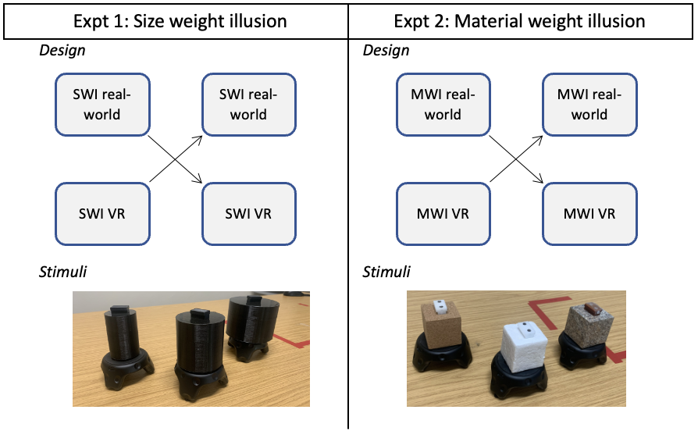

Materials

Real object lifting conditions
Experiment 1 - SWI. As in Buckingham (2019), participants will be asked to lift and judge the weight of three 7.5-cm tall black plastic cylinders, using a lifting handle fitted with an ATI Nano-17 Force transducer. Objects will differ in physical diameter (small: 5 cm, medium: 7.5cm, large: 10 cm) but will all be filled with packing foam and lead shot to weigh 486 g, with the centre of mass balanced around the centre of the object. Hence, the objects will differ in volume, but not weight. To animate the objects in the VR condition, a Vive tracking device will be attached to the base of the object (see Figure 3) and will therefore also be included in the real-world condition. The dimensions of trackers are 70.9 × 79.0 × 44.1 mm and they weigh 75g, taking the total weight of each object to 561g. Independent testing has supported the accuracy of the trackers for accurate visualization, even in more vigorous activities (Merker et al., 2023).
Figure 3
Real-world (top) and VR (bottom) SWI stimuli
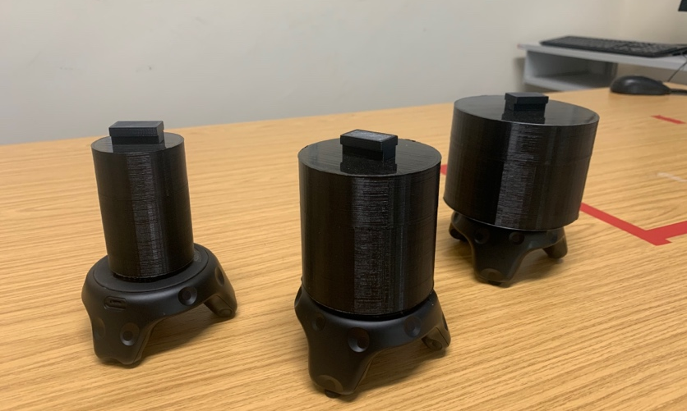
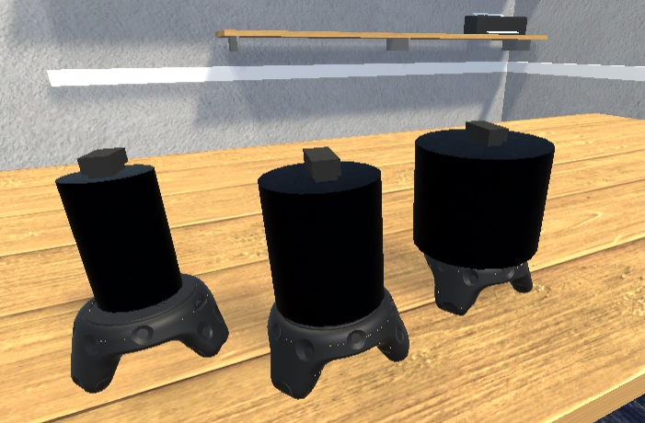

Experiment 2 - MWI. The three identically sized cubes made from three different materials – polystyrene (unaltered density 0.05g/cm3), cork (unaltered density 0.24g/cm3), and granite (unaltered density 2.67g/cm3) (Figure 4) – will be used to elicit the MWI (as used in Naylor et al., 2022). The three boxes (5 x 5 x 5 cm) have been hollowed out and lead weights have been placed inside to ensure they all weigh exactly 123g (+75g). Hence, they will only differ to participants in their surface material. Prior to the experiment, participants will be given no indication about the weight of the boxes and the experimenter will not visibly handle the blocks within their field of view.
Figure 4
Real-world (top) and VR (bottom) MWI stimuli
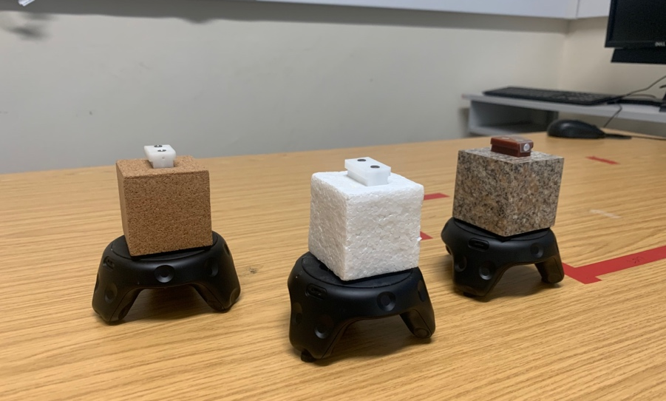
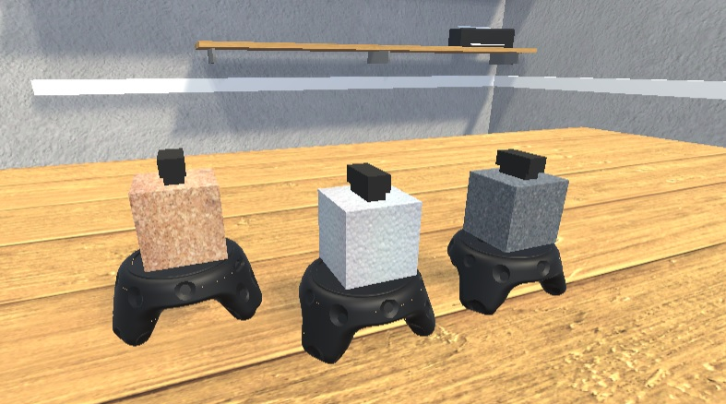

Virtual conditions
Experiment 1 - SWI. The virtual condition will involve lifting the same objects as the real condition, but participants will view digital recreations in a VR head-mounted-display (HMD). Crucially, these object recreations will be positioned in congruence with the actual physical objects and matched in size to these three differently-sized items. Participants will lift the objects in a bespoke immersive VR game environment designed to look like a duplicate of the testing laboratory. The task will be presented via an HTC Vive Pro Eye headset (HTC, Taiwan), a high-precision VR system which has proven valid for small-area movement research tasks (Niehorster et al., 2017). The Pro Eye headset is a 6-degrees of freedom, consumer-grade system which presents a 360° environment with 110° field of view. Participants will wear a Vive tracker attached to the wrist of their dominant hand so that a white sphere can be rendered in the place of their hand to enable grasping in the virtual task (matching the approach of Buckingham, 2019). The VR task has been developed using the gaming engine Unity 2019.2.12 (Unity technologies, CA) and C#. Graphics have been generated with an HP EliteDesk PC running Windows 10, with an Intel i7 processor and Titan V graphics card (NVIDIA Corp., Santa Clara, CA). Three ‘lighthouse’ base stations will be used to monitor positions and rotations of the headset and Vive tracker devices at 90 Hz. The Unity environment can be found online (https://osf.io/3zhna/).
Experiment 2 - MWI. For the material weight study, the same VR set up will be used, but the visual properties of the objects will be changed to match the different object materials, creating three identically sized objects in VR that appear to be made of polystyrene, cork, and granite. This has been achieved in the VR simulation by applying different textures to the virtual objects in Unity.

Measures (identical for Expt 1 & 2)

Estimated weight

Prior to the first lift in each condition, participants will be asked to verbally estimate the weight of the objects. Participants will be instructed to provide a numerical rating on a scale of their own choosing (i.e., absolute magnitude estimation) (Zwislocki & Goodman, 1980). They will be told that they can use any numbers they like (e.g., negatives, decimals, 10s, 100s) but that they should adopt a consistent rating scale across both conditions. This approach follows that used in many weight illusion studies and enables a subjective judgement to be captured, whilst still providing a quantifiable measure that can be standardized using across conditions using z-scores (Buckingham, 2019; Buckingham et al., 2011).

Perceived heaviness
Heaviness ratings. After each lift, participants will give a verbal numerical judgment of the perceived heaviness of the object. In order to minimize ratio scaling biases, no constraints or scale for these estimates will be provided. Participants will simply be instructed that larger numbers represent heavier weights (as in Arthur et al., 2020; Buckingham et al., 2016). These heaviness ratings will then be normalized to a z-score distribution to enable inter-individual analyses.
SWI / MWI score. A size-weight illusion score will be calculated by subtracting average heaviness ratings (over 10 lifts) for the larger objects from the smaller objects, such that a larger score indicates a larger perceptual illusion. An equivalent material-weight illusion score will be calculated by subtracting average heaviness ratings for the least dense object (polystyrene) from the densest object (granite). We interpret a larger illusion score to indicate a stronger influence of prior predictions on perception.
Force measures
Following Arthur et al. (2020), we will adopt peak grip and load force rate differences between smaller and larger (or less dense and more dense) objects as metrics of sensorimotor prediction. Force data will be obtained from an ATI Nano-17 Force transducer attached to the lifting point on the top of the objects. The force transducer records force perpendicular to the surface of the handle (i.e., grip force) and tangential forces (i.e., load forces) at 500Hz. The force data will be smoothed using a 14-Hz Butterworth filter. To determine peak force rates, data will be differentiated with a 5-point central difference equation. Trial-by-trial plots of grip force will be inspected manually to ensure that the correct peak is taken for the dependent variables.
Sensorimotor prediction. From this processed force data we will derive the metrics peak grip force rate difference (pGFRdiff) and peak load force rate difference (pLFRdiff). For both grip (perpendicular) and load (tangential) force rates, size-related prediction errors will be calculated by subtracting values for the first test lift of the smaller (or denser-looking) objects from the larger (or less dense looking) object (as in Arthur et al., 2020; Buckingham et al., 2016). A larger difference score would therefore indicate that the fingertip forces were more strongly influenced by prior expectations of object heaviness.
Presence
The Slater-Usoh-Steed (SUS) Presence questionnaire (Slater et al., 1998; Usoh et al., 1999) will be used to measure participants’ sense of presence in the VR environment for the purpose of exploratory analyses. The SUS consists of six questions that relate to three themes: i) the sense of being in the virtual environment; ii) the extent to which the virtual environment becomes the dominant reality; and iii) the extent to which the virtual environment is remembered as a ‘place’. Questions are answered on a 1 to 7 scale where the higher score indicates greater presence. The presence score is taken as the number of answers that have a score of ‘6’ or ‘7’.
Procedure
Participants will attend the lab for one visit lasting ~90 minutes. They will have the experiment verbally explained to them and will provide written informed consent. Participants will be told that they will lift objects of different sizes and materials and that we are interested in how they perceive those objects. They will first put on the VR headset and be allowed some time to become familiar with the task environment (but will not be able to interact with any stimuli). Participants will first complete the SWI experiment and then the MWI experiment. Before any lifts take place, the three test objects (small/medium/large or polystyrene/cork/granite) will be placed in front of the participant on the table and they will be asked to estimate their heaviness based on their visual appearance using absolute magnitude estimation (Buckingham & Goodale, 2013). On each lifting trial, participants will sit at a table with their eyes closed. One of the three test objects will be placed in front of them, and they will be told to open their eyes and pick up the object with the thumb and forefinger of their dominant hand in a smooth, controlled, and confident manner. They will be told to then hold it steady at a comfortable height above the surface, before replacing it gently on the table surface. The lift and replace phases of each trial will be signalled by two computer-generated auditory tones, each separated by 4 seconds. Each condition will begin with five ‘baseline’ or ‘washout’ trials of either the medium sized object (expt 1 - SWI) or the cork object (expt 2 - MWI). The baseline lifts will be followed by 30 ‘test’ trials in which each of the three objects is lifted ten times in one of three pseudorandomized orders (following the procedures of closely related previous studies: Arthur et al., 2020; Buckingham, 2019; Naylor et al., 2022). These predetermined trial sequences will guarantee that each ‘heavy’ item is lifted at least once before any ‘light’ trials (see orders on OSF page: https://osf.io/2htwr), thereby ensuring that initial lifts are unexpectedly heavy relative to baseline trials. After each lift, participants will be asked to numerically report how heavy the object felt to them on that trial. After completing the SWI experiment, participants will be allowed a short break and will then perform the MWI. Participants will be remunerated £35 for taking part.
Data treatment
Data will be analysed using JASP (v0.16.3). Data will be checked for univariate outliers more than 3.29 standard deviations from the mean. This value was chosen as a conservative cut-off and based on previous SWI studies (Arthur et al., 2020) and recommendations (Tabachnick & Fidell, 2019). Outlying values will be windsorised, by replacing the outlying value with a score 1% larger (or smaller) than the next most extreme value (Pek et al., 2018). Data will be checked for extreme deviations from normality based on skewness and kurtosis scores. Skewness or kurtosis scores less than -2 or greater than 2 will be taken to indicate extreme skewness or kurtosis (George & Mallery, 2019). Assuming data adhere to these assumptions the tests outlined in the table of questions will be run. The table of questions outlines analyses relating to the primary research question (H1-H2) plus manipulation checking analyses (H3-H5) which will be run first to ensure the SWI and MWI manipulations were successful. Non-parametric alternatives will be used if data deviate substantially from normality: Mann-Whitney U-Tests will be used for the independent comparisons and Wilcoxon tests will be used for paired comparisons. Significance will be accepted at p<.05. Bayes factors using a symmetric Cauchy prior will also be used to quantifying the strength of evidence for the alternative and null hypotheses. These Bayesian analyses will be used as additional information for interpreting the strength of the results but will not be the primary determinant of our conclusions, which will be entirely based on the analyses outlined in the design table.

References
Anglin, J. M., Sugiyama, T., & Liew, S.-L. (2017). Visuomotor adaptation in head-mounted virtual reality versus conventional training. Scientific Reports, 7(1), Article 1. https://doi.org/10.1038/srep45469
Arthur, T., Vine, S., Brosnan, M., & Buckingham, G. (2020). Predictive sensorimotor control in autism. Brain, 143(10), 3151–3163. https://doi.org/10.1093/brain/awaa243
Bar, M. (2007). The proactive brain: Using analogies and associations to generate predictions. Trends in Cognitive Sciences, 11(7), 280–289. https://doi.org/10.1016/j.tics.2007.05.005
Behrens, T. E. J., Woolrich, M. W., Walton, M. E., & Rushworth, M. F. S. (2007). Learning the value of information in an uncertain world. Nature Neuroscience, 10(9), Article 9. https://doi.org/10.1038/nn1954
Bingham, G. P., Bradley, A., Bailey, M., & Vinner, R. (2001). Accommodation, occlusion, and disparity matching are used to guide reaching: A comparison of actual versus virtual environments. Journal of Experimental Psychology: Human Perception and Performance, 27(6), 1314–1334. https://doi.org/10.1037/0096-1523.27.6.1314
Brock, K., Vine, S. J., Ross, J. M., Trevarthen, M., & Harris, D. J. (2023). Movement kinematic and postural control differences when performing a visuomotor skill in real and virtual environments. Experimental Brain Research. https://doi.org/10.1007/s00221-023-06639-0
Buckingham, G. (2014). Getting a grip on heaviness perception: A review of weight illusions and their probable causes. Experimental Brain Research, 232(6), 1623–1629. https://doi.org/10.1007/s00221-014-3926-9
Buckingham, G. (2019). Examining the size–weight illusion with visuo-haptic conflict in immersive virtual reality. Quarterly Journal of Experimental Psychology, 72(9), 2168–2175. https://doi.org/10.1177/1747021819835808
Buckingham, G., Cant, J. S., & Goodale, M. A. (2009). Living in A Material World: How Visual Cues to Material Properties Affect the Way That We Lift Objects and Perceive Their Weight. Journal of Neurophysiology, 102(6), 3111–3118. https://doi.org/10.1152/jn.00515.2009
Buckingham, G., & Goodale, M. A. (2013). Size Matters: A Single Representation Underlies Our Perceptions of Heaviness in the Size-Weight Illusion. PLOS ONE, 8(1), e54709. https://doi.org/10.1371/journal.pone.0054709
Buckingham, G., Michelakakis, E. E., & Rajendran, G. (2016). The Influence of Prior Knowledge on Perception and Action: Relationships to Autistic Traits. Journal of Autism and Developmental Disorders, 46(5), 1716–1724. https://doi.org/10.1007/s10803-016-2701-0
Buckingham, G., Ranger, N. S., & Goodale, M. A. (2011). The material–weight illusion induced by expectations alone. Attention, Perception, & Psychophysics, 73(1), 36–41. https://doi.org/10.3758/s13414-010-0007-4
Burdea, G. C., & Coiffet, P. (2003). Virtual Reality Technology. John Wiley & Sons.
Charpentier, A. (1891). Analyse experimentale: De quelques elements de la sensation de poids. Archives de Phisiologie Normale et Pathologique, 3, 122–135.
Clark, A. (2013). Whatever next? Predictive brains, situated agents, and the future of cognitive science. Behavioral and Brain Sciences, 36(3), 181–204. https://doi.org/10.1017/S0140525X12000477
de Lange, F. P., Heilbron, M., & Kok, P. (2018). How Do Expectations Shape Perception? Trends in Cognitive Sciences, 22(9), 764–779. https://doi.org/10.1016/j.tics.2018.06.002
Desmurget, M., Pélisson, D., Rossetti, Y., & Prablanc, C. (1998). From Eye to Hand: Planning Goal-directed Movements. Neuroscience & Biobehavioral Reviews, 22(6), 761–788. https://doi.org/10.1016/S0149-7634(98)00004-9
Ellis, R. R., & Lederman, S. J. (1999). The material-weight illusion revisited. Perception & Psychophysics, 61(8), 1564–1576. https://doi.org/10.3758/BF03213118
Flanagan, J. R., & Beltzner, M. A. (2000). Independence of perceptual and sensorimotor predictions in the size–weight illusion. Nature Neuroscience, 3(7), 737–741. https://doi.org/10.1038/76701
Friston, K. (2010). The free-energy principle: A unified brain theory? Nature Reviews Neuroscience, 11(2), 127–138. https://doi.org/10.1038/nrn2787
George, D., & Mallery, P. (2019). IBM SPSS Statistics 26 Step by Step: A Simple Guide and Reference (16th ed.). Routledge. https://doi.org/10.4324/9780429056765
Gerig, N., Mayo, J., Baur, K., Wittmann, F., Riener, R., & Wolf, P. (2018). Missing depth cues in virtual reality limit performance and quality of three dimensional reaching movements. PLOS ONE, 13(1), e0189275. https://doi.org/10.1371/journal.pone.0189275
Harris, D. J., Bird, J. M., Smart, A. P., Wilson, M. R., & Vine, S. J. (2020). A framework for the testing and validation of simulated environments in experimentation and training. Frontiers in Psychology, 11(605). https://doi.org/10.3389/fpsyg.2020.00605
Harris, D. J., Buckingham, G., Wilson, M. R., & Vine, S. J. (2019). Virtually the same? How impaired sensory information in virtual reality may disrupt vision for action. Experimental Brain Research, 237(11), 2761–2766. https://doi.org/10.1007/s00221-019-05642-8
Heineken, E., & Schulte, F. P. (2007). Seeing Size and Feeling Weight: The Size-Weight Illusion in Natural and Virtual Reality. Human Factors, 49(1), 136–144. https://doi.org/10.1518/001872007779598028
Helmholtz, H. V. (1860). Treatise on Physiological Optics. New York: Dover.
Henderson, J. M. (2017). Gaze control as prediction. Trends in Cognitive Sciences, 21(1), 15–23. https://doi.org/10.1016/j.tics.2016.11.003
Hohwy, J. (2013). The Predictive Mind. Oxford University Press.
Knill, D. C., & Pouget, A. (2004). The Bayesian brain: The role of uncertainty in neural coding and computation. Trends in Neurosciences, 27(12), 712–719. https://doi.org/10.1016/j.tins.2004.10.007
Körding, K. P., & Wolpert, D. M. (2004). Bayesian integration in sensorimotor learning. Nature, 427(6971), 244–247. https://doi.org/10.1038/nature02169
Meehan, M., Insko, B., Whitton, M., & Brooks, F. P., Jr. (2002). Physiological Measures of Presence in Stressful Virtual Environments. Proceedings of the 29th Annual Conference on Computer Graphics and Interactive Techniques, 645–652. https://doi.org/10.1145/566570.566630
Merker, S., Pastel, S., Bürger, D., Schwadtke, A., & Witte, K. (2023). Measurement Accuracy of the HTC VIVE Tracker 3.0 Compared to Vicon System for Generating Valid Positional Feedback in Virtual Reality. Sensors, 23(17), Article 17. https://doi.org/10.3390/s23177371
Naylor, C. E., Proulx, M. J., & Buckingham, G. (2022). Using Immersive Virtual Reality to Examine How Visual and Tactile Cues Drive the Material-Weight Illusion. Attention, Perception, & Psychophysics, 84(2), 509–518. https://doi.org/10.3758/s13414-021-02414-x
Niehorster, D. C., Li, L., & Lappe, M. (2017). The Accuracy and Precision of Position and Orientation Tracking in the HTC Vive Virtual Reality System for Scientific Research: I-Perception, 8(3), 2041669517708205. https://doi.org/10.1177/2041669517708205
Pek, J., Wong, O., & Wong, A. C. M. (2018). How to Address Non-normality: A Taxonomy of Approaches, Reviewed, and Illustrated. Frontiers in Psychology, 9. https://www.frontiersin.org/articles/10.3389/fpsyg.2018.02104
Ramos, A. A., Hørning, E. C., & Wilms, I. L. (2019). Simulated prism exposure in immersed virtual reality produces larger prismatic after-effects than standard prism exposure in healthy subjects. PLOS ONE, 14(5), e0217074. https://doi.org/10.1371/journal.pone.0217074
Rzepka, A. M., Hussey, K. J., Maltz, M. V., Babin, K., Wilcox, L. M., & Culham, J. C. (2022). Familiar size affects perception differently in virtual reality and the real world. Philosophical Transactions of the Royal Society B: Biological Sciences, 378(1869), 20210464. https://doi.org/10.1098/rstb.2021.0464
Saccone, E. J., Landry, O., & Chouinard, P. A. (2019). A meta-analysis of the size-weight and material-weight illusions. Psychonomic Bulletin & Review, 26(4), 1195–1212. https://doi.org/10.3758/s13423-019-01604-x
Shadmehr, R., Smith, M. A., & Krakauer, J. W. (2010). Error Correction, Sensory Prediction, and Adaptation in Motor Control. Annual Review of Neuroscience, 33(1), 89–108. https://doi.org/10.1146/annurev-neuro-060909-153135
Singh, A. K., Chen, H.-T., Cheng, Y.-F., King, J.-T., Ko, L.-W., Gramann, K., & Lin, C.-T. (2018). Visual Appearance Modulates Prediction Error in Virtual Reality. IEEE Access, 6, 24617–24624. https://doi.org/10.1109/ACCESS.2018.2832089
Slater, M. (2009). Place illusion and plausibility can lead to realistic behaviour in immersive virtual environments. Philosophical Transactions of the Royal Society B: Biological Sciences, 364(1535), 3549–3557. https://doi.org/10.1098/rstb.2009.0138
Slater, M., Antley, A., Davison, A., Swapp, D., Guger, C., Barker, C., Pistrang, N., & Sanchez-Vives, M. V. (2006). A Virtual Reprise of the Stanley Milgram Obedience Experiments. PLOS ONE, 1(1), e39. https://doi.org/10.1371/journal.pone.0000039
Slater, M., Steed, A., McCarthy, J., & Maringelli, F. (1998). The Influence of Body Movement on Subjective Presence in Virtual Environments. Human Factors, 40(3), 469–477. https://doi.org/10.1518/001872098779591368
Smith, S. M., & Vela, E. (2001). Environmental context-dependent memory: A review and meta-analysis. Psychonomic Bulletin & Review, 8(2), 203–220. https://doi.org/10.3758/BF03196157
Stoffregen, T. A., Bardy, B. G., Smart, L. J., & Pagulayan, R. (2003). On the Nature and Evaluation of Fidelity in Virtual Environments. In L.J. Hettinger & M.W. Haas (Eds.), Virtual and Adaptive Environments: Applications, Implications and Human Performance Issues (pp-111-128). Mahwah, NJ: Lawrence Erlbaum Associates.
Tabachnick, B. G., & Fidell, L. S. (2019). Using multivariate statistics (Seventh edition). Pearson.
Trapp, S., & Bar, M. (2015). Prediction, context, and competition in visual recognition. Annals of the New York Academy of Sciences, 1339(1), 190–198. https://doi.org/10.1111/nyas.12680
Usoh, M., Arthur, K., Whitton, M. C., Bastos, R., Steed, A., Slater, M., & Brooks, F. P. (1999). Walking > walking-in-place > flying, in virtual environments. Proceedings of the 26th Annual Conference on Computer Graphics and Interactive Techniques - SIGGRAPH ’99, 359–364. https://doi.org/10.1145/311535.311589
Viau, A., Feldman, A. G., McFadyen, B. J., & Levin, M. F. (2004). Reaching in reality and virtual reality: A comparison of movement kinematics in healthy subjects and in adults with hemiparesis. Journal of NeuroEngineering and Rehabilitation, 1(1), 11. https://doi.org/10.1186/1743-0003-1-11
Welch, T. D. J., & Ting, L. H. (2014). Mechanisms of Motor Adaptation in Reactive Balance Control. PLOS ONE, 9(5), e96440. https://doi.org/10.1371/journal.pone.0096440
Wijeyaratnam, D. O., Chua, R., & Cressman, E. K. (2019). Going offline: Differences in the contributions of movement control processes when reaching in a typical versus novel environment. Experimental Brain Research, 237(6), 1431–1444. https://doi.org/10.1007/s00221-019-05515-0
Wolpert, D. M., & Flanagan, J. R. (2001). Motor prediction. Current Biology, 18(11), R729–R732. https://doi.org/10.1016/S0960-9822(01)00432-8
Yarossi, M., Mangalam, M., Naufel, S., & Tunik, E. (2021). Virtual Reality as a Context for Adaptation. Frontiers in Virtual Reality, 2, 139. https://doi.org/10.3389/frvir.2021.733076
Yu, A. J., & Dayan, P. (2005). Uncertainty, Neuromodulation, and Attention. Neuron, 46(4), 681–692. https://doi.org/10.1016/j.neuron.2005.04.026
Zwislocki, J. J., & Goodman, D. A. (1980). Absolute scaling of sensory magnitudes: A validation. Perception & Psychophysics, 28(1), 28–38. https://doi.org/10.3758/BF03204312

Question | Hypothesis | Sampling plan | Analysis Plan | Rationale for deciding the sensitivity of the test for confirming or disconfirming the hypothesis | Interpretation given different outcomes | Theory that could be shown wrong by the outcomes
Primary research question (LPP v HPP account):
1a. Does the magnitude of the perceptual illusion during the SWI task indicate higher or lower precision of prior beliefs in VR?  1b. Does the magnitude of the perceptual illusion during the MWI task indicate higher or lower precision of prior beliefs in VR? | H1_{A}: Prior expectations will be weaker in VR, hence the magnitude of the SWI (perceptual illusion) will be smaller compared to the real world.  H1_{B}: Prior expectations will be weaker in VR, hence the magnitude of the MWI (perceptual illusion) will be smaller compared to the real world.  NOTE: these hypotheses for the SWI and MWI tasks are being treated as individual hypotheses that are related to the same question, rather than employing a disjunctive or conjunctive logic (Rubin, 2021). | Power analysis  Independent t-test, power = 0.85, alpha = 0.05, d = 0.8, 60 participants | Between-groups (real-world v VR) comparison of the SWI (Expt1) and MWI (Expt2) score using independent t-tests. This will use just the first condition that people take part in.  We will also run a second repeated measures analysis in which we compare real-world v VR using both conditions from each participant and control for order using a covariate. | Our sample size justification was based on the following rationale related to the smallest effect size of interest (Lakens; 2022). Our intention in this work was to examine whether substantial differences in the role of priors exist between the real-world and VR. In this context, small differences are relatively uninformative as they may be a function of the specifics of the technologies used (e.g., visual and haptic realism) and therefore do not answer the broader HPP versus LPP question. Therefore, the value of information for rejecting small effects is low (Lakens, 2022). Given resource constraints, the costs of detecting small effects outweighs the benefits. We therefore aimed to power the study based on a medium-to-large sized effect (d = 0.8). The selected effect size was also based on typical effects observed in the literature for related manipulations. For instance:  SWI – perceived heaviness  Heineken & Schulte (2007) reported a very large main effect of η_{p}² = 0.57 (equivalent to d = 2.3) when comparing the SWI across different visual presentation mediums (VR, 2D screen).  MWI – perceived heaviness  Naylor et al. (2022) reported large effect sizes when comparing the magnitude of the MWI between different presentation conditions in VR (visual appearance only compared to visual-tactile matched [dz = 1.20], visual-tactile mismatched [dz = 0.79] and tactile only [dz = 1.09] conditions).  SWI – peak grip force rate  When comparing the effect of object categories (same-coloured v different-coloured) Buckingham et al. (2016) reported a size*group interaction of η_{p}² = 0.11 (d = 0.72) for pGFR.  We did not find a comparable effect size for a manipulation of the MWI on peak grip force rate.  Considering that these manipulations yielded medium-to-large effects in SWI and MWI tasks, the decision to not detect effects smaller than this holds significance for the field. Such findings would imply that the influence of VR is less impactful than these established manipulations. | Smaller SWI scores in VR would support the LPP hypothesis, while larger SWI scores in VR would support the HPP hypothesis.  No statistically significant difference between conditions would indicate no difference in strength of prior expectations.  Smaller MWI scores in VR would support the LPP hypothesis, while larger MWI scores in VR would support the HPP hypothesis.  No statistically significant difference between conditions would indicate no difference in strength of prior expectations. | LPP hypothesis versus HPP hypothesis of perception in VR.
2a. Does the magnitude of the sensorimotor prediction effect during the SWI task indicate higher or lower precision of prior beliefs in VR?  2b. Does the magnitude of the sensorimotor prediction effect during the MWI task indicate higher or lower precision of prior beliefs in VR? | H2_{A}: The peak grip force rate difference scores (subtracting first lift of small from first lift of large) will be smaller in VR than in the real world.  H2_{B}: The peak grip force rate difference scores (subtracting first lift of polystyrene from first lift of granite) will be smaller in VR than in the real world.  NOTE: these hypotheses for the SWI and MWI tasks are being treated as individual hypotheses that are related to the same question, rather than employing a disjunctive or conjunctive logic (Rubin, 2021). | Power analysis  Independent t-test, power = 0.85, alpha = .05, d = 0.8, 60 participants | Between-groups (real-world v VR) comparison of pGFRdiff scores during both the SWI (Expt1) and MWI (Expt2) tasks, using independent t-tests. This will use just the first condition that people take part in.  We will also run a second repeated measures analysis in which we compare real-world v VR using both conditions from each participant and control for order using a covariate. |  | Smaller pGFRdiff scores in VR during the SWI task would support the LPP hypothesis, while larger pGFRdiff scores in VR would support the HPP hypothesis. No statistically significant difference in pGFRdiff scores would indicate no difference in strength of prior expectations.  Smaller pGFRdiff scores in VR during the MWI task would support the LPP hypothesis, while larger pGFRdiff scores in VR would support the HPP hypothesis. No statistically significant difference in pGFRdiff scores would indicate no difference in strength of prior expectations.
Manipulation checking analyses:
The following analyses will be performed first to ensure the validity of the main analyses
3a. Do the stimuli induce the SWI in the real world?  3b. Do the stimuli induce the MWI in the real world? | H3_{A}: The real-world SWI stimuli will create a perceptual illusion whereby smaller objects will feel heavier that equally weighted larger objects.  H3_{B}: The real-world MWI stimuli will create a perceptual illusion whereby granite objects will feel lighter than identically weighted polystyrene objects. | Sample determined by primary question (above)  Sample determined by primary question (above) | Paired t-test on heaviness ratings (large v small) averaged across all lifts in the real-world condition.  Paired t-test on heaviness ratings (granite v polystyrene) averaged across all lifts in the real-world condition. | Given the sample size of 60, a paired t-test (alpha = 0.05) will provide 85% power to detect effects in the region of dz = 0.39. This is much lower than the typical SWI effect (d = 1.82 based on meta-analysis of Saccone et al., 2019) and MWI effect (d = 1.00 from Saccone et al., 2019). We therefore have adequate power to perform this test. | If larger objects feel lighter than smaller objects, the SWI was successfully induced.  If typically denser objects feel lighter than less-dense looking objects, the MWI was successfully induced. | If the SWI/MWI perceptual effect does not emerge it will show that the task was not working as in previous studies (probably because they were not reporting their perception of weight appropriately). This would render any other results uninformative.
4a. Do the SWI stimuli induce a sensorimotor prediction effect in the real world?  4b. Do the MWI stimuli induce a sensorimotor prediction effect in the real world? | H4_{A}: The real-world SWI stimuli will induce a sensorimotor prediction effect whereby larger objects will be grasped with more force than smaller objects.  H4_{B}: The real-world MWI stimuli will induce a sensorimotor prediction effect whereby typically denser objects (granite) will be grasped with more force than typically less dense objects (polystyrene). |  | Paired t-test comparing peak grip force between the first test lifts of the smaller and the larger object (real-world condition).  Paired t-test comparing difference in peak grip force rate between the first test lifts of the granite and the polystyrene object (real-world condition). | Given the sample size of 60, a paired t-test (alpha = 0.05) will provide 85% power to detect effects in the region of dz = 0.39. This is much lower than the typical effect of size (d = 0.89; Buckingham et al., 2016) and material cues (d = 1.33; Buckingham et al., 2010) on peak grip forces. We therefore have adequate power to perform this test. | If the large object is grasped with more force than the smaller object, participants are showing the typical pattern of sensorimotor prediction.  If the denser-looking object (granite) is grasped with more force than the less-dense looking object (polystyrene), participants are showing the typical pattern of sensorimotor prediction. | If the SWI/MWI sensorimotor prediction effect does not emerge it will show that participants are not interacting with the objects in a predictive fashion. This would render any other results uninformative.
5a. Do people articulate an expectation that larger objects will be heavier than smaller objects (SWI)?  5b. Do people articulate an expectation that typically denser (but equally sized) objects will be heavier than typically less dense objects (MWI)? | H5_{A}: When asked to estimate the weight of the objects prior to any lifts, we expect people to estimate the large object to be heavier than the small object.  H5_{B}:When asked to estimate the weight of the objects prior to any lifts, we expect people to estimate the granite object to be heavier than the polystyrene object. |  | Paired t-test on estimated heaviness prior to any lifts (large v small) for the real-world condition.  Paired t-test on estimated heaviness prior to any lifts (granite v polystyrene) for the real-world condition. | Given the sample size of 60, a paired t-test (alpha = 0.05) will provide 85% power to detect effects in the region of dz = 0.39. This is much lower than the typical SWI (d = 2.21 from Arthur et al., 2020) and MWI (d = 1.38 from Naylor et al., 2022) effect sizes for pre-lift predictions of heaviness. We therefore have adequate power to perform this test. | If larger objects are estimated to be heavier than smaller objects, then participants would appear to understand the apparent mass of the objects .  If typically denser objects are grasped with more force than typically less-dense objects, then participants would appear to understand the apparent mass of the objects . | If people do not articulate the expected conscious expectations of heaviness in line with the objects’ visual cues, participants might have diminished expectations based on the experimental context under which the stimuli were presented. This would render any other results uninformative.

I.e., learning and selecting from multiple motor programs dependent upon recognition of the same sensory conditions.
In the real-world condition participants will also be fitted with eye tracking glasses to record eye movement data, but this data will not be reported in this manuscript.
Note: all tests are two-tailed

