Sunk cost effects for time versus money:
Replication of Soman (2001)
[Registered Report Stage 1]

Nikolay B Petrov
Cardiff University Brain Research Imaging Centre, University of Cardiff, Cardiff, UK
nikbpetrov@gmail.com

*Yin Kan (Megan) Chan
mykchan@connect.hku.hk / megan.y.k.chan@gmail.com
*Cheuk Nam (Chris) Lau
u3569175@connect.hku.hk / cheuknam10@hotmail.com
*Tin Ho (Donald) Kwok
u3570878@connect.hku.hk / kwoktinho@yahoo.com.hk
*Lok Ching (Estelle) Chow
estellec@connect.hku.hk / chowlcestelle@gmail.com
*Wai Yan Vivian LO
u35690036@connect.hku.hk / lovivi0419@gmail.com
Department of Psychology, University of Hong Kong, Hong Kong SAR

Wenkai Song
ShanghaiTech University
wenkaissong@gmail.com

^Gilad Feldman
Department of Psychology, University of Hong Kong, Hong Kong SAR
gfeldman@hku.hk / giladfel@gmail.com

*Shared second author
^Corresponding author

Author bios
Nikolay B Petrov is a research assistant in the Cognition and Computational Brain lab, based at Cardiff University Brain Research Imaging Centre, University of Cardiff, Cardiff, UK.
Yin Kan CHAN, Cheuk Nam LAU, Tin Ho KWOK is, Lok Ching CHOW, and Wai Yan LO were undergraduate students at the Department of Psychology, University of Hong Kong during the academic year 2020/21.
Wenkai Song is with the School of Entrepreneur and Management, ShanghaiTech University, Shanghai.
Gilad Feldman is an Assistant Professor at the Department of Psychology, University of Hong Kong.
Declaration of conflict of interest
The authors declared no potential conflicts of interest with respect to the authorship and/or publication of this article.
Financial disclosure
The authors received no financial support for the research and/or authorship of this article. [open to revision following in-principle acceptance.]
Authorship declaration
Yin Kan CHAN, Cheuk Nam LAU, Tin Ho KWOK, Lok Ching CHOW, and Wai Yan LO designed the study, developed the experimental materials for each study respectively and wrote an initial draft of the Registered Report Stage 1. Nikolay B Petrov took lead over the project, redid the analysis, finalized the materials and analysis scripts, and wrote the manuscript for submission. Wenkai provided feedback on the analyses and documents. Gilad Feldman supervised the project, collected data, and finalized the manuscript for submission.
Acknowledgement
We thank Devin Zaixuan ZHANG for his help assisting with feedback.
We thank Soman for his support and for making the materials available for reproduction.
Corresponding author
Gilad Feldman, Department of Psychology, University of Hong Kong, Hong Kong SAR; gfeldman@hku.hk.
Rights
CC-BY or equivalent license is applied to the AAM arising from this submission (clarification).

Contributor Roles Taxonomy
In the table below, we employed CRediT (Contributor Roles Taxonomy) to identify the contribution and roles played by the contributors in the current replication effort.
Role | Nikolay Petrov | Yin Kan CHAN, Cheuk Nam LAU,  Tin Ho KWOK.  Lok Ching CHOW,  Wai Yan LO | Wenkai Song | Gilad Feldman
Conceptualization |  | X |  | X
Data curation | X | X |  | X
Formal analysis | X | X
Funding acquisition |  |  |  | X
Investigation | X | X
Preregistration verification | X |  | X
Data analysis verification | X
Methodology | X | X
Project administration |  |  |  | X
Resources | X | X |  | X
Software | X | X
Supervision |  |  |  | X
Validation | X
Visualization | X | X
Writing – original draft | X | X
Writing – review and editing | X |  | X | X

Abstract
[IMPORTANT: This is a Registered Report Stage 1 before data collection. Written in the past tense as a template to simulate what the final manuscript will look like. No pre-registration or data collection have been conducted.]

The sunk cost effect is the tendency for an individual's decision-making to be biased based on unrecoverable previous investments of resources. Soman (2001) found that sunk cost effect is weaker for time than for money (Studies 1 and 2) and that the facilitation of money-like accounting strengthens the sunk cost effect for time (Study 5). We conducted a close, high-powered, pre-registered replication of Soman (2001) with an online sample of US American Amazon Mechanical Turk (N = 600). We also conducted additional exploratory analyses of the original’s hypotheses. We found support/failed to find support for [effect sizes and confidence intervals of original versus replication, split per hypothesis/effect]. Materials, data, and code are available on: https://osf.io/pm264/

Keywords: Judgment, decision-making, sunk cost, escalation of commitment, time, money, opportunity cost

PCIRR-Study Design Table
Question | Hypothesis | Sampling plan | Analysis plan | Rationale for test | Interpretation given different outcomes | Theory that could be shown wrong by the outcomes
Is the sunk cost effect weaker for time than for money? | The sunk cost effect is weaker for time than for money. | Participants recruited online using the US American Amazon platform. | Chi-square test | We follow the statistical methods of the original paper. | Based on the criteria used by LeBel et al. (2018) we will examine the replicability of the findings of Soman (2001). | The sunk cost effect is weaker for time than for money and the facilitation of money-like accounting for sunk time costs strengthens the sunk cost effect.
Does the facilitation of money-like accounting for sunk time costs strengthen the sunk time cost effect? | Facilitation of money-like accounting by using education about economic approaches to time strengthens the sunk cost effect of time |  | Two-way between-subject ANOVA

Sunk cost effects for time versus money: Replication of Soman (2001)
[Registered Report Stage 1]

[IMPORTANT: This is a Registered Report Stage 1 before data collection. Written in the past tense as a template to simulate what the final manuscript will look like. No pre-registration or data collection have been conducted.]

People will often increase time and money investments in a failing course of action to try and recover or justify an initial investment, leading to an escalating commitment to a losing course of action. This phenomenon has been coined the “sunk cost effect” (Arkes & Blumer, 1985; Thaler, 1980), given that with larger sunk costs there are stronger tendencies to further escalate.

The sunk cost effect has mostly been investigated with the invested resources being either money or time (or both, e.g. Pandey & Sharma, 2019). In the money domain, findings have been largely consistent and in support of sunk money effects (Arkes & Blumer, 1985; Bornstein et al., 1999; Coleman, 2009; Navarro & Fantino, 2005; Soman & Cheema, 2001), though there were several failures, such as that of Friedman et al. (2007).
Compared to sunk money costs, sunk time costs seem more volatile. For example, Navarro & Fantino (2009) found that undergraduate students were susceptible to sunk time effects across various factors, including the difficulty of and enjoyment from the future time investment and personality responsibility. Silva Castillo et al. (2020) also found evidence for sunk time costs in a within-subject study of 46 undergraduate students, also showing that there is a linear relationship between the time investment and the subjective value placed on the outcome. In comparing money and time for sunk costs, Park and Jang (2014) found that among people from the general population both sunk time and sunk money costs independently predicted intentions to cancel a future hypothetical trip. In a similar vein, Pandey and Sharma (2019), across three vignette experiments, found that graduate students were susceptible to sunk time costs but found no support for difference between sunk time and sunk money costs when the money was recoverable. However, in this study, the sunk time cost effect only appeared when the time investment exceeded a specific threshold, which raises the question of what other factors affect the different expressions of the sunk money and sunk time effects.
Some research already points to potential candidates that distinguish between sunk money and sunk time effects. For instance, across online and field studies, Soster et al. (2010) showed that the sunk money and sunk time effects are equivalent if the accounting period is the same, but asymmetrical if the accounting periods are different. Another example comes from Okada and Hoch (2004) who showed that both risk aversion and ambiguity in the outcome produce differences in how time and money costs are accounted for.
Another factor that might differentially affect sunk money and sunk time costs is age. Strough et al. (2008) showed that younger adults are less likely to be susceptible to sunk money costs. One way to contextualise this finding is to consider that sunk costs are not taken in their absolute values, but relative to an individual’s total available resource (Garland & Newport, 1991), and older adults are generally wealthier and have less available time, compared to younger adults. Another contextualising factor for the age effect is that experience accounting for both time and money has been shown to predict susceptibility to sunk costs, and younger people likely have much less experience (Bornstein et al., 1999; DeVoe & Pfeffer, 2007; Ronayne et al., 2021).
Methods-wise, Rego et al. (2018) showed that although participants are more likely to stay in an unhealthy relationship when money, but not time, was invested, the effect of sunk time costs was stronger when the outcome was measured on a continuum scale (amount of time willing to invest in an unhappy relationship) rather than as a binary choice (whether or not to invest time).
Overall, although these studies hint at some factors that might affect sunk money and sunk time effects differently, the underlying reasons for these differences remain unclear.
To address this question, Soman (2001) focused on three reasons that make accounting for the sunk costs of time more difficult compared to those of money: 1) time cannot be inventoried or replaced, 2) time is not as easily aggregated as money, 3) accounting for money, unlike time, is a routine activity.
In this seminal work, Soman (2001) asked participants, across several experiments, to read scenarios that only differed in whether they were related to time or money and whether there were any sunk costs to be accounted for. Soman’s (2001) core finding was that the strength of the sunk cost effect was weaker for time than for money. He further showed that the facilitation of money-like accounting for sunk time costs by highlighting opportunity costs or by educating about an economic approach to time strengthens the sunk time cost effect.
The ubiquity of sunk costs in everyday life and the impact of Soman's (2001) work (439 citations on Google Scholar as of August 2022) suggests the value of revisiting and expanding on this work. To the best of our knowledge, Soman's (2001) research has not been directly replicated.
We aimed to revisit the classic phenomenon and examine the reproducibility and replicability of the classic findings by replicating the studies and improving the design with extensions. Following the recent growing recognition of reproducibility and replicability in psychological science (Brandt et al., 2014; Open Science Collaboration, 2015; Nosek et al., 2022; Zwaan et al., 2018), we embarked on a well-powered pre-registered replication and extensions of Soman (2001).
We focused our replication on Studies 1 and 2 as they provided the baseline test of the core hypothesis to elucidate whether people account for both the magnitude (Study 1) and the presence (Study 2) of sunk costs in each domain. We also targeted Study 5 as it suggested a method for potential mitigation of the effect. We summarized the hypotheses and effects for Studies 1, 2, and 5 in Table 1.

Table 1
Soman (2001): Summary of studies and hypotheses and a comparison of original and replication effects
Hypotheses | Study | Description | Statistical test | Original or Replication | Effect Sizeª  [95% CI] | Replication outcome^{b}
Hypothesis 1:  The sunk-cost effect is weaker in the domain of temporal costs than in the domain of monetary costs. | 1  (Theatre and concert tickets) | Two types of tickets are expressed in two different types of sunk cost domains – either time or money to investigate the relative strength of each domain. | Chi-square; difference between sunk time and sunk money conditions in rate of choosing a ticket | Original | φ_{c} = .61 [.43, .78] | no signal – inconsistent
 |  |  |  | Replication | φ_{c} = .01 [.00, .10]
 | 2  (Choosing a project) | The domain (time/money) and the existence of sunk cost (present/absent) are manipulated within a scenario, describing potential projects to work on to test the strength of the sunk cost effects across domains. | Chi-square; difference between sunk time and no sunk time conditions in rate of choosing a project | Original | φ_{c} = .02 [.00, .18] | no signal – consistent
 |  |  |  | Replication | φ_{c} = .00 [.00, .04]
 |  |  | Chi-square; difference between sunk money and no sunk money conditions in rate of choosing a project | Original | φ_{c} = .32 [.12, .52] | no signal – inconsistent
 |  |  |  | Replication | φ_{c} = .03 [.00 - .15]
Hypothesis 2a:  If the absence of a sunk time cost effect is due to difficulties associated with the accounting of time, then the facilitation of accounting should cause the effect to reappear. [Alternative hypothesis]  Hypothesis 2b:  If the absence of a sunk time cost effect is due to the fact that individuals behave rationally when evaluating past time investments, then the facilitation of accounting should not cause the effect to reappear. [Null hypothesis] | 5  (Education and opportunity costs) | The level of opportunity cost (high/low) and education (present/absent) were manipulated to evaluate the strength of sunk cost effects. | ANOVA; opportunity cost main effect | Original | $η_{p}^{2}$ = .09 [.00, .23] | no signal – inconsistent
 |  |  |  | Replication | $η_{p}^{2}$ = .00 [.00, .02]
 |  |  | ANOVA; education main effect | Original | $η_{p}^{2}$ = .17 [.04, .32] | no signal – inconsistent
 |  |  |  | Replication | $η_{p}^{2}$ = .01 [.00, .02]
 |  |  | ANOVA; opportunity cost by education interaction | Original | $η_{p}^{2}$ = .00 [.00, .02] | no signal – consistent
 |  |  |  | Replication | $η_{p}^{2}$ = .00 [.00, .02]
ª We provide additional detail regarding the calculation of effect sizes in the supplementary materials “Effect sizes calculation and power analysis”.
^{b} We classified each effect using the criteria set out by LeBel et al. (2018)

Studies overview: Replications of Studies 1, 2, and 5
[IMPORTANT:
Method and results sections were written using a randomized dataset produced by Qualtrics to simulate what these sections will look like after data collection. These will be updated following the data collection. This is written in the past tense, yet no pre-registration or data collection have been conducted.]

Open Science Declaration
This replication is submitted as a Registered Report (Chambers & Tzavella, 2022; Nosek & Lakens, 2014; Scheel et al., 2021; Wiseman et al., 2019).
We will pre-register the experiment on the Open Science Framework (OSF) and data collection will be launched shortly after pre-registration. Pre-registrations and all materials used in these experiments are available in the supplementary materials. We provided all materials, data, code, and pre-registration on: https://osf.io/pm264/.
All measures, manipulations, and exclusions conducted for this investigation will be reported, all studies will be pre-registered with power analyses, and data collection will be completed before analyses. We reported results after exclusions below, and in the supplementary materials, we detailed a comparison between pre- and post-exclusion findings as well as any deviations from the pre-registered plan (“Comparisons and deviations” subsection), with additional disclosures (“Open science disclosures” subsection).

Procedure
[For review: The Qualtrics survey .QSF file and an exported DOCX file are provided in the OSF folder. A preview link of the Qualtrics survey is provided on: https://hku.au1.qualtrics.com/jfe/preview/SV_bNSYF5TiOnh8VrU?Q_CHL=preview&Q_SurveyVersionID=current ]

We focused on Soman's (2001) Studies 1, 2, and 5. We combined the three studies into a unified single data collection. This allowed us to maximize our resources and had the added advantage that we can rule out any sample characteristics that might be driving differences in successful versus unsuccessful replications. Additionally, a single unified survey allowed us to conduct additional exploratory within-subjects analyses and explore links between different studies, something that is not possible with the original’s design. Given that the replication of Study 5 involved education about sunk time costs with a scenario that was first introduced in Study 1, we fixed the order so that Study 5 is always last, with randomized order for the replications of Studies 1 and 2.
Participants first provided consent, after which they read an outline for the studies and three questions confirmed participants qualifications as being American, their understanding of the study procedures, and their agreement to pay close attention (Yes/No/Not sure presented in random order, and participants not answering Yes were asked to return the task). Participants then completed three studies, first Studies 1 and 2 in randomized order, followed by Study 5. In each of the studies, participants read a hypothetical scenario presenting them with two alternatives. In all studies, participants indicated their choice between the two alternatives, and in Studies 1 and 5 they also indicated their preference between the two options on a Likert scale (see below). After completing the studies, participants answered questions inquiring about their seriousness and familiarity with the materials, reported their experience during the survey, and provided demographic information (with no implications for participation or pay). Finally, participants were thanked and debriefed. Our replication project received ethical approval from the University of Hong Kong (REF ID: EA210265).

Materials
The descriptions of the stimuli in the target article were limited. We reached out to the authors and received a scanned copy of the paper materials used in the original. We are very grateful for the author’s support in making these available. The survey used was made available on the OSF, and a summary of the materials and questions used is provided in the supplementary materials (“Materials used” subsection).

Power analysis
We used a “small-telescope” approach in planning our sample size (Simonsohn, 2015). This approach allows us to both achieve the power to reject a zero-effect null hypothesis, assuming there is a true effect, and to detect an effect much smaller than the original could have possibly detected. To achieve this, it is recommended to use a replication sample 2.5 times that of the original. This is an especially powerful approach in conjunction with our implementation of the studies by combining them into a single survey as it means that powering the largest study entails giving even more power to the other ones. Thus, given that Soman (2001) used a sample size of 206 in his Study 2, we aimed to recruit 600 participants, which is 2.5 times the original plus a 15% planned exclusion rate.
We conducted a sensitivity analysis, and the expected final sample, after the pre-registered exclusion criteria have been applied, (N=515) was sufficiently large to detect same effects as the original (>99.9%), and to detect effect sizes at least 2 times smaller than that of the original (80% power to detect 5 times smaller for Study 1, 2 times smaller for Study 2, 2.5 times smaller for Study 5 – see “Power analysis” subsection).

Exclusion criteria
We excluded participants who indicated low proficiency in English and the understanding of our materials (<5 on a 1-7 scale), low seriousness (<4 on 1-5 scale), familiarity with the materials (answered “Yes” to seeing these materials before), and participants who dropped out and failed to complete all three studies.

Participants
Overall, 515 participants passed the exclusion criteria and were included in the final analyses (M_{age} = 56.69, SD_{age} = 23.94; 24.08% females, 27.38% males). We provided details of the sample and a comparison to Soman’s (2001) samples in Table 2.
We will recruit native English speakers who were born, raised, and located in the US on Amazon Mechanical Turk using the CloudResearch/TurkPrime platform (Litman et al., 2017). Based on our extensive experience of running similar judgment and decision-making replications on MTurk, to ensure high-quality data collection, we will employ the following CloudResearch options: Duplicate IP Block. Duplicate Geocode Block, Suspicious Geocode Block, Verify Worker Country Location, Enhanced Privacy, CloudResearch Approved Participants, Block Low Quality Participants, etc. We will also employ Qualtrics’ fraud and spam prevention measures: reCAPTCHA, prevent multiple submissions, prevent ballot stuffing, bot detection, security scan monitor, and relevantID. We provided more details in the “Additional information about the study” subsection in the supplementary materials.
The assignment pay was calculated based on the federal wage of 7.25USD/hour (though we did not restrict participation based on state-level minimum wage). We first pretested survey duration with 30 participants to make sure our time run estimate was accurate and then adjust pay as needed. The data from the 30 participants was not analyzed separately from the rest of the sample other than to assess survey completion duration and needed pay adjustments. For those pretest participants, if the survey duration was longer than expected, they were paid a bonus as a pay adjustment.

Table 2
Comparison of the Soman’s (2001) and the current sample.
 | Soman (2001) | Replication
Sample size | Study 1: 122  Study 2: 206  Study 5: 72 | 515
Geographic origin | Study 1: Hong Kong  Study 2: US American  Study 5: US American | US American  Amazon Mechanical Turk workers
Gender | Undisclosed | 141 males, 124 females, 250 other/did not disclose
Median age (years) | Undisclosed | 56
Average age (years) | Undisclosed | 56.69
Standard deviation age (years) | Undisclosed | 23.94
Age range (years) | Undisclosed | 18-99
Medium (location) | Study 1: Physical survey  Study 2: Physical survey  Study 5: Physical survey | Computer (online)
Compensation | Study 1: Credit  Study 2: Undisclosed  Study 5: Undisclosed | Nominal payment
Year | 2001 | 2022
Sample source | Undergraduate students | General population

Replication of Study 1
Study 1 was meant to test the first hypothesis that the sunk cost effect is weaker for time than for money. Participants read a hypothetical scenario about having invested either time or money and needed to decide whether to invest further resources into a preferred or a non-preferred option. We provided more information on the stimuli, procedure and measures in the supplementary materials (“Materials used” subsection).

Method

Design and procedure
We employed a between-subject design with random allocation in either time or money sunk cost condition. In both conditions, the dependent variables were the same: a two-alternative forced choice, like the original, and a continuous preference scale, which we added (see next section).

Both the sunk time and the sunk money conditions asked participants to imagine that they had invested more resource (time or money) for a ticket for a theatre performance compared to the resource (time or money) invested for a ticket for a rock concert, but that they preferred going to the rock concert.

Measures

Two-alternative Forced Choice (replication)
Participants then had to decide whether they would prefer to go to the theatre performance or the rock concert.

Preference (extension)
Because Study 5 employed very similar scenarios, we wanted to compare the responses from Study 1 to those of Study 5. To do so, we added in Study 1 the same measure as the original Study 5, which asked participants to indicate their preference on a scale of 1 (Rock concert) to 9 (Theater performance). The scale was presented to participants as 4 (Definitely Rock Concert) through 0 (Indifferent) to 4 (Definitely Theater Performance). A higher score on the scale represents less susceptibility to sunk cost fallacy. As a preliminary insight, in our replication of Study 5, we added the two-alternative forced choice that the current Study 1 had with the same aim of comparing responses across studies.

Results

Two-alternative Forced Choice (replication)

We conducted a chi-square test and found no support for differences in participants’ choice of theatre performance vs rock concert ticket between the sunk time cost (48.8% chose theatre performance ticket) and sunk money cost (50.2% chose theatre performance ticket) conditions, χ²(1) = .09, p = .758, φ_{c} = .01, 95% CI [.00, .10] - see Figure 1A).
Whereas in the original study they found that 4.8% of participants preferred the theatre performance ticket in the sunk time condition, and 61.7% in the sunk money condition, thereby showing a strong effect of sunk cost domain, χ²(1) = 44.68, p < .001, φ_{c} = .61 95% CI [.43, .78], in the current study, we failed to find support for this finding.

Preference (extension)
We conducted an independent samples t-test and found no support for differences between the preference ratings of people in the time condition (M = 4.85, SD = 2.60) compared to those in the money condition (M = 4.85, SD = 2.55), t(512.88) = 0.00, p = .998 – see Figure 1A.

Discussion
[To be added at Stage 2]

Replication of Study 2
In this study, we further interrogated the first hypothesis, namely that the sunk cost effect is weaker for time than for money, by building on the previous study by adding another condition: whether there is a sunk cost or not. This allowed us to test whether the sunk cost effect would appear when comparing sunk cost versus no sunk cost conditions in each domain (time/money).

Method

Design
We employed a 2 (sunk cost domain: time or money) x 2 (sunk cost presence: sunk cost or no sunk cost) between-subjects design with random allocation. In all conditions, the dependent variable was the same two-alternative forced choice.

Procedure

In the sunk cost conditions (regardless of the sunk cost domain), participants were asked to imagine that they had already invested substantial resources in developing a new rocket engine invention for a competition compared to no resource invested in developing a solar-powered pump. To finish either project would require the same resources, but they learn that the winner of last year’s competition also worked on a rocket engine design. They are then asked whether they would prefer to continue working on the rocket engine design (on which they have already spent resources) or to complete a solar-powered pump design.
In the no sunk cost condition, participants are presented with the same story, but they are not told that they had already invested resources in either design. We provided additional details in the “Materials used” subsection of the supplementary materials.

Results
We conducted two chi-square tests to analyze the difference between the sunk cost and no sunk cost conditions in each domain (time and money). With time sunk cost, we found no support for differences between those that read the sunk cost scenario (45.1% chose the rocket engine) and those who read the no sunk cost scenario (44.9% chose the rocket engine) in choosing which design to work on, χ²(1) = .00, p = .970, φ_{c} = .00, 95% CI [.00, .04]. With money sunk cost, we also found no support for differences between those that read the sunk cost scenario (51.9% chose the rocket engine) and those who read the no sunk cost scenario (49.2% chose the rocket engine) in choosing which design to work on, χ²(1) = .19, p = .665, φ_{c} = .03, 95% CI [.00, .15] – see Figure 1B).
In comparison, the original study also found no support for an effect in the time domain, 20.4% chose the rocket engine in the sunk cost, and 19.0% in the no sunk cost, χ²(1) = .04, p = .852, φ_{c} = .02, 95% CI [.00, .18], but did find support for an effect in the money domain, 55.1% chose the rocket engine in the sunk cost, and 24.0% in the no sunk cost, χ²(1) = 10.03, p = .002, φ_{c} = .32, 95% CI [.12, .52].
We failed to find support for differences between sunk cost and no sunk cost conditions in either time or money domain. This conclusion is in line with the original’s findings for the time domain but contradicts the findings for the money domain.

Discussion
[To be added at Stage 2]

Replication of Study 5
In this study, we tested the second hypothesis, namely whether the facilitation of accounting for time strengthens the sunk time cost effect. To do this, we presented participants with a few paragraphs aimed at educating them about economic approaches to time. Additionally, we also varied the magnitude of the opportunity cost, such that it could be either low or high. This setup allowed us to test not only whether the education intervention works, but also the conditions in which that occurs.

Method

Design
We employed a 2 (opportunity cost: low or high) x 2 (education: education or no education) between-subjects design with random allocation. In all conditions, the dependent variables were the same: a continuous preference scale, like the original, and a two-alternative forced choice, which we added (see next section).

Procedure

The scenario was similar to the one used in the replication of Study 1 with two differences. First, in the high opportunity cost condition, participants were told that they were ‘badly pressed for time’, while in the low opportunity cost condition they were told that there is ‘relative flexibility in your schedule’. Second, an education intervention was implemented: those who received education about opportunity costs were asked to read a short passage, which explained what an opportunity cost is and gave a thorough example. We provided additional details in the “Materials used” subsection of the supplementary materials.

Measures
Preference (replication)
Participants indicated their preferences on a scale of 1 (Rock concert) to 9 (Theater performance) which we presented to participants as 4 (Definitely Rock Concert), 0 (Indifferent) and 4 (Definitely Theater Performance). A higher score on the scale represents less susceptibility to sunk cost fallacy. We note that this is a deviation from the original’s measure that ranged from 1 to 9 in presentation. We made this adjustment to avoid biasing participants towards the option presented with larger numbers.
Forced Choice (extension)
To be able to compare the findings of Study 1 with that of Study 5 that employed similar stimuli we added the same two-alternative forced choice measure that was used in Study 1. As in Study 1 (above), participants had to decide whether they would prefer to go to the theatre performance or the rock concert.

Results

Preference (replication)
To analyze the effects of opportunity cost and education on preference ratings for one ticket or the other, we selected Type-III ANOVA (to account for any variance in potential interactions; Field 2017). Assumptions for normality, outliers and homogeneity of variances were met, although ANOVA is robust to these violations with large samples (Blanca et al., 2017).
We conducted a 2 (Opportunity cost) x 2 (Education) between-groups ANOVA on preference ratings. We found no support for a main effect of opportunity cost, F(1, 511) = .64, p = .425, ω² = -.00, $η_{p}^{2}$ = .00, 95% CI [.00, .02] with those in the high opportunity cost condition (M = 4.89, SD = 2.61) not providing statistically different preference ratings than those in the low opportunity cost condition (M = 5.07, SD = 2.60). We also found no support for a main effect of education, F(1, 511) = 2.65, p = .104, ω² = .00, $η_{p}^{2}$ = .01, 95% CI [.00, .02] with no support for differences preference ratings between those who underwent education (M = 5.17, SD = 2.53) compared to those who did not undergo education (M = 4.79, SD = 2.67). We found no support for an interaction effect between the independent variables, F = 1.11, p = .294 – see Figure 1C).
In comparison, in the original study they found a main effect of opportunity cost, F(1, 68) = 6.63, p < .020, ω² = .073, $η_{p}^{2}$ = .089, 95% CI [.00-.23], with those in the high opportunity cost condition (M = 6.20) providing higher preference ratings that those in the low opportunity cost condition (M = 4.86). The original study also found a main effect of education, F(1, 68) = 13.65, p < .001, ω² = .149, $η_{p}^{2}$ = .167, 95% CI [.04-.32], with those who underwent education (M = 6.36) providing higher preference ratings than those who did not undergo education (M = 4.52). The interaction between the two factors was not supported in the original study, p > .950.
Thus, though we also find no interaction effects, we fail to replicate the main effects of opportunity cost and education.

Forced choice (extension)
To analyze the two-alternative forced choice responses, we built a generalized linear model (GLM). We have already built this model for our later exploratory analyses (see section “Study 1 versus Study 5: Analysis of within-subject effects” for details of the model building procedure) which included the same two independent variables as the ANOVA, namely opportunity cost, education and their interaction, as well as an additional independent variable and other interactions. In that generalized linear model, we coded the factors such that we get the results for the current study, therefore we report the results for the two main effects of interest and their interaction.
Specifically, the GLM showed no support for a main effect of opportunity cost (OR = .71 [.43, 1.16], p = .172), no support for a main effect of education (OR = .99 [.70, 1.40], p = .967), and no support for an interaction (OR = 1.95 [.98, 3.91], p = .059) – see Figure 1C right-hand side as well as Table 3.

Discussion
[To be added at Stage 2]

Figure 1
Summary of results comparing Soman's original studies to the current replication effort
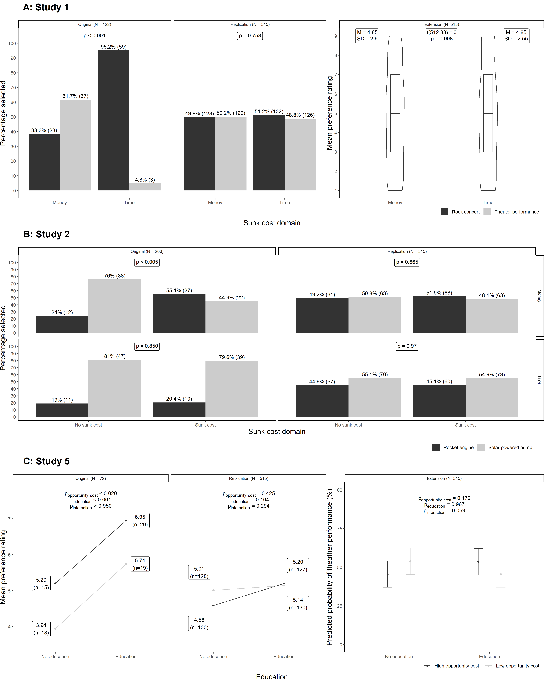
Note. Bold text denotes support for an effect at the 0.05 level.

Summary of results

Replication results
[Evaluation of findings using LeBel et al. (2019) criteria and discussion on effects, see Table 1 for summary]

Additional analyses and checks

Sunk cost effect stronger for money than for time: Re-analysis using logistic regression
To address H1, Soman (2001) conducted multiple chi-square tests. Specifically, in Study 2, he showed that in the money condition, the chi-square test found support for differences between sunk cost and no sunk cost conditions, whereas the same difference was not supported for the time condition.
A different way to approach H1 is to ask whether the likelihood of picking the option associated with sunk costs (rocket engine in Study 2) is different not only between levels of a single independent variable (sunk cost presence or sunk type) but also whether there was an interaction between the two variables. To address this question, we conducted logistic regression analyses for Study 2 for both the original and the replication data.

We ran a logistic regression for Study 2. The dependent variable was coded as 0 (solar-powered pump) and 1 (rocket engine). The predictors in the model were sunk type (money/time) and sunk cost presence (no sunk cost/sunk cost) as well as their interaction. We wanted our model to test whether there was a main effect of sunk type in the sunk cost present condition (thereby replicating the effect from Study 1) and also whether there was a main effect of sunk presence, regardless of the sunk type. In order to achieve this, we coded sunk type as a sum contrast and sunk presence as a treatment contrast, with sunk cost present as its baseline condition. In order to get predicted probabilities from the model for main effects with no baseline condition for remaining factors (in this case the main effect for sunk presence), we applied marginal standardization, which has been reliably shown to be a robust method compared to alternatives (Muller & MacLehose, 2014; Williams, 2012).
The results of the logistic regression for Study 2 on Soman’s (2001) original data showed that there was support for a main effect of sunk type, such that the odds of selecting the rocket engine design in the sunk cost condition went down by 79% in the domain of time compared to money (OR = .21 [.08, .50], p = .001). Soman’s data also revealed support for a main effect of sunk cost presence, regardless of sunk type, such that the odds of selecting the rocket engine were 52% lower in the no sunk cost compared to the sunk cost condition (OR= .48 [.25, .92], p = .027; sunk cost effect differences between the money and time domains: OR = 3.55 [.99, 13.06], p = .053; see Figure 2A).
We conducted a logistic regression for Study 2 in our replication data and found no support for a main effect of sunk type (OR = .76 [.47, 1.23], p = .270), no support for a main effect of sunk presence (OR = .94 [.67, 1.33], p = .739), and no support for an interaction (OR = 1.10 [.55, 2.21], p = .779) – see Figure 2B. See Table 4 for a summary.

Figure 2
Study 2: Predicted probabilities from logistic regression analyses

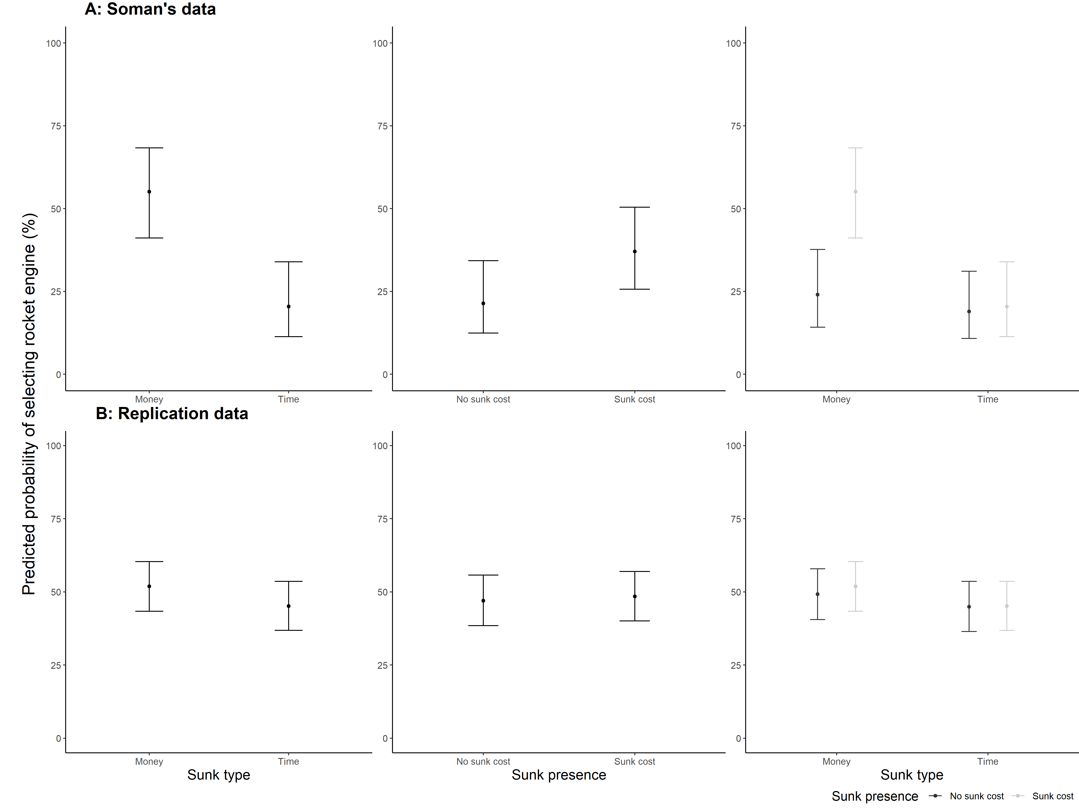
Note. The main effect of sunk type is plotted based on predicted probabilities from the sunk cost present condition, while the main effect of sunk presence is plotted using marginal standardization across levels of sunk type.

Study 1 versus Study 5: Analysis of within-subject effects
We extended the original analyses of H2 by considering an additional within-subject factor: study. Specifically, we took advantage of three of our design choices: 1) the replications of Study 1 and Study 5 both involved the same theater performance vs rock concert ticket scenario, with the only difference that the design of Study 5 was a 2x2 between-subjects; 2) the same participants completed both Study 1 and Study 5 in the same survey; 3) we included both the two-alternative forced choice and the Likert response scales in both Study 1 and Study 5.
This allowed us to address two additional questions: 1) What are the differences between Study 1 and the high versus low opportunity cost conditions in Study 5 (i.e., study by opportunity cost interaction, in the no education condition in Study 5), and 2) Are those differences affected by education (study by opportunity cost by education interaction). To test both questions, we focused on the time sunk cost domain, as Study 5 only included the vignette version in the time domain.
To address these questions, we constructed two linear models: one linear model (LM) with preference ratings on a continuous scale as the dependent variable and one generalized LM (GLM) with ticket choice (theater performance coded as 1 and rock concert as 0) as the dependent variable. We included three independent variables: study (Study 1 vs Study 5), opportunity cost (low vs high), education (no education vs education), and all their interactions. The factor variables were coded such that study was set as a treatment contrast, with Study 5 as the baseline condition, opportunity cost was coded as a sum contrast, and education was coded as a treatment contrast, with no education as the baseline condition.
The results of both models suggested that there was no two-way interaction between study and opportunity cost in the no education condition, nor was there a three-way interaction between opportunity cost, study and education in either of the models – see Figure 3 and Table 3 for outputs of those models and Table 4 for a summary of the results.

Table 3
Results of linear (DV: Preference) and generalized linear (DV: Binary choice) models from the additional within-subjects analysis

Predictors | Preference |  |  | Two-alternative forced choice
 | Estimate | 95% CI | p | Odds Ratio | 95% CI | p
opportunity cost | -.06 | -.96 – .85 | .901 | .71 | .43 – 1.16 | .172
study | -.07 | -.63 – .48 | .795 | .80 | .52 – 1.23 | .315
education | -.04 | -.68 – .60 | .902 | .99 | .70 – 1.40 | .967
opportunity cost x study | -.37 | -1.47 – 0.74 | .518 | .82 | .35 – 1.94 | .656
opportunity cost x education | .26 | -1.02 – 1.54 | .692 | 1.95 | .98 – 3.91 | .059
study x education | .41 | -.37 – 1.19 | .302 | 1.48 | .81 – 2.71 | .204
opportunity cost x study x education | .22 | -1.34 – 1.79 | .780 | .96 | .29 – 3.23 | .954

Figure 3
Predicted responses from linear (DV: preference) and generalized linear (DV: two-alternative forced choice) models from the three-way interaction between the predictors

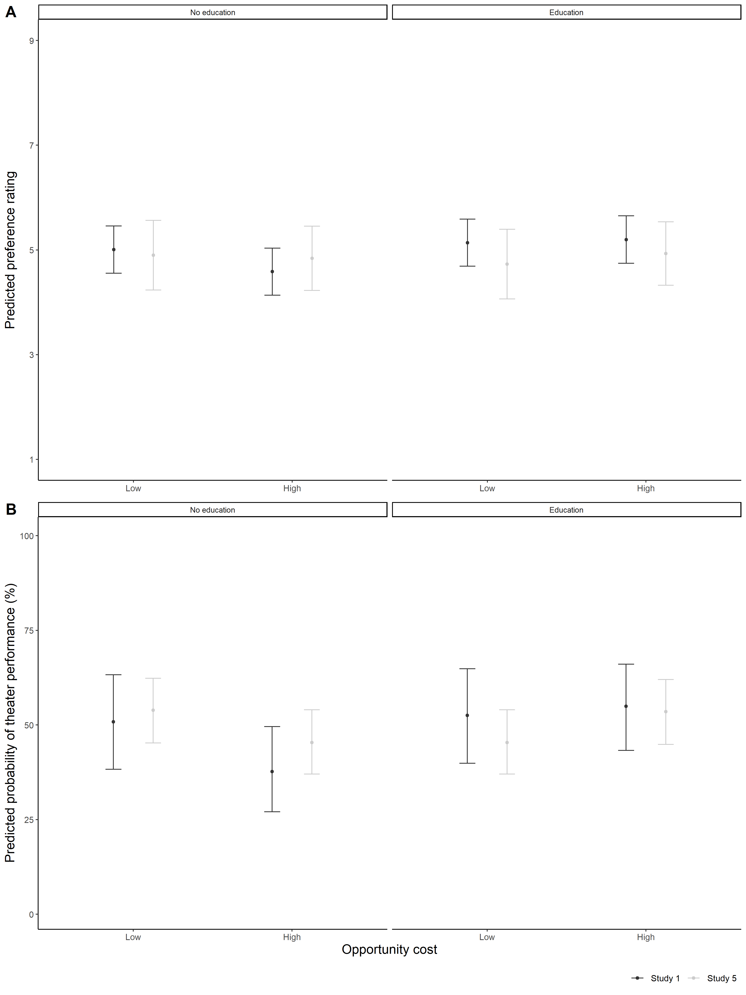Note. Panel A shows the three-way interaction for the LM with the continuous preference variable as the DV and Panel B shows the three-way interaction for the GLM with the binary choice between rock concert and theater performance as the DV.

Table 4
Summary of additional analyses
Hypothesis | Question addressed | Analysis used | Consistent with replication analysis (Yes/Mixed/No) | Details
The sunk cost effect is weaker for time than for money. | Does the likelihood of picking the option associated with sunk costs (rocket engine in Study 2) vary significantly between levels of one independent variables (sunk cost presence or sunk type) given a change in the other (i.e., an interaction effect)? | 2x2 logistic regression on both Soman’s original data as well as the replication data. | Yes | Both re-analyses yielded the same conclusions as the replication analyses, despite being at odds with each other in terms of effects detected.
Facilitation of money-like accounting by using education about economic approaches to time strengthens the sunk cost effect of time (tested only in the time domain). | What are the differences between Study 1 and the high versus low opportunity cost conditions in Study 5 (i.e., study by opportunity cost interaction, in the no education condition in Study 5)? | Two linear models: one linear model with preference ratings as the dependent variable and one generalized LM with 2-alternative ticket choice as the dependent variable. The models included three independent variables: study (Study 1 vs Study 5), opportunity cost (low vs high), education (no education vs education), and all their interactions. | Yes | Both statistically non-significant interactions show that, at least in the time domain, neither the opportunity cost, nor the education manipulations, made a difference. Although this is aligned with the replication analyses in our sample, it contradicts Soman’s (2001) conclusion.
 | Are differences between Study 1 and the high versus low opportunity cost conditions in Study 5 affected by education (study by opportunity cost by education interaction)? |  | Yes

Between subject studies and order effects (exploratory)
[If we fail to find support for the target’s findings, we will conduct additional exploratory analyses examining order effects and controlling for order.]
[If we fail to find support for the target’s findings, we will conduct additional exploratory analyses examining Studies 1 and 2 only when they were the first study presented to participants. This would address possible confounds between the studies, resembling running two separate studies.]

General Discussion
[To be added/expanded at Stage 2]

Limitations of the original study: Directions for improvement
[To be added at Stage 2]
[Addressing reviewers’ feedback on best fit analyses, and our inclusion of both the target’s analyses and new analyses.]

Limitations of our replication and directions for future research
[To be expanded at Stage 2. Below is a sample text, which will be updated/expanded after data collection.]
[Our replication was conducted more than two decades after Soman (2001) was published, with changes in the way people think of both time and money that might have impacted the findings. This is partly why ongoing repeating replications are needed, to keep our knowledge about an important phenomenon up to date. ]
[Our replication had limitations, and we needed to make several adjustments to the target’s design to accommodate our sample and method of delivery. First, participants in the original study were students who were enrolled in a particular class, whereas participants in our replication were sampled from the general population. This makes it possible that the student sample was systematically different in some respect, compared to the general population. Second, we made adjustments to the opportunity cost manipulation. Third, in the original, the education intervention was implemented by manipulating when the study was conducted – either before a classroom discussion about the economic value of time (control condition) or after (education condition) – whereas in our replication, the intervention was implemented by having participants read information on the screen and complete comprehension checks. These changes were necessary given the change in the medium, yet it may have affected the results. Fourth, the studies were originally run separately, and in our design, we ran the studies together, with Study 5 always last, given its similarity to Study 1. This allowed us additional insights and a comparison between Study 5 and Study 5, yet this does mean that our adjustments make the replication of Study 5 less direct in comparison to Studies 1 and 2, with higher likelihood of the results being different than that of the target’s.]
[Based on feedback from peer review: potentially discuss how sample demographics, such as education level or employment experience, and our pay based on a federal minimum wage rather than by state, may correlate with outcome measures.]

Conclusion
[To be added at Stage 2]

References
Arkes, H. R., & Blumer, C. (1985). The psychology of sunk cost. Organizational Behavior and Human Decision Processes, 35(1), 124–140. https://doi.org/10.1016/0749-5978(85)90049-4
Blanca, M. J., Alarcón, R., & Arnau, J. (2017). Non-normal data: Is ANOVA still a valid option? Psicothema, 29.4, 552–557. https://doi.org/10.7334/psicothema2016.383
Bornstein, B. H., Christine Emler, A., & Chapman, G. B. (1999). Rationality in medical treatment decisions: Is there a sunk-cost effect? Social Science & Medicine, 49(2), 215–222. https://doi.org/10.1016/S0277-9536(99)00117-3
Chambers, C. D., & Tzavella, L. (2022). The past, present and future of Registered Reports. Nature Human Behaviour, 6(1), 29–42. https://doi.org/10.1038/s41562-021-01193-7
Coleman, M. D. (2009). Sunk Cost and Commitment to Dates Arranged Online. Current Psychology, 28(1), 45–54. https://doi.org/10.1007/s12144-009-9042-5
DeVoe, S. E., & Pfeffer, J. (2007). When time is money: The effect of hourly payment on the evaluation of time. Organizational Behavior and Human Decision Processes, 104(1), 1–13. https://doi.org/10.1016/j.obhdp.2006.05.003
Friedman, D., Pommerenke, K., Lukose, R., Milam, G., & Huberman, B. A. (2007). Searching for the sunk cost fallacy. Experimental Economics, 10(1), 79–104. https://doi.org/10.1007/s10683-006-9134-0
Garland, H., & Newport, S. (1991). Effects of absolute and relative sunk costs on the decision to persist with a course of action. Organizational Behavior and Human Decision Processes, 48(1), 55–69. https://doi.org/10.1016/0749-5978(91)90005-E

LeBel, E. P., McCarthy, R. J., Earp, B. D., Elson, M., & Vanpaemel, W. (2018). A Unified Framework to Quantify the Credibility of Scientific Findings. Advances in Methods and Practices in Psychological Science, 1(3), 389–402. https://doi.org/10.1177/2515245918787489
LeBel, E. P., Vanpaemel, W., Cheung, I., & Campbell, L. (2019). A brief guide to evaluate replications. Meta-Psychology, 3.
Litman, L., Robinson, J., & Abberbock, T. (2017). TurkPrime.com: A versatile crowdsourcing data acquisition platform for the

behavioral sciences. Behavior Research Methods, 49(2), 433–442. https://doi.org/10.3758/
s13428-016-0727-z
Muller, C. J., & MacLehose, R. F. (2014). Estimating predicted probabilities from logistic regression: Different methods correspond to different target populations. International Journal of Epidemiology, 43(3), 962–970. https://doi.org/10.1093/ije/dyu029
Navarro, A. D., & Fantino, E. (2005). The Sunk Cost Effect in Pigeons and Humans. Journal of the Experimental Analysis of Behavior, 83(1), 1–13. https://doi.org/10.1901/jeab.2005.21-04
Navarro, A. D., & Fantino, E. (2009). The sunk-time effect: An exploration. Journal of Behavioral Decision Making, 22(3), 252–270. https://doi.org/10.1002/bdm.624
Nosek, B. A., & Lakens, D. (2014). Registered Reports. Social Psychology, 45(3), 137–141. https://doi.org/10.1027/1864-9335/a000192
Okada, E. M., & Hoch, S. J. (2004). Spending Time versus Spending Money. Journal of Consumer Research, 31(2), 313–323. https://doi.org/10.1086/422110
Pandey, S. K., & Sharma, D. (2019). Sunk time fallacy with recoverable monetary costs. Marketing Intelligence & Planning, 37(2), 154–167. https://doi.org/10.1108/MIP-02-2018-0052
Park, J.-Y., & Jang, S. (Shawn). (2014). Sunk costs and travel cancellation: Focusing on temporal cost. Tourism Management, 40, 425–435. https://doi.org/10.1016/j.tourman.2013.08.005
Rego, S., Arantes, J., & Magalhães, P. (2018). Is there a Sunk Cost Effect in Committed Relationships? Current Psychology, 37(3), 508–519. https://doi.org/10.1007/s12144-016-9529-9
Ronayne, D., Sgroi, D., & Tuckwell, A. (2021). Evaluating the sunk cost effect. Journal of Economic Behavior & Organization, 186, 318–327. https://doi.org/10.1016/j.jebo.2021.03.029
Scheel, A. M., Schijen, M. R. M. J., & Lakens, D. (2021). An Excess of Positive Results: Comparing the Standard Psychology Literature With Registered Reports. Advances in Methods and Practices in Psychological Science, 4(2), 25152459211007468. https://doi.org/10.1177/25152459211007467

Silva Castillo, L. H., Cisneros Plazola, M. C., Torres Ceja, C. de J., & Hernández Rosas, E. (2020). The sunk-time effect: Effect of time invested and reward magnitude using within-subject design. Behavioural Processes, 181, 104247. https://doi.org/10.1016/j.beproc.2020.104247
Soman, D. (2001). The mental accounting of sunk time costs: Why time is not like money. Journal of Behavioral Decision Making, 14(3), 169–185. https://doi.org/10.1002/bdm.370
Soman, D., & Cheema, A. (2001). The Effect of Windfall Gains on the Sunk-Cost Effect. Marketing Letters, 12(1), 51–62.
Soster, R. L., Monga, A., & Bearden, W. O. (2010). Tracking Costs of Time and Money: How Accounting Periods Affect Mental Accounting. Journal of Consumer Research, 37(4), 712–721. https://doi.org/10.1086/656388
Strough, J., Mehta, C. M., McFall, J. P., & Schuller, K. L. (2008). Are Older Adults Less Subject to the Sunk-Cost Fallacy Than Younger Adults? Psychological Science, 19(7), 650–652. https://doi.org/10.1111/j.1467-9280.2008.02138.x
Thaler, R. (1980). Toward a positive theory of consumer choice. Journal of Economic Behavior & Organization, 1(1), 39–60. https://doi.org/10.1016/0167-2681(80)90051-7

Williams, R. (2012). Using the Margins Command to Estimate and Interpret Adjusted Predictions and Marginal Effects. The Stata Journal: Promoting Communications on Statistics and Stata, 12(2), 308–331. https://doi.org/10.1177/1536867X1201200209
Wiseman, R., Watt, C., & Kornbrot, D. (2019). Registered reports: An early example and analysis. PeerJ, 7, e6232. https://doi.org/10.7717/peerj.6232

The original did not report standard deviations.

