Revisiting Partition Priming in judgment under uncertainty:   
Replication and extension Registered Report of Fox and Rottenstreich (2003)

Kerou Ding  
ORCID: 0009-0006-9295-0215  
Department of Psychology, University of Hong Kong, Hong Kong SAR  
[u3624657@connect.hku.hk](mailto:u3624657@connect.hku.hk) ; [keruoding@qq.com](mailto:keruoding@qq.com)

^Gilad Feldman  
OCRID: 0000-0003-2812-6599  
Department of Psychology, University of Hong Kong, Hong Kong SAR  
[gfeldman@hku.hk](mailto:gfeldman@hku.hk) ; [giladfel@gmail.com](mailto:giladfel@gmail.com)

^Corresponding author

## Author bios:

Kerou Ding was a thesis student at the University of Hong Kong during 2023-4.

Gilad Feldman is an assistant professor with the University of Hong Kong psychology department. His research focuses on judgment and decision-making.

## Declaration of Conflict of Interest:

The author(s) declared no potential conflicts of interests with respect to the authorship and/orpublication of this article.

## Financial disclosure/funding:

The project is supported by the University of Hong Kong Teaching Development Grant.

## Authorship declaration:

Kerou Ding conducted the project as part of her thesis in psychology.

Gilad Feldman guided the project, supervised each step in the project, ran data collection, and edited the manuscript for submission.

## Corresponding author

Gilad Feldman, Department of Psychology, University of Hong Kong, Hong Kong SAR; [gfeldman@hku.hk](mailto:gfeldman@hku.hk) ; 0000-0003-2812-6599

## Rights:

CC BY or equivalent license is applied to the AAM arising from this submission. ([clarification](https://bit.ly/rrs-primer))

## Citation of the target research article:

Fox, C. R., & Rottenstreich, Y. (2003). Partition priming in judgment under uncertainty. *Psychological Science*, *14*(3), 195-200.

## Acknowledgements (with ORCID)

## Contributor Roles Taxonomy

|  |  |  |
| --- | --- | --- |
| **Role** | **Kerou Ding** | **Gilad Feldman** |
| Conceptualization | X | X |
| Pre-registration | X | X |
| Data curation |  | X |
| Formal analysis | X |  |
| Funding acquisition |  | X |
| Investigation | X |  |
| Pre-registration peer review / verification |  | X |
| Data analysis peer review / verification |  | X |
| Methodology | X |  |
| Project administration |  | X |
| Resources |  | X |
| Software | X |  |
| Supervision |  | X |
| Validation |  | X |
| Visualization | X |  |
| Writing-original draft | X |  |
| Writing-review and editing |  | X |

# PCIRR-Study Design Table

|  |  |  |  |  |  |  |
| --- | --- | --- | --- | --- | --- | --- |
| **Question** | **Hypothesis** | **Sampling plan** | **Analysis plan** | **Statistical tests rationale** | **Interpretation given outcomes** | **Theory affected by the outcomes** |
| Studies 1a and 1b: Do people utilize partition-dependent ignorance priors when forming probability judgments under ignorance or near ignorance? | Studies 1a and 1b: Individuals  utilize partition-dependent ignorance priors when forming probability judgments under ignorance or near ignorance. | We aimed to recruit 600 US Americans through Prolific. See details in the Method’s power and sensitivity analyses subsection.  We calculated Cohen’s h/w and Cohen’s d using the data provided in the target article. | Mann-Whitney U test  Welch’s t-test  Chi squared test | This is a replication.  We mostly followed the statistical analyses of the target article, with some improvements and adjustments. | We will evaluate the replicability of our findings against the target article’s findings using the LeBel et al. (2019) paradigm (examining signal and comparison of confidence intervals with the target article’s effect size). | The principle of insufficient reason.  Partition dependence. |
| Study 3: Do people utilize partition-dependent ignorance priors when forming probability judgments under uncertainty? | Study 3: Individuals utilize partition-dependent probabilities when forming judgments under uncertainty (1/2 > 1/n). | Mann-Whitney U test  Welch’s t-test  Chi squared test |
| Study 4: Do people exhibit a tendency to rely on partition-dependent ignorance priors when making decisions? | Study 4: Individuals utilize partition-dependent probabilities when making decisions under ignorance (1/2 > 1/n). | Two proportion z-test (/chi-square) |

# Abstract

Partition dependence is the phenomenon in which individuals' evaluations of probabilities are influenced by the partitioning of the information in the way the information is presented or framed. In a Registered Report experiment with an American online Prolific sample (*N* = 603), we conducted a replication and extension of Studies 1a, 1b, 3, and 4 from a classic article by Fox and Rottenstreich (2003) demonstrating the phenomenon. They showed that participants’ estimations of an event’s likelihood shifted based on minor adjustments of the framing that suggested a change in partitioning perspective (“ignorance prior” priming). Based on a pre-registered replication evaluation criterion, we concluded a mostly successful replication of Fox and Rottenstreich (2003)’s findings. Specifically, we found support for partition dependence in scenarios from Study 1a items 1 and 2, Study 1b, and Study 3, with weaker effects, yet with no consistent support for Study 1a item 3 and Study 4. Our extensions further explored the robustness of partition dependence by examining participants’ probability evaluations of complementary events (happen vs. not happen) and the impact of task order on judgment and decision-making. Overall, the findings suggest support for partition dependence yet as more nuanced and context-dependent than expected, and the need for further research to understand its mechanisms, robustness, and implications across different contexts. Materials, data, and code are available on: <https://osf.io/g9czs/>

*Keywords*: bias, judgment and decision making, partition dependence, ignorance prior, risk, registered report, replication

# 

# Revisiting Partition Priming in judgment under uncertainty: Replication and extension Registered Report of Fox and Rottenstreich (2003)

## Background

When lacking specific knowledge about a situation, people tend to rely on an “ignorance prior”, an assumption that assigns equal chances to different possibilities. Yet, the perceived ignorance prior may depend on the way the information is presented, and how the person mentally maps the available possibilities. Fox and Rottenstreich (2003) demonstrated that a slight change in the framing of the same problem, partitioning, may lead to the use of different ignorance priors and therefore shift evaluations of perceptions of the probabilities. For example, when asked about the weather the following week with no relevant information, the questions “will Sunday be the hottest day next week?” and "will Sunday be hotter than all other days next week?" might trigger different ignorance priors. The first might trigger a 1/2 versus 1/2 given a mental split of “hotter than rest of the week” vs. “not hotter”, whereas the latter might trigger a 1/7 vs. 6/7 given a mental comparison of Sunday against each of the other six days.

We conducted an independent close replication and extension Registered Report of Fox and Rottenstreich (2003), as one of the classic articles of the partition dependence phenomenon. We begin by introducing the literature on ignorance priors and the chosen article for replication - Fox and Rottenstreich (2003). We then discuss our motivations for the current replication, review their work and outline the chosen studies from the target article, their experimental design, and our adaptations and extensions.

## Ignorance priors and partition dependence

Decision making and risk analysis often involve the assessment of probabilities for uncertain events. Individuals rely on the perceived number of potential events in making likelihood estimations when no other information is provided (Johnson-Laird et al., 1999; Fox & Rottenstreich, 2003; Fox & Clemen, 2005). For example, if there are 10 candidates in a competition and no information is available regarding their abilities, one might assign a probability of 1/10 to each candidate's chance of winning the competition. In this case, 1/10 is referred to as the “ignorance prior” of each candidate winning the competition. An ignorance prior denotes a default judgment that assigns equal probabilities to all potential possibilities in a given query, in the absence of any other relevant information.

While the reliance on ignorance priors may initially seem intuitively appealing, it may be sensitive to presentation and framing (Fox & Rottenstreich, 2003; Fox & Clemen, 2005). To illustrate, consider the competition example previously discussed. Imagine an assessor, lacking detailed information on the competition's difficulty and scoring system, is tasked with judging the likelihood that the competition winner receives a score lower than 50. In this scenario, the question tends to elicit a binary partition: {score lower than 50; score higher than 50}. However, if the task is framed so that the task is to estimate the likelihood that the winner's score falls between 50 and 100, then the partition tends to elicit a three-fold partition: {score lower than 50; score between 50 and 100; score higher than 100}. Consequently, this partitioning increases the likelihood that each of those three possibilities is assigned an ignorance prior of 1/3. This adjustment in how the stated space is partitioned might shift the assessed probability (Fox & Rottenstreich, 2003; Fox & Clemen, 2005; See et al., 2006). In other words, the default ignorance prior assigned by an assessor is partition-dependent.

The influence of partition dependence on decision making has been observed across different contexts. Fox et al. (2005) reported that the subjective grouping of options influences decision making and resource allocation, recently successfully replicated by Li and Feldman (2024). For example, in a study where participants were asked to select candies from three bowls containing a total of four types of candy, they tended to spread their choices not only across the bowls but also across the different types of candy. This suggested that the distribution of choices was influenced by the way the candies were subjectively grouped or partitioned into different bowls by the experimenters. Feng et al. (2020) showed that when job applicants were partitioned on the basis of various criteria such as gender, nationality, and university, individuals tended to select a more diverse pool of candidates within each specific partitioned criterion. This effect was observed even among experts (seasoned human resource professionals).

The assumption of the “principle of insufficient reason” is the absence of any relevant information favoring one outcome over another, and yet according to Fox and Rottenstreich (2003) individuals often possess some knowledge they consider to be relevant in many real-life situations. In such cases, people may resort to a combination of evaluative strategies and the “principle of insufficient reason”. Thus, individuals' judged probabilities may exhibit a consistent bias towards partition dependence under conditions of both ignorance (complete absence of relevant knowledge) and uncertainty (possession of relevant knowledge to some extent).

## Choice of study for replication: Fox and Rottenstreich (2003)

We embarked on a replication and extension Registered Report of Fox and Rottenstreich (2003). We aimed to revisit the phenomenon to examine the reproducibility and replicability of the findings with an independent well-powered replication and extension Registered Report. This follows the recent growing recognition of the importance of reproducibility and replicability in psychological science (e.g., Nosek et al., 2022; Zwaan et al., 2018).

We chose Fox and Rottenstreich (2003) based on several factors: its academic and practical impact, the potential for improvements in methodology, and the mixed findings in the literature.

Fox and Rottenstreich (2003)’s findings have had an impact on scholarly research in the domains of judgment bias, subjective probability estimation, and risk assessment. At the time of writing (February, 2025), there were 255 Google Scholar citations of the article and many important follow-up theoretical and empirical articles, such as Fox and Clemen (2005) and See et al. (2006)’s research on partition-dependent ignorance priors, exploring how these priors were influenced by individuals’ expertise and confidence levels.

There is some indication for mixed findings in the partition dependence literature. For example, Reichelson et al. (2017) attempted to replicate the candy bowl study previously conducted by Fox et al. (2005), recruiting both children and adults. They concluded no evidence supporting the impact of candy partition on participants' choices, inconsistent with the findings of Fox et al. (2005). Their findings were in contrast to our successful replication of the same article as a Registered Report (Li & Feldman, 2024).

We attempted to analyze Fox and Rottenstreich (2003)’s studies. The methods and the statistical tests varied across the different studies, despite having very similar designs and hypotheses, with inconsistent reporting of key details for both the procedures and the results. Their brief reporting proved a challenge in deducing the procedure and materials for a replication and comparing the different scenarios. We believe that revisiting classics like our target article with reproductions and replications helps clarify important needed details and increase the quality of the literature building on these findings.

## Selection of studies to replicate: Studies 1a, 1b, 3, and 4

Fox and Rottenstreich (2003) investigated ignorance priors and partition dependence in five studies (Studies 1a, 1b, 2, 3, and 4). Studies 1a and 1b focused on judgment under ignorance or near-ignorance situations, where implementing evaluative approaches is difficult, thereby highlighting reliance on the ignorance prior. In Study 1a, questions presented in the binary (1/2) case-prime condition elicited higher ignorance priors compared to the N-fold (1/n) class-prime condition. To address an alternative interpretation suggesting that class formulations might depress probability judgments relative to case formulations, Study 1b involved a situation in which there were higher expected class-primed ignorance priors than case-primed ignorance priors.

Studies 2 and 3 investigated partition dependence in judgment under uncertainty, where individuals can draw on relevant knowledge and may rely on both evaluative assessment and the ignorance prior. Study 2 tasked participants with estimating their score range within a group, leveraging their knowledge of other group members. In Study 3, participants estimated the probability of a candidate’s success in a job application after reading a recommendation letter excerpt of that candidate.

While Studies 1a, 1b, 2, and 3 centered on judgments, Study 4 explored partition dependence in decision-making. Participants were presented with two options and were informed that some would receive a real reward in accordance with their choices. The first option did not involve probability estimation and remained constant across the two conditions. The second option was riskier than the first option. It was formulated with either a case-primed or a class-primed ignorance prior in either the case or the class condition (see Table 7). Participants’ tendency to choose the second option implicitly indicated their probability estimation of the event described by the second option.

We focused our investigation on the studies examining how partition dependence affects judgements and decision making under ignorance and uncertainty: Studies 1a, 1b, 3, and 4 (Table 1). We chose not to replicate Study 2 given that it was conducted in an in-class setting with almost no information provided about both methods, procedure, and results.

## Fox and Rottenstreich (2003): Hypotheses and findings

We did our best to analyze the brief details provided by Fox and Rottenstreich (2003) and summarized our interpretation of the different designs in Table 1, their hypotheses and findings in Table 2, and their descriptives and statistical results in Table 3.

###### Table 1 *Studies 1a, 1b, 3 and 4: Comparison of design*

|  |  |  |  |  |
| --- | --- | --- | --- | --- |
| Study | 1a | 1b | 3 | 4 |
| Situation | Ignorance | Ignorance | Uncertainty | Ignorance |
| Task | Probability judgment | Probability judgment | Probability judgment | Decision  making |
| Dependent variable | Numerical probability | Numerical probability | Numerical probability | Categorical decision outcome |

*Note*. In situations of ignorance, participants have no or little relevant knowledge. In situations of uncertainty, participants have the opportunity to apply relevant knowledge to some extent.

## 

###### Table 2 *Studies 1a, 1b, 3, and 4: Summary of hypotheses and findings*

|  |  |  |  |
| --- | --- | --- | --- |
| **S** | **Scenario** | **Hypothesis** | **Findings of the target article** |
| 1a | Judgments under ignorance | Individuals utilize partition-dependent probabilities when forming judgments under ignorance when the case prime facilitates a greater ignorance prior of an event’s occurrence than the class prime (1/2 > 1/n). | Participants showed a bias towards partition-dependent ignorance priors. Specifically, participants' judgments differed between the case-prime and the class-prime condition:  (1) Responses were higher in the case-prime condition with an ignorance prior of 1/2 than in the class-prime condition with an ignorance prior of 1/n, indicated by both means and medians of judged probabilities.  (2) 1/2 responses were more common under the case prime than under the class prime. 1/n responses were more common under the class prime than under the case prime. |
| 1b | Judgments under ignorance | Individuals utilize partition-dependent probabilities when forming judgments under ignorance when the class prime facilitates a higher default probability than the case prime (1/2 < x/n). | Participants showed a bias towards partition-dependent ignorance priors. Specifically, participants' judgments differed between the case-prime and the class-prime condition:  (1) Responses were lower in the case-prime condition with an ignorance prior of 1/2 than in the class-prime condition with an ignorance prior of x/n, indicating by both means and medians of judged probabilities.  (2) x/n responses were more common under the class prime than under the case prime. |
| 3 | Judgments under uncertainty | Individuals utilize partition-dependent probabilities when forming judgments under uncertainty (1/2 > 1/n). | Participants showed a bias towards partition-dependent ignorance priors. Specifically, participants' judgments differed between the case-prime and the class-prime condition:  (1) Responses were higher in the case-prime condition with an ignorance prior of 1/2 than in the class-prime condition with an ignorance prior of 1/n, indicated by comparison of medians of judged probabilities.  (2)1/n responses were more common under the class prime than under the case prime. |
| 4 | Decisions under ignorance | Individuals utilize partition-dependent probabilities when making decisions under ignorance (1/2 > 1/n). | Participants showed a bias towards partition-dependent ignorance priors. Specifically, under the case prime, the risker choice had an ignorance prior of 1/2, while under the class prime, the risker choice had an ignorance prior of 1/n. A larger proportion of participants in the case-prime condition made decisions favoring the risker choice when compared to those in the class-prime condition, 23% vs. 11%, *z* =1.95, *p* < .05, one-tailed. |

*Note*. Under case prime, the ignorance prior of the target event’s occurrence is 1/2. In Studies 1a, 3, and 4, under class prime, the ignorance prior of the target event’s occurrence is 1/n where n stands for the number of all possible events in the question. In Study 1b, participants were tasked with estimating the probability of a collection of single events, with x denoting the number of events in that collection. In Study 1a, the comparison between the proportions of 1/2 and 1/n responses relied solely on proportion figures. No statistical test results were provided for this comparison. In Studies 1b, 3, and 4, the χ2 test was used to compare the proportions of 1/n or x/n judgments between the class-prime and case-prime conditions.

###### Table 3 *Studies 1a, 1b, 3 and 4: Summary of reported results*

|  |  |  |  |  |  |
| --- | --- | --- | --- | --- | --- |
|  | | Study 1a | Study 1b | Study 3 | Study 4 |
| Dependent variable | | Probability estimation | Probability estimation | Probability estimation | Choice |
| *n* | Case | 41 | 22 | 32 | 74 |
| Class | 53 | 20 | 41 | 70 |
| *Med* | Case | - | 0.69 | 0.40 |  |
| Class | - | 0.71 | 0.23 |  |
| *M* | Case | - | 0.61 | - |  |
| Class | - | 0.72 | - |  |
| Proportion of case-primed 1/2 responses | Case | 19% | - | - |  |
| Class | 8% | - | - | Taking the bet: |
| Proportion of class-primed 1/n (x/n) responses | Case | 19% | 23% | 6% | 23% |
| Class | 49% | 55% | 28% | 11% |
| Mann-Whitney *U* | *U*-statistic | - | - | - |  |
| *p* | < .01 | < .05 | < .05 |  |
| Welch’s *t* | *t* | - | 2.75 | - |  |
| *df* | - | 22 | - |  |
| *p* | - | = .01 | - |  |
|  | *d* | 0.55  [0.13, 0.96] | -0.87  [-1.51, -0.22] | 0.47 [0.00, 0.93] |  |
|  | *N* required | 174 | 71 | 238 |  |
| χ2 | χ2 | - | 4.63 | 5.67 |  |
| *df* | - | 1 | 1 |  |
| *p* | - | < .05 | < .05 |  |
| *z* |  |  |  | 1.95 |
|  | *p* |  |  |  | .05 |
|  | *h* | 0.65 [0.24, 1.06] | 0.67 [0.07, 1.28] | 0.62 [0.16, 1.08] | 0.32  [0.00, 0.65] |
|  | *N* required | 136 | 121 | 164 | 508 |

*Note.* *Med* indicates median. *M* indicates mean. "-" denotes that the results were not reported in the target article. The range of probability estimation spans from 0 (0%) to 1 (100%). For Studies 1a and 3, Cohen’s *d* was estimated from the p values of the Mann-Whitney *U* test using the esc package (Lüdecke, 2019), despite these analyses meant for *t*-test *p*-values, as we assumed that .01 is a good enough proxy for a signal regardless of analysis. For Study 1b, Cohen’s *d* was calculated from Welch’s *t* and using the effectsize package (Ben-Shachar et al., 2020). See accompanying Rmarkdown for effect size calculations. We aligned all effects of Welch’s *t* tests (Cohen’s *d*) to go in the same direction with case condition higher than class condition, yet Study 1b was meant to demonstrate class condition higher than case condition, and so the effects are coded as negative.

In Fox and Rottenstreich (2003)’s studies, partition priming was manipulated by the linguistic reformulation of a probability query. In what they referred to as a “case partition”, the target event either will or will not occur. For example, the question “What is the probability that Sunday will be hotter than every other day next week?” would facilitate a binary case partition: Sunday either will or will not be hotter than every other day. In what they referred to as a “class partition”, the probability of a target event is compared against an entire class of possible events. For example, the question “What is the probability that the hottest day of the week will be Sunday?” would facilitate a seven-fold class partition: {Sunday hottest, Monday hottest, . . ., Saturday hottest}. Participants were randomly assigned to make probability estimations in either the case-prime condition, where all the probability questions featured case partition, or the case class-prime condition, where all the probability questions featured class partition. The only distinction between the two experimental conditions was in its linguistic formulation, the target events remained consistent in nature across both conditions.

Given the reporting standards at the time, the reporting of both methodology and the findings were brief with many missing details. In Study 1a, three pairs of questions were presented in each condition. They reported a Mann-Whitney *U* test for all three items and a result of *p* < .01. In Studies 2b and 3, they compared the class-prime and case-prime conditions proportions of judgments that were precisely in accordance with the class-prime ignorance prior (1/n; χ2 test).

## Extensions: Complementary hypotheses

We aimed to extend the replication study by incorporating pairs of complementary hypotheses into Studies 1b and 3. Complementary hypotheses predict mutually exclusive outcomes for the same event. For instance, "Sunday will be the hottest next week" and "Sunday will *not* be the hottest next week" constitute a pair of complementary hypotheses. The target article only included two complementary hypotheses for the three items in Study 1a, but not in Studies 1b and 3. Fox and Rottenstreich (2003) did not elucidate the rationale behind adding the alternative hypothesis. Furthermore, it was unclear whether each participant encountered both mutually exclusive hypotheses or if half of the participants in each condition estimated the probability of a target event occurring, while the other half estimated the probability of the positive target *not* occurring. Our best guess based on the description “assigned probabilities to three pairs of complementary hypotheses” is that participants rated both hypotheses.

We therefore decided to expand the original design by incorporating pairs of complementary hypotheses also into Studies 1b and 3. This expansion offers several important advantages. First, it allows for a more comprehensive comparative analysis of the partition priming effects of “happen” and “not happen” responses across the three estimation studies - Studies 1a, 1b, and 3. Through this approach, we can explore whether participants demonstrate the same pattern of reliance on ignorance priors and partition dependence when estimating negative complementary events as their mutually exclusive positive events, and for several scenarios. Second, seeing both hypotheses helps increase the likelihood that participants are processing a fuller range of events, and allows us to indirectly test for both attentiveness and understanding, given that the two probabilities should sum to 100 or close (if there are rounding issues). We contemplated whether to force the two estimations to have to add up to 100, yet decided to instead allow participants to enter whatever approximations to allow for the possibility that participants were systematically deviating from our expected use of the complementary hypotheses, which we could then analyze using exploratory analyses.

## Pre-registration and open-science

We provided all materials, data, and code on: <https://osf.io/g9czs/>. This project received Peer Community in Registered Report Stage 1 in-principle acceptance (https://rr.peercommunityin.org/articles/rec?id=670; https://osf.io/px6vb) after which we created a frozen pre-registration version of the entire Stage 1 packet https://osf.io/k4up5) and proceeded to data collection. All measures, manipulations, exclusions conducted for this investigation are reported, and data collection was completed before analyses. This Registered Report was written based on the Registered Report template by Feldman (2023).

# Method

## Power and sensitivity analyses

We first calculated effect sizes and conducted a power analysis based on the effects reported in the target article. We used information from the target article (summarized in Table 3) to calculate effect sizes and confidence intervals using R 4.3.3 (R Core Team, 2024) with the help of a guide by Jané et al. (2024). We used the effectsize package (Ben-Shachar et al., 2020), the esc package (Lüdecke, 2019), and pwrss (Bulus, 2023) to compute Cohen’s *d* and Cohen’s *h*.

We concluded that the minimum required sample size was 508 participants in total.‎ We provided more information regarding these calculations in the “Power analysis of the original study effect to assess the required sample for replication” subsection of the supplementary materials.

Moreover, given the likelihood that the target article’s effects were an overestimation and the difficulty in computing the effect sizes of Studies 1a, 1b, and 3, we used the “small-telescope” approach (Simonsohn, 2015) aiming for enough power to detect effects much weaker than those reported by the original study (*d*33%) with the general rule of thumb to multiply the largest sample in the target by 2.5. This resulted in a sample of 360 (2.5 times the sample size of Study 4, 144). Given that 360 is less than 508, we maintained the sample size at 508. Accounting for our integrated design, and allowing for the potential of additional analyses, we aimed for a larger total sample of 600 participants, more than 4 times larger than any of the samples in the target article.

We conducted a sensitivity analysis using Gpower (Faul et al., 2007) which indicated that a sample of 600 would allow the detection of effect sizes of Cohen’s *d =* 0.27 for independent *t*-tests in Studies 1a, 1b, and 3, and Cohen’s *w* = 0.14 for chisquare to compare proportions reported in Studies 1a, 1b, 3, and 4 (all alpha = 5%, power = 95%, one-tail). These results correspond to weak to medium effects in social psychology (Jané et al., 2024). We also note that we completed a similar well-powered Replication Registered Report project conducted with Peer Community in Registered Reports (PCIRR) on diversification bias and partition dependence (Li & Feldman, 2021), with very large effects overall but with one small effect of *d* = 0.27, which the target sample was sufficiently powered to detect.

## Participants

We recruited a total of 603 US American participants from Prolific (Palan & Schitter, 2018; *Mage* = 42.96, *SD* = 13.96; 333 females, 261 males, 9 other or did not disclose). We note that 707 subjects began the survey but 104 did not proceed beyond the consent and verifications. We summarized a comparison of the target article sample and the replication samples in Table 4.

We targeted US Americans using Prolific’s filters. We prescreened our participants using the following standards: “Nationality: United States”, “Country of birth: United States”, “Place of most time spent before turning 18: United States”, “Minimum Approval Rate: 95, Maximum Approval Rate: 100”, “Minimum Submissions: 100, Maximum Submissions: 10000”.

We first pretested the survey duration and technical feedback with 30 participants to make sure our time run estimate was accurate and adjusted pay as needed. The data of the 30 pretest participants was not analyzed other than to assess survey completion duration, feedback regarding possible technical issues and payment, and needed pay adjustments. We pre-registered that unless there were serious technical issues that affect data quality and require survey modification, these participants will be included in the overall analysis. We did not identify technical issues with the pretest.

###### 

###### Table 4 *Difference and similarities between original study and replication*

|  |  |  |
| --- | --- | --- |
|  | Fox and Rottenstreich (2003) | US Americans on Prolific |
| Sample size | Study 1a: 94  Study 1b: 42  Study 3: 73  Study 4: 144  Overall: 353 | 603 | |
| Geographic origin | US American | US American | |
| Gender | not reported | 333 males, 261 females, 9 other/did not disclose | |
| Median age (years) | not reported | 40 | |
| Average age (years) | not reported | 42.96 | |
| Standard deviation age (years) | not reported | 13.96 | |
| Age range (years) | not reported | 19-95 | |
| Medium (location) | not reported (potentially in person on a US university campus) | Computer (online) | |
| Compensation | Study 1a and 3: 1 dollar reward  Study 1b: a donation to charity (the value was not mentioned)  Study 4: Random chance of receiving rewards in line with the participant’s choice | Thirty participants taking part in the pretest received £0.95 (~$1.20) as compensation. Each of the remaining participants received £1.05 (~$1.33). The payment was determined based on the estimated completion time from the pretest, aiming for £9 (~$11.37) per hour. | |
| Year | 2003 or earlier | 2024 | |

*Note*. It is unlikely that the maximum age range in the replication was indeed 95, it is more likely that some participants were misreporting, yet we report the demographics as is. We reported compensation in British Pounds given that Prolific charges researchers in pounds. US dollar estimates are according to the exchange rate in February 2025 (1 pound = 1.2635 US dollars).

## Design: Replication and Extension

In the target article, Studies 1a, 1b, 3, and 4 were conducted separately with independent samples. We ran the four studies together in a single unified data collection, with all scenarios from the four studies presented in random order. Participants were first randomly allocated to either the case-prime or the class-prime condition. This unified design combining replications of several studies into a singular data collection was previously tested successfully in many of the replications and extensions conducted by our team (e.g., Chan & Feldman, 2024; Jacobs et al., 2024; Wong & Feldman, 2024), also with one successful replication Registered Report on partition dependence with no impact of order effects (Li & Feldman, 2024). We believe that this design is especially powerful in addressing concerns about the target sample (e.g., naivety and attentiveness) when some studies replicate successfully whereas others do not, as has happened in this replication, as well as in allowing for drawing inferences about links between the different studies and consistency in participants’ responding to similar decision-making paradigms. We return to this point in our discussion.

We summarized the experimental designs in Table 5 and Table 6, and our adjustments to the target article in Table 7. The baseline main effect design mirroring the target article was a simple between-subjects two partition contrast of case prime versus class prime. The fuller design including the within-subject extensions for Studies 1a/b and 3 were a 2 (case prime versus class prime, between) by 2 (“happen” versus “not happen”; within) by 5 (all scenarios; within) mixed design. The presentation order of task items (happen vs. not happen) was also randomized.

###### Table 5 *Studies 1a, 1b and 3: Replication and extension experimental design [Between]*

|  |  |
| --- | --- |
| **Case prime condition**  Binary case partition: {a target event will happen vs.  a target event will not happen}  Ignorance prior: 1/2 | **Class prime condition**  N-fold class partition {Event 1 will happen,  Event 2 will happen,...  Event n will happen}  n = number of comparable events in a query.  Ignorance prior: 1/n |
| **DV**: **Probability judgements** [replication]  Participants make probability judgments of a target event which includes a pair of complementary hypotheses  There are three items in Study 1a:  Item 1 target event: The noontime temperature at O’Hare Airport on Sunday will be higher than other days next week.  Item 2 target event: the University of Michigan will win the scoring title of the Big Ten Conference in women’s lacrosse for the upcoming season.  Item 3 target event: International Business Machines Corporation (IBM)’s stock price will rise by more than any other stock on the Dow Jones Industrial Average (DJIA) tomorrow.  There is one item in Study 1b and 3 respectively.  Study 1b target event: The warmest day of the week next week (afternoon high temperature) will fall on a weekday (Mon-Fri) rather than the weekend (Sat-Sun).  Study 3 target event: K.T. will be offered a job this year by ACME.  Happen: Estimation of the probability that a target event will happen:  Scale: 0 = *Target event will not happen*; 1 = *Target event will happen*  Not happen: Estimation of the probability that a target event will not happen:  Scale: 0 = *Target event will happen*; 1 = *Target event will not happen* | |
|

*Note*. An ignorance prior is a default judgment which assigns equal likelihood to each comparable event in a query when the judge has little or no relevant knowledge of the events. Study 1a explores judgments under conditions of ignorance, where participants have limited or no access to relevant knowledge. Study 1b investigated judgments under conditions of ignorance, whereas Study 3 explored judgments under uncertainty. In situations of uncertainty, participants have the opportunity to apply relevant knowledge and may employ a combination of evaluative strategies and ignorance priors. In Study 3, participants are informed that ACME Corporation plans to extend job offers to 10 out of 100 applicants. Subsequently, they read excerpts from a recommendation letter portraying applicant K.T. as cheerful, bright, and hardworking, but somewhat set in her ways.

###### 

###### Table 6 *Study 4: Replication and extension experimental design [Between]*

|  |  |
| --- | --- |
| **Case prime condition**  Option 1: Receive $10 for sure.  Option 2: Receive $50 if IBM’s price per share rises by a greater percentage today than any other stock on the DJIA.  Ignorance prior of option 2: 1/2 | **Class prime condition**  Option 1: Receive $10 for sure  Option 2: Receive $50 if the stock whose price per share rises by the greatest percentage on the DJIA today is IBM.  Ignorance prior of option 2: 1/30 |
| **DV**: **Decision** [replication]  Participants make decisions between two options.  Scale (categorical): option 1; option 2 | |
|

*Note.* Study 4 examined decisions under ignorance. All participants were reminded that “the Dow-Jones Industrial Average (DJIA) consists of 30 large industrial stocks, including International Business Machines Corporation (IBM)”.

We made several adjustments to the target article’s stimuli. In Study 1a, the original target event of Item 2 identified by Fox and Rottenstreich (2003) was the University of Illinois winning the scoring title. In 2003, the Big Ten Conference in women’s lacrosse consisted of 11 teams. However, in recent years, the league has been reduced to seven teams, with the University of Illinois no longer participating. Consequently, we adjusted this item to estimate the University of Michigan's winning rate. Fox and Rottenstreich (2003) did not explicitly specify that the Big Ten Conference had 11 teams. They assumed that some of their participants would know the information, whereas others would not, considering both 1/10 and 1/11 as ignorance priors. In contrast, given our broader sample, we needed to explicitly inform our participants that there were seven teams in the league so that they can make an informed decision. Therefore, our ignorance prior for this item was set at 1/7. This is a deviation from the target, but we felt a needed and crucial one because without this information and/or asking participants for their knowledge about that league, we are assuming too much and many things can go wrong.

Likewise, in both item 3 of Study 1a and Study 4, Fox and Rottenstreich (2003) originally targeted General Motors’ (GM’s) stock price rising more than any other stock on the Dow Jones Industrial Average (DJIA). However, the components of the DJIA have undergone changes over time and GM is no longer a constituent of the DJIA. Consequently, we have replaced GM with International Business Machines Corporation (IBM), which at the time of data collection was a component of the DJIA (2024).

## Procedure

We reconstructed the target’s survey items of Study 1a, 1b, 3 and 4 and adjusted it to an online Qualtrics survey based on the information provided in the article.

Participants were initially presented with the informed consent form and a detailed outline of the study's requirements and procedures. To proceed, they were asked to indicate their consent with four questions confirming their eligibility, understanding, and agreement with study terms, which they must answer with a “yes” and required responses in order to proceed to the study. Three of the four questions also served as attention checks, with the options order being rotated (yes, no, not sure). Failing those attention checks would mean that the participants did not indicate consent and therefore could not embark on the study.

Upon confirming their consent and demonstrating understanding of the study instructions, participants were randomly assigned participants to either the case-prime condition or the class-prime condition (“evenly presented” randomizer in Qualtrics). Within each condition, participants answered all scenarios from the four studies of the target article in a randomized order.

We implemented two questions of competing hypotheses for all scenarios in Studies 1a, 1b, and 3 (see clarification above). We note that in Study 1a of the target article, it was reported that participants encountered three pairs of complementary hypotheses, yet Fox and Rottenstreich (2003) did not specify whether each pair was presented concurrently or if all six questions (3 items × 2 hypotheses) were presented in a counterbalanced manner. Given the repetition of the complementary hypotheses in all five scenarios, we were concerned that randomizing the order would confuse participants, and so presented the pairs in fixed order, where the “happen” hypothesis is always presented first, and the “not happen” hypothesis is always presented second.

In both conditions, participants made a series of probability prediction queries including several numerical probability estimations and a two-option decision-making task. Under the case prime, the queries were designed to facilitate a binary case partition with an ignorance prior of 1/2. Under the class prime, the queries were designed to facilitate a n-fold class partition with an ignorance prior of 1/n. At the end of the experiment, participants answered a number of funneling and demographic questions.

## Manipulations

### Partition priming (between-groups)

Each participant was randomly assigned to complete tasks involving likelihood estimation either in the case-prime or the class-prime condition with either case or class formulations of the same queries.

### Scenario (within-groups)

Each participant completed two types of tasks: numerical probability estimation task and two-option decision making task. For the numerical probability estimation task, participants rated the likelihood of an event’s occurrence in percentages. In the decision-making task, the first option was consistent across both conditions, whereas the second option included an ignorance prior aligned with either case or class formulations of the same event. Participants were directed to select between the two options. Although participants' tendency to select the second option correlated with their probability estimation of the occurrence of the target event associated with the second option, they were not required to provide numerical responses during the decision-making task.

## Measures

### Replication

#### Studies 1a, 1b and 3: Probability estimation

Based on the information presented in the target article, the participants in Fox and Rottenstreich's study (2003) recorded probability estimations in both fractions and decimals (e.g., 1/2 and 0.5). In our study, we maintained the probability scale from 0 to 1 as used in the target article, but we specifically instructed participants to record probabilities as percentages. The percentage scale ranged from 0% to 100%, with 0% indicating that the target event will not happen and 100% indicating that the target event will happen (see Table 5).

#### Study 4: Choice

The decision outcome is either option 1 or option 2 (see Table 6).

## Deviations

We made a few needed adjustments to the target article’s studies and stimuli and summarized those in Table 7.

###### Table 7 *Replication and extension adjustments to the target article’s methods and design*

| **Study** | **Factor** | **Target article** | **Adjustment in current study** | **Reason for change / Justifications** |
| --- | --- | --- | --- | --- |
| 1a | Item 2 (see Table 6 for details) | The target event was the University of Illinois winning the Big Ten Conference in women’s lacrosse | We changed the target event to the University of Michigan winning the Big Ten Conference in women’s lacrosse | The University of Illinois is not currently competing in the Big Ten Conference in women’s lacrosse. |
| 1a | Item 2 ignorance prior and information presentation | 1/10 | 1/7  Explicitly informing participants regarding the number of teams (7). | Fox and Rottenstreich (2003) did not mention to the participants that the Big Ten Conference comprised 11 teams. Given the relative obscurity of the league and its suggestive name, they assumed that most participants would perceive the league as having 10 teams. |
| 1a | Item 3 (see Table 5 for details) | The target event was GM’s stock price rising by the greatest amount on the DJIA | We changed the target event into IBM’s stock price rising by the greatest amount on the DJIA | GM is not a component of the DJIA currently (2024). |
| 1b, 3, | Extra items | Only Study 1a incorporated pairs of complementary hypotheses of the same event. | We added a complementary hypothesis to each item in Study 1b and 3. | Refer to the “extensions” section for details. |
| 1a, 1b, 3 | Data format: probability | Participants recorded probability estimations in both fractions and decimals | We specifically asked our participants to record probability estimation in percentages, fraction answers were not allowed. We clarified in the instructions that participants could convert a fraction response into a percentage. | Consistency, ensuring the same processing mode across participants, allowing for answer validation in Qualtrics, and for more accurate data analysis that does not require conversions. |
| 1a, 1b, 3 | Classification of responses aligned with ignorance priors | ±1% or exact values of the ignorance prior | ±5% of the ignorance prior | Consistency across Studies 1a, 1b, and 3, |
| 1a | Data analysis | Mann-Whitney *U* test | Mann-Whitney *U* test, Welch’s *t*-test, and  Chi-squared test (the proportion of case-primed responses and class-primed responses in the two conditions) | Robustness checks and improving on the target’s data analysis. |
| 1b | Data analysis | Mann-Whitney *U,* test Welch’s *t*-test, and  Chi-squared test (the proportion of class-primed responses in the two conditions) | Mann-Whitney *U* test  Welch’s *t*-test  Chi-squared test (the proportion of case-primed responses and class-primed responses in the two conditions) | Robustness checks and improving on the target’s data analysis. |
| 3 | Data analysis | Chi-squared test (the proportion of class-primed responses in the two conditions) | Mann-Whitney *U* test  Welch’s *t*-test  Chi-squared test (the proportion of case-primed responses and class-primed responses in the two conditions) | Robustness checks and refining data analysis strategy. |
| 1a (item 3) and 4 | Data analysis | There was no analysis for order effect because Studies 1a and 4 were conducted independently with different participants. | We will test the order effect. Specifically, we will examine whether the order of task presentation (Study 1a Item3 and Study 4) influence decision-making outcomes in Study 4. | To explore whether the reliance on ignorance priors is influenced by the use of a numerical response scale or not. |
| 1a, 1b, and 3 | Data analysis | Mann-Whitney *U* test,  Welch’s *t*-test, and Chi-squared test. | An additional 2 (condition: between-subjects) × 5 (question: within-subjects) × 2 (event: within-subjects) mixed ANOVA. | A mixed ANOVA allows for the examination of interaction effects between condition (between-subjects), and question and event (within-subjects), providing a comprehensive analysis of how these factors influence participants’ responses |
| 1a, 1b, 3, and 4 | Compensation | Study 1a and 3: 1 dollar reward  Study 1b: a donation to charity (the value was not mentioned)  Study 4: Random chance of receiving rewards in line with the participant’s choice | Nominal Prolific pay for a single data collection of all four studies | The original studies exclusively targeted university students, affording Fox and Rottenstreich (2003) greater flexibility in compensation adjustment. Our participant recruitment was conducted through Prolific, which mandates a minimal hourly reward requirement. Consequently, we have opted not to replicate the initial payments adjusted for inflation. |
| 4 | Study 4 Reward | Participants were informed that randomly selected respondents would receive an actual reward based on their choices. | All participants were paid a fixed amount for the single data collection with all the studies combined. We did not randomly select participants for reward. | Simple, equal, and fair pay for all participants. |

## 

## Evaluation criteria for replication findings

We pre-registered our strategy to evaluate our conclusion of whether the target article successfully replicated overall based on the number of studies in which our findings indicated a signal in the same direction as the target article, per the following: successful: three or four out of four studies; a failed replication: no studies; mixed findings: one or two studies. After data collection when writing our results, we realized that these criteria were not sufficiently specified, and we extended the spirit of these criteria to also apply to the three items in Study 1a, such that two and three out of the three items would be considered successful. We explain this in greater detail in our analyses in the results and discussion sections.

## Replication closeness evaluation

We provided details on the classification of the replications using the criteria by LeBel et al. (2018) criteria in Table 8. Given the adjustments to the stimuli, data analysis, our extensions, and the unified design, we summarized the replication as being between direct and conceptual, a “close to far” replication. Much was based on the target article, but any replication that would aim to repeat the target’s method would need to make adjustments and our extensions and planned analyses overall help strengthen the replication, improve accuracy, and reduce noise.

## 

###### Table 8 *Classification of the replication, based on LeBel et al. (2018)*

|  |  |  |
| --- | --- | --- |
| **Design facet** | **Replication** | **Details of deviation and severity [minor/major]** |
| Effect/hypothesis | Same |  |
| IV construct | Same |  |
| DV construct | Same |  |
| IV operationalization | Similar | We made minor adjustments to the scenarios to update them to current times (see Table 7). |
| DV operationalization | Different | Major: Across all studies we elicited both the affirmative and the negative of the probability (will versus will not occur). |
| IV stimuli | Same |  |
| Procedural details | Different | Major;  Procedure: Fox and Rottenstreich (2003) recruited different participants for Studies 1a, 1b, 3, and 4. We combined the four studies into a cohesive single data collection. Each participant completed tasks from all four studies.  Compensation: Fox and Rottenstreich (2003) employed varying compensation schemes across the four studies we chose to replicate, as detailed in Table 4. We have adhered to the standard payment rates on Prolific. |
| Contextual variables | Same |  |
| Population (e.g., age) | Different | Major; Fox and Rottenstreich (2003)’s participants were exclusively undergraduate and M.B.A students of US universities. Our participants were drawn from the general US population. |
| Replication classification | Close to far replication |  |

*Note*. Criteria for evaluation of replications by LeBel et al. (2018). "Similar" category was added to the LeBel et al. (2018) typology to refer to minor deviations or extensions aimed to adjust the study to the target sample that are not expected to have major implications on replication success.

We summarized the descriptives of replication results in Table 9 and statistical tests in Tables 10 and 11.

## Replication

### 

To mirror the target article’s analyses, we conducted a series of Mann-Whitney *U* tests and Welch’s *t*-tests to compare the case and class conditions on probability estimations in Studies 1a, 1b and 3. Additionally, we ran chi-squared tests to compare the case and class conditions on the prevalence of responses aligning with ignorance priors.

A pre-registered deviation from the target was that we based our assessment of overall support for the hypotheses based on the estimations, rather than the comparison of the arbitrary categorization of match with ignorance priors. We felt that the theory of partition dependence was more aligned with the overall shift in preference rather than whether some participants were closer to ignorance priors, so we supplemented our reporting with chi-squared for the sake of consistency with the target and completeness.

## 

# 

#### Probability estimations

We summarized descriptive statistics of Studies 1a, 1b, and 3 in Table 9. Our findings are presented in Table 10 and plotted in Figure 1.

Our Mann-Whitney *U* tests revealed differing probability judgments between the two conditions in the expected direction, except for Study 1a item 3 (business), which showed no support for differences. Our Welch’s *t*-tests found similar results, yet with no support for Study 1a item 2 (sports). We found *higher* probability judgments in the case-prime condition compared to the class-prime condition for Study 1a item 1 (weather) and Study 3 (offer), where the ignorance priors under the case formulation were higher than those under the class formulation. However, in Study 1b, as expected, we identified *lower* probability judgments in the case-prime condition compared to the class-prime condition, where the ignorance priors under the case formulation were lower than those under the class formulation (see Table 9 and the lower panel of Table 10).

###### 

###### 

###### Table 9 *Study 1a, b, and 3: Descriptive statistics of probability estimation of “happen” target events*

|  |  |  |  |  |  |  |  |  |  |
| --- | --- | --- | --- | --- | --- | --- | --- | --- | --- |
|  |  | Case prime (*n* = 300) | | | | Class prime (*n* = 303) | | | |
| S | Item | Ignorance prior | *Med (*%) | *M (*%) | *SD (*%) | Ignorance prior | *Med (*%) | *M* *(*%) | *SD* *(*%) |
| 1a | Weather | 1/2 (50%) | 23.75 | 31.93 | 22.00 | 1/7 (14%) | 15.00 | 26.66 | 20.92 |
| Sports | 1/2 (50%) | 20.00 | 27.74 | 18.50 | 1/7 (14%) | 15.00 | 25.06 | 18.41 |
| Business | 1/2 (50%) | 10.00 | 19.77 | 21.61 | 1/30 (3%) | 5.00 | 17.97 | 21.18 |
| 1b | Weather | 1/2 (50%) | 60.00 | 56.83 | 23.39 | 5/7 (71%) | 71.00 | 66.91 | 18.17 |
| 3 | Offer | 1/2 (50%) | 70.00 | 59.93 | 29.54 | 1/10 (10%) | 50.00 | 47.53 | 32.56 |

*Note*. *Med* indicates median judged probability, *M* indicates mean, *SD* indicates standard deviation, *n* indicates condition sample size. The units of *Med, M, and SD* are percentages.

###### Table 10 *Study 1a, b, and 3: results of Mann-Whitney U and Welch’s t test comparing probability estimation (“happen” events)*

|  |  |  |  |  |  |  |
| --- | --- | --- | --- | --- | --- | --- |
| Study | | 1a | | | 1b | 3 |
|  |  | Item 1 | Item 2 | Item 3 |
| Mann-Whitney *U* | *U* | 40166* | 40551* | 41854 | 33026*** | 35824*** |
|  | *p* | .013 | .021 | .092 | < .001 | < .001 |
|  | Rank biserial *r* and 95% CI | 0.12 [0.03, 0.21] | 0.11 [0.02, 0.20] | 0.08 [-0.01. 0.17] | -0.27 [-0.36, -0.19] | 0.21 [0.12, 0.30] |
| Welch’s *t* | *t* | 3.02** | 1.78 | 1.03 | -5.90*** | 4.90*** |
|  | *df* | 598.8 | 600.9 | 600.6 | 563.8 | 596.5 |
|  | *p* | .003 | .075 | .304 | < .001 | < .001 |
|  | Cohen’s *d* and 95% CI | 0.25 [0.09, 0.41] | 0.15 [-0.14, 0.31] | 0.08 [-0.08, 0.24] | -0.48 [-0.64, -0.32] | 0.40 [0.24, 0.56] |

*Note*. * *p* < .05, ** *p* < .01, *** *p* < .001. We aligned all effects to go in the same direction with case condition higher than class condition, yet Study 1b was meant to demonstrate class condition higher than case condition, and so the effects are coded as negative.

###### Figure 1 *Studies 1a, 1b, and 3: Comparison of estimations between the Case and Class conditions (Mann-Whitney tests)*

Study 1a Q1

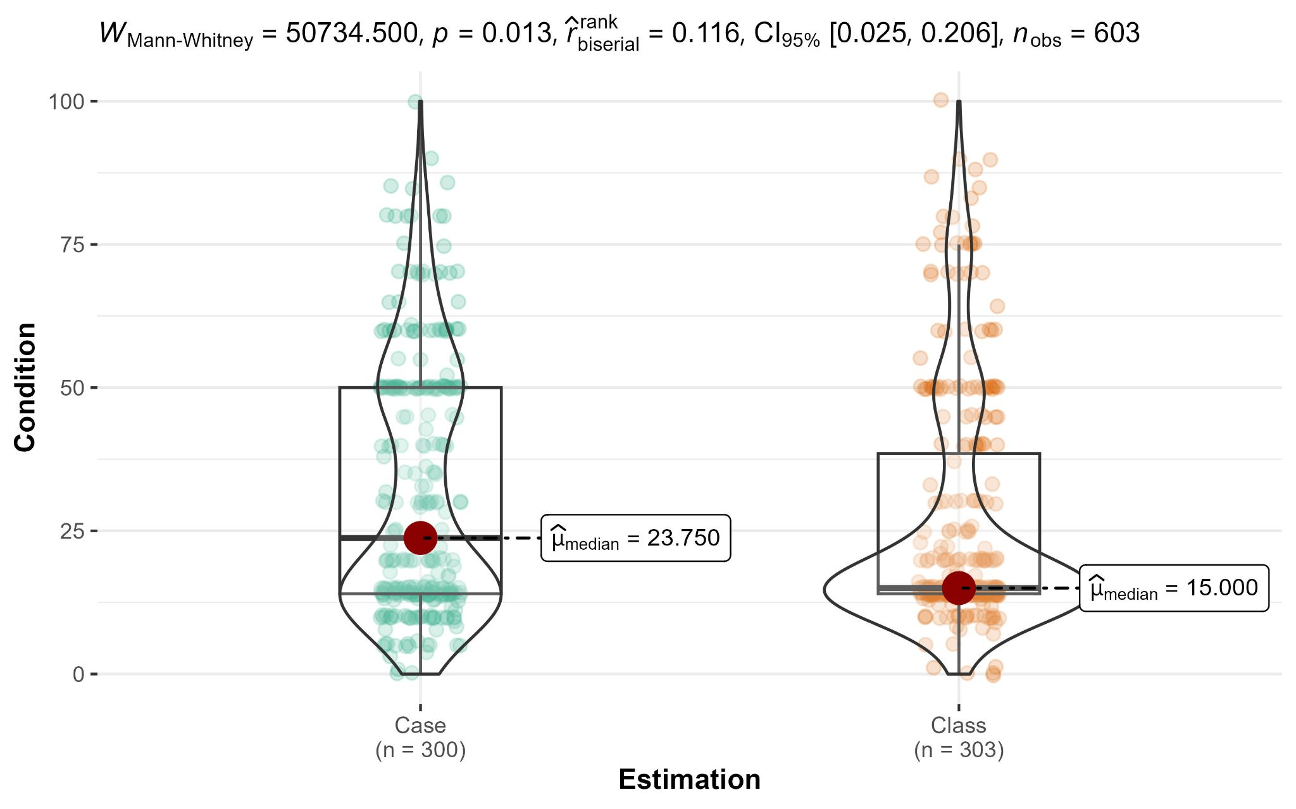

Study 1a Q2

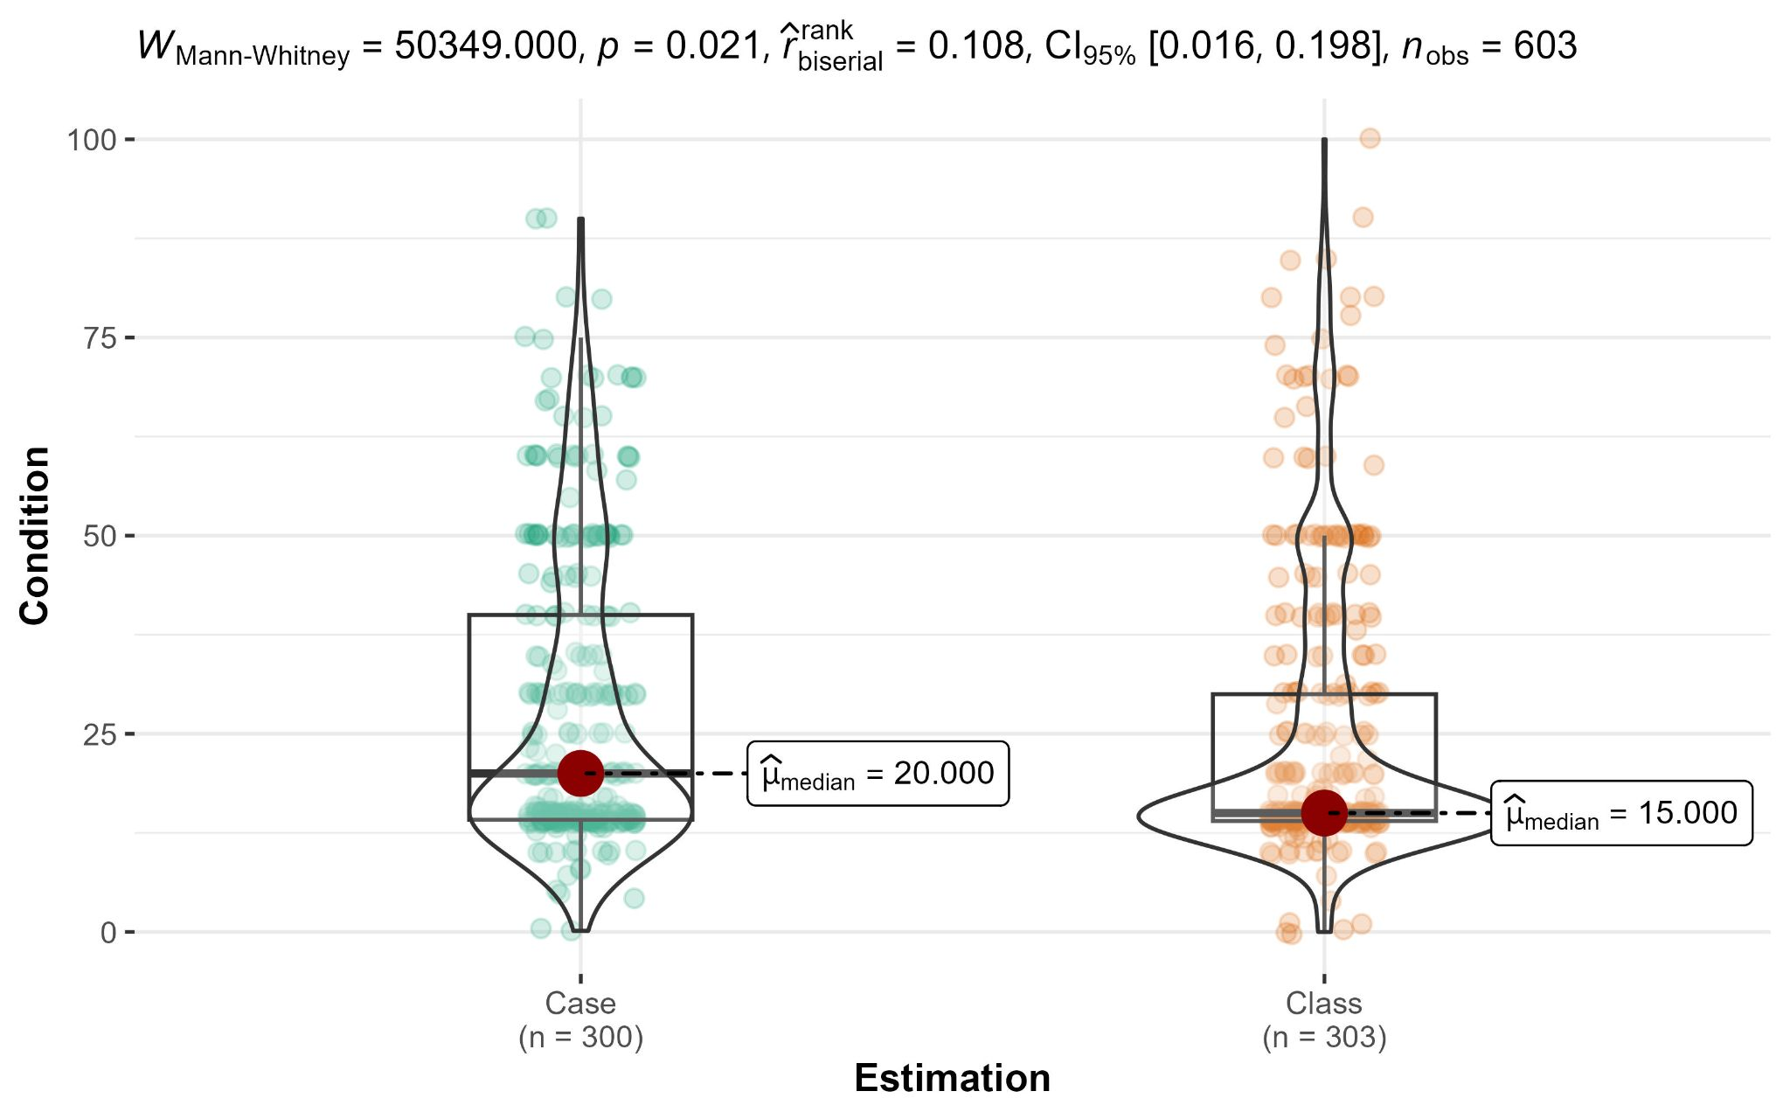

Study 1a Q3

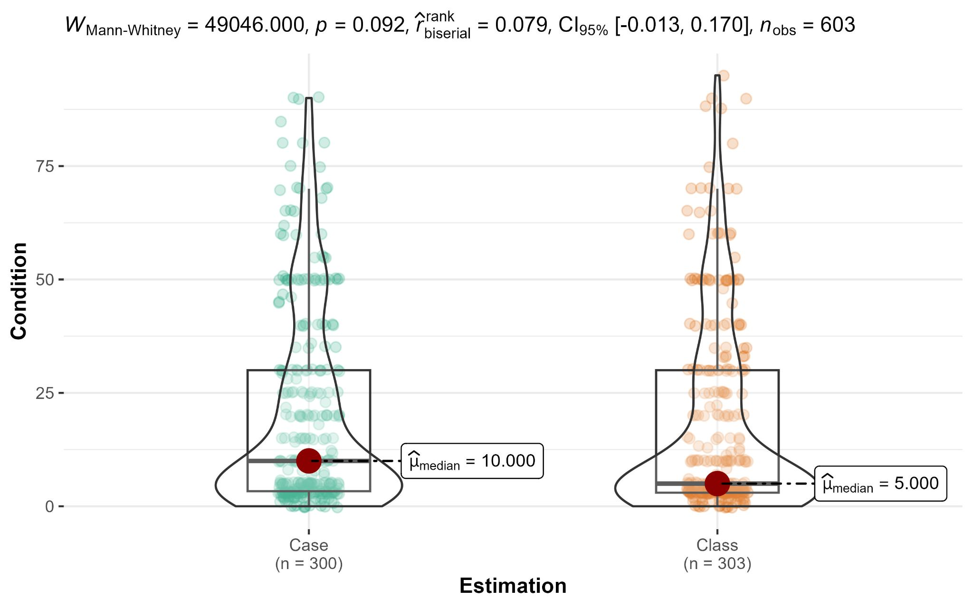

Study 1b

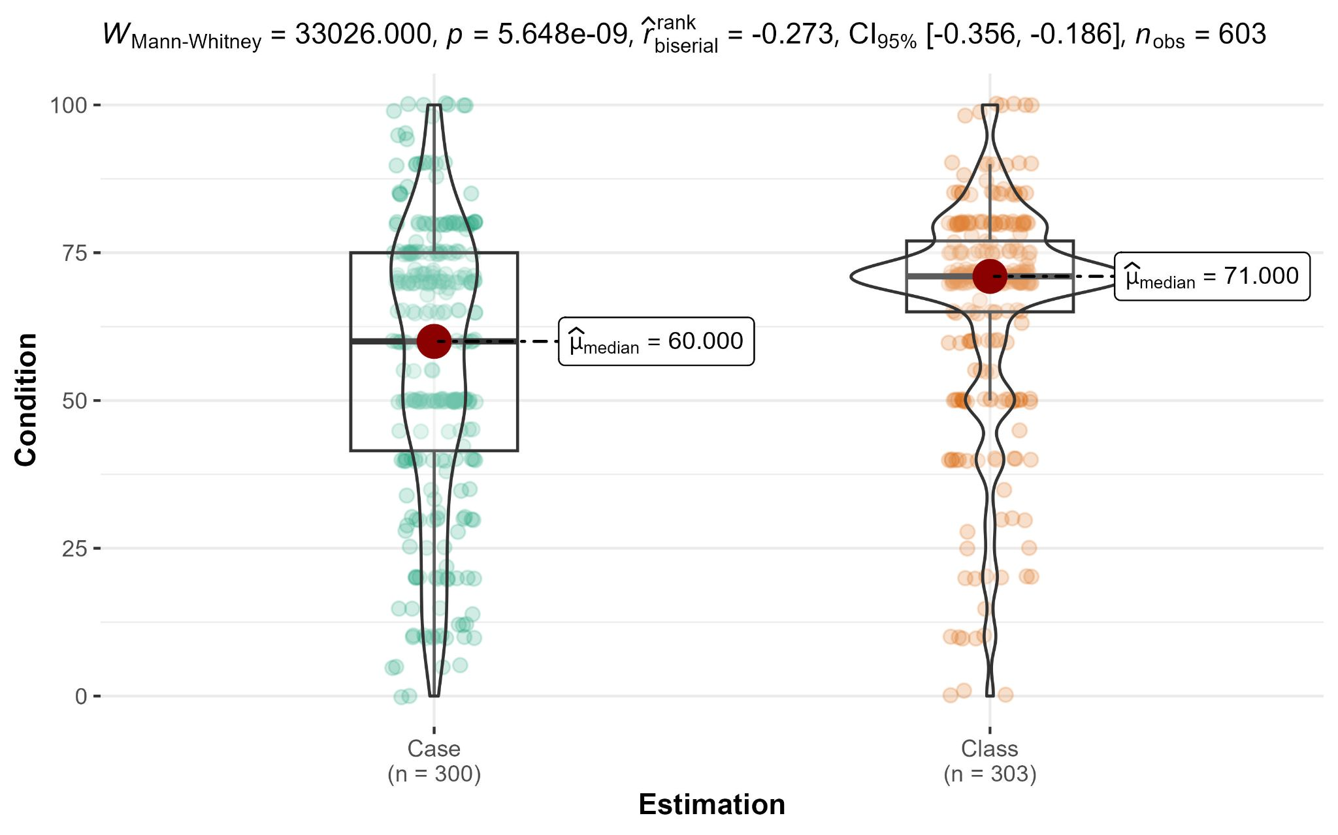

Study 3

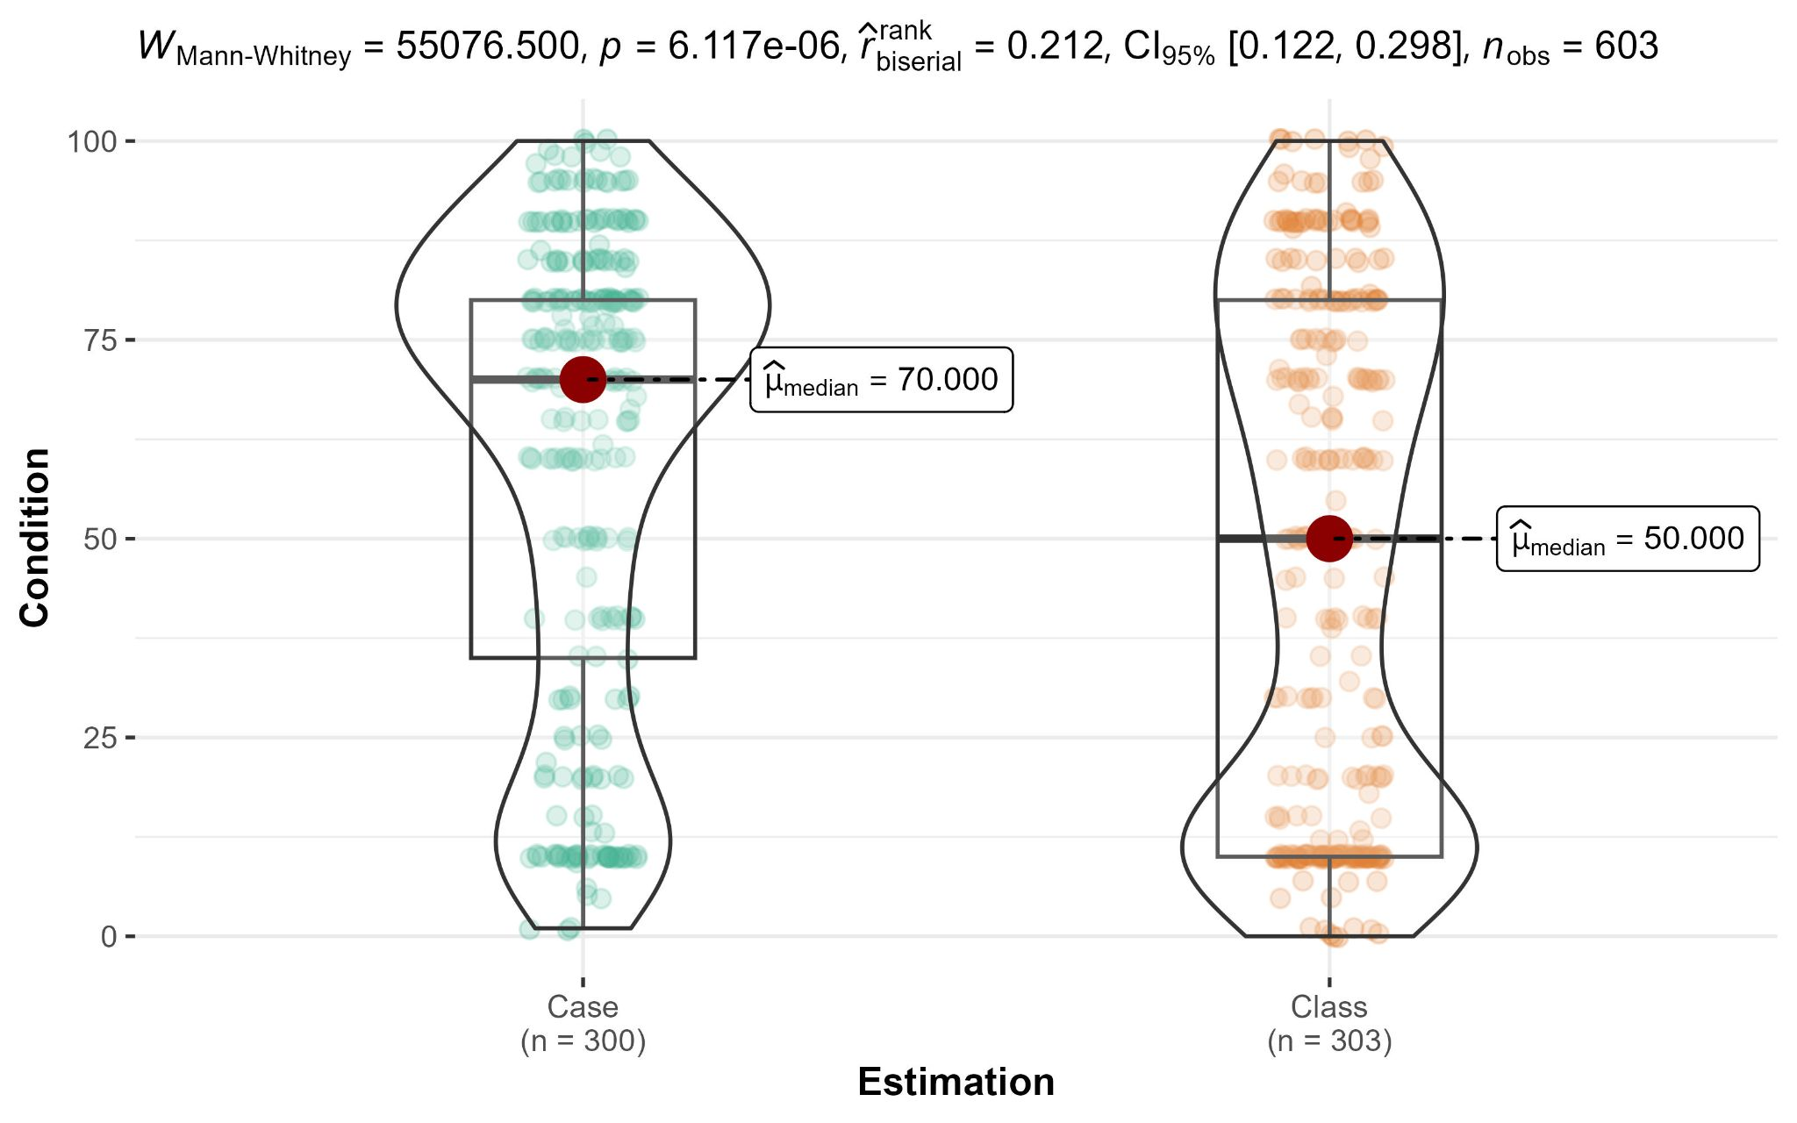

Violin plots of the distribution of responses, boxplots displaying the median, first, and third quartiles, and the red circle identifying the median value.

#### Ignorance priors

We also examined the proportions of responses aligned with ignorance priors across different conditions and items, summarized in Table 11 and plotted in Figure 2. Specifically, we examined for the two case and class conditions: (a) proportions of judgments aligned with the case-prime ignorance prior (1/2), and (b) proportions of judgments aligned with the class-prime ignorance prior (1/n or x/n).

We pre-registered the decision to classify all responses falling within ±5% of the ignorance prior as influenced by partition priming, a criteria that was not well-specified in the target article.

We performed a series of chi-squared tests comparing the proportions of case-primed and class-primed responses in the two experimental conditions (Table 12; Figure 2). Our results demonstrated the varying influence of priming conditions on responses' alignment with ignorance priors across the different scenarios.

For Study 1a Q1 (weather) and 1b (weather), we found support for greater proportions of both case-primed and class-primed responses in the respective conditions, with higher proportion of case-primed responses in the case condition and a greater proportion of class-primed responses in the class condition. For Study 1a Q2 (sports) and Study 3 (offer), we only found support for the class-primed responses, as participants in the class condition made these responses more frequently than those in the case condition. For Study 1a Q3 (business), we found no evidence for alignment with either case-primed or class-primed responses.

### Study 4

We conducted a two-proportion *z*-test and found no support for differences in the proportion of participants selecting the second option (uncertain high payment) between the case and the class condition, with proportions of 21.00% (case) and 23.76% (class), *z* = 0.81, *p* = .415, Cohen’s *h* = 0.08, 95% CI [-0.11, 0.27] (see bottom of Figure 2).

###### 

###### 

###### Table 11 *Studies 1a, b, and 3: Proportions of response aligned with ignorance priors (“happen” events)*

|  |  |  |  |  |  |  |
| --- | --- | --- | --- | --- | --- | --- |
| Condition | Condition | Study 1a Q1 | Study 1a Q2 | Study 1a Q3 | Study 1b | Study 3 |
| Case | Case-primed responses | 19.33% | 11.33% | 9.67% | 19.67% | 5.00% |
| Class-primed response | *33.67%* | *41.33%* | *41.00%* | *22.67%* | *15.67%* |
|  | Neither | 47.00% | 47.34% | 49.33% | 57.66% | 79.33% |
| *Class* | Case-primed responses | 10.56% | 9.24% | 7.59% | 8.58% | 8.25% |
| Class-primed response | *48.18%* | *50.17%* | *40.92%* | *40.92%* | *29.70%* |
|  | Neither | 41.26% | 40.59% | 51.49% | 50.50% | 62.05% |

*Note.* Responses falling within ±5% of the ignorance prior were considered to be influenced by partition priming (aligned with ignorance priors). Case comparisons are underlined and class comparisons are italicized to aid readers.

###### 

###### Table 12 *Studies 1a, b, and 3:* χ2 *test comparing the proportions of case-primed and class-primed responses in the two experimental conditions (“happen” events)*

|  |  |  |  |
| --- | --- | --- | --- |
|  | Study | Case-primed response | Class-primed response |
| χ2 (*df* = 1) | 1a Q1 | 9.14** | 13.14*** |
|  | 1a Q2 | 0.72 | 4.74* |
|  | 1a Q3 | 0.82 | 0.00 |
|  | 1b | 15.30*** | 23.15*** |
|  | 3 | 2.57 | 16.92*** |
| *p* | 1a Q1 | .003 | < .001 |
|  | 1a Q2 | .398 | .030 |
|  | 1a Q3 | .364 | .985 |
|  | 1b | < .001 | < .001 |
|  | 3 | .109 | < .001 |

*Note*. *N*case = 600, *N*class = 603. * *p* < .05, ** *p* < .01, *** *p* < .001.

###### Figure 2 *Studies 1a, 1b, 3, and 4: Comparison of ignorance priors (1a/b and 3) and decisions (4) between the Case and Class conditions (Chi-squared tests)*

Study 1a Q1

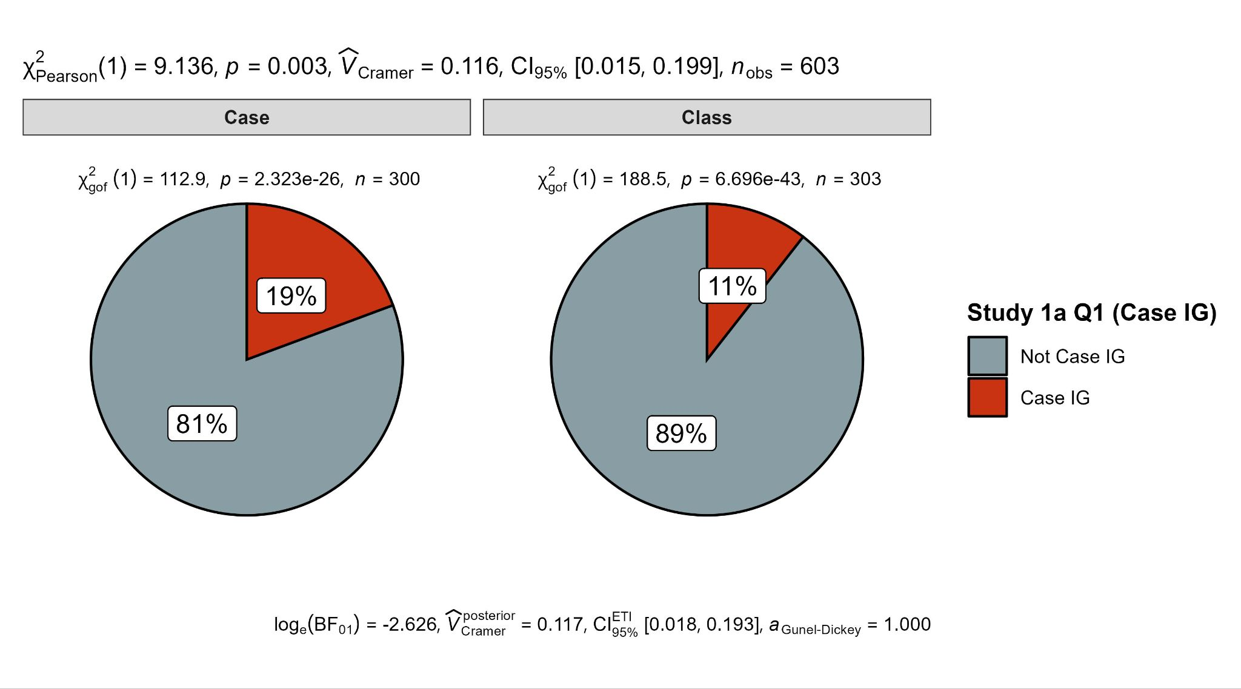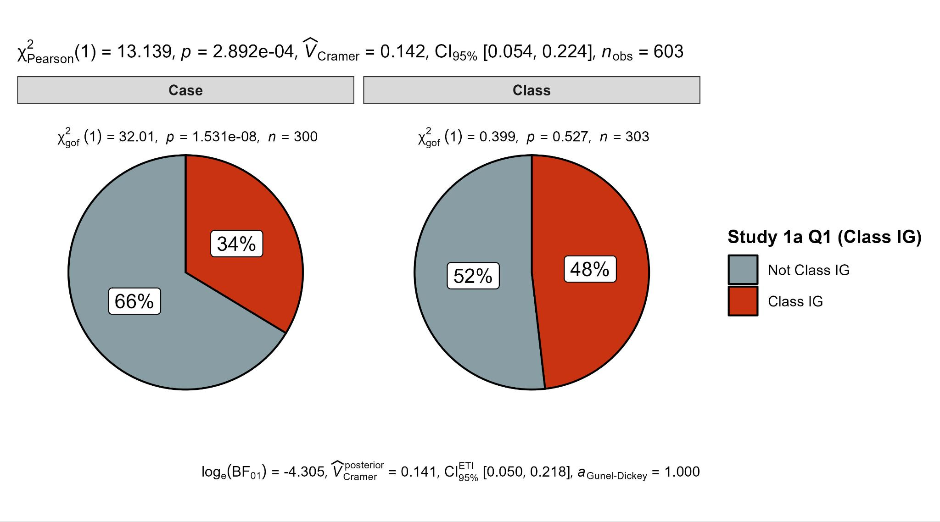

Study 1a Q2

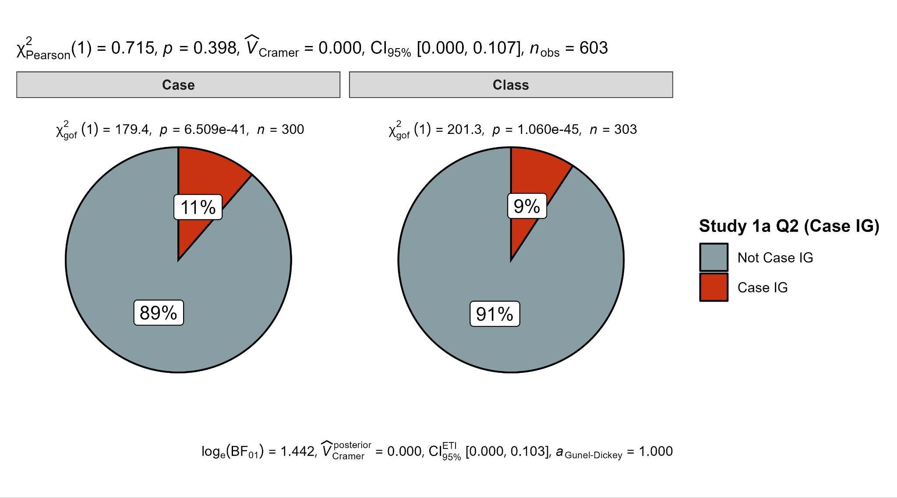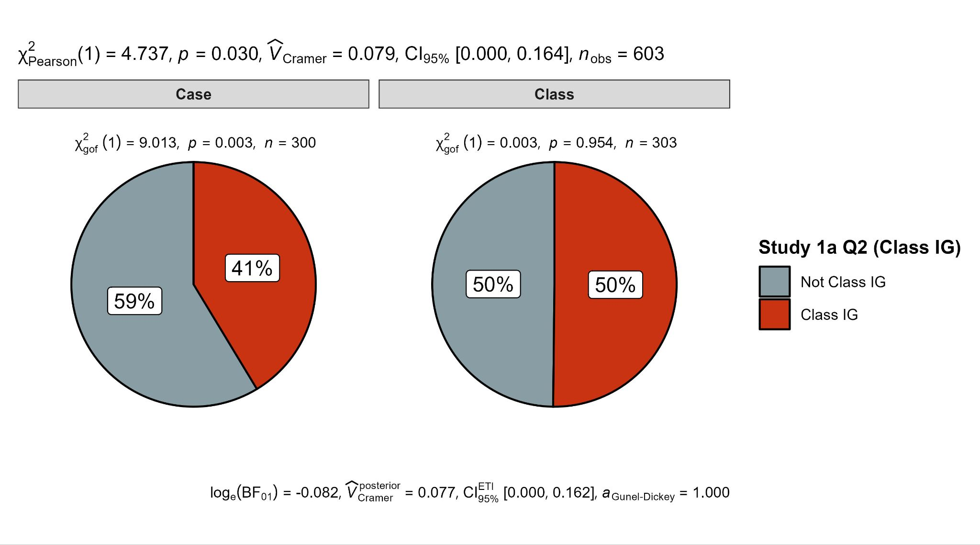

Study 1a Q3

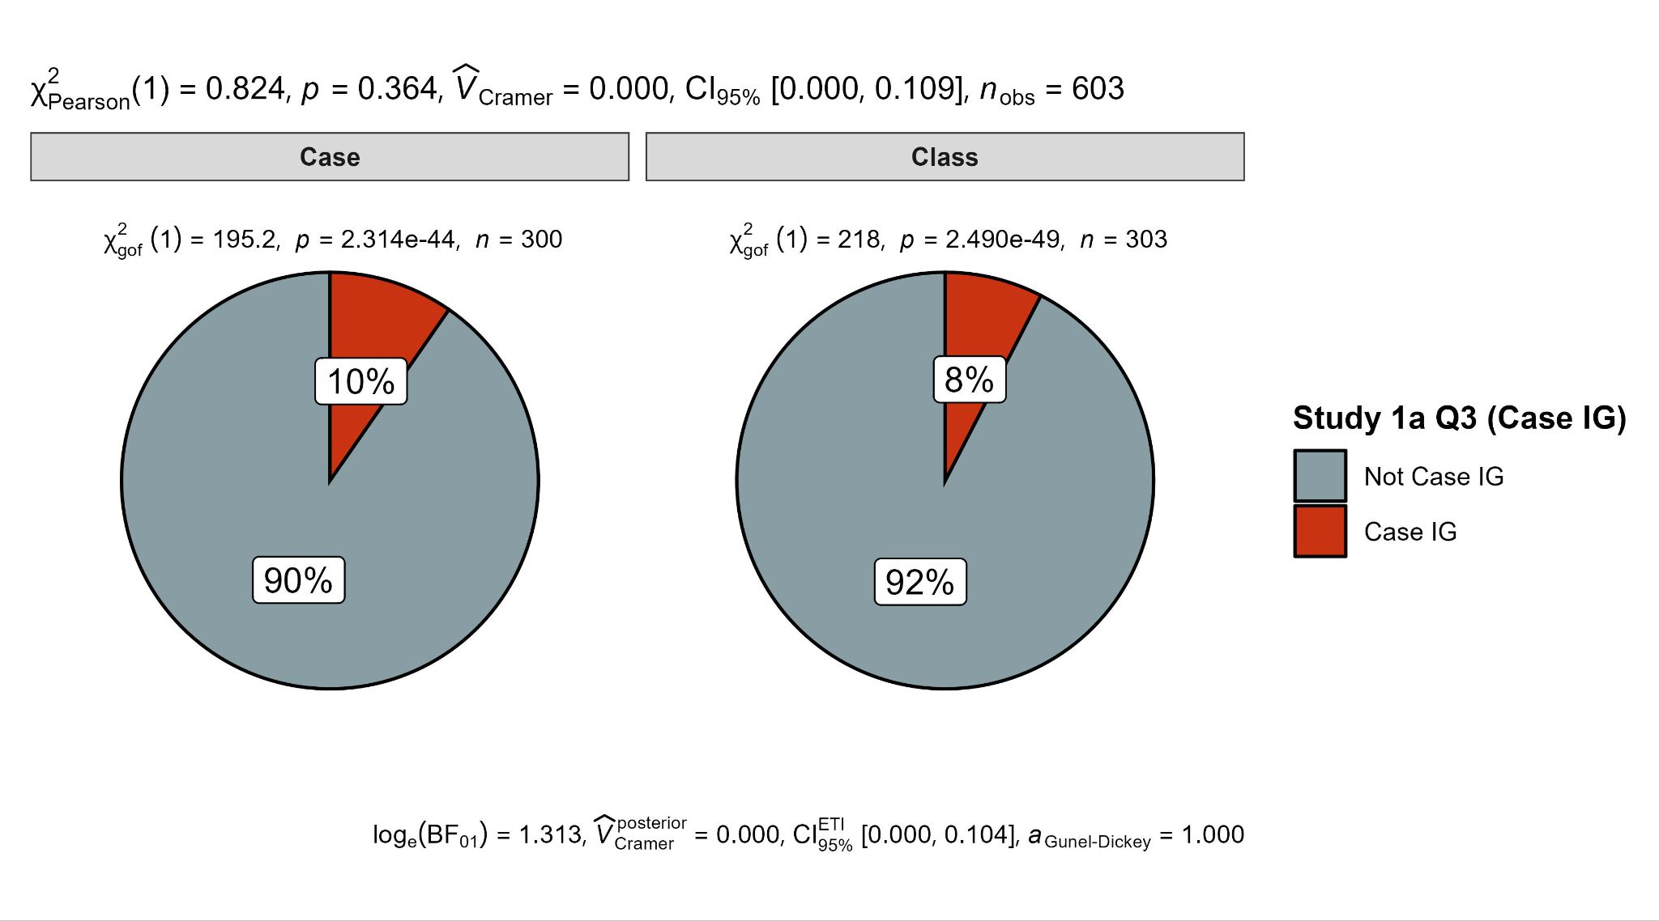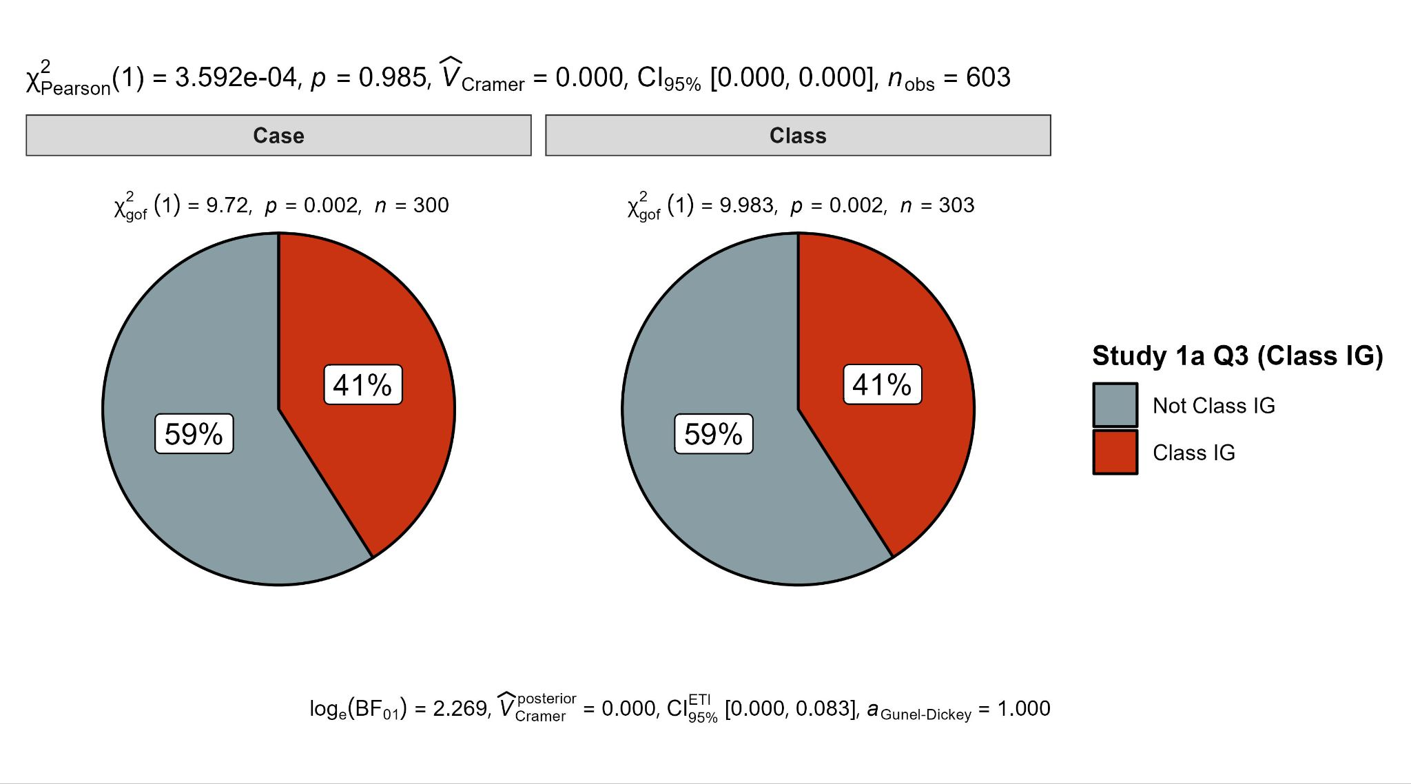

Study 1b

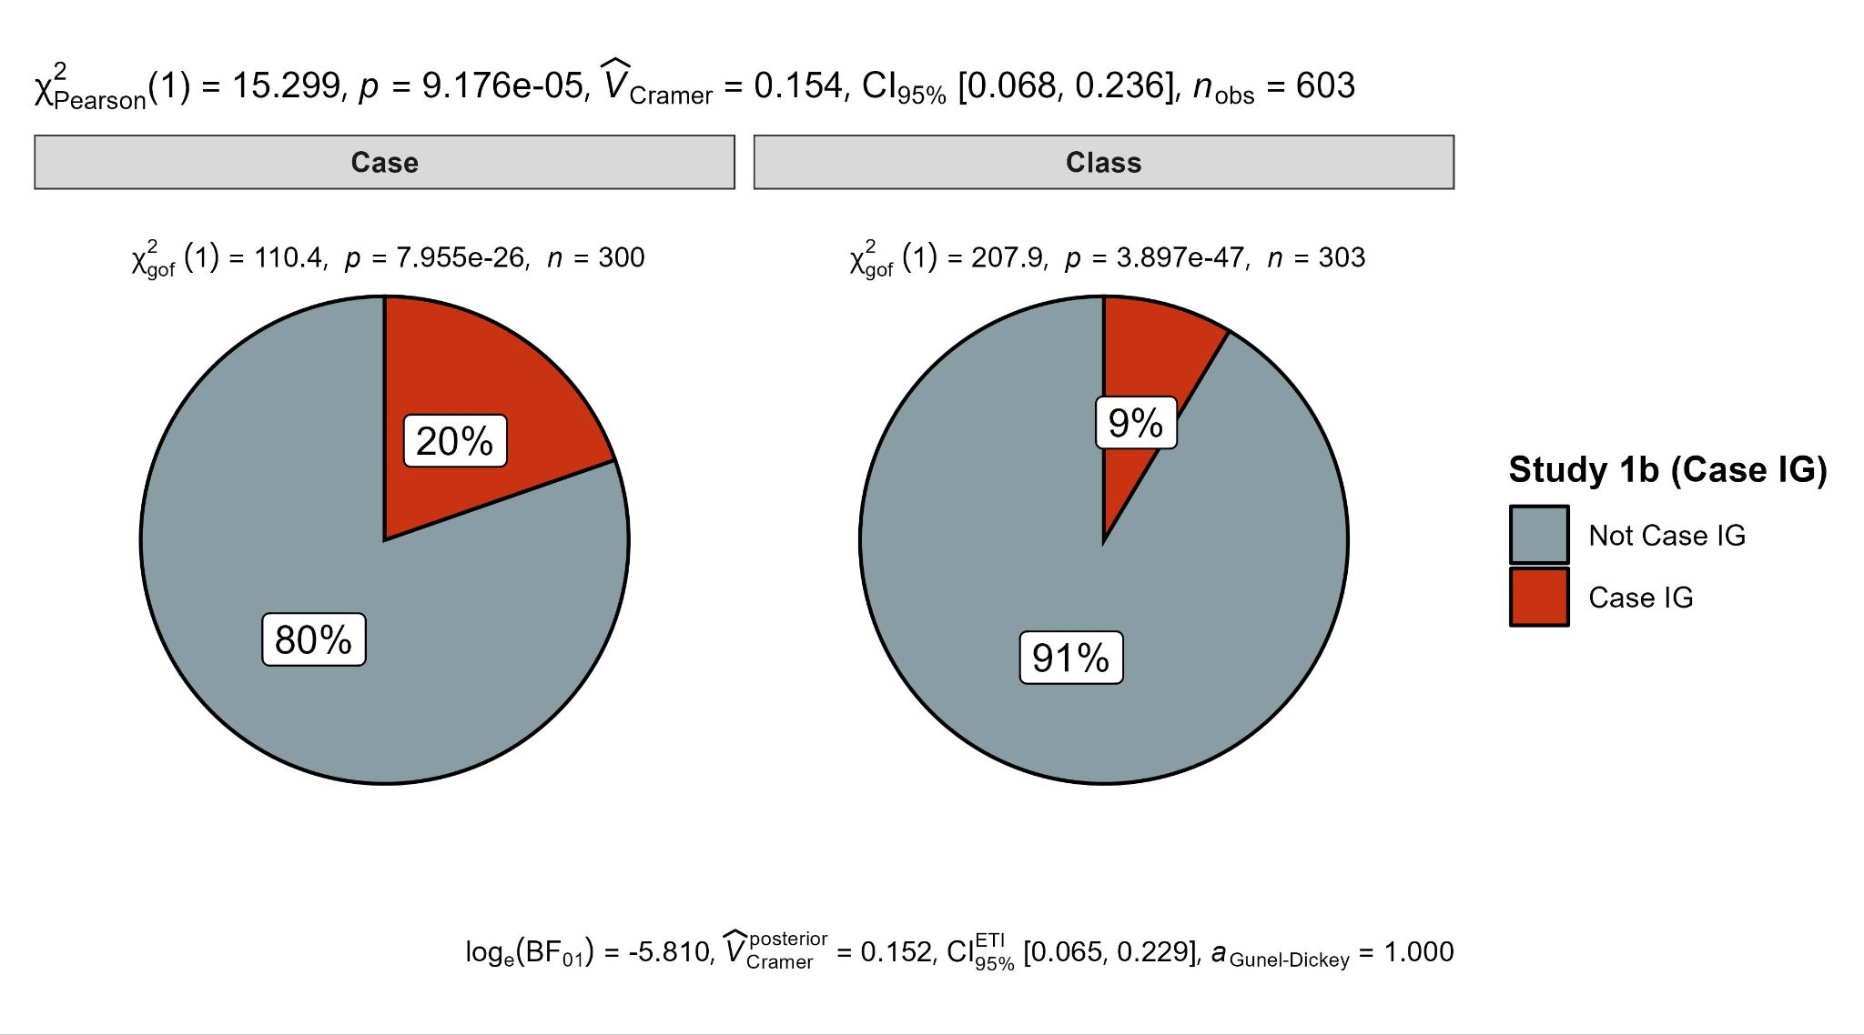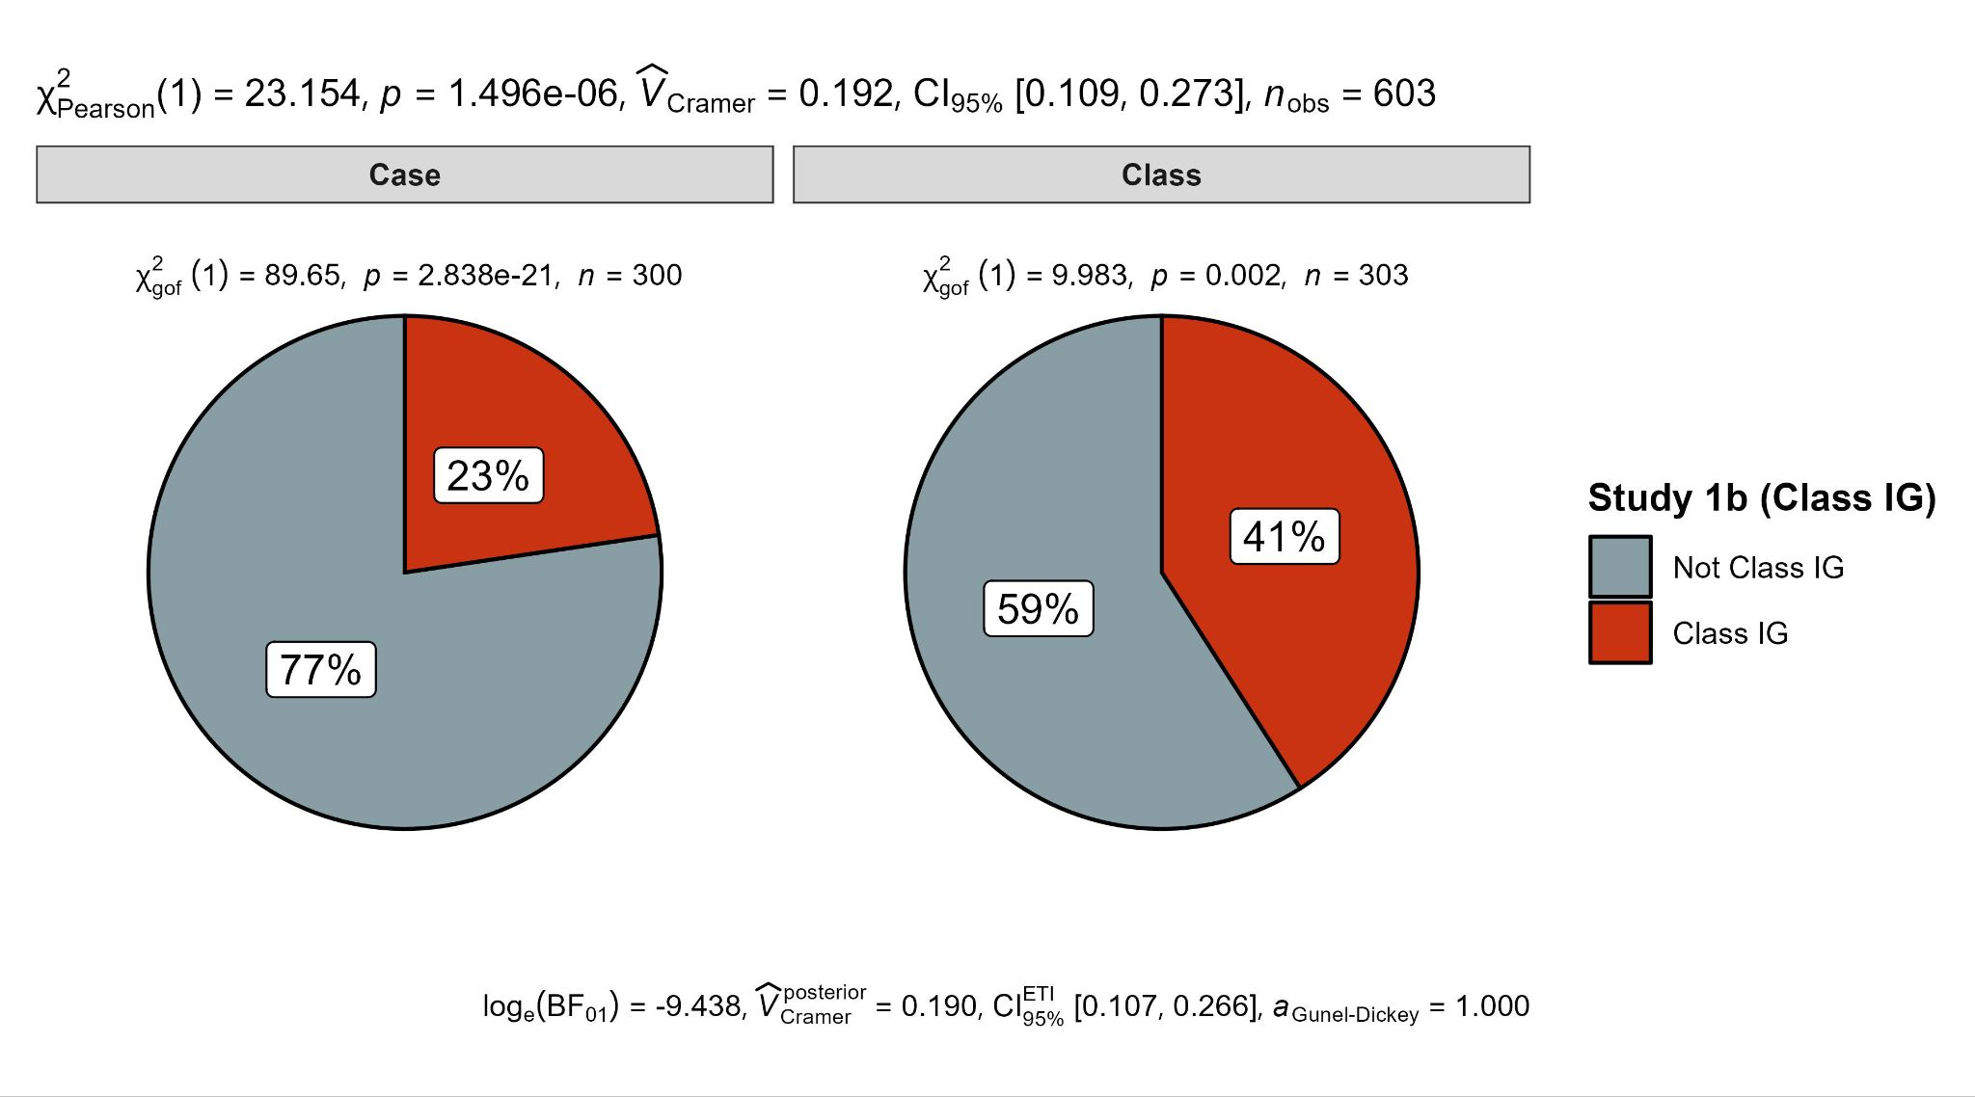

Study 3

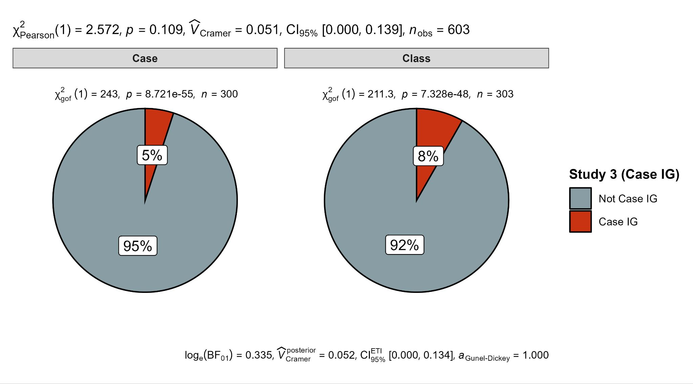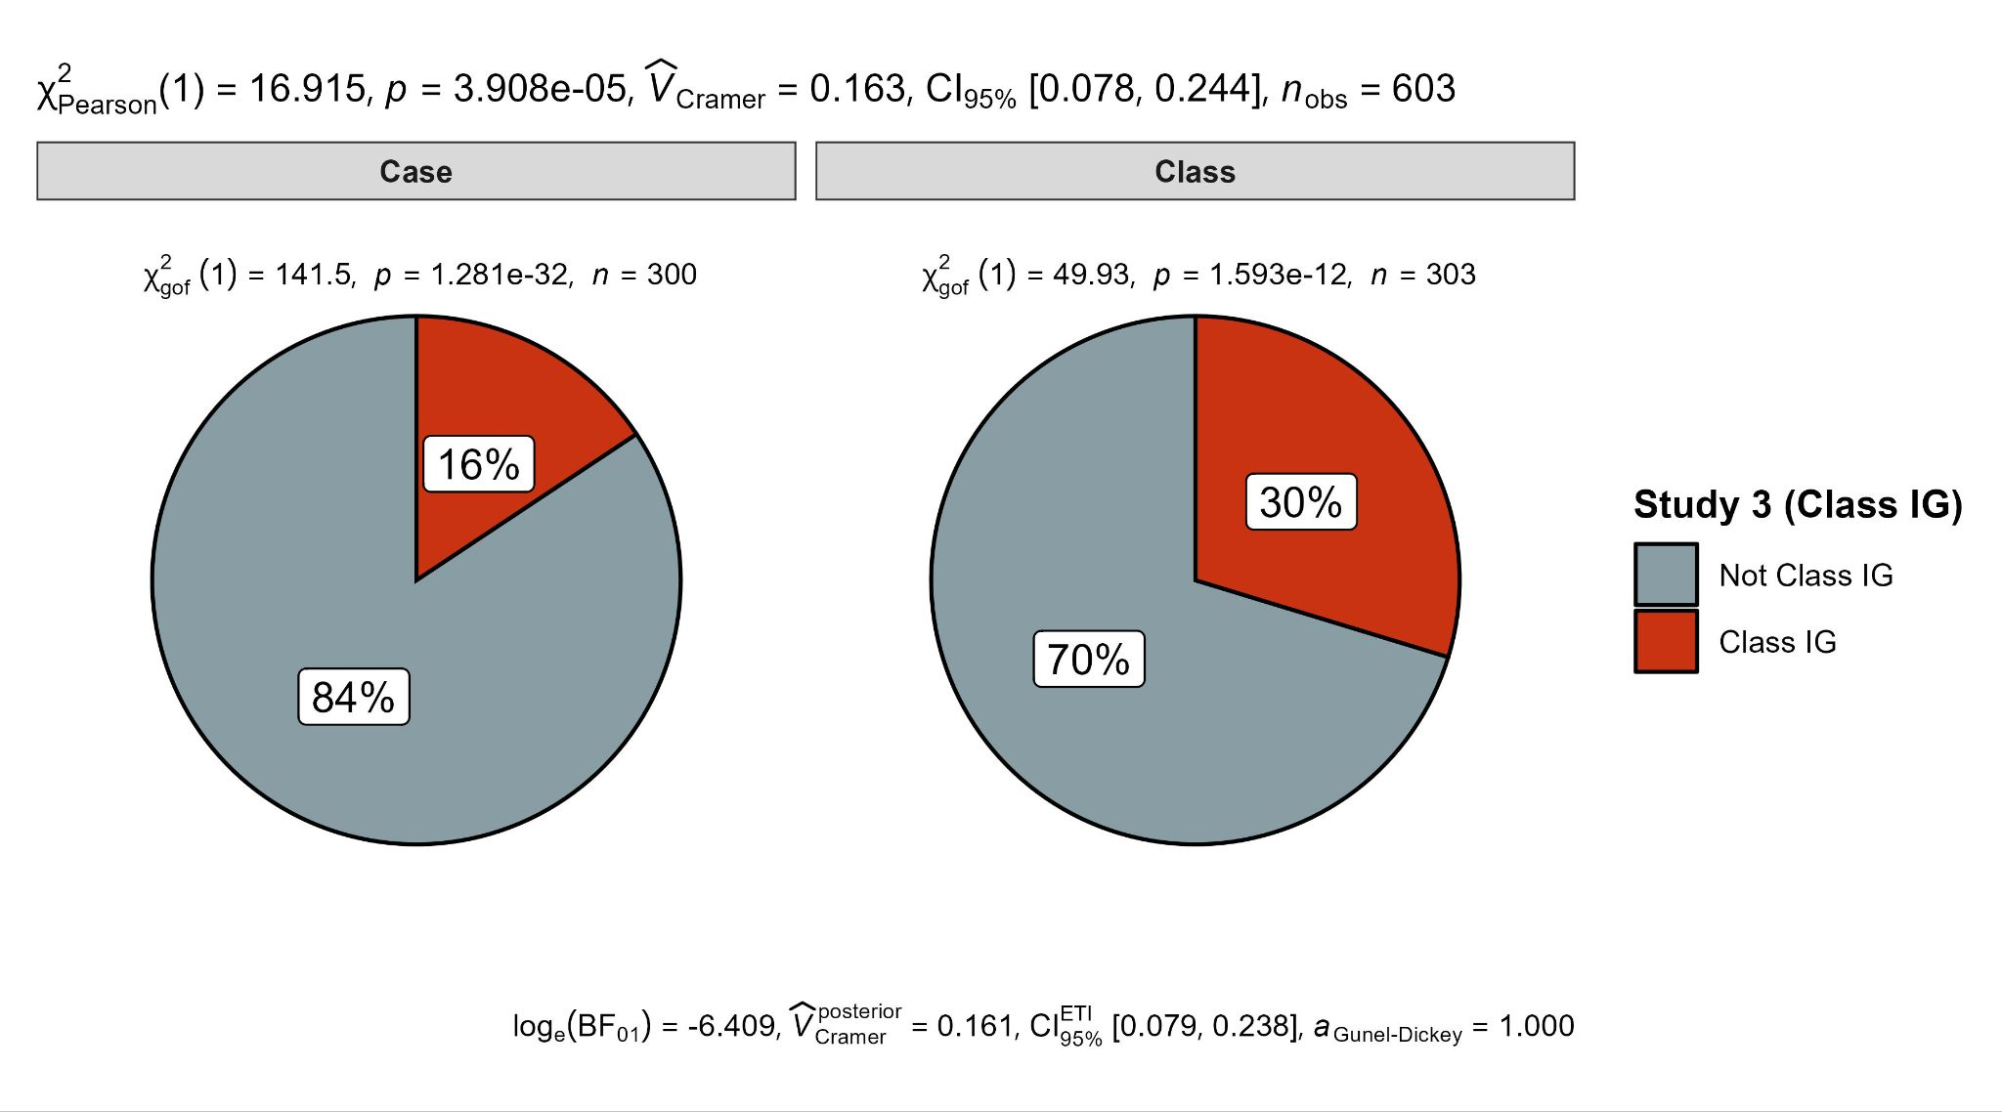

Study 4

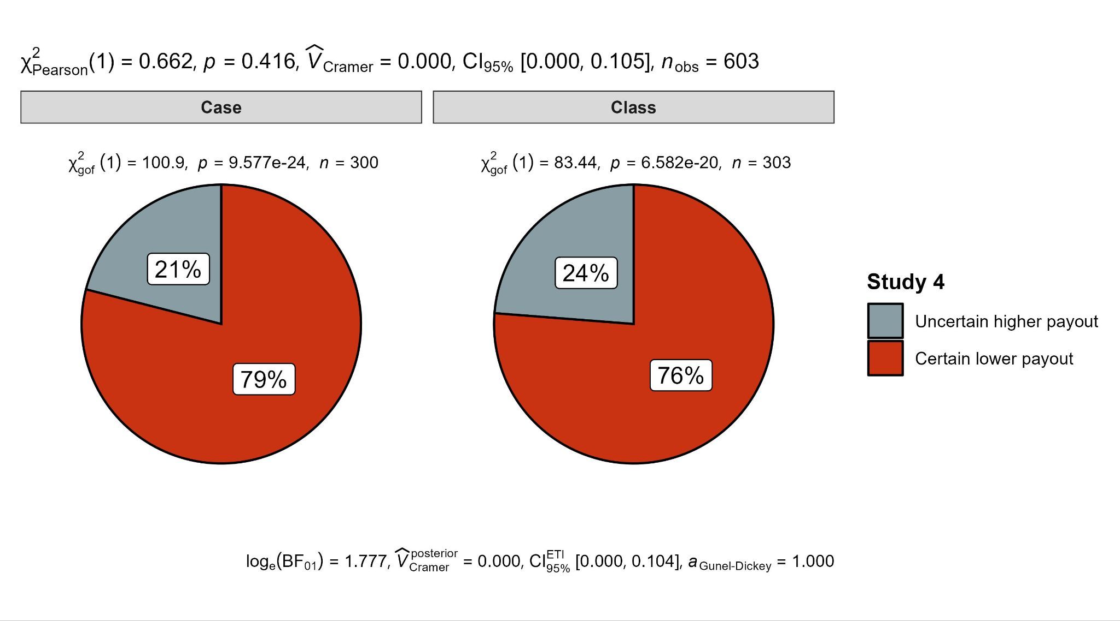

*Note.* For Studies 1a, 1b, and 3, the left panel shows comparison between responses that aligned with case-primed ignorance priors and those that did not. The right panel shows comparison between responses that aligned with class-primed ignorance priors and those that did not. For Study 4, the left panel depicts the proportions of

participants choosing

## the uncertain higher payment option versus the certain lower payment option in the case condition, and

the right



panel shows the proportions of these choices in the class condition.

## Replication Evaluation

To assess the reproducibility of our results compared to those of the target article, we employed the paradigm outlined by LeBel et al. (2019), examining the existence of a signal and comparing confidence intervals with the effect size reported in the target article. We summarized the outcomes of this comparison in Table 13.

After the analysis we realized that our pre-registered criteria for concluding effects for Study 1a given the three items was under-specified, given that there are three items, of which two were supported, and we did not indicate in advance how we would treat such a case. Post-analysis, in the spirit of our pre-registered criteria that if the majority of studies are supported then we conclude a successful replication, we applied similar criteria to the items in Study 1a, and we note that as a deviation/expansion. We decided to conclude support for an effect if two out of three items were supported, resulting in our classification of Study 1a as a successful replication. We also were not clear enough which of all the tests used, we would use as the core analysis for the evaluation of replication, and decided to focus on the main Mann-Whitney *U* test as the most closely aligned with our pre-registration.

Given that three of the four studies were supported for the core main dependent variable, based on our pre-registered criteria we concluded our attempt as a (mostly) successful replication.

###### *between the target article and our replication using the LeBel et al. (2019) replication evaluation criteria*

|  |  |  |  |  |
| --- | --- | --- | --- | --- |
| **Study** |  | **Target article** | **Replication** |  |
| Estimations | | Cohen's *h* and CI | Cohen's *h* and CI | Interpretation |
| 1a | Item 1 | 0.65 [0.24, 1.06] | 0.30 [0.14, 0.46] | Signal - inconsistent, smaller |
|  | Item 2 | 0.65 [0.24, 1.06] | 0.18 [0.02, 0.34] | Signal - inconsistent, smaller |
|  | Item 3 | 0.65 [0.24, 1.06] | 0.00 [-0.16, 0.16] | No signal - inconsistent |
| 1b |  | 0.67 [0.07, 1.28] | 0.43 [0.25, 0.60] | Signal - inconsistent, smaller |
| 3 |  | 0.62 [0.16, 1.08] | 0.41 [0.21, 0.60] | Signal - inconsistent, smaller |
| 4 |  | 0.32 [0.00, 0.65] | 0.08 [-0.11, 0.27] | No signal - inconsistent |
| Ignorance priors | | Cohen's *d* and CI | Cohen's *d* and CI | Interpretation |
| 1a | Item 1 | 0.55 [0.13, 0.96] | 0.25 [0.09, 0.41] | Signal - inconsistent, smaller |
|  | Item 2 | 0.55 [0.13, 0.96] | 0.15 [-0.14, 0.31] | Signal - inconsistent, smaller |
|  | Item 3 | 0.55 [0.13, 0.96] | 0.08 [-0.08, 0.24] | No signal - inconsistent |
| 1b |  | -0.87 [-1.51, -0.22] | -0.48 [-0.64, -0.32] | Signal - inconsistent, smaller |
| 3 |  | 0.47 [0.00, 0.93] | 0.40 [0.24, 0.56] | Signal - consistent |

*Note*. DVs: Studies 1a/b, and 3 are probability estimations, and Study 4 is decision outcome. CI = 95% confidence intervals. Upper panel presents Cohen’s *h* comparing proportions of class-primed responses in the two experimental conditions (Studies 1a, 1b, and 3, “happen” events) and proportions of choice option (Study 4). Lower panel presents Cohen’s *d* comparing probability judgements (Studies 1a, 1b, and 3). We aligned all effects of Welch’s *t*-tests (Cohen’s *d*) to go in the same direction with case condition higher than class condition, yet Study 1b was meant to demonstrate class condition higher than case condition, and so the effects are coded as negative. In the target article, we derived Cohen’s *h* and Cohen’s *d* in Study 1a by combining responses across all three items, as statistics for individual items were unavailable. For Study 1b in the target article, Cohen’s *d* was derived from the *p*-value reported in the target article.   
We used the LeBel et al. (2019) replication evaluation criteria, summarized in the supplementary materials Figures S4a/b. Briefly: “Signal – consistent”: The confidence intervals (CI) for the replication effect size (ES) excludes zero and includes the original study’s ES; “Signal – inconsistent, smaller”: The replication ES CI excludes zero and the upper CI is smaller than the original study’s ES; “No signal – inconsistent”: The replication ES CI includes zero and does not overlap with the original study’s ES.

## Extension: A three-way mixed ANOVA for Studies 1a (cases 1/2/3), 1b, and 3

One of the advantages of our unified design combining several items and studies, is the ability to run a more comprehensive analysis comparing the effects across the different scenarios. We also added an extension going beyond the replication of asking for the probability of something to “happen” and also asked about the probability of something to “not happen”. This approach served to examine differences across scenarios and in competing hypotheses framing, as a potential examining of the generalizability of the phenomenon.

We conducted a three-way mixed ANOVA to examine the impact of condition (2 between conditions; case vs. class), question (5 within conditions; Study 1a Item 1, Study 1a Item 2, Study 1a Item 3, Study 1b, Study 3), and evaluation type (2 within conditions; happen vs. reverse not happen) on participants' probability judgments[1]. We plotted the results in Figure 3.

We found support for a main effect of question (*F*(4, 2404) = 446.96, *p <* .001), and an interaction between question and condition (*F*(4, 2404) = 24.32, *p* < .001), which are both to be expected given that Study 2 has the deliberate reversal effect. We also found support for a main effect of evaluation type (*F*(1, 601) = 19.32, *p* < .001), with a weak interaction between evaluation type and condition (*F*(1,601) = 4.17, *p* = .042). We found no support for the main effect of condition on probability judgments (*F*(1, 601) = 2.05, *p* = .153) or for a three-way interaction between evaluation type, question, and condition (*F*(4, 2404) = 1.42, *p* = .227).

###### Figure 3 *Three-way mixed ANOVA of condition, scenario, and evaluation type on probability judgments*

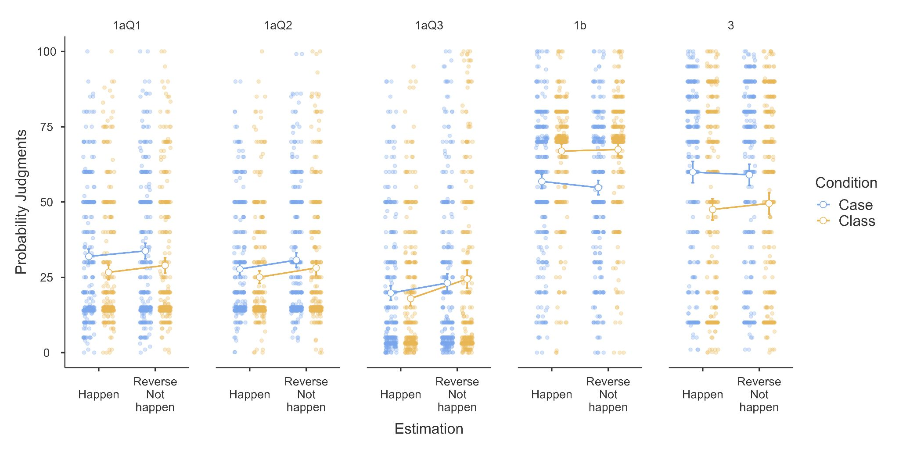

To explore whether participants' estimations of two competing hypotheses summed to 100% and whether this interacted with condition and scenario, we focused on post-hoc tests of specific contrasts of interest[2]. We found support for differences between estimations of two complementary events in Study 1a Q3 in the class condition (*t* = −16.24, *p* < .001). Specifically, participants' average assessment of “happen” probabilities (*M* = 17.97, *SE* = 1.23) was lower for “happen” than for reverse “not happen” (*M* = 24.46, *SE* = 1.54). All other comparisons showed no differences, suggesting that participants' estimations for two mutually exclusive events generally summed to 100%.

###### 

## Extensions: Negative complementary events (Studies 1a, 1b, and 3 exploratory analysis)

We examined whether participants' likelihood judgments of negative complementary events displayed a consistent or divergent pattern of reliance toward partition-dependent priors across Studies 1a, 1b, and 3. The Mann-Whitney *U* tests indicated differing probability judgments between the case-prime and class-prime conditions for Items 1 and 2 of Study 1a, Study 1b, and Study 3, while no difference was found for Item 3 of Study 1a (Table 15). Welch’s *t*-tests found support for lower probability judgments in the case condition for Item 1 of Study 1a and Study 3 where ignorance priors under case prime were lower than that under class prime, and higher probability judgments for Study 1b in the case condition where ignorance priors under case prime were higher than that under class prime (Table 14 and 15). Welch’s *t*-test failed to find support for an effect of condition on Items 2 and 3 of Study 1a.

###### Table 14 *Study 1a, b, and 3: Descriptive statistics of probability estimation of “not happen” target events*

|  |  |  |  |  |  |  |  |  |  |
| --- | --- | --- | --- | --- | --- | --- | --- | --- | --- |
|  |  | Case prime (*n* = 300) | | | | Class prime (*n* = 303) | | | |
| Study | Item | Ignorance prior | *Med (*%) | *M (*%) | *SD (*%) | Ignorance prior | *Med (*%) | *M* *(*%) | *SD* *(*%) |
| 1aQ1 | Weather | 1/2 (50%) | 72.00 | 66.23 | 23.12 | 6/7 (86%) | 85.00 | 71.04 | 22.42 |
| 1aQ2 | Sports | 1/2 (50%) | 80.00 | 69.28 | 21.01 | 6/7 (86%) | 85.00 | 71.89 | 21.57 |
| 1aQ3 | Business | 1/2 (50%) | 90.00 | 76.89 | 25.36 | 29/30 (97%) | 90.00 | 75.54 | 28.08 |
| 1b | Weather | 1/2 (50%) | 45.50 | 45.20 | 23.48 | 2/7 (29%) | 29.00 | 32.58 | 18.20 |
| 3 | Offer | 1/2 (50%) | 30.00 | 40.95 | 29.82 | 9/10 (90%) | 50.00 | 50.47 | 32.19 |

*Note*. *Med* indicates median judged probability, *M* indicates mean, *SD* indicates standard deviation, *n* indicates condition sample size. The units of *Med, M, and SD* are percentages.

###### Table 15 *Study 1a, b, and 3: Mann-Whitney U and Welch’s t test comparing probability estimation of “not happen” (complementary hypotheses) target events*

|  |  |  |  |  |  |  |
| --- | --- | --- | --- | --- | --- | --- |
| Study | | 1a | | | 1b | 3 |
|  |  | Item 1 | Item 2 | Item 3 |
| Mann-Whitney *U* | *U* | 40568* | 41078* | 44869 | 30615*** | 38062*** |
|  | *p* | .022 | .040 | .786 | < .001 | < .001 |
|  | Rank biserial *r* and 95% CI | 0.11  [0.02, 0.20] | 0.10  [0.00, 0.19] | 0.01  [-0.08. 0.11] | -0.32  [-0.41, -0.24] | 0.16  [0.07, 0.25] |
| Welch’s *t* | *t* | 2.59* | 1.50 | -0.62 | -7.37*** | 3.77*** |
|  | *df* | 600.0 | 600.8 | 596.0 | 563.2 | 598.4 |
|  | *p* | .010 | .133 | .536 | < .001 | < .001 |
|  | Cohen’s *d* and 95% CI | 0.21  [0.05, 0.37] | 0.12  [-0.03, 0.28] | -0.05  [-0.21, 0.11] | -0.60  [-0.76, -0.44] | 0.31  [0.15, 0.47] |

*Note.* Probability estimations were recorded in percentages. * *p* < .05, ** *p* < .01, *** *p* < .001. For the "happen" events, effect sizes were recorded in their original scales (Table 10). For the "not happen" events presented in this table, effect sizes were recorded in reverse (negative values were converted to positive, and positive values to negative) to aid direct comparison. For example, consider the scenario of Study 3: For the “happen” event, the case ignorance prior was 1/2 and the class ignorance prior was 1/10. For the “not happen” event, the case ignorance prior was 1/2 and the class ignorance prior was 9/10. The effect sizes for “not happen” events were recorded in reverse to facilitate comparison. By aligning the direction of the effect sizes, it is easier to assess whether the patterns of partition dependence are consistent across different scenarios (happen vs. not happen).

## 

participants choosing

###### *the uncertain higher payout in Study 4 based on task order (Study 1a Item 3 vs. Study 4) and condition*

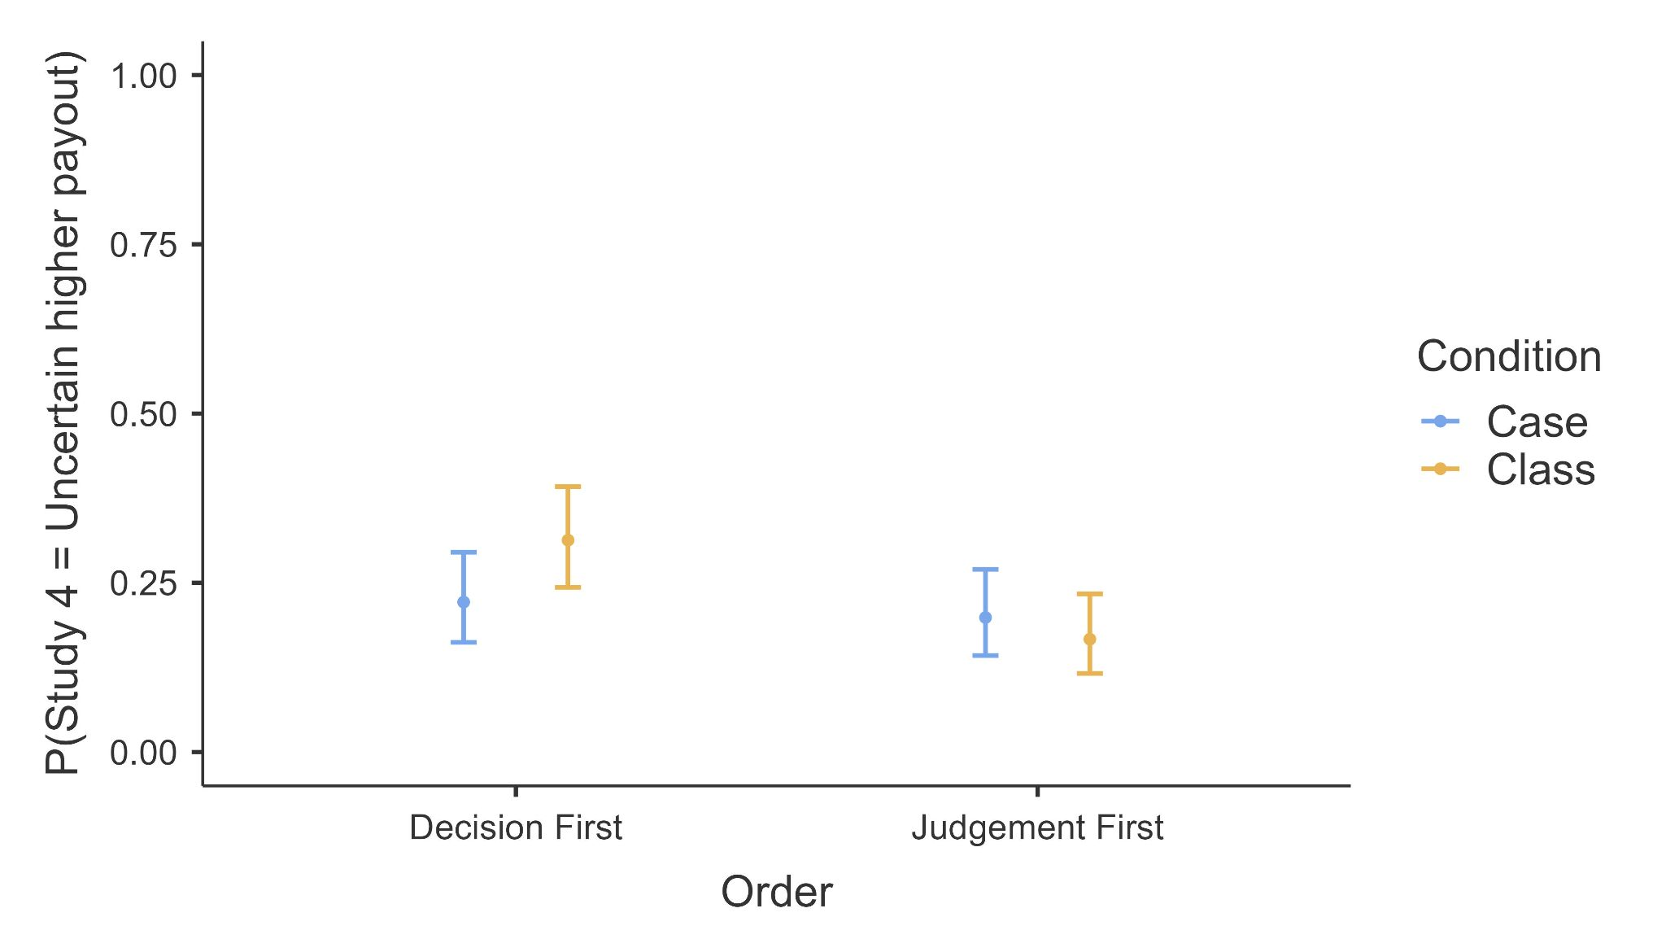

## 

## 

the

# Discussion

We conducted a replication and extension Registered Report of Fox and Rottenstreich (2003) to revisit their findings on partition-dependent ignorance priors in probability judgments and decisions. We summarized the comparison of effects between our findings and the target article’s using the LeBel et al. (2019) criteria in Table 13. Overall, we concluded our replication as (mostly) successful with effects generally weaker than the ones reported in the target article.

Specifically, we successfully replicated Studies 1a items 1 and 2 (2 out of 3 items), 1b, and 3, and failed to find support for Study 1a item 3 and for Study 4. Effect sizes were only consistent with those reported in the target article for Study 3, with all other studies having weaker effects than the target’s in the same direction. These mostly successful yet mixed results suggest that the phenomenon might be more nuanced than expected, with some aspects robust and holding as is over time, yet with others requiring better understanding to be applicable across different contexts and time.

###### Table 16 S*tudies 1a (Q1-Q3), 1b, and 3: Summary of support for core hypothesis using the different tests*

|  |  |  |  |  |
| --- | --- | --- | --- | --- |
| Study | Mann-Whitney *U* | Welch’s *t* | *χ²* (case-primed) | *χ²* (class-primed) |
| 1a Q1 (weather) | Supported* | Supported** | Supported** | Supported*** |
| 1a Q2 (sports) | Supported* | Not supported | Not supported | Supported* |
| 1a Q3 (business) | Not supported | Not supported | Not supported | Not supported |
| 1b (weather) | Supported*** | Supported*** | Supported*** | Supported*** |
| 3 (job offer) | Supported*** | Supported*** | Not supported | Supported*** |

*Note.* * *p* < .05, ** *p* < .01, *** *p* < .001.   
Replication success evaluation criteria focused on the Mann-Whitney U tests.

## Replication

Study 1a examined partition dependence under near ignorance when participants had limited information. For Item 1 (weather), participants exhibited a reliance on partition-dependent ignorance priors. Mann-Whitney *U* tests and Welch’s *t*-tests showed that probability assessments were higher in the case-prime condition with an ignorance prior of 1/2 than in the class-prime condition with an ignorance prior of 1/n (1/n < 1/2). Chi-squared tests revealed that there were more responses aligned with ignorance priors under the case formulation (1/2 ± 5%) in the case condition than in the class condition. Similarly, there were more responses aligned with ignorance priors under the class formulation (1/n ± 5%) in the class condition than in the case condition.

We found support for Item 2 (sports competition) when using Mann-Whitney *U* tests and chi-squared tests comparing class-primed judgments in the two conditions, yet not when applying Welch’s *t*-tests and chi-squared tests comparing case-primed judgments. We did not observe support for partition dependence in Item 3 (business) using any statistical tests, also when examining order effects.

Study 1b focused on probability judgments under near ignorance when the class prime was expected to facilitate a higher default probability (5/7) than the case prime (1/2). Participants' judgments showed a bias towards partition-dependent ignorance priors. Mann-Whitney *U* tests and Welch’s *t*-tests indeed indicated lower probability judgments in the case-prime condition compared to the class-prime condition. Chi-squared tests confirmed that class-primed responses (5/7 ± 5%) were more frequent in the class condition than in the case condition. Similarly, case-primed responses (1/2 ± 5%) were more frequent in the case condition than in the class condition.

Study 3 examined partition-dependent probabilities under uncertainty, where participants could apply relevant knowledge to some degree. Participants were asked to make probability judgments similar to those in Studies 1a and 1b. Mann-Whitney *U* tests and Welch’s *t*-tests showed higher probability judgments in the case-prime condition (1/2) than in the class-prime condition (1/10). Chi-squared tests indicated more class-primed responses (1/10 ± 5%) in the class condition than in the case condition, However, we found no support for differences between the proportions of case-primed responses (1/2 ± 5%) in the two conditions.

Study 4 investigated decision-making under ignorance, where participants made categorical decisions without providing numerical responses. A two-proportion *z*-test suggested no difference in participants' likelihood of choosing the high reward option with higher risk (Option 2). Our replication results did not provide evidence for partition dependence in decision-making.

It is also worth noting that the target article only compared class-primed responses and did not provide data on proportions of case-primed responses nor conduct related tests apart from Study 1a (see Table 2). In our chi-squared tests we tested both and found more class-primed responses in the class condition than in the case condition for four items, with more case-primed responses observed in the case condition for only two items (Table 16). One possible explanation for this pattern could be that class-primed responses are better aligned with standard probability theories.

Previous literature has shown that partition dependence could vary depending on the context and the nature of the decision-making tasks (Fox & Clemen, 2005; Fox et al., 2005). Theoretically, our replication findings may contribute to the literature on judgment and decision-making by highlighting the context-dependent nature of partition priming. Our results suggested that individuals' probability evaluations might be more influenced by partitioning in some contexts (e.g., everyday scenarios including Item 1 and 2 of Study 1a, Study 1b, and Study 3) than in others (e.g., financial judgments such as Item 3 of Study 1a and Study 4). Practically, these results underscore the need for more testing and replications, and the need for humility and caution when applying partition-dependent probability models in different settings. For instance, it is possible that financial decision-making may require better fine-tuning or altogether do not align as well with these models, suggesting that alternative approaches might be necessary for accurately predicting such decisions.

## Extensions

We conducted several exploratory extensions without pre-registered hypotheses to examine the robustness and generalizability of partition dependence under different conditions and scenarios. Specifically, we investigated participants’ probability estimations of pairs of complementary events with a three-way mixed ANOVA contrasting: 1) the target event will happen; 2) the target event will not happen (reversed). We also investigated whether the sequential order of task presentation between Study 1a Item 3 and Study 4 affected participants' judgments in Study 1a Q3 and decisions in Study 4, aiming to determine if partition dependence is tied to individuals’ explicit awareness of numerical scales.

For the core hypotheses on partition dependence, the same pattern appeared for the “not happen” items, where evidence supportive of partition dependence to varying extents was observed for all items in the three studies investigating probability judgments, except for Study 1a Q3 (business), where no evidence of partition dependence was found.

For the complementary events analysis, we found differences between “happen” and reverse “not happen” only for Study 1a Q3 in the class condition, suggesting that participants' probability judgments in this specific scenario did not sum to 100%. This was also the one estimation item that did not replicate well. This points to potential variations with binary additivity in subjective probability judgments. It is not immediately clear to us what makes this item special, and how much that issue impacted the replicability of the findings, and future studies may try and explore that further.

In the target article, the rationale for Study 4 was to investigate whether the reliance on ignorance priors still exhibit without using a numerical response scale. In Item 3 of Study 1, participants estimated the probability of a stock price rising to the highest level in the DJIA numerically. In contrast, Study 4 required decision-making without numerical responses. Our analyses revealed no clear indication for the impact of condition, order, or their interaction on the findings of either study.

## Implications, limitations, and directions for future research

Our results mostly aligned with previous research indicating that individuals' probability judgments may exhibit biases towards partition dependence under conditions of both ignorance and uncertainty (Fox & Clemen, 2005; See et al., 2006). However, the deviation observed in some items (Study 1a Q3 and Study 4) highlights the necessity for deeper understanding of how different contexts interact with biases in probability assessment.

In this replication we only conducted a replication of a limited number of scenarios of the target article, yet given our results we feel that this calls for a more systematic examination of more scenarios from the broader follow-up literature on this phenomenon.

One limitation of any replication study is the need to follow the methodological framework of the original studies. We aimed to closely follow Fox and Rottenstreich (2003)’s analysis, yet felt that the replication would be better served by making adjustments and adding analyses and extensions to address issues that were not covered by the target article. This is a classic dilemma for replicators, weighing the pros of cons, taking into account that it is possible and even likely that by making these changes we will impact findings and will arrive at a more complex view of the phenomenon. We also conducted a comprehensive test of several studies in the target article, combining those into a single unified data collection. Our results show why such a method is so important. If replication studies were to only focus on Study 1a item 3 or Study 4 and then fail to replicate those, they may have concluded no support for the phenomenon, possibly resulting in an misaligned conclusion or a back and forth in the community between replicators and those who have successfully observed the phenomenon, to overinvest in focusing only on those studies thereby missing the broader mostly successful framework. This also shows why making replications mainstream is so important, no single article or study can convincingly inform for or against a phenomenon, for us to establish the robustness of a phenomenon or to claim its falsification, we need several rigorous well-designed well-powered independent replications across many contexts and samples.

In summary, we see many promising directions for future research. First, expanding the range of scenarios to test the robustness of partition dependence across different contexts, particularly those involving financial judgments and rewards versus everyday scenarios. This approach would help determine whether the observed differences in the current study are consistent across a broader range of situations. Additionally, further investigations are needed to understand the cognitive processes underlying the unique findings regarding estimations of mutually exclusive events in Study 1a Q3, class condition. Future research may explore whether specific biases or heuristics are more prevalent in financial decision-making and how they interact with partition dependence and influence probability judgments. Continued efforts to replicate and extend these findings with larger, more diverse samples will help establish the reliability and generalizability of ignorance priors and partition dependence. Finally, future replication studies should carefully assess the methodologies of the original studies and make appropriate adjustments while reporting necessary statistics for a clear unambiguous replication evaluation criteria. This would ensure that the replication process addresses any methodological shortcomings of the original and provides a comprehensive assessment of the robustness of the findings.

# Conclusion

We conducted a Registered Report of a replication and extensions of the findings by Fox and Rottenstreich (2003) on partition dependence in judgment and decision-making under uncertainty and ignorance. We were mostly successful in observing partition dependence, in scenarios involving the context of weather, sports, and job application, yet with weaker effects than in the target article, and with failure to find support for the effect in items involving financial contexts like stock price predictions.

# References

Ben-Shachar, M., Lüdecke, D., Makowski, D. (2020). effectsize: Estimation of Effect Size Indices and Standardized Parameters. *Journal of Open Source Software, 5*(56), 2815. doi:10.21105/joss.02815

Bulus, M. (2023). Pwrss: Statistical power and sample size calculation tools. *R Package Version 0.3*, *1*.

Chan, M., & Feldman, G. (2024). Factors impacting effective altruism: Revisiting heuristics and biases in charity in a replication and extensions Registered Report of Baron and Szymanska (2011). Received Stage 1 in-principle acceptance from *Peer Community in Registered Reports*.<https://doi.org/10.17605/OSF.IO/BEP78> Retrieved from:<https://osf.io/5vk2m>

Coles, N. A., Tiokhin, L., Scheel, A. M., Isager, P. M., & Lakens, D. (2018). [The costs and benefits of replication studies](https://www.cambridge.org/core/journals/behavioral-and-brain-sciences/article/costs-and-benefits-of-replication-studies/65E3C8C7DAF24F06FE58E800A4F4DA69). *Behavioral and Brain Sciences*, *41*. <https://doi.org/10.1017/S0140525X18000596>

Faul, F., Erdfelder, E., Lang, A.-G., & Buchner, A. (2007). G*Power 3: a flexible statistical power analysis program for the social, behavioral, and biomedical sciences. *Behavior Research Methods*, 39(2), 175–191. <https://doi.org/10.3758/BF03193146>

Feldman, G. (2023). Registered Report Stage 1 manuscript template. <https://doi.org/10.17605/OSF.IO/YQXTP>

Feng, Z., Liu, Y., Wang, Z., & Savani, K. (2020a). Let’s choose one of each: Using the partition dependence effect to increase diversity in organizations. *Organizational Behavior and Human Decision Processes*, *158*, 11–26. <https://doi.org/10.1016/j.obhdp.2020.01.011>

Fox, C. R.,

Ratner, R. K., & Lieb, D. S. (2005). How Subjective Grouping of Options Influences Choice and Allocation: Diversification Bias and the Phenomenon of Partition Dependence. *Journal of Experimental Psychology: General*, *134*(4), 538–551. <https://doi.org/10.1037/0096-3445.134.4.538>

Jacobs, T. P., Wang, M., Leach, S., Siu, H. L., Khanna, M., Chan, K. W., ... & Feldman, G. (2024). Revisiting the Motivated Denial of Mind to Animals Used for Food: Replication Registered Report of Bastian et al. (2012). *International Review of Social Psychology*, 37(1), 6.<https://doi.org/10.5334/irsp.932>

Johnson-Laird, P. N., Legrenzi, P., Girotto, V., Legrenzi, M. S., & Caverni, J.-P. (1999). Naive probability: A mental model theory of extensional reasoning. *Psychological Review*, *106*(1), 62–88. <https://doi.org/10.1037/0033-295x.106.1.62>

LeBel, E. P., McCarthy, R. J., Earp, B. D., Elson, M., & Vanpaemel, W. (2018). A unified framework to quantify the credibility of scientific findings. *Advances in Methods and Practices in Psychological Science*, *1*, 389-402. <https://doi.org/10.1177/2515245918787489>

LeBel, E. P., Vanpaemel, W., Cheung, I., & Campbell, L. (2019). A brief guide to evaluate replications. *Meta-Psychology*, 3, 1-9. DOI: 10.15626/MP.2018.843 <https://doi.org/10.15626/MP.2018.843>

Lee, M. D., & Wagenmakers, E.-J. (2013). *Bayesian cognitive modeling: A practical course.* Cambridge University Press. [https://doi.org/10.1017/CBO9781139087759](https://psycnet.apa.org/doi/10.1017/CBO9781139087759)

Li, M., & Feldman, G. (2024). Revisiting diversification bias and partition dependence: Replication and extensions of Fox, Ratner, and Lieb (2005) Studies 1, 2, and 5. Registered Report Stage 1 in-principle acceptance from Peer Community in Registered Reports. <https://doi.org/10.17605/OSF.IO/FUJSV>

Lüdecke, D. (2019). _esc: Effect Size Computation for Meta Analysis (Version 0.5.1). <https://doi.org/10.5281/zenodo.1249218>

Nosek, B. A., Hardwicke, T. E., Moshontz, H., Allard, A., Corker, K. S., Dreber, A., ... & Vazire, S. (2022). Replicability, robustness, and reproducibility in psychological science. *Annual Review of Psychology*, 73(1), 719-748. <https://doi.org/10.1146/annurev-psych-020821-114157>

Palan, S., & Schitter, C. (2018). Prolific. ac—A subject pool for online experiments. *Journal of Behavioral and Experimental Finance*, *17*, 22-27. <https://doi.org/10.1016/j.jbef.2017.12.004>

R Core Team (2024). R: A Language and environment for statistical computing. (Version 4.3.3) [Computer software]. Retrieved from <https://cran.r-project.org>.

Reichelson, S., Zax, A., Bass, I., Patalano, A. L., & Barth, H. C. (2017). Partition dependence in consumer choice: Perceptual groupings do not reliably shape decisions. *Psychonomic Bulletin & Review*, *25*(3), 1178–1183. <https://doi.org/10.3758/s13423-017-1326-4>

See, K. E., Fox, C. R., & Rottenstreich, Y. S. (2006). Between ignorance and truth: Partition dependence and learning in judgment under uncertainty. *Journal of Experimental Psychology: Learning, Memory, and Cognition*, *32*(6), 1385–1402. <https://doi.org/10.1037/0278-7393.32.6.1385>

The JAMOVI project (2023). JAMOVI. (Version 2.4.8) [Computer Software]. Retrieved from <https://www.jamovi.org>.

Yeung, S. K., & Feldman, G. (2022). Revisiting the temporal pattern of regret in action versus inaction: Replication of Gilovich and Medvec (1994) with extensions examining responsibility. *Collabra: Psychology*, *8*(1), 37122. <https://doi.org/10.1525/collabra.37122>

Zwaan, R. A., Etz, A., Lucas, R. E., & Donnellan, M. B. (2018). Making replication mainstream. *The Behavioral and Brain Sciences*, *41*, 1-e120. <https://doi.org/10.1017/S0140525X17001972>

1. We note a slight deviation from our pre-registered plan. Instead of using the original “not happen” probabilities, we created a new variable called "reverse not happen", calculated as Probability (reverse not happen) = 100% − Probability (not happen). “Happen ” and “not happen” were a pair of complementary events (Table 5), and in principle, their likelihood of occurrence should add up to 100%. However, participants' assessments might have been biased, and the sum of their estimations of the two mutually exclusive events might exhibit a deviation from 100%. We felt that directly comparing participants' assessments of "not happen" and "happen" probabilities without this adjustment would make it unclear whether any observed differences indicate a deviation from the sum of 100%. With no adjustment it would be difficult to interpret whether the differences were due to actual biases in estimation (e.g., 30% for a “happen” event and 60% for a “not happen” event) or simply because of the inherent issue that the probabilities are different (e.g., 30% for a “happen” event and 70% for a “not happen” event).

   By using this new variable, we aimed to provide a clearer comparison of how participants estimated probabilities for a pair of complementary events. This transformation ensures that the comparison between the probabilities for "happen" and "reverse not happen" is meaningful and directly interpretable.
2. We did not conduct post-hoc tests for all interactions which our results showed evidence for. For example, although we found support for an interaction between question and condition, a direct comparison between Study 3 case and Study 3 class would not be informative because the probability estimations contained both happen and reverse not happen. Therefore, we primarily examined Tukey’s post-hoc tests following the three-way interaction, comparing pairs of complementary events within each specific combination of question and condition (e.g., study 1a case happen vs. study 1a case reverse not happen, study 1a class happen vs. study 1a class reverse not happen).