Title
Repetitive negative thinking as a transdiagnostic mediator in the interplay of interpretation biases and psychological symptoms in depression and paranoia: A three-wave longitudinal study.

Authors and Affiliations
Chung, Ho-Fung, Department of Psychology, The University of Hong Kong, Pokfulam, Hong Kong
Cheung, Sing-Hang, Department of Psychology, The University of Hong Kong, Pokfulam, Hong Kong
Field and keywords
Field: Cognitive Psychopathology
Keywords: depression, paranoia, repetitive negative thinking, interpretation bias, transdiagnostic, longitudinal study
Introduction
Ambiguous information from the environment is common in daily life. People make sense of ambiguous information through interpretation. Interpretation is a semantic process to resolve ambiguous content by constructing and adopting mental representations (Blanchette & Richards, 2010; Hirsch et al, 2016). Emotionally ambiguous visual and semantic information encompasses the possibility to be interpreted as positive (admirative, supportive, and benign) and negative (opposing, criticizing, and hostile). Interpretation reflects the assumptions we make implicitly about how ambiguous scenario will proceed. An interpretation bias is essentially a distortion in such assumptions that favors positive or negative contents.
Populations with internalizing traits, such as depression and anxiety, tend to interpret information more negatively than those without (Blanchette & Richards, 2010). Many experimental studies have demonstrated robust interpretation biases in individuals with different internalizing disorders, including depression (Bowler et al, 2012; Everaert et al, 2014; Everaert et al, 2017; Hirsch et al, 2016; Lee et al, 2016; for a comprehensive review, see Everaert, Podina & Koster, 2017b), anxiety (Subar, Humphrey & Rozenman, 2021), and social phobia (Amin, 1998). Interpretation biases were also discovered in individuals with paranoia (Savulich et al, 2015; Trotta et al, 2020) and the onset of psychosis (Yiend et al, 2019). Likewise, interpretation bias modification to induce positive interpretation showed therapeutic effects (Jones & Sharpe, 2017; Mathews et al, 2007; Mackintosh et al, 2006; Watkins et al, 2009). Negative interpretation bias is hence believed to contribute to psychological symptoms as it exposed individuals to more negative experiences (Wilson et al, 2006). Here, we examine the bidirectional relationships between interpretation bias and psychological symptoms in subclinical depression and paranoia, and the transdiagnostic mediating role of repetitive negative thinking in such relationships.

Negative interpretation biases and psychological symptoms

There have been different theories proposed to explain how biased interpretation leads to psychological outcomes. One of the most prevailing cognitive models to explain the association between interpretation biases and psychological outcomes is Beck’s schema theory (Beck & Haigh, 2014). Schemas are cognitive structures which consist of core beliefs about oneself, one’s relationship with others, and the world (Beck, 1976; Beck et al, 1979). Cognitive schemas guide several cognitive processes, including attention, appraisal, as well as worrying and rumination (Beck & Clark, 1988; Friedberg & McClure, 2015). Negative cognitive schemas are developed through complex interactions of genetic factors and adverse experiences in the environment. When individuals encounter stressful events, negative cognitive schemas will be activated to guide individuals to interpret surrounding ambiguous information. Hence, activation of negative schemas leads to biased interpretation and exposes individuals to more negative experiences, which in turn viciously strengthens the negative schemas.
Similar conceptualization is found in paranoia, the ‘unfounded thoughts that others are deliberately intending to cause harm (Murphy et al, 2018)’. Although paranoia is a cardinal symptom of psychosis, paranoid beliefs are ubiquitous in the general population (Freeman, 2005) and exist on a continuum (Elahi et al, 2017; van Os, 2003). Negative schemas about the self and others have been implicated in paranoid thoughts. Freeman et al (2002) asserted that the combination of negative schematic beliefs of self and that of others gave rise to the emergence of paranoid thoughts. A paranoid individual might interpret ambiguous information (like stares from strangers or reactions from surrounding others) as negative, which activates negative schematic beliefs of self as weak versus others as dangerous. Anxiety also plays a role as elevated vigilance to the surrounding others. It is such a combined schema activation that leaves an individual not only feelings of being vulnerable but also being at risk of harm (Humphrey et al, 2021). Studies of interpretation bias in paranoia have important implications as more severe paranoid appraisals entail more psychotic-like experiences; the most severe paranoid ideations might underly the development of persecutory delusions and hence the risk of psychosis onset (van Os, 2003).
Despite the association between negative interpretation biases and the respective psychological disorders has been well established, whether negative interpretation biases precede psychological symptoms remains unclear. Negative interpretation biases and psychological symptoms might exert reciprocal influence over one another. In other words, psychological symptoms might affect how we perceive the world, while at the same time, negative interpretation biases contribute to more psychological symptoms. For example, mood induction study conducted by Liu et al (2019) showed that induced anxiety increased attentional biases to negative content, indicating pathway from psychological states to cognitive biases might exist. To date, there is no longitudinal study assessing temporal precedence in the relationship between negative interpretation biases and psychological symptoms.
Given negative interpretation biases appear to be a shared cognitive mechanism in both internalizing symptoms and paranoid thoughts, there have been attempts to see whether bias modification can reduce both internalizing symptoms and paranoid thoughts. One study found that compassion intervention targeting negative emotions in a subclinical sample with psychotic symptoms could reduce paranoid thoughts (Lincoln, Hohenhaus & Hartmann, 2013). The underlying hypothesis was that, since depressive schema activation could trigger attentional biases that led to more paranoid thoughts (Provencio et al, 2011), bias modification could alleviate paranoid concerns by preventing depressive schema activation. This highlights two points. First, internalizing symptoms might trigger negative interpretation biases for psychosis and contribute to more paranoid thoughts. Second, internalizing symptoms and paranoid thoughts might have overlapping triggers of schema activation.
However, few studies have worked on whether one type of psychological symptom (e.g. depression) would be associated with another type of interpretation bias (e.g. interpretation bias for psychosis) and contribute to psychological symptoms in another spectrum (e.g. paranoid thoughts). There is also no study working on whether one type of interpretation bias (e.g. for depression) would be associated with another type of psychological symptoms (paranoid thoughts), and contribute to vulnerability to comorbid psychological conditions. Although this link has not yet been established, recent studies did highlight the correlation between depressive symptoms and paranoia (Mortiz et al, 2017; Salokangas et al, 2016). Depressive symptoms were also frequent among first-episode psychosis patients (Sönmez et al, 2016), and predicted poorer long-term prognosis in individuals at high risk for psychosis (Deng et al, 2021).
The role of repetitive negative thinking

In the recent decade, researchers have attended to repetitive negative thinking as a transdiagnostic mechanism that contributes to psychiatric comorbidity. Repetitive negative thinking refers to recurrent, prolonged negative thoughts about one’s self, one’s concerns, and one’s experience (Watkins, 2008). Repetitive negative thinking differs from negative automatic thoughts; while negative automatic thoughts exert effects through shorter appraisals of loss and guilt, repetitive negative thinking consists of longer chains of self-focused processing that occur as a response to the initial negative thought (Papageorgiou & Wells, 2004). Repetitive negative thinking retains negative content in the mind and maintains negative experiences in individuals.
Some subtypes of repetitive negative thinking are historically associated with internalizing disorders. For instance, rumination is often considered conceptually associated with depression (Nolen-Hoeksema et al, 2008), whereas worry (apprehensive expectation) is considered associated with generalized anxiety. Early conceptualization saw rumination as an emotional-focused response to depressed mood (Nolen-Hoeksema, 1991). Later on, Alloy and colleagues (Alloy et al, 2000; Robinson & Alloy, 2003) extended Nolen-Hoeksema (2004)’s response style theory and proposed stress-reactive rumination, a subtype of rumination activated by stressful encounters.
Although some researchers treated rumination and worry as indistinguishable components of perseverative thinking (Ruscio et al, 2011), rumination and worry appear to be different mechanisms. Rumination provokes self-referential concerns about loss and failures (Nolen-Hoeksema, 1991), whereas worry provokes thoughts that overestimate the likelihood and consequences of negative events as a result of encountering uncertainty (Berenbaum, 2010). In addition, factor analyses revealed that rumination and worry specific items loaded on two different factors (Castro et al, 2022; Hur et al, 2016; Madian et al, 2019).
Watkins and Roberts (2020) viewed rumination as a transdiagnostic construct that exacerbated psychopathological outcomes by amplifying negative mood states and reducing sensitivity to changing contingencies and contexts. Rumination elaborates and further polarizes related thought contents (Watkin, 2008), which is likely associated with magnifying and catastrophizing the likelihood of negative outcomes. Experimental studies showed induced rumination would retain negative emotions from a prior failure event (Watkins, 2004) and increase negative emotional reactivity (Watkins, Moberly, & Moulds, 2008). In terms of cognitive impairment, rumination is associated with making rumination-consistent interpretations but not threatening interpretations (Mor et al, 2014).
Large scale longitudinal studies found that rumination predicts multiple forms of psychopathology (Ehring, Frank, & Ehlers, 2008; Eisma et al, 2013; Nolen-Hoeksema et al, 2007) after controlling for the initial symptoms. Rumination mediated the associations between fear disorders and general distress disorders and vice versa (Drost et al, 2014), suggesting that psychological symptoms might reciprocally influence each other through rumination. In a 5-year prospective longitudinal study, baseline depression predicted anxiety disorders five years later (and vice versa) and such association was mediated by the level of repetitive negative thinking captured two years after the baseline (Spinhoven, van Hemert, & Penninx, 2019). These findings suggested vulnerability to comorbid psychological conditions might exist through repetitive negative thinking as a transdiagnostic mediator.
As for psychosis, rumination might amplify the effects of paranoid thought contents and retain negative cognitive contents for further paranoid elaborations, which might provoke another long chain of self-referential processing. Individuals experiencing psychosis reported elevated levels of rumination (Vorontsova, Garety, & Freeman, 2013). On the contrary, rumination predicts psychotic symptoms; an EMA study conducted by Hartley and colleagues (2014) showed that rumination and worry predicted later self-report psychotic symptoms. Experimental studies showed that induced rumination maintained levels of paranoid thoughts following a paranoia induction. Likewise, worry intervention significantly reduced persecutory delusions and paranoia (Freeman et al, 2015).
Castro et al (2022)’s recent replication study has enriched our understanding of repetitive thinking. In their study, the dysfunctional aspect of rumination and worry loaded more on a general factor of repetitive (negative) thinking rather than their own specific factor. Repetitive (negative) thinking as a general factor was associated with internalizing symptoms and neuroticism (Castro et al, 2022). In contrast, rumination and worry as content-specific factors were not significantly associated with internalizing symptoms. Castro et al (2022)’s findings highlighted that it might be the general form of repetitive negative thinking, not the specific features of rumination and worry, that contributes to psychological symptoms. If repetitive negative thinking is considered the transdiagnostic process across disorders, it will be meaningful to evaluate the effect of general repetitive negative thinking on psychological symptoms.
From a broader perspective, repetitive negative thinking as a transdiagnostic mediator has been studied in depression and anxiety (Hsu et al, 2015; McLaughlin & Nolen-Hoeksema, 2011), depression and PTSD (Mendoza, Mordeno & Nalipay, 2021), antisocial and borderline personality disorder symptoms (Kelley, Walgren & DeShong, 2021). Particularly, Rumination was found as a relevant predictor and mediator across mood, anxiety, and psychosis (Hartley et al, 2014; Wolkenstein et al, 2014). While the interplay between cognitive biases, rumination, and psychological symptoms remains unclear, empirical evidence suggested that rumination might be one of the cognitive processes underlying symptom co-occurrence and development of multiple forms of psychopathology (Aldao & Nolen-Hoeksema, 2010; McLaughlin & Nolen-Hoeksema, 2011).
Repetitive negative thinking in interpretation biases and psychological symptoms
Given the associations between repetitive negative thinking,
negative cognitive style and psychological symptoms were established and supported by previous research (Krahé et al, 2019; Mor et al, 2014; Spasojevic & Alloy, 2001), repetitive negative thinking can be hypothesized as an underlying process in the formulation of cognitive vulnerability and psychological symptoms. If we follow Beck’s schema theory and consider that negative interpretation biases provoke psychological symptoms, whereas repetitive negative thinking is a mechanism for secondary appraisal, repetitive negative thinking might be a mechanism through which cognitive vulnerability and psychological symptoms were linked.
However, this role remains debatable due to contradicting findings and the lack of further research. Although a significant mediating effect of rumination has previously been observed in the relationship between negative cognitive biases and depression (Everaert et al, 2017; Lo et al, 2008; Wisco et al, 2014), a more recent study from Wisco & Harp (2021) discovered rumination only mediated the relationship between interpretation biases and depressive symptoms in cross-sectional models, not in longitudinal models. In the same study, rumination (specifically brooding) was even a more robust predictor of later depressive symptoms than interpretation biases. This raises an interesting question of whether it is interpretation biases that provoke repetitive negative thinking, or repetitive negative thinking that provokes more interpretation biases (i.e. more negative experiences).
As for paranoid thoughts, the role of repetitive negative thinking is far under-researched as compared with depression. Although rumination was found significantly associated with the maintenance of paranoid thoughts (Lebert et al, 2020; Martinelli, Cavanagh & Dudley, 2013; Simpson et al, 2012), no study has investigated the role of repetitive negative thinking (and their subtypes) in the relationship between interpretation biases and paranoid thoughts in a longitudinal design.

Towards a better understanding of symptom comorbidity

Throughout the years, psychiatric comorbidity has presented challenges in both traditional diagnostic systems and cognitive psychopathological studies. As the historical conceptualization of psychological disorders emphasizes heavily on content specificity (Beck, 1976; Mathews & MacLeod, 1994), psychiatric comorbidity challenges the conceptual boundaries of different diagnoses. For individuals who present multiple psychological symptoms that fit into the criteria of different psychiatric disorders, clinical practitioners either diagnose co-occurring, putatively independent disorders or make hierarchical diagnoses (Cowan & Mittal, 2021). However, these approaches did not explain the interplay of symptom dimensions that potentially contribute to psychiatric co-morbidity.
The emergence of the Hierarchical Taxonomy of Psychopathology (HiTOP) system (Caspi et al, 2014; Krueger et al, 2006; Kotov et al, 2017; Oltmanns et al, 2018; Smith et al, 2020) prompted researchers to reconceptualize comorbidity based on symptom correlations. Rather than viewing different psychological disorders as independent from each other, the HiTOP system conceptualizes symptoms as correlated indicators of latent dimensions that can be linked to higher-order spectra, such as internalizing, externalizing, and thought disorder. These spectra load onto the p-factor, the one general factor that has stronger explanatory power than disorder-specific components across spectra. Interestingly, in statistical analyses, a bifactor model (encompassing internalizing and externalizing) displayed a better fit to the data than did a one-factor or a correlated three-factor model (encompassing internalizing, externalizing, and thought disorder) (Oltmanns et al, 2018; Smith et al, 2020). Thought disorder variables in the bifactor model loaded strongly onto the p-factor, despite having their specific factor. The result indicated thought disorder components might not be as distant from other factors (internalizing and externalizing) as previous researchers have conceptualized. Rather, internalizing symptoms, externalizing symptoms, and though disorder components might either share a pathway across spectra through the p-factor. Although what p-factor represents remains controversial (Fried, Greene, & Eaton, 2021), the p-factor was hypothesized to reflect dispositional negative emotionality (Lahey et al, 2017; Tackett et al, 2013) or thought dysfunction that entailed irrational fear or intrusive thoughts (Caspi & Moffitt, 2018), both linked to emotional regulation strategies and information processing.
To improve our understanding of the dynamics among cognitive vulnerability, emotional regulation, and psychological symptoms, it will be crucial to examine how they interact with each other in a longitudinal design. Such a longitudinal study can address the question of temporal precedence in the relationship between negative interpretation biases and psychological symptoms, as well as the mediating role of repetitive negative thinking. Specifically, we would separate within-person effects from between-person individual differences (i.e. the stable trait factors) as we want to focus on the dynamics among the fluctuating parts of interpretation biases, repetitive negative thinking, and psychological symptoms. These fluctuating parts represent targets for short-term cognitive bias modifications and psychological interventions. We also plan for a three-wave data collection at one-month intervals to examine how the three factors interplay and contribute to the changes of psychological symptoms within a short period of time.
The random-intercept cross-lagged panel model (RI-CLPM) (Hamaker et al, 2015) is an analytical technique that separates observations into the fluctuating within-personal level and the stable between-person levels. Extended versions of the RI-CLPM technique (Mulder & Hamaker, 2020) allow researchers to include time-invariant personal characteristics as predictors. In this study, it will be meaningful to take biological sex as the time-invariant predictor for outcomes in the three dimensions.
Study aims
Taking everything into account, this study aims to extend current theories by examining the role of rumination in the relationship between interpretation biases and psychological symptoms using a longitudinal design. Guided by the evidence from the literature review, we hypothesize that the association between negative interpretation biases and psychological symptoms is bidirectional. Within their psychopathological spectra, both interpretation biases and psychological symptoms might exert reciprocal influences (e.g., negative interpretation biases for depression → internalizing symptoms, negative interpretation biases for psychosis → paranoid thoughts). Repetitive negative thinking might mediate the longitudinal associations.
For further exploratory analyses, psychological symptoms might be associated with interpretation biases across spectra and lend vulnerability to another psychological condition (e.g. internalizing symptoms → negative interpretation biases for psychosis). Internalizing symptoms and paranoid thoughts might have overlapping cognitive vulnerability (negative interpretation biases for depression → paranoid thoughts). At last, this study will examine the transdiagnostic role of repetitive negative thinking in the relationship between cognitive vulnerability and psychological symptoms.
Hypotheses
First, we hypothesize that the association between negative interpretation biases and psychological symptoms is bidirectional.

H1a: Negative interpretation bias for depression will longitudinally and positively predict depressive symptoms (See Figure 1a). (Null hypothesis: negative interpretation biases for depression do not longitudinally predict depressive symptoms.)
H1b: Negative interpretation bias for psychosis will longitudinally and positively predict paranoid thoughts (See Figure 1a). (Null hypothesis: negative interpretation biases for psychosis do not longitudinally predict paranoid thoughts.)
H1c: Depressive symptoms will longitudinally and positively predict more negative interpretation bias for depression (See Figure 1a). (Null hypothesis: depressive symptoms do not longitudinally predict negative interpretation biases for depression.)
H1d: Paranoid thoughts will longitudinally and positively predict more negative interpretation bias for psychosis (See Figure 1a). (Null hypothesis: paranoid thoughts do not longitudinally predict negative interpretation biases for psychosis.)
We also hypothesize negative interpretation biases might be longitudinally associated with repetitive negative thinking.
H1e: Negative interpretation bias for depression will longitudinally and positively predict more repetitive negative thinking (See Figure 1b). (Null hypothesis: negative interpretation biases for depression do not longitudinally predict more repetitive negative thinking.)
H1f: Negative interpretation bias for psychosis will longitudinally and positively predict more repetitive negative thinking (See Figure 1b). (Null hypothesis: negative interpretation biases for psychosis do not longitudinally predict more repetitive negative thinking.)

Next, we hypothesize repetitive negative thinking might be longitudinally associated with psychological symptoms.
H1g: Repetitive negative thinking will longitudinally and positively predict more depressive symptoms (See Figure 1c). (Null hypothesis: negative interpretation biases for depression do not longitudinally predict more repetitive negative thinking.)
H1h: Repetitive negative thinking will longitudinally and positively predict more paranoid thoughts (See Figure 1c). (Null hypothesis: negative interpretation biases for psychosis do not longitudinally predict more repetitive negative thinking.)

Then, we hypothesize that within spectra, interpretation biases and psychological symptoms might exert reciprocal influences across dimensions through repetitive negative thinking.

H2a: Repetitive negative thinking mediates the relationship between negative interpretation biases for depression and depressive symptoms (See Figure 2). (Null hypothesis: the indirect effect of negative interpretation biases for depression on internalizing symptoms through repetitive negative thinking is zero)
H2b: Repetitive negative thinking mediates the relationship between negative interpretation biases for psychosis and paranoid thoughts (See Figure 2). (Null hypothesis: the indirect effect of negative interpretation biases for psychosis on paranoid thoughts through repetitive negative thinking is zero)
At last, we hypothesize that repetitive negative thinking is a transdiagnostic mechanism in the association between cognitive vulnerability and psychological symptoms
H3a: Repetitive negative thinking mediates the relationship between negative interpretation biases for depression and paranoid thoughts across time points (See Figure 3). (Null hypothesis: the indirect effect of negative interpretation biases for depression on paranoid thoughts through repetitive negative thinking is zero)
H3b: Repetitive negative thinking mediates the relationship between negative interpretation biases for psychosis and depressive symptoms across time points (See Figure 3). (Null hypothesis: the indirect effect of negative interpretation biases for psychosis on depressive symptoms through repetitive negative thinking is zero)

Method
Research Design
Participants
This is a three-wave longitudinal study at one-month intervals. Young adults who 1) aged 18 to 30 and 2) are fluent in English will be recruited through the online research platform managed by Prolific Academic Ltd. Prolific is an online platform that consists of approximately 150,000 individuals around the globe (https://www.prolific.co/). Researchers are required to pay participants a minimum of US $8.00 per hour. Participants will receive a total of USD12.00 upon completion of three consecutive surveys. Exclusion criteria were 1) incomplete responses to any one of the surveys and 2) inability to use a web-based application to answer the survey. Through Prolific, participants will be guided to the research website where they can read information about the project and answer the questionnaire anonymously should they agree to participate in the study. Data will be collected using Qualtrics, a widely used online survey platform for social science.
Estimated Sample Size
According to Sedory (2020)’s empirical estimate, assuming 95% power, α=0.05, to detect a total mediating effect is 0.021, the minimum sample size for three-wave longitudinal mediation analysis is 550. Meta-analysis indicates the average retention to longitudinal cohort studies is 73.5% (Teague et al, 2018); the observed retention rate in a one-year longitudinal study via the research platform Prolific is broadly consistent with this estimation (Kothe & Ling, 2019). Based on the two results, assuming the average retention rate is 75%, the targeted sample will be 859. We attempt to recruit up to 860 to round up the number of samples. The calculation of sample size is as follows:
$$Required Sample size×Attrition_{Wave1}×Attrition_{Wave2}$$
=350550×1+25%×1+25%
=859547
≅860550
Measurements
Sociodemographic information
Sociodemographic information including age, sex, gender, educational level, employment status, and previous psychiatric history will be self-reported.
Depressive symptoms
Depressive symptoms of participants will be assessed by the 20-item general depression and dysphoria subscale from the Inventory of Depression and Anxiety Symptoms (IDAS; Watson et al, 2007). Within the scale, item on suicidality (item 7) will not be administered for ethical concerns. Each item assesses the presence of an depressive symptom in the past two weeks, rating on a Likert-5 scale (1=not at all, 5=extremely). The IDAS is a multi-dimensional instrument designed to assess major depression and relevant anxiety disorders. The subscale used in this study can yield two scores representing general depression and dysphoria. Results yielded can be grouped into higher-order structures following the HiTOP system (Kotov et al, 2017). Higher scores in IDAS indicate more severe symptoms.

Paranoid thoughts
Paranoid thoughts will be assessed by the revised Green et al. Paranoia Thought Scale (R-GPTS; Freeman et al, 2021), a self-report measure designed for both clinical and non-clinical populations. The 18-item scale assesses ideas of reference (part A) and ideas of persecution (part B), rating on a Likert-5 scale (0=Not at all, 4=Totally). The total score of part A ranges from 0 to 32 while that of part B ranges from 0 to 40. Higher scores in R-GPTS indicate greater levels of paranoid thoughts. The R-GPTS is also considered HiTOP-friendly assessing the cognitive or perceptual dysregulation according to a recent study (Wendt et al, 2021).
Repetitive negative thinking
Repetitive negative thinking will be assessed by the Perseverative Thinking Questionnaire (PTQ) (Ehring et al., 2011). The 15-item self-report questionnaire measures frequency of content-independent repetitive negative thoughts, rating on a Likert-5 scale (0=never,4=Almost always). The total score of the PTQ ranges from 0 to 60. Higher scores in PTQ indicate more frequent ruminative responses to negative experiences.
Measures of Interpretation Bias
Ambiguous Scenario Test for Depression (AST-D; Berna et al, 2011)
The AST-D is a self-report measure of interpretation bias accessing how participants process ambiguous scenarios with potential negative outcomes. Participants will be instructed to read 24 ambiguous scenarios. In each trial, participants will have to form a mental image of the scenario, e.g. You wake up, get out of bed, stretch and really notice how you feel today and rate the pleasantness and vividness of the mental image respectively. The pleasantness will be rated on a Likert-9 scale from 0=extremely unpleasant to 9=extremely pleasant, while vividness will be rated on a Likert-7 scale from 0=not vivid at all to 7=extremely vivid. The outcome is an emotional valence rating in response to different scenarios, which represents a person’s negative interpretation biases for depression. Lower scores in the AST-D indicate more negative interpretation biases.
Cognitive Bias for Psychosis Questionnaire (CBQp; Peters et al, 2014)
The CBQp is a self-report instrument that measures psychosis-prone reasoning and interpretation biases. Participants will be instructed to read descriptions of everyday situations and form a mental image, e.g. Imagine that you are on a train when you suddenly have a strong feeling you have been there before. Participants will choose among three options the best that describes his or her thoughts about that scenario, e.g. 1= This is a weird, but common experience, 2= I wonder whether this is some kind of premonition, 3=This is some kind of premonition that something awful has happened or will happen. The CBQp covers five cognitive biases: intentionalising, catastrophizing, dichotomous thinking, jumping to conclusions, and emotional reasoning. Each bias is assessed by six items, making up a total of 30 items. Higher scores in the CBQp indicates the presence of greater psychosis-prone cognitive bias.
Procedures
Ethical Consideration
Ethics approval from the Departmental Research Ethics Committee (DREC) has been obtained. Instruments and assessments used in the present study have no invasive procedures. Written informed consent from participants will be obtained before initiating the study.
Data Collection
After receiving informed consent from participants, a 20-minute online survey powered by Qualtrics (http://www.qualtrics.com) that compiles of the abovementioned questionnaires will be given. After the completion of the first online survey, two identical follow up questionnaires will be sent at a one-month interval.
Analytic Strategy
Descriptive statistics and Pearson’s correlation for variables will be obtained. Correlations and independent sample t-tests will be used to explore gender differences (1=male, 2=female). We will examine the cross-sectional relationships among the variables based on the Pearson’s correlations in all three waves.
Longitudinal associations between negative interpretation biases and psychological symptoms (H1a to H1d), negative interpretation biases and repetitive negative thinking (H1e and H1f), repetitive negative thinking and psychological symptoms (H1g and H1h) will first be examined through bivariate RI-CLPMs (See Figure 1a-c). The model examining the longitudinal association between negative interpretation biases for depression and depressive symptoms will include the (a) autoregressive paths within the same variable across timepoints (e.g. AST-D (T1) → AST-D (T2) → AST-D (T3)), (b) cross-lagged paths between different variables (e.g. AST-D (T1) → IDAS-D (T2)), and (c) covariance between different variables measured at the same time point (e.g. AST-D (T1) ↔ IDAS-D (T1)).
Multivariate longitudinal associations will be examined by RI-CLPM using repetitive negative thinking as a mediator within the two psychopathological spectra (Figure 2), i.e., H2a: AST-D (T1) → PTQ (T2) →IDAS-D (T3); H2b: CBQp (T1) → PTQ (T2) →R-GPTS (T3). At last, the transdiagnostic role of repetitive negative thinking (H3a and H3b) will be examined by multivariate RI-CLPM (Figure 3a-c). For exploratory analyses, multiple-group RI-CLPM will be used to examine whether sex difference exists in the dynamic model.
For each model, we will report standard fit indices, including the root mean square error of approximation (RMSEA), the comparative fit index (CFI), the Goodness of Fit index (GFI), the Tucker-Lewis Index (TLI), and the Akaike information criterion (AIC). We then compare these models’ goodness of fit. RMSEA values of less than .07 are considered an acceptable fit, whereas values less than .05 are considered a very good fit. TLI, CFI, and GFI values above .95 are considered acceptable fit, whereas values greater than .97 are considered a good fit. The model that satisfies the above criteria and with the lowest AIC value will be considered the most parsimonious model. In addition, sex will be added as a time-invariant predictor in the RI-CLPM models . For further exploratory analyses, multiple group RI-CLPM will be used to examine whether the pattern of parameters was equivalent across genders.
All statistical analyses will be conducted using IBM SPSS Version 26.0 and R. The level of statistical significance will be set at p<.05 threshold (two-tailed) and determined by 95% CIs. To control the false discovery rate, an FDR adjusted p-value will be used according to the number of hypotheses.
Figure 1a
Proposed bivariate random intercept cross-lagged panel model of the relationship between IB and PS
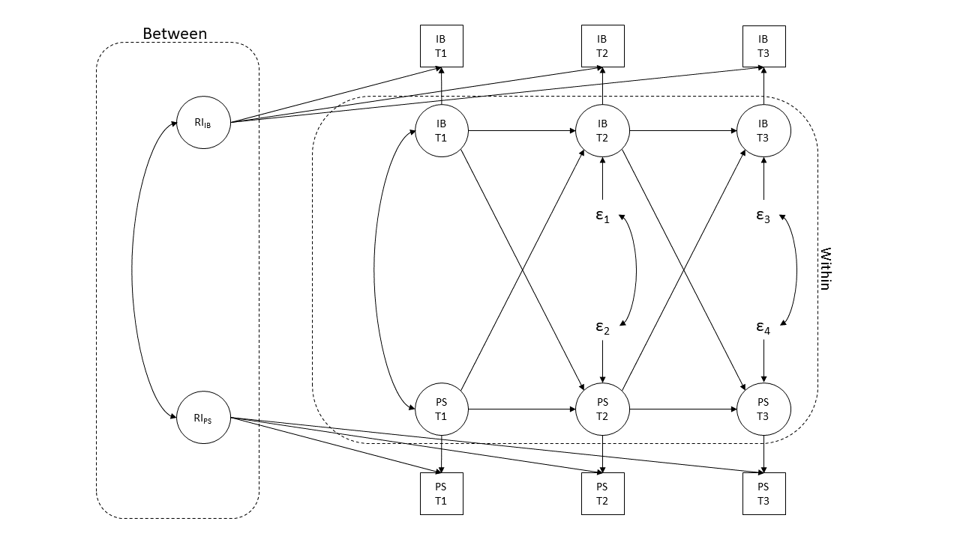
Notes: IB= Interpretation Bias, PS= Psychological Symptoms. This proposed model will be used to examine the bivariate association between IB and PS in the two respective spectra. For depression, IB refers to Interpretation Bias for Depression, whereas PS refers to Depressive symptoms. For paranoia, IB refers to Interpretation Bias for Psychosis, whereas PS refers to Paranoid Thoughts.

Figure 1b
Proposed bivariate random intercept cross-lagged panel model of the relationship between IB and RT
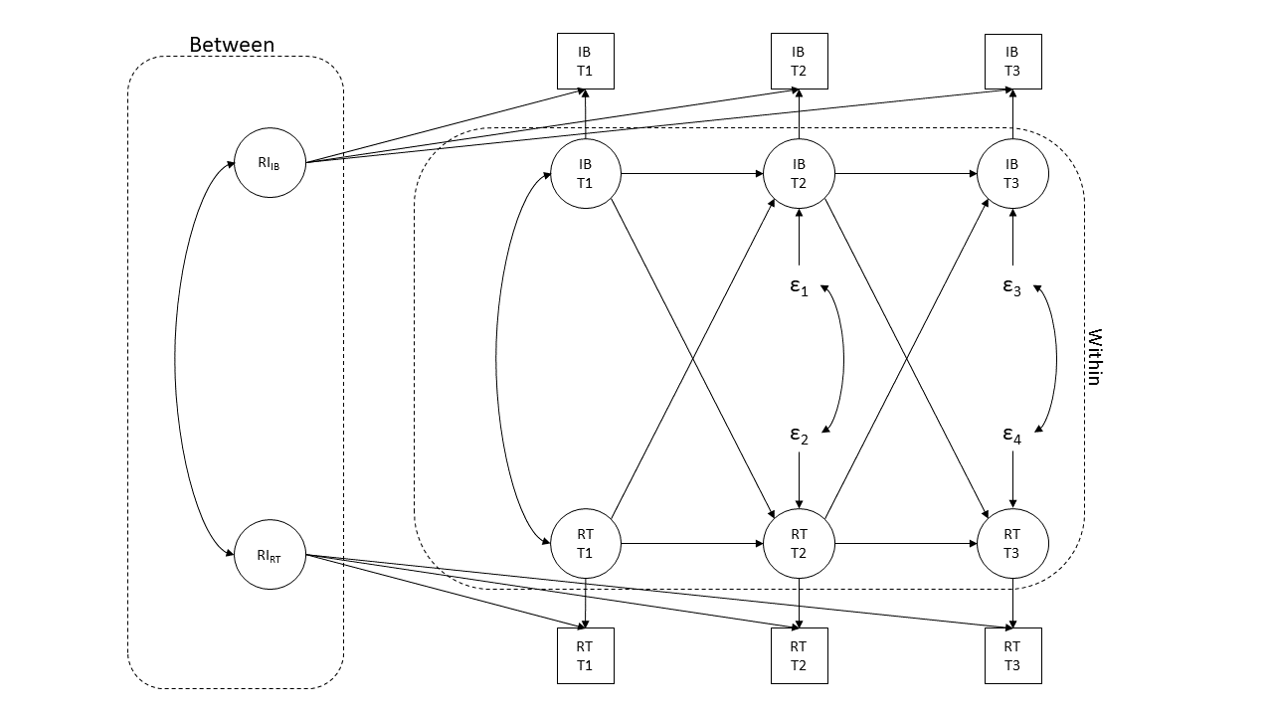
Notes: IB= Interpretation Bias, RT= Repetitive Negative Thinking. This proposed model will be used to examine the bivariate association between IB and RT in the two respective spectra. For depression, IB refers to Interpretation Bias for Depression. For paranoia, IB refers to Interpretation Bias for Psychosis

Figure 1c
Proposed bivariate random intercept cross-lagged panel model of the relationship between RT and PS
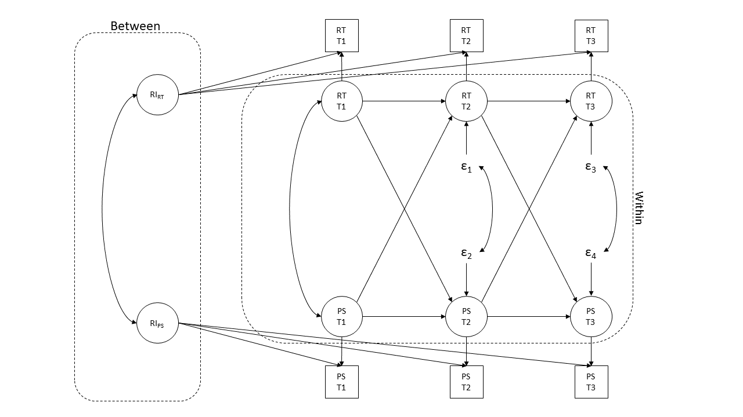
Notes: PS= Psychological Symptoms, RT= Repetitive Negative Thinking. This proposed model will be used to examine the bivariate association between RT and PS in the two respective spectra. For depression, PS refers to Depressive symptoms. For paranoia, PS refers to Paranoid Thoughts.

Figure 2
Proposed multivariate random intercept cross-lagged panel model of the relationship among IB, RT and PS
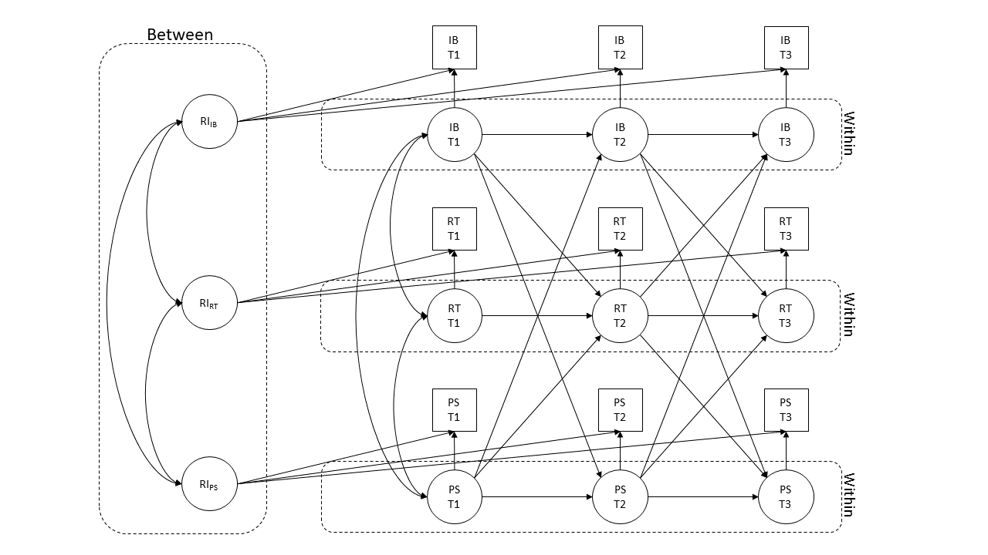
Notes: IB= Interpretation Bias, PS= Psychological Symptoms, RT= Repetitive Negative Thinking. This proposed model will be used to examine the multivariate association among IB, RT and PS in the two respective spectra. For depression, IB refers to Interpretation Bias for Depression, whereas PS refers to Depressive symptoms. For paranoia, IB refers to Interpretation Bias for Psychosis, whereas PS refers to Paranoid Thoughts.

Figure 3a
Proposed multivariate random intercept cross-lagged panel model of the relationship among IB-D, IB-P, RT, D, and PT
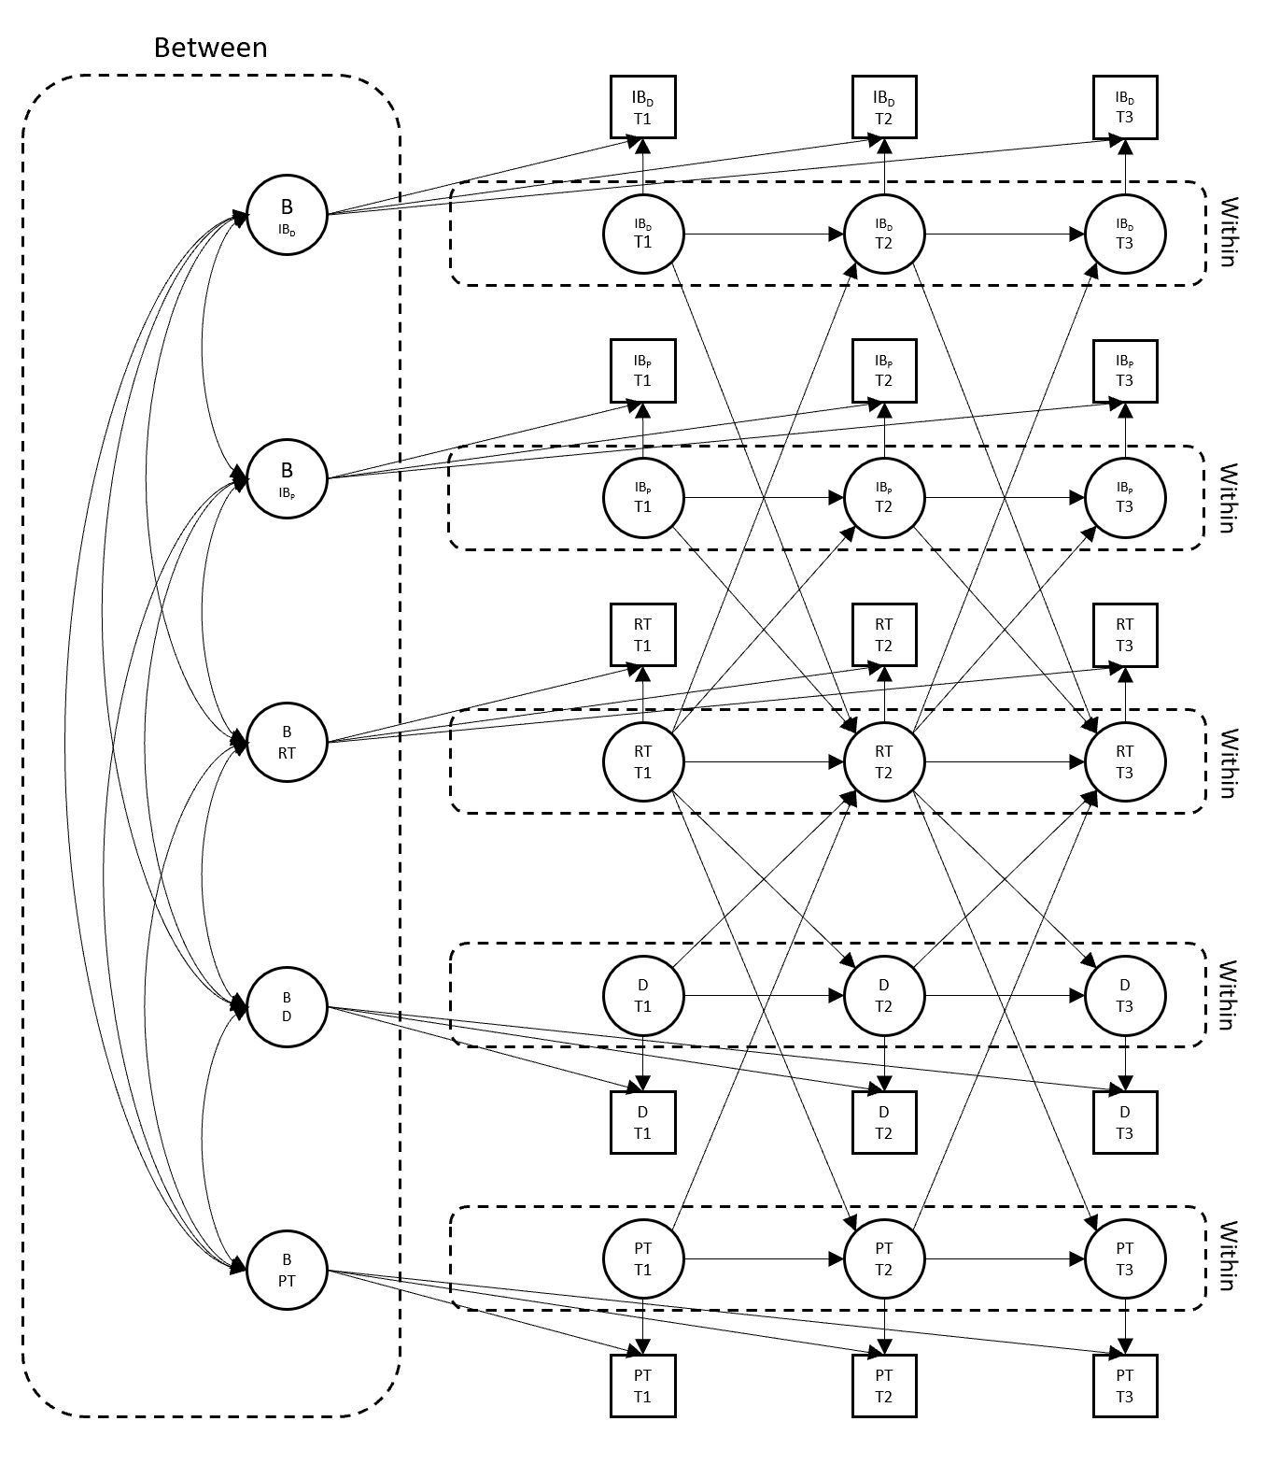
Notes: D= Depressive symptoms, IB-D= Interpretation Bias for Depression, IB-P= Interpretation Bias for Psychosis, PT= Paranoid Thoughts, RT= Repetitive Negative thinking.

Study Design Table
Question | Hypothesis | Sampling plan | Analysis Plan | Rationale for deciding the sensitivity of the test for confirming or disconfirming the hypothesis | Interpretation given different outcomes | Theory that could be shown wrong by the outcomes
Q1a: Is the association between negative interpretation biases and psychological symptoms bidirectional? | H1a: Negative interpretation bias for depression will longitudinally and positively predict internalizing symptoms. | According to Sedory (2020)’s empirical estimate, assuming 85% power, α=0.05, to detect a total mediating effect is 0.021, the minimum sample size for three-wave longitudinal mediation analysis is 550. Meta-analysis indicates the average retention to longitudinal cohort studies is 73.5% (Teague et al, 2018); the observed retention rate in a one-year longitudinal study via the research platform Prolific is broadly consistent with this estimation (Kothe & Ling, 2019).  Based on the two results, assuming the average retention rate is 75%, the minimum sample will be 859. We will attempt to recruit up to 860 to round up the number of samples.  The calculation of sample size is as follows:  Required Sample size×AttritionWave1×AttritionWave2  =550×1+25%×1+25%  =859 (Correct to 2 d.p.)  ≅860 | See Figure 1a.  Bivariate longitudinal associations will be examined through random intercept cross-lagged panel model (RI-CLPM).  Regression analyses will be used to examine whether AST-D predicts IDAS scores across time points in the RI-CLPM. | The degree of negative interpretation bias for depression-and-depressive symptoms correlation (r) is .31 (Everaert, Podina & Koster, 2017).  We expect a smaller but still significant correlation after controlling the autoregression of IDAS-D. | Positive results support the established association between interpretation biases for depression and depressive symptoms.  Negative results suggest interpretation biases might not precede depressive symptoms | Interpretation biases might not precede psychological symptoms; cognitive vulnerability might not be the cause of psychological symptoms as proposed in Beck’s schema theory, but a cognitive effect brought by symptoms
 | H1b: Negative interpretation bias for psychosis will longitudinally and positively predict paranoid thoughts. |  | See Figure 1a.  Bivariate longitudinal associations will be examined through random intercept cross-lagged panel model (RI-CLPM).  Regression analyses will be used to examine whether CBQp predicts RGPTS scores across time points in the RI-CLPM. | The degree of negative interpretation bias for psychosis-and-paranoia correlation (r) was .32 (Trotta et al, 2020).  We expect a smaller but still significant correlation after controlling the autoregression of RGPTS | Positive results support the established association between interpretation biases for psychosis and paranoid thoughts.  Negative results suggest interpretation biases might not precede paranoid thoughts.
 | H1c: Internalizing symptoms will longitudinally and positively predict negative interpretation bias for depression. |  | See Figure 1a.  Bivariate longitudinal associations will be examined through random intercept cross-lagged panel model (RI-CLPM).  Regression analyses will be used to examine whether IDAS-D predicts AST-D scores across time points in the RI-CLPM | The degree of negative interpretation bias for depression-and-depressive symptoms correlation (r) is .31 (Everaert, Podina & Koster, 2017).  We expect a smaller but still significant correlation after controlling the autoregression of AST-D. | Positive results support the established association between interpretation biases for depression and depressive symptoms.  Negative results suggest depressive symptoms might not precede negative interpretation biases for depression | Psychological symptoms might not precede interpretation biases; Symptoms might not alter how we perceive the world.
 | H1d: Paranoid thoughts will longitudinally and positively predict more negative interpretation bias for psychosis. |  | See Figure 1a.  Bivariate longitudinal associations will be examined through random intercept cross-lagged panel model (RI-CLPM).  Regression analyses will be used to examine whether RGPTS predicts CBQp scores across time points in the RI-CLPM | The degree of negative interpretation bias for psychosis-and-paranoia correlation (r) was .32 (Trotta et al, 2020).  We expect a smaller but still significant correlation after controlling the autoregression of CBQp
Q1b Are negative interpretation biases associated with repetitive negative thinking over time? | H1e: Negative interpretation bias for depression will longitudinally and positively predict repetitive negative thinking. | According to Sedory (2020)’s empirical estimate, assuming 85% power, α=0.05, to detect a total mediating effect is 0.021, the minimum sample size for three-wave longitudinal mediation analysis is 550. Meta-analysis indicates the average retention to longitudinal cohort studies is 73.5% (Teague et al, 2018); the observed retention rate in a one-year longitudinal study via the research platform Prolific is broadly consistent with this estimation (Kothe & Ling, 2019).  Based on the two results, assuming the average retention rate is 75%, the minimum sample will be 859. We will attempt to recruit up to 860 to round up the number of samples.  The calculation of sample size is as follows:  Required Sample size×AttritionWave1×AttritionWave2  =550×1+25%×1+25%  =859 (Correct to 2 d.p.)  ≅860 | See Figure 1b.  Bivariate longitudinal associations will be examined through random intercept cross-lagged panel model (RI-CLPM).  Regression analyses will be used to examine whether AST-D predicts PTQ scores across time points in the RI-CLPM | The degree of negative interpretation bias for depression-and-rumination correlation (r) is .39 (Mor et al, 2014)  We expect a smaller but still significant correlation after controlling the autoregression of  PTQ | Positive results support the hypothesis that negative interpretation biases are associated with repetitive negative thinking  Negative results suggest negative interpretation biases and repetitive negative thinking might not be linked. | Repetitive negative thinking might not be associated with negative cognitive style as rumination did.
 | H1f: Negative interpretation bias for psychosis will longitudinally and positively predict more repetitive negative thinking. |  | See Figure 1b.  Bivariate longitudinal associations will be examined through random intercept cross-lagged panel model (RI-CLPM).  Regression analyses will be used to examine whether CBQp predicts PTQ scores across time points in the RI-CLPM | The degree of negative interpretation bias for psychosis-and-rumination correlation (r) is .32 (Trotta et al, 2020)  We expect a smaller but still significant correlation after controlling the autoregression of  PTQ | Positive results support the hypothesis that negative interpretation biases are associated with repetitive negative thinking  Negative results suggest negative interpretation biases and repetitive negative thinking might not be linked. | Repetitive negative thinking might not be associated with negative cognitive style as rumination did.
Q1c Is repetitive negative thinking associated with psychological symptoms over time? | H1g: Repetitive negative thinking will longitudinally and positively predict depressive symptoms | According to Sedory (2020)’s empirical estimate, assuming 85% power, α=0.05, to detect a total mediating effect is 0.021, the minimum sample size for three-wave longitudinal mediation analysis is 550. Meta-analysis indicates the average retention to longitudinal cohort studies is 73.5% (Teague et al, 2018); the observed retention rate in a one-year longitudinal study via the research platform Prolific is broadly consistent with this estimation (Kothe & Ling, 2019).  Based on the two results, assuming the average retention rate is 75%, the minimum sample will be 859. We will attempt to recruit up to 860 to round up the number of samples.  The calculation of sample size is as follows:  Required Sample size×AttritionWave1×AttritionWave2  =550×1+25%×1+25%  =859 (Correct to 2 d.p.)  ≅860 | See Figure 1c.  Bivariate longitudinal associations will be examined through random intercept cross-lagged panel model (RI-CLPM).  Regression analyses will be used to examine whether PTQ predicts IDAS-D scores across time points in the RI-CLPM | The degree of rumination-and-depressive symptoms correlation (r) is .42 (Wisco et al, 2021).  We expect a smaller but still significant correlation after controlling the autoregression of  IDAS-D | Positive results support the hypothesis that repetitive negative thinking is associated with depressive symptoms  Negative results suggest repetitive negative thinking and depressive symptoms might not be linked with each other like rumination. | Repetitive negative thinking might not be associated with depressive symptoms as rumination did.
 | H1h: Repetitive negative thinking will longitudinally and positively predict more paranoid thoughts. |  | See Figure 1c.  Bivariate longitudinal associations will be examined through random intercept cross-lagged panel model (RI-CLPM).  Regression analyses will be used to examine whether PTQ predicts R-GPTS scores across time points in the RI-CLPM | The degree of repetitive negative thinking-and-paranoid thoughts correlation (r) is .54 (Lebert et al, 2020).  We expect a smaller but still significant correlation after controlling the autoregression of  R-GPTS. | Positive results support the hypothesis that repetitive negative thinking is associated with paranoid thoughts.  Negative results suggest repetitive negative thinking and paranoid thoughts might not be linked with each other. | Repetitive negative thinking might not be associated with paranoid thoughts.
Q2 Within spectra, do negative interpretation biases and psychological symptoms exert reciprocal influences across dimensions through repetitive negative thinking? | H2a: Repetitive negative thinking mediates the relationship between negative interpretation biases for depression and depressive symptoms across time points | According to Sedory (2020)’s empirical estimate, assuming 85% power, α=0.05, to detect a total mediating effect is 0.021, the minimum sample size for three-wave longitudinal mediation analysis is 550. Meta-analysis indicates the average retention to longitudinal cohort studies is 73.5% (Teague et al, 2018); the observed retention rate in a one-year longitudinal study via the research platform Prolific is broadly consistent with this estimation (Kothe & Ling, 2019).  Based on the two results, assuming the average retention rate is 75%, the minimum sample will be 859. We will attempt to recruit up to 860 to round up the number of samples.  The calculation of sample size is as follows:  Required Sample size×AttritionWave1×AttritionWave2  =550×1+25%×1+25%  =859 (Correct to 2 d.p.)  ≅860 | See Figure 2.  Multivariate longitudinal associations among AST-D, PTQ, and IDAS-D will be examined through random intercept cross-lagged panel model (RI-CLPM).  Mediation analyses will be used to examine whether AST-D predicts IDAS-D through PTQ | The degree of negative interpretation bias for depression-and-rumination correlation (r) is .39 (Mor et al, 2014)  while that for rumination-depressive symptoms is .42 (Wisco et al, 2021)  We expect a smaller but still significant correlation after controlling the autoregression of variables. To test the mediating effect of rumination, we opt for a conservative small effect size of a1 and a2=0.07, b=0.15. | Positive results support the hypothesis that repetitive negative thinking is a mechanism that links negative interpretation biases to depressive symptoms  Negative results suggest negative interpretation biases and depressive symptoms are linked in other mechanisms | Repetitive negative thinking might not be the mechanism to explain the co-occurrence of cognitive biases and psychological symptoms.
 | H2b: Repetitive negative thinking mediates the relationship between negative interpretation biases for psychosis and paranoid thoughts across time points |  | See Figure 2.  Multivariate longitudinal associations among AST-D, PTQ, and IDAS-D will be examined through random intercept cross-lagged panel model (RI-CLPM).  Mediation analyses will be used to examine whether AST-D predicts IDAS-D through PTQ | The degree of negative interpretation bias for psychosis-and-rumination correlation ® is .32 (Trotta et al, 2020)  while that for rumination-paranoid thoughts is .54 (Lebert et al, 2020).  We expect a smaller but still significant correlation after controlling the autoregression of variables. To test the mediating effect of rumination, we opt for a conservative small effect size of a1 and a2=0.07, b=0.15. | Positive results support the hypothesis that repetitive negative thinking is a mechanism that links negative interpretation biases to paranoid thoughts.  Negative results suggest negative interpretation biases and paranoid thoughts are linked in other mechanisms | Repetitive negative thinking might not be the mechanism to explain the co-occurrence of cognitive biases and psychological symptoms.
Q3 Is repetitive negative thinking a transdiagnostic mediator for depression and paranoid thoughts? | H3a: Repetitive negative thinking mediates the relationship between negative interpretation biases for depression and paranoid thoughts across time points | According to Sedory (2020)’s empirical estimate, assuming 85% power, α=0.05, to detect a total mediating effect is 0.021, the minimum sample size for three-wave longitudinal mediation analysis is 550. Meta-analysis indicates the average retention to longitudinal cohort studies is 73.5% (Teague et al, 2018); the observed retention rate in a one-year longitudinal study via the research platform Prolific is broadly consistent with this estimation (Kothe & Ling, 2019).  Based on the two results, assuming the average retention rate is 75%, the minimum sample will be 859. We will attempt to recruit up to 860 to round up the number of samples.  The calculation of sample size is as follows:  Required Sample size×AttritionWave1×AttritionWave2  =550×1+25%×1+25%  =859 (Correct to 2 d.p.)  ≅860 | See Figure 3  Multivariate longitudinal associations among AST-D, CBQp, PTQ, IDAS-D, and R-GPTS will be examined through random intercept cross-lagged panel model (RI-CLPM)  Mediation analyses will be used to examine whether AST-D predicts R-GPTS through PTQ | We have decided on a conservative and small effect size as this study is investigating a novel mediating effect that has not been examined before. To the best of our knowledge, there has not been any published work investigating the transdiagnostic role of repetitive negative thinking in depressive symptoms and paranoid thoughts. | Positive results support that repetitive negative thinking is a transdiagnostic mechanism that contributes to cross-spectra negative interpretation biases and psychological symptoms.  Negative interpretation biases for depression might be associated with paranoid thoughts through repetitive negative thinking.  Negative results suggest that there is no indirect effect through repetitive negative thinking. | Repetitive negative thinking might not be a transdiagnostic mechanism to explain the co-occurrence of internalizing and thought disorder components.
 | H3b: Repetitive negative thinking mediates the relationship between negative interpretation biases for psychosis and depressive symptoms across time points |  | See Figure 3  Multivariate longitudinal associations among AST-D, CBQp, PTQ, IDAS-D, and R-GPTS will be examined through random intercept cross-lagged panel model (RI-CLPM)  Mediation analyses will be used to examine whether CBQp predicts IDAS-D through PTQ | We have decided on a conservative and small effect size as this study is investigating a novel mediating effect that has not been examined before. To the best of our knowledge, there has not been any published work investigating the transdiagnostic role of repetitive negative thinking in depressive symptoms and paranoid thoughts. | Positive results support that repetitive negative thinking is a transdiagnostic mechanism that contributes to cross-spectra negative interpretation biases and psychological symptoms.  Negative interpretation biases for psychosis might be associated with paranoid thoughts through repetitive negative thinking.  Negative results suggest that there is no indirect effect through repetitive negative thinking. | Repetitive negative thinking might not be a transdiagnostic mechanism to explain the co-occurrence of internalizing and thought disorder components.

Required Sample size×AttritionWave1×AttritionWave2
=350×1+25%×1+25%
=547
≅550

Guidance Notes
- Question: articulate each research question being addressed in one sentence.
- Hypothesis: where applicable, a prediction arising from the research question, stated in terms of specific variables rather than concepts. Where the testability of one or more hypotheses depends on the verification of auxiliary assumptions (such as positive controls, tests of intervention fidelity, manipulation checks, or any other quality checks), any tests of such assumptions should be listed as hypotheses. Stage 1 proposals that do not seek to test hypotheses can ignore or delete this column.
- Sampling plan: For proposals using inferential statistics, the details of the statistical sampling plan for the specific hypothesis (e.g power analysis, Bayes Factor Design Analysis, ROPE etc). For proposals that do not use inferential statistics, include a description and justification of the sample size.
- Analysis plan: For hypothesis-driven studies, the specific test(s) that will confirm or disconfirm the hypothesis. For non-hypothesis-driven studies, the test(s) that will answer the research question.
- Rationale for deciding the sensitivity of the test for confirming or disconfirming the hypothesis: For hypothesis-driven studies that employ inferential statistics, an explanation of how the authors determined a relevant effect size for statistical power analysis, equivalence testing, Bayes factors, or other approach.
- Interpretation given different outcomes: A prospective interpretation of different potential outcomes, making clear which outcomes would confirm or disconfirm the hypothesis.
- Theory that could be shown wrong by the outcomes: Where the proposal is testing a theory, make clear what theory could be shown to be wrong, incomplete, or otherwise inadequate by the outcomes of the research.

Reference
Aldao, A., Nolen-Hoeksema, S., & Schweizer, S. (2010). Emotion-regulation strategies across psychopathology: A meta-analytic review. Clinical psychology review, 30(2), 217–237. https://doi.org/10.1016/j.cpr.2009.11.004
Alloy, L. B., Abramson, L. Y., Hogan, M. E., Whitehouse, W. G., Rose, D. T., Robinson, M. S., Kim, R. S., & Lapkin, J. B. (2000). The Temple-Wisconsin Cognitive Vulnerability to Depression Project: lifetime history of axis I psychopathology in individuals at high and low cognitive risk for depression. Journal of abnormal psychology, 109(3), 403–418.
Amin, N., Foa, E. B., & Coles, M. E. (1998). Negative interpretation bias in social phobia. Behaviour research and therapy, 36(10), 945–957. https://doi.org/10.1016/s0005-7967(98)00060-6
Beck, A. T. (1976). Cognitive therapy and the emotional disorders. International Universities Press.
Beck, A. T., & Clark, D. A. (1988). Anxiety and depression: An information processing perspective. Anxiety Research, 1(1), 23–36. https://doi.org/10.1080/10615808808248218
Beck, A. T., & Haigh, E. A. (2014). Advances in cognitive theory and therapy: the generic cognitive model. Annual review of clinical psychology, 10, 1–24. https://doi.org/10.1146/annurev-clinpsy-032813-153734
Beck, A. T., Rush. A. J., Shaw, B. F., & Emery, G. (1979). Cognitive therapy of depression. New York: Guilford Press
Berenbaum H. (2010). An initiation-termination two-phase model of worrying. Clinical psychology review, 30(8), 962–975. https://doi.org/10.1016/j.cpr.2010.06.011
Berna, C., Lang, T. J., Goodwin, G. M., & Holmes, E. A. (2011). Developing a measure of interpretation bias for depressed mood: An ambiguous scenarios test. Personality and individual differences, 51(3), 349–354. https://doi.org/10.1016/j.paid.2011.04.005
Blanchette, I., & Richards, A. (2010). The influence of affect on higher level cognition: A review of research on interpretation, judgement, decision making and reasoning. Cognition and Emotion, 24(4), 561–595. https://doi.org/10.1080/02699930903132496
Bowler, J. O., Mackintosh, B., Dunn, B. D., Mathews, A., Dalgleish, T., & Hoppitt, L. (2012). A comparison of cognitive bias modification for interpretation and computerized cognitive behavior therapy: effects on anxiety, depression, attentional control, and interpretive bias. Journal of consulting and clinical psychology, 80(6), 1021–1033. https://doi.org/10.1037/a0029932
Caspi, A., Houts, R. M., Belsky, D. W., Goldman-Mellor, S. J., Harrington, H., Israel, S., Meier, M. H., Ramrakha, S., Shalev, I., Poulton, R., & Moffitt, T. E. (2014). The p Factor: One General Psychopathology Factor in the Structure of Psychiatric Disorders?. Clinical psychological science : a journal of the Association for Psychological Science, 2(2), 119–137. https://doi.org/10.1177/2167702613497473
Caspi, A., & Moffitt, T. E. (2018). All for One and One for All: Mental Disorders in One Dimension. The American journal of psychiatry, 175(9), 831–844. https://doi.org/10.1176/appi.ajp.2018.17121383
Chen, F. F. (2007). Sensitivity of goodness of fit indexes to lack of measurement invariance. Structural Equation Modeling, 14(3), 464–504. https://doi.org/10.1080/10705510701301834
Cowan, H., & Mittal, V. (2021). Transdiagnostic Dimensions of Psychiatric Comorbidity in Individuals at Clinical High Risk for Psychosis: A Preliminary Study Informed by HiTOP. Frontiers In Psychiatry, 11. https://doi.org/10.3389/fpsyt.2020.614710

Deng, W., Addington, J., Bearden, C., Cadenhead, K., Cornblatt, B., & Mathalon, D. et al. (2021). Depression Predicts Global Functional Outcomes in Individuals at Clinical High Risk for Psychosis. Psychiatric Research And Clinical Practice, 3(4), 163-171. https://doi.org/10.1176/appi.prcp.20210023
Drost, J., van der Does, W., van Hemert, A. M., Penninx, B. W., & Spinhoven, P. (2014). Repetitive negative thinking as a transdiagnostic factor in depression and anxiety: A conceptual replication. Behaviour research and therapy, 63, 177–183. https://doi.org/10.1016/j.brat.2014.06.004
Eisma, M. C., Stroebe, M. S., Schut, H. A., Stroebe, W., Boelen, P. A., & van den Bout, J. (2013). Avoidance processes mediate the relationship between rumination and symptoms of complicated grief and depression following loss. Journal of abnormal psychology, 122(4), 961–970. https://doi.org/10.1037/a0034051
Ehring, T., Frank, S., & Ehlers, A. (2008). The Role of Rumination and Reduced Concreteness in the Maintenance of Posttraumatic Stress Disorder and Depression Following Trauma. Cognitive therapy and research, 32(4), 488–506. https://doi.org/10.1007/s10608-006-9089-7
Ehring, T., Zetsche, U., Weidacker, K., Wahl, K., Schönfeld, S., & Ehlers, A. (2011). The Perseverative Thinking Questionnaire (PTQ): validation of a content-independent measure of repetitive negative thinking. Journal of behavior therapy and experimental psychiatry, 42(2), 225–232. https://doi.org/10.1016/j.jbtep.2010.12.003
Elahi, A., Perez Algorta, G., Varese, F., McIntyre, J. C., & Bentall, R. P. (2017). Do paranoid delusions exist on a continuum with subclinical paranoia? A multi-method taxometric study. Schizophrenia research, 190, 77–81. https://doi.org/10.1016/j.schres.2017.03.022
Everaert, J., Duyck, W., & Koster, E. H. W. (2014). Attention, interpretation, and memory biases in subclinical depression: A proof-of-principle test of the combined cognitive biases hypothesis. Emotion, 14(2), 331–340. https://doi.org/10.1037/a0035250
Everaert, J., Grahek, I., Duyck, W., Buelens, J., Van den Bergh, N., & Koster, E. H. (2017). Mapping the interplay among cognitive biases, emotion regulation, and depressive symptoms. Cognition & emotion, 31(4), 726–735. https://doi.org/10.1080/02699931.2016.1144561
Everaert, J., Podina, I. R., & Koster, E. (2017). A comprehensive meta-analysis of interpretation biases in depression. Clinical psychology review, 58, 33–48. https://doi.org/10.1016/j.cpr.2017.09.005
Freeman, D., Dunn, G., Startup, H., Pugh, K., Cordwell, J., Mander, H., Černis, E., Wingham, G., Shirvell, K., & Kingdon, D. (2015). Effects of cognitive behaviour therapy for worry on persecutory delusions in patients with psychosis (WIT): a parallel, single-blind, randomised controlled trial with a mediation analysis. The lancet. Psychiatry, 2(4), 305–313. https://doi.org/10.1016/S2215-0366(15)00039-5
Freeman, D., Garety, P. A., Bebbington, P. E., Smith, B., Rollinson, R., Fowler, D., Kuipers, E., Ray, K., & Dunn, G. (2005). Psychological investigation of the structure of paranoia in a non-clinical population. The British journal of psychiatry : the journal of mental science, 186, 427–435. https://doi.org/10.1192/bjp.186.5.427
Freeman, D., Garety, P. A., Kuipers, E., Fowler, D., & Bebbington, P. E. (2002). A cognitive model of persecutory delusions. The British journal of clinical psychology, 41(Pt 4), 331–347. https://doi.org/10.1348/014466502760387461
Freeman, D., Loe, B. S., Kingdon, D., Startup, H., Molodynski, A., Rosebrock, L., Brown, P., Sheaves, B., Waite, F., & Bird, J. C. (2021). The revised Green et al., Paranoid Thoughts Scale (R-GPTS): psychometric properties, severity ranges, and clinical cut-offs. Psychological medicine, 51(2), 244–253. https://doi.org/10.1017/S0033291719003155
Fried, E. I., Greene, A. L., & Eaton, N. R. (2021). The p factor is the sum of its parts, for now. World psychiatry : official journal of the World Psychiatric Association (WPA), 20(1), 69–70. https://doi.org/10.1002/wps.20814
Friedberg, R. D., & McClure, J. M. (2015). Clinical practice of cognitive therapy with children and adolescents (2nd ed.). Guilford Press.
Hamaker, E. L., Kuiper, R. M., & Grasman, R. P. (2015). A critique of the cross-lagged panel model. Psychological methods, 20(1), 102–116. https://doi.org/10.1037/a0038889
Hartley, S., Haddock, G., Vasconcelos E Sa, D., Emsley, R., & Barrowclough, C. (2014). An experience sampling study of worry and rumination in psychosis. Psychological medicine, 44(8), 1605–1614. https://doi.org/10.1017/S0033291713002080
Hirsch, C. R., Meeten, F., Krahé, C., & Reeder, C. (2016). Resolving Ambiguity in Emotional Disorders: The Nature and Role of Interpretation Biases. Annual review of clinical psychology, 12, 281–305. https://doi.org/10.1146/annurev-clinpsy-021815-093436
Hsu, K., Beard, C., Rifkin, L., Dillon, D., Pizzagalli, D., & Björgvinsson, T. (2015). Transdiagnostic mechanisms in depression and anxiety: The role of rumination and attentional control. Journal Of Affective Disorders, 188, 22-27. https://doi.org/10.1016/j.jad.2015.08.008
Humphrey, C., Bucci, S., Varese, F., Degnan, A., & Berry, K. (2021). Paranoia and negative schema about the self and others: A systematic review and meta-analysis. Clinical psychology review, 90, 102081. https://doi.org/10.1016/j.cpr.2021.102081
Hur, J., Heller, W., Kern, J., & Berenbaum, H. (2016). A Bi-Factor Approach to Modeling the Structure of Worry and Rumination. Journal Of Experimental Psychopathology, 8(3), 252-264. https://doi.org/10.5127/jep.057116

Jones, E. B., & Sharpe, L. (2017). Cognitive bias modification: A review of meta-analyses. Journal of Affective Disorders, 223, 175–183. https://doi.org/10.1016/j.jad.2017.07.034
Kelley, K., Walgren, M., & DeShong, H. L. (2021). Rumination as a transdiagnostic process: The role of rumination in relation to antisocial and borderline symptoms. Journal of affective disorders, 295, 865–872. https://doi.org/10.1016/j.jad.2021.08.034
Kothe, E. J., & Ling, M. (2019, September 6). Retention of participants recruited to a multi-year longitudinal study via Prolific. https://doi.org/10.31234/osf.io/5yv2u
Kotov, R., Krueger, R. F., Watson, D., Achenbach, T. M., Althoff, R. R., Bagby, R. M., Brown, T. A., Carpenter, W. T., Caspi, A., Clark, L. A., Eaton, N. R., Forbes, M. K., Forbush, K. T., Goldberg, D., Hasin, D., Hyman, S. E., Ivanova, M. Y., Lynam, D. R., Markon, K., Miller, J. D., … Zimmerman, M. (2017). The Hierarchical Taxonomy of Psychopathology (HiTOP): A dimensional alternative to traditional nosologies. Journal of abnormal psychology, 126(4), 454–477. https://doi.org/10.1037/abn0000258
Krahé, C., Whyte, J., Bridge, L., Loizou, S., & Hirsch, C. (2019). Are Different Forms of Repetitive Negative Thinking Associated With Interpretation Bias in Generalized Anxiety Disorder and Depression?. Clinical Psychological Science, 7(5), 969-981. https://doi.org/10.1177/2167702619851808
Krueger, R. F., & Markon, K. E. (2006). Reinterpreting comorbidity: a model-based approach to understanding and classifying psychopathology. Annual review of clinical psychology, 2, 111–133. https://doi.org/10.1146/annurev.clinpsy.2.022305.095213
Lahey, B. B., Krueger, R. F., Rathouz, P. J., Waldman, I. D., & Zald, D. H. (2017). Validity and utility of the general factor of psychopathology. World psychiatry : official journal of the World Psychiatric Association (WPA), 16(2), 142–144. https://doi.org/10.1002/wps.20410
Lebert, L., Turkington, D., Freeston, M., & Dudley, R. (2020). Rumination, intolerance of uncertainty and paranoia in treatment resistant psychosis. Psychosis, 13(1), 65-70. https://doi.org/10.1080/17522439.2020.1798489
Lee, J. S., Mathews, A., Shergill, S., & Yiend, J. (2016). Magnitude of negative interpretation bias depends on severity of depression. Behaviour research and therapy, 83, 26–34. https://doi.org/10.1016/j.brat.2016.05.007
Lincoln, T. M., Hohenhaus, F., & Hartmann, M. (2013). Can paranoid thoughts be reduced by targeting negative emotions and self-esteem? An experimental investigation of a brief compassion-focused intervention. Cognitive Therapy and Research, 37(2), 390–402. https://doi.org/10.1007/s10608-012-9470-7
Lo, C. S., Ho, S. M., & Hollon, S. D. (2008). The effects of rumination and negative cognitive styles on depression: a mediation analysis. Behaviour research and therapy, 46(4), 487–495. https://doi.org/10.1016/j.brat.2008.01.013
Mackintosh, B., Mathews, A., Yiend, J., Ridgeway, V., & Cook, E. (2006). Induced biases in emotional interpretation influence stress vulnerability and endure despite changes in context. Behavior therapy, 37(3), 209–222. https://doi.org/10.1016/j.beth.2006.03.001
Madian, N., Bredemeier, K., Heller, W., Miller, G. A., & Warren, S. L. (2019). Repetitive negative thought and executive dysfunction: An interactive pathway to emotional distress. Cognitive Therapy and Research, 43(2), 464–480. https://doi.org/10.1007/s10608-018-9966-x
Martinelli, C., Cavanagh, K., & Dudley, R. E. (2013). The impact of rumination on state paranoid ideation in a nonclinical sample. Behavior therapy, 44(3), 385–394. https://doi.org/10.1016/j.beth.2013.02.002
Mathews, A., & MacLeod, C. (1994). Cognitive approaches to emotion and emotional disorders. Annual Review of Psychology, 45, 25–50. https://doi.org/10.1146/annurev.ps.45.020194.000325
Mathews, A., Ridgeway, V., Cook, E., & Yiend, J. (2007). Inducing a benign interpretational bias reduces trait anxiety. Journal of behavior therapy and experimental psychiatry, 38(2), 225–236. https://doi.org/10.1016/j.jbtep.2006.10.011
McLaughlin, K. A., & Nolen-Hoeksema, S. (2011). Rumination as a transdiagnostic factor in depression and anxiety. Behaviour research and therapy, 49(3), 186–193. https://doi.org/10.1016/j.brat.2010.12.006
Mendoza, N., Mordeno, I., & Nalipay, M. (2021). The Transdiagnostic Role of Rumination in the Comorbidity of PTSD and Depression. Journal Of Loss And Trauma, 1-15. https://doi.org/10.1080/15325024.2021.2018197
Mor, N., Hertel, P., Ngo, T. A., Shachar, T., & Redak, S. (2014). Interpretation bias characterizes trait rumination. Journal of behavior therapy and experimental psychiatry, 45(1), 67–73. https://doi.org/10.1016/j.jbtep.2013.08.002
Moritz, S., Göritz, A. S., McLean, B., Westermann, S., & Brodbeck, J. (2017). Do depressive symptoms predict paranoia or vice versa?. Journal of behavior therapy and experimental psychiatry, 56, 113–121. https://doi.org/10.1016/j.jbtep.2016.10.002
Mulder, J. D., & Hamaker, E. L. (2021). Three extensions of the random intercept cross-lagged panel model. Structural Equation Modeling, 28(4), 638–648. https://doi.org/10.1080/10705511.2020.1784738
Murphy, P., Bentall, R. P., Freeman, D., O'Rourke, S., & Hutton, P. (2018). The paranoia as defence model of persecutory delusions: a systematic review and meta-analysis. The lancet. Psychiatry, 5(11), 913–929. https://doi.org/10.1016/S2215-0366(18)30339-0
Nolen-Hoeksema, S. (1991). Responses to depression and their effects on the duration of depressive episodes. Journal of Abnormal Psychology, 100(4), 569–582. https://doi.org/10.1037/0021-843X.100.4.569
Nolen-Hoeksema, S., Stice, E., Wade, E., & Bohon, C. (2007). Reciprocal relations between rumination and bulimic, substance abuse, and depressive symptoms in female adolescents. Journal of abnormal psychology, 116(1), 198–207. https://doi.org/10.1037/0021-843X.116.1.198
Oltmanns, J. R., Smith, G. T., Oltmanns, T. F., & Widiger, T. A. (2018). General Factors of Psychopathology, Personality, and Personality Disorder: Across Domain Comparisons. Clinical psychological science : a journal of the Association for Psychological Science, 6(4), 581–589. https://doi.org/10.1177/2167702617750150
Papageorgiou, C., & Wells, A. Nature, Functions, and Beliefs about Depressive Rumination. Depressive Rumination, 1-20. https://doi.org/10.1002/9780470713853.ch1
Peters, E. R., Moritz, S., Schwannauer, M., Wiseman, Z., Greenwood, K. E., Scott, J., Beck, A. T., Donaldson, C., Hagen, R., Ross, K., Veckenstedt, R., Ison, R., Williams, S., Kuipers, E., & Garety, P. A. (2014). Cognitive Biases Questionnaire for psychosis. Schizophrenia bulletin, 40(2), 300–313. https://doi.org/10.1093/schbul/sbs199
Provencio, M., Vázquez, C., Valiente, C., & Hervas, G. (2011). Depressive Primes Stimulate Initial Avoidance of Angry Faces: An Eye-Tracking Study of Paranoid Ideation. Cognitive Therapy And Research, 36(5), 483-492. https://doi.org/10.1007/s10608-011-9388-5
Robinson, L.A., Alloy, L.B. (2003). Negative cognitive styles and stress-reactive rumination interact to predict depression: A prospective study. Cognitive Therapy and Research, 27, 275–292.
Ruscio, A. M., Seitchik, A. E., Gentes, E. L., Jones, J. D., & Hallion, L. S. (2011). Perseverative thought: a robust predictor of response to emotional challenge in generalized anxiety disorder and major depressive disorder. Behaviour research and therapy, 49(12), 867–874. https://doi.org/10.1016/j.brat.2011.10.001
Salokangas, R. K., Schultze-Lutter, F., Hietala, J., Heinimaa, M., From, T., Ilonen, T., Löyttyniemi, E., von Reventlow, H. G., Juckel, G., Linszen, D., Dingemans, P., Birchwood, M., Patterson, P., Klosterkötter, J., Ruhrmann, S., & EPOS Group (2016). Depression predicts persistence of paranoia in clinical high-risk patients to psychosis: results of the EPOS project. Social psychiatry and psychiatric epidemiology, 51(2), 247–257. https://doi.org/10.1007/s00127-015-1160-9
Savulich, G., Freeman, D., Shergill, S., & Yiend, J. (2015). Interpretation biases in paranoia. Behavior therapy, 46(1), 110–124. https://doi.org/10.1016/j.beth.2014.08.002
Sedory, A.C. (2020). Sample Size Calculations for Longitudinal Mediation Analysis with Continuous-time Markov Chain Variables. UT School of Public Health Dissertations (Open Access), 116. https://digitalcommons.library.tmc.edu/uthsph_dissertsopen/116
Selig, J., & Preacher, K. (2009). Mediation Models for Longitudinal Data in Developmental Research. Research In Human Development, 6(2-3), 144-164. https://doi.org/10.1080/15427600902911247
Simpson, J., MacGregor, B., Cavanagh, K., & Dudley, R. (2012). Safety Behaviours, Rumination and Trait Paranoia in a Non-Clinical Sample. Journal Of Experimental Psychopathology, 3(4), 612-623. https://doi.org/10.5127/jep.027212
Smith, G. T., Atkinson, E. A., Davis, H. A., Riley, E. N., & Oltmanns, J. R. (2020). The General Factor of Psychopathology. Annual review of clinical psychology, 16, 75–98. https://doi.org/10.1146/annurev-clinpsy-071119-115848
Spasojević, J., & Alloy, L. (2001). Rumination as a common mechanism relating depressive risk factors to depression. Emotion, 1(1), 25-37. https://doi.org/10.1037/1528-3542.1.1.25
Spinhoven, P., van Hemert, A. M., & Penninx, B. W. (2019). Repetitive negative thinking as a mediator in prospective cross-disorder associations between anxiety and depression disorders and their symptoms. Journal of behavior therapy and experimental psychiatry, 63, 6–11. https://doi.org/10.1016/j.jbtep.2018.11.007
Sönmez, N., Røssberg, J. I., Evensen, J., Barder, H. E., Haahr, U., Ten Velden Hegelstad, W., Joa, I., Johannessen, J. O., Langeveld, H., Larsen, T. K., Melle, I., Opjordsmoen, S., Rund, B. R., Simonsen, E., Vaglum, P., McGlashan, T., & Friis, S. (2016). Depressive symptoms in first-episode psychosis: a 10-year follow-up study. Early intervention in psychiatry, 10(3), 227–233. https://doi.org/10.1111/eip.12163
Subar, A. R., Humphrey, K., & Rozenman, M. (2021). Is interpretation bias for threat content specific to youth anxiety symptoms/diagnoses? A systematic review and meta-analysis. European child & adolescent psychiatry, 10.1007/s00787-021-01740-7. Advance online publication. https://doi.org/10.1007/s00787-021-s01740-7
Tackett, J. L., Lahey, B. B., van Hulle, C., Waldman, I., Krueger, R. F., & Rathouz, P. J. (2013). Common genetic influences on negative emotionality and a general psychopathology factor in childhood and adolescence. Journal of abnormal psychology, 122(4), 1142–1153. https://doi.org/10.1037/a0034151
Teague, S., Youssef, G., Macdonald, J., Sciberras, E., Shatte, A., & Fuller-Tyszkiewicz, M. et al. (2018). Retention strategies in longitudinal cohort studies: a systematic review and meta-analysis. BMC Medical Research Methodology, 18(1). https://doi.org/10.1186/s12874-018-0586-7
Trotta, A., Kang, J., Stahl, D., & Yiend, J. (2020). Interpretation Bias in Paranoia: A Systematic Review and Meta-Analysis. Clinical Psychological Science, 9(1), 3-23. https://doi.org/10.1177/2167702620951552
van Os J. (2003). Is there a continuum of psychotic experiences in the general population?. Epidemiologia e psichiatria sociale, 12(4), 242–252. https://doi.org/10.1017/s1121189x00003067
Vorontsova, N., Garety, P., & Freeman, D. (2013). Cognitive factors maintaining persecutory delusions in psychosis: the contribution of depression. Journal of abnormal psychology, 122(4), 1121–1131. https://doi.org/10.1037/a0034952
Watkins E. R. (2004). Adaptive and maladaptive ruminative self-focus during emotional processing. Behaviour research and therapy, 42(9), 1037–1052. https://doi.org/10.1016/j.brat.2004.01.009
Watkins, E. R. (2008). Constructive and unconstructive repetitive thought. Psychological Bulletin, 134(2), 163-206. doi:10.1037/0033-2909.134.2.163
Watkins, E. R., Baeyens, C. B., & Read, R. (2009). Concreteness training reduces dysphoria: proof-of-principle for repeated cognitive bias modification in depression. Journal of abnormal psychology, 118(1), 55–64. https://doi.org/10.1037/a0013642
Watkins, E., Moberly, N. J., & Moulds, M. L. (2008). Processing mode causally influences emotional reactivity: distinct effects of abstract versus concrete construal on emotional response. Emotion (Washington, D.C.), 8(3), 364–378. https://doi.org/10.1037/1528-3542.8.3.364
Watkins, E. R., & Roberts, H. (2020). Reflecting on rumination: Consequences, causes, mechanisms and treatment of rumination. Behaviour research and therapy, 127, 103573. https://doi.org/10.1016/j.brat.2020.103573
Watson, D., O'Hara, M. W., Simms, L. J., Kotov, R., Chmielewski, M., McDade-Montez, E. A., Gamez, W., & Stuart, S. (2007). Development and validation of the Inventory of Depression and Anxiety Symptoms (IDAS). Psychological assessment, 19(3), 253–268. https://doi.org/10.1037/1040-3590.19.3.253
Wendt, L. P., Jankowsky, K., Zimmermann, J., Schroeders, U., Nolte, T., Fonagy, P., … Olaru, G. (2021, January 8). Mapping established psychopathology scales onto the Hierarchical Taxonomy of Psychopathology (HiTOP). https://doi.org/10.31234/osf.io/j4gp8
Wilson, E. J., MacLeod, C., Mathews, A., & Rutherford, E. M. (2006). The causal role of interpretive bias in anxiety reactivity. Journal of abnormal psychology, 115(1), 103–111. https://doi.org/10.1037/0021-843X.115.1.103
Wisco, B. E., Gilbert, K. E., & Marroquín, B. (2014). Maladaptive Processing of Maladaptive Content: Rumination as a Mechanism Linking Cognitive Biases to Depressive Symptoms. Journal of experimental psychopathology, 5(3), 329–350. https://doi.org/10.5127/jep.038213
Wisco, B., & Harp, D. (2021). Rumination as a mechanism of the association between interpretation bias and depression symptoms: A longitudinal investigation. Journal Of Experimental Psychopathology, 12(2), 204380872110152. https://doi.org/10.1177/20438087211015233
Wolkenstein, L., Zwick, J. C., Hautzinger, M., & Joormann, J. (2014). Cognitive emotion regulation in euthymic bipolar disorder. Journal of affective disorders, 160, 92–97. https://doi.org/10.1016/j.jad.2013.12.022
Yiend, J., Allen, P., Lopez, N. D., Falkenberg, I., Tseng, H. H., & McGuire, P. (2019). Negative Interpretation Biases Precede the Onset of Psychosis. Behavior therapy, 50(4), 718–731. https://doi.org/10.1016/j.beth.2018.11.002

