The link between Empathy and Forgiveness:
Replication and extensions of
McCullough et al. (1997)'s Study 1

Chi Fung Chan
ORCID: 0000-0002-7425-8421
Department of Psychology, University of Hong Kong
tccf312@connect.hku.hk / timothychan312@gmail.com
^Gilad Feldman
ORCID: 0000-0003-2812-6599
University of Hong Kong
gfeldman@hku.hk / giladfel@gmail.com

^Corresponding author

Author bios:
Chi Fung Chan was a thesis student at the University of Hong Kong during the academic year 2022-3.
Gilad Feldman is an assistant professor with the University of Hong Kong psychology department. His research focuses on judgment and decision-making.

Declaration of Conflict of Interest:
The author(s) declared no potential conflicts of interests with respect to the authorship and/or publication of this article.

Financial disclosure/funding:
The project is supported by the University of Hong Kong Teaching Development Grant.

Authorship declaration:
Chi-Fung CHAN conducted the replication as part of his thesis in psychology.
Gilad Feldman guided the replication efforts, supervised each step in the project, ran data collection, conducted the pre-registration, and edited the manuscript for submission.
[open to revision following in-principle acceptance.]

Corresponding author
Gilad Feldman, Department of Psychology, University of Hong Kong, Hong Kong SAR; gfeldman@hku.hk ; 0000-0003-2812-6599

Rights:
CC BY or equivalent license is applied to the AAM arising from this submission. (clarification)

Citation of the target research article:
McCullough, M. E., Worthington, E. L., & Rachal, K. C. (1997). Interpersonal Forgiving in Close Relationships. Journal of Personality and Social Psychology, 73(2), 321–336. https://doi.org/10.1037/0022-3514.73.2.321

Contributor Roles Taxonomy

Role | Chi-Fung Chan | Gilad Feldman
Conceptualization | X | X
Pre-registration | X | X
Data curation |  | X
Formal analysis | X
Funding acquisition |  | X
Investigation | X
Pre-registration peer review / verification |  | X
Data analysis peer review / verification |  | X
Methodology | X
Project administration |  | X
Resources |  | X
Software | X
Supervision |  | X
Validation |  | X
Visualization | X
Writing-original draft | X
Writing-review and editing |  | X

Abstract
[IMPORTANT:
Abstract, method, and results were written using a randomized dataset produced by Qualtrics to simulate what these sections will look like after data collection. These will be updated following the data collection. For the purpose of the simulation, we wrote things in past tense, but no pre-registration or data collection took place yet.]

The empathy model of forgiveness conceptualized forgiving as an empathy-facilitated motivational change that leads to reductions in the motivation to behave in relationship -destructive ways and increases in the motivation to behave in relationship-constructive ways toward an offender. In a Replication Registered Report with a US American Prolific sample (N = TBD), we replicated Study 1 from McCullough et al. (1997) with extensions manipulating empathy to determine causality and measuring revenge motivation adopted from McCullough et al. (1998). [The following findings are simulated random noise and will be updated after data collection:] We found no support for affective empathy of the wronged person as associated with perceived apology (r = 0.08, 95% CI [-0.03, 0.18]) or with forgiveness toward the offender (r = -0.02, 95% CI [-0.13, 0.08]). In terms of behavioral motivations, we found no support for forgiveness as associated with avoidance motivation (r = 0.01, 95% CI [-0.11, 0.12]) or with revenge motivation (r = -0.01, 95% CI [-0.12, 0.09]). We found no support for an association between conciliatory motivation and forgiveness (r = -0.01, 95% CI [-0.11, 0.10]). Extending the replication by manipulating empathy, we could not find a significant difference in forgiveness among the three empathy conditions, η²_{p} < 0.01, 90% CI [0.00, 0.01]. We therefore cannot conclude a genuine casual relationship between affective empathy and forgiveness toward an offender. Overall, we found [weak to no] empirical support for the empathy model of forgiveness. All materials, data, and code were made available on: https://osf.io/fmuv2/
Keywords: forgiveness, empathy, apology, motivational change, relationship, registered report, replication,
social psychology

PCIRR-Study Design Table
Question | Hypothesis | Sampling plan | Analysis plan | Rationale for deciding the sensitivity of the test for confirming or disconfirming the hypothesis | Interpretation given different outcomes | Theory that could be shown wrong by the outcomes
Is empathy associated with perceived apology and forgiveness? | The relationship between apology and forgiving is largely mediated by empathy.  [Reframed as: Apology, forgiving, and empathy are correlated. Empathy causally impacts forgiveness and apology (extension)] | The current  study aimed to  recruit 800  participants, well-powered enough  to detect effects  much weaker  than the smallest  effects in the  target. See Power  analysis section | Pearson correlation, Between-subject ANOVA (Extension),  Bootstrapping mediation (Exploratory) | We followed analysis in the original article and extended it to better addressing the research questions and report of results.  We conducted a power analysis of the target’s reported effects, decided on following the sample size of the target’s (239), more than 2.5 times of the required sample (94). Sensitivity analysis reveals shows we are able to detect correlations of r = 0.21 in the control condition. With 2 more conditions for the extension, overall sample of 717 (after exclusions) allows detection of f = 0.15 (95% power, alpha = 5%, one-tail).  Alpha of 5% followed the target’s, and high power of 95% is on par and higher than typical replications in PCIRR. | We examine the replicability of McCullough et al. (1997) and support for our suggested extensions. | That apology, forgiveness, and empathy are correlated. And that empathy impacts apology and forgiveness
Is forgiveness associated with behavioral motivations? | Forgiving promotes constructive actions toward the offender (i.e., conciliation) and inhibits destructive actions toward the offender (i.e., avoidance and revenge) following an interpersonal offense |  | Pearson correlation |  |  | Forgiving as a motivational transformation that inclines people to inhibit relationship-destructive responses and to behave constructively toward someone who has behaved destructively toward them

The link between Empathy and Forgiveness:
Replication and extensions of McCullough et al. (1997)'s Study 1

Background
Many theories and models have been suggested to explain forgiveness and explain its social roots and implications (e.g., Enright & Coyle, 1998; Strelan & Covic, 2006; Worthington & Scherer, 2004). McCullough et al. (1997)’s empathy model conceptualized forgiveness as the motivation to inhibit relationship-destructive responses and behave constructively toward an offender. Their research demonstrated that (a) relationship between receiving an apology from and forgiving one’s offender is a function of increased empathy for the offender and (b) forgiving is uniquely related to conciliatory behavior and avoidance behavior toward the offending partner. Their empathy model of forgiveness is summarized in Figure 1.

Figure 1
Empathy model of forgiveness reconstructed from McCullough et al. (1997)
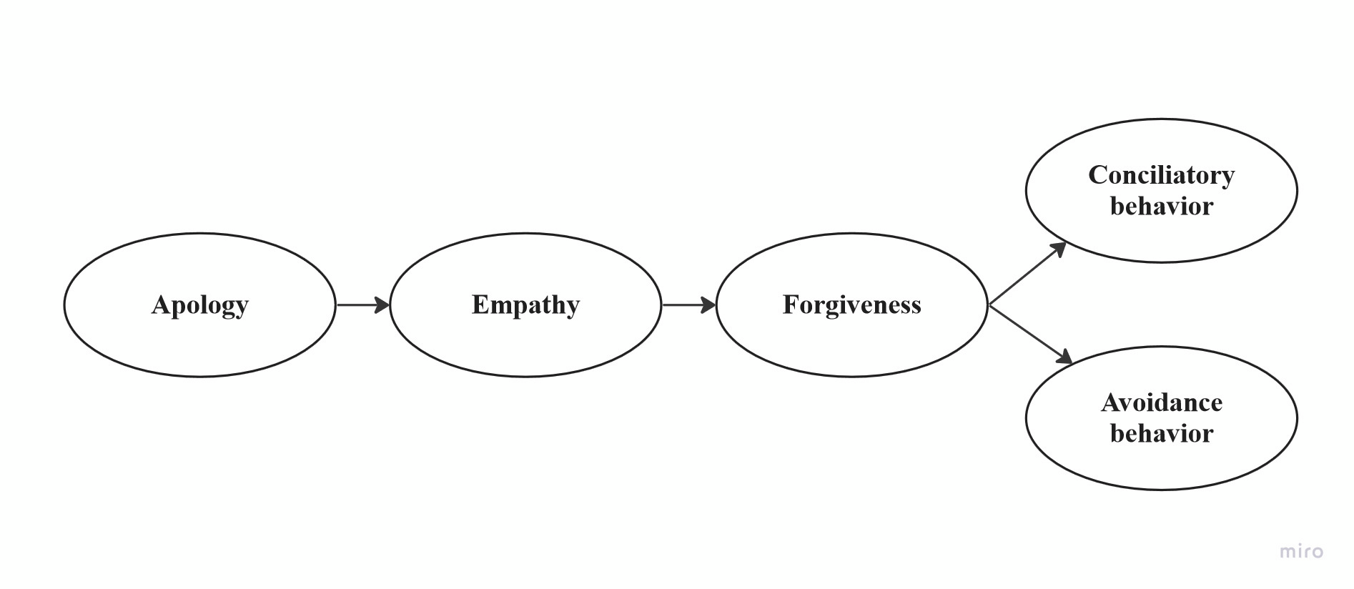

We report a close replication and extension of McCullough et al. (1997) with two main goals. Our first goal was to conduct an independent close replication of the associations among empathy, perceived apology, forgiving, and various behavioral motivations. Our second goal was to extend the target article’s design to examine causality by manipulating empathy attributions and incorporating avoidance motivation and revenge motivation measures from a related follow-up study by McCullough et al. (1998) (Study 1). Together, we were hoping to have a broader causal and more extensive view on the associations and impact of empathy.
We begin by introducing the literature on forgiveness and the chosen article for replication. We discuss our motivation for the current replication study, the hypotheses and study design, with our adjustments and added extensions.

Interpersonal forgiveness
Despite different definitions across contexts and theories, forgiveness is generally agreed by scholars to be an intentional and voluntary process (or the result of a process) that involves a change in emotion and attitude regarding an offender, driven by a deliberate decision to forgive (Enright & Fitzgibbons., 2000; Fincham et al., 2004; Worthington & Scherer, 2004). This process usually leads to decreased motivation to retaliate or maintain estrangement from an offender, and requires setting free of negative affects toward the offender (Macaskill, 2012; Webb & Toussaint, 2019).
Field et al. (2013) generalized forgiveness into four major components: Self-awareness, letting go, perspective-taking, and moving on. Whether an apology and reconciliation are necessary for forgiveness remains controversial among theorists (Fincham et al., 2004; Kelley et al., 2018; Strabbing, 2020). The main arguments against their necessity include the inapplicability of relationship restorations to self-forgiveness (Hall & Fincham, 2005) and the impossibility of receiving an apology from those who have passed away (Breitbart, 2018; Gassin & Lengel, 2014), and yet forgiveness is generally believed as sensible in both situations. Putting aside this unsolved debate, we mainly focus on McCullough et al. (1997)’s interpersonal forgiveness in which apology and reconciliation are possible.
The benefits of interpersonal forgiveness have been widely studied, as - for example - forgiveness seems crucial for psychological healing in broken relationships (Menahem & Love, 2013). Lee and Enright (2019)’s meta-analysis indicated a positive association between forgiveness and physical health (e.g., lowering blood pressure and cortisol levels, improving the immune system), and there is evidence in support of a positive association with marital adjustment (Agu & Nwankwo, 2019; Fahimdanesh et al., 2020; McNulty, 2008), quality of friendships (Boon et al., 2022) and familial relationships (Gordon et al., 2009; Maio et al., 2008).

Empathy in forgiveness
McCullough et al. (1997) conceptualized empathy as a crucial facilitative condition for overcoming the tendency toward destructive responding following an interpersonal offense, leading to forgiveness. Their hypothesis was based on the facilitating effect of empathy occurring in other prosocial phenomena, such as in corporations, altruism, and the inhibition of aggressions. (Batson et al., 1991; Eisenberg & Fabes, 1990; Hoffman, 1981; Moore, 1990; Tangney, 1991; as cited in McCullough et al., 1997). More recent studies also further supported this argument, showing a close association between empathy and forgiveness, across genders (Mellor et al., 2012; Miller et al., 2008), and contributing to personal self-esteem (Turnage et al., 2012; Yao et al., 2017).
Empathy can be treated as either an affect (emotion) in response to stimuli or a dispositional (personality) trait of a person. We followed the target article to focus on the affective dimension of empathy, unless mentioned otherwise .

Revenge, Avoidance, and Conciliation
McCullough et al. (1997) suggested the primacy of the behavioral tendencies toward revenge and avoidance in response to interpersonal offense is motivated by two key affective responses illustrated by Gottman’s (1994) research on a close relationship: righteous indignation (e.g., anger, contempt) and hurt-perceived attack (e.g., internal whining, innocent victimhood). This was largely endorsed by recent research on revenge psychology (Jackson et al., 2019; McCullough et al., 2013; Sjöström & Gollwitzer, 2015).
Based on Batson’s Empathy-Altruism hypothesis (Batson et al., 1991; Batson & Charles, 2011), McCullough et al. (1997) proposed the psychological similarity between the relationship among empathy, forgiving, and resulting behavioral responses and the sequence of events by which empathy leads to the motivation to care for others (i.e., altruism) and how that altruistic motivation can produce behavioral outcomes (e.g., helping, allocating resources in a social dilemma, cooperating). Therefore, McCullough et al. (1997) suggested empathy may counteract the motivation of relationship-destructive response of revenge and avoidance, in response to interpersonal offense, promoting conciliation through forgiveness.

Choice of study for replication
We chose the McCullough et al. (1997)’s study based on two factors: impact, potential for further extensions examining causality and revenge, and the absence of direct replications.
The article has had an impact on scholarly research, especially in the domains of social and clinical psychology. At the time of writing (January 2023), there were 2404 Google Scholar citations of the article with important follow-up theoretical and empirical articles, such as Thompson et al. (2005) on the dispositional dimension of forgiveness and Raes et al. (2011) on the construction of the self‐compassion scale. The influential 2-component motivational model of forgiveness proposed by McCullough et al. (1998) was also an extension built on this initial empathy model. The empathy-forgiveness link demonstrated by McCullough et al. (1997)’s research has been one of the most critical foundations of forgiveness therapy which is nowadays widely adopted in clinical settings (Akhtar & Barlow, 2018; Enright & Fitzgibbons, 2015; Yu et al., 2021).
McCullough et al. (1997)'s is considered one of the first theoretical and empirical bases to explore forgiveness, conceptualizing forgiveness and its correlated factors, providing a new framework to understand forgiveness, transforming it from a sacred virtue or a remote moral standard into an explainable social phenomenon. This has led to further studies of the implications of forgiveness aiming to aid the public in improving social well-being and interpersonal relationships in their daily lives (Akhtar & Barlow, 2018; Worthington et al., 2007). McCullough et al. (1997)’s research offered a scientific framework for forgiveness intervention and psychotherapy. The empathy-forgiving link was the theoretical foundation for several psychological treatments and therapies for a variety of life problems and mental illnesses in clinical settings, ranging from spousal infidelity (Chi et al., 2019) or bereavement (Záhorcová et al., 2021), to borderline personality disorder (Sandage et al., 2015) or post-traumatic stress disorder (Akhtar & Barlow, 2018; Currier et al., 2016).
The target article suggested what appears to be a causal model (see Figure 1), and yet the methods employed to test the mediation were based on correlational designs. We saw potential in extending their design with modifications aiming to establish the causality of the impact of empathy on forgiveness.
To the best of our knowledge, there are currently no published independent direct replications of this article. McCullough et al. (1998) extended their model by adding other variables such as commitment, impact of the offense, and rumination, into predicting forgiveness, which we aimed to further integrate into our replication as an extension. Donovan et al. (2020) conducted a related conceptual replication of the Model of Motivated Interpersonal Forgiveness, with different measurements and designs.
Following the recent growing recognition of the importance of reproducibility and replicability in psychological science (e.g., Brandt et al., 2014; Open Science Collaboration, 2015; Nosek et al., 2022; Zwaan et al., 2018), we aimed to revisit the classic Empathy Model of Forgiveness with a well-powered close independent replication Registered Report of McCullough et al. (1997), integrating developments from McCullough et al. (1998) and aiming to test causality.

Original hypotheses and findings in the target article
McCullough et al. (1997) conceptualized interpersonal forgiving as the set of motivational changes whereby one becomes (a) less motivated to retaliate against an offending relationship partner, (b) more motivated to maintain estrangement from the offender, and (c) more motivated towards conciliation and goodwill for the offender, despite the offender’s hurtful actions. Affective empathy was conceptualized as a crucial facilitative condition for overcoming the primary tendency toward destructive responses following a significant interpersonal offense. On the basis of these conceptual analyses, McCullough et al. (1997) proposed three core hypotheses. We summarized the hypotheses of the target article in Table 1.

Table 1
Summary of hypotheses of the target article
Hypothesis | Description
1 | Empathy mediates relationships between dispositional and environmental variables and their causal effects on forgiving.
 | a | There is a positive association between a wronged person's empathy for an offender and reported forgiveness for the offender.
 | b | Apology increases the likelihood of forgiving, mediated by empathy.
2 | Forgiving promotes constructive actions toward the offender and inhibits destructive actions toward the offender following an interpersonal offense.
 | a | Forgiveness is positively associated with conciliation motivation.
 | b | Forgiveness is negatively associated with (i) avoidance motivation and (ii) revenge motivation.
 | c | Forgiving is causally more proximal (and more strongly related) to behavioral motivation (i.e., conciliation, avoidance and revenge) than is empathy.
3* | Clinical efforts to influence clients' capacity to forgive will succeed insofar as they induce empathy for the offender.
Note. Hypothesis 3 is not included in the replication because it involves a clinical intervention.

We mainly focus on Study 1 of the target article, examining the link between apology, forgiving, and empathy for offending partners and whether forgiving is associated with increased conciliation and decreased avoidance motivation following the offense.
In the target’s study, they recruited a sample of university undergraduates who were asked to think of a particular person who treated them unfairly and hurt them at some point in the past. After visualizing and re-experiencing the situation again, participants described the interpersonal injury they had received and then completed the empathy, forgiving, and behavioral self-report measures. We summarized the associations reported in the target article in Table 2, adopted from the target article.

Table 2
Target article: Means, Standard Deviations, Internal Consistency Reliabilities and Intercorrelations
Variables | M | SD | α | 1 | 2 | 3 | 4 | 5
1. Degree of apology | 5.63 | 2.84 | .79 | _
2. Empathy | 13.22 | 5.95 | .88 | .36** | _
3. Forgiving | 16.82 | 6.73 | .87 | .43** | .67** | _
4. Conciliatory behavior | 6.74 | 2.50 | .74 | .44** | .63** | .70** | _
5. Avoidance behavior | 10.11 | 3.89 | .90 | -.47** | -.58** | -.73** | -.56** | _
Note. Apology scores ranged from 2 to 10. Empathy scores ranged from 0 to 20. Forgiving Scale scores ranged from 5 to 25. Conciliatory behavior scores ranged from 2 to 10. Avoidance behavior scores ranged from 3 to 15. **p < .01. Adopted from McCullough et al. (1997), p. 325

Extension: Examining causal link with empathy manipulation
We aimed to extend the replication study by manipulating empathy. McCullough et al. (1997) indicated that one of the major limitations of their Study 1 was the correlational study design, limiting causal claims implied in their model. We used the target’s Study 1 as our control condition, and added two additional conditions manipulating empathy in the recalled situation.
Our main focus was the replication, with the extension added as an exploratory direction. Therefore, the extension is using the same recall method about the elicited past experience, and builds on top of that. Our aim with the extension was to manipulate the elicitation of recalled situations in which empathy has been experienced so that the person can reflect and evaluate other factors in that situation. Therefore, the manipulation is of the recalled past experience and not the empathy that the participant is experiencing while taking part in the experiment. This is different from some of the research that tried to manipulate empathy through a perspective-taking approach for emotions experienced during the experiment., in which participants were asked to remain objective (vs emotionally-attached) to the main character when reading a scenario (Berenguer, 2007, 2010).
Our extension approach of manipulating elements of a recalled past event is therefore aligned with the replication and follows commonly used methods in social psychology that study evaluations of emotion ladened situations. We previously implemented similar manipulations in recall tasks in various judgment and decision making replication projects (e.g., Chen et al., 2023; Yeung & Feldman, 2022), both based on classic articles in the literature that have previously employed a manipulation of factors in the recalled scenario (e.g., Carter & Gilovich, 2012; Gilovich & Medvec, 1994).

Pre-registration and open-science
We provided all materials, data, and code on: https://osf.io/fmuv2/.
This project received Peer Community in Registered Report Stage 1 in-principle acceptance ((ENTER LINK AFTER IPA); (ENTER LINK AFTER IPA)) after which we created a frozen pre-registration version of the entire Stage 1 packet (ENTER LINK AFTER IPA) and proceeded to data collection. All measures, manipulations, exclusions conducted for this investigation are reported, and data collection was completed before analyses.

Method
[IMPORTANT:
Method and results were written using a randomized dataset produced by Qualtrics to simulate what these sections will look like after data collection. These will be updated following the data collection. For the purpose of the simulation, we wrote things in past tense, but no pre-registration or data collection took place yet.]

Power analysis
We calculated effect sizes (ES) and power based on the statistics reported in the target article. Both the ES and power were computed using R studio (Version: 1.4.2) with packages “MBESS” and “pwr”. We focused on the intercorrelations between the variables, aiming for a power of 0.95 with an alpha 0.05. The largest minimum sample size required for the correlational tests reported with significant results (i.e., apology vs. empathy) was 94 participants. The calculation was based on the effect size of r = .36, with a power of 0.95 and an alpha of 0.05.
To ensure we have enough power to detect all the effects in the original study, the sample size in the replication and extension study should not be lower than the sample size in the original study. The estimated minimum sample size in our power analysis is lower than the original study. Thus, we will follow the original’s sample size of 239 participants. A sensitivity analysis shows this sample is enough to detect correlations of r = 0.21, which is weaker than the lower bound of the weakest effect in the target article (apology vs empathy: r = 0.36, 95% Cl [0.24, 0.47]).
In our extension, we added two extra conditions from the original study by manipulating empathy, so the total sample size is multiplied by 3 to 717 participants. Accounting for possible exclusions of 0-10% based on our previous experience with the target sample, our integrated design, and allowing for the potential of additional analyses, we aimed for a larger total sample of 800 participants. A sensitivity analysis indicated that a sample of 717 (after exclusions) would allow the detection of f = 0.15 for a three-conditions ANOVA for our experimental design (95% power, alpha = 5%, one-tail) for our extension. Also, the sample would be sufficiently powered to detect contrasts of d = 0.33 (95% power, alpha = 5%, two-tail), which correspond to a medium effect in social psychology research (Lovakov & Agadullina, 2021). Based on our previous experience, recall tasks in judgment and decision-making tended to show medium to very strong effects (e.g., Chen et al., 2023; Feldman et al., 2016; Yeung & Feldman, 2022).

Participants
[To demonstrate what the results would look like after data collection we simulated a dataset of 1000 participants using Qualtrics and reported our analyses below based on that dataset. Results will later be updated in full to a sample of 800 and the real data.]
We recruited a total of 1000 US American student participants using Prolific (M_{age} = 49.7, SD = 28.8). A comparison of the target article sample and the replication samples is provided in Table 4. We employed the Qualtrics fraud and spam prevention measures: reCAPTCHA, prevent multiple submissions, prevent ballotstuffing, bot detection, security scan monitor, and relevantID.
[The assignment pay is based on the federal wage of 7.25USD/hour, per minute, so for example 5-8 minutes survey would be paid 1 USD per participant.]
We first pretested survey duration with 30 participants to make sure our time run estimate was accurate and adjusted pay as needed, the data of the 30 participants was not analyzed other than to assess survey completion duration and needed pay adjustments. For those pretest participants, if survey duration was longer than expected, they were paid a bonus as pay adjustment.

Table 3
Difference and similarities between original study and replication
 | McCullough et al. (1997) | US Prolific
Sample size | 239 | X
Geographic origin | University undergraduate¹ | US American students
Gender | 108 males, 131 females | X males, X females, X other/did not disclose
Ethnic group | 83% White, 14% Black, 3% other
Median age (years) | Unreported | 50
Average age (years) | 19 | 49.7
Standard deviation age (years) | Unreported | 28.8
Age range (years) | Unreported | 0 -100
Medium (location) | Unreported | Computer (online)
Compensation | Extra course credit | Nominal payment
Year | 1997 | 2022
Note. ¹ Origin was not explicitly mentioned in the target article, though we suspect it was US American, given the authors’ affiliation at the time.

Experimental design
We summarized the experimental design in Table 4, a between-subject experimental design with one independent variable and three conditions. We manipulated empathy towards the offender in the recalled situation (i.e., High empathy vs Low empathy vs Control) and compared the intercorrelations of the dependent variables (e.g., perceived apology, empathy, and forgiving). We provided all measures in the “Scales used in the experiments” section in the supplementary.

Table 4
Replication and extension experimental design
Level of empathy (between-subject) | High empathy condition (Extension)  “you were highly empathetic toward the person who had hurt you.” | Low empathy condition (Extension)  “you were not empathetic toward the person who had hurt you” | Control condition (Replication)  No indication of empathy towards the offender
Dependent variables (DV) | Offense-related information  Questions include:  “What was your relationship with the person who had hurt you”  “How long has it been since the event occurred”  “Please indicate the degree to which the offense had hurt you”  (1 = Hurt very little to 5 = Hurt so much)  “The person was not wrong in what he/ she did to me.”  (0 = Strongly disagree to 5 = Strongly agree)  (Source: McCullough et al., 1997)
Perceived apology
“The offender has apologized?”
“The offender has attempted to explain their hurtful behavior?”
(1 = Strongly disagree to 5 = Strongly agree)
(Source: McCullough et al., 1997)
Empathy
“Please rate each adjective to indicate the degree to which you feel each of the following affects for the offender”
Sympathetic, empathic, concerned, moved, compassionate, warm, softhearted and tender
(0 = Not at all to 5 = Extremely)
(Source: Batson et al., 1982)
[Note: McCullough measured all 8 emotions, though only some analyzed. We kept all 8.]
Forgiving
“I wish him/her well”, “I disapprove of him/her”, “I think favorably of him/her” and “I condemn the person.”
(0 = Not at all to 5 = Extremely)
“I have forgiven the person.”
(1 = I have not at all forgiven to 5 = I have completely forgiven)
(Source: Wade, 1989)
Conciliatory motivation
“I tried to make amends”
“I took steps toward reconciliation: Wrote them, called them, expressed love, showed concern…”
(1 = Strongly disagree to 5 = Strongly agree)
Avoidance motivation
“I keep as much distance between us as possible"
“I live as if he/she doesn’t exist, isn’t around”
“I don’t trust him/her”
“I find it difficult to act warmly toward him/ her.”
“I avoid him/her”
“I cut off the relationship with him/her.”
“I withdraw from them”
(1 = Strongly disagree to 5 = Strongly agree)
(Source: McCullough et al., 1998)
Revenge motivation
“I'll make him/her pay”
“I wish that something bad would happen to him/her”
“I want him/her to get what he/she deserves”
“I’m going to get even.”
“I want to see him/her hurt and miserable.”
(1 = Strongly disagree to 5 = Strongly agree)
(Source: McCullough et al., 1998)
Comprehension checks (CC) | Questions include:  (1) What type of behavior are you asked to recall?  (Someone treated me badly / Someone treated me nicely / Someone had an interaction with me)  (2) How many people are you asked to focus on?  (1 /2 / 3)
Note. CC questions were newly designed for this replication study but did not exist in the original article.

Procedure
[For review: The Qualtrics survey .QSF file and an exported DOCX file are provided on the OSF folder. A preview link of the Qualtrics survey is provided on: https://hku.au1.qualtrics.com/jfe/preview/previewId/d52a8690-3476-4219-ae46-f7076b96a388/SV_0VeUxDaZu96QUfk?Q_CHL=preview&Q_SurveyVersionID=current ]

Participants completed the survey via the online survey system Qualtrics. They were randomly assigned into the experimental conditions, which were counterbalanced using the randomizer “evenly present” function in Qualtrics.
We designed comprehension checks to ensure that participants fully understood their tasks before responding to our study measures. These comprehension check questions are as follows: “What type of behavior done on you are you asked to recall”, “How many people are you asked to focus on”, and “What emotion towards the offender in the situation are you asked to recall”. Participants needed to answer all the questions correctly before proceeding to the next page.
There were three conditions in our experiment (i.e., High Empathy condition, Low Empathy condition, Control condition). In the High Empathy condition, participants (n = 334) were asked to recall a hurting experience that they were “highly empathetic to the person who had hurt you”, whereas in the Low Empathy condition, they (n = 333) were asked to recall a hurting experience that they were “not empathetic to the person who had hurt you”. Participants then described the interpersonal injury they received and explained the reason why they were empathetic/unempathetic towards the offender, completing the self-report measures of perceived apology, empathy, forgiveness, and behaviors.
The third control condition was a replication of the original study. Participants (n = 333) were asked to think of a person whom they experienced as treating them unfairly and hurting them at some point in the past without any indication/ reference of empathy towards the offender. Then, participants described the interpersonal injury they received, completing the self-report measure as in the first two conditions. As the control condition was identical to the original study, we conducted all the replication analyses on the control condition.
At the end of the experiment, participants answered a number of funneling questions and provided their demographic information. We provided a more comprehensive overview of the survey procedure in “Instructions and experimental material” in the supplementary.

Manipulations
Participants were randomly assigned to one of the three conditions. We expected that participants in the High Empathy condition would rate higher empathy than those in the Low Empathy condition. We conducted independent-sample t-tests to check manipulations of empathy between conditions.
We provided additional details of the manipulations, the differences between the three conditions, the experimental design, and complete scales used in the current replication in “Materials and scales used in the replication + extension experiment” in the Supplementary Materials.

Measures

Replication

Offense-related information
Identical to the original study, participants indicated their age, gender, relationship with the person who had hurt them, the time since the offense occurred, and a brief description of the offense. Many of the offenders whom participants described were romantic partners (14.4%), relatives (16.5%), or friends of the same gender (16.8%).
Then, participants indicated the degree to which the offense hurt them on a 5-point scale. Participants indicated their agreement with the statement “The person was not wrong in what he/ she did to me” on a 6-point Likert-type item that ranged from 0 (Strongly disagree) to 5 (Strongly agree).

Perceived degree of apology
The extent to which participants perceived that the offender apologized for the offense was measured with a scale consisting of two 5-point Likert-type items that ranged from 1 (Strongly disagree) to 5 (Strongly agree). Items included the degree to which participants perceived that their offenders apologized and attempted to explain their hurtful behavior. This measure scored from 2 to 10 (α = -.01, ω = -.00 ).

Affective empathy
Batson's eight-item empathy scale (Archer et al., 1981; Batson et al., 1986; Batson et al., 1983; Coke et al., 1978; Fultz et al., 1986; Tbi & Batson, 1982) was refined by McCullough et al. (1997) into four emotions (empathic, concerned, moved, softhearted) that participants rated on a 6-point scale ranging from 0 (Not at all) to 5 (Extremely) to indicate the degree to which they felt toward their offender (α = -.05, ω = .12). The score was from 0 to 20.

Forgiveness
A five-item measure of forgiving assessed the degree to which the respondent experienced a constructive disposition and the absence of a destructive disposition in light of the offending partner's hurtful actions: “I wish him/her well”, “I disapprove of him/her”, “I think favorably of him/her”, “I condemn the person” and “I have forgiven the person”. The first four items were on a 6-point scale (0 = Strongly disagree; 5 = Strongly agree). The final forgiving item was on a 5-point scale (1 = I have not at all forgiven; 5 = I have completely forgiven). The score ranged from 1 to 25 (α = -.21, ω = -.07).

Conciliatory motivation toward the offender
Two items measured engagement in two reconciliation behaviors: “I tried to make amends" and "I took steps toward reconciliation: Wrote them, called them, expressed love, showed concern, etc.". Items were on a 5-point scale from 1 (Strongly disagree) to 5 (Strongly agree), and scored from 2 to 10 (α = .03, ω = 0.03).

Avoidance and Revenge motivations toward the offender
This measure was derived from the transgression-related interpersonal motivations (TRIM) inventory developed by McCullough et al. (1998). TRIM aimed at evaluating respondents’ motivation to avoid personal and psychological contact with the offender (i.e., avoidance) and the motivation to seek revenge or see harm come to the offender (i.e., revenge).
The 7 avoidance motivation items were: “I keep as much distance between us as possible”, “I live as if he/she doesn't exist, isn't around”, “I don't trust him/her.”, “I find it difficult to act warmly toward him/her”, “I avoid him/her”, “I cut off the relationship with him/her”, or “I withdraw from him/her”. (α = -.27, ω = -.17) The 5 revenge motivation items were: “I’ll make him/her pay”, “I wish that something bad would happen to him/her.”, “I want him/her to get what he/she deserves.”, “I'm going to get even.”, “I want to see him/her hurt and miserable”. (α = -.04, , ω = .01) Both the avoidance motivation and revenge items from TRIM were on a 5-point scale (1 = Strongly disagree; 5 = Strongly agree). Their overall scores ranged from 7 to 35 and 5 to 25 respectively.

Extension

Offense-related information
Identical to the measures in Replication above, participants indicated their age, gender, relationship with the person who had hurt them, how much time passed since the offense occurred, as well as the degree of the offense. Yet, in the extension conditions, participants were also asked to explain why they were empathetic/ unempathetic to the offender according to their randomly-assigned condition.

Affective empathy
The identical empathy measure of Batson's eight-item scale in the target article was used for manipulation check in the Extension.

Deviations
We made minor deviations from the original study in several aspects, summarized in Table 5.

Table 5
Comparison of original versus replication
 | Original | Replication | Reason for change
Study design | Participants completed the studies with pen and paper in the laboratories. | Participants completed the studies on an online survey. | Lower cost and higher efficiency.
Sample characteristics | N = 239  Sample origin:  University undergraduate | N = 800  US American Prolific students | Two extra conditions in extension; Generalizability of results by including a wider variety of participants.
Procedure | Items of all dependent variables (DV) were not randomized | Items of all DV were randomized | Addressing potential order effects.
 | Three items for the measure of Avoidance motivation | Extended to seven items | McCullough et al. (1998) modified their measure of avoidance motivation with the TRIM inventory
 | No comprehension check | Comprehension checks exist | Ensuring participants read and understood the task.
Statistical analysis | Pearson’s R;  Nested structural equation models (SEM) | Pearson’s R | The SEM used in the original article were based on correlations. Our extension changed to testing causality. We toned down the importance of the causal chain, and changed mediation to an exploratory analysis.
Conditions | 1 condition | 1 conditions  identical to the original (Control) with 2 extension conditions. | To examine the causal relationship between empathy and forgiveness in Extension

Evaluation criteria for replication findings
McCullough et al. (1997) conducted 10 correlation tests in the original article as shown in Table 2. We aimed to compare the replication’s control condition effects with those in the original article using the criteria set by LeBel et al. (2019) (see subsection “Replication evaluation” in the Supplementary Materials).

Replication closeness evaluation
We provided details on the classification of the replications using the criteria by LeBel et al. (2018) criteria in Table 6 below (see section “replication closeness evaluation” in the supplementary). We did not set out to replicate the nested structural equation models (SEMs) in the original article due to its limitation in testing the proposed causal chain (Table 1). LeBel et al. (2018) did not consider statistical tests as an important criterion in its replication closeness evaluation, yet we consider it relevant for replication research. Thus, we summarized the replication as a close replication (rather than a very close replication).

Table 6
Classification of the replication, based on LeBel et al. (2018)
Design facet | Replication | Details of deviation
Effect/hypothesis | Same
IV construct | Same
DV construct | Same
IV operationalization | Same
DV operationalization | Similar | The transgression-related interpersonal motivations inventory (TRIM, McCullough et al., 1998) is incorporated to examine the behavioral motivation of avoidance and revenge.
Population (e.g. age) | Similar | Students were recruited through an online research platform Prolific using their demographic filtering.
IV stimuli | Same
DV stimuli | Same
Procedural details | Similar | Order of items were randomized
Physical settings | Different | Experiment is conducted online instead of via traditional paper survey
Contextual variables | Different | Participants were recruited online using Prolific.
Replication classification | Close replication

Data analysis strategy

Replication: Correlation tests
We conducted Pearson's correlations to examine the associations between the six measures of interest: perceived apology, affective empathy, forgiving, conciliatory motivation, avoidance, and revenge motivation.
We did not replicate the full three nested structural equation models (SEM) used in the original article in our study. There are limitations in the original article’s attempt to establish a causal mediation relationship using SEM (Rohrer et al., 2022), and requires more careful designs and much larger samples than originally employed. Instead, our extensions aimed to manipulate empathy to test causality directly, and flagged the target’s mediation analysis in the control condition as an exploratory analysis, and not core to assessing the target’s claims or replicability.
We employed Diedenhofen and Musch (2015)’s “cocor” R package for correlation comparisons. The “cocor” R package is powerful and comprehensive since it compares overlapping correlations from dependent groups with up to 10 commonly used approaches (i.e., Dunn & Clark, 1969; Hendrickson et al., 1959; Hittner et al., 2003; Hotelling, 1940; Meng, 1992; Olkin, 1967; Pearson & Filon, 1898; Steiger, 1980; Williams, 1959; Zou, 2007). These would be conducted as exploratory analyses for addressing Hypothesis 2c.

Extension: the impact of Empathy on Forgiveness
We conducted two between-subjects ANOVAs to examine how apology and forgiveness differ across 3 conditions (High empathy vs Low empathy and Control). We conducted post-hoc tests contrasting condition pairs. We chose post-hoc Scheffe tests because they are the most conservative post-hoc pairwise comparison method, generating the widest confidence intervals of group means difference.

Outliers and exclusions
In this study, we would not classify outliers. We included all the data collected in our analysis. Please refer to the section “Exclusion criteria” in the supplementary for more details.

Results
[IMPORTANT:
Method and results were written using a randomized dataset produced by Qualtrics to simulate what these sections will look like after data collection. These will be updated following the data collection. For the purpose of the simulation, we wrote these sections in past tense, but no pre-registration or data collection took place yet.]

We summarized descriptive statistics in Table 7, correlations in Tabel 8, and hypotheses and statistical tests results in Table 9. We conducted the analyses with R (Version: 4.1.2).

Table 7
Descriptive statistics for all conditions
 | High empathy  (Extension) | Low empathy  (Extension) | Control  (Replication) | Overall
 | (n = 333) | (n = 334) | (n = 333) | (N = 1000)
Perceived apology | 6.08 [2.03] | 5.96 [1.93] | 6.01 [2.00] | 6.02 [1.98]
Empathy | 9.77 [3.40] | 9.76 [3.47] | 10.11 [3.35] | 9.88 [3.41]
Forgiveness | 12.86 [3.61] | 12.82 [3.700] | 12.74 [3.41] | 12.82 [3.57]
Conciliatory motivation | 6.15 [1.94] | 6.08 [1.99] | 5.82 [2.05] | 6.02 [2.00]
Avoidance motivation | 20.98 [3.67] | 20.66 [3.82] | 21.15 [3.33] | 20.93 [3.61]
Revenge motivation | 15.10 [3.30] | 15.05 [3.18] | 15.14 [3.16] | 15.1 [3.21]
Note. Format: Mean [standard deviation] (sample size).
Perceived apology ranged from 2 to 10.
Empathy ranged from 0 to 20.
Forgiveness ranged from 1 to 25.
Conciliatory motivation ranged from 2 to 10.
Avoidance motivation ranged from 7 to 35.
Revenge motivation ranged from 5 to 25.

Table 8
Replication: Intercorrelations with confidence intervals
Variable | M | SD | α | ω | 1 | 2 | 3 | 4 | 5 | 6
1 - Perceived apology | 6.01 | 2.00 | -.01 | -.00
2 - Empathy | 10.11 | 3.35 | -.05 | .12 | .03
 |  |  |  |  | [-.08, .14]
3 - Forgiveness | 12.74 | 3.41 | -.21 | -.07 | -.09 | -.01
 |  |  |  |  | [-.19, .02] | [-.12, .09]
4 - Conciliatory motivation | 5.82 | 2.05 | .03 | .03 | .06 | .02 | .07
 |  |  |  |  | [-.04, .17] | [-.08, .13] | [-.03, .18]
5 - Avoidance motivation | 21.15 | 3.33 | -.27 | -.17 | .01 | .02 | .01 | .03
 |  |  |  |  | [-.10, .12] | [-.09, .13] | [-.09, .12] | [-.08, .13]
6 - Revenge motivation | 15.14 | 3.16 | -.04 | .01 | -.01 | .05 | -.09 | -.01 | .04
 |  |  |  |  | [-.11, .10] | [-.0, .16] | [-.02, .19] | [-.11 .10] | [-.07, .15]
Note. Correlations in the control condition for the replication (n = 333). Format: Pearson’s correlations [confidence interval].
* p < .05; ** p < .01; *** p < .001.

Table 9
Summary of statistical tests and their interpretation
Hypothesis | Original |  |  | Replication |  |  | Interpretation
 | p | Effect size | CI | p | Effect size | CI
1a | < .001 | r = .67 | [0.59,  0.73] | = -.014 | r = -.01 | [-0.08, 0.14] | [signal/no-signal] [consistent/inconsistent] [opposite/smaller/similar/larger]
1b | < .001 | r = .36 | [0.24,  0.47] | = .584 | r = .03 | [-0.12, 0.09] | [signal/no-signal] [consistent/inconsistent] [opposite/smaller/similar/larger]
2a | < .001 | r = .70 | [0.73,  0.76] | = .175 | r = .07 | [-0.03, 0.18] | [signal/no-signal] [consistent/inconsistent] [opposite/smaller/similar/larger]
2bi | < .001 | r = -.73 | [-0.78,  -0.66] | = .832 | r = .01 | [-0.09, 0.12] | [signal/no-signal] [consistent/inconsistent] [opposite/smaller/similar/larger]
2bii | / | / | / | = .831 | r = -.01 | [-0.09, 0.12] | [signal/no-signal] [consistent/inconsistent] [opposite/smaller/similar/larger]
Note. Analyses are Pearson’s correlations. CI = 95% confidence intervals. The interpretations of the outcomes are based on LeBel et al. (2019).
n = [sample size for the control condition]

Replication
We conducted 15 correlation tests (Pearson’s correlation) to test the associations between variables using the control (replication) condition, summarized in Table 8.
First, we found no support for hypotheses 1a and 1b that empathy is associated with perceived apology, r(331) = 0.03, 95% CI [-0.08, 0.14], p = .584, and forgiveness, r(331) = -0.01, 95% CI [-0.12, 0.09], p = -.014. We provided the summary scatterplots for the relationship between perceived apology and affective empathy as well as affective empathy forgiveness in Figures 2 and 3.

We failed to find support for hypotheses 2a and 2b that forgiveness is positively correlated to conciliation motivation, r(331) = 0.07, 95% CI [-0.03, 0.18], p = .175, and negatively correlated to avoidance motivation, r(331) = 0.01, 95% CI [-0.09, 0.12], p = .832, and revenge motivation, r(331) = -0.01, 95% CI [-0.09, 0.12], p = .831. We provided the summary scatterplots in Figures 4, 5 and 6.

Figure 2
Scatterplot for the association between perceived apology and affective empathy in the replication (Control) condition
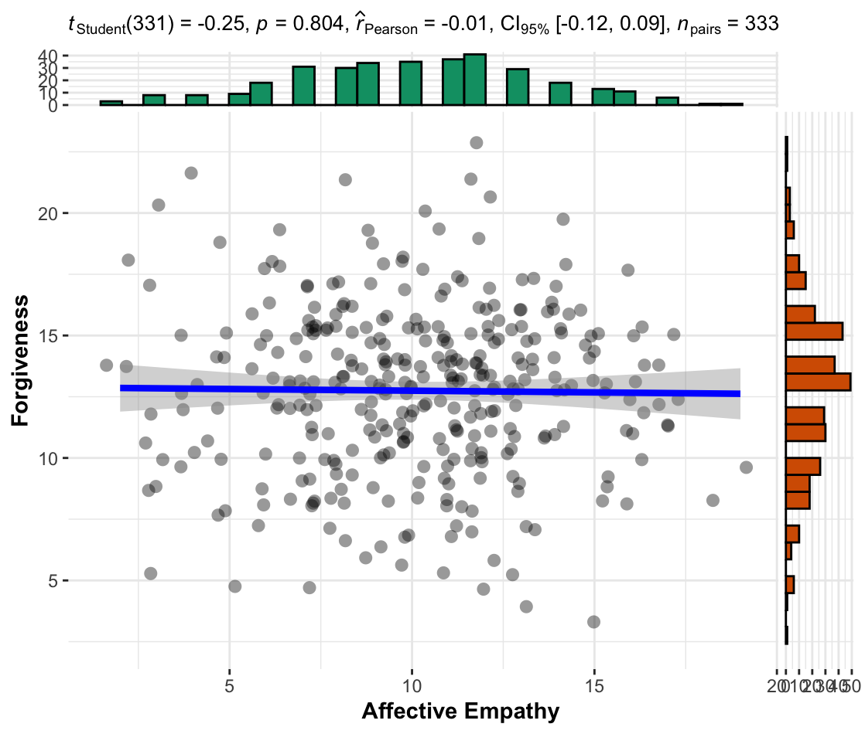

Figure 3
Scatterplot for the association between affective empathy and forgiveness in the replication (Control) condition
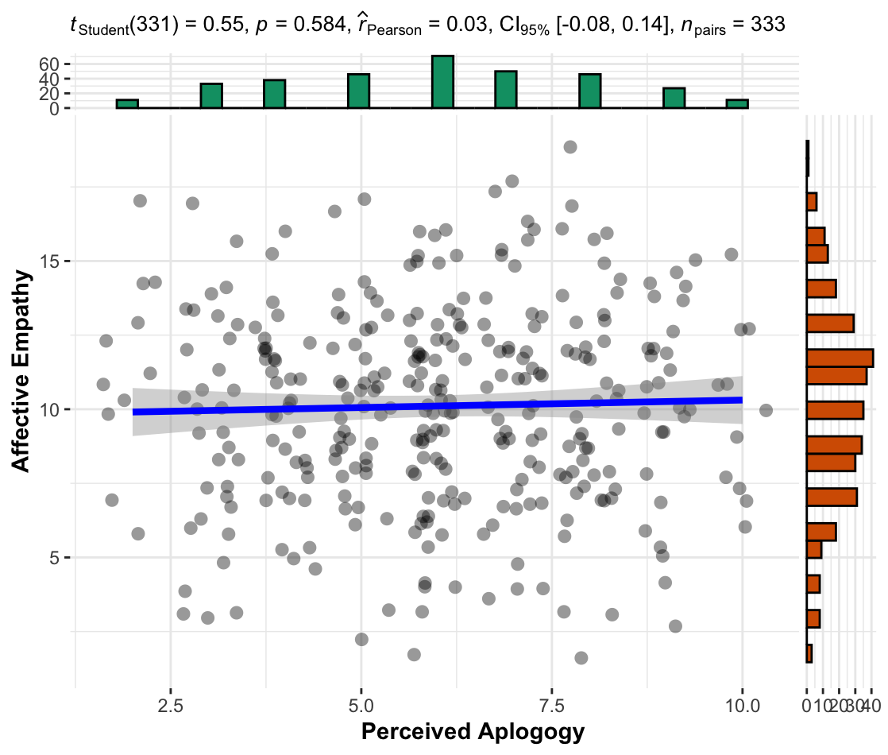

Figure 4
Scatterplot for the association between forgiveness and conciliatory motivation

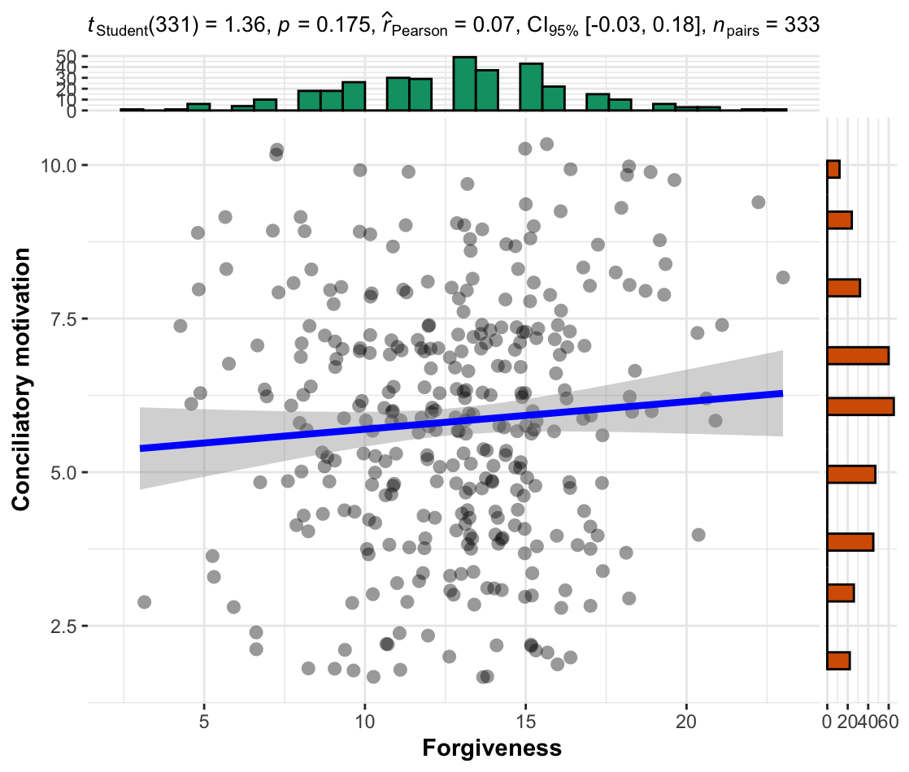

Figure 5
Scatterplot for the association between empathy and forgiveness
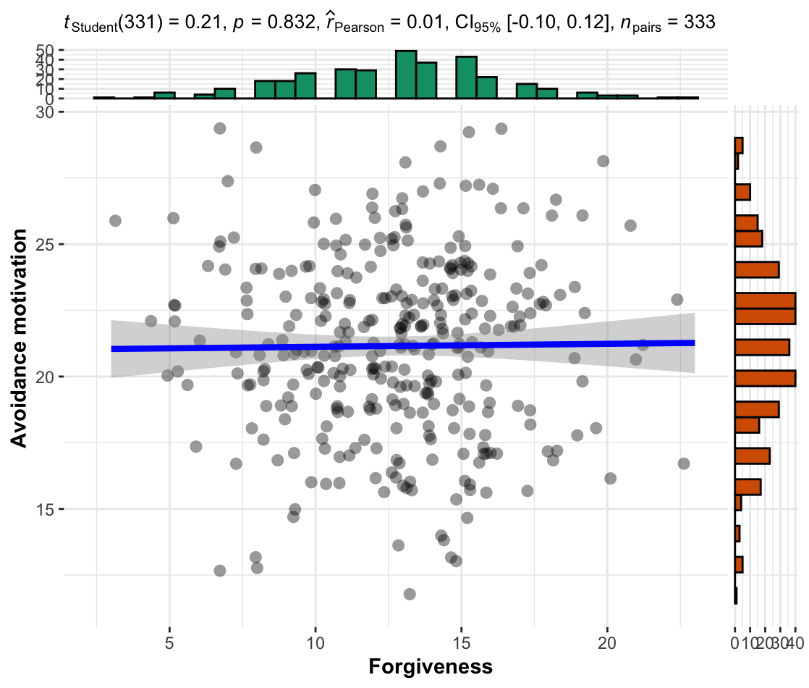

Figure 6
Scatterplot for the association between forgiveness and revenge motivation
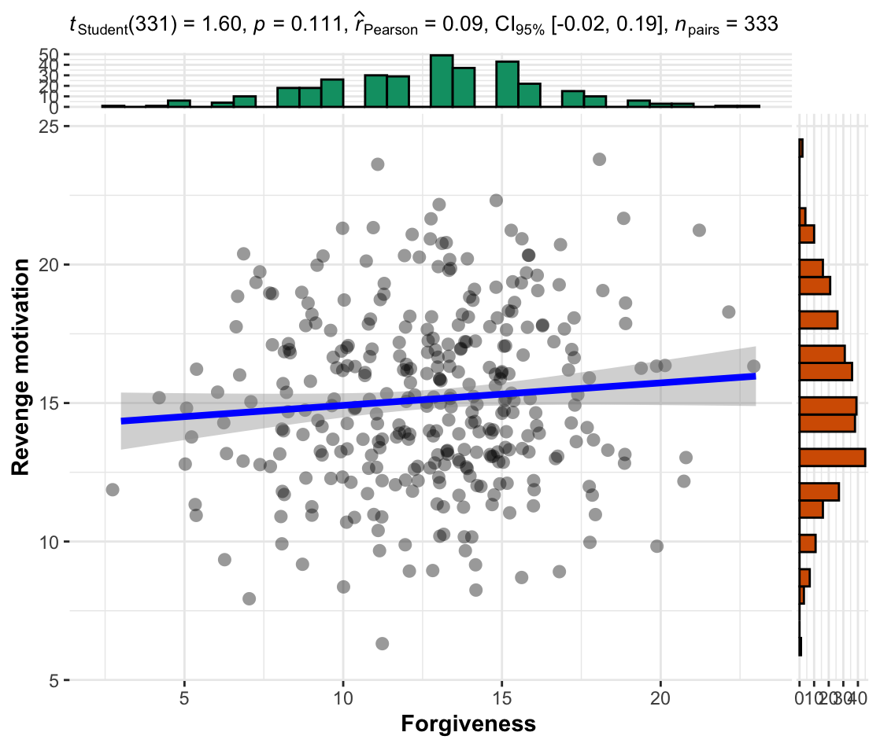

Exploratory analysis: Correlations comparisons
We conducted correlation comparisons with the “cocor” R package and found no support for Hypothesis 2c that forgiveness is more associated with behavioral motivations (i.e., conciliation, avoidance and revenge) than is empathy. We failed to find support for empathy as correlated to conciliation motivation, r(331) = 0.02, 95% CI [-0.08, 0.13], p = .72, avoidance motivation, r(331) = 0.02, 95% CI [-0.09, 0.13], p = .682, and revenge motivation, r(331) = 0.05, 95% CI [-0.06, 0.16], p = .359. None of the ten correlation comparisons indicated evidence of differences between correlations. We provided full analyses and results for the comparisons in the “Additional analyses and results” section in the supplementary.

Comparing replication to original findings
We failed to replicate all of the significant results in the original article. See Table 10 for the summary of replication results and their interpretations based on LeBel et al. (2019).

Extensions: empathy manipulation

Manipulation checks
We conducted independent samples Welch’s t-tests (two-tailed) and failed to find support for differences between affective empathy in the high empathy condition (n = 333; M = 9.77, SD = 3.40) and the low empathy condition (n = 334; M = 9.76, SD = 3.47; M_{d} = 0.03; t (664.79) = 0.020, p = .984; d < 0.00, 95% CI [-0.15, 0.15]) and Control condition (n = 333; M = , SD = 10.11; M_{d} = 0.01; t (663.87) = -1.31, p = .191; d = .-10, 95% CI [-0.25, 0.05]), and between low empathy condition and the control condition (t (664.33) = -1.32, p = .188; d = -0.10, 95% CI [-0.25, 0.05])

Figure 7
Comparison of affective empathy between empathy conditions
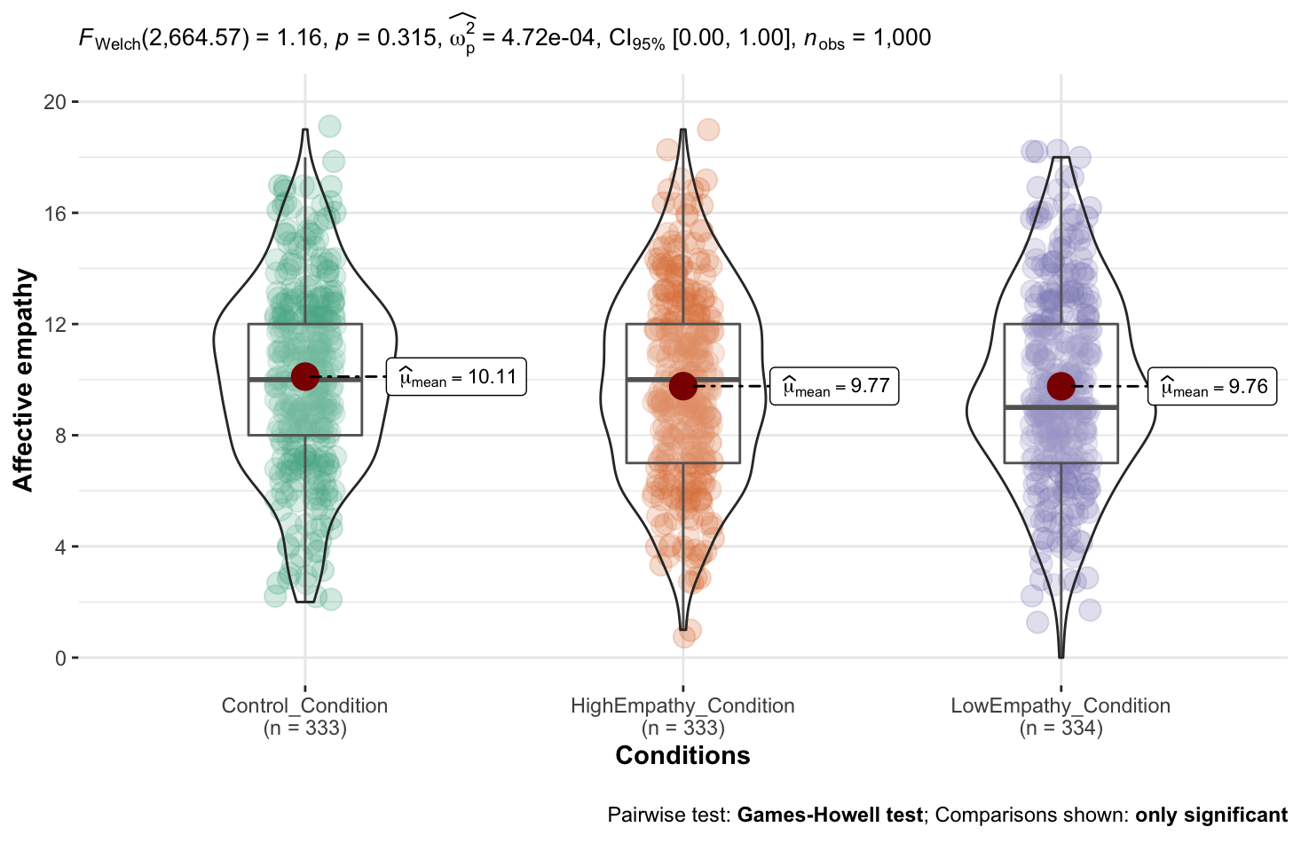
Note. The scale is from 0 to 20, higher values indicate stronger affective empathy towards the offender.

Forgiveness and apology
We conducted a one-way ANOVA (Type 3) and failed to find support for empathy affecting forgiveness and differences in forgiveness between the three empathy conditions (F(2, 997) = 0.09, p =.913; η²_{p} < 0.01, 90% CI [0.00, 0.01].
We conducted post-hoc Scheffe tests and found no support for differences in forgiveness between the high empathy condition (M = 12.86, SD = 3.61) and low empathy condition (M = 12.82, SD = 3.700; M_{d} = -.04, 95% CI [-0.72, 0.63], p = .987) or control condition (M = 12.74, SD = 3.41; M_{d} = 0.12, 95% CI [-0.56, 0.80], p = .914), or between the low empathy condition and the control condition (M_{d} = 0.07, 95% CI [-0.61, 0.75], p = .966).
We found no support for differences in apology between the three empathy conditions (F(2, 997) = 0.28, p =.755; η²_{p} < 0.01, 90% CI [0.00, 0.00]).
We conducted post-hoc Scheffe tests and found no support for differences in apology between the high empathy condition (M = 6.08, SD = 2.03) and low empathy condition (M = 5.96, SD =1.93; M_{d} = -0.04, 95% CI [-0.72, 0.63], p = .987) or control condition (M = 6.01, SD = 2.00; M_{d} = 0.12, 95% CI [-0.56, 0.80], p = .914) or between the low empathy condition and the control condition (M_{d} = 0.07, 95% CI [-0.61, 0.75], p = .966).

Figure 8
Comparison of forgiveness between empathy conditions
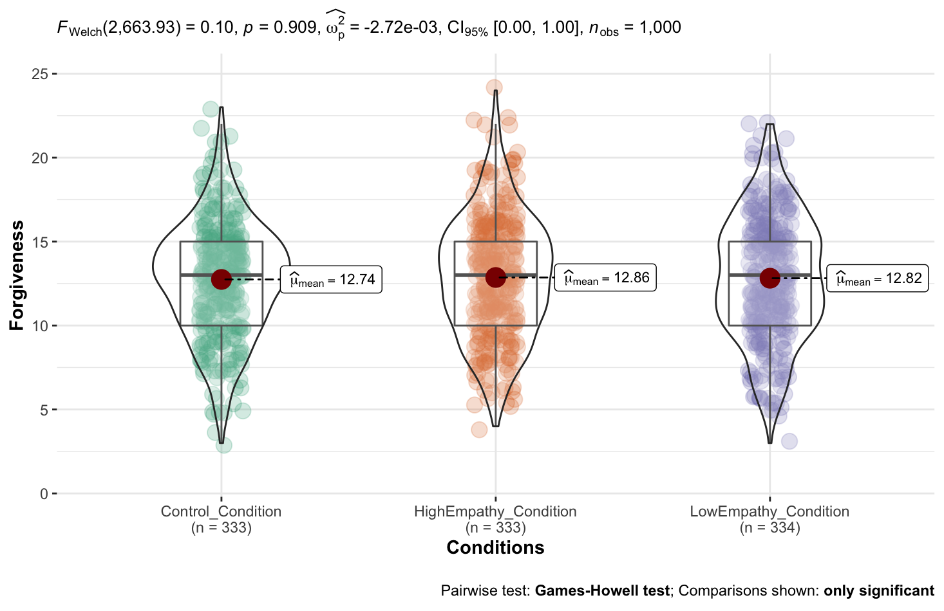
Note. The scale is from 1 to 25, higher values indicate a stronger tendency to forgive the offender.

Figure 9
Comparison of perceived apology across empathy conditions
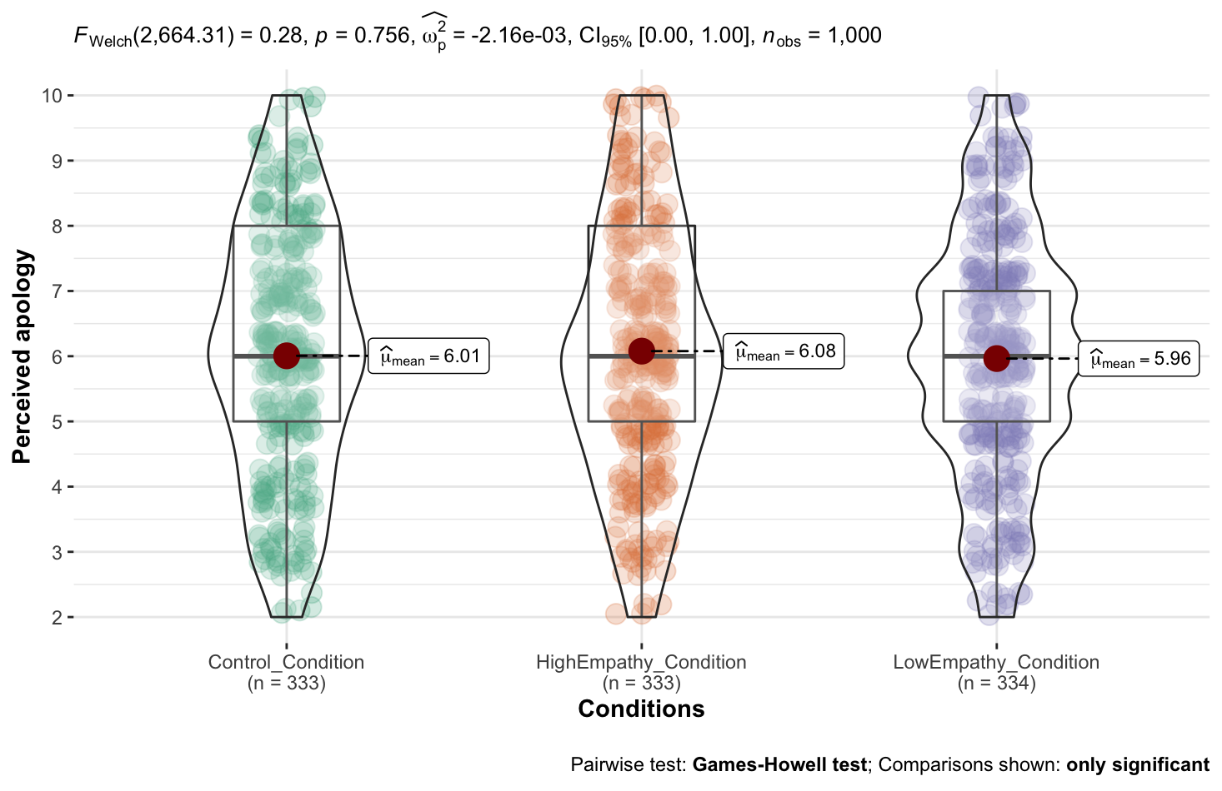
Note. The scale is from 2 to 10, higher values indicate stronger the perceived apology from the offender.

Exploratory analysis: Mediation analyses
We conducted an exploratory mediation (bootstrapping) test to examine the meditation effects of empathy between apology and forgiveness in the control condition. We summarized the effects in Figure 10.
We failed to find support for the effect of perceived apology on forgiveness being mediated via the affective empathy. Examining the regression coefficients there was no support for an association between perceived apology and forgiveness (β = -0.15, t(331) = -1.61, p = .109), between empathy and forgiveness (β = -0.01, t(330)= -0.20, p = .841), and between apology and empathy (β = 0.05, t(331)= 0.54, p = .584). The overall indirect effect was (-.01)*(.05) = -.05, whereas the bootstrapped unstandardized indirect effect (Average Causal Mediation Effect, ACME) was -.001, 95% CI [-.01 to .01], p = .91. Therefore, we concluded no support for an indirect effect.

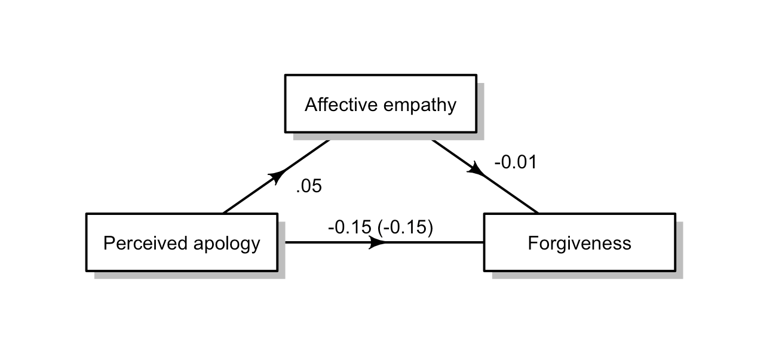
Figure 10
Exploratory mediation analyses in the control condition
Note. Regression coefficients between variables. (Average direct effect
).

Discussion
[Please note that the discussion is only to be completed in Stage 2 following data collection]
We conducted a pre-registered replication of the empathy model of forgiveness. The results are [consistent/not consistent/partially consistent and partially inconsistent] with the original results (see Table X for a summary of the replication).

Replication
Overall, we found that: (1) [...] , (2) [...] , (3) [...], and (4) [...]
In summary, the goal of the project was to assess the replicability of the research presented by McCullough (1997) in support of the empathy model of forgiveness.

Extensions
We ran extensions examining .... Overall, our findings showed that [...] We found [weak to no / weak / medium / strong] support for our hypothesis.

Implications, limitations, and directions for future research
[Based on Reviewer 2 Dr./Prof. James Bartlett’s point about multiple comparisons for correlations, and the lack of outlier handling in the target article, we will discuss these weaknesses in this section.]

Conclusion

References
Agu, S. A., & Nwankwo, B. E. (2019). Influence of religious commitment, intentionality in marriage and forgiveness on marital satisfaction among married couples. Ife Psychologia, 27(2), 121–133.
Akhtar, S., & Barlow, J. (2018). Forgiveness Therapy for the Promotion of Mental Well-Being: A Systematic Review and Meta-Analysis. Trauma, Violence, & Abuse, 19(1), 107–122. https://doi.org/10.1177/1524838016637079
Batson, C. D., Batson, J. G., Slingsby, J. K., Harrell, K. L., Peekna, H. M., & Todd, R. M. (1991). Empathic Joy and the Empathy-Altruism Hypothesis. Journal of Personality and Social Psychology, 61(3), 413–426. https://doi.org/10.1037/0022-3514.61.3.413
Batson, C. D. ,Charles D. (2011). Altruism in humans. Oxford University Press.
Berenguer, J. (2007). The Effect of Empathy in Proenvironmental Attitudes and Behaviors. Environment and Behavior, 39(2), 269–283. https://doi.org/10.1177/0013916506292937
Berenguer, J. (2010). The Effect of Empathy in Environmental Moral Reasoning. Environment and Behavior, 42(1), 110–134. https://doi.org/10.1177/0013916508325892
Boon, S. D., Hojjat, M., Paulin, M., & Stackhouse, M. R. D. (2022). Between friends: Forgiveness, unforgiveness, and wrongdoing in same-sex friendships. Journal of Social and Personal Relationships, 39(6), 1693–1716. https://doi.org/10.1177/02654075211062272
Breitbart, W. (2018). Forgiveness. Palliative & Supportive Care, 16(3), 244–245. https://doi.org/10.1017/S1478951518000408
Chen, E. Y., Chee, M. X., & Feldman, G. (2023). Revisiting the Differential Centrality of Experiential and Material Purchases to the Self: Replication and Extension of Carter and Gilovich (2012). Collabra: Psychology, 9(1). https://doi.org/10.1525/collabra.57785
Chi, P., Tang, Y., Worthington, E. L., Chan, C. L., Lam, D. O., & Lin, X. (2019). Intrapersonal and interpersonal facilitators of forgiveness following spousal infidelity: A stress and coping perspective. Journal of clinical psychology, 75(10), 1896-1915.
Coles, N. A., Tiokhin, L., Scheel, A. M., Isager, P. M., & Lakens, D. (2018). The costs and benefits of replication studies. The Behavioral and Brain Sciences, 41, e124–e124. https://doi.org/10.1017/S0140525X18000596
Currier, J. M., Drescher, K. D., Holland, J. M., Lisman, R., & Foy, D. W. (2016). Spirituality, forgiveness, and quality of life: Testing a mediational model with military veterans with PTSD. The International Journal for the Psychology of Religion, 26(2), 167-179.
Diedenhofen, B. & Musch, J. (2015). cocor: A Comprehensive Solution for the Statistical Comparison of Correlations. PLoS ONE, 10(4): e0121945. doi:10.1371/journal.pone.0121945
Donovan, L. A. N., & Priester, J. R. (2020). Exploring the Psychological Processes That Underlie Interpersonal Forgiveness: Replication and Extension of the Model of Motivated Interpersonal Forgiveness. Frontiers in Psychology, 11, 2107–2107. https://doi.org/10.3389/fpsyg.2020.02107
Dunn, O. J., & Clark, V. (1969). Correlation coefficients measured on the same individuals. Journal of the American Statistical Association, 64(325), 366-377.
Enright, R. D., & Coyle, C. T. (1998). Researching the process model of forgiveness within psychological interventions. Dimensions of forgiveness: Psychological research and theological perspectives, 1, 139-161.
Enright, R. D., & Fitzgibbons, R. P. (2000). Helping clients forgive: An empirical guide for resolving anger and restoring hope. American Psychological Association.
Enright, R. D., & Fitzgibbons, R. P. (2015). Forgiveness therapy an empirical guide for resolving anger and restoring hope (2nd ed.). American Psychological Association.
Fahimdanesh, F., Noferesti, A., & Tavakol, K. (2020). Self-Compassion and Forgiveness: Major Predictors of Marital Satisfaction in Young Couples. The American Journal of Family Therapy, 48(3), 221–234. https://doi.org/10.1080/01926187.2019.1708832
Farhadian, C. E., & Emmons, R. A. (2009). The psychology of forgiveness in the world religions. In Forgiveness and reconciliation (pp. 55-70). Springer, New York, NY.
Feldman, G., Wong, K. F. E., & Baumeister, R. F. (2016). Bad is freer than good: Positive–negative asymmetry in attributions of free will. Consciousness and Cognition, 42, 26–40. https://doi.org/10.1016/j.concog.2016.03.005
Field, S. M., Hoekstra, R., Bringmann, L., & van Ravenzwaaij, D. (2019). When and Why to Replicate: As Easy as 1, 2, 3?. Collabra: Psychology, 5(1).
Field, C., Zander, J., & Hall, G. (2013). Forgiveness is a present to yourself as well: An intrapersonal model of forgiveness in victims of violent crime. International Review of Victimology, 19(3), 235–247. https://doi.org/10.1177/0269758013492752
Fincham, F. D., Beach, S. R., & Davila, J. (2004). Forgiveness and conflict resolution in marriage. Journal of family Psychology, 18(1), 72.
Fisher, R. A. (1915). Frequency distribution of the values of the correlation coefficient in samples from an indefinitely large population. Biometrika, 10(4), 507-521.
Frise, N. R., & McMinn, M. R. (2010). Forgiveness and reconciliation: The differing perspectives of psychologists and Christian theologians. Journal of Psychology and Theology, 38(2), 83-90.
Gassin, E. A., & Lengel, G. J. (2014). Let me hear of your mercy in the mourning: forgiveness, grief, and continuing bonds. Death studies, 38(7), 465-475.
Giannini, H. C. (2017). Hope as Grounds for Forgiveness - A Christian Argument for Universal, Unconditional Forgiveness. The Journal of Religious Ethics, 45(1), 58–82. https://doi.org/10.1111/jore.12168
Gordon, K. C., Hughes, F. M., Tomcik, N. D., Dixon, L. J., & Litzinger, S. C. (2009). Widening Spheres of Impact: The Role of Forgiveness in Marital and Family Functioning. Journal of Family Psychology, 23(1), 1–13. https://doi.org/10.1037/a0014354
Gottman, J. M. (1994). What predicts divorce? : the relationship between marital processes and marital outcomes. Lawrence Erlbaum Associates.
Guzmán, M., Tapia, M. J., Tejada, M., & Valenzuela, K. (2014). Evaluación del Perdón en Relaciones de Pareja: Propiedades Psicométricas del Transgression-Related Interpersonal Motivations Inventory (TRIM-18) en un Contexto Chileno. Psykhe, 23(2), 1–12. https://doi.org/10.7764/psykhe.23.2.623
Hall, J., & Fincham, F. (2005). Self-forgiveness: The stepchild of forgiveness research. Journal of Social and Clinical Psychology, 24(5), 621–637. https://doi.org/10.1521/jscp.2005.24.5.621
Heirene, R. (2020, January 7). A call for replications of addiction research: Which studies should we replicate & what constitutes a “successful” replication?. https://doi.org/10.31234/osf.io/xzmn4
Hendrickson, G. F., Stanley, J. C., & Hills, J. R. (1970). Olkin's new formula for significance of r13 vs. r23 compared with Hotelling's method. American Educational Research Journal, 7(2), 189-195.
Hittner, J. B., May, K., & Silver, N. C. (2003). A Monte Carlo evaluation of tests for comparing dependent correlations. The Journal of general psychology, 130(2), 149-168.
Hotelling, H. (1940). The selection of variates for use in prediction with some comments on the general problem of nuisance parameters. The Annals of Mathematical Statistics, 11(3), 271-283.
Isager, P. M. (2019). Quantifying Replication Value: A formula-based approach to study selection in replication research. Open Science 2019, Trier, Germany.
Jackson, J. C., Choi, V. K., & Gelfand, M. J. (2019). Revenge: A Multilevel Review and Synthesis. Annual Review of Psychology, 70(1), 319–345. https://doi.org/10.1146/annurev-psych-010418-103305
Jeter, W. K., & Brannon, L. A. (2018). I’ll Make It Up to You: Examining the effect of apologies on forgiveness. The Journal of Positive Psychology, 13(6), 597–604. https://doi.org/10.1080/17439760.2017.1291854
Kelley, D. L., Waldron, V. R., & Kloeber, D. N. (2018). A communicative approach to conflict, forgiveness, and reconciliation: Reimagining our relationships. Routledge.
Klein, R. A., Vianello, M., Hasselman, F., Adams, B. G., Babalola, M. T., Bahník, Š., Batra, R., Berkics, M., Bernstein, M. J., Binan, E. D., Bocian, K., Busching, R., Cai, H., Cambier, F., Cantarero, K., Carmichael, C. L., Ceric, F., Chen, E. E., Cheong, W., … Davis, W. E. (2018). Many Labs 2: Investigating Variation in Replicability Across Samples and Settings. Advances in Methods and Practices in Psychological Science, 1(4), 443–490. https://doi.org/10.1177/2515245918810225
LeBel, E. P., McCarthy, R. J., Earp, B. D., Elson, M., & Vanpaemel, W. (2018). A unified framework to quantify the credibility of scientific findings. Advances in Methods and Practices in Psychological Science, 1, 389-402.
LeBel, E. P., Vanpaemel, W., Cheung, I., & Campbell, L. (2019). A brief guide to evaluate replications. Meta-Psychology, 3, 1-9. DOI: 10.15626/MP.2018.843
Lee, Y.-R., & Enright, R. D. (2019). A meta-analysis of the association between forgiveness of others and physical health. Psychology & Health, 34(5), 626–643. https://doi.org/10.1080/08870446.2018.1554185
Lovakov, A., & Agadullina, E. R. (2021). Empirically derived guidelines for effect size interpretation in social psychology. European Journal of Social Psychology, 51(3), 485-504. https://doi.org/10.1002/ejsp.2752
McCullough, M. E., Worthington, E. L., & Rachal, K. C. (1997). Interpersonal Forgiving in Close Relationships. Journal of Personality and Social Psychology, 73(2), 321–336. https://doi.org/10.1037/0022-3514.73.2.321
McCullough, M. E., Rachal, K. C., Sandage, S. J., Worthington, E. L., Brown, S. W., & Hight, T. L. (1998). Interpersonal Forgiving in Close Relationships: II. Theoretical Elaboration and Measurement. Journal of Personality and Social Psychology, 75(6), 1586–1603. https://doi.org/10.1037/0022-3514.75.6.1586
McCullough, M. E., Kurzban, R., & Tabak, B. A. (2013). Cognitive systems for revenge and forgiveness. The Behavioral and Brain Sciences, 36(1), 1–15. https://doi.org/10.1017/S0140525X11002160
Macaskill, A. (2012). Differentiating dispositional self-forgiveness from other-forgiveness: Associations with mental health and life satisfaction. Journal of Social and Clinical Psychology, 31(1), 28.
Maio, G. R., Thomas, G., Fincham, F. D., & Carnelley, K. B. (2008). Unraveling the Role of Forgiveness in Family Relationships. Journal of Personality and Social Psychology, 94(2), 307–319. https://doi.org/10.1037/0022-3514.94.2.307
McNulty, J. K. (2008). Forgiveness in Marriage: Putting the Benefits Into Context. Journal of Family Psychology, 22(1), 171–175. https://doi.org/10.1037/0893-3200.22.1.171
Mellor, D., Fung, S. W. T., & binti Mamat @ Muhammad, N. H. (2012). Forgiveness, Empathy and Gender—A Malaysian Perspective. Sex Roles, 67(1-2), 98–107. https://doi.org/10.1007/s11199-012-0144-4
Menahem, S., & Love, M. (2013). Forgiveness in Psychotherapy: The Key to Healing: Forgiveness. Journal of Clinical Psychology, 69(8), 829–835. https://doi.org/10.1002/jclp.22018
Meng, X. L., Rosenthal, R., & Rubin, D. B. (1992). Comparing correlated correlation coefficients. Psychological bulletin, 111(1), 172.
Miller, A. J., Worthington, E. L., & McDaniel, M. A. (2008). Gender and Forgiveness: A Meta–Analytic Review and Research Agenda. Journal of Social and Clinical Psychology, 27(8), 843–876. https://doi.org/10.1521/jscp.2008.27.8.843
Moshontz, H., Campbell, L., Ebersole, C. R., IJzerman, H., Urry, H. L., Forscher, P. S., Grahe, J. E., McCarthy, R. J., Musser, E. D., Antfolk, J., Castille, C. M., Evans, T. R., Fiedler, S., Flake, J. K., Forero, D. A., Janssen, S. M. ., Keene, J. R., Protzko, J., Aczel, B., … Baskin, E. (2018). The psychological science accelerator: advancing psychology through a distributed collaborative network. Advances in Methods and Practices in Psychological Science, 1(4), 501–515. https://doi.org/10.1177/2515245918797607
Nosek, B. A., & Errington, T. M. (2020). What is replication?. PLOS Biology, 18(3), e3000691. https://doi.org/10.1371/journal.pbio.3000691
Nosek, B. A., Hardwicke, T. E., Moshontz, H., Allard, A., Corker, K. S., ber, A., Fidler, F., Hilgard, J., Struhl, M. K., Nuijten, M. B., Rohrer, J. M., Romero, F., Scheel, A. M., Scherer, L. D., Schönbrodt, F. D., & Vazire, S. (2022). Replicability, Robustness, and Reproducibility in Psychological Science. Annual Review of Psychology, 73(1), 719–748. https://doi.org/10.1146/annurev-psych-020821-114157
Nouri, F. L., Lotfali, S., Sahranavard, S., Amiri, F., Fatideh, Z. A., & Fatideh, N. A. (2021). Measuring forgiveness among Iranian adolescents: Evaluation of psychometric properties of Persian version of transgression-related interpersonal motivations inventory. Current Psychology, 40(4), 1968–1978. https://doi.org/10.1007/s12144-019-0135-5
Olkin, I. (1967). Correlations Revisited In: Stanley JC, editor. Improving Experimental Design and Statistical Analysis.
Olsson-Collentine, A., Wicherts, J. M., & van Assen, M. A. L. M. (2020). Heterogeneity in Direct Replications in Psychology and Its Association With Effect Size. Psychological Bulletin, 146(10), 922–940. https://doi.org/10.1037/bul0000294
Patil, I. (2021). Visualizations with statistical details: The 'ggstatsplot' approach. Journal of Open Source Software, 6(61), 3167, doi:10.21105/joss.03167
Pearson, K., & Filon, L. N. G. (1897). Mathematical Contributions to the Theory of Evolution. IV. On the Probable Errors of Frequency Constants and on the Influence of Random Selection on Variation and Correlation. Proceedings of the Royal Society of London, 62, 173-176.
Rohrer, J. M., Hünermund, P., Arslan, R. C., & Elson, M. (2022). That’s a Lot to Process! Pitfalls of Popular Path Models. Advances in Methods and Practices in Psychological Science, 5(2), 251524592210958–. https://doi.org/10.1177/25152459221095827
Sandage, S. J., Long, B., Moen, R., Jankowski, P. J., Worthington, E. L., Wade, N. G., & Rye, M. S. (2015). Forgiveness in the Treatment of Borderline Personality Disorder: A Quasi-Experimental Study: Forgiveness in the Treatment of Borderline Personality Disorder. Journal of Clinical Psychology, 71(7), 625–640. https://doi.org/10.1002/jclp.22185
Steiger, J. H. (1980). Tests for comparing elements of a correlation matrix. Psychological bulletin, 87(2), 245.
Sjöström, A., & Gollwitzer, M. (2015). Displaced revenge: Can revenge taste “sweet” if it aims at a different target? Journal of Experimental Social Psychology, 56, 191–202. https://doi.org/10.1016/j.jesp.2014.09.016
Strabbing, J. T. (2020). Forgiveness and Reconciliation. Australasian Journal of Philosophy, 98(3), 531-545.
Strelan, P., & Covic, T. (2006). A review of forgiveness process models and a coping framework to guide future research. Journal of Social and Clinical Psychology, 25(10), 1059-1085.
Tarusarira, J. (2019). The Anatomy of Apology and Forgiveness: Towards Transformative Apology and Forgiveness. The International Journal of Transitional Justice, 13(2), 206–224. https://doi.org/10.1093/ijtj/ijz006
Thompson, L. Y., Snyder, C. R., Hoffman, L., Michael, S. T., Rasmussen, H. N., Billings, L. S., Heinze, L., Neufeld, J. E., Shorey, H. S., Roberts, J. C., & Roberts, D. E. (2005). Dispositional Forgiveness of Self, Others, and Situations. Journal of Personality, 73(2), 313–360. https://doi.org/10.1111/j.1467-6494.2005.00311.x
Turnage, B. F., Hong, Y. J., Stevenson, A. P., & Edwards, B. (2012). Social Work Students’ Perceptions of Themselves and Others: Self-Esteem, Empathy, and Forgiveness. Journal of Social Service Research, 38(1), 89–99. https://doi.org/10.1080/01488376.2011.610201
Webb, J. R., & Toussaint, L. L. (2019). Forgiveness, well-being, and mental health. In Handbook of forgiveness (pp. 188-197). Routledge.
Williams, E. J. (1959). The comparison of regression variables. Journal of the Royal Statistical Society: Series B (Methodological), 21(2), 396-399.
Wong, L. C., Chu, A. M. Y., & Chan, C. L. W. (2014). Measuring the Transgression-Related Interpersonal Motivations Inventory in Marital Relationships: Forgiveness in the Chinese Context (C-TRIM). Research on Social Work Practice, 24(3), 356–363. https://doi.org/10.1177/1049731513498622
Worthington, E. L., & Scherer, M. (2004). Forgiveness is an emotion-focused coping strategy that can reduce health risks and promote health resilience: Theory, review, and hypotheses. Psychology & Health, 19(3), 385-405.
Worthington, E. L., Witvliet, C. V. O., Pietrini, P., & Miller, A. J. (2007). Forgiveness, health, and well-being: A review of evidence for emotional versus decisional forgiveness, dispositional forgivingness, and reduced unforgiveness. Journal of behavioral medicine, 30(4), 291-302.
Yao, S., Chen, J., Yu, X., & Sang, J. (2017). Mediator Roles of Interpersonal Forgiveness and Self-Forgiveness between Self-Esteem and Subjective well-Being. Current Psychology, 36(3), 585–592. https://doi.org/10.1007/s12144-016-9447-x
Yeung, S. K., & Feldman, G. (2022). Revisiting the Temporal Pattern of Regret in Action Versus Inaction: Replication of Gilovich and Medvec (1994) With Extensions Examining Responsibility. Collabra: Psychology, 8(1). https://doi.org/10.1525/collabra.37122
Yu, L., Gambaro, M., Song, J. Y., Teslik, M., Song, M., Komoski, M. C., Wollner, B., & Enright, R. D. (2021). Forgiveness therapy in a maximum‐security correctional institution: A randomized clinical trial. Clinical Psychology and Psychotherapy, 28(6), 1457–1471. https://doi.org/10.1002/cpp.2583
Záhorcová, L., Enright, R., & Halama, P. (2021). The Effectiveness of a Forgiveness Intervention on Mental Health in Bereaved Parents—A Pilot Study. Omega: Journal of Death and Dying, 3022282110244–302228211024479. https://doi.org/10.1177/00302228211024479
Zou, G. Y. (2007). Toward using confidence intervals to compare correlations. Psychological methods, 12(4), 399.

