Revisiting the impact of affection on insurance purchase and claim decision-making: Replication and extensions Registered Report of
Hsee and Kunreuther (2000) Studies 1, 2, 4, and 5
[Stage 1]

Yan Yi Law
ORCID: 0009-0003-3158-4731
The University of Hong Kong, Hong Kong SAR
veronlyy@connect.hku.hk / veronicalyany@gmail.com
^Gilad Feldman
ORCID: 0000-0003-2812-6599
Department of Psychology, The University of Hong Kong, Hong Kong SAR
gfeldman@hku.hk / giladfel@gmail.com

^Corresponding author

Author bios:
Yan Yi Law was a master student at the University of Hong Kong during the academic year 2021 - 2023.
Gilad Feldman is an assistant professor with the University of Hong Kong psychology department. His research focuses on judgment and decision-making.
Declaration of Conflict of Interest:
The author(s) declared no potential conflicts of interests with respect to the authorship and/or publication of this article.

Financial disclosure/funding:
The project is supported by the University of Hong Kong Teaching Development Grant.

Authorship declaration:
Yan Yi Law conducted the replication as part of dissertation in the PYSC7308 course.
Gilad supervised each step in the project, conducted the pre-registrations, ran data collection, and guided on writing the manuscript.

Corresponding author

Gilad Feldman, Department of Psychology, University of Hong Kong, Hong Kong SAR; gfeldman@hku.hk ; 0000-0003-2812-6599
Rights:
CC BY or equivalent license is applied to the AAM arising from this submission. (clarification)

Acknowledgements (with ORCID)

Contributor Roles Taxonomy

Role | Yan Yi LAW | Gilad Feldman
Conceptualization | X | X
Pre-registration | X | X
Data curation |  | X
Formal analysis | X
Funding acquisition |  | X
Investigation | X
Pre-registration peer review / verification |  | X
Data analysis peer review / verification |  | X
Methodology | X
Project administration |  | X
Resources |  | X
Software | X
Supervision |  | X
Validation |  | X
Visualization | X
Writing-original draft | X
Writing-review and editing |  | X

Abstract
[IMPORTANT: Abstract, method, and results were written using a randomized dataset produced by Qualtrics to simulate what these sections will look like after data collection. These will be updated following the data collection. For the purpose of the simulation, we wrote things in past tense, but no pre-registration or data collection took place yet.]
Hsee and Kunreuther (2000) found an affection effect in the insurance context with a phenomenon coined the “consolation hypothesis”. It posited that people who have higher affection towards an object are more sensitive to its loss and thus are more willing to claim compensation or purchase insurance for the object. In a Registered Report with an American Online Amazon Mechanical Turk sample (N = 700), we conducted a replication and extensions of Studies 1, 2, 4, and 5 from Hsee and Kunreuther (2000).
[The following findings are simulated random noise and will be updated after data collection:]
We found no support for the affection effect on insurance decision-making in Study 1 (original: d = 0.54, 95% CI [0.31, 0.78], replication: d = 0.10, 95% CI [-0.22, 0.43]), no support in Study 2 (original: d = 0.48, 95% CI [0.26, 0.70], replication: d = -0.05, 95% CI [-0.37, 0.28]), no support in Study 4 (original: d = 0.82, 95% CI [0.47, 1.16]), replication: d = -0.15, 95% CI [-0.47, 0.17]), and no support in Study 5 (original: d = 0.81, 95% CI [0.58, 1.04], replication: d = 0.02, 95% CI [-0.30, 0.34]). Thus, we concluded no empirical support for the affection effect of insurance decision-making and we failed to replicate Hsee and Kunreuther (2000). We extended the replication and found …, additionally we examined the interaction effect between affection, the type of insurance decision, and the studies' scenarios and found … All materials, data, and code were made available at: https://osf.io/ad6xj/

Keywords: Affection effect, bias, judgment and decision making, registered replication, insurance

Stage 1 Snapshot [Revised]
Provisional title.
Revisiting the impact of affection on insurance purchase and claim decision-making: Replication and extensions of Hsee and Kunreuther (2000) Studies 1, 2, 4, and 5

Authors and affiliations.
Yan Yi (Veronica) Law, Gilad Feldman; Department of Psychology, University of Hong Kong

Research question(s) and/or theory.
We aim to conduct a replication and extension of Hsee and Kunreuther (2000)’s Studies 1, 2, 4, and 5 and will test their hypotheses and demonstrated phenomenon.
Research questions: Replication - 1) Are people more willing to claim and/or purchase insurance in high affect compared to low affect decisions? (Studies 1, 2, 4, and 5), Exploratory extensions: Does the effect vary based on scenario (/study), purchase of insurance versus claim of insurance (dependent variables)?

Hypotheses (Where applicable).
Our replication of Hsee and Kunreuther (2000) Studies 1, 2, 4, and 5 will closely follow the target’s hypotheses and design, and compare our findings to those reported in the original article.

Study design and methods.
We will recruit participants from Amazon Mechanical Turk using CloudResearch using best practices to ensure high quality data. We initially determined the required sample size with a power analysis of the originally reported effects (95%, 0.05), then multiplied by 2 for added extension conditions, and added margins for the exploratory interactions, and accounting for possible exclusions.
Replication: We contrasted high affect versus low affect in Studies 1, 2, 4, and 5 scenarios.
Extensions: We standardized four studies by two means - 1) Included both claim-compensation and purchase-insurance scenarios in each study 2) Included both Hours/Pay DV and Likelihood DV in each scenario. In addition, we combined the four studies into a single unified data collection. Participants were randomly assigned to either high-affect versus low-affect condition and they were presented with either the purchase-insurance or claim-compensation scenarios. The scenarios were presented in a random order. Employing a mixed design allows us to compare effects for the different scenarios.

Key analyses that will test the hypotheses and/or answer the research question(s).
For the replications, we followed the original data analysis conducted in the experiments. For Studies 1, 2, 4, and 5 we will compare the differences between high-affection and low-affection groups by two-way ANOVA. For extensions: mixed ANOVA (affection between, scenario within).

‎Conclusions that will be drawn given different results.
We will evaluate the replicability of our findings against the original’s using the Lebel et al. (2019) paradigm (examining signal and comparisons of effect confidence intervals).

Key references.
Hsee and Kunreuther (2000). https://doi.org/10.1023/A:100787690726
LeBel et al. (2019). https://doi.org/10.15626/MP.2018.843

Note on changes to snapshot:
Initially, we intended to undertake a complete replication of all the studies detailed in the original article, including Studies 3 and 6. However, we realized that these two studies are very different from the other and introduced complexities that would result in a very complex and hard to interpret project, especially given our added extensions. We therefore made the decision to focus the replication on Studies 1, 2, 4, and 5 which are centered on the main effect. Once we establish that those hold and generalize, future studies could build on that to examine studies that test interactions and mechanisms.
We also adjusted the power analysis and target sample, and added a sensitivity analysis.

PCIRR-Study Design Table
Question | Hypothesis | Sampling plan | Analysis plan | Rationale for deciding the sensitivity of the test for confirming or disconfirming the hypothesis | Interpretation given different outcomes | Theory affected
Does affection influence insurance purchasing and claiming? | People with higher affection towards an object are more willing to claim compensation for the object. | One combined data collection online using CloudResearch/ MTurk of 1000  participants. | Two-way ANOVA | We followed analysis in the original article and extended it to better addressing the research questions and report of results.  We conducted a power analysis of the target’s reported effects, doubled for additional conditions, and compensated for the exploratory interaction extension and possible exclusions.  Alpha of 5% followed the target’s, and high power of 95% is on par and higher than typical replications in PCIRR. | We examine the replicability of Hsee and Kunreuther (2000) and support for our suggested extensions. using the criteria used by Lebel et al. (2019) | Affect Heuristic  Consolation hypothesis
 | People with higher affection towards an object are more willing to purchase insurance for the object.
Does affection impact insurance purchasing and insurance claiming differently? | The impact of affection on willingness to purchase insurance is greater than to claim compensation. |  | Two-way ANOVA
Are there any variations among the scenarios in Studies 1, 2, 4, and 5? | (Exploratory)  There are variances among scenarios of Studies 1, 2, 4, and 5 that contributed to the findings of the original article. |  | Three-way mixed ANOVA

Revisiting the impact of affection on insurance purchase and claim decision-making: Replication and extensions Registered Report of
Hsee and Kunreuther (2000) Studies 1, 2, 4, and 5

[IMPORTANT:
Section is written in the past tense to simulate what the manuscript will look like after data collection, yet no pre-registration or data collection took place yet.]

Background
Hsee and Kunreuther (2000) were the first to showcase the affection effect in insurance scenarios, where individuals with a stronger emotional attachment to an object are more likely to claim compensation or purchase insurance for it. They also supported the "consolation hypothesis," indicating that the effect is driven by intensified sadness towards the object's loss.
We conducted a replication and extension of the Registered Report of Studies 1, 2, 4, and 5 in Hsee and Kunreuther (2000) with the following goals. Our first goal was to conduct an independent close replication of the affection effect in insurance related decision-making. Our second goal was to extend the target article’s design and examine possible discrepancy in affection effect in the two types of insurance decision-making - claim compensation versus purchase insurance, and to compare effects in the different scenarios used in the target article.
We begin with our motivation for the current study with a review of the target article and their hypotheses and findings, then introduce our extensions, and outline our design.

Choice of study for replication: Hsee and Kunreuther (2000)
We chose Hsee and Kunreuther (2000)’s article based on three factors: impact, the potential for generating new research insights, and the absence of independent direct replications.
This article has had a significant impact on scholarly research in the areas of judgment and decision-making, behavioral economics, and insurance customer behavior. As of May 2023, the article has received 251 citations according to Google Scholar, and has inspired many important follow-up theoretical and empirical articles. One example is the highly influential “affect heuristic” regarding people’s tendency to make intuitive decisions based on emotions rather than rational thinking (Slovic et al., 2007), which has become a central concept in the judgment and decision-making literature. Hsee and Kunreuther (2000) showed the real-life implications of the affect heuristic in insurance settings (Kunreuther et al., 2013).
Despite its potential impact, to the best of our knowledge, there are currently no published direct replications of their study. Aseervatham et al. (2015) conducted an adapted replication of Hsee and Kunreuther (2000) with a small sample of 96 participants, testing generalizability to incentive compatible insurance decisions. Although Aseervatham et al. (2015) did not examine the decision-making of claim compensation, their study claimed a robust and moderate affection effect in the decision-making of purchasing insurance. As reported in their study, participants in the affection-activation group paid more for insurance to protect their possession than those without affection activation (r = 0.34). Their findings concluded support for the generalizability of Hsee and Kunreuther (2000) to a more high-stakes context. We saw that as motivation for a comprehensive pre-registered well-powered close replication with extensions that would reaffirm the original’s findings while also allowing for insights regarding differences between purchasing and claiming and comparing likelihood and investment, in several hypothetical scenarios.
Following the recent growing recognition of the importance of reproducibility and replicability in psychological science (e.g., Brandt et al., 2014; Open Science Collaboration, 2015; Nosek et al., 2022; Zwaan et al., 2018), we aimed to revisit the classic phenomenon to examine the reproducibility and replicability of the findings with an independent well-powered close replication Registered Report of Hsee and Kunreuther (2000) with extensions examining nuances that allow for new insights.

Linking Affect and Insurance decision-making: Appraisal-Tendency Framework (ATF)
Hsee and Kunreuther (2000) describe affect as the emotional attachment that individuals form with specific objects, which is rooted in memories or sentimental value. This attachment signifies the affective bond between a person and the object. Lerner and Keltner (2000) introduced the Appraisal-Tendency Framework (ATF) to offer a comprehensive theoretical foundation for understanding how this emotional attachment, or affect, can impact decision-making in insurance contexts.
According to the ATF, people's emotional reactions stem from cognitive evaluations of events, which involve assessing the likelihood of positive or negative outcomes linked to the object in question. When individuals have a strong emotional attachment to an object, they may perceive it as having significant personal and/or sentimental value. This initial appraisal can lead to a subsequent higher evaluations, where individuals also come to consider the possibility of negative outcomes, such as in the loss or damage of the object. Then, based on that possibility, individuals may feel more inclined to purchase insurance or seek compensation for the object in order to safeguard against the potential emotional distress that might result from loss or damage.
In contrast, sadness is marked by the appraisal theme of experiencing an irrevocable loss (Lazarus, 1991). Individuals in a sad emotional state tend to be more sensitive to losses (Lerner et al., 2014) and may be more likely to invest additional resources to compensate for these losses (Raghunathan & Pham, 1999). Consequently, the presence of sadness could also contribute to the decision-making process in insurance by amplifying the desire to protect against potential losses.
In summary, affect seems to play a role in insurance decision-making by shaping individuals' cognitive evaluations of potential outcomes and their sensitivity to losses. Both emotional attachment and sadness may drive people to invest in insurance or seek compensation to protect their valued possessions and mitigate the emotional impact of potential losses.

Hsee and Kunreuther (2000): Hypotheses and findings
One of the primary objectives of Hsee and Kunreuther (2000) was to demonstrate the presence of the affection effect in insurance decision-making. The authors proposed that an individual's level of affection towards an object is associated with their willingness to claim compensation or purchase insurance for that object.

Selection of studies to replicate: Studies 1, 2, 4, and 5
We focused our investigation on the four between-subject studies examining the baseline main-effect: Studies 1, 2, 4, and 5. We chose not to replicate Study 3 that examined an interaction between purpose of payment and affect, and Study 6 that employed a within-subject design, which we thought introduced complexities that should be revisited after the baseline phenomenon has been confirmed, and given our extensions aiming to contrast claiming compensation and purchasing insurance.
In all studies, the independent variable (IV) was affection level, with two conditions: 1) high affection and 2) low affection. Each study featured a single dependent variable (DV). Studies 1 and 2 involved claim compensation scenarios (painting and camera), while Studies 4 and 5 focused on purchase insurance scenarios (vase and clock). The dependent variables (DVs) consisted of three types: 1) maximum hours participants were willing to spend driving to claim compensation (hours DV), 2) maximum amount participants were willing to pay for insurance (pay DV), and 3) likelihood of claiming compensation or purchasing insurance (likelihood DV).
Figure 1 and Table 1 summarized the setup of Studies 1, 2, 4, and 5, along with the corresponding hypotheses and findings from the original article. These were later incorporated into our replication and extension figures and tables for easy comparison between the target methods and design and our own. We built on those later in our replication and extension figures and tables to allow for an easy comparison between the target’s methods and design and ours.

Figure 1
Hsee and Kunreuther (2000) Studies 1, 2, 4, and 5: Summary of samples, type, and DV

Study 1 : N = 83, Claim Compensation (Hour DV)
Study 2 : N = 89, Claim Compensation (Likelihood DV)
Study 4 : N = 46, Purchase Insurance (Pay DV)
Study 5 : N = 98, Purchase Insurance (Pay DV)

Full sample N = (varies)
Low Affection
High Affection
~Half
~Half

Table 1
Hsee and Kunreuther (2000) Studies 1, 2, 4, and 5: Summary of hypotheses and findings
Study | Feature of the scenario | Prediction | Findings of the original article
1 | Painting scenario -  Baseline for Claim Compensation. | Higher affection towards the object leads to higher willingness to claim compensation | Those in the High Affection condition were willing to drive longer to claim the compensation than those in the Low Affection condition.  (d = 0.54, CI [0.31, 0.78])
2 | Camera scenario -  No revenge Claim Compensation:  Scenario with no blame towards the shipping company for damage and seeking compensation as a form of revenge. |  | Those in the High Affection condition were more willing to claim the compensation than those in the Low Affection group.  (d = 0.48, CI [0.26, 0.70])
4 | Vase scenario -  Baseline Purchase Insurance | Higher affection towards the object leads to higher willingness to purchase insurance | Those in the High Affection condition were willing to pay more for the insurance than those in the Low Affection condition.  (d = 0.82, CI [0.47, 1.16])
5 | Clock scenario  No Market Value Purchase Insurance:  Scenario with no market value of the object |  | Those in the High Affection condition were willing to pay more for the insurance than those in the Low Affection condition.  (d = 0.81, CI [0.58, 1.04])
Note. d = Cohen’s d. CI = 95% confidence intervals.

High Affection and Low Affection Manipulation
High affection refers to a strong emotional attachment to an object with high sentimental value, while low affection refers to a neutral emotional attachment to an object with sentimental value equivalent to its market value. In the original study, the authors manipulated the level of affection by showing participants with different affection-modified scenarios. We highlighted the contrast of high-affection and low-affection of different scenarios in Table 2.
In Study 1, the individual held high affection for the painting, valuing it more than its purchase price. Study 2 described the camera as one of the individual's most treasured possessions, signifying high affection. In Study 3, the individual's years-long search for the vase indicated high affection and sentimental value. Lastly, in Study 4, the clock carried high sentimental value as a gift from the individual's grandparents. While the original article did not provide an explanation for the variations in affect manipulation, our primary goal was to ensure a close replication of Hsee and Kunreuther (2000). As such, we will conduct the replication without delving into the specifics of the affect manipulation variations. Additionally, we added an emotional attachment item as an affection manipulation check, which was not included in the target article.

Table 2
Affection manipulations in Studies 1, 2, 4, and 5
Study | High Affection | Low Affection
1 | You liked the now-damaged painting very much and you fell in love with it at first sight. Although you paid only $100, it was worth a lot more to you. | You were not particularly crazy about the now-damaged painting. You paid $100 for it, and that’s about how much you think it was worth.
2 | You liked that camera very much. You fell in love with it the minute you first saw it. It became one of your most cherished possessions. Now it’s totally damaged. You won’t ever be able to find another camera like this. | You were not particularly crazy about that camera. You didn’t have any particular feelings for it. You think it’s just worth how much you paid.
4 | You fell in love with the vase at first sight. Even though you bought it for only $200, you feel it is priceless to you, since you have been searching for such a vase for many years. | You don’t have any special feeling for this vase; you find it is OK for its price.  You bought it for $200, and think that’s about how much it is worth to you.
5 | However, it has a lot of sentimental value to you. It was a gift from your grandparents on your 5th birthday. You grew up with it. You learned how to read time from it. You have always loved it very much. | It does not have much sentimental value to you. It was a gift from a remote relative on your 5th birthday. You didn’t like it very much then, and you still don’t have any special feeling for it now.
Note. For readability, we bolded the terms that indicate affect, though bold does not appear in the materials.

Extensions: Examining the interaction between affection, claim versus purchasing, and scenario
The scenarios in Studies 1, 2, 4, and 5 of the target article featured a multitude of variables, including the type of insurance decision-making, the object itself, the market value of the object, and the insurance policy. To allow for a comprehensive examination of the interplay of these factors in shaping individuals' insurance-related choices, we created four extension scenarios that built on the scenarios presented in Hsee and Kunreuther (2000). In addition, we included extension DVs in each scenario.
Scenario extensions
Expanding on Hsee and Kunreuther (2000), we standardized Studies 1, 2, 4, and 5 by ensuring that for each study/scenario there will be a claim compensation version and a purchase insurance version. We therefore created a purchase insurance scenario version for Studies 1 and 2, which only had a claim compensation scenario in the target article, and created an insurance claim scenario version for Studies 4 and 5, which only had purchase insurance scenarios in the target article.
Dependent variables extensions
We standardized the dependent variables across all studies, so that each scenario had two dependent variables, one examining likelihood (likelihood DV), and one examining investment (hours or pay DV).
We summarized our replication and extension design in Table 3 and Figure 2 (building on the Table 1 and Figure 1 above). And we provided the full versions of claim-compensation and purchase-insurance scenarios in Table 4 and Table 5.

Figure 2
Replication and extension: Summary of design, samples, and scenarios

Claim Compensation
(n = XXX)
Full sample
(N = XXX)
High Affection
(n = XXX)
Low Affection
(n = XXX)
Purchase
Insurance
(n = XXX)
Claim Compensation
(n = XXX)
Purchase
Insurance
(n = XXX)
Scenarios :
- Study 4 (replication)
- Study 5 (replication)
- Study 1 (extension)
- Study 2 (extension)
Scenarios :
- Study 4 (replication)
- Study 5 (replication)
- Study 1 (extension)
- Study 2 (extension)
Scenarios :
- Study 1 (replication)
- Study 2 (replication)
- Study 4 (extension)
- Study 5 (extension)
Scenarios :
- Study 1 (replication)
- Study 2 (replication)
- Study 4 (extension)
- Study 5 (extension)

Table 3
Replication and extension: Summary of scenarios and DVs
# | Study | Replication/ Extension Scenario | Type of insurance decision-making | Replication/ Extension DV | DV
1 | 1 | Replication | Claim compensation | Replication | Hours
 |  |  |  | Extension | Likelihood
2 |  | Extension | Purchase Insurance | Extension  Extension | Pay
 |  |  |  |  | Likelihood
3 | 2 | Replication | Claim compensation | Extension | Hours
 |  |  |  | Replication | Likelihood
4 |  | Extension | Purchase Insurance | Extension  Extension | Pay
 |  |  |  |  | Likelihood
5 | 4 | Replication | Purchase Insurance | Replication | Pay
 |  |  |  | Extension | Likelihood
6 |  | Extension | Claim compensation | Extension  Extension | Hours
 |  |  |  |  | Likelihood
7 | 5 | Replication | Purchase Insurance | Replication | Pay
 |  |  |  | Extension | Likelihood
8 |  | Extension | Claim compensation | Extension  Extension | Hours
 |  |  |  |  | Likelihood

Table 4
Replication and extension: scenarios of Claim-compensation conditions
Scenario  (Presented randomly) | High Affection | Low Affection
Study 1  Painting  $100 | “The painting  Imagine the following situation:  You were in Italy last month. You bought a painting there for $100, and had a local company ship it to your home in the US. When the painting arrived, you found it badly damaged. In order to claim compensation, you must drive a long distance to a branch of the shipping company and show them the damaged painting yourself. If you go there, it is certain that you will get a fixed compensation of $100 - the price you paid for the painting. You won’t get more or less than that. If you don’t go there, you won’t get any compensation.  You liked the now-damaged painting very much and you fell in love with it at first sight. Although you paid only $100, it was worth a lot more to you.” | “The painting  Imagine the following situation:  You were in Italy last month. You bought a painting there for $100, and had a local company ship it to your home in the US. When the painting arrived, you found it badly damaged. In order to claim compensation, you must drive a long distance to a branch of the shipping company and show them the damaged painting yourself. If you go there, it is certain that you will get a fixed compensation of $100 - the price you paid for the painting. You won’t get more or less than that. If you don’t go there, you won’t get any compensation.  You were not particularly crazy about the now-damaged painting. You paid $100 for it, and that’s about how much you think it was worth.”
Study 2  Camera  $100 | “The camera  Imagine the following situation:  Suppose that you recently bought a used camera for $100. You accidentally dropped it yesterday and it was damaged beyond repair. You remember that the camera came with some insurance. You check with the insurance company and they agree to compensate you for what you paid for the camera, namely, $100. In order to claim this compensation, you must personally go to the insurance company within 24 hours and fill out many forms. The whole process will take 4 hours. You have an important meeting coming up in a week and time is precious for you.  You liked that camera very much. You fell in love with it the minute you first saw it. It became one of your most cherished possessions. Now it’s totally damaged. You won’t ever be able to find another camera like this.” | “The camera  Imagine the following situation:  Suppose that you recently bought a used camera for $100. You accidentally dropped it yesterday and it was damaged beyond repair. You remember that the camera came with some insurance. You check with the insurance company and they agree to compensate you for what you paid for the camera, namely, $100. In order to claim this compensation, you must personally go to the insurance company within 24 hours and fill out many forms. The whole process will take 4 hours. You have an important meeting coming up in a week and time is precious for you.  You were not particularly crazy about that camera. You didn’t have any particular feelings for it. You think it’s just worth how much you paid.”
Study 4  Vase  $200 | “The Vase  Imagine the following situation:  You are in Europe and bought a vase there for $200. Before shipping it back to your home in the US, you bought insurance from an independent insurance company. And you found it damaged when the vase arrived. In order to claim compensation, you must drive a long distance to a branch of the shipping company and show them the damaged vase yourself. If you go there, it is certain that you will get a fixed compensation of $200 - the price you paid for the vase. You won’t get more or less than that. If you don’t go there, you won’t get any compensation.  You fell in love with the vase at first sight. Even though you bought it for only $200, you feel it is priceless to you, since you have been searching for such a vase for many years.” | “The Vase  Imagine the following situation:  You are in Europe and bought a vase there for $200. Before shipping it back to your home in the US, you bought insurance from an independent insurance company. And you found it damaged when the vase arrived. In order to claim compensation, you must drive a long distance to a branch of the shipping company and show them the damaged vase yourself. If you go there, it is certain that you will get a fixed compensation of $200 - the price you paid for the vase. You won’t get more or less than that. If you don’t go there, you won’t get any compensation.  You don’t have any special feelings for this vase; you find it is OK for its price. You bought it for $200, and think that’s about how much it is worth to you.”
Study 5  Clock  $100 | “The Antique Clock  Imagine the following situation:  You recently moved to a new city, and your company has paid all the moving expenses. Among the things you asked the moving company to ship is an antique clock, which you have purchased shipping insurance for it from an independent company. When you arrived in the new city, you found it damaged. When you arrived in the new city, you found it damaged. In order to claim compensation, you must drive a long distance to a branch of the insurance company and show them the damaged clock yourself. If you go there, it is certain that you will get a fixed compensation of $100 - the price you paid for the antique clock. You won’t get more or less than that. If you don’t go there, you won’t get any compensation.  The clock no longer works and cannot be repaired. It has literally no market value.  However, it has a lot of sentimental value to you. It was a gift from your grandparents on your 5th birthday. You grew up with it. You learned how to read time from it. You have always loved it very much.” | “The Antique Clock  Imagine the following situation:  You recently moved to a new city, and your company has paid all the moving expenses. Among the things you asked the moving company to ship is an antique clock, which you have purchased shipping insurance for it from an independent company. When you arrived in the new city, you found it damaged. When you arrived in the new city, you found it damaged. In order to claim compensation, you must drive a long distance to a branch of the insurance company and show them the damaged clock yourself. If you go there, it is certain that you will get a fixed compensation of $100 - the price you paid for the antique clock. You won’t get more or less than that. If you don’t go there, you won’t get any compensation.  The clock no longer works and cannot be repaired. It has literally no market value.  It does not have much sentimental value to you. It was a gift from a remote relative on your 5th birthday. You didn’t like it very much then, and you still don’t have any special feeling for it now.”

Table 5
Replication and extension: Purchase-insurance conditions
Scenario  (random order) | High Affection | Low Affection
Study 1  Painting  $100 | “The painting  Imagine the following situation:  You are in Italy and bought a new painting there for $100. You ask a local company to ship it to your home in the US. There is some chance that the painting will get damaged during shipment. You can buy insurance from the shipping company. Buying the insurance will not change the chances that the painting will get damaged. But if you buy the insurance and the painting gets damaged, you will be compensated by the insurance company for what you paid for the painting, namely, a $100 check. Additionally, to claim compensation, you will have to drive a long distance to a branch of the shipping company in the US. and show them the damaged painting yourself. If you don’t buy the insurance and the painting gets damaged, you will not receive any compensation.  You liked the painting very much and you fell in love with it at first sight. Although you paid only $100, it was worth a lot more to you.” | “The painting  Imagine the following situation:  You are in Italy and bought a new painting there for $100. You ask a local company to ship it to your home in the US. There is some chance that the painting will get damaged during shipment. You can buy insurance from the shipping company. Buying the insurance will not change the chances that the painting will get damaged. But if you buy the insurance and the painting gets damaged, you will be compensated by the insurance company for what you paid for the painting, namely, a $100 check. Additionally, to claim compensation, you will have to drive a long distance to a branch of the shipping company in the US. and show them the damaged painting yourself. If you don’t buy the insurance and the painting gets damaged, you will not receive any compensation.  You were not particularly crazy about the painting. You paid $100 for it, and that’s about how much you think it was worth.”
Study 2  Camera  $100 | “The camera  Imagine the following situation:  Suppose that you recently bought a used camera for $100. There is some chance that you will drop it and it will be damaged beyond repair. You can purchase insurance for the camera. You check with the insurance company and they agree to compensate you for what you paid for the camera, namely, $100. In order to claim this compensation, you must personally go to the insurance company within 24 hours and fill out many forms. The whole process will take 4 hours. You have an important meeting every week and time is precious for you.  You liked that camera very much. You fell in love with it the minute you first saw it. It became one of your most cherished possessions. You won’t ever be able to find another camera like this.” | “The camera  Imagine the following situation:  Suppose that you recently bought a used camera for $100. There is some chance that you will drop it and it will be damaged beyond repair. You can purchase insurance for the camera. You check with the insurance company and they agree to compensate you for what you paid for the camera, namely, $100. In order to claim this compensation, you must personally go to the insurance company within 24 hours and fill out many forms. The whole process will take 4 hours. You have an important meeting every week and time is precious for you.  You were not particularly crazy about that camera. You didn’t have any particular feelings for it. You think it’s just worth how much you paid.”
Study 4  Vase  $200 | “The Vase  Imagine the following situation:  You are in Europe and bought a vase there for $200. It is too heavy for you to carry home. You ask a local shipping company to ship the vase to your home in the U.S. There is some chance that the vase will get damaged during shipment. You can buy shipping insurance from an independent insurance company. Buying the insurance will not change the chances that the vase will get damaged. But if you buy the insurance and if the vase gets damaged, you will be compensated by the insurance company for what you paid for the vase, namely, a $200 check. If you don’t buy the insurance and if the vase gets damaged, you will not receive any compensation.  You fell in love with the vase at first sight. Even though you bought it for only $200, you feel it is priceless to you, since you have been searching for such a vase for many years.” | “The Vase  Imagine the following situation:  You are in Europe and bought a vase there for $200. It is too heavy for you to carry home. You ask a local shipping company to ship the vase to your home in the U.S. There is some chance that the vase will get damaged during shipment. You can buy shipping insurance from an independent insurance company. Buying the insurance will not change the chances that the vase will get damaged. But if you buy the insurance and if the vase gets damaged, you will be compensated by the insurance company for what you paid for the vase, namely, a $200 check. If you don’t buy the insurance and if the vase gets damaged, you will not receive any compensation.  You don’t have any special feeling for this vase; you find it is OK for its price. You bought it for $200, and think that’s about how much it is worth to you.”
Study 5  Clock  $100 | “The Antique Clock  Imagine the following situation:  Suppose that you are about to move to a new city. Your company will pay for all the moving expenses. Among the things you ask the moving company to ship is an antique clock. There is some chance that the clock may get lost in shipment. The moving company does not provide insurance, but you can purchase insurance from an independent company yourself. Buying insurance will not affect the chance of loss, but if you buy insurance and the clock is lost, you will receive a $100 in compensation.  The clock no longer works and cannot be repaired. It has literally no market value.  However, it has a lot of sentimental value to you. It was a gift from your grandparents on your 5th birthday. You grew up with it. You learned how to read time from it. You have always loved it very much.” | “The Antique Clock  Imagine the following situation:  Suppose that you are about to move to a new city. Your company will pay for all the moving expenses. Among the things you ask the moving company to ship is an antique clock. There is some chance that the clock may get lost in shipment. The moving company does not provide insurance, but you can purchase insurance from an independent company yourself. Buying insurance will not affect the chance of loss, but if you buy insurance and the clock is lost, you will receive a $100 in compensation.  The clock no longer works and cannot be repaired. It has literally no market value.  It does not have much sentimental value to you. It was a gift from a remote relative on your 5th birthday. You didn’t like it very much then, and you still don’t have any special feeling for it now.”

Pre-registration and open-science
We provided all materials, data, and code on: https://osf.io/ad6xj/.
This project received Peer Community in Registered Report Stage 1 in-principle acceptance ((ENTER LINK AFTER IPA); (ENTER LINK AFTER IPA)) after which we created a frozen pre-registration version of the entire Stage 1 packet (ENTER LINK AFTER IPA) and proceeded to data collection. All measures, manipulations, exclusions conducted for this investigation are reported, and data collection was completed before analyses.

Method

[IMPORTANT:
Method and results were written using a randomized dataset produced by Qualtrics to simulate what these sections will look like after data collection. These will be updated following the data collection. For the purpose of the simulation, we wrote things in past tense, but no pre-registration or data collection took place yet.]

Power and sensitivity analyses
We first calculated effect sizes (ES) of the findings reported in the target article, then conducted an a priori power analysis (power = 0.95, alpha = 0.05) summarized in Table 6, and finally made upward adjustments and conducted a sensitivity analysis on the final planned sample. Our power analyses calculations are provided with our code on the OSF, and sensitivity analyses are provided in the supplementary materials subsection “Sensitivity analyses”.
Our power analyses showed that the largest required sample size based on the target’s reported effect sizes is 230 (Table 6). We doubled the sample size given the extension of doubling the number of conditions given the additional independent variable (= 460), added margins to compensate for the exploratory interaction, and for any potential data exclusions. As a result, we concluded we would aim for a sample size of 1000 participants, 250 per each of the four conditions, likely 800+ overall and 200+ per condition after exclusions.‎
A sensitivity analysis indicated that a sample of 800 (after exclusions) would allow the detection of f = 0.13 for a four-conditions 2x2 between-subject design ANOVA interactions in our experimental design (95% power, alpha = 5%). Also, the sample would be sufficiently powered to detect contrasts of d = 0.32 (200 per condition, 95% power, alpha = 5%, one-tail), which correspond to weak to medium effects in social psychology research, and considered weak in judgment and decision-making (Xiao et al., 2023).

Table 6
Reported statistics, calculated effect size, and power analysis in the current study
Study | t-statistic | N | df | ES | Required sample size
1 | 2.45 | 83 | 81 | 0.54 | 178
2 | 2.23 | 89 | 87 | 0.48 | 230
4 | 2.71 | 46 | 44 | 0.82 | 80
5 | 3.96 | 98 | 96 | 0.81 | 82
Note. The original article did not report df for Study 4. Based on the reported sample size, we inferred df = 44 for Study 4. The required sample size was calculated based on a power analysis aiming for 95% with an alpha of 5%.

[Note: To demonstrate the results after data collection we simulated a dataset of 300 participants using Qualtrics and reported our analyses below based on that dataset. Results will later be updated to a sample of 1000 with the real data.]

Participants
We recruited a total of 300 US American participants on Amazon Mechanical Turk using CloudResearch (Litman, Robinson, & Abberbock, 2017) (Mean age = 48.74, SD age = 30.24; 83 females).
Based on our extensive experience running similar judgment and decision-making replications on MTurk, we will employ the following CloudResearch options: Duplicate IP Block to ensure high-quality data collection. Duplicate Geocode Block, Suspicious Geocode Block, Verify Worker Country Location, Enhanced Privacy, CloudResearch Approved Participants and Block Low-Quality Participants. We will also employ the Qualtrics fraud and spam prevention measures: reCAPTCHA, prevent multiple submissions, prevent ballotstuffing, bot detection, security scan monitor and relevantID, etc.
[The assignment pay is based on the federal wage of 7.25USD/hour, per minute, so for example 5-8 minutes survey would be paid 1 USD per participant. We first pretested survey duration with 30 participants to make sure our time run estimate was accurate and adjusted pay as needed, the data of the 30 participants was not analyzed other than to assess survey completion duration and needed pay adjustments. For those pretest participants, if survey duration was longer than expected, they were paid a bonus as pay adjustment. The pretest participants' responses were included in the final analysis.]

We summarized a comparison of the original article sample and the replication sample in Table 7.

Table 7

Differences and similarities between the original article sample and replication sample
 | Hsee and Kunreuther (2000) |  |  |  | US MTurk  Workers
Study | 1 | 2 | 4 | 5
Sample size | 83 | 89 | 46 | 98 | 300
Geographic origin | U.S. college students  (From two Midwestern universities, two West Coast universities, and one East Coast universities) |  |  |  | US American
Gender | Not Reported |  |  |  | 68 males, 83 females, 71 other/ 78 rather not disclose
Median age (years) | Not Reported |  |  |  | 45.00
Average age (years) | Not Reported |  |  |  | 48.74
Standard deviation of age (years) | Not Reported |  |  |  | 30.24
Age range (years) | Not Reported |  |  |  | 0 - 100
Medium (location) | In-person Questionnaire |  |  |  | Computer (online)
Compensation | Respondents either received course credit, candies, or payment for their participation |  |  |  | Nominal payment
Year | 2000 or earlier |  |  |  | 2023

Design: Replication and Extension
In the target article, Studies 1, 2, 4, and 5 were conducted separately with independent samples. We ran the four studies together in a single unified data collection. The display of scenarios and conditions were counterbalanced using the randomizer “evenly present” function in Qualtrics. Participants were first assigned to either high or low affection, then to either claim or purchase, and within each affection-type combination were presented the four scenarios in random order. This method was previously tested successfully in many of the replications and extensions conducted by our team (e.g., Petrov et al., 2023; Vonasch et al., 2023; Yeung & Feldman, 2022; Zhu & Feldman, 2023), and is especially powerful in addressing concerns about the target sample (e.g., naivety and attentiveness) when some studies replicate successfully whereas others do not, as well as in allowing for drawing inferences about links between the different studies and consistency in participants’ responding to similar decision-making paradigms.
Our study was a 2 (between: high vs. low affection) x 2 (between: claim compensation vs. purchase insurance) x 4 study scenarios (within: Studies 1, 2, 4, and 5 / painting, camera, vase, and clock scenarios) mixed design.
We summarized the experimental designs of the current study in Table 8, our adjustments to the target’s in Table 9.

Table 8

Replication and extension: Experimental Design
Study X:  Scenario (amount)  DV Type  (replication/extension) | IV1: High Affection Condition  Participants in this condition were told they have high affection towards the object | IV1: Low Affection Condition  Participants in this condition were told they have low affection towards the object
Study 1:  Painting scenario ($100)  Claim compensation (replication) | DV: Likelihood (extension)  “Please indicate how likely you are to drive and claim compensation.”  (0 = Definitely not; 5 = Definitely yes)  DV: Hours (replication)  “Please indicate the maximum number of hours that you are willing to spend driving in order to claim the compensation.”  (0 hours; 1 hour; 2 hours; 3 hours; 4 hours; 5 hours; 6 hours; 7 hours; 8 hours; 9 hours; 10 hours or more)  Manipulation check (extension)  “Please indicate how emotionally connected you feel towards the painting”  (0 = Not at all connected; 5 = Strongly connected)
Study 1:  Painting scenario ($100)  Purchase insurance (extension) | DV: Likelihood (extension)  “Please indicate how likely you are to purchase this insurance.”  (0 = Definitely not; 5 = Definitely yes)  DV: Pay (extension)  “Please indicate the maximum amount that you are willing to pay for the insurance.”  ($0; $5; $10; $15; $20; $25; $30; $35; $40; $45; $50 or more)  Manipulation check (extension)  “Please indicate how emotionally connected you feel towards the painting”  (0 = Not at all connected; 5 = Strongly connected)
Study 2:  Camera scenario ($100)  Claim compensation (replication) | DV: Likelihood (replication)  “Please indicate how likely you are to drive and claim compensation.”  (0 = Definitely not; 5 = Definitely yes)  DV: Hours (extension)  “Please indicate the maximum number of hours that you are willing to spend driving in order to claim the compensation.”  (0 hours; 1 hour; 2 hours; 3 hours; 4 hours; 5 hours; 6 hours; 7 hours; 8 hours; 9 hours; 10 hours or more)  Manipulation check (extension)  “Please indicate how emotionally connected you feel towards the camera”  (0 = Not at all connected; 5 = Strongly connected)
Study 2:  Camera scenario ($100)  Purchase insurance (extension) | DV: Likelihood (extension)  “Please indicate how likely you are to purchase this insurance.”  (0 = Definitely not; 5 = Definitely yes)  DV: Pay (extension)  “Please indicate how likely you are to purchase this insurance.”  ($0; $5; $10; $15; $20; $25; $30; $35; $40; $45; $50 or more)  Manipulation check (extension)  “Please indicate how emotionally connected you feel towards the camera”  (0 = Not at all connected; 5 = Strongly connected)
Study 4:  Vase scenario ($200)  Claim compensation (extension) | DV: Likelihood (extension)  “Please indicate how likely you are to drive and claim compensation.”  (0 = Definitely not; 5 = Definitely yes)  DV: Hours (extension)  “Please indicate the maximum number of hours that you are willing to spend driving in order to claim the compensation..”  (0 hours; 1 hour; 2 hours; 3 hours; 4 hours; 5 hours; 6 hours; 7 hours; 8 hours; 9 hours; 10 hours or more)  Manipulation check (extension)  “Please indicate how emotionally connected you feel towards the vase”  (0 = Not at all connected; 5 = Strongly connected)
Study 4:  Vase scenario ($200  Purchase insurance (replication) | DV: Likelihood (extension)  “Please indicate how likely you are to purchase this insurance.”  (0 = Definitely not; 5 = Definitely yes)  DV: Pay (replication)  “Please indicate the maximum amount that you are willing to pay for the insurance.”  ($0; $10; $20; $30; $40; $50; $60; $70; $80; $90; $100 or more)  Manipulation check (extension)  “Please indicate how emotionally connected you feel towards the vase”  (0 = Not at all connected; 5 = Strongly connected)
Study 5:  Clock scenario ($100)  Claim compensation (extension) | DV: Likelihood (extension)  “Please indicate how likely you are to drive and claim compensation.”  (0 = Definitely not; 5 = Definitely yes)  DV: Hours (extension)  “Please indicate the maximum number of hours that you are willing to spend driving in order to claim the compensation.”  (0 hours; 1 hour; 2 hours; 3 hours; 4 hours; 5 hours; 6 hours; 7 hours; 8 hours; 9 hours; 10 hours or more)  Manipulation check (extension)  “Please indicate how emotionally connected you feel towards the antique clock”  (0 = Not at all connected; 5 = Strongly connected)
Study 5:  Clock scenario ($100)  Purchase insurance (replication) | DV: Likelihood (extension)  “Please indicate how likely you are to purchase this insurance.”  (0 = Definitely not; 5 = Definitely yes)  DV: Pay (replication)  “Please indicate the maximum amount that you are willing to pay for the insurance.”  ($0; $5; $10; $15; $20; $25; $30; $35; $40; $45; $50 or more)  Manipulation check (extension)  “Please indicate how emotionally connected you feel towards the antique clock”  (0 = Not at all connected; 5 = Strongly connected)

Table
9
Replication and extension adjustments to the original article’s methods and design
# | Studies | In original article | Adjustment in current study | Justifications
1 | 1 | Single DV: hours | Added DV: likelihood to claim compensation | To allow comprehensive data comparison across studies/scenarios.
2 | 2 | Single DV: likelihood to claim compensation | Added DV: hours
3 | 4 and 5 | Single DV: pay | Added DV: likelihood to purchase insurance
4 | 2 | 2 | Study 2 scenario included: “...You have an important exam coming up…” | We changed “exam” to “meeting”
5 | 1, 2, 4, and 5 | No Affection manipulation check | We asked the participants to rate their emotional attachment to the object’s loss | To assess the validity of the intervention

Procedures

We did our best to reconstruct the target’s questionnaires and adjust it to an online Qualtrics survey based on the information provided in the article. Participants indicated their consent, with four questions confirming their eligibility, understanding, and agreement with study terms, which they must answer with a “yes” and required responses in order to proceed to the study. Three of the four questions also served as attention checks, with the options order being rotated (yes, no, not sure). Participants were randomized into different conditions and responses to the four scenarios in the assigned conditions accordingly. At the end of the experiment, participants answered a number of funneling and demographic questions, and were debriefed.

[For review: The Qualtrics survey .QSF file and an exported DOCX file are provided on the OSF folder. A preview link of the Qualtrics survey is provided on:
https://hku.au1.qualtrics.com/jfe/preview/previewId/a47f486f-5889-40cc-9860-7bd3c2ac432c/SV_bej6502BTx12Wlo?Q_CHL=preview&Q_SurveyVersionID=current ]

Evaluation criteria for replication findings
We aimed to compare the replication effects with the original effects in the original article using the criteria set by LeBel et al. (2019) (see section “Replication evaluation” in the supplementary).
We pre-register our overall strategy to conclude a successful replication if at least 75% of the studies (i.e., 3 or 4, out of 4) showed a signal in the same direction as the original study by Hsee and Kunreuther (2000), a failed replication if no studies (i.e., 0 out of 4) showed a signal in the same direction as the original, and any mixed findings with lower than 75% and above 0% (i.e., 1 or 2, out of 4) to be a mixed results replication.

Table 10

Classification of the replication, based on LeBel et al. (2018)
Design facet | Replication | Details of deviation
Effect/hypothesis | Same
IV construct | Same
DV construct | Same
IV operationalization | Same
DV operationalization | Same
Population (e.g., age) | Different | U.S. American participants yet with a more diversified population on an online labor market
IV stimuli | Similar | With added conditions (between design)
DV stimuli | Similar | With added extensions (displayed in the same page after the replication)
Procedural details | Similar | Procedures within each study were the same. On a study level, we combined the four studies into a single data collection using the same participants, presented in random order.
Physical settings | Different | Online questionnaire
Contextual variables | Different | Different year: The original article was published in 2000, whereas the replication study was conducted in 2023
Replication classification | Close replication

Replication closeness evaluation
We provided details on the classification of the replications of each study using the criteria by LeBel et al., (2018) criteria in Table 10 below (see section “replication closeness evaluation” in the supplementary). We summarized the replication as a close replication.

Data analysis strategy

Replication: As in the original
We examined the main effect of two-way ANOVA tests for the replication DVs, which were stated as “Replication” in Table 3, to mirror the t-test condition comparisons in Studies 1, 2, 4, and 5 - Hours DV for Study 1, Likelihood DV for Study 2, and Pay DV for Studies 4 and 5. Replication findings evaluations will be according to these DVs.

Extensions
We then examined the two-way ANOVA to test for interactions between affection and purchasing versus claiming. We tested the predictions regarding the extensions by examining the main effect two-way ANOVA tests for the extension DVs, which were stated as “Extension” in Table 3, in Studies 1, 2, 4, and 5.
To test whether there were any variations in the effect between the different scenarios/studies, we conducted a three-way ANOVA and examined the three-way interaction between affection, purchasing versus claiming, and study scenario.

Floor and Ceiling Effect, and Sensitivity of DVs

To probe the floor and ceiling effects, we analyzed the distribution of the DVs' data to identify any potential floor or ceiling effects. We calculated the percentage of participants who scored at the minimum (floor) or maximum (ceiling) levels of the scale for each scenario. If more than 15% of the participants were at the extreme ends of the scale, it might have indicated the presence of floor or ceiling effects. On the other hand, to assess the sensitivity of the DVs, we performed t-tests to determine whether there are differences in the responses between different groups or conditions, such as the baseline (low affect) conditions for the $200 vase and the $100 items. If there were no differences, it might have suggested that the DVs were not sensitive enough to detect the impact of the manipulation.

Outliers and exclusions

We pre-register that in case we fail to find support for the core hypotheses in our replication of the target article, we will then supplement our analyses with rerunning the analyses with outlier exclusion and strict alpha to account for multiple analyses (alpha = .005): We would detect and exclude the (univariate) outliers by using the Median Absolute Deviation (MAD), with a cutoff of 3 standard deviations plus or minus the mean. In such a case we will report findings of both before and after exclusions, and document differences in the findings.

Order effects between studies
One deviation from the target article is that all participants completed all scenarios in random order. We considered this to be a stronger design with many advantages, yet one disadvantage is that answers to one scenario may bias participants’ answers to following scenarios.
We therefore pre-register that if we fail to find support for our hypotheses that we rerun analyses for the failed study by focusing on the participants that completed that study first and examine order as a moderator (without outlier exclusions). To compensate for multiple comparisons and increased likelihood of capitalizing on chance, we will set the alpha for the additional analyses to a stricter .005.
[TBD conclusion based on our experience with a unified design so far: We found [no] differences in conclusions]

Bayesian analyses
We pre-register that in case we fail to find support for the hypothesis for any of the studies, that we will run a complementary Bayesian analysis for that study (without outlier exclusions) using a prior of 0.707 to quantify support for the null.

Results
[IMPORTANT:
Methods and results were written using a randomized dataset produced by Qualtrics to simulate what these sections will look like after data collection. These will be updated following the data collection. For the purpose of the simulation, we wrote things in past tense, but no pre-registration or data collection took place yet.]

Manipulation check
[We will describe the results of an independent samples t-test comparing low and high affection for each of the studies/scenarios on the manipulation check.]

Replication
We summarized the descriptives and statistical tests of the replication in Table 11 and Table 12, and provided a summary table of all effects in Table 13 and summary plots in Figures 3 - 10.

Table 11
Descriptive statistics of the replication in current study
Replication Study | High affection  (n = 75) | Low affection  (n = 75) | Overall  (n = 150)
1 | 0.05 [1.01] | -0.05 [0.99] | -0.00 [1.00]
2 | 2.44 [1.78] | 2.52 [1.67] | 2.48 [1.72]
4 | -0.08 [1.05] | 0.08 [0.95] | 0.00 [1.00]
5 | 0.01 [1.03] | -0.01 [0.89] | -0.00 [1.00]
Note. The data is presented as MM.MM [SD.SD], where MM.MM indicates mean and SD.SD indicates standard deviation. n indicates sample size for that condition. The dependent variable in Studies 1, 4, and 5 are z-score of investment (hours/pay) DV. The dependent variable in Study 2 in the raw likelihood DV score.

Table 12
Replication: Summary of statistical tests, effects, and evaluation
# | t | df | p | Mean difference | Cohen's d and CI | Interpretation
1 | 0.64 | 296.00 | [=] .919 | 0.10 | 0.10  [-0.22, 0.43] | no-signal; inconsistent
2 | -0.28 | 296.00 | [=] .992 | -0.08 | -0.05  [-0.37, 0.28] | no-signal; inconsistent
4 | -0.92 | 296.00 | [=] .793 | -0.15 | -0.15  [-0.47, 0.17] | no-signal; inconsistent
5 | 0.13 | 296.00 | [=] .999 | 0.02 | 0.02  [-0.30, 0.34] | no-signal; inconsistent
Note. Two-way ANOVA, N = 300. See supplementary for full statistics. p = $p_{tukey}$. CI = 95% confidence intervals. The two-way ANOVA for Study 1, 4, and 5 were conducted using the computed z-score of hours/pay DV. The two-way ANOVA for Study 2 was conducted using the likelihood DV. The interpretation of outcome is based on LeBel et al. (2019).

Table 13
Replication and extensions: Summary of effects
# | Contrasts | Statistical test | Original article |  |  | Replication/Extension
 |  |  | Effect | LCI | HCI | Effect | LCI | HCI
1 | Study 1 [Replication]  Between: high vs low affection  DV: z-score of hours | Two-way ANOVA | 0.54 | 0.31 | 0.78 | 0.10 | -0.22 | 0.43
2 | Study 2 [Replication]  Between: high vs low affection  DV: likelihood | Two-way ANOVA | 0.48 | 0.26 | 0.70 | -0.05 | -0.37 | 0.28
3 | Study 4 [Replication]  Between: high vs low affection  DV: z-score of pay | Two-way ANOVA | 0.82 | 0.47 | 1.16 | -0.15 | -0.47 | 0.17
4 | Study 5 [Replication]  Between: high vs low affection  DV: z-score of pay | Two-way ANOVA | 0.81 | 0.58 | 1.04 | 0.02 | -0.30 | 0.34
5 | Study 1 [Extension]  Between: high vs low affection  DV: likelihood | Two-way ANOVA | N/A |  |  | -0.13 | -0.45 | 0.19
6 | Study 2 [Extension]  Between: high vs low affection  DV: z-score of hours | Two-way ANOVA | N/A |  |  | -0.36 | -0.68 | -0.03
7 | Study 4 [Extension]  Between: high vs low affection  DV: likelihood | Two-way ANOVA | N/A |  |  | -0.08 | -0.40 | 0.24
8 | Study 5 [Extension]  Between: high vs low affection  DV: likelihood | Two-way ANOVA | N/A |  |  | -0.06 | -0.38 | 0.27
9 | All studies [Extension]  Between: high vs low affection;  Between: claim vs purchase;  Within: Study scenario;  DV1: z-score of hours/pay  DV2: likelihood | Three-way mixed ANOVA | N/A |  |  | Hours/Pay: 0.01  Likelihood: 0.00 | N/A
9a | Study 1 [Extension]  Between: high vs low affection;  Between: claim vs purchase;  DV1: z-score of hours/pay  DV2: likelihood | Two-way between ANOVA | N/A |  |  | Hours/Pay: 0.01  Likelihood: 0.00 | N/A
9b | Study 2 [Extension]  Between: high vs low affection;  Between: claim vs purchase;  DV1: z-score of hours/pay  DV2: likelihood | Two-way between ANOVA | N/A |  |  | Hours/Pay: 0.01  Likelihood: 0.00 | N/A
9c | Study 4 [Extension]  Between: high vs low affection;  Between: claim vs purchase;  DV1: z-score of hours/pay  DV2: likelihood | Two-way between ANOVA | N/A |  |  | Hours/Pay: 0.00  Likelihood: 0.01 | N/A
9d | Study 5 [Extension]  Between: high vs low affection;  Between: claim vs purchase;  DV1: z-score of hours/pay  DV2: likelihood | Two-way between ANOVA | N/A |  |  | Hours/Pay: 0.00  Likelihood: 0.00 | N/A
Note. The effect sizes reported for #1-8 were cohen’s d; the effect sizes reported for #9 were partial eta-square for the interaction between affection, type of insurance decision-making and study’s scenario; and the effect sizes reported for #9a/9b/9c/9d were partial eta-square for the interaction between affection and type of insurance decision-making.
Figure 3
Study 1 Painting: Willingness to drive/pay for insurance claim/purchase (Hours/pay DV)

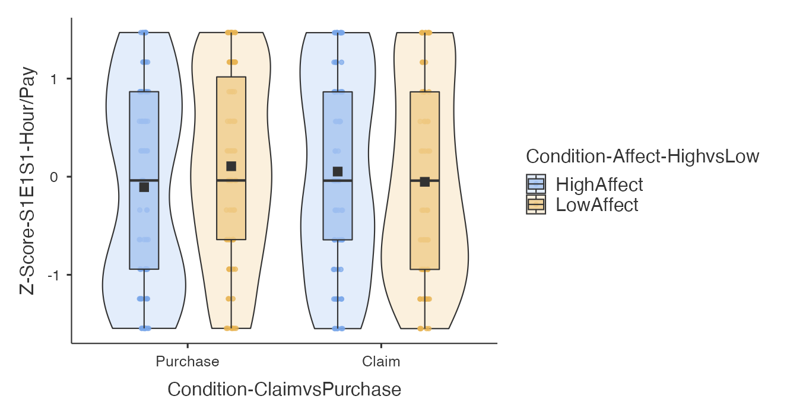
Note. Dependent variables were converted to Z-scores to allow for the comparison between scenarios.
Hours DV in the claim compensation scenario: 11-item scale (0 = 0 hours; 10 = 10 hours or more). Pay DV in the purchase insurance scenario: 11-item scale (0 = $0; 10 = $50 or more).

Figure 4
Study 1 Painting: Likelihood to claim compensation or purchase insurance

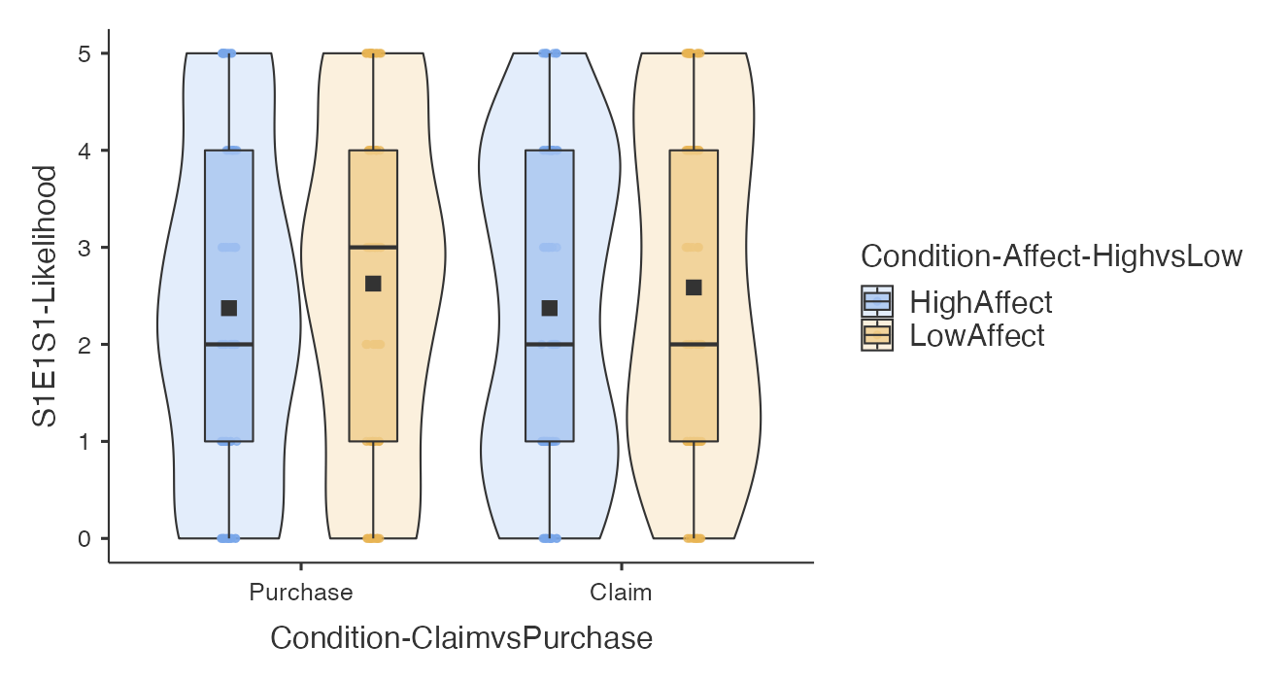
Note. 6-item scale (0 = Definitely not; 5 = Definitely yes).

Figure 5
Study 2 Camera: Willingness to drive/pay for insurance claim/purchase (Hours/pay DV)

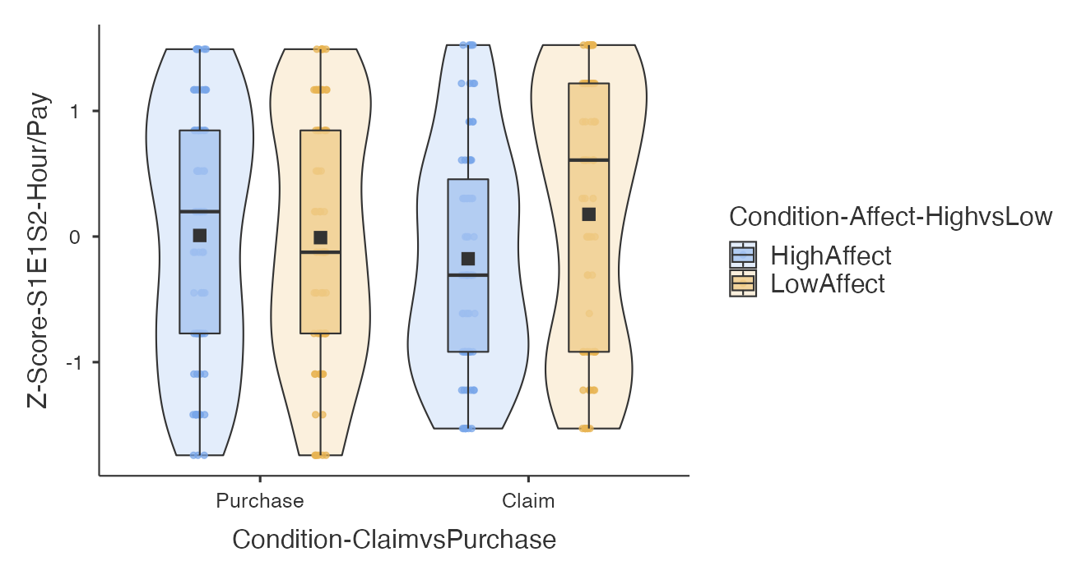
Note. Dependent variables were converted to Z-scores to allow for the comparison between scenarios.
Hours DV in the claim compensation scenario: 11-item scale (0 = 0 hours; 10 = 10 hours or more). Pay DV in the purchase insurance scenario: 11-item scale (0 = $0; 10 = $50 or more).

Figure 6
Study 2 Camera: Likelihood to claim compensation or purchase insurance

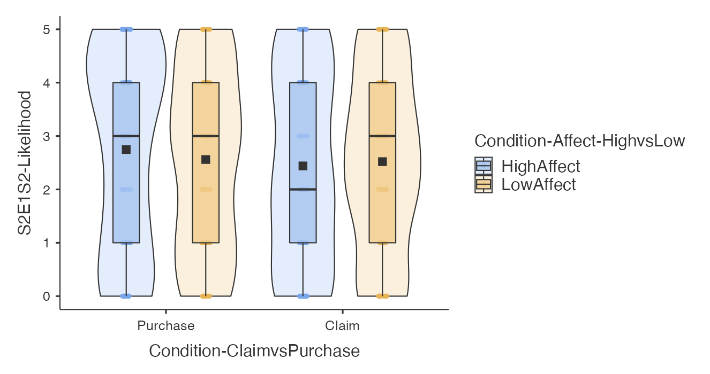
Note. 6-item scale (0 = Definitely not; 5 = Definitely yes).

Figure 7
Study 4 Vase: Willingness to drive/pay for insurance claim/purchase (Hours/pay DV)
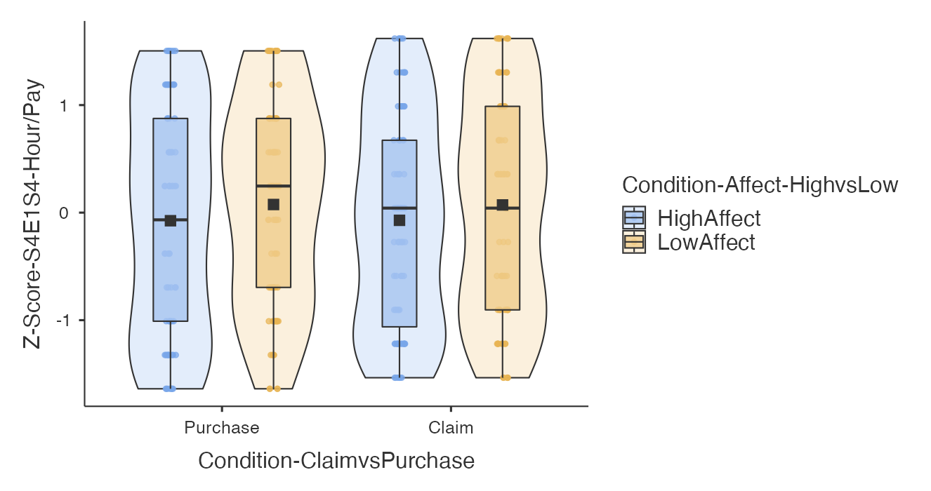Note. Dependent variables were converted to Z-scores to allow for the comparison between scenarios.
Hours DV in the claim compensation scenario: 11-item scale (0 = 0 hours; 10 = 10 hours or more). Pay DV in the purchase insurance scenario: 11-item scale (0 = $0; 10 = $100 or more).

Figure 8
Study 4 Vase: Likelihood to claim compensation or purchase insurance

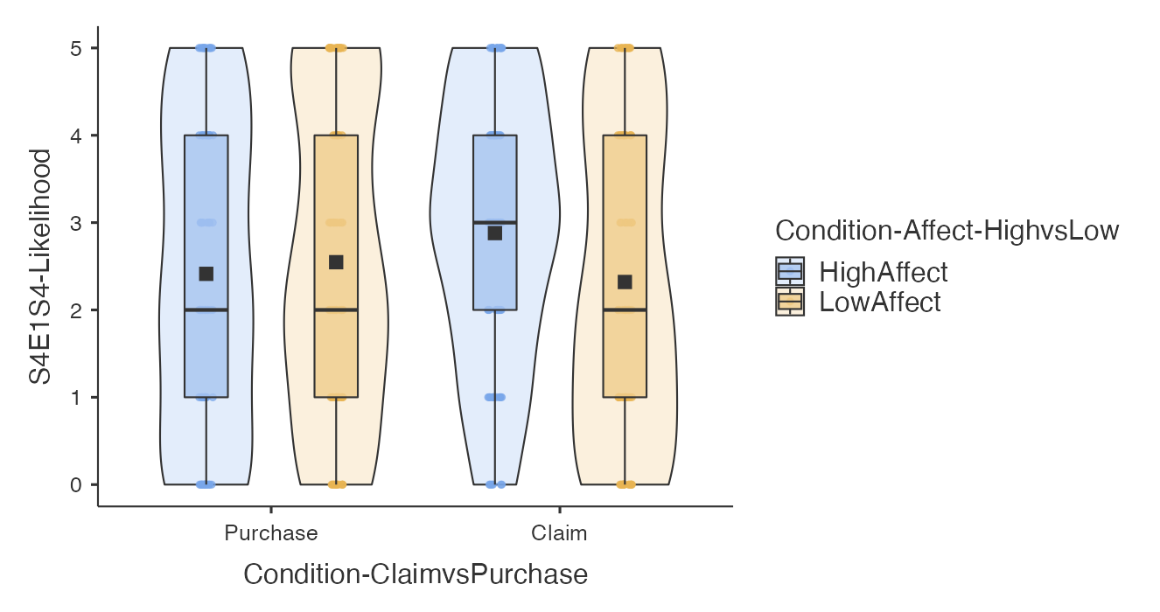
Note. 6-item scale (0 = Definitely not; 5 = Definitely yes).

Figure 9
Study 5 Clock: Willingness to drive/pay for insurance claim/purchase (Hours/pay DV)

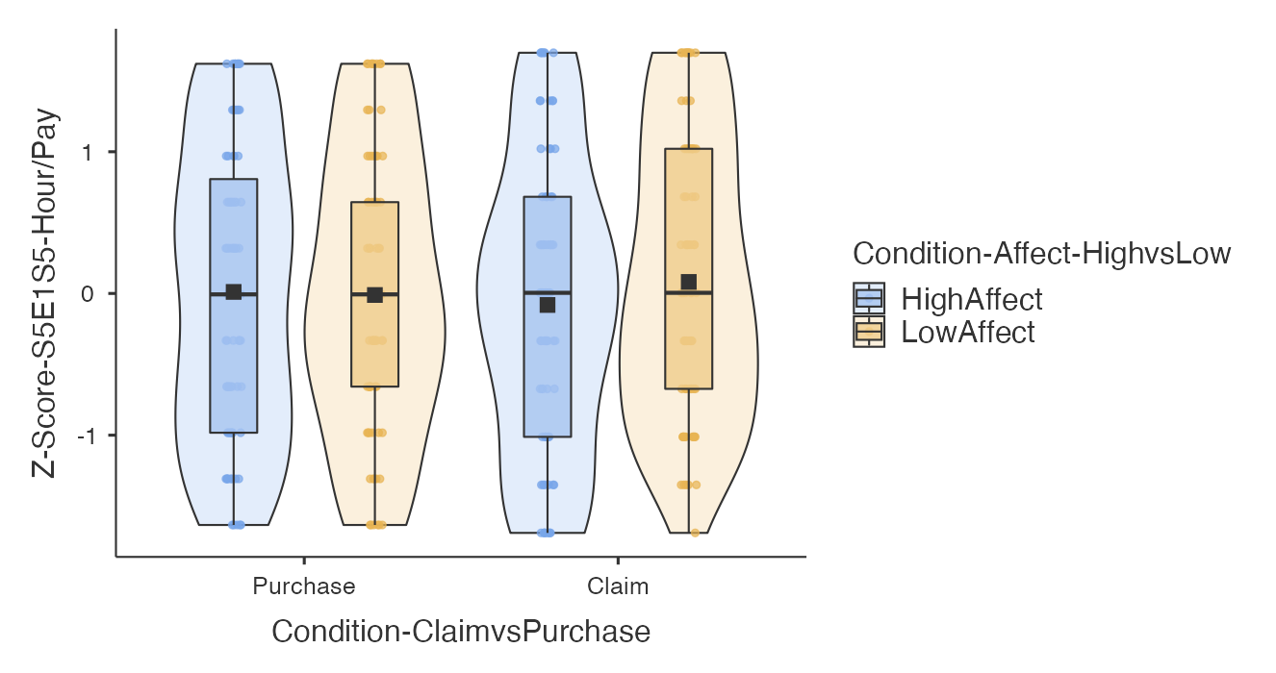
Note. Dependent variables were converted to Z-scores to allow for the comparison between scenarios.
Hours DV in the claim compensation scenario: 11-item scale (0 = 0 hours; 10 = 10 hours or more). Pay DV in the purchase insurance scenario: 11-item scale (0 = $0; 10 = $50 or more).

Figure 10
Study 5 Clock: Likelihood to claim compensation or purchase insurance
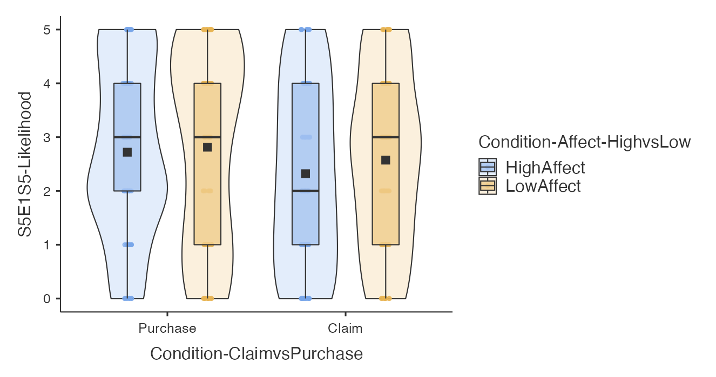Note. 6-item scale (0 = Definitely not; 5 = Definitely yes).

In our replication of Study 1, we found no support for differences in hours willing to spend driving to claim the compensation between high affection and low affection group (High affection : n = 75; M = 0.05, SD = 1.01; Low affection : n = 75; M = -0.05, SD = 0.99; M_{d} = 0.10; t (296) = 0.64, p =.919; d = 0.10, 95% CI [-0.22, 0.43]) (target article: High affection; M = 4.12; Low affection; M = 2.89; M_{d} = 1.23; t(81) = 2.45, p < .025; d = 0.54, 95% CI [0.31, 0.78]).
In our replication of Study 2, we found no support for differences in likelihood to claim the compensation between high affection and low affection group (High affection : n = 75; M = 2.44, SD = 1.78; Low affection : n = 75; M = 2.52, SD = 1.67; M_{d} = -0.08; t(296) = -0.28, p = .992; d = -0.05, 95% CI [-0.37, 0.28]) (target article: High affection; M = 4.18; Low affection; M = 3.58; M_{d} = 0.6; t(87) = 0.18, p <.05; d = 0.12, 95% CI [0.26, 0.70]).
In our replication of Study 4, we found no support for differences between maximum amount willing to pay for the insurance between high affection and low affection group (High affection : n = 75; M = -0.08, SD = 1.05; Low affection : n = 75; M = 0.08, SD = 0.95; M_{d} = -0.15; t(296) = -0.92, p =.793; d = -0.15, 95% CI [-0.47, 0.17]) (target article: High affection; M = $44.8; Low affection; M = $24.76; M_{d} = 20.04; t = 0.41, p < .01; d = 0.82, 95% CI [0.47, 1.16]).
In our replication of Study 5, we found no support for differences in maximum amount willing to pay for the insurance between high affection and low affection group (High affection : n = 75; M = 0.01, SD = 1.03; Low affection : n = 75; M = -0.01, SD = 0.98; M_{d} = 0.02; t (296) = 0.13, p =.999; d = 0.02, 95% CI [-0.30, 0.34]).

Table 14

Summary of statistical tests results of Studies 1, 2, 4 and 5 (Extension DV for Studies 1, 4, and 5 : Likelihood; DV for Study 2 : Hours)
# |  | t | df | p | Mean difference | Cohen's d and CI
5 | Study 1 [Extension]  Between: high vs low affection  DV: likelihood | -0.78 | 296 | [=] .865 | -0.21 | -0.13  [-0.45, 0.19]
6 | Study 2 [Extension]  Between: high vs low affection  DV: z-score of hours | -2.18 | 296 | [=] .132 | -0.35 | -0.36  [-0.68, -0.03]
7 | Study 4 [Extension]  Between: high vs low affection  DV: likelihood | -0.48 | 296 | [=] .964 | -0.13 | -0.08  [-0.40, 0.24]
8 | Study 5 [Extension]  Between: high vs low affection  DV: likelihood | -0.34 | 296 | [=] .987 | -0.09 | -0.06  [-0.38, 0.27]
Note. The tests were to examine the effect #5-8 in Table 6. Two-way ANOVA, N = 300. p = $p_{tukey}$ CI = 95% confidence intervals.

Extensions
We found no support for the affection effect in Studies 1, 4, and 5 with the extension DVs. Exceptionally, we found inconsistent and opposite support of the affection effect in Study 2 with the extension DV. We provided the result summary in Table 14.
In addition, we failed to find support the interaction between affection and type of insurance decision-making with neither the z-score of hours/pay DV (Study 1:$η^{2}$= 0.01, p =.170; Study 2:$η^{2}$= 0.01 , p =.107; Study 4:$η^{2}$= 0.00, p =.973; Study 5:$η^{2}$= 0.00, p =.462) nor the likelihood DV (Study 1:$η^{2}$= 0.00, p =.918; Study 2:$η^{2}$= 0.00, p =.512 Study 4:$η^{2}$= 0.01 , p =0.080 Study 5:$η^{2}$= 0.00, p =.681).
Furthermore, we found no support for the interaction between affection, type of insurance decision-making, and study’s scenario. (Z-score of hours/pay DV: $η^{2}$= 0.01, p =.175 ; Likelihood DV: $η^{2}$= 0.00 , p =.312 ). We provided the result summary of the ANOVA tests in Table 15.

Table 15
Extension Study : Summary of Two-way ANOVA results (Affection x Type of insurance decision-making) and Three-way ANOVA results (Affection x Type of insurance decision-making x Study’s scenario)
# | Contrast
 |  | DV | Condition | df | F | p | eta-  square
9 | All studies [Extension]  Between: High vs Low affection;  Between: Claim vs Purchase;  Within: Study scenario; | Hours/Pay | Study’s Scenario :  S1, S2, S4, and S5 | 3 | 0.00 | 1.000 | 0.00
 |  |  | Study’s Scenario x Affection :  High vs Low | 3 | 0.24 | 0.868 | 0.00
 |  |  | Study’s Scenario x Type :  Claim vs Purchase | 3 | 0.00 | 1.000 | 0.00
 |  |  | Affection x Type x  Study’s Scenario | 3 | 1.65 | 0.175 | 0.01
 |  | Likelihood | Study’s Scenario :  S1, S2, S4, and S5 | 3 | 0.25 | 0.864 | 0.00
 |  |  | Study’s Scenario x Affection :  High vs Low | 3 | 1.10 | 0.350 | 0.00
 |  |  | Study’s Scenario x Type :  Claim vs Purchase | 3 | 0.93 | 0.425 | 0.00
 |  |  | Affection x Type x  Study’s Scenario | 3 | 1.19 | 0.312 | 0.00
9a | Study 1 [Extension]  Between: High vs Low affection;  Between: Claim vs Purchase; | Hours/Pay | Affection :  High vs Low | 1 | 0.22 | 0.639 | 0.00
 |  |  | Type :  Claim vs Purchase | 1 | 0.00 | 1.000 | 0.00
 |  |  | Affection x Type | 1 | 1.89 | 0.170 | 0.01
 |  | Likelihood | Affection :  High vs Low | 1 | 1.44 | 0.230 | 0.00
 |  |  | Type :  Claim vs Purchase | 1 | 0.01 | 0.918 | 0.00
 |  |  | Affection x Type | 1 | 0.01 | 0.918 | 0.00
9b | Study 2 [Extension]  Between: High vs Low affection;  Between: Claim vs Purchase; | Hours/Pay | Affection :  High vs Low | 1 | 2.15 | 0.144 | 0.01
 |  |  | Type :  Claim vs Purchase | 1 | 0.00 | 1.000 | 0.00
 |  |  | Affection x Type | 1 | 2.61 | 0.107 | 0.01
 |  | Likelihood | Affection :  High vs Low | 1 | 0.07 | 0.793 | 0.00
 |  |  | Type :  Claim vs Purchase | 1 | 0.73 | 0.394 | 0.00
 |  |  | Affection x Type | 1 | 0.43 | 0.512 | 0.00
9c | Study 4 [Extension]  Between: High vs Low affection;  Between: Claim vs Purchase; | Hours/Pay | Affection :  High vs Low | 1 | 1.62 | 0.205 | 0.01
 |  |  | Type :  Claim vs Purchase | 1 | 0.00 | 1.000 | 0.00
 |  |  | Affection x Type | 1 | 0.00 | 0.973 | 0.00
 |  | Likelihood | Affection :  High vs Low | 1 | 1.17 | 0.280 | 0.00
 |  |  | Type :  Claim vs Purchase | 1 | 0.37 | 0.543 | 0.00
 |  |  | Affection x Type | 1 | 3.09 | 0.080 | 0.01
9d | Study 5 [Extension]  Between: High vs low affection;  Between: Claim vs Purchase; | Hours/Pay | Affection :  High vs Low | 1 | 0.37 | 0.543 | 0.00
 |  |  | Type :  Claim vs Purchase | 1 | 0.00 | 1.000 | 0.00
 |  |  | Affection x Type | 1 | 0.63 | 0.462 | 0.00
 |  | Likelihood | Affection :  High vs Low | 1 | 0.79 | 0.373 | 0.00
 |  |  | Type :  Claim vs Purchase | 1 | 2.71 | 0.101 | 0.01
 |  |  | Affection x Type | 1 | 0.17 | 0.681 | 0.00

Note. The ANOVA tests were to examine the effect #9, #9a - 9d in Table 6. N = 300, df = Degree of Freedom, F = F-statistic, p = p-value

Exploratory analyses

Correlations between dependent variables
[Planned exploratory analyses to be completed in Stage 2 following data collection.]

Floor and ceiling effects and DV sensitivity
[Planned exploratory analyses to be completed in Stage 2 following data collection.]

Outlier and exclusion analyses (for failed replication hypotheses)
[Planned outlier and exclusion analyses to be completed in Stage 2 following data collection in case of failed support for replication hypotheses. Alpha threshold set to .005]

Order effects
[Planned order effect analyses to be completed in Stage 2 following data collection in case of failed support for replication hypotheses. Alpha threshold set to .005]

Complementary Bayesian analyses (for failed replication hypotheses)
[Please note that the Complementary Bayesian analyses is only to be completed in Stage 2 following data collection in case of failed support for replication hypotheses]

Differences between the scenarios
[In case some of the studies are supported whereas others do not: We will report differences between scenarios, with a special focus on differences between the Study 4 vase that was $200 compared to Studies 1, 2, and 4 that were $100, and between the Study 2 camera that explicitly noted 4 hours claim time versus the rest that did not indicate number of hours.]

Discussion
[To be completed in Stage 2 following data collection]

[Planned discussion (following feedback from reviewer Dr./Prof. Bence Palfi: The affection manipulations were a bit different between the scenarios and sometimes with no clear contrast between the high and low affection conditions (e.g., liked vs. not particularly crazy, and fell in love with vs. don’t have any special feeling). We will discuss ways to further examine such contrasts, and also discuss high versus low affect versus high positive affect versus high negative affect versus no affect.]
[Planned discussion (following feedback from reviewer Dr./Prof. Bence Palfi: Discuss the possibility of demand effects in the target’s design, reasons why and why not this may be the case (see reply to decision letter), and taking indirect measures to try and reassure readers (examining the funneling section).]
[Planned discussion based on exploratory analyses for differences between the studies, discussing the differences in the vase scenario being $200 and the camera scenario setting processing hours to 4, and possible implications and future directions.]

Conclusion

References
Aseervatham, V., Jaspersen, J. G., & Richter, A. (2015). The affection effect in an incentive compatible insurance demand experiment. Economics Letters, 131, 34-37.
Brandt, M. J., IJzerman, H., Dijksterhuis, A., Farach, F. J., Geller, J., Giner-Sorolla, R., Grange, J. A., Perugini, M., Spies, J. R., & van ’t Veer, A. (2014). The Replication Recipe: What makes for a convincing replication? Journal of Experimental Social Psychology, 50, 217–224. https://doi.org/10.1016/j.jesp.2013.10.005
Hsee, C. K., & Kunreuther, H. C. (2000). The Affection Effect in Insurance Decisions. Journal of Risk and Uncertainty, 20(2), 141–159. https://doi.org/10.1023/A:1007876907268
Kunreuther, H. C., Pauly, M. V., & McMorrow, S. (2013). Insurance and behavioral economics: Improving decisions in the most misunderstood industry. Cambridge University Press.
Lazarus, R. S. (1991). Emotion and adaptation. Oxford University Press.
LeBel, E. P., McCarthy, R. J., Earp, B. D., Elson, M., & Vanpaemel, W. (2018). A unified framework to quantify the credibility of scientific findings. Advances in Methods and Practices in Psychological Science, 1, 389-402.
LeBel, E. P., Vanpaemel, W., Cheung, I., & Campbell, L. (2019). A brief guide to evaluate replications. Meta Psychology, 3, 1-9. DOI: 10.15626/MP.2018.843
Lerner, J. S., Han, S., & Keltner, D. (2007). Feelings and Consumer Decision Making: Extending the Appraisal-Tendency Framework. Journal of Consumer Psychology, 17(3), 181–187. https://doi.org/10.1016/S1057-7408(07)70027-X
Litman, L., Robinson, J., & Abberbock, T. (2017). TurkPrime. com: A versatile crowdsourcing data acquisition platform for the behavioral sciences. Behavior Research Methods, 49(2), 433-442.

Open Science Collaboration. (2015). Estimating the reproducibility of psychological science. Science, 349(6251), aac4716.
Nosek, B. A., Hardwicke, T. E., Moshontz, H., Allard, A., Corker, K. S., Dreber, A., ... & Vazire, S. (2022). Replicability, robustness, and reproducibility in psychological science. Annual Review of Psychology, 73(1), 719-748.
Petrov, N., Chan, Y., Lau, C., Kwok, T., Chow, L., Lo, W., Song, W., & Feldman, G. (2023). Comparing time versus money in sunk cost effects: Replication Registered Report of Soman (2001). Peer Community In Registered Reports. DOI 10.17605/OSF.IO/PM264 Retrieved from https://osf.io/pm264/
Raghunathan, R., & Pham, M. T. (1999). All Negative Moods Are Not Equal: Motivational Influences of Anxiety and Sadness on Decision Making. Organizational Behavior and Human Decision Processes, 79(1), 56–77. https://doi.org/10.1006/obhd.1999.2838
Slovic, P., Finucane, M. L., Peters, E., & MacGregor, D. G. (2007). The affect heuristic. European Journal of Operational Research, 177(3), 1333-1352.
Vonasch, A. J., Hung, W. Y., Leung, W. Y. M., Nguyen, A. T. B., Chan, S., Cheng, B. L., & Feldman, G. (2023). "Less is better" in separate evaluations versus" More is better" in joint evaluations: Mostly successful close replication and extension of Hsee (1998). Collabra:Psychology. DOI 10.17605/OSF.IO/9UWNS Retrieved from https://osf.io/9uwns/
Xiao, Q., Yeung, S. K., Dunleavy, D. J., Röseler, L., Elsherif, M., & Feldman, G. (2023) Effect sizes and confidence intervals guide. DOI: 10.17605/OSF.IO/D8C4G . Retrieved from: https://osf.io/d8c4g/
Yeung, S. K., & Feldman, G. (2022). Revisiting the Temporal Pattern of Regret in Action Versus Inaction: Replication of Gilovich and Medvec (1994) With Extensions Examining Responsibility. Collabra: Psychology, 8(1). https://doi.org/10.1525/collabra.37122
Zhu, M. & Feldman. G. (2023). Revisiting the links between numeracy and decision making: Replication Registered Report of Peters et al. (2006) with an extension examining confidence. Collabra:Psychology. Retrieved from https://osf.io/62wqb. DOI: 10.17605/OSF.IO/4HJCK
Zwaan, R. A., Etz, A., Lucas, R. E., & Donnellan, M. B. (2018). Making replication mainstream. The Behavioral and Brain Sciences, 41, 1–e120. https://doi.org/10.1017/S0140525X17001972

