Revisiting the Psychology of Waste:
Replication and extensions Registered Report of Arkes (1996) [Stage 1]

Zijin (Cora) Zhu
ORCID: 0009-0008-4541-8634
OSF: https://osf.io/vgtkf/
Department of Psychology, University of Hong Kong, Hong Kong SAR
corazhu@connect.hku.hk ; corazhuzijin@gmail.com
^Gilad Feldman
OCRID: 0000-0003-2812-6599
Department of Psychology, University of Hong Kong, Hong Kong SAR
gfeldman@hku.hk ; giladfel@gmail.com

^Corresponding author

Author bios:
Zijin Zhu was a thesis student at the University of Hong Kong during the academic year 2023-4.
Gilad Feldman is an assistant professor with the University of Hong Kong psychology department. His research focuses on judgment and decision-making.

Declaration of Conflict of Interest:
The author(s) declared no potential conflicts of interests with respect to the authorship and/or publication of this article.

Financial disclosure/funding:
The project is supported by the University of Hong Kong Teaching Development Grant.

Authorship declaration:
Zijin Zhu conducted the project as part of her thesis in psychology.
Gilad Feldman guided the project, supervised each step in the project, ran data collection, and edited the manuscript for submission.

Corresponding author
Gilad Feldman, Department of Psychology, University of Hong Kong, Hong Kong SAR; gfeldman@hku.hk ; 0000-0003-2812-6599

Rights:
CC BY or equivalent license is applied to the AAM arising from this submission. (clarification)

Citation of the target research article:
Arkes, H. R. (1996). The psychology of waste. Journal of Behavioral Decision Making, 9(3), 213-224.

Acknowledgements (with ORCID)

Contributor Roles Taxonomy
Role | Cora Zhu | Gilad Feldman
Conceptualization | X | X
Pre-registration | X | X
Data curation |  | X
Formal analysis | X
Funding acquisition |  | X
Investigation | X
Pre-registration peer review / verification |  | X
Data analysis peer review / verification |  | X
Methodology | X
Project administration |  | X
Resources |  | X
Software | X
Supervision |  | X
Validation |  | X
Visualization | X
Writing-original draft | X
Writing-review and editing |  | X

PCIRR-Study Design Table
Question | Hypothesis | Sampling plan | Analysis plan | Statistical tests rationale | Interpretation given different outcomes | Theory affected by the outcomes
Does perceived waste (lost opportunity to save) impact the decision to make a purchase? | People perceive those who rejected an opportunity to save on a purchase as less willing to make the purchase. | See power and sensitivity analyses section.  Conducted analyses of original effects with boost using small-telescopes approach (Simonsohn, 2015).  Recruiting 660 US American participants online on Prolific | Chi-squared test | This is a replication.  We follow the statistical analyses of the target article. | Based on the criteria used by Lebel et al. (2019)  We examine the replicability of the findings of Arkes (1996) and support for our suggested extensions. | Classic theory: People only care about utility (and should not care about perceived waste)  vs.  Target article’s wastefulness theory: People compromise utility maximization to avoid appearing wasteful.
Does perceived waste (less utilization of a previous purchase) impact the decision to make a purchase? | Having purchased an old program, people are more willing to purchase a new program, when they can receive a rebate on the old purchase compared to when they cannot. |  | Chi-squared test
Does perceived waste (inability to reutilize an abandoned failing project) impact the decision to make a purchase? | People are more likely to escalate commitment to a losing project when abandoning the project means foregoing any utility that goes beyond mere parts. |  | Chi-squared test
Do people consider waste or utility maximization as most important in their decision making? | Exploratory competing hypotheses (see Table 1) |  | ANOVA (1) and Mixed ANOVA (2-3). | 1: 4 within  2-3: 2 between, 4 within
How is wastefulness associated with willingness to act? | There is a negative association between wastefulness and willingness to engage in behaviors. |  | Paired (1) and Welch t-tests (2-3) | 1: 2 within.  2-3: 2 between.
What is the degree of perception among individuals regarding the wastefulness exhibited in a particular behavior? | Individuals are likely to perceive greater wastefulness in behaviors intentionally designed to appear wasteful. |  | Paired t-test (1) and Mixed ANOVA (2-3). | 1: 2 within  2-3: 2 between, 2 within

Abstract
[IMPORTANT: Abstract, method, and results were written using a randomized dataset produced by Qualtrics to simulate what these sections will look like after data collection. These will be updated following the data collection. For the purpose of the simulation, we wrote things in past tense, but no pre-registration or data collection took place yet.]

Arkes (1996) demonstrated a phenomenon of wastefulness avoidance, showing that people may compromise their own self-interest to avoid appearing wasteful. In a Registered Report experiment with a Prolific sample (N = 600), we conducted a replication and extensions of Studies 1, 2, and 3 from Arkes (1996). [The following findings are concluded from simulated random noise and will be updated after data collection.] We [found/failed to find] empirical support for making non-wasteful decisions in the movie package scenario in Study 1 (χ² = X.XX, 95% CI [X.XX, X.XX]), tax program scenario in Study 2 (χ² = X.XX, 95% CI [X.XX, X.XX]), and tent project scenario in Study 3 (χ² = X.XX, 95% CI [X.XX, X.XX]). Extending the replication, we added reasons for making economic decisions, willingness, and perceived wastefulness as extensions and [found/did not find support…]. Extending the replication, we added [...] and [found/did not find support…]. Overall, we conclude that …. Materials, data, and code are available on: https://osf.io/vgtkf/
Keywords: wastefulness; avoidance; bias; signal; judgment and decision making; registered report; replication; sunk cost effect; outcome bias

Revisiting the Psychology of Waste:
Replication and extensions Registered Report of Arkes (1996) [Stage 1]
[IMPORTANT: Section is written in the past tense to simulate what the manuscript will look like after data collection, yet no pre-registration or data collection took place yet.]

Background
Research by Arkes (1996) demonstrated that people have an aversion to wastefulness, and that they may even make choices that compromise their own self-interest to avoid waste and appearing wasteful.
As an example, imagine a scenario in which Mary visited an amusement park and had the option of buying a single ticket or a season pass. Given that she only planned to visit once that year, she chose the cheaper single ticket option, which best aligned with her economic interest at that point in time. However, later, she was unexpectedly invited to join to go to the park again in the same year, and therefore, faces a dilemma - She would have been able to visit the park for free had she spent an extra small amount to get the season pass, and so now buying the extra ticket feels to her and appears to others as wasteful. This example shows that people may consider waste and the appearance of wastefulness when they make decisions.
Arkes (1996) reported three studies testing different instances of wastefulness. The first study examined overspending, in which an individual faces a dilemma of whether to spend more if it appears wasteful, much like our opening example. The second study examined the definition concerning underutilization, in which a previously purchased item has not been fully utilized. The third study made the connection between wastefulness and the classic sunk cost effect (or, “escalation of commitment”), wherein withdrawing from a course of action with time, money, or effort sunk costs feels wasteful and therefore avoided.
We conducted a replication and extension Registered Report of Arkes (1996) with the following main goals. Our first goal was to conduct an independent close replication of a classic article demonstrating the phenomenon of avoiding the appearance of wastefulness in decision-making, following recent growing recognition of the importance of reproducibility and replicability in psychological science (e.g., Nosek et al., 2022; Zwaan et al., 2018). Our secondary goal was to build on the target’s design and add extensions to refine the target’s methods and gain further insights. We added three extensions examining: 1) whether people indicate waste as a factor impacting their decisions in these situations, 2) a continuous measure of willingness to engage in behaviors to supplement the target’s dichotomous choice measure, 3) the degree to which participants perceive the different options as wasteful, serving as the missing manipulation check .
We begin by introducing the chosen article for replication - Arkes (1996). We then discuss our motivations for the current replication and review the article by Arkes (1996) and the theory and hypotheses. Finally, we outline our chosen studies for replication from the target article, the target’s experimental design, and our adaptations and extensions.

Choice of article for replication: Arkes (1996)
We chose Arkes (1996) based on several factors: its academic and practical impact, the potential for improvements in methodology and extensions to gain additional insights, and the absence of direct replications.
The article has had a significant impact on scholarly research in the areas of judgment and decision-making and behavioral economics. At the time of writing (January, 2024), the article had 336 Google Scholar citations. In addition, Arkes's (1996) work on waste aversion has important practical implications, such as in the domains of consumer decision-making (Lin & Chang, 2017) and in the links to other classic phenomena such as the sunk cost effect (Arkes et al., 1997) and “less is more” (e.g., Bolton & Alba, 2012).
The studies had very small samples (Studies 1, 2, and 3 had 48, 55, and 55 participants, respectively) and the findings were reported briefly and were mostly descriptive, with one of the studies not reporting any statistical tests. This is understandable given the decision-making literature at the time, yet pointing to the need to revisit and reproduce the procedures, analyses, and findings, to allow others to assess and better build on these findings. To our knowledge, there are currently no published direct independent replications of this article.
Going beyond the direct replication, the straightforward design of the studies allowed for the inclusion of extensions, such as: 1) a needed manipulation check of perceived level of wastefulness, 2) a quantitative analysis of the reasons underlying people’s decision-making (replacing the qualitative approach in the target article), and 3) a continuous preference scale to complement the original forced choice measure.

Replicating Studies 1, 2, and 3
We aimed to replicate all three studies reported by Arkes (1996). We summarized the setup of Studies 1, 2, and 3, along with the corresponding hypotheses and findings from the target article in Tables 1 and 2. We provided more detailed study design tables of the experiments in Tables 4, 5, and 6.

Study 1: Movie package
Study 1 examined the first concept of wastefulness, namely, spending more than necessary. The hypothesis was that people tend to view those who have passed up a chance to save on a present purchase as less likely to proceed with the purchase.
Arkes (1996) conducted an experiment with 48 university students. The study was centered around a hypothetical scenario involving two individuals, Mr. Munn and Mr. Fry, who had different options for attending a local movie theater. In the scenario, Mr. Munn had the option to purchase a discounted three-pack of tickets for Monday movie nights, but chose to buy individual tickets at $5 each. Mr. Fry, who could only attend on Fridays, did not have the three-pack option and also bought individual tickets. After both men had attended two movies, a schedule change introduced a new movie that both were interested in. The catch was that seeing this new movie would cost the typical $5 for a single ticket, yet if Mr. Munn would have purchased the three-pack, he could have watched it for free without any extra cost. Participants rated which of the two they thought would be more likely to purchase the third ticket and explain their choice in one or two sentences. Their answers were then manually qualitatively coded into several categories of reasons.
The findings were that a majority of participants (70.8%, or 34 out of 48) thought that Mr. Munn would be less likely to purchase the third ticket after initially forgoing the $12 three-pack. The main reasons identified were "wasting or losing money," "expression of negative emotions," and "​​anticipated enjoyment of the movie is worth the price."

Study 2: Tax program
The second study in Arkes (1996) demonstrated underutilization, as an additional kind of wastefulness. The idea was that individuals who bought software which has become outdated would be more inclined to invest in buying a new updated software, if they perceive the new purchase being less wasteful. For example, receiving a rebate for the previous purchase would seem less wasteful, compared to when there is no use for the old software, even when the overall costs are the same, and the actual rebate does not matter other than the perception of waste.
To test this hypothesis, 55 participants were divided into two conditions of underutilization (waste) or not. In a hypothetical scenario they were asked to imagine that they had previously bought a computer program for their income tax calculation. However, due to an annual change in the tax laws, the old purchased program was now obsolete. They then have to decide whether to purchase a new program, priced at $50, and provide reasons for their decision. In the first condition, the old program had no trade-in value. In the second scenario, the company provided a $30 rebate for the old program, which brought down the new program's cost to $50, identical to the cost in the first scenario.
They found that 3 out of 26 subjects (11.5%) in the waste (no rebate) condition chose to buy the program. However, 11 out of 29 subjects (37.9%) in no waste (rebate) condition made the same purchase (difference: χ²(1) = 5.03, p < .05).

Study 3: Tent project
Arkes’s (1996) Study 3 examined the link between perceived waste (or less utility) and the sunk cost effect, suggesting that people are less likely to escalate commitment to a losing course of action when abandoning a project is perceived as wasteful.
A total of 55 participants read a scenario, in which they owned a company that had already invested $40,000 into a tent project that was 90% complete. However, as in classic sunk cost effect scenarios, at that point in time they learn that a competitor introduced a superior and cheaper alternative. Participants decided between investing more to complete the project or abandoning it for $5,000. In one condition, abandoning the project means selling it for scraps (no utilization). In another condition, abandoning the project means selling it to a roofer who can utilize it beyond its mere parts, therefore appearing to have more utility and less waste.
The findings were that in the no utility condition, 23 out of 26 participants (88%) chose to continue the project and escalate their commitment to a losing course of action. In contrast, in the utility condition, only 19 out of 26 participants (66%) chose to continue the project (χ²(1) = 4.15, p < .05).

Table 1
Arkes (1996) Studies 1, 2 and 3: Summary of hypotheses and findings
S | Scenario |  | Hypothesis | Findings of the Target article
1 | Constrained to specific movie nights: Mr. Munn (3-movie bundle possible; bought single tickets); Mr. Fry (No movie bundle possible; bought single tickets). Mr. Munn chose individual tickets ($5 each) over a discounted three-pack ($12). After two movies, a schedule change introduces a new movie in which both are interested. |  | People perceive those who rejected an opportunity to save on a purchase as less willing to make the purchase. | 70.8% of participants (34 out of 48) thought Mr. Munn will be less likely to purchase the third ticket after initially forgoing the $12 three-pack.
2 | Tax program bought in the previous year becomes worthless due to changes in tax laws, participants need to decide whether to purchase a new program.  In one condition participants receive a rebate for the old program, those in the other condition do not. Both spend the same amount. |  | Having purchased an old program, people are more willing to purchase a new program, when they can receive a rebate on the old purchase compared to when they cannot. | Purchased new program  Waste (no rebate) condition: 11.5% (3 of 26).  No waste (rebate) condition:  37.9% (11 of 29).  χ²(1) = 5.03, p < .05
3 | With the tent project 90% complete (cost $40,000), a competitor offers a better alternative. Decision: Invest more to complete the project or abandon it for $5,000. In one condition, the abandoned project is sold for scrap (no utilization), in another, it’s sold to another roofer who can utilize it. |  | People are more likely to escalate commitment to a losing project when abandoning the project means foregoing any utility that goes beyond mere parts. | Escalated commitment:  No utility: 23 of 26 (88%)  Utility:19 of 26 (66%)  χ²(1) = 4.15, p < .05
Extensions |  | Hypothesis
1-3 | Reasons | Exploratory competing hypotheses:  Rational: People rate utility as the most important reason.  Non rational: People rate utility similarly or lower than other reasons.  Waste: People rate waste as higher than utility.  Waste-top: People rate waste as the most important reason.  Interaction: We expected bigger emphasis on waste in the waste condition.
 | Willingness | There is a negative association between perceived wastefulness of a certain action and the willingness to engage in that action.
 | Perceived wastefulness (manipulation check) | Wasteful behaviors (Mr. Munn, no rebate, no utilization) are perceived as more wasteful compared to the alternative behaviors (Mr. Fry, rebate, utilization).

Table 2
Arkes (1996) Studies 1, 2 and 3: Summary of findings
Study 1 (N=48)
Dependent Variables | / | df | p | Effect size | CIL | CIH
The likelihood of purchasing the third ticket |  | / | <.05 | Cohen’s h/w = 0.43 | 0.03  0.25 | 0.83  1.00
Study 2 (N=55)
Dependent Variables | χ2 | df | p | Effect size | CIL | CIH
Choice of whether to purchase a new package | 5.03 | 1 | <.05 | Cohen’s w = 0.27 | 0.00 | 0.55
Study 3 (N=55)
Dependent Variables | χ2 | df | p | Effect size | CIL | CIH
Choice of whether to continue a failing project | 4.15 | 1 | <.05 | Cohen’s w = 0.23 | 0.00 | 0.52
Note. CIL = lower bounds for CIs. CIH = higher bounds of CIs. Effect sizes for all three Studies and confidence intervals for Studies 2 and 3 were not reported in the target article and are based on our reconstructed calculations. In Study 1 first line CIs are for Cohen’s h 2x2, and second line CIs are for Cohen’s w 3x2. See accompanying Rmarkdown file for details and calculations.

Extensions
We aimed to extend the replication study by examining the reasons, willingness, and perceived wastefulness, and included extensions in the experiments’ design tables Table 4, 5, and 6.

Reasons
We aimed to quantitatively examine the determinants underpinning individuals’ decision-making processes within the context of avoiding the appearance of wastefulness. In the original Studies 1 and 2, Arkes (1996) asked participants to write down their reasons for their choices. In Study 1, Arkes, along with two independent raters, analyzed and categorized the written rationales. They excluded two responses that opted for Mr. Munn (3-movie bundle possible; bought single tickets) being more likely to buy the extra ticket, as one subject “obviously misunderstood the scenario,” and the other response was incomprehensible. They then identified four categories. In Study 2, Arkes did not analyze the answers because they were “theoretically uninformative,” without providing any examples. Nonetheless, the answers provided valuable insights into how people interpreted the scenarios and made decisions. Apart from the hypothesized reason of avoiding the appearance of wastefulness, it also helped explain if people made other choices.
Given that the coding procedure was not provided and the process involved a qualitative process with subjective ratings that may result in very different insights that would be challenging to compare to the original, we decided to instead build on the target’s design and categorization, and switch from an open qualitative design to a fixed quantitative design. This also allowed us to implement this extension in all scenarios.
For the list of rated reasons, we included the first three reasons mentioned in the original Study 1. We derived the fourth reason from Study 3, which examined the sunk cost effect. This reason was added to explore the influence of past behavior and decisions on current choices, as individuals might prefer to be consistent with their previous actions, especially when faced with sunk costs. This reason was applicable to all three studies as each contains some form of an initial decision with a change in the situation.
According to the rational agent model in neo-classical economics the top reason would be to maximize utility. Given that the core argument of the target article is that people have considerations of waste that sometimes conflict with maximization of utility, this means that waste, emotions, or past behavior may be rated as higher priority than utility maximization. We therefore had competing hypotheses: The neo-classical hypothesis is that utility maximization would be the strongest reason, the target article’s hypothesis given the emphasis on waste would be that ratings of waste reason would be higher than that of utility maximization, and two additional possibilities are hypotheses countering the neo-classical agent model that past behavior or emotions would be higher than utility maximization. We planned an exploratory analysis comparing the different reasons, and expected that (if waste indeed has an impact on decisions) people would rate waste as higher than utility. We outlined the competing hypotheses in Table 1.

Willingness (to complement the forced choice)
The original studies by Arkes (1996) focused on binary choices, without delving into the nuances of the decision-making process. We added an extension to examine evaluations of the described agents’ willingness towards the different choices on a continuous scale, to go beyond the forced choice to examine how participants perceive each choice, allowing for a more nuanced understanding quantifying the extent to which one option is preferred over the other.
We hypothesized that individuals are more willing to choose behaviors perceived as less wasteful. This extension was applicable to all three studies in the original research by Arkes and allowed us to examine varying degrees of willingness to avoid wasteful behavior.

Perceived wastefulness (needed manipulation check)
In this extension, we aimed to examine the extent to which individuals perceive wastefulness in behaviors presented in the study scenarios. Given the inherent subjectivity of the concept of wastefulness and the potential for diverse interpretations, it is crucial to ensure that the different conditions manipulating wastefulness are indeed working as intended. When reproducing these scenarios, we were concerned about a possible discrepancy between the Arkes’s (1996) conceptualization of the concept of wastefulness, and the laypersons’ perspective of wastefulness, given that there were no pre-tests reported and no included manipulation checks. As an exploratory direction, we also were interested in the differences in the strength of the wastefulness manipulations across the different scenarios, and the association between manipulation strength (as indicated by the manipulation checks) with the wastefulness avoidance effect.

Pre-registration and open-science
We provided all materials, data, and code on https://osf.io/gf8rc/ . [To be updated in Stage 2:] This project received Peer Community in Registered Report Stage 1 in-principle acceptance (ENTER LINK AFTER IPA); (ENTER LINK AFTER IPA), after which we created a frozen pre-registration version of the entire Stage 1 packet (ENTER LINK AFTER IPA) and proceeded to data collection.
All measures, manipulations, and exclusions conducted for this investigation are reported, and data collection was completed before analyses. This Registered Report was written using the Registered Report template by Feldman (2023).

Method
[IMPORTANT: Method and results were written using a randomized dataset produced by Qualtrics to simulate what these sections will look like after data collection. These will be updated following the data collection. For the purpose of the simulation, we wrote things in past tense, but no pre-registration or data collection took place yet.]

Power and sensitivity analyses
We calculated effect sizes (ES) and power based on the statistics reported in the target article. We then conducted a power analysis based on the smallest effect size of interest. Effect size and power were all calculated with the help of a guide by Jané et al. (2024) and R (Version 4.3.2; R Core team, 2023) using package “pwr” (Version 1.3-0; Champely, 2020) and G*Power 3.1 (Faul et al., 2007) for the factors that the authors found support for in the target article (flagged as significant results).
We calculated the effects in Study 1 to be Cohen’s h = 0.43 [0.03, 0.83] with a required sample size of 70, effect in Study 2 to be Cohen’s w = 0.27 [0.00, 0.55] with a required sample size of 179, and effect in Study 3 as Cohen’s w = 0.23 [0.00, 0.52], with a required sample size of 240. We aimed for 95% power with an alpha of .05 across all analyses
Rounding up to the highest minimum sample size required for three studies, we concluded that the minimum required sample size was 240 participants in total.‎ We provided more information regarding these calculations in an accompanying Rmarkdown file on the OSF and “Power analysis of the target article effects to assess required sample for replication” subsection of the supplementary materials.
Given the likelihood that the target article’s effects are overestimated, we used the “small-telescope” approach (Simonsohn, 2015), aiming for enough power to detect effects much weaker than those reported by the original study (d_{33%}) with the general rule of thumb to multiply the estimated required sample of 240 by 2.5, even if meant for other designs. This resulted in a sample of 600, more than 10 times bigger than the largest sample in the target article, and more than 3 times bigger than all the samples combined. As a reminder, to allow for an easy comparison, the target article Study 1 had 48 participants, and Study 2 and Study 3 had 55 participants.
Accounting for our integrated design, and allowing for the potential of additional analyses, we aimed for a larger total sample of 660 participants. A sensitivity analysis using GPower (Faul et al., 2007) indicated that a sample of 600 would allow the detection of effect size Cohen’s h = 0.20 for z test for Study 1 (95% power, alpha = 5%, two-tail) and effect size Cohen’s w = 0.15 for chi-square tests for both Study 2 and Study 3 (both 95% power, alpha = 5%, one-tail), which are effects much weaker than any of the effects reported in the original.

Participants

[To demonstrate what the results would look like after data collection we simulated a dataset of 600 participants using Qualtrics and reported our analyses below based on that dataset. Results will later be updated in full to a sample of 600 and the real data.]
[Stage 1: We will first pretest the survey duration and technical feedback with 30 participants to make sure our time run estimate was accurate and adjusted pay as needed, the data of the 30 participants will not be analyzed in that stage other than to assess survey completion duration, feedback regarding possible technical issues and payment, and needed pay adjustments. Unless in the case of serious technical issues that affect data quality and require survey modification, these participants will be included in the overall analyses.]
[The assignment pay is based on the federal wage of 7.25USD/hour, per minute, so for example 5-8 minutes survey would be paid 1 USD per participant. For those pretest participants, if survey duration was longer than expected, they were paid a bonus as pay adjustment.]

We recruited a total of 600 US Americans on Prolific (M_{age} = 50, SD = 29.3; 144 females, 159 males, 297 others or did not disclose). We summarized a comparison of the target article samples and the replication samples in Table 3. We targeted US Americans using Prolific’s filters. We restricted the location to the US using “standard sample”, we set it to “Nationality: United States”, “Country of birth: United States”, “Minimum Approval Rate: 90, Maximum Approval Rate: 100”, “Minimum Submissions: 50, Maximum Submissions: 100000”.

Table 3
Differences and similarities between the original study and replication
 | Arkes (1996) Study 1 | Arkes (1996) Study 2 | Arkes (1996) Study 3 | US Americans on Prolific
Sample size | 48 | 55 | 55 | 600
Geographic origin | US | US | US | US American
Gender | Not reported | Not reported | Not reported | 159 males,  144 females,  155 other,  142 rather not disclose
Median age (years) | Not reported | Not reported | Not reported | 49
Average age (years) | Not reported | Not reported | Not reported | 50
Standard deviation age (years) | Not reported | Not reported | Not reported | 29.3
Age range (years) | Not reported | About 41 (75%) participants aged between 30-40; About 7 (12.5%) participants aged between 18-22 (typical undergraduate age) | Not reported | 0-100
Medium (location) | Not reported | Not reported | Not reported | Computer (online)
Compensation | Not reported | Not reported | Not reported | Nominal payment
Year | 1996 | 1996 | 1996 | 2024

Design: Replication and Extension
We summarized the experimental designs in Tables 4, 5, and 6. Studies 1, 2, and 3 in the target article were conducted separately with independent samples. We ran the three scenarios together in a single unified data collection - Participants completed all three scenarios in random order. The display of scenarios and conditions was counterbalanced using the randomizer “evenly present” function in Qualtrics.
Scenario 1 had no manipulations, and all participants answered the same questions. In Scenarios 2 and 3, participants were randomly assigned to either the wastefulness or the control condition. All three scenarios were presented in random order, and participants were randomly and evenly assigned to different conditions in Scenarios 2 and 3. This unified design combining replications of several studies into a singular data collection was previously tested successfully in many of the replications and extensions conducted by our team (e.g., Petrov et al., 2023; Vonasch et al., 2023; Yeung & Feldman, 2022; Zhu & Feldman, 2023), and is especially powerful in addressing concerns about the target sample (e.g., naivety and attentiveness) when some studies replicate successfully whereas others do not, as well as in allowing for drawing inferences about links between the different studies and consistency in participants’ responding to similar decision-making paradigms.
[Note: In case we fail to find support for the target article’s hypotheses, we will test for order effects (order as a moderator) and for effects for each scenario when it is displayed first. See “data analysis strategy” section below.] [For review: The Qualtrics survey .QSF file and an exported DOCX file are provided on the OSF folder. A preview link of the Qualtrics survey is provided on:
https://hku.au1.qualtrics.com/jfe/preview/previewId/1d9e5f02-121f-4083-a143-79ee31ad8687/SV_6QIXLrPc6cqrWYu?Q_CHL=preview&Q_SurveyVersionID=current]

Table 4
Scenario 1 (overspending): Replication and extension experimental design (one-sample proportion)
Scenario:
Mr Munn and Mr Fry each live in an apartment near the local movie theater. Mr Munn can go to the movies only on Monday night. Mr Fry can go to the movies only on Friday night. Each movie costs $10, no matter which night it is shown. Each movie generally is shown for a whole week.
Since Monday night is generally a pretty ‘slow’ night at the movies, the manager of the theater offers a package to those who go to the movies on Mondays. Although tickets are $10, the manager will sell a three-pack for $24. The three-pack can be used on any three Mondays during the next month. Mr Munn looks over the schedule for the next month and sees only two movies he is interested in seeing. So he decided not to buy the three-pack. Instead he pays $10 on each of the first two Mondays of the month to see a movie. Mr Fry also pays $10 on each of the first two Fridays of the month to see a movie.
Then there is a change in the schedule. One of the movies that was supposed to come that month cannot be obtained. Instead the manager substitutes a new movie that both Mr Munn and Mr Fry are somewhat interested in seeing. Had Mr Munn bought the three-pack, he could have seen this new movie without paying any more money than the extra $4 he would have needed to buy the $24 three-pack. Since he didn’t buy the three-pack, both Mr Munn and Mr Fry will have to pay $10 to see the new movie.
Dependent variables:
Likelihood of purchasing the third ticket [Replication]
“Will one of the two men be more likely to pay to see the new movie?”
-1 = Mr. Munn (3-movie bundle possible; bought single tickets) will be more likely to pay to see the new movie
0 = They will be equally likely to pay to see the new movie
1 = Mr. Fry (No movie bundle possible; bought single tickets) will be more likely to pay to see the new movie [appearance of waste]
Reasons of predicting likelihood of purchasing the third ticket [Extension]
“To what extent did the following reasons influence your decision?”
Reasons:
- Option chosen minimizes waste
- Option chosen minimizes negative emotions (regret, anger, sadness, shame, etc.)
- Option chosen maximizes value per money spent (benefit, enjoyment, convenience, etc.)
- Option chosen is more consistent with previous behavior and decisions
Scale: 0 = Did not influence at all; 6 = Influenced very much
Willingness for Mr. Munn and Mr. Fry purchasing the additional ticket [Extension]
“How willing do you think Mr. Munn (3-movie bundle possible; bought single tickets) and Mr. Fry (No movie bundle possible; bought single tickets) are to purchase the additional ticket?”
Scale: 0 = Absolutely not willing; 6 = Absolutely willing (two questions, one for each)
Perceived wastefulness for Mr. Munn and Mr. Fry purchasing the additional ticket [Extension]
“How wasteful do you think Mr. Munn (3-movie bundle possible; bought single tickets) would be if he purchased the additional ticket?”
“How wasteful do you think Mr. Fry (No movie bundle possible; bought single tickets) would be if he purchased the additional ticket?”
Scale: 0 = Not at all wasteful; 6 = Very wasteful.
Note. Prices in the replication were doubled to adjust for inflation between the years 1996 and 2024.

Table 5
Scenario 2 (underutilization): Replication and extension experimental design (between-subject)
Scenario:
2A:
It is now possible to buy computer programs that help you calculate your income taxes. Suppose that you have purchased one of the standard tax programs for $50, which is a very good price. This program does all your federal income tax calculations for you, and it even generates the forms you have to send in to the Internal Revenue Service. Suppose you are very pleased with the product.
Now it is one year later, and you have to pay your taxes for this new year. Since the Congress always changes the tax laws every year, you have to buy a new computer program for your federal taxes. The old program you purchased is completely worthless this year. This year the computer program that calculates your federal taxes is being sold with a computer program that does your state taxes. (The package of two programs costs $160, but you can get them on sale for $100.) Since you cannot buy the programs separately, you will have to spend $100 if you want to do your taxes with a computer. Of course, you can save $100 by doing your state and federal taxes by hand without the computer programs.
2B:
Scenario 2B was identical to 2A, except that the bracketed portion of 2A was replaced with the following:
The package of two programs costs $160. However, the money you spent on last year’s program isn’t wasted; the company that sells the programs is offering a $60 rebate to people who bought last year’s federal tax computer program. If you send in your old computer program, they will give you a $60 reduction in the $160 purchase price so that the package of two new programs will cost you only $100.
Waste (no rebate) (2A) condition  Spend $100 on the new tax package (appearance of waste) | No waste (rebate) (2B) condition  Trade in of the old tax program from last year and use a $60 rebate to buy the new tax package at $100
Dependent variables:
Choice of whether to purchase a new package [Replication]
“Would you be willing to spend $100 for the package of two computer programs to do your taxes?”
1 = Yes ; 0 = No
Reasons for choosing whether to purchase a new package [Extension]
“To what extent did the following reasons influence your decision?”
Reasons:
- Option chosen minimizes waste
- Option chosen minimizes negative emotions (regret, anger, sadness, shame, etc.)
- Option chosen maximizes value per money spent (benefit, enjoyment, convenience, etc.)
- Option chosen is more consistent with previous behavior and decisions.
Scale: 0 = Did not influence at all; 6 = Influenced very much
Willingness to purchase new package [Extension]
“How willing are you to purchase the new package for $100?”
Scale: 0 = Absolutely not willing; 6 = Absolutely willing
Perceived wastefulness of purchasing a new tax package [Extension]
“How wasteful do you think it is to purchase a new tax package of $100?”
“How wasteful do you think it is to not purchase a new tax package of $100?”
Scale: 0 = Not at all wasteful; 6 = Very wasteful.
Note. Prices in the replication were doubled to adjust for inflation between the years 1996 and 2024. The target article had slight grammar issues such as “As you many know”, which possibly meant “As you may know”, and reference to a marketing survey. We removed/adjusted those.

Table 6
Scenario 3 (presence of sunk cost): Replication and extension experimental design (between-subject)
Scenario:
As the owner of your own company, you have used $80,000 of your company’s research funds to develop a type of plastic cloth which would be used to manufacture camping tents. This material is very light, so backpackers would find it easy to carry from one campsite to another. Furthermore it is completely waterproof, so it could keep campers dry, no matter how hard it was raining. The best part is that the cloth cannot be punctured. It is so durable that campers could use it without fear of accidentally damaging the tent. When the project is 90% completed, another firm begins marketing a waterproof tent that is made of material that is more durable than the material you have developed. It is also apparent that their tent is much cheaper than the tent you are building, and furthermore, it is much lighter. The question is: should you invest the last 10% of your research funds to finish your tent, or should you just abandon the project?

IV1: Sell to roofer (3A)  Sell the unfinished tent project for $10,000 to the roofer  If you abandon the project, a roofer said that he’d buy all the cloth you’ve developed so far for $10,000. He wants to sew all the tent-sized pieces together into one big tarp. He said this would come in handy as a waterproof tarp to place over roofs after he’s taken old shingles off. If it rains before he gets the new shingles on, the exposed wood on the roof would be protected by the big tarp. Unfortunately you can’t manufacture the cloth in this large size, and nobody wants a tarp of tent-sized pieces sewn together. The roofer can really use the cloth you’ve manufactured so far, however. | IV1: Sell for its scrap value (3B)  Sell the unfinished tent project for its scrap value of $10,000 (appearance of waste)  If you abandon the project, you could sell all the cloth you’ve developed for its scrap value, which is $10,000.
Dependent variables:
Choice of whether to continue a failing project [Replication]
“Please check the option you prefer:”
1 = Invest the last 10% of your research funds to finish your tent (you have invested $80,000) (escalation);
3A - 0 = Abandon the project and sell the tent material to the roofer for $10,000 (de-escalation)
3B - 0 = Abandon the project and sell for its scrap value of $10,000
Reasons for choosing whether to continue the project [Extension]
“To what extent did the following reasons influence your decision?”
Reasons:
- Option chosen minimizes waste
- Option chosen minimizes negative emotions (regret, anger, sadness, shame, etc.)
- Option chosen maximizes value per money spent (benefit, enjoyment, convenience, etc.)
- Option chosen is more consistent with previous behavior and decisions.
Scale: 0 = Did not influence at all; 6 = Influenced very much
Willingness to continue the project [Extension]
“How willing are you to invest the last 10% of your research funds to finish the tent project, in which you have invested $80,000?”
Scale: 0 = Absolutely not willing; 6 = Absolutely willing
Perceived wastefulness of abandoning the project [Extension]
“How wasteful do you think it is to abandon the tent project?”
“How wasteful do you think it is to finish your project?”
Scale: 0 = Not at all wasteful; 6 = Very wasteful.
Note. Prices in the replication were doubled to adjust for inflation between the years 1996 and 2024.

Procedure
We reconstructed the target’s stimuli and adjusted it to an online Qualtrics survey based on the information provided in the article.
Participants first indicated their consent, with four questions confirming their eligibility, understanding, and agreement with study terms, which they must answer with a “yes” and required responses in order to proceed to the study. Three of the four questions also served as attention checks, with a randomized display order of the options (yes, no, not sure) - 1) “Are you able to pay close attention to the details provided and carefully answer questions that follow?”, 2) “Do you understand the study outline and are willing to participate in a survey with comprehension checks?”, and 3) “Are you a native English speaker born, raised, and currently located in the US?”. These were followed by writing or copy-pasting a statement indicating that they understand and agree and terms, which participants had to enter correctly in order to proceed, with as many attempts as needed. Upon completion of these steps, participants proceeded to begin the survey.
Participants then answered Scenarios 1, 2, and 3, presented in random order. For Scenarios 2 and 3, they were randomly assigned to one of the two experimental conditions (waste versus non-waste) and responded to the assigned conditions accordingly.
We also added two multiple-choice comprehension checks presented after the scenario description which participants had to answer correctly before proceeding to the dependent measures. If answered incorrectly, participants are asked to re-examine their responses with as many attempts as needed until they answer correctly. This procedure was designed to signal the importance of carefully reading and comprehending the scenario, and to ensure that the participants read, processed, and understood the key piece of information in the scenarios. We note that this is a deviation from the target’s procedure and was meant to ensure that participants understand the crucial scenario information and know what they are rating.
On the following page, participants encountered a reminder of the scenario and then indicated their decision-making choice (replication). They then proceeded to the next page for extensions. They then again read a reminder of the scenario and indicated their choices and ratings for reasons, willingness, and perceived wastefulness.
At the end of the experiment, participants answered a number of funneling and demographics questions and were debriefed.

Manipulations

Scenario 1
Scenario 1 had no manipulations and contrasted waste versus no waste in a single scenario describing two people. Participants were presented with a movie package scenario where Mr. Munn faced the appearance of wastefulness for overspending - He was offered a 3-movie bundle but decided to buy 2 single tickets, and then faced the decision of whether to purchase the third ticket for the original price. Mr. Fry was described as having no option for a movie-bundle, therefore buying the third ticket should be less of a waste. Participants indicated which of the two was more likely (or equally likely) to purchase the third ticket. The order of choice was randomized.

Scenario 2
Participants were randomly assigned to either Waste (no rebate) or No waste (rebate) conditions. They read a scenario involving the purchase of a new tax program package, given that the program purchased the previous year had become obsolete due to alterations in tax legislation. In the underutilization condition, participants read that they could purchase the new tax program on sale for $100. While in the control condition, participants read that they could use the old program to get a $60 rebate and then purchase the new tax program for $100 ($160 minus the $60 rebate). Participants then indicated their decision on whether to purchase the new software package or not (do taxes manually).

Scenario 3
Participants were randomly assigned to one of two conditions. Participants read a sunk cost scenario of a failing tent project and facing the choice of whether to proceed with the project or to abandon and sell it. In the no-waste (“Sell to roofer”) condition, participants sell the project to a roofer who can utilize the remaining tent material. In the waste (“Sell for its scrap value”) condition, participants sell the material for scrap value, which would appear wasteful. The selling price was the same in both conditions, with the only difference between whether the materials served a purpose beyond scrap value.

Comprehension checks
We added two multiple-choice questions for each scenario as comprehension checks to ensure participants understood the scenario content. One question was about the general scenario context, and the second was about the manipulation. Participants had to answer these questions correctly before proceeding to the next stage to answer the dependent measures.
In Scenario 1, we asked - “Which is true for Mr. Munn?” and “Which is true for Mr. Fry?”, with options: 1) “Goes to the movies on Mondays, was offered a three-movie pack for $24, and has already watched two movies ($10 each, $20 overall)”; 2) “Goes to the movies on Fridays, was not offered a three-movie pack, and has already watched two movies ($10 each, $20 overall).”; 3) “Goes to the movies on Mondays, was not offered a three-movie pack for $24, and has already watched two movies ($10 each, $20 overall).”; and 4) “Goes to the movies on Fridays, was offered a three-movie pack, and has already watched two movies ($10 each, $20 overall). “.
In Scenario 2, we asked - “How much did you originally pay for the tax program you are no longer able to use?” ($0, $50, $100, $160), and “What happens to the old tax program you bought?” (“You can get a full refund for it”; “You can trade it in for a discount on the new package”; “It becomes completely useless”; “You can still use it for federal tax this year.”).
In Scenario 3, we asked - “What makes the tent developed by the other firm more competitive?” (“It's more waterproof.”; “It's easier to carry.”; “It's cheaper and lighter.”; “It's more customizable.”), and “What would happen if you abandon the project?” (“It would become useless and have no value.”; “You could sell it in smaller pieces for various applications.”; “You could sell it to the roofer for his tarp project.”; “You could sell it all as scrap for $5,000.”)

Measures
We detailed the measures of the replications and extensions for each condition in Tables 4-6.

Replication: Choice
In Scenario 1, participants indicated which of the two described actors representing waste versus no waste is more likely to make a purchase (-1 = Waste, 0 = Equally likely, 1 = No waste; participants do not see assigned value). In Scenarios 2 and 3, participants indicated in their assigned conditions (representing either waste or no/less waste) whether they would make a purchase (Scenario 2; 1 = Purchase, 0 = Not purchase) or continue the project with a further investment (1 = Continue, 0 = Sell).

Extensions

Reasons
Instead of the qualitative open question used in the target article, we implemented quantitative continuous measures of specific reasons deduced in the target article to measure participants’ reasons for their choices. Participants indicated the extent to which the listed reasons influenced their decision-making (0 = Not at all; 6 = Absolutely). We provided more detailed explanations about the reasons extension in the “Explanations for reasons extension ” section in the supplementary.

Willingness
We included the degree of willingness toward behaviors perceived as wasteful or not. We utilized a Likert scale ranging from 0 (Absolutely not willing) to 6 (Absolutely willing) to gauge this measurement.

Perceived wastefulness (manipulation check)
We incorporated the perception of wastefulness (0 = Not at all wasteful; 6 = Very wasteful) to assess whether the manipulation of instances of waste was indeed perceived as more wasteful, and to allow a comparison of the degree of wastefulness across the scenarios.

Deviations
We made a few adjustments with reference to the original study design and summarized those in Table 7.

Table 7
Replication and extension adjustments to the target article’s methods and design
Scenario | Factor | Original | Replication | Reason(s) for change
1-3 | Sample characteristics | N₁ = 48; N₂ = 55; N₃ = 55  University students and employees | N = 600  Online recruited via Prolific | Accounting for the possibility of underestimated effects, the unified design, and multiple analyses with three extensions. More diversified sample.
 | Procedure | No comprehension and manipulation check | Comprehension  checks after reading each assigned scenario  Added perceived wastefulness manipulation check extension. | Ensuring participants read and understood the scenario.  Assessing manipulations are working as intended, and allowing for a comparison of wastefulness across scenarios.
 |  | Three studies were conducted separately | Three scenarios were combined into a unified design in a single data collection, presented in random order | To address possible order effects;  Allow comparisons and examine consistency across the different scenarios as an exploratory direction.
 | Study design | Dollar amount:  Study 1: $5 for each ticket, $12 for three-pack;  Study 2: old tax programs for $25, new package original price of $80, on sale for $50, $30 rebate;  Study 3:used $40,000 in research funds, sell to roofer/for scrap value of $5,000 | Adjusted to doubled the dollar amounts  Scenario 1: $10 for each ticket, $24 for three-pack;  Scenario 2: old tax programs for $50, new package original price of $160, on sale for $100, $60 dollar rebate  Scenario 3:used $80,000 in research funds, sell to roofer/for scrap value of $10,000 | Accounting for inflation rate since 1990s
1-2 | Question format | Text input:  “Please write a sentence or two explaining your answer.” | Adjusted text input to a multiple choice questions extension with continuous ratings for several fixed reasons. | Allowing for a quantitative analysis and a comparison between the reasons.

Evaluation criteria for replication findings
We aimed to compare the replication effects with the original effects in the target article using the criteria set by LeBel et al. (2019).
We pre-registered our overall strategy to conclude a successful replication if all 3 scenarios showed a signal in the same direction as the target article, a failed replication if no scenario showed a signal in the same direction, and mixed findings if only 1 or 2 of the scenarios showed a signal in the same direction.

Replication closeness evaluation
We provided details on the classification of the replications using the criteria by LeBel et al. (2018) criteria in Table 8 below. We summarized the replication as a "close” replication.

Table 8
Classification of the replication, based on LeBel et al. (2018)
Design facet | Replication | Details of deviation
Effect/hypothesis | Same
IV construct | Same
DV construct | Same
IV operationalization | Similar | Added comprehension checks for validation.
DV operationalization | Similar
IV stimuli | Same
DV stimuli | Different | Dollar amounts adjusted for inflation.  Reasons presented as multiple choices instead of text input
Procedural details | Different | Three scenarios were randomly assigned and read a warning pledge before the test  Added extensions.
Physical settings | Different | Online questionnaire
Contextual variables | Different/Unknown | Little is known about the context. Different time and procedure.
Population (e.g., age) | Similar/different | US Americans in both. Recruited online on Prolific, a more diverse sample.
Replication classification | Close replication

Data analysis strategy
We performed the analyses using R (Version: 4.3.2) with packages "jmv" (Selker et al., 2023), “tidyverse” (Wickham et al., 2019), "ggstatsplot" (Patil, 2021).

Replication
To mirror the target article’s analyses, we first ran a chi-square test for Scenario 2 to test the hypothesis that having purchased an old program, people are more willing to purchase a new program, when they can repurpose the old purchase than when they cannot. We also ran a chi-square test for Scenario 3 to test the hypothesis that people are less likely to escalate commitment to a losing course of action when the abandoned project appears to have more utility beyond mere parts.
We addressed the issue of Scenario 1 being descriptive and lacking statistical tests. We aimed to supplement the target article’s analyses by also running a chi-square supplemented by a one-sample proportion test also treating the three choices as a continuous scale. The hypothesis for Scenario 1 was that people perceive those who rejected an opportunity to save on a current purchase as less willing to make the purchase.

Extensions
For the reasons extension, in Scenario 1 we ran a repeated ANOVA to compare the four reasons. In Scenarios 2 and 3 we ran a mixed ANOVA with the four reasons as the within factor and the two waste conditions as the between factor.
We ran paired t-tests for willingness and perceived wastefulness measures for Scenario 1, given the single scenario with two questions for each of these measures. We ran Welch independent samples t-tests for willingness and mixed ANOVA for perceived wastefulness in Scenarios 2 and 3, with the rating of wastefulness of the two options as the repeated measure and waste as the between factor..

Outliers and exclusions
We did not classify outliers in this study. All data from participants who successfully completed the survey were included.

Order effects
One deviation from the target article was that all participants completed all scenarios in random order. We considered this to be a more robust design with many advantages, yet one disadvantage is that answers to one scenario may bias participants’ answers to the following scenarios.
We, therefore, pre-registered that if we failed to find support for our hypotheses, we would examine order as a moderator, meaning that we will run the analyses first with the unsupported study displayed first and then with the unsupported study not displayed first, and report the differences between the two, and examine whether the confidence intervals of the effect overlap. To compensate for multiple comparisons and the increased likelihood of capitalizing on chance, we set the alpha for the additional analyses to a stricter .005.

[TBD conclusion based on our experience with a unified design so far: We found no differences in conclusions]

Bayesian and likelihood analyses
We pre-registered that in case we failed to find support for the hypothesis for any of the scenarios, we would run a complementary Bayesian analysis for that scenario (without outlier exclusions) using a prior of 0.707 and report likelihood ratio tests to quantify support for the null.

Results
[IMPORTANT: Method and results were written using a randomized dataset produced by Qualtrics to simulate what these sections will look like after data collection. These will be updated following the data collection. For the purpose of the simulation, we wrote things in past tense, but no pre-registration or data collection took place yet.]

We summarized the descriptives in Table 9 and statistical tests in Table 10, with plots in Figures 1-3.

Table 9
Scenarios 1, 2, and 3: Replication descriptive statistics
Scenario | Conditions
Scenario 1 movie package | (Single scenario, no manipulation)
-1 = Mr. Munn (3-movie bundle possible; bought single tickets) will be more likely to pay to see the new movie  0 = They will be equally likely to pay to see the new movie  1 = Mr. Fry (No movie bundle possible; bought single tickets) will be more likely to pay to see the new movie [appearance of waste] | Mr. Fry |  | Equally | Mr. Munn
 | n = 182  (30%) |  | n = 215  (36%) | n = 203  (34%)
Likelihood of purchasing the third ticket | M = -0.04  SD = 0.8
Scenario 2 tax program | Waste (no rebate) (2A) |  | No waste (rebate) (2B)
 | n = 300 |  | n = 300
 | Yes | No | Yes | No
Choice of whether to purchase a new package | n = 152 (51%) | n = 148 (49%) | n = 160 (53%) | n = 140  (47%)
1 = Yes ; 0 = No | M = 0.51  SD = 0.5 |  | M = 0.53  SD = 0.5
Scenario 3 tent project | Sell to roofer (3A) |  | Sell for its scrap value (3B)
 | n = 301 |  | n = 299
 | Finish | Abandon | Finish | Abandon
Choice of whether to continue a failing project | n = 155 (51%) | n = 146 (49%) | n = 149 (50%) | n = 150  (40%)
3A/B: 1 = Invest the last 10% of your research funds to finish your tent (you have invested $80,000) (escalation);  3A: 0 = Abandon the project and sell the tent material to the roofer for $10,000 (de-escalation)  3B: 0 = Abandon the project and sell for its scrap value of $10,000 | M = 0.51  SD = 0.5 |  | M = 0.5  SD = 0.5
Note. N = 600. The numbers denote counts of participants selecting each option, and percentages are shown in parentheses. “n” indicates sample size for that condition. “M” indicates mean. “SD” indicates standard deviation.

Table 10
Scenarios 1, 2 and 3: Summary of statistical tests, effects, and evaluation of current study
 |  | Replication |  |  |  |  | Target article
 | Scenario | df | χ² | p | Cohen's h and CI | df | χ² | p | Cohen's h and CI | Interpretation
1 | Movie package (overspending);  - Mr. Munn (3-movie bundle possible; bought single tickets)  - Mr. Fry (No movie bundle possible; bought single tickets) | 2 | 2.79 | .248 | -0.40 | 2 | / | p < .05 | 0.43  [0.03, 0.83] | no-signal, inconsistent
 | Scenario | df | χ² | p | Cohen's w and CI | df | χ² | p | Cohen's w and CI | Interpretation
2 | Tax program (underutilization)  -Waste (no rebate) (2A)  -No waste (rebate) (2B) | 1 | 0.43 | .513 | 0.00  [0.00, 1.00] | 1 | 5.03 | p < .05 | .27  [0.00, 0.55] | no-signal, inconsistent
3 | Tent project (presence of sunk cost)  -Sell to roofer (3A)  -Sell for its scrap value (3B) | 1 | 0.17 | .684 | 0.00  [0.00, 1.00] | 1 | 4.15 | p < .05 | .23  [0.00, 0.52] | no-signal, inconsistent
Note. CI = 95% confidence intervals. The interpretation of the outcome was based on LeBel et al. (2019).

Replication

Scenario 1 (overspending): Movie package
We hypothesized that people perceive those who rejected an opportunity to save on a purchase as less willing to make the purchase. We conducted a one-proportion test among the three choices and found no support for the main effect of avoiding the appearance of wastefulness by choosing the option that Mr. Fry ((No movie bundle possible; bought single tickets) is more likely to purchase the third ticket than Mr Munn (3-movie bundle possible; bought single tickets) (χ² (2, N = 600) = 2.79, p = .248). We provided a summary plot in Figure 1.

Figure 1
Scenario 1: Comparison of participant choice

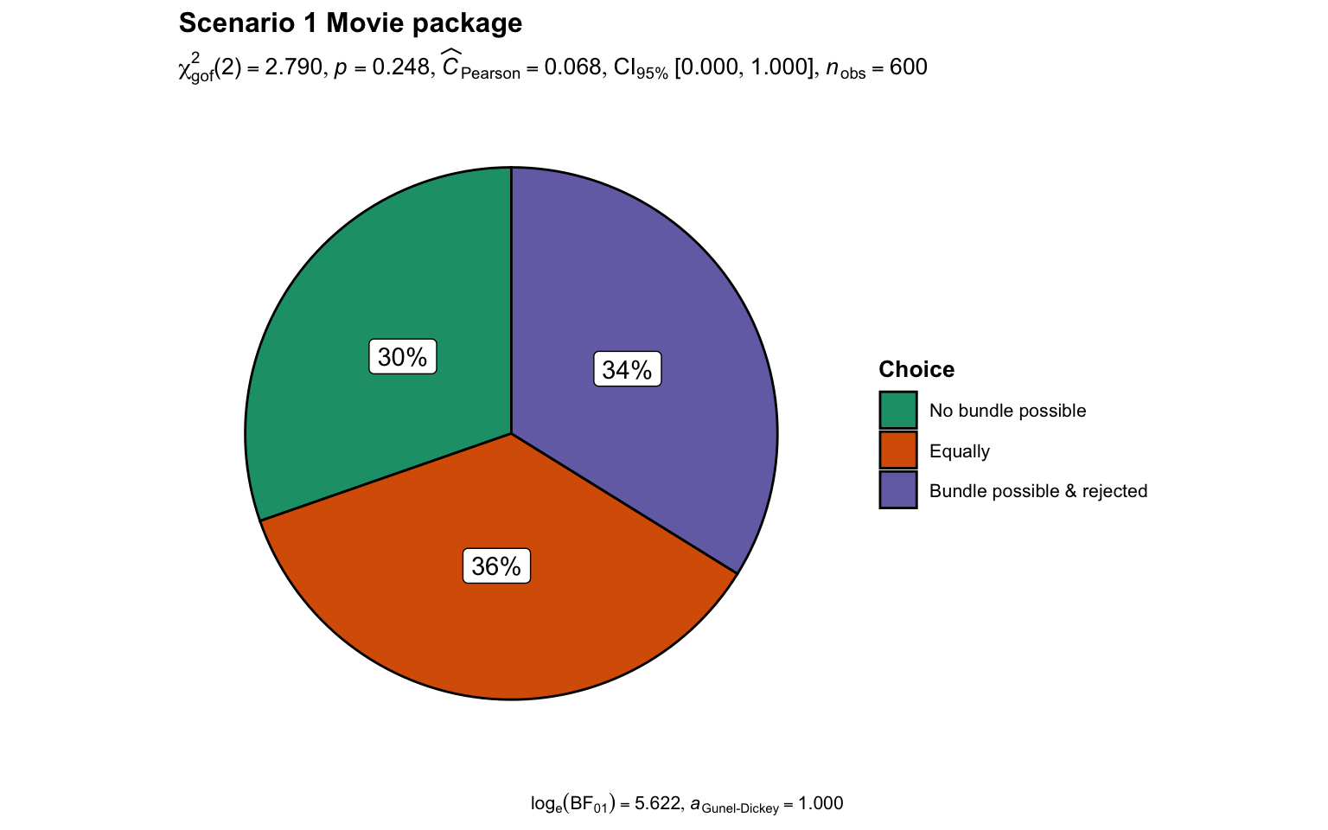
Note. The upper confidence interval is set to 1.00 by ggstatsplot (Patil, 2021) because they assume one-sided CIs. Please refer to Table 10 for confidence intervals.

Scenario 2 (underutilization): Tax program
We hypothesized that once having purchased an old program, people are more willing to purchase a new program, when they can receive a rebate on the old purchase compared to when they cannot. We conducted a chi-square test between two conditions, namely the “Waste (no rebate)” condition and “No waste (rebate)” condition, and found no support for the main effect of avoiding the appearance of wastefulness by less willingness to make direct purchases than trading in the old one first (χ² (1, N = 600) = 0.43, p = .513; 95% CI [0.00, 1.00]). We provided a summary plot in Figure 2.

Figure 2
Scenario 2: Comparison of participant choice in Waste (no rebate) and No waste (rebate) conditions

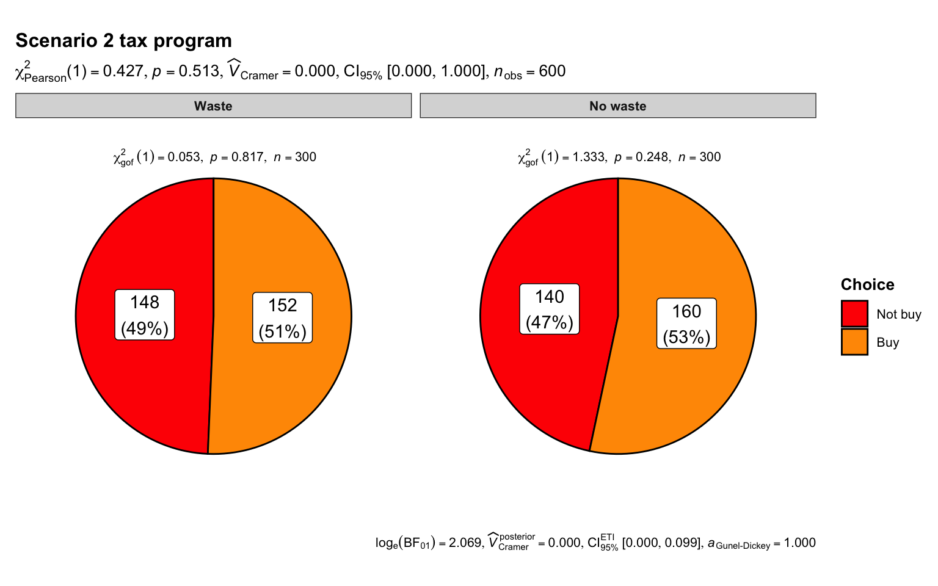
Note. The upper confidence interval is set to 1.00 by ggstatsplot (Patil, 2021) because they assume one-sided CIs. Please refer to Table 10 for confidence intervals.

Scenario 3 (sunk cost): Tent project
We hypothesized that people are more likely to escalate commitment to a losing project when abandoning the project means foregoing any utility that goes beyond mere parts. We conducted a chi-square test comparing between “no waste (sell to roofer)” condition (count = , proportion = ) and “waste (sell for its scrap value)” condition (count = , proportion = ), and found no support differences in choosing whether to proceed with the project (χ²(1, N = 600) = 0.17, p = .684; 95% CI [0.00, 1.00]). We provided a summary plot in Figure 3.

Figure 3
Scenario 3: Comparison of participant choice in Sell to roofer and Sell for its scrap value conditions

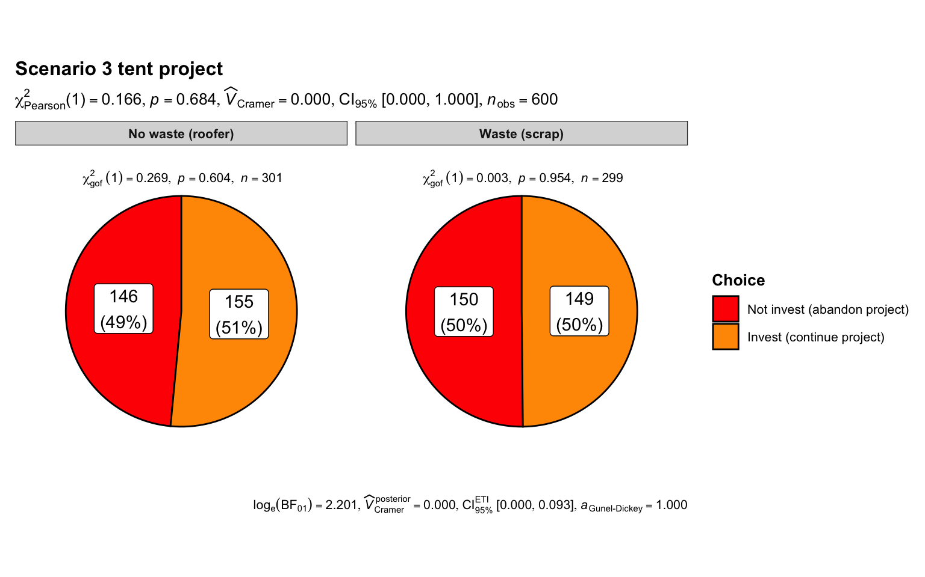
Note. The upper confidence interval is set to 1.00 by ggstatsplot (Patil, 2021) because they assume one-sided CIs. Please refer to Table 10 for confidence intervals.

Extensions

Reasons
We tested exploratory competing hypotheses as to which of the reasons would be rated as the most important, contrasting rational, non-rational, waste, and waste-top predictions (see Table 1). We summarized descriptives in Table 11 and the statistical tests findings in Table 12.

Table 11
Scenarios 1, 2 and 3: Descriptive statistics for Reasons extension
Scenario  condition | Minimizes waste | Minimizes negative emotions | Maximizes value per money spent | More consistent with previous behavior and decisions | Overall
1 | M = 2.94  SD= 2.00 | M = 2.88  SD = 2.01 | M = 3.05  SD = 2.04 | M = 3.11  SD = 2.01 | n = 600  M = 3.0  SD = 2.02
2a | M = 3.12  SD= 2.06 | M = 3.06  SD = 1.97 | M = 2.96  SD = 1.97 | M = 2.92  SD = 2.02 | n = 300  M = 3.02  SD = 2.00
2b | M = 2.91  SD= 2.00 | M = 2.94  SD = 2.06 | M = 3.07  SD = 1.93 | M = 3.02  SD = 1.86 | n = 300  M = 2.98  SD = 1.96
3a | M = 3.10  SD= 2.04 | M = 3.10  SD = 1.99 | M = 3.06  SD = 2.01 | M = 3.08  SD = 2.00 | n = 301  M = 3.08  SD = 2.01
3b | M = 2.78  SD= 1.97 | M = 2.92  SD = 2.05 | M = 2.99  SD = 2.08 | M = 3.07  SD = 2.03 | n = 299  M = 2.94  SD = 2.03

Table 12
Scenarios 1-3 Reasons extension: Summary of statistical tests
Scenario | Statistical test | df | F | p
1 | ANOVA | (3, 1797) | 1.63 | .180
2 | Mixed ANOVA
 | Reasons (within) | (3, 1797) | 0.07 | .978
 | Waste condition (between) | (1, 598) | 0.15 | .694
 | Reasons:Waste interaction | (3, 1797) | 0.92 | .426
3 | Mixed ANOVA
 | Reasons (within) | (3, 1797) | 0.46 | .712
 | Waste condition (between) | (1, 598) | 2.98 | .085
 | Reasons:Waste interaction | (3, 1797) | 0.69 | .559
Note. CI = 95% confidence intervals. The interpretation of the outcome was based on LeBel et al. (2019).

Scenario 1
We conducted a repeated ANOVA in Scenario 1 and found no support for differences in ratings of importance of reasons (F(3, 1791) = 1.63, p = .180, ω² = 0, 95% CI [0.00, 1.00]). We provided a summary plot in Figure 4.

Figure 4
Scenario 1: Reasons extension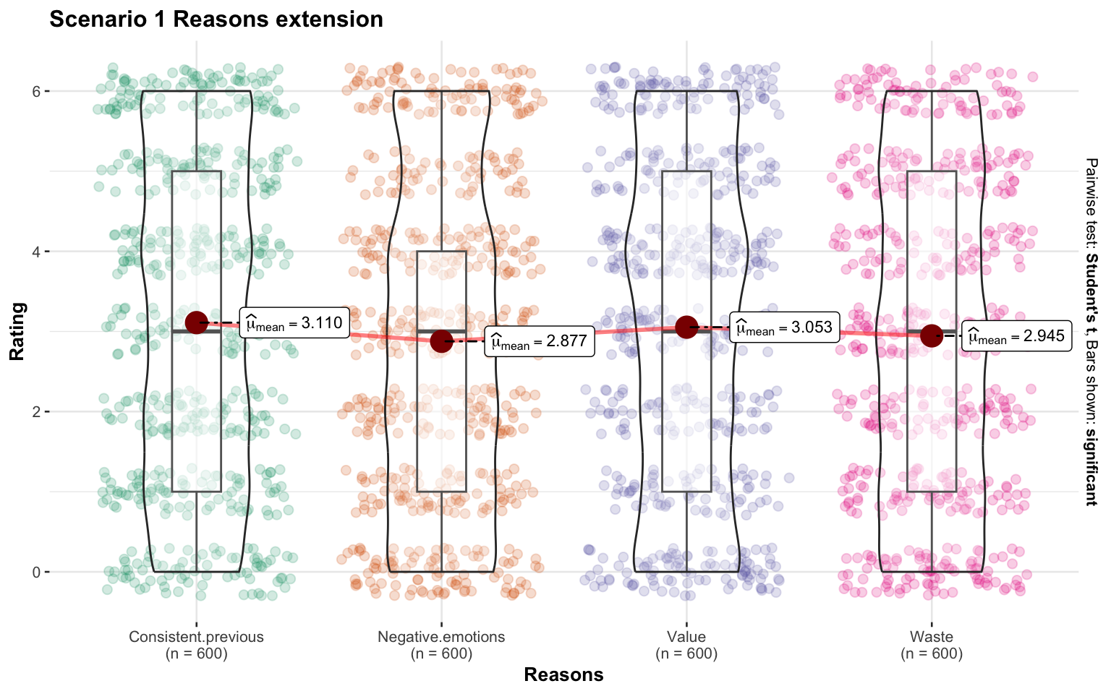Note. Created with ggstatsplot (Patil, 2021).

Scenario 2
In Scenario 2, we conducted a 4 (within) by 2 (between; by choice) mixed ANOVA and found [...] . We provided a summary plot in Figure 5.

Figure 5
Scenario 2: Reasons extension

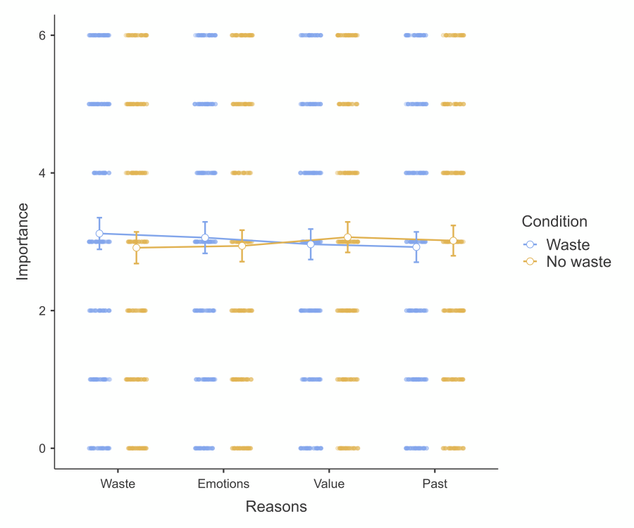
Note. Created using JAMOVI.

Scenario 3
In Scenario 3, we conducted a 4 (within) by 2 (between; by choice) mixed ANOVA and found [...]. We provided a summary plot in Figure 6.

Figure 6
Scenario 3: Reasons extension

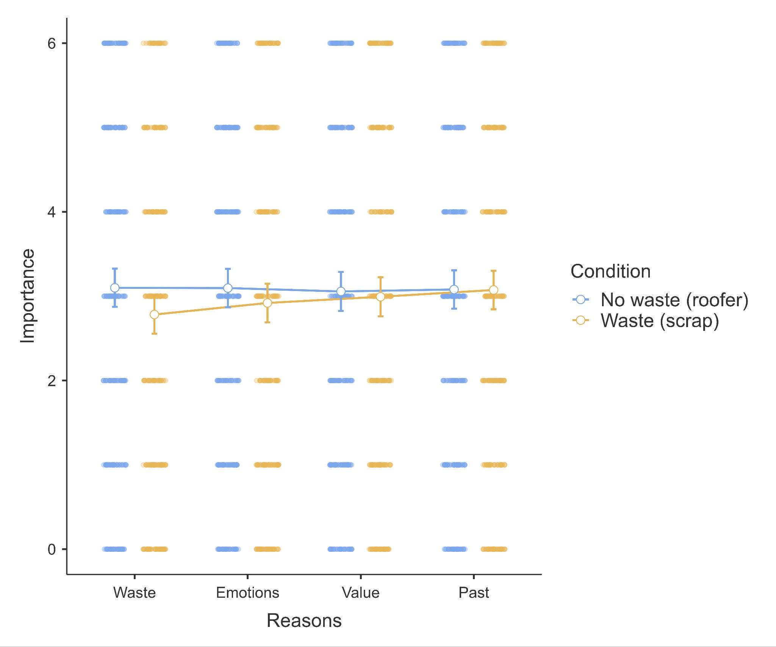
Note. Created using JAMOVI.

Willingness
We summarized descriptives in Table 13 and findings in Table 14.

Table 13
Scenarios 1-3 Willingness extension: Descriptive statistics
Scenario | Waste | No waste
Scenario 1 movie package  Willingness to buy ticket | Mr. Munn  2.92 (2.01) | Mr. Fry  3.02 (1.92)
Scenario 2 tax program  Willingness to purchase program | No rebate  2.96 (1.96) | Rebate  2.85 (2.02)
Scenario 3 tent project  Willingness to proceed with project | Scrap value  3.04 (2.03) | Roofer  2.93 (2.05)
Note. Format = Mean (standard deviation)

Table 14
Scenarios 1-3 Willingness extension: Summary of statistical tests
Scenario | Statistical test | t | df | p | Hedges' g and CI
1 | Paired t-test | 0.88 | 599 | .377 | 0.04  [-0.04, 0.12]
2 | Welch two sample t-test | 0.66 | 598 | .512 | 0.05  [-0.11, 0.21]
3 | Welch two sample t-test | 0.62 | 598 | .536 | 0.05  [-0.11, 0.21]
Note. CI = 95% confidence intervals. The interpretation of the outcome was based on LeBel et al. (2019).

Scenario 1
We conducted a paired t-test in Scenario 1 and found no support for the hypothesis that participants think Mr Fry (No movie bundle possible; bought single tickets) is more willing to purchase the third ticket than Mr Munn (3-movie bundle possible; bought single tickets) (t(599) = 0.88, p = .377, g = 0.04, 95% CI [-0.04, 0.12]). We provided a summary plot in Figure 7.

Figure 7
Scenario 1: Willingness extension
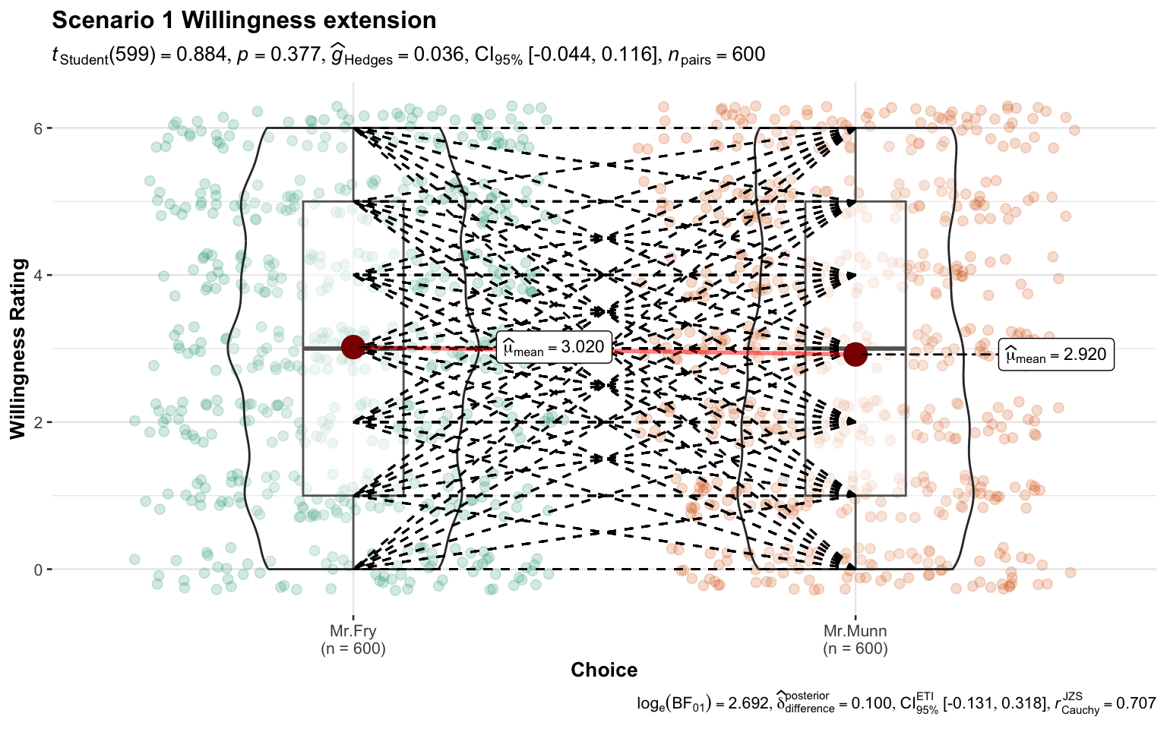
Note. Created with ggstatsplot (Patil, 2021). The dotted lines indicate the link between the two willingness responses for each participant.

Scenario 2
We conducted a two-sample Welch’s t-test in Scenario 2 and found no support for the hypothesis that participants in trade-in condition are more willing to purchase the new tax program (t(598) = 0.66, p = .512, g = 0.05, 95% CI [-0.11, 0.21]). We provided a summary plot in Figure 8.

Figure 8
Scenario 2: Willingness extension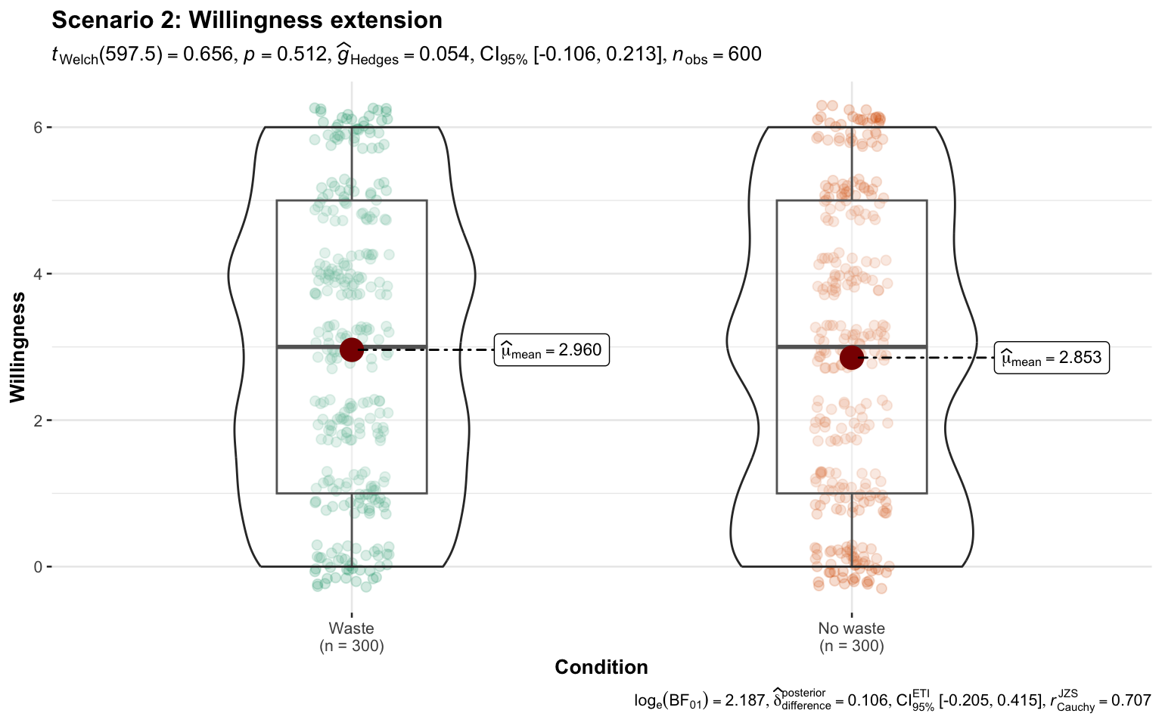Note. Created with ggstatsplot (Patil, 2021).

Scenario 3
We conducted a two-sample Welch’s t-test in Scenario 3 and found no support for the hypothesis that people in the “Sell to roofer” condition are more willing to abandon the tent project compared with people in the “Sell for its scrap value” condition (t(598) = 0.62, p = .536, g = 0.05, 95% CI [-0.11, 0.21]). We provided a summary plot in Figure 9.

Figure 9
Scenario 3: Willingness extension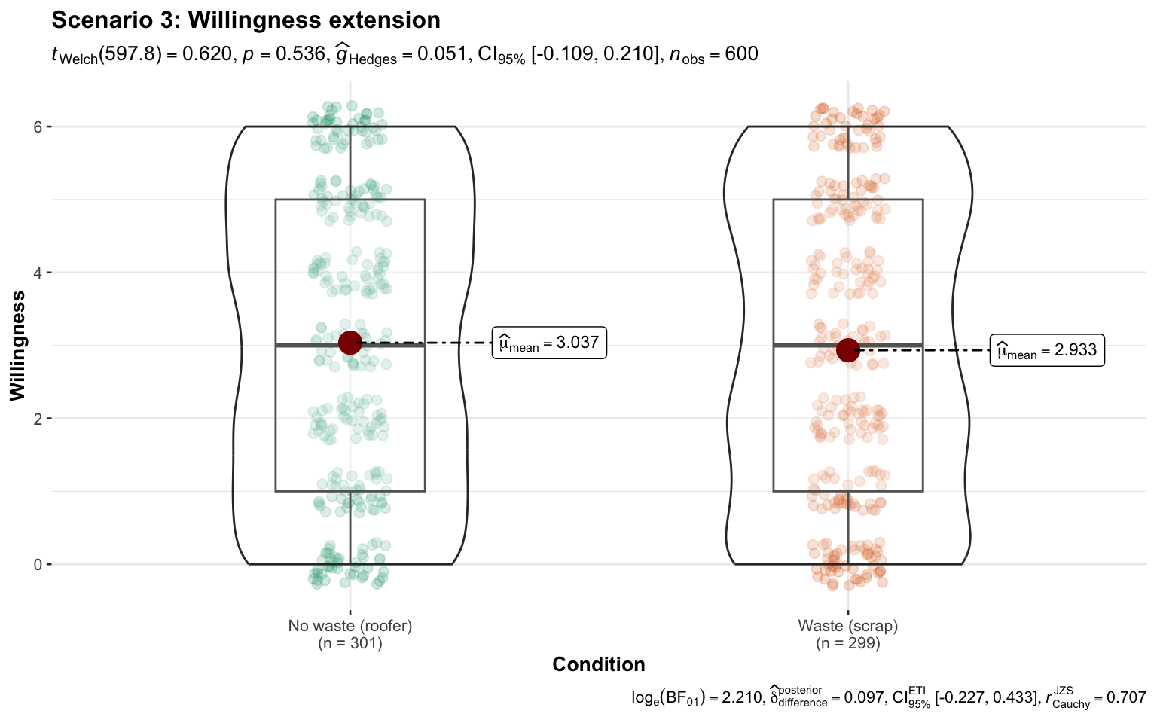Note. Created with ggstatsplot (Patil, 2021).

Perceived wastefulness (manipulation check)
We summarized descriptives in Table 15 and findings in Table 16.

Table 15
Scenarios 1, 2 and 3 Perceived wastefulness extension: Descriptive statistics
Scenario | Waste | No waste
Scenario 1 movie package | Mr. Munn  3.06 (1.98) | Mr. Fry  3.08 (1.98)
Scenario 2 tax program  Buy  Not buy | No rebate  3.02 (2.07)  2.78 (1.92) | Rebate  2.84 (2.02)  3.11 (1.99)
Scenario 3 tent project  Proceeding  Abandoning | Scrap value  3.11 (1.87)  2.93 (2.05) | Roofer  3.09 (2.02)  2.93 (2.03)
Note. Format = Mean (standard deviation)

Table 16
Scenarios 1-3 Perceived wastefulness: Summary of statistical tests
Scenario | Statistical test | df | statistic | p
1 | Paired t-test | 599 | t = 0.25 | .802
2 | Mixed ANOVA |  | F =
 | Wastefulness (within) | (1, 598) | 0.41 | .524
 | Waste condition (between) | (1, 598) | 0.01 | .922
 | Wastefulness by Waste | (1, 598) | 5.16 | .024
3 | Mixed ANOVA |  | F =
 | Wastefulness (within) | (1, 598) | 0.24 | .622
 | Waste condition (between) | (1, 598) | 4.65 | .032
 | Wastefulness by Waste | (1, 598) | 0.48 | .491
Note. CI = 95% confidence intervals. The interpretation of outcome was based on LeBel et al. (2019).

Scenario 1
We conducted a paired t-test in Scenario 1 and found no support for the hypothesis that people think the situation of Mr. Munn (3-movie bundle possible; bought single tickets) shows more wastefulness than Mr. Fry (No movie bundle possible; bought single tickets) (t(599) = 0.25, p = .802, g = 0.01, 95% CI [-0.07, 0.09]). We provided a summary plot in Figure 10.

Figure 10
Scenario 1: Perceived wastefulness extension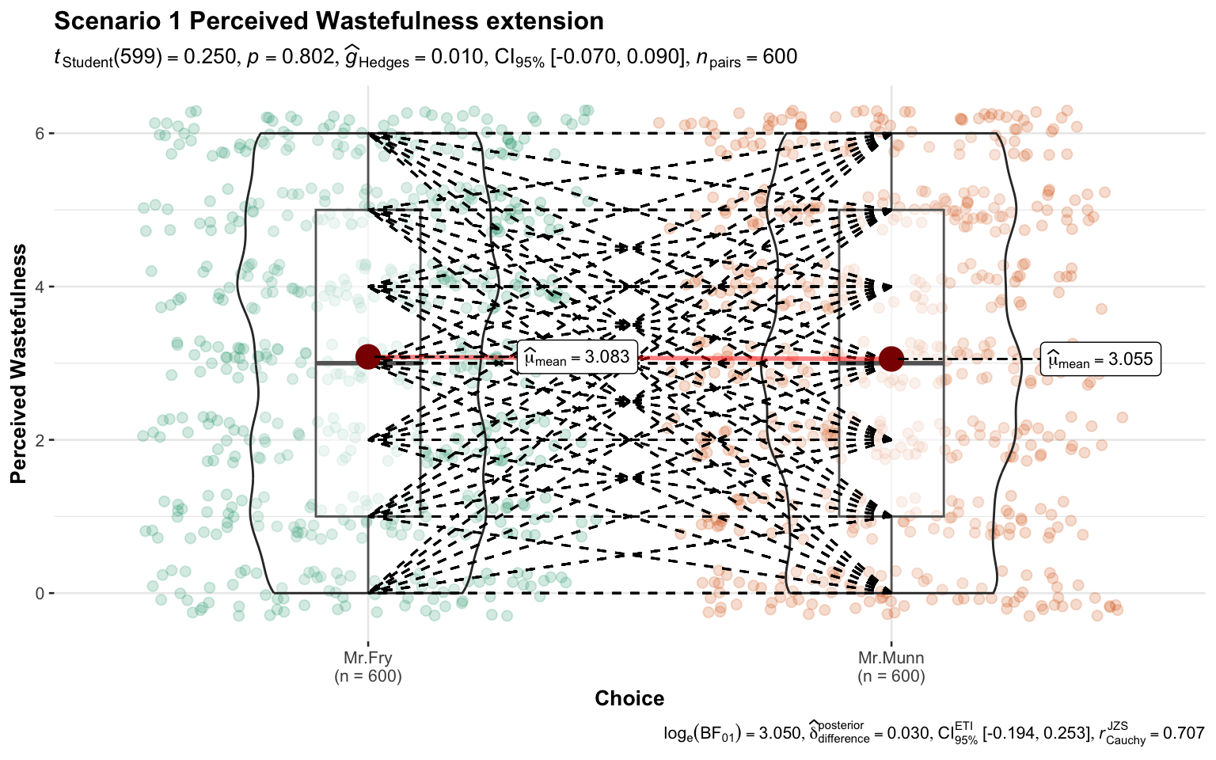Note. Created with ggstatsplot (Patil, 2021). The dotted lines indicate the link between the two willingness responses for each participant.

Scenario 2
We conducted a mixed ANOVA in Scenario 2 and found [...]. We provided a summary plot in Figure 11.

Figure 11
Scenario 2: Perceived wastefulness extension

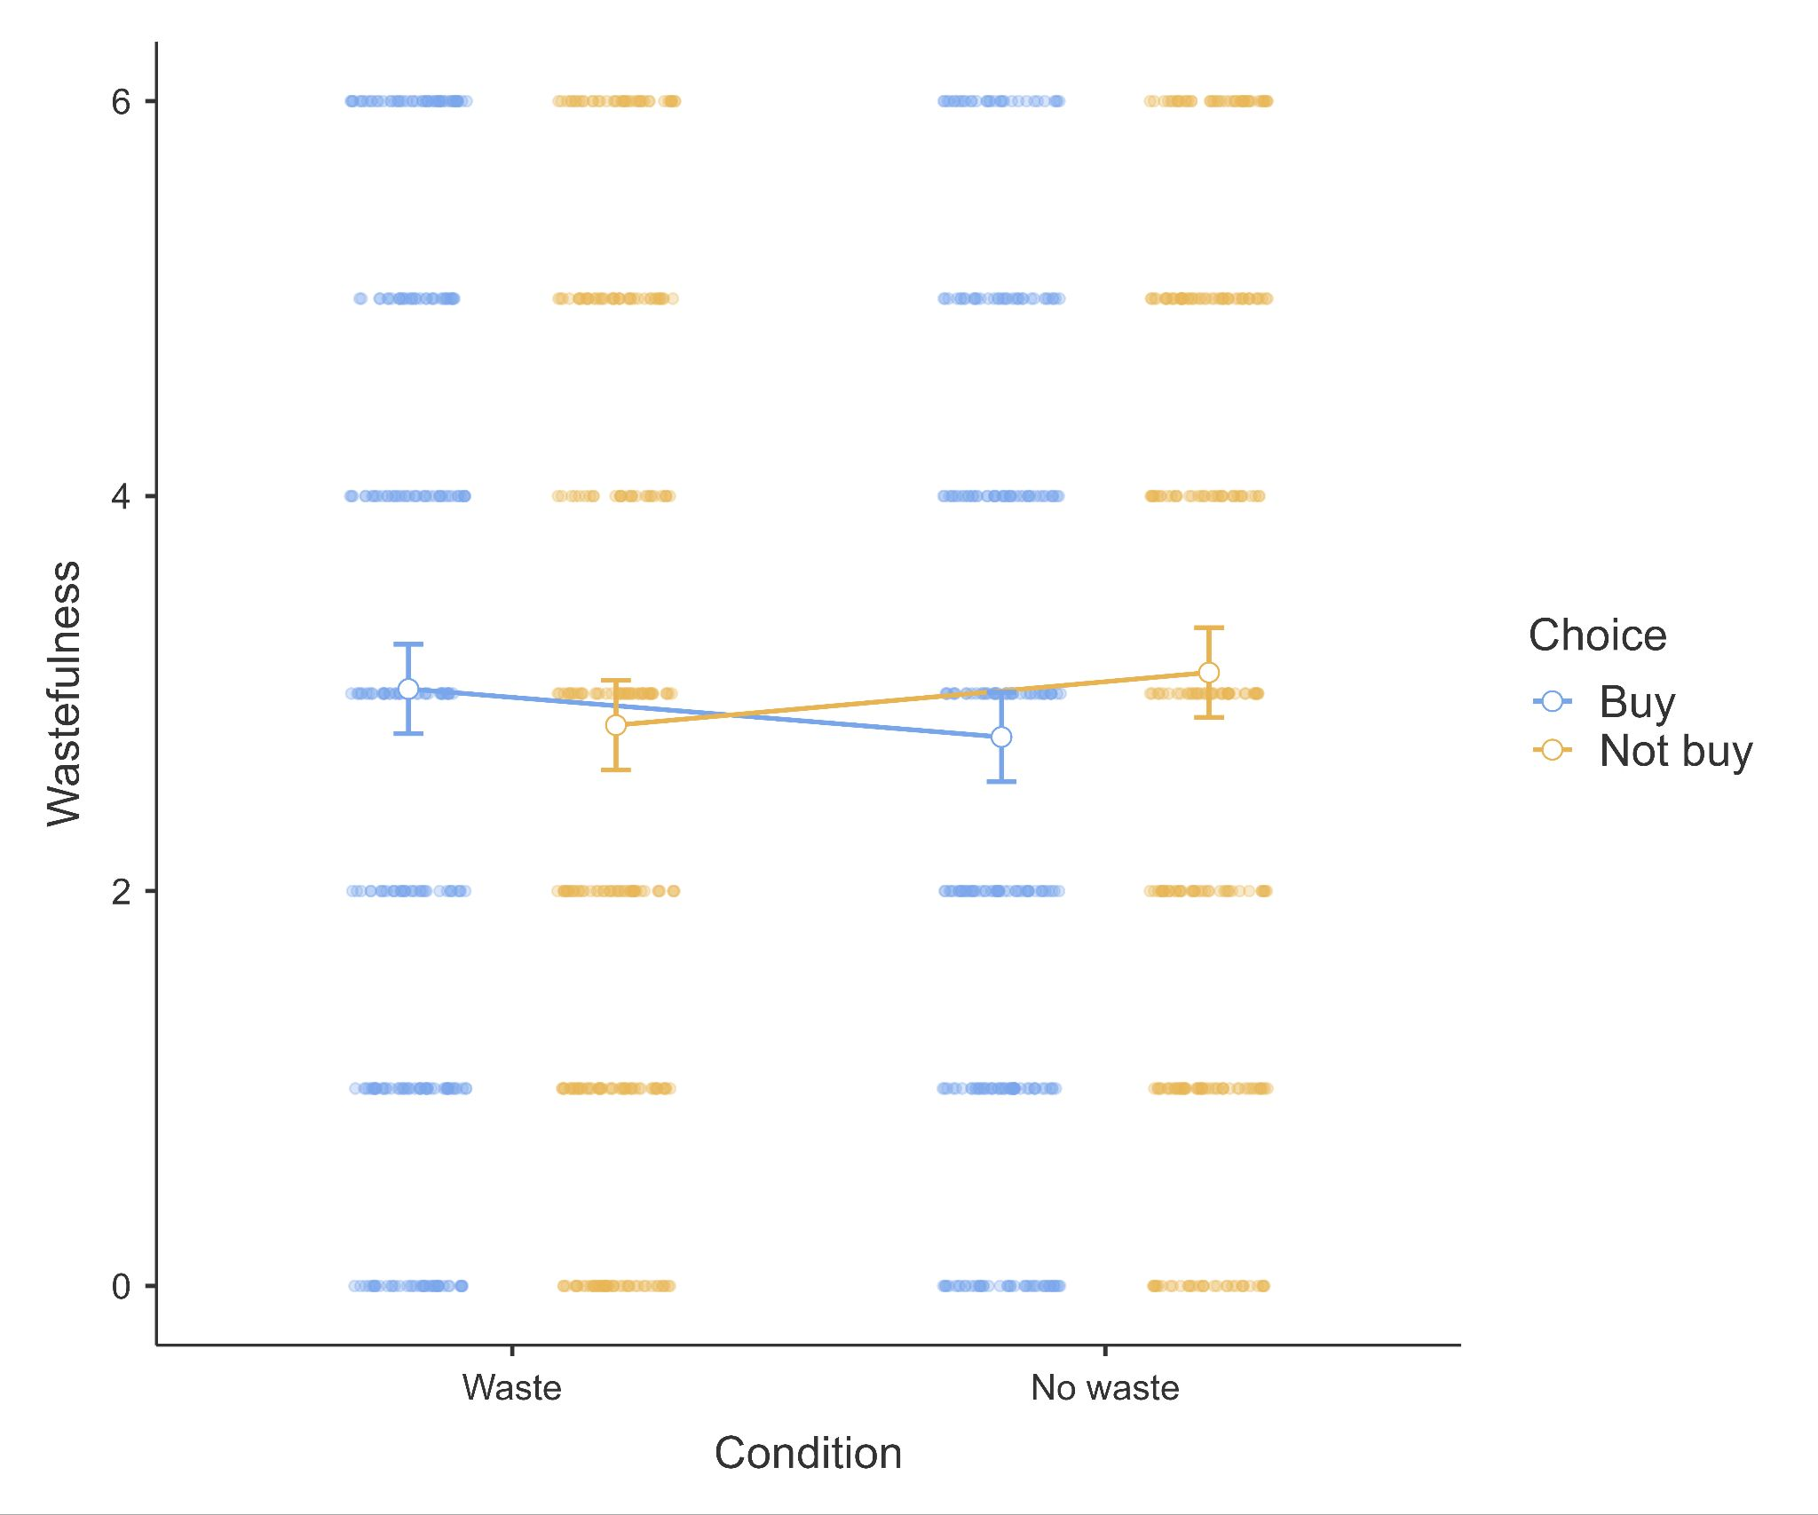
Note. Created with ggstatsplot (Patil, 2021).

Scenario 3
We conducted mixed ANOVA in Scenario 3 and found [...]. We provided a summary plot in Figure 12.

Figure 12
Scenario 3: Perceived wastefulness extension

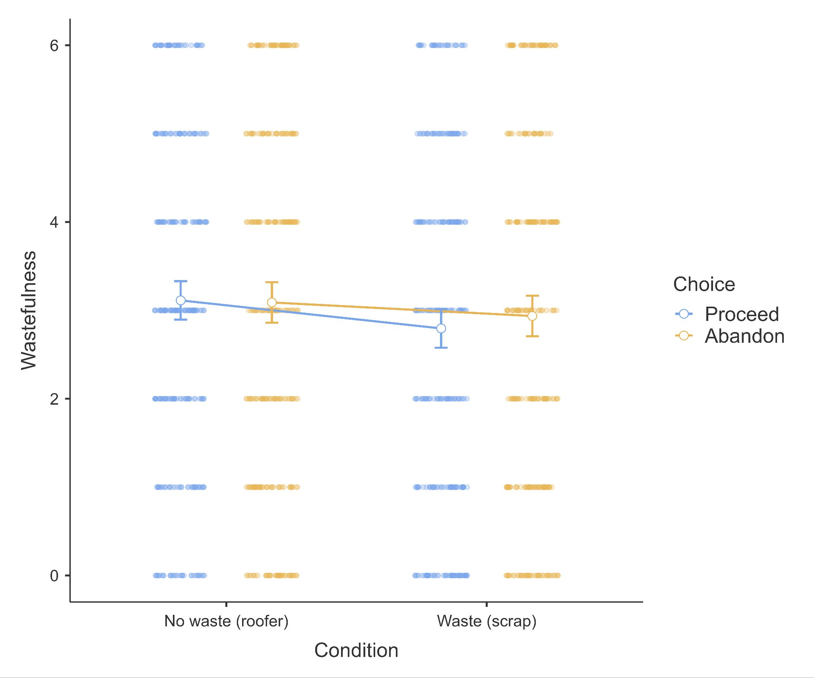
Note. Created with ggstatsplot (Patil, 2021).

Comparing replication to target article’s findings
We summarized a comparison between the target article and the replication in Table 10.

Discussion
[Please note that the discussion is only to be completed in Stage 2 following data collection]
[Following on Dr./Prof. Quentin Andre’s comment, we will discuss the importance of conducting further direct and conceptual replications, with further adjustments, different contexts, and testing of potential moderating factors.]

Conclusion
[Please note that the conclusion section will only be completed in Stage 2 following data collection]

References
Arkes, H. R., Hutzel, L., Bazerman, M., Messick, D., Tenbrunsel, A., & Wade-Benzoni, K. (1997). Waste heuristics. Environment, ethics, and behavior: The psychology of environmental valuation and degradation, 154-168.
Bolton, L. E., & Alba, J. W. (2012). When less is more: Consumer aversion to unused utility. Journal of consumer psychology, 22(3), 369-383.
Champely, S. (2020). Pwr: Basic Functions for Power Analysis. https://CRAN.R-project.org/package=pwr.
Coles, N. A., Tiokhin, L., Scheel, A. M., Isager, P. M., & Lakens, D. (2018). The costs and benefits of replication studies. Behavioral and Brain Sciences, 41. https://doi.org/10.1017/S0140525X18000596
Faul, F., Erdfelder, E., Lang, A.-G., & Buchner, A. (2007). G*Power 3: a flexible statistical power analysis program for the social, behavioral, and biomedical sciences. Behavior Research Methods, 39(2), 175–191. https://doi.org/10.3758/BF03193146
Feldman, G. (2023). Registered Report Stage 1 manuscript template. https://doi.org/10.17605/OSF.IO/YQXTP
Jané, M., Xiao, Q., Yeung, S., Ben-Shachar, M. S., Caldwell, A., Cousineau, D., Dunleavy, D. J., Elsherif, M., Johnson, B., Moreau, D., Riesthuis, P., Röseler, L., Steele, J., Vieira, F., Zloteanu, M., & Feldman, G. (2024). Guide to Effect Sizes and Confidence Intervals. http://dx.doi.org/10.17605/OSF.IO/D8C4G
Klein, R. A., Vianello, M., Hasselman, F., Adams, B. G., Adams Jr, R. B., Alper, S., ... & Batra, R. (2018). Many Labs 2: Investigating variation in replicability across samples and settings. Advances in Methods and Practices in Psychological Science, 1(4), 443-490. https://journals.sagepub.com/doi/full/10.1177/2515245918810225
LeBel, E. P., McCarthy, R. J., Earp, B. D., Elson, M., & Vanpaemel, W. (2018). A unified framework to quantify the credibility of scientific findings. Advances in Methods and Practices in Psychological Science, 1, 389-402. https://doi.org/10.1177/2515245918787489
LeBel, E. P., Vanpaemel, W., Cheung, I., & Campbell, L. (2019). A brief guide to evaluate replications. Meta-Psychology, 3, 1-9. DOI: 10.15626/MP.2018.843 https://doi.org/10.15626/MP.2018.843
Lin, Y., & Chang, C. A. (2017). Exploring wasteful consumption. Journal of Environmental Psychology, 49, 106-111. https://doi.org/10.1016/j.jenvp.2017.01.001
Litman, L., Robinson, J., & Abberbock, T. (2017). TurkPrime. com: A versatile crowdsourcing data acquisition platform for the behavioral sciences. Behavior Research Methods, 49(2), 433-442. https://doi.org/10.3758/s13428-016-0727-z
Moshontz, H., Campbell, L., Ebersole, C. R., IJzerman, H., Urry, H. L., Forscher, P. S., ... & Castille, C. M. (2018). The Psychological Science Accelerator: Advancing psychology through a distributed collaborative network. Advances in Methods and Practices in Psychological Science, 1(4), 501-515. https://doi.org/10.1177/2515245918797607
Nosek, B. A., Hardwicke, T. E., Moshontz, H., Allard, A., Corker, K. S., Dreber, A., ... & Vazire, S. (2022). Replicability, robustness, and reproducibility in psychological science. Annual Review of Psychology, 73(1), 719-748. https://doi.org/10.1146/annurev-psych-020821-114157
Patil, I. (2021). Visualizations with statistical details: The'ggstatsplot'approach. Journal of Open Source Software, 6(61), 3167. https://doi.org/10.21105/joss.03167
Petrov, N. B., Chan, Y. K. M., Lau, C. N., Kwok, T. H., Chow, L. C. E., Lo, W. Y., Song, W., & Feldman, G. (2023). Sunk Cost Effects for Time Versus Money: Replication and Extensions Registered Report of Soman (2001). International Review of Social Psychology, 36(1): 17, 1–18. DOI: https://doi. org/10.5334/irsp.883
R Core Team (2022). R: A Language and environment for statistical computing. (Version 4.1) [Computer software]. Retrieved from https://cran.r-project.org. (R packages retrieved from CRAN snapshot 2023-04-07).
The JAMOVI project (2023). JAMOVI. (Version 2.4) [Computer Software]. Retrieved from https://www.jamovi.org.
Vonasch, A. J., Hung, W. Y., Leung, W. Y., Nguyen, A. T. B., Chan, S., Cheng, B. L., & Feldman, G. (2023). ‎“Less Is Better” in Separate Evaluations Versus “More Is Better” in Joint Evaluations: Mostly ‎Successful Close Replication and Extension of Hsee (1998)‎. Collabra: Psychology, 9(1). doi: 10.1525/collabra.77859 https://doi.org/10.1525/collabra.77859
Yeung, S. K., & Feldman, G. (2022). Revisiting the temporal pattern of regret in action versus inaction: Replication of Gilovich and Medvec (1994) with extensions examining responsibility. Collabra: Psychology, 8(1), 37122. https://doi.org/10.1525/collabra.37122
Zhu, M., & Feldman, G. (2023). Revisiting the Links Between Numeracy and Decision Making: Replication Registered Report of Peters et al.(2006) With an Extension Examining Confidence. Collabra: Psychology, 9(1). https://doi.org/10.1525/collabra.77608
Zwaan, R. A., Etz, A., Lucas, R. E., & Donnellan, M. B. (2018). Making replication mainstream. The Behavioral and Brain Sciences, 41, 1-e120. https://doi.org/10.1017/S0140525X17001972

