Revisiting the psychological sources of ambiguity avoidance:
Replication and extensions of Curley, Yates, and Abrams (1986)

Sze Ying (Dawn) Yiu
ORCID: 0000-0002-6312-7290
University of Hong Kong
syiu1@connect.hku.hk / dawnyiuyiu@gmail.com
^Gilad Feldman
OCRID: 0000-0003-2812-6599
University of Hong Kong
gfeldman@hku.hk / giladfel@gmail.com

^Corresponding author

Author bios:
Sze Ying Yiu was a student at the University of Hong Kong during the academic year 2021-2022.
Gilad Feldman is an assistant professor with the University of Hong Kong psychology department. His research focuses on judgment and decision-making.

Declaration of Conflict of Interest:
The author(s) declared no potential conflicts of interests with respect to the authorship and/or publication of this article.

Financial disclosure/funding:
The author(s) received no financial support for the research and/or authorship of this article.

Authorship declaration:
Sze Ying Yiu conducted the replication as part of PSYC 7308 course.
Gilad was the course instructor for PSYC 7308 and led the replication efforts in the course. Gilad supervised each step in the project, conducted the pre-registrations, and ran data collection.

Corresponding author
Gilad Feldman, Department of Psychology, University of Hong Kong, Hong Kong SAR; gfeldman@hku.hk ; 0000-0003-2812-6599

Rights:
CC BY or equivalent license is applied to the AAM arising from this submission. (clarification)
Important links and information
Citation of the target research article:
Curley, S. P., Yates, J., & Abrams, R. A. (1986). Psychological sources of ambiguity avoidance. Organizational Behavior and Human Decision Processes, 38(2), 230–256. https://doi.org/10.1016/0749-5978(86)90018-x

Contributor Roles Taxonomy
In the table below, employ CRediT (Contributor Roles Taxonomy) to identify the contribution and roles played by the contributors in the current replication effort. Please refer to https://www.casrai.org/credit.html for details and definitions of each of the roles listed below.
Role | Sze Ying Yiu |  |  |  | Gilad Feldman
Conceptualization  Pre-registration  Data curation  Formal analysis  Funding acquisition  Investigation  Pre-registration peer review / verification  Data analysis peer review / verification  Methodology  Project administration  Resources  Software  Supervision  Validation  Visualization  Writing-original draft  Writing-review and editing |  |  | X |  |  | X
 |  |  | X |  |  | X
 |  |  |  |  |  | X
 |  |  | X
 |  |  |  |  |  | X
 |  |  | X
 |  |  |  |  |  | X
 |  |  |  |  |  | X
 |  |  | X
 |  |  |  |  |  | X
 |  |  |  |  |  | X
 |  |  | X
 |  |  |  |  |  | X
 |  |  |  |  |  | X
 |  |  | X
 |  |  | X |  |  | X

Abstract
[IMPORTANT:
Method and results sections were written using a randomized dataset produced by Qualtrics to simulate what these sections will look like after data collection. These will be updated following the data collection. This is written in past tense yet no pre-registration or data collection have been conducted.]
Ambiguity avoidance is a phenomenon that refers to people’s tendency to prefer choice options with lower ambiguity. Curley et al. (1986) attempted to uncover the psychological mechanisms underlying ambiguity aversion. We conducted a pre-registered close replication of Curley et al. (1986)’s Study 1 and extensions of conceptual replications of their Studies 2 and 4, with an online US American Amazon Mechanical Turk sample (N =1000). In our replication of Study 1, we found support for ambiguity avoidance (${\hat{V}}_{Cramer }$ = 0.34, 95% CI [.25, 1.00]) and the associations between risk aversion and ambiguity aversion (r(247) = .89, 95% CI [0.86, 0.91]). In our extensions, we found weak to no support for ambiguity aversion being impacted by hostility bias (VCramer = 0.40, 95% CI[0.31, 1.00]), anticipated future regret (VCramer = 0.17, 95%CI[0.00, 0.23]), or being evaluated by others (d = -0.09, 95% CI[-0.27, 0.08]). Supplementary materials, data, and code are available on the OSF: https://osf.io/ycxh3/.
Keywords: Ambiguity avoidance, bias, judgment and decision making, registered replication, psychological sources, risk

PCIRR-Study Design Table
Question | Hypothesis | Analysis Plan | Interpretation given different outcomes | Theory that could be questioned/shown wrong by the outcomes
How do people react to ambiguity? How is that is relation to how they react to risk? | People tend to avoid ambiguity.  Risk preferences should positively correlate to ambiguity preferences. | Correlation, t-tests, Chi-square, binomial tests | Based on the criteria used by Lebel et al. (2019)  We examine the replicability of the findings of Curley et al. (1986) Study 1, and support for our suggested extensions based on their Studies 2 and 4. | Risk avoidance and ambiguity avoidance are two distinct constructs with a positive association.
Does negative bias towards ambiguity moderate ambiguity avoidance? | Weaker belief in ambiguity being negatively biased (hostile) is associated with weaker ambiguity avoidance. | T-test, ANOVA |  | Hostility bias as a mechanism for ambiguity avoidance.
Does other-evaluation moderate ambiguity avoidance? | Ambiguity avoidance is stronger when a choice of the ambiguous option is more likely to be evaluated by others. | T-test, ANOVA |  | Other-evaluation as a mechanism for ambiguity avoidance.
Does self-evaluation moderate ambiguity avoidance? | Ambiguity avoidance is stronger with stronger anticipated regret for the ambiguous option. | T-test, ANOVA |  | Self-evaluation as a mechanism for ambiguity avoidance.
Note. Please see the power analysis and introduction sections below for sampling plan and rationale.

Revisiting the psychological sources of ambiguity avoidance:
Replication and extensions of Curley, Yates, and Abrams (1986)

Ellsberg (1961) provided the first demonstration that people tend to try and avoid ambiguity. In a seminal follow-up paper on ambiguity avoidance with five studies, Curley et al. (1986) attempted to uncover underlying mechanisms, examining six possible candidate theories, and concluding other-evaluation as the most promising of those: People avoid ambiguity because ambiguous decision are harder to justify to others.
Recognizing the importance of their study, we revisited their methodology and designs, and identified the need to revisit their conclusions with the potential of gaining additional insights with an improved design. We therefore embarked on a replication and extension of Curley et al. (1986) with the following goals. Our first goal was to conduct an independent close replication of ambiguity avoidance, with their Study 1’s design as our baseline, to demonstrate ambiguity avoidance and its distinction from and association with risk avoidance. Our second goal was to extend this design by conducting conceptual replications of their Studies 2 and 4 examining hostility, self-evaluation, and other evaluation as moderators of ambiguity avoidance within a single unified experimental paradigm.
We introduce the literature on ambiguity avoidance and the chosen article for replication - Curley et al. (1986). We then review the target article and introduce their hypotheses and study design. Finally, we outline our suggested extensions inspired by and improving on the original’s examined moderators: hostility bias, self evaluation (anticipated regret), and others evaluation.

Ambiguity Avoidance
Ambiguity is inherent in complex diverse situations, from investment decisions, relationships, and interactions to clinical practice and organizational settings. Though ambiguity was initially thought of as being similar or identical to risk, researchers have over the years come to conceptualize it as a separate unique construct (McLain 2015, Gard & Leung 2020). In the psychology literature, ambiguity often refers to “stimuli that are complex, unfamiliar, or insoluble” (McLain 2009, p. 976), yet in the economics and decision-making literature literature, ambiguity is conceptualized differently, more in line with the target’s reference to “the uncertainty about the success probability itself” (Curley et al, 1986, p. 230). This differentiation was further supported by Jach and Smillie (2019) demonstrating that ambiguity intolerance from the personality perspective has little association to ambiguity aversion from decision theory perspective. For the purpose of this paper we will be focusing on the target’s definition.
Risk is typically characterized by having a known probability of given outcomes, whereas ambiguity is often conceptualized as an unknown probability of given outcomes (De Groot & Thurik 2018; Ellsberg 1961). Imagine for example an investment fund manager facing a choice between two funds. The first fund has a 50% guaranteed chance of yielding $1000, whereas the second fund has an unknown probability of a guaranteed chance of paying $1000. Both funds, on average, seem to have the same risk of 50%. The second fund is considered equivalent to the first fund with the same risk of 50%, given that the averaging of all the range of possibilities equals 50%. Yet, the second fund introduces an additional layer of ambiguity, giving a range of options for risk and introducing a level of uncertainty. Given a choice between a fund with a certain risk and another with more uncertainty regarding the risk, investors tend towards ambiguity avoidance, in that they prefer the higher certainty first fund over the other more ambiguous fund (Becker & Brownson, 1964; Slovic & Tversky, 1974).
Curley et al. (1986) examined several plausible theoretically driven explanations for ambiguity aversion suggested in the previous literature: hostility, other-evaluation (Ellsberg, 1963), self-evaluation (Ellsberg, 1963), forced-choice (Roberts, 1963), and uncertainty avoidance (Curley et al., 1968). Among these, Curley et al. (1986) concluded other-evaluation as the most promising and likely mechanism, in that people avoid ambiguity because of anticipated evaluation. A decision made based on known probabilities is easier to justify than a decision made based on unknown probabilities. especially when the decision maker is accountable to another person for their decision, or that when or that when “the decision maker desires to appear competent to others” (Curley et al, 1986, p. 232) therefore people are more likely to choose a decision that has known probabilities.

Choice of target for replication: Curley et al. (1986)
We chose the Curley et al. (1986) study based on its impact and the potential for methodological improvement and new insights.
We identified several areas for improvement in the original study. The article tested several proposed mechanisms for ambiguity avoidance in a series of separate studies and found support for only one of six mechanisms - other evaluation, concluding that factor offers the most promising direction for future research on ambiguity avoidance. We found these conclusions to be premature, given that 1) mechanisms were tested in separate experiments and not tested in a single unified experiment of the same design, 2) conclusions about null effects relied on using null hypothesis significance testing and not finding support for an effect (p > .05), and 3) all the studies but the one that concluded empirical support were severely underpowered (ns for Experiments 1, 2, 3, and 5 were 26, 39, 16, 70).
The article has had much impact on scholarly research in social psychology, judgment and decision making, behavioral economics, consumer behavior, and cognitive psychology. At the time of writing (March 2022), there were 663 Google Scholar citations of the article and many important follow-up theoretical and empirical articles (Frisch & Baron, 1988; Keren & Gerritsen, 1999), such as the development of the construct “tolerance of ambiguity” (Furnham & Ribchester, 1995) with its application in a variety of fields (Camerer & Weber, 1992).
We aimed to revisit the classic phenomenon and examine the reproducibility and replicability of the classic findings by replicating the studies and improving the design with extensions. Following the recent growing recognition of reproducibility and replicability in psychological science (Open Science Collaboration, 2015; Zwaan et al., 2018), we embarked on a well-powered pre-registered replication and extensions of Curley et al. (1986).

Original hypotheses and findings in the target article
Curley et al. (1986) summarized six plausible reasons for ambiguity avoidance and tested those in five separate studies. In their baseline first study they adopted the general procedure from Ellsberg (1961)’s two urns experiment, presenting participants with the choice between two lotteries, each containing 100 chips. The first bag included 50 red chips and 50 black chips, and the other an unknown probability of a composition of red or black chips. Participants chose a color, then decided on one of the two lotteries to play, with the potential of winning $5 if they picked the color of a chip drawn from the selected lottery.
We summarized the hypotheses and findings of the chosen studies of the target article in Table 1.

Table 1
Summary of hypotheses and findings of the chosen studies in the target article
S | Mechanism | Hypotheses | Test | Findings
1 | Ambiguity avoidance | People have an overall tendency to avoid ambiguity.  There is a positive association between risk avoidance and ambiguity avoidance. | One-sample t-test  Correlation | d =.75 [0.30, 1.17],  p < .001  r = 0.11 [-.29, 0.48], p > .5
2 | Hostility bias | Weaker belief in ambiguity being negatively biased (hostile) is associated with weaker ambiguity avoidance. | One-sample t-test | d = .71 [0.11, 1.28],  p = .02
4 | Self - evaluation | Ambiguity avoidance is stronger with stronger anticipated regret for the ambiguous option. | Two-way ANOVA | η2 = 0.01 [0.00, 0.05],  p = .429
 | Other - evaluation | Ambiguity avoidance is stronger when a choice of the ambiguous option is more likely to be evaluated by others. | Two-way ANOVA | η2 = 0.05 [0.01, 0.14],  p = .015
5 | 5a (extension) | The higher tolerance for risk or for ambiguity, the lower the tendency to avoid ambiguity. | Correlation | Extension
 | 5b (extensions null) | There is no relationship between risk or ambiguity tolerance to ambiguity aversion (examined as correlation coefficient confidence intervals lower than r = 0.1) | Correlation | Extension

Extensions: Hostility and self-other evaluations
We extended our replication of Study 1 by integrating additional conditions in a between-subject design that serve as conceptual replications of the target’s Studies 2 and 4. We built on the original’s general idea, implementing different manipulations of the baseline control-condition design that we believed captured the underlying mechanism well.
The original’s Study 2 tested the effects of hostile bias towards ambiguous options. The hypothesis was that people tend to perceive ambiguous choices more negatively, in that ambiguity may be more hostile or biased against them, leading to their avoidance of the ambiguous option.
The target article’s Study 4 tested self-other evaluations regarding feedback provided regarding the ambiguity. The “self-evaluation” hypothesis argues that decisions are made in anticipation of self-evaluation of that choice in the future. Ambiguity may result in future regret once the ambiguous odds are exposed (and are possibly negative), so learning of being told that ambiguity will be resolved by odds being exposed would lead to lower preferences for the ambiguous option to reduce anticipated regret (Ellsberg, 1963). Support for the hypothesis would suggest that people avoid ambiguity to reduce their anticipated regret. On the other hand, the “other-evaluation” hypothesis argument was that decisions are made based on how others will evaluate them, and therefore people make choices that would be more justifiable as to reduce future social criticism resulting from others’ evaluations (Toda & Shuford, 1965). People seem to associate more predictable and less ambiguous choices as more accountable, and for social norms to put pressure on members of society to be more predictable, thereby also being more accountable (Lerner & Tetlock, 1999), with conformity meant to reduce anticipate uncertainty and ambiguity to regulate the predictability of the the social environments (Theriault et al., 2021).
We, therefore, added two conditions that directly manipulate anticipated regret testing the “self-evaluation” hypothesis and social norms testing the “other-evaluation” hypothesis.

Exploratory extension: Trait predictors
We added two scales of trait risk and ambiguity tolerance to examine associations with ambiguity avoidance behavior. We entertained competing hypotheses detailed as H5 in Table 1.

Overview of the replication and extensions
Our replication focused on Study 1 from Curley et al. (1986), which served as our baseline control condition, to which we added three extension conditions to an adjusted combined experimental design.
The experiment introduced a scenario involving a choice of a color, white or red, and then a choice between two lottery bags consisting of 100 chips each. The first lottery bag (Bag 1) has 50 white and 50 red chips, whereas the second (Bag 2) has 100 chips of the unknown composition of red and white chips. Participants indicate the minimum amount of money they are willing to receive in exchange for not playing the lottery bag. They then indicate which lottery bag they prefer to play (Bag 1 or 2). The hypothetical scenario indicated a cash prize if the chosen color was randomly drawn from the chosen lottery. After indicating their preferences, participants give a reason for their choice. In our combined design, all four conditions followed this baseline experimental design, except that in each of the manipulation conditions there is an added information varying the context. In the condition conceptually replicating Study 2 we indicated that the ambiguous option is negatively biased against them. In the two conditions conceptually replicating Study 4, one condition indicated revealing the ambiguous odds thereby eliciting anticipated regret, and one condition indicated that the choice will be evaluated by others.

Pre-registration and open-science
We pre-registered the experiment on the Open Science Framework (OSF) and data collection was launched later that week. Pre-registrations, power analyses, and all materials used in these experiments are available in the supplementary materials. We provided all materials, data, code, and pre-registration on the OSF: https://osf.io/ycxh3/. We provided additional open-science details and disclosures in the supplementary materials under “Open Science disclosures” sub-section.
All measures, manipulations, exclusions conducted for this investigation are reported, all studies were pre-registered, and data collection was completed before any analyses.

Method
[IMPORTANT:
Method and results sections were written using a randomized dataset produced by Qualtrics to simulate what these sections will look like after data collection. These will be updated following the data collection. This is written in past tense yet no pre-registration or data collection have been conducted.]

Power analysis
We calculated effect sizes (ES) and power based on the statistics reported in the target article. We then conducted a power analysis using G*Power (Faul et al., 2007) and R package “pwr”, choosing the smallest effect size of each study to ensure enough power for all measurements. We provided further information regarding these calculations in the “Power analysis” subsection in the supplementary materials.
We concluded that the minimum required sample size for a power of 0.95 and alpha of 0.05 was 297.‎ Given the possibility that the original effects are overestimated, we used the suggested Simonsohn (2015) rule of thumb, even if meant for other designs, and multiplied 297 by 2.5 resulting in 743 participants. Accounting for possible exclusions and the integrated design, and allowing for the potential of additional analyses, we aimed for a larger total sample of 800 participants. A sensitivity analysis indicated that a sample of 800 would allow the detection of f = 0.15 (groups = 4, df = 1) and d = 0.33 for contrasts between the manipulations and the control condition (independent samples; both 95% power, alpha = 5%, one-tail), effects weaker than any of the supported effects reported in the target article.

To demonstrate what the results would look like after data collection we simulated a dataset of 1000 participants using Qualtrics, which we will later update with the real data and our sample of ~800.

Participants
We will recruit participants from Amazon Mechanical Turk using the CloudResearch/Turkprime platform (Litman et al., 2017). Based on our extensive experience of running similar replications on MTurk, to ensure high quality data collection, we employed the following CloudResearch options: Duplicate IP Block. Duplicate Geocode Block, Suspicious Geocode Block, Verify Worker Country Location, Enhanced Privacy, CloudResearch Approved Participants, Block Low Quality Participants, etc. We will also employ the Qualtrics fraud and spam prevention measures: reCAPTCHA, prevent multiple submission, prevent ballot stuffing, bot detection, security scan monitor, relevantID, etc.
Assignment pay is based on the federal wage of 7.25USD/hour, per minute, so for example - 5-8 minutes survey would be paid 1USD per participant. We first pretest survey duration with 30 participants to make sure our time run estimate was accurate and then adjust pay as needed, the data of the 30 participants will not be analyzed separately from the rest of the sample other than to assess survey completion duration and needed pay adjustments. For those pretest participants, if survey duration was longer than expected, they would be paid a bonus as pay adjustment.
We summarized the comparison of the original study’s sample and the current sample in Table 2.

Table 2
Difference and similarities between original study and replication
 | Curley et al. (1986) | American MTurk Workers
Sample size | 201 | 1000
Geographic origin | Americans | [US American/UK]
Gender | N/A | [XXX] males, [XXX] females, [XXX] other/did not disclose
Median age (years) | N/A | [XX]
Average age (years) | N/A | [XX.X]
Standard deviation age (years) | [XX.XX] | [XX.XX]
Age range (years) | Undergraduates | [XX-XX]
Medium (location) | US University Campus | Computer (online)
Compensation | Unpaid and Nominal Payment | Nominal payment
Year | 1986 | 2022
Note. N/A = Not provided from the article

Design
We summarized the experimental design in Table 3. The study was a 4-conditions between-subject design replicating Study 1 in a neutral condition, and conceptually replicating Studies 2 and 4 as an extension with three additional conditions manipulating hostility, self-evaluation, and other-evaluation. Additionally, individual differences measures were added to test exploratory directions.

Table 3
Replication and extension experimental design
Individual differences (Exploratory extension)
General Risk Propensity Scale (GRiPS) (Zhang et al, 2018)
Multiple Stimulus Types Ambiguity Tolerance (MSTAT II) (McLain, D.L, 2009)
IV1 (between)  Original’s Study 1  Neutral Control:  Baseline | IV1: (between)  Conceptual Replication, Original’s Study 2  Hostile Bias  Subjects are told the chips in Lottery Bag 2 might be composited in a way that the bias is against them | IV1: (between)  Conceptual Replication, Original’s Study 4  Self-Evaluation (Anticipated Regret)  Make a decision that are least likely to regret if they are shown the content of Lottery 2 | IV1: (between)  Conceptual Replication, Original’s Study 4  Other-Evaluation  (Conformity Norms)  Make a decision that will be evaluated by others as a highly justifiable decision by others.
Dependent variables
Risk Preference
Imagine the possibility of being offered money instead of playing this lottery. What would be the minimum amount of money you would demand to give up playing the Bag 1 Lottery?
(0 to 500 cents)**
Imagine the possibility of being offered money instead of playing this lottery. What would be the minimum amount of money you would demand to give up playing the Bag 1 Lottery?
(0 to 500 cents)**
Ambiguity Preference
Which Lottery bag did you choose? Bag 1 or Bag 2?
(1: Bag 1; 2: Bag 2)
Hostile Bias manipulation check
To what extent do you feel that the odds of winning Bag were fair or biased against you?
(-3 = Very biased against me; 0 = Neutral; 3 = Fair, not at all biased)
To what extent do you feel that the odds of winning Bag 2 were fair or biased against you?
(-3 = Very biased against me; 0 = Neutral; 3 = Fair, not at all biased)
Ambiguity perception
How ambiguous is Bag 1?
How ambiguous is Bag 2?
(Both: 0 = Very unambiguous; 6 = Very ambiguous )
Confidence of possibility of bias
How confident are you that your feelings regarding a possible bias against you in Bags 1 and 2 are accurate?
(-3 = Very unconfident; 0 = Neutral; 3 = Very confident)
Anticipated Regret manipulation check
How likely are you to regret the choice you made between Bag 1 Lottery and Bag 2 Lottery after learning of Bag 2's odds and the outcome? (0 = Very unlikely to regret; 6 =Very likely to regret)
Conformity Norms manipulation check
How justifiable to others is your choice between Bag 1 and Bag 2?
(0 = Not at all justifiable to others; 6 = Highly justifiable to others)
Comprehension Check
When considering Bag X* Lottery, what are the type(s) of uncertainty(ies) involved in this lottery?
Bag X lottery involves uncertainty about the success probability itself (Yes/No)
Bag X lottery involves uncertainty about which outcome will occur (Yes/No)
*X referring to Bag 1 and Bag 2 in separate questions
Note. See supplementary for full scales. *Cash Equivalent = smallest amount of money the participants would accept in exchange for the opportunity to play the lottery; ** in 5 cent increments

Procedure
Participants first agreed to the consent form, and answered several brief generalized qualification questions. Participants were then randomly assigned to one of the four experimental conditions. Thereafter, all the participants answered all comprehension and manipulation check questions related to the manipulations in the four conditions, and the questions were presented in random order. Following, participants answered two individual differences scales examining trait risk and ambiguity tolerance, presented randomly. Finally, participants answered funneling and demographics sections. Exploratory funneling questions asked about participants’ seriousness when filling in the survey (1 = Not at all; 5 - Very much), their exposure to similar surveys (Yes/No), their understanding of the purpose of the study (open), and feedback they have for us to improve in our future studies (open).
For fuller and more extensive details on the funneling questions please see the supplementary under section “Materials and scales used in the replication + extension experiment”.
[For review: The Qualtrics survey .QSF file and an exported DOCX file are provided on the OSF folder. A preview link of the Qualtrics survey is provided on: https://hku.au1.qualtrics.com/jfe/preview/SV_6XKUL1ifn8pSqmW?Q_CHL=preview&Q_SurveyVersionID=current ]

Manipulations

Replication of Study 1: Control Condition
Participants first read through a hypothetical scenario that illustrates a lottery game setup. Then, they read the rules of the game, which provided a general procedure of how to play the game. The participants have to imagine themselves playing a game, where they have to choose between two lottery bags, Lottery Bag 1 or Lottery Bag 2. Each lottery bag contained a mixture of red and white poker chips totaling 100. Lottery Bag 1 and Lottery Bag 2 differentiate in their composition of how many red and white chips there are in the bag. Lottery Bag 1 has 50 red and 50 white chips, while the specific composition of red and white poker chips in Lottery Bag 2 is unknown.

The game rules were as follow:
“For each lottery, you will name the “valuable `` chip color (red or white), then you will need to choose which bag to draw from and then draw a poker chip from that bag. If your selected chip is the color of the one you named valuable, you will win 500 cents, but if not, you will win nothing.”
These two lottery bags, including the bag composition, were displayed to the participants. Next, participants were asked to evaluate and indicate a minimum amount of money they were willing to accept to give up playing the lottery (from 0 to 500 cents) and then indicate which lottery bag they would prefer to play. Finally, the participants were asked to explain why they selected their chosen lottery bag.

Conceptual replication of Study 2: Hostile Bias Condition (Extension)
The procedure began the same way as the procedure from the replication of Study 1. However, an additional statement was provided as a manipulation of the condition. Following the display of the composition of the lottery bags, the participants were asked to consider the following statement carefully:
“The mix of chips in Bag 2 Lottery is unknown, but it is likely to be distributed in a biased manner against you.”
After which, the participants were asked to evaluate and indicate a minimum amount of money they were willing to accept to give up playing the lottery (from 0 to 500 cents). The same statement was once again shown to the participants before they were asked to indicate which lottery bag they would prefer to play with and explain their choice of lottery bag.

Conceptual replication of Study 4: Self-Evaluation “Anticipated Regret” (Extension)
We added a condition of self-evaluation as an extension condition to manipulate anticipated regret. After displaying the composition of the lottery bags, the participants were asked to imagine that their future self will be evaluating their decision made then. Then the participants were to indicate the minimum amount of money they were willing to accept to give up playing the lottery (from 0 to 500 cents). Following this, the participants were asked to make a decision that their future self will least likely regret upon knowing Lottery Bag 2’s precise composition of red and white poker chips. They had to indicate which was their preferred lottery bag to play and explain their choice of lottery bag.

Conceptual replication of Study 4: Other Evaluation “Social norms” (Extension)
We added the condition “other-evaluation" as an extension condition to manipulate social norms by providing an additional scenario after displaying the composition of the lottery bags. The participants were told that they would receive money if “if a stranger would rate your decision as well-justified.”. The participants were then asked to indicate the minimum amount of money they were willing to accept to give up playing the lottery (from 0 to 500 cents). Following this, the participants were reminded that they would receive the money if a stranger evaluated their decision as a well-justifiable decision. They then had to indicate which was their preferred lottery bag to play and explain their choice of lottery bag.

Measures

Baseline risk/ambiguity task (Replication of Study 1)
For each of the lottery bags, participants rated their willingness to forgo playing the lottery (0 to 500 cents). From those two measures, we followed the original’s categorization for risk and ambiguity preferences, as indicated below. If risk and ambiguity are related, we expect risk premium and ambiguity premiums to be positively correlated.

Risk Preferences and Risk Premium.
Risk preferences were calculated using the amount of money the subjects had declared they were willing to accept to forgo playing Lottery Bag 1, which implicitly has the expected value of 250 cents (50% of 500 cents max). In accordance with the originals’s analyses, risk preferences were categorized according to the following: (1) risk-avoiding if lower than 250 cents, (2) risk-neutral if equal to 250 cents, and (3) risk-seeking if higher than 250 cents.
Risk premium measures the degree of risk avoidance - this refers to the amount of expected winnings the subjects were willing to give up to avoid the riskiness of the lottery. The risk premium is calculated using 250 cents minus the cash equivalence of Lottery Bag 1. Therefore a subject that is risk-avoidant has a positive risk premium, and a subject who is risk-seeking has a negative risk premium.

Ambiguity Preferences and (normalized) Ambiguity Premium.
Lottery Bag 2 carries the same aggregate risk as Lottery Bag 1, but has higher uncertainty given there were no specified probabilities. Ambiguity preference was calculated as the differences between subjects’ responses to the minimum amount of money the subjects were willing to accept to forgo the chance of playing Lottery Bag 1 and Lottery Bag 2. In accordance with the originals’s analyses, ambiguity preferences were categorized according to the following: (1) ambiguity avoiding: Lottery bag 2 < Lottery Bag 1, (2) ambiguity neutral: Lottery bag 2 = Lottery Bag 1, and (3) Lottery bag 2 > Lottery Bag 1.
Ambiguity premium provides a measure of expected winnings that subjects were willing to give up to avoid additional uncertainty of Lottery Bag 2. Ambiguity premium is calculated by comparing CE of Lottery Bag 1 to CE of Lottery Bag 2.
We calculated a normalized measure of ambiguity premiums due to the difference between the price ranges for risk premium (-250 cents to 250 cents) and ambiguity premium (-500 cents to 500 cents) to ensure that risk and ambiguity premiums can be compared on the same scale range. For example, a subject could indicate 500 to forego Lottery Bag 1, 0 to forego Lottery Bag 2, or vice versa. Normalized ambiguity premium was therefore calculated as ambiguity premium divided by 2.

Comprehension Checks.
We added comprehension checks to evaluate subjects’ comprehension of the risk and ambiguity differentiation in the study. The two questions for each bag were: Bag X lottery involves uncertainty about the success probability itself (Yes/No); Bag X lottery involves uncertainty about which outcome will occur (Yes/No). If we fail to find support for the hypotheses, we will rerun the analyses excluding those who failed these comprehension checks.

Extensions
We added three conditions to the baseline control condition, and for each of the conditions we added a dependent variable that serves both as a manipulation check and as a dependent variable measured in all conditions to test associations between ambiguity, risk, hostility, anticipated regret, and others’ evaluations.

Hostility Bias and confidence of possibility of bias (Study 2 manipulation check)
Hostility bias was determined by the extent to which the subjects felt the odds of winning were biased against them in each of the lotteries (-3 = Very biased against me; 0 = Neutral; 3 = Fair, not at all biased).
We added measures for participants’ confidence regarding the ambiguous option being biased against them due to information of the possibility of Bag 2 being against them (-3 = Very unconfident; 0 = Neutral; 3 = Very confident).
Finally, we measured participants’ perception of ambiguity of the bags to examine whether the hostile manipulation shifted participants perceptions of the ambiguity of either bag (0 = Very unambiguous; 6 = Very ambiguous).

Anticipated Regret (Study 4 manipulation check)
Anticipated regret was measured by subjects’ ratings of the likelihood that they will regret their choices if they chose each of the lotteries (0 = Very unlikely to regret; 6 = Very likely to regret).

Others’ evaluation (Study 4 manipulation check)
Others’ evaluation was measured by subjects’ ratings on how they think others would evaluate the justifiability of their choices if they chose each of the lotteries (0 = Not at all justifiable to others; 6 = Highly justifiable to others). Hence, “justifiable” here refers to the subject’s ability to justify their choices to others.

Trait predictors (exploratory extension)
We were interested in examining whether trait risk tolerance and trait ambiguity tolerance predicts ambiguity avoidance behavior as exploratory directions, and therefore added two individual differences scales. Trait risk tolerance was measured using General Risk Propensity Scale (GRIPS) (Zhang et al., 2018) (1 = Strongly disagree, 5 = Strongly agree). Trait ambiguity tolerance was measured using Multiple Stimulus Types Ambiguity Tolerance (MSTAT II) (McLain, D.L, 2009) (1 = Strongly disagree, 5 = Strongly agree). Further details are provided in the supplementary.

Deviations
We summarized the deviations from the target’s in Table 4. We adjusted the experimental procedure to the use of hypothetical scenarios to be administered online with online labor market workers, rather than in person.

Evaluation criteria for replication findings
We aimed to compare the replication effects with the original effects using the criteria set by LeBel et al. (2019) summarized in the supplementary materials, including (1) tendency towards ambiguity avoidance (d = 0.74, 95% CI [0.30, 1.17]), (2) hostile bias moderations (d = 0.71, 95% CI [0.11, 1.28]), (3) self evaluation moderation (η2= 0.01 [0.00, 0.05], p = .429), and (4) others’ evaluation moderation (η2 = 0.05, 90% CI [.01, 0.14]).

Replication closeness evaluation
We provided details on the classification of the replications using the criteria by LeBel et al. (2018) in Table 10 below and in “Replication closeness evaluation” in the supplementary. We summarized the replication as a "close” replication.

Table 4
Classification of the replication, based on LeBel et al. (2018)
Design facet | Replication | Details of deviation
Effect/hypothesis | Same
IV construct | Same
DV construct | Same
IV operationalization | Same
DV operationalization | Same
IV stimuli | Same
DV stimuli | Same
Procedural details | Similar | We kept the design similar, with one change transitioning the design to hypothetical scenarios not involving cash rewards.
Physical settings | Different | The original study was conducted in person whereas our study was performed using Qualtrics online survey online platform.
Contextual variables | Different | The original study was done around 1986 in person, with interaction between experimenters and participants, whereas our current study is conducted in 2022 using hypothetical scenarios.
Population (e.g. age) | Different | Online labor market MTurk workers of a wider range of demographics.
Replication classification | Close replication

Data analysis strategy
We used R/RStudio Version 4.0.3 (RStudio Team, 2020) to conduct the following data analyses and plotting of graphs.

Baseline control condition (Study 1 replication)
We will follow the analysis by the target article. First, we calculate risk and ambiguity preferences and risk, ambiguity, and normalized ambiguity premiums. We will then create a 3x3 frequency table to classify frequencies of risk and ambiguity preferences following the original article’s reporting summarized in Table 5.

We then run a chi-square test, test for the independence of risk preferences and ambiguity preferences, and a correlation to test the associations between risk premiums, ambiguity premiums, and normalized ambiguity premiums.
Subsequently, we will run a one-sample t-test and binomial test on risk preferences and ambiguity preferences to examine overall risk and ambiguity avoidance tendencies.

Examining moderators
We will run a one-way ANOVA comparing the four conditions with post-hoc contrasts t-tests on the dependent variables: hostility versus control (conceptual replication of Study 2), and self evaluation versus other evaluation (conceptual replication of Study 4), supplemented with self-evaluation and other-evaluation versus control.

Exclusion criteria
Our reporting will focus on the full sample of participants who completed the study. We predetermined exclusions that we will examine in one additional joint analysis in case we fail to find support for our predictions. Our exclusion criteria is as follows: 1) responding “neutral” for hostility bias manipulation check, pertaining only to Study 2 data analysis, 2) low proficiency of English (self-report < 5, on a 1-7 scale), 3) self-reporting not being serious about filling in the survey (self-report < 4, on a 1-5 scale), 4) self-reporting to have seen or done the survey before. In such a case, we will report and compare both the pre and post exclusion findings and summarize the differences.

Results
[IMPORTANT:
Method and results sections were written using a randomized dataset produced by Qualtrics to simulate what these sections will look like after data collection. These will be updated following the data collection. This is written in past tense yet no pre-registration or data collection have been conducted.]

We summarized the risk and ambiguity preference classifications in Table 5 and the descriptive statistics in Table 6.

Table 5
Frequencies of Risk and Ambiguity Preference Classifications
 | Risk Avoiding | Risk Neutral | Risk Seeking
Ambiguity Avoiding
Ambiguity Neutral
Ambiguity Seeking

Table 6
Summary of descriptive statistics for all conditions
 | Bag 1 |  | Bag 2 |  | Premiums
Condition | C | Prices  M [SD] | C | Prices  M [SD] | Risk  M [SD] | Amb  M [SD] | N.Amb  M [SD]
Control | 116 | 250.32 [143.95] | 133 | 244.92 [141.08] | 0.32  [143.94] | 5.40  [188.87] | 127.86  [152.39]
Hostile Bias | 121 | 240.34 [147.08] | 130 | 243.69 [146.48] | -9.66  [147.08] | -3.35  [213.28] | 118.50  [167.92]
Anticipated Regret | 110 | 259.28 [145.15] | 140 | 242.78 [142.81] | 9.28  [145.15] | 16.50  [210.48] | 137.89  [166.09]
Conformity Norms | 120 | 240.72  [156.02] | 130 | 255.98 [145.41] | -9.28  [156.02] | -15.26  [217.64] | 112.73  [174.84]
Note. M = Means, SD = Standard Deviation, C = counts of choices for Bag1 and Bag 2. Amb = Ambiguity, N.Amb = Normalized Ambiguity

Control Group: Hypothesis 1 (Study 1 Replication)
Hypothesis 1 states that a shared attitude towards uncertainty predicts a positive relationship between risk preferences and ambiguity preferences. If subjects display choice for risk-seeking, they will also indicate a preference for ambiguity seeking.
We conducted a chi-squared test of independence on risk premiums and ambiguity premiums and found support for a relationship between risk and ambiguity ($Χ^{2}$(4) = 61.63, ${\hat{V}}_{Cramer }$ = 0.34, 95% CI [.25, 1.00], p < .001). Additionally, we found support for a positive association between between risk premiums and ambiguity premiums (r(247) = .67, p < .001, 95%CI [0.60, 0.73]) and between risk premiums and normalized ambiguity premiums (r(247) = .89, p < .001, 95% CI [0.86, 0.91]).
We examined risk-seeking tendencies by running one-sample t test on risk premiums (M =0.32, SD = 143.94; t(248)= 0.04, p = 0.972; d = 0.03, 95%CI [-0.10, 0.15]), with similar results using a binomial test (48%; h = -0.09, 95% CI [.42, .54], p = 0.526).
We examined ambiguity seeking tendencies running a one sample t-test on ambiguity premiums (M = 5.40, SD = 188.87; t(248)= 0.45, p = .652; d = 0.03, 95% CI [-0.10, 0.03 ]) and on normalized ambiguity premiums (M = 127.86, SD = 152.39; t(248)= 13.24, p < .001; d =, 95% CI [,]). Similarly, we ran a binomial test on the choice data (47%, p = 0.311; h = -0.14, 95%CI [.40, .53]). We summarized the statistical tests in Table 7 with accompanying plots in Figure 1, 2, 3.

Table 7
Control condition (original replication): Statistics summary
Variables | Types of Test | df | p | Effect Size | CI
Risk Premiums and Ambiguity Premiums | $Χ^{2}$ = 61.63 | 4 | < .001 | ${\hat{V}}_{Cramer }$ =0.34 | [.25, 1.00]
Risk Premiums and Ambiguity Premiums | r = .67 | 247 | < .001 | r = .67 | [0.60, 0.73]
Risk Premiums and Normalized Ambiguity Premiums | r = .89 | 247 | < .001 | r = .89 | [0.86, 0.91]
Risk Preferences | t = 0.04 | 248 | = 0.972 | d = 0.03 | [-0.10, 0.15]
Risk Preferences;  Risk Avoiding to Risk Seeking | Binomial =  0.48, < 0.5 | 248 | = 0.526 | h = -0.09 | [.42, .54]
Ambiguity Preferences | t = 0.45 | 248 | = 0.652 | d = 0.03 | [-0.10, 0.03]
Normalized Ambiguity Preferences | t = 13.24 | 248 | < .001 | d = | []
Ambiguity preferences;  Ambiguity Seeking to Ambiguity Avoiding | Binomial =  0.47, < 0.5 | 248 | = 0.311 | h = -0.14 | [0.40, 0.53]

Figure 1
Frequency Plots on risk and ambiguity premiums Chi-Square independent test on Control Group
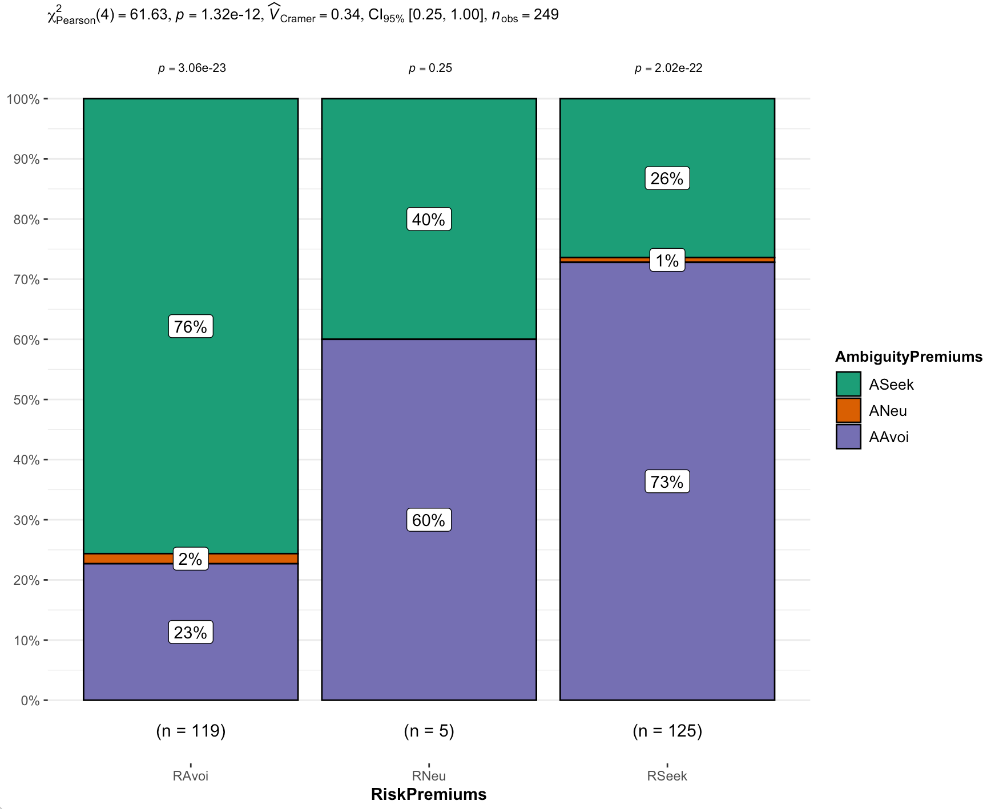

Figure 2
Correlations Plot between Risk Premiums and Ambiguity Premiums in the control condition

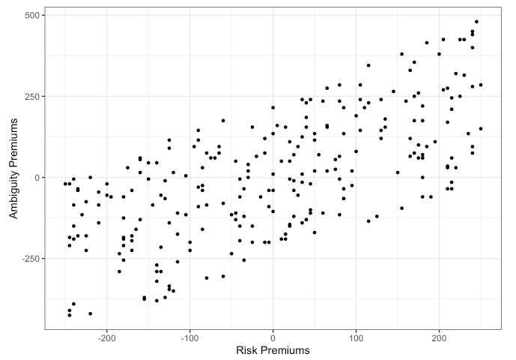

Figure 3
Correlations Plot between Risk Premiums and Normalized Ambiguity Premiums in the control condition

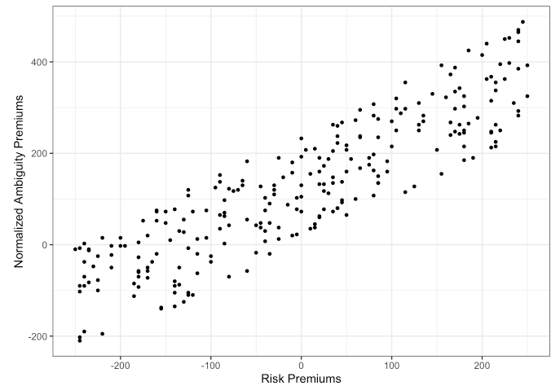

Hostility condition (Extension): Hypothesis 2 (Conceptual replication of Study 2)
Hypothesis 2 predicts that a weaker belief in negative bias towards ambiguous option avoidance will lead to weaker ambiguity avoidance.
We first ran a binomial test on the control group to examine if ambiguity avoiding or ambiguity seeking dominated among those who have asserted that felt the ambiguous options was hostile to them (45% , p = 0.886; h = -0.21, 95%CI[.37, 1.00]). We ran a similar test in the hostile condition group (52%, p = 0.382; h = -0.08, 95% CI [.43, 1.00]).
We compared ambiguity premiums and normalized ambiguity premiums of the control condition (M =5.40 , SD = 188.87; M = 127.86, SD = 152.39) to the hostility condition (M = -3.35, SD = 213.28; M = 118.50, SD = 167.92) by conducting a Welch’s independent t-test (t(205) = -1.45, p = .075, d =0.20, 95%CI[-0.47, 0.07]; t(207) = -1.03, p = .152, d = -0.14, 95%CI [-0.47, 0.13]).
We summarized our statistical tests in Table 8 with its accompanying plots in Figure 4.

Table 8
Count of perceived hostility in the ambiguity option and their lottery choices
 | Perceived ambiguity hostility | Perceived no ambiguity hostility
Control Group | 116 | 100
Lottery Bag 1 | 52 | 48
Lottery Bag 2 | 64 | 52
Hostile Bias | 105 | 109
Lottery Bag 1 | 58 | 42
Lottery Bag 2 | 47 | 67
*Those who indicted neutral to bias were excluded

Table 9
Hostility bias condition Statistics summary
Condition | Variables | Test | df | p | Effect Size | CI
Hostility Condition | Risk Premiums and Ambiguity Premiums | $Χ^{2}$ = 84.24 | 4 | < .001 | $${\hat{V}}_{Cramer }$$  = 0.40 | [0.32, 1.00]
Control Condition | Ambiguity avoidance among those perceiving hostility | Binomial = 0.45, <0.5 | 116 | = 0.886 | h = -0.21 | [.37, 1.00]
Control Condition | Ambiguity seeking among those not perceiving hostility | Binomial = 0.52, > 0.5 | 100 | = 0.382 | h = -0.08 | [.43, 1.00]
Hostility Condition | Ambiguity avoidance among those perceiving hostility | Binomial = 0.55, >0.5 | 105 | = 0.165 | h = 0.21 | [.47, 1.00]
Hostility Condition | Ambiguity seeking among those not perceiving hostility | Binomial = 0.62, >0.5 | 109 | = 0.011 | h = 0.46 | [.53, 1.00]
Control versus hostility conditions | Ambiguity Premium | t = -1.45 | 205 | = 0.075 | d = 0.20 | [-0.47, 0.07]
Control versus hostility conditions | Normalized Ambiguity Premiums | t = -1.03 | 207 | = 0.152 | d = -0.14 | [-0.47, 0.13]

Figure 4
Hostility condition: Frequency plots for risk and ambiguity premiums

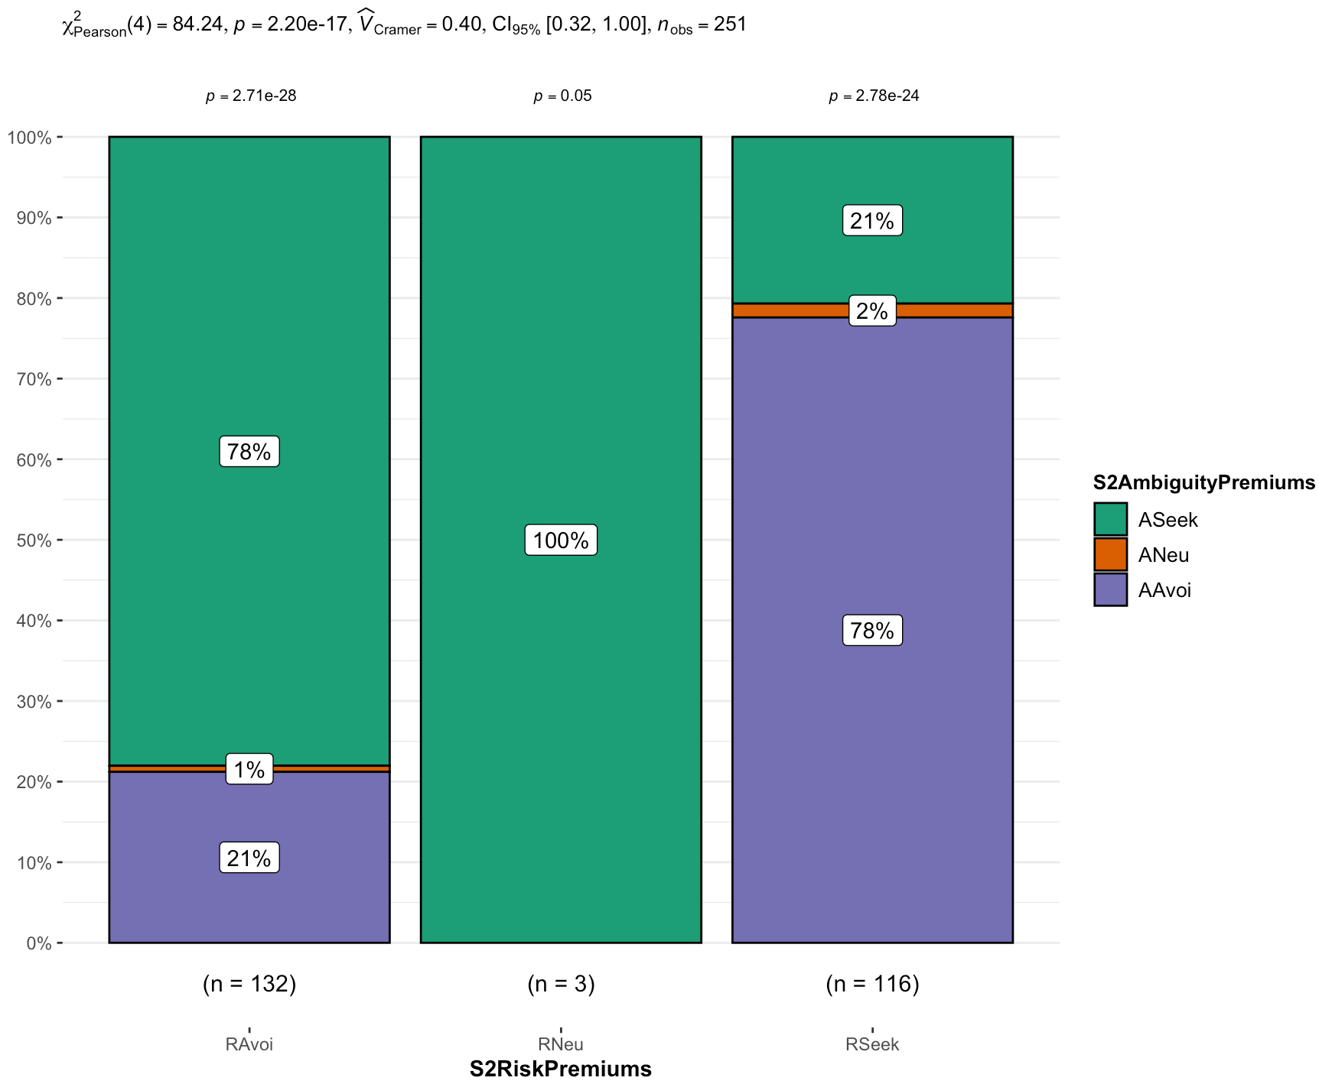

Anticipated Regret vs. Others evaluation (Extension; Conceptual replication Study 4)
We conducted a Welch independent t-test on non-normalized and normalized ambiguity premiums comparing anticipated regret condition (M = 16.50, SD = 210.48; M = 137.89, SD = 166.09) and conformity norms (M = -15.26, SD = 217.64; M = 112.73, SD = 173.84) (t(497) = -1.66, p = .098, d = -0.15 , 95% CI [-0.32, 0.03]; t(497) = -1.65, p = .100, d = -0.15, 95% CI [-0.32, 0.03]).
We also conducted a Wilcoxon test on the choice data to examine strength of ambiguity avoidance when compared between anticipated regret (N = 110) and others evaluation condition (N = 120) (W =, p = .370, r = .04, 95% CI [-0.06, 0.14]).

Anticipated regret versus control conditions (Extension)
We conducted a Welch independent t-test on ambiguity premiums and normalized ambiguity premiums comparing the control (M =5.40 , SD = 188.87; M = 127.86, SD = 152.39) and anticipated regret condition (M =-3.35 , SD = 213.28; M = 118.50, SD = 167.92) (t(492) = 0.62, p = .268, d = 0.06, 95% CI [-0.12, 0.23]; t(494) = 0.70, p = .241, d = 0.06 , 95% CI [-0.11, 0.24]).

Others evaluation versus control conditions (Extension)
We conducted a Welch independent t-test on ambiguity premiums and normalized ambiguity premiums respectively comparing the control (M = 5.40 , SD = 188.87; M = 127.86, SD = 152.39) and others evaluation condition (M = -15.26 , SD = 217.64; M = 112.73, SD = 174.84) and did not find support for differences (t(489) = -1.13, p = .871, d = 0.10 , 95% CI [-0.28, 0.07]; t(489) = -1.03, p = .848, d = -0.09, 95% CI [-0.27, 0.08]).

Table 10
Summary of Statistics for extensions: Anticipated Regret (Self-Evaluation) and Conformity Norms (Other-Evaluation)
Condition | Variables | Test | df | p | Effect Size | CI
Anticipated regret | Risk and ambiguity premiums | $Χ^{2}$ = 83.09 | 4 | < .001 | ${\hat{V}}_{Cramer }$ = 0.40 | [0.31, 1.00]
Control versus anticipated regret | Ambiguity premium | t = 0.62 | 492 | = .268 | d = 0.06 | [-0.12, 0.23]
Control versus anticipated regret | Normalized ambiguity premium | t = 0.70 | 494 | = .241 | d = 0.06 | [-0.11, 0.24]
Others evaluation | Risk and ambiguity premiums | $Χ^{2}$ = 74.08 | 2 | < .001 | ${\hat{V}}_{Cramer }$ = 0.54 | [0.43, 1.00]
Control group versus others evaluation | Ambiguity premium | t = -1.13 | 489 | = .871 | d = -0.10 | [-0.28, 0.07]
Control group versus others evaluation | Normalized ambiguity premium | t = -1.03 | 489 | = .848 | d = -0.09 | [-0.27, 0.08]
Anticipated regret versus others evaluation | Ambiguity premium | t = -1.66 | 497 | = .098 | d = -0.15 | [-0.32, 0.03]
Anticipated regret versus others evaluation | Normalized Ambiguity Premium | t = -1.65 | 497 | = .100 | d = -0.15 | [-0.32, 0.03]
Anticipated regret versus others evaluation | Ambiguity Seeking or Avoiding | w = 32500 | 500 | = .370 | r = .04 | [-0.06, 0.14]

Figure 5
Anticipated Regret: Frequency plots for risk and ambiguity premiums
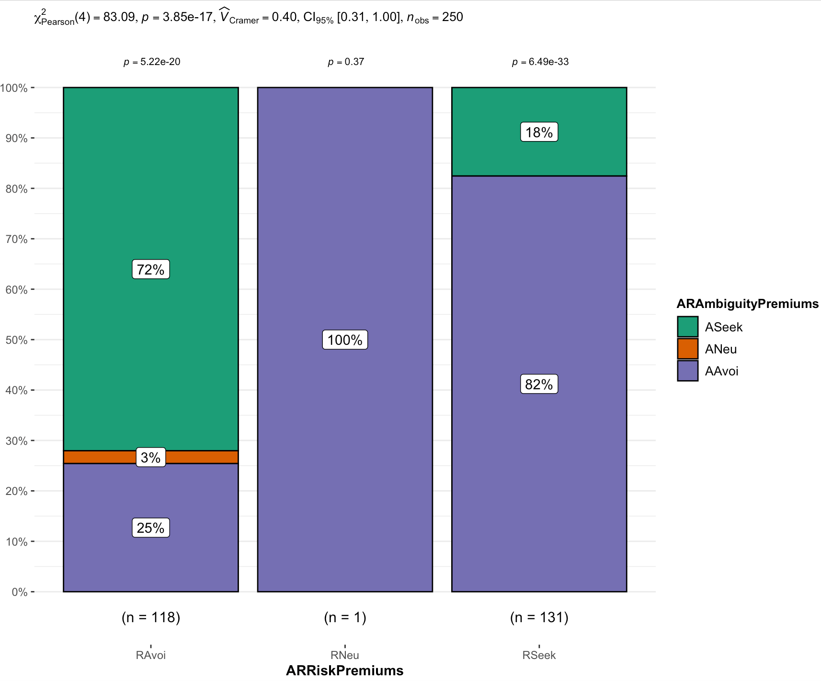

Figure 6
Others evaluations: Frequency plots for risk and ambiguity premiums

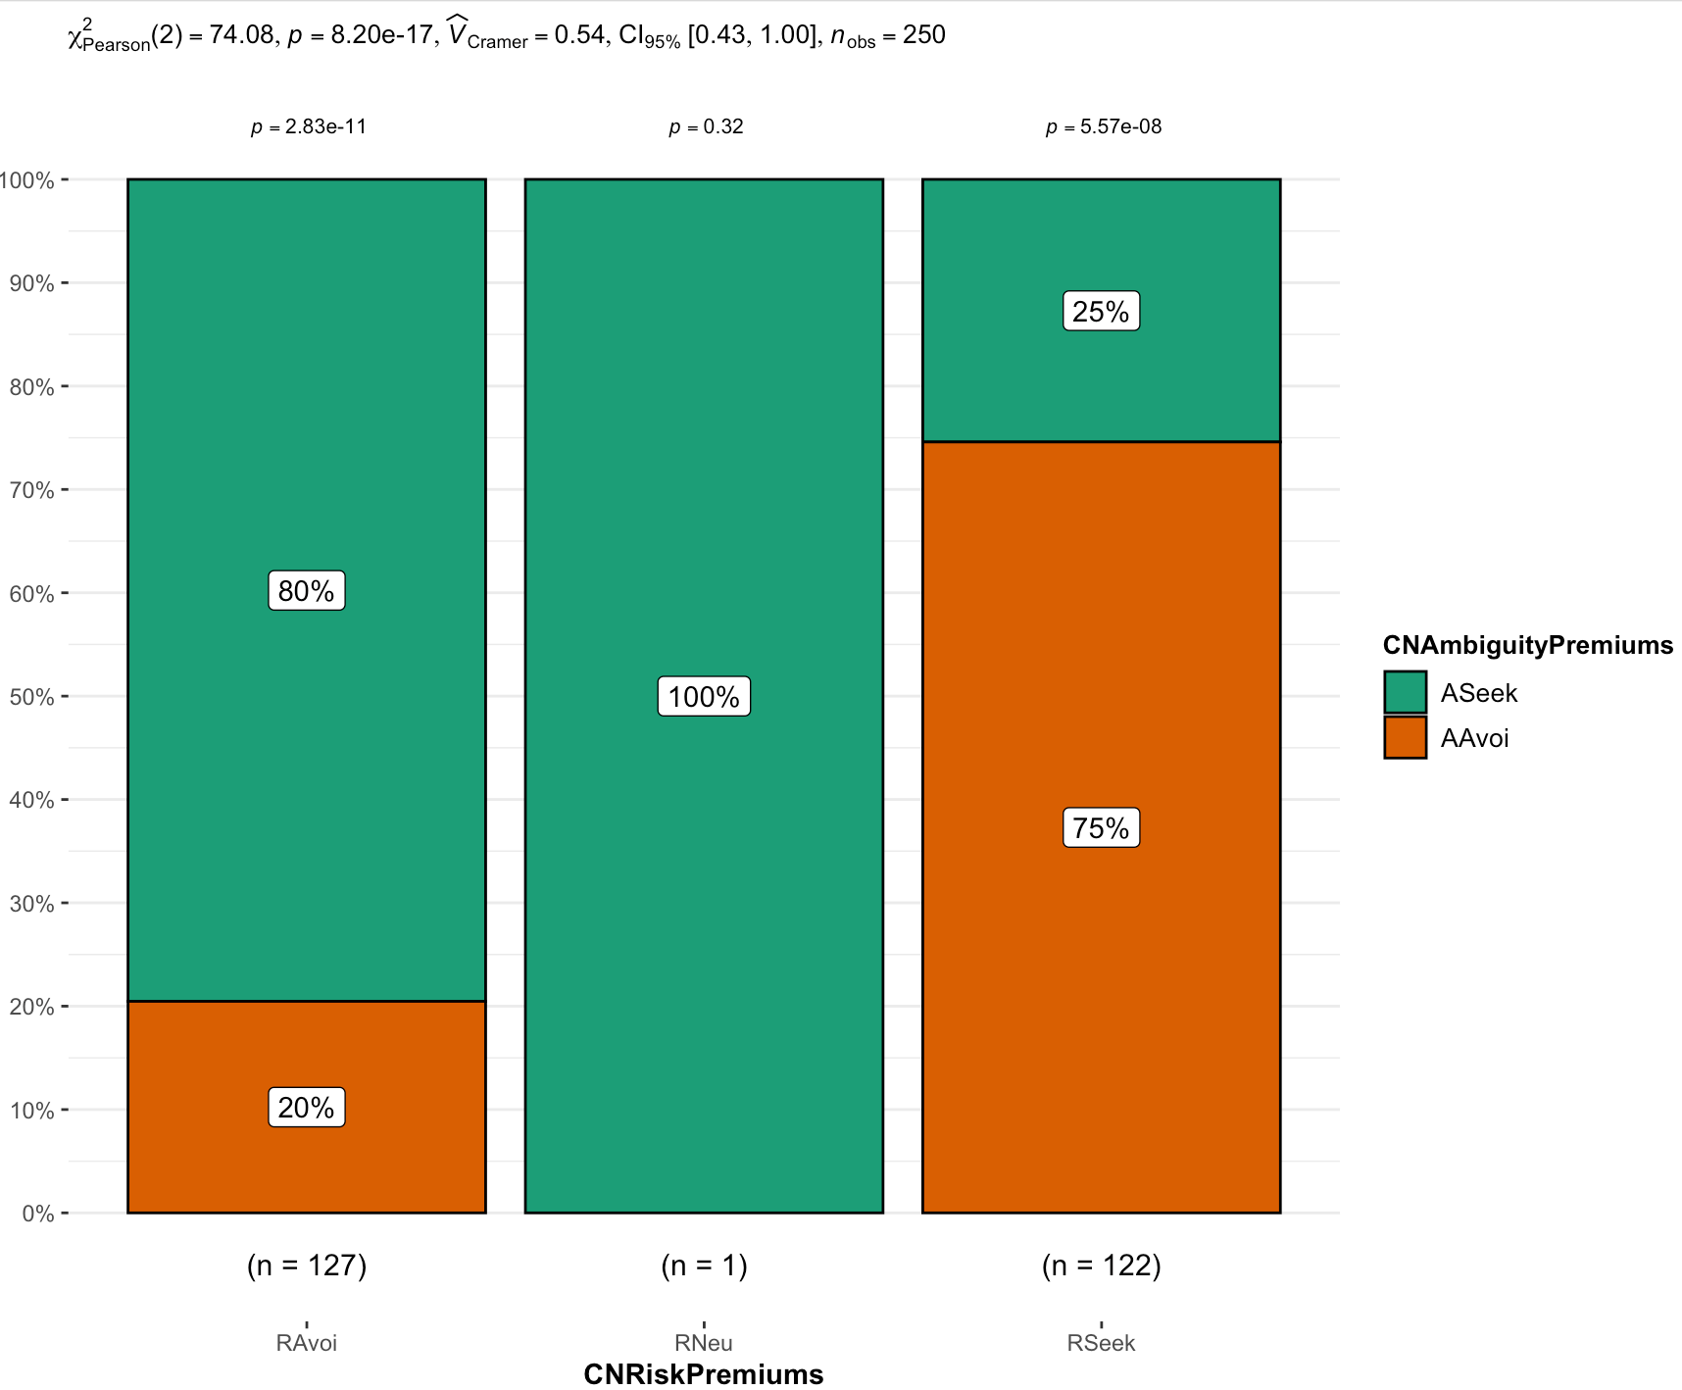

Combined comparison all condition (Extension)
We compared all conditions on ambiguity avoidance (F(3, 999) = 1.05, p = 0.371, η² = 0.00, 90% CI [0.00, 0.01]), with post hoc comparisons, which we summarized in Figure 7.

Figure 7
All conditions: Ambiguity avoidance

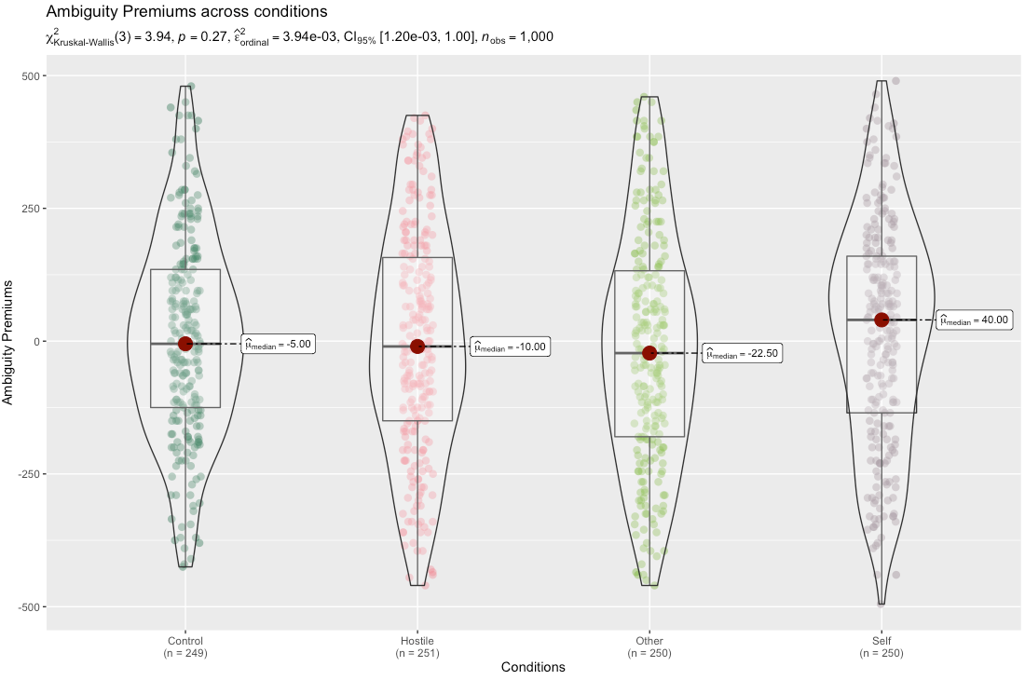

Table 11
Summary of findings: Replication versus original effect sizes and confidence intervals
Replication  Hypothesis | Replication effect size and CI | Original effect size and CI | Signal / no signal | Consistency / Inconsistency | Replication is of larger/smaller/  opposite effect. compared to the original
1 - Control | r = .89  [0.86, 0.91] | d =.75  [0.30, 1.17] | Signal | Inconsistent | Larger
2 - Hostile Bias | ${\hat{V}}_{Cramer }$ = 0.40  [0.31, 1.00] | d = .71  [0.11, 1.28], | Signal | Inconsistent | Smaller
3 - Self Evaluation | d = 0.06  [-0.12, 0.23] | η2= 0.01 [0.00, 0.05] | No Signal | Consistent | Larger
4 - Other Evaluation | d = -0.09  [-0.27, 0.08] | η2= 0.05  [0.01, 0.14] | No signal | Inconsistent | Opposite

Trait Predictors (Exploratory extension)
We examined the association between trait risk tolerance and trait ambiguity tolerance with ambiguity avoidance behavior as exploratory directions. We found no support for these associations between risk tolerance and ambiguity avoidance (r(998) = .02, p = .430, 95% CI [-0.04, 0.09]), or for an association between trait ambiguity tolerance and ambiguity avoidance behavior (r(998) = .04, p = .160, 95% CI [-0.02, 0.11]).

Discussion
[Please note that the discussion is only to be completed in Stage 2 following data collection]

Limitations and future directions
[Following peer review feedback, we plan to add: Discuss associations between ambiguity traits and ambiguity attitudes, linking the psychology and economics literatures.]
[Following peer review feedback, we plan to add: Discuss running multiple trials, assessing consistency and change in repeating trials.]

References
Bruner, J. S., & Postman, L. (1949). On the perception of incongruity: A paradigm. Journal of Personality, 18(2), 206–223. https://doi.org/10.1111/j.1467-6494.1949.tb01241.x
Buchanan, E., Gillenwaters, A., Scofield, J., & Valentine, K. (2019). MOTE: Measure of the effect: Package to assist in effect size calculations and their confidence intervals. (R Package Version 1.0.2). https://github.com/doomlab/MOTE
Camerer, C., & Weber, M. (1992). Recent developments in modeling preferences: Uncertainty and ambiguity. Journal of Risk and Uncertainty, 5(4), 325–370. https://doi.org/10.1007/bf00122575
Champely, S. (2020, March 17). pwr: Basic functions for power analysis. (R Package Version 1.3-0). https://cran.r-project.org/web/packages/pwr/index.html
Cohen, J. (1988). Statistical power analysis for the Behavioral Sciences (Second ed.). Routledge, New York, NY: Routledge Academic.
Curley, S. P., Yates, J., & Abrams, R. A. (1986). Psychological sources of ambiguity avoidance. Organizational Behavior and Human Decision Processes, 38(2), 230–256. https://doi.org/10.1016/0749-5978(86)90018-x
De Groot, K., & Thurik, R. (2018). Disentangling risk and uncertainty: When risk-taking measures are not about risk. Frontiers in Psychology, 9. https://doi.org/10.3389/fpsyg.2018.02194
Durodié, B. (2020). Handling uncertainty and ambiguity in the COVID-19 pandemic. Psychological Trauma: Theory, Research, Practice, and Policy, 12(S1), S61–S62. https://doi.org/10.1037/tra0000713
Ellsberg, D. (1961). Risk, ambiguity, and the savage axioms. The Quarterly Journal of Economics, 75(4), 643. https://doi.org/10.2307/1884324
Ellsberg, D. (1963). Risk, Ambiguity, and the Savage Axioms:Reply. The Quarterly Journal of Economics, 77(2), 336. https://doi.org/10.2307/1884409
Faul, F., Erdfelder, E., Lang, A. G., & Buchner, A. (2007). G*Power 3: A flexible statistical power analysis program for the social, behavioral, and biomedical sciences. Behavior Research Methods, 39(2), 175–191. https://doi.org/10.3758/bf03193146
Field, S. M., Hoekstra, R., Bringmann, L., & van Ravenzwaaij, D. (2019). When and why to replicate: as easy as 1, 2, 3? Collabra: Psychology, 5(1). https://doi.org/10.1525/collabra.218
Frisch, D., & Baron, J. (1988). Ambiguity and rationality. Journal of Behavioral Decision Making, 1(3), 149–157. https://doi.org/10.1002/bdm.3960010303
Furnham, A., & Ribchester, T. (1995). Tolerance of ambiguity: A review of the concept, its measurement and applications. Current Psychology, 14(3), 179–199. https://doi.org/10.1007/bf02686907
Gard, D. E., & Leung, L. N. (2021). How meaning is made: Ambiguity tolerance as a central, operationalizable concept for Psychotherapy Integration. International Journal of Integrative Psychotherapy, 11(1), 97–123. https://merl.sfsu.edu/merl/selected-publications
Heirene, R. (2020, January 7). A call for replications of addiction research: Which studies should we replicate & what constitutes a “successful” replication?. https://doi.org/10.31234/osf.io/xzmn4
Isager, P. M., van Aert, R. C. M., Bahník, Š., Brandt, M. J., DeSoto, K. A., Giner-Sorolla, R., … Lakens, D. (2020, September 2). Deciding what to replicate: A formal definition of “replication value” and a decision model for replication study selection. https://doi.org/10.31222/osf.io/2gurz
Jach, H. K., & Smillie, L. D. (2019). To fear or fly to the unknown: Tolerance for ambiguity and big five personality traits. Journal of Research in Personality, 79, 67–78. https://doi.org/10.1016/j.jrp.2019.02.003
Keren, G., & Gerritsen, L. E. (1999). On the robustness and possible accounts of ambiguity aversion. Acta Psychologica, 103(1–2), 149–172. https://doi.org/10.1016/s0001-6918(99)00034-7
LeBel, E. P., McCarthy, R. J., Earp, B. D., Elson, M., & Vanpaemel, W. (2018). A unified framework to quantify the credibility of scientific findings. Advances in Methods and Practices in Psychological Science, 1, 389-402.
LeBel, E. P., Vanpaemel, W., Cheung, I., & Campbell, L. (2019). A brief guide to evaluate replications. Meta-Psychology, 3, 1-9. DOI: 10.15626/MP.2018.843
Lerner, J. S., & Tetlock, P. E. (1999). Accounting for the effects of accountability. Psychological Bulletin, 125(2), 255.
Litman, L., Robinson, J., & Abberbock, T. (2017). TurkPrime. com: A versatile crowdsourcing data acquisition platform for the behavioral sciences. Behavior research methods, 49(2), 433-442.
McLain, D. L. (2009). Evidence of the properties of an ambiguity tolerance measure: The Multiple Stimulus Types Ambiguity Tolerance Scale–II (MSTAT–II). Psychological Reports, 105(3), 975–988. https://doi.org/10.2466/pr0.105.3.975-988
Heirene, R. (2020, January 7). A call for replications of addiction research: Which studies should we replicate & what constitutes a “successful” replication?. https://doi.org/10.31234/osf.io/xzmn4
Open Science Collaboration. (2015). Estimating the reproducibility of psychological science. Science, 349(6251). https://doi.org/10.1126/science.aac4716
Rosenbaum, G. M., Venkatraman, V., Steinberg, L., & Chein, J. M. (2021). Do adolescents always take more risks than adults? A within-subjects developmental study of context effects on decision making and processing. PLOS ONE, 16(8). https://doi.org/10.1371/journal.pone.0255102
Simons, D. J., Shoda, Y., & Lindsay, D. S. (2017). Constraints on Generality (COG): A proposed addition to all empirical papers. Perspectives on Psychological Science, 12(6), 1123–1128. https://doi.org/10.1177/1745691617708630
Theriault, J. E., Young, L., & Barrett, L. F. (2021). The sense of should: A biologically-based framework for modeling social pressure. Physics of Life Reviews, 36, 100-136. https://doi.org/10.1016/j.plrev.2020.01.004
Toda, M., & Shuford, E. H. (1965). Utility, induced utilities, and small worlds. Behavioral Science, 10(3), 238–254. https://doi.org/10.1002/bs.3830100303
Trautmann, S. T., Vieider, F. M., & Wakker, P. P. (2008). Causes of ambiguity aversion: Known versus unknown preferences. Journal of Risk and Uncertainty, 36(3), 225–243. https://doi.org/10.1007/s11166-008-9038-9
Tymula, A., Rosenberg Belmaker, L. A., Roy, A. K., Ruderman, L., Manson, K., Glimcher, P. W., & Levy, I. (2012). Adolescents’ risk-taking behavior is driven by tolerance to ambiguity. Proceedings of the National Academy of Sciences, 109(42), 17135–17140. https://doi.org/10.1073/pnas.1207144109
Zhang, D. C., Highhouse, S., & Nye, C. D. (2018). Development and validation of the General Risk Propensity Scale (GRiPS). Journal of Behavioral Decision Making, 32(2), 152–167. https://doi.org/10.1002/bdm.2102
Zwaan, R. A., Etz, A., Lucas, R. E., & Donnellan, M. B. (2017). Making replication mainstream. Behavioral and Brain Sciences, 41. https://doi.org/10.1017/s0140525x17001972

