Title:
Somatosensory Response Changes During Illusory Finger Stretching in Healthy and Chronic Pain Participants

Author names and affiliations:
Kirralise J. Hansford¹, Daniel H. Baker¹, Kirsten J. McKenzie² & Catherine E. J. Preston¹.

¹University of York, Heslington, York, UK, YO10 5DD

²University of Lincoln, Brayford, Pool, Lincoln, UK, LN6 7TS

Corresponding author:
Kirralise J. Hansford – kh1474@york.ac.uk

Abstract
Current pharmaceutical interventions for chronic pain are reported to be minimally effective, leading researchers to investigate non-pharmacological avenues for chronic pain treatment. One such avenue is the use of resizing illusions delivered using augmented reality. Here, the illusion resizes the affected body part through stretching or shrinking manipulations. These resizing illusions have been shown to give analgesic effects; however, the neural underpinnings remain undefined. This study seeks to understand the neural mechanisms behind these illusions in healthy and chronic pain participants, by using somatosensory steady state evoked potentials in addition to subjective self-report questionnaires, to enhance knowledge of what drives the subjective embodiment and analgesic effects. [results and conclusions to be added].

Key Words: Chronic Pain, EEG, Resizing Illusions

- Introduction
Chronic pain is classified as pain that lasts or reoccurs for more than 3 months (Merskey, 1986; NICE, 2021), and is the leading cause of disability globally (Vos et al., 2017). Current pharmaceutical interventions for chronic pain conditions are minimally effective, with treatments having ill-defined long-term effects (Altman, 2000), and often being no more effective than placebo at reducing pain or improving functionality (Meenagh et al., 2004; Heyworth et al., 2008). In addition, many of the drugs prescribed for pain result in around 60% of patients reporting no pain improvement or even adverse effects (Dworkin et al., 2010; Corriger et al., 2022). Surgical interventions to reduce chronic pain can result in up to 34% of patients reporting unfavourable pain outcomes (Beswick et al., 2012). Due to current treatments being largely ineffective, there is a clear need to find a non-pharmaceutical and non-surgical option for chronic pain patients.
It has been suggested that in individuals with chronic pain there may be a cortical misrepresentation of the body and its incoming somatosensory signals, including pain, along with perceptual size dysfunctions of affected limbs, which underpin their persistent pain (Boesch et al., 2016). There is often reported a lack of concordance between radiographic (physical damage) and symptomatic pain (Szebenyi et al., 2006; Felson, 2005). This highlights the likelihood of a cortical misrepresentation driving pain rather than structural damage, explaining why surgical interventions to treat structural elements of pain could be ineffective. Theories underlying this cortical misrepresentation are the predictive coding account (Friston, 2008) and the central sensitisation theory (Arendt-Nielsen & Graven-Nielsen, 2003; Arendt-Nielsen et al., 2010). Predictive coding posits that any mismatch between predicted and actual sensory inputs, such as the difference between peripheral signals and symptomatic pain, generates prediction errors. A possible lack of updating of top-down expectations in chronic pain individuals, could lead to constant mismatches between symptomatic and radiographic painful sensory inputs. Central sensitisation theory, however, refers to the central nervous system changing, distorting, or amplifying pain in a way that no longer reflects the peripheral input from the body, leading to pain becoming an illusory perception (Woolf, 2011). Central sensitisation and predictive coding theories are not positioned in opposition to each other, but rather both contribute to our overall understanding of potential causes of chronic pain conditions. Both theories also support the suitability of illusion therapies for the amelioration of chronic pain, as they can induce perceptual modulations of the painful body part, altering the patient’s perception of their body and the pain related to it.
Illusory finger stretching is a form of multisensory illusion, specifically a resizing illusion, which alters the subjective perceptual experience of the size of one’s finger. This illusion is based on the rubber hand illusion, in which touch is delivered to a visible fake hand at the same time and in the same place that touch is delivered to the hidden real hand. This manipulation elicits feelings of ownership over the fake hand, through the integration of multisensory (tactile and visual) inputs highlighting the apparent malleability of bodily self (Botvinick & Cohen, 1998). Resizing illusions, through changing the way in which a body part is perceived, further exploit these principles of multisensory integration to elicit modulations in the perceived size and shape of the body (Preston & Newport 2011; Preston et al., 2020; Stanton et al. 2018). Multisensory resizing illusions typically involve both tactile and visual inputs to the patient / participant and can be delivered via an augmented reality system or through magnifying optics. Due to previous research showing a reduction in hand and knee pain in osteoarthritis (OA) patients using an augmented reality system (Preston & Newport, 2011; Preston et al., 2020; Stanton et al., 2018), this will be the medium of resizing illusion discussed further.
The augmented reality system presents real-time video capture of the hand, from the same position and perspective as if the hand were being viewed directly (Preston & Newport, 2011). This allows the experimenter to deliver tactile manipulations, such as gently pulling or pushing the hand, whilst the participant views the hand either stretching or shrinking in the augmented image. Newport, Pearce and Preston (2010) found strong embodiment using this multisensory visuotactile illusion, and previous pilot data using the same experimental set up as the current study, has shown trends towards greater illusory experience in healthy and chronic pain participants during synchronous visuotactile manipulations compared to asynchronous (mismatching visuotactile manipulation) control conditions (Appendix C). When comparing multisensory visuotactile resizing illusions to unimodal visual resizing illusions, our recent work (Hansford et al., 2022) shows that multisensory illusions elicit significantly greater illusory experience in healthy participants, whilst also showing that a subset of participants who experienced an illusion in the unimodal visual condition reported a stronger illusory experience in this condition than in an asynchronous control condition.
Resizing illusions have not only been found to reduce pain in osteoarthritis patients, but also in chronic pain conditions such as complex regional pain syndrome (CRPS) (Moseley, Parsons & Spence, 2008), and chronic back pain (Diers et al., 2013). The rationale for analgesic resizing is based on findings that chronic pain patients often misreport the size of their affected limb, with CRPS patients reporting their arms feeling larger (Lewis et al., 2007; Moseley, 2005; Peltz et al., 2011) and OA patients reporting their hands feeling smaller (Gilpin et al., 2014) and knees feeling larger (Stanton et al., 2018) than controls. These findings indicate that resizing illusions are likely to be targeting the misrepresentation of the body seen in chronic pain conditions, rather than pain more generally. There is uncertainty, however, regarding how best to treat this misrepresentation, as evidence supports resizing the affected limb to normal size (Moseley, Parsons & Spence, 2008; Preston & Newport, 2011) as well as resizing to match the misrepresented size (Stanton et al., 2018). Therefore, it is important to understand the patient’s perceived limb-size before utilising a resizing illusion as a form of analgesic treatment, as stretching an affected body part which is perceived as larger than accurate, has also been found to increase pain (Moseley et al., 2006). Further research is, therefore, needed to determine which resizing illusions are most effective for each chronic pain condition. There are two main theories underlying the analgesia seen during resizing illusions, firstly the somatosensory blurring hypothesis, which posits that the cortical representation of a painful body part is blurred, and that viewing the body part sharpens this representation. This is supported through findings in healthy participants, where visual analgesia has been found following experimentally induced pain (Haggard et al., 2013). The other theory is from Gilpin et al. (2015), which showed that participants with arthritis make smaller hand judgements compared to healthy participants, and posited that this could be influencing pain, as when stretching their hands, the pain was reduced. Therefore, it could be that increasing the cortical representation through magnifying the affected body part, reduced their pain. Both theories predict that the cortical misrepresentations mentioned previously through the predictive coding and central sensitisation accounts, therefore occur at the somatosensory cortex, with both theories predicting different neural changes regarding the experience of pain. Specifically, somatosensory blurring hypothesis predicts a larger, more diffuse representation of the painful body part that would be reduced (sharpened) with the illusions, whereas the magnification theory would predict a shrunken representation of the painful body part that would be enlarged following illusory stretching.
Neuroimaging has previously been used in healthy populations experiencing resizing illusions, whereby modulation of the primary somatosensory cortex has been found using neuromagnetic source imaging during visual only resizing illusions of the arm (Schaefer et al., 2007). Briefly, the more the subjects felt the subjective experience of an elongated arm, the more the cortical distance between the first and fifth digit decreased, showing the topographical representation of the somatosensory cortex being modulated by perceived location of a peripheral stimulus. Specifically looking at the stretching multisensory visuotactile illusions found to reduce pain in OA (Preston & Newport, 2011), recent research suggests that these illusions directly impact the neural representations of the body and reflect early-stage multimodal stimulus integration (Kanayama et al., 2021). We have recently investigated this illusion in healthy participants using electroencephalography (EEG) and have found support for this previous research, finding significant increases in gamma band power, likely reflecting multimodal stimulus integration, in multisensory visuotactile compared to unimodal visual conditions during illusory resizing of a finger (Hansford et al., 2022). Previous research using rubber hand illusions found this multisensory integration effect in early-stage gamma band increases (Kanayama et al., 2021), whilst our recent findings show a later stage of multimodal stimulus integration when using illusory finger resizing manipulations (Hansford et al., 2022).
Looking specifically at research into somatosensory cortex modulation using steady-state evoked potentials (SSEPs), low-level somatosensory responses have been induced directly using vibrations of a known frequency applied to a body part. These generate a frequency-locked steady-state evoked potential detectable at the scalp using EEG (Snyder, 1992; Tobimatsu et al., 1999), and are an index of the cortical response to a stimulus. This paradigm has been used with other sensory modalities to better understand the neural mechanisms underlying multisensory integration, with findings showing that presentation of temporally congruent auditory and visual stimuli significantly enhances the magnitude and inter-trial phase coherence of auditory and visual steady-state responses (Nozaradan et al., 2012). However, research has also found evidence of enhanced steady-state responses for within-modality stimulation (Giani et al., 2012), in contrast to previous findings. Research using vibrotactile stimulation has found greater increases in steady-state response magnitude when this corresponds with the amplitude modulation rate of stimulation (Colon et al., 2012; Rees et al., 1986) suggesting an entrainment of oscillatory activity to temporal features of sensory stimulation (Timora & Budd, 2018). Given these findings, we anticipate that somatosensory steady-state signals might change during the resizing illusion, due to the multisensory manipulations present, to give a potential index of changes in neural representations during the illusion. These SSEPs can therefore be used as a measure of the somatosensory blurring hypothesis (Haggard et al., 2013) and the magnifying hypothesis (Gilpin et al., 2015), as an increased SSEP response could indicated evidence supporting the magnification hypothesis, as there is more cortical area being used to represent the body part, whereas a smaller SSEP response could indicate evidence supporting the somatosensory blurring hypothesis, as the cortical representation of the body part has become sharpened.
Despite several studies investigating the analgesic effect of resizing illusions, the understanding of how these illusions reduce pain is still undetermined. It has been suggested that there are cortical misrepresentations of the size of the affected body part, however, it is unknown if resizing illusions affect this cortical misrepresentation, and if this is therefore what causes the reduction in pain. No study has yet used neuroimaging with a chronic pain population to determine the cortical activity correlated with this illusory analgesia. The main aim of this study, therefore, is to examine potential changes in the somatosensory cortex during illusory finger resizing in both healthy and chronic pain participants, using vibrotactile SSSEPs. If we can show a link between illusory analgesia and somatosensory cortex changes, this will enhance our understanding of what is happening in the brain during this illusion-induced analgesic effect. Looking forward to utilising illusory resizing as a non-pharmaceutical pain treatment, having a greater understanding of the neural underpinnings of this technique will likely enhance the effectiveness of such treatment, increase patient trust in the therapy, and will allow the resizing illusions to be adapted for differing chronic pain conditions.
Using different sensory manipulations of finger resizing illusions, in addition to using an electromagnetic solenoid stimulator, this study aims to investigate subjective illusory experience and SSEP responses in both healthy and chronic pain patients, to better understand the relationship between body ownership illusions and experiences of chronic pain from subjective experience and cortical representation perspectives. To test this, different resizing illusions consisting of multisensory (visuotactile) stretching (MS), unimodal-visual stretching (UV), a non-illusion control condition without tactile input (NI), and a non-illusion control condition with tactile input (NIT) will be used to assess alternate aspects of illusory resizing manipulations and their related effects on SSEP response. In line with previous findings regarding effective UV conditions (Hansford et al., 2022), subjective questionnaire data will be used to identify individuals who experience an effective UV condition, and these participant’s SSEP data will then be analysed. The first hypothesis, acting as a positive control (1), is that (1a) there will be a greater illusory experience, measured via a subjective illusory experience questionnaire, in the MS condition compared to the non-illusion conditions in the healthy group. There will also be (1b) a greater illusory experience, measured via a subjective illusory experience questionnaire, in the MS condition compared to the non-illusion conditions in the chronic pain group. The main experimental hypothesis for this study is that (2) there will be a significant difference in SSEP response when comparing (2a) MS visuotactile illusory resizing to non-illusions, and when comparing (2b) effective UV illusory resizing to non-illusions in the healthy group. There will also be a significant difference in SSEP response when comparing (2c) MS visuotactile illusory resizing to non-illusions, and when comparing (2d) effective UV illusory resizing to non-illusions in the chronic pain group. Also, (2e) there will be a significant difference when comparing healthy to chronic pain participant’s baseline NI SSEP responses. The final hypothesis is that (3) we expect to find a subjective reduction in pain, measured via a 21-point numeric rating scale, comparing before and after scores for (3a) MS and (3b) UV conditions, whilst we expect (3c) no reduction of pain following the NI condition, nor (3d) a reduction of pain following the NIT condition.

- Methods
  - Sample Size
Overall, based on the power analyses in section 2.5, a total sample size of 68 participants (34 healthy, 34 chronic pain) will be recruited, to adhere to the higher end of sample size estimates (Hypothesis 2 (2.5.2)).

2.2 Participants
Ethical approval for this research was gained from the Department of Psychology, University of York (ethics application code 950), in line with the Declaration of Helsinki. Informed consent from each participant will be gained prior to the start of any experimental set up, and participants will be instructed that they can withdraw their participation at any time during or after completion of the experiment.
Chronic pain and healthy participants will be matched based on sex, age and handedness, creating a matched pairs design experiment. Due to increased difficulties recruiting from clinical populations, chronic pain participants will be recruited first, and then healthy participants matched on sex, age and handedness will be recruited. An upper age limit of 75 years is used based on data from the NHS (2019) showing rates of chronic pain conditions increasing from 16% among people aged 16-24, to 53% for those 75 years and older. All participants will take part in all illusory conditions and will complete the subjective illusory experience questionnaire, with chronic pain participants also completing the pain rating scale.
Sample inclusion / exclusion criteria:
Inclusion and exclusion criteria will be determined using self-report responses relating to each item listed below:
- Inclusion Criteria: Right-handed, over 18 years of age, no older than 75 years of age.
*Chronic pain participant specific inclusion criteria: must have a diagnosed chronic pain condition involving current hand-based pain in the right hand, hand-based pain present on day of testing.

- Exclusion Criteria: Prior knowledge or expectations about the research, a history of developmental, neurological or psychiatric disorders, history of drug or alcohol abuse, history of sleep disorders, history of epilepsy, having visual abnormalities that cannot be corrected optically (i.e. with glasses), or being under 18 years of age, or over 75 years of age.
*Healthy participant specific exclusion criteria: a history of chronic pain conditions, operations or procedures that could damage peripheral nerve pathways in the hands, current experiences of pain or more than 4 hours of consistent pain experienced in the preceding week.
*Chronic pain participant specific exclusion criteria: Diagnosed with Complex Regional Pain Syndrome, no restrictions apply regarding any medication the participant might be taking. (Complex Regional Pain Syndrome is excluded as a chronic pain condition here, due to research showing increasing pain after stretching illusions (Moseley et al., 2006).

Raw data exclusion criteria:
- Less than 100% of the experiment completed by a participant, more than 50% of electrodes needing removal from EEG data.
2.3 Experimental Procedure
All participants will fill out a demographic survey, asking their age and sex, and will be asked to complete the revised Waterloo Handedness Questionnaire (WHQr) (Elias et al., 1998). The WHQr self-reported handedness questionnaire consists of 36 questions. The questions are answered on a 5-level, Likert scale to determine the degree of preferred hand use, with left always being -2, left usually being -1, equal use being 0, right usually being 1 and right always being 2. The sum of the total WHQr score can then be used to categorise a respondent as left-handed (score of -24 or less), mixed handed (score of -23 to +23), or right-handed (score of +24 or higher). Only participants who are categorised as right-handed will continue participation. Clinical participants will then be asked questions regarding what chronic pain condition they are diagnosed with, how long it has been since diagnosis, what medications (if any) they are taking, and their pain score on that day for their digit in the most pain using a 21-point numeric rating scale (NRS) (0 = no pain at all; 20 = most severe pain imaginable). This 21-point NRS will also be administered on the morning of the day of testing, to check that the participant has pain in their hand on that day. This 21-point scale has equivalent reliability to a more frequently used 11-point scale (Jensen & Karoly, 2001) and was chosen to aid comparability with previous studies which have used the 21-point NRS (Preston & Newport, 2011; Preston, Gilpin & Newport, 2020). Additionally, since the scale is different to a typical rating scale of 1-10, participants will be more likely to think about the answer they give, rather than giving a number they always use when asked to rate their pain on a scale of 1-10.
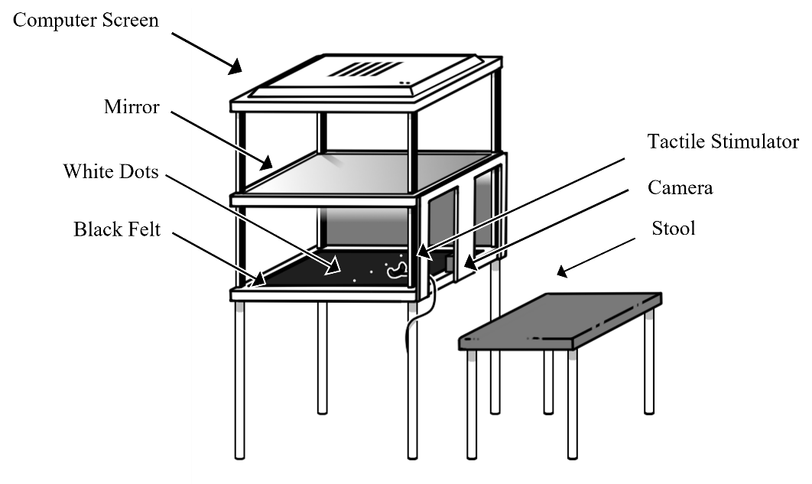
Both healthy and chronic pain participants will then be set up with an appropriately sized 64-channel EEG cap with electrodes arranged according to the 10/20 system. The experimenter will use conductive gel to make a conductive bridge between the electrodes and the scalp to attempt to obtain impedance levels of <10kΩ per electrode. The whole head average will be used as a reference.

Figure 1. Schematic of Augmented Reality System with Tactile Stimulator.
Participants will then be seated behind the augmented reality system (Figure 1) and instructed to place their hand onto the black felt fabric within the augmented reality system. Within the self-built system there is a 1920 x 1080 Spedal Webcam Wide Angle Camera situated in the middle of the central area, away from the participant’s view. 26cms above the felt base of this central area, there is a mirror, which is placed 26cms below a 1920 x 1200 resolution screen, with a width of 52cms. This screen is 54cms from the base of the system, and the base of the system is 82cms from the ground. Chronic pain participants will be asked which digit is in the most pain and will be asked to place this digit outstretched onto the felt. If multiple digits are equally painful, the digit that the participant chooses as their preference will be used. Healthy participants will be asked to outstretch a digit that has been matched to that of a chronic pain participant. There will be two white dots for each hand on the felt and participants will be instructed to place their hand between these two dots. Participants will be instructed to view their hand’s image in the mirror (the real hand will be hidden from view) throughout the experiment. The camera placed underneath the mirror on the felt base will be used to deliver a live feed video of the participants hands to the computer screen at the top of the augmented reality system, which will show in the mirror reflection to the participants.
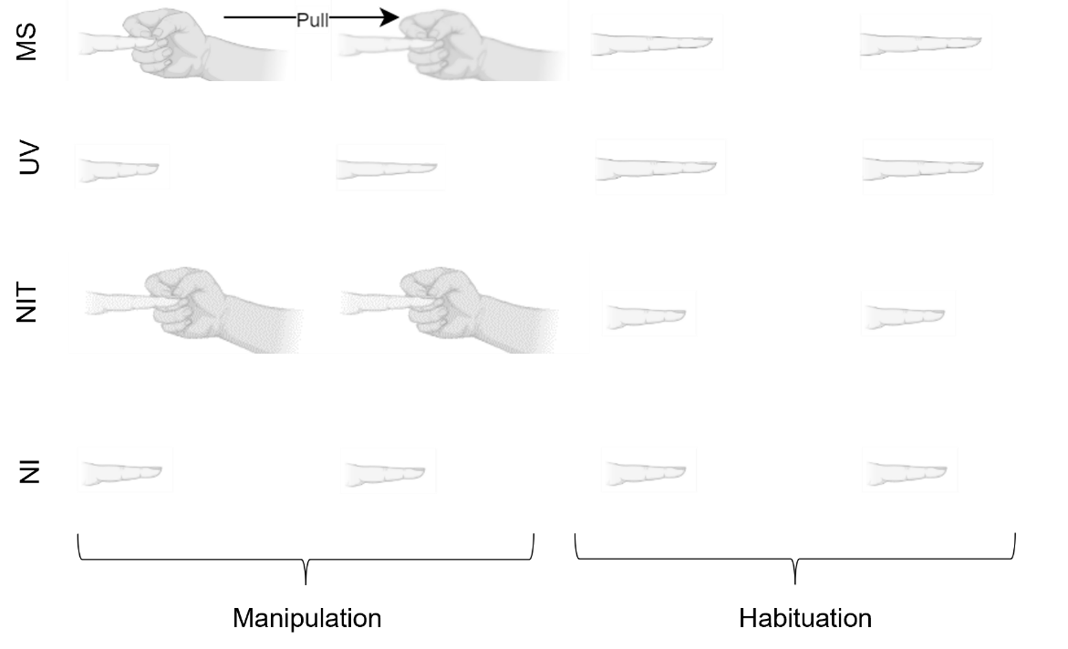
Participants will undergo 4 conditions: multisensory stretching (MS), unimodal-visual stretching (UV), a non-illusion control condition without tactile input (NI), and a non-illusion control condition with tactile input (NIT). There will be vibrotactile stimulation to the finger in all conditions, but only tactile input of the researcher touching the participants hand in the conditions where this is mentioned. Each trial will last 2.4 seconds for the manipulation phase, where the finger will be stretched by 60 pixels (2.1 centimetres) in UV and MS conditions, followed by a further 2.4 second habituation phase in which participants can view and move their augmented finger before the screen goes dark, indicating that the next trial can start. MS conditions consist of the researcher touching and pulling the participant’s finger as the participant views their finger stretching in a congruent manner. UV conditions consist of the participants viewing their finger stretch without any experimenter manipulation. The NI condition provides no visual or touching tactile manipulations to the finger. The second NI control condition will involve no visual input of the finger stretching, instead the image of their finger will be visible but unchanged. Additionally, this condition will include tactile input of the experimenter’s hand touching the participant’s finger, but without pulling. Previous research has suggested that tactile input alone can reduce pain ratings (Mancini et al., 2014; Nahra & Palghki, 2009), therefore this second control condition will demonstrate if it is the illusion itself that is driving any changes in analgesia rather than the tactile or combined sensory inputs. Visualisation of all conditions can be seen in Figure 2.
Figure 2. Infographic of Experimental Conditions. MS = Multisensory, UV = Unimodal Visual, NIT = Non-Illusion Tactile, NI = Non-Illusion. Manipulation phase (2.4 seconds) is where experimenter creates illusion, habituation phase (2.4 seconds) is where participants are free to move their finger. Arrow denotes the direction of the experimenter’s action.
The experimenter will be seated opposite the participant, the other side of the augmented reality machine and will pull the digit by holding onto the distal interphalangeal joint and gently pulling the finger whilst the participant keeps their hand in place. Conditions will be delivered across 4 blocks, with each block consisting of 24 trials of the same experimental condition, totalling 96 trials over all 4 blocks. The ordering of the blocks will be randomised for each participant to prevent ordering effects. The experiment will be programmed in, and the conditions randomised using MATLAB R2017a and the experimenter will be informed of whether to pull the finger or to apply no manipulation via an indicative box displayed on the screen out of the participant’s view. If the box is blue, this will indicate a need to pull the finger, if it is white it will indicate a need to touch the finger. The researcher will use a button press to dictate the start of the manipulation, and will start pulling the finger, when needed, synchronously within the 2.4 second manipulation phase. If the experimenter forgets to pull the finger on a multisensory condition, or mistakenly pulls the finger in a control trial, then this will be noted during the experiment, and that trial will be removed from analysis. Vibrations will be delivered to the participant’s finger in all conditions using a miniature electromagnetic solenoid stimulator/bone conductor (Dancer Design Tactor; diameter 1.8mm) emitting vibrations produced by sending amplified 26Hz sine wave sound files, with stimulus intensity controlled by an amplifier (Dancer Design TactAmp). The tactor is driven at 50% of the maximum (i.e. a peak input voltage of 3V) using a 26Hz sine-wave, and delivers a peak force of 0.18N. The electromagnetic solenoid stimulator will be attached to the participant’s finger that is outstretched and will receive the manipulations, between the knuckle and the first finger joint, using a black Velcro strip and will give continuous stimulation for the duration of each trial. Clinical participants will be asked before each illusory manipulation and then again immediately after each manipulation to rate their pain on the 21-point NRS, which will be a verbal report that the experimenter will input onto a Samsung Galaxy A6 Tablet. Participants will be encouraged to take a break between each of the blocks to stretch their hand. EEG will be recorded throughout as a continuous recording with conditions denoted by numbered 8-bit digital triggers sent when the researcher presses a button box to start each condition (USB-TTL Module, Black Box Toolkit Ltd.).
Finally, each condition will be presented once in a randomised fashion, after which, the participant will be asked to complete the subjective illusory experience questionnaire for each trial using the Samsung Galaxy Tab A6 tablet via a questionnaire on Qualtrics (Qualtrics, Provo, UT). The questionnaire consists of six questions relating to the trial the participant had just experienced, and trials they have experienced previously that were similar. Two statements relate to illusory experience: “It felt like my finger was really stretching” / “It felt like the finger I saw was part of my body”, two relate to disownership: “It felt like the finger I saw no longer belonged to me” / “It felt like the finger I saw was no longer part of my body”, and two are control questions: “It felt as if my finger had disappeared” / “It felt as if I might have had an extra finger index finger” (all questions will be directed towards the participants manipulated finger). Control questions are included to create an index for the illusion and disownership questions (more detail can be found in section 2.4.1 - Preprocessing steps), whilst disownership questions are included to assess if the potential analgesia from the illusions results from a disownership of the body part, or from subjective embodiment of said body part (McCabe, 2011). A visual analogue scale from 0 – 100 will be used for each statement, with 0 being strongly disagree, 50 being neutral and 100 being strongly agree.
Data collection will be terminated when the full sample of participants have been recruited (34 healthy, 34 chronic pain). If a participant completes <100% of the experiment their data will not be included, and additional participants will be recruited to fill any lost data.

2.4 Analysis Pipeline

2.4.1 Preprocessing steps
Using MATLAB r2019a and EEGlab, a 50Hz notch filter will first be applied to the raw EEG data for all electrodes, which will then be analysed to show standard errors for each electrode for each participant. Across all the standard errors, the top 5% of standard errors will be used to create a standard error threshold. Any electrode with a standard error above this threshold, or with a value of 0, will be removed from analysis. Where a participant has over 50% of their electrodes over the standard error threshold, or with a value of 0, their data will be removed.
Regarding questionnaire data, scores for both illusion experience questions will be combined to give median scores, along with both disownership questions and both control questions, resulting in 3 median scores per trial per participant. The median control scores will be used to create an index of the illusion and disownership scores by subtracting the median control score from the median illusion and median disownership scores, in line with previous research doing similarly (Matsumiya, 2021; Kilteni & Ehrsson, 2017; Kalckert & Ehrsson, 2012).
Pain data will be averaged for pre and post all experimental conditions, resulting in 8 averages per participant.

2.4.2 Planned analyses

2.4.2.1 Hypothesis 1 (Positive Control)
(1a – Positive Control) There will be a greater illusory experience, measured via a subjective illusory experience questionnaire, in the multisensory condition compared to the non-illusion condition in the Healthy Group. There will also be (1b) a greater illusory experience, measured via a subjective illusory experience questionnaire, in the multisensory condition compared to the non-illusion conditions in the Chronic Pain Group.
The subjective illusory experience questionnaire will be used as a positive control for the current study. Previous research has shown significantly greater illusion strength for MS conditions compared to NI conditions, which we will attempt to replicate. Questionnaire data will be analysed using JASP (JASP Team, 2022). A one-way ANOVA will be run to compare the dependent variable of median illusion score from each independent condition. Given significant findings, post-hoc tests will be run, with Bonferroni correction for 4 comparisons (MS / NI conditions, UV / NI conditions) at an initial alpha of 0.05. Subjective data will also be used to identify participants who effectively experience the unimodal visual condition where participants will be included in further EEG analysis if their median illusion scores on the subjective illusory questionnaire scale for the unimodal-visual condition are greater than 50, in line with previous research using mean subjective embodiment scales (Carey et al., 2019), which will indicate experience of the illusion. If the positive control is successful in these analyses, then there would be scope to run exploratory analyses between the healthy and chronic pain groups regarding their subjective illusory experiences.

Interpretations for hypothesis 1 can be found in the design table (Appendix B).

2.4.2.2 Hypothesis 2
There will be a significant difference in SSEP response when comparing (2a) multisensory visuotactile illusory resizing to non-illusion, and when comparing (2b) effective unimodal visual illusory resizing to non-illusion in the healthy group. There will also be a significant difference in SSEP response when comparing (2c) multisensory visuotactile illusory resizing to non-illusion, and when comparing (2d) effective unimodal visual illusory resizing to non-illusion in the chronic pain group. Finally, (2e) there will be a significant difference when comparing healthy to chronic pain participant’s baseline NI SSEP responses.
After pre-processing steps as mentioned in section 2.4.1 are taken, analysis of EEG data will first involve importing the waveforms from MATLAB into R, and then using R to take a Fourier transform for each waveform across all remaining electrodes, to obtain individual results per participant. These will then be averaged across all participants to give overall results, before running a dependent samples t test (two-sided) comparing MS to NI and one comparing UV to NI in the healthy group, along with a dependent samples t test (two-sided) comparing MS to NI and one comparing UV to NI in the chronic pain group. We will finally run a dependent samples t test (two-sided) comparing the healthy group baseline NI data to the chronic pain group’s baseline NI data. The dependent variable will be SSSEP amplitude in µV, whilst the independent variable will be the different manipulations given in each comparison condition. No additional filtering or denoising steps will be applied to the EEG data, in line with Figueira et al.’s (2022) report that only a Fourier transform is typically needed for this type of EEG data. If differences are seen in these analyses, then there would be scope to run exploratory analyses between the healthy and chronic pain groups. Based on the pilot data in Figure 3, we would expect to see activation most pronounced over mid-frontal distributions, covering F1 and FC1 electrodes.
Interpretations for hypothesis 2 can be found in the design table (Appendix B).

2.4.2.3 Hypothesis 3
(3) We expect to find a subjective reduction in pain, measured via a 21-point numeric rating scale, comparing before and after scores for (3a) multisensory and (3b) unimodal-visual conditions whilst we expect (3c) no reduction of pain following the non-illusion condition, nor (3d) a reduction of pain following the non-illusion tactile condition.
Pain data will also be analysed using JASP (JASP Team, 2022). Since the data will be ordinal, non-parametric Wilcoxon signed rank tests (one-sided) will be used to compare the dependent variable of median pain scores before and after each independent condition. Comparisons of the visuotactile and the non-illusion tactile conditions will be exploratory and will assess whether a reduction in pain is due to the illusory manipulations or rather, due to the addition of tactile input.
Interpretations for hypothesis 3 can be found in the design table (Appendix B).

2.5 Power Analysis

2.5.1 Hypothesis 1 (Positive Control)
Effect sizes are determined by research from Hansford et al (2022) using the subjective illusory experience questionnaire and comparing MS and UV finger-based resizing illusions using the same finger stretching illusions and the same equipment, which show an effect size of n² = .33 (converted to a Cohen’s f = .73) when comparing all participants, and an effect size of n² = .35 (converted to a Cohen’s f = .74) when looking at participants who experience an effective uni-modal visual illusion. Additional effect size information comes from a visual capture study using a subjective embodiment questionnaire and visual and tactile manipulations to a mannequin body (Carey et al., 2019), showing an effect size of r = .64 (converted to a Cohen’s f = .83). An effect size of .73 was used for hypothesis 1a and .74 was used for hypothesis 1b to adhere to the lower end of previous effect sizes.
A priori power analysis using G*Power for the smallest effect size of interest (f = .73) shows that for a repeated measures, within factors one way ANOVA, with an effect size (f) of 0.73, alpha of 0.05, power at 80% and 2 groups with three measurements, 6 participants are needed for each group.

2.5.2 Hypothesis 2
This is the first study to investigate illusory finger stretching using SSEPs, so appropriate effect size estimates are not available. We therefore conducted power calculations based on a smallest effect size of interest (Lakens, 2014) of d = 0.5 (a medium effect, see Cohen, 1988).
A priori power analysis using G*Power shows that for a matched pairs two-sided t test, with an effect size of d = .5, alpha of 0.05, power at 80%, a total sample size of 34 participants is needed for each participant group.

2.5.3 Hypothesis 3
Effect size is determined using those listed in previous research using the 21-point numeric pain rating scale (Preston et al., 2020) and from previous pilot data using the same MS resizing illusions for analgesic effect, finding post illusion pain scores to be significantly lower than pre illusion scores (t(10)=3.32, p = .008, d = 1.0).
A priori power analysis using G*Power shows that for a Wilcoxon signed-rank test (two-sided, matched pairs), with an effect size (dz) of 1, alpha of 0.05, and power at 80%, for a two tailed test with normal parent distribution, 11 chronic pain participants are needed in total.
A Design planner (Table B1) encompassing research questions, hypotheses, sampling and analysis plans and their resulting interpretations, can be seen in appendix B.

3. Pilot Data
Previous literature states that the ideal vibration frequency to use to elicit somatosensory steady state evoked potentials (SSSEPs) ranges from 26-27Hz (Muller et al., 2001; Muller-Putz et al., 2001; Breitweiser et al., 2016; Pokorny et al., 2016; Snyder, 1992). Due to resizing illusions often manipulating the index finger, and previous studies using the index finger supporting around 26Hz as an optimal frequency (Muller-Putz et al., 2001; Breitweiser et al., 2016; Pokorny et al., 2016), it was hypothesised that 26Hz would elicit a dependable SSSEP. Therefore, we ran a pilot study to check that our setup and equipment can reliably elicit and record a SSSEP at 26Hz, using the resizing illusion and EEG.
Pilot data was collected for 3 healthy participants. Participants underwent the same experimental protocol as mentioned in the “Experimental Procedure” section, minus the subjective illusory experience and pain rating scales. No additional filtering or denoising steps were applied to the EEG data, in line with Figueira et al.’s (2022) report that only a Fourier transform is typically needed for this type of EEG data. A Fourier transform was calculated for each waveform at each electrode for all conditions, and then averaged across repetition to obtain individual results. These were then averaged across all 3 participants to give the result seen in Figure 3.
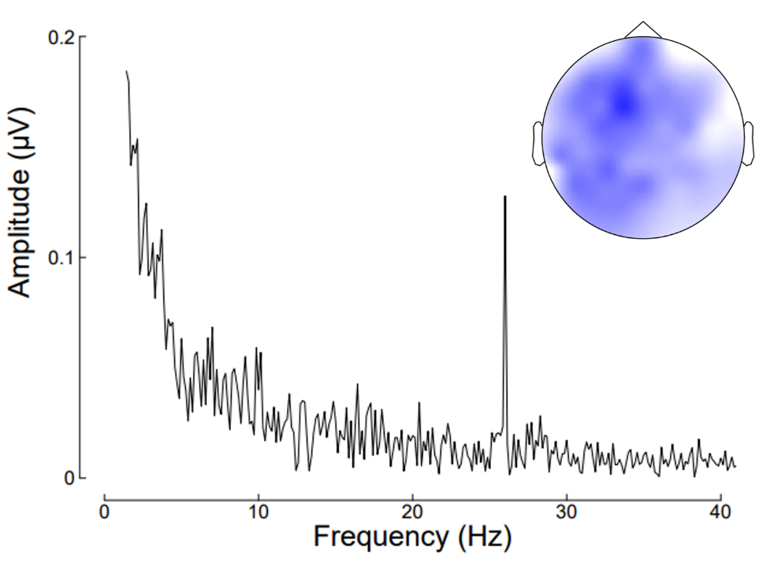
As can be seen, there is a clear SSSEP response at 26Hz, which is strongest around electrodes F1 and FC1. Previous research using vibrotactile 21Hz stimulation have also found the scalp topography of the activation to be most pronounced over mid-frontal distributions (Porcu et al., 2014; Timora & Budd, 2018), in line with the scalp topography seen here. Given these finding of a distinct 26Hz signal and mid-frontal scalp location, it appears appropriate for 26Hz to be used as the vibration frequency in the proposed study.
Figure 3. Averaged Pilot Data showing peak frequency at 26Hz, centred between electrodes F1 and FC1.
Pilot data was also collected using the vibrotactile stimulator at 26Hz to make sure that the illusory experience is not removed due to the addition of this vibrotactile input. Pilot data was collected from 4 healthy participants, who underwent the same experimental protocol as mentioned in the “Experimental Procedure” section, simply without EEG caps fitted, and without pain scales used. Illusory experience was calculated using the average of both illusion scores for each participant, and then averaging over participants to give the results seen in Figure 4.
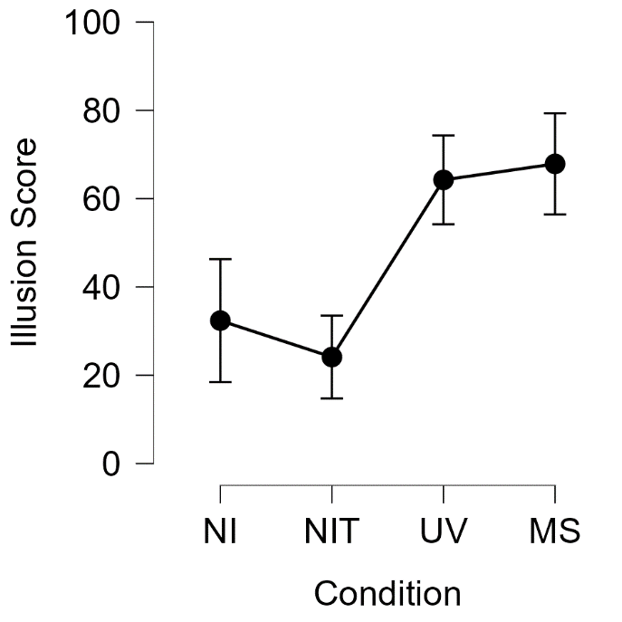
As can be seen, there is a greater subjective experience of the resizing illusion, indexed by participant’s illusion score, in both experimental conditions (UV average = 64.25; MS average = 67.88) compared to both control conditions (NI average = 32.38; NIT average = 24.13). Scores below 50 are indicative of disagreement of experience of the illusion, whilst a score of 50 is a neutral option regarding the illusion experience, and scores above 50 are indicative of agreement of experiencing the illusion. This therefore shows that the addition of the vibrotactile stimulation does not remove the experience of the resizing illusion and can therefore be used in the proposed study to elicit SSEPs without affecting the subjective illusory experience of the resizing illusion.

Figure 4. Averaged Illusion score for each condition. Error bars represent standard errors.

References
Altman, R. D. (2000). Intra-articular sodium hyaluronate in osteoarthritis of the knee. Seminars in Arthritis and Rheumatism, 30(2), 11–18.

Arendt-Nielsen, L., & Graven-Nielsen, T. (2003). Central sensitization in fibromyalgia and other musculoskeletal disorders. Current Pain and Headache Reports, 7(5), 355–361. https://doi.org/10.1007/s11916-003-0034-0

Arendt-Nielsen, L., Nie, H., Laursen, M. B., Laursen, B. S., Madeleine, P., Simonsen, O. H., & Graven-Nielsen, T. (2010). Sensitization in patients with painful knee osteoarthritis. Pain, 149(3), 573–581. https://doi.org/10.1016/j.pain.2010.04.003

Beswick, A. D., Wylde, V., Gooberman-Hill, R., Blom, A., & Dieppe, P. (2012). What proportion of patients report long-term pain after total hip or knee replacement for osteoarthritis? A systematic review of prospective studies in unselected patients. BMJ Open, 2(1), e000435. https://doi.org/10.1136/bmjopen-2011-000435

Boesch, E., Bellan, V., Moseley, G. L., & Stanton, T. R. (2016). The effect of bodily illusions on clinical pain: A systematic review and meta-analysis. Pain, 157(3), 516–529. https://doi.org/10.1097/j.pain.0000000000000423

Botvinick, M., & Cohen, J. (1998). Rubber hands ‘feel’ touch that eyes see. Nature, 391(6669), 756–756. https://doi.org/10.1038/35784

Breitwieser, C., Pokorny, C., & Müller-Putz, G. R. (2016). A hybrid three-class brain–computer interface system utilizing SSSEPs and transient ERPs. Journal of Neural Engineering, 13(6), 066015. https://doi.org/10.1088/1741-2560/13/6/066015

Carey, M., Crucianelli, L., Preston, C., & Fotopoulou, A. (2019). The Effect of Visual Capture Towards Subjective Embodiment Within the Full Body Illusion. Scientific Reports, 9(1), 2889. https://doi.org/10.1038/s41598-019-39168-4

Cohen, J. (1988). Statistical power analysis for the behavioural sciences. (2nd ed.). Hillsdale, NJ: Erlbaum.

Colon, E., Legrain, V., & Mouraux, A. (2012). Steady-state evoked potentials to study the processing of tactile and nociceptive somatosensory input in the human brain. Neurophysiologie Clinique/Clinical Neurophysiology, 42(5), 315–323. https://doi.org/10.1016/j.neucli.2012.05.005

Corriger, A., Voute, M., Lambert, C., Pereira, B., & Pickering, G. (2022). Ketamine for refractory chronic pain: A 1-year follow-up study. Pain, 163(4), 690–701. https://doi.org/10.1097/j.pain.0000000000002403

Diers, M., Zieglgänsberger, W., Trojan, J., Drevensek, A. M., Erhardt-Raum, G., & Flor, H. (2013). Site-specific visual feedback reduces pain perception. Pain, 154(6), 890–896. https://doi.org/10.1016/j.pain.2013.02.022

Dworkin, R. H., Turk, D. C., Peirce-Sandner, S., Baron, R., Bellamy, N., Burke, L. B., Chappell, A., Chartier, K., Cleeland, C. S., Costello, A., Cowan, P., Dimitrova, R., Ellenberg, S., Farrar, J. T., French, J. A., Gilron, I., Hertz, S., Jadad, A. R., Jay, G. W., … Witter, J. (2010). Research design considerations for confirmatory chronic pain clinical trials: IMMPACT recommendations. Pain, 149(2), 177–193. https://doi.org/10.1016/j.pain.2010.02.018

Elias, L. J., Bryden, M. P., & Bulman-Fleming, M. B. (1998). Footedness is a better predictor than is handedness of emotional lateralization. Neuropsychologia, 36(1), 37–43. https://doi.org/10.1016/S0028-3932(97)00107-3

Felson, D. T. (2005). The sources of pain in knee osteoarthritis: Current Opinion in Rheumatology, 17(5), 624–628. https://doi.org/10.1097/01.bor.0000172800.49120.97

Figueira, J. S. B., Kutlu, E., Scott, L. S., & Keil, A. (2022). The FreqTag toolbox: A principled approach to analyzing electrophysiological time series in frequency tagging paradigms. Developmental Cognitive Neuroscience, 54, 101066.
https://doi.org/10.1016/j.dcn.2022.101066

Friston, K. (2008). Hierarchical Models in the Brain. PLoS Computational Biology, 4(11), e1000211. https://doi.org/10.1371/journal.pcbi.1000211

Giani, A. S., Ortiz, E., Belardinelli, P., Kleiner, M., Preissl, H., & Noppeney, U. (2012). Steady-state responses in MEG demonstrate information integration within but not across the auditory and visual senses. NeuroImage, 60(2), 1478–1489. https://doi.org/10.1016/j.neuroimage.2012.01.114

Gilpin, H. R., Moseley, G. L., Stanton, T. R., & Newport, R. (2015). Evidence for distorted mental representation of the hand in osteoarthritis. Rheumatology, 54(4), 678–682. https://doi.org/10.1093/rheumatology/keu367

Hansford, K. J., Baker, D. H., McKenzie, K. J., & Preston, C. E. (2023). Distinct Neural Signatures of Multimodal Resizing Illusions: Implications for Chronic Pain Treatment. bioRxiv, 2023-01. https://doi.org/10.1101/2023.01.18.524558

Haggard, P., Iannetti, G. D., & Longo, M. R. (2013). Spatial sensory organization and body representation in pain perception. Current Biology, 23(4), R164-R176.
https://doi.org/10.1016/j.cub.2013.01.047

Heyworth, B. E., Lee, J. H., Kim, P. D., Lipton, C. B., Strauch, R. J., & Rosenwasser, M. P. (2008). Hylan Versus Corticosteroid Versus Placebo for Treatment of Basal Joint Arthritis: A Prospective, Randomized, Double-Blinded Clinical Trial. The Journal of Hand Surgery, 33(1), 40–48. https://doi.org/10.1016/j.jhsa.2007.10.009

Jensen, M. P., & Karoly, P. (2011). Self-report scales and procedures for assessing pain in adults. In D. C. Turk & R. Melzack (Eds.), Handbook of pain assessment (pp. 19–44). The Guilford Press.

Kalckert, A., & Ehrsson, H. H. (2012). Moving a rubber hand that feels like your own: a dissociation of ownership and agency. Frontiers in human neuroscience, 6, 40. https://doi.org/10.3389/fnhum.2012.00040

Kanayama, N., Hara, M., & Kimura, K. (2021). Virtual reality alters cortical oscillations related to visuo-tactile integration during rubber hand illusion. Scientific Reports, 11(1), 1436. https://doi.org/10.1038/s41598-020-80807-y

Kilteni, K., & Ehrsson, H. H. (2017). Body ownership determines the attenuation of self-generated tactile sensations. Proceedings of the National Academy of Sciences, 114(31), 8426-8431. https://doi.org/10.1073/pnas.1703347114

Lakens, D. (2014). Performing high‐powered studies efficiently with sequential analyses. European Journal of Social Psychology, 44(7), 701-710.

Lewis, J. S., Kersten, P., McCabe, C. S., McPherson, K. M., & Blake, D. R. (2007). Body perception disturbance: A contribution to pain in complex regional pain syndrome (CRPS). Pain, 133(1), 111–119. https://doi.org/10.1016/j.pain.2007.03.013

Mancini, F., Nash, T., Iannetti, G. D., & Haggard, P. (2014). Pain relief by touch: A quantitative approach. Pain, 155(3), 635–642. https://doi.org/10.1016/j.pain.2013.12.024
Matsumiya, K. (2021). Awareness of voluntary action, rather than body ownership, improves motor control. Scientific reports, 11(1), 1-14. doi: 10.1038/s41598-020-79910-x
McCabe, C. S. (2011). When illusion becomes reality. Rheumatology, 50(12), 2151-2152.

Meenagh, G. K. (2004). A randomised controlled trial of intra-articular corticosteroid injection of the carpometacarpal joint of the thumb in osteoarthritis. Annals of the Rheumatic Diseases, 63(10), 1260–1263. https://doi.org/10.1136/ard.2003.015438
Merskey, H. (Ed.). (1986). Classification of chronic pain: Descriptions of chronic pain syndromes and definitions of pain terms. Pain, Suppl 3, 226.

Moseley, G. L. (2005). Distorted body image in complex regional pain syndrome. Neurology, 65(5), 773–773. https://doi.org/10.1212/01.wnl.0000174515.07205.11

Moseley, G. L., McCormick, K., Hudson, M., & Zalucki, N. (2006). Disrupted cortical proprioceptive representation evokes symptoms of peculiarity, foreignness and swelling, but not pain. Rheumatology, 45(2), 196–200. https://doi.org/10.1093/rheumatology/kei119

Moseley, G. L., Parsons, T. J., & Spence, C. (2008). Visual distortion of a limb modulates the pain and swelling evoked by movement. Current Biology, 18(22), R1047–R1048. https://doi.org/10.1016/j.cub.2008.09.031

Muller, G. R., Neuper, Ch., & Pfurtscheller, G. (2001). „Resonance-like“ Frequencies of Sensorimotor Areas Evoked by Repetitive Tactile Stimulation—Resonanzeffekte in sensomotorischen Arealen, evoziert durch rhythmische taktile Stimulation. Biomedizinische Technik/Biomedical Engineering, 46(7–8), 186–190. https://doi.org/10.1515/bmte.2001.46.7-8.186

Nahra, H., & Plaghki, L. (2003). Modulation of perception and neurophysiological correlates of brief CO ₂ laser stimuli in humans using concurrent large fiber stimulation. Somatosensory & Motor Research, 20(2), 139–147. https://doi.org/10.1080/0899022031000105172

NHS Digital (2019) Health survey for England 2017. NHS Digital. https://digital.nhs.uk

National Institute for Health and Care Excellence. (2021). Chronic pain (primary and secondary) in over 16s: assessment of all chronic pain and management of chronic primary pain. NICE guideline No. NG193. https://www.nice.org.uk/guidance/ng193

Newport, R., Pearce, R., & Preston, C. (2010). Fake hands in action: Embodiment and control of supernumerary limbs. Experimental Brain Research, 204(3), 385–395. https://doi.org/10.1007/s00221-009-2104-y

Nozaradan, S., Peretz, I., & Mouraux, A. (2012). Steady-state evoked potentials as an index of multisensory temporal binding. NeuroImage, 60(1), 21–28. https://doi.org/10.1016/j.neuroimage.2011.11.065

Peltz, E., Seifert, F., Lanz, S., Müller, R., & Maihöfner, C. (2011). Impaired Hand Size Estimation in CRPS. The Journal of Pain, 12(10), 1095–1101. https://doi.org/10.1016/j.jpain.2011.05.001

Pokorny, C., Breitwieser, C., & Müller-Putz, G. R. (2016). The Role of Transient Target Stimuli in a Steady-State Somatosensory Evoked Potential-Based Brain–Computer Interface Setup. Frontiers in Neuroscience, 10. https://doi.org/10.3389/fnins.2016.00152

Porcu, E., Keitel, C., & Müller, M. M. (2014). Visual, auditory and tactile stimuli compete for early sensory processing capacities within but not between senses. NeuroImage, 97, 224–235. https://doi.org/10.1016/j.neuroimage.2014.04.024

Preston, C., Gilpin, H. R., & Newport, R. (2020). An exploratory investigation into the longevity of pain reduction following multisensory illusions designed to alter body perception. Musculoskeletal Science and Practice, 45, 102080. https://doi.org/10.1016/j.msksp.2019.102080

Preston, C., & Newport, R. (2011). Analgesic effects of multisensory illusions in osteoarthritis. Rheumatology, 50(12), 2314–2315. https://doi.org/10.1093/rheumatology/ker104

Rees, A., Green, G. G. R., & Kay, R. H. (1986). Steady-state evoked responses to sinusoidally amplitude-modulated sounds recorded in man. Hearing Research, 23(2), 123–133. https://doi.org/10.1016/0378-5955(86)90009-2

Schaefer, M., Flor, H., Heinze, H.-J., & Rotte, M. (2007). Morphing the body: Illusory feeling of an elongated arm affects somatosensory homunculus. NeuroImage, 36(3), 700–705. https://doi.org/10.1016/j.neuroimage.2007.03.046

Snyder, A. Z. (1992). Steady-state vibration evoked potentials: Description of technique and characterization of responses. Electroencephalography and Clinical Neurophysiology/Evoked Potentials Section, 84(3), 257–268. https://doi.org/10.1016/0168-5597(92)90007-X

Stanton, T. R., Gilpin, H. R., Edwards, L., Moseley, G. L., & Newport, R. (2018). Illusory resizing of the painful knee is analgesic in symptomatic knee osteoarthritis. PeerJ, 6, e5206. https://doi.org/10.7717/peerj.5206

Szebenyi, B., Hollander, A. P., Dieppe, P., Quilty, B., Duddy, J., Clarke, S., & Kirwan, J. R. (2006). Associations between pain, function, and radiographic features in osteoarthritis of the knee. Arthritis & Rheumatism, 54(1), 230–235. https://doi.org/10.1002/art.21534

Timora, J. R., & Budd, T. W. (2018). Steady-State EEG and Psychophysical Measures of Multisensory Integration to Cross-Modally Synchronous and Asynchronous Acoustic and Vibrotactile Amplitude Modulation Rate. Multisensory Research, 31(5), 391–418. https://doi.org/10.1163/22134808-00002549

Tobimatsu, S., Zhang, Y. M., & Kato, M. (1999). Steady-state vibration somatosensory evoked potentials: Physiological characteristics and tuning function. Clinical Neurophysiology, 110(11), 1953–1958. https://doi.org/10.1016/S1388-2457(99)00146-7

Vos, T., Abajobir, A. A., Abate, K. H., Abbafati, C., Abbas, K. M., Abd-Allah, F., Abdulkader, R. S., Abdulle, A. M., Abebo, T. A., Abera, S. F., Aboyans, V., Abu-Raddad, L. J., Ackerman, I. N., Adamu, A. A., Adetokunboh, O., Afarideh, M., Afshin, A., Agarwal, S. K., Aggarwal, R., … Murray, C. J. L. (2017). Global, regional, and national incidence, prevalence, and years lived with disability for 328 diseases and injuries for 195 countries, 1990–2016: A systematic analysis for the Global Burden of Disease Study 2016. The Lancet, 390(10100), 1211–1259. https://doi.org/10.1016/S0140-6736(17)32154-2

Woolf, C. J. (2011). Central sensitization: Implications for the diagnosis and treatment of pain. Pain, 152(3), S2–S15. https://doi.org/10.1016/j.pain.2010.09.030

Appendix A

Timeline
Figure A1. Timeline for Proposed Study.

Recruitment for clinical participants will start first, these individuals will then be tested, and demographic information will inform recruitment of the healthy participant sample. Recruitment will overlap with data acquisition. Data acquisition is estimated to take almost 4 months, which is based on data acquisition completed by this research group for a previous study also using EEG and resizing illusions, in which c.50 participants were tested in 7 weeks. Doubling this to c.100 participants tested, to account for participant drop-out for the current study needing 94 participants, predicts 14 weeks of testing (3.5months). Analysis is predicted to take around one month, with report write up also being allocated around one month (overlapping). Proposed submission date for stage 2, if stage 1 review is successful, is therefore towards the end of month 6.

Appendix B
Table B1: Design Planner
Question | Hypothesis | Sampling plan (e.g., power analysis) | Analysis plan | Interpretation given different outcomes | Theory that could be proved wrong given outcomes
Does the finding of greater subjective illusory experience in multisensory compared to non-illusion conditions replicate in this study? | (1a/b – Positive Control) There will be a greater illusory experience, measured via a subjective illusory experience questionnaire, in the multisensory condition compared to the no illusion condition in both groups. | A priori power analysis using G*Power shows that for a repeated measures, within factors ANOVA, with an effect size (f) of 0.73, alpha of 0.05, power at 80% and 2 groups with three measurements, 6 participants are needed for each group. | An ANOVAwill be run to compare mean scores from each condition. Given significant findings, post-hoc tests will be run, with Bonferroni correction for 3 comparisons at an initial alpha of 0.05 (adjusted alpha = .016). | If Hypotheses 1a/b are supported: Indicates that the augmented reality manipulations are inducing effective illusions, and shows success of positive control, giving weight to the subsequent EEG and Pain findings.  If Hypotheses 1a/b are unsupported: Indicates that the augmented reality manipulations are not inducing effective illusions, and therefore the findings regarding hypotheses 2 and 3 will be called into question. | The theory that adding vibrotactile stimulation will not influence the subjective illusion experience of resizing illusions would be proved wrong within this sample if hypotheses 1a/b are unsupported.
Are there significant changes in the somatosensory response when comparing multisensory visuotactile to non-illusion conditions in healthy participants? | (2a) There will be a significant difference in SSEP response when comparing multisensory visuotactile illusory resizing to non-illusion in the healthy Group. | A priori power analysis using G*Power shows that for a matched pairs one-sided t test, with an effect size of d = .5, alpha of 0.05, power at 80%, a total sample size of 34 participants is needed for the healthy group. | A dependent samples t test will be run comparing MS to NI in the healthy group. The dependant variable will be SSSEP amplitude in µV. | If Hypothesis 2a is supported: Indicates that there are significant differences between MS and NI conditions in the healthy group.  If Hypothesis 2a is unsupported: Indicates that there is no evidence of a difference between MS and NI conditions in the healthy group. | The theories regarding cortical shrinking (blurring theory) and cortical enlarging would be proved wrong if hypothesis 2a is unsupported.
Are there significant changes in the somatosensory cortex when comparing unimodal visual to non-illusion conditions in healthy participants? | (2b) There will be a significant difference in SSEP response when comparing unimodal visual illusory resizing to non-illusion in the hHealthy Group. | A priori power analysis using G*Power shows that for a matched pairs one-sided t test, with an effect size of d = .5, alpha of 0.05, power at 80%, a total sample size of 34 participants is needed for the healthy group. | A dependent samples t test will be run comparing UV to NI in the healthy group. The dependant variable will be SSSEP amplitude in µV. | If Hypothesis 2b is supported: Indicates that there are significant differences between UV and NI conditions in the healthy group.  If Hypothesis 2b is unsupported: Indicates that there is no evidence of a difference between UV and NI conditions in the healthy group. | The theories regarding cortical shrinking (blurring theory) and cortical enlarging would be proved wrong if hypothesis 2a is unsupported.
Are there significant changes in the somatosensory response when comparing multisensory visuotactile to non-illusion conditions in chronic pain participants? | (2c) There will be a significant difference in SSEP response when comparing multisensory visuotactile illusory resizing to non-illusion in the cChronic pPain gGroup. | A priori power analysis using G*Power shows that for a matched pairs one-sided t test, with an effect size of d = .5, alpha of 0.05, power at 80%, a total sample size of 34 participants is needed for the chronic pain group. | A dependent samples t test will be run comparing MS to NI in the chronic pain group. The dependant variable will be SSSEP amplitude in µV. | If Hypothesis 2c is supported: Indicates that there are significant differences between MS and NI conditions in the chronic pain group.  If Hypothesis 2c is unsupported: Indicates that there is no evidence of a difference between MS and NI conditions in the chronic pain group. | The theories regarding cortical shrinking (blurring theory) and cortical enlarging would be proved wrong if hypothesis 2a is unsupported.
Are there significant changes in the somatosensory cortex when comparing unimodal visual to non-illusion conditions in chronic pain participants? | (2d) There will be a significant difference in SSEP response when unimodal visual illusory resizing to non-illusion in the chronic pain group. | A priori power analysis using G*Power shows that for a matched pairs one-sided t test, with an effect size of d = .5, alpha of 0.05, power at 80%, a total sample size of 34 participants is needed for the chronic pain group. | A dependent samples t test will be run comparing UV to NI in the chronic pain group. The dependant variable will be SSSEP amplitude in µV. | If Hypothesis 2d is supported: Indicates that there are significant differences between UV and NI conditions in the chronic pain group.  If Hypothesis 2d is unsupported: Indicates that there is no evidence of a difference between UV and NI conditions in the chronic pain group. | The theories regarding cortical shrinking (blurring theory) and cortical enlarging would be proved wrong if hypothesis 2a is unsupported.
Are there significant differences between healthy and chronic pain participants SSEP responses at baseline level? | (2e) There will be a significant difference when comparing healthy to chronic pain participant’s baseline NI SSEP responses. | A priori power analysis using G*Power shows that for a matched pairs one-sided t test, with an effect size of d = .5, alpha of 0.05, power at 80%, a total sample size of 34 participants is needed for the chronic pain group. | A dependent samples t test will be run comparing baseline (NI) SSEPs in the healthy group compared to the chronic pain group. The dependant variable will be SSSEP amplitude in µV | If Hypothesis 2e is supported: Indicates that there are significant differences in baseline SSEPs between healthy and chronic pain participants.  If Hypothesis 2e is unsupported: Indicates that there is no evidence of a difference in baseline SSEP responses between healthy and chronic pain participants. | The theory that the cortical misrepresentation of incoming pain signals is seen in chronic pain participants would be proved wrong within this sample if hypothesis 2e is unsupported.
Are there analgesic effects of multisensory and uni-modal visual resizing illusions? | (3a/b) We expect to find a subjective reduction in pain, measured via a 21-point numeric rating scale, comparing before and after scores for multisensory and unimodal-visual conditions. | A priori power analysis using G*Power shows that for a Wilcoxon signed-rank test (matched pairs), with an effect size (dz) of 1, alpha of 0.05, and power at 80%, for a one tailed test with normal parent distribution, 11 participants are needed in total., to get an achieved power of 92%. | Non-parametric Wilcoxon signed rank tests will be used to compare mean pain scores before and after each condition. | If Hypotheses 3a/b are supported: Indicates that analgesia can arise from multisensory and unimodal visual illusory resizing.  If Hypothesis 3a/b areis unsupported: Indicates that analgesia is either associated with one condition (either multisensory or unimodal-visual), or with neither condition.” | The theory that multisensory or unimodal visual resizing illusions can provide analgesic effects for chronic pain participants would be proved wrong within this sample if hypotheses 3a/b are unsupported.
Are there analgesic effects of multisensory and uni-modal visual resizing illusions? | (3c/d) We expect to find no reduction in pain following both non-illusion conditions | A priori power analysis using G*Power shows that for a Wilcoxon signed-rank test (matched pairs), with an effect size (dz) of 1, alpha of 0.05, and power at 80%, for a one tailed test with normal parent distribution, 11 participants are needed in total. | Non-parametric Wilcoxon signed rank tests will be used to compare mean pain scores before and after each condition. | If Hypotheses 3c/d are supported: Indicates that analgesia does not arise from either non-illusion condition.  If Hypothesis 3c/d are unsupported: Indicates that analgesia is either associated with one condition (either multisensory or unimodal-visual), or with both conditions. Rational for analgesia being associated with the non-illusion tactile condition could be due to affective touch. | The theory that only multisensory or unimodal visual resizing illusions can provide analgesic effects for chronic pain participants would be proved wrong within this sample if hypotheses 3a/b are unsupported.

Appendix C:

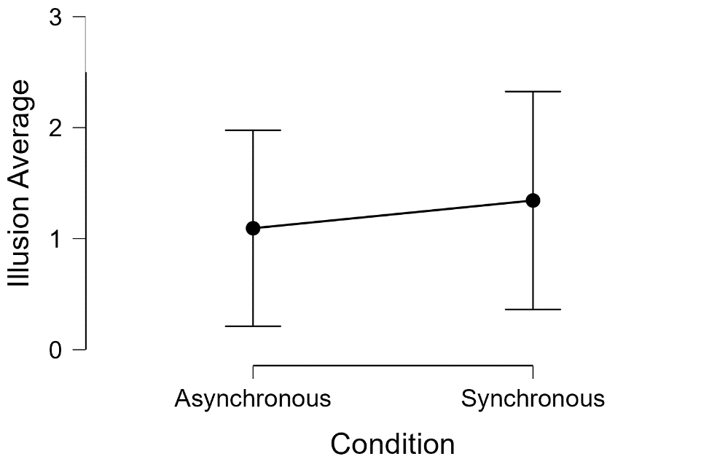
Pilot data regarding the efficacy of the illusion for both healthy and chronic pain patients undergoing synchronous and asynchronous illusory resizing of the index finger can be seen in figure C1. 16 participants (7 chronic pain, 9 healthy) had either synchronous or asynchronous multimodal manipulations delivered first in a random order, and were then given the other condition, after which all participants were given an illusion scale. Findings showed that across all participants, no significant difference in illusion experience between the synchronous and asynchronous conditions, t(15) = 0.525, p = 0.60, however as can be seen in figure C1, despite the small sample size, illusion strength was seen to be greater in the synchronous condition compared to the asynchronous condition.

Figure C1. Pilot data from Chronic Pain and Healthy Participants Undergoing Synchronous and Asynchronous Illusory Finger Resizing.

