Title

Registered Report: Are anticipatory auditory predictions enhanced
in tinnitus and independent of hearing loss?

Authors

L. Reisinger^{1,*}, G. Demarchi¹, S. Rösch³, E. Trinka^{1,2,4}, J. Obleser^{5,6}, N. Weisz^{1,2}

¹ Centre for Cognitive Neuroscience and Department of Psychology, Paris-Lodron- University Salzburg, Salzburg, Austria.
² Neuroscience Institute, Christian Doppler University Hospital, Paracelsus Medical University, Salzburg, Austria.
³ Department of Otorhinolaryngology, Head and Neck Surgery, Paracelsus Medical University Salzburg, Salzburg, Austria
⁴ Department of Neurology, Christian Doppler University Hospital, Paracelsus Medical University, Salzburg, Austria.
⁵ Department of Psychology, University of Lübeck, Lübeck, Germany.
⁶ Center of Brain, Behavior and Metabolism, University of Lübeck, Lübeck, Germany.
* Corresponding author: lisa.reisinger@plus.ac.at

In-principle-accepted Stage 1 Registered Report can be found here:
https://osf.io/6gvpy
Abstract
Phantom perceptions occur without any identifiable environmental or bodily source. The mechanisms and key drivers behind phantom perceptions like tinnitus are not well understood. The dominant “altered-gain”-framework suggests that tinnitus results from neural hyperactivity in the auditory pathway following hearing damage. Alternatively, however, researchers have tried to explain perceptual and potential neural aberrations in tinnitus within a more parsimonious predictive-coding framework. In line with this model, a recent magnetoencephalography (MEG) study reported that individuals with tinnitus engage more strongly in anticipatory sensory predictions compared to controls without tinnitus. However, correlations with hearing loss could not be drawn due to the study design. This registered report aimed to close this gap. We used an established passive-listening paradigm, in which the regularity (i.e. predictability) of pure-tone sequences was either random or ordered. Analyses encompassed data from 80 participants. 40 participants with tinnitus and 40 control subjects without tinnitus were not only matched for age and gender, but importantly also in terms of hearing loss. We were able to replicate our previous main finding: individuals with tinnitus showed relatively stronger pre-activations of carrier-frequency-specific neural activity patterns, supporting the hypothesis that chronic tinnitus is associated with maladaptively upregulated predictive neural processing. This effect was not driven by tinnitus distress and the groups did not differ in terms of decoding of tone frequencies. While our work firmly excludes hearing loss as explanation, future longitudinal studies need to determine whether dysregulated predictive processes are a consequence of tinnitus or rather pose a risk factor for developing this condition.
Keywords: auditory perceptions, tinnitus, predictive coding, decoding, hearing loss, MEG
Introduction
Subjective perceptual awareness is based on huge amounts of environmental inputs (sensations), which are transduced by sensory receptors. Phantom perceptions are peculiar in that they cannot be explained by sensory input. In the case of tinnitus, individuals consciously perceive one or more pure tones or narrowband noises that lack any identifiable source in the environment or the body (Baguley et al., 2013).
Approximately 10-15% of the young to middle-aged adult population experience tinnitus as a common auditory phantom perception, with greater prevalence of 24% in older adults (Henry et al., 2020; Jarach et al., 2022). For a smaller portion of the population, the sensation of bothersome tinnitus poses a significant detriment to quality of life, due to reduced sleep quality, substantially increased distress, and anxiety (Dobie, 2003) – all largely independent of the intensity or duration of the phantom perception (Kandeepan et al., 2019; Meyer et al., 2014).
What neural mechanisms contribute to the generation of tinnitus remains unresolved. Hearing loss has been identified as a main risk factor for tinnitus (Kim et al., 2015). Indeed, for 75-80% of people with tinnitus, objective audiometric testing indicates hearing loss (Wallhäusser-Franke et al., 2017). Previous findings support the idea that some form of auditory damage – even without clear audiometric changes – facilitates tinnitus development (Roberts et al., 2006; Schaette and McAlpine, 2011; Schaette et al., 2012; Weisz et al., 2006) and provokes maladaptive changes.
Based on the observation of enhanced neural activity following hearing loss in animal models (Eggermont and Roberts, 2004; Roberts et al., 2010), a still-influential “altered-gain“ view holds that reduced auditory input following hearing damage leads neurons in the auditory pathway to increase their responsivity, thereby restoring their activity level; in this framework, the perception of phantom sounds is a “downside“ to this homeostatic process, as spontaneous activity can engage downstream auditory regions (Schaette and Kempter, 2006; Sedley, 2019). This model of phantom sound perceptions is supported by research in both animals and computational models (Roberts and Salvi, 2019; Schaette, 2014; Schaette and Kempter, 2012). In humans, resting-state M/EEG studies reported divergent patterns, especially in the delta, alpha and gamma frequency band ranges within and beyond auditory regions (de Ridder et al., 2011; van der Loo et al., 2009; Weisz et al., 2005; for an opposite finding see e.g., Adjamian et al., 2012; Zobay and Adjamian, 2015). In this regard, the thalamocortical dysrhythmia hypothesis proposes as well that tinnitus development is a consequence of altered neural thalamo-cortical coherence. Findings concerning this hypothesis state that tinnitus is both related to enhanced theta, delta and gamma-band activity in the auditory cortex as well as decreased connectivity between the thalamic medial geniculate body and auditory regions (Brinkmann et al., 2021; De Ridder et al., 2015; Llinas et al., 1999).
Other potential explanations for tinnitus perception are for instance noise cancellation models (Rauschecker et al., 2010). The noise cancellation model states that due to cochlear lesions and resulting neuroplastic reorganization, hyperactivity in auditory pathways generates or enables acute tinnitus. Normally, noise cancellation mechanisms in the limbic system start identifying and inhibiting the wrong sound signal but in cases of dysfunctions in the limbic system and especially in the anterior cingulate cortex, noise signals persist consciously as tinnitus in the auditory system. Permanent dysfunctions lead to cortical reorganizations which result in chronic phantom sound perceptions (Rauschecker et al., 2010; Song et al., 2015). More recent work also states alterations in a more general cognitive network including prefrontal, limbic, and subcortical structures which lead to the chronicity of tinnitus (Lan et al., 2022).
Apart from a significant shortage of data bridging animal and human research in these different frameworks, empirical support in humans is weak, difficult to replicate, and marked by strong interindividual variability (Eggermont and Roberts, 2015; Elgohyen et al., 2015). Beyond the lack of solid evidence, the models face further explanatory challenges (Sedley, 2019): 1) People with hearing loss do not necessarily experience tinnitus (Wallhäusser-Franke et al., 2017). 2) The onsets of tinnitus and hearing loss often do not occur at the same time. 3) Not all cases of acute tinnitus transform into chronic tinnitus (Mühlmeier et al., 2016; Vielsmeier et al., 2020). Overall, this situation calls for the pursuit of alternative or complementary models that place less emphasis on the hearing status of the individual.
One attempt along these lines has been the development of a Bayesian inference framework for tinnitus perception (Sedley et al., 2016). This framework emphasizes the constructive nature of perception being guided by internal models (von Helmholtz, 1867). Therein, sensory input is dynamically compared to predictions or so-called priors. The framework holds that spontaneous activity in the auditory pathway acts as a precursor of tinnitus. In the healthy auditory system, spontaneous activity is “ignored”, due to the default prior of silence. However, certain circumstances can shift this prior, such that a sound is expected (Hullfish et al., 2019; Sedley et al., 2016). This conceptual model bridges several explanatory gaps: for example, the inconsistent findings in humans regarding the “altered gain” view which states enhanced neural activity in the auditory pathway. The Bayesian inference framework could, therefore, explain the experience of tinnitus in lieu of any increase in neural activity in the auditory system.
However, convincing empirical support is still sparse, due to the difficulty of deriving robust measures for tinnitus-supporting priors from ongoing brain activity. Few studies have provided support for altered prediction processes in tinnitus, which is in line with the predictive coding framework using either EEG evoked responses (Mohan et al., 2022; Sedley et al., 2019) or computational modeling (Hu et al., 2021). Furthermore, the question of why only some individuals would shift priors, thus developing tinnitus, remains unclear.
In a previous work (Partyka et al., 2019), we proposed that, given the tendency to predict auditory events, individuals with stronger prediction tendencies are more vulnerable to developing tinnitus (this is similar to the strong prior hypothesis developed by Corlett et al., 2019). However, using a cross-sectional design alternative explanations cannot be excluded with certainty, such as tinnitus being the cause of altered prediction tendencies or that there is a third variable being responsible for predictions and tinnitus development. Adjudicating research would require longitudinal studies in humans or animals. As such research is challenging to implement, especially in humans, we first focused on finding group differences between individuals with and without tinnitus.
We utilized a powerful, recently established experimental approach (Demarchi et al., 2019) showing anticipatory activations of tonotopically specific auditory templates for regular tone sequences. The results were highly supportive of increased anticipatory engagement of predictive processes in tinnitus individuals: That is, with increasing regularities of sound sequences, people with tinnitus exhibited stronger anticipatory representations of upcoming stimuli. While these patterns were not correlated with hearing loss within the tinnitus group, we lacked audiometric data for individuals without tinnitus. Thus, conclusions that our identified patterns are due to tinnitus rather than hearing loss could not be drawn with certainty.
For this registered report, we recruited a large, new sample in which individuals with and without tinnitus were matched for hearing loss. Using a highly similar but more targeted experimental design as well as identical analysis methods, we aimed to replicate our previous findings, thus strengthening the previous claims.

Hypotheses
We specified the following hypotheses, based on the findings of our previous work (Partyka et al., 2019), in general terms here. The underlying experimental procedure and methods were described in the next section.

H1: Regularity-dependent anticipatory auditory predictions are enhanced in tinnitus.
Our study design allowed us to analyze group differences between people with and without tinnitus who were individually matched for age, gender, and hearing loss. We therefore expected group differences in the analyses to be driven by aspects of tinnitus. In the experiment, participants listened passively to tone sequences of four unique carrier frequencies with one of two regularity levels (i.e. random or ordered). As previous results (see Demarchi et al., 2019) suggested, we assumed anticipatory activations of auditory templates during regular tone sequences but not during unpredictable sequences. Additionally, anticipatory activations seemed to be enhanced in patients with tinnitus (Partyka et al., 2019). Using the same analysis steps, we could draw conclusions about 1) how neural information is affected by regularity of carrier-frequency sound sequences and 2) how this is affected by tinnitus while taking into account hearing loss as a potential confound. We hypothesized that we would find differences in regularity-driven carrier-frequency-specific neural pre-activations between the tinnitus group and the matched control group.

With the second and third hypotheses, we aimed to strengthen the findings regarding H1 by analyzing potential influences of the results.

H2: Individuals with tinnitus show normal processing of tone-carrier frequencies.
With our paradigm, we planned to analyze both the group effects of regularity-dependent neural activity from sound sequences and the influences of hearing loss and tinnitus characteristics on these effects. We aimed to ensure that the actual effects of interest – i.e. the patterns of anticipatory predictions established by the regularity of tone sequences in people with tinnitus versus those in control subjects – were not due to altered encoding of tone-carrier frequencies in general for tinnitus individuals. Therefore, it was important that the decoding accuracy for carrier frequencies was similar for both groups in the random sound sequence.

H3: Enhanced regularity-dependent anticipatory predictions in tinnitus are not related to subjective tinnitus distress.
People with tinnitus varied in levels of subjectively perceived tinnitus distress. These individual differences within the tinnitus sample were previously addressed in our work and no influence on the main effect was found. In order to strengthen the results, we planned to address these differences in a statistical manner as well to draw conclusions about potential influences on auditory predictions. In the case that enhanced anticipatory auditory prediction was more a general feature for individuals developing tinnitus, we hypothesized that our main effects would not be correlated to tinnitus distress. In line with the direction of the hypothesis, we would be able to support the assumption that temporally more stable features of each individual would draw the effects, instead of current tinnitus characteristics.

Methods
For this study, participants were already recruited and measured using magnetoencephalography (MEG), but the data was not processed prior to the in-principle acceptance of the Stage 1 registered report. We proposed Level 3 for the registered report since MEG data was accessible to the corresponding author via a group-internal database before in-principle acceptance. However, we justified that no part of the data had been observed. Due to the procedure to create anonymous participant codes, it was not apparent to the authors which data files corresponded to individuals with or without tinnitus. Further analyses of the participant characteristics were necessary to link information regarding tinnitus to the participant codes and corresponding files. These characteristics were with a colleague and had not been accessed by the authors. In order to further blind the researchers during the analyses, the subject files were assigned to two groups (tinnitus versus control) without the involved researchers knowing which group represented which condition. The information was not passed to the researchers involved until the analyses were completed.
We obtained approval for the experimental procedure from the ethics committee of the University of Salzburg (EK-GZ: 22/2016 with Addenda). The study design consisted of pure-tone audiometry, followed by the MEG experiment (see below).

Sampling Plan
We planned to reach a sample size of 80 individuals - i.e. 40 participants with tinnitus and 40 age-, gender- and hearing-matched controls without tinnitus. The following arguments strengthened this decision. Most MEG studies targeting tinnitus include smaller samples up to 25 participants per group (see for example Lorenz et al., 2009; Okamoto et al., 2009; Schlee et al., 2009). One recent work based their analyses on an outstanding „larger MEG data set” (Paraskevopoulos et al., 2019), including 40 tinnitus patients and 40 control subjects. However, individuals were not matched for audiometric hearing loss as it is the case in our work. Based on previous research in this field, our sample was therefore even more unique and outstanding.
Also, we targeted a clinical topic for which recruiting participants was more challenging since we were looking for specific characteristics in volunteers. Additionally, finding suitable controls for our strict matching procedure was time consuming as well since lab capacities were restricted. With respect to clinical relevance, solely strong effects are worth pursuing because of the difficult circumstances in data collection. Therefore, our power analysis was based on a theoretical estimate of a medium to large effect size (d=0.75). Using G*Power (Faul et al. 2009), we calculated an estimated sample size for a one-sided t-test, expecting a true effect of d=0.75. We used a power of 0.95 and a one-sided α-error probability of 0.05, which resulted in a required total sample size of at least 80 participants. This is also in line with our previous arguments warranting a sample of 40 individuals with tinnitus and 40 controls.
At the date of the Stage 1 in-principle acceptance, data collection of 80 participants was already completed. With our analyses, we therefore aimed for a smallest estimated effect size of interest of d=0.75 to be found with a power of 95 % and a conventional alpha at 5 %.

Participants
40 individuals with tinnitus (16 females, age 24-74 years, mean=57.73, sd=14.12), as well as 40 hearing-, age- and gender-matched control subjects (16 females, age 24-76 years, mean=57.43, sd=13.94) have completed the experiment. For the tinnitus group, inclusion criteria were a tinnitus duration of more than six months. No participants with psychiatric or neurological diseases were included in the sample. Participants were recruited via two procedures. First, we used an online study by our group on hearing epidemiology in the county of Salzburg (Austria) as a recruiting database. The online study included demographic information as well as questionnaires covering tinnitus (German short version of Tinnitus Questionnaire, Mini-TQ (Goebel and Hiller, 1992)) and hearing characteristics (German version of the Speech, Spatial and Qualities of Hearing Scale, SSQ (Kiessling et al., 2012)), along with an online hearing test (Shoebox, Ottawa, Canada). The Mini-TQ includes subscales targeting emotional distress, cognitive distress and sleep disturbances which we will use to draw conclusions about the impact of tinnitus distress (Hiller & Goebel, 2004). We included a question asking whether participants would be interested in further investigations in the laboratory, and we contacted them depending on their consent and their hearing profile from the online hearing test. Second, our paradigm was part of a broader epidemiological study (Frey et al., 2022), and participants from this cohort were invited to the MEG lab for further measurements, including the experimental paradigm described in this study.
We performed standardized pure-tone audiometry for frequencies from .125 to 8 kHz in all participants using an Interacoustic AS608 audiometer to characterize hearing status. Hearing loss was defined by a hearing threshold above 30 dB in at least one frequency. Four individuals with tinnitus did not show any audiometric peculiarity; four of the participants showed unilateral hearing impairments; 26 volunteers had high-frequency hearing loss; and six individuals were hearing impaired over most frequencies. The control group was recruited afterwards in order to match the distribution of the tinnitus group by age, gender and hearing status. Accordingly, we aimed to find the best possible match that our data allowed for between individuals with tinnitus and control subjects regarding the results of the audiometry. By visually inspecting individual patterns in the hearing profile, we were able to take into account individual outliers in specific frequencies and searched for a control participant with a similar hearing pattern.
We calculated the individual mean hearing ability based on the values for 500, 1000, 2000, and 4000 Hz, which is a common approach for averaging results of pure-tone audiometry (i.e., PTA-4, see for example Lin et al. (2011); Ozdek et al. (2010)). Using independent t-tests, we found no differences in hearing status between groups for the left (t=-1.19, p=.238) and right ear (t=-1.72, p=.09) (Figure 1). Control subjects were age-matched to each tinnitus participant by a +/-2-year criterion, choosing the closest match when more than one subject was suitable. All participants provided written informed consent before participating.
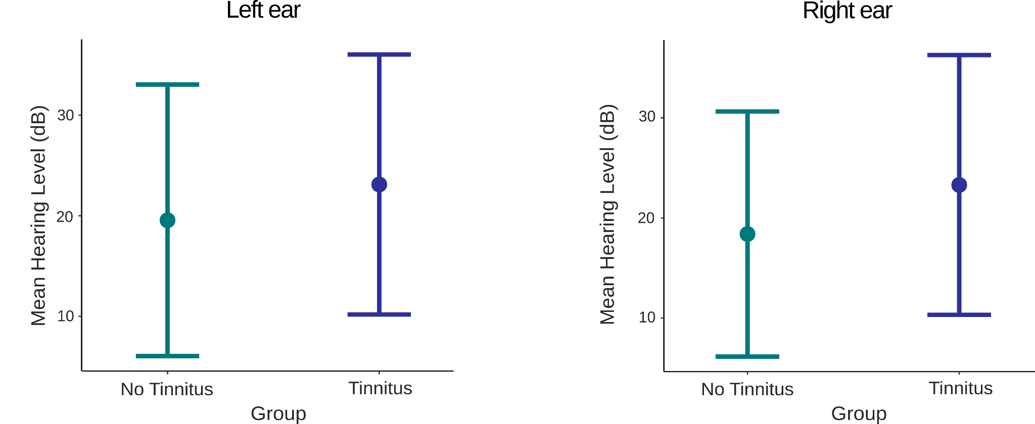
Fig. 1: Mean hearing levels (dB) for the tinnitus and control group, displayed for each ear separately.

Stimuli and experimental procedure
Prior to entering the shielded MEG room, we applied five head position indicator (HPI) coils to the scalp of each participant. We used a Polhemus FASTRAK (Polhemus, Colchester, Vermont, U.S.A) digitizer to register head shape and position for each individual by marking nasion and left/right pre-auricular points, location of the HPI coils and approximately 300 additional points over the scalp. After this preparation, we performed a 5-minute resting-state recording and a 20-minute audiobook block (neither used in the analyses of this work). Next, participants passively listened to sound sequences without further instruction, while watching a silent nature documentary. The movie was displayed using a projector (PROPIXX, VPixx technologies, Canada) and a periscope onto a screen inside the shielded room. Auditory stimulation was presented to both ears via MEG-compatible pneumatic in-ear headphones (SOUNDPixx, ibid).
We presented four different pure (sinusoidal) tones, with carrier frequencies logarithmically spaced between approximately 400 and 1000Hz (i.e. 440 Hz, 587 Hz, 782 Hz, 1043 Hz; Figure 2). This frequency range differs from our original paradigm (Demarchi et al., 2019) of frequencies between 200 and 2000Hz. We reduced the carrier frequencies to a maximum of 1000Hz to further ensure that the sounds provided were within a region of normal audiometric thresholds. Specifically, we aimed to avoid potential effects of high-frequency hearing loss on the highest-frequency tones. Each tone lasted 100 ms, tapered at both ends with 5 ms linearly ascending/descending periods, and we presented the sounds at a constant 3Hz stimulation rate. Sound intensity was individually determined by presenting a short audio sequence to the participants and adjusting the loudness according to an individual pleasant volume. We combined the sound sequences into two continuous blocks, each lasting approximately 8 minutes. In contrast to our previous work (Partyka et al., 2019), we did not include omissions of single tones in the sequences. We balanced the number of stimuli across blocks, and each block contained 1500 particular tone frequencies. Within each block, groups of 500 consecutive stimuli followed the same regularity (entropy) level, which was parametrically modulated using various transition matrices (Nastase et al., 2014). We used two entropy conditions for the design. The random condition had the highest entropy (i.e. the lowest regularity), and the transition probabilities from one sound to another were equal, preventing any possibility of accurately predicting upcoming stimuli. By contrast, the ordered condition had the lowest entropy level (i.e. the highest regularity), and in 75% of trials, one sound was followed by a specific other sound. In 25% of trials, the same sound was repeated (Figure 2). These groups of 500 stimuli with a particular entropy condition were presented in random order within each of the two blocks. To balance the number of conditions, one of the two blocks started with a random condition (500 stimuli), followed by an ordered sequence (500 stimuli) and ended with a random condition (500 stimuli). For the other block, sounds started accordingly in an ordered condition, followed by random sounds and a second sequence of ordered sounds. Therefore, data collection comprised 1500 stimuli of each condition. The experiment was written using the MATLAB-based (version 9.1 The MathWorks, Natick, Massachusetts, U.S.A) Psychophysics Toolbox (Brainard, 1997).

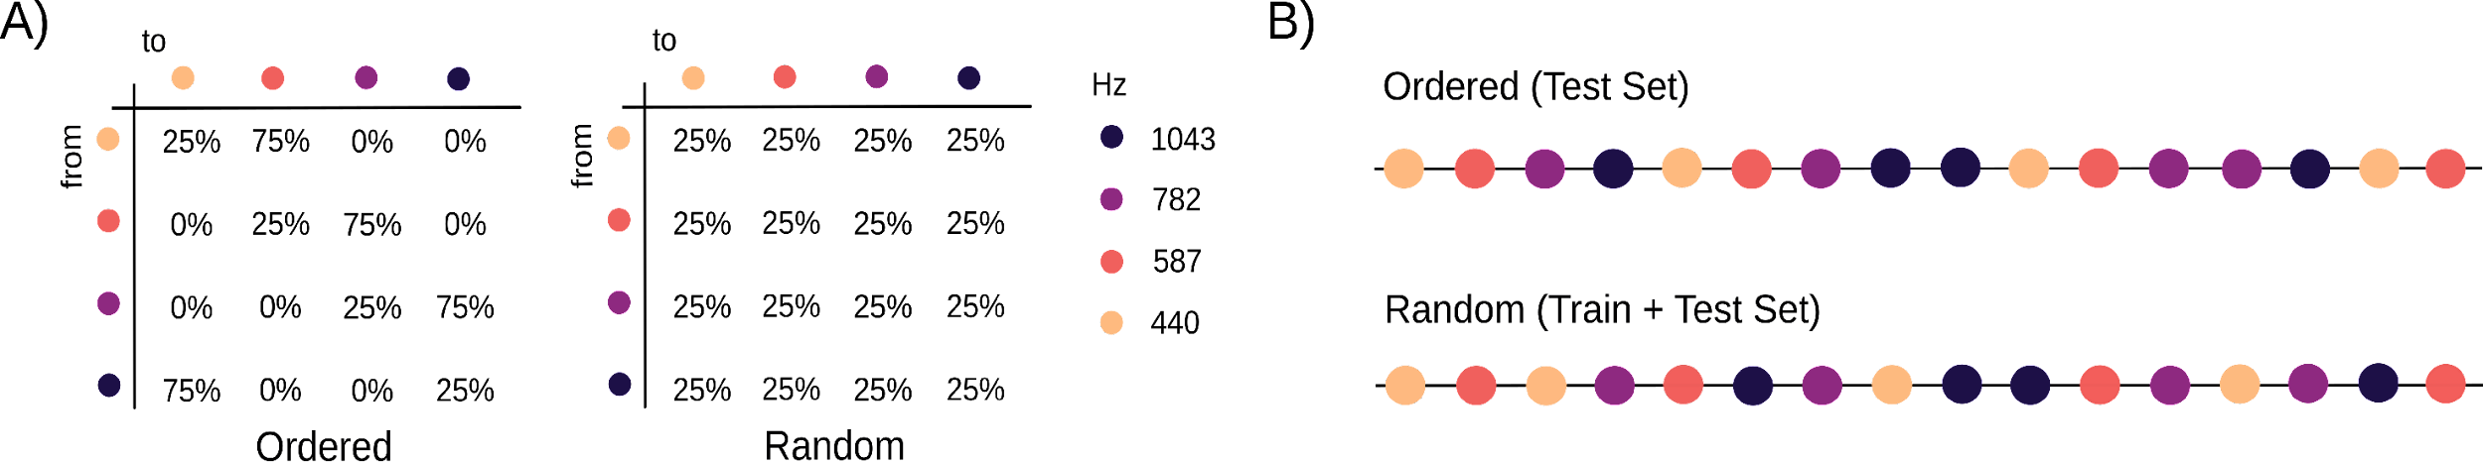
Fig. 2: Stimulus design. A) We presented sound sequences of four different carrier frequencies to participants. Transition probabilities varied between the different entropy conditions (ordered versus random). B) Example sequences for the ordered and random conditions.

MEG data acquisition and preprocessing
We measured magnetic brain activity using a whole-head MEG (Triux, MEGIN Oy, Finland), in which brain signals were captured by 102 magnetometers and 204 orthogonally placed planar gradiometers. Participants sat in a dimly lit magnetically shielded room (AK3b, Vacuumschmelze, Germany) and were measured with a sampling rate of 1000 Hz and default hardware filters set by the manufacturer (0.1 Hz high pass - 330 Hz low pass). We used a signal-space separation algorithm (SSS (Taulu and Kajola, 2005)) implemented in the Maxfilter program (version 2.2.15) to reduce external noise from the MEG signal (mainly 16.6 Hz, and 50 Hz-plus harmonics) and to realign data of different measurement blocks to a common standard-head position (“-trans default” Maxfilter parameter), based on the head position measured at the beginning of each block (Cichy and Pantazis, 2017). Additionally, the Maxfilter algorithm detected bad channels, removed and interpolated the data. Within the tinnitus group, an average of 2.05 (sd=1.90) channels were removed. Within the control group, an average of 1.92 (sd=1.55) channels were removed and therefore, we did not assume any influence on the reported effects based on the interpolation of the data.
The analyses were based on magnetometers only, since information between magnetometers and gradiometers is mixed after the Maxfilter step (Garcés et al., 2017) and were carried out with our own scripts, including the Fieldtrip toolbox (Oostenveld et al., 2011). For preprocessing the data, we applied a high-pass filter at 0.1 Hz (6th order zero-phase Butterworth filter), as well as a low-pass filter at 30 Hz, to the raw data and used it as an input for an Independent Component Analysis (ICA) algorithm. Next, we inspected the ICA components visually to detect and remove unwanted artifacts, such as eye blinks and movements, heartbeats and 16 ⅔ Hz artifacts (the frequency of German/Austrian train power supply). For the tinnitus group, an average of 2.3 components (sd=0.72) were removed. In the group without tinnitus, an average of 2.25 components (sd=0.67) were removed, indicating no difference between the two samples. After eliminating these components, we epoched the continuous data into chunks from 400 ms before to 500 ms after sound onset to enable analysis of both regularity-dependent pre-activations and post-stimulus decoding accuracies. In a final step, we down-sampled the data to 100 Hz to further use it for multivariate pattern analyses (MVPA).

Multivariate Pattern Analysis (MVPA) and decoding weights projection analysis
We used Multivariate Pattern Analysis (MVPA) as implemented in the MVPA-Light toolbox (https://github.com/treder/MVPA-Light), which was modified to extract classifier weights (https://github.com/gdemarchi/MVPA-Light/tree/devel). For decoding, we defined four target classes in line with the frequencies of the sound presented in each specific trial. To avoid potential carryover effects from previous sounds and to focus exclusively on carrier-frequency-related information and the corresponding neural templates, we trained the classifier solely on the random sound sequences.
We trained a multiclass linear discriminant analysis (LDA) classifier on each sample point of the random condition and averaged the classification accuracy for each subject at a group level for further comparisons. Additionally, we used a temporal generalization method (King and Dehaene, 2014) to analyze the ability of the classifier to generalize across time points in the training set to time points in the testing set. When testing on the ordered condition, we did not perform any cross-validation, as our approach already consisted of cross-decoding. For testing on the random tones, we performed a 5-fold cross-validation. It is further important to specify that we trained on the post-stimulus interval and tested on the pre-stimulus interval of the random tones. We constructed two time-generalization matrices: one for each condition.
In a final step, we extracted the training decoder weights of relevant pre-stimulus time frames and projected them in the source space in order to localize the informative activity of carrier-frequency processing (Demarchi et al., 2019; Marti and Dehaene, 2017). We computed single-shell head models (Nolte, 2003) by co-registering the headshapes of the participants with a standard brain template from the Montreal Neurological Institute (MNI, Montreal, Canada). A grid with 1 cm resolution and 2982 voxels was morphed to fit the individual brain volumes of the participants. As a result, we were able to perform group-level comparisons, since all grid points belong to the same brain regions across subjects.

Statistical analysis
With the decoding approach, we obtained decoding accuracies over time for each participant. For statistical analyses, we used cluster-based permutation t-tests (Maris and Oostenveld, 2007), with 1000 permutations and a value of p < .05 to threshold the clusters in order to account for multiple comparisons. We used these cluster-based permutation t-tests to compare the tinnitus and control groups in terms of H1 and H2. Accordingly, we targeted the pre-stimulus and post-stimulus intervals separately.
For H1, we analyzed group comparisons of whether regularity-dependent pre-activations of carrier-frequency-specific information differs between individuals with and without tinnitus. For this, we considered the pre-stimulus interval (-400 to 0 ms) to perform cluster-based permutation t-tests. In a time-generalized manner, we trained the classifier on the random sound sequences and tested on the ordered sequences to take into account the predictability in the ordered sound sequences. Using both entropy conditions, we were able to extract potential regularity-dependent pre-activations of carrier-frequency-specific information. Therefore, we calculated the difference between entropies, meaningly subtracting accuracies in the random condition from the ordered condition. Next, we computed group averages and extracted relevant clusters in the pre-stimulus interval as an indicator for regularity-dependent pre-activations. For our statistical analyses, we focused on the time window between 470 and 570 ms as training time. Since we aimed to replicate the findings of Partyka et al. (2019), we considered this time frame of their highest effect and tested on the overall pre-stimulus interval (-400 to 0 ms). We statistically inspected the differences in the clusters between the groups by performing cluster-based permutation t-tests and comparing mean decoding accuracies between tinnitus and control groups.
Then, considering the post-stimulus interval (0 to 400 ms) for statistical analysis, we were able to draw conclusions about H2, regarding normal carrier-frequency processing in the tinnitus and control groups. This allowed us to strengthen the effects of the first analysis by controlling for potential basic differences in carrier-frequency processing between the tinnitus and control groups. For this analysis, we considered solely the random-sound condition to analyze frequency decoding per se, without potential predictability effects. We were then able to compare the resulting decoding accuracies over time between groups by implementing cluster-based permutation t-tests. Since we expected no difference between groups, we added equivalence testing to strengthen our results (Walker & Nowacki, 2011).
We analyzed H3 by extracting individual values of the short version of the Tinnitus Questionnaire (Mini-TQ) and calculating the mean subjective tinnitus distress for each individual of the tinnitus group. Next, we correlated the individual tinnitus distress values with the mean decoding accuracy of each individual in the previously analyzed pre-stimulus interval. Importantly, information regarding tinnitus distress was not available for all 40 tinnitus subjects but solely 31 subjects were included in this analysis. We therefore excluded the nine subjects that did not complete the Mini-TQ for this specific analysis.

Results
Carrier frequency information of tones can be decoded from MEG data
Our analysis critically relies on the ability of our classifier to reliably decode carrier frequency information from MEG data. As illustrated in Figure 3A (red line) for the entire sample this is clearly the case (t₂₆₀=8.40, 95% CI[0.0092, 0.0148], p<.001), with a rapid increase of decoding performance peaking at ~100 ms, and a slow decrease however with above chance decoding performance lasting throughout the entire post-stimulus period, including a small increase following the subsequent tone presented at 333 ms. Consecutive source analyses demonstrated strong activations in the temporal areas in both hemispheres for the first time window which were still present in the later time window – however less pronounced and more lateralized (Figure 3B).
Descriptively this very much resembles the pattern reported by Partyka et al. (2019), as shown as orange line in Figure 3A, who also observed similar peaks in decoding accuracies around 100 ms (T1) and 450 ms (T2) after target stimulus presentation. However, when comparing the outcomes of both studies, some differences can be noticed. Firstly, an ~30 ms delay can be seen in the present study and more importantly, accuracies were significantly lower in the current sample (t₂₆₀=2.16, 95% CI[0.0005, 0.0109], p=.031). These differences are most likely due to the much narrower sound frequency range in the present study (1.3 octaves) as compared to the previous one (3.3 octaves), making the decoding more challenging. This is of relevance when comparing and interpreting differences of group effects, presented, and discussed further below.
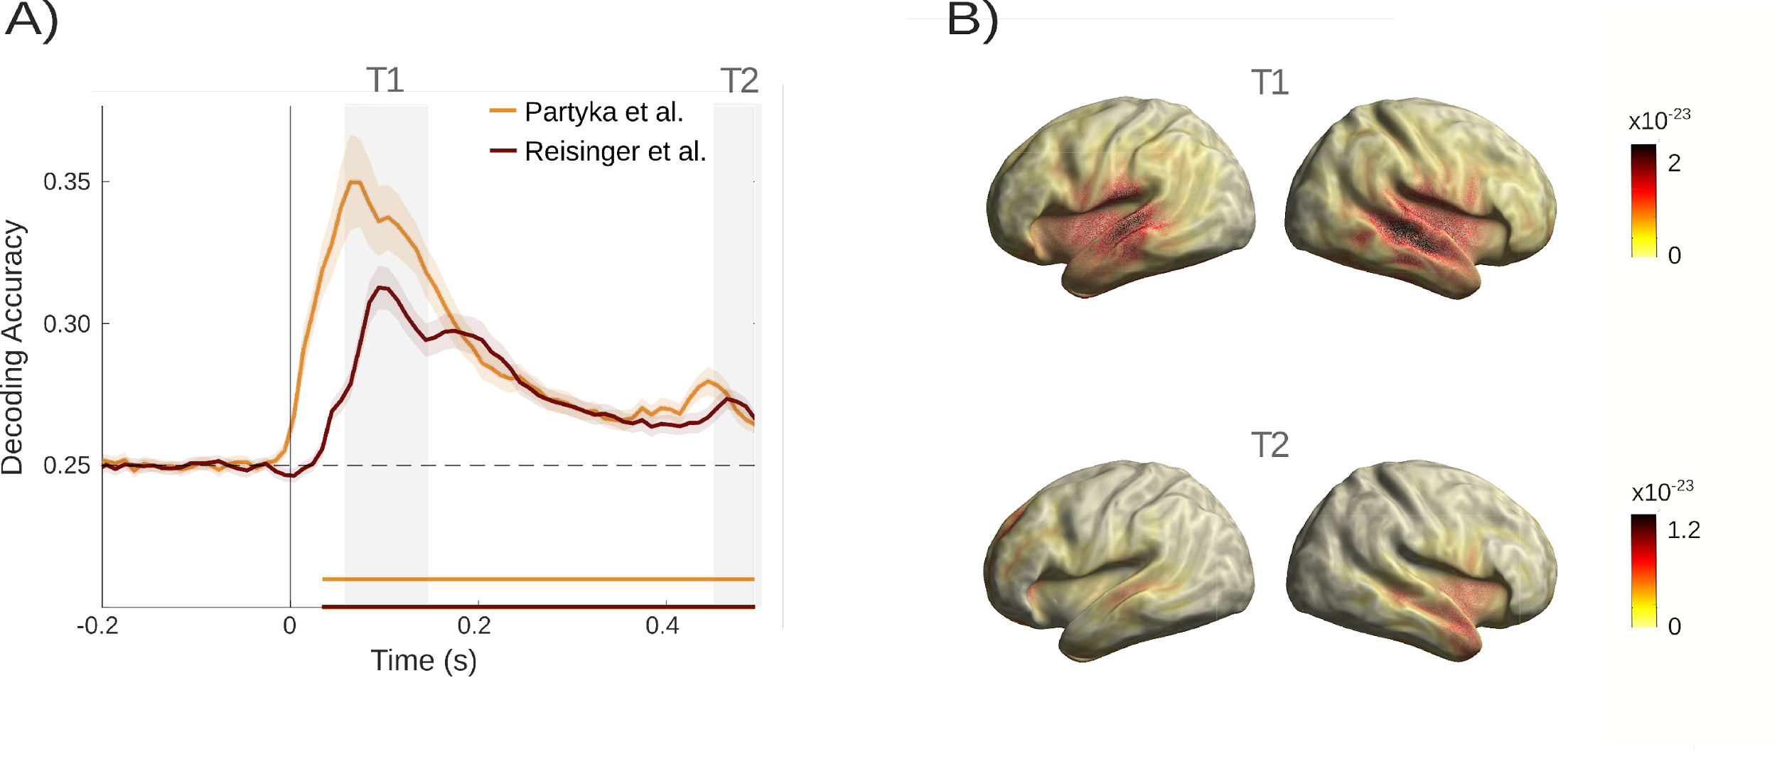Fig. 3: Random tone decoding accuracies. A) Comparison of random tone decoding accuracies between the current dataset and the dataset in Partyka et al. (2019). Grey areas indicate relevant peaks in decoding accuracies. B) Source plots demonstrating activity in the auditory cortex for both time windows.

Anticipatory sound carrier frequency information is relatively enhanced in tinnitus
Our main hypothesis (H1), based on Partyka et al. (2019), states that neural signatures of predictive pre-activation of carrier-frequency specific information are stronger in the tinnitus as compared to the control group. As in the previous study, we trained the classifier on the random tone sequence, and applied it to both regularity levels, to assess whether this changes decoding accuracies. Figure 4 shows the constructed time generalization matrices for the tinnitus and non-tinnitus group. When training on the post-stimulus interval and testing on the pre-stimulus interval, the matrices descriptively indicated differences between the groups in the processing of ordered versus random sounds. In the training interval around 500 ms and the testing interval around -400 ms differences in decoding ordered versus random sounds appeared to be more pronounced in the group without tinnitus.
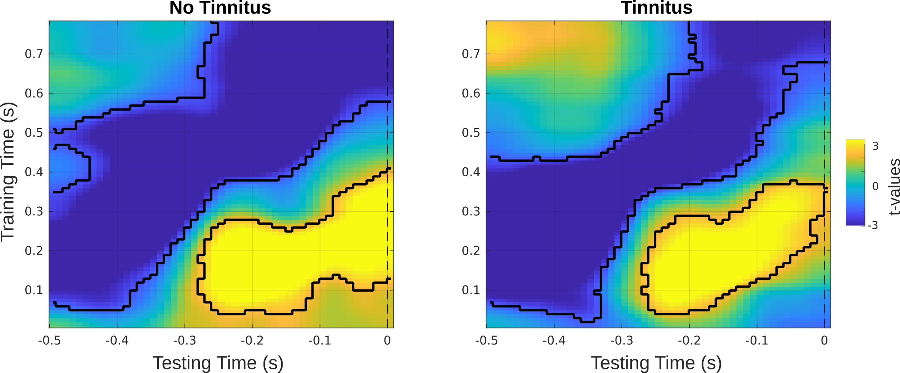 Fig. 4: Time generalization matrices over training and testing time for the tinnitus and control groups. Black masks indicate significant difference clusters between the ordered and random sound condition.

To focus our analysis on the replication we targeted a 470-570 ms time window for training, which yielded the strongest effect in Partyka et al. (2019). When testing on the pre-stimulus interval between -400 ms and 0 ms, one-sided cluster-based permutation t-tests revealed a significant positive cluster (t_{sum}=26.2, p=.046). In line with our prediction, this indicated relatively higher decoding accuracies in the tinnitus group and therefore replicated the central finding by Partyka et al. (2019) (Figure 5A). The effect appeared to be most pronounced in the time window between -410 ms and -310 ms. In this time frame relevant t-values ranged from t=1.90 to t=2.75 with significant p-values between p=.005 and p=.036, indicating stronger differences in decoding accuracy between ordered and random sound sequences in the tinnitus group. The statistical difference, however, is not informative about what is driving the effect. Figure 5A, is suggestive that group differences could be mainly driven by below-chance decoding in the control group. To follow this up, we extracted the individual values for the tinnitus and control groups at the time point with the greatest group difference (around -380 ms) and displayed them to further illustrate the difference between the two groups on an individual level (Figure 5B). Comparing the difference of decoding accuracy against zero within each group indicated non-significance for the tinnitus group with t₇₈=0.063, 95% CI[-0.0017, 0.0018], p=.950. In the group without tinnitus, however, differences of decoding accuracy significantly varied from zero (t₇₈=-3.65, 95% CI[-0.0047, -0.0014], p<.001). This indeed indicates that pre-activations differences between tinnitus and control groups are driven by below-chance accuracy in the control group at these late training time intervals. Interestingly, upon revisiting Partyka et al. (2019), effects showed a similar pattern in the original study. Thus, while these results are overall in line with our first hypothesis, the processes underlying the group differences exhibit more complex dynamics than initially assumed.

General processing of tone carrier frequencies does not differ between tinnitus and controls
As in Partyka et al. (2019), it is important to ensure that reported group differences in H1 cannot be “trivially” explained but are genuinely due to differences in predictive processing. By design, the confounding impact of hearing loss was eliminated. Nevertheless, it is possible that one group exhibits superior processing capacities of carrier-frequency information.
Thus, our second hypothesis (H2) stated that participants with tinnitus show normal processing of tone-carrier frequencies. As the random tone sequence was used in general to train the classifier, we used it to specifically test this hypothesis. Averaged over time, no significant difference between the participants with and without tinnitus was observed using an independent sample t-tests (t₂₆₀=0.795, 95% CI[-0.0024, 0.0056], p=.428). As absence of evidence does not equal evidence of absence of an effect, we included an additional equivalence test (Walker & Nowacki, 2011). This yielded a significant result of t_{73.93}=-19.08, p<.001, indicating equivalence between the two groups (Figure 5C).
These results are in line with our hypothesis, and replicate Partyka et al. (2019), in showing that the two groups show the same overall decoding patterns in terms of processing carrier frequency information. Hence, the group difference reported above can indeed be attributed to an altered (anticipatory) processing of tones presented at different levels of regularity.

Pre-stimulus differences in ordered and random tone sequences are not related to tinnitus distress
Observing a group difference (tinnitus versus no tinnitus), as reported previously, could also be driven by unspecific effects, such as the perceived distress of individuals rather than due to the condition. Thus, building up on our previous study, we hypothesized that tinnitus distress is not correlated to the difference in decoding accuracy between ordered and random sequence in the relevant time window of the group difference (H3). In line with this hypothesis, Spearman’s rank correlation revealed no significant relation between tinnitus distress and decoding accuracy with r(30)=0.25, p=.168 (Figure 5D). Together, with the result reported by Partyka et al. (2019), our results strongly support the notion that unspecific distress due to tinnitus is not a good explanation for the identified differences in decoding accuracy.
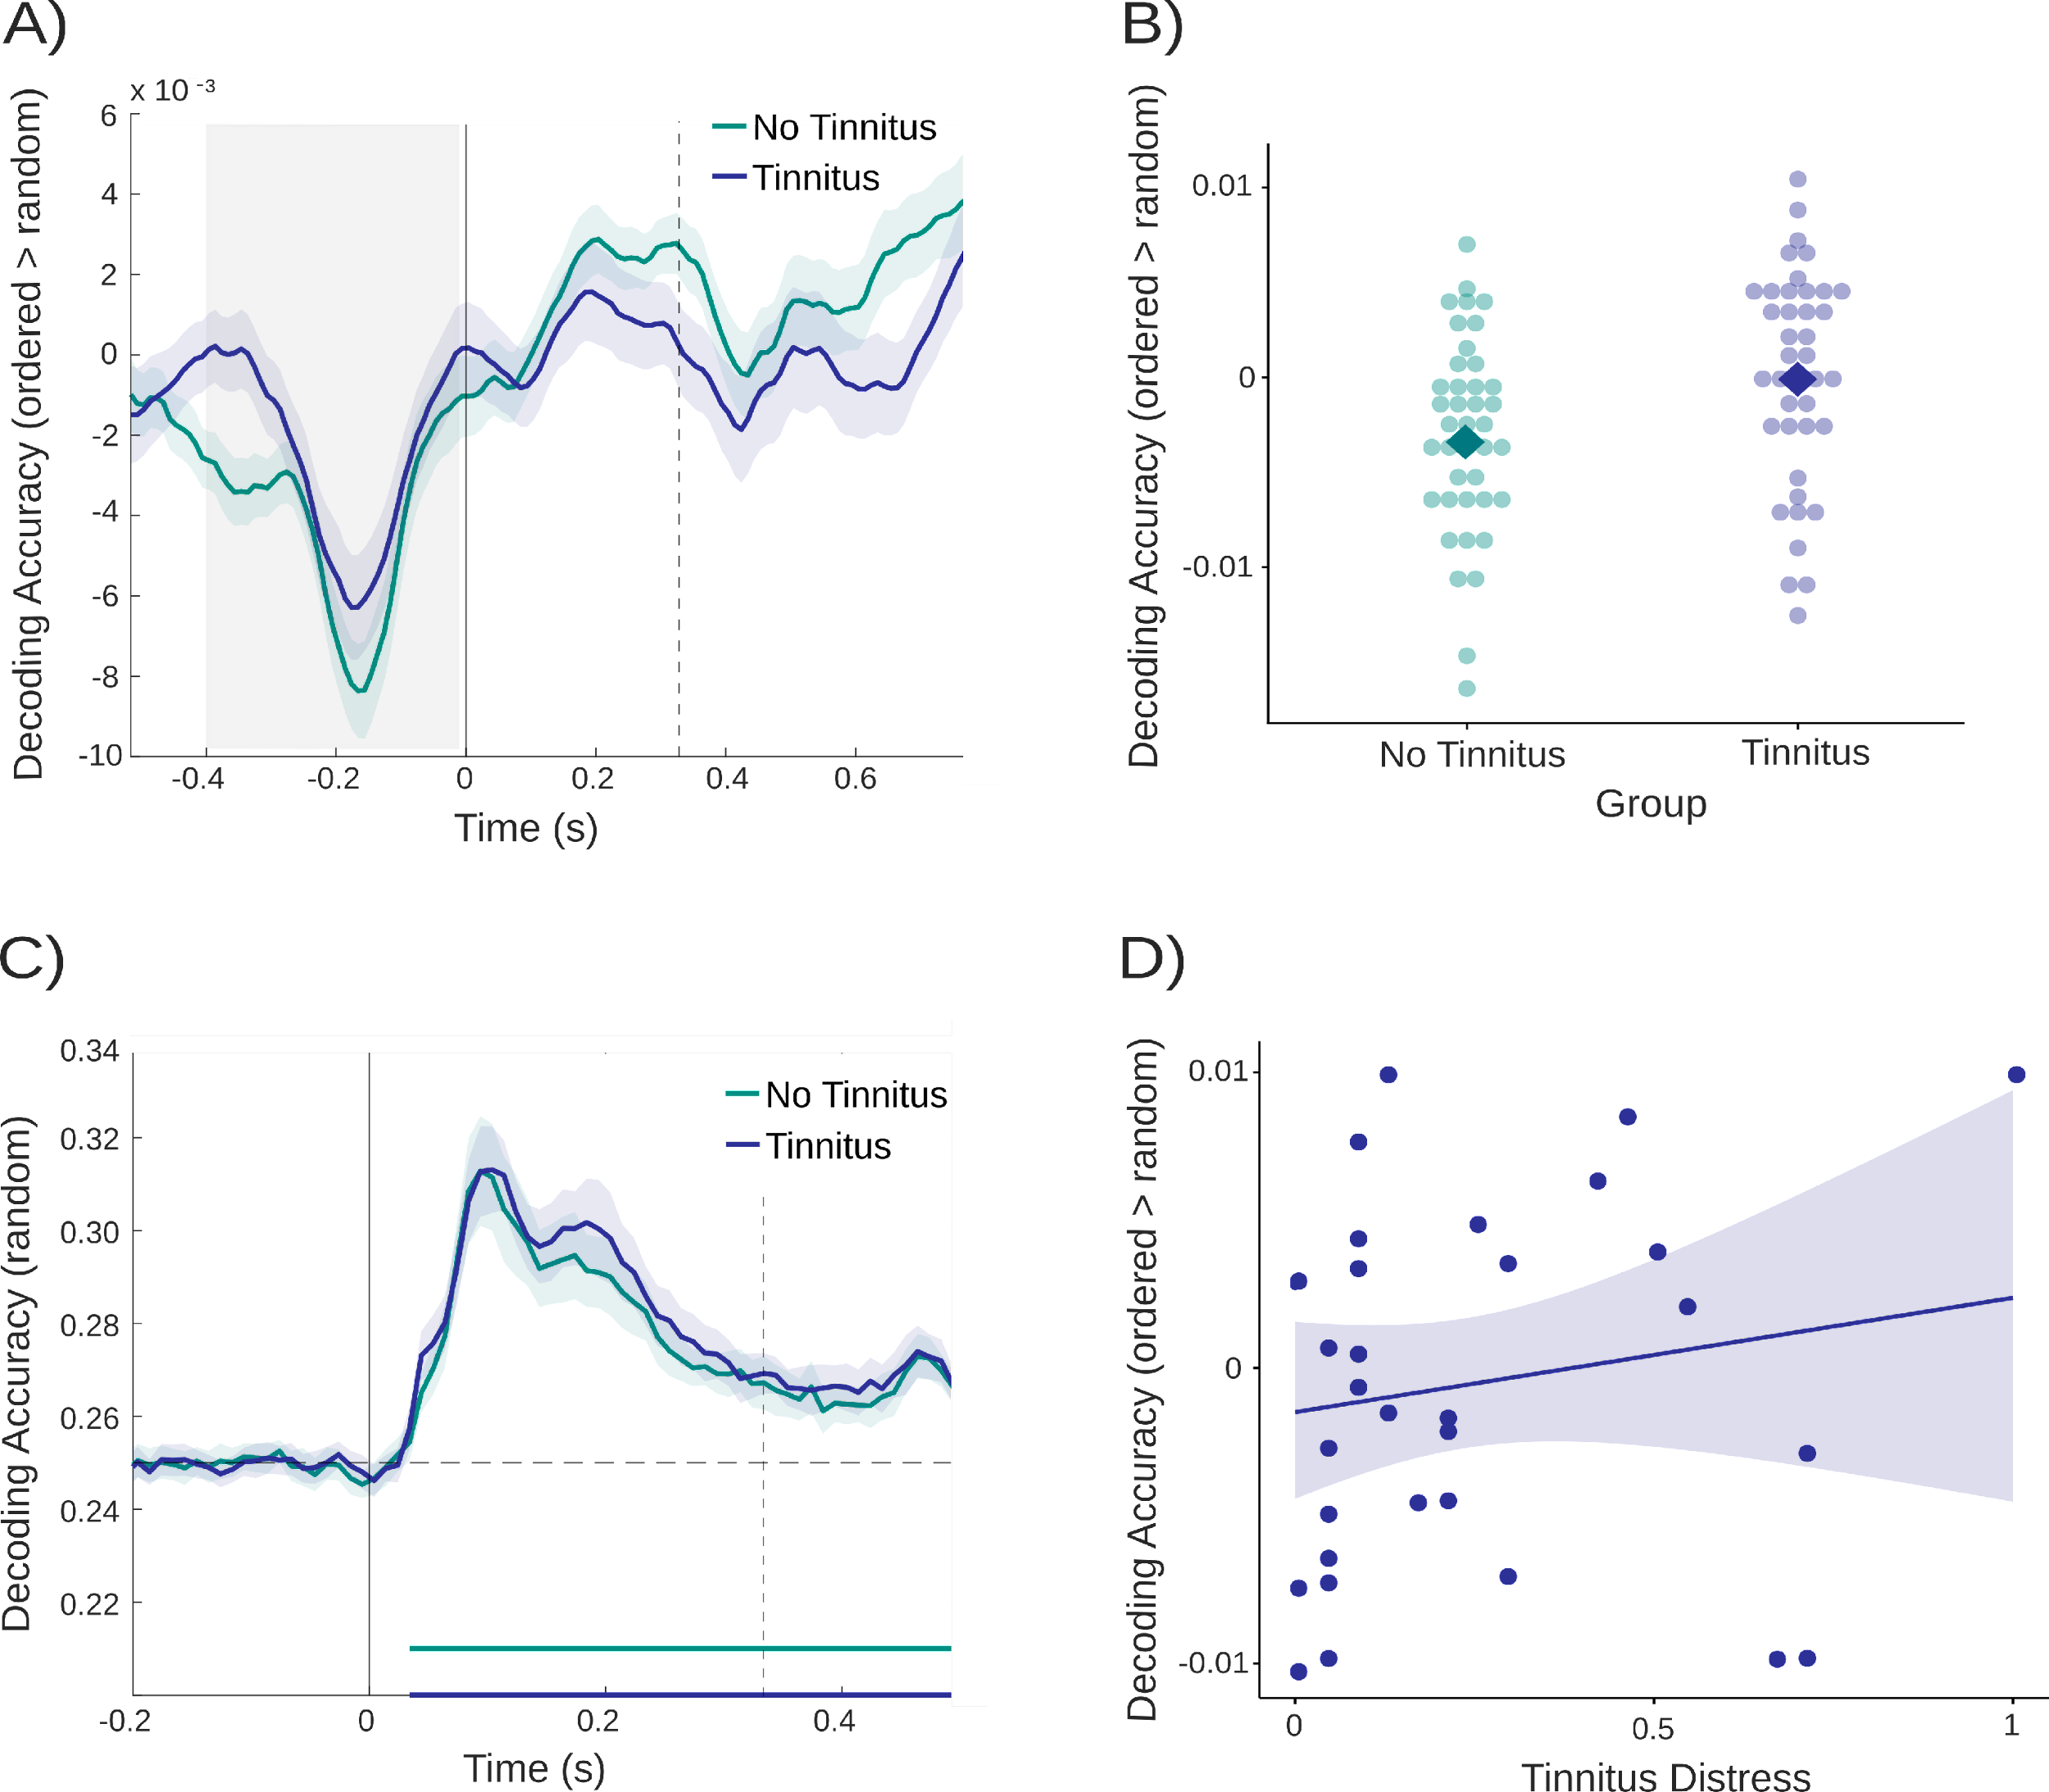Fig. 5: Differences in decoding accuracies between groups and correlations with tinnitus distress. A) Group comparison of the difference in decoding accuracy with the second time window (470-570ms, i.e. the relevant time window in Partyka et al. (2019)) as training time. The grey area depicts the time window used for statistical analyses and vertical lines indicate sound onsets. B) For illustration purposes, depiction of individual decoding accuracy differences between ordered and random tones at the time point of the most pronounced group difference (-380 ms). Squares indicate the mean of each group. C) Random tone decoding accuracy over time for both groups. Vertical lines indicate sound onsets and the dashed horizontal line depicts decoding at chance level. D) Positive, non-significant correlation between mean decoding accuracy and tinnitus distress reported in the tinnitus group.

Exploratory Results
Overall stronger group differences in Partyka et al. (2019)
As mentioned previously, decoding accuracy for carrier frequencies in the random tone sequences was overall stronger in the previous study as compared to our replication study. Also, the descriptively core effect supporting H1 appears to be smaller compared to the one reported in Partyka et al. (2019) (see Figure 5A). To put this descriptive impression into quantitative terms, in a first step, we compared the time-varying overall difference in decoding accuracy between ordered and random tones for the tinnitus and control group in both samples that are completely independent. Bayes factors demonstrated relevant effects in both datasets in the pre-stimulus interval at around -400 ms, however, values are much higher in the sample of Partyka et al. (2019) as compared to the present sample (maximum BF 120.7 versus 7.4). In the post-stimulus interval, our data does not reach a Bayes Factor over at least 3, indicating no difference between the tinnitus and control group. For the dataset of Partyka et al. (2019), higher values were found as well in the post-stimulus interval, starting at around 400 ms (Figure 6A).
It is worth noting again that the samples for these two studies are completely independent and in the second sample rigorous control of hearing loss was undertaken. While this may have a diminishing impact on the effects linked to predictive processing, other factors related to paradigm adaptations may have played a more decisive role. To guide future design decisions, it is therefore important to understand the influence of relevant experimental choices on the group difference effect. We have previously noted that the setting of the tone frequency boundaries was much broader in Partyka et al. (2019) as compared to the present study (1.3 versus 3.3 octaves). This was done to ensure that the highest frequency in participants falls into a normal hearing range. The closer frequencies come along with more similar neural patterns that are more difficult to classify. This becomes apparent when comparing the decoding of pure tones, with significantly higher accuracy in the Partyka et al. (2019) study as well as earlier peaks. As the classifier is trained on the random sequence and applied to the ordered sequence, a less accurate classifier in our study likely decreased the sensitivity of correctly classifying patterns in the pre-stimulus period. Overall, the choice of frequencies in the present study likely leads to an underestimation of the true group differences.

Group differences depend on the number of trials available for training the classifier
Apart from the choice of carrier frequencies, another obvious difference between the two studies was the difference in trial numbers. The very high trial number in Partyka et al. (2019) was due to maintaining the exact study design of Demarchi et al. (2019) that had one focus on investigating omission periods. As omission responses were not of interest in the present design, and the experiment was embedded in further testing, we decided to implement less trials in the current study design. While reducing measurement time significantly, our design choice also meant that less trials could be used to run the decoding analyses. To get a grasp on how the quantity of trials impacts the strength of observed group differences we used the data of Partyka et al. (2019) which had 3600 trials for each condition. We randomly drew various amounts of trials ranging from 200 to 3600 trials for each carrier frequency and recalculated the group difference effects expressed in Bayes Factors (see Figure 6B). Bayes factors greater than 3 are considered supportive of a difference (Schönbrodt & Wagenmakers, 2018). These values were solely found for subsets with higher numbers of trials (i.e. 3600 or 1500 trials). A lower number of trials like 750 or 200 trials showed no relevant group differences. Therefore, the number of trials highly impacts the strength of effects and was likely responsible for the smaller effects in the current study since solely 1500 trials per condition were included.
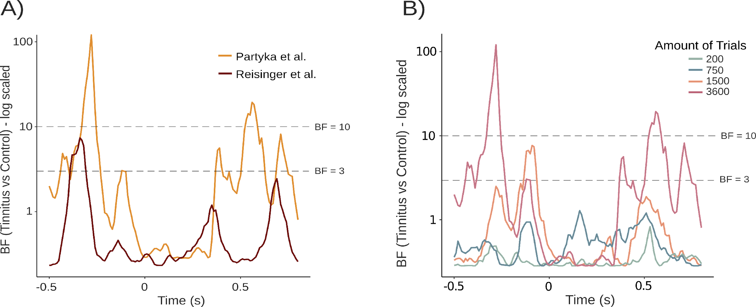 Fig. 6: Exploratory analyses. A) Bayes factor analyses of the differences in decoding accuracies between the tinnitus and control group for both datasets indicated higher effects in the dataset used by Partyka et al. (2019). B) Comparing different numbers of trials used for the decoding, Bayes factor analyses demonstrated higher and relevant effects solely in datasets with a high amount of trials.

Group differences in predictive processing are not confounded by hearing loss
As described previously, a major challenge for the interpretation of group differences in the Partyka et al. (2019) work was their lack of control for hearing loss, which most likely differs between the two groups when not explicitly taken care of. In the present study, by design, we diligently matched both groups for overall level of hearing loss, hence making it unlikely that this factor accounts for the group difference reported in Partyka et al. (2019) and replicated in our study (H1). To provide further corroborative evidence, we decided to analyse the group difference effect using a complementary approach. For this purpose, we used logistic regression to analyse the presence of tinnitus as a dependent variable, and (mean) difference in decoding accuracy between the ordered and random tones in the pre-stimulus interval as independent variable, controlling for hearing loss by including mean hearing ability as a covariate. In a first model, predicting tinnitus solely by mean difference in decoding accuracy, we could identify this as a significant predictor (b=27.96, SE=11.53, p=.018). As expected, when adding mean hearing loss to the model, it does not significantly predict the presence of tinnitus in our sample (b=0.007, SE=0.004, p=.076). Importantly (see Figure 7), controlling for the influence of hearing loss, the pre-stimulus decoding differences between ordered and random tones, still significantly predicted whether participants experience tinnitus (b=24.63, SE=11.51, p=.036). Reversing this model, we also analysed whether the presence of tinnitus can predict differences in decoding accuracy. This model was significant as well (b=0.003, SE=0.001, p=.018), indicating a statistically relevant influence of tinnitus on the differences in decoding accuracies and further supporting our previous findings. Overall, this analysis strongly supports the notion that the main effect reported by us and Partyka et al. (2019), genuinely reflects a process related to the experience or statistical risk of experiencing tinnitus.
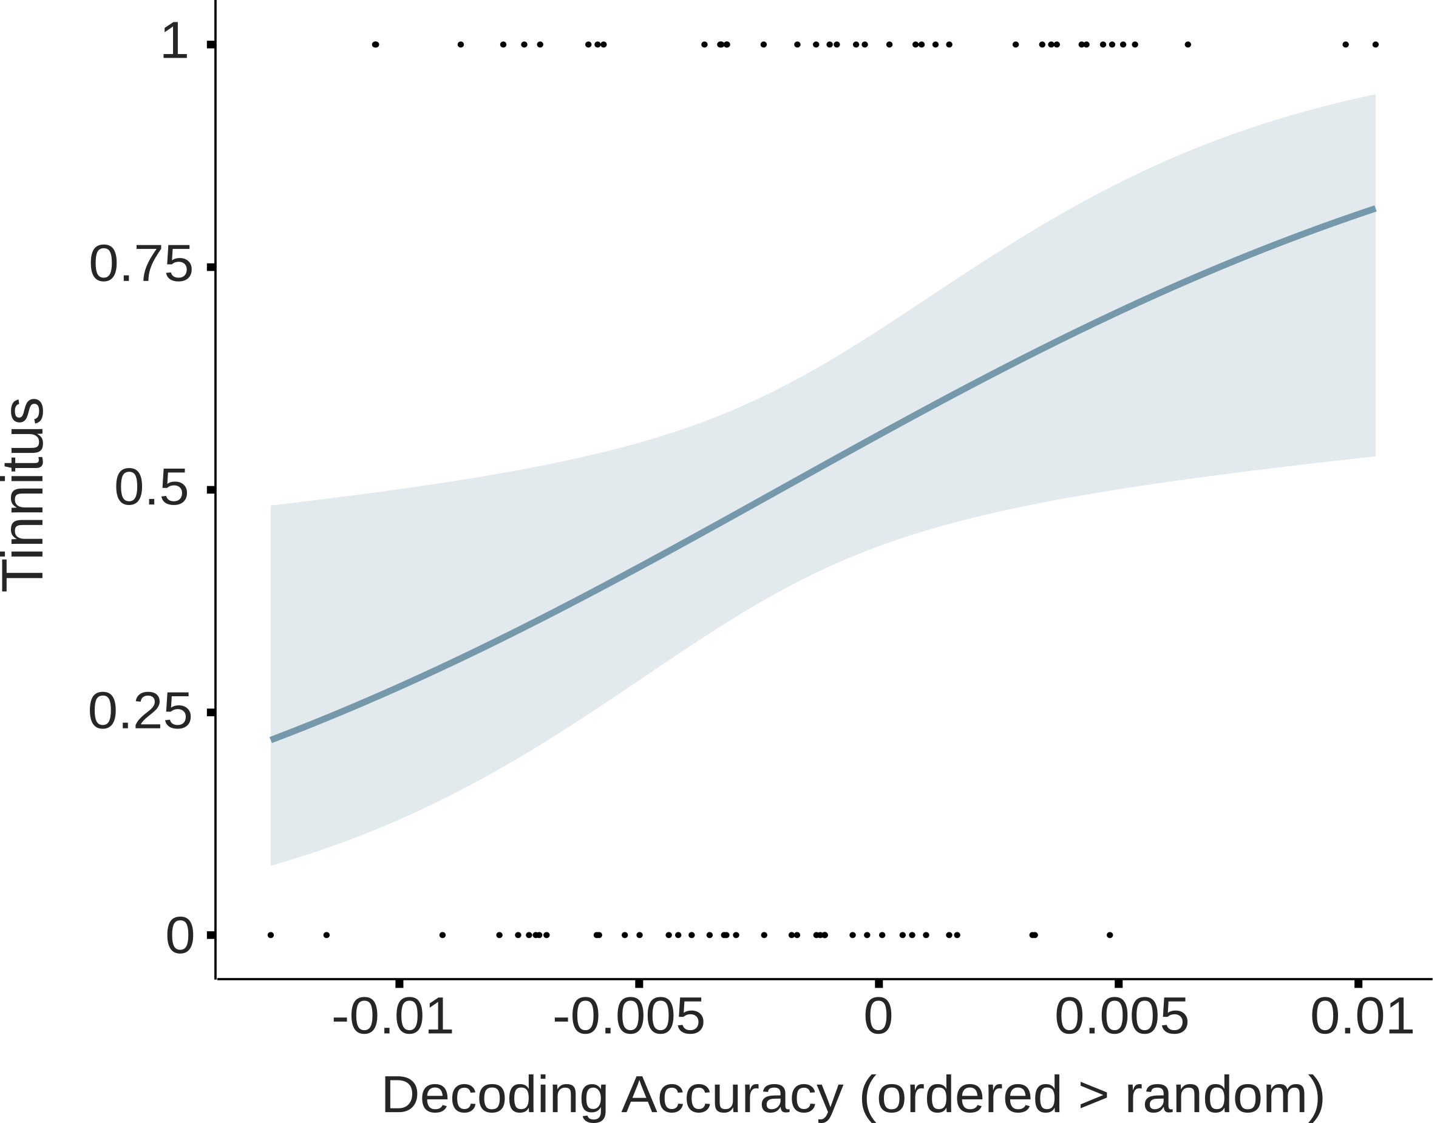
Fig. 7: Logistic regression indicates that higher differences in decoding accuracies (ordered>random) significantly predict the status as tinnitus participant (P(Tinnitus) = 1).

Discussion
Despite strong efforts, neuroscientific tinnitus research in humans is in dire need of robust findings that would enable a deeper understanding of this condition (Reisinger et al., 2023). Large amounts of studies, especially using EEG or MEG, have focused on spectral characteristics of resting state activity. Apart from empirical robustness of various “neural correlates“, most of the underlying conceptual assumptions, often based on hyperactive or hypersynchronous neural ensembles, are insufficient in explaining distinct phenomena (Sedley, 2019). A conceptual challenge is observing why some individuals with hearing loss develop tinnitus, whereas others with comparable hearing loss do not. To overcome these issues, the application of predictive processing models to tinnitus has become particularly popular (Sedley et al., 2016). Distinct predictive processing patterns could e.g., either develop within an individual in contributing to chronification of tinnitus (e.g., shift of “default prediction” from silence to sound; Sedley, 2019). Alternatively, they could be conceived as sensory processing style, making certain individuals more vulnerable to develop tinnitus under certain conditions (e.g., hearing loss, aging), a notion reminiscent of the “strong prior” hypothesis of hallucinations (Corlett et al., 2019). In any case, any more conclusive claims would require longitudinal data, ideally with a tinnitus-free baseline, something that the field is currently lacking. Recently, using a simple MEG paradigm (Demarchi et al., 2019), we were able to show relatively enhanced tone frequency specific pre-activation in tinnitus (Partyka et al., 2019). The present study overcame a key limitation of the study by rigorously controlling for hearing loss. By showing that the key effect remains robust in a new sample and despite some important changes in the paradigm, it provides robust evidence for a role of altered predictive processing in understanding tinnitus. We will refer to this tone frequency specific pre-activation as a “neural prediction score” in tinnitus, indicating deviations between random and predictable sounds that are specifically found in tinnitus patients. By now, this “neural prediction score” specifies merely a broader concept than a concrete numerical score. Influencing factors and underlying mechanisms are still not fully understood and it is therefore not applicable yet to determine a concrete value to quantify neural predictions.

The relevant group difference of Partyka et al. (2019) was successfully replicated and cannot be explained by general tone processing, hearing loss or tinnitus distress
In this study, we replicated the findings of Partyka et al. (2019) and reported differences between tinnitus and control groups regarding the decoding accuracy in the pre-stimulus interval. Using a late training time interval (470-570 ms), the neural prediction score was significantly higher in the tinnitus group in the pre-stimulus time-window of interest, and especially pronounced ~400 ms prior to stimulus onset. As the classifier was trained on the random sequence, it is important to show that groups do not generally differ in terms of decoding accuracy of carrier frequency information. Source analyses revealed auditory activations in both hemispheres for these two timeframes, in a comparable manner to Partyka et al. (2019). Importantly, replicating the previous study, we showed that decoding accuracy did not differ between groups, and can even be seen to be statistically equivalent. This means that any group difference in terms of neural prediction scores needs to be attributed to altered processing of the regularity of the sound sequence.
However, as groups can differ with respect to many aspects, this does not mean that the effect reported by Partyka et al. (2019) and the current study is specific to the perception of the phantom sound. One possibility is that tinnitus goes along with some distress, which could be the actual cause for the pre-stimulus effect. In this case, we would expect a correlation of this effect with tinnitus related distress. However, corroborating the pattern in Partyka et al. (2019), the correlation was not significant. Thus, distress is not a potent candidate in explaining the reported effect.
A strength of the current design was that apart from matching the participants regarding age and sex, the present work rigorously controlled for hearing loss. This was unfortunately not assessed in the previous study, leaving the possibility open that predictive processing effects were due to hearing loss rather than tinnitus. Replicating Partyka et al. (2019), we showed that analogous differences can be observed between groups that did not differ with respect to hearing loss. In a complementary analysis, we used our neural prediction score in addition to hearing loss magnitudes as predictors of tinnitus in a logistic regression. Prediction related pre-activation levels were informative whether participants perceived tinnitus, also when statistically controlling for hearing loss.
In conclusion, the results followed our pre-defined hypotheses and together with Partyka et al. (2019) provide strong support for the notion that aspects of predictive processing play some – to be defined – role in understanding tinnitus.

The group differences in the neural prediction score are driven by below chance decoding in non-tinnitus individuals – implications for understanding tinnitus
Overall, enhanced neural prediction scores in the tinnitus group were shown in both studies, though we still do not know the underlying mechanisms of this effect. These stronger pre-activations could indicate a higher predisposition or vulnerability to develop tinnitus, e.g. in terms of the strong prior hypothesis by Corlett et al. (2019). Within this framework, it is assumed that hallucinations or phantom perceptions arise when prior beliefs disproportionately influence perceptual inferences, leading to perceptions without sensory input (Friston, 2009; Powers et al., 2017). Therefore, vulnerability to develop tinnitus might be due to stronger individual predictions or pre-activations of future sounds, i.e. higher neural prediction scores. However, as for Partyka et al. (2019), it is clear that the group difference with respect to pre-activation patterns stems from below chance decoding for the control group. This does not fit to a very simplistic notion of generally enhanced predictive processing in individuals with tinnitus.
For both studies the pre-stimulus group effect was identified at late training time intervals. These refer to patterns, trained on the random sound sequences, which are visible as small late peaks (see Figure 5C). As they follow the onset of the subsequent tone, in the random tone sequence they are indicative of a reactivation of carrier frequency specific information and potentially neural processes involved in forming associations between events and hence formation of auditory memories. Applied to ordered sequences, below chance decoding indicates a meaningful lacking activation of the target carrier frequency in non-tinnitus individuals for these putatively higher-order auditory processes. Interestingly, neural prediction scores showed high between-subjects variability (see Figure 5B). Since we ruled out hearing loss as a potential confound, other - yet unknown - factors seem to influence neural prediction scores in tinnitus and controls. Although our current design does not include other options to analyze interindividual differences, this phenomenon opens up possibilities for future work to further investigate this variability.
Even though the group difference appears most pronounced prior to target stimulus onset, it is more difficult here to speak of pre-activation effects, as in an ordered sequence the previous and subsequent tones are more likely to be a specific other carrier frequency (as determined by the transition matrix). Indeed, while below chance decoding drives the pre-stimulus effect in both studies, the opposite effect is present following the subsequent tone(s) in Partyka et al. (2019) and – albeit not significant – a descriptively similar patterns can be seen in the present study (see Figure 5A and Figure 6A). The absence of a clearer effect in the post-stimulus period in the present study could be attributable to the design limitations presented above and discussed below.
Since pre-activation of early training time windows are similar in both groups (no difference in Partyka et al. (2019); similar pattern in Figure 3), we speculate that once the regularity of the sound sequence is learned, individuals with tinnitus downregulate these higher-level auditory processes. Translated into more conceptual terms, this could mean that individuals without tinnitus use associative contextual information to continuously “monitor” internal models and these associative processes are less engaged in tinnitus once an internal model has formed. This fundamental difference in auditory processing “styles” could also be an interesting conceptual bridge to addressing why tinnitus becomes chronic and so therapy-resistant in some individuals.
As indicated above, this interpretation remains speculative at this stage and requires further investigation. We acknowledge that there are other possibilities on how to interpret the below-chance decoding and therefore encourage future work to implement novel approaches to gain more insights into the exact underlying mechanisms driving this effect. An increased focus on hippocampal regions, e.g., in fMRI, patient, or animal studies, could be a worthwhile complement to our MEG work, given the outstanding relevance of medial temporal areas in the formation of associations in statistical learning paradigms (see e.g., Covington et al., (2018); Schapiro et al., (2016)).

Lessons learned for future studies using the tone regularity paradigm
Despite the successful replication of our core findings, it is noticeable that group differences effects were weaker compared to Partyka et al. (2019). This becomes particularly evident when comparing time-varying Bayes Factors for the effects from both studies (Figure 6A). While the strongest Bayes Factors in the pre-stimulus period reached values above 100 in Partyka et al. (2019), they reached a value of around 7 in the present study. Understanding which aspects contribute to this decline in effect size is relevant for future works.
An obvious assumption could be that the control for hearing loss led to a decrease in the magnitude of the effect. Even though this possibility cannot be completely excluded, we deem it very unlikely as hearing loss was neither associated with the neural prediction score in our previous work (audiometry was available for the tinnitus group) nor in the present sample assessed in the logistic regression analysis.
Next to the control for hearing loss, the current study deviated in some respects from the original study, which are more likely to influence the strength of the effect. Firstly, we chose a narrower frequency range at lower frequencies (1.3 octaves versus 3.3 octaves in Partyka et al. (2019)), with the intention to assure that carrier frequencies fall into the normal hearing range. However, closer frequencies lead to more similar neural patterns hence making it more challenging for a classifier to decode tone frequencies. The lower decoding accuracy for carrier frequencies and slightly shifted decoding peaks in the random sequence in the present study are a testimony to this issue. As these classifiers were also applied to the pre-stimulus periods of the ordered sequence, less reliable decoding likely obscured group differences to some extent.
Secondly, a difference between the two datasets is the number of trials included in the decoding analyses. In our sample, less than half the trial number was used to train the classifier as compared to Partyka et al. (2019). The generous number of trials in the original study allowed to quantify the influence of trial number on the group difference for the core predictive processing effect. By repeating the analysis pipeline for a varying amount of randomly sampled trials we observed that Bayes Factors decreased with fewer trials and were pointing to no effects once going below 1,000 trials per carrier frequency. The current study included 1,500 trials per carrier frequency, which is likely on the boundary of finding predefined group effects.
Overall, in combination with Partyka et al. (2019), our work clearly underlines the true presence of differences in terms of predictive processing between individuals with and without tinnitus. At the same time, distinct design choices impact the strength of the effects. Next to controlling for basic variables (age, sex, hearing loss), future studies using our paradigm and analysis approach should opt for a broader frequency spacing (>2 octaves) and ideally more than 2000 trials per carrier frequency in the random sequence. These recommendations are likely even more important for efforts of testing this paradigm using EEG, which normally comes with inferior data quality as compared to MEG.
Next to implementing broader frequency spacing, future studies should also focus on the opposite direction, namely narrowing down the sound range around the individual tinnitus frequency. Recent MEG studies already focused on the tinnitus frequencies in their designs (Reisinger et al., 2023) and in terms of predictive coding, this approach can allow insights into the predictive processing of tinnitus vs non-tinnitus tones.
Further, apart from the methodological specifications mentioned above, attention appears to be relevant in tinnitus as well, both in the generation and the formation of predictions (Durai et al., 2018; Roberts et al., 2013; Sedley et al., 2016). In the current study, we used a passive listening task including a movie to reduce attentional focus on the presented stimuli. Therefore, we can not draw conclusions whether differences in attention between the two groups had an influence on the effects. Future studies should include more manipulations of attention to investigate its relevance.
Additionally, we rigorously controlled for hearing loss and ruled out any influence of tinnitus distress on the effects, however, we did not screen our participants for hyperacusis. This hypersensitivity to mild sounds is widely correlated with the sensation of tinnitus and underlying neural mechanisms are potentially intertwined with tinnitus processes (Schilling et al., 2023; Yukhnovich et al., 2023; Zheng, 2020). Screening for hyperacusis in future work can therefore reveal more details on participant characteristics influencing predictive processing.

Conclusions
The present study has successfully replicated the main findings of Partyka et al. (2019), particularly the core effect of an enhanced neural prediction score in tinnitus. The present results bear particular relevance by excluding hearing loss as a confounding explanation for the observed differences in anticipatory neural information in tinnitus. Thus, our main finding poses the rare instance of a replicable effect in the human neuroscientific tinnitus literature. Bolstered by the preregistration of hypotheses and methods, the robustness of the effect despite changes of some design details is worth emphasizing. For example, the narrower frequency range in this study showed that the effects are to some extent generalizable and not bound to e.g., higher frequency falling into a tinnitus-frequency range. However, some of the design details as specified in the present study likely had an adverse impact on the effect size. Concrete suggestions for future studies using our paradigm have been offered.
One aspect, neither considered sufficiently in Partyka et al. (2019) nor when conceiving the present study, was that the core pre-stimulus predictive processing effect is caused by a below-chance decoding accuracy in the non-tinnitus group. This indicates that our original notion of a more generally enhanced neural prediction score in tinnitus individuals is likely too simplistic. We have offered some speculations, however, further studies using complementary methods and designs will be needed to better understand this effect.
To conclude, the replicability of this effect strengthens its importance and relevance in understanding tinnitus mechanisms. In future, these neural prediction scores could be possibly further developed as a diagnostic marker for tinnitus or – depending on its functional role – individual as a measure of tinnitus vulnerability. The latter offers the potential to differentiate patients with a greater risk of (chronic) tinnitus and to implement more focused prevention or treatment options. To achieve this, however, causal evidence is needed that anticipatory aberrations precede tinnitus. More research, and especially longitudinal data, is required to determine whether this pre-stimulus difference is a cause of tinnitus onset or a predisposing factor. New insights into these relations will allow conceptual advances in tinnitus research and facilitate the understanding of these auditory phantom perceptions.
References

Adjamian, P., Sereda, M., Zobay, O., Hall, D. A., & Palmer, A. R. (2012). Neuromagnetic indicators of tinnitus and tinnitus masking in patients with and without hearing loss. Journal of the Association for Research in Otolaryngology, 13, 715-731. https://doi.org/10.1007/s10162-012-0340-5.

Aitken, F., Menelaou, G., Warrington, O., Koolschijn, R. S., Corbin, N., Callaghan, M. F., & Kok, P. (2020). Prior expectations evoke stimulus-specific activity in the deep layers of the primary visual cortex. PLoS biology, 18(12), e3001023. https://doi.org/10.1371/journal.pbio. 3001023.

Baguley, D., McFerran, D., & Hall, D. (2013). Tinnitus. The Lancet, 382(9904), 1600-1607. https://doi.org/10.1016/S0140-6736(13)60142-7.

Blom, T., Feuerriegel, D., Johnson, P., Bode, S., & Hogendoorn, H. (2020). Predictions drive neural representations of visual events ahead of incoming sensory information. Proceedings of the National Academy of Sciences, 117(13), 7510-7515. https://doi.org/10.1073/pnas.1917 777117.

Brainard, D. H., & Vision, S. (1997). The psychophysics toolbox. Spatial vision, 10(4), 433-436.

Brinkmann, P., Kotz, S. A., Smit, J. V., Janssen, M. L., & Schwartze, M. (2021). Auditory thalamus dysfunction and pathophysiology in tinnitus: a predictive network hypothesis. Brain Structure and Function, 226(6), 1659-1676. https://doi.org/10.1007/s00429-021-02284-x.

Cichy, R. M., & Pantazis, D. (2017). Multivariate pattern analysis of MEG and EEG: A comparison of representational structure in time and space. NeuroImage, 158, 441-454. https://doi. org/10.1016/j.neuroimage.2017.07.023.

Corlett, P. R., Horga, G., Fletcher, P. C., Alderson-Day, B., Schmack, K., & Powers III, A. R. (2019). Hallucinations and strong priors. Trends in cognitive sciences, 23(2), 114-127. https://doi.org/10.1016/j.tics.2018.12.001.

Covington, N. V., Brown-Schmidt, S., & Duff, M. C. (2018). The necessity of the hippocampus for statistical learning. Journal of cognitive neuroscience, 30(5), 680-697. https://doi.org/10.1162/jocn_a_01228.

Demarchi, G., Sanchez, G., & Weisz, N. (2019). Automatic and feature-specific prediction-related neural activity in the human auditory system. Nature communications, 10(1), 1-11.

De Ridder, D., Elgoyhen, A. B., Romo, R., & Langguth, B. (2011). Phantom percepts: tinnitus and pain as persisting aversive memory networks. Proceedings of the National Academy of Sciences, 108(20), 8075-8080. https://doi.org/10.1073/pnas.101846610.

De Ridder, D., Vanneste, S., Langguth, B., & Llinas, R. (2015). Thalamocortical dysrhythmia: a theoretical update in tinnitus. Frontiers in neurology, 6, 124. https://doi.org/10.3389/fneur.2015.00124.

Dobie, R. A. (2003). Depression and tinnitus. Otolaryngologic Clinics of North America, 36(2), 383- 388. https://doi.org/10.1016/S0030-6665(02)00168-8.

Durai, M., O’Keeffe, M. G., & Searchfield, G. D. (2018). A review of auditory prediction and its potential role in tinnitus perception. Journal of the American Academy of Audiology, 29(06), 533-547. https://doi.org/10.3766/jaaa.17025.

Eggermont, J. J., & Roberts, L. E. (2004). The neuroscience of tinnitus. Trends in neurosciences, 27(11), 676-682. https://doi.org/10.1016/j.tins.2004.08.010.

Eggermont, J. J., & Roberts, L. E. (2015). Tinnitus: animal models and findings in humans. Cell and tissue research, 361(1), 311-336.

Elgoyhen, A. B., Langguth, B., De Ridder, D., & Vanneste, S. (2015). Tinnitus: perspectives from human neuroimaging. Nature Reviews Neuroscience, 16(10), 632-642.

Faul, F., Erdfelder, E., Buchner, A., & Lang, A.-G. (2009). Statistical power analyses using G*Power 3.1: Tests for correlation and regression analyses. Behavior Research Methods, 41, 1149- 1160.

Frey, V., Langthaler, P., Raphaelis, E., Ring-Dimitriou, S., Kedenko, L., Aigner, E., ... & Paulweber, B. (2022). Paracelsus 10,000: A prospective cohort study based on the population of Salzburg, Austria. Rationale, objectives and study design, (preprint). https://doi.org/10.21203/rs.3. rs- 740574/v2.

Friston, K., & Kiebel, S. (2009). Predictive coding under the free-energy principle. Philosophical transactions of the Royal Society B: Biological sciences, 364(1521), 1211-1221. https://doi.org/10.1098/rstb.2008.0300.

Garcés, P., López-Sanz, D., Maestú, F., & Pereda, E. (2017). Choice of magnetometers and gradiometers after signal space separation. Sensors, 17(12), 2926. https://doi.org/10.3390/s17122926.

Goebel, G., & Hiller, W. (1992). Psychische Beschwerden bei chronischem Tinnitus: Erprobung und Bewertung des Tinnitus-Fragebogens (TF). Verhaltenstherapie, 2(1), 13-22.

Henry, J. A., Reavis, K. M., Griest, S. E., Thielman, E. J., Theodoroff, S. M., Grush, L. D., & Carlson, K. F. (2020). Tinnitus: an epidemiologic perspective. Otolaryngologic Clinics of North America, 53(4), 481-499. https://doi.org/10.1016/j.otc.2020.03.002.

Hiller, W., & Goebel, G. (2004). Rapid assessment of tinnitus-related psychological distress using the Mini-TQ. Int J Audiol, 43(10), 600-604.

Hu, S., Hall, D. A., Zubler, F., Sznitman, R., Anschuetz, L., Caversaccio, M., & Wimmer, W. (2021). Bayesian brain in tinnitus: Computational modeling of three perceptual phenomena using a modified Hierarchical Gaussian Filter. Hearing research, 410, 108338. https://doi.org/ 10.1016/j.heares.2021.108338.

Hullfish, J., Sedley, W., & Vanneste, S. (2019). Prediction and perception: Insights for (and from) tinnitus. Neuroscience & Biobehavioral Reviews, 102, 1-12. https://doi.org/10.1016/ j.neubiorev.2019.04.008.

Jarach, C. M., Lugo, A., Scala, M., van den Brandt, P. A., Cederroth, C. R., Odone, A., ... & Gallus, S. (2022). Global prevalence and incidence of tinnitus: A systematic review and meta-analysis. JAMA neurology, 79(9), 888-900. https://doi.org/10.1001/jamaneurol.2022.2189.
Kandeepan, S., Maudoux, A., Ribeiro de Paula, D., Zheng, J. Y., Cabay, J. E., Gómez, F., ... & Soddu, A. (2019). Tinnitus distress: a paradoxical attention to the sound?. Journal of Neurology, 266(9), 2197-2207. https://doi.org/10.1007/s00415-019-09390-1.
Kiessling, J., Grugel, L., Meister, H., & Meis, M. (2011). Übertragung der Fragebögen SADL, ECHO und SSQ ins Deutsche und deren Evaluation. Z Audio, 50, 6-16.
Kim, H. J., Lee, H. J., An, S. Y., Sim, S., Park, B., Kim, S. W., ... & Choi, H. G. (2015). Analysis of the prevalence and associated risk factors of tinnitus in adults. PloS one, 10(5), e0127578. https://doi.org/10.1371/journal.pone.0127578.
King, J. R., & Dehaene, S. (2014). Characterizing the dynamics of mental representations: the temporal generalization method. Trends in cognitive sciences, 18(4), 203-210. https://doi.org/10.1016/j.tics.2014.01.002.
Kok, P., Mostert, P., & De Lange, F. P. (2017). Prior expectations induce prestimulus sensory templates. Proceedings of the National Academy of Sciences, 114(39), 10473-10478. https://doi.org/10.1073/pnas.1705652114.
Lan, L., Chen, Y. C., Lu, L., Xu, J. J., Yin, X., Wu, Y., & Cai, Y. (2022). Topological features of limbic dysfunction in chronicity of tinnitus with intact hearing: New hypothesis for ‘noise-cancellation’mechanism. Progress in Neuro-Psychopharmacology and Biological Psychiatry, 113, 110459. https://doi.org/10.1016/j.pnpbp.2021.110459.
Lange, J., Keil, J., Schnitzler, A., van Dijk, H., & Weisz, N. (2014). The role of alpha oscillations for illusory perception. Behavioural brain research, 271, 294-301. https://doi.org/10.1016/ j.bbr.2014.06.015.
Langers, D. R., Kleine, E. D., & Dijk, P. V. (2012). Tinnitus does not require macroscopic tonotopic map reorganization. Frontiers in systems neuroscience, 6, 2. https://doi.org/10.3389/ fnsys.2012.00002.
Leske, S., Tse, A., Oosterhof, N. N., Hartmann, T., Müller, N., Keil, J., & Weisz, N. (2014). The strength of alpha and beta oscillations parametrically scale with the strength of an illusory auditory percept. Neuroimage, 88, 69-78. https://doi.org/10.1016/j.neuroimage.2013.11.014.
Lin, F. R., Metter, E. J., O’Brien, R. J., Resnick, S. M., Zonderman, A. B., & Ferrucci, L. (2011). Hearing loss and incident dementia. Archives of neurology, 68(2), 214-220. https://doi.org/10.1001/archneurol.2010.362.
Llinás, R. R., Ribary, U., Jeanmonod, D., Kronberg, E., & Mitra, P. P. (1999). Thalamocortical dysrhythmia: a neurological and neuropsychiatric syndrome characterized by magnetoencephalography. Proceedings of the National Academy of Sciences, 96(26), 15222-15227. https://doi.org/10.1073/pnas.96.26.15222.
Lorenz, I., Müller, N., Schlee, W., Hartmann, T., & Weisz, N. (2009). Loss of alpha power is related to increased gamma synchronization—a marker of reduced inhibition in tinnitus?. Neuroscience letters, 453(3), 225-228. https://doi.org/10.1016/j.neulet.2009.02.028.
Maris, E., & Oostenveld, R. (2007). Nonparametric statistical testing of EEG-and MEG-data. Journal of neuroscience methods, 164(1), 177-190. https://doi.org/10.1016/j.jneumeth.2007.03.024.
Marti, S., & Dehaene, S. (2017). Discrete and continuous mechanisms of temporal selection in rapid visual streams. Nature communications, 8(1), 1-13. https://doi.org/10.1038/s41467-017 02079-x.
Meyer, M., Luethi, M. S., Neff, P., Langer, N., & Büchi, S. (2014). Disentangling tinnitus distress and tinnitus presence by means of EEG power analysis. Neural Plasticity, 2014. https://doi. org/10.1155/2014/468546.
Mühlmeier, G., Baguley, D., Cox, T., Suckfüll, M., & Meyer, T. (2016). Characteristics and spontaneous recovery of tinnitus related to idiopathic sudden sensorineural hearing loss. Otology & Neurotology, 37(6), 634. https://doi.org/10.1097/MAO.0000000000001081.
Müller, N., Keil, J., Obleser, J., Schulz, H., Grunwald, T., Bernays, R. L., ... & Weisz, N. (2013). You can't stop the music: reduced auditory alpha power and coupling between auditory and memory regions facilitate the illusory perception of music during noise. Neuroimage, 79, 383- 393. https://doi.org/10.1016/j.neuroimage.2013.05.001.
Mohan, A., Luckey, A., Weisz, N., & Vanneste, S. (2022). Predisposition to domain-wide maladaptive changes in predictive coding in auditory phantom perception. NeuroImage, 248, 118813. https://doi.org/10.1016/j.neuroimage.2021.118813.
Nastase, S., Iacovella, V., & Hasson, U. (2014). Uncertainty in visual and auditory series is coded by modality‐general and modality‐specific neural systems. Human brain mapping, 35(4), 1111- 1128. https://doi.org/10.1002/hbm.22238.
Nolte, G. (2003). The magnetic lead field theorem in the quasi-static approximation and its use for magnetoencephalography forward calculation in realistic volume conductors. Physics in Medicine & Biology, 48(22), 3637.
Oostenveld, R., Fries, P., Maris, E., & Schoffelen, J. M. (2011). FieldTrip: open source software for advanced analysis of MEG, EEG, and invasive electrophysiological data. Computational intelligence and neuroscience, 2011. https://doi.org/10.1155/2011/156869.
Okamoto, H., Stracke, H., Stoll, W., & Pantev, C. (2010). Listening to tailor-made notched music reduces tinnitus loudness and tinnitus-related auditory cortex activity. Proceedings of the National Academy of Sciences, 107(3), 1207-1210. https://doi.org/10.1073/pnas.09112 68107.
Ozdek, A., Karacay, M., Saylam, G., Tatar, E., Aygener, N., & Korkmaz, M. H. (2010). Comparison of pure tone audiometry and auditory steady-state responses in subjects with normal hearing and hearing loss. European archives of oto-rhino-laryngology, 267, 43-49. https://doi.org/10.1007/s00405-009-1014-8
Partyka, M., Demarchi, G., Roesch, S., Suess, N., Sedley, W., Schlee, W., & Weisz, N. (2019). Phantom auditory perception (tinnitus) is characterised by stronger anticipatory auditory predictions. BioRxiv, 869842. https://doi.org/10.1101/869842.
Paraskevopoulos, E., Dobel, C., Wollbrink, A., Salvari, V., Bamidis, P. D., & Pantev, C. (2019). Maladaptive alterations of resting state cortical network in Tinnitus: A directed functional connectivity analysis of a larger MEG data set. Scientific Reports, 9(1), 1-11. https://doi.org/10.1038/s41598-019-51747-z.
Powers, A.R., Mathys, C., & Corlett, P.R. (2017). Pavlovian conditioning–induced hallucinations result from overweighting of perceptual priors. Science 357, 596-600. https://doi.org10.1126/science.aan3458.
R Core Team (2020). R: A language and environment for statistical computing. R Foundation for Statistical Computing, Vienna, Austria.
Rauschecker, J. P., Leaver, A. M., & Mühlau, M. (2010). Tuning out the noise: limbic-auditory interactions in tinnitus. Neuron, 66(6), 819-826. https://doi.org/10.1016/j.neuron.2010.04.032.
Reisinger, L., Demarchi, G., & Weisz, N. (2023). Eavesdropping on Tinnitus Using MEG: Lessons Learned and Future Perspectives. Journal of the Association for Research in Otolaryngology, 1-17. https://doi.org/10.1007/s10162-023-00916-z.
Roberts, L. E., Eggermont, J. J., Caspary, D. M., Shore, S. E., Melcher, J. R., & Kaltenbach, J. A. (2010). Ringing ears: the neuroscience of tinnitus. Journal of Neuroscience, 30(45), 14972- 14979. https://doi.org/10.1523/JNEUROSCI.4028-10.2010.
Roberts, L. E., Husain, F. T., & Eggermont, J. J. (2013). Role of attention in the generation and modulation of tinnitus. Neuroscience & Biobehavioral Reviews, 37(8), 1754-1773. https://doi.org/10.1016/j.neubiorev.2013.07.007.
Roberts, L. E., Moffat, G., & Bosnyak, D. J. (2006). Residual inhibition functions in relation to tinnitus spectra and auditory threshold shift. Acta Oto-Laryngologica, 126(sup556), 27-33. https://doi.org/10.1080/03655230600895358.
Roberts, L. E., & Salvi, R. (2019). Overview: Hearing loss, tinnitus, hyperacusis, and the role of central gain. Neuroscience, 407, 1-7.
Schaette, R. (2014). Tinnitus in men, mice (as well as other rodents), and machines. Hearing Research, 311, 63-71. https://doi.org/10.1016/j.heares.2013.12.004.
Schaette, R., & Kempter, R. (2006). Development of tinnitus‐related neuronal hyperactivity through homeostatic plasticity after hearing loss: a computational model. European Journal of Neuroscience, 23(11), 3124-3138. https://doi.org/10.1111/j.1460-9568.2006.04774.x.
Schaette, R., & Kempter, R. (2012). Computational models of neurophysiological correlates of tinnitus. Frontiers in systems neuroscience, 6, 34. https://doi.org/10.3389/fnsys.2012. 00034.
Schaette, R., & McAlpine, D. (2011). Tinnitus with a normal audiogram: physiological evidence for hidden hearing loss and computational model. Journal of Neuroscience, 31(38), 13452- 13457. https://doi.org/10.1523/JNEUROSCI.2156-11.2011.
Schaette, R., Turtle, C., & Munro, K. J. (2012). Reversible induction of phantom auditory sensations through simulated unilateral hearing loss. PloS one, 7(6), e35238. https://doi.org/10. 1371/journal.pone.0035238.
Schapiro, A. C., Turk‐Browne, N. B., Norman, K. A., & Botvinick, M. M. (2016). Statistical learning of temporal community structure in the hippocampus. Hippocampus, 26(1), 3-8. https://doi.org/10.1002/hipo.22523.
Schilling, A., Sedley, W., Gerum, R., Metzner, C., Tziridis, K., Maier, A., ... & Krauss, P. (2023). Predictive coding and stochastic resonance as fundamental principles of auditory phantom perception. Brain, 146(12), 4809-4825. https://doi.org/10.1093/brain/awad255.
Schlee, W., Hartmann, T., Langguth, B., & Weisz, N. (2009). Abnormal resting-state cortical coupling in chronic tinnitus. BMC neuroscience, 10(1), 1-11. https://doi.org/10.1186/1471-2202-10-11.
Schönbrodt, F. D., & Wagenmakers, E. J. (2018). Bayes factor design analysis: Planning for compelling evidence. Psychonomic bulletin & review, 25(1), 128-142. https://doi.org/10.3758/s13423-017-1230-y.
Sedley, W., Gander, P. E., Kumar, S., Kovach, C. K., Oya, H., Kawasaki, H., ... & Griffiths, T. D. (2016). Neural signatures of perceptual inference. elife, 5, e11476. https://doi.org/ 10.7554/eLife.11476.
Sedley, W., Friston, K. J., Gander, P. E., Kumar, S., & Griffiths, T. D. (2016). An integrative tinnitus model based on sensory precision. Trends in neurosciences, 39(12), 799-812. https://doi.org/10.1016/j.tins.2016.10.004.
Sedley, W. (2019). Tinnitus: does gain explain?. Neuroscience, 407, 213-228. https://doi.org/10.1016/j.neuroscience.2019.01.027.

Sedley, W., Alter, K., Gander, P. E., Berger, J., & Griffiths, T. D. (2019). Exposing pathological sensory predictions in tinnitus using auditory intensity deviant evoked responses. Journal of Neuroscience, 39(50), 10096-10103. https://doi.org/10.1523/JNEUROSCI.1308-19.2019.

Song, J. J., Vanneste, S., & De Ridder, D. (2015). Dysfunctional noise cancelling of the rostral anterior cingulate cortex in tinnitus patients. PloS one, 10(4), e0123538. https://doi.org/10.1371/journal.pone.0123538.

Taulu, S., & Kajola, M. (2005). Presentation of electromagnetic multichannel data: the signal space separation method. Journal of Applied Physics, 97(12), 124905. https://doi.org/10.1063/ 1.1935742.

Van Der Loo, E., Gais, S., Congedo, M., Vanneste, S., Plazier, M., Menovsky, T., ... & De Ridder, D. (2009). Tinnitus intensity dependent gamma oscillations of the contralateral auditory cortex. PloS one, 4(10), e7396. https://doi.org/10.1371/journal.pone.0007396.

Vanneste, S., Alsalman, O., & De Ridder, D. (2019). Top-down and bottom-up regulated auditory phantom perception. Journal of Neuroscience, 39(2), 364-378. https://doi.org/10.1523/ JNEUROSCI.0966-18.2018.

Von Helmholtz, H. (1867). Handbuch der physiologischen Optik: mit 213 in den Text eingedruckten Holzschnitten und 11 Tafeln (Vol. 9). Voss.

Vielsmeier, V., Santiago Stiel, R., Kwok, P., Langguth, B., & Schecklmann, M. (2020). From acute to chronic tinnitus: pilot data on predictors and progression. Frontiers in Neurology, 11, 997. https://doi.org/10.3389/fneur.2020.00997.

Walker, E., & Nowacki, A. S. (2011). Understanding equivalence and noninferiority testing. Journal of general internal medicine, 26, 192-196. https://doi.org/10.1007/s11606-010-1513-8.

Wallhäusser-Franke, E., D’Amelio, R., Glauner, A., Delb, W., Servais, J. J., Hörmann, K., & Repik, I. (2017). Transition from acute to chronic tinnitus: predictors for the development of chronic distressing tinnitus. Frontiers in neurology, 8, 605. https://doi.org/10.3389/fneur.2017.00605.

Weisz, N., Moratti, S., Meinzer, M., Dohrmann, K., & Elbert, T. (2005). Tinnitus perception and distress is related to abnormal spontaneous brain activity as measured by magnetoencephalography. PLoS medicine, 2(6), e153. https://doi.org/10.1371/journal. pmed.0020153.

Weisz, N., Hartmann, T., Dohrmann, K., Schlee, W., & Norena, A. (2006). High-frequency tinnitus without hearing loss does not mean absence of deafferentation. Hearing research, 222(1-2), 108-114. https://doi.org/10.1016/j.heares.2006.09.003.

Weisz, N., Müller, S., Schlee, W., Dohrmann, K., Hartmann, T., & Elbert, T. (2007). The neural code of auditory phantom perception. Journal of Neuroscience, 27(6), 1479-1484. https://doi. org/10.1523/JNEUROSCI.3711-06.2007.

Yukhnovich, E. A., Alter, K., & Sedley, W. (2023). Nuances in intensity deviant asymmetric responses as a biomarker for tinnitus. PLoS One, 18(8), e0289062. https://doi.org/10.1371/journal.pone.0289062.

Zeng, F. G. (2020). Tinnitus and hyperacusis: central noise, gain and variance. Current opinion in physiology, 18, 123-129. https://doi.org/10.1016/j.cophys.2020.10.009.

Zobay, O., & Adjamian, P. (2015). Source-space cross-frequency amplitude-amplitude coupling in tinnitus. BioMed Research International, 2015. https://doi.org/10.1155/2015/489619.

