Is the past farther than the future?
A registered replication and test of the time-expansion hypothesis based on the filling rate of duration

Qinjing Zhang^{１*}, Yoshitaka Masuda^{１}, Kohei Ueda^{１}, Kodai Toda^{１}, and Yuki Yamada^{２}

^{１}Graduate School of Human-Environment Studies, Kyushu University, Fukuoka, Fukuoka, Japan
^{２}Faculty of Arts and Science, Kyushu University, Fukuoka, Fukuoka, Japan

*Corresponding author:
E-mail: zhang.qinjing.156@s.kyushu-u.ac.jp (QZ)

Abstract
People sometimes feel events to be psychologically closer while farther at other times. Caruso et al. (2013) reported the Temporal Doppler Effect (TDE) in which people feel that the past is farther than the future, despite an equivalent objective temporal distance. They hypothesized that movement based on the spatio-temporal metaphor implies an asymmetry in psychological distance in time and explained the TDE from this perspective. However, in this study, we assume that there is another asymmetry between the past and the future related to the TDE, the filling rate of duration. Specifically, we think that asymmetrical perceptions concerning the filling rate of duration between the past and the future could explain the TDE. Previous studies have shown that people tend to perceive durations with more events or changes as longer than those with fewer changes – the filled-duration illusion (FDI). If the TDE is explained by an FDI-like effect, then over a long duration, such as a month or a year, the filling rate of duration should positively predict the estimated psychological distance. We aim to directly replicate the TDE and test a novel explanation for it based on the filling rate of duration.
Keywords: Temporal Doppler Effect, filling rate of duration, psychological distance, filled-duration illusion

Introduction
Our estimation of time is often inaccurate and does not correspond to objective time although the ability to perceive and estimate time is fundamental to daily life (Buhusi & Meck, 2005). For example, on the millisecond timescale, durations were perceived to be longer as the number of dots, stimulus size, luminance, and numbers increased (Xuan, Zhang, He, and Chen, 2007). In addition, various factors such as emotion (Droit-Volet & Meck, 2007; Yamada & Kawabe, 2011), arousal (Schwarz, Winkler, & Sedlmeier, 2013), and temporal frequency (Yuasa & Yotsumoto, 2015) have been reported to affect subjective time.
Even for longer durations, various factors affect the estimation of time, and our subjective time estimation sometimes does not match the physical time. For example, negative events are felt more distant than positive events, such as social success or proud events (Ross & Wilson, 2002). Without deadlines, events that require more effort to achieve are felt more distant in time than those that need less effort (Jiga-Boy, Clark, & Semin, 2010).
Temporal Doppler Effect
Our estimation of time is not limited to past events. It has also been reported that in temporal estimation of the past and future, our subjective time estimation and physical time are not equivalent. An example is the Temporal Doppler Effect (TDE). Caruso, Van Boven, Chin, and Ward (2013) reported that people tend to feel that the past is farther than the future, even when the objective temporal distance is the same. In Study 1a, they asked participants to either think back 1 month or ahead 1 month, and then report the target day’s psychological distance. In Study 1b, they changed the duration from 1 month to 1 year. In Study 2, they asked participants to report the psychological distance from, a fixed date, Valentine’s Day. The results of these studies indicate that the past feels farther than the future.
It has been suggested that the mental representations of time (e.g., past, and future) may be based on metaphors for space and movement in time. Generally, describing time requires spatial analogies and metaphors (Matlock, Ramscar, & Boroditsky, 2005). Temporal cognition relies heavily on spatial concepts as well (Casasanto & Boroditsky, 2008). In fact, while describing a temporal duration, we use words such as “long” or “far away,” which can also describe a physical distance. Additionally, it has been argued that temporal and spatial movement (especially forward and backward) may be closely related to our behavior and temporal cognition. Miles, Nind, and Macrae (2010) reported that our body tends to lean forward while thinking about the future, and backward while thinking about the past. Another finding suggests that our thoughts about the future, or past increase when observing vection stimuli that prompt the sensation of moving forward, or backward, respectively (Miles, Karpinska, Lumsden, & Macrae, 2010).
Based on these studies, Caruso et al. (2013) conducted a third study to prove that the TDE is caused by movement based on spatio-temporal metaphor. Study 3 examined whether participants felt the future was closer than the past because the future approaches, and the past recedes from the present. They used virtual motion to manipulate the direction of participants’ physical movement, which affected their orientation to the past and the future. They predicted that people’s movement would moderate the asymmetry in psychological distance. The results indicated that when the participants perceived moving forward, the past felt more distant than the future. In contrast, the future felt farther than the past when they perceived moving backward, although the effect was not significant. Further, the psychological distance of the future when moving forward was not significantly different from that of the past when moving backward. Similarly, there was no significant difference in the psychological distance of the future when moving backward and the past when moving forward. Consequently, Caruso et al. (2013) proposed that the temporal asymmetry of psychological distance is formed by the perception that people are moving toward the future and moving away from the past; approaching (i.e., future) events are felt psychologically closer while retreating (i.e., past) events are felt farther, despite having the same objective temporal distance. Caruso et al. (2013) named TDE as an analogy of the well-known physical phenomenon of the Doppler Effect. The importance of spatial movement was also examined in a later study (Aksentijevic & Treider, 2016).
However, several studies have attempted to explain the TDE from perspectives other than spatial movement, such as personality traits and positive affect (Gan, Miao, Zheng, & Liu, 2017), simulational fluency (Mrkva, Travers, & Van Boven, 2018), and development (McCormack, Burns, O’Connor, Jaroslawska, & Caruso, 2019). The present study aims to test an explanation that arises from another perspective of the asymmetry between the past and future–the filling rate of duration.
Filled-duration illusion
The filled-duration illusion (FDI) is a phenomenon in which people perceive a filled duration to be longer than an empty duration, even though both durations are objectively the same (Thomas & Brown, 1974; Wearden, Norton, Martin, & Montford-Bebb, 2007). Previous studies used intervening discrete elements (e.g., a click sound, or flash) as stimuli to fill the duration (Buffardi, 1971; Thomas & Brown, 1974). Some studies used additional tasks, such as mental arithmetic, as the content of the filled duration (Burnside, 1971; Hicks, Miller, & Kinsbourne, 1976).
The FDI has mainly been investigated for very short durations, such as milliseconds (e.g., Hasuo, Nakajima, Tomimatsu, Grondin, & Ueda, 2014; Wearden et al., 2007). Does the FDI-like phenomenon still exist when changing the duration to hours, days, months, or longer? Analogous to the stimuli and tasks used in research for short durations, we assume that for longer durations the extent of events filling the duration, which we refer to as the filling rate of duration in the present study, will also influence the psychological distance. The filling rate of duration is a function of the number of events and the length of each event in the past and future. When considering this aspect, there is a qualitative difference between the past and the future, irrespective of whether they have already been experienced. The past comprises both predetermined, and sudden events (e.g., a sudden invitation to dinner from a friend). All past events contribute to its filling rate of duration, whereas only scheduled and expected events contribute to the future duration. Therefore, it is assumed that the number of events and the length of each event affecting the filling rate of duration is greater for the past. In summary, we assume that the filling rate of duration would be greater in the past than in the future, and the FDI-like effect would make us feel that the past duration is longer than the future duration, although both temporal distances are objectively equivalent.
Contrastingly, Caruso et al. (2013) conducted a study to demonstrate that the TDE is independent of “filling of the time.” To examine whether the “filled in” (i.e. intervening events) could increase the psychological distance in the future, some participants were asked to list multiple plans they would complete, while other participants were not. The results suggested that listing such plans reduced the psychological distance between the present and the future.
However, the filling rate of duration we focus on is different from the “filled in” used by Caruso et al. (2013). They manipulated the extent of how much the interval is “filled in” by listing events. The filling rate of duration in our study is not only the number of intervening events in the duration, but also the length of each event. Moreover, there must be events that we have actually experienced in the past (and will experience in the future), even if they are not listed. What we focus on in our study is each event that we have experienced or will experience in the future, and its length.
Aims of the present study
Findings that support our hypothesis (i.e., greater the filling rate of duration makes the duration feel longer) have been studied in areas, such as the estimation of the date of past events and how psychologically distant the events feel. We tend to estimate the date of an event in the past to be more recent or older than the actual date. This tendency is called telescoping (e.g., Janssen, Chessa, & Murre, 2006; Thompson, Skowronski, & Lee, 1988). Thompson et al. (1988) proposed that when we are unsure about the date of a specific event, we may use the number of events between that specific event and the present as a cue for date estimation. When the number of events that occurred in this duration was greater, the date was estimated to be older, and vice versa. Additionally, Zauberman, Levav, Diehl, and Bhargave (2010) reported that the more event occurrences we can recollect between the present and the past, the more distant the events feel. These studies suggest that the number of intervening events is related to estimating the date of past events and the psychological distance from them. However, it has not been examined whether psychological distance between both the past, and future can be explained by the filling rate of duration.
The present study aims to replicate the TDE and test the overarching hypothesis that it arises from the filling rate of duration. We will replicate TDE directly using a registered report. To prevent the publication bias of replication research, we choose to do it as a registered report as (non-reviewed) pre-registration is insufficient to prevent such biases (Ikeda, Xu, Fuji, Zhu, & Yamada, 2019). It will contribute to the robustness and transparency of TDE research.
For the time conditions, we will use 1 month and 1 year, based on the original study (Caruso et al., 2013). The TDE has previously been replicated in a variety of time conditions. For example, Gan, Miao, Zheng, and Liu (2017) conducted experiments with six durations (1 week, 2 weeks, 1 month, 3 months, 6 months, and 12 months), and the results showed that the TDE was observed under all these conditions. However, our study follows the time conditions of the original study, since we do not investigate the effect of time scale.
We plan to test the following hypotheses. First, we hypothesize that people will feel the past is farther than the future, despite an equivalent objective temporal distance, as in the original study (H1). Second, we expect that people will have a greater filling rate of duration for the past than the future (H2-1), because all past events have been experienced, while only scheduled events can be considered for the future. Furthermore, in analogy to FDI, we hypothesize that there will be a positive correlation between psychological distance and filling rate of duration in a relatively long time, such as 1 month, or 1 year (H2-2). If H2-1 and H2-2 are supported, we can provide a novel explanation of the TDE from the perspective of the filling rate of duration. If the TDE is successfully replicated while the filling rate of duration in the past is not greater than that in the future, the filling rate of duration cannot explain the TDE. On the contrary, if the TDE is not replicated but H2-2 (the psychological distance will be farther when the duration is fuller) is supported, only the psychological distance between the past and the future can be explained by the filling rate of duration.

Study 1
Method
Key independent and dependent variable(s).
Independent variables.
Temporal direction (past, future). There are two temporal directions in our study: the past, and the future. In our study, the temporal direction follows a between-subject design to replicate Caruso et al.’ (2013) study directly (H1), and a within-subject design to verify our novel explanation (H2-1 and H2-2). In the within-subject design, the temporal direction is counterbalanced.
Filling rate of duration. The filling rate of duration is defined as the perceived fullness of events, relating to the number of events and the length of each event, that people have already experienced, or will experience, during a specific duration. We will use a Likert scale from 1 (not filled at all) to 10 (all filled up) using the same methodology as Caruso et al.’s (2013) Study 1a. The participants will report how many errands and events they have already experienced or will experience in 1 month, and 1 year, in Studies 1, and 2, respectively. It is the within-subject factor.
Dependent variable.
Psychological distance. Psychological distance refers to the distance people feel from the past or the future (Trope & Liberman, 2010; Van Boven & Caruso, 2015). In our studies, psychological distance will be measured using a Likert scale from 1 (a really short time from now) to 10 (a really long time from now), using the same methodology as Caruso et al.’s (2013) Study 1a. The participants will be asked to evaluate the psychological distance of exactly 1 month, and 1 year ago/later in Studies 1, and 2, respectively.
Participants.
Sample size and power analysis. As we used different analysis designs for each hypothesis, we conducted the power analysis separately and will recruit the maximum number of participants. Based on the power analysis elaborated below, 936 participants will be recruited for Study 1, which includes the replication of Study 1a by Caruso et al. (2013). In their study, the effect size was calculated as Cohen’s d = 0.52, and the sample size was 95. Nevertheless, the small sample size might overestimate the effect size. Furthermore, in accordance with previous replication studies (Guo et al., 2020; Nitta, Tomita, Zhang, Zhou, & Yamada, 2018; Yonemitsu et al., 2020), we halved the effect size of Caruso et al.’s (2013) Study 1a and used Cohen’s d = 0.26 to calculate the sample size required for our study. As Cashen and Geiger (2004) suggested the use of a power of .95 to reduce the possibility of Type II error, we conducted a power analysis for H1, at Cohen’s d = 0.26, α = .02, 1−β = .95, using G*Power 3.1 (Faul, Erdfelder, Lang, & Buchner, 2007) and pwr package 1.3-0 (Chamely, 2020) on R 4.0.5 (R Core Team, 2021). The power analysis result indicated that 468 participants per group (936 participants in total) were required to obtain a power of .95. For H2-1, we conducted a power analysis at Cohen’s d = 0.4, which has been advocated by Brysbaert (2019), α = .02, 1−β = .95, and the result indicated that 102 participants would be recruited. For H2-2, we use Brysbaert’s (2019) advocated effect size again, and conduct our power analysis at r = .2 α = .02, 1−β = .95; 386 participants should be recruited to meet a power of .95. Considering these results, we aim to recruit 936 participants to meet the requirement for H1, but only need to analyze the first 102 participants’ data, extracted using the timestamps of the survey form, to examine H2-1, and the first 386 participants’ data for H2-2.
Recruitment and screening. All the participants will be recruited online via Yahoo! Crowdsourcing Service. All the questions need to be filled for the participants to submit the answer.
Inclusion criteria include:
- Individuals between 18 to 99 years of age.
- Residents of Japan; as means of payment were only available in Japan.
Exclusion criteria include:
- Individuals under 18 or over 99 years of age.
- Individuals who failed the attention check.
Data collection will continue until the minimum sample size (936 participants) indicated by the power analysis has been met, considering the above criteria. We will use the data from the 1st timestamp to the 936th for further analysis.
Procedure.
The participants will read instructions and give their informed consent before taking part in the study. They will also be informed that they can withdraw their participation at any time. We will not collect any personal information, except for gender and age. The collected data will be strictly protected.
Our studies will strictly follow the procedures used in Caruso et al.’s (2013) study, except for using crowdsourcing to recruit participants and presenting the instructions and the questionnaire in Japanese. Data will be collected using Google Forms. Details of the instructions and translations are provided in the Supplementary Information.
After reading the instructions and giving their informed consent, the participants will be instructed to report their gender and age. Then, participants will be requested to think back to exactly 1 month ago (past condition), or exactly 1 month later (future condition), from the day of this study and report the target day’s psychological distance. Answers will be recorded using a Likert scale from 1 (大変短い時間である: a really short time from now) to 10 (大変長い時間である: a really long time from now). Next, the participants will report how much the past month (past condition) was filled with errands and events, or how much the coming month (future condition) will be filled with errands and events, using a Likert scale from 1 (まったく埋まっていなかった: not filled at all) to 10 (すべて埋まっていた: all filled up). For the query, we will use 2 Japanese words, “用事” and “出来事” (see Supplementary Information). The first word is similar to the English word “errands,” and includes a nuance of important aspects, such as meetings, rather than everyday routines, such as bathing. The second word is similar to “events,” and it often refers to something that happens accidentally.
After this, the participants will be requested to think in the opposite condition (i.e., future, or past) and report the psychological distance and filling rate of duration in order. To exclude invalid responses, they will complete an attention check test at the end by answering “Which year of Reiwa is it now?” Reiwa is the current regnal era name of Japan, and the year 2021 AD is Reiwa 3. Japanese people are familiar with this era name; hence, we can use the same scale from 1 to 10 in the attention check. The order in which participants are asked about the past and the future is counterbalanced between participants.
Data analysis.
A two-sample t-test (past vs. future) will be conducted to compare the estimated psychological distance in the past and future conditions (H1). Since this study includes a replication of the TDE, we will analyze the data in the same way as Caruso et al. (2013). Subsequently, we will compare whether the filling rate of duration differs in the past and future conditions based on a paired t-test (H2-1). In addition, we will also conduct a correlation analysis between psychological distance and the filling rate of duration using Spearman’s rank correlation coefficient (H2-2). In this correlation analysis, we will not distinguish between the future and the past in terms of psychological distance, and will analyze both conditions simultaneously.
The criteria for confirming our hypotheses are as follows: For H1, we predict that psychological distance scores in the past condition will be significantly larger than in the future condition (α = .02). This result would indicate the acceptance of H1 as well as the success of the replication of Caruso et al.’s (2013) Studies 1a and 1b. For H2-1, we predict that the filling rate of duration scores in the past condition will be significantly larger than in the future condition (α = .02). This result would indicate the acceptance of H2-1. For H2-2, we predict that the filling rate of duration is related to psychological distance. A correlation analysis between the filling rate of duration and psychological distance will be performed, and a significant positive correlation would indicate the acceptance of H2-2.

Study 2
Method
Key independent and dependent variable(s).
The key independent and dependent variables are the same as those in Study 1.
Participants.
In Study 2, similar to Caruso et al.’s (2013) Study 1b, we only change the duration from 1 month to 1 year. The effect size in Caruso et al.’s Study 1b was calculated as Cohen’s d = 0.45. Hence, we conducted a power analysis in the same way as in Study 1 at Cohen’s d = 0.22, α = .02, 1−β = .95, and will recruit 1308 participants in accordance with the results of the power analysis for H1. Consistent with the power analysis of H2-1, and H2-2 in Study 1, 102 participants should be recruited for H2-1, and 386 participants for H2-2. Considering these results, we will recruit 1308 participants to meet the requirement for H1. We only need to analyze the first 102 participants’ data, which will be extracted using the timestamps of the survey form, to examine H2-1, and the first 386 participants’ data for H2-2, same as Study 1. The participants will be limited to those who have not participated in Study 1 by using the blacklist function offered by Yahoo! Crowdsourcing Service.
The inclusion and exclusion criteria are the same as that in Study 1.
Procedure.
Study 2 will be conducted in the same way as Study 1, except for the change in the duration from 1 month to 1 year.
Data analysis.
Study 2 will conduct the same analysis and definitions for acceptance of our hypotheses as in Study 1, except for the change in the duration from 1 month to 1 year.

Ethics
The ethics committee of Kyushu University approved this protocol (number: 2021-007). All the participants will read the instructions before participating in the study, which states that they can withdraw their participation at any time and that we will protect their personal information. This study is being conducted according to the principles expressed in the Declaration of Helsinki.

Question | Hypothesis | Sampling plan | Analysis Plan | Rationale for deciding the sensitivity of the test for confirming or disconfirming the hypothesis | Interpretation given different outcomes | Theory that could be shown wrong by the outcomes
Q1: Which is psychologically closer, the future or the past? | H1: People will feel the past as farther than the future as in the original study (Caruso et al., 2013). | 936 participants will be recruited in Study 1.  Another 1308 participants will be recruited in Study 2.  The number of participants is based on power analyses. | Similar to Caruso et al.’s (2013) Study 1a and 1b, we will use a two-sample t-test to compare the estimated psychological distance in the past and future conditions in a between-subject design. | Significant difference between the past condition and the future condition (α = .02) would indicate the acceptance of H1 and the successful replication of Caruso et al.’s (2013) Study 1a (when duration is 1 month) or 1b (when the duration is 1 year). | If H1 is not supported, there may be two reasons for it.  First, the results of psychological distance may be affected by the recruitment method of participants (i.e., crowdsourcing).  Second, there is a possibility that the TDE does not exist, or only exists under very limited conditions. | Q1 and H1 aim to replicate Caruso et al.’s (2013) study directly. Therefore, no theory could be proved wrong by the outcomes.
Q2-1: Which duration is fuller, the future or the past? | H2-1: Duration will be fuller in the past than in the future. | The first 102 participants’ data (based on a power analysis) which will be extracted using the timestamps of the survey form will be analyzed. | We will use a paired t-test to compare whether the filling rate of duration differs in the past and future conditions in a within- subject design. | Significant difference between the past and future conditions (α = .02) would indicate the acceptance of H2-1. | If H2-1 and H2-2 are not supported, it would suggest that the filling rate of duration is not an appropriate explanation for the TDE. If H2-2 is supported but H2-1 is not, we cannot explain TDE by the filling rate of duration. However, there might be some distortion of time estimation, which is based on the FDI-like effect. | We are not aiming to contradict Caruso et al.’s (2013) explanations. Our aim is to provide another explanation for it, regardless of spatial-temporal metaphor.
Q2-2: Does the filling rate of duration affect the psychological distance in the future and past conditions? | H2-2: When the duration is fuller, the psychological distance will be farther. | The first 386 participants’ data (based on a power analysis) which will be extracted using the timestamps of the survey form will be analyzed. | We will conduct a correlation analysis between psychological distance and filling the rate of duration, using Spearman’s rank correlation coefficient. We will analyze both future and past data simultaneously. | Significant positive correlation between psychological distance and the filling rate of duration would indicate the acceptance of H2-2.

Supplementary Information
Instructions of the experiments in Japanese and English translations:
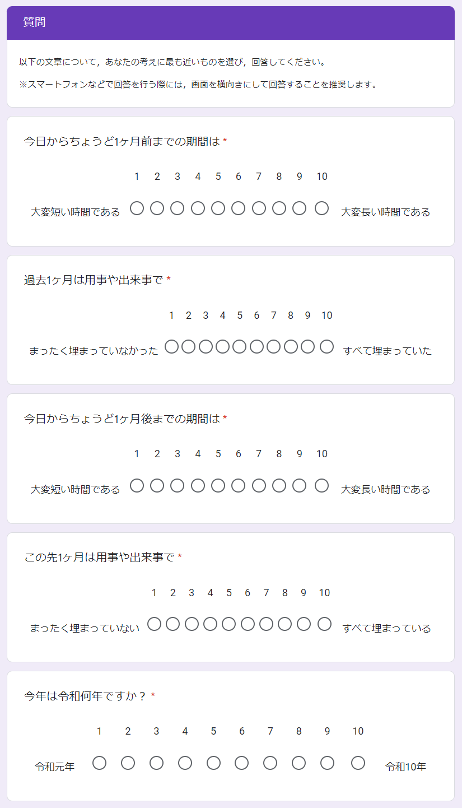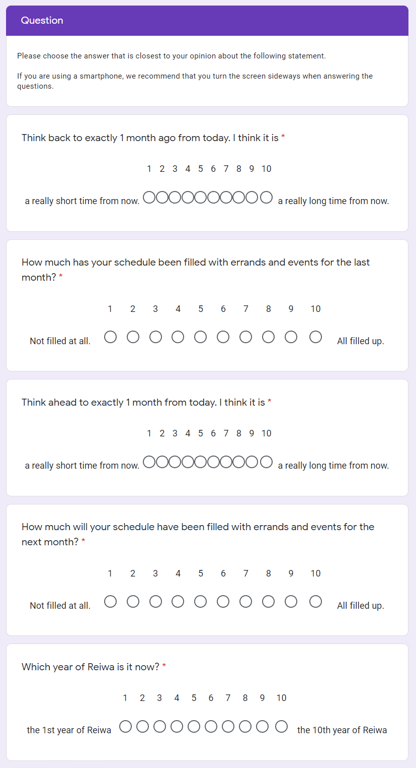
References
Aksentijevic, A., & Treider, J. M. G. (2016). It’s all in the past: Deconstructing the temporal Doppler effect. Cognition, 155, 135–145. https://doi.org/10.1016/j.cognition.2016.07.001
Buffardi, L. (1971). Factors affecting the filled-duration illusion in the auditory, tactual, and visual modalities. Perception & Psychophysics, 10(4-B), 292–294. https://doi.org/10.3758/BF03212828
Buhusi, C. V., & Meck, W. H. (2005). What makes us tick? Functional and neural mechanisms of interval timing. Nature Reviews Neuroscience, 6(10), 755–765. https://doi.org/10.1038/nrn1764
Burnside, W. (1971). Judgment of short time intervals while performing mathematical tasks. Perception & Psychophysics, 9(5), 404–406. https://doi.org/10.3758/BF03210238
Caruso, E. M., Van Boven, L., Chin, M., & Ward, A. (2013). The temporal doppler effect: When the future feels closer than the past. Psychological Science, 24(4), 530–536. https://doi.org/10.1177/0956797612458804
Casasanto, D., & Boroditsky, L. (2008). Time in the mind: Using space to think about time. Cognition, 106(2), 579–593. https://doi.org/10.1016/j.cognition.2007.03.004
Cashen, L. H., & Geiger, S. W. (2004). Statistical power and the testing of null hypotheses: A review of contemporary management research and recommendations for future studies. Organizational Research Methods, 7(2), 151–167. https://doi.org/10.1177/1094428104263676
Champely, S. (2020). pwr: Basic functions for power analysis. R package version 1.3-0. https://CRAN.R-project.org/package=pwr
Droit-Volet, S., & Meck, W. H. (2007). How emotions colour our perception of time. Trends in Cognitive Sciences, 11(12), 504–513. https://doi.org/10.1016/j.tics.2007.09.008
Faul, F., Erdfelder, E., Lang, A. G., & Buchner, A. (2007). G* Power 3: A flexible statistical power analysis program for the social, behavioral, and biomedical sciences. Behavior Research Methods, 39(2), 175-191. https://doi.org/10.3758/BF03193146
Gan, Y., Miao, M., Zheng, L., & Liu, H. (2017). Temporal doppler effect and future orientation: Adaptive function and moderating conditions. Journal of Personality, 85(3), 313–325. https://doi.org/10.1111/jopy.12242
Guo, W., Liu, H., Yang, J., Mo, Y., Zhong, C., & Yamada, Y. (2020). Stage 2 Registered Report: How subtle linguistic cues prevent unethical behaviors. F1000Research, 9, 996. https://doi.org/10.12688/f1000research.25573.2
Hasuo, E., Nakajima, Y., Tomimatsu, E., Grondin, S., & Ueda, K. (2014). The occurrence of the filled duration illusion: A comparison of the method of adjustment with the method of magnitude estimation. Acta Psychologica, 147, 111–121. https://doi.org/10.1016/j.actpsy.2013.10.003
Hicks, R. E., Miller, G. W., & Kinsbourne, M. (1976). Prospective and retrospective judgments of time as a function of amount of information processed. The American Journal of Psychology, 89(4), 719–730. https://doi.org/10.2307/1421469
Ikeda, A., Xu, H., Fuji, N., Zhu, S., & Yamada, Y. (2019). Questionable research practices following pre-registration. Japanese Psychological Review, 62(3), 281–295. https://doi.org/10.24602/sjpr.62.3_281
Jiga-Boy, G. M., Clark, A. E., & Semin, G. R. (2010). So much to do and so little time: Effort and perceived temporal distance. Psychological Science, 21(12), 1811-1817. https://doi.org/10.1177/0956797610388043
Janssen, S. M. J., Chessa, A. G., & Murre, J. M. J. (2006). Memory for time: How people date events. Memory & Cognition, 34(1), 138–147. https://doi.org/10.3758/BF03193393
Matlock, T., Ramscar, M., & Boroditsky, L. (2005). On the experiential link between spatial and temporal language. Cognitive Science, 29(4), 655–664. https://doi.org/10.1207/s15516709cog0000_17
McCormack, T., Burns, P., O’Connor, P., Jaroslawska, A., & Caruso, E. M. (2019). Do children and adolescents have a future-oriented bias? A developmental study of spontaneous and cued past and future thinking. Psychological Research, 83(4), 774–787. https://doi.org/10.1007/s00426-018-1077-5
Miles, L. K., Karpinska, K., Lumsden, J., & Macrae, C. N. (2010). The meandering mind: Vection and mental time travel. PLOS ONE, 5(5), e10825. https://doi.org/10.1371/journal.pone.0010825
Miles, L. K., Nind, L. K., & Macrae, C. N. (2010). Moving through time. Psychological Science, 21(2), 222–223. https://doi.org/10.1177/0956797609359333
Mrkva, K., Travers, M., & Van Boven, L. (2018). Simulational fluency reduces feelings of psychological distance. Journal of Experimental Psychology: General, 147(3), 354–376. https://doi.org/10.1037/xge0000408
Nitta, H., Tomita, H., Zhang, Y., Zhou, X., & Yamada, Y. (2018). Disgust and the rubber hand illusion: A registered replication report of Jalal, Krishnakumar, and Ramachandran (2015). Cognitive Research: Principles and Implications, 3. https://doi.org/10.1186/s41235-018-0101-z
R Core Team (2021). R: A language and environment for statistical computing. R Foundation for Statistical Computing, Vienna, Austria. URL https://www.R-project.org/
Ross, M., & Wilson, A. E. (2002). It feels like yesterday: Self-esteem, valence of personal past experiences, and judgments of subjective distance. Journal of Personality and Social Psychology, 82(5), 792-803. https://doi.org/10.1037/0022-3514.82.5.792
Schwarz, M. A., Winkler, I., & Sedlmeier, P. (2013). The heart beat does not make us tick: The impacts of heart rate and arousal on time perception. Attention, Perception, & Psychophysics, 75(1), 182–193. https://doi.org/10.3758/s13414-012-0387-8
Thomas, E. C., & Brown, I. (1974). Time perception and the filled-duration illusion. Perception & Psychophysics, 16(3), 449–458. https://doi.org/10.3758/BF03198571
Thompson, C. P., Skowronski, J. J., & Lee, D. J. (1988). Telescoping in dating naturally occurring events. Memory & Cognition, 16(5), 461–468. https://doi.org/10.3758/BF03214227
Trope, Y., & Liberman, N. (2010). Construal-level theory of psychological distance. Psychological Review, 117(2), 440-463. https://doi.org/10.1037/a0018963
Van Boven, L., & Caruso, E. M. (2015). The tripartite foundations of temporal psychological distance: Metaphors, ecology, and teleology. Social and Personality Psychology Compass, 9(11), 593-605. https://doi.org/10.1111/spc3.12207
Wearden, J. H., Norton, R., Martin, S., & Montford-Bebb, O. (2007). Internal clock processes and the filled-duration illusion. Journal of Experimental Psychology: Human Perception and Performance, 33(3), 716–729. https://doi.org/10.1037/0096-1523.33.3.716
Xuan, B., Zhang, D., He, S., & Chen, X. (2007). Larger stimuli are judged to last longer. Journal of Vision, 7(10), 2–2. https://doi.org/10.1167/7.10.2
Yamada, Y., & Kawabe, T. (2011). Emotion colors time perception unconsciously. Consciousness and Cognition, 20(4), 1835–1841. https://doi.org/10.1016/j.concog.2011.06.016
Yonemitsu, F., Ikeda, A., Yoshimura, N., Takashima, K., Mori, Y., Sasaki, K., Qian, K., & Yamada, Y. (2020). Warning ‘Don’t spread’ versus ‘Don’t be a spreader’ to prevent the COVID-19 pandemic. Royal Society Open Science, 7(9), 200793. https://doi.org/10.1098/rsos.200793
Yuasa, K., & Yotsumoto, Y. (2015). Opposite distortions in interval timing perception for visual and auditory stimuli with temporal modulations. PLOS ONE, 10(8), e0135646. https://doi.org/10.1371/journal.pone.0135646
Zauberman, G., Levav, J., Diehl, K., & Bhargave, R. (2010). 1995 feels so close yet so far: The effect of event markers on subjective feelings of elapsed time. Psychological Science, 21(1), 133–139. https://doi.org/10.1177/0956797609356420

Acknowledgements
We would like to thank Editage (www.editage.com) for English language editing.

Authors’ contributions
CRediT Statement for Stage 1 manuscript
Conceptualization: QZ, YM, KU, KT, YY; Funding acquisition: YY; Methodology: QZ, YM, KU, KT; Project administration: YY; Supervision: YY; Visualization: QZ, YM, KU, KT; Writing - original draft: QZ, YM, KU, KT, YY

Funding
This research is supported by JSPS KAKENHI: JP16H03079, JP17H00875, JP18K12015, JP20H04581, and 21H03784.

To keep the significant numbers consistent with Caruso et al.’s (2013) Study 1b, Cohen’s d = 0.225 is counted as 0.22.

