Stage 1 Registered Report:
Does pupillometry provide a valid measure of spatial attentional bias (pseudoneglect)?

Nicola E Burns and Robert D McIntosh*
Human Cognitive Neuroscience, Psychology, University of Edinburgh, UK

*Corresponding author
Human Cognitive Neuroscience,
Psychology, University of Edinburgh,
7 George Square, Edinburgh, UK.
EH8 9JZ
r.d.mcintosh@ ed.ac.uk

Version 2, submitted to Peer Community in Registered Reports, 12/10/2023

Open data
All data and analysis scripts can be found at the open science framework (https://osf.io/t4mq8/).
Abstract
Strauch et al. (2022) introduced a novel approach to assess biases of visual attention, by measuring pupillary constriction in response to split-field stimuli, in which a bright patch is presented to one visual field and a dark patch to the other. Their study suggested that pupillary constriction is more pronounced in response to bright stimuli in the left visual field compared to the right, consistent with a neurotypical attentional bias towards the left side (pseudoneglect). This pupillometric bias was also found to correlate with performance on the greyscales task, an established behavioural measure of pseudoneglect. The present study seeks to replicate these findings, and investigates the influence of the eye of recording on the pupillary constriction bias measured by this split-field method.

1. Introduction
1.1. A pupillometric measure of pseudoneglect
Neurotypical adults tend to show a slight bias of attention towards the left side of space (Jewell & McCourt, 2000). This is known as ‘pseudoneglect’, by analogy to the more dramatic rightward bias of patients with left spatial neglect following stroke. Pseudoneglect is mainly studied in the visual modality, and has been found for a range of psychophysical tasks, including line bisection, which requires the participant to mark or judge the midpoint of horizontal lines, and the greyscales task, which involves relative brightness judgements for shaded gradients (Mattingley et al., 1994, 2004). Pseudoneglect is relatively subtle: a meta-analysis of 73 lab-based bisection studies (n = 2191) estimated a standardised effect size (Cohen’s d) of -0.37 to -0.44 (Jewell & McCourt, 2000), and a recent online study of bisection behaviour (n = 229) found effect sizes between -0.14 and -0.34 depending on the performance measure used (Mitchell et al., 2022). Given these modest effects, rather large sample sizes may be required to detect the population bias reliably.
Strauch and colleagues (2022) recently proposed a novel method for measuring biases of visual attention, based on the pupillary light reflex: the automatic constriction of the pupil in bright conditions. The constriction response is mediated by the parasympathetic nervous system, but it is not immune to cognitive influences, and it can be modulated by cueing participants to shift attention covertly to brighter or darker regions of the visual field (Binda et al., 2013; Mathôt et al., 2013, 2014). This pupillary cueing effect can be very strong (d ~ 1), and comparable in magnitude to reaction-time-based indices of covert orienting (Mathôt et al., 2013). Strauch and colleagues (2022) realised that the pupillary light reflex might also be sensitive to pseudoneglect, such that it would be more strongly driven by bright stimuli on the left than on the right, even with no cueing. They tested this idea in two experiments in which participants fixated at the centre of a screen whilst a bright field was shown on the left or the right with a dark field on the other. The key outcome measure was the pupillary constriction bias: the difference in pupillary constriction between bright-left and bright-right conditions, which we here code so that negative values mean more constriction for the bright-left condition (i.e., pseudoneglect). Strauch and colleagues found a strong negative pupillary constriction bias, with an estimated effect size (across two experiments) of d = -0.75. Their second experiment also found that the pupillary constriction bias correlated significantly with performance on the greyscales task (r = .51, n = 26), suggesting that it is a valid measure of pseudoneglect.
The proposed pupillometric index of spatial attention has potentially high value for researchers and clinicians. First, because it requires no behavioural response other than fixation, it could be used to measure attention passively, unconfounded by cognitive or response demands. Second, because pupil size can be monitored continuously, the timecourse of attention can be tracked at a temporal resolution that is not possible for tasks requiring an explicit response. Third, the overarching effect size estimated by Strauch and colleagues is around twice that typically measured by behavioural tasks such as line bisection, suggesting that the pupillometric method may have superior sensitivity.

1.2. A first attempt at replication
Inspired by these possibilities, we attempted to replicate the basic effect. We used a split-field stimulus, with a bright (white) field on one side, a dark (black) field on the other, and a 10˚ dividing strip of intermediate grey (Figure 1a); this is similar to the third horizontal condition of Strauch et al’s Experiment 2. Participants placed their head in an EyeLink 1k headrest, and fixated on a central cross against a grey background for one second, followed by the split-field stimulus for a further two seconds. If eye position deviated by more than 1˚ from the centre of the cross, or if the participant blinked, the trial was excluded. Each of 17 healthy adults completed ten valid trials for each horizontal split-field condition (bright-left, bright-right), in shuffled order.
Our main interest was in the horizontal (left-right) asymmetry, but we also added a vertical condition, in which the stimulus was split between the upper and lower fields (Figure 1b). Strauch and colleagues had used this as a control condition in their second experiment, to confirm the absence of a correlation with the lateral greyscales bias. The lack of correlation was confirmed, but interestingly the pupillometry data suggested an upper field bias that was even stronger than the bias in the horizontal trials (see Strauch et al., 2022, Supplementary Materials). This could potentially relate to differential cortical and subcortical representation of the upper and lower visual fields (e.g. Wang & Munzos, 2018), or might indicate a bias of attention toward the upper visual field (Chapin et al., 2022; Churches et al., 2017; Ciricugno et al., 2021; McCourt & Olafson, 1997; Suavansri et al., 2012). In our replication, the vertical condition was included as a separate block of trials, otherwise similar to the horizontal block.
Our analysis strategy was informed by a reanalysis of Strauch and colleagues’ (2022) data. Their original analysis extracted a measure of pupil constriction from each trial, which was the minimum pupil area during 2000 ms after the onset of the split-field display, expressed as a difference from the baseline pupil area. The difference in pupil constriction between bright-left and bright-right trials defined the pupillary constriction bias for each participant. We first followed this original analysis pipeline, reproducing the results reported by the original study, as shown in Table 1a. However, we found that larger effect sizes could be obtained by modifying the analysis, in two main ways. First, the raw measure of pupil size can be recorded as pupil area or as pupil diameter, which are non-linear transformations of one another, related by the formula for the area of a circle, A = (d/2)². We found that the distribution of baseline pupil area was positively skewed, whilst the distribution of baseline diameter was symmetrical and normal, which gave us a reason to prefer pupil diameter as the raw measure. Second, the timecourse of pupil constriction in each trial is prone to chance variation, so we averaged the timecourse across trials to smooth out trial-level noise, before extracting dependent measures per condition (cf. Nuthmann & Van Der Meer, 2005; Reilly et al., 2019); see Figure 1c for an illustration. A modified analysis pipeline using condition-wise averaging of pupil diameter gave substantially enhanced effect sizes (Table 1b).
We note in passing that enhancements of effect size could also be obtained if we kept pupil area as the raw measure but calculated constriction as a proportional reduction from baseline (divisive baseline correction), rather than as an absolute difference (subtractive baseline correction). Pupil area with divisive baseline correction has been used by some studies of attentional influences on the pupillary light reflex (Mathôt et al., 2013, 2014), whilst others have used pupil diameter with subtractive baseline correction (Binda et al., 2013). We prefer the latter method because we consider pupil diameter to be a more intuitive and imageable metric of pupil size, and because subtractive baseline correction is more robust to variations in baseline pupil size (Mathôt et al., 2018).

(a) Strauch et al (2022), original analysis pipeline
 | Orientation | N | Trial n | Pupillary constriction bias  effect size (Hedges’ g)
Experiment 1 (left eye) | Horizontal | 15 | 38.8 | -1.23 [-1.74, -0.73]
Experiment 2 (both eyes) | Horizontal | 26 | 58.2 | -0.41 [-0.79, -0.03]
 | Vertical | 26 | 16.3 | 1.93 [1.55, 2.32]
(b) Strauch et al (2022), modified analysis pipeline
Experiment 1 (left eye) | Horizontal | 15 | 38.8 | -1.81 [-2.32, -1.30]
Experiment 2 (both eyes) | Horizontal | 26 | 58.2 | -0.57 [-0.95, -0.18]
 | Vertical | 26 | 16.3 | 2.42 [2.03, 2.80]
(c) Replication experiment, modified analysis pipeline
Replication (right eye) | Horizontal | 17 | 20 | 1.02 [1.50, 0.55]
 | Vertical | 17 | 20 | 0.68 [0.21, 1.16]
(d) Strauch Experiment 2, by eye of recording, modified analysis pipeline
Left eye | Horizontal | 25 | 29.8 | -1.14 [-1.53, -0.75]
Right eye | Horizontal | 26 | 29.5 | 0.19 [-0.19, 0.58]
Left eye | Vertical | 25 | 8.3 | 1.85 [1.46, 2.24]
Right eye | Vertical | 26 | 8.3 | 2.20 [1.82, 2.59]
Table 1. Summary of results for different datasets and analysis pipelines, reporting the number of participants contributing data (N), the average number of valid trials per participant in each analysis (Trial n), and a standardised effect size (Hedges’ g) for the pupillary constriction bias [+/- 95 CIs], where negative values indicate more responsiveness to light in the left (or lower) field, and positive values indicate more responsiveness to light in the right (or upper) field. Our main interest is in the horizontal condition, but we also report the vertical condition for completeness. Raw effect sizes are not given, because Strauch et al’s (2022) pupil area data were recorded in arbitrary (uncalibrated) units. (a) Reanalysis of Strauch et al’s data, with the original analysis pipeline, which uses trial-wise analysis of pupil area constriction with subtractive baseline correction. (b) Reanalysis of Strauch et al’s data, with a modified analysis pipeline, which uses condition-wise analysis of pupil diameter constriction with subtractive baseline correction. (c) Analysis of our replication study, with the modified analysis pipeline. (d) Reanalysis of Strauch et al’s Experiment 2 data, split by eye of recording, with the modified analysis pipeline.
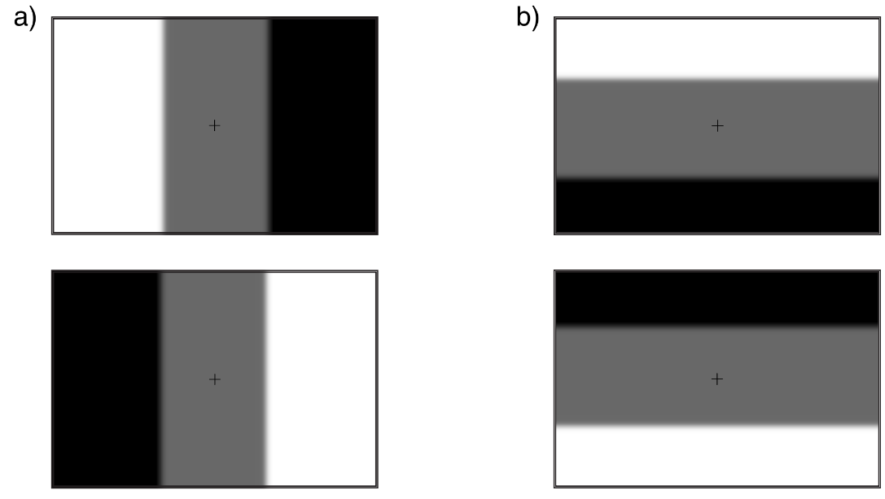
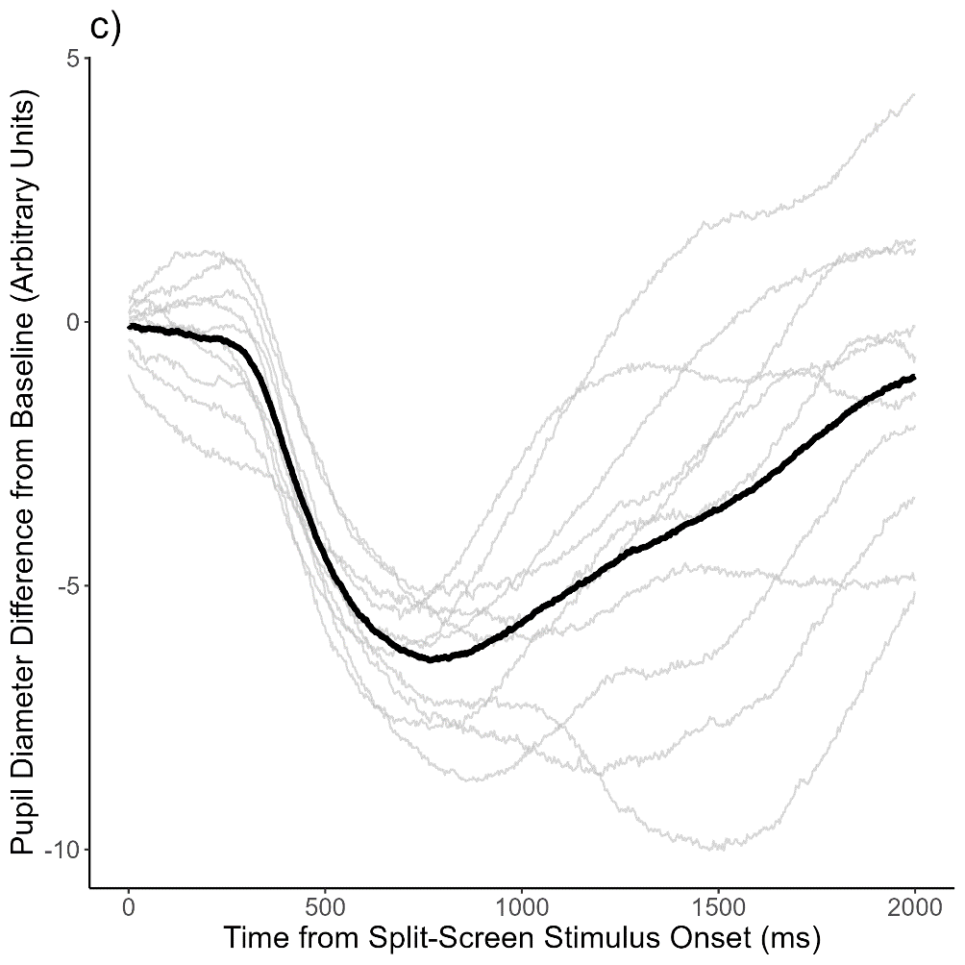
Figure 1. (a) Horizontal split-field stimuli (bright-left, bright-right). (b) Vertical split-field stimuli (bright-top, bright-bottom). (c) Example data from Strauch et al.’s (2022) Experiment 1, showing the timecourse of pupil constriction for two seconds following split-screen stimulus onset. The plot shows individual traces (grey lines) for ten trials for one participant in one stimulus condition, with the mean pupil trace superimposed (thick black line). Negative values on the y-axis indicate pupillary constriction from the pre-stimulus baseline level. Note that pupil diameter is in arbitrary units; an extra calibration step is needed to transform to mm (see Section 2.2). The data and analysis scripts can be found at https://osf.io/5s4yu.
We next applied the modified analysis pipeline to our replication study data (Table 1c). We confirmed a positive pupillary constriction bias in the vertical dimension, such that the pupillary light reflex is more responsive to the upper field. However, note that we did not explicitly control the height of the eyes with respect to the screen, because eye height had not been specified bv Strauch et al (2022). In fact, the eyes were aligned above the midpoint of the screen in our study; this placed them physically closer to the upper field display, which could provide a trivial explanation for the upward pupillary constriction bias. In the horizontal dimension, we also found a strong bias, but favouring the right rather than the left visual field; that is, opposite to the expected pseudoneglect. At first we assumed that we had made a coding error that had caused the horizontal results to flip (e.g., swapping condition labels), but we were subsequently able to rule out any such error. Instead, this directional reversal may relate to a critical aspect of our methodology that we had initially overlooked.

1.3. The eye of recording
In our replication study, we recorded eye position and pupil size using the EyeLink 1k system in tower-mount mode, which is limited to monocular recording. Based on the widely-cited idea that the pupils of the two eyes are always equal in size in healthy participants due to cross-innervation of the pupillary light responses (Loewenfeld, 1999), it seemed an arbitrary choice whether to record from the left or the right eye. We recorded from the right eye, whereas Strauch and colleagues recorded from the left eye in Experiment 1, and from each eye in separate blocks in Experiment 2. Our right-eye recording produced a strong rightward pupillary constriction bias, opposite to the leftward bias in Strauch et al’s Experiment 1. This raises the possibility that the eye of recording may partly or wholly determine the pupillary constriction bias for horizontal split-field stimuli.
Further reading reveals that there is in fact an established literature showing that the direct pupillary light reflex (same eye response) is stronger than the consensual pupillary light reflex (other eye response). That is, illumination of one eye can cause differential constriction of the two pupils (contraction anisocoria) in healthy observers (Fan et al., 2009; Smith et al., 1979; Wang et al., 2018). This asymmetry is driven by illumination of the nasal hemiretina (Schmid et al., 2000; Wyatt & Musselman, 1981), such that each pupil contracts more when bright stimuli are presented in the temporal (ipsilateral) visual field (Carle et al., 2011; Cox & Drewes, 1984). Contraction anisocoria could potentially explain our data because, when a participant fixates at the centre of the screen, the ipsilateral field projects to the nasal hemiretina. The ipsilateral field is also slightly closer to the eye than is the contralateral field. Each pupil can thus be expected to contract more when the bright side is ipsilateral, predicting a leftward pupillary constriction bias when recording from the left eye (as in Strauch et al’s Experiment 1), and a rightward bias when recording from the right (as in our replication). This ipsilateral constriction bias would be a physiological asymmetry, not an attentional asymmetry.
To explore this possibility further, we reanalysed the data from Strauch et al’s Experiment 2, splitting the analysis by the eye of recording. In the horizontal condition, there was a leftward bias for the left eye and a rightward bias for the right (Table 1d), consistent with the ipsilateral bias predicted by contraction anisocoria. Averaging across the two eyes should theoretically control for this physiological effect, so any net bias could potentially be due to an attentional asymmetry. In Strauch et al’s Experiment 2, the leftward bias for the left eye was much stronger than the rightward bias for the right eye, giving an average leftward bias overall, and this average bias correlated with greyscales performance, supporting an attentional interpretation. On the other hand, our replication found a rightward pupillary constriction bias for the right eye that was much stronger than that in Strauch and colleagues’ right-eye data. Overall, it is hard to draw firm conclusions from these post-hoc analyses. To disentangle the relative roles of physiological and attentional biases more definitively, it would be useful to run a novel replication using binocular pupil recording in the split-field pupillometry paradigm. This is the purpose of the present Registered Report.

1.4. Experimental hypotheses
The three hypotheses are as follows:

(H1) The ‘contraction anisocoria hypothesis’ predicts that the pupils will constrict more to illumination of the ipsilateral than of the contralateral field.

(H2) The ‘pupillary pseudoneglect hypothesis’ predicts that the pupils will constrict more to illumination of the left than of the right field.

(H3) The ‘attentional asymmetry hypothesis’ predicts that, if the split-field pupillometry task is sensitive to lateral biases of attention, then the pupillary constriction bias will correlate positively with attentional bias as measured by the greyscales task.

2. Methods
2.1. Participants
Participants will be self-reported neurologically healthy right-handed adults aged 18–50 with vision normal or corrected-to-normal by contact lenses. Participants will complete the short form version of the Edinburgh Handedness Inventory (Oldfield, 1971; Veale, 2014). We will include participants with a positive Laterality Quotient only, because pseudoneglect may be slightly stronger amongst right-handers than left-handers (Jewell & McCourt, 2000). We will include a simple test of eye dominance (Porta test), but this will be purely exploratory and inclusion criteria are unrelated to eye dominance. A maximum of 80 valid datasets (after exclusions) will be collected (see Section 2.7 for the detailed sampling plan).

2.2. Experimental set-up
The participant will be seated in a quiet, dimly lit room with their head stabilised in an SR EyeLink headrest, centrally facing a CRT monitor at a viewing distance of 600 mm, with the eyes at the same height as the vertical midline of the display. The monitor will be a 24" BenQ, with an active display area of 531.26*298.89 mm, running at a resolution of 1920x1080 pixels and a refresh rate of 144 Hz. In this arrangement, each horizontal half-field subtends 23.9˚ visual angle, and each vertical half-field 14˚ visual angle. Eye movements and pupil sizes will be recorded binocularly at 500 Hz by the EyeLink 1k camera in remote desktop mount, with a 25 mm lens. Prior to the experiment, binocular recordings will be made of two identical artificial pupils (3.5 mm diameter) fixed at the viewing position of the left and right eyes, to derive scaling factors to convert each eye’s pupil size from arbitrary units to mm diameter. During the greyscales task, a four-button box will be placed on the desk to allow manual responding.

2.3. Stimuli
The horizontal split-field stimuli for the pupillometry task are based on the third horizontal condition of Strauch and colleagues’ (2022) Experiment 2, as in our initial replication study. As shown in Figure 1a, the stimuli are made up of black, white and grey regions; in the experimental setting, these have luminances of 0.44cd/m², 165.2cd/m², and 25.3cd/m², respectively. The grey regions are thus 15% of the way from black to white, in terms of objective brightness. The horizontal stimuli are white on one side and black on the other (bright-left or bright-right), with a 10° grey strip down the vertical midline, which fades into the background with a 0.5° Gaussian blur to avoid sharp edges between regions, which could induce small pupillary constrictions (Slooter & van Norren, 1980; Ukai, 1985). The vertical split-screen stimuli are similar, but bright-top or bright-bottom, and the grey strip across the horizontal midline is slightly thinner (9°), because the vertical extent of the display is less than the horizontal. The same grey level is used as a full field stimulus for the baseline period in each pupillometry trial. Throughout the baseline and split-field periods, a 0.5˚ black fixation cross (+) is shown continuously at the screen centre.
Figure 2b includes examples of the greyscales stimuli, which are the original paired greyscale gradients used by Strauch et al. (2022). Each pair has a total height of 3° (each gradient is 1° high, with 1° vertical spacing between them), and a width of 7.7°, 9.6°, or 11.4°. Each gradient transitions gradually from white at one end to black at the other, and the two gradients in each pair are mirror images of one another, so they have equal objective brightness overall. The task tests whether forced-choice judgements about which gradient is lighter (or darker) tend to be biased towards what is seen on the left or the right side of the display. Additional pairs of gradients in which one gradient is objectively darker (75% black) will be used as practice trials, to check that participants understand the task.

2.4. Procedure
Participants will first stand oriented towards a distant wall (> 2 m). With both eyes open, the participants will position their index finder approximately 20 cm in front of their eyes, aligning it with a prominent dark vertical stripe presented on the wall. Subsequently, participants will be guided through the Porta test, in which they will sequentially close one eye and then the other eye in order to determine which eye’s monocular view is most similar to the binocular view. The experimenter will categorise eye dominance as left, right, or mixed, based on the participant’s responses.
Participants will then fill out the short-form Edinburgh Handedness Inventory (Veale, 2014), on a laptop, followed by the experimental tasks, completed in three blocks. The first block will be the horizontal split-field condition of the pupillometry task. The second block will be the greyscales task. The third block will be the vertical condition of the pupillometry task, which is not part of the core registered experiment but is of exploratory interest. Each experimental block will be preceded by a nine-point horizontal-vertical calibration and validation sequence (sequences exceeding 1° average error for either eye will not be accepted). Re-calibration will be performed if needed during the experimental blocks. The tasks are implemented in Experiment Builder Version 2.4.1 (SR Research Experiment Builder, 2020).
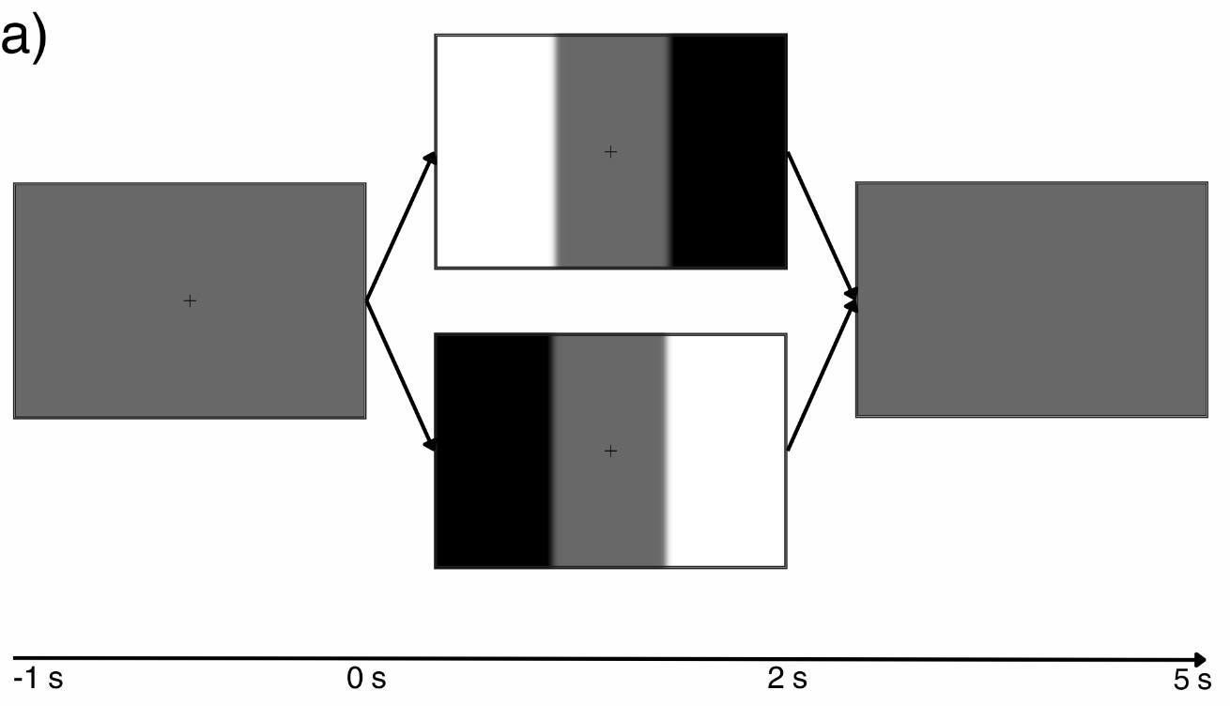
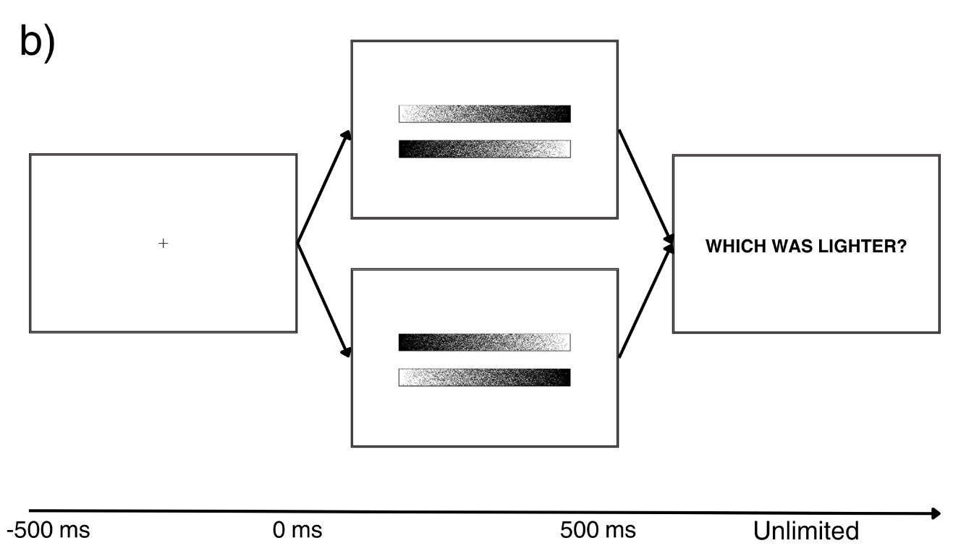
Figure 2. (a) Example pupillometry trial sequence. (b) Example greyscales trial sequence.

The split-field pupillometry trial sequence is illustrated in Figure 2a. Participants will be required to keep their head still in the headrest and to fixate on the cross at the centre of a grey screen. Once fixation is stable, the experimenter will initiate the trial, with continued presentation of the grey screen for a 1000 ms baseline period, followed by the split-field stimulus for 2000 ms. Participants will be required to maintain fixation without blinking until the split-field disappears. EyeLink samples will be processed online, and any trial in which a blink is detected or the gaze position deviates by more than 1.5° from the screen centre will be terminated with an on-screen feedback message (“BLINK” or “UNSTABLE FIXATION”) and shuffled back into the block. Each trial will be followed by a 3000 ms grey screen, with no fixation cross, during which the participant will be free to move their eyes and to blink. Each pupillometry block will have ten repetitions of each stimulus in a random order (bright-left and bright-right in the horizontal condition; bright-top and bright-bottom in the vertical condition), with invalid trials reshuffled. If the full set of 20 valid trials is not complete after 100 trials have been run, then the entire testing session will be terminated.
The greyscales trial sequence is illustrated in Figure 2b. Participants will be required to keep their head still and to fixate on the cross at the centre of a white screen until the stimuli appear. Once fixation is stable, the experimenter will initiate the trial, with the greyscales stimuli presented on a white background for 500 ms. Each trial will be followed by a white screen with an onscreen question (“WHICH WAS LIGHTER?” or “WHICH WAS DARKER?”), and the participant will be required to press both the upper left and upper right buttons of the response box to indicate the upper gradient, or both the lower left and right buttons to indicate the lower gradient (double responding should minimise accidental response errors). The required discrimination (“WHICH WAS LIGHTER?” or “WHICH WAS DARKER?”) will be alternated between participants.
An initial short practice block will give onscreen instructions on the required discrimination and how to use the button box to respond, followed by practice trials in which one greyscale gradient is objectively (and quite obviously) darker than the other. Participants will receive on-screen feedback (“CORRECT” or “INCORRECT”) after each trial, and the task will terminate when they respond correctly on five consecutive trials. If 25 practice trials are completed without five consecutive correct responses, then the entire testing session will be terminated. Otherwise, the practice block will be followed by the experimental block, in which mirror-equivalent greyscale pairs will always be presented, and no feedback on response accuracy will be given. The experimental block will have 18 repetitions of each stimulus (white-left and white-right), six for each gradient width (7.7°, 9.6°, or 11.4°), with the order of trials shuffled randomly.

2.5. Data processing and exclusion criteria
Invalid trials will be excluded and reshuffled (see Section 2.4), so all completed blocks should have full valid data. If full valid data are not available for the horizontal pupillometry block, then that participant will be excluded from the experiment. If only the vertical pupillometry block is without full data, then that participant will be retained for the main analysis but excluded from exploratory analysis of the vertical condition.
For the pupillometry task, the raw samples of pupil size for each eye will be converted into mm diameter using the scaling factors derived from the pupil calibration step (Section 2.2). The samples will then be trimmed to include the last 200 ms of the baseline period and the 2000 ms of the split-field display. For each trial, for each eye, the baseline pupil size will be calculated as the average across the 200 ms trimmed baseline period, and this baseline value will be subtracted from all of the samples (subtractive baseline correction) to convert pupil diameter into a measure of pupil constriction, with constriction signed negatively, and dilation signed positively. The baseline samples will then be removed and the average timecourse of pupil constriction calculated per participant, per eye, per condition, across the 1000 samples of the split-field period (2 seconds at 500 Hz). The minimum pupil size will be extracted from the average timecourse as a measure of pupil change from baseline per participant, per eye, per condition.
For the horizontal task, the pupillary constriction bias will be calculated in two alternative ways, to test the first and second experimental hypotheses (see Section 1.4). First, to test the contraction anisocoria hypothesis (H1), the pupillary constriction bias will be calculated in an eye-relative frame of reference, by subtracting the pupil change when the bright field is ipsilateral (bright-left for left eye, bright-right for right eye) from the pupil change when the bright field is contralateral (bright-right for left eye, bright-left for right eye), and then averaged across the eyes. For this eye-relative measure, negative values indicate a stronger pupillary response to the contralateral field, and positive values a stronger response to the ipsilateral field. Second, to test the pupillary pseudoneglect hypothesis (H2), the pupillary constriction bias will be calculated in a space-relative frame of reference, by subtracting the pupil change for the bright-right condition, from the pupil change for the bright-left condition, and then averaged across the eyes. For this space-relative measure, negative values indicate a stronger response to the left field, and positive values a stronger response to the right field. Finally, for the vertical task, (space-relative) pupillary constriction bias will be calculated by subtracting the pupil change for the bright-top condition from that for the bright-bottom condition, so that negative values indicate a stronger response to the lower field, and positive values indicate stronger response to the upper field.
The greyscales bias will be calculated as the number of trials in which the gradient chosen as lighter (or darker) was objectively lighter (or darker) on its left side, subtracted from the number of responses in which it was objectively lighter (or darker) on its right side, divided by the total number of responses (36). Greyscale scores can thus range from -1.0 (maximum leftward bias) to +1.0 (maximum rightward bias), with unbiased performance at zero (Mattingley et al., 1994).

2.6. Inferential statistical tests
The experimental hypotheses, as stated in Section 1.4, concern the horizontal pupillometry and greyscales tasks. The predicted pattern of data of pupillary responses for H1 and H2 are illustrated graphically in Figure 3. The three hypotheses will be tested statistically as follows (see Table 2 for a summary):

(H1) For the contraction anisocoria hypothesis, we will test the prediction that the pupil constricts more to illumination of the ipsilateral field. We will perform a one-tailed, one-sample t-test, to test whether the eye-relative pupillary constriction bias is ipsilateral (i.e., positive). A significant outcome would confirm that a physiological asymmetry (contraction anisocoria) influences pupillary constriction responses in this task.

(H2) For the pupillary pseudoneglect hypothesis, we will test the prediction that the pupil constricts more to illumination of the left field. We will perform a one-tailed, one-sample t-test, to test whether the space-relative pupillary constriction bias is leftward (i.e., negative). A significant outcome would confirm that the split-field pupillometry task is sensitive to pseudoneglect.

(H3) For the attentional asymmetry hypothesis, we will test the correlation of the average space-relative pupillary constriction bias with the greyscales bias. A significant positive correlation would validate split-field pupillometry as a task that is sensitive to lateral biases of attention.

Note that it is possible that the split-field pupillometry task could be validated as sensitive to lateral biases of attention (H3) even if it does not show pseudoneglect (H2), because pseudoneglect may be subtle enough to be missed even in a sample as large as our maximum sample size of 80 (Jewell & McCourt, 2000; Mitchell et al., 2022). Or it could show apparent pseudoneglect (H2), but which is uncorrelated with greyscales bias (H3), given that different proposed measures of pseudoneglect do not always correlate (Learmonth et al., 2015). Either of these outcomes would be weaker evidence for the validity of the pupillometry task as a measure of spatial attention than if both H2 and H3 were confirmed. If H2 and H3 are not supported, then there will be very little support for an attentional interpretation of pupillary constriction bias.
Further, exploratory analyses will be made for the vertical pupillometry condition. Asymmetries in pupil constriction in the vertical condition may be less noteworthy than in the horizontal condition because, unlike the lateral visual fields, the upper and lower visual fields are not of equivalent extent. The data from the vertical condition of Strauch and colleagues’ (2022) Experiment 2, and our replication study, indicate a strong upper-field pupillary constriction bias (see Table 1). However, neither study explicitly aligned the eyes with the vertical midline of the display. Indeed, in our replication study, eye height was above the vertical midline of the display, so the viewing position would be slightly closer to the upper field than to the lower. One aim of the exploratory analysis will be to assess whether any vertical bias remains once viewing height is controlled.

2.7. Effect size, power, and sample size
The sampling plan is determined by the smallest effect size of theoretical interest for any of the three hypotheses. The limiting hypothesis here is the pupillary pseudoneglect hypothesis (H2). For pupillometry to have any potential utility as an index of pseudoneglect, it should be at least as sensitive as an established behavioural measure such as line bisection. Jewell and McCourt (2000) estimated pseudoneglect for line bisection tasks to have effect sizes between -0.37 to -0.44. We will accordingly set our smallest effect size of interest for H2 at d = 0.4. Note that Strauch and colleagues (2022) claimed that the pupillometry pseudoneglect effect was empirically large (d > 0.7), although this overarching estimate may have been boosted by a physiological asymmetry in Experiment 1, in which only the left eye was tested. If we consider just their Experiment 2, then the pupillary constriction bias, averaged across left and right eyes, has an estimated effect size of -0.57 (Table 1b). The smallest effect size of interest that we are targeting (d = 0.4) is thus conservative with respect to prior data.
If we design our experiment to detect an effect size of d = 0.4 for the pupillary pseudoneglect hypothesis (H2), then we can also make this the smallest effect size of interest for the contraction anisocoria hypothesis (H1). An effect of this size would still be interesting, even if we again expect that the true effect is much larger. This expectation is based on our (right eye) replication, which revealed a very strong rightward (i.e., ipsilateral) bias (Table 1c). A more modest, but still substantial effect size estimate of 0.67 can be obtained by recoding the pupillary constriction bias for Strauch et al’s Experiment 2 data (Table 1d) into an eye-relative frame of reference (i.e., by flipping the sign of the values for the left eye, so that an ipsilateral bias is always positive).
Finally, with respect to the attentional asymmetry hypothesis (H3), Strauch and colleagues argued that the split-field pupillometry task is a valid measure of spatial attention, based on a significant correlation with greyscales performance (r = .51, n = 26). However, if our experiment is powered to detect relatively small effects for H1 and H2, it will also be sensitive to a smaller than expected correlation for H3 (r = .38). We suggest that this is a reasonable level for the smallest effect size of interest for H3 because any correlation below about .4 would provide little confidence that the pupillary split-field and greyscales tasks are tapping substantially into the same underlying bias.
Given that the smallest effect size of interest for each hypothesis is smaller than the effect expected from prior data, it may be efficient to adopt a sequential analysis strategy (Lakens, 2014; Lakens et al., 2021). We will run the inferential tests initially after 40 participants, terminating the experiment in the case that all three tests find significant results, and otherwise continuing to double the sample size to 80 participants before running the tests a second time. Using the Pocock correction method (Pocock, 1977), implemented in the rpact package for R (Pahlke, 2023), we will apply an adjusted significance criterion of .012 at both stages, constraining the global alpha for each hypothesis to the .02 level. With a maximum sample size of 80 participants, and an alpha of .012 (one-tailed) for each individual test, we will have .90 power to detect the smallest effect size of interest, as defined above, for each of the three hypotheses.

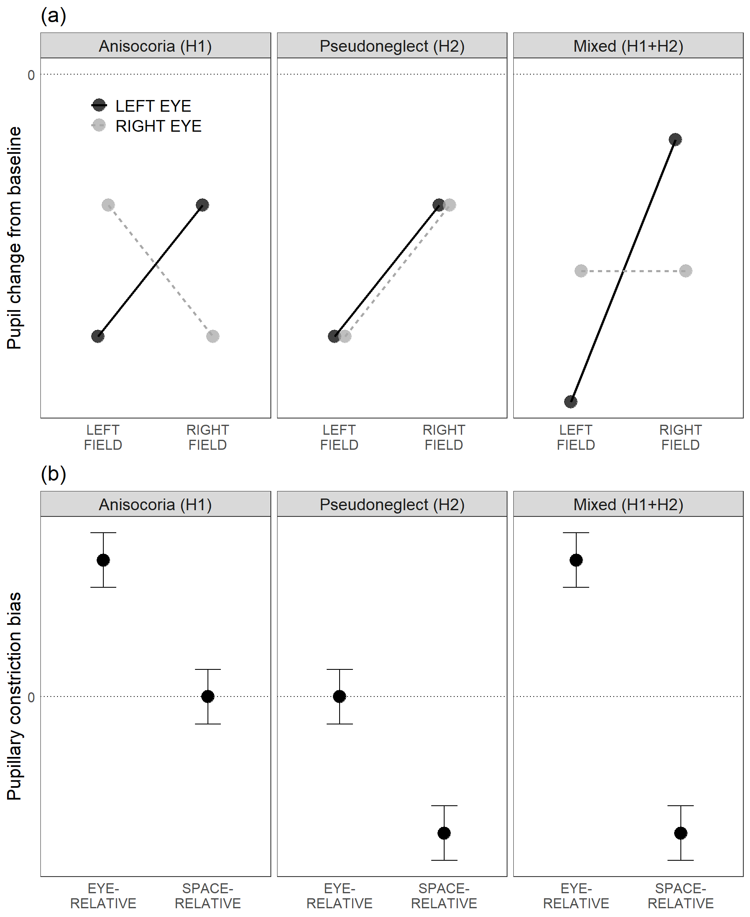
Figure 3. Idealised data illustrating the predictions of the contraction anisocoria hypothesis (H1) and the pupillary pseudoneglect hypothesis (H2). The two hypotheses are not mutually exclusive, so it is possible that both will be supported, as shown by the ‘mixed’ plots in the right hand column. (a) Plot showing the pattern of pupil change predicted by each hypothesis across eye and field conditions. (b) Plot showing the same data recoded in terms of the key dependent measures of eye-relative and space-relative pupillary constriction bias (see Section 2.5). H1 predicts a positive (ipsilateral) eye-relative bias, and H2 predicts a negative (leftward) space-relative bias. For clarity and convenience, we have depicted the predicted effects as large, and of equivalent magnitude for each hypothesis.
References
Binda, P., Pereverzeva, M., & Murray, S. O. (2013). Attention to Bright Surfaces Enhances the Pupillary Light Reflex. Journal of Neuroscience, 33(5), 2199–2204. https://doi.org/10.1523/JNEUROSCI.3440-12.2013
Carle, C. F., Maddess, T., & James, A. C. (2011). Contraction Anisocoria: Segregation, Summation, and Saturation in the Pupillary Pathway. Investigative Ophthalmology & Visual Science, 52(5), 2365–2371. https://doi.org/10.1167/iovs.10-6335
Chapin, B. A., Pisanuwongrak, K., Williamson, J. B., & Heilman, K. M. (2022). Vertical pseudoneglect: Sensory-attentional versus action-intentional. Journal of Clinical and Experimental Neuropsychology, 44(2), 163–170. https://doi.org/10.1080/13803395.2022.2098934
Churches, O., Loetscher, T., Thomas, N. A., & Nicholls, M. E. R. (2017). Perceptual Biases in the Horizontal and Vertical Dimensions are Driven by Separate Cognitive Mechanisms. Quarterly Journal of Experimental Psychology, 70(3), 444–460. https://doi.org/10.1080/17470218.2015.1131841
Ciricugno, A., Bartlett, M. L., Gwinn, O. S., Carragher, D. J., & Nicholls, M. E. R. (2021). The effect of cognitive load on horizontal and vertical spatial asymmetries. Laterality, 26(6), 706–724. https://doi.org/10.1080/1357650X.2021.1920972
Cox, T. A., & Drewes, C. P. (1984). Contraction Anisocoria Resulting From Half-Field Illumination. American Journal of Ophthalmology, 97(5), 577–582. https://doi.org/10.1016/0002-9394(84)90375-1
Fan, X., Miles, J. H., Takahashi, N., & Yao, G. (2009). Sex-specific lateralization of contraction anisocoria in transient pupillary light reflex. Investigative Ophthalmology & Visual Science, 50(3), 1137–1144. https://doi.org/10.1167/iovs.08-2329
Jewell, G., & McCourt, M. E. (2000). Pseudoneglect: A review and meta-analysis of performance factors in line bisection tasks. Neuropsychologia, 38(1), 93–110. https://doi.org/10.1016/S0028-3932(99)00045-7
Lakens, D. (2014). Performing high-powered studies efficiently with sequential analyses. European Journal of Social Psychology, 44(7), 701–710. https://doi.org/10.1002/ejsp.2023
Lakens, D., Pahlke, F., & Wassmer, G. (2021). Group Sequential Designs: A Tutorial. PsyArXiv. https://doi.org/10.31234/osf.io/x4azm
Learmonth, Gallagher, A., Gibson, J., Thut, G., & Harvey, M. (2015). Intra- and Inter-Task Reliability of Spatial Attention Measures in Pseudoneglect. PloS One, 10(9), e0138379–e0138379. https://doi.org/10.1371/journal.pone.0138379
Mathôt, S., Dalmaijer, E., Grainger, J., & Van der Stigchel, S. (2014). The pupillary light response reflects exogenous attention and inhibition of return. Journal of Vision, 14(14), 7. https://doi.org/10.1167/14.14.7
Mathôt, S., Fabius, J., Van Heusden, E., & Van der Stigchel, S. (2018). Safe and sensible preprocessing and baseline correction of pupil-size data. Behavior Research Methods, 50(1), 94–106. https://doi.org/10.3758/s13428-017-1007-2
Mathôt, S., Linden, L. van der, Grainger, J., & Vitu, F. (2013). The Pupillary Light Response Reveals the Focus of Covert Visual Attention. PLOS ONE, 8(10), e78168. https://doi.org/10.1371/journal.pone.0078168
Mattingley, J. B., Berberovic, N., Corben, L., Slavin, M. J., Nicholls, M. E. R., & Bradshaw, J. L. (2004). The greyscales task: A perceptual measure of attentional bias following unilateral hemispheric damage. Neuropsychologia, 42(3), 387–394. https://doi.org/10.1016/j.neuropsychologia.2003.07.007
Mattingley, J. B., Bradshaw, J. L., Nettleton, N. C., & Bradshaw, J. A. (1994). Can task specific perceptual bias be distinguished from unilateral neglect? Neuropsychologia, 32(7), 805–817. https://doi.org/10.1016/0028-3932(94)90019-1
McCourt, M. E., & Olafson, C. (1997). Cognitive and perceptual influences on visual line bisection: Psychophysical and chronometric analyses of pseudoneglect. Neuropsychologia, 35(3), 369–380. https://doi.org/10.1016/S0028-3932(96)00143-1
Mitchell, A. G., Kandt, P. O., & McIntosh, R. D. (2022). On line bisection: Validity and reliability of online measures of pseudoneglect. Laterality, 27(4), 443–466. https://doi.org/10.1080/1357650X.2022.2109657
Nuthmann, A., & Van Der Meer, E. (2005). Time’s arrow and pupillary response. Psychophysiology, 42(3), 306–317. https://doi.org/10.1111/j.1469-8986.2005.00291.x
Oldfield, R. C. (1971). The assessment and analysis of handedness: The Edinburgh inventory. Neuropsychologia, 9(1), 97–113. https://doi.org/10.1016/0028-3932(71)90067-4
Pahlke, G. W. and F. (2023, July 6). RPACT - rpact: Confirmatory Adaptive Clinical Trial Design, Simulation, and Analysis. https://www.rpact.org/
Pocock, S. J. (1977). Group sequential methods in the design and analysis of clinical trials. Biometrika, 64(2), 191–199. https://doi.org/10.1093/biomet/64.2.191
Reilly, J., Kelly, A., Kim, S. H., Jett, S., & Zuckerman, B. (2019). The human task-evoked pupillary response function is linear: Implications for baseline response scaling in pupillometry. Behavior Research Methods, 51(2), 865–878. https://doi.org/10.3758/s13428-018-1134-4
Schmid, R., Wilhelm, B., & Wilhelm, H. (2000). Naso-temporal asymmetry and contraction anisocoria in the pupillomotor system. Graefe’s Archive for Clinical and Experimental Ophthalmology = Albrecht von Graefes Archiv Fur Klinische Und Experimentelle Ophthalmologie, 238(2), 123–128. https://doi.org/10.1007/pl00007879
Slooter, J., & van Norren, D. (1980). Visual acuity measured with pupil responses to checkerboard stimuli. Investigative Ophthalmology & Visual Science, 19(1), 105–108.
Smith, S. A., Ellis, C. J., & Smith, S. E. (1979). Inequality of the direct and consensual light reflexes in normal subjects. British Journal of Ophthalmology, 63(7), 523–527. https://doi.org/10.1136/bjo.63.7.523
Suavansri, K., Falchook, A. D., Williamson, J. B., & Heilman, K. M. (2012). Right up there: Hemispatial and hand asymmetries of altitudinal pseudoneglect. Brain and Cognition, 79(3), 216–220. https://doi.org/10.1016/j.bandc.2012.03.003
Ukai, K. (1985). Spatial pattern as a stimulus to the pupillary system. JOSA A, 2(7), 1094–1100. https://doi.org/10.1364/JOSAA.2.001094
Veale, J. F. (2014). Edinburgh Handedness Inventory – Short Form: A revised version based on confirmatory factor analysis. Laterality, 19(2), 164–177. https://doi.org/10.1080/1357650X.2013.783045
Wang, & Munoz, D. P. (2018). Neural basis of location-specific pupil luminance modulation. Proceedings of the National Academy of Sciences - PNAS, 115(41), 10446–10451. https://doi.org/10.1073/pnas.1809668115
Wang, C.-A., Tworzyanski, L., Huang, J., & Munoz, D. P. (2018). Response anisocoria in the pupillary light and darkness reflex. European Journal of Neuroscience, 48(11), 3379–3388. https://doi.org/10.1111/ejn.14195
Wyatt, H. J., & Musselman, J. F. (1981). Pupillary light reflex in humans: Evidence for an unbalanced pathway from nasal retina, and for signal cancellation in brainstem. Vision Research, 21(4), 513–525. https://doi.org/10.1016/0042-6989(81)90097-3

Question | Hypothesis | Sampling plan | Analysis Plan | Rationale for deciding the sensitivity of the test for confirming or disconfirming the hypothesis | Interpretation given different outcomes
Does the pupillometry task induce contraction anisocoria? | (H1) The contraction anisocoria hypothesis predicts that the pupils will contract more to illumination of the ipsilateral than of the contralateral field. | Test after 40 participants. If H1, H2, and H3 tests show significance, terminate the experiment. If not, proceed to 80 participants. | Encode pupillary constriction bias in eye-relative frame, to reflect contralateral (-ve) or ipsilateral (+ve bias). Average across the eyes.  Perform a one-tailed, one-sample t-test, to test whether the pupillary constriction bias is ipsilateral (+ve). | Despite anticipating that the true physiological effect could be much larger (d ~ 1), the smallest effect size of interest is set at d = 0.4, for consistency with H2.  An adjusted alpha of .012 (one-tailed) for each test constrains alpha to .02 (one-tailed) across the two stages of sequential testing. The maximum sample size of 80 will provide .90 power to detect the smallest effect size of interest (d = 0.4). | A significant outcome would confirm that contraction anisocoria influences pupillary constriction responses in the split-field pupillometry task.  A non-significant result would suggest that the effect, if it exists, is smaller than d = 0.4, which is unlikely to be of practical significance.
Is the pupillometry task sensitive to pseudoneglect, leading to greater pupil contraction in response to illumination of the left field compared to the right field? | (H2) The pupillary pseudoneglect hypothesis predicts that the pupils will contract more to the illumination of the left than of the right field. | Sequential analysis strategy: as for H1. | Encode pupillary constriction bias in space-relative frame, to reflect leftward (-ve) or rightward (+ve) bias. Average across the eyes.  Perform a one-tailed, one-sample t-test, to test whether the pupillary constriction bias is leftward (-ve). | The smallest effect size of interest is based on estimates of effect size for common behavioural measures of pseudoneglect (Jewell & McCourt, 2000). Pupillometry is unlikely to be a useful measure of pseudoneglect if the effect does not meet this minimal level.  Alpha and power are as for H1. | A significant outcome would confirm that the split-field pupillometry task is sensitive to pseudoneglect.  A non-significant result would suggest that the effect, if it exists, is smaller than d = 0.4, which is unlikely to be of practical significance.
Is the pupillometry task sensitive to lateral biases of attention? | (H3) The ‘attentional asymmetry’ hypothesis predicts that the space-relative pupillary constriction bias will correlate positively with attentional bias as measured by the greyscales task. | Sequential analysis strategy: as for H1. | Correlate the mean space-relative pupillary constriction bias with the attentional bias captured by the greyscales task. | The sampling plan for H2 will provide us with .9 power to detect a correlation of r ≥ .38 for H3. This is conservative, relative to the correlation of r = .51 reported by Strauch et al. (2022).  A correlation below ~.4 would provide little confidence that the pupillary split-field and greyscales tasks are tapping into the same bias. | A significant correlation would suggest that the pupillary split-field task a valid measure of spatial attentional bias.  A non-significant result would suggest that it does not measure attentional bias to a degree that is likely to be of practical significance.
Table 2. Design summary of how the experimental hypotheses (H1, H2, H3) map onto inferential statistical tests and theoretical interpretations.

This experiment was conducted for the MSc dissertation of the first author. Here, we describe only the most relevant conditions and details, but the full experiment is reported in the dissertation archived at https://osf.io/uc9y7.
Our outcomes are close but not numerically identical to those reported by Strauch et al (2022), presumably due to minor differences in the analysis scripts, which were re-written from scratch for our reanalysis.

