Is the past farther than the future?
A registered replication and test of the time-expansion hypothesis based on filling rate of duration

Qinjing Zhang^{１*}, Yoshitaka Masuda^{１}, Kohei Ueda^{１}, Kodai Toda^{１}, and Yuki Yamada^{２}

^{１}Graduate School of Human-Environment Studies, Kyushu University, Fukuoka, Fukuoka, Japan
^{２}Faculty of Arts and Science, Kyushu University, Fukuoka, Fukuoka, Japan

*Corresponding author:
E-mail: zhang.qinjing.156@s.kyushu-u.ac.jp (QZ)

Abstract
People sometimes feel events to be psychologically closer while farther at other times. Related to this, Caruso et al. (2013) reported the phenomenon of the Temporal Doppler Effect (TDE) in which people feel the past farther than the future despite an equivalent objective temporal distance. They hypothesized that movement based on spatio-temporal metaphor implies an asymmetry in psychological distance in time and explained the TDE from this perspective. However, besides this perspective, we assume that there is still other asymmetry between the past and the future which is also related to the TDE (i.e. filling rate of duration). More specifically, we think that the TDE might be explained by asymmetrical perceptions concerning the filling rate of duration between the past and the future. Previous studies have shown that people tend to perceive durations with more events or changes as longer than those with fewer changes – a phenomenon termed the filled-duration illusion (FDI). If the TDE is explained by the FDI-like effect, then over a long duration such as a month or a year, the filling rate of duration should positively predict the estimated psychological distance. In this research, we aim to make a direct replication of the TDE and test a novel explanation for this phenomenon from a perspective of the filling rate of duration.
Keywords: Temporal Doppler Effect, filling rate of duration, psychological distance, filled-duration illusion

Introduction
Our estimation of time is often inaccurate and does not correspond to objective time although the ability to perceive and estimate time is fundamental in our daily life (Buhusi & Meck, 2005). For example, on the millisecond timescale, durations were perceived longer as the number of dots, stimulus size, luminance, and numbers increased (Xuan, Zhang, He, and Chen, 2007). In addition, various factors such as emotion (Droit-Volet & Meck, 2007; Yamada & Kawabe, 2011), arousal (Schwarz, Winkler, & Sedlmeier, 2013), and temporal frequency (Yuasa & Yotsumoto, 2015) have been reported to affect subjective time.
Even for longer durations, various factors affect the estimation of time, and our subjective time estimation sometimes does not match the physical time. For example, negative events are felt more distant than positive events such as social success or proud events (Ross & Wilson, 2002). In the case of no deadlines, events with more effort required to achieve them are felt to be more distant in time than events with less effort (Jiga-Boy, Clark, & Semin, 2010).
Temporal Doppler Effect
Our estimation of time is not only for past events. It has also been reported that our subjective time estimation and physical time are not equivalent when it comes to temporal estimation of the past and future. One example is the Temporal Doppler Effect (TDE): Caruso, Van Boven, Chin, and Ward (2013) reported that people tend to feel that the past is farther than the future, even when the objective temporal distance is the same. In their Study 1a, they asked participants either to think back 1 month ago or to think ahead 1 month later from that day, and then to report the target day’s psychological distance. In Study 1b, they changed the duration from 1 month to 1 year. In Study 2, they used the reference of Valentine’s Day and asked the participants to report the psychological distance from the fixed date. All the results of these studies indicated that the past feels farther than the future.
It has been suggested that the mental representations of time (e.g., past and future) may be based on metaphors of space and movement in it. Generally, describing time requires spatial analogies and metaphors (Matlock, Ramscar, & Boroditsky, 2005). It is noted that temporal cognition relies heavily on spatial concepts as well (Casasanto & Boroditsky, 2008). In fact, while describing a temporal duration, we use words like “long” or “far away,” which are also used to describe a physical distance. Additionally, it has been argued that temporal and spatial movement may be closely related to our behaviors and temporal cognition. Miles, Nind, and Macrae (2010) reported that our body tends to lean forward while thinking about the future, whereas it tends to lean back while thinking about the past. It is also suggested that our thoughts about the future or past increase when observing vection stimuli that prompt the sensation of moving forward and backward, respectively (Miles, Karpinska, Lumsden, & Macrae, 2010). These studies indicate that spatial movement (especially forward and backward movement) is associated with our behaviors and temporal cognition.
Based on these previous studies, Caruso et al. (2013) conducted their Study 3 to provide evidence that the TDE is caused by movement based on spatio-temporal metaphor. Their Study 3 examined whether participants feel the future is closer than the past because the future approaches the present while the past recedes from the present. They used virtual motion to manipulate the direction of participants’ physical movement, which affected their orientation to the past and the future. They predicted that people’s movement would moderate the asymmetry in psychological distance. The results indicated that when the participants perceived moving forward, the past felt more distant than the future. In contrast, the future felt farther than the past when they perceived moving backward although the effect was not significant. Further, the psychological distance of the future when moving forward was not significantly different from that of the past when moving backward. Moreover, the psychological distance of the future when moving backward was also not significantly different from the past when moving forward. Due to this result, Caruso et al. (2013) proposed that the temporal asymmetry of psychological distance is formed by the perception that people are moving toward the future and moving away from the past. In other words, approaching (i.e., future) events are felt to be psychologically closer while moving away (i.e., past) events are felt to be farther, even though the objective temporal distance is the same. In analogy to the well-known physical phenomenon of the Doppler Effect, Caruso et al. (2013) named this phenomenon the Temporal Doppler Effect. The importance of spatial movement is also examined in the later study (Aksentijevic & Treider, 2016).
However, several studies have attempted to explain the TDE from perspectives other than spatial movement. Gan, Miao, Zheng, and Liu (2017) examined the effects of personal traits and environmental factors on the TDE. Their results suggested that higher personality traits of future orientation contribute to the stronger TDE. In addition, the TDE was based on interaction between positive emotions and the personality trait of future orientation. They pointed out that the TDE may be useful for adaptation to future challenges. From the developmental perspective, McCormack, Burns, O’Connor, Jaroslawska, and Caruso (2019) found that only adults tend to be future-oriented in the mind-wandering task while participants in all groups were much more likely to describe past events in the cue word task. They hold the opinion that the asymmetry in past and future arising from future-oriented bias and developmental changes may be task-specific. Mrkva, Travers, and Van Boven (2018) claimed that simulational fluency may be the basis of psychological distance to events. When an event can be simulated fluently (i.e., easier to imagine), the psychological distance to that event tends to be short. The present study aims to test an explanation of this phenomenon that arises from another perspective of the asymmetry between past and future: the filling rate of duration.
Filled-duration illusion
The filled-duration illusion (FDI) is the phenomenon that people perceive a filled duration to be longer than an empty duration, even though both durations are objectively the same (Thomas & Brown, 1974; Wearden, Norton, Martin, & Montford-Bebb, 2007). Previous studies used intervening discrete elements (e.g., click sound, flash) as stimuli to fill the duration (Buffardi, 1971; Thomas & Brown, 1974). Some studies also used additional tasks, such as mental arithmetic, as the content of the filled duration (Burnside, 1971; Hicks, Miller, & Kinsbourne, 1976).
The FDI has been mainly investigated for very short durations, such as milliseconds (e.g., Hasuo, Nakajima, Tomimatsu, Grondin, & Ueda, 2014; Wearden et al., 2007). Does the FDI-like phenomenon still exist when changing the duration to hours, days, months or longer? Analogous to the stimuli and tasks used in research of short durations, in longer durations we assume that how much the duration is filled with events, which we refer to as the filling rate of the duration in the present study, will also have an influence on psychological distance. The filling rate of the duration is a function of the number of events and the length of each event in the past and future. When considering that, the past and the future have a qualitative difference in whether they have already been experienced or not. The past comprises not only expected events but also unexpected events (e.g., a sudden invitation for dinner from a friend). All past errands and events contribute to the filling rate of the past duration, whereas only scheduled and expected events contribute to that of the future duration. From these reasons, it is assumed that the number of events and the length of each event affecting the filling rate of duration is greater in the past. In summary, we assume that the filling rate of duration would be greater in the past than the future, and the FDI-like effect would make us feel that a past duration is longer than a future duration, although both temporal distances are objectively equivalent.
Related to the above, Caruso et al. (2013) conducted an additional study to demonstrate that the TDE is independent of “filling of the time”. To examine whether the “filled in” could increase the psychological distance in the future, some participants were asked to list a number of plans they will do in the future while the other participants were not. The “filled in” refers to the intervening events during a specific duration. The results suggested that listing such plans reduced psychological distance between present and future.
However, the filling rate of duration we focus on is different from the “filled in” by Caruso et al. (2013). They manipulated the extent of how much the interval is “filled in” by listing events. The filling rate of duration in our study is not only the number of intervening events in the duration, but also the length of each event (see Supplementary Information). Moreover, there must be events that we have actually experienced in the past (will experience in the future), even if they are not listed. What we focus on in our study is the event, which we have actually experienced or will experience in the future, and its length. In this respect, the focus of our study is different from that of Caruso et al. (2013).
Aims of the present study
Findings which support our hypothesis (i.e., greater the filling rate of duration makes the duration feel longer) have been studied in areas such as the estimation regarding the date of past events and how distant the events feel psychologically. We tend to estimate the date of an event in the past to be more recent or older than the actual date. This tendency is called telescoping (e.g., Janssen, Chessa, & Murre, 2006; Thompson, Skowronski, & Lee, 1988). Thompson et al. (1988) proposed that when we are unsure about the date of a specific event, we may use the number of events between the specific event and the present as a cue for date estimation. Specifically, when the number of events that occurred between the present and the date to be evaluated is greater, the date is estimated to be older, and vice versa. Besides telescoping, Zauberman et al. (2010) reported that the more event occurrences we can recollect between the present and the past, the more distant the events feel. These studies suggest that the number of intervening events is related to estimating the date of past events and the psychological distance from them. However, it has not been examined whether psychological distance about both past and future can be explained by the filling rate of duration.
The present study aims to replicate the TDE and test the overarching hypothesis that it arises from the filling rate of duration. We will replicate the TDE directly by a registered report. To prevent the publication bias of replication research, we choose to do it as a registered report because pre-registration is not enough to prevent such bias (Ikeda, Xu, Fuji, Zhu, & Yamada, 2019). This will contribute to the robustness and transparency of the TDE research.
For the time conditions, we will use 1 month and 1 year which is the same as the original study (Caruso et al., 2013). Certainly, the TDE has been replicated in a variety of time conditions. For example, Gan, Miao, Zheng, and Liu (2017) conducted experiments with six durations (1 week, 2 weeks, 1 month, 3 months, 6 months, and 12 months), and the results showed that the TDE were observed in all these conditions. However, our study does not deal with different time conditions from the original study, since the purpose of our study is not to investigate the effect of time scale.
We plan to test two sets of hypotheses. First, we hypothesize that people will feel the past to be farther than the future in spite of an equivalent objective temporal distance, as in the previous original study (H1). In other words, we predict that Caruso et al.’s (2013) Studies 1a and 1b will be replicated successfully. Second, we expect people will have a greater filling rate of the duration in the past than future (H2-1), because all the past events have been experienced, while only the scheduled events can be considered in the future. Furthermore, in analogy to the FDI, we hypothesize that the psychological distance will be farther when the duration is fuller in a relatively long time such as 1 month or 1 year (H2-2). There will be a positive correlation between the filling rate of duration and psychological distance. If H2-1 and H2-2 are supported, we can provide a novel explanation of the TDE from the perspective of the filling rate of duration. In summary, when people have more events in the past than the future, people feel the past is farther than the future. However, if the TDE is successfully replicated while the filling rate of duration in the past is not greater than the future, the filling rate of duration cannot explain the TDE. On the other hand, if the TDE is not replicated but H2-2 (the psychological distance will be farther when the duration is fuller) is supported, only the psychological distance of the past and the future can be explained by the filling rate of duration.

Study 1
Method
Key independent and dependent variable(s).
Independent variables.
Temporal direction (past, future). There are two temporal directions in our study: past and future. In our replication of Caruso et al.’s (2013) study (H1), temporal direction is a between-subject design to replicate directly, while it is treated as a within-subject design to verificate of our novel explanation (H2-1and H2-2). In the within-subject design, temporal direction is counterbalanced.
Filling rate of duration. The filling rate of duration is defined as the perceived fulfillness with events, relating to the number of events and the length of each event that people have already experienced or will experience during a specific duration. We will use a Likert scale from 1 (not filled at all) to 10 (all filled up) in the same methodology that used in Caruso et al.’s (2013) Study 1a, and participants will report how many errands and events they have already experienced or will experience in 1 month (1 year in Study 2). It is a within-subject factor.
Dependent variable.
Psychological distance. Psychological distance refers to the distance people feel from the past or the future (Trope & Liberman, 2010; Van Boven & Caruso, 2015). In our studies, psychological distance will be measured using a Likert scale from 1 (a really short time from now) to 10 (a really long time from now) in the same methodology used in Caruso et al.’s (2013) Study 1a as well. Participants will be asked to evaluate the psychological distance of exactly 1 month (1 year in Study 2) ago/later.
Participants.
Sample size and power analysis. As we use different analysis designs for each hypothesis, we conducted the power analysis separately and will recruit the maximum number of participants. Based on the power analysis elaborated below, 936 participants will be recruited for Study 1, which includes replication of Study 1a by Caruso et al. (2013). In their study, the effect size was calculated as Cohen’s d = 0.52 and the sample size was 95. Nevertheless, a small sample size might overestimate the effect size. Furthermore, in accordance with previous replication studies (Guo et al., 2020; Nitta, Tomita, Zhang, Zhou, & Yamada, 2018; Yonemitsu et al., 2020), we halved the effect size of Caruso et al.’s (2013) Study 1a and used Cohen’s d = 0.26 to calculate the sample size required for our study. As Cashen and Geiger (2004) suggested the use of the power of .95 to reduce the possibility of Type II error, we conducted a power analysis for H1, the replication of previous study, at Cohen’s d = 0.26, α = .02, 1−β = .95 using G*Power 3.1 (Faul, Erdfelder, Lang, & Buchner, 2007) and pwr package 1.3-0 (Chamely, 2020) on R 4.0.5 (R Core Team, 2021). The power analysis result indicated that 468 participants per group (936 participants in total) were required to obtain a power of .95. We also conducted an a priori sensitivity power analysis reporting that dz = 0.13 for H2-1 and critical r = .076 for H2-2 which are much smaller than dz = 0.4 (r = .2) advocated by Brysbaert (2019). Considering these results above, we have to recruit 936 participants to meet the requirement for H1.
Recruitment and screening. All participants will be recruited online via Yahoo! Crowdsourcing Service. All the questions need to be filled in, or participants will not be able to submit the answer.
Inclusion criteria include:
- Individuals between 18 to 99 years of age.
- Residents of Japan; as means of payment are only available in Japan.
Exclusion criteria include:
- Individuals under 18 or over 99 years of age.
- Individuals who failed the attention check.
Data collection will continue until the minimum sample size (936 participants) indicated by the power analysis has been met taking the exclusion criteria into consideration. We will use the data from the earliest timestamp to the 936th for further analysis.
Procedure.
Participants will read instructions and give their informed consent before participating in the study. They will also be informed that they can withdraw their participation at any time. We will not collect any personal information except for gender and age. The collected data will be strictly protected.
Our studies will strictly follow the procedures used in Caruso et al.’s (2013) study, except for using crowdsourcing to recruit participants and presenting the instructions and the questionnaire in Japanese. Data will be collected using Google Forms. Details of instruction and translations are given in the Supplementary Information.
After reading the instructions and giving their informed consent, participants will be instructed to report their gender and age. Then, participants will be requested to think back to exactly 1 month ago from the day of this study (past condition) or to think ahead to exactly 1 month from the day of this study (future condition) and report the target day’s psychological distance, using a Likert scale from 1 (大変短い時間である: a really short time from now) to 10 (大変長い時間である: a really long time from now). Next, participants will report how much the past month (past condition) was filled with errands and events or how much the coming month (future condition) will be filled with errands and events using a Likert scale from 1 (まったく埋まっていなかった: not filled at all) to 10 (すべて埋まっていた: all filled up). For the query, we will use 2 Japanese words, “用事” and “出来事” (see Supplementary Information). The former one has a similar meaning to “errands” in English, and includes a nuance of important things like meetings rather than everyday routine such as bathing. The latter one is similar to “events” and it often means something happens accidentally.
After that, participants will be requested to think in the opposite condition (i.e. future or past condition) and report the psychological distance and filling rate of duration in order. To exclude invalid responses, participants will complete an attention check test at last: “Which year of Reiwa is it now (2022)?”. Reiwa is the current regnal era name of Japan and the year 2022 AD is Reiwa 4. Japanese people are very familiar with this era name and hence we can use the same scale from 1 to 10 in the attention check which is also used in other questions. The order in which participants are asked about the past and the future is counterbalanced between participants.
Data analysis.
A two-sample t-test (past vs. future) will be conducted to compare the estimated psychological distance in the past condition and the future condition (H1). Since this study includes a replication for the TDE, we will analyze the data in the same way as Caruso et al. (2013). Subsequently, we will compare whether the filling rate of duration differs in the past condition and the future condition based on a paired t-test (H2-1). In addition, we will also conduct a correlation analysis between psychological distance and the filling rate of duration using Spearman’s rank correlation coefficient (H2-2). In this correlation analysis, we do not distinguish between the future and the past in terms of psychological distance. We will analyze both future and past data simultaneously.
The criteria for confirming our hypothesis are as follows. For H1, we predict that psychological distance scores in the past condition will be significantly larger than in the future condition (α = .02). This result indicates the acceptance of H1 as well as the success for the replication of Caruso et al.’s (2013) Studies 1a and 1b. For H2-1, we predict that the filling rate of duration scores in the past condition will be significantly larger than in the future condition (α = .02). This result indicates the acceptance of H2-1. For H2-2, we predict that the filling rate of duration is related to psychological distance. A correlation analysis between the filling rate of duration and psychological distance will be performed and a significant positive correlation indicates the acceptance of H2-2.

Study 2
Method
Key independent and dependent variable(s).
The key independent and dependent variables are the same as those in Study 1.
Participants.
In Study 2, similar to Caruso et al.’s (2013) Study 1b, we only change the duration from 1 month to 1 year. The effect size in Caruso et al.’s Study 1b was calculated as Cohen’s d = 0.45. Hence, we conducted a power analysis in the same way in Study 1 at Cohen’s d = 0.22, α = .02, 1−β = .95 and will recruit 1308 participants in accordance with the result of the power analysis for H1. Consistent with Study 1, we also conducted an a priori sensitivity power analysis reporting that dz = 0.11 for H2-1 and critical r = .064 for H2-2 which are much smaller than dz = 0.4 (r = .2) advocated by Brysbaert (2019) as well. We will recruit 1308 participants to meet the requirement for H1. The participants will be limited to those who have not participated in Study 1 by using the blacklist function offered by Yahoo! Crowdsourcing Service.
The inclusion and exclusion criteria are the same as that in Study 1.
Procedure.
Study 2 will be conducted in the same way as Study 1, except for the change in the duration from 1 month to 1 year.
Data analysis.
Study 2 will conduct the same analysis and definitions for acceptance of our hypotheses as in Study 1, except for the change in the duration from 1 month to 1 year.

Ethics
The ethics committee of Kyushu University approved this protocol (number: 2021-007). All participants will read instructions before participating in the study, with the understanding that they can withdraw their participation at any time and that we will protect participants’ personal information. This study is conducted according to the principles expressed in the Declaration of Helsinki.

Question | Hypothesis | Sampling plan | Analysis Plan | Rationale for deciding the sensitivity of the test for confirming or disconfirming the hypothesis | Interpretation given different outcomes | Theory that could be shown wrong by the outcomes
Q1: Which is psychologically closer, future or past? | H1: People feel the past to be farther than the future as in the previous original study. (The same as Caruso et al.’s (2013) results). | 936 participants will be recruited in Study 1.  Another 1308 participants will be recruited in Study 2.  All the number of participants is based on a power analysis. | Similar to Caruso et al.’s (2013) Study 1a and 1b, we will use a two-sample t-test to compare the estimated psychological distance in the past condition and future condition in a between-subject design. | Power analyses conducted using G*Power 3.1 (Faul, Erdfelder, Lang, & Buchner, 2007) and pwr package 1.3-0 (Chamely, 2020) on R 4.0.5 (R Core Team, 2021) indicate that this sample size will have 95% statistical power to detect an effect size of d = 0.26 (d = 0.22 in Study 2) for the comparison between past group and future group in Study 1 at a significance level of .02. | In Study 1 (or 2), significant difference between the past condition and the future condition (α = .02) indicates the acceptance of H1 in 1 month (or 1 year) condition and the replication success of Caruso et al.’s (2013) Study 1a (or 1b). If H1 is not accepted, there may be two reasons for it.  First, psychological distance may be affected by the recruitment method of participants (i.e., crowdsourcing).  Second, there is a possibility that the TDE does not exist or only exists under very limited conditions. | Q1 and H1 are aimed to replicate Caruso et al.’s (2013) study directly. Therefore, no theory could be proved wrong by the outcomes.
Q2-1: Which duration is fuller, future or past? | H2-1: Duration is fuller in the past than in the future. |  | We will use a paired t-test to compare whether the filling rate of duration differs in the past condition and the future condition in a within- subject design. | For H2-1 and H2-2, we also conducted an a priori sensitivity power analysis and the effect size is much smaller than dz = 0.4 (r = .2) which we determined to use. As a matter of fact, we will also use the full sample size to test these hypotheses.  (see Sample size and power analysis section for further details) | Significant difference between the past condition and the future condition (α = .02) indicates the acceptance of H2-1.  Significant positive correlation between psychological distance and the filling rate of duration indicates the acceptance of H2-2.  If H2-1 and H2-2 are not supported, it suggests that the filling rate of duration is not an appropriate explanation for the TDE. If H2-2 is supported but H2-1 is not supported, we cannot explain TDE by the filling rate of duration. However, there might be some distortion of time estimation, which is based on the FDI-like effect. | We are not aiming at contradicting Caruso et al.’s (2013) explanations. Our aim is to provide another explanation for it, regardless of spatial-temporal metaphor.
Q2-2: Does the filling rate of duration affect the psychological distance in the future condition and the past condition? | H2-2: When the duration is fuller , the psychological distance is farther. |  | We will conduct a correlation analysis between psychological distance and the filling rate of duration using Spearman’s rank correlation coefficient. We will analyze both future and past data simultaneously.

Supplementary Information
Instructions of the experiments in Japanese and English translations:
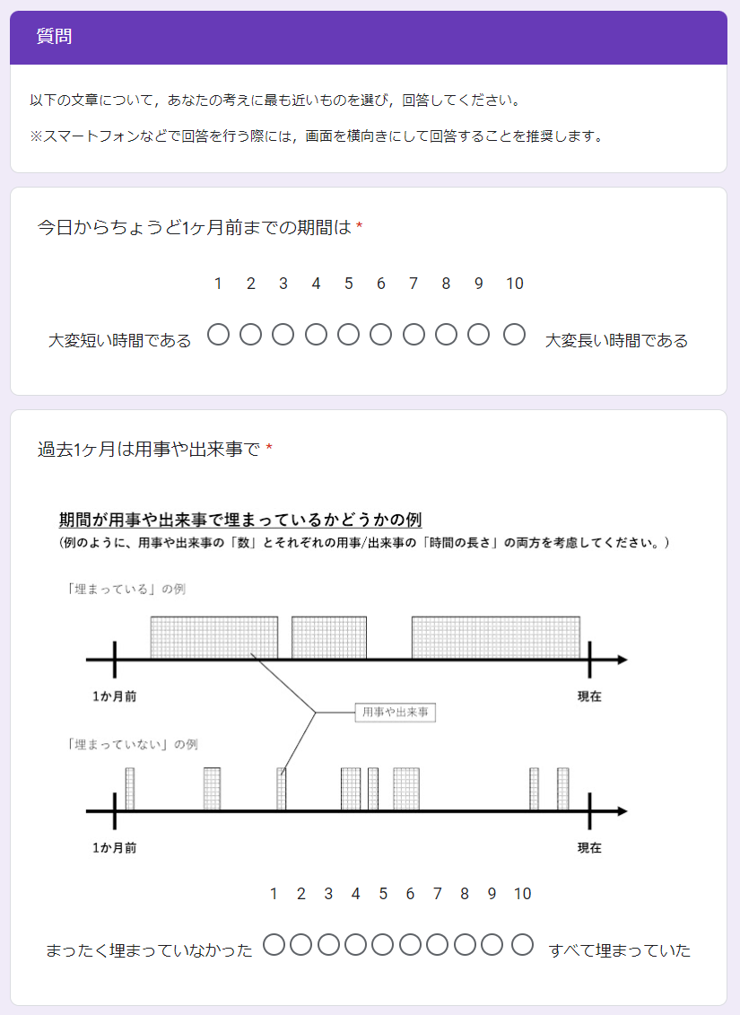
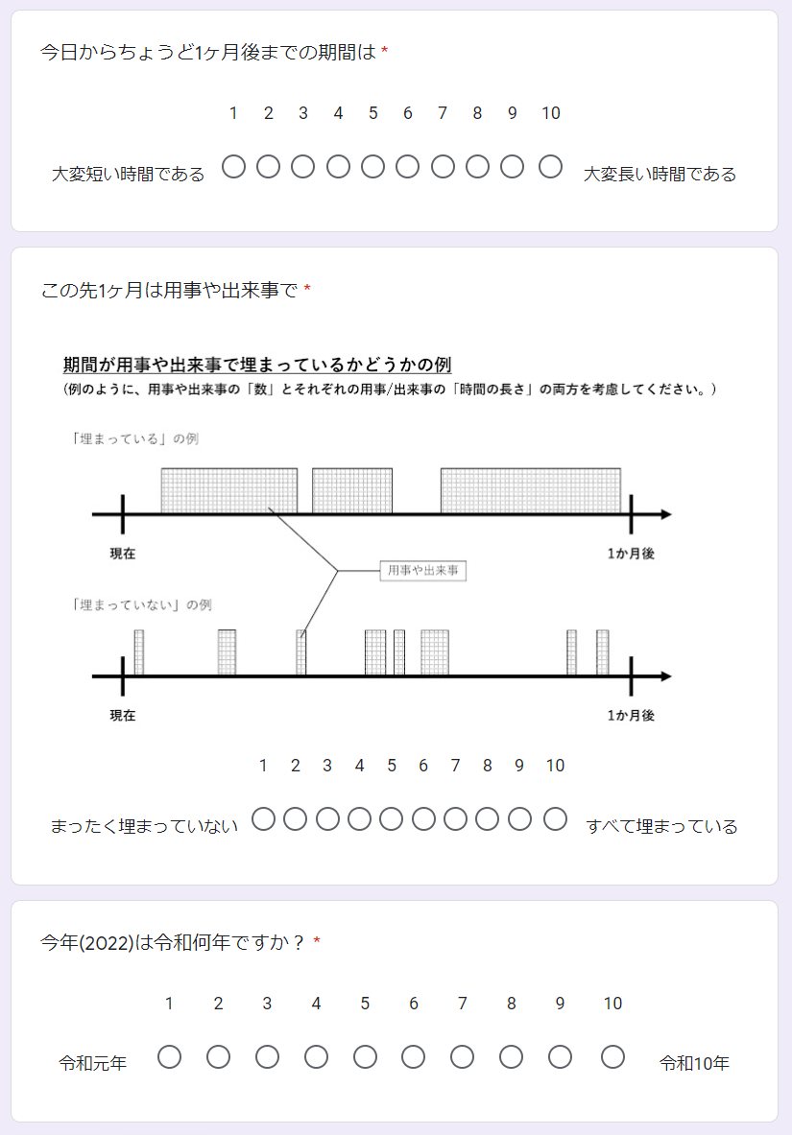
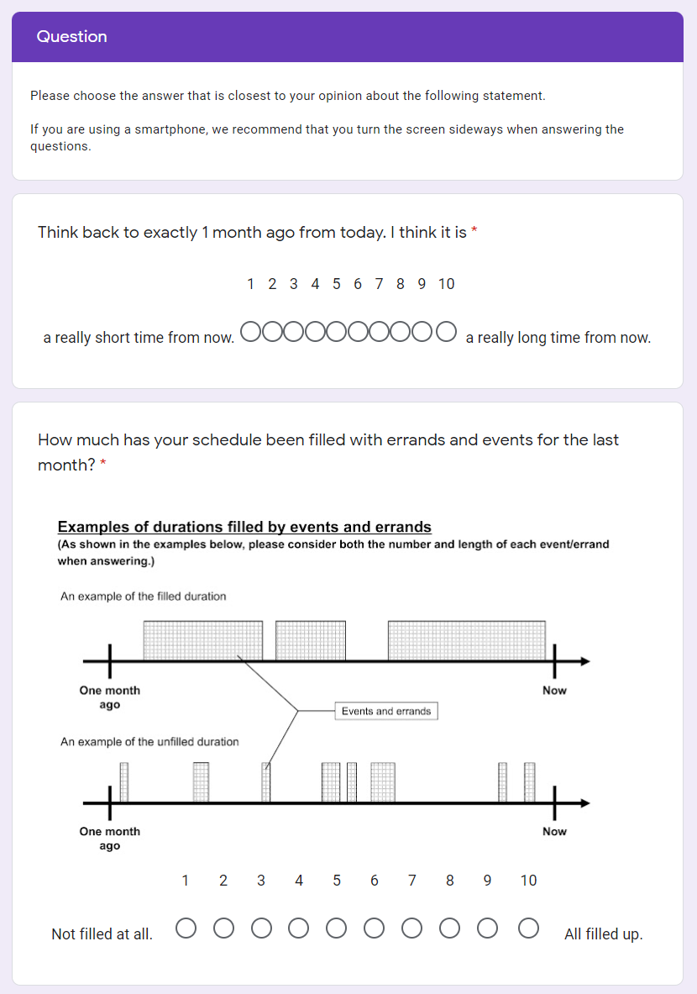
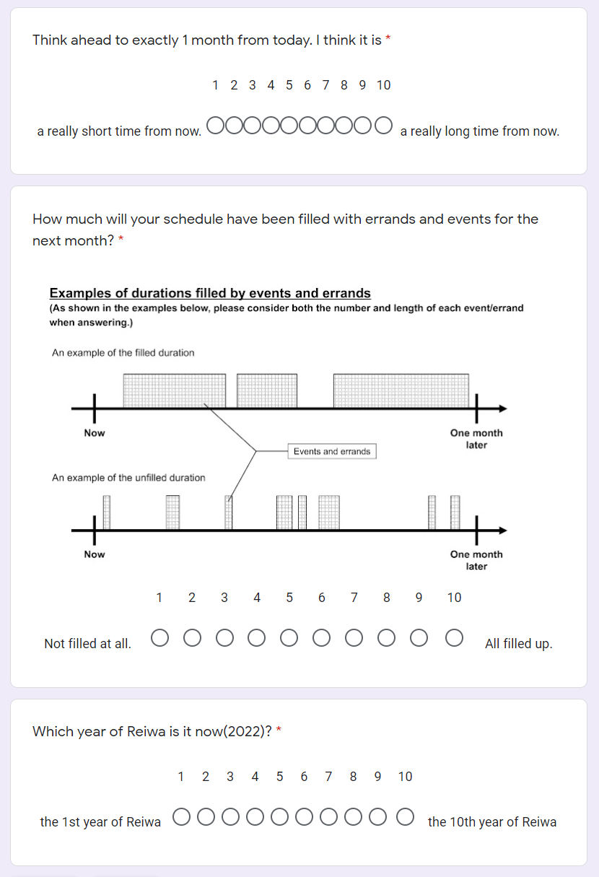

References
Aksentijevic, A., & Treider, J. M. G. (2016). It’s all in the past: Deconstructing the temporal Doppler effect. Cognition, 155, 135–145. https://doi.org/10.1016/j.cognition.2016.07.001
Brysbaert, M. (2019). How many participants do we have to include in properly powered experiments? A tutorial of power analysis with reference tables. Journal of Cognition, 2(1), 16. https://doi.org/10.5334/joc.72
Buffardi, L. (1971). Factors affecting the filled-duration illusion in the auditory, tactual, and visual modalities. Perception & Psychophysics, 10(4-B), 292–294. https://doi.org/10.3758/BF03212828
Buhusi, C. V., & Meck, W. H. (2005). What makes us tick? Functional and neural mechanisms of interval timing. Nature Reviews Neuroscience, 6(10), 755–765. https://doi.org/10.1038/nrn1764
Burnside, W. (1971). Judgment of short time intervals while performing mathematical tasks. Perception & Psychophysics, 9(5), 404–406. https://doi.org/10.3758/BF03210238
Caruso, E. M., Van Boven, L., Chin, M., & Ward, A. (2013). The temporal doppler effect: When the future feels closer than the past. Psychological Science, 24(4), 530–536. https://doi.org/10.1177/0956797612458804
Casasanto, D., & Boroditsky, L. (2008). Time in the mind: Using space to think about time. Cognition, 106(2), 579–593. https://doi.org/10.1016/j.cognition.2007.03.004
Cashen, L. H., & Geiger, S. W. (2004). Statistical power and the testing of null hypotheses: A review of contemporary management research and recommendations for future studies. Organizational Research Methods, 7(2), 151–167. https://doi.org/10.1177/1094428104263676
Champely, S. (2020). pwr: Basic functions for power analysis. R package version 1.3-0. https://CRAN.R-project.org/package=pwr
Droit-Volet, S., & Meck, W. H. (2007). How emotions colour our perception of time. Trends in Cognitive Sciences, 11(12), 504–513. https://doi.org/10.1016/j.tics.2007.09.008
Faul, F., Erdfelder, E., Lang, A. G., & Buchner, A. (2007). G* Power 3: A flexible statistical power analysis program for the social, behavioral, and biomedical sciences. Behavior Research Methods, 39(2), 175-191. https://doi.org/10.3758/BF03193146
Gan, Y., Miao, M., Zheng, L., & Liu, H. (2017). Temporal doppler effect and future orientation: Adaptive function and moderating conditions. Journal of Personality, 85(3), 313–325. https://doi.org/10.1111/jopy.12242
Guo, W., Liu, H., Yang, J., Mo, Y., Zhong, C., & Yamada, Y. (2020). Stage 2 Registered Report: How subtle linguistic cues prevent unethical behaviors. F1000Research, 9, 996. https://doi.org/10.12688/f1000research.25573.2
Hasuo, E., Nakajima, Y., Tomimatsu, E., Grondin, S., & Ueda, K. (2014). The occurrence of the filled duration illusion: A comparison of the method of adjustment with the method of magnitude estimation. Acta Psychologica, 147, 111–121. https://doi.org/10.1016/j.actpsy.2013.10.003
Hicks, R. E., Miller, G. W., & Kinsbourne, M. (1976). Prospective and retrospective judgments of time as a function of amount of information processed. The American Journal of Psychology, 89(4), 719–730. https://doi.org/10.2307/1421469
Ikeda, A., Xu, H., Fuji, N., Zhu, S., & Yamada, Y. (2019). Questionable research practices following pre-registration. Japanese Psychological Review, 62(3), 281–295. https://doi.org/10.24602/sjpr.62.3_281
Jiga-Boy, G. M., Clark, A. E., & Semin, G. R. (2010). So much to do and so little time: Effort and perceived temporal distance. Psychological Science, 21(12), 1811-1817. https://doi.org/10.1177/0956797610388043
Janssen, S. M. J., Chessa, A. G., & Murre, J. M. J. (2006). Memory for time: How people date events. Memory & Cognition, 34(1), 138–147. https://doi.org/10.3758/BF03193393
Matlock, T., Ramscar, M., & Boroditsky, L. (2005). On the experiential link between spatial and temporal language. Cognitive Science, 29(4), 655–664. https://doi.org/10.1207/s15516709cog0000_17
McCormack, T., Burns, P., O’Connor, P., Jaroslawska, A., & Caruso, E. M. (2019). Do children and adolescents have a future-oriented bias? A developmental study of spontaneous and cued past and future thinking. Psychological Research, 83(4), 774–787. https://doi.org/10.1007/s00426-018-1077-5
Miles, L. K., Karpinska, K., Lumsden, J., & Macrae, C. N. (2010). The meandering mind: Vection and mental time travel. PLOS ONE, 5(5), e10825. https://doi.org/10.1371/journal.pone.0010825
Miles, L. K., Nind, L. K., & Macrae, C. N. (2010). Moving through time. Psychological Science, 21(2), 222–223. https://doi.org/10.1177/0956797609359333
Mrkva, K., Travers, M., & Van Boven, L. (2018). Simulational fluency reduces feelings of psychological distance. Journal of Experimental Psychology: General, 147(3), 354–376. https://doi.org/10.1037/xge0000408
Nitta, H., Tomita, H., Zhang, Y., Zhou, X., & Yamada, Y. (2018). Disgust and the rubber hand illusion: A registered replication report of Jalal, Krishnakumar, and Ramachandran (2015). Cognitive Research: Principles and Implications, 3. https://doi.org/10.1186/s41235-018-0101-z
R Core Team (2021). R: A language and environment for statistical computing. R Foundation for Statistical Computing, Vienna, Austria. URL https://www.R-project.org/
Ross, M., & Wilson, A. E. (2002). It feels like yesterday: Self-esteem, valence of personal past experiences, and judgments of subjective distance. Journal of Personality and Social Psychology, 82(5), 792-803. https://doi.org/10.1037/0022-3514.82.5.792
Schwarz, M. A., Winkler, I., & Sedlmeier, P. (2013). The heart beat does not make us tick: The impacts of heart rate and arousal on time perception. Attention, Perception, & Psychophysics, 75(1), 182–193. https://doi.org/10.3758/s13414-012-0387-8
Thomas, E. C., & Brown, I. (1974). Time perception and the filled-duration illusion. Perception & Psychophysics, 16(3), 449–458. https://doi.org/10.3758/BF03198571
Thompson, C. P., Skowronski, J. J., & Lee, D. J. (1988). Telescoping in dating naturally occurring events. Memory & Cognition, 16(5), 461–468. https://doi.org/10.3758/BF03214227
Trope, Y., & Liberman, N. (2010). Construal-level theory of psychological distance. Psychological Review, 117(2), 440-463. https://doi.org/10.1037/a0018963
Van Boven, L., & Caruso, E. M. (2015). The tripartite foundations of temporal psychological distance: Metaphors, ecology, and teleology. Social and Personality Psychology Compass, 9(11), 593-605. https://doi.org/10.1111/spc3.12207
Wearden, J. H., Norton, R., Martin, S., & Montford-Bebb, O. (2007). Internal clock processes and the filled-duration illusion. Journal of Experimental Psychology: Human Perception and Performance, 33(3), 716–729. https://doi.org/10.1037/0096-1523.33.3.716
Xuan, B., Zhang, D., He, S., & Chen, X. (2007). Larger stimuli are judged to last longer. Journal of Vision, 7(10), 2–2. https://doi.org/10.1167/7.10.2
Yamada, Y., & Kawabe, T. (2011). Emotion colors time perception unconsciously. Consciousness and Cognition, 20(4), 1835–1841. https://doi.org/10.1016/j.concog.2011.06.016
Yonemitsu, F., Ikeda, A., Yoshimura, N., Takashima, K., Mori, Y., Sasaki, K., Qian, K., & Yamada, Y. (2020). Warning ‘Don’t spread’ versus ‘Don’t be a spreader’ to prevent the COVID-19 pandemic. Royal Society Open Science, 7(9), 200793. https://doi.org/10.1098/rsos.200793
Yuasa, K., & Yotsumoto, Y. (2015). Opposite distortions in interval timing perception for visual and auditory stimuli with temporal modulations. PLOS ONE, 10(8), e0135646. https://doi.org/10.1371/journal.pone.0135646
Zauberman, G., Levav, J., Diehl, K., & Bhargave, R. (2010). 1995 feels so close yet so far: The effect of event markers on subjective feelings of elapsed time. Psychological Science, 21(1), 133–139. https://doi.org/10.1177/0956797609356420

Acknowledgements
We would like to thank Editage (www.editage.com) for English language editing.

Authors’ contributions
CRediT Statement for Stage 1 manuscript
Conceptualization: QZ, YM, KU, KT, YY; Funding acquisition: YY; Methodology: QZ, YM, KU, KT; Project administration: YY; Supervision: YY; Visualization: QZ, YM, KU, KT; Writing - original draft: QZ, YM, KU, KT, YY

Funding
This research is supported by JSPS KAKENHI: JP16H03079, JP17H00875, JP18K12015, JP20H04581, and 21H03784.

To keep the significant numbers consistent with Caruso et al.’s (2013) Study 1b, Cohen’s d = 0.225 is counted as 0.22.

