Title:
Somatosensory Response Changes During Illusory Finger Stretching

Author names and affiliations:
Kirralise J. Hansford¹, Daniel H. Baker¹, Kirsten J. McKenzie² & Catherine E. J. Preston¹.

¹University of York, Heslington, York, UK, YO10 5DD
²University of Lincoln, Brayford, Pool, Lincoln, UK, LN6 7TS

Corresponding author:
Kirralise J. Hansford – kh1474@york.ac.uk

Abstract
Resizing illusions, delivered using augmented reality, resize a body part through either stretching or shrinking manipulations. These resizing illusions have been investigated in visuotactile, visual-only and visuo-auditory presentations. However, the neural underpinnings of these resizing illusions remain undefined. This study seeks to understand the neural mechanisms behind these illusions in healthy participants, by using somatosensory steady state evoked potentials in addition to subjective self-report questionnaires, to enhance knowledge of what drives the subjective embodiment during resizing illusions. Resizing Illusions have been shown to provide analgesic effects for individuals with chronic pain conditions, therefore, this study also aims to provide an empirical basis for later investigations in chronic pain samples undergoing resizing illusions. [results and conclusions to be added].

Key Words: Somatosensory Evoked Potentials, , EEG, Resizing Illusions
- Introduction

Illusory finger stretching is a form of multisensory illusion, specifically a resizing illusion, which alters the subjective perceptual experience of the size of one’s finger. Resizing illusions, through changing the way in which a body part is perceived, exploit principles of multisensory integration to elicit modulations in the perceived size and shape of the body (Preston & Newport 2011; Preston et al., 2020; Stanton et al. 2018). Resizing illusions are based on the rubber hand illusion, in which touch is delivered to a visible fake hand at the same time and in the same place that touch is delivered to the hidden real hand. This manipulation elicits feelings of ownership over the fake hand, through the integration of multisensory (tactile and visual) inputs highlighting the apparent malleability of bodily self (Botvinick & Cohen, 1998). Multisensory resizing illusions also typically involve both tactile and visual inputs to the participant and can be delivered via an augmented reality system or through magnifying optics. However, recent studies have also shown resizing illusions to be effectively administered through visual only, and visuo-auditory manipulations (Schaefer et al., 2007; Tajadura-Jiménez et al., 2017), with multisensory manipulations reported as the most effective at inducing a strong experience of the illusion within an augmented reality system (Hansford et al., 2023).
The augmented reality system used to deliver these resizing illusions presents real-time video capture of the hand, from the same position and perspective as if the hand were being viewed directly (Preston & Newport, 2011). This allows the experimenter to deliver tactile manipulations, such as gently pulling or pushing the hand, whilst the participant views the hand either stretching or shrinking in the augmented image. Newport, Pearce and Preston (2010) found strong embodiment using this multisensory visuotactile illusion, which was replicated in our pilot data using the same experimental set up as the current study, showing a greater illusory experience during synchronous visuotactile manipulations compared to asynchronous (mismatching visuotactile manipulation) control conditions (Appendix C). When comparing multisensory visuotactile resizing illusions to unimodal visual resizing illusions, our recent work (Hansford et al., 2023a) shows that multisensory illusions elicit significantly greater illusory experience compared to unimodal visual illusions in healthy participants. We also showed, in exploratory analysis, that a subset of participants who experienced an illusion in the unimodal visual condition reported a stronger illusory experience in this condition than in an incongruent control condition. This subset analysis, however, was of a small sample size, and further replication of the findings are needed. Furthermore, we have demonstrated that a visuo-auditory presentation of the resizing illusion, using non-naturalistic auditory input, provides a stronger illusory experience than a visual only presentation, but this does not surpass the illusion strength given by a visuo-tactile illusion (Hansford et al., 2023b).

Neuroimaging has previously been used in healthy populations experiencing resizing illusions, whereby modulation of the primary somatosensory cortex has been found using neuromagnetic source imaging during visual only resizing illusions of the arm (Schaefer et al., 2007). Briefly, the more the subjects felt the subjective experience of an elongated arm, the more the cortical distance between the first and fifth digit decreased, showing the topographical representation of the somatosensory cortex being modulated by perceived location of a peripheral stimulus. Specifically looking at stretching multisensory visuotactile illusions, which as mentioned are those which elicit the greatest illusion strength in a majority of participants, recent research suggests that these illusions directly impact the neural representations of the body and reflect early-stage multimodal stimulus integration through modulation of gamma band activity (Kanayama et al., 2021). We have recently investigated this illusion in healthy participants using electroencephalography (EEG) and have found support for this previous research, finding significant increases in gamma band power, likely reflecting multimodal stimulus integration, in multisensory visuotactile compared to unimodal visual conditions during illusory resizing of a finger (Hansford et al., 2023a). Previous research using rubber hand illusions found this multisensory integration effect in early-stage gamma band increases (Kanayama et al., 2021), whilst our recent findings show a later stage of multimodal stimulus integration when using illusory finger resizing manipulations (Hansford et al., 2023a).
Looking specifically at research into somatosensory cortex modulation using steady-state evoked potentials (SSEPs), low-level somatosensory responses have been induced directly using vibrations of a known frequency applied to a body part. These generate a frequency-locked steady-state evoked potential detectable at the scalp using EEG (Snyder, 1992; Tobimatsu et al., 1999), and are an index of the cortical response to a stimulus. This paradigm has been used with other sensory modalities to better understand the neural mechanisms underlying multisensory integration, with findings showing that presentation of temporally congruent auditory and visual stimuli significantly enhances the magnitude and inter-trial phase coherence of auditory and visual steady-state responses (Nozaradan et al., 2012). However, research has also found evidence of enhanced steady-state responses for within-modality stimulation of auditory and visual stimuli in isolation (Giani et al., 2012), in contrast to Nozaradan et al.’s findings regarding visuo-auditory combination. Research using vibrotactile stimulation has found greater increases in steady-state response magnitude when this corresponds with the amplitude modulation rate of stimulation (Colon et al., 2012; Rees et al., 1986) suggesting an entrainment of oscillatory activity to temporal features of sensory stimulation (Timora & Budd, 2018). Given these findings, we anticipate that somatosensory steady-state signals might change during the resizing illusion, due to the multisensory manipulations present, to give a potential index of changes in neural representations during the illusion.
Several studies have investigated the analgesic effect of these resizing illusions, as they have been shown to reduce chronic pain in conditions such as osteoarthritis (Preston & Newport, 2011; Preston et al., 2020; Stanton et al., 2018), chronic back pain (Diers et al., 2013), and complex regional pain syndrome (Moseley, Parsons & Spence, 2008). However, the understanding of how these illusions reduce pain is still undetermined. It has been suggested that chronic pain involves cortical misrepresentations of the size of the affected body part, however, it is unknown if resizing illusions affect this cortical misrepresentation, and if this is therefore what causes the reduction in pain. No study has yet used neuroimaging with a chronic pain population to determine the cortical activity correlated with this illusory analgesia. However, importantly, there has also not been research conducted using SSEPs in healthy participants, to understand what the cortical representations of these resizing illusions are like without the impact of a chronic pain condition. Therefore, the aim of this study is to examine potential changes in the somatosensory cortex during illusory finger resizing in healthy participants, using vibrotactile SSSEPs, to use as a basis for later investigations in a sample of chronic pain participants. If we can identify a link between illusory resizing and somatosensory cortex changes, this will enhance our understanding of what is happening in the brain during these illusions and will act as a reference for comparison with neural representations in individuals with chronic pain conditions.
Using different sensory manipulations of finger resizing illusions, in addition to using an electromagnetic solenoid stimulator, this study aims to investigate subjective illusory experience and SSEP responses in healthy participants, to better understand the experience of body ownership illusions from subjective experience and cortical representation perspectives. To test this, different resizing illusions consisting of multisensory (visuotactile) stretching (MS), unimodal-visual stretching (UV), a non-illusion control condition without tactile input (NI), and a non-illusion control condition with tactile input (NIT) will be used to assess alternate aspects of illusory resizing manipulations and their related effects on SSEP response. In line with previous findings regarding effective UV conditions (Hansford et al., 2023a), subjective questionnaire data will be used to identify individuals who experience an effective UV condition, and these participant’s SSEP data will then be analysed. The first hypothesis, acting as a positive control (1), is that there will be a greater illusory experience, measured via a subjective illusory experience questionnaire, in the MS condition compared to the NI conditions. The main experimental hypothesis for this study is that (2) there will be a significant difference in SSEP response across the electrodes of interest (F1 & FC1, see section 3. Pilot Data) when comparing (2a) MS visuotactile illusory resizing to NI conditions, and when comparing (2b) effective UV illusory resizing to NI conditions..

- Methods
  - Sample Size
Overall, based on the power analyses in section 2.5, a total sample size of 30 participants will be recruited, to adhere to the higher end of sample size estimates (Hypothesis 2 (2.5.2)) and to account for the likely reduced sample size in the unimodal visual SSEP analysis.
2.2 Participants
Ethical approval for this research was gained from the Department of Psychology, University of York (ethics application code 950), in line with the Declaration of Helsinki. Informed consent from each participant will be gained prior to the start of any experimental set up, and participants will be instructed that they can withdraw their participation at any time during or after completion of the experiment.

Sample inclusion / exclusion criteria:
Inclusion and exclusion criteria will be determined using self-report responses relating to each item listed below:
- Inclusion Criteria: Right-handed, 18 years of age or over, no older than 75 years of age (include those aged 75 years).

- Exclusion Criteria: Prior knowledge or expectations about the research, a history of developmental, neurological or psychiatric disorders, history of drug or alcohol abuse, history of sleep disorders, history of epilepsy, having visual abnormalities that cannot be corrected optically (i.e. with glasses), or being under 18 years of age, or over 75 years of age.
a history of chronic pain conditions, operations or procedures that could damage peripheral nerve pathways in the hands, current experiences of pain or more than 4 hours of consistent pain experienced in the preceding week.

Raw data exclusion criteria:
- Less than 100% of the experiment completed by a participant, more than 50% of electrodes for a single participant requiring removal from EEG data, or if both electrodes F1 and FC1 (electrodes of interest) require removalMore information about data removal can be found in section 2.4.1 Preprocessing Steps.

2.3 Experimental Procedure
All participants will complete a demographic survey, asking their age and sex, and will be asked to complete the revised Waterloo Handedness Questionnaire (WHQr) (Elias et al., 1998). The WHQr self-reported handedness questionnaire consists of 36 questions. The questions are answered on a 5-level, Likert scale to determine the degree of preferred hand use, with left always being -2, left usually being -1, equal use being 0, right usually being 1 and right always being 2. The sum of the total WHQr score can then be used to categorise a respondent as left-handed (score of -24 or less), mixed handed (score of -23 to +23), or right-handed (score of +24 or higher). Only participants who are categorised as right-handed will continue participation.
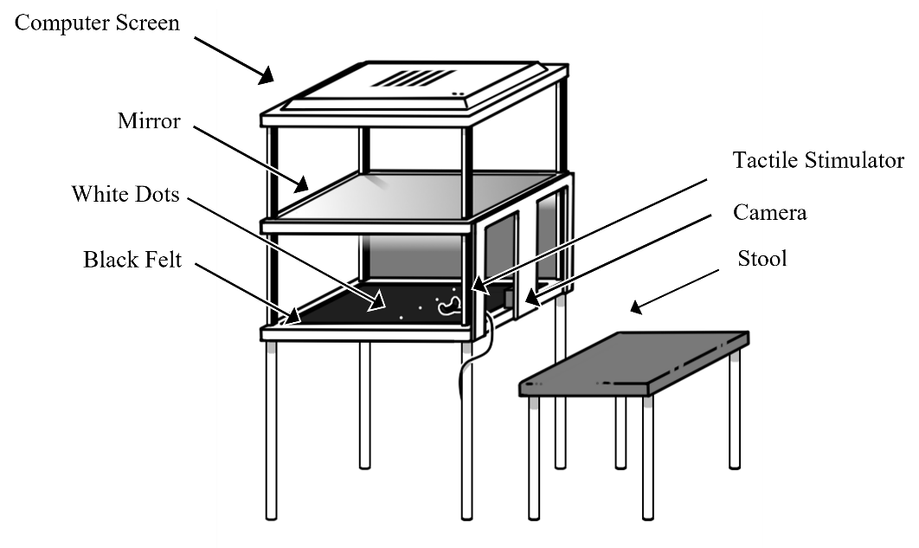
Participants will then be set up with an appropriately sized 64-channel EEG cap with electrodes arranged according to the 10/20 system. The experimenter will use conductive gel to make a conductive bridge between the electrodes and the scalp to attempt to obtain impedance levels of <10kΩ per electrode. The whole head average will be used as a reference.

Figure 1. Schematic of Augmented Reality System with Tactile Stimulator.
Participants will then be seated behind the augmented reality system (Figure 1) and instructed to place their hand onto the black felt fabric within the augmented reality system. Within the self-built system there is a 1920 x 1080 pixel Spedal Webcam Wide Angle Camera situated in the middle of the central area, away from the participant’s view. 26cms above the felt base of this central area, there is a mirror, which is placed 26cms below a screen with a resolution of 1920 x 1200 pixels, with a width of 52cms and a height of 32cms. This screen is 54cms from the base of the system, and the base of the system is 82cms from the ground. Participants will be instructed to place either their index or middle finger outstretched onto the felt. The decision of whether the participant will use their index or middle finger will be pseudo randomised (to give equal representation of each finger) via MATLAB prior to any participants taking part. There will be two white dots for each hand on the felt and participants will be instructed to place their hand between these two dots. Participants will be instructed to view their hand’s image in the mirror (the real hand will be hidden from view) throughout the experiment. The camera placed underneath the mirror on the felt base will be used to deliver a live feed video of the participants hands to the computer screen at the top of the augmented reality system, which will show in the mirror reflection to the participants. There is a delay of 170ms in the video processing pipeline from the camera image to the augmented video image.
Participants will undergo 4 conditions: multisensory stretching (MS), unimodal-visual stretching (UV), a non-illusion control condition without tactile input (NI), and a non-illusion control condition with tactile input (NIT). There will be vibrotactile stimulation to the finger in all conditions, but only tactile input of the researcher touching the participants hand in the conditions where this is mentioned. Each trial will last 2.4 seconds for the manipulation phase, where the finger will be stretched by 60 pixels (2.1 centimetres) in UV and MS conditions, followed by a further 2.4 second habituation phase in which participants can view and move their (augmented) finger, whilst they keep the rest of their hand still, before the screen goes dark, indicating that the next trial can start. The MS condition consist of the researcher touching and pulling the participant’s finger as the participant views their finger stretching in a congruent manner. The UV conditions consist of the participants viewing their finger stretch without any experimenter manipulation. The NI condition provides no visual or touching tactile manipulations to the finger. The NIT control condition will involve no visual input of the finger stretching, instead the image of their finger will be visible but unchanged. Additionally, this condition will include tactile input of the experimenter’s hand touching the participant’s finger, but without pulling. The inclusion of this condition is to assess if the localisation of the cortical representation arises from the resizing manipulation to the finger, or whether it stems from the tactile input given to the finger. Visualisation of all conditions can be seen in Figure 2.
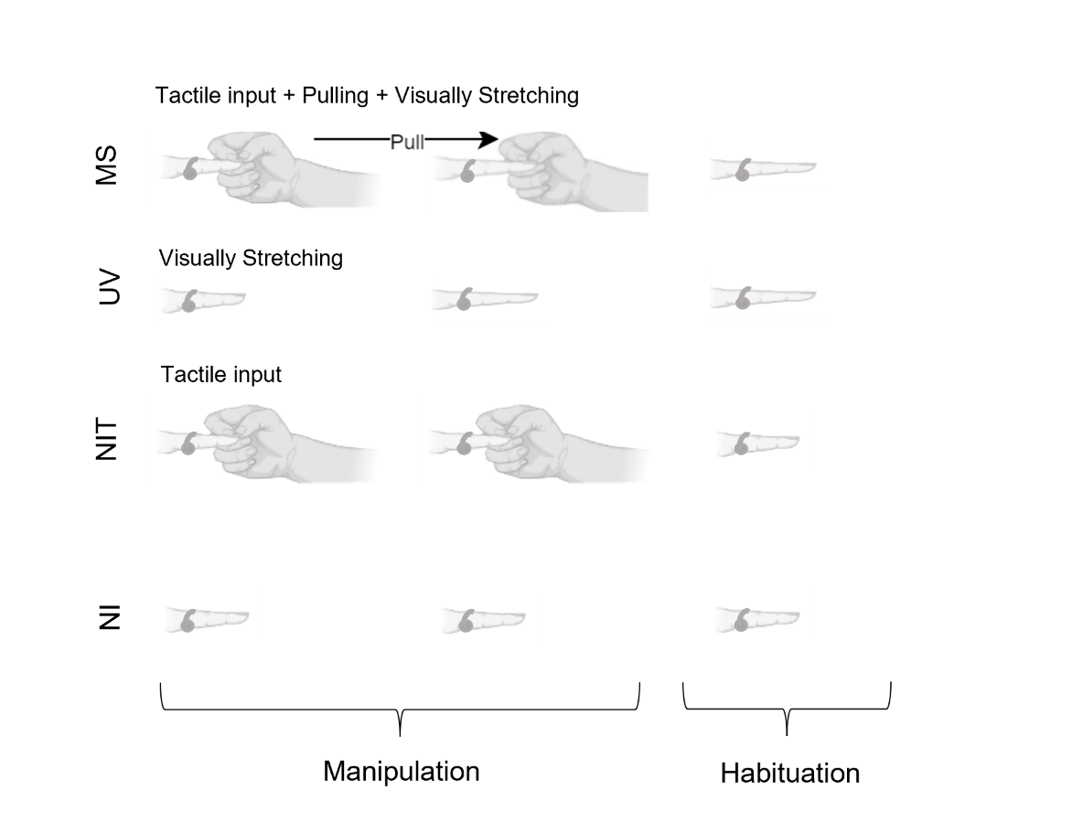
Figure 2. Infographic of Experimental Conditions. MS = Multisensory Stretching, UV = Unimodal Visual Stretching, NIT = Non-Illusion Tactile, NI = Non-Illusion. Manipulation phase (2.4 seconds) is where experimenter creates illusion within MS and UV conditions, or provides tactile input during NIT condition, habituation phase (2.4 seconds) is where participants are free to move their finger. Arrow denotes the direction of the experimenter’s action. Stimulator is included in each phase of the experiment as tactile stimulation is present throughout.
The experimenter will be seated opposite the participant, the other side of the augmented reality machine and will pull the digit by holding onto the distal interphalangeal joint and gently pulling the finger whilst the participant keeps their hand in place. Conditions will be delivered across 4 blocks, with each block consisting of 24 trials of the same experimental condition, totalling 96 trials over all 4 blocks. The ordering of the blocks will be randomised for each participant to prevent ordering effects. The experiment will be programmed in, and the conditions randomised using MATLAB R2017a and the experimenter will be informed of whether to pull the finger or to touch the finger via an indicative box displayed on the screen out of the participant’s view. If the box is blue, this will indicate a need to pull the finger, if it is white it will indicate a need to touch the finger. The researcher will use a button press to dictate the start of the manipulation, and will start pulling the finger, when needed, synchronously within the 2.4 second manipulation phase. If the experimenter forgets to pull the finger on a multisensory condition, or mistakenly pulls the finger in a control trial, then this will be noted during the experiment, and that trial will be removed from analysis. Vibrations will be delivered to the participant’s finger in all conditions using a miniature electromagnetic solenoid stimulator/bone conductor (Dancer Design Tactor; diameter 1.8mm) emitting vibrations produced by sending amplified 26Hz sine wave sound files, with stimulus intensity controlled by an amplifier (Dancer Design TactAmp). The tactor is driven at 50% of the maximum (i.e. a peak input voltage of 3V) using a 26Hz sine-wave, and delivers a peak force of 0.18N. The electromagnetic solenoid stimulator will be attached to the participant’s finger that is outstretched and will receive the manipulations, between the knuckle and the first finger joint, using a black Velcro strip and will give continuous stimulation for the duration of each trial. = Participants will be encouraged to take a break between each of the blocks to stretch their hand. EEG will be recorded throughout as a continuous recording with conditions denoted by numbered 8-bit digital triggers sent when the researcher presses a button box to start each condition (USB-TTL Module, Black Box Toolkit Ltd.).
Finally, each condition will be presented once in a randomised fashion with tactile stimulation, after which, the participant will be asked to complete the subjective illusory experience questionnaire for each trial using the Samsung Galaxy Tab A6 tablet via a questionnaire on Qualtrics (Qualtrics, Provo, UT). The questionnaire consists of six questions relating to the trial the participant had just experienced, and trials they have experienced previously that were similar. Two statements relate to illusory experience: “It felt like my finger was really stretching” / “It felt like the finger I saw was part of my body”, two relate to disownership: “It felt like the finger I saw no longer belonged to me” / “It felt like the finger I saw was no longer part of my body”, and two are control questions: “It felt as if my finger had disappeared” / “It felt as if I might have had an extra finger index finger” (all questions will be directed towards the participants manipulated finger). Control questions are included to create an index for the illusion and disownership questions (more detail can be found in section 2.4.1 - Preprocessing steps), whilst disownership questions are included to assess if the potential experience from the illusions results from a disownership of the body part, or from subjective embodiment of said body part (McCabe, 2011). A visual analogue scale from 0 – 100 will be used for each statement, with 0 being strongly disagree, 50 being neutral and 100 being strongly agree.
Data collection will be terminated when the full sample of participants have been tested. If a participant completes <100% of the experiment or if over 50% of electrodes need removal, or if either electrode F1 or FC1 needs removal, then their data will not be included, and additional participants will be recruited to fill any lost data.

2.4 Analysis Pipeline
2.4.1 Preprocessing steps

Data will first be converted using MATLAB and EEGlab from the ANT EEprobe .cnt format to EEGlab .set format. All subsequent analysis will then be conducted using the MNE-Python toolbox (Gramfort et al., 2013). A 50Hz notch filter will first be applied to the raw EEG data for all electrodes, followed by calculation of the standard error across time for each electrode for each participant (Luck et al., 2021). Across all the standard errors, the 5% of electrodes showing the largest standard errors will be used to create a standard error threshold. Any electrode with a standard error above this threshold, or with a value of 0, will be removed from analysis. Where a participant has over 50% of their electrodes over the standard error threshold or with a value of 0, or if the electrodes requiring removal contain both electrodes F1 and FC1 (electrodes of interest), then their data will be removed. Primary analysis of the remaining EEG data will then involve averaging the signal across the electrodes of interest (F1 and FC1), and calculating the Fourier transform for each trial. Statistical comparisons will then be performed on the Fourier amplitudes at the stimulation frequency (26Hz), across conditions and participants. No additional filtering or denoising steps will be applied to the EEG data, in line with Figueira et al.’s (2022) report that only a Fourier transform is typically needed for this type of EEG data.
Regarding questionnaire data, all data will be collected from a range of 0 – 100, with scores below 50 being indicative of disagreement to the statement, whilst a score of 50 is a neutral option regarding the statement, and scores above 50 are indicative of agreement with the statement. Scores for both illusion experience questions will be combined to give median scores, along with both disownership questions and both control questions, resulting in 3 median scores per trial per participant. The median control scores will be used to create an index of the illusion and disownership scores by subtracting the median control score from the median illusion and median disownership scores, in line with previous research doing similarly (Matsumiya, 2021; Kilteni & Ehrsson, 2017; Kalckert & Ehrsson, 2012).

2.4.2 Planned analyses
2.4.2.1 Hypothesis 1 (Positive Control)
(1 – Positive Control) There will be a greater illusory experience, measured via a subjective illusory experience questionnaire, in the multisensory condition compared to the non-illusion condition.
The subjective illusory experience questionnaire will be used as a positive control for the current study. Previous research has shown significantly greater illusion strength for MS conditions compared to NI conditions, which we will attempt to replicate. Questionnaire data will be analysed using R (R Core Team, 2021). A one-way ANOVA will be run to compare the dependent variable of median illusion score from each independent condition. Given significant findings, post-hoc tests will be run, with Bonferroni correction for 4 comparisons (MS / NI conditions, UV / NI conditions) at an initial alpha of 0.05. Subjective data will also be used to identify participants who effectively experience the unimodal visual condition where participants will be included in further EEG analysis if their median illusion scores on the subjective illusory questionnaire scale for the unimodal-visual condition are greater than 50, in line with previous research using mean subjective embodiment scales (Carey et al., 2019), which will indicate experience of the illusion.
Interpretations for hypothesis 1 can be found in the design table (Appendix B).
2.4.2.2 Hypothesis 2
There will be a significant difference in SSEP response across the electrodes of interest (F1 & FC1) when comparing (2a) multisensory visuotactile illusory resizing to non-illusion, and when comparing (2b) effective unimodal visual illusory resizing to non-illusion conditions.

As mentioned in the EEG pre-processing steps in section 2.4.1, analysis of EEG data will involve taking a Fourier transform for each waveform averaged across the electrodes of interest, to obtain the amplitude for each trial at the vibration frequency (26Hz). These amplitudes will then be averaged across trials to give overall results for each participant, before running a repeated measures one way ANOVA comparing SSEP response from each experimental condition. The dependent variable will be SSSEP amplitude in µV, whilst the independent variable will be the different manipulations given in each comparison condition. Based on the pilot data in Figure 3, we would expect to see activation most pronounced over mid-frontal distributions, covering F1 and FC1 electrodes and therefore these electrodes are selected as the electrodes of interest.
Interpretations for hypothesis 2 can be found in the design table (Appendix B).

2.5 Power Analysis
2.5.1 Hypothesis 1 (Positive Control)
Effect sizes are determined by research from Hansford et al (2023) using the subjective illusory experience questionnaire and comparing MS and UV finger-based resizing illusions using the same finger stretching illusions and the same equipment, which show an effect size of n² = .33 (converted to a Cohen’s f = .73). Additional effect size information comes from a visual capture study using a subjective embodiment questionnaire and visual and tactile manipulations to a mannequin body (Carey et al., 2019), showing an effect size of r = .64 (converted to a Cohen’s f = .83) when comparing embodiment scores from the questionnaire against control scores. An effect size of .73 was used for hypothesis 1 to adhere to the lower end of previous effect sizes.
A priori power analysis using G*Power for the smallest effect size of interest (f = .73) shows that for a repeated measures, within factors one way ANOVA, with an effect size (f) of 0.73, alpha of 0.05, power at 80% and 1 group with four measurements, 4 participants are needed..

2.5.2 Hypothesis 2
This is the first study to investigate illusory finger stretching using SSEPs, so appropriate effect size estimates are not available. We therefore conducted power calculations based on a smallest effect size of interest, in line with Lakens (2014) recommendation. Here, we have chosen an effect size of d = 0.5 (a medium effect, see Cohen, 1988), since this is the smallest effect size we are interested in detecting, which we have converted to a Cohen’s f of 0.25 for power analyses.
A priori power analysis using G*Power shows that for a repeated measures, within factors one way ANOVA, with an effect size (f) of 0.25, alpha of 0.05, power at 80%, and four measurements, a total sample size of 24 participants is needed..
A Design planner (Table A1) encompassing research questions, hypotheses, sampling and analysis plans and their resulting interpretations can be seen in appendix A.

3. Pilot Data
Previous literature states that the ideal vibration frequency to use to elicit somatosensory steady state evoked potentials (SSSEPs) ranges from 26-27Hz (Muller et al., 2001; Muller-Putz et al., 2001; Breitweiser et al., 2016; Pokorny et al., 2016; Snyder, 1992). Due to resizing illusions often manipulating the index finger, and previous studies using the index finger supporting around 26Hz as an optimal frequency (Muller-Putz et al., 2001; Breitweiser et al., 2016; Pokorny et al., 2016), it was hypothesised that 26Hz would elicit a dependable SSSEP. Therefore, we ran a pilot study to check that our setup and equipment can reliably elicit and record a SSSEP at 26Hz, using the resizing illusion and EEG.
Pilot data was collected for 3 healthy participants. Participants underwent the same experimental protocol as mentioned in the “Experimental Procedure” section, minus the subjective illusory experiencequestionnaire. No additional filtering or denoising steps were applied to the EEG data, in line with Figueira et al.’s (2022) report that only a Fourier transform is typically needed for this type of EEG data. A Fourier transform was calculated for each waveform at each electrode for all conditions, and then averaged across repetition to obtain individual results. These were then averaged across all 3 participants to give the result seen in Figure 3.
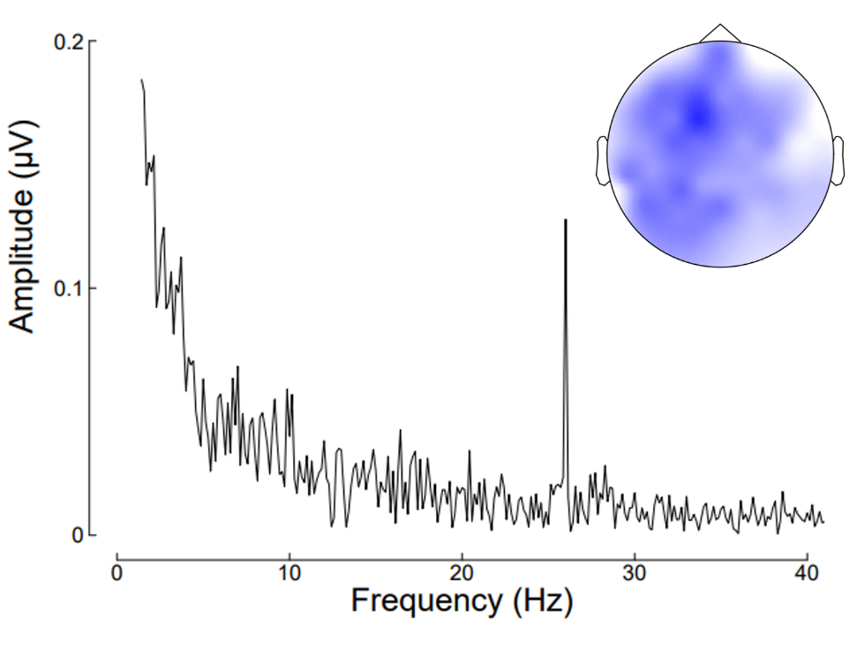
As can be seen, there is a clear SSSEP response at 26Hz, which is strongest around electrodes F1 and FC1. Previous research using vibrotactile 21Hz stimulation have also found the scalp topography of the activation to be most pronounced over mid-frontal distributions (Porcu et al., 2014; Timora & Budd, 2018), in line with the scalp topography seen here. Given these finding of a distinct 26Hz signal and mid-frontal scalp location, it appears appropriate for 26Hz to be used as the vibration frequency in the proposed study.
Figure 3. Averaged Pilot Data showing peak frequency at 26Hz, centred between electrodes F1 and FC1.
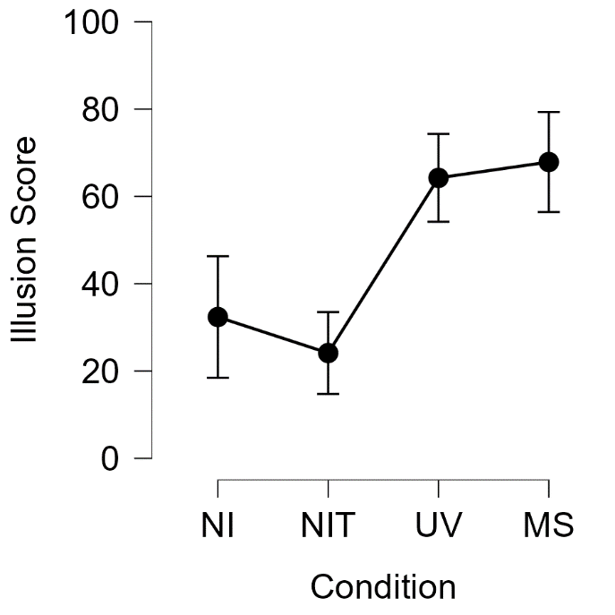
Pilot data was also collected using the vibrotactile stimulator at 26Hz to make sure that the illusory experience is not removed due to the addition of this vibrotactile input. Pilot data was collected from 4 additional healthy participants, who underwent the same experimental protocol as mentioned in the “Experimental Procedure” section, simply without EEG caps fitted. Illusory experience was calculated using the average of both illusion scores for each participant minus their averaged control scores, as per the preprocessing steps regarding the control index, and then the data were averaged over participants to give the results seen in Figure 4. As can be seen, there is a greater subjective experience of the resizing illusion, indexed by participant’s illusion score, in both experimental conditions (UV average = 64.25; MS average = 67.88) compared to both control conditions (NI average = 32.38; NIT average = 24.13). Scores below 50 are indicative of disagreement of experience of the illusion, whilst a score of 50 is a neutral option regarding the illusion experience, and scores above 50 are indicative of agreement of experiencing the illusion. This therefore shows that the addition of the vibrotactile stimulation does not remove the experience of the resizing illusion and can therefore be used in the proposed study to elicit SSEPs without affecting the subjective illusory experience of the resizing illusion.

Figure 4. Averaged Illusion score for each condition. Error bars represent standard errors. NI represents the non-Illusion condition, NIT refers to the non-illusion tactile condition, UV refers to the unimodal-visual condition, and MS refers to the multisensory condition.

References
Altman, R. D. (2000). Intra-articular sodium hyaluronate in osteoarthritis of the knee. Seminars in Arthritis and Rheumatism, 30(2), 11–18.

Arendt-Nielsen, L., & Graven-Nielsen, T. (2003). Central sensitization in fibromyalgia and other musculoskeletal disorders. Current Pain and Headache Reports, 7(5), 355–361. https://doi.org/10.1007/s11916-003-0034-0

Arendt-Nielsen, L., Nie, H., Laursen, M. B., Laursen, B. S., Madeleine, P., Simonsen, O. H., & Graven-Nielsen, T. (2010). Sensitization in patients with painful knee osteoarthritis. Pain, 149(3), 573–581. https://doi.org/10.1016/j.pain.2010.04.003

Beswick, A. D., Wylde, V., Gooberman-Hill, R., Blom, A., & Dieppe, P. (2012). What proportion of patients report long-term pain after total hip or knee replacement for osteoarthritis? A systematic review of prospective studies in unselected patients. BMJ Open, 2(1), e000435. https://doi.org/10.1136/bmjopen-2011-000435

Boesch, E., Bellan, V., Moseley, G. L., & Stanton, T. R. (2016). The effect of bodily illusions on clinical pain: A systematic review and meta-analysis. Pain, 157(3), 516–529. https://doi.org/10.1097/j.pain.0000000000000423

Botvinick, M., & Cohen, J. (1998). Rubber hands ‘feel’ touch that eyes see. Nature, 391(6669), 756–756. https://doi.org/10.1038/35784

Breitwieser, C., Pokorny, C., & Müller-Putz, G. R. (2016). A hybrid three-class brain–computer interface system utilizing SSSEPs and transient ERPs. Journal of Neural Engineering, 13(6), 066015. https://doi.org/10.1088/1741-2560/13/6/066015

Carey, M., Crucianelli, L., Preston, C., & Fotopoulou, A. (2019). The Effect of Visual Capture Towards Subjective Embodiment Within the Full Body Illusion. Scientific Reports, 9(1), 2889. https://doi.org/10.1038/s41598-019-39168-4

Cohen, J. (1988). Statistical power analysis for the behavioural sciences. (2nd ed.). Hillsdale, NJ: Erlbaum.

Colon, E., Legrain, V., & Mouraux, A. (2012). Steady-state evoked potentials to study the processing of tactile and nociceptive somatosensory input in the human brain. Neurophysiologie Clinique/Clinical Neurophysiology, 42(5), 315–323. https://doi.org/10.1016/j.neucli.2012.05.005

Corriger, A., Voute, M., Lambert, C., Pereira, B., & Pickering, G. (2022). Ketamine for refractory chronic pain: A 1-year follow-up study. Pain, 163(4), 690–701. https://doi.org/10.1097/j.pain.0000000000002403

Diers, M., Zieglgänsberger, W., Trojan, J., Drevensek, A. M., Erhardt-Raum, G., & Flor, H. (2013). Site-specific visual feedback reduces pain perception. Pain, 154(6), 890–896. https://doi.org/10.1016/j.pain.2013.02.022

Dworkin, R. H., Turk, D. C., Peirce-Sandner, S., Baron, R., Bellamy, N., Burke, L. B., Chappell, A., Chartier, K., Cleeland, C. S., Costello, A., Cowan, P., Dimitrova, R., Ellenberg, S., Farrar, J. T., French, J. A., Gilron, I., Hertz, S., Jadad, A. R., Jay, G. W., … Witter, J. (2010). Research design considerations for confirmatory chronic pain clinical trials: IMMPACT recommendations. Pain, 149(2), 177–193. https://doi.org/10.1016/j.pain.2010.02.018

Elias, L. J., Bryden, M. P., & Bulman-Fleming, M. B. (1998). Footedness is a better predictor than is handedness of emotional lateralization. Neuropsychologia, 36(1), 37–43. https://doi.org/10.1016/S0028-3932(97)00107-3

Felson, D. T. (2005). The sources of pain in knee osteoarthritis: Current Opinion in Rheumatology, 17(5), 624–628. https://doi.org/10.1097/01.bor.0000172800.49120.97

Figueira, J. S. B., Kutlu, E., Scott, L. S., & Keil, A. (2022). The FreqTag toolbox: A principled approach to analyzing electrophysiological time series in frequency tagging paradigms. Developmental Cognitive Neuroscience, 54, 101066.
https://doi.org/10.1016/j.dcn.2022.101066

Friston, K. (2008). Hierarchical Models in the Brain. PLoS Computational Biology, 4(11), e1000211. https://doi.org/10.1371/journal.pcbi.1000211

Giani, A. S., Ortiz, E., Belardinelli, P., Kleiner, M., Preissl, H., & Noppeney, U. (2012). Steady-state responses in MEG demonstrate information integration within but not across the auditory and visual senses. NeuroImage, 60(2), 1478–1489. https://doi.org/10.1016/j.neuroimage.2012.01.114

Gilpin, H. R., Moseley, G. L., Stanton, T. R., & Newport, R. (2015). Evidence for distorted mental representation of the hand in osteoarthritis. Rheumatology, 54(4), 678–682. https://doi.org/10.1093/rheumatology/keu367

Gramfort, A., Luessi, M., Larson, E., Engemann, D. A., Strohmeier, D., Brodbeck, C., ... & Hämäläinen, M. (2013). MEG and EEG data analysis with MNE-Python. Frontiers in neuroscience, 267.
doi:10.3389/fnins.2013.00267.

Hansford, K. J., Baker, D. H., McKenzie, K. J., & Preston, C. E. (2023). Distinct neural signatures of multimodal resizing illusions. Neuropsychologia, 108622. https://doi.org/10.1016/j.neuropsychologia.2023.108622

Hansford, K., Baker, D. H., McKenzie, K., & Preston, C. (2023, August 3). Multisensory Integration and Proprioceptive Drift During Resizing Illusions. https://doi.org/10.31234/osf.io/n56ha

Haggard, P., Iannetti, G. D., & Longo, M. R. (2013). Spatial sensory organization and body representation in pain perception. Current Biology, 23(4), R164-R176.
https://doi.org/10.1016/j.cub.2013.01.047

Heyworth, B. E., Lee, J. H., Kim, P. D., Lipton, C. B., Strauch, R. J., & Rosenwasser, M. P. (2008). Hylan Versus Corticosteroid Versus Placebo for Treatment of Basal Joint Arthritis: A Prospective, Randomized, Double-Blinded Clinical Trial. The Journal of Hand Surgery, 33(1), 40–48. https://doi.org/10.1016/j.jhsa.2007.10.009

Jensen, M. P., & Karoly, P. (2011). Self-report scales and procedures for assessing pain in adults. In D. C. Turk & R. Melzack (Eds.), Handbook of pain assessment (pp. 19–44). The Guilford Press.

Kalckert, A., & Ehrsson, H. H. (2012). Moving a rubber hand that feels like your own: a dissociation of ownership and agency. Frontiers in human neuroscience, 6, 40. https://doi.org/10.3389/fnhum.2012.00040

Kanayama, N., Hara, M., & Kimura, K. (2021). Virtual reality alters cortical oscillations related to visuo-tactile integration during rubber hand illusion. Scientific Reports, 11(1), 1436. https://doi.org/10.1038/s41598-020-80807-y

Kilteni, K., & Ehrsson, H. H. (2017). Body ownership determines the attenuation of self-generated tactile sensations. Proceedings of the National Academy of Sciences, 114(31), 8426-8431. https://doi.org/10.1073/pnas.1703347114

Lakens, D. (2014). Performing high‐powered studies efficiently with sequential analyses. European Journal of Social Psychology, 44(7), 701-710.

Lewis, J. S., Kersten, P., McCabe, C. S., McPherson, K. M., & Blake, D. R. (2007). Body perception disturbance: A contribution to pain in complex regional pain syndrome (CRPS). Pain, 133(1), 111–119. https://doi.org/10.1016/j.pain.2007.03.013

Luck, S. J., Stewart, A. X., Simmons, A. M., & Rhemtulla, M. (2021). Standardized measurement error: A universal metric of data quality for averaged event-related potentials. Psychophysiology, 58, e13793.

Mancini, F., Nash, T., Iannetti, G. D., & Haggard, P. (2014). Pain relief by touch: A quantitative approach. Pain, 155(3), 635–642. https://doi.org/10.1016/j.pain.2013.12.024
Matsumiya, K. (2021). Awareness of voluntary action, rather than body ownership, improves motor control. Scientific reports, 11(1), 1-14. doi: 10.1038/s41598-020-79910-x
McCabe, C. S. (2011). When illusion becomes reality. Rheumatology, 50(12), 2151-2152.

Meenagh, G. K. (2004). A randomised controlled trial of intra-articular corticosteroid injection of the carpometacarpal joint of the thumb in osteoarthritis. Annals of the Rheumatic Diseases, 63(10), 1260–1263. https://doi.org/10.1136/ard.2003.015438
Merskey, H. (Ed.). (1986). Classification of chronic pain: Descriptions of chronic pain syndromes and definitions of pain terms. Pain, Suppl 3, 226.

Moseley, G. L. (2005). Distorted body image in complex regional pain syndrome. Neurology, 65(5), 773–773. https://doi.org/10.1212/01.wnl.0000174515.07205.11

Moseley, G. L., McCormick, K., Hudson, M., & Zalucki, N. (2006). Disrupted cortical proprioceptive representation evokes symptoms of peculiarity, foreignness and swelling, but not pain. Rheumatology, 45(2), 196–200. https://doi.org/10.1093/rheumatology/kei119

Moseley, G. L., Parsons, T. J., & Spence, C. (2008). Visual distortion of a limb modulates the pain and swelling evoked by movement. Current Biology, 18(22), R1047–R1048. https://doi.org/10.1016/j.cub.2008.09.031

Muller, G. R., Neuper, Ch., & Pfurtscheller, G. (2001). „Resonance-like“ Frequencies of Sensorimotor Areas Evoked by Repetitive Tactile Stimulation—Resonanzeffekte in sensomotorischen Arealen, evoziert durch rhythmische taktile Stimulation. Biomedizinische Technik/Biomedical Engineering, 46(7–8), 186–190. https://doi.org/10.1515/bmte.2001.46.7-8.186

Nahra, H., & Plaghki, L. (2003). Modulation of perception and neurophysiological correlates of brief CO ₂ laser stimuli in humans using concurrent large fiber stimulation. Somatosensory & Motor Research, 20(2), 139–147. https://doi.org/10.1080/0899022031000105172

NHS Digital (2019) Health survey for England 2017. NHS Digital. https://digital.nhs.uk

National Institute for Health and Care Excellence. (2021). Chronic pain (primary and secondary) in over 16s: assessment of all chronic pain and management of chronic primary pain. NICE guideline No. NG193. https://www.nice.org.uk/guidance/ng193

Newport, R., Pearce, R., & Preston, C. (2010). Fake hands in action: Embodiment and control of supernumerary limbs. Experimental Brain Research, 204(3), 385–395. https://doi.org/10.1007/s00221-009-2104-y

Nozaradan, S., Peretz, I., & Mouraux, A. (2012). Steady-state evoked potentials as an index of multisensory temporal binding. NeuroImage, 60(1), 21–28. https://doi.org/10.1016/j.neuroimage.2011.11.065

Peltz, E., Seifert, F., Lanz, S., Müller, R., & Maihöfner, C. (2011). Impaired Hand Size Estimation in CRPS. The Journal of Pain, 12(10), 1095–1101. https://doi.org/10.1016/j.jpain.2011.05.001

Pokorny, C., Breitwieser, C., & Müller-Putz, G. R. (2016). The Role of Transient Target Stimuli in a Steady-State Somatosensory Evoked Potential-Based Brain–Computer Interface Setup. Frontiers in Neuroscience, 10. https://doi.org/10.3389/fnins.2016.00152

Porcu, E., Keitel, C., & Müller, M. M. (2014). Visual, auditory and tactile stimuli compete for early sensory processing capacities within but not between senses. NeuroImage, 97, 224–235. https://doi.org/10.1016/j.neuroimage.2014.04.024

Preston, C., Gilpin, H. R., & Newport, R. (2020). An exploratory investigation into the longevity of pain reduction following multisensory illusions designed to alter body perception. Musculoskeletal Science and Practice, 45, 102080. https://doi.org/10.1016/j.msksp.2019.102080

Preston, C., & Newport, R. (2011). Analgesic effects of multisensory illusions in osteoarthritis. Rheumatology, 50(12), 2314–2315. https://doi.org/10.1093/rheumatology/ker104

Rees, A., Green, G. G. R., & Kay, R. H. (1986). Steady-state evoked responses to sinusoidally amplitude-modulated sounds recorded in man. Hearing Research, 23(2), 123–133. https://doi.org/10.1016/0378-5955(86)90009-2

Schaefer, M., Flor, H., Heinze, H.-J., & Rotte, M. (2007). Morphing the body: Illusory feeling of an elongated arm affects somatosensory homunculus. NeuroImage, 36(3), 700–705. https://doi.org/10.1016/j.neuroimage.2007.03.046

Snyder, A. Z. (1992). Steady-state vibration evoked potentials: Description of technique and characterization of responses. Electroencephalography and Clinical Neurophysiology/Evoked Potentials Section, 84(3), 257–268. https://doi.org/10.1016/0168-5597(92)90007-X

Stanton, T. R., Gilpin, H. R., Edwards, L., Moseley, G. L., & Newport, R. (2018). Illusory resizing of the painful knee is analgesic in symptomatic knee osteoarthritis. PeerJ, 6, e5206. https://doi.org/10.7717/peerj.5206

Szebenyi, B., Hollander, A. P., Dieppe, P., Quilty, B., Duddy, J., Clarke, S., & Kirwan, J. R. (2006). Associations between pain, function, and radiographic features in osteoarthritis of the knee. Arthritis & Rheumatism, 54(1), 230–235. https://doi.org/10.1002/art.21534

Timora, J. R., & Budd, T. W. (2018). Steady-State EEG and Psychophysical Measures of Multisensory Integration to Cross-Modally Synchronous and Asynchronous Acoustic and Vibrotactile Amplitude Modulation Rate. Multisensory Research, 31(5), 391–418. https://doi.org/10.1163/22134808-00002549

Tobimatsu, S., Zhang, Y. M., & Kato, M. (1999). Steady-state vibration somatosensory evoked potentials: Physiological characteristics and tuning function. Clinical Neurophysiology, 110(11), 1953–1958. https://doi.org/10.1016/S1388-2457(99)00146-7

Vos, T., Abajobir, A. A., Abate, K. H., Abbafati, C., Abbas, K. M., Abd-Allah, F., Abdulkader, R. S., Abdulle, A. M., Abebo, T. A., Abera, S. F., Aboyans, V., Abu-Raddad, L. J., Ackerman, I. N., Adamu, A. A., Adetokunboh, O., Afarideh, M., Afshin, A., Agarwal, S. K., Aggarwal, R., … Murray, C. J. L. (2017). Global, regional, and national incidence, prevalence, and years lived with disability for 328 diseases and injuries for 195 countries, 1990–2016: A systematic analysis for the Global Burden of Disease Study 2016. The Lancet, 390(10100), 1211–1259. https://doi.org/10.1016/S0140-6736(17)32154-2

Woolf, C. J. (2011). Central sensitization: Implications for the diagnosis and treatment of pain. Pain, 152(3), S2–S15. https://doi.org/10.1016/j.pain.2010.09.030

Appendix A

Table A1: Design Planner
Question | Hypothesis | Sampling plan (e.g., power analysis) | Analysis plan | Interpretation given different outcomes | Theory that could be proved wrong given outcomes
Does the finding of greater subjective illusory experience in multisensory compared to non-illusion conditions replicate in this study? | (1 – Positive Control) There will be a greater illusory experience, measured via a subjective illusory experience questionnaire, in the MS condition compared to the NI conditions. | A priori power analysis using G*Power shows that for a repeated measures, within factors ANOVA, with an effect size (f) of 0.73, alpha of 0.05, power at 80% and 1group with three measurements, 4 participants are needed. | An ANOVA will be run to compare median scores from each condition. Given significant findings, post-hoc tests will be run, with Bonferroni correction for 4 comparisons at an initial alpha of 0.05 (adjusted alpha = .016). | If Hypothesis 1is supported: Indicates that the augmented reality manipulations are inducing effective illusions, and shows success of positive control, giving weight to the subsequent EEG findings.  If Hypothesis 1is unsupported: Indicates that the augmented reality manipulations are not inducing effective illusions, and therefore the findings regarding hypotheses 2 will be called into question. | The theory that adding vibrotactile stimulation will not influence the subjective illusion experience of resizing illusions would be proved wrong within this sample if hypothesis is unsupported.
Are there significant changes in the somatosensory response when comparing multisensory visuotactile to non-illusion conditions in healthy participants? | (2a) There will be a significant difference in SSEP response when comparing MS illusory resizing to NI conditions. | A priori power analysis using G*Power shows that for a repeated measures, within factors one way ANOVA, with an effect size of f = .25, alpha of 0.05, power at 80%, a total sample size of 24 participants is needed. | A repeated measures one way ANOVA will be run comparing all experimental conditions. The dependant variable will be SSSEP amplitude in µV. | If Hypothesis 2a is supported: Indicates that there are significant differences between MS and NI conditions in healthy participants.  If Hypothesis 2a is unsupported: Indicates that there is no evidence of a difference between MS and NI conditions in a healthy population. | The theory regarding cortical changes in somatosensory representation during illusory finger stretching would be proved wrong if hypothesis 2a is unsupported.
Are there significant changes in the somatosensory cortex when comparing unimodal visual to non-illusion conditions in healthy participants? | (2b) There will be a significant difference in SSEP response across the electrodes of interest (F1 & FC1) when comparing UV illusory resizing to NI conditons. | A priori power analysis using G*Power shows that for repeated measures, within factors one way ANOVA, with an effect size of f = .25, alpha of 0.05, power at 80%, a total sample size of 24 participants is needed. | A repeated measures one way ANOVA will be run comparing all experimental conditions. The dependant variable will be SSSEP amplitude in µV. | If Hypothesis 2b is supported: Indicates that there are significant differences between UV and NI conditions in healthy participants.  If Hypothesis 2b is unsupported: Indicates that there is no evidence of a difference between UV and NI conditions in a healthy population. | The theory regarding cortical changes in somatosensory representation during illusory finger stretching would be proved wrong if hypothesis 2b is unsupported.

Appendix C:

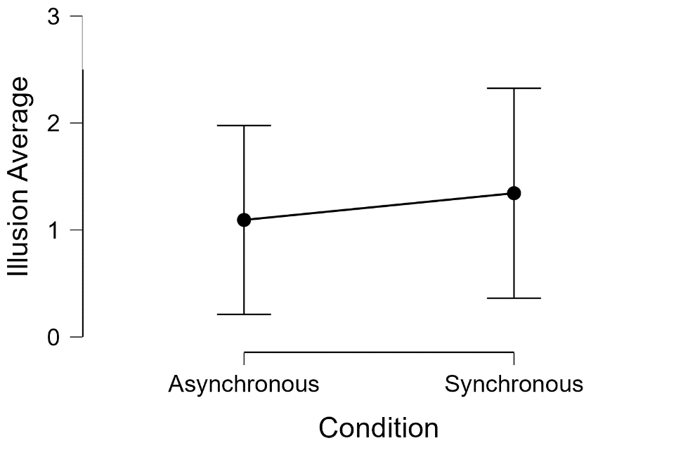
Pilot data regarding the efficacy of the illusion for both healthy and chronic pain patients undergoing synchronous and asynchronous illusory resizing of the index finger can be seen in figure C1. 16 participants (7 chronic pain, 9 healthy) had either synchronous or asynchronous multimodal manipulations delivered first in a random order, and were then given the other condition, after which all participants were given an illusion scale. Findings showed that across all participants, no significant difference in illusion experience between the synchronous and asynchronous conditions, t(15) = 0.525, p = 0.60, however as can be seen in figure C1, despite the small sample size, illusion strength was seen to be greater in the synchronous condition compared to the asynchronous condition.

Figure C1. Pilot data from Chronic Pain and Healthy Participants Undergoing Synchronous and Asynchronous Illusory Finger Resizing.

