Cerebral laterality as assessed by functional transcranial Doppler ultrasound in left-and right-handers: A comparison between handwriting and writing using a smartphone.

Abstract
Neuroscientific studies of traditional handwriting have revealed a left cerebral lateralization pattern for written language production, with distinct patterns between left- and right-handers. However, no study to date has investigated the cerebral lateralization of writing using a smartphone. Studying writing using a smartphone is important as more than 6 and a half billion mobile phone subscriptions were in place in 2022. In this pre-registration we present a forthcoming study which aims to compare the cerebral lateralization of handwriting and writing using a smartphone, and examine the effects of handedness. We will use functional trans-cranial Doppler ultrasound (fTCD), which allows for reliable measurements of cerebral laterality during written language. We hypothesize that there will be no difference in the cerebral lateralization between handwriting and writing using a smartphone after controlling for motor activity. We also hypothesize that left-handers will exhibit a weaker left-hemispheric lateralization when compared to right-handers for the linguistic part of writing using a smartphone. Findings will highlight the neural mechanisms underlying language production using novel technologies.
Keywords: cerebral language lateralization, functional transcranial Doppler ultrasound (fTCD), writing, smartphone typing, handedness
Word count: 6740
Cerebral laterality as assessed by functional transcranial Doppler ultrasound in left-and right-handers: A comparison between handwriting and writing using a smartphone.

INTRODUCTION
The majority of humans exhibit left cerebral lateralization during oral language production (Kherdr et al., 2002; Loring et al., 1990; Petit et al., 2020). This left cerebral lateralization pattern also manifests in written language production (Kondyli, et al., 2017; Menon & Desmond, 2001; Papadatou-Pastou et al., 2022; Planton et al., 2013). However, these findings on written language production predominantly derive from studies that employ handwriting tasks. Given the rising popularity of electronic devices, such as smartphones, for written communication, this approach may now be considered somewhat dated. To illustrate, over six and a half billion mobile phone subscriptions were in place in 2022 (Statista, 2023). In other words, despite the significant shift towards digital means of written language production, current neuroscientific literature doesn't reflect this change, with no study yet investigating cerebral laterality of language during writing using a smartphone.
The cerebral lateralization of written language has primarily been investigated using functional magnetic resonance imaging (fMRI). FMRI lends itself to the study of the neural substrates of oral language, but it poses an important limitation for the study of written language, namely the supine position required, which results in an unnatural way of writing (i.e., laying down and remaining still). Karimpoor et al. (2018) introduced an fMRI-compatible tablet that participants used to copy sentences, phone numbers, and grocery lists while lying in the fMRI machine and receiving visual feedback of their writing. This research was conducted as a proof-of-concept to test methods of assessing neurological impairments related to writing (such as those exhibited in Altzheimer’s disease), but the ecological validity of the method was not assessed. Subsequently, Baumann et al. (2022) assessed the ecological validity of writing in a tablet during fMRI experiments and reported a correlation between the handwriting movements during regular handwriting outside fMRI and the writing movements on the tablet inside fMRI. However, in this study, participants did not receive visual feedback while writing using the tablet, as they had to view task instructions instead (Baumann et al., 2022). These limitations, along with the high cost of operating the magnet, makes fMRI a non-optimal method of conducting writing experiments. Another technique, fTCD, is a reliable alternative to fMRI for studying cerebral lateralization (Bishop et al., 2009), including cerebral lateralization of written language (e.g., Kondyli et al., 2017). FTCD operates at a fraction of the cost and facilitates seated writing. FTCD works by positioning ultrasound probes over the temporal windows of the participants on either side of the head and to measure the blood flow velocity of the middle cerebral arteries (MCAs). Targeting the MCAs is appropriate as they supply blood to 50-70% of the cortex, including the areas subserving writing (Hirohiko et al., 1981; Kim et al., 2019). The difference in blood flow velocity between the left and the right MCA indicates which hemisphere is more activated during a cognitive task.
Written language was indeed recently investigated in two fTCD studies (Kondyli et al., 2017; Papadatou-Pastou et al., 2022). In Kondyli et al. (2017), 60 participants (31 left-handers) performed a written and a silent word generation task (WGT). In the WGT, participants were asked to produce words beginning with a cued letter. Comparing the cerebral lateralization index (LI) for written and silent WGT revealed that left-handers showed a greater difference between these two tasks than right-handers. One explanation is the existence of a more dispersed writing-specific language network in left-handers compared to right-handers. A limitation to that interpretation was the lack of a hand-motion control task. Papadatou-Pastou et al. (2022) addressed this limitation by introducing a symbol-copying task (repeatedly copying a cued symbol) which activated the motor but not the linguistic component of writing. The LI during that symbol-copying task was compared to the LI during a written WGT in 23 left- and 31 right-handers. The activation in the left hemisphere was significantly stronger during the WGT compared to the symbol-copying in right-handers but not in left-handers. These findings could be explained again by the language production network being more dispersed in left-handers, or by the greater variability in cerebral laterality patterns among left-handers compared to right-handers. Attentional demands (right-hemisphere activation; Shaw et al., 2009) of the novel symbol copying task offer another interpretation. Despite their limitations, these studies concluded that cerebral lateralization for written language shows a left-hemispheric dominance pattern similarly to oral language and that left-handers show a weaker and more dispersed lateralization pattern for written language compared to right-handers. It is important to stress that these findings were derived from studying handwriting.
Overall, no study to date has addressed the cerebral lateralization for written language using more modern, digital means of writing, such as typing on a smartphone screen. Writing using a smartphone (i.e., texting using the touch-screen smartphone keyboard) has similarities to handwriting, but it is a distinct skill. Handwriting is a complex process that involves (i) fine motor skills for letter formation and appropriate placement on the paper (e.g., Mangen & Velay, 2010), (ii) the integration of visual and sensory feedback (e.g., Mangen & Velay, 2010), and (iii) access to long-term memory where letter shapes are stored. In contrast, typing on a smartphone keyboard involves pressing the keys on the touch screen, which does require access to long-term memory for key configuration, but in this case letter formation is done automatically. It is worth noting that there are also distinct advantages of smartphone writing compared to traditional handwriting. For example, a positive application of smartphone keyboard technology came from Japan with the development of a 10-key layout, which allows users to type combinations of elements presented on the screen to write Japanese faster than handwriting the intricate Kanji characters on paper. Given the widespread adoption of smartphones for texting, the distinct characteristics of writing with the smartphone, and the possible advantages that smartphone writing has over handwriting, investigating writing using a smartphone seems worthwhile. Expanding our knowledge on language lateralization to address writing using a smartphone can provide insights into how the neurobiological basis of language functions compares between traditional means of writing and modern, digital means. As the literature on the overall neurobiological basis of writing using smartphones is very limited, studying the cerebral lateralization of written language production using smartphones indeed seems to be a good starting point. In addition, should the lateralization of handwritten language and writing using smartphones be found to be comparable, then the laterality of writing could be studied using smartphones, which allow for off-site data collection. Laterality data per se can be collected remotely, for example through remote EEG using EmotivPRO Builder (reference for EmoticPRO Builder) and EmotivLABS (Williams et al., 2023).
Consequently, handedness differences have not been previously studied in this specific context. Investigating handedness differences in the cerebral laterality of writing using a smartphone is important, as left-handers and right-handers are consistently found to differ in the cerebral organisation of other language functions, such as oral language production and comprehension (e.g., Knecht et al., 2000; Packheiser et al., 2020), but also in the context of written language via handwriting tasks, as discussed above (Kondyli et al., 2017; Papadatou-Pastou etal., 2022). Another reason why comparing left-handers to right-handers is deemed worthwhile in the context of the cerebral lateralization of writing, is that 90% of right-handers but only 70% of left-handers exhibit left-hemispheric language lateralization (Carey & Johnstone, 2014). An implication of that is that only 30% of left-handers (compared to 90% of right-handers) have their language processes located in the contra-lateral hemisphere to their writing hand (Carey & Johnstone, 2014), while limb movements are predominantly controlled by the contralateral hemisphere. Furthermore, left-handers account for approximately 10% of the population (Papadatou-Pastou et al., 2020), thereby necessitating consideration of their phenotypical variation to thoroughly understand the function of the human brain. Indeed, left-handers have been identified as a compelling and widely available, yet largely untapped, resource for neuroscientific studies (Willems, Van der Haegen, Fisher, & Francks, 2014). More recently, Bailey et al. (2020) quantified this observation, showing that only about 3% of participants in neuroimaging studies, from whom handedness data are available, are adextral. Bailey et al. (2020) thus also advocate for a more balanced consideration of handedness.
The present study aims to investigate the cerebral laterality of writing using a smartphone, by comparing it with the cerebral laterality of the best available benchmark task, namely handwriting. At present, there is no data available on other writing modalities. Oral language tasks, on the other hand, are not directly comparable due to differences like the absence of a motor component in oral language. Regardless, we here attempt to isolate the linguistic component of writing (both in the context of handwriting as well as in the context of typing in a smartphone screen), by using motor control tasks designed for the motor movement involved in each mode of writing. We expect that the language network underlying writing will be consistent across the two modes of writing and thus the cerebral lateralization during those tasks will not show significant differences. If our hypothesis is not supported, and we find differences between the lateralization of the two writing modes, then this could guide future studies using neuroimaging techniques with higher spatial resolution to localise the different networks subserving the linguistic component of the two writing modes. In addition, we aim to explore potential handedness differences in the cerebral laterality of writing using a smartphone.
We form the following hypotheses:
Hypothesis 1: There will be an absence of difference in the cerebral laterality of the linguistic component of writing as assessed during handwriting vs. writing using a smartphone.
Hypothesis 2: Right-handers will exhibit stronger left-hemispheric lateralization compared to left-handers for the linguistic part of writing using a smartphone.

MATERIALS & METHODS

Sampling plan
The initial sample size will be 40 healthy adult volunteers (20 left- and 20 right-handed, classified using the Edinburgh Handedness Inventory (EHI; Oldfield, 1971), which is an adequate size for counterbalancing between the four versions of presentation of the study’s material. We will implement a Bayesian approach in our analysis and our goal is to achieve a BF10 greater than 3 (or a BF10 smaller than 1/3) which corresponds to “moderate evidence” (M. D. Lee & Eric-Jan Wagenmakers, 2014), for both of our hypotheses. If this BF value is not reached in our initial sample, we will keep adding two participants in both handedness groups using the Sequential Bayesian Factor (SBF) with Maximal n design (Schönbrodt et al., 2017). This process will continue until our goal is reached or until a total of 80 participants have been recruited, given resource and time constraints, but also given that Schönbrodt et al. (2017) has shown that 24 participants in each group for an SBF Design is an average sample size free from wrong inference associated with false negative evidence, a sample size we will exceed with our maximum n. We will recruit the participants by advertising the study in social media and in our lab and project websites. An additional pool of participants will be recruited from the university in return for course credit (undergraduate and postgraduate students). Monetary incentives will not be provided. The criteria that we will use for the recruitment are as follows:
Inclusion Criteria
1. Participants will have to self-report as healthy adults with Greek as their only first language (absence of systematic exposure to any other language for their first 6 years), with normal or corrected-to-normal vision.
2. Ability to operate a smartphone keyboard using their thumb on their dominant hand. We will test this by having participants perform a word composition task using a smartphone keyboard and measure their Words Per Minute (WPM) typing speed. For this word composition task, participants will be given 60 seconds to write as many words as they can think of as fast and accurately as they can. The total amount of written words will be measured and this will be the WPM score of each participant. We will set a baseline of 12 WPM because that translates to three words in 15 seconds which is the time window that our participants will have during the experiment to compose words starting from the cue letter.
3. Participants will have an EHI score of 0-40% (left-handers) or 60-100% (right-handers).
Exclusion Criteria (self-reported)
1. History of dyslexia, dysgraphia, or other neurodevelopmental disorders.
2. Existing neurological problems or related issues affecting the normal function and mobility of the hands. Consumption of medication with the potential to affect the central nervous system in the last six months, current substance abuse, or current use of illicit drugs.

Assessment of linguistic lateralization
An agile headset that supports two 2-MHz robotic transducer probes of a Doppler ultrasonographic device that is commercially available (Delica EMS-9F), will be fitted on the participant, placed over both (left and right) temporal windows. The optimal depth for the ultrasonography of the MCAs is 45-56 mm, and we will adjust the angle of the probes for signal optimization. The PsychoPy software will be used for the presentation of the auditory (cueing tones) and visual (instructions and cueing letters) signals, and for sending the trigger marks from the ultrasonography device to annotate the beginning of each trial. After the experiment, the Doppler signal will be extracted as a spectral envelope at 125 Hz and saved as a text document for offline analysis.
The MATLAB-based toolbox, DOPOSCCI (https://github.com/nicalbee/dopStep; Badcock et al., 2012; Badcock et al., 2017), will be utilized to process the data. Unnecessary data will be trimmed from the start and the end of the recording. The beginning of each epoch will be 18 seconds prior to the cueing tone and continue for 36 seconds after the cueing tone. The heartbeat-related variability will be subtracted (Knecht et al., 1998; Meyer et al., 2014) by applying a linear correction (see Badcock et al., 2018). The cases of extreme values that exceed -3 to 4 standard deviations from the mean (assuming they are a byproduct of minor signal dropout that affects no more than 5% of the data) will be corrected by applying a linear interpolation from 1.5 seconds from either side of the value that was deemed extreme. The blood flow velocity values will be normalized to a mean equal to 100 for both the left and right channel at an epoch-by-epoch basis. Blood flow velocity values will be rejected for (i) being lower than 70% or higher than 130% of the mean or (ii) having an absolute difference between the left and right channel greater than or equal to 20% multiplied by the inter-quartile range of the individual, affecting 1% or more of the data. The data will then be baseline corrected (i.e., removing the average of the period before the cueing tone). Our period of interest (POI) will be between 7 and 24 seconds after the presentation of the cuing tone, as this is when we expect the maximum activation to take place based on neurovascular coupling. The last step is the averaging of the data and the calculation of the LI as the average difference between the left-minus-right channels within the POI.
Each trial includes the following (see Figure 1 for a schematic representation):
1. Relaxation period: A 35-second period where the Greek translation of the text “Try to clear your mind” will be displayed on a grey background. The start of this period will be accompanied by a cuing tone (440 Hz) with a duration of 0.5 seconds.
2. Preparatory period: A 5-second period starting with a second cueing tone (440 Hz, duration of 0.5 seconds) where no text is displayed on the screen. Participants will be prompted to use this pause to focus their attention on the forthcoming task.
3. Display of a cue letter: The screen will display a capital (Greek) letter (Arial font) in white color on a grey background for 2.5 seconds. The beginning of this phase will also trigger a marker from the computer that is used for stimuli presentation to the fTCD device for synchronization.
4. Word-generation/control-task period: A 15-second period that starts with the presentation of the cue letter (and includes the period that the cue letter is displayed) where the word generation/control task will take place.
For the word generation/control period, participants will be instructed to perform one task out of the following four (corresponding to the four conditions of the experiment):
1. “Handwriting”: Participants will be instructed to write as many words as possible that start with the cue letter using pen-and-paper.
2. “Handwriting Control”: Participants will be instructed to copy the cue letter as many times as possible. This will act as a control condition for the hand motion during handwriting.
3. “Typing”: Participants will be instructed to type as many words as possible that start with the cue letter by typing the keyboard of the smartphone using the thumb of their dominant hand.
4. “Typing Control”: Participants will be instructed to tap randomly on the smartphone keyboard using the thumb of their dominant hand after the cue letter is presented. This will act as a control condition for the hand motion during writing using a smartphone.
Figure 1
An fTCD task trial example
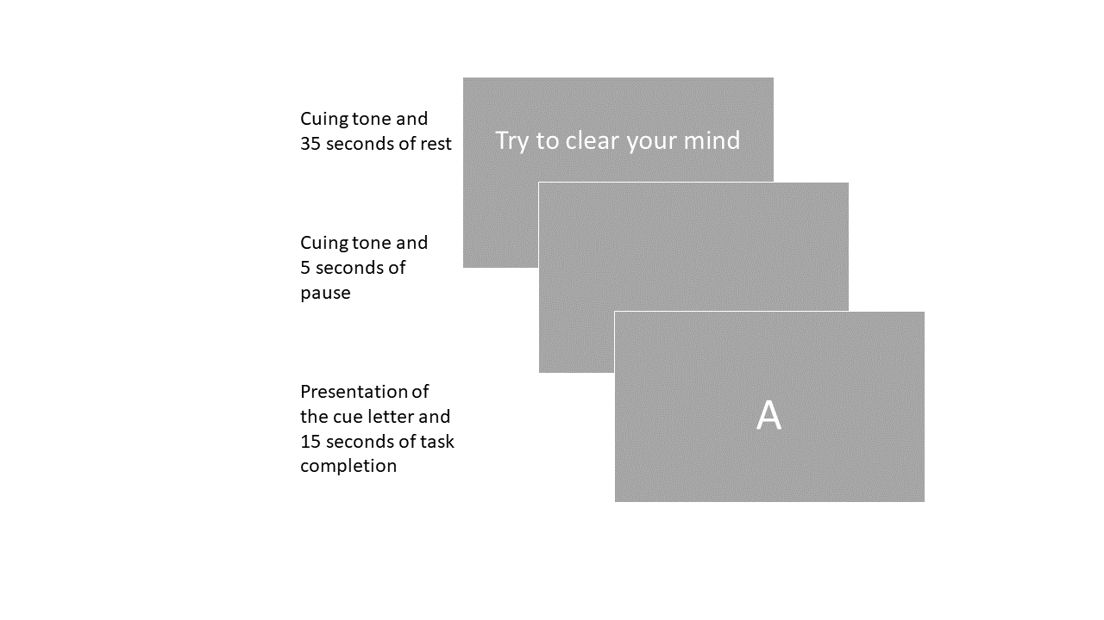
The “Typing” conditions will be performed on the same smartphone device in portrait orientation, which we will be providing to the participants. Intelligent entry techniques such as “autocomplete” and “autocorrect” will be turned off. The participants will be asked to hold the phone with their dominant hand and tap the keyboard using their thumb because this method parallels the single hand use that is present in handwriting.
For the word generation tasks (“Handwriting” and “Typing”), participants will be free to write in their accustomed way (using capital or lower-case letters, stressing the words or not). We will ignore misspellings for the purpose of calculating words per minute.
The experimental procedure will comprise 80 trials (two blocks of 40 trials, with a break between blocks). Each block will consist of 10 trials of each condition. The order of the trials will be the same for both blocks and will be randomly assigned for each participant, counterbalanced between participants. To simplify the procedure for the participant, “Handwriting” trials will always take place before or after the “Handwriting Control” trials and “Typing” will be before or after “Typing Control” trials.
Out of the 24 letters of the Greek alphabet, 20 letters will be used as cues (each presented once in every condition for a total of four times during the experiment) according to the pilot procedure that is described in Kondyli et al. (2017). These letters allow for the maximum number of words to be generated. The generated words will be recorded.
Six cerebral LIs will be calculated for each participant:
1. LI_handwriting corresponding to the “Handwriting” condition,
2. LI_handwriting_control corresponding to the “Handwriting Control” condition,
3. LI_handwriting_corrected corresponding to the cerebral LI for the linguistic component of handwriting (after hand motion correction; LI_handwriting - LI_handwriting_control),
4. LI_typing corresponding to the “Typing” condition, corresponding to the “Typing Control” condition, and
5. LI_typing_control corresponding to the “Typing Control” condition,
6. LI_typing_corrected corresponding to the cerebral LI for the linguistic component of writing on the smartphone (after hand motion correction; (LI_typing - LI_typing_control).
Participants will be excluded at this stage in the cases of:
1. Inadequate ultrasound penetration of the skull (determined as inability to get a working ultrasonography signal using our equipment, making the ultrasonography impossible),
2. Noisy data (in the cases where less than 10 out of the 20 epochs in each condition are accepted; i.e., less than 10 epochs that have cerebral blood flow volume values in the range of 70% to 130% of the mean velocity or an absolute left-minus right channel difference less than 20% multiplied by the inter-quartile range of the individual).
To address the reliability of our measures, we will:
(i) provide a scatterplot showing individual mean LIs for all six LIs with horizontal and vertical error bars denoting standard errors, following Bishop et al. (2021), in order to visually inspect reliability.
(ii) plot left and right hemisphere activation as a function of epoch time for all four tasks (namely Handwriting, Handwriting Control, Typing, Typing Control) as well as for the two difference scores (Handwriting minus Handwriting Control and Typing minus Typing Control), again following Bishop et al. (2021), to visually establish whether the maximum differences between left and right channels in different tasks are occurring at a similar time point.
(iii) perform a split-half reliability test separately for each task (namely Handwriting, Handwriting Control, and their difference score; Typing, Typing Control, and their difference score). If the correlation is below 60%, we will assume that our tasks are not suitable to show the effects of interest and not include these tasks in further analyses.

Assessment of handedness
The handedness categorization for our primary analysis will be conducted by self-report using the Greek version of the Edinburgh Handedness Inventory (Oldfield, 1971). Participants will indicate their hand preference in ten activities: throwing a ball; drawing; using scissors; holding a knife to carve meat; using a toothbrush; holding a spoon; striking a match; holding a broom (upper hand); and opening the lid of a box. Two more items will be included in the self-report (looking with the one eye and kicking a ball) which will not be part of the registered analysis but will be shared as raw data. For the above items, participants will be instructed to give one of the five possible responses regarding the limb or eye preference: “always left” (scoring 0 points), “usually left” (1 point), “no preference” (2 points), “usually right” (3 points), and “always right” (4 points). The points will be summed for each participant, divided by 40 (the maximum possible score), and multiplied by 100 to get a percentage score. The handedness LI ranges from 0% (extreme left-handedness) to 100% (extreme right-handedness). Participants will then be classified as left-handers (if their score is within the range of 0% to 49%) or right-handers (if their score is within the range of 50% to 100%).
Further handedness measures will also be collected and shared in our raw data set as they might be useful for future studies and/or meta-analyses. The reasoning behind this decision is based on large studies (e.g., Cornish & McManus, 1996; DeLisi et al., 2002; Gorynia & Müller, 2006; Groen et al., 2013) and meta-analyses (e.g., Papadatou-Pastou et al., 2020) that recommend the use of a comprehensive set of the handedness measures that includes both hand skill and hand preference assessments.
1. Hand Skill: Participants will perform the Annett’s pegboard task (Annett et al., 1979) to test their relative hand skill. The apparatus is a wooden 32 x 18 cm board consisting of two attached pieces, each having ten holes drilled in equal spaces across their length. The diameter of the holes will be 1.2 cm and the pegs (that will have to be inserted in the holes) will have a diameter of 1.0 cm and a length of 7.0 cm (see Figure 2 for a visual representation of the pegboard). To complete the task, the participants will have to move as quickly as possible all ten pegs from the upper row of the pegboard to the row closer to them using one hand at the time, starting from the side of the board ipsilateral to their operating hand. Every participant will begin the trial with their right hand and alternate between hands for a total of 6 repetitions (3 for each hand). In the instance that a peg is dropped, the participant will repeat the trial. Participants will be asked to remain silent during the trials because talking might interfere with their performance. We will use a stopwatch to manually record the time that each participant takes to complete each trial (from touching the first peg until releasing the last). The time in the 3 trials of each of the hands will be added to create the values RH (right hand) and LH (left hand). We will calculate a hand skill LI using the following formula: LI = [(LH-RH) / (LH+RH)]*100. A positive score will signify superior right hand skill, while a negative score will signify superior left-hand skill.
Figure 2
Picture of the wooden pegboard that will be used in our experiment.
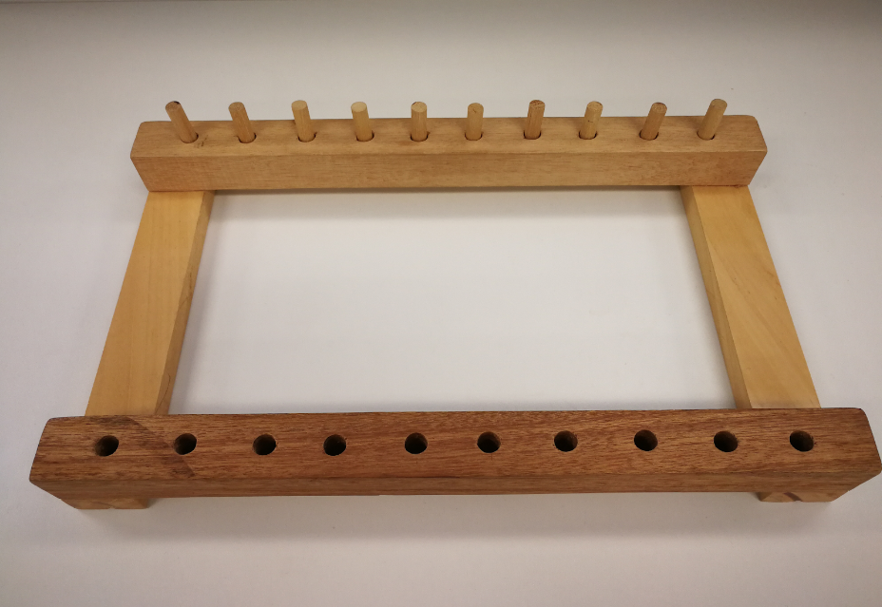
2. Hand Preference: We will observe (rather than rely on the self-report as per the EHI) the hand preference of the participants by having them perform the Quantification of Hand Preference Test (QHPT; Bishop et al., 1996). Seven locations will be set on a table, each at 40 cm from the midpoint (the spot on the table right in front of the participant) and at 30° from each other. Twenty-one cards will be placed on the table, three at each location (see Figure 3 for a schematic representation of the QHPT setup). Participants will stand in front of the table with their hands resting on their sides and will be instructed to pick up one named card at a time and place it in a box lying in front of them. The card order will be random but unchanged between the participants. We will record the hand used to pick up each card. The scoring for this task will be as follows: 2 points will be added if they use their right hand, 1 point if they change hands, and 0 points if they use their left hand to pick up a card. The actual score of the participant will be divided by the maximum score (42) and multiplied with 100 to get a percentage, which will be their hand preference LI. The range for this score will be 0-100% with a value of 0% signifying extreme left-handedness and 100% signifying extreme right-handedness. A binary classification will proceed with participants being characterized as left-handers if they have a score of 0-49% and as right-handers if they have a score of 50-100%.
Figure 3
Representation of the spatial planning of the Quantification of Hand Preference Task (QHPT).
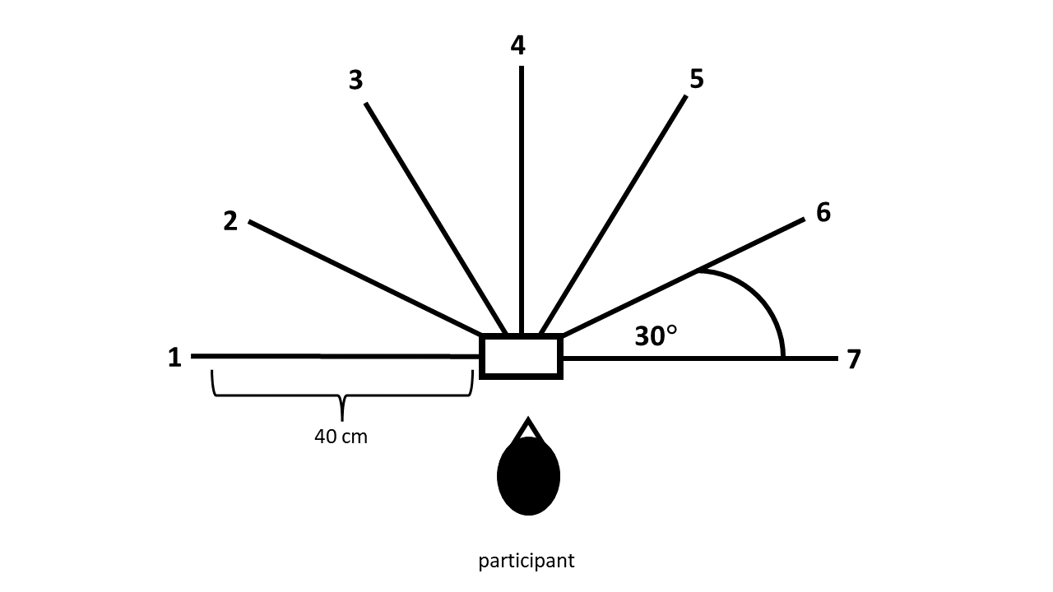

Procedure
The initial screening will be conducted through an online questionnaire, sent to individuals who express an interest in participation (to confirm normal vision, absence from illicit drug use, etc.). Three days before participation, an information document will then be shared with participants to provide adequate time for them to decide upon participating. Upon arrival at the test site, we will explain the study to the participants and answer any questions. Following this, participants will give their written informed consent and will be explicitly told that they are free to leave at any time without providing a reason. The study will take place in a quiet room where participants will be seated in front of a computer and will be handed a smartphone (the same for all participants) to perform the word composition task. We will then proceed with adjusting the fTCD probes and the participants will be given a choice to watch the first few minutes off a movie during this process. We will then proceed with the data collection. After the first 40 trials (10 in each condition) participants will take a break during which we will collect the handedness measures. Then, participants will resume with the second (and final) 40 trials. We will then debrief the participants about the study.

Analysis Plan
Hypothesis 1: There will be no difference in the cerebral laterality during handwriting vs. writing using a smartphone after hand motion correction (linguistic component). To test Hypothesis 1, we will perform a Bayesian dependent samples t-test for the LI_handwriting_corrected and LI_typing_corrected. The prior chosen for the t-test will be a Cauchy distribution with a 0.707 width parameter, corresponding to a “medium” effect size according to Morey et al., (2011).
Hypothesis 2: Left handers will exhibit a weaker left-hemispheric lateralization when compared to right-handers for the linguistic part of writing using a smartphone (after hand motion correction). To test hypothesis 2, we will perform a Bayesian independent samples t-test for LI_typing_corrected between left- and right-handers. The Bayes Factor will represent the likelihood of the alternative hypothesis (the linguistic components of writing differ between the handedness groups) over the null. The prior chosen for the t-test will be a half-Cauchy distribution (Rouder et al., 2009) with a width parameter of 0.94 (Schmalz et al., 2021) which is equal to Cohen’s d for the lateralization difference of the linguistic component of writing (implementing a symbol-copying condition as a control to writing words) between left- and right-handers in Papadatou-Pastou et al. (2022).
LI measurement reliability: The consistency of the measurement of the lateralization indices across trials was verified using Spearman correlation of the mean LI of each task type (LI_{oral}, LI_{words}, LI_{letters}, and LI_{difference}) between odd and even trials (Bishop et al., 2021). In order to ensure that we were able to estimate any level of reliability, we assigned equal probability to all possible correlations. Therefore, the priors for the Spearman correlations were described by Beta(1,1) distributions, which corresponded to uniform distributions with equal probabilities for all values between 0 and 1.
Data Availability Statement
Material, data, and analysis code (with accompanying text) will be publicly available at the open data repository “Open Science Framework” (osf.io). This will include the raw fTCD data, the handedness data, as well as the MATLAB and R [MPP1] scripts that will be used for the pre-processing of the data and the subsequent statistical analyses that will be performed on them.
Conflict of Interest Statement
Authors declare no conflict of interest.

Question | Hypothesis | Sampling plan | Analysis Plan | Rationale for deciding the sensitivity of the test for confirming or disconfirming the hypothesis | Interpretation given different outcomes
Does cerebral lateralization during writing change if writing is performed in different mediums? I.e., will cerebral lateralization during handwriting and during writing using a smartphone be different? | Cerebral laterality during handwriting is not different from writing with a smartphone | Initial sample of 40 healthy adult volunteers (20 left- and 20 right-handed). If we do not achieve “moderate evidence” in favour or against our hypothesis (represented by a Bayes Factor greater than 3 (or lower than 1/3 respectively) for our initial sample, we will recruit 2 more participants for each group using the sequential Baysian Factor with Maximal n design until the target Bayes Factor is achieved, or we reach the upper limit of 80 participants due to time and resource constraints. | Bayesian dependent samples t-test for the LI_typing_corrected. The prior chosen for the t-test will be a Cauchy distribution with a 0.707 width parameter. | Evidence is expected to be in favour of the null hypothesis. The chosen prior corresponds to a “medium” effect size (Morey et al., 2011). | Evidence in favour of the null hypothesis that cerebral lateralization shows a similar pattern between the two modes of writing will indicate that the medium of writing does not affect the lateralization pattern of the linguistic component of written language. Evidence in favour of the alternative hypothesis will indicate that writing using a smartphone keyboard results in a different cerebral lateralization pattern compared to handwriting.
Is the greater left-hemispheric lateralization found for oral language processes in right- compared to left-handers also going to be present for the language processes during writing using a smartphone? | Right-handers will exhibit stronger left-hemispheric lateralization compared to left-handers for writing using a smartphone. |  | Bayesian independent samples t-test for LI_typing_corrected between left- and right-handers. The Bayes Factor will represent the likelihood of the alternative hypothesis over the null. The prior chosen for the t-test will be a half-Cauchy distribution (Rouder, Speckman, Sun, Morey, & Iverson, 2009) with a width parameter of 0.94 (Schmalz, Manresa, & Zhang, 2021). | The width parameter for the prior is equal to Cohen’s d for the lateralization difference of the linguistic component of writing (implementing a symbol-copying condition as a control to writing words) between left- and right-handers in Papadatou-Pastou et al. (2022). | Evidence in favour of the null hypothesis would indicate that no difference in lateralization exist between right-and left-handers, indicating that handedness does not affect cerebral lateralization during typing. Evidence in favour of the alternative would indicate that right-handers show a greater left cerebral lateralization compared to left-handers, which would be consistent with the lateralization results from the literature on handwriting.

REFERENCES
Annett, J., Annett, M., Hudson, P. T. W., & Turner, A. (1979). The control of movement in the preferred and non-preferred hands. The Quarterly Journal of Experimental Psychology, 31(Pt 4), 641–652. https://doi.org/10.1080/14640747908400755
Badcock, Nicholas. A., Holt, G., Holden, A., & Bishop, D. V. M. (2012). dopOSCCI: A functional transcranial Doppler ultrasonography summary suite for the assessment of cerebral lateralization of cognitive function. Journal of Neuroscience Methods, 204(2), 383–388. https://doi.org/10.1016/J.JNEUMETH.2011.11.018
Badcock, Nicholas. A., Spooner, R., Hofmann, J., Flitton, A., Elliott, S., Kurylowicz, L., … Keage, H. A. D. (2017). What box: A task for assessing language lateralization in young children. Https://Doi.org/10.1080/1357650x.2017.1363773, 23, 391–408. https://doi.org/10.1080/1357650X.2017.1363773
Badcock, Nicholas. A., Spooner, R., Hofmann, J., Flitton, A., Elliott, S., Kurylowicz, L., … Keage, H. A. D. (2018). What Box: A task for assessing language lateralization in young children. Laterality, 23(4), 391–408. https://doi.org/10.1080/1357650X.2017.1363773
Bailey, L. M., McMillan, L. E., & Newman, A. J. (2020). A sinister subject: Quantifying handedness‐based recruitment biases in current neuroimaging research. European Journal of Neuroscience, 51(7), 1642-1656.
Baumann, A., Tödt, I., Knutzen, A., Gless, C. A., Granert, O., Wolff, S., … Zeuner, K. E. (2022). Neural correlates of executed compared to imagined writing and drawing movements: A functional magnetic resonance imaging study. Frontiers in Human Neuroscience, 0, 105. https://doi.org/10.3389/FNHUM.2022.829576
Bishop, D. V. M., Ross, V. A., Daniels, M. S., & Bright, P. (1996). The measurement of hand preference: A validation study comparing three groups of right-handers. British Journal of Psychology, 87(2), 269–285. https://doi.org/10.1111/J.2044-8295.1996.TB02590.X
Bishop, D. V. M., Watt, H., & Papadatou-Pastou, M. (2009). An efficient and reliable method for measuring cerebral lateralization during speech with functional transcranial Doppler ultrasound. Neuropsychologia, 47(2), 587–590. https://doi.org/10.1016/j.neuropsychologia.2008.09.013
Bishop DVM, Grabitz CR, Harte SC et al. Cerebral lateralisation of first and second languages in bilinguals assessed using functional transcranial Doppler ultrasound [version 2; peer review: 2 approved, 1 not approved]. Wellcome Open Res 2021, 1:15 (https://doi.org/10.12688/wellcomeopenres.9869.2)
Carey, D. P., & Johnstone, L. T. (2014). Quantifying cerebral asymmetries for language in dextrals and adextrals with random-effects meta analysis. Frontiers in Psychology, 5(NOV), 1128. https://doi.org/10.3389/fpsyg.2014.01128
Chilosi, A. M., Bulgheroni, S., Turi, M., Cristofani, P., Biagi, L., Erbetta, A., … Cioni, G. (2019). Hemispheric language organization after congenital left brain lesions: A comparison between functional transcranial Doppler and functional MRI. Journal of Neuropsychology, 13(1), 46–66. https://doi.org/10.1111/JNP.12128
Cornish, K. M., & McManus, I. C. (1996). Hand preference and hand skill in children with autism. Journal of Autism and Developmental Disorders 1996 26:6, 26(6), 597–609. https://doi.org/10.1007/BF02172349
DeLisi, L. E., Svetina, C., Razi, K., Shields, G., Wellman, N., & Crow, T. J. (2002). Hand preference and hand skill in families with schizophrenia. Http://Dx.doi.org/10.1080/13576500143000294, 7(4), 321–332. https://doi.org/10.1080/13576500143000294
Deppe, M., Knecht, S., Papke, K., Lohmann, H., Fleischer, H., Heindel, W., … Henningsen, H. (2000). Assessment of hemispheric language lateralization: A comparison between fMRI and fTCD. Journal of Cerebral Blood Flow and Metabolism, 20(2), 263–268. https://doi.org/10.1097/00004647-200002000-00006
Gorynia, I., & Müller, J. (2006). Hand skill and hand–eye preference in relation to verbal ability in healthy adult male and female right-handers. Laterality, 11(5), 415–435.
Groen, M. A., Whitehouse, A. J. O., Badcock, Nicholas. A., & Bishop, D. V. M. (2013). Associations between handedness and cerebral lateralisation for language: A comparison of three measures in children. PLoS ONE, 8(5), e64876. https://doi.org/10.1371/journal.pone.0064876
Hirohiko, G., Carver, C., C., Rhoton, A., L., Lenkey, C., & Mitchell, R., J. (1981). Microsurgical anatomy of the middle cerebral artery. Journal of Neurosurgery, 54(2), 151–169. https://doi.org/10.3171/jns.1981.54.2.0151
Karimpoor, M., Churchill, N. W., Tam, F., Fischer, C. E., Schweizer, T. A., & Graham, S. J. (2018). Functional MRI of handwriting tasks: A study of healthy young adults interacting with a novel touch-sensitive tablet. Frontiers in Human Neuroscience, 12, 30. https://doi.org/10.3389/fnhum.2018.00030
Kherdr, E. M., Hamed, E., Said, A., & Basahi, J. (2002). Handedness and language cerebral lateralization. European Journal of Applied Physiology, 87(4-5), 469–473. https://doi.org/10.1007/s00421-002-0652-y
Kim, D. E., Park, J. H., Schellingerhout, D., Ryu, W. S., Lee, S. K., Jang, M. U., … Bae, H. J. (2019). Mapping the supratentorial cerebral arterial territories using 1160 large artery infarcts. JAMA Neurology, 76(1), 72–80. https://doi.org/10.1001/jamaneurol.2018.2808
Knecht, S., Deppe, M., Ebner, A., Henningsen, H., Huber, T., Jokeit, H., & Ringelstein, E. B. (1998). Noninvasive determination of language lateralization by functional transcranial Doppler sonography: A comparison with the Wada test. Stroke, 29(1), 82–86. https://doi.org/10.1161/01.STR.29.1.82
Knecht, S., Dräger, B., Deppe, M., Bobe, L., Lohmann, H., Flöel, A., Ringelstein, E. B., & Henningsen, H. (2000). Handedness and hemispheric language dominance in healthy humans. Brain, 123(12), 2512–2518. https://doi.org/10.1093/BRAIN/123.12.2512
Kondyli, D., Stathopoulou, D., Badcock, Nicholas. A., & Papadatou-, M. (2017). Language in male and female right- and left- handers: a functional transcranial doppler ultrasound study. Acta Neuropsychologica, 15(4), 407–432.
Lee, B. (2021). Comparing writing vs. Smartphone tapping speed. JALTCALL Publications, PCP2020, 78. https://doi.org/10.37546/jaltsig.call2020.6
Lee, M. D., & Eric-Jan Wagenmakers. (2014). Bayesian Cognitive Modeling: A Practical Course. https://doi.org/https://doi.org/10.1017/CBO9781139087759
Loring, D. W., Meador, K. J., Lee, G. P., Murro, A. M., Smith, J. R., Flanigin, H. F., … King, D. W. (1990). Cerebral language lateralization: Evidence from intracarotid amobarbital testing. Neuropsychologia, 28(8), 831–838. https://doi.org/10.1016/0028-3932(90)90007-B
Mangen, A., & Velay, J.-L. (2010). Digitizing literacy: Reflections on the haptics of writing (3rd ed., Vol. 1, pp. 386–402). InTech.
Mazoyer, B., Zago, L., Jobard, G., Crivello, F., Joliot, M., Perchey, G., … Tzourio-Mazoyer, N. (2014). Gaussian mixture modeling of hemispheric lateralization for language in a large sample of healthy individuals balanced for handedness. PLOS ONE, 9, e101165. https://doi.org/10.1371/JOURNAL.PONE.0101165
Menon, V., & Desmond, J. E. (2001). Left superior parietal cortex involvement in writing: integrating fMRI with lesion evidence. Cognitive Brain Research, 12(2), 337–340. https://doi.org/10.1016/S0926-6410(01)00063-5
Meyer, G. F., Spray, A., Fairlie, J. E., & Uomini, N. T. (2014). Inferring common cognitive mechanisms from brain blood-flow lateralization data: A new methodology for fTCD analysis. Frontiers in Psychology, 5(JUN), 552. https://doi.org/10.3389/FPSYG.2014.00552/BIBTEX
Morey, R. D., & Rouder, J. N. (2011). Bayes factor approaches for testing interval null hypotheses. Psychological Methods, 16(4), 406–419. https://doi.org/10.1037/a0024377
Oldfield, R. C. (1971). The assessment and analysis of handedness: The edinburgh inventory. Neuropsychologia, 9, 97–113. https://doi.org/10.1016/0028-3932(71)90067-4
Packheiser, J., Schmitz, J., Arning, L., Beste, C., Güntürkün, O., & Ocklenburg, S. (2020). A large-scale estimate on the relationship between language and motor lateralization. Scientific Reports 2020 10:1, 10(1), 1–10. https://doi.org/10.1038/s41598-020-70057-3
Papadatou-Pastou, M., Ntolka, E., Schmitz, J., Martin, M., Munafò, M. R., Ocklenburg, S., & Paracchini, S. (2020). Human handedness: A meta-analysis. Psychological Bulletin, 146(6), 481–524. https://doi.org/10.1037/bul0000229
Papadatou-Pastou, M., Sampanis, P., Koumzis, I., Stefanopoulou, S., Sousani, D., Tsigkou, A., & Badcock, Nicholas. A. (2022). Cerebral laterality for writing in right- and left- handers: A functional transcranial Doppler ultrasound study. bioRxiv, 2020.07.14.203588. https://doi.org/10.1101/2020.07.14.203588
Petit, S., Badcock, Nicholas. A., & Woolgar, A. (2020). Finding hidden treasures: A child-friendly neural test of task-following in individuals using functional Transcranial Doppler ultrasound. Neuropsychologia, 146, 107515. https://doi.org/10.1016/J.NEUROPSYCHOLOGIA.2020.107515
Planton, S., Jucla, M., Démonet, J. F., & Soum-Favaro, C. (2017). Effects of orthographic consistency and word length on the dynamics of written production in adults: psycholinguistic and rTMS experiments. Reading and Writing, 32(1), 115–146. https://doi.org/10.1007/s11145-017-9776-7
Planton, S., Jucla, M., Roux, F., & Cortex, J. D. (2013). The “handwriting brain”: a meta-analysis of neuroimaging studies of motor versus orthographic processes. Elsevier.
Potgieser, A. R. E., Van Der Hoorn, A., & De Jong, B. M. (2015). Cerebral activations related to writing and drawing with each hand. PLoS ONE, 10(5). https://doi.org/10.1371/journal.pone.0126723
Rouder, J. N., Speckman, P. L., Sun, D., Morey, R. D., & Iverson, G. (2009). Bayesian t tests for accepting and rejecting the null hypothesis. Psychonomic Bulletin and Review, 16(2), 225–237. https://doi.org/10.3758/PBR.16.2.225
Roux, F. E., Dufor, O., Giussani, C., Wamain, Y., Draper, L., Longcamp, M., & Démonet, J. F. (2009). The graphemic/motor frontal area exner’s area revisited. Annals of Neurology, 66, 537–545. https://doi.org/10.1002/ANA.21804
Samsouris, C., Badcock, N. A., Vlachos, F., Phylachtou, P., Papadatou-Pastou, M., (2022). Cerebral lateralization during handwritten and typed word generation: A functional transcranial Doppler ultrasound study in left- and right-handers. European Journal of Neuroscience (Stage 1 Register Report with In Principal Acceptance). https://osf.io/9qmge/?view_only=62cd4305f2d24ea8aae8810bb659e407
Schmalz, X., Manresa, J. B., & Zhang, L. (2021). What Is a Bayes Factor? Psychological Methods. https://doi.org/10.1037/MET0000421
Schönbrodt, F. D., Wagenmakers, E. J., Zehetleitner, M., & Perugini, M. (2017). Sequential hypothesis testing with Bayes factors: Efficiently testing mean differences. Psychological Methods, 22(2), 322–339. https://doi.org/10.1037/met0000061
Segal, E., & Petrides, M. (2012). The anterior superior parietal lobule and its interactions with language and motor areas during writing. European Journal of Neuroscience, 35(2), 309–322. https://doi.org/10.1111/j.1460-9568.2011.07937.x
Somers, M., Aukes, M. F., Ophoff, R. A., Boks, M. P., Fleer, W., Visser, K. (C ).L. de, … Sommer, I. E. (2015). On the relationship between degree of hand-preference and degree of language lateralization. Brain and Language, 144, 10–15. https://doi.org/10.1016/J.BANDL.2015.03.006
Somers, M., Neggers, S. F., Diederen, K. M., Boks, M. P., Kahn, R. S., & Sommer, I. E. (2011). The measurement of language lateralization with functional transcranial doppler and functional MRI: A critical evaluation. Frontiers in Human Neuroscience, 0(MARCH), 31. https://doi.org/10.3389/FNHUM.2011.00031/BIBTEX
Statista Research Department (2023). Number of smartphone subscriptions worldwide from 2016 to 2022, with forecasts from 2023 to 2027. Retrieved from https://www.statista.com/statistics/330695/number-of-smartphone-users-worldwide/
Tam, F., Churchill, N. W., Strother, S. C., & Graham, S. J. (2011). A new tablet for writing and drawing during functional MRI. Human Brain Mapping, 32(2), 240–248. https://doi.org/10.1002/hbm.21013
Williams, N. S., King, W., Mackellar, G., Randeniya, R., McCormick, A., & Badcock, N. A. (2023). Crowdsourced EEG experiments: A proof of concept for remote EEG acquisition using EmotivPRO Builder and EmotivLABS. Heliyon, 9(8), e18433. https://doi.org/10.1016/J.HELIYON.2023.E18433
Willems, R. M., der Haegen, L. V., Fisher, S. E., & Francks, C. (2014). On the other hand: including left-handers in cognitive neuroscience and neurogenetics. Nature Reviews Neuroscience, 15(3), 193-201.

