Gaming Disorder:
A qualitative meta-synthesis of related case studies

Stage 1 RR, v2

Tiina Auranen ^{1*, **}, Matus Adamkovič ^{1, 2, 3, **}, Marcel Martončik ^{1,2} , Solip Park ^{1,4},
Valtteri Kauraoja ¹, Miia Siutila ^{1,5}, Yaewon Jin ^{1,6}, & Veli-Matti Karhulahti ¹

* Corresponding author: tiina.m.auranen@jyu.fi
** First authorship shared.

1 University of Jyväskylä
2 Slovak Academy of Sciences
3 Charles University
4 Aalto University
5 University of Turku
6 The Game and Science Institute

Abstract
Several meta-analyses and reviews have been published on gaming-related health problems, which are today studied mainly in the context of the World Health Organization’s new mental disorder construct, “gaming disorder”. However, none of those reviews have focused on the problems reported by individuals seeking treatment. The present study synthesizes such evidence from case studies, case reports, and case series of treatment-seekers for gaming-related health problems. First, using deductive coding, the study will synthesize problems, reasons for seeking help, as well as the potential causal links between gaming and the reported problems. Second, a thematic synthesis will be applied to construct themes regarding the contexts of the individuals and the reported problems. A sensitivity analysis based on the level of informativeness of the studies will be carried out. Lastly, the study will assess how well the reported problems and their contexts align with the Coping model, Value fulfillment theory and the Theory of cultural dissonance.
KEYWORDS: gaming disorder, qualitative, meta-synthesis, case study, treatment, review

Introduction
Video games have become one of the dominant forms of pastime around the world in recent years. Research has suggested that gaming may be beneficial in many regards: for relaxation and stress reduction (Snodgrass et al. 2011), social health (Kowert et al. 2015), decreasing loneliness and social anxiety (Martončik & Lokša 2016) and general well-being (Johannes et al. 2021), as well as carrying several other benefits in the cognitive, motivational, emotional and social domains (Granic et al. 2014). On the other hand, concerns have been raised by parents and health professionals over gaming that seems excessive or interfering with other life areas (UNICEF 2017).
Being a subject of study since the 1980’s, gaming-related health problems have been described in numerous terms, e.g., compulsive Internet use (van Rooij et al. 2010), online gaming addiction (Charlton & Danforth 2007), problematic online game use (Kim & Kim 2010) and problem video game playing (King et al. 2011; Salguero & Moran 2002). The multitude of descriptions gives a preliminary idea of differences of opinion in the field (Ferguson & Colwell 2020). Included as a stand-alone diagnosis in the World Health Organization’s (WHO) International Classification of Diseases (ICD-11) since 2019, gaming disorder (offline or online) is today conceptualized as follows: a pattern of persistent or recurring gaming behavior described by impaired control over gaming, increasing priority given to gaming that is taking precedence over other life interests and daily activities, and continuation or escalation of gaming despite negative consequences. The current Diagnostic and Statistical Manual of Mental Disorders (DSM-5-TR 2022), in turn, proposes nine symptoms: preoccupation, loss of control, tolerance, withdrawal, deceiving about the behavior, and jeopardizing important relationships or perspectives by continuing the behavior despite negative consequences.
Both the ICD-11 and DSM-5-TR based concepts have been challenged for multiple reasons, including ambiguous definitions, a scarcity of multidisciplinary and person-centered perspectives, and methodological weaknesses in published studies (see Smart 2019 for a summary). The main criticism has been directed at the criteria used by both diagnostic systems (e.g., Aarseth et al. 2017; Bean et al. 2017; Billieux et al. 2015), especially for their origins in the research on gambling and substance use. While neurobiological parallels have been found between some problematic gamers and those with substance-related disorders (Kuss et al. 2018), questions have been raised about the “addictive” elements in gaming-related problems (e.g., Kardefelt-Winther 2016). Moreover, problematic behavioral patterns associated with gaming might also be conceptualized through other mental health issues (Shaffer et al. 2004, Taipale 2017, West & Brown 2013).
It is important to note that mental disorder categories are not natural kinds, namely, their inclusion and exclusion criteria are social constructs that evolve and alter over time. Of the many relevant terms introduced above, in the rest of this study we use two. First, we use the term “gaming disorder” when specifically referring to the diagnosis in the ICD-11. Second, we use the term “gaming-related health problems” when generally referring to the phenomenon outside of the ICD-11 diagnosis. This operationalisation is also visible in the title of this article: although the work primarily contributes to the current research paradigms of gaming disorder, our historical approach will also be inclusive to relevant findings that were made before the formalization of the diagnosis. In other words, we are not only interested in cases that would qualify as “gaming disorder” today, but all cases of “gaming-related health problems” that have qualified for medical attention in the past and over time that contributed to the formation of the gaming disorder diagnosis.
Despite the recurring occurrence of new addictive behaviors with distinct diagnostic criteria and prevalence figures (Baggio et al. 2018), few theoretically sound models exist and there is no consensus regarding which ones are useful (Billieux et al. 2015; Karhulahti et al. 2023b). Kardefelt-Winther (2014a; 2014b; 2017) and Snodgrass et al. (2014) have been at the forefront to suggest gaming-related problems to serve as coping strategies—also known as the self-medication hypothesis in substance use psychiatry (Khantzian, 1997). This idea of compensatory use bears resemblance to Taipale’s (2017) efforts to rephrase “addictive” behaviors: what is wanted from an addictive “object” is a modification of one’s potentialities, and therefore addictive behavior is a form of assisted self-regulation.
Alternatively, gaming problems have been interpreted as responses to childhood attachment issues (Schimmenti et al. 2012; 2014) or disorders of impulse control (Starcevic & Aboujaoude 2017). Karhulahti et al. (2023c) investigated 110 adults’ reasons for seeking treatment for their gaming problems and found five main sources of problems: addictive experiences being but one next to social, existential, and practical reasons as well as general wish for support. These miscellaneous reasons may at least partially reflect the conflicts that players have with local cultural values or the values of their own.
The conflicts that players have with their local cultural values have been addressed through at least two theoretical frames. Within the first frame, addictive behaviors are perceived through “harmful dysfunction” (e.g., Amendola 2023; Wakefield 2020), which entails the presence of harm as a conflict with social values, and the presence of dysfunction as a failure to perform tasks relevant to everyday survival and thriving (e.g., Wakefield 1992). In the harmful dysfunction model, a conflict with local cultural values is not sufficient for psychopathological diagnosis, but explicit dysfunction is required as well. The second theoretical frame for perceiving the local conflict is the “cultural dissonance” model, which originates from medical anthropology (see Dressler 2022) and has been recently developed especially by Snodgrass et al. (e.g., 2011; 2014; 2021). In the cultural dissonance frame, ‘addiction’ serves as a means to resolve the paradox where a person subjectively values gaming but the society does not—‘addiction’ is also applied without dysfunction, if both the individual and society so decide.
To our knowledge, the conflicts that players experience with gaming and their own values have not been modelled theoretically yet, but promising directions have been opened. In our own phenomenological work (Karhulahti et al. 2022), we found treatment-seekers describing their experiences of disorder to derive from gaming interfering with what they want to be, do, and have throughout life. In post hoc analysis, we see this finding consistent with the recently emerging “value fulfillment theory”, which defines well-being as the degree to which an individual is able to fulfill their values (e.g., DeYoung & Tiberius, 2023). In other words, if a player’s well-being is the fulfillment of their psychologically integrated values, and gaming (or what it demands) is in conflict with those values, it is possible to conceptualize the related disorder or problem as a value fulfillment conflict.

Although the worldwide prevalence of gaming disorder has been estimated in meta-analyses at around 3% (Stevens et al. 2021; Ferguson et al. 2011), the use of varied methodological approaches significantly affects comparability of prevalence studies (Mihara & Higuchi 2017; Stevens et al. 2021). First, problems arise from basing inferences on samples that consist of selected populations such as children (Carbonell 2017) and thus are poorly representative. Second, numerous scales have been used to measure gaming behaviors (King et al. 2020). These different measures tend to identify different groups, suggesting the existence of multiple ontologically different underlying constructs instead of a single “gaming disorder” (Karhulahti et al. 2023a). As an example of this, using criteria that describe highly engaged players (e.g., cognitive salience, tolerance, and euphoria) versus those describing pathological ones is known to result in significantly different prevalence rates (Charlton 2002, Charlton & Danforth 2007, Kuss et al. 2017, Wood 2008).
In comparison with most psychiatric diagnoses, gaming disorder—or gaming-related health problems more generally—still has a relatively short history. The research community is still far from unanimous on what these problems are (Aarseth et al. 2017, Griffiths et al. 2016). As the gaming disorder diagnosis entails ‘significant distress and impairment’, researchers owe it to the billions of players and their close ones worldwide to form a clearer understanding of what is known about the manifestations of such distress. This study aims to shed more light on the issue by synthesizing the extant evidence on problems and their context as reported in cases of gaming treatment-seekers.
Present Study
Although it is beyond the present methodology to systematically review the entire field of gaming disorder research, almost all peer reviewed article publications (we estimate more than 95%) are driven by quantitative or statistical methods. Based on searches in PubMed (February 2024), no less than 228 meta-analyses (including umbrella reviews; e.g., Colder Carras et al. 2020) and/or reviews (including narrative reviews) have already been published on gaming disorder (with an alternative search word “game addiction”). We were, however, able to find but one review focusing on qualitative findings (Douglas et al. 2008), and the focus of this meta-synthesis was on the diverse types of “internet addiction” (reviewing 10 articles), thus addressing gaming-related problems only tangentially.

Despite the lack of focus on qualitative and case studies, review authors often select one or more such publications as examples of clinical evidence. For example, Kuss & Griffiths (2012) cite a few qualitative studies in two sentences, whereas a review that aims to understand the underlying cognitive psychology of the disorder (King & Delfabbro 2014) cites one case study in the limitations. In an influential review provided by a group of clinicians and researchers convened via the WHO (Saunders et al. 2017), likewise, a few selected case reports are mentioned—e.g., one where “prolonged sitting at computer” was the direct cause of death (Lee 2004)—but it remains unclear how representative these selected cases are of the gaming disorder construct.

Considering the present situation, there is a dire need for a systematic review of qualitative research on gaming disorder, at least for three major reasons. First, reviewing the existing qualitative research will significantly help draw a more detailed picture of the evidence for gaming disorder beyond studies that draw quantitative and theoretical inferences. Second, with reference to the WHO expert group’s recent call for “phenomenological and qualitative work conducted in treatment-seeking gamers” (Castro-Calvo et al. 2022), a systematic review of previous qualitative work can significantly contribute not only to the current conceptualization of gaming disorder but also its historical understanding. Finally, and perhaps most importantly, reviewing qualitative evidence can help us improve the state of art regarding gaming disorder as a construct by assessing the (latent) entity in the light of actual treatment-seeking contexts. To make these contributions in this study, we focus on case studies of people with gaming-related problems, and ask:

RQ1.1: What are participants’ reported problems in case studies concerning gaming-related problems?
RQ1.2: What are the reported reasons for people to seek help for their gaming?
RQ1.3: What are the reported causal links between gaming and reported problems?
RQ2: What is the context of these individuals/problems?
RQ3: How do the outcomes of RQ1 and RQ2 differ between studies of high and low levels of informativeness?

Methodology
Because the vast diversity of qualitative methods easily leads to methodological review challenges, the present study will focus on case studies, case reports, and case series alone. This decision establishes a clear focus on detailed descriptions of individual treatment-seeking cases, which is the main function of case-based publication types. The review aims to answer our RQs by using two parallel coding approaches: deductively driven coding that will assess the relevant content of publications by predefined categories (RQ1), and thematic synthesis that will yield new, inductive themes regarding context (RQ2). Sensitivity analysis is carried out for the results overall (RQ3). We explain both approaches in more detail below.
In this study, our epistemology is a mix of critical and semi-positivist knowledge. We value objectivity as an epistemic scientific goal but simultaneously believe that both the reviewed studies and our own review of them can be meaningfully influenced by the implicit positions of researchers. Therefore, we code the researcher positions reported in the reviewed studies and make coder views regarding the controversial topic of gaming-related health problems visible too (https://ore.jyu.fi/english/our-team). Our ontology, in turn, is socially pragmatic: we do not believe that gaming disorder ‘exists’ as a natural concept but it is rather a social construct that is currently in psychiatric use in some cultural contexts for practical purposes. More generally, our work follows a pragmatist philosophy of science (Chang 2023) and its ‘epistemic iteration’ where:
“successive stages of knowledge are created, each building on the preceding one, in order to enhance the achievement of certain epistemic goals. In each step, the later stage is based on the earlier stage but cannot be deduced from it; later developments often correct and refine the presuppositions made in the earlier stage” (p. 208)
In line with these epistemological and ontological positions, our goal is to contribute to the ongoing iterative ‘reconstruction’ of knowledge regarding gaming disorder and its related (previous) concepts—ultimately to make such knowledge useful in theory and practice.
Search
The focal constructs of this review are “gaming-related health problems,” some of which have recently acquired an official diagnostic status as “gaming disorder.” To account for similar terms (including MeSH suggestions), the search string includes:
“gaming disorder” OR “problematic gaming“ OR “problematic play*” OR “pathological play*” OR “pathological gaming” OR “disordered gaming” OR “disordered play“ OR “addictive play*“ OR “addictive gaming” OR “gaming addiction” OR “gaming dependency” OR “game addiction” OR “game dependency” OR “excessive gaming” OR “excessive play*” OR “problematic play*” OR “heavy gami*” OR “heavy game*” OR “internet addiction”
The term “internet addiction” is used additionally due to gaming disorder having been historically studied as such (e.g., Young 1998). As this review focuses on case studies, case reports, and case series, the terms mentioned above are coupled with “case”. The searches will be focused on titles, abstracts, and key words provided by the authors.
Forward and backward citation searches will be carried out on eligible studies. If we find an additional relevant study outside this systematic search, it will be added to the review. To be included as relevant, case studies, reports, and series must address problems related to gaming (playing video games), especially health problems (mental, social, physical) but not excluding other problems that may not fit the domain of health (e.g., overspending). The only exclusion criterion is that a study only reports gambling problems without problems related to non-gambling video games. Following the ICD-11, we define gambling as the act of wagering real-world money or its virtual equivalent on outcomes that are at least partly determined by randomness outside of a player’s control, with the intention of earning a monetary reward.
The literature search will be carried out in Web Of Knowledge Core Collection, Scopus, and PubMed. The search will be limited to peer-reviewed articles, peer-reviewed conference proceedings, and case studies which are published as letters or editorials (i.e., it will not include monographs, dissertations, preprints, or non-peer-reviewed conference proceedings) written in English, Finnish, Korean, or Slovak language. The eligible studies need to be explicitly framed as case studies or examinations of particular cases. We will exclude (1) instances which are merely detailed descriptions of selected participants in a larger qualitative dataset, as well as (2) studies that apply any systematic method to a dataset, such as thematic or content analyses, unless they are explicitly framed as case studies, reports, or series.
All the records found either by using the systematic search, forward/backward citation search, or studies found outside the systematic search will first be checked for duplicates. The study-related data and abstracts will be imported to Rayyan (Ouzzani et al. 2016), in which the initial (title and abstract) screening will be carried out by two independent coders (MA & TA) blinded to each other’s decisions. None of the studies will be excluded unless agreed upon by both coders (in case of disagreement, an additional coder will be consulted). Studies for which we will be unable to obtain the full text through database search or direct request from the corresponding author (including a gentle reminder after two weeks) will be excluded after three weeks of waiting. The process of study selection is depicted in Figure 1.
Figure 1. Study search and selection flowchart
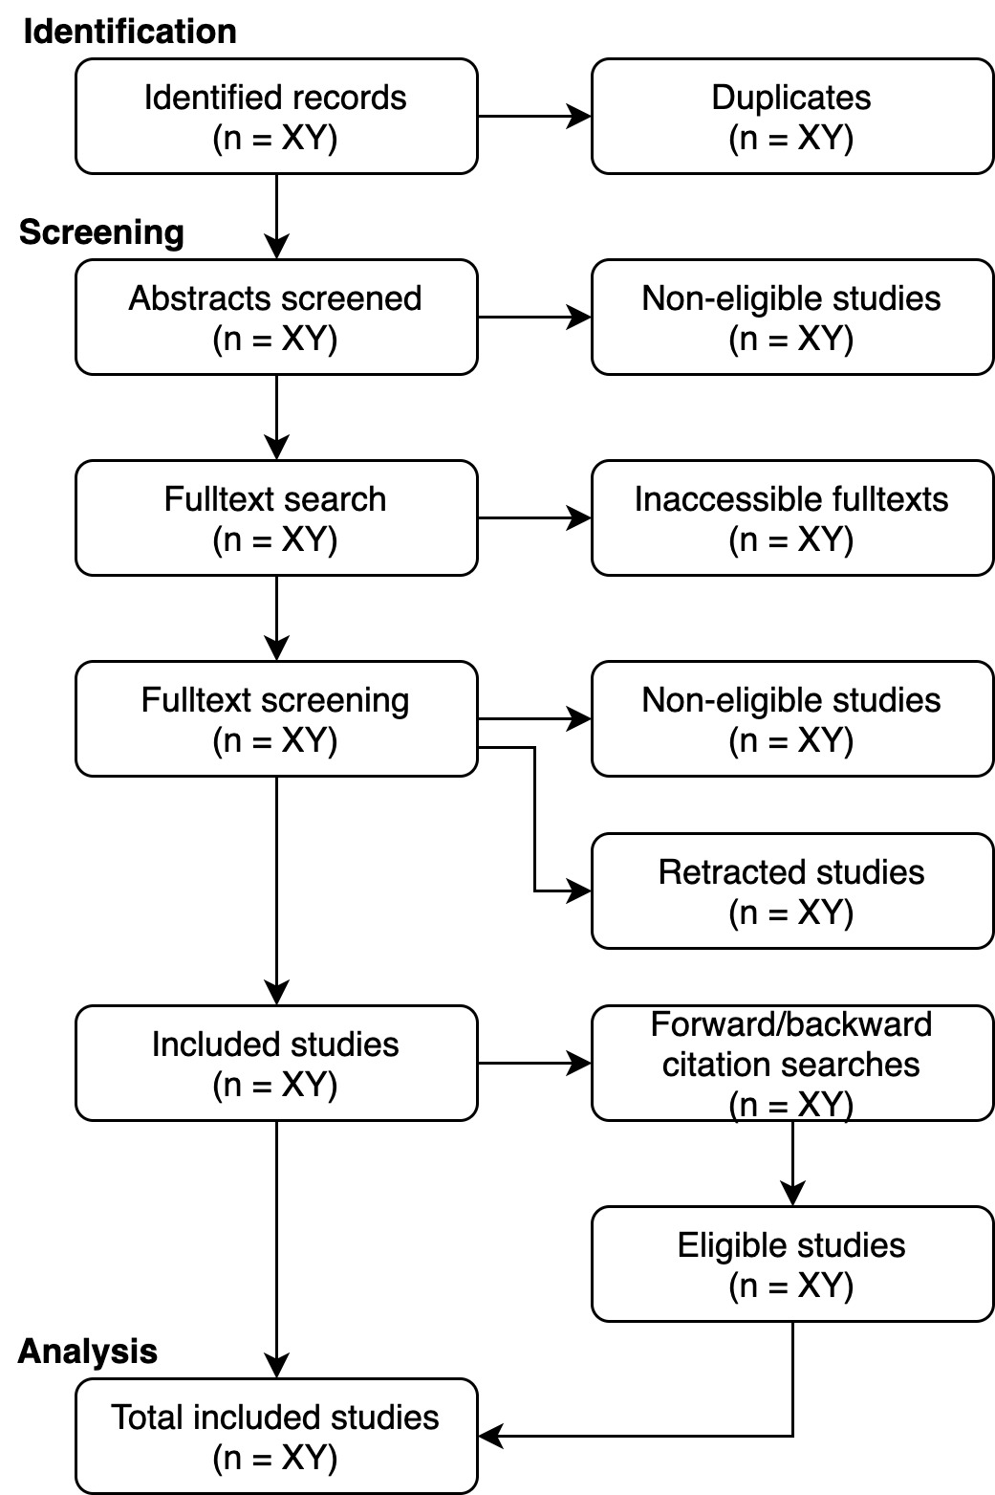
We will not constrain the search historically. The inclusion of the entire spectrum of the available literature ensures that the evolution of gaming-related health problems over time will be captured, minimizing potential biases caused by time as a confounding factor. For instance, in the 1980’s merely spending considerable time on video games was deemed unusual, perhaps enough to warrant a case study. However, in the contemporary context, the bar for what is considered sufficiently peculiar to qualify for a case study publication has evolved significantly due to the normalization of gaming and the discourse around gaming disorder.

Coding workflow
The coding plan was generated by iteration in two pilot rounds where three independent members of the team applied the draft sheet for two randomly selected case studies (Ng et al. 2003; Sattar & Ramaswamy 2004). The team met and updated the coding sheet based on feedback from both rounds until agreement. The coding was agreed to be conducted in three phases: (P1) coding of primary studies, (P2) synthesis of higher-order information, and (P3) sensitivity analysis. Each phase involves a deductive (D/RQ1) and inductive (I/RQ2) part. The team held two collective training sessions to synchronize the process of coding and theme generation, and to familiarize themselves with the three theories described below. An overview of the coding workflow is depicted in Figure 2, while a scheme of the whole analytic workflow is presented in Figure 3.
Figure 2. An overview of the coding workflow
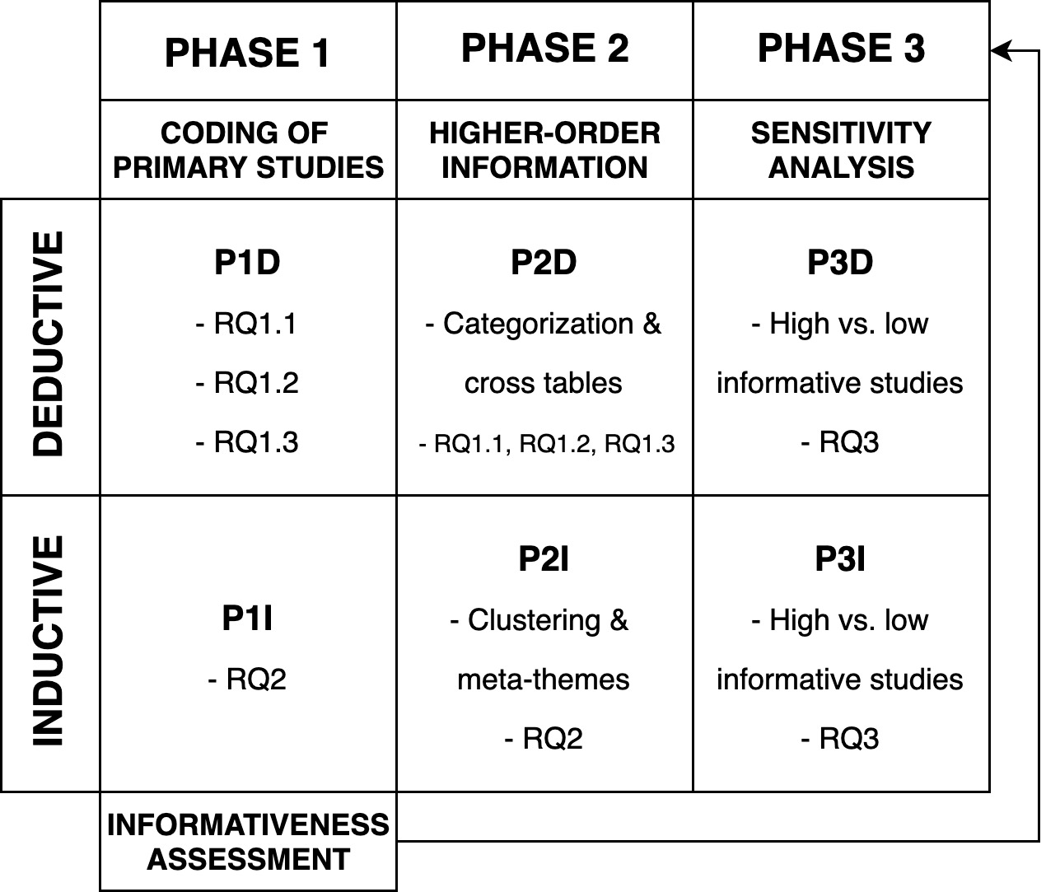

Complete coding information with instructions is attached (Supplement 1). In P1D, primary studies will be coded by extracting (copy-pasting) the following information.
- RQ 1.1: Reported description of the problem with information whether the problem is identified by the participant, clinician, or original authors
- RQ 1.2: Reported reasons for seeking help
- RQ 1.3: Reported causal link between gaming and the problems

Additionally, the coders will collect bibliographic information and meta-data (reported COIs, number of citations), description of the case (demographic characteristics; comorbidity; exclusion of hazardous gaming and bipolar disorder, played games, online vs. offline gaming, and dominant gaming device), positive effects of gaming on the case, informativeness scores (see below), and how the study authors nosologically position the case (according to DSM, ICD, or other). The coders will finally assess whether the reported problem(s) and their context fit

- the coping model by which we refer to the idea that gaming-related problems manifest primarily as an outcome of earlier, underlying problems, for which gaming serves as an ameliorating means (e.g., Kardefelt‐Winther, 2017).
- the value fulfillment theory, by which we refer to the idea that well-being is defined by the degree to which an individual is able to fulfill their values (e.g., DeYoung & Tiberius, 2023).
- the theory of cultural dissonance, which here refers to the conflict between gaming and cultural values, and the subsequent attempts to minimize such conflicts (e.g., Snodgrass et al., 2021). We also code whether dysfunction was present to generate evidence also in the light of the harmful dysfunction model (e.g., Wakefield, 1992).

All coders familiarize themselves with the theories by reading articles on each theory and discussing them collectively to form a consensus view. We stress that theoretical assessment is exploratory and does not aim to answer any RQ. However, we plan to discuss these findings in relation to the themes that answer RQ2—especially regarding cultural differences—in order to assess to what degree the potential thematic findings overlap with them.

P2D, in turn, continues with the above copy-pasted sections identified as codes. In this second deductive phase, such codes are further clustered by a new pair of coders into existing and potentially new categories, as explained below.

- RQ 1.1: The identified problem descriptions are given five predefined categories. Physical, mental, and social health are selected based on the WHO’s three core areas of health, in addition to which problems related to occupational performance and finances are selected due to the strong current evidence for them to be common problem types in relation to video games (as listed in ICD-11; Kleinman & Das 2020). Problems not fitting to any of these categories will be classified as “other” and an extra category will be created if there are at least three instances of that new problem type.
- RQ 1.2: The identified reasons for help seeking are categorized by eleven predefined categories (social compliance, social improvement, resolvement of lost meaning in gaming, resolvement of lost meaning in life, amelioration of performance harms, amelioration of health harms, amelioration of financial harms, change of behavior, acknowledgement of problems, interaction and experiences sharing, gaining guidance) based on an earlier study (Karhulahti et al. 2023c), which explicitly aimed to identify such reasons. If an extracted reason is outside the scope of the predefined themes, it will be categorized into “other”. Reasons not fitting to any of these categories will be classified as “other” and an extra category will be created if at least three such instances occur.
- RQ 1.3: The identified descriptions of causality (or lack thereof) will be categorized by three classes: gaming reported as the sole cause of problems, gaming reported as one of the causes of problems, and gaming reported as a consequence of problems. These three categories are based simply on available logical possibilities, as the lack of any reported link between the two would not lead to a relevant case study. However, descriptions not fitting to any of these categories will be classified as “other” and an extra category will be created if at least three such instances occur.

To answer RQ1, we use descriptive reporting with cross tables in the results section. These results will be accompanied with the coding outcomes of variables that are not part of RQ1.

In P1I, thematization will be carried out to identify related contextual factors. As a thematization method, we follow the established tradition of thematic synthesis (Thomas and Harden 2008), which is based on reviewing text line by line, constructing descriptive themes, and generating analytical themes. Accordingly, the coders will

- RQ 2.0: code all contextual factors from the case studies by highlighting relevant lines in PDF text documents, after which turning them into descriptive thematic whole(s) and refining them, in the end, into complete analytic themes. For the present purposes, we define “contextual” as any type of relevant information linked to the participant’s culture, gaming, life, or problems, as reported in the published case. Such analytic contextual themes should not repeat coded information but add depth or dimensions to them. In P2I, two new coders will synthesize all identified contextual themes into 3–6 meta-themes, which represent the overall literature.

Our rationale for choosing thematic synthesis is its ability to retain an explicit link to the primary research in a transparent manner: it is a fairly linear and modular method, which corresponds well with case-based reporting and is applicable to exploring the potential role for theories (Booth et al., 2016), such as those discussed above. Furthermore, thematic synthesis allows reviewing studies independent of their epistemology or thickness of data (Booth et al., 2016), which is important for case publications that often represent “thin” qualitative data and would be difficult to synthesize, for instance, by means of meta-ethnography. Finally, it is worth adding that thematic synthesis is a suitable method for producing findings that directly inform practitioners (Thomas & Harden, 2008).

Ultimately, P3D and P3I will serve as a sensitivity analysis and will be based on the informativeness scores obtained in P1D. Given the specifics of the present research and the available risk of bias assessment tools (e.g., Joanna Briggs Institute 2017; Joanna Briggs Institute 2020; Lewin et al. 2015; Noyes et al. 2019), we decided to develop a new tool for assessing informativeness of case studies for the purposes of meta-reviews and syntheses. The tool is inspired by the available tools and provides an effective way to assess informativeness in each case study based on these relevant areas:
- Coherence between investigation and interpretations
  - Reported information is not coherent with provided interpretations (1)
  - There are mostly weak links between reported information and provided interpretations (2)
  - There are both weak and strong links between reported information and provided interpretations (3)
  - Reported information is mostly coherent with provided interpretations (4)
  - Reported information is fully coherent with provided interpretations (5)
- Demographic characteristics, personal history, and context clearly described
  - Only basic information (e.g., age and gender) about the participant and their biographical or sociocultural historical context is provided (1)
  - In addition to basic information, some relevant history or context (e.g., social relationships) is described about the participant (2)
  - Relevant context about the participant is described, but there are clear contextual gaps that could easily explain reported problems (3)
  - Almost all relevant historical and contextual information is provided (4)
  - All relevant historical and contextual information is provided (5)
- Behavior (gaming) and related problems clearly described
  - Both behavior (gaming) and problems are described very vaguely (1)
  - Either behavior (gaming) or problems are described very vaguely (2)
  - Both behavior (gaming) and problems are described sufficiently but critical information that could further explain the case is lacking (3)
  - Both behavior (gaming) and problems are described well but some information that could further explain the case is lacking (4)
  - Both behavior (gaming) and problems are described in detail (5)
- Positionality clearly described
  - There is no information about the backgrounds, beliefs, or views of the authors and experts whose interpretations are reported (1)
  - There is basic information (e.g., clinical specialization) about some authors and experts whose interpretations are reported (2)
  - There is basic information (e.g., clinical specialization) about all authors and experts whose interpretations are reported (3)
  - Deep relevant positionality (e.g., related beliefs) is given for some authors and experts whose interpretations are reported (4)
  - Deep relevant positionality (e.g., related beliefs) is given for all authors and experts whose interpretations are reported (5)
- Transparent reporting principles considered
  - It is unclear how the data were obtained, selected, and the origin of reported information (1)
  - There is some transparency about the data and reporting process, e.g. personal communication by the authors and participant (2)
  - Data sources and the role of each author in their generation or interpretation are mostly clear (3)
  - Data sources and the role of each author in their generation or interpretation are clear, and there are supplementary materials (4)
  - Data sources and the role of each author in their generation or interpretation are clear, and the data are available for reuse (5)
The informativeness level will be assessed by each of the three coders in Phase 1. For each study, informativeness will be reported as a summary score from 5 to 25.
- RQ3: Scores by all three rates will be averaged. If a difference of 3 or more points occurs between raters, discrepancy is resolved during the collective discussion with the facilitator. Sensitivity analysis will be carried out in order to compare the studies with the lowest informativeness scores with the studies with the highest informativeness scores (50% threshold). Phase 2 is completely rerun with low and high scoring studies forming independent groups.
All the above tasks associated with the coding will be done by eight people (all authors of the study) divided into three independent work teams to prevent biases that could occur during the transfer process between the phases. Team 1 will consist of four people. The team will be responsible for data extraction in Phase 1. Each eligible study will be analyzed by three coders, which are randomly selected from the team of four. The coders will work independently. The workload will be equally distributed across coders so that each author will code the same number of studies, with the caveat that the number of identified studies may lead some authors to code one study less. If we find Finnish studies, coders will be selected from our four Finnish authors. Korean and Slovakian studies will be coded only by two authors with native language expertise. Team 2 will consist of two people who will be responsible for all the Phase 2 coding. Because this section operates with existing codes, there is less labor and half of the size of Team 1 was considered optimal. The coders will work independently. Team 3 will comprise two people whose job will be to facilitate the discussions within each phase. Both facilitators will be present at all the discussions in Phase 1. With the facilitator’s help, the coders will qualitatively compare their reports, discuss and resolve the disagreements for RQ1.1, RQ1.2, and RQ1.3. In Phase 2, the facilitators will help collectively synthesize themes, which will be reported as the main output of RQ2. Any major discrepancies will be succinctly reported within the results section. Full versions of the reports of the specific coders will be available in supplementary material.

Figure 3. A scheme of the analytic workflow
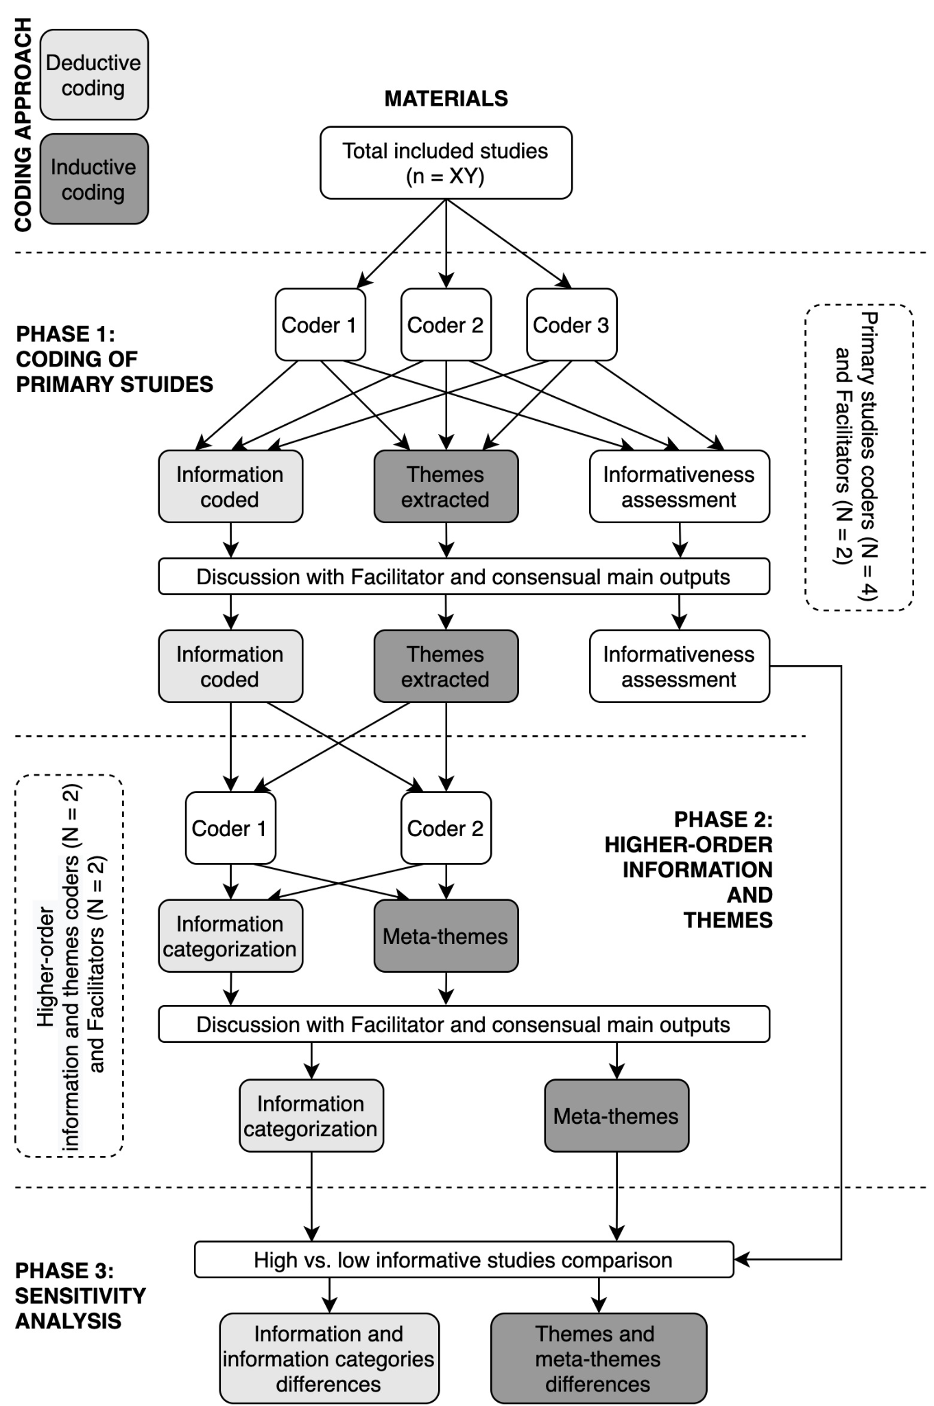
Para-exploratory analysis

In addition to the research question and methods described above, which are non-confirmatory by nature, we will conduct analyses that we label explicitly as para-exploratory. We will use a large language model (LLM) to carry out all the phases of the coding process. Specifically, we plan to feed GPT-4 (its most recent version available at the time; or another LLM we deem the most appropriate for the task) with the eligible papers, prompting it to extract information related to RQ1 and conduct a thematic analysis related to RQ2. Additional prompts and fine-tuning might be necessary, and we will maintain a detailed record of the chat history. We aim for a balanced trade-off between deterministic and creative data processing by GPT-4. Accordingly, the temperature setting will be set to 1. This analysis will only commence after registering the results of the aforementioned analysis, ensuring that the research team's work is unaffected by the model’s findings. In the main paper, we will briefly summarize the outputs from GPT-4, while the full results will be included in the supplementary materials. This approach could unveil themes potentially overlooked by human coders and will serve as a primer for exploring the use of LLMs in qualitative text analysis.

As there might be heterogeneity in gaming-related health problems across different play styles, we will also carry out two additional sensitivity analyses. In the first analysis, we will examine how the outcomes of RQ1 and RQ2 differ between cases where video games are played predominantly online and offline. Because online video games were not widely available before the high-speed internet and wireless networks in the 2000s, this analysis can also yield results that are historically informative. In the second additional analysis, we will assess how the outcomes of RQ1 and RQ2 differ between cases that report gaming predominantly on domestic devices (e.g., computer, console) and portable devices (e.g., mobile phone, handheld). These sensitivity analyses will be limited to cases with a clear distinction and conducted only if at least three instances are identified in each subgroup.

For descriptive purposes (in addition to thematic considerations), we code all named gaming titles, their genre distribution, as well as gaming motives and styles (see Supplement 1 for details). We will also code the country/region of each study and whether that information is explicitly reported as the location of the participant(s) or inferred from the authors’ institutions.

Lastly, to control for negativity bias (see Baumeister et al., 2001), we will investigate the positive effects of gaming reported in the case studies. We will then divide them into two categories: (1) positive effect (e.g., cognitive benefits, social skills, education and learning); (2) enjoyment (e.g., entertainment, relaxation, achievement, community belonging).

Limitations

We pre-identified two main limitations of the present meta-synthesis. (1) Case studies typically represent instances that are notable for their rarity, peculiarity, or novelty within a specific time and cultural context. Despite their inherent bias (e.g., a high risk of selection bias and low certainty of evidence), case reports remain a valuable resource for guiding medical literature due to their unique insights. To alleviate the effects of selection bias, our review encompasses the relevant case studies without any time restrictions, incorporating historical context to provide a more comprehensive understanding of gaming-related health problems (some of which in the current scientific era are diagnosed as gaming disorders in certain cultures). For instance, health issues related to gaming identified in the 1980s have been well-documented over the decades, leading to the publication of more novel and specific case reports in recent times. Secondly, this study does not generalize the case findings to represent the entire spectrum of possible cases. Instead, we infer only about the published body of case reports. (2) A better understanding of gaming-related health problems necessitates considering the wide diversity of gaming practices as well as health expressions across different cultures. Ideally, our synthesis would have been enriched by including studies published in various languages besides English, Finnish, Korean, and Slovak. By making our methodology and coding sheet publicly available, we encourage researchers from other cultural and linguistic backgrounds to investigate case studies published in their languages and build upon our findings.

Funding statement

Funded by the European Union (ERC, ORE, 101042052). Views and opinions expressed are however those of the author(s) only and do not necessarily reflect those of the European Union or the European Research Council. Neither the European Union nor the granting authority can be held responsible for them. The study was supported by project PRIMUS/24/SSH/017 and by the Slovak Research and Development Agency under contract no. APVV-22-0458.

Conflicts of Interest

VMK is one of the PCI Registered Reports recommenders. Salaries received in the past four years from game companies: YJ received salaries from Riot Games Korea from 2019 to 2021. Stocks owned in game companies: YJ owns stocks in Netmarble, Nexon Games. For historical transparency, more than a decade ago VMK was one of the co-founders and developers of the IGDB website, which is an open online database for various types of game knowledge. VMK never received salaries for that work, but when the website was turned into a company, he became a co-shareholder until a merger four years ago (2019) and has not been involved since. Non-financial interests: some authors have personal gaming histories and hobbies, which are documented as positionality statements: https://ore.jyu.fi/english/our-team. We also wish to make it transparent that our team is actively negotiating with gaming companies to establish research collaborations with the industry. We also work with various health professionals and organizations in research collaboration.

References
Aarseth, E., Bean, A. M., Boonen, H., Colder Carras, M., Coulson, M., Das, D., Deleuze, J., Dunkels, E., Edman, J., Ferguson, C. J., Haagsma, M. C., Helmersson Bergmark, K., Hussain, Z., Jansz, J., Kardefelt-Winther, D., Kutner, L., Markey, P., Nielsen, R. K. L., Prause, N., Przybylski, A., Quandt, T., Schimmenti, A.,Starcevic, V., Stutman, G., van Looy, J.,& van Rooij, A.J. (2017). Scholars’ open debate paper on the World Health Organization ICD-11 Gaming Disorder proposal. Journal of Behavioral Addictions, 6(3), 267–270. https://doi.org/10.1556/2006.5.2016.088
Amendola, S. (2023). Commentary on Karhulahti et al. (2022): Exploring gaming disorder from the harmful dysfunction analysis perspective. Addiction Research & Theory, 31(3), 168-169. https://doi.org/10.1080/16066359.2023.2173743
Baggio, S., Starcevic, V., Studer, J., Simon, O., Gainsbury, S. M., Gmel, G., & Billieux, J. (2018). Technology-mediated addictive behaviors constitute a spectrum of related yet distinct conditions: A network perspective. Psychology of Addictive Behaviors, 32(5), 564–572. https://doi.org/10.1037/adb0000379
Baumeister, R. F., Bratslavsky, E., Finkenauer, C., & Vohs, K. D. (2001). Bad is stronger than good. Review of General Psychology: Journal of Division 1, of the American Psychological Association, 5(4), 323–370. https://doi.org/10.1037/1089-2680.5.4.323
Bean, A. M., Nielsen, R. K. L., van Rooij, A. J., & Ferguson, C. J. (2017). Video game addiction: The push to pathologize video games. Professional Psychology: Research and Practice, 48(5), 378–389. https://doi.org/10.1037/pro0000150
Billieux, J., Schimmenti, A., Khazaal, Y., Maurage, P., & Heeren, A. (2015). Are we overpathologizing everyday life? A tenable blueprint for behavioral addiction research. Journal of Behavioral Addictions, 4(3), 119–123. https://doi.org/10.1556/2006.4.2015.009
Booth, A., Noyes, J., Flemming, K., Gerhardus, A., Wahlster, P., van der Wilt, G. J., Mozygemba, K., Refolo, P., Sacchini, D., Tummers, M., & Rehfuess, E. (2016). Guidance on choosing qualitative evidence synthesis methods for use in health technology assessments of complex interventions.
Carbonell, X. (2017). From Pong to Pokemon Go, catching the essence of the Internet Gaming Disorder diagnosis: Commentary on: Chaos and confusion in DSM-5 diagnosis of Internet Gaming Disorder: Issues, concerns, and recommendations for clarity in the field (Kuss et al.). Journal of Behavioral Addictions, 6(2), 124–127. https://doi.org/10.1556/2006.6.2017.010
Castro‐Calvo, J., King, D. L., Stein, D. J., Brand, M., Carmi, L., Chamberlain, S. R., ... & Billieux, J. (2021). Expert appraisal of criteria for assessing gaming disorder: An international Delphi study. Addiction, 116(9), 2463-2475. https://doi.org/10.1111/add.15411
Chang, H. (2023). Realism for Realistic People. Cambridge University Press.
Charlton, J. P. (2002). A factor-analytic investigation of computer ‘addiction’ and engagement. British Journal of Psychology, 93, 329–344.
Charlton, J. P., & Danforth, I. D. W. (2007). Distinguishing addiction and high engagement in the context of online game playing. Computers in Human Behavior, 23(3), 1531–1548.
Colder Carras, M., Porter, A. M., Van Rooij, A. J., King, D., Lange, A., Carras, M., & Labrique, A. (2018). Gamers’ insights into the phenomenology of normal gaming and game “addiction”: A mixed methods study. Computers in Human Behavior, 79, 238–246. https://doi.org/10.1016/j.chb.2017.10.029
Conry-Murray, C., Waltzer, T., DeBernardi, F. C., Fossum, J. L., Haasova, S., Matthews, M. S., O'Mahony, A., Moreau, D., Baum, M. A., Karhulahti, V-M., Paterson, H. M., McSweeney, K., & Elsherif, M. M. (2023) (preprint). Validity and transparency in quantifying open-ended data. https://osf.io/preprints/psyarxiv/86y9f
DeYoung, C. G., & Tiberius, V. (2023). Value fulfillment from a cybernetic perspective: A new psychological theory of well-being. Personality and Social Psychology Review, 27(1), 3-27.
Douglas, A. C., Mills, J. E., Niang, M., Stepchenkova, S., Byun, S., Ruffini, C., Lee, S. K., Loutfi, J., Lee, J.-K., Atallah, M., & Blanton, M. (2008). Internet addiction: Meta-synthesis of qualitative research for the decade 1996–2006. Computers in Human Behavior, 24(6), 3027–3044. https://doi.org/10.1016/j.chb.2008.05.009
Ferguson, C. J., & Colwell, J. (2020). Lack of consensus among scholars on the issue of video game “addiction”. Psychology of Popular Media, 9(3), 359–366. https://doi.org/10.1037/ppm0000243
Ferguson, C. J., Coulson, M., & Barnett, J. (2011). A meta-analysis of pathological gaming prevalence and comorbidity with mental health, academic and social problems. Journal of Psychiatric Research, 45(12), 1573–1578. https://doi.org/10.1016/j.jpsychires.2011.09.005
Granic, I., Lobel, A., & Engels, R. C. M. E. (2014). The benefits of playing video games. American Psychologist, 69(1), 66–78. https://doi.org/10.1037/a0034857
Griffiths, M. D., Rooij, A. J., Kardefelt‐Winther, D., Starcevic, V., Király, O., Pallesen, S., Müller, K., Dreier, M., Carras, M., Prause, N., King, D. L., Aboujaoude, E., Kuss, D. J., Pontes, H. M., Lopez Fernandez, O., Nagygyorgy, K., Achab, S., Billieux, J., Quandt, T., Carbonell, X., Ferguson, C. J., Hoff, R. A., Derevensky, J., Haagsma, M. C., Delfabbro, P., Coulson, M. Hussain, Z., Demetrovics, Z. (2016). Working towards an international consensus on criteria for assessing internet gaming disorder: A critical commentary on Petry et al. (2014). Addiction, 111(1), 167–175. https://doi.org/10.1111/add.13057
Joanna Briggs Institute (2017). The Joanna Briggs Institute Critical Appraisal tools for use in JBI Systematic Reviews. Checklist for Case Reports. https://jbi.global/sites/default/files/2019-05/JBI_Critical_Appraisal-Checklist_for_Case_Reports2017_0.pdf
Joanna Briggs Institute (2020). Critical Appraisal tools for use in JBI Systematic Reviews. Checklist for Case Reports. https://jbi.global/sites/default/files/2020-08/Checklist_for_Case_Reports.pdf
Johannes, N., Vuorre, M., & Przybylski, A. K. (2021). Video game play is positively correlated with well-being. Royal Society Open Science, 8(2), rsos.202049, 202049. https://doi.org/10.1098/rsos.202049
Kardefelt-Winther, D. (2014). A conceptual and methodological critique of internet addiction research: Towards a model of compensatory internet use. Computers in Human Behavior, 31, 351–354. https://doi.org/10.1016/j.chb.2013.10.059
Kardefelt-Winther, D. (2014). Problematizing excessive online gaming and its psychological predictors. Computers in Human Behavior, 31, 118–122. https://doi.org/10.1016/j.chb.2013.10.017
Kardefelt-Winther, D. (2016). Conceptualizing Internet use disorders: Addiction or coping process? Psychiatry and Clinical Neurosciences, 71: 459–466.
Karhulahti, V. M., Siutila, M., Vahlo, J., & Koskimaa, R. (2022). Phenomenological strands for gaming disorder and esports play: a qualitative registered report. Collabra: Psychology, 8(1), 38819. https://doi.org/10.1525/collabra.38819
Karhulahti, V.-M., Vahlo, J., Martončik, M., Munukka, M., Koskimaa, R., & Von Bonsdorff, M. (2023a). Ontological diversity in gaming disorder measurement: A nationally representative registered report. Addiction Research & Theory, 31(3), 157–167. https://doi.org/10.1080/16066359.2022.2115033
Karhulahti, V. M., Adamkovič, M., Vahlo, J., Martončik, M., Munukka, M., Koskimaa, R., & von Bonsdorff, M. (2023b). Reply to Billieux and Fournier (2022): collaborative shortcut to ontological diversity. Addiction Research & Theory, 31(3), 174-177.
Karhulahti, V. M., Behm, S., & Lukka, L. (2023c). Why do adults seek treatment for gaming (disorder)? A qualitative study. Humanities and Social Sciences Communications, 10(1), 1-8. https://doi.org/10.1057/s41599-023-01775-y
Khantzian, E. J. (1997). The self-medication hypothesis of substance use disorders: A reconsideration and recent applications. Harvard review of psychiatry, 4(5), 231-244.
Kim, M. G., & Kim, J. (2010). Cross-validation of reliability, convergent and discriminant validity for the problematic online game use scale. Computers in Human Behavior, 26(3), 389–398.
King, D. L., & Delfabbro, P. H. (2014). The cognitive psychology of Internet gaming disorder. Clinical psychology review, 34(4), 298-308. https://doi.org/10.1016/j.cpr.2014.03.006
King, D. L., Delfabbro, P. H., & Zajac, I. T. (2011). Preliminary Validation of a New Clinical Tool for Identifying Problem Video Game Playing. International Journal of Mental Health and Addiction, 9(1), 72–87. https://doi.org/10.1007/s11469-009-9254-9
Kleinman, R. A., & Das, S. (2020). Excessive Spending in a “Free‐to‐Play” Smartphone Game. The American Journal on Addictions, 29(6), 528-530. https://doi.org/10.1111/ajad.13049
Kowert, R., Domahidi, E., & Quandt, T. (2014). The Relationship Between Online Video Game Involvement and Gaming-Related Friendships Among Emotionally Sensitive Individuals. Cyberpsychology, Behavior, and Social Networking, 17(7), 447–453. https://doi.org/10.1089/cyber.2013.0656
Kuss, D. J., & Griffiths, M. D. (2012). Internet gaming addiction: A systematic review of empirical research. International journal of mental health and addiction, 10, 278-296. https://doi.org/10.1007/s11469-011-9318-5
Kuss, D. J., Griffiths, M. D., & Pontes, H. M. (2017). Chaos and confusion in DSM-5 diagnosis of Internet Gaming Disorder: Issues, concerns, and recommendations for clarity in the field. Journal of Behavioral Addictions, 6(2), 103–109. https://doi.org/10.1556/2006.5.2016.062
Kuss, D. J., Pontes, H. M., & Griffiths, M. D. (2018). Neurobiological Correlates in Internet Gaming Disorder: A Systematic Literature Review. Frontiers in Psychiatry, 9, 166. https://doi.org/10.3389/fpsyt.2018.00166
Lee, H. (2004). A new case of fatal pulmonary thromboembolism associated with prolonged sitting at computer in Korea. Yonsei Medical Journal, 45, 349–351. doi:10.3349/ymj.2004.45.2.349
Lewin, S., Glenton, C., Munthe-Kaas, H., Carlsen, B., Colvin, C. J., Gülmezoglu, M., Noyes, J., Booth, A., Garside, R., & Rashidian, A. (2015). Using Qualitative Evidence in Decision Making for Health and Social Interventions: An Approach to Assess Confidence in Findings from Qualitative Evidence Syntheses (GRADE-CERQual). PLOS Medicine, 12(10), e1001895. https://doi.org/10.1371/journal.pmed.1001895
Luquiens, A., Von Hammerstein, C., Benyamina, A., & Perney, P. (2021). Burden and Help-Seeking Behaviors Linked to Problem Gambling and Gaming: Observational Quantitative and Qualitative Analysis. JMIR Mental Health, 8(11), e26521. https://doi.org/10.2196/26521
Martončik, M, Lokša, J (2016). Do World of Warcraft (MMORPG) players experience less loneliness and social anxiety in online world (virtual environment) than in real world (offline)? Computers in Human Behavior 56: 127–134.
Mihara, S., & Higuchi, S. (2017). Cross‐sectional and longitudinal epidemiological studies of Internet gaming disorder: A systematic review of the literature. Psychiatry and Clinical Neurosciences, 71(7), 425–444. https://doi.org/10.1111/pcn.12532
Ng, S. M., Khurana, R. M., Yeang, H. W. A. W., Hughes, U. M., & Manning, D. J. (2003). Is prolonged use of computer games a risk factor for deep venous thrombosis in children? Case study. Clinical Medicine, 3(6), 593–594. https://doi.org/10.7861/clinmedicine.3-6-593
Noyes, J., Booth, A., Moore, G., Flemming, K., Tunçalp, Ö., & Shakibazadeh, E. (2019). Synthesising quantitative and qualitative evidence to inform guidelines on complex interventions: Clarifying the purposes, designs and outlining some methods. BMJ Global Health, 4(Suppl 1), e000893. https://doi.org/10.1136/bmjgh-2018-000893
Salguero, R. A. T., & Moran, R. M. B. (2002). Measuring problem video game playing in adolescents. Addiction, 97(12), 1601–1606.
Sattar, P., & Ramaswamy, S. (2004). Internet gaming addiction. Canadian journal of psychiatry. Revue canadienne de psychiatrie, 49(12), 869–870.
Saunders, J. B., Hao, W., Long, J., King, D. L., Mann, K., Fauth-Bühler, M., ... & Poznyak, V. (2017). Gaming disorder: Its delineation as an important condition for diagnosis, management, and prevention. Journal of behavioral addictions, 6(3), 271-279. https://doi.org/10.1556/2006.6.2017.039
Schimmenti A, Guglielmucci F, Barbasio C, & Granieri G. (2012). Attachment disorganization and dissociation in virtual worlds: A study on problematic Internet use among players of online role playing games. Clin. Neuropsychiatry, 9: 195–202.
Schimmenti A., Passanisi A., Gervasi A.M., Manzella S., & Famà F.I. (2014). Insecure attachment attitudes in the onset of problematic Internet use among late adolescents. Child Psychiatry Hum. Dev., 45: 588–595.
Shaffer, H. J., LaPlante, D. A., LaBrie, R. A., Kidman, R. C., Donato, A. N., & Stanton, M. V. (2004). Toward a Syndrome Model of Addiction: Multiple Expressions, Common Etiology. Harvard Review of Psychiatry, 12(6), 367–374. https://doi.org/10.1080/10673220490905705
Skoric, M. M., Teo, L. L. C., & Neo, R. L. (2009). Children and video games: addiction, engagement, and scholastic achievement. Cyberpsychology & Behavior, 12(5), 567–572.
Snodgrass J, Lacy M, Dengah F, Eisenhauer S, Batchelder G, Cookson R. (2014). A vacation from your mind: Problematic online gaming is a stress response. Comput. Hum. Behav.; 38: 248–260.
Snodgrass, J. G., Dengah, H. F., Upadhyay, C., Else, R. J., & Polzer, E. (2021). Indian gaming zones as oppositional subculture: A norm incongruity “cultural dissonance” approach to internet gaming pleasure and distress. Current Anthropology, 62(6), 771-797.
Snodgrass, J, Lacy, M, Dengah, F. (2011). Magical flight and monstrous stress: Technologies of absorption and mental wellness in Azeroth. Culture, Medicine, and Psychiatry 35(1): 26–62.
Starcevic, V., & Aboujaoude, E. (2017). Internet Gaming Disorder, Obsessive-Compulsive Disorder, and Addiction. Current Addiction Reports, 4(3), 317–322. https://doi.org/10.1007/s40429-017-0158-7
Starcevic V., Choi T.Y., Kim T.H., Yoo S.K., Bae S., Choi B.S., Han D.H. (2020). Internet gaming disorder and gaming disorder in the context of seeking and not seeking treatment for video-gaming. Journal of Psychiatric Research, 1;129:31-9.
Stevens, M. W., Dorstyn, D., Delfabbro, P. H., & King, D. L. (2021). Global prevalence of gaming disorder: A systematic review and meta-analysis. Australian & New Zealand Journal of Psychiatry, 55(6), 553–568. https://doi.org/10.1177/0004867420962851
Taipale, J. (2017). Controlling the uncontrollable. Self-regulation and the dynamics of addiction. The Scandinavian Psychoanalytic Review, 40(1), 29–42. http://doi.org/10.1080/01062301.2017.1343546
Thomas, J., & Harden, A. (2008). Methods for the thematic synthesis of qualitative research in systematic reviews. BMC Medical Research Methodology, 8(1), 45. https://doi.org/10.1186/1471-2288-8-45
UNICEF, United Nations Children’s Fund (2017). Children in a Digital World. United Nations Children’s Fund.
van Rooij, A. J., Schoenmakers, T. M., van de Eijnden, R., & van de Mheen, D. (2010). Compulsive Internet use: the role of online gaming and other Internet applications. The Journal of Adolescent Health, 47(1), 51–57.
Wakefield, J. C. (1992). The concept of mental disorder: on the boundary between biological facts and social values. American psychologist, 47(3), 373.
Wakefield, J. C. (2015). DSM-5 substance use disorder: how conceptual missteps weakened the foundations of the addictive disorders field. Acta psychiatrica Scandinavica, 132(5), 327-334.
West, R., & Brown, J. (2013). Theory of Addiction, 2nd Ed. Wiley Blackwell.
Wood, R. T. A. (2008). Problems with the Concept of Video Game “Addiction”: Some Case Study Examples. International Journal of Mental Health and Addiction, 6(2), 169–178. https://doi.org/10.1007/s11469-007-9118-0
Young, K. S. (1998). Internet Addiction: The Emergence of a New Clinical Disorder. Cyberpsychology & Behavior, 1(3). https://doi.org/10.1089/cpb.1998.1.237

Search strings are available as Supplement 2 at https://osf.io/5jb2f.
Studies in Finnish, Korean, and Slovak language will be screened for eligibility by a native author of that language.
Unless comorbidity is explicitly reported as a problem, we categorize it as a descriptive characteristic of the case.
The current version of the ICD-11 names hazardous gaming, bipolar type I disorder, and bipolar type II disorder as exclusions from gaming disorder. We will examine if these two have been considered historically.
Each coder will have a separate private sheet for descriptive themes coding. The descriptive themes will be shared as supplemental material (Conry-Murray et al. 2023).
Note that the informativeness score concerns a study, not the lived experiences of a participant.
There were three main reasons for constructing a new tool: (1) the available appraisal checklist for case reports (JBI 2017) includes items whose content does not align well with the present research questions, which could have led to biased sensitivity analysis; (2) the available tools for qualitative research assessment often include items, especially on methodology, that are not applicable to case studies by default; (3) we aimed to develop a comprehensive tool covering congruity (i.e., how well the interpretations are grounded in reported data), reporting practices (ensuring that the case study presents sufficient information about the context and conditions, allowing for a nuanced understanding of presented findings), and transparency (capturing layers of subjectivity), which will result in a continuum of scores. These are elements, which have central presence in both case and qualitative study guidelines but are not exclusive to them.

