**Noninvasive neuromodulation of visual perception and neural connectivity in body dysmorphic disorder: a registered report**

Joel P. Diaz-Fong1-4, Madison Lewis1,6, Jessica Qian1, Wan-Wa Wong1,7, Andrew F. Leuchter4,5, Reza Tadayonnejad4,5, Daphne Voineskos2,8-10, Gerasimos Konstantinou8-10, Eileen Lam9, Daniel M. Blumberger2,8-10, Jamie D. Feusner1,2,10,11

1Brain Health Imaging Centre, Centre for Addiction and Mental Health, Toronto, Ontario, Canada; 2Institute of Medical Science, Temerty Faculty of Medicine, University of Toronto, Toronto, Ontario, Canada; 3Data Sciences Institute, University of Toronto, Toronto, Ontario, Canada; 4Department of Psychiatry and Biobehavioral Science, David Geffen School of Medicine at University of California Los Angeles, Los Angeles, California, United States; 5TMS Clinical and Research Service, Neuromodulation Division, Semel Institute for Neuroscience and Human Behavior at University of California Los Angeles, Los Angeles, California, United States; 6Department of Psychology, University of Toronto Scarborough, Toronto, Ontario, Canada; 7Hong Kong Center for Neurodegenerative Diseases, Hong Kong Science Park, Hong Kong, China; 8Temerty Centre for Therapeutic Brain Intervention, Campbell Family Research Institute, Centre for Addiction and Mental Health, Toronto, Ontario, Canada; 9Poul Hansen Family Centre for Depression, Centre for Mental Health, University Health Network, Toronto, Ontario, Canada; 10Department of Psychiatry, Temerty Faculty of Medicine, University of Toronto, Toronto, Ontario, Canada; 11Department of Women's and Children's Health, Karolinska Institutet, Stockholm, Sweden

**Author Note**

Joel P. Diaz-Fong, <https://orcid.org/0000-0002-2108-6830>

Madison Lewis, [https://orcid.org/0009-0007-1429-0845](https://orcid.org/0009-0007-1429-0845%20)

Jessica Qian, <https://orcid.org/0009-0008-6000-312X>

Jamie D. Feusner, <https://orcid.org/0000-0002-0391-345X>

Gerasimos Konstantinou, <https://orcid.org/0000-0002-0303-1633>

**Correspondence**

Jamie D. Feusner, 250 College St. #645, Toronto, Ontario M5T 1R8, Canada.

Email: [jamie.feusner@utoronto.ca](mailto:jamie.feusner@utoronto.ca)

**Abstract**

Body dysmorphic disorder is a debilitating and understudied psychiatric condition characterized by perceptual distortions pertaining to one’s physical appearance. Current evidence suggests that abnormalities in visual processing likely underlie this core symptom of body dysmorphic disorder. Separate pre-clinical studies testing perceptual and attentional interventions and non-invasive neuromodulation suggest that these visual processing abnormalities may be modifiable. The current study will be the first to examine the effects of combining either continuous or intermittent theta burst stimulation (cTBS and iTBS, respectively), two types of repetitive transcranial magnetic stimulation, with a visual attention modulation paradigm on functional neural connectivity and visual perceptual biases in 40 adults with BDD or subclinical BDD.

*Keywords*: BDD, global and local processing, perceptual retraining, repetitive transcranial magnetic stimulation, theta burst stimulation

**Noninvasive neuromodulation of visual perception and neural connectivity in body dysmorphic disorder: a registered report**

Individuals with body dysmorphic disorder (BDD) misperceive aspects of their appearance to be conspicuously flawed or defective, despite these being unnoticeable or appearing minuscule to others (American Psychiatric Association, 2013, p. 991). With convictions of disfigurement and unattractiveness, they typically have poor insight or delusional beliefs, obsessive preoccupations and repetitive behaviours, anxiety, and depression, resulting in significant difficulties in functioning and elevated risk for suicide (approximately 25% lifetime attempt rate; Phillips & Menard, 2006). Though BDD may involve concerns about any appearance feature, these are most commonly centred around the face and head, involving features such as skin, hair, and nose (Phillips, 2005, p. 412). BDD affects approximately 2% of the general population (Buhlmann et al., 2010; Koran et al., 2008; Rief et al., 2006; Schieber et al., 2015), 7.4% of psychiatric patients (McGrath et al., 2023), and up to 20% of patients presenting for cosmetic surgery (McGrath et al., 2023; Salari et al., 2022). Despite this, relatively few neurobiological or treatment studies have been conducted thus far. Robust treatments specifically targeting the core symptom of perceptual distortions of appearance in BDD are lacking. This underscores a critical need for research to identify novel intervention targets based on a comprehensive understanding of the pathophysiological mechanisms of BDD.

To date, some of the mechanisms that may underlie perceptual distortions experienced by those with BDD include prominent abnormalities in visual processing systems (Deckersbach et al., 2000; Feusner, Moller, et al., 2010; Jefferies et al., 2012; Mundy & Sadusky, 2014; Stangier et al., 2008). Further, those with BDD exhibit attentional biases. Studies using eye-tracking have revealed biases away from features they rate as attractive (Kollei et al., 2017) and towards unattractive features (Greenberg et al., 2014) as well as imagined defects (Grocholewski et al., 2012). These have contributed to a model of diminished global/holistic processing and enhanced local/detailed processing (Feusner et al., 2011; Feusner, Moody, et al., 2010; Li et al., 2015; Moody et al., 2021), attributed to “bottom-up” and “top-down” disturbances in perception. Specifically, individuals with BDD exhibit reduced activation and connectivity within the dorsal visual stream and (although less consistently) increased activation and connectivity within the ventral visual stream compared to healthy controls, implicating regions associated with global/holistic visual processing and local/detailed visual processing, respectively (Li et al., 2015; Moody et al., 2021). Such disturbances in perceptual processing have been observed through psychophysical tests, such as the face inversion effect, a robust phenomenon in visual processing, marked by a reduction in recognition accuracy and an increase in reaction time when viewing inverted compared to upright faces (Bruyer, 2011; Yin, 1969). This effect is attributed to a disruption in the habitual global visual processing strategies used to identify human faces, induced by inversion of the faces, requiring detailed feature-based processing strategies (Freire et al., 2000). Diminished inversion effects have been observed in individuals with high body dysmorphic concern and in individuals with BDD in response to face (Beilharz et al., 2016; Jefferies et al., 2012; Mundy & Sadusky, 2014) and body (Dhir et al., 2018) stimuli. While one study found no difference in performance on inverted face recognition by individuals with BDD (Monzani et al., 2013), this may have been attributable to the shortened presentation of the stimuli. In fact, abnormalities in holistic visual processing may be present in response to long- (5000 ms), but not short-duration (500 ms) stimulus presentation (Feusner, Moller, et al., 2010). Thus, while global/holistic processing strategies may be habitually under-used in individuals with BDD and those with high body image concerns, these abnormalities may be modifiable under certain circumstances.

Evidence of such modification has been observed through changes in patterns of activation in, and connectivity between, the primary visual cortex (V1) and ventral visual stream as a result of viewing stimuli presented at various durations and frequencies. While the dorsal visual stream appears to be tuned to rapid stimulus presentation (Derrington & Lennie, 1984; McKeeff et al., 2007; Mullen et al., 2010; Schiller et al., 1990), ventral visual stream activation and connectivity decrease with greater stimulus frequency and reduced stimulus duration (D’Souza et al., 2011; Gauthier et al., 2012; Mullen et al., 2010).

Modification to the visual processing systems of individuals with BDD and healthy controls may also be achieved with a novel visual attention modification paradigm (Wong, Rangaprakash, Diaz-Fong, et al., 2022). In this paradigm, individuals view photographs of their own face under two conditions: they begin by viewing the images as they normally would (naturalistically) before receiving instructions to focus their attention on a translucent crosshair in the center of the photos (ModV), followed by looking at the images naturalistically once again. The ModV paradigm may reduce the extensive scanpaths observed in individuals with BDD (Toh et al., 2017) and affect both top-down and bottom-up mechanisms by reducing foveal attention to perceived defects, which may enhance dorsal visual stream functioning. In fact, for both individuals with BDD and healthy controls, ventral visual stream and dorsal visual stream activation was reduced during ModV, and connectivity between V1 and (posterior) dorsal visual stream increased during the second run of naturalistic viewing (Wong, Rangaprakash, Diaz-Fong, et al., 2022).

Similar modifications to dynamic effective connectivity within these visual processing systems has also been achieved with theta burst stimulation (TBS), a type of repetitive transcranial magnetic stimulation (TMS), in a pilot sample of 14 unmedicated adults with BDD with face concerns (Wong et al., 2021). During naturalistic own-face viewing, dynamic effective connectivity was increased in the anterior dorsal visual stream in those receiving high intensity (100% active motor threshold) compared to those receiving low intensity stimulation (10% active motor threshold). In addition, there was a significant improvement in appearance evaluations in those receiving high stimulation compared with those receiving low stimulation. This preliminary study provides evidence for the modifiability of aberrant visual processing mechanisms in BDD with exogenous neuromodulation of visual processing systems. This may be accomplished through alterations in neuroplasticity induced by exogenous modulation (Karabanov et al., 2015), which then enhance the effects and/or durability of attentional modulation, or due to the additive effects of TMS and attentional modulation, which have been independently proven to enhance dorsal visual stream function. Thus, the combination of exogenous modulation and behavioural, attentional modification potentially could induce the magnitude of functional changes necessary to achieve clinically meaningful improvements in perceptual experiences in those with BDD.

This will be the first study to test the effects of noninvasive neuromodulation with TBS combined with a visual attention modulation paradigm. Using a within-subject crossover design, the proposed experiment will determine whether intermittent (iTBS) and continuous (cTBS) “enhance” and “inhibit”, respectively, the effects of behavioural visual attention modification on brain connectivity and global visual processing. This will be tested in individuals with clinical BDD and in individuals with subclinical BDD; the latter group is included to explore specific relationships to body dysmorphic symptoms, as milder symptomology may be associated with the same perceptual phenotypes (Beilharz et al., 2016; Dhir et al., 2018; Feusner, Moller, et al., 2010; Jefferies et al., 2012; Mundy & Sadusky, 2014), but with lower comorbid anxiety and depressive symptoms, which may confound the findings. Results will contribute to a comprehensive mechanistic model of abnormal visual information processing underlying the core symptom domain of misperceptions of appearance, and the modifiability of implicated neural systems with a combination of behavioural and exogenous neuromodulatory stimulation. Insights from this study will be critical for the development and optimization of future combinations of neuromodulation and novel perceptual retraining treatments.

Excitatory and inhibitory effects have traditionally been observed following 600 pulses of iTBS and cTBS, respectively (Huang et al., 2005). At this duration, iTBS is believed to induce long-term potentiation and enhance neuroplasticity, while cTBS is thought to induce long-term depression and decrease neuroplasticity (Gamboa et al., 2010; Houdayer et al., 2008; Kobayashi et al., 2017). The primary outcome of interest for this study relates to excitatory effects that, based on our pilot data, suggest enhanced dorsal visual stream connectivity may increase global processing. While a sham-controlled design using iTBS was initially considered, participants’ experiences with active versus sham TBS (e.g. 10% of MT) are very different since expectations about the simulation effects can be powerful (Rabipour et al., 2018); this could result in different explicit or implicit expectations, confounding the design. To avoid this, we chose to test the dissociable effects of excitatory and inhibitory stimulations, which have been shown to increase and decrease functional connectivity, respectively, in specific brain circuits (Grefkes et al., 2010; Howard et al., 2020). The opposite effects from inhibitory stimulation would provide additional mechanistic proof of concept.

In this study, we will investigate the effects of the interaction between iTBS or cTBS on visual attention modulation and dynamic effective connectivity within the lateral parietal portion of the dorsal visual stream. We predict that iTBS will increase connectivity within the dorsal visual stream and reduce connectivity within the ventral visual stream during naturalistic own-face viewing, while cTBS will result in opposite effects: decreased connectivity within the dorsal visual stream and increased connectivity within the ventral visual stream.

This study also aims to test the effects of TBS to the dorsal visual stream, when combined with visual attention modulation, on global/holistic visual perception, measured with the face inversion effect. It is expected that iTBS will be associated with increased global visual processing biases and cTBS with decreased global visual processing biases. We also hypothesize that the degree of change in dynamic effective connectivity within the dorsal visual stream following both iTBS and cTBS will be associated with the degree of change in global visual processing biases (see study design template in Table 1).

**Methods**

**Ethics Information**

The protocol has been reviewed and approved by the Research Ethics Boards at the Centre for Addiction and Mental Health and the University Health Network and has been registered with ClinicalTrials.gov (NCT05607121). Informed consent will be obtained from all participants prior to engagement with study procedures and participants will be advised that they may withdraw their consent at any time without penalty. Compensation of $160 CAD and reimbursement for travel expenses will be provided for participation in the study. Participants will also be provided a list of possible clinical resources for them to seek evaluation and treatment.

**Sampling Plan**

***Participants***

Adult men and women between the ages of 18 and 40 with (1) a DSM-5 diagnosis of BDD with face concerns (N = 20) and a Yale-Brown Obsessive-Compulsive Scale Modified for BDD (BDD-YBOCS; Phillips et al., 1997) score of ≥20 or (2) subclinical BDD (N = 20), as indicated by a score ≥8 on the Dysmorphic Concern Questionnaire (DCQ; Oosthuizen et al., 1998) (which is 1 standard deviation higher than population norms; Samad et al., 2021) but not meeting full DSM-5 criteria for BDD, will be recruited from the Greater Toronto Area. Participants who meet any of the following criteria will be excluded from enrollment: (a) a concurrent Axis I disorder, except for anxiety and depressive disorders for those in the BDD group; (b) a lifetime history of psychotic or bipolar disorder; (c) have taken psychotropic medications within the 8 weeks prior to study enrollment, aside from short half-life sedative/hypnotic for insomnia or short half-life benzodiazepine as needed for anxiety (not exceeding a frequency of 3 doses in one week and not to be taken on the days of study session); (d) are currently engaged in treatment with cognitive-behavioural therapy; (e) or have contraindications to TMS or MRI. Participants must also have corrected visual acuity greater than or equal to 20/35 for each eye, determined by the Snellen close vision visual acuity chart.

***Assessments***

Prior to enrollment, participants will complete the DCQ and undergo a diagnostic evaluation to determine eligibility. During the evaluation, a clinician will administer the Diagnostic Interview for Anxiety, Mood, and OCD and Related Neuropsychiatric Disorders (DIAMOND; Tolin et al., 2018), and the BDD Diagnostic Module for DSM-5. The clinician will also administer the BDD-YBOCS and the Brown Assessment of Beliefs Scale (BABS; Eisen et al., 1998) to assess body dysmorphic symptom severity and level of insight, respectively.

During the initial visit, participants will complete the Edinburgh Handedness Inventory (EHI; Oldfield, 1971) to determine handedness, one item from the Body Dysmorphic Disorder Symptom Scale (BDD-SS; Wilhelm et al., 2016) to assess mirror and reflective surface avoidance, and the Depression Anxiety and Stress Scale (DASS-21; Lovibond & Lovibond, 1995) to include depression and anxiety symptoms as a covariate in subsequent analyses. The Body Image States Scale (BISS; Cash et al., 2002) will be collected to assess momentary appearance satisfaction prior to and following administration of both TBS and ModV, while the State-Trait Anxiety Inventory (STAI-S; Spielberger et al., 1971) and Profile of Mood States (POMS-2; Morfeld et al., 2007) will be collected once prior to administration of TBS and once following ModV to assess momentary anxiety and mood, respectively (see Figure 1). The Face Concern Visual Analog Scale (VAS) and Brief Subjective Distress Ratings will also be completed following ModV to assess participants’ perceived level of distress after viewing the photographs of their own face.

**Figure 1**

*Within-Subject Crossover Design Study Schema*

*Note.* Each participant will undergo both iTBS and cTBS sessions, with the order counterbalanced across participants to mitigate potential order effects; BISS, Body Image States Scale; FIE, face inversion effect; fMRI, functional MRI; POMS-2, Profile of Mood States Second Edition; STAI-S, state anxiety items from the State-Trait Anxiety Inventory; sMRI, structural MRI; TBS, theta burst stimulation; VAS, face concern visual analog scale.

**Design**

***Face Inversion Effect Task***

Global and local processing biases will be assessed with the face inversion effect task, a two-alternative forced-choice recognition test consisting of upright and inverted faces (Feusner, Moller, et al., 2010). The face inversion effect task will be administered on a laptop computer, programmed using the E-Prime (v2.0; Psychology Software Tools, Inc.) stimulus presentation software. Participants will be seated approximately 50 cm from the screen and will undergo some practice trials before starting the task. The task will be administered prior to and following the TMS session and ModV paradigm, respectively.

The task contains four pseudo-randomized blocks, each block consisting of a combination of either upright or inverted faces presented for either a short (500 ms) or a long (5000 ms) duration (see Figure 2). Each block contains 28 trials, and each trial consists of a target other face (short or long duration) followed by two selection faces (3000 ms). Participants will be instructed to indicate which of the selection faces is the same as the target face as quickly and as accurately as possible. All participants will receive the same order of pseudo-randomized blocks.

The face inversion effect task stimuli consist of 28 greyscale photographs of male and female neutral expression faces, cropped to remove clothing and hair. The incorrect selection faces were previously created by morphing each of the individual correct selection faces 50% with another gender-matched face, thereby creating a more difficult identification task (refer to Feusner, Moller, et al., 2010 for details).

**Figure 2**

*Face Inversion Effect Trial Design*

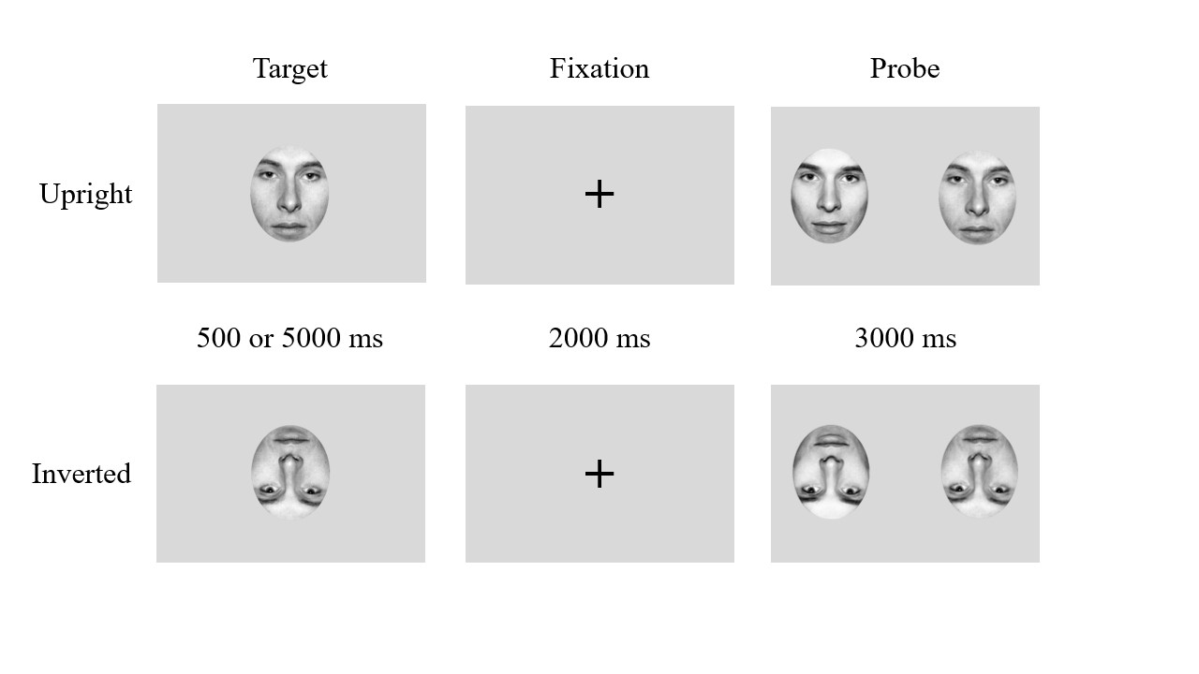

*Note.* Participants will be presented with an upright or inverted target face for 500 or 5000 ms, followed by a fixation cross for 2000 ms. A probe with two selection faces will then appear for 3000 ms.

***Photo Taking and Processing Procedures***

Colour photographs of participants’ faces will be obtained for the fMRI tasks. Prior to taking photos, participants will remove all jewelry, glasses, and makeup. During the photographs, they will be instructed to maintain a neutral facial expression and to gaze directly into the camera without turning their heads. Each photo will be taken twice, one with and once without a light directed at the participant’s face (dimmer and brighter lighting conditions).

White balance will be standardized across the 8 raw photographs using Adobe Bridge (Adobe, Mountain View, United States). Clothing and background elements will be removed from the images using Adobe Photoshop (Adobe, Mountain View, United States), and replaced with a black background. In addition, the photo will be cropped so that the center of the image will be between the two eyes (or the bridge of the nose). Each photograph will also be scrambled using a fast Fourier transform to randomly scramble the phase while maintaining the same colour, luminance, and frequency spectrum of the original image. The ModV paradigm will consist of the same stimuli overlaid with a translucent crosshair placed in the center of the images. In total, the photograph processing procedures will yield 32 images for each participant: eight own face images, eight own face images with crosshair, eight phase scrambled images, and eight phase scrambled images with crosshair (Fig. 3).

**Figure 3**

*Standardized Photography Setup*

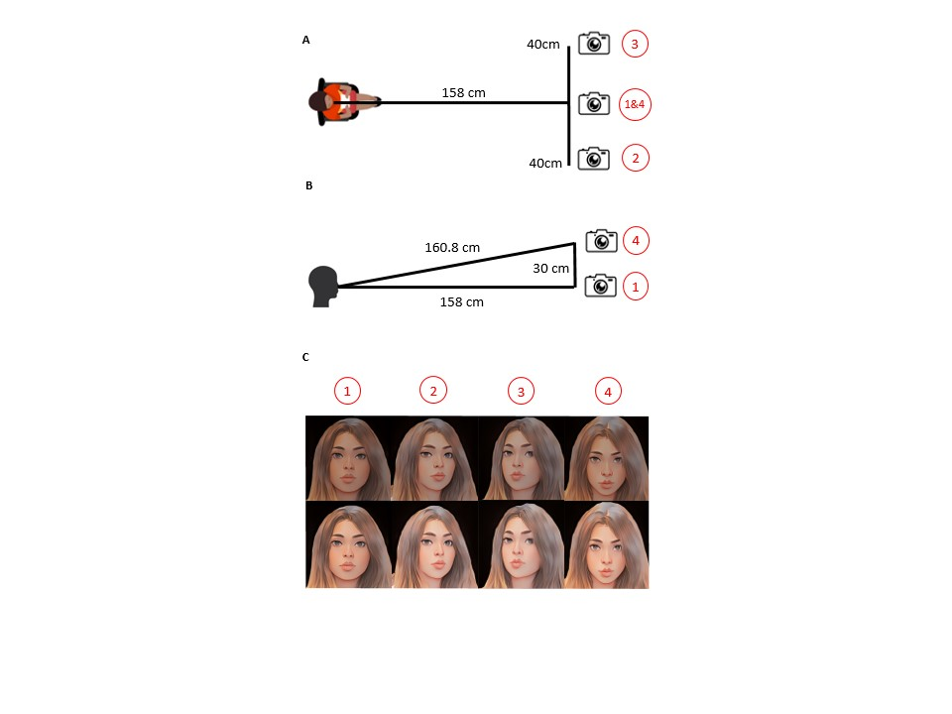

*Note.* Visual representation of the standardized photography setup. One set of photos will be taken at participants’ eye height at a distance 158 cm, one set will be taken at eye level 40 cm to the left of the centre, one 40 cm to the right of the centre, and one from the top down, 30 cm above eye level. (A) Top-down view of photography set-up. (B) Side view of photography set-up. (C) In total, eight photos taken from four different angles and two lighting conditions (dimmer and brighter) will be captured.

***Initial MRI Procedures***

Initial MRI data will be collected using a Siemens 3T *Prisma* scanner with a 32-channel head coil. Specifically, T1-weighted MPRAGE (*tfl3d1; TR/TE: 2300/2.27 ms; flip angle: 8°; 256 x 256 matrix; voxel size: 1 mm3; 192 slices) images will be collected and used for neuronavigation and registration purposes.

***Theta Burst Stimulation (TBS) Procedures***

Neurostimulation will be administered using a MagPro X100/R30 (MagVenture, Farum, Denmark) stimulator equipped with a fluid-cooled 70-mm figure-of-eight coil (cool-B70). Resting motor threshold (MT) will be determined for both left and right hemispheres with the BrainSight2 (Rogue Research, Montreal, Canada) built-in two-channel electromyography (EMG) device. Readings will be taken from the opposite abductor pollicis brevis muscle using pre-gel disposable surface electrodes while stimulation is delivered over the respective motor cortex. Resting MT will be defined as the minimum intensity required to evoke greater than 50 μV motor evoked potential (MEP) in 5 out of 10 consecutive trials as determined by EMG (Rossini et al., 2015).

T1-weighted images will be loaded into the BrainSight2 software and registered to MNI space after manual identification of the anterior and posterior commissures. From this, a three-dimensional reconstruction of the participant’s scalp and brain will be derived to define the target sites of stimulation. The BrainSight2 neuronavigation system will facilitate MRI-guided coil placement at the target foci, which were determined from meta-analysis of functional brain imaging studies for “dorsal visual stream” (Neurosynth; https://neurosynth.org/), yielding the following foci (MNI co-ordinates): left lateral parietal cortex (-38, -38, 46) and right lateral parietal cortex (32, 44, 46), corresponding to CP3 and CP4 respectively on the EEG 10-10 system. The coil will be placed on the lateral parietal cortex at a 45-degree orientation, with respect to the midline of the head. Stimulation will be delivered at 100% of resting MT. The stimulation parameters for each TBS session will consist of 600 pulses delivered in triplet 50 Hz bursts, repeated at 5 Hz for 2 seconds. For iTBS, each burst will be repeated after an 8 s rest, while bursts will be applied continuously for cTBS.

Covariate adaptive randomization will be used to determine the order in which participants receive iTBS and cTBS as well as that in which the right and left hemispheres are stimulated during each session. There will be a minimum of one day of separation between TBS sessions to eliminate carry-over effects. To control for order effects, randomization will be counterbalanced within BDD and subclinical BDD groups. Gender will be balanced as a covariate. Participants, research assistants conducting the tasks, individuals involved in data analysis, and the primary investigator and co-investigator will be blinded to the condition until data analysis is completed to reduce placebo effects and biases.

***fMRI Acquisition and Procedures***

Task-based functional MRI data acquisition will be performed with a 64-channel head coil using an HCP multiband sequence (https://www.cmrr.umn.edu/multiband): T2*-weighted echo planar imaging sequence (epfid2d1; TR/TE: 1000/30 ms; multi-band accel. factor: 5; flip angle: 60°; 104 x 104 matrix; voxel size: 2 mm3; 65 slices). Additionally, field maps will be collected in opposite phase encoding directions as echo planar spin-echo (epse) sequences (epse2d1; TR/TE: 6629/60 ms; flip angle: 90°; 104 x 104 matrix; voxel size: 2 mm3; 65 slices) to estimate the displacement map for susceptibility distortion correction. Data acquisition will take place within 15 minutes of administration of TBS (although the effects of the stimulation may last beyond one hour; Huang et al., 2005). fMRI tasks will be presented on a 32-inch monitor (resolution: 1920 x 1080 pixels; refresh rate: 60 Hz) using custom MATLAB (MathWorks, Inc.), that utilize the Psychophysics Toolbox extension (PTB-3; [www.psychtoolbox.org](http://www.psychtoolbox.org/)). The tasks will consist of natural viewing (NatV), visual modification (ModV), and fast faces. The participant’s compliance with the fMRI task will be monitored with the LiveTrack AV video eye tracking system (Cambridge Research Systems, Ltd, England). If a participant is found to be non-compliant during the task (e.g., consistently failing to maintain fixation or not following task instructions), the corresponding session will be excluded from further analysis.

***Natural Viewing (NatV) Task.*** During fMRI acquisition, six blocks will be presented in each of three task runs. In the first task run, participants will be instructed to view the photographs naturally, as they normally would, and press a button whenever an image (face or scrambled) appears to ensure engagement and compliance.

***Visual Modification (ModV) Task.*** In the second, they will engage in ModV, during which they will be asked to fixate on a translucent crosshair in the middle of the image. Following the ModV task, the NatV task is repeated, and participants are asked to view the photos naturally again.

**Figure 4**

*fMRI Task Paradigm*

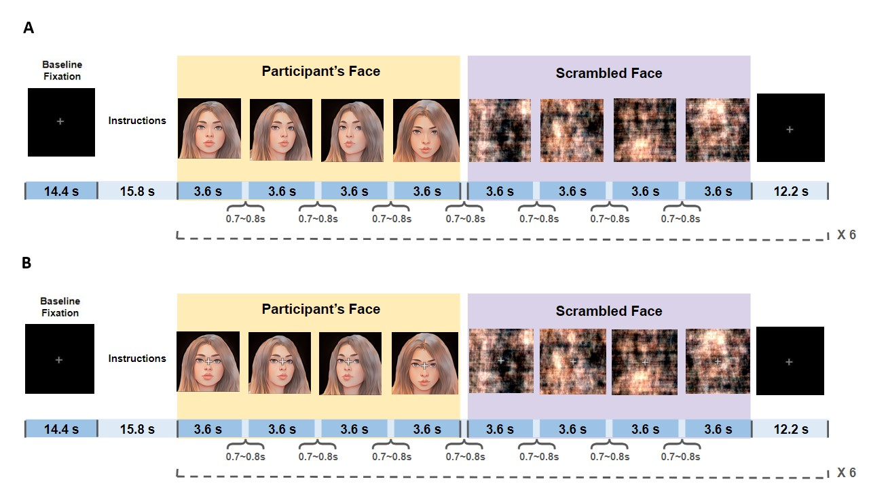

*Note.* (A) Natural Viewing (NatV) Task and (B) Visual Modification (ModV) designs. A block design will be used to present both participant face stimuli and scrambled images for 3.6 s each with 0.7 to 0.8 s between image presentations. Following each block, a fixation cross will be presented for 12.2 s.

***fMRI Processing.*** Images will be processed using fMRIPrep (Esteban et al., 2019). Spatial normalization of the T1-weighted image to standard MNI space will be performed through nonlinear registration. The processing of the BOLD timeseries will consist of head-motion estimation, slice time correction, and susceptibility distortion correction utilizing two spin echo field maps of opposite phase encoding directions. The processed BOLD timeseries will then be resampled in their native space in a single interpolation step. The BOLD timeseries will also be resampled into standard MNI space, generating the spatially-normalized, preprocessed BOLD runs. Spatial smoothing will be performed with a Gaussian kernel of 6 mm FWHM prior to automated removal of motion artifacts with independent component analysis (ICA-AROMA; Pruim et al., 2015).

**Analysis Plan**

The dynamic effective connectivity analysis strategy used for this investigation is based on previous studies (Wong et al., 2021; Wong, Rangaprakash, Moody, et al., 2022). Briefly, blind deconvolution (Wu et al., 2013) will be performed on timeseries extracted from the 14 regions of interest (ROIs), derived from a Neurosynth (https://neurosynth.org/) functional meta-analysis in the dorsal visual stream and ventral visual stream (see Figure 5). Maps generated through association tests were acquired using search queries including "primary visual," "ventral visual," "visual stream," and "dorsal visual”. Dynamic effective connectivity between pairs of ROIs will be computed at each time point using time-varying Granger causality and a dynamic multivariate autoregressive (dMVAR) model, solved in a Kalman-filter framework (Büchel & Friston, 1998) using custom MATLAB scripts. Twelve intra-hemispheric connections will be chosen and divided into 4 categories: 1) lower dorsal visual stream *[calcarine to superior occipital gyrus (SOG)]*, 2) higher dorsal visual stream *[SOG to inferior parietal lobule (IPL); SOG to superior parietal lobule (SPL)]*, 3) lower ventral visual stream *[calcarine to inferior occipital gyrus (IOG)]*, and 4) higher ventral visual stream *[IOG to fusiform gyrus (FG); IOG to inferior temporal gyrus (ITG)]*. Timepoints in the higher and lower dorsal visual stream and ventral visual stream associated with face viewing trials will be extracted for further analysis.

**Figure 5**

*Regions of Interest (ROIs) for Connectivity Analyses*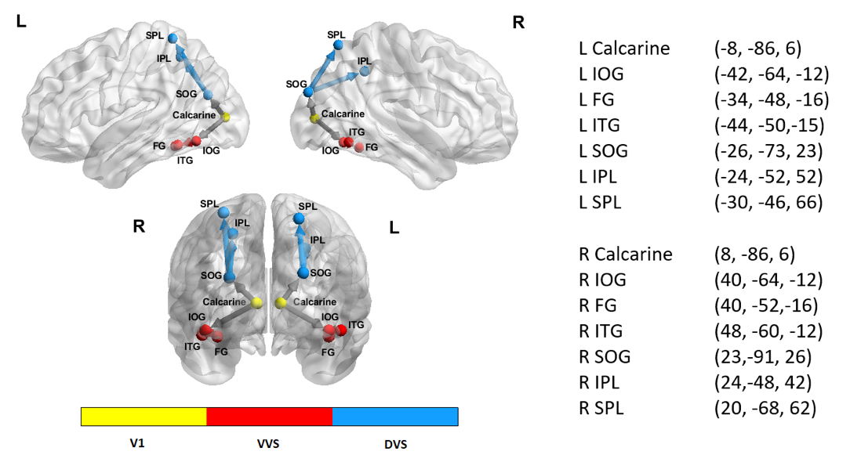

*Note:* 14 regions of interest (ROIs) consisting of the V1 [bilateral calcarine], 6 ROIs in ventral visual stream (VVS) [bilateral inferior occipital gyrus (IOG), fusiform gyrus (FG), and inferior temporal gyrus (ITG)], and 6 ROIs in dorsal visual stream (DVS) [bilateral superior occipital gyrus (SOG), inferior parietal lobule (IPL), and superior parietal lobule (SPL)] will be included in the analyses. All spheres have a radius of 5 mm. Center-of-mass coordinates obtained from the clusters are x, y and z in the MNI space.

To examine changes in dynamic effective connectivity during naturalistic own-face viewing, separate general linear mixed models (GLMM) for each TBS condition will be used, with task condition (naturalistic own face viewing before or after ModV), dorsal visual stream and ventral visual stream level (lower or higher), and their interactions as fixed factors, participant as a random factor, and head motion (DVARS) as a covariate of non-interest. Pairwise comparisons will be performed in the event of significant interaction effects.

Connectivity = β0 + β1(Task condition) + β2(Visual stream level) + β3(Task condition × Visual stream level) + β4(DVARS) + (1|Participant) + ε

Paired t-tests will be performed to compare the face inversion effect before and after iTBS and cTBS. In addition, GLMM will be performed to determine the association between changes in dynamic effective connectivity and face inversion effect following TBS. Specifically, changes in dynamic effective connectivity in both dorsal visual stream levels from the first naturalistic viewing condition to the second, TBS type, and their interactions will be modelled as independent variables and changes in face inversion effect as a dependent variable:

Face inversion effect = β0 + β1(Connectivity) + β2(TBS type) + β3(Connectivity × TBS type) + (1|Participant) + ε

For each GLMM, we will assess potential sources of interindividual variability, including age, gender, time of day, time elapsed between stimulation and scan, TBS order, resting MT, and depression and anxiety measures. Covariates will be retained in the final model only if they reach statistical significance (*p* < .05). Non-significant covariates will be excluded to maintain model parsimony and interpretability.

To ensure that blinding is effective, participants will be asked whether they believe that they have received iTBS or cTBS following their session. If blinding was not successful, participants’ guesses about the type of TBS received will be included as a covariate.

***Power Analysis***

This study will enroll 40 participants to account for 10% unusable data and attrition. As this is the first study to test the effects of TMS combined with ModV on neural connectivity and visual perception in BDD, expected effect sizes are unknown. Based on prior research using iTBS to modulate connectivity during naturalistic own-face viewing in BDD (Wong et al., 2021), the expected effect size for similar interactions was estimated to range from small to moderate (Cohen’s 𝑓≈.159). To estimate the sample size for the current study, a simulation-based power analysis was conducted using the *simr* package in R. The GLMM included fixed effects for task condition, visual stream level, and their interaction, as well as random effects for participants and a small covariate effect (DVARS). All fixed effects, including their interaction, were set to *β*=.1 (small effect), and the random effects variance was set to 0.1. Based on 1,000 simulations at α=.05, results indicated that a sample size of 36 would provide power of .94 (95% CI: .921, .952) to detect a small effect for changes in dynamic effective connectivity during naturalistic own face viewing following TBS and ModV.

To evaluate the adequacy of the sample size for detecting differences in the face inversion effect before and after iTBS and cTBS, a power analysis was conducted. Using empirical data from Feusner, Moller, et al., (2010), and assuming the TBS effect would be similar to the observed group (BDD vs. healthy controls) differences in face inversion effect from that study, the effect size was estimated to be moderate to large (Cohen’s *d*≈.622). A power analysis using the *pwr* package in R indicated that with *n*=36 paired participants (pre- and post-TBS) and α=.05, a paired t-test would achieve .95 power to detect this effect. These results support the adequacy of the planned sample size for robust detection of differences in the face inversion effect before and after TBS.

A separate power analysis assessed the adequacy of the sample size for detecting the interaction effect of connectivity and TBS type on the face inversion effect. Simulations included 36 participants contributing 10 trials each (360 total observations). Connectivity values were simulated as the average of the unitless lower and higher dorsal visual stream values (range: -0.55 to 0.6), consistent with prior findings (Wong et al., 2021; Wong, Rangaprakash, Moody, et al., 2022). Reaction times for upright and inverted faces were simulated based on empirical data from Feusner, Moller, et al., (2010), with means of 1.2 seconds and 1.6 seconds, respectively, and bounded between 0.3 and 2.9 seconds. Face inversion effect was calculated as the difference between inverted and upright reaction times. Using a likelihood ratio test (α=.05), the power to detect the interaction term (Connectivity × TBS Type) was estimated at .64 (95% CI: .609, .670) based on 1000 simulations. Though the study may not be sufficiently powered to detect effects of smaller magnitude related to changes in global processing biases following TBS and ModV, the results may still provide preliminary feasibility data for larger projects.

**References**

American Psychiatric Association (Ed.). (2013). *Diagnostic and statistical manual of mental disorders: DSM-5* (5th ed). American Psychiatric Association.

Beilharz, F. L., Atkins, K. J., Duncum, A. J. F., & Mundy, M. E. (2016). Altering Visual Perception Abnormalities: A Marker for Body Image Concern. *PLOS ONE*, *11*(3), e0151933. https://doi.org/10.1371/journal.pone.0151933

Bruyer, R. (2011). Configural Face Processing: A Meta-Analytic Survey. *Perception*, *40*(12), 1478–1490. https://doi.org/10.1068/p6928

Büchel, C., & Friston, K. j. (1998). Dynamic changes in effective connectivity characterized by variable parameter regression and kalman filtering. *Human Brain Mapping*, *6*(5–6), 403–408. https://doi.org/10.1002/(SICI)1097-0193(1998)6:5/6<403::AID-HBM14>3.0.CO;2-9

Buhlmann, U., Glaesmer, H., Mewes, R., Fama, J. M., Wilhelm, S., Brähler, E., & Rief, W. (2010). Updates on the prevalence of body dysmorphic disorder: A population-based survey. *Psychiatry Research*, *178*(1), 171–175. https://doi.org/10.1016/j.psychres.2009.05.002

Cash, T. F., Fleming, E. C., Alindogan, J., Steadman, L., & Whitehead, A. (2002). Beyond Body Image as a Trait: The Development and Validation of the Body Image States Scale. *Eating Disorders*, *10*(2), 103–113. https://doi.org/10.1080/10640260290081678

Deckersbach, T., Savage, C. R., Phillips, K. A., Wilhelm, S., Buhlmann, U., Rauch, S. L., Baer, L., & Jenike, M. A. (2000). Characteristics of memory dysfunction in body dysmorphic disorder. *Journal of the International Neuropsychological Society*, *6*(6), 673–681. https://doi.org/10.1017/S1355617700666055

Derrington, A. M., & Lennie, P. (1984). Spatial and temporal contrast sensitivities of neurones in lateral geniculate nucleus of macaque. *The Journal of Physiology*, *357*(1), 219–240. https://doi.org/10.1113/jphysiol.1984.sp015498

Dhir, S., Ryan, H. S., McKay, E. L., & Mundy, M. E. (2018). Parameters of visual processing abnormalities in adults with body image concerns. *PLOS ONE*, *13*(11), e0207585. https://doi.org/10.1371/journal.pone.0207585

D’Souza, D. V., Auer, T., Strasburger, H., Frahm, J., & Lee, B. B. (2011). Temporal frequency and chromatic processing in humans: An fMRI study of the cortical visual areas. *Journal of Vision*, *11*(8), 8. https://doi.org/10.1167/11.8.8

Eisen, J. L., Phillips, K. A., Baer, L., Beer, D. A., Atala, K. D., & Rasmussen, S. A. (1998). The Brown Assessment of Beliefs Scale: Reliability and Validity. *American Journal of Psychiatry*, *155*(1), 102–108. https://doi.org/10.1176/ajp.155.1.102

Esteban, O., Markiewicz, C. J., Blair, R. W., Moodie, C. A., Isik, A. I., Erramuzpe, A., Kent, J. D., Goncalves, M., DuPre, E., Snyder, M., Oya, H., Ghosh, S. S., Wright, J., Durnez, J., Poldrack, R. A., & Gorgolewski, K. J. (2019). fMRIPrep: A robust preprocessing pipeline for functional MRI. *Nature Methods*, *16*(1), 111–116. https://doi.org/10.1038/s41592-018-0235-4

Feusner, J. D., Hembacher, E., Moller, H., & Moody, T. D. (2011). Abnormalities of object visual processing in body dysmorphic disorder. *Psychological Medicine*, *41*(11), 2385–2397. https://doi.org/10.1017/S0033291711000572

Feusner, J. D., Moller, H., Altstein, L., Sugar, C., Bookheimer, S., Yoon, J., & Hembacher, E. (2010). Inverted face processing in body dysmorphic disorder. *Journal of Psychiatric Research*, *44*(15), 1088–1094. https://doi.org/10.1016/j.jpsychires.2010.03.015

Feusner, J. D., Moody, T., Hembacher, E., Townsend, J., McKinley, M., Moller, H., & Bookheimer, S. (2010). Abnormalities of Visual Processing and Frontostriatal Systems in Body Dysmorphic Disorder. *Archives of General Psychiatry*, *67*(2), 197. https://doi.org/10.1001/archgenpsychiatry.2009.190

Freire, A., Lee, K., & Symons, L. A. (2000). The Face-Inversion Effect as a Deficit in the Encoding of Configural Information: Direct Evidence. *Perception*, *29*(2), 159–170. https://doi.org/10.1068/p3012

Gamboa, O. L., Antal, A., Moliadze, V., & Paulus, W. (2010). Simply longer is not better: Reversal of theta burst after-effect with prolonged stimulation. *Experimental Brain Research*, *204*(2), 181–187. https://doi.org/10.1007/s00221-010-2293-4

Gauthier, B., Eger, E., Hesselmann, G., Giraud, A.-L., & Kleinschmidt, A. (2012). Temporal Tuning Properties along the Human Ventral Visual Stream. *Journal of Neuroscience*, *32*(41), 14433–14441. https://doi.org/10.1523/JNEUROSCI.2467-12.2012

Greenberg, J. L., Reuman, L., Hartmann, A. S., Kasarskis, I., & Wilhelm, S. (2014). Visual hot spots: An eye tracking study of attention bias in body dysmorphic disorder. *Journal of Psychiatric Research*, *57*, 125–132. https://doi.org/10.1016/j.jpsychires.2014.06.015

Grefkes, C., Nowak, D. A., Wang, L. E., Dafotakis, M., Eickhoff, S. B., & Fink, G. R. (2010). Modulating cortical connectivity in stroke patients by rTMS assessed with fMRI and dynamic causal modeling. *NeuroImage*, *50*(1), 233–242. https://doi.org/10.1016/j.neuroimage.2009.12.029

Grocholewski, A., Kliem, S., & Heinrichs, N. (2012). Selective attention to imagined facial ugliness is specific to body dysmorphic disorder. *Body Image*, *9*(2), 261–269. https://doi.org/10.1016/j.bodyim.2012.01.002

Houdayer, E., Degardin, A., Cassim, F., Bocquillon, P., Derambure, P., & Devanne, H. (2008). The effects of low- and high-frequency repetitive TMS on the input/output properties of the human corticospinal pathway. *Experimental Brain Research*, *187*(2), 207–217. https://doi.org/10.1007/s00221-008-1294-z

Howard, J. D., Reynolds, R., Smith, D. E., Voss, J. L., Schoenbaum, G., & Kahnt, T. (2020). Targeted Stimulation of Human Orbitofrontal Networks Disrupts Outcome-Guided Behavior. *Current Biology*, *30*(3), 490-498.e4. https://doi.org/10.1016/j.cub.2019.12.007

Huang, Y.-Z., Edwards, M. J., Rounis, E., Bhatia, K. P., & Rothwell, J. C. (2005). Theta Burst Stimulation of the Human Motor Cortex. *Neuron*, *45*(2), 201–206. https://doi.org/10.1016/j.neuron.2004.12.033

Jefferies, K., Laws, K. R., & Fineberg, N. A. (2012). Superior face recognition in Body Dysmorphic Disorder. *Journal of Obsessive-Compulsive and Related Disorders*, *1*(3), 175–179. https://doi.org/10.1016/j.jocrd.2012.03.002

Karabanov, A., Ziemann, U., Hamada, M., George, M. S., Quartarone, A., Classen, J., Massimini, M., Rothwell, J., & Siebner, H. R. (2015). Consensus Paper: Probing Homeostatic Plasticity of Human Cortex With Non-invasive Transcranial Brain Stimulation. *Brain Stimulation: Basic, Translational, and Clinical Research in Neuromodulation*, *8*(3), 442–454. https://doi.org/10.1016/j.brs.2015.01.404

Kobayashi, B., Cook, I. A., Hunter, A. M., Minzenberg, M. J., Krantz, D. E., & Leuchter, A. F. (2017). Can neurophysiologic measures serve as biomarkers for the efficacy of repetitive transcranial magnetic stimulation treatment of major depressive disorder? *International Review of Psychiatry*, *29*(2), 98–114. https://doi.org/10.1080/09540261.2017.1297697

Kollei, I., Horndasch, S., Erim, Y., & Martin, A. (2017). Visual selective attention in body dysmorphic disorder, bulimia nervosa and healthy controls. *Journal of Psychosomatic Research*, *92*, 26–33. https://doi.org/10.1016/j.jpsychores.2016.11.008

Koran, L. M., Abujaoude, E., Large, M. D., & Serpe, R. T. (2008). The Prevalence of Body Dysmorphic Disorder in the United States Adult Population. *CNS Spectrums*, *13*(4), 316–322. https://doi.org/10.1017/S1092852900016436

Li, W., Lai, T. M., Bohon, C., Loo, S. K., McCurdy, D., Strober, M., Bookheimer, S., & Feusner, J. (2015). Anorexia nervosa and body dysmorphic disorder are associated with abnormalities in processing visual information. *Psychological Medicine*, *45*(10), 2111–2122. https://doi.org/10/f7dqkt

Lovibond, P. F., & Lovibond, S. H. (1995). The structure of negative emotional states: Comparison of the Depression Anxiety Stress Scales (DASS) with the Beck Depression and Anxiety Inventories. *Behaviour Research and Therapy*, *33*(3), 335–343. https://doi.org/10.1016/0005-7967(94)00075-U

McGrath, L. R., Oey, L., McDonald, S., Berle, D., & Wootton, B. M. (2023). Prevalence of body dysmorphic disorder: A systematic review and meta-analysis. *Body Image*, *46*, 202–211. https://doi.org/10.1016/j.bodyim.2023.06.008

McKeeff, T. J., Remus, D. A., & Tong, F. (2007). Temporal Limitations in Object Processing Across the Human Ventral Visual Pathway. *Journal of Neurophysiology*, *98*(1), 382–393. https://doi.org/10.1152/jn.00568.2006

Monzani, B., Krebs, G., Anson, M., Veale, D., & Mataix-Cols, D. (2013). Holistic versus detailed visual processing in body dysmorphic disorder: Testing the inversion, composite and global precedence effects. *Psychiatry Research*, *210*(3), 994–999. https://doi.org/10.1016/j.psychres.2013.08.009

Moody, T. D., Morfini, F., Cheng, G., Sheen, C. L., Kerr, W. T., Strober, M., & Feusner, J. D. (2021). Brain activation and connectivity in anorexia nervosa and body dysmorphic disorder when viewing bodies: Relationships to clinical symptoms and perception of appearance. *Brain Imaging and Behavior*, *15*(3), 1235–1252. https://doi.org/10.1007/s11682-020-00323-5

Morfeld, M., Petersen, C., Krüger-Bödeker, A., Von Mackensen, S., & Bullinger, M. (2007). The assessment of mood at workplace-psychometric analyses of the revised Profile of Mood States (POMS) questionnaire. *GMS Psycho-Social Medicine*, *4*.

Mullen, K. T., Thompson, B., & Hess, R. F. (2010). Responses of the human visual cortex and LGN to achromatic and chromatic temporal modulations: An fMRI study. *Journal of Vision*, *10*(13), 13. https://doi.org/10.1167/10.13.13

Mundy, M. E., & Sadusky, A. (2014). Abnormalities in visual processing amongst students with body image concerns. *Advances in Cognitive Psychology*, *10*(2), 39–48. https://doi.org/10/f62qtd

Oldfield, R. C. (1971). The assessment and analysis of handedness: The Edinburgh inventory. *Neuropsychologia*, *9*(1), 97–113. https://doi.org/10.1016/0028-3932(71)90067-4

Oosthuizen, P., Lambert, T., & Castle, D. J. (1998). Dysmorphic Concern: Prevalence and Associations with Clinical Variables. *Australian & New Zealand Journal of Psychiatry*, *32*(1), 129–132. https://doi.org/10.3109/00048679809062719

Phillips, K. A. (2005). *The broken mirror: Understanding and treating body dysmorphic disorder* (pp. xii, 412). Oxford University Press.

Phillips, K. A., Hollander, E., Rasmussen, S. A., & Aronowitz, B. R. (1997). A severity rating scale for body dysmorphic disorder: Development, reliability, and validity of a modified version of the Yale-Brown Obsessive Compulsive Scale. *Psychopharmacology Bulletin*, *33*(1), 17–22.

Phillips, K. A., & Menard, W. (2006). Suicidality in Body Dysmorphic Disorder: A Prospective Study. *Am J Psychiatry*.

Pruim, R. H. R., Mennes, M., van Rooij, D., Llera, A., Buitelaar, J. K., & Beckmann, C. F. (2015). ICA-AROMA: A robust ICA-based strategy for removing motion artifacts from fMRI data. *NeuroImage*, *112*, 267–277. https://doi.org/10.1016/j.neuroimage.2015.02.064

Rabipour, S., Wu, A. D., Davidson, P. S. R., & Iacoboni, M. (2018). Expectations may influence the effects of transcranial direct current stimulation. *Neuropsychologia*, *119*, 524–534. https://doi.org/10.1016/j.neuropsychologia.2018.09.005

Rief, W., Buhlmann, U., Wilhelm, S., Borkenhagen, A., & Brähler, E. (2006). The prevalence of body dysmorphic disorder: A population-based survey. *Psychological Medicine*, *36*(6), 877–885. https://doi.org/10.1017/S0033291706007264

Rossini, P. M., Burke, D., Chen, R., Cohen, L. G., Daskalakis, Z., Di Iorio, R., Di Lazzaro, V., Ferreri, F., Fitzgerald, P. B., George, M. S., Hallett, M., Lefaucheur, J. P., Langguth, B., Matsumoto, H., Miniussi, C., Nitsche, M. A., Pascual-Leone, A., Paulus, W., Rossi, S., … Ziemann, U. (2015). Non-invasive electrical and magnetic stimulation of the brain, spinal cord, roots and peripheral nerves: Basic principles and procedures for routine clinical and research application. An updated report from an I.F.C.N. Committee. *Clinical Neurophysiology*, *126*(6), 1071–1107. https://doi.org/10.1016/j.clinph.2015.02.001

Salari, N., Kazeminia, M., Heydari, M., Darvishi, N., Ghasemi, H., Shohaimi, S., & Mohammadi, M. (2022). Body dysmorphic disorder in individuals requesting cosmetic surgery: A systematic review and meta-analysis. *Journal of Plastic, Reconstructive & Aesthetic Surgery*, *75*(7), 2325–2336. https://doi.org/10.1016/j.bjps.2022.04.098

Samad, M., Ralph-Nearman, C., Hellemann, G., Khalsa, S. S., Shams, L., & Feusner, J. D. (2021). Disturbed Eating and Body Dysmorphic Symptoms in a Young Adult Sample Are Separable Constructs That Each Show a Mixture of Distributions. *Assessment*, *28*(3), 890–898. https://doi.org/10.1177/1073191119879241

Schieber, K., Kollei, I., de Zwaan, M., & Martin, A. (2015). Classification of body dysmorphic disorder—What is the advantage of the new DSM-5 criteria? *Journal of Psychosomatic Research*, *78*(3), 223–227. https://doi.org/10.1016/j.jpsychores.2015.01.002

Schiller, P. H., Logothetis, N. K., & Charles, E. R. (1990). Functions of the colour-opponent and broad-band channels of the visual system. *Nature*, *343*(6253), Article 6253. https://doi.org/10.1038/343068a0

Spielberger, C. D., Gonzalez-Reigosa, F., Martinez-Urrutia, A., Natalicio, L. F., & Natalicio, D. S. (1971). The state-trait anxiety inventory. *Revista Interamericana de Psicologia/Interamerican Journal of Psychology*, *5*(3 & 4).

Stangier, U., Adam-Schwebe, S., Müller, T., & Wolter, M. (2008). Discrimination of facial appearance stimuli in body dysmorphic disorder. *Journal of Abnormal Psychology*, *117*(2), 435–443. https://doi.org/10.1037/0021-843X.117.2.435

Toh, W. L., Castle, D. J., & Rossell, S. L. (2017). How individuals with body dysmorphic disorder (BDD) process their own face: A quantitative and qualitative investigation based on an eye-tracking paradigm. *Cognitive Neuropsychiatry*, *22*(3), 213–232. https://doi.org/10.1080/13546805.2017.1300090

Tolin, D. F., Gilliam, C., Wootton, B. M., Bowe, W., Bragdon, L. B., Davis, E., Hannan, S. E., Steinman, S. A., Worden, B., & Hallion, L. S. (2018). Psychometric Properties of a Structured Diagnostic Interview for DSM-5 Anxiety, Mood, and Obsessive-Compulsive and Related Disorders. *Assessment*, *25*(1), 3–13. https://doi.org/10.1177/1073191116638410

Wilhelm, S., Greenberg, J. L., Rosenfield, E., Kasarskis, I., & Blashill, A. J. (2016). The Body Dysmorphic Disorder Symptom Scale: Development and preliminary validation of a self-report scale of symptom specific dysfunction. *Body Image*, *17*, 82–87. https://doi.org/10.1016/j.bodyim.2016.02.006

Wong, W.-W., Rangaprakash, D., Diaz-Fong, J. P., Rotstein, N. M., Hellemann, G. S., & Feusner, J. D. (2022). Neural and behavioral effects of modification of visual attention in body dysmorphic disorder. *Translational Psychiatry*, *12*(1), Article 1. https://doi.org/10.1038/s41398-022-02099-2

Wong, W.-W., Rangaprakash, D., Larson, M. S., Diaz-Fong, J. P., Tadayonnejad, R., Leuchter, A. F., & Feusner, J. D. (2021). Can excitatory neuromodulation change distorted perception of one’s appearance? *Brain Stimulation*, *14*(5), 1197–1200. https://doi.org/10.1016/j.brs.2021.07.010

Wong, W.-W., Rangaprakash, D., Moody, T. D., & Feusner, J. D. (2022). Dynamic Effective Connectivity Patterns During Rapid Face Stimuli Presentation in Body Dysmorphic Disorder. *Frontiers in Neuroscience*, *16*. https://doi.org/10.3389/fnins.2022.890424

Wu, G.-R., Liao, W., Stramaglia, S., Ding, J.-R., Chen, H., & Marinazzo, D. (2013). A blind deconvolution approach to recover effective connectivity brain networks from resting state fMRI data. *Medical Image Analysis*, *17*(3), 365–374. https://doi.org/10.1016/j.media.2013.01.003

Xia, M., Wang, J., & He, Y. (2013). BrainNet Viewer: A Network Visualization Tool for Human Brain Connectomics. *PLOS ONE*, *8*(7), e68910. https://doi.org/10.1371/journal.pone.0068910

Yin, R. K. (1969). Looking at upside-down faces. *Journal of Experimental Psychology*, *81*(1), 141–145. https://doi.org/10.1037/h0027474

**Declarations**

**Funding**

Funding for this study is provided by the National Institute of Mental Health (NIMH) grant number: R21MH128815 (Feusner).

**CRediT Authorship Contribution Statement**

**Joel P. Diaz-Fong:** Investigation, Visualization, Writing – original draft, Writing – review & editing. **Madison Lewis:** Investigation, Visualization, Writing – original draft. **Jessica Qian:** Investigation, Visualization, Writing – review & editing. **Wan-Wa Wong:** Conceptualization, Methodology, Writing – review & editing. **Andrew F. Leuchter:** Conceptualization, Methodology, Writing – review & editing. **Reza Tadayonnejad:** Conceptualization, Methodology. **Daphne Voineskos:** Investigation, Resources, Supervision, Writing – review & editing. **Gerasimos Konstantinou:** Investigation, Writing – review & editing. **Eileen Lam:** Investigation, Project administration, Writing – review & editing. **Daniel M. Blumberger:** Resources, Writing – review & editing. **Jamie D. Feusner:** Conceptualization, Funding acquisition, Investigation, Methodology, Supervision, Writing – original draft, Writing – review & editing.

**Competing Interests**

DMB receives research support from CIHR, NIH, Brain Canada and the Temerty Family through the CAMH Foundation and the Campbell Family Research Institute. He received research support and in-kind equipment support for an investigator-initiated study from Brainsway Ltd. He was the site principal investigator for three sponsor-initiated studies for Brainsway Ltd. He also received in-kind equipment support from Magventure for investigator-initiated studies. He received medication supplies for an investigator-initiated trial from Indivior. He is a scientific advisor for Sooma Medical. He is the Co-Chair of the Clinical Standards Committee of the Clinical TMS Society (unpaid). DV holds the Labatt Family Professorship in Depression Biology, a University Named Professorship at the University of Toronto. She receives research support from CIHR, NIMH, the Centre for Addiction and Mental Health (CAMH), The Centre for Mental Health at University Health Network and the Department of Psychiatry at the University of Toronto. DV declares no biomedical interests or conflicts. The remaining authors declare that they have no competing interests.

**Data Availability Statement**

The data that support the findings of this study will be openly available in the NIMH Data Archive (<https://nda.nih.gov/>). By the time of Stage 2 submission, the experiment code of the study will be made publicly available on an open access repository.

**Acknowledgments**

The funders have/had no role in study design, data collection and analysis, decision to publish or preparation of the manuscript. Attributions: illustration of person sitting in Figure 3 (A) designed by macrovector (freepik.com); camera and silhouette images in Figure 3 (A) and (B) from vecteezy.com; brain networks in Figure 6 were visualized with the BrainNet Viewer (<http://www.nitrc.org/projects/bnv/>; Xia et al., 2013).

**Study Stage**

Data collection has begun.

|  |  |  |  |  |  |
| --- | --- | --- | --- | --- | --- |
| **Question** | **Hypothesis** | **Sampling plan** | **Analysis plan** | **Rationale for deciding the sensitivity of the test for confirming or disconfirming the hypothesis** | **Interpretation given different outcomes** |
| How do intermittent theta burst stimulation (iTBS) and continuous theta burst stimulation (cTBS) affect dynamic effective connectivity (DEC) in the dorsal visual stream (DVS) and ventral visual stream (VVS) in individuals with body dysmorphic disorder (BDD) and subclinical BDD during naturalistic own face viewing following visual modification (ModV)? | iTBS will increase DEC in the DVS and decrease DEC in the VVS during naturalistic own face viewing after, compared with before, ModV. cTBS will decrease DEC in the DVS and increase DEC within the VVS. | Forty adult men and women between the ages of 18 and 40 with BDD (n=20) or subclinical BDD (n=20) with face concerns will be recruited from the Greater Toronto Area. | GLMM with task condition, DVS or VVS level and their interactions as fixed factors, participant as a random factor, and DVARS as covariate of non-interest. Pairwise t-tests to compare DEC during the first naturalistic viewing run to second, in the case of a significant interaction. | As this is the first study to test the effects of TBS combined with ModV on neural connectivity and visual perception in BDD, expected effect sizes are unknown. Based on prior research using iTBS to modulate connectivity during naturalistic own-face viewing in BDD, the expected effect size for similar interactions was estimated to range from small to moderate (Cohen’s 𝑓≈.159). To estimate the sample size for the current study, a simulation-based power analysis was conducted. The GLMM included fixed effects for task condition, visual stream level, and their interaction, as well as random effects for participants and a small covariate effect (DVARS). All fixed effects, including their interaction, were set to *β*=.1 (small effect), and the random effects variance was set to 0.1. Based on 1,000 simulations at α=.05, results indicated that a sample size of 36 would provide power of .94 (95% CI: .921, .952) to detect a small effect. | Results in favour for the hypothesis will indicate that iTBS and cTBS followed by ModV differentially modulates DEC in DVS and VVS, providing evidence of potentially meaningful functional changes when combining exogenous modulation with an attentional modification paradigm that could alter clinically relevant perceptual experiences in those with BDD.  Results contrary to the hypothesis could indicate that, rather than VVS connectivity being downregulated/upregulated by virtue of increased/decreased DEC connectivity downregulating/upregulating VVS connectivity, TBS itself may be modulating VVS through signal propagation down white matter pathways that may connect DVS to VVS regions resulting in iTBS and cTBS having excitatory and inhibitory effects on VVS, respectively.  Evidence for the null hypothesis may indicate that iTBS and cTBS using these parameters may not be sufficient for inducing DEC in the DVS and VVS. |
| How do intermittent theta burst stimulation (iTBS) and continuous theta burst stimulation (cTBS), combined with visual modification (ModV), affect global visual processing biases, measured with the face inversion effect (FIE)? | Global visual processing biases will be enhanced following iTBS and ModV and reduced following cTBS and ModV. | Paired t-tests comparing FIE before and after TMS and ModV. | Assuming the TBS effect would be similar to observed group (BDD vs. healthy controls) differences in face inversion effect, the effect size is estimated to be moderate to large (Cohen’s *d*≈.622). A power analysis indicated that with *n*=36 paired participants (pre- and post-TBS) and α=.05, a paired t-test would achieve .95 power to detect changes in global processing biases following TBS and ModV. | Evidence in support of the hypothesis, showing increases in global processing biases (greater FIE) after iTBS and ModV, would indicate that iTBS may be an effective tool for enhancing ModV in inducing functional changes in global visual perception.  Results contrary to the hypothesis will show that the combination of iTBS and ModV decreases global processing biases while cTBS and ModV increases global processing biases. These results will indicate that cTBS instead of iTBS may be an effective tool for enhancing ModV in inducing functional changes in global visual perception.  Evidence for the null hypothesis may indicate that TBS using these parameters may not be sufficient for inducing the magnitude of functional changes needed to alter visual processing biases in BDD. |
| How are the expected changes in neural connectivity related to the expected changes in global visual processing biases? | The degree of change in DEC within the DVS for both iTBS and cTBS will be associated with the degree of change in face inversion task accuracy and response time. |  | GLMM with changes in DEC in lower and higher DVS, type of TBS received, and their interactions as independent variables with changes in FIE as a dependent variable. | A simulation-based power analysis included 36 participants contributing 10 trials each (360 total observations). Connectivity values were simulated as the average of the unitless lower and higher DVS values (range: -0.55 to 0.6), consistent with prior findings. Reaction times for upright and inverted faces were simulated based on empirical data, with means of 1.2 seconds and 1.6 seconds, respectively, and bounded between 0.3 and 2.9 seconds. FIE was calculated as the difference between inverted and upright reaction times. Using a likelihood ratio test (α=.05), the power to detect the interaction term (Connectivity × TBS Type) was estimated at .64 (95% CI: .609, .670) based on 1000 simulations.  (The study was primarily powered for the first and second research questions.) | Evidence for the hypothesis will indicate that the magnitude of changes in DEC within the DVS will be associated with the degree of change in the FIE, suggesting that increased DEC in the DVS associates with enhanced global visual processing biases. This will provide evidence that TBS followed by ModV may enhance global visual processing biases mechanistically with positive, linear increases in DEC in the DVS.  Evidence contrary to the hypothesis will show increased DEC in the DVS associates with reduced global visual processing biases. This may suggest that changes in DEC within the DVS may have a negative linear association with enhanced global visual processing biases.  Results in support of the null hypothesis could suggest either that the study was not sufficiently powered to answer this question, or TBS using these parameters may not be sufficient for inducing the magnitude of functional and behavioral changes needed to alter visual processing biases in BDD. |

**Table 1**

*Study Design*