Revisiting the Effects of Helper Intention on Gratitude and Indebtedness:
Replication and extensions Registered Report of Tsang (2006)
[Stage 1]

Chi Fung Chan
ORCID: 0000-0002-7425-8421
Department of Psychology, University of Hong Kong
tccf312@connect.hku.hk ; timothychan312@gmail.com
*Hiu Ching Lim, *Fung Yee Lau, *Wing Ip, *Chak Fong Shannon Lui
Department of Psychology, University of Hong Kong
u3568980@connect.hku.hk ; victorialimhc@gmail.com
heatherlau@connect.hku.hk ; heatherlau654@gmail.com
juneipw@connect.hku.hk ; wiishtcaauserexe@gmail.com
u3560176@connect.hku.hk ; shannonlui0512@gmail.com
Katy Y. Y. Tam
ORCID: 0000-0003-2197-8705
University of Toronto
yuenyan1211@gmail.com
^Gilad Feldman
OCRID: 0000-0003-2812-6599
Department of Psychology, University of Hong Kong, Hong Kong SAR
gfeldman@hku.hk ; giladfel@gmail.com
* Shared second coauthor
^Corresponding author

Author bios:
Chi Fung Chan, Hiu Ching Lim, Fung Yee Lau, Wing Ip, and Chak Fong Shannon Lui were students at the University of Hong Kong during the academic year 2021.
Katy Y. Y. Tam was a PhD Candidate at the University of Hong Kong and King’s College London during the academic year 2021/22.
Gilad Feldman is an assistant professor with the University of Hong Kong psychology department. His research focuses on judgment and decision-making.

Declaration of Conflict of Interest:
The author(s) declared no potential conflicts of interests with respect to the authorship and/or publication of this article.

Financial disclosure/funding:
The project was supported by the University of Hong Kong Teaching Development Grant awarded to Gilad Feldman.

Authorship declaration:

Chi Fung Chan, Hiu Ching Lim, Fung Yee Lau, Wing Ip, and Chak Fong Shannon Lui designed the study, developed the experimental materials for each study respectively, and wrote an initial draft of the Registered Report Stage 1. Katy Y. Y. Tam provided feedback and guidance in the initial stages.
Chi Fung Chan integrated the team’s projects, verified the materials and analyses, and prepared the manuscript for submission.
Gilad Feldman guided the replication efforts, supervised each step in the project, ran data collection, conducted the pre-registration, and edited the manuscript for submission.
[open to revision following in-principle acceptance.]

Corresponding author:
Gilad Feldman, Department of Psychology, University of Hong Kong, Hong Kong SAR; gfeldman@hku.hk; ORCID: 0000-0003-2812-6599

Rights:
CC BY or equivalent license is applied to the AAM arising from this submission. (clarification)

Citation of the target research article:
Tsang, J.-A. (2006). The effects of helper intention on gratitude and indebtedness. Motivation and Emotion, 30(3), 199–205. https://doi.org/10.1007/s11031-006-9031-z

Contributor Roles Taxonomy

Role | Chi Fung Chan | Gilad Feldman | Hiu Ching Lim, Fung Yee Lau, Wing Ip, and Chak Fong Shannon Lui | Katy Y. Y. Tam
Conceptualization | X | X
Pre-registration | X | X | X
Data curation |  | X
Formal analysis | X |  | X
Funding acquisition |  | X
Investigation | X |  | X | X
Pre-registration peer review / verification |  | X | X | X
Data analysis peer review / verification |  | X | X | X
Methodology | X
Project administration |  | X |  | X
Resources |  | X
Software | X |  | X
Supervision |  | X |  | X
Validation |  | X
Visualization | X |  | X
Writing-original draft | X
Writing-review and editing |  | X

Abstract
[IMPORTANT:
Abstract, method, and results were written using a randomized dataset produced by Qualtrics to simulate what these sections will look like after data collection. These will be updated following the data collection. For the purpose of the simulation, we wrote things in past tense, but no pre-registration or data collection took place yet.]

Gratitude and indebtedness are common emotions in response to a favor, but are experienced differently depending on situations. Tsang (2006) suggested that gratitude for a favor depended on perceived helper intention, while indebtedness did not. Specifically, she proposed that a benevolent helper intention yielded higher gratitude from beneficiaries when compared to a selfish one, whereas helper intention did not influence the level of indebtedness induced. In a Replication Registered Report with a US Prolific student sample (N = 1000), we conducted a replication and extension of Studies 2 and 3 from Tsang (2006). Tsang found support for the impact of the helper’s intention on gratitude (Study 2: η²_{p} = .2, 90% CI = [0.08, 0.32]; Study 3: η²_{p} = .14, 95% CI = [0.03, 0.26]), but not for indebtedness (Study 2: η²_{p} = .01, 90% CI = [0.00, 0.08]; Study 3: η²_{p} = .00, 95% CI = [0.00, 0.03]). [The following findings are simulated random noise and will be updated after data collection:]. We [found/failed to find] support for the effect on gratitude (Study 2: η²_{p} < .001, 90% CI = [0.00, 0.03]; Study 3: η²_{p} < .001, 90% CI = [0.00, 0.01]), and [found/failed to find] support for effect on indebtedness (Study 2: η²_{p} = .03, 90% CI = [0.00, 0.08]; Study 3: η²_{p} = .03, 90% CI = [0.00, 0.05]). We concluded that … [conclusion].
Extending the replication, we examined the impact of perceived helpers’ intention on perceived expectations for reciprocity (d = -0.13, 95% CI = [-0.27, 0.03]), beneficiaries’ reciprocity tendency (d = -0.12, 95% CI = [-0.27, 0.03]), and associations of perceived reciprocity expectations with gratitude (r = .01, 95%CI = [-.05, 0.07]) and indebtedness (r < .001, 95%CI = [-0.05, 0.06]). Materials, data, and code are available on: https://osf.io/ghfy4/

Keywords: Gratitude, indebtedness, intent, reciprocity, affect, judgment and decision making, replication

Stage 1 Snapshot

Research questions and theory.
We aim to replicate Studies 2 and 3 in Tsang (2006) which showed that gratitude and indebtedness are fundamentally different emotions by showing that they change differently in response to helpers’ intentions (selfish versus benevolent). The differences were demonstrated in both the context of personally experienced scenarios in the past (Study 2) and an objective scenario without attributions about helpers’ intentions (Study 3).

Hypotheses.
We followed Tsang’s (2006) hypothesis in the target article: The impact of helper’s intentions on gratitude is stronger than on indebtedness. People feel more grateful in response to favors done with benevolent intentions, whereas individuals’ feelings of indebtedness are not sensitive to benefactors’ intentions.

Study design and methods.
In our replications, we follow Tsang’s (2006) study designs for Studies 2 and 3, combining them into one single randomized display within-subject design. Participants are recruited online via Prolific. Participants complete the two studies examining the emotional change of gratitude and indebtedness across situations (Study 2: report sense of gratitude and indebtedness after recalling a personal experience of receiving a favor, Study 3: report sense of gratitude and indebtedness after reading the assigned story). We also added an extension in Study 3 to examine the effect of benefactors' intention on (1) the perceived expectation for reciprocation of benefactors and (2) the reciprocity tendency of beneficiaries. We aim to determine sample size with a priori power analysis (95%, alpha=0.05) of a conservative estimate of the original findings of the weakest supported effect, aiming for 2.5 times the calculated sample with a sensitivity analysis.

Key analyses that will test the hypotheses and/or answer the research question(s).
We will follow the original analyses. Study 2: Pearson correlations tests between gratitude and indebtedness in different conditions (i.e., benevolent and selfish conditions); ANCOVAs of selfish and benevolent conditions on gratitude and indebtedness emotions after controlling magnitude of favor. Study 3: ANOVAs of gratitude and indebtedness across situations (i.e., benevolent, selfish, and ambiguous)

‎Conclusions that will be drawn given different results.
We will evaluate the replicability of our finding against the original’s using the Lebel et al. (2019) paradigm (examining signal and comparison of confidence intervals with the original’s effect size).

Key references.
LeBel et al. (2019). https://doi.org/10.15626/MP.2018.843
Tsang (2006). https://doi.org/10.1007/s11031-006-9031-z

PCIRR-Study Design Table
Question | Hypothesis | Sampling plan | Analysis plan | Rationale for deciding the sensitivity of the test for confirming or disconfirming the hypothesis | Interpretation given different outcomes | Theory that could be shown wrong by the outcomes
How does the perceived helper intentions influence gratitude? | Benevolent favors result in more gratitude than selfish favors, even after controlling the magnitude of favor. | Participants will be recruited online via Prolific. We aim to recruit 800 participants based on our power analysis which is sufficient to detect the weakest effect of interest. | ANCOVA, One-way between-subject ANOVA, Independent samples t-tests | We follow the statistical analyses of the target article. | We examine the replicability of the finding of Tsang (2006) based on the criteria used by Lebel et al. (2019). | Gratitude is impacted more strongly than indebtedness by helpers’ intentions.
How do the perceived helper intentions influence indebtedness? | Benevolent favors result in more indebtedness than selfish favors even after, controlling the magnitude of favor. [Reframed from the original’s null hypothesis] |  | ANCOVA, One-way between-subject ANOVA, Independent samples t-tests
What is the relationship between indebtedness and gratitude? | Gratitude is associated with indebtedness under both selfish and benevolent intentions. |  | Pearson correlation

Revisiting the Effects of Helper Intention on Gratitude and Indebtedness:
Replication and extensions Registered Report of Tsang (2006)

[IMPORTANT: Section is written in the past tense to simulate what the manuscript will look like after data collection, yet no pre-registration or data collection took place.]

Background
Gratitude and indebtedness are common emotions in response to receiving help, but studies suggested that they are experienced differently depending on the situation. Tsang (2006) showed that helper intentions are associated with feelings of gratitude, yet less so for indebtedness: people report feeling more grateful when the helper’s motivations were perceived as being less selfish, with weaker to no motivation differences for feelings of indebtedness.
We conducted a close replication and extension of Tsang (2006) with the following goals. Our first goal was to conduct an independent replication of the impact of the helper’s intentions comparing gratitude and indebtedness. Our second goal was to examine extensions, aiming to enrich our understanding of how differences in helper intentions impact reciprocation.
We begin by introducing the literature on gratitude and indebtedness, and the impact of helpers’ intentions on these emotions. We then discuss our motivations for the current replication and review Tsang (2006) as our chosen article for replication. Finally, we review the replication and extension hypotheses, study design, and methods.

The effect of helper intention on gratitude and indebtedness
Gratitude and indebtedness are common reactions to receiving help, with these emotions varying across situations (Bartlett & DeSteno, 2006; Gray et al., 2001, Peng et al., 2018). Consider, for example, how a student would respond to a classmate who has volunteered to help with homework depends on perceptions of selfish-ulterior motives. The student’s gratitude and indebtedness may depend on whether the act of helping seemed to have been purely benevolent to help another, or rather based on selfish-ulterior motives. These two emotions have often been equated in the early literature and yet evidence showing that these emotions are elicited in different situations suggested the need to differentiate between them (Greenberg, 1980; Tsang, 2006; Watkin et al., 2006).
Gratitude is commonly defined as a positive emotion arising from the appreciation of an action by another person that is desirable and valuable to oneself (Ortony et al., 1988). McCullough et al.(2008) argued that it is associated with the prosocial and voluntary nature of the act, as well as the cost incurred and benefits received. Therefore, gratitude may depend on evaluations of the helpers’ cost, altruistic motivations, and the value of the favor to the person being helped (Bar-Tal, et al., 1977; Graham, 1988; Lane & Anderson, 1976; Tesser et al., 1968). This echoes the cognitive perspective that gratitude is defined as the product of the cognition that one has been the beneficiary of others’ goodwill (McCullough, 2002).
Greenberg (1980) defined indebtedness as a beneficiary’s feeling of obligation to repay the benefactor following norms of reciprocity (Gouldner, 1960), so as to restore equality in social exchange (Mathews & Green, 2010). In this context, the favor does not necessarily have to be altruistic. Peng et al. (2018) suggested that it is the cost of the favor, rather than its intent, that determines the inequality of social exchange, thus affecting feelings of indebtedness.

Relationship and differences between gratitude and indebtedness
Algoe et al. (2010) posited that gratitude is a positive emotion whereas indebtedness is a negative emotion. Gratitude leads people to thank their benefactor, whereas indebtedness leads people to try and return the favor. This aligns with Frijda’s (1988) work showing that distinct emotions manifest distinct action tendencies – a consequential urge to carry out certain expressive behaviors. It also echoes Gray et al. (2001)’s research indicating that gratitude is associated with prosocial motivation whereas indebtedness is associated with avoidance motivations. This was later explained by Fredrickson’s (2004) broaden and build theory, that gratitude, as one of the positive emotions, serves to broaden one’s thoughts and actions to reciprocate, whereas indebtedness is associated with a relatively narrower tit-for-tat reciprocity.
Researchers have tried to distinguish the two emotions in different ways. In terms of their causes, Watkins et al. (2006) distinguished them by manipulating helpers’ expectations of reciprocity, finding that higher expectations resulted in decreased gratitude yet increased indebtedness. In line with the difference in action tendencies between gratitude and indebtedness, they also found that participants were more likely to express willingness to return the favor if the benefactor communicated weaker reciprocation expectations (reciprocation negatively associated with reciprocation expectations). However, this predicted outcome is arguably counter to combining Tsang's (2006) and Algoe et al.'s (2010) theoretical paradigms, which together suggest that beneficiaries would be less likely to reciprocate if benefactors held weaker reciprocation expectations (reciprocation positively associated with reciprocation expectations).
Emmons and Crumpler (2000) proposed that gratitude is an interpersonal emotion that enhances relational well-being, with Mathews and Green (2010) arguing that indebtedness is more of a self-focused emotion. Therefore, self-focused people felt less commitment and closeness toward the benefactor. This supported Algoe et al. (2010)’s conclusion that gratitude enhances relationships whereas indebtedness only maintains relationships. As shown in the research that distinguishes them, they differ in terms of causes and effects.
Furthermore, research indicated that these two emotions play different functions in sociality. For example, accumulated literature suggested that gratitude contains a relation-oriented function to promote intimate bonds (e.g., Algoe et al., 2013; Bartlett et al., 2012; Kubacka et al., 2011; Peng et al., 2018; Williams & Bartlett, 2015), whereas indebtedness contains an exchange-oriented function (e.g., Goyal et al., 2022; Naito & Sakata, 2010; Peng et al., 2018). These functional differences may explain why helpers’ intentions are influential to one’s gratitude and indebtedness.

Perceived Helper Intention
The differences between gratitude and indebtedness can be reflected in perceived helpers’ intentions. Ames et al. (2004) found that when beneficiaries perceived helpers’ intention as caring they experienced more positive feelings toward the helper (e.g., happiness and gratitude). Alternatively, perceiving helping intent as manipulative or deceitful triggered negative affect (e.g., indebtedness and anger).
Tsang (2006) further examined the effects of helper intentions on feelings of gratitude and indebtedness. The result was partially consistent with Watkins et al. (2006), with participants feeling more grateful for favors offered with benevolent intentions, whereas selfish intentions did not seem to affect indebtedness, which seemed less sensitive to helper intentions. However, more recent findings by Welsh et al. (2022) found helpers’ motives (prosocial vs. self-interested) do influence individuals’ levels of indebtedness. They argued that favors with self-interested motives induced less indebtedness than those with prosocial motives, contradicting Tsang’s (2006) work. If both findings hold in independent well-powered pre-registered replications, then more work is needed to account for these mixed results.

Choice of study for replication: Tsang (2006)
We embarked on a well-powered close replication and extension Registered Report of Tsang (2006). We aimed to revisit the phenomenon to examine the reproducibility and replicability of the findings with an independent pre-registered well-powered replication and extension. This follows the recent growing recognition of the importance of reproducibility and replicability in psychological science (e.g., Brandt et al., 2014; Open Science Collaboration, 2015; Nosek et al., 2022; Zwaan et al., 2018).
We chose Tsang’s (2006) study based on several factors: its profound academic impact, the absence of direct replications, and the realignment in the literature initiated by the article. The article has had an impact on scholarly research in the area of social psychology, and at the time of writing (January, 2024), there were 343 Google Scholar citations of the article with many impactful follow-up theoretical and empirical articles. One example is the work by Algoe et al. (2010) on how gratitude and indebtedness affect romantic relationships. They concluded that gratitude improves interpersonal relationship quality, whereas indebtedness exerts no detectable influence. Based on Tsang’s (2006) findings, they established a link between the nature of these two emotions and such interpersonal outcomes. That is, the dependence of gratitude on helpers; intention entails that the focus is on the helper’s positive feelings and favorable mental states (e.g., being generous / caring more for the beneficiary). Meanwhile, indebtedness, insensitive to helper intention, focuses on the benefit and thus triggers reciprocity only as a dutiful exchange. Therefore, Tsang (2006) contributed to the development of the field by elaborating on the contrast between the two emotions. Her work deepened our understanding of their distinct role in different aspects of life, such as interpersonal relationships. To the best of our knowledge, there are currently no published direct replications of this study.
Despite its impact, the departure of Tsang’s (2006) theory and findings from previous research necessitates independent replications to help ensure the realignment is built on solid grounds, examine the robustness of the findings, and clarify possible directions for resolution. Prior to Tsang, many studies did not distinguish between the two emotions and instead measured them as one single construct (Greenberg, 1980; Komter, 2004; Tesser et al., 1968). The more recent body of research has mostly aligned with the notion that gratitude and indebtedness are distinct emotions.
In addition, the target article presented a theoretical model that predicted no effects for the impact of intent on indebtedness. In their findings, they also reported failing to find a signal in support of rejecting the null hypothesis of finding no differences for indebtedness between the benevolent and selfish intent conditions, and built on that to conclude no effects. However, Null Hypothesis Significance Testing (NHST) methods are not well suited for testing and quantifying support for a null hypothesis. We felt it important to revisit the theoretical model by reframing the null hypothesis to differences in effects between gratitude and indebtedness, to rerun the studies with well-powered samples, and to add additional analyses that address the null hypothesis issue to gain deeper insights into the phenomenon.

Original hypotheses and findings in the target article
Tsang (2006) examined how perceived helper intentions are associated with gratitude and indebtedness experienced by the beneficiary. The core hypothesis was that benevolent (versus selfish) intentions were more strongly associated with gratitude than with indebtedness. We focused our replication on Tsang’s (2006) Studies 2 and 3, given that Study 3 contains all the essential experimental designs of Study 1 with an extra condition of ambiguous helper intention for investigation. We briefly outline the studies below.
Study 2 examined the effect of perceived helper intentions on levels of gratitude and indebtedness experienced by the beneficiary in real-life situations. It was conducted using an undergraduate sample at Baylor University, asking participants to recall and write about an experience in which someone offered them a valuable favor, randomly assigning participants to either recall a benevolent or a selfish helper. Study 3 had similar research questions to Study 2 yet had different experimental designs. Rather than instructing participants to recall favors to them, it presented participants with a scenario describing benefactors’ motives, either benevolent or selfish, randomly assigned. It added an extra condition of ambiguous motives as a control condition, allowing participants to assign their own attributions regarding the helper’s intention.
We provided a summary of the hypotheses and their corresponding findings in Table 1 (see “analysis of the original article” subsection of the supplementary materials for further details). The target article had many hypotheses and many associated analyses, and we therefore pre-registered that our replication criteria will focus on the following. In our replication of Study 2, our focus was on the comparison of Hypotheses 2 and 3: “Impact of intent (benevolent > selfish) on gratitude is stronger than on indebtedness.”. In our replication of Study 3 our focus was on the comparison of Hypotheses 7b/c and 8b/c: “Impact of intent (benevolent > ambiguous > selfish) on gratitude is stronger than on indebtedness.”.
Given the two studies, we pre-registered our overall strategy to conclude a successful replication if the findings of the two studies are aligned with a signal in the same direction as the target article by Tsang (2006), mixed results if only one of two is supported, and failed replication if we fail to find support for the hypotheses in both studies.

Table 1
Summary of Effect Size and Confidence Interval of the target article
Study | Hypothesis | Hypotheses | p | Effect size | 90%CI | 95%CI
2 | 1a | Gratitude is associated with indebtedness across conditions (selfish-ulterior and benevolent combined). | <.001* | r = .57 | / | [0.41, 0.69]
 | 1b | Gratitude is associated with indebtedness in the selfish-ulterior condition. | <.001* | r = .61 | / | [0.39, 0.76]
 | 1c | Gratitude is [not] associated with indebtedness in Benevolent condition.  [Reframed from the target article’s null hypothesis] | >.20 | r = .20 | / | [-0.10, 0.47]
 | 1b+1c | Combined: Gratitude is more strongly associated with indebtedness in the selfish-ulterior condition than in the benevolent condition.  [Reframed from the target article’s effect/no-effect] |  | .61 > .20
 | 2 | Benevolent favors result in more gratitude than selfish-ulterior favors, even after controlling the magnitude of favor. | <.001* | η²_{p} = 0.2 | [0.08, 0.32] | /
 | 3 | Benevolent favors [do not] result in more indebtedness than selfish-ulterior favors, even after controlling the magnitude of favor.  [Reframed from the target article’s null hypothesis] | >.20 | η²_{p} = 0.01 | [0.00, 0.08] | /
 | 2+3 | Combined: Impact of intent on gratitude (benevolent > selfish) is stronger than on indebtedness.  [Reframed from the target article’s effect/no-effect] |  | 0.2 > 0.01
 | 4 (2r) | [Regression complementary analysis] Benevolent favors result in more gratitude than selfish-ulterior favors, even after controlling the magnitude of favor. | <.001*  (a) <.01  (b) <.01 | R² = .73  β=.32 β=.62 | / | [0.61, 0.81]
 | 5 (3r) | [Regression complementary analysis] Benevolent favors result in more indebtedness than selfish-ulterior favors, even after controlling the magnitude of favor.  [Reframed from the target article’s null hypothesis] | <.001*  (a) >.20  (b) <.001 | R² = .26  β=.13  β=.42 | / | [0.10, 0.41]
 | 4 + 5 (2r+3r) | [Regression complementary analysis] Benevolent favors result in more indebtedness than selfish-ulterior favors, even after controlling the magnitude of favor.  [Reframed from the target article’s null hypothesis] |  | .32 > .13
3 | 6 | Gratitude is associated with indebtedness in the Ambiguous condition. | <.05* | r = .42 | / | [0.06, 0.68]
 | 7a | Gratitude is different between the three conditions (Benevolent, Ulterior and Ambiguous). | <.01* | η²_{p} = .14 | [0.03, 0.26] | /
 | 7b | Gratitude is higher in the benevolent condition compared to the ambiguous condition. | <.05* | d = 0.55 | / | [0.02, 1.08]
 | 7c | Gratitude is higher in the ambiguous condition compared to the selfish-ulterior condition. | .07 | d = 0.49 | / | [-0.04, 1.01]
 | 8a | Indebtedness is [not] different between the three conditions (Benevolent, Selfish, and Ambiguous)  [Reframed from the target article’s null hypothesis] | >.20 | η²_{p} = .00 | [0.00, 0.03] | /
 | 8b | Indebtedness is [not] higher in the benevolent condition compared to the ambiguous condition.  [Reframed from the target article’s null hypothesis] | >.20 | d = 0.13 | / | [-0.39, 0.64]
 | 8c | Indebtedness is [not] higher in the ambiguous condition compared to the selfish-ulterior condition.  [Reframed from the target article’s null hypothesis] | >.20 | d = 0.03 | / | [-0.49, 0.55]
 | 7b/c+  8b/c | Combined: Impact of intent on gratitude (benevolent > ambiguous > selfish) is stronger than on indebtedness.  [Reframed from the target article’s effect/no-effect] |  | .55>.13  |-.49|>|-.03|
 | 9 | Ratings of helper intentions are associated with gratitude in the ambiguous condition. | <.05* | r = -.40 | / | [-0.67,  -0.04]
 | 10 | Ratings of helper intentions are [not] associated with indebtedness in the ambiguous condition.  [Reframed from the target article’s null hypothesis] | >.20 | r = .00 | / | [-0.37,  0.37]
 | 9+10 | Combined: Ratings of helper intentions are more strongly associated with gratitude than indebtedness in the ambiguous condition.  [Reframed from the target article’s effect/no-effect] |  | .40 > .00
Extensions
3 | 11a | Competing hypotheses: Benevolent helping is perceived as involving lower expectations for reciprocation than selfish helping.
 | 11b | Competing hypotheses: Benevolent helping is perceived as involving higher expectations for reciprocation than selfish helping.
 | 12a | Competing hypotheses: Benevolent helping leads to lower intent to reciprocate than selfish helping.
 | 12b | Competing hypotheses: Benevolent helping leads to higher intent to reciprocate than selfish helping.
 | 13 | Lower expectations for reciprocity is associated with a stronger intent to reciprocate.
 | 14 | Higher expectation for reciprocity is associated with less gratitude.
 | 15 | Higher expectation for reciprocity is associated with more indebtedness.
Note. All calculations are corrected to 2 decimal places if possible. Effect = Cohen's d or partial Eta Squared. CI = Confidence Interval. * refers to hypotheses supported with p < 0.05.
Bolded hypotheses are the core hypotheses which will be used to test the replicability of the target article. Hypotheses 4, 5, and 4 + 5, are re-analyses of the hypotheses 2r, 3r, and 2r + 3r.
Hypotheses 1c, 3, 8a, 8b, 8c were originally null hypotheses, yet we reframed those to a testable alternative to the null, with indication of the null hypothesis in brackets (e.g., “[not]”). Similarly, the combined Hypotheses 1b+1c, 2+3, and 7b/c+8b/c reframed a the null hypotheses from 1c, 3, 8a, 8b, 8c to a testable hypothesis expecting stronger effects for gratitude compared to indebtedness.

Exploratory extension: Effect of helper intentions on reciprocity expectations and behavior
We aimed to extend Study 3 by supplementing emotional reactions with behavioral intentions, examining the impact of helper intentions (benevolent versus selfish-ulterior versus ambiguous) on reciprocity using two measures: 1) perceived reciprocity expectations. and 2) intentions to reciprocate.
We built our extension on the findings by Watkins et al. (2006) who, like Tsang (2006), argued that gratitude and indebtedness are distinct and that expectations for reciprocity would increase indebtedness but decrease gratitude. Tying these findings together with the experimental paradigm of Tsang (2006), we aimed to examine the associations between benevolent intent and expectations for reciprocity. If benevolent intent is associated with higher expectations then it would, according to Watkins et al. (2006), be associated with increased indebtedness and decreased gratitude. However, if benevolent intent is associated with lower expectations then it would, according to Watkins et al. (2006), be associated with decreased indebtedness and increased gratitude. Therefore, if we were to try and tie the two sets of findings together then the more theory consistent association seems to be that higher benevolent intent is associated with lower expectations and therefore higher gratitude than indebtedness.
Findings in the literature about the associations between gratitude and reciprocal prosocial behavior have so far been mixed. For example, a seminal study by Bartlett and DeSteno (2006) illustrated that gratitude is positively associated with reciprocity whereas Peng et al. (2020) failed to replicate Bartlett and DeSteno (2006) and did not find any support for links with reciprocity for both gratitude and indebtedness. Therefore, our extension could be thought of as a conceptual replication of the Bartlett and DeSteno (2006) and Peng et al. (2020) directions to try and determine whether reciprocity might play a role, using an empirical design from a different study. To the best of our knowledge, there has been no research examining the impact of helper intention on reciprocation magnitude. A related research by Nelson et al. (2023) examined the influence of gratitude and indebtedness on prosocial behaviors, and our extension would complement that by examining helper intentions and using a different paradigm and measures.
In summary, our extension ties and contrasts the predictions by Tsang (2006) and Watkins et al. (2006) and by Bartlett and DeSteno (2006) and Peng et al. (2020) to examine: 1) the associations between helper intentions and expectations for reciprocity, and 2) the relationship between reciprocal behaviors, gratitude, and indebtedness.

Overview of replication and extension
Replication
Tsang’s (2006) empirical work consisted of 3 studies, and the current replication focused on Studies 2 and 3, which were run in one batch, and the study order was randomized to reduce the order effect that the participants may not be as attentive in the latter study than in the former one. Also, this allows further analysis of respective participants who viewed the two studies first, as a separate examination. Finally, running in one batch allows us to examine potential consistency between questions, that is, whether a certain answer to one question is predictive of a certain answer in other questions.
Extension
We extended Study 3 to test whether helper intention influences reciprocity tendency. In the extension, five more hypotheses were proposed and tested, and they are summarized in Table 1. It is expected to show support for the consequential link between helper intention, gratitude, and reciprocation tendency (See Table 4 for extension experimental design).

Pre-registration and open-science
We provided all materials, data, and code on: https://osf.io/ghfy4/. This project received Peer Community in Registered Report Stage 1 in-principle acceptance ((ENTER LINK AFTER IPA); (ENTER LINK AFTER IPA)) after which we created a frozen pre-registration version of the entire Stage 1 packet (ENTER LINK AFTER IPA) and proceeded to data collection. All measures, manipulations, exclusions conducted for this investigation are reported, and data collection was completed before analyses. This Registered Report was written based on the Registered Report template by Feldman (2023).

Method
[IMPORTANT: Method and results were written using a randomized dataset produced by Qualtrics to simulate what these sections will look like after data collection. These will be updated following the data collection. For the purpose of the simulation, we wrote these sections in past tense, but no pre-registration or data collection took place yet.]

Power and sensitivity analyses
We first calculated effect sizes (ES) and conducted a power analysis based on the effects reported in the target article. Effect size and confidence intervals were calculated with R (Version: 4.1.2; R Core Team, 2020) with the help of a guide by Jané et al. (2024), and power analyses were then conducted with a combination of R and GPower (Version 3.1.9.6; Faul et al., 2007) for the factors that the authors found support for in the target article (flagged as significant results). Rounding up to the highest minimum sample size required for both studies, we concluded that the minimum required sample size was 264 participants in total.‎ This calculation is based on the effect size of d = 0.55, with power of 0.95, alpha of 0.05 and allocation ratio of 1:1. We provided more information regarding these calculations in the “Power analysis of the original study effect to assess the required sample for replication” subsection of the supplementary materials. To allow for a comparison, the target article’s Study 2 had 92 participants, and Study 3 had 86 participants.
Given the likelihood that the original effects are overestimated, we used the suggested Simonsohn (2015) rule of thumb, even if meant for other designs, and multiplied the estimated required sample of 264 by 2.5 to result in 660. Accounting for possible exclusions of 0-10% based on our previous experience with the target sample, our integrated design, and allowing for the potential of additional analyses, we aimed for a larger total sample of 800 participants, over four times larger than the combined samples in the target article.
A sensitivity analysis indicated that a sample of 750 (after exclusions) would allow the detection of d = 0.24 for independent t-test two conditions contrasts for the Study 2 design and f = 0.14 for a three conditions ANOVA for the Study 3 design and d = 0.29 for contrasts between conditions with n = 250 (all 95% power, alpha = 5%, one-tail), which is typically considered medium effects in social psychology research (Jané et al., 2024). These are much smaller effects than those reported in the target article.

Participants
[To demonstrate what the results would look like after data collection we simulated a dataset of 1000 participants using Qualtrics and reported our analyses below based on that dataset. Results will later be updated in full to a sample of 800 and the real data.]
We recruited a total of 1000 US American students through Prolific who completed the study online using Qualtrics (M_{age} = 49.3, SD = 29.3; 253 males, 229 females; 255 other; 263 did not disclose). We summarized a comparison of the target article sample and the replication samples in Table 2.
We targeted US American students using Prolific’s filters. We restricted the location to the US using “standard sample”, we set it to “Nationality: United States”, “Country of birth: United States”, “Student status: Yes”, “Minimum Approval Rate: 90, Maximum Approval Rate: 100”, “Minimum Submissions: 50, Maximum Submissions: 100000”

[We will first pretest the survey duration and technical feedback with 30 participants to make sure our time run estimate was accurate and adjusted pay as needed, the data of the 30 participants will not analyzed other than to assess survey completion duration, feedback regarding possible technical issues and payment, and needed pay adjustments. Unless in the case of serious technical issues that affect data quality and require survey modification, these participants will be included in the overall analyses. ]

Table 2
Difference and similarities between the target article and replication
 | Tsang (2006) | US Prolific workers
Sample size | Study 2: 92  Study 3: 86 | 1000
Geographic origin | Undergraduates studying in Baylor University | US American Prolific students
Gender | Study 2:  16 males, 76 females  Study 3:  13 males, 49 females, 24 did not disclose | 253 males, 229 females, 255 other and 263 did not disclose
Median age (years) | Unreported | 50
Average age (years) | Unreported | 49.3
Standard deviation age (years) | Unreported | 29.2
Age range (years) | Unreported | 1-100
Medium (location) | Study 2:  laboratory cubicles at University  Study 3:  Unreported | Online
Compensation | Receiving extra course credit for their participation | Nominal payment
Year | 2006 or earlier | 2023

Design
We ran the two studies together in a single unified data collection. The display of scenarios and conditions was counterbalanced using the randomizer “evenly present” function in Qualtrics. Scenarios were presented in random order and participants were randomly and evenly assigned to the different conditions. This method was previously tested successfully in many of the replications and extensions conducted by our team (e.g., Chen et al., 2023; Yeung & Feldman, 2022), and is especially powerful in addressing concerns about the target sample (naivety, attentiveness, etc.) when some studies from the same target article replicate successfully whereas others do not, as well as in the potential in drawing inferences about the links between the different studies and consistency in participants’ responding to similar decision-making paradigms.

Replication
We summarized the experimental design in Tables 3 and 4. Study 2 was a between-subject experiment with 2 conditions (perceived helper intention: benevolent vs. selfish-ulterior condition). Study 3 was a between-subject experiment with 3 conditions (perceived helper intention: benevolent, ambiguous, selfish-ulterior). We provided all measures in the Qualtrics export in the OSF folder.

Table 3
Study 2: Replication and extension experimental design
Independent variable (IV): Motives of helper in recalling conditions [between-subject] | Benevolent condition  Asked to recall a situation that someone has done something good for a benevolent reason | Selfish-ulterior condition  Asked to recall a situation that someone has done something good for a selfish reason
Dependent variables (DV) | DV1: Gratitude  “To what extent would you feel the following emotions in this scenario?”  Emotion adjectives include grateful, thankful, and appreciative.  Scale: 1 = Would feel very little of this emotion, 7 = Would feel a lot of this emotion  (source: McCullough et al., 2004)  DV2: Indebtedness  “To what extent would you feel the following emotions in this scenario?”  Emotion adjectives include indebted and obligated.  Scale: 1= Would feel very little of this emotion, 7 = Would feel a lot of this emotion  (source: Greenberg, 1980)  DV3: Other Emotions  “To what extent would you feel the following emotions in this scenario?”  Emotion adjectives include calm, pleased, resentful, upset, and annoyed.  Scale: 1= Would feel very little of this emotion, 7 = Would feel a lot of this emotion  DV4 (Manipulation check): Perceived Helpers’ Motivations  “Please rate the helper's intention in the scenario.”  Scale: 1 = Very concerned about me, 7 = Motivated mostly by selfish reasons  DV5 (Extension): Perceived expectations for reciprocity  “Please rate your understanding of the other person’s expectations of you to reciprocate”  Scale: 1 = No expectations to reciprocate, 7 = Very high expectations to reciprocate
Covariate (C) | Magnitude of the favor  “How big of a favor do you think the other person did for you?” and “How costly (in terms of money, time, effort, etc.) do you think this situation was for the person who did something good for you?”  Scale: 1 = A very small favor, 7 = A very big favor
Comprehension Checks (CC) | (1) What type of helping behavior are you asked to recall?  (2) Whose helping behavior are you asked to recall?
Note. DV3 was found in the study materials provided by the author but not reported in the target article. Comprehension Check questions were newly designed for this replication and extension study and are not from the target article.

Table 4
Study 3: Replication and extension experimental design
Independent variables (IV) Motives of helper in the provided in the paragraph (between-subject) | Benevolent condition  “You can tell that your friend is really concerned about you and wants to help you out, so you say yes.” | Selfish-ulterior condition  “You know that your friend is really doing you this favor in order to borrow your car next weekend, but you really need those textbooks, so you say yes.” | Ambiguous condition  “You really need those textbooks, so you say yes. The next weekend that same friend asks you if they can borrow your car to run some errands.”
Dependent variables (DV) | DV1: Gratitude  “To what extent would you feel the following emotions in this scenario?”  Emotion adjectives include: grateful, thankful, and appreciative.  Scale: 1 = Would feel very little of this emotion, 7 = Would feel a lot of this emotion  (source: McCullough et al., 2004)  DV2: Indebtedness  “To what extent would you feel the following emotions in this scenario?”  Emotion adjectives include: indebted and obligated.  Scale: 1= Would feel very little of this emotion, 7 = Would feel a lot of this emotion  (source: Greenberg, 1980)  DV3: Other Emotions  “To what extent would you feel the following emotions in this scenario?”  Emotion adjectives include calm, pleased, resentful, upset, and annoyed.  Scale: 1= Would feel very little of this emotion, 7 = Would feel a lot of this emotion  DV4 (Manipulation check): Perceived helpers’ motivations  “Please rate the helper's intention in the scenario.”  Scale: 1 = Very concerned about me, 7 = Motivated mostly by selfish reasons.  DV5: Loaning experience  “Have you ever had a friend loan you money for textbooks?”  Choice: Yes or No  DV6 (Extension): Perceived expectations for reciprocity  “Please rate your understanding of the other person’s expectations of you to reciprocate”  Scale: 1 = No expectations to reciprocate, 7 = Very high expectations to reciprocate  DV7 (Extension): Reciprocity tendency  “To what extent would you have the urge to act in the following ways?”  Items include: (1) I would feel like helping my friend in return, (2) I would feel like giving my friend a gift in return, and (3) I would feel like doing something for my friend in return.  Scale: 1= Slight urge, 7 = Very strong urge  (source: Watkins et al., 2006)
Covariate (C) | Magnitude of the favor  “How big of a favor do you think the other person did for you?”  Scale: 1 = A very small favor, 7 = A very big favor
Comprehension Checks (CC) | Specific CC questions include:  (Q1) “How much money did the friend offer to give to help pay for the textbooks? “  (Q2) “What was the favor offered in the scenario?”  (Q3) “According to the text: Why is your friend offering to help you”
Note. DV3 and DV5 were found in the materials provided by the author but not reported in the target article. CC-Q1 was extracted from the target article materials. CC-Q2 and Q3 were newly designed for this replication and extension study.

Procedure
[For review: The Qualtrics survey .QSF file and an exported DOCX file are provided on the OSF folder. A preview link of the Qualtrics survey is provided on: https://hku.au1.qualtrics.com/jfe/preview/previewId/7e16f955-69ea-43c0-83b6-81042095b2e2/SV_a63OLLxmRbm2Rdc?Q_CHL=preview&Q_SurveyVersionID=current ]

We reached out to the author of the target article and are very grateful for the materials she provided which were very helpful in our reconstruction of the studies.
Following consent and qualification questions, participants completed the two studies as replications of Studies 2 and 3 in the target article, in random order. In contrast to the original paper where the two studies were conducted separately, we combined the two studies into a single data collection.
In Study 2, participants recalled an experience in the past year in which they felt that “someone else had caused, and was controlling, what was happening in the situation,” and “the positive consequences of this other person’s actions were important to you”. Participants in the benevolent condition recalled a situation in which “the other person was doing something good for you for unselfish reasons”. Participants in the selfish-ulterior condition recalled someone having done something good for them for selfish reasons.
We used comprehension checks to ensure that participants read and understood the instructions, with multiple choice questions that participants had to answer correctly in order for them to proceed to the task. These questions were as follows: “What type of helping behavior are you asked to recall”, and “Whose helping behavior are you asked to recall”. Then, participants recalled the described experiment and rated their thoughts and emotions that they were feeling in that experience. After that, they proceeded to type the details of the situation in the given box. We then asked about their current emotions in response to the recalled experience with the 7-point gratitude and indebtedness scales used in the target article. They also rated the helpers’ intention and the magnitude of the favor in the experience.
In Study 3, participants were randomly assigned to read one of the three scenarios, namely benevolent, selfish-ulterior, and ambiguous. We instructed them to imagine themselves in the scenario. We used the scenarios from the target article, followed by comprehension checks, including questions about what favor was offered in the scenario and why the benefactor offered the favor. The remaining dependent measures, including gratitude and indebtedness scales, favor magnitude scale, and helper intention scale, were identical to the items provided in Study 2.
Finally, they moved on to extension. We asked about their tendency for reciprocation. We picked three items from the Thought/Action readiness items (Watkins et al., 2006) relevant to behavior reciprocation. Justifications were included in the Measures section below.
We employed the Qualtrics fraud and spam prevention measures: reCAPTCHA, prevent multiple submissions, prevent ballotstuffing, bot detection, security scan monitor, and relevantID.

Manipulations
Manipulation for helper intention (Study 2)
We manipulated the perceived helper intention in the recalling tasks. Participants in the Benevolent condition were expected to rate the helper’s motives as less selfish in the manipulation checks.

Manipulation for helper intention (Study 3)
We manipulated the helper intention in the scenario of condition (i.e., benevolent, ambiguous and selfish-ulterior conditions) assigned.
Participants were expected to rate the helper as less selfish in the benevolent condition compared to the selfish-ulterior condition in the manipulation checks.
We provided additional details of the experimental design, and complete scales used in the Qualtrics exports in the OSF folder.

Measures

Replication

Emotional responses on gratitude and indebtedness
We adopted the gratitude and indebtedness scales used in the target article. Specifically, the gratitude scale consisted of the emotional adjectives “grateful”, “thankful”, and “appreciative” (Study 2: α = -.057; Study 3: α = .022), and the indebtedness scale consisted of “indebted” and “obligated” (Study 2: α = .022; Study 3: α = .064). Both were on a 7-point Likert scale (1 = Would feel very little of this emotion; 7 = Would feel a lot of this emotion). We took an average for these adjectives to get an overall score of gratitude and indebtedness individually.
We also found five emotions, i.e., “calm”, “pleased”, “resentful”, “upset” and “annoyed”, which were on the scale from the target article’s materials provided by the author, but they were not included in the analysis of gratitude and indebtedness. We followed the target article and added them to the data collection.

Helper intention (manipulation check)
We adopted the helper intention scale from the target article. Participants rated the helper’s intention in the situation from 1 = “Very concerned about me” to 7 = “Motivated mostly by selfish reasons”.

Magnitude of the favor
We adopted the favor magnitude scale from the original material. Items were as follows: “How big of a favor do you think the other person did for you,” and “How costly (in terms of money, time, effort, etc.) do you think this situation was for the person who did something good for you” (α = -.002). Participants rated the magnitude of the favor from 1 = “A very small favor” to 7 = “A very big favor”.

Extensions

Perceived expectations for reciprocity
We asked subjects to rate their perceived reciprocity expectation of the benefactor from 1 = “No expectations to reciprocate” to 7 = “Very high expectations to reciprocate”. We note that although the target article did not set off to manipulate expectations, Study 3 did vary expectations for reciprocity between the conditions with specific mention of such expectations in the selfish condition. As one reviewer noted, this measure could be considered a manipulation check examining the impact of making that expectation explicit in one of the conditions.

Reciprocity tendency
We picked three items from the Thought/Action readiness items (Watkins et al., 2006) to measure the tendency of reciprocity (α = 0.074). Items were as follows: “I would feel like helping my friend”, “I would feel like giving my friend a gift in return”, and “I would feel like doing something for my friend in return”.
We chose these items based on their relevance to the reciprocation tendency, excluding items about affect (e.g., I would feel like thinking positive thoughts or happy memories about my friend) and those irrelevant to reciprocity (e.g., I would feel like ignoring my friend), focusing on those about actual behavioral reciprocation. To better suit our study goal of reciprocity, we slightly modified the items by adding the words “in return” at the end of the sentences (e.g., I would feel like helping my friend in return). It was originally a 5-point Likert scale about the inclination to have certain thoughts and actions. We changed it to 7-point (1 = Slight urge to 7 = Very strong urge) to align this measure with the other measures in the study so as to not confuse participants in shifting scale ranges. We took an average for these items to get an overall score of reciprocity tendency individually.

Deviations
The current replication deviated from the target article in a few aspects, which were summarized in Table 5 below.

Evaluation criteria for replication findings
There were 16 effect sizes calculated from the target study (see Table 1). We aimed to compare the replication effects with the corresponding original effects calculated from the target article using the criteria set by LeBel et al. (2019) (we provided more details in section “Replication evaluation” in the supplementary materials).

Replication closeness evaluation
We provided details on the classification of the replications using the criteria by LeBel et al., (2018) criteria in Table 6 below (See section “replication closeness evaluation” in the supplementary materials). We summarized the replication as a “close” replication.

Table 5
Comparison of target article versus replication
 | Target article | Replication | Reasons for change
Study design | Participants completed the studies with pen and paper in the laboratories. | Participants completed the studies with an online survey. | To reach more and a wider variety of participants; to conduct the studies with lower cost and higher efficiency.
Sample characteristics | Sample size:  Study 2: 92; Study 3: 86  Geographic origin:  Undergraduates studying at Baylor University | N = 1000 (TBC)  Students at online research platform Prolific | Generalizability of results by including a more and larger variety of participants.
Procedure | Items on gratitude and indebtedness were not randomized | Items on gratitude and indebtedness were randomized | To reduce the order effect.
 | Studies 2 and 3 were conducted separately | Studies 2 and 3 were conducted with the same participants in one setting | Potentially explore consistency in participants’ answers across studies (whether an answer in one study is predictive of an answer  in the other study) and order/decline effects.
 |  | The order of Studies 2 and 3 is randomized for the participants. | To explore and address potential order effects.  Allows subsequent separate analysis on participants who took Study 2 / 3 as their first presented study.
Procedure | No comprehension check | We added comprehension checks for Studies 2 and 3 | To ensure that the participants read and understood the instructions and scenarios.
Conditions | No Change | No Change | NA

Table 6
Classification of the replication, based on LeBel et al. (2018)
Design facet | Replication | Details of deviation
Effect/hypothesis | Same
IV construct | Same
DV construct | Same
IV operationalization | Same
DV operationalization | Same
Population (e.g., age) | Similar | Target article: The study recruited students from Baylor University in the United States  Current replication: The study targeted students on the online research platform Prolific
IV stimuli | Similar | Target article: Two groups of subjects were recruited to receive stimuli from Study 2 and Study 3 respectively  Current replication: The same participants answered both Study 2 and Study 3
DV stimuli | Same
Procedural details | Similar | 1.  Target article: One comprehension check was used  Replication: One extra comprehension check was added  2.  Target article: Items on action tendency, Positive and Negative Affect Schedule (PANAS), Gratitude Resentment and Appreciation Scale (GRAT) and The Gratitude Questionnaire – Six Item Form (GQ-6) questionnaire were not randomized.  Replication:  These items on the questionnaire were randomized
Physical settings | Different | Target article:  Participants completed the studies with pen and paper in a laboratory setting  Replication:  Participants completed the studies online through Prolific.
Contextual variables | Different | Different time and context.
Replication classification | Close replication

Data analysis strategy

Replication: As in the target article
In both Studies 2 and 3, to mirror the target article’s analyses we first ran (Pearson's) correlation tests to examine the associations between gratitude and indebtedness across conditions and then in the separate benevolent and selfish helper intention conditions.
In Study 2, we used ANCOVAs to examine the effect of helper intention (benevolent versus selfish) on gratitude and indebtedness, with the magnitude of favor as the covariate. We supplemented those with regression analyses using the same factors which served a similar purpose to the ANCOVA, and merely meant to mirror that target article’s analyses and reported effects.
In Study 3, we used one-way ANOVAs to examine the impact of helper intention (benevolent versus selfish-ulterior versus ambiguous) on gratitude and indebtedness. After that, we conducted planned comparisons to examine the differences in emotions between helper intention conditions.

Replication: Extension analyses
In both studies, the comparison between gratitude and indebtedness was done by comparing signals, in which one intent affected gratitude but no indebtedness, which we reframed to a comparison of the effects of the two dependent variables. To complement that analyses, we will conduct extension analyses of a 2-way mixed ANOVA, with intention conditions as a between-subject factor (benevolent versus selfish-ulterior in Study 2, and benevolent versus selfish-ulterior versus ambiguous in Study 3), emotion type as a within-subject factor (gratitude versus indebtedness), and emotion ratings as the dependent variable.

Extensions
We conducted independent samples’ Welch’s t-tests (two-tailed) to examine the differences in perceived expectations for reciprocity and reciprocity tendency respectively between the benevolent and selfish-ulterior conditions. Then, we used correlation tests (Pearson's Correlation) to examine the association between perceived reciprocity expectation and reciprocity tendency with the two emotions.

Order effects
One deviation from the target article is that all participants completed all scenarios in random order. We considered this to be a stronger design with many advantages, yet one disadvantage is that answers to one scenario may bias participants’ answers to the following scenarios.
We therefore pre-register that if we fail to find support for our hypotheses that we rerun exploratory analyses for the failed study by focusing on the participants that completed that study first, and examine order as a moderator (without outlier exclusions). To compensate for multiple comparisons and increased likelihood of capitalizing on chance, we will set the alpha for the additional analyses to a stricter .005. Our planned sample size (1000) is large enough to provide sufficient statistical power to conduct moderation analyses and examine the order effects, if needed.

[TBD conclusion based on our experience with a unified design so far: We found [no] differences in conclusions]

Outliers and exclusions
We pre-register that if we fail to find support for our hypotheses that we rerun exploratory analyses for the failed study by excluding participants who failed the manipulation checks. To compensate for multiple comparisons and increased likelihood of capitalizing on chance, we will set the alpha for the additional analyses to a stricter .001. We plan this as a second order analysis only after the “Order effects” analyses above also fail to find support for the analyses.

Assumptions checks
Levene’s homogeneity of variance tests and Shapiro-Wilk normality tests were used for assumption checks for all the t-tests. Yet, regardless of the assumption checks result, we would adopt Welch’s t-tests instead of Student’s t-tests for all the independent t-tests due to its tested robustness in psychological science (Delacre et al., 2017). To keep with the original’s analyses and focus on effect sizes and confidence intervals, we would not employ non-parametric statistical analyses even if the assumptions were not met.

Results
[IMPORTANT: Method and results were written using a randomized dataset produced by Qualtrics to simulate what these sections will look like after data collection. These will be updated following the data collection. For the purpose of the simulation, we wrote these sections in past tense, but no pre-registration or data collection took place yet.]
We presented descriptive statistics of all measures in Table 7. Statistical tests of the hypotheses for replication and extension are summarized in Tables 8 and 9 respectively. The following analyses were all performed with R (Version: 4.1.2).

Table 7
Descriptive statistics for all conditions
Study and factors | Benevolent | Selfish/ Ulterior | Ambiguous
Study 2 | (n = 500) | (n = 500)
Gratitude | 3.90 [1.12] | 3.97 [1.13]
Indebtedness | 4.01 [1.48] | 4.09 [1.38]
Perceived helper intention | 3.86 [1.94] | 3.92 [1.96]
Magnitude of the favor | 4.01 [1.42] | 4.06 [1.41]
Perceived expectations for reciprocity (Extension) | 4.01 [2.00] | 3.99 [2.01]
Study 3 | (n = 333) | (n = 333) | (n = 334)
Gratitude | 4.01 [1.19] | 4.04 [1.14] | 4.04 [1.22]
Indebtedness | 3.99 [1.42] | 3.86 [1.44] | 4.10 [1.40]
Perceived helper intention | 4.04 [2.00] | 3.92 [2.11] | 4.17 [1.96]
Magnitude of the favor | 4.06 [2.00] | 3.99 [1.99] | 3.75 [1.93]
Perceived expectations for reciprocity (Extension) | 3.95 [2.08] | 4.21 [2.15] | 4.09 [2.02]
Reciprocity tendency (Extension) | 3.91 [1.20] | 3.99 [1.26] | 4.08 [1.22]
Note. Mean [standard deviation] (sample size).

Replication
[Addressing the comment by Editor Dr./Prof. Zhang Chen we will structure the replication section such that we flag and focus our reporting on the core hypotheses.]

Study 2

Manipulation check: Helper intention
We conducted an independent samples t-test (Welch’s, two-tailed) and found no support for differences in helper intention between the benevolent condition (n = 500, M = 3.86, SD = 1.12) and the selfish-ulterior condition (n = 500, M = 3.92, SD = 1.96; M_{d} = -0.06; t(997.91) = -0.50, p = .616; d = -0.38, 95% CI [-0.15, 0.09]).
We also found no support for differences in the magnitude of favor (benevolent: n = 500; M = 4.01, SD = 1.42; selfish: n = 500; M = 4.06, SD = 1.41; M_{d} = -.04; t(997.98) = -0.49, p = .623; d = -0.03, 95% CI [-0.15, 0.09]).

Associations between gratitude and indebtedness
We conducted correlation tests (Pearson's Correlation) and found no support for an association between gratitude and indebtedness, both across conditions (Hypothesis 1a: r(998) = -0.01, 95% CI [-0.07, 0.05], p = .73), in the selfish-ulterior condition (Hypothesis 1b: r(498) = 0.00, 95% CI [-0.09, 0.09], p = .966), and in the benevolent condition (Hypothesis 1c: r(498) = -0.02, 95% CI [-0.11, 0.07], p = .619).
We provided the summary scatterplots for the relationship between gratitude and indebtedness for the two conditions in Figures 1 and 2.

Figure 1
Study 2 benevolent condition: Association between gratitude and indebtedness

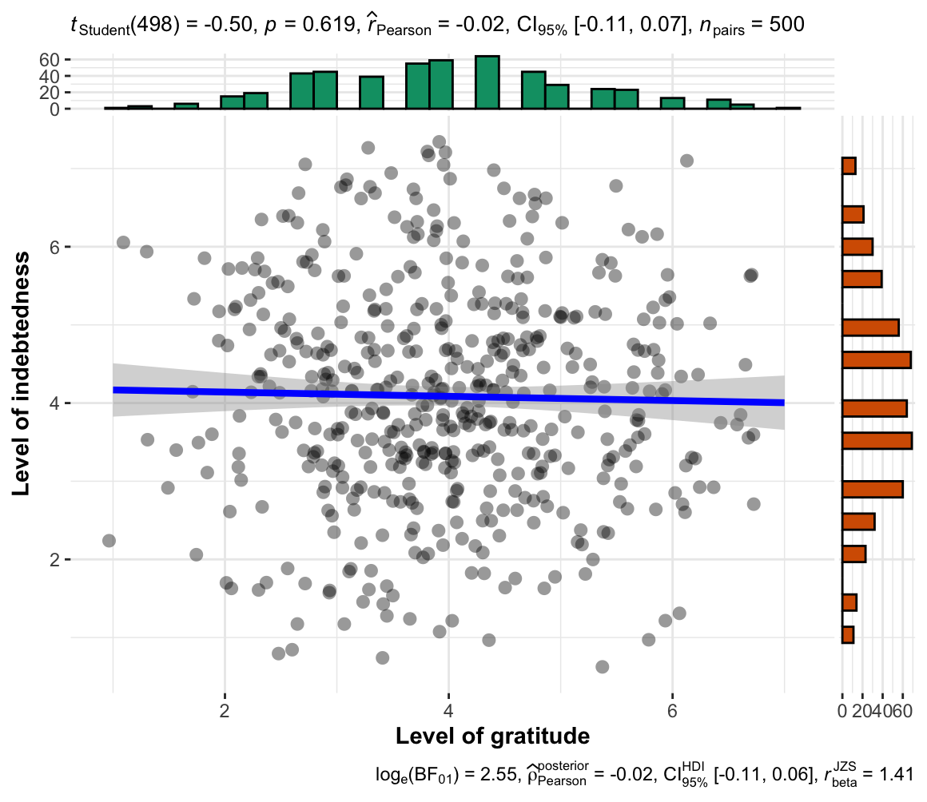

Figure 2
Study 2 selfish-ulterior condition: Association between gratitude and indebtedness

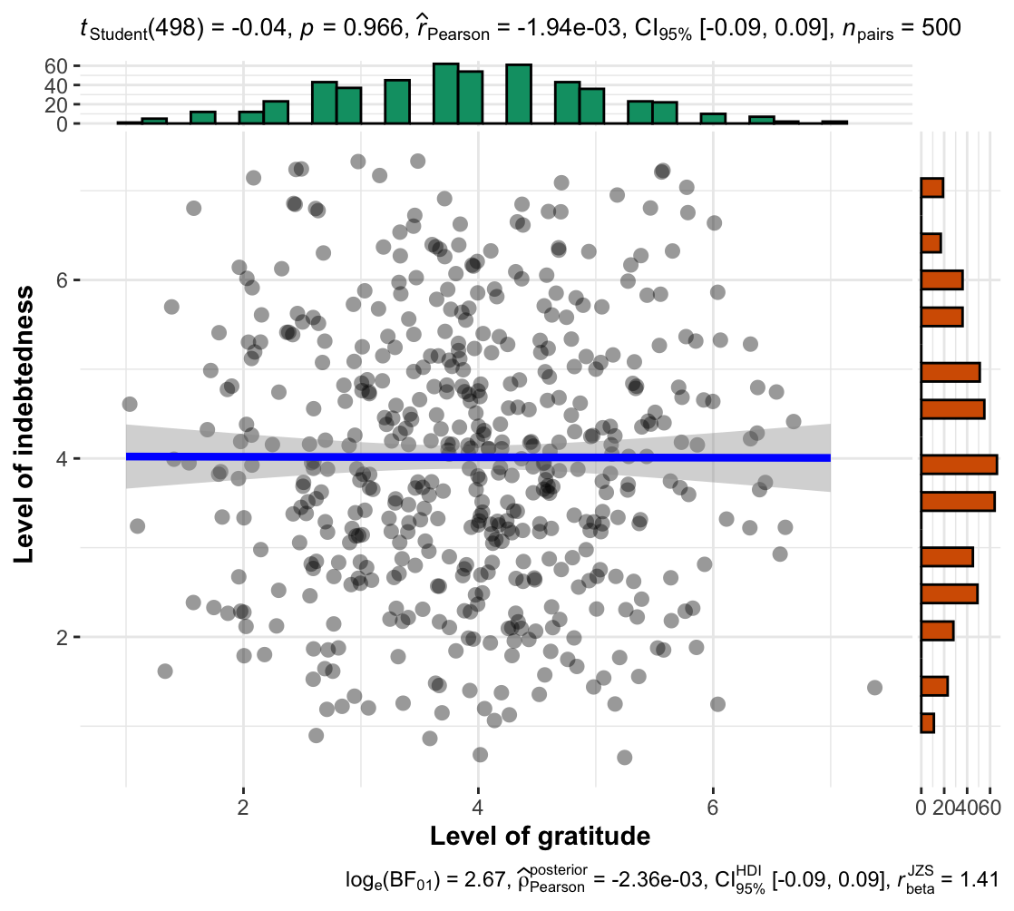

Core hypothesis: Impact of intent (benevolent > selfish) on gratitude is stronger than on indebtedness
We conducted ANCOVAs, with the rated magnitude of favor as a covariate, and found no support for differences in gratitude between the benevolent condition and the selfish-ulterior condition (F(1, 997) = 1.06, p = .302; η²_{p} < .01, 90% CI [0.00, 0.01]) or for indebtedness (F(1, 997) = 0.68, p = .411; η²_{p} < .01, 90% CI [0.00, 0.01]). We, therefore, conclude that we failed to find support for Hypotheses 2 and 3 that more grateful/ indebted emotions are experienced when recalling a selfish favor compared to a benevolent favor after controlling the magnitude of favor.

Complementary regression analyses
We conducted regression analyses with a condition variable contrasting benevolent and selfish helper intent and magnitude of favor predicting gratitude and indebtedness. For gratitude, we found no support for both intention conditions (β = 0.033, t(997) = 1.03, p = 0.302) and magnitude of favor (β = 0.01, t(997) =0.302, p =0.763) as predictors of feelings of gratitude (R² < .01, 95% CI [0.00, 0.02], F(2, 997) = .583, p = .56).
For indebtedness, we found no support for both intention conditions (β = 0.03, t(997) = 1.03, p = .302) and magnitude of favor (β = 0.01, t(997) = 0.30, p = .76) as predictors of feelings of indebtedness (R² < .001, 95% CI [0.00, 0.01], F(2, 997) = 0.582, p = .560).
We failed to find support for Hypotheses 4 and 5 that helpers’ motives (benevolent/ selfish-ulterior) and magnitude of favor predict feelings of gratitude or indebtedness.

Figure 3
Study 2: Helper intention impact on gratitude
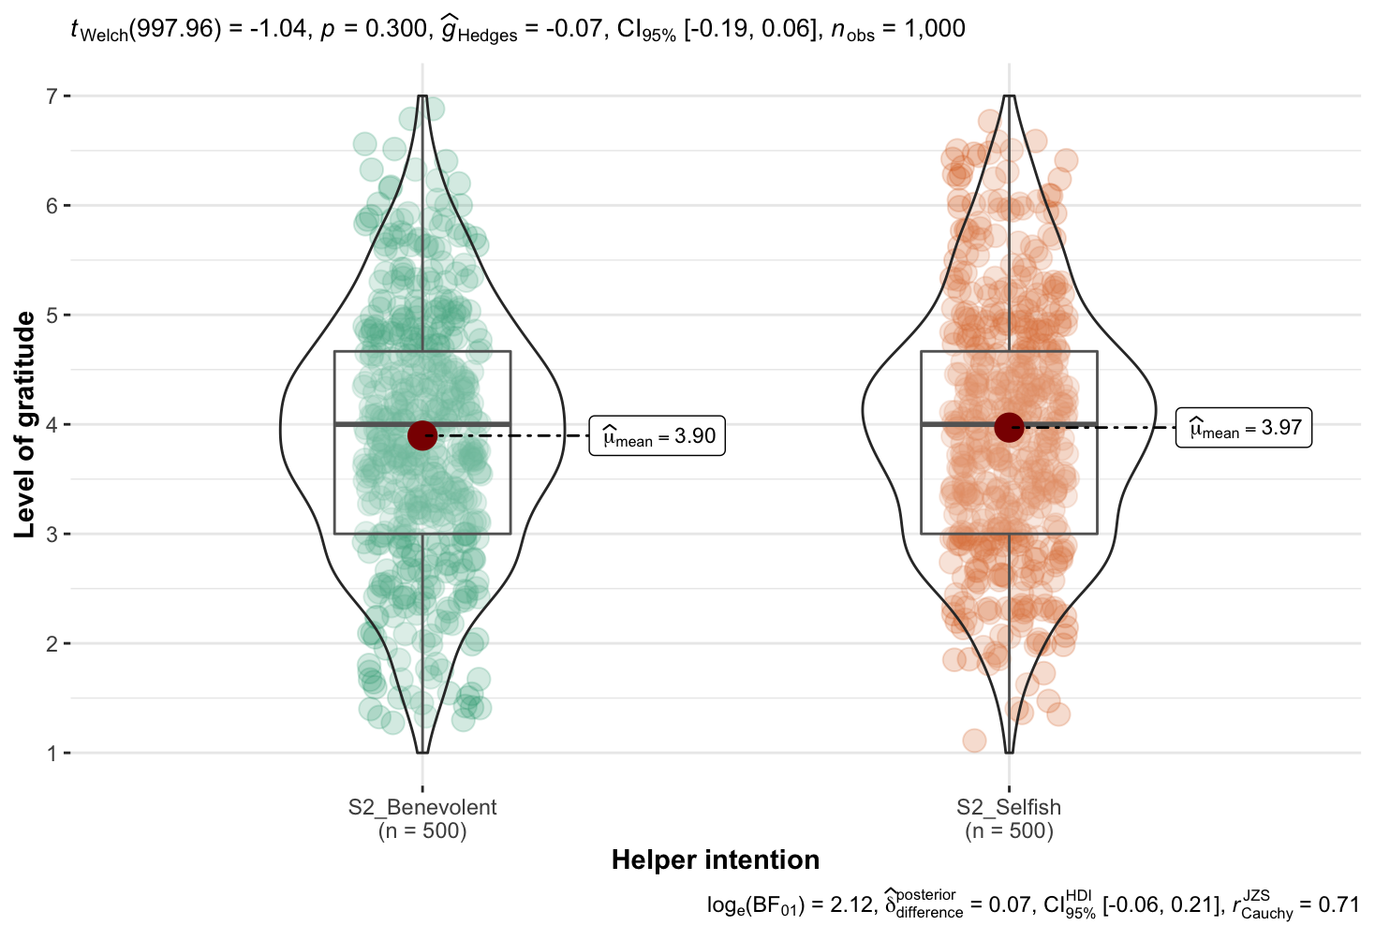
Note. The scale is from 1 to 7, higher values indicate stronger feelings of gratitude.

Figure 4
Study 2: Impact of helper intention on indebtedness

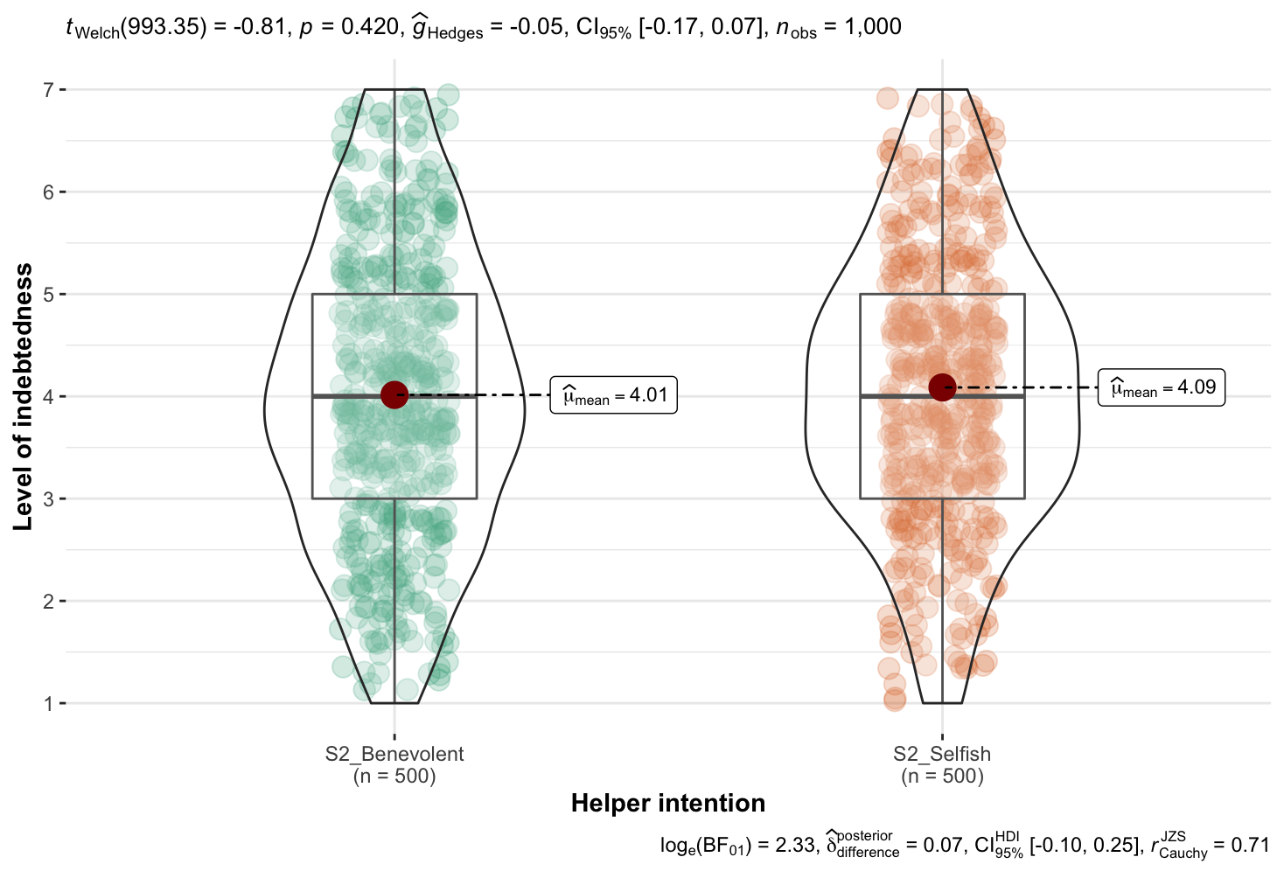
Note. The scale is from 1 to 7, higher values indicate stronger feelings of indebtedness.

Interaction between intent and emotions (gratitude vs. indebtedness): Extension analysis of a direct test to core hypothesis
[To be completed in Stage 2]
We conducted a mixed ANOVA examining the interaction between intent (benevolent versus selfish-ulterior; between-subject) and emotion type (gratitude versus indebtedness; repeated) and found… (Figure 5)

Figure 5
Study 2: Interaction between helper intention and emotions

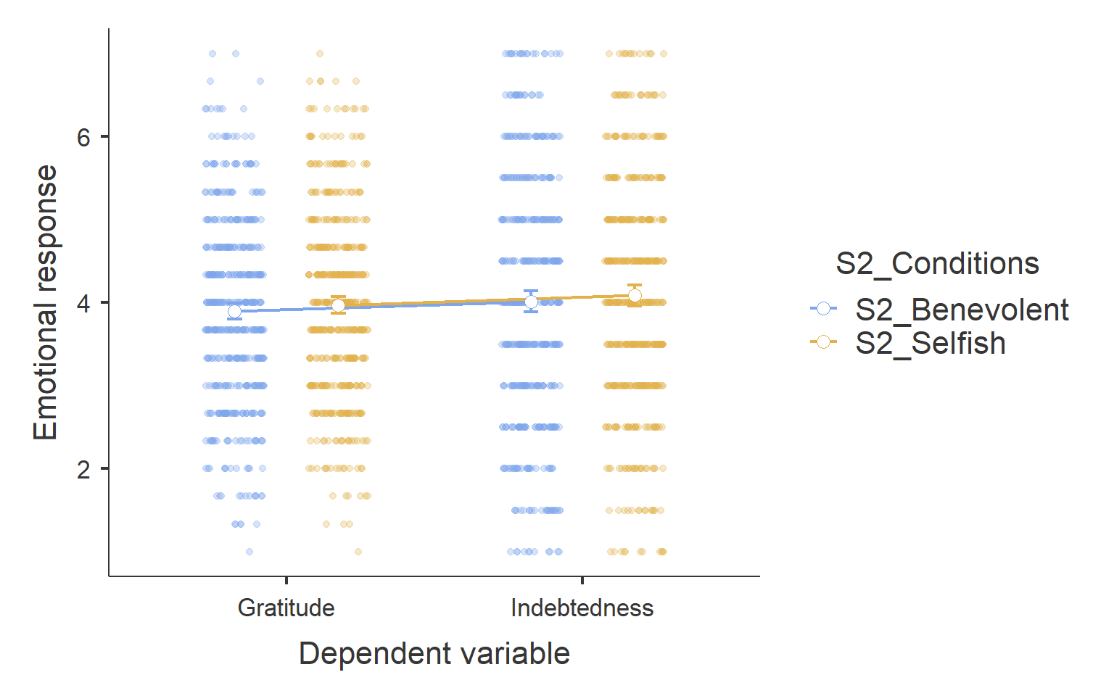
Note. Scale is from 1 to 7, higher values indicate stronger feelings of the emotion.

Study 3

Manipulation check: Helper intention
We conducted independent samples t-tests (Welch’s t, two-tailed) and found no support for perceived helper intention in the selfish-ulterior condition as different from those in the benevolent condition (selfish-ulterior: n = 333; M = 3.92, SD = 2.11; benevolent: n = 333; M = 4.04, SD = 2.00; M_{d} = -0.12; t (662.36) = -0.70, p = .486; d = -0.05, 95% CI [-0.21, 0.10]) and in ambiguous condition (n = 334; M = 4.17, SD = 1.96; M_{d} = -0.24; t (661.43) = -1.55, p = .119; d = -0.12, 95% CI [-0.27, 0.03]). We also found no support for rated helper intention in the benevolent condition as different from that in ambiguous condition (t (664.62) = -0.87, p = .381; d < 0.01, 95% CI [-0.22, 0.08]).
We conducted independent samples t-tests (Welch’s t, two-tailed) and found no support for the rated magnitude of favor in the selfish-ulterior condition as different from those in the benevolent condition (selfish-ulterior: n = 333; M = 3.95, SD = 2.08; benevolent: n = 333; M = 4.06, SD = 2.00; M_{d} = -0.11; t (663.99) = -0.47, p = .641; d = -0.04, 95% CI [-0.191, 0.12]) and in the ambiguous condition (n = 334; M = 3.75, SD = 1.93; M_{d} = 0.236; t (664.16) = 1.56, p = .120; d = 0.12, 95% CI [-0.03, 0.27]). We also found no support for rated helper intention in the benevolent condition as different from that in ambiguous condition (t (663.95) = 2.02, p = .043; d = 0.23, 95% CI [0.00, 0.44]).

Associations between gratitude and indebtedness
We conducted correlation tests (Pearson's Correlation) and found no support for an association between gratitude and indebtedness in the benevolent condition (r(331) = -.02, 95% CI [-0.14, 0.08], p = .62), the selfish-ulterior condition (r(331) = -.060, 95% CI [-0.16, 0.05], p = .27), or the ambiguous condition (r(332) = 0.04, 95% CI [-0.07, 0.14], p = .489). We therefore concluded no support for Hypothesis 6 that gratitude is associated with indebtedness in ambiguous conditions.

Core hypothesis: Impact of intent (benevolent > ambiguous > selfish) on gratitude is stronger than on indebtedness.
We conducted one-way ANOVAs and found no support for helper intention impact on gratitude (F(2, 997) = 0.08, p =.924; η²_{p} < 0.001, 90% CI [0.00, 0.03]), or on indebtedness (F(2, 997) = 2.54, p = .079; η²_{p} < 0.00, 90% CI [0.00, 0.01]), and therefore no support for the hypothesis that gratitude (Hypothesis 7a) and indebtedness (Hypothesis 8a) are different across three conditions (benevolent, selfish-ulterior, and ambiguous).
Following the ANOVAs, we conducted post-hoc contrasts analyses for Hypotheses 7b and 7c, and found no support for differences in feelings of gratitude comparing the Ambiguous condition (n = 334; M = 4.04, SD = 11.22) to both the benevolent condition (n = 333; M = 4.01, SD = 1.19; M_{d} = -0.03; t (997) = 0.35, p = .728; d = 0.03, 95% CI [-0.12, 0.18]), and the selfish-ulterior condition (n = 333; M = 4.04, SD = 1.14; M_{d} = 0.03; t (997) = 0.01, p = .992; d < -.001, 95% CI [-0.15, 0.15]).
Also, we conducted post-hoc contrasts analyses for Hypotheses 8b and 8c and found no support for feelings of indebtedness comparing the benevolent condition (M = 3.99, SD = 1.42) to both the ambiguous condition (M = 4.10, SD = 1.40; M_{d} = -.11; t (997) = 0.35, p = .728; d = 0.03, 95% CI [-0.12, 0.18]) and the selfish-ulterior condition (M = 3.86, SD = 1.44; M_{d} = 0.13; t (997) = -0.34, p = .735; d = -0.02, 95% CI [-0.17, 0.13]).

Figure 6
Study 3: Helper intention impact on gratitude

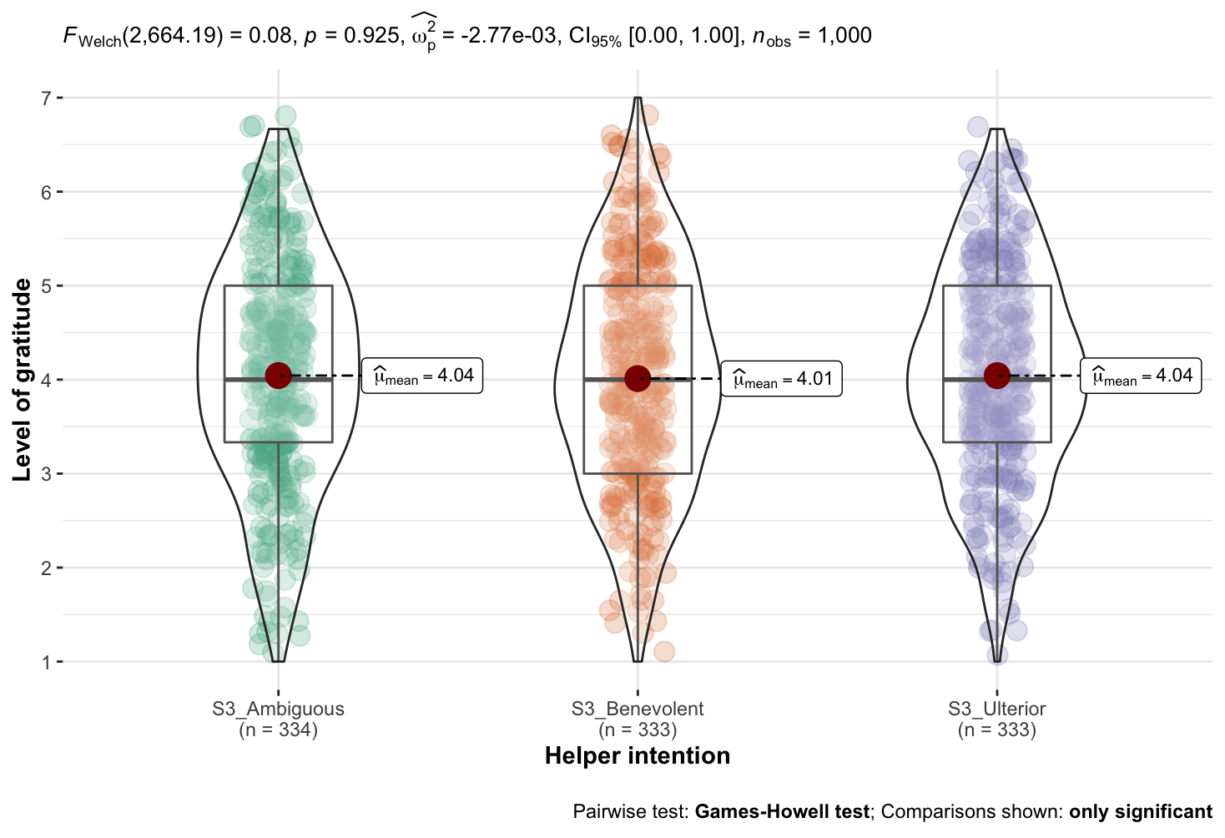
Note. The scale is from 1 = [Lowest on the scale], to 7 = [Highest on the scale]; Higher values indicate stronger feelings of gratitude.

Figure 7
Study 3: Helper intention impact on indebtedness
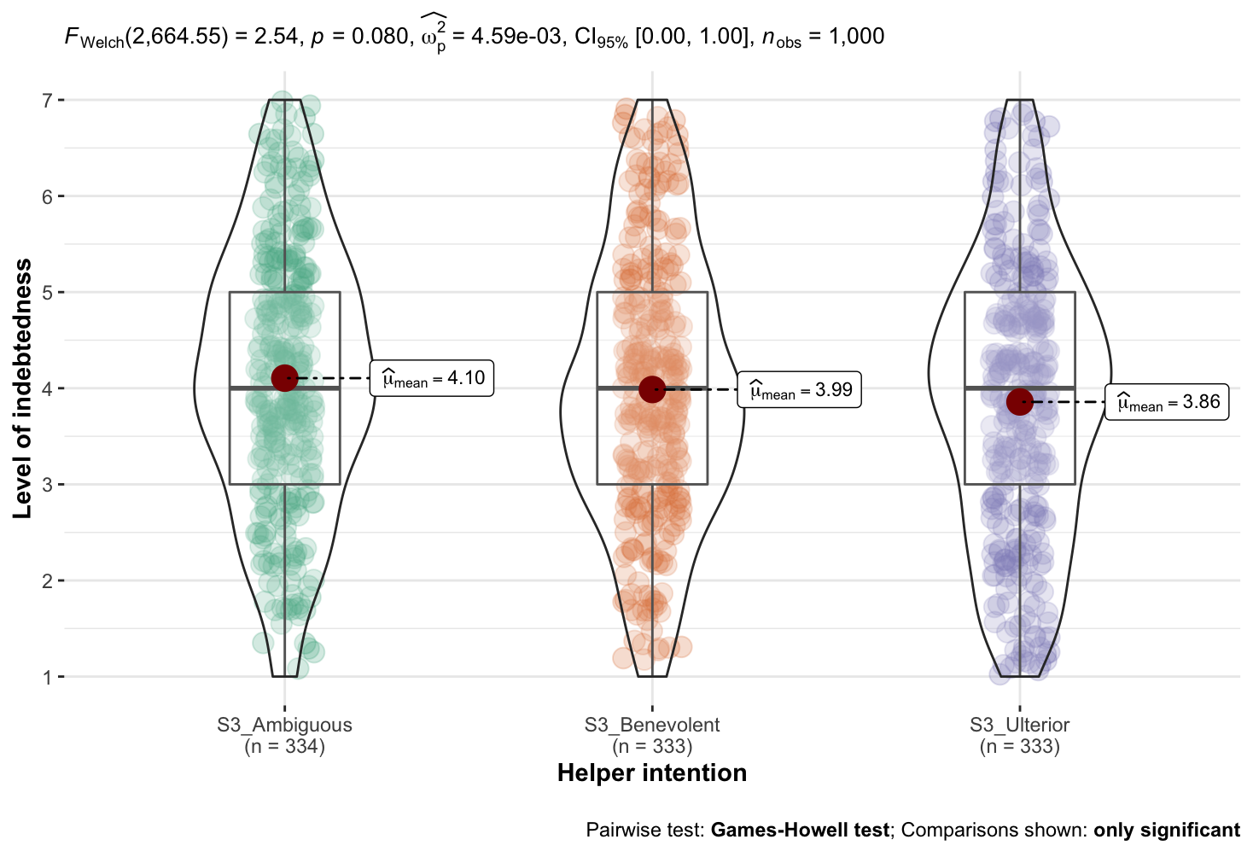
Note. The scale is from 1 = [Lowest on the scale], to 7 = [Highest on the scale]; Higher values indicate stronger feelings of indebtedness.

Interaction between intent and emotions (gratitude vs. indebtedness): Extension analysis of a direct test to core hypothesis
We conducted a mixed ANOVA examining the interaction between intent (benevolent versus selfish-ulterior versus ambiguous; between-subject) and emotion type (gratitude versus indebtedness; repeated) and found… (Figure 8)

Figure 8
Study 3: Interaction between helper intention and emotions

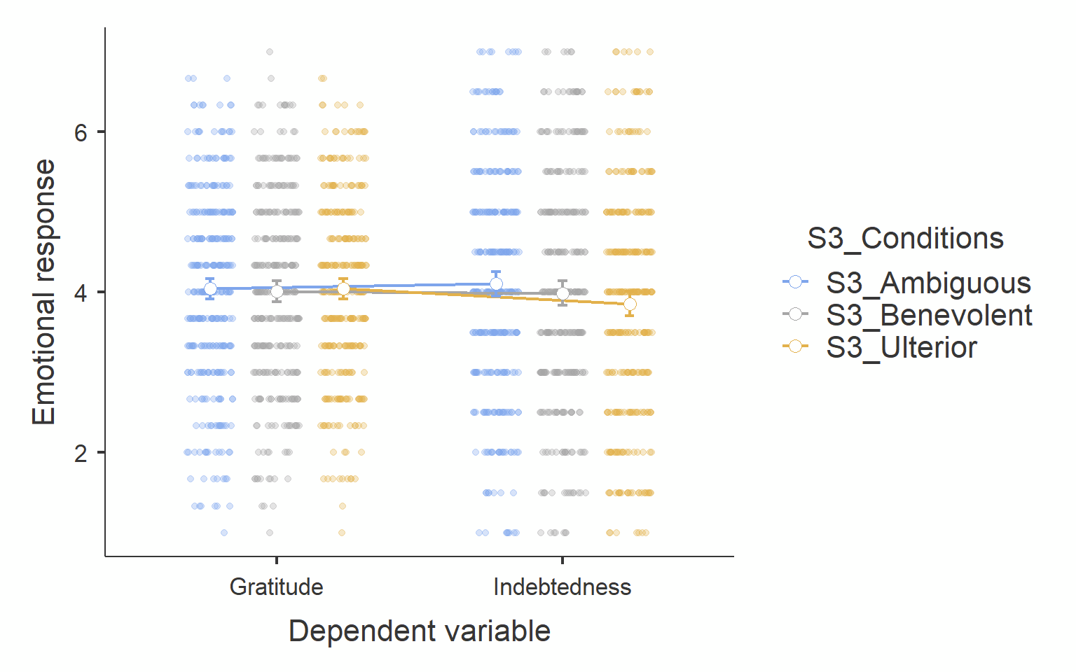
Note. The scale is from 1 to 7, higher values indicate stronger feelings of the emotion.

Table 8
Summary of statistical tests and results interpretation
H | Stat. tests | df | p | Effect size | CI | Interpretation
1a | Pearson correlation | 998 | = .73 | r = -.01 | [-0.07, 0.05]
1b | Pearson correlation | 498 | = .97 | r < .001 | [-0.09, 0.09]
1c | Pearson correlation | 498 | = .619 | r = -.02 | [-0.11, 0.07]
2 | ANCOVA | 1, 997 | = .302 | η²_{p} < .01 | [0.00, 0.01]
3 | ANCOVA | 1, 997 | = .411 | η²_{p} < .01 | [0.00, 0.01]
2+3 | Mixed ANOVA (extension)
4 | Linear regression | 2, 997 | = .560  (a) = .302  (b) = .585 | R² < .01  β= 0.03  β= 0.01 | [0.00, 0.02]
5 | Linear regression | 2, 997 | = .56  (a) = .302  (b) = .560 | R² < .001  β= 0.03  β= 0.02 | [0.00, 0.01]
6 | Pearson correlation | 332 | = .489 | r = 0.04 | [-0.07, 0.14]
7a | One-way ANOVA | 2, 997 | = .924 | η²_{p} < 0.01 | [0.00, 0.03]
7b | Independent t-test (two-tailed) | 997 | = .728 | d = 0.03 | [-0.12, 0.18]
7c | Independent t-test (two-tailed) | 997 | = .992 | d < 0.01 | [-0.12, 0.18]
7b/c+  8b/c | Mixed ANOVA (extension)
8a | One-way ANOVA | 2, 997 | = .079 | η²_{p} < 0.01 | [0.00, 0.01]
8b | Independent t-test (two-tailed) | 997 | = .728 | d = 0.03 | [-0.12, 0.18]
8c | Independent t-test (two-tailed) | 997 | = .735 | d < 0.01 | [-0.17, 0.13]
9 | Pearson correlation | 332 | = .740 | r = .02 | [-0.09, 0.13]
10 | Pearson correlation | 332 | = .220 | r = -.07 | [-0.13, 0.04]
Note. See Table 1 for hypotheses. See supplementary for more details. CI = 95% confidence intervals. For partial eta-squared, 90% confidence intervals are calculated specifically instead of 95% in order not to include zero with the p-value falling below .05 (Lakens, 2014). The interpretation of outcome is based on LeBel et al. (2019).

Associations between helper intentions, gratitude, and indebtedness
We conducted correlation tests (Pearson's Correlation) in the ambiguous condition and found no support for helper intentions as associated with gratitude (r(332) = 0.02, 95% CI [-0.09, 0.13], p = .740), or with indebtedness (r(332) = -0.07, 95% CI [-0.13, 0.04], p = .220).

Extensions
We added perceived expectations for reciprocity and reciprocity tendency as two extensional dependent variables in study 3 and evaluated how they are different across conditions and associated with gratitude and indebtedness.

Figure 9
Study 3: Helper intention impact on perceived reciprocity
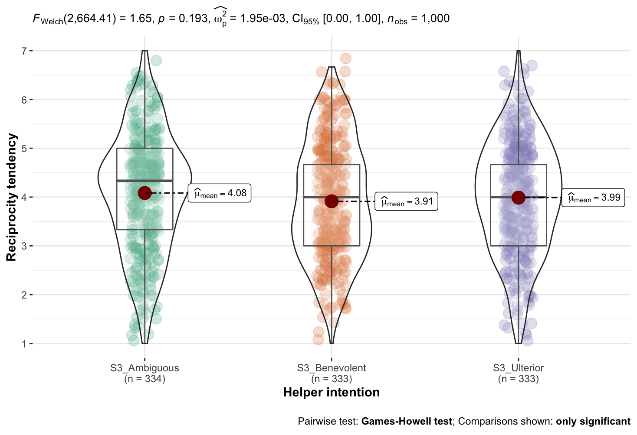
Note. The scale is from 1 to 7 ; Higher values indicate higher perceived expectation for reciprocity.

First, we conducted independent samples t-tests (Welch’s t, two-tailed) and found no support for perceived expectation for reciprocity in selfish-ulterior condition as different from those in the benevolent condition (benevolent: n = 333; M = 3.95, SD = 2.08; selfish-ulterior: n = 334; M = 4.09, SD = 1.26; M_{d} = 0.14; t (663.26) = -1.63, p = .103; d = -0.13, 95% CI [-0.27, 0.03]). We concluded that we failed to find support for Hypothesis 11 that favors with benevolent intentions will trigger stronger perceived expectations for reciprocity compared to selfish-ulterior intentions.
Then, we conducted independent samples t-tests (Welch’s t, two-tailed) and found no support for reciprocity tendency in selfish-ulterior condition as different from those in the benevolent condition (benevolent: n = 333; M = 3.91, SD = 1.2; selfish-ulterior: n = 333; M = 3.99, SD = 1.26; M_{d} = -0.08; t (663.21) = -0.83, p = .405; d = -0.12, 95% CI [-0.27, 0.03]). We failed to find support for Hypothesis [11] that favors with benevolent intentions will trigger a stronger reciprocity tendency compared to selfish-ulterior intentions.
After that, we conducted correlation tests (Pearson's Correlation) and found no support for a link between reciprocity tendency and perceived reciprocity expectation, r(998)= 0.07, 95% CI [0.01, 0.13], p = .026. We failed to find support for Hypotheses [13] that perceived reciprocity expectation is associated with reciprocity tendency.

Figure 10
Study 3: The association between reciprocity tendency and perceived expectation for reciprocity
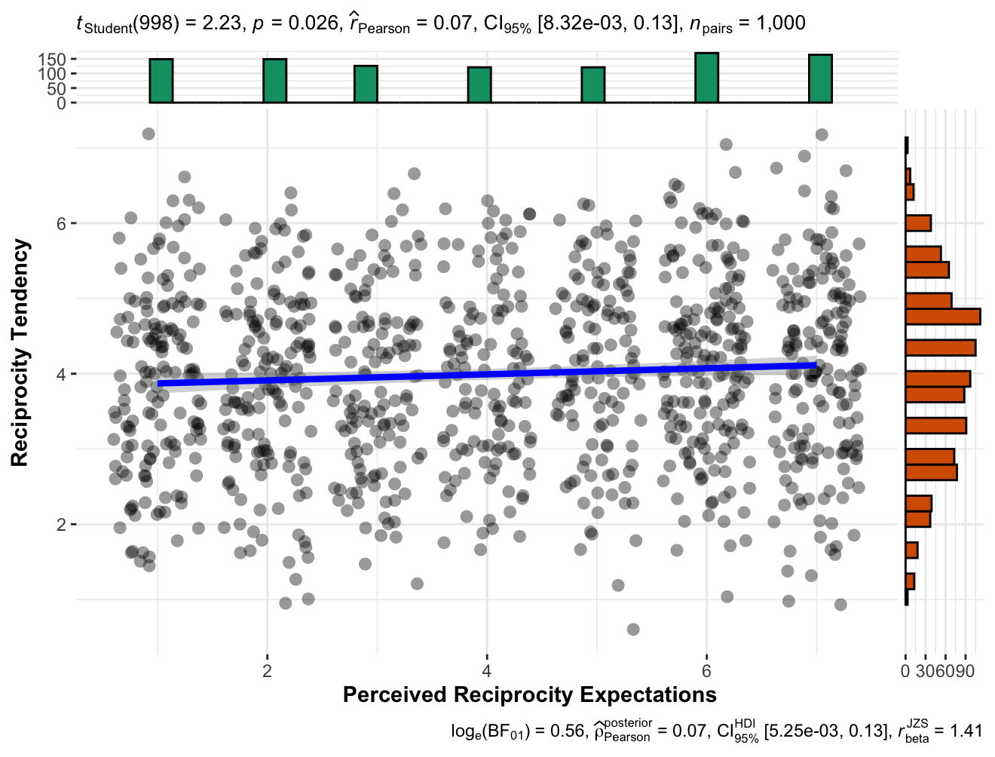

Eventually, we conducted correlation tests (Pearson's Correlation) and found no support for a link between perceived reciprocity expectation and gratitude, r(998)= .01, 95% CI [-0.05, 0.07], p = .790, as well as indebtedness, r(998)= .004, 95% CI [-0.05, 0.06], p = .890. We failed to find support for Hypotheses [14] and [15] that gratitude and indebtedness are associated with perceived expectation for reciprocity.

Table 9
Extension: Summary of statistical tests
Hypothesis | Stat. tests | df | p | Effect size | CI
11 | Independent t-test  (two-tailed) | 663.26 | = .103 | d = -0.12 | [-0.27, 0.03]
12 | Independent t-test  (two-tailed) | 663.21 | = .405 | d = -0.12 | [-0.27, 0.03]
13 | Pearson correlation | 998 | = .026 | r = .07 | [0.01, 0.13]
14 | Pearson correlation | 998 | = .79 | r = .01 | [-0.05, 0.07]
15 | Pearson correlation | 998 | = .89 | r = .004 | [-0.05, 0.06]
Note. See Table 1 for all hypotheses’ contents. CI = 95% confidence intervals.

Comparing replication to target article’s findings
[Comparison would be completed in Stage 2 following data collection]

Discussion
[Please note that the discussion is only to be completed in Stage 2 following data collection]

Implications, limitations, and directions for future research
[Planned discussion in Stage 2 following Dr./Prof. Jo-Ann Tsang’s comment: $200 in 2006 is fairly equal to $300 in 2023. We will discuss the dilemma of whether to change stimuli in both our study and more broadly for replications, and our decision not to change the stimuli, with calls for future research to conduct more regular replications, to state clearly theoretical factors and predictions that might impact the effects and future replications, and to examine moderators like amount of money involved.]
[Planned discussion in Stage 2 following Dr./Prof. Cong Peng comment: We will discuss the need for a systematic review and meta-analysis of the literature pointing to the findings in the literature that built up on the target article.]
[Planned discussion in Stage 2 following Dr./Prof. Cong Peng comment: We will discuss the expectations of reciprocity extension and its role as a possible manipulation check, given that the scenario also explicitly mentioned expectations in the selfish condition.]

References
Algoe, S. B., Gable, S. L., & Maisel, N. C. (2010). It's the little things: Everyday gratitude as a booster shot for romantic relationships. Personal Relationships, 17(2), 217-233. https://doi.org/10.1111/j.1475-6811.2010.01273.x
Algoe, S. B., Fredrickson, B. L., & Gable, S. L. (2013). The social functions of the emotion of gratitude via expression. Emotion, 13(4), 605.
Ames, D. R., Flynn, F. J., & Weber, E. U. (2004). It’s the thought that counts: On perceiving how helpers decide to lend a hand. Personality and Social Psychology Bulletin, 30(4), 461-474. https://doi.org/10.1177/0146167203261890
Bar-Tal, D., Bar-Zohar, Y., Greenberg, M. S., & Hermon, M. (1977). Reciprocity behavior in the relationship between donor and recipient and between harm-doer and victim. Sociometry, 40(3), 293. https://doi.org/10.2307/3033537
Bartlett, M. Y., & DeSteno, D. (2006). Gratitude and Prosocial Behavior: Helping When It Costs You. Psychological Science, 17(4), 319–325. https://doi.org/10.1111/j.1467-9280.2006.01705.x
Bartlett, M. Y., Condon, P., Cruz, J., Baumann, J., & Desteno, D. (2012). Gratitude: Prompting behaviours that build relationships. Cognition & emotion, 26(1), 2-13.
Brandt, M. J., IJzerman, H., Dijksterhuis, A., Farach, F. J., Geller, J., Giner-Sorolla, R., ... & Van't Veer, A. (2014). The replication recipe: What makes for a convincing replication?. Journal of Experimental Social Psychology, 50, 217-224.
Chen, Y., Chee, X., & Feldman, G. (2023). Revisiting the Differential Centrality of Experiential and Material Purchases to the Self: Replication and extension of Carter and Gilovich (2012). Collabra:Psychology. Retrieved December 2022, from https://osf.io/v2w5h/.
Coles, N. A., Tiokhin, L., Scheel, A. M., Isager, P. M., & Lakens, D. (2018). The costs and benefits of replication studies. Behavioral and Brain Sciences, 41. https://doi.org/10.1017/S0140525X18000596
Delacre, M., Lakens, D., & Leys, C. (2017). Why Psychologists Should by Default Use Welch’s t-test Instead of Student’s t-test. International Review of Social Psychology, 30(1), 92–101. DOI: http://doi.org/10.5334/irsp.82
Emmons, R. A., & Crumpler, C. A. (2000). Gratitude as a human strength: Appraising the evidence. Journal of Social and Clinical Psychology, 19(1), 56-69. https://doi.org/10.1521/jscp.2000.19.1.56
Faul, F., Erdfelder, E., Lang, A.-G., & Buchner, A. (2007). G*Power 3: a flexible statistical power analysis program for the social, behavioral, and biomedical sciences. Behavior Research Methods, 39(2), 175–191. https://doi.org/10.3758/BF03193146
Feldman, G. (2023). Registered Report Stage 1 manuscript template. https://doi.org/10.17605/OSF.IO/YQXTP
Field, S. M., Hoekstra, R., Bringmann, L., & van Ravenzwaaij, D. (2019). When and Why to Replicate: As Easy as 1, 2, 3?. Collabra: Psychology, 5(1).
Fredrickson, B. L. (2004). Gratitude, like other positive emotions, broadens and builds. The Psychology of Gratitude, 144-166.
Frijda, N. H. (1988). The laws of emotion. American psychologist, 43(5), 349.
Gouldner, A. W. (1960). The norm of reciprocity: A preliminary statement. American Sociological Review, 25(2), 161. https://doi.org/10.2307/2092623
Goyal, N., Adams, M. M., Wice, M., Sullivan, S., & Miller, J. G. (2022). Gratitude endures while indebtedness persuades: investigating the unique influences of gratitude and indebtedness in helping. Cognition and Emotion, 36(7), 1361-1373.
Graham, S. (1988). Children's developing understanding of the motivational role of affect: An attributional analysis. Cognitive Development, 3(1), 71-88. https://doi.org/10.1016/0885-2014(88)90031-7
Gray, S. A., Emmons, R. A., & Morrison, A. (2001 August). Distinguishing gratitude from indebtedness in affect and action tendencies. Poster presented at the annual meeting of the American Psychological Association, San Francisco, CA.
Greenberg, M. S. (1980). A theory of indebtedness. In K. J. Gergen, M. S. Greenberg, & R. H. Willis (Eds.), Social exchange: Advances in theory and research (pp. 3–26). New York: Plenum Press
Heirene, R. (2020, January 7). A call for replications of addiction research: Which studies should we replicate & what constitutes a “successful” replication?. https://doi.org/10.31234/osf.io/xzmn4
Isager, P. M. (2019). Quantifying Replication Value: A formula-based approach to study selection in replication research. Open Science 2019, Trier, Germany.
Isager, P. M., van Aert, R. C. M., Bahník, Š., Brandt, M. J., DeSoto, K. A., Giner-Sorolla, R., … Lakens, D. (2020, September 2). Deciding what to replicate: A formal definition of “replication value” and a decision model for replication study selection. https://doi.org/10.31222/osf.io/2gurz
Jané, M., Xiao, Q., Yeung, S., Ben-Shachar, M. S., Caldwell, A., Cousineau, D., Dunleavy, D. J., Elsherif, M., Johnson, B., Moreau, D., Riesthuis, P., Röseler, L., Steele, J., Vieira, F., Zloteanu, M., & Feldman, G. (2024). Guide to Effect Sizes and Confidence Intervals. http://dx.doi.org/10.17605/OSF.IO/D8C4G
Klein, R. A., Vianello, M., Hasselman, F., Adams, B. G., Adams Jr, R. B., Alper, S., ... & Batra, R. (2018). Many Labs 2: Investigating variation in replicability across samples and settings. Advances in Methods and Practices in Psychological Science, 1(4), 443-490. https://journals.sagepub.com/doi/full/10.1177/2515245918810225
Komter, A. E. (2004). Gratitude and gift exchange. The Psychology of Gratitude, 194-212. https://doi.org/10.1093/acprof:oso/9780195150100.003.0010
Kubacka, K. E., Finkenauer, C., Rusbult, C. E., & Keijsers, L. (2011). Maintaining close relationships: Gratitude as a motivator and a detector of maintenance behavior. Personality and Social Psychology Bulletin, 37(10), 1362-1375.
Lane, J., & Anderson, N. H. (1976). Integration of intention and outcome in moral judgment. Memory & Cognition, 4(1), 1-5. https://doi.org/10.3758/bf03213247
LeBel, E. P., McCarthy, R. J., Earp, B. D., Elson, M., & Vanpaemel, W. (2018). A unified framework to quantify the credibility of scientific findings. Advances in Methods and Practices in Psychological Science, 1, 389-402. https://doi.org/10.1177/2515245918787489
LeBel, E. P., Vanpaemel, W., Cheung, I., & Campbell, L. (2019). A brief guide to evaluate replications. Meta-Psychology, 3, 1-9. DOI: 10.15626/MP.2018.843

Litman, L., Robinson, J., & Abberbock, T. (2017). TurkPrime. com: A versatile crowdsourcing data acquisition platform for the behavioral sciences. Behavior research methods, 49(2), 433-442. https://doi.org/10.3758/s13428-016-0727-z
Mathews, M. A., & Green, J. D. (2010). Looking at me, appreciating you: Self-focused attention distinguishes between gratitude and indebtedness. Cognition & Emotion, 24(4), 710-718.
McCullough, M. E. (2002). Savoring life, past and present: Explaining what hope and gratitude share in common. Psychological Inquiry, 13(4), 302-304. https://psycnet.apa.org/record/2003-01827-007
McCullough, M. E., Tsang, J.-A., & Emmons, R. A. (2004). Gratitude in Intermediate Affective Terrain: Links of Grateful Moods to Individual Differences and Daily Emotional Experience. Journal of Personality and Social Psychology, 86(2), 295–309. https://doi.org/10.1037/0022-3514.86.2.295
Moshontz, H., Campbell, L., Ebersole, C. R., IJzerman, H., Urry, H. L., Forscher, P. S., ... & Castille, C. M. (2018). The Psychological Science Accelerator: Advancing psychology through a distributed collaborative network. Advances in Methods and Practices in Psychological Science, 1(4), 501-515. https://doi.org/10.1177/2515245918797607
Naito, T., & Sakata, Y. (2010). Gratitude, indebtedness, and regret on receiving a friend’s favor in Japan. Psychologia, 53(3), 179-194.
Nelson, J. M., Hardy, S. A., Tice, D., & Schnitker, S. A. (2023). Returning thanks to God and others: prosocial consequences of transcendent indebtedness. The Journal of Positive Psychology, 1-15. https://doi.org/10.1080/17439760.2023.2190926
Nosek, B. A., & Errington, T. M. (2020). What is replication?. PLOS Biology, 18(3), e3000691. https://doi.org/10.1371/journal.pbio.3000691
Nosek, B. A., Hardwicke, T. E., Moshontz, H., Allard, A., Corker, K. S., Dreber, A., ... & Vazire, S. (2022). Replicability, robustness, and reproducibility in psychological science. Annual Review of Psychology, 73, 719-748.
Olsson-Collentine, A., van Assen, M. A. L. M., & Wicherts, J. M. (2020). Heterogeneity in direct replications in psychology and its association with effect size. Psychological Bulletin. https://doi.org/10.1037/bul0000294
Open Science Collaboration. (2015). Estimating the reproducibility of psychological science. Science, 349(6251), aac4716.
Ortony, A., Clore, G. L., & Collins, A. (1988). The cognitive structure of emotions. Cambridge: Cambridge University Press.
Patil, I. (2021). Visualizations with statistical details: The 'ggstatsplot' approach. Journal of Open Source Software, 6(61), 3167, doi:10.21105/joss.03167
Peng, C., Nelissen, R. M., & Zeelenberg, M. (2018). Reconsidering the roles of gratitude and indebtedness in social exchange. Cognition and Emotion, 32(4), 760-772.
Peng, C., Malafosse, C., Nelissen, R. M. A., & Zeelenberg, M. (2020). Gratitude, indebtedness, and reciprocity: an extended replication of Bartlett & DeSteno (2006). Social Influence, 15(1), 4–16. https://doi.org/10.1080/15534510.2019.1710248
Peng, C., Nelissen, R. M., & Zeelenberg, M. (2018). Reconsidering the roles of gratitude and indebtedness in social exchange. Cognition and Emotion, 32(4), 760-772. https://doi.org/10.1080/02699931.2017.1353484
R Core Team (2022). R: A Language and environment for statistical computing. (Version 4.1) [Computer software]. Retrieved from https://cran.r-project.org. (R packages retrieved from CRAN snapshot 2023-04-07).
Roberts, R. C. (1991). Virtues and rules. Philosophy and Phenomenological Research, 51(2), 325. https://doi.org/10.2307/2108130
Tesser, A., Gatewood, R., & Driver, M. (1968). Some determinants of gratitude. Journal of Personality and Social Psychology, 9(3), 233-236. https://doi.org/10.1037/h0025905
​​The JAMOVI project (2023). JAMOVI. (Version 2.4) [Computer Software]. Retrieved from https://www.jamovi.org.
Tsang, J. (2006). The effects of helper intention on gratitude and indebtedness. Motivation and Emotion, 30(3), 198-204. https://doi.org/10.1007/s11031-006-9031-z
Watkins, P., Scheer, J., Ovnicek, M., & Kolts, R. (2006). The debt of gratitude: Dissociating gratitude and indebtedness. Cognition & Emotion, 20(2), 217-241. https://doi.org/10.1080/02699930500172291
Welsh, D. T., Baer, M. D., Kim, J. K., Thiel, C., & Smith, I. H. (2022). Desirable or deceitful? How social exchange dynamics shape responses to pro‐coworker unethical behavior. Personnel Psychology, 75(3), 619-644.
Williams, L. A., & Bartlett, M. Y. (2015). Warm thanks: gratitude expression facilitates social affiliation in new relationships via perceived warmth. Emotion, 15(1), 1.
Yeung, S. K., & Feldman, G. (2022). Revisiting the Temporal Pattern of Regret in Action Versus Inaction: Replication of Gilovich and Medvec (1994) With Extensions Examining Responsibility. Collabra: Psychology, 8(1). doi: 10.1525/collabra.37122
Zwaan, R. A., Etz, A., Lucas, R. E., & Donnellan, M. B. (2018). Making replication mainstream. Behavioral and Brain Sciences, 41, e120.

