Revisiting the Effects of Helper Intention on Gratitude and Indebtedness:  
Replication and extensions Registered Report of Tsang (2006)

Chi Fung Chan  
ORCID: 0000-0002-7425-8421  
Department of Psychology, University of Hong Kong  
[tccf312@connect.hku.hk](mailto:tccf312@connect.hku.hk) ; [timothychan312@gmail.com](mailto:timothychan312@gmail.com)

*Hiu Ching Lim, *Fung Yee Lau, *Wing Ip, *Chak Fong Shannon Lui  
Department of Psychology, University of Hong Kong  
[u3568980@connect.hku.hk](mailto:u3568980@connect.hku.hk) ; [victorialimhc@gmail.com](mailto:victorialimhc@gmail.com)  
[heatherlau@connect.hku.hk](mailto:heatherlau@connect.hku.hk) ; [heatherlau654@gmail.com](mailto:heatherlau654@gmail.com)   
[juneipw@connect.hku.hk](mailto:juneipw@connect.hku.hk) ; [wiishtcaauserexe@gmail.com](mailto:wiishtcaauserexe@gmail.com)   
[u3560176@connect.hku.hk](mailto:u3560176@connect.hku.hk) ; [shannonlui0512@gmail.com](mailto:shannonlui0512@gmail.com)

Katy Y. Y. Tam  
ORCID: 0000-0003-2197-8705  
University of Toronto   
[katy.tam@utoronto.ca](mailto:katy.tam@utoronto.ca) / [yuenyan1211@gmail.com](mailto:yuenyan1211@gmail.com)

^Gilad Feldman  
OCRID: 0000-0003-2812-6599  
Department of Psychology, University of Hong Kong, Hong Kong SAR  
[gfeldman@hku.hk](mailto:gfeldman@hku.hk) ; [giladfel@gmail.com](mailto:giladfel@gmail.com)

* Shared second coauthor  
^Corresponding author

## Author bios:

Chi Fung Chan, Hiu Ching Lim, Fung Yee Lau, Wing Ip, and Chak Fong Shannon Lui were students at the University of Hong Kong during the academic year 2021.

Katy Y. Y. Tam is an assistant professor at the University of Toronto.

Gilad Feldman is an assistant professor with the University of Hong Kong psychology department. His research focuses on judgment and decision-making.

## Declaration of Conflict of Interest:

The author(s) declared no potential conflicts of interests with respect to the authorship and/orpublication of this article.

## Financial disclosure/funding:

The project was supported by the University of Hong Kong Teaching Development Grant awarded to Gilad Feldman.

## Authorship declaration:

Chi Fung Chan, Hiu Ching Lim, Fung Yee Lau, Wing Ip, and Chak Fong Shannon Lui designed the study, developed the experimental materials for each study respectively, and wrote an initial draft of the Registered Report Stage 1.

Chi Fung Chan integrated the team’s projects, verified the materials and analyses, prepared the manuscript for submission, and replied to reviewer feedback.

Gilad Feldman guided the team and project, supervised each step of the project, ran data collection, conducted the pre-registration, and edited the manuscript for submission and the reply to reviewer feedback.

## Corresponding author:

Gilad Feldman, Department of Psychology, University of Hong Kong, Hong Kong SAR; [gfeldman@hku.hk](mailto:gfeldman@hku.hk); ORCID: 0000-0003-2812-6599

## Rights:

CC BY or equivalent license is applied to the AAM arising from this submission. ([clarification](https://bit.ly/rrs-primer))

## Citation of the target research article:

Tsang, J.-A. (2006). The effects of helper intention on gratitude and indebtedness. Motivation and Emotion, 30(3), 199–205. https://doi.org/10.1007/s11031-006-9031-z

## Contributor Roles Taxonomy

|  |  |  |  |  |
| --- | --- | --- | --- | --- |
| **Role** | **Chi Fung Chan** | **Gilad Feldman** | **Hiu Ching Lim, Fung Yee Lau, Wing Ip, and Chak Fong Shannon Lui** | **Katy Y. Y. Tam** |
| Conceptualization | X | X |  |  |
| Pre-registration | X | X | X |  |
| Data curation |  | X |  |  |
| Formal analysis | X |  | X |  |
| Funding acquisition |  | X |  |  |
| Investigation | X |  | X | X |
| Pre-registration peer review / verification |  | X | X | X |
| Data analysis peer review / verification |  | X | X | X |
| Methodology | X |  |  |  |
| Project administration |  | X |  | X |
| Resources |  | X |  |  |
| Software | X |  | X |  |
| Supervision |  | X |  | X |
| Validation |  | X |  |  |
| Visualization | X |  | X |  |
| Writing-original draft | X |  |  |  |
| Writing-review and editing |  | X |  |  |

# Abstract

Gratitude and indebtedness are common emotions in response to a favor, yet research suggests that they are experienced differently depending on the situation. Tsang (2006) found that gratitude for a favor depended on perceived helper intention, whereas indebtedness did not. Specifically, Tsang (2006) proposed that perceived benevolent helper intentions were associated with higher gratitude from beneficiaries compared to selfish ones, yet had no associations with indebtedness. In a Registered Report with a US Prolific student sample (*N* = 759), we conducted a replication and extensions of Studies 2 and 3 from Tsang (2006). In the original studies, Tsang found support for the impact of the helper’s intention on gratitude (Study 2: *η*2p = .20 [0.08, 0.32]; Study 3: *η2p* = .14 [0.03, 0.26]), but not for indebtedness (Study 2: *η*2p = .01 [0.00, 0.08]; Study 3: *η2p* = .00 [0.00, 0.03]). In our replications, we found support for the effect on gratitude (Study 2: *η2p* = .33 [0.28, 0.37]; Study 3: *η2p* = .16 [0.12, 0.20]), and - as expected - no support for an effect on indebtedness (Study 2: *η*2p = .00 [0.00, 0.01]; Study 3: *η2p* = .01 [0.00, 0.01]). We concluded a successful replication that helping intent was more strongly associated with gratitude than indebtedness. Extending the replication, we found evidence for the impact of helper intention on perceived expectations for reciprocity (*d* = 1.51 [1.31, 1.71]), and reciprocity inclination (*d* = 0.66 [0.48, 0.84]), and for associations of perceived reciprocity expectations with gratitude (*r* = -.28 [-0.35, -0.22]) and indebtedness (*r* = 0.17 [0.10, 0.24]). Materials, data, and code are available on: <https://osf.io/ghfy4/>

Keywords: Gratitude, indebtedness, intent, reciprocity, affect, judgment and decision making, replication

# PCIRR-Study Design Table

|  |  |  |  |  |  |  |
| --- | --- | --- | --- | --- | --- | --- |
| Question | Hypothesis | Sampling plan | Analysis plan | Rationale for deciding the sensitivity of the test for confirming or disconfirming the hypothesis | Interpretation given different outcomes | Theory that could be shown wrong by the outcomes |
| How do perceived helper intentions influence gratitude? | Benevolent favors result in more gratitude than selfish favors, even after controlling the magnitude of favor. | Participants were recruited online via Prolific. We aimed to recruit 750 participants based on our power and sensitivity analyses, which is sufficient to detect the weakest effect of interest.  Our final sample was 759. | ANCOVA, One-way between-subject ANOVA, Independent samples t-tests | We followed the statistical analyses of the target article. | We examined the replicability of the findings by Tsang (2006) based on the criteria by Lebel et al. (2019). | Gratitude is impacted more strongly than indebtedness by helpers’ intentions. |
| How do the perceived helper intentions influence indebtedness? | Benevolent favors result in more indebtedness than selfish favors even after controlling the magnitude of favor. [Reframed from the original’s null hypothesis] | ANCOVA, One-way between-subject ANOVA, Independent samples t-tests |
| What is the relationship between indebtedness and gratitude? | Gratitude is associated with indebtedness under both selfish and benevolent intentions. | Pearson correlation |

# Revisiting the Effects of Helper Intention on Gratitude and Indebtedness: Replication and extensions Registered Report of Tsang (2006)

## Background

Gratitude and indebtedness are common emotions in response to receiving help, but studies suggest that they are experienced differently depending on the situation. Tsang (2006) showed that helper intentions were associated with feelings of gratitude, yet less so for indebtedness: people reported feeling more grateful when the helper’s motivations were perceived as being less selfish, with weaker to no motivation for feelings of indebtedness.

We conducted a close replication and extension of Tsang (2006) with two main goals. Our first goal was to conduct an independent replication of the impact of the helper’s intentions, comparing gratitude and indebtedness. Our second goal was to examine extensions, aiming to enrich our understanding of how differences in helper intentions impact reciprocation.

We begin by introducing the literature on gratitude and indebtedness, and the impact of helpers’ intentions on these emotions. We then discuss our motivations for the current replication and review Tsang (2006) as our chosen article for replication. Finally, we outline the replication and extension hypotheses, study design, and methods.

## The effect of helper intention on gratitude and indebtedness

Gratitude and indebtedness are common reactions to receiving help, with these emotions varying across situations (Bartlett & DeSteno, 2006; Gray et al., 2001, Peng et al., 2018). Consider, for example, how a student would respond to a classmate who has volunteered to help with homework depends on perceptions of selfish-ulterior motives. The student’s gratitude and indebtedness may depend on whether the act of helping seemed to have been purely benevolent to help another, or rather based on selfish-ulterior motives. These two emotions have often been equated in the early literature and yet evidence showing that these emotions are elicited in different situations suggested the need to differentiate between them (Greenberg, 1980; Tsang, 2006; Watkin et al., 2006).

Gratitude is commonly defined as a positive emotion arising from the appreciation of an action by another person that is desirable and valuable to oneself (Ortony et al., 1988). McCullough et al. (2008) argued that it is associated with the prosocial and voluntary nature of the act, as well as the cost incurred and benefits received. Therefore, gratitude may depend on evaluations of the helpers’ costs, altruistic motivations, and the value of the favor to the person being helped (Bar-Tal, et al., 1977; Graham, 1988; Lane & Anderson, 1976; Tesser et al., 1968). This is in line with the cognitive perspective that gratitude is defined as the product of the cognition that one has been the beneficiary of others’ goodwill (McCullough, 2002).

Greenberg (1980) defined indebtedness as a beneficiary’s feeling of obligation to repay the benefactor following norms of reciprocity (Gouldner, 1960), so as to restore equality in a social exchange (Mathews & Green, 2010). In this context, the favor does not necessarily have to be altruistic. Peng et al. (2018) suggested that it is the cost of the favor, rather than its intent, that determines the inequality of social exchange, thus affecting feelings of indebtedness.

### 

### Relationship and differences between gratitude and indebtedness

Algoe et al. (2010) posited that gratitude is a positive emotion whereas indebtedness is a negative emotion. Gratitude leads people to thank their benefactor, whereas indebtedness leads people to try and return the favor. This aligns with Frijda’s (1988) work showing that distinct emotions manifest distinct action tendencies – a consequential urge to carry out certain expressive behaviors. It also echoes Gray et al. (2001)’s research indicating that gratitude is associated with prosocial motivation whereas indebtedness is associated with avoidance motivations. This was later explained by Fredrickson’s (2004) broaden-and-build theory, that gratitude, as one of the positive emotions, serves to broaden one’s thoughts and actions to reciprocate, whereas indebtedness is associated with a relatively narrower tit-for-tat reciprocity.

Researchers have tried to distinguish the two emotions in different ways. In terms of their causes, Watkins et al. (2006) distinguished them by manipulating helpers’ expectations of reciprocity, finding that higher expectations resulted in decreased gratitude yet increased indebtedness. In line with the difference in action tendencies between gratitude and indebtedness, they also found that participants were more likely to express willingness to return the favor if the benefactor communicated weaker reciprocation expectations (reciprocation negatively associated with reciprocation expectations). However, this predicted outcome is arguably counter to combining Tsang's (2006) and Algoe et al.'s (2010) theoretical paradigms, which together suggest that beneficiaries would be less likely to reciprocate if benefactors held weaker reciprocation expectations (reciprocation positively associated with reciprocation expectations).

Emmons and Crumpler (2000) proposed that gratitude is an interpersonal emotion that enhances relational well-being, with Mathews and Green (2010) arguing that indebtedness is more of a self-focused emotion. Therefore, self-focused people felt less commitment and closeness toward the benefactor. This supported Algoe et al. (2010)’s conclusion that gratitude enhances relationships whereas indebtedness only maintains relationships. As shown in the research that distinguishes them, they differ in terms of causes and effects.

Furthermore, there is some research that indicates that these two emotions play different functions in sociality. For example, accumulated literature suggested that gratitude contains a relation-oriented function to promote intimate bonds (e.g., Algoe et al., 2013; Bartlett et al., 2012; Kubacka et al., 2011; Peng et al., 2018; Williams & Bartlett, 2015), whereas indebtedness contains an exchange-oriented function (e.g., Goyal et al., 2022; Naito & Sakata, 2010; Peng et al., 2018). These functional differences may explain why helpers’ intentions are influential to one’s gratitude and indebtedness.

### Perceived helper intention

The differences between gratitude and indebtedness can be reflected in perceived helpers’ intentions. Ames et al. (2004) found that when beneficiaries perceived helpers’ intention as caring they experienced more positive feelings toward the helper (e.g., happiness and gratitude). Alternatively, perceiving helping intent as manipulative or deceitful triggered negative affect (e.g., indebtedness and anger).

Tsang (2006) further examined the effects of helper intentions on feelings of gratitude and indebtedness. The result was partially consistent with Watkins et al. (2006), with participants feeling more grateful for favors offered with benevolent intentions, compared to favors perceived as having selfish intentions which did not seem to affect indebtedness. However, more recent findings by Welsh et al. (2022) found helpers’ motives (prosocial vs. self-interested) do influence individuals’ levels of indebtedness. They argued that favors with self-interested motives induced less indebtedness than those with prosocial motives, contradicting Tsang’s (2006) work. If both findings hold in independent well-powered pre-registered replications, then more work is needed to account for these mixed results.

## Choice of study for replication: Tsang (2006)

We embarked on a well-powered close replication and extension Registered Report of Tsang (2006). We aimed to revisit the phenomenon to examine the reproducibility and replicability of the findings with an independent pre-registered well-powered replication and extension. This follows the recent growing recognition of the importance of reproducibility and replicability in psychological science (e.g., Brandt et al., 2014; Open Science Collaboration, 2015; Nosek et al., 2022; Zwaan et al., 2018).

We chose Tsang’s (2006) study based on several factors: its profound academic impact, the absence of direct replications, and the realignment in the literature initiated by the article. The article has had an impact on scholarly research in the area of social psychology, and at the time of writing (February, 2025), there were 377 Google Scholar citations of the article with many impactful follow-up theoretical and empirical articles. One example is the work by Algoe et al. (2010) on how gratitude and indebtedness affect romantic relationships. They concluded that gratitude improves interpersonal relationship quality, whereas indebtedness exerts no detectable influence. Based on Tsang’s (2006) findings, they established a link between the nature of these two emotions and such interpersonal outcomes. That is, the dependence of gratitude on helper’s intentions entails that the focus is on the helper’s positive feelings and favorable mental states (e.g., being generous / caring more for the beneficiary). Meanwhile, indebtedness, being less sensitive to helper’s intentions, focuses on the benefit and thus triggers reciprocity only as a dutiful exchange. Therefore, Tsang (2006) contributed to the development of the field by elaborating on the contrast between the two emotions. Her work deepened our understanding of their distinct role in different aspects of life, such as interpersonal relationships. To the best of our knowledge, there are currently no published direct replications of this study.

Despite its impact, the departure of Tsang’s (2006) theory and findings from previous research necessitates independent replications to help ensure the realignment is built on solid grounds, examine the robustness of the findings, and clarify possible directions for resolution. Prior to Tsang, many studies did not distinguish between the two emotions and instead measured them as one single construct (Greenberg, 1980; Komter, 2004; Tesser et al., 1968). The more recent body of research has mostly aligned with the notion that gratitude and indebtedness are distinct emotions.

In addition, the target article presented a theoretical model that predicted no effects for the impact of intent on indebtedness. In their findings, they also reported failing to find a signal in support of rejecting the null hypothesis of finding no differences for indebtedness between the benevolent and selfish intent conditions, and built on that to conclude no effects. However, Null Hypothesis Significance Testing (NHST) methods are not well suited for testing and quantifying support for a null hypothesis. We felt it important to revisit the theoretical model by reframing the null hypothesis to differences in effects between gratitude and indebtedness, to rerun the studies with well-powered samples, and to add additional analyses that address the null hypothesis issue to gain deeper insights into the phenomenon.

## Overview of our replication and extensions

Tsang’s (2006) empirical work consisted of three studies, and in the current replication we focused on Studies 2 and 3, which we ran in a single data collection, with the study order randomized to address order effects, and to allow us to examine potential consistency between studies. We extended Study 3 to test whether helper intentions were associated with reciprocity inclination. In the extension, we proposed and tested five hypotheses, summarized in Table 1. We expected to find support for an association between helper intention, gratitude, and reciprocation inclination (see Table 4 for extension experimental design).

## Original hypotheses and findings in the target article

Tsang (2006) examined how perceived helper intentions are associated with gratitude and indebtedness experienced by the beneficiary. The core hypothesis was that benevolent (versus selfish) intentions were more strongly associated with gratitude than with indebtedness. We focused our replication on Tsang’s (2006) Studies 2 and 3, given that Study 3 contains all the essential experimental designs of Study 1 with an extra condition of ambiguous helper intention for investigation. We briefly outline the studies below.

Study 2 examined the effect of perceived helper intentions on levels of gratitude and indebtedness experienced by the beneficiary in real-life situations. It was conducted using an undergraduate sample at Baylor University, asking participants to recall and write about an experience in which someone offered them a valuable favor, randomly assigning participants to either recall a benevolent or a selfish helper. Study 3 had similar research questions to Study 2 yet had different experimental designs. Rather than instructing participants to recall favors to them, it presented participants with a scenario describing benefactors’ motives, either benevolent or selfish, randomly assigned. It added an extra condition of ambiguous motives as a control condition, allowing participants to assign their own attributions regarding the helper’s intention.

We provided a summary of the hypotheses and their corresponding findings in Table 1 (see “analysis of the original article” subsection of the supplementary materials for further details). The target article had many hypotheses and many associated analyses, and we therefore pre-registered that our replication criteria will focus on the following. In our replication of Study 2, our focus was on the comparison of Hypotheses 2 and 3: “Impact of intent (benevolent > selfish) on gratitude is stronger than on indebtedness.”. In our replication of Study 3 our focus was on the comparison of Hypotheses 7b/c and 8b/c: “Impact of intent (benevolent > ambiguous > selfish) on gratitude is stronger than on indebtedness.”.

Given the two studies, we pre-registered our overall strategy to conclude a successful replication if the findings of the two studies are aligned with a signal in the same direction as the target article by Tsang (2006), mixed results if only one of two is supported, and failed replication if we fail to find support for both studies.

###### 

###### Table 1 *Summary of Effect Size and Confidence Interval of the target article*

| **Study** | **Hypothesis** | **Hypotheses** | ***p*** | **Effect size** | **90%CI** | **95%CI** |
| --- | --- | --- | --- | --- | --- | --- |
| 2 | 1a | Gratitude is associated with indebtedness across conditions (selfish-ulterior and benevolent combined). | <.001* | *r* = .57 | / | [0.41, 0.69] |
|  | 1b | Gratitude is associated with indebtedness in the selfish-ulterior condition. | <.001* | *r* = .61 | / | [0.39, 0.76] |
|  | 1c | Gratitude is [not] associated with indebtedness in Benevolent condition.  [Reframed from the target article’s null hypothesis] | >.20 | *r* = .20 | / | [-0.10, 0.47] |
|  | 1b+1c | **Combined: Gratitude is more strongly associated with indebtedness in the selfish-ulterior condition than in the benevolent condition.**  [Reframed from the target article’s effect/no-effect] |  | .61 > .20 |  |  |
|  | 2 | Benevolent favors result in more gratitude than selfish-ulterior favors, even after controlling the magnitude of favor. | <.001* | *η2p* = 0.2 | [0.08, 0.32] | / |
|  | 3 | Benevolent favors [do not] result in more indebtedness than selfish-ulterior favors, even after controlling the magnitude of favor.  [Reframed from the target article’s null hypothesis] | >.20 | *η2p* = 0.01 | [0.00, 0.08] | / |
|  | **2+3** | **Combined: Impact of intent on gratitude (benevolent > selfish) is stronger than on indebtedness.**  [Reframed from the target article’s effect/no-effect] |  | 0.2 > 0.01 |  |  |
|  | 4 (2r) | [Regression complementary analysis] Benevolent favors result in more gratitude than selfish-ulterior favors, even after controlling the magnitude of favor. | <.001* (a) <.01  (b) <.01 | *R2* = .73  β=.32 β=.62 | / | [0.61, 0.81] |
|  | 5 (3r) | [Regression complementary analysis] Benevolent favors result in more indebtedness than selfish-ulterior favors, even after controlling the magnitude of favor. [Reframed from the target article’s null hypothesis] | <.001* (a) >.20  (b) <.001 | *R2* = .26 β=.13  β=.42 | / | [0.10, 0.41] |
|  | 4 + 5 (2r+3r) | [Regression complementary analysis] Benevolent favors result in more indebtedness than selfish-ulterior favors, even after controlling the magnitude of favor.  [Reframed from the target article’s null hypothesis] |  | .32 > .13 |  |  |
| 3 | 6 | Gratitude is associated with indebtedness in the ambiguous condition. | <.05* | *r* = .42 | / | [0.06, 0.68] |
|  | 7a | Gratitude is different between the three conditions (Benevolent, Ulterior, and Ambiguous). | <.01* | *η2p* = .14 | [0.03, 0.26] | / |
|  | 7b | Gratitude is higher in the benevolent condition compared to the ambiguous condition. | <.05* | *d* = 0.55 | / | [0.02, 1.08] |
|  | 7c | Gratitude is [not] higher in the ambiguous condition compared to the selfish-ulterior condition.  [Reframed from the target article’s null result] | .07 | *d* = 0.49 | / | [-0.04, 1.01] |
|  | 8a | Indebtedness is [not] different between the three conditions (Benevolent, Selfish, and Ambiguous) [Reframed from the target article’s null hypothesis] | >.20 | η2p = .00 | [0.00, 0.03] | / |
|  | 8b | Indebtedness is [not] higher in the benevolent condition compared to the ambiguous condition. [Reframed from the target article’s null hypothesis] | >.20 | *d* = 0.13 | / | [-0.39, 0.64] |
|  | 8c | Indebtedness is [not] higher in the ambiguous condition compared to the selfish-ulterior condition. [Reframed from the target article’s null hypothesis] | >.20 | *d* = 0.03 | / | [-0.49, 0.55] |
|  | **7b/c+ 8b/c** | **Combined: Impact of intent on gratitude (benevolent > ambiguous > selfish) is stronger than on indebtedness.**  [Reframed from the target article’s effect/no-effect] |  | .55>.13  |-.49|>|-.03| |  |  |
|  | 9 | Ratings of helper intentions are associated with gratitude in the ambiguous condition. | <.05* | *r* = -.40 | / | [-0.67,  -0.04] |
|  | 10 | Ratings of helper intentions are [not] associated with indebtedness in the ambiguous condition.  [Reframed from the target article’s null hypothesis] | >.20 | *r* = .00 | / | [-0.37,  0.37] |
|  | 9+10 | Combined: Ratings of helper intentions are more strongly associated with gratitude than indebtedness in the ambiguous condition.  [Reframed from the target article’s effect/no-effect] |  | .40 > .00 |  |  |
| Extensions | |  |  |  |  |  |
| 3 | 11a | Competing hypotheses: Benevolent helping is perceived as involving *lower* expectations for reciprocation than selfish helping. |  |  |  |  |
|  | 11b | Competing hypotheses: Benevolent helping is perceived as involving *higher* expectations for reciprocation than selfish helping. |  |  |  |  |
|  | 12a | Competing hypotheses: Benevolent helping leads to *lower* intent to reciprocate than selfish helping. |  |  |  |  |
|  | 12b | Competing hypotheses: Benevolent helping leads to *higher* intent to reciprocate than selfish helping. |  |  |  |  |
|  | 13 | Lower expectation for reciprocity is associated with a stronger intent to reciprocate. |  |  |  |  |
|  | 14 | Higher expectation for reciprocity is associated with less gratitude. |  |  |  |  |
|  | 15 | Higher expectation for reciprocity is associated with more indebtedness. |  |  |  |  |

*Note.* All calculations are corrected to 2 decimal places if possible. Effect = Cohen's *d* or partial Eta Squared. CI = Confidence Interval. * refers to hypotheses supported with *p* < 0.05.  
Bolded hypotheses are the core hypotheses which will be used to test the replicability of the target article. Hypotheses 4, 5, and 4 + 5, are re-analyses of the hypotheses 2r, 3r, and 2r + 3r.  
Hypotheses 1c, 3, 8a, 8b, 8c were originally null hypotheses, yet we reframed those to a testable alternative to the null, with indication of the null hypothesis in brackets (e.g., “[not]”). Similarly, the combined Hypotheses 1b+1c, 2+3, and 7b/c+8b/c reframed the null hypotheses from 1c, 3, 8a, 8b, 8c to a testable hypothesis expecting stronger effects for gratitude compared to indebtedness.

## 

## Exploratory extension: Effect of helper intentions on reciprocity expectations and inclination

We aimed to extend Study 3 by examining the impact of helper intentions (benevolent versus selfish-ulterior versus ambiguous) on reciprocity using two measures: 1) perceived reciprocity expectations, and 2) inclination to reciprocate.

We built our extension on the findings by Watkins et al. (2006), who, like Tsang (2006), argued that gratitude and indebtedness are distinct, but went further to argue that expectations for reciprocity would increase indebtedness but decrease gratitude. Tying these findings together with the experimental paradigm of Tsang (2006), we aimed to examine the associations between perceived expectations for reciprocity and the inclination to reciprocate. If perceived expectations to reciprocate are *positively* associated with inclination to reciprocate then it would, according to Watkins et al. (2006), be associated with *increased* indebtedness and *decreased* gratitude. However, if perceived expectations to reciprocate are *negatively* associated with inclination to reciprocate, then then it would, according to Watkins et al. (2006), be associated with *decreased* indebtedness and *increased* gratitude. Therefore, if we were to try and tie the two sets of findings together then the more theory consistent association seems to be that inclination to reciprocate is negatively associated with expectations to reciprocate and therefore higher gratitude than indebtedness.

Findings in the literature about the associations between gratitude and reciprocity have so far been mixed. For example, a seminal study by Bartlett and DeSteno (2006) illustrated that gratitude is positively associated with reciprocity whereas Peng et al. (2020) failed to replicate Bartlett and DeSteno (2006) and did not find any support for links with reciprocity for both gratitude and indebtedness. Therefore, our extension could be thought of as a conceptual replication of the Bartlett and DeSteno (2006) and Peng et al. (2020) directions to try and determine whether reciprocity might play a role, using an empirical design from a different study. To the best of our knowledge, there has been no research examining the impact of helper intention on reciprocation magnitude.

In summary, our extension ties and contrasts the predictions by Tsang (2006) and Watkins et al. (2006) and by Bartlett and DeSteno (2006) and Peng et al. (2020) to examine: 1) the associations between helper intentions and expectations for reciprocity, and 2) the relationship between reciprocity inclination, gratitude, and indebtedness.

## Pre-registration and open-science

We provided all materials, data, and code on: <https://osf.io/ghfy4/>. This project received Peer Community in Registered Report Stage 1 in-principle acceptance (<https://rr.peercommunityin.org/articles/rec?id=373>; <https://osf.io/uyfvq/>) after which we created a frozen pre-registration version of the entire Stage 1 packet (<https://osf.io/ka2sv/>) and proceeded to data collection. [To be updated after Stage 2 endorsement:] It has then gone through peer review and officially endorsed by Peer Community in Registered Reports ([Endorsement citation]; [Endorsement link]). All measures, manipulations, exclusions conducted for this investigation are reported, and data collection was completed before analyses. This Registered Report was written based on the Registered Report template by Feldman (2023).

# Method

## Power and sensitivity analyses

We first calculated effect sizes (ES) and conducted a power analysis based on the effects reported in the target article. Effect size and confidence intervals were calculated with R (Version: 4.1.2; R Core Team, 2020) with the help of a guide by Jané et al. (2024), and power analyses were then conducted with a combination of R and GPower (Version 3.1.9.6; Faul et al., 2007) for the factors that the authors found support for in the target article (i.e., flagged as significant results). Rounding up to the highest minimum sample size required for both studies, we concluded that the minimum required sample size was 264 participants in total.‎ This calculation was based on the effect size of *d* = 0.55, with power of 0.95, alpha of 0.05 and allocation ratio of 1:1. We provided more information regarding these calculations in the “Power analysis of the original study effect to assess the required sample for replication” subsection of the supplementary materials. To allow for a comparison, the target article’s Study 2 had 92 participants, and Study 3 had 86 participants.

Given the likelihood that the original effects are overestimated, we used the suggested Simonsohn (2015) rule of thumb, even if meant for other designs, and multiplied the estimated required sample of 264 by 2.5 to result in 660. We then aimed for an even larger sample size of 800.

In Stage 1, we reported a sensitivity analysis for a sample of 750, expecting that some participants would not complete the survey, which was close to our final sample of 759 we report below. We found that it allowed for the detection of *d* = 0.24 for independent t-test two conditions contrasts for the Study 2 design and *f* = 0.14 for a three conditions ANOVA for the Study 3 design and *d* = 0.29 for contrasts between conditions with *n* = 250 (all 95% power, alpha = 5%, one-tail), which are typically considered medium effects in social psychology research (Jané et al., 2024). These are much smaller effects than those reported in the target article.

## Participants

We recruited US American students online through Prolific, with a final sample of 759 participants (*Mage* = 30.47, *SD* = 11.02; 297 males, 439 females; 18 other; 5 did not disclose). We note that 907 persons began the survey but 148 did not proceed beyond the consent and verifications and therefore had no data to analyze (explained in “Procedure”). We did not pre-register any additional exclusion criteria. We summarized a comparison of the target article sample and the replication samples in Table 2.

We targeted US American students using Prolific’s filters. We restricted the location to the US using “standard sample”, we set it to “Nationality: United States”, “Country of birth: United States”, “Student status: Yes”, “Minimum Approval Rate: 90”, “Maximum Approval Rate: 100”, “Minimum previous submissions: 50”, “Maximum previous submissions: 10000” (Prolific’s upper limit), “Place of most time spent before turning 18: United States”.

###### 

###### **Table 2** *Difference and similarities between the target article and replication*

|  |  |  |
| --- | --- | --- |
|  | Tsang (2006) | US Prolific workers |
| Sample size | Study 2: 92  Study 3: 86 | 759 |  |
| Geographic origin | Undergraduates studying at Baylor University | US American Prolific students |  |
| Gender | Study 2:  16 males, 76 females  Study 3:  13 males, 49 females, 24 did not disclose | 297 males, 439 females, 18 others and 5 did not disclose |  |
| Median age (years) | Unreported | 27 |  |
| Average age (years) | Unreported | 30.47 |  |
| Standard deviation age (years) | Unreported | 11.02 |  |
| Age range (years) | Unreported | 18-85 |  |
| Medium (location) | Study 2:  University laboratory cubicles  Study 3:  Unreported | Online |  |
| Compensation | Receiving extra course credit for their participation | Nominal payment |  |
| Year | 2006 or earlier | 2024 |  |

## 

## Design

We ran the two studies together in a single unified data collection. The display of scenarios and conditions was counterbalanced using the randomizer “evenly present” function in Qualtrics. Scenarios were presented in random order and participants were randomly and evenly assigned to the different conditions. This method was previously tested successfully in many of the replications and extensions conducted by our team (e.g., Chen et al., 2023; Yeung & Feldman, 2022), and is especially powerful in addressing concerns about the target sample (naivety, attentiveness, etc.) when some studies from the same target article replicate successfully whereas others do not, as well as in the potential in drawing inferences about the links between the different studies and consistency in participants’ responding to similar psychology paradigms.

### Replication

We summarized the experimental design in Tables 3 and 4. The replication of Study 2 was a between-subject experiment with 2 conditions (perceived helper intention: benevolent vs. selfish-ulterior condition). The replication of Study 3 was a between-subject experiment with 3 conditions (perceived helper intention: benevolent, ambiguous, selfish-ulterior). We provided all measures in the Qualtrics export in the OSF folder.

###### **Table 3** *Study 2: Replication and extension experimental design*

|  |  |  |
| --- | --- | --- |
| **Independent variable (IV):** Motives of helper in recalling conditions [between-subject] | **Benevolent condition**  Asked to recall a situation that someone has done something good for a benevolent reason | **Selfish-ulterior condition**  Asked to recall a situation that someone has done something good for a selfish reason |
| **Dependent variables (DV)** | DV1: **Gratitude**  “Please choose the number by each adjective to indicate the extent to which you feel each of the following emotions right now in reaction to thinking about the past situation:”  Emotion adjectives include *grateful*, *thankful*, and *appreciative*.  Scale: 1 = *Would feel very little of this emotion*, 7 = *Would feel a lot of this emotion*  (source: McCullough et al., 2004)  DV2: **Indebtedness**  “Please choose the number by each adjective to indicate the extent to which you feel each of the following emotions right now in reaction to thinking about the past situation:”  Emotion adjectives include *indebted* and *obligated*.  Scale: 1= *Would feel very little of this emotion*, 7 = *Would feel a lot of this emotion*  (source: Greenberg, 1980)  DV3: **Other Emotions**  “Please choose the number by each adjective to indicate the extent to which you feel each of the following emotions right now in reaction to thinking about the past situation:”  Emotion adjectives include *calm*, *pleased*, *resentful*, *upse*t, and *annoyed*.  Scale: 1= *Would feel very little of this emotion*, 7 = *Would feel a lot of this emotion*  DV4 (Manipulation check): **Perceived Helpers’ Motivations**  “Please rate the other person’s motivations on the following scale:”  Scale: 1 = *Very concerned about me*, 7 = *Motivated mostly by selfish reasons*  DV5 (Extension): **Perceived expectations for reciprocity**  “Please rate your understanding of the other person’s expectations of you to reciprocate”  Scale: 1 = *No expectations to reciprocate*, 7 = *Very high expectations to reciprocate* | |
| **Covariate (C)** | **Magnitude of the favor**  “How big of a favor do you think the other person did for you?” and “How costly (in terms of money, time, effort, etc.) do you think this situation was for the person who did something good for you?” Scale: 1 = *A very small favor*, 7 = *A very big favor* | |
| **Comprehension Checks (CC)** | (1) What type of helping behavior are you asked to recall?  (2) Whose helping behavior are you asked to recall? | |

*Note.* DV3 was found in the study materials provided by the author but not reported in the target article. Comprehension Check questions were newly designed for this replication and extension study and are not from the target article.

###### **Table 4** *Study 3: Replication and extension experimental design*

|  |  |  |  |
| --- | --- | --- | --- |
| **Independent variables (IV)** Motives of helper in the provided in the paragraph (between-subject) | **Benevolent condition**  “You can tell that your friend is really concerned about you and wants to help you out, so you say yes.” | **Selfish-ulterior condition**  “You know that your friend is really doing you this favor in order to borrow your car next weekend, but you really need those textbooks, so you say yes.” | **Ambiguous condition**  “You really need those textbooks, so you say yes. The next weekend that same friend asks you if they can borrow your car to run some errands.” |
| **Dependent variables (DV)** | DV1: **Gratitude**  “Please choose the number by each adjective to indicate the extent to which you would feel each of these emotions in the scenario you just read:”  Emotion adjectives include: *grateful*, *thankful*, and *appreciative*.  Scale: 1 = *Would feel very little of this emotion*, 7 = *Would feel a lot of this emotion*  (source: McCullough et al., 2004)  DV2: **Indebtedness**  “Please choose the number by each adjective to indicate the extent to which you would feel each of these emotions in the scenario you just read:”  Emotion adjectives include: *indebted* and *obligated*.  Scale: 1= *Would feel very little of this emotion*, 7 = *Would feel a lot of this emotion*  (source: Greenberg, 1980)  DV3: **Other Emotions**  “Please choose the number by each adjective to indicate the extent to which you would feel each of these emotions in the scenario you just read:”  Emotion adjectives include *calm*, *pleased*, *resentful*, *upset,* and *annoyed*.  Scale: 1= *Would feel very little of this emotion*, 7 = *Would feel a lot of this emotion*  DV4 (Manipulation check): **Perceived helpers’ motivations**  “Please rate the friend's motivations on the following scale:”  Scale: 1 = *Very concerned about me*, 7 = *Motivated mostly by selfish reasons*.  DV5: **Loaning experience**  “Have you ever had a friend loan you money for textbooks?”  Choice: *Yes* or *No*  DV6 (Extension): **Perceived expectations for reciprocity**  “Please rate your understanding of the other person’s expectations of you to reciprocate”  Scale: 1 = No expectations to reciprocate, 7 = Very high expectations to reciprocate  DV7 (Extension): **Reciprocity inclination**  “To what extent would you have the urge to act in the following ways?” Items include: (1) *I would feel like helping my friend in return*, (2) *I would feel like giving my friend a gift in return,* and (3) *I would feel like doing something for my friend in return*.  Scale: 1= *Slight urge*, 7 = *Very strong urge*  (source: Watkins et al., 2006) | | |
| **Covariate (C)** | **Magnitude of the favor**  “How much of a favor do you think the friend did by giving money for the textbooks?”  Scale: 1 = *A very small favor*, 7 = *A very big favor* | | |
| **Comprehension Checks (CC)** | Specific CC questions include: (Q1) “How much money did the friend offer to give to help pay for the textbooks? “ (Q2) “What was the favor offered in the scenario?” (Q3) “According to the text: Why is your friend offering to help you” | | |

*Note.* DV3 and DV5 were found in the materials provided by the author but not reported in the target article. CC-Q1 was extracted from the target article materials. CC-Q2 and Q3 were newly designed for this replication and extension study.

## Procedure

We reached out to the author of the target article and are very grateful for the materials she provided which were very helpful in our reconstruction of the studies.

Participants first indicated their consent, with four questions confirming their eligibility, understanding, and agreement with study terms, which they had to answer with a “yes” and the required responses in order to proceed to the study. Three of the four questions also served as attention checks, with a randomized display order of the options (yes, no, not sure) - 1) “Are you able to pay close attention to the details provided and carefully answer questions that follow?”, 2) “Do you understand the study outline and are willing to participate in a survey with brief writing and comprehension checks?”, and 3) “Are you a native English speaker born, raised, and currently located in the US?”. Failing any of the three attention questions meant that the participants did not indicate consent and therefore could not embark on the study. These were followed by writing or copy-pasting a statement indicating that they understand and agree and terms, which participants had to enter correctly in order to proceed, with as many attempts as needed. Upon completion of these steps, participants proceeded to begin the survey.

Following consent and qualification questions, participants completed two studies, a replication of Study 2 and a replication of Study 3 from the target article, in random order. In contrast to the original paper where the two studies were conducted separately, we combined the two studies into a single data collection.

In the replication of Study 2, participants recalled an experience in the past year in which they felt that “someone else had caused, and was controlling, what was happening in the situation,” and “the positive consequences of this other person’s actions were important to you”. Participants in the benevolent condition recalled a situation in which “the other person was doing something good for you for unselfish reasons”. Participants in the selfish-ulterior condition recalled someone having done something good for them for selfish reasons.

We used comprehension checks to ensure that participants read and understood the instructions, with multiple choice questions that participants had to answer correctly in order for them to proceed to the task. These questions were as follows: “What type of helping behavior are you asked to recall”, and “Whose helping behavior are you asked to recall”. Then, participants recalled the described experience and rated their thoughts and emotions that they were feeling in that experience. After that, they proceeded to type the details of the situation in the given box. We then asked about their current emotions in response to the recalled experience with the 7-point gratitude and indebtedness scales used in the target article. They also rated the helpers’ intention and the magnitude of the favor in the experience.

In the replication of Study 3, participants were randomly assigned to read one of the three scenarios, namely benevolent, selfish-ulterior, and ambiguous. We instructed them to imagine themselves in the scenario. We used the scenarios from the target article, followed by comprehension checks, including questions about what favor was offered in the scenario and why the benefactor offered the favor. The remaining dependent measures, including gratitude and indebtedness scales, favor magnitude scale, and helper intention scale, were identical to the items provided in Study 2.

Finally, they moved on to the extension. We asked about their inclination to reciprocate. We picked three items from the Thought/Action readiness items (Watkins et al., 2006) relevant to reciprocation. Justifications were included in the Measures section below.

## Manipulations of Helper Intentions

### Study 2

We manipulated the perceived helper intentions using a recall task (Table 3). Participants in the benevolent condition were expected to rate the helper’s motives as less selfish in the manipulation checks.

**Study 3**

We manipulated the helper intentions in a vignette according to the condition assigned (i.e., benevolent, ambiguous, and selfish-ulterior conditions; Table 4). Participants were expected to rate the helper as less selfish in the benevolent condition compared to the selfish-ulterior condition in the manipulation checks.

## Measures

### Replication

#### Emotional responses on gratitude and indebtedness

We adopted the gratitude and indebtedness scales used in the target article. Specifically, the gratitude scale consisted of the emotional adjectives “grateful”, “thankful”, and “appreciative” (Study 2: α = .97; Study 3: α = .91), and the indebtedness scale consisted of “indebted” and “obligated” (Study 2: α = .72; Study 3: α = .65). Both were on a 7-point Likert scale (1 = *Would feel very little of this emotion*; 7 = *Would feel a lot of this emotion*). We took an average for these adjectives to get an overall score of gratitude and indebtedness individually.

We also found five emotions, i.e., “calm”, “pleased”, “resentful”, “upset” and “annoyed”, which were on the scale from the target article’s materials provided by the author, but they were not included in the analysis of gratitude and indebtedness. We followed the target article and added them to the data collection.

#### Helper intention (manipulation check)

We adopted the helper intention scale from the target article. Participants rated the helper’s intention in the situation from 1 = “*Very concerned about me*” to 7 = “*Motivated mostly by selfish reasons*”.

#### Magnitude of the favor

We adopted the favor magnitude scale from the original material. Items were as follows: “How big of a favor do you think the other person did for you,” and “How costly (in terms of money, time, effort, etc.) do you think this situation was for the person who did something good for you” (α = .71). Participants rated the magnitude of the favor from 1 = “*A very small favor*” to 7 = “*A very big favor*”.

### Extensions

#### Perceived expectations for reciprocity

We asked subjects to rate their perceived reciprocity expectations of the benefactor from 1 = “*No expectations to reciprocate*” to 7 = “*Very high expectations to reciprocate*”. We note that although the target article did not set off to manipulate expectations, Study 3 did vary expectations for reciprocity between the conditions with specific mention of such expectations in the selfish condition. As one reviewer noted, this measure could be considered a manipulation check examining the impact of making that expectation explicit in one of the conditions.

#### Inclination to reciprocate

We picked three items from the thought/action readiness items (Watkins et al., 2006) to measure the inclination to reciprocate (α = .83): “I would feel like helping my friend in return”, “I would feel like giving my friend a gift in return”, and “I would feel like doing something for my friend in return”.

We chose these items based on their relevance to the reciprocation inclination, excluding items about affect (e.g., “I would feel like thinking positive thoughts or happy memories about my friend”) and those irrelevant to reciprocity (e.g., “I would feel like ignoring my friend”), focusing on those about actual reciprocation. To better suit our study goal of reciprocity, we slightly modified the items by adding the words “in return” at the end of the sentences (e.g., I would feel like helping my friend *in return*). It was originally a 5-point Likert scale about the inclination to have certain thoughts and actions. We changed it to 7-point (1 = *Slight urge[1]* to 7 = *Very strong urge*) to align this measure with the other measures in the study so as to not confuse participants in shifting scale ranges. We took an average for these items to get an overall score of reciprocity inclination.

## Evaluation criteria for replication findings

There were 16 effect sizes calculated from the target study (see Table 1). We compared the replication effects with the corresponding original effects calculated from the target article using the criteria set by LeBel et al. (2019) (see “Replication evaluation” in the supplementary materials).

## Replication closeness evaluation and deviations

We deviated from the target article in a few aspects, summarized in Table 5. We evaluated the classification of the replications using the criteria by LeBel et al. (2018) criteria, summarized in Table 6 below (See section “replication closeness evaluation” in the supplementary materials). We summarized the replication as a “close” replication.

###### **Table 5** *Comparison of target article versus replication*

|  | **Target article** | **Replication** | **Reasons for change** |
| --- | --- | --- | --- |
| Study design | Participants completed the studies with pen and paper in the laboratories. | Participants completed the studies with an online survey. | To reach more and a wider variety of participants; to conduct the studies with lower cost and higher efficiency. |
| Sample characteristics | Sample size:  Study 2: 92; Study 3: 86  Geographic origin:  Undergraduates studying at Baylor University | *N =* 759  Students at the online research platform *Prolific* | Generalizability of results by including a larger more diverse sample of participants. |
| Procedure | Items on gratitude and indebtedness were not randomized | Items on gratitude and indebtedness were randomized | To reduce the order effect. |
|  | Study 2 and Study 3 were conducted separately | The replication of Study 2 and the replication of Study 3 were conducted with the same participants in one setting. | Potentially explore consistency in participants’ answers across the two studies (whether an answer in one study is predictive of an answer in the other study) and order/decline effects. |
|  |  | The order of the replications of Study 2 and Study 3 was randomized. | To explore and address potential order effects.  Allows subsequent separate analysis on participants who took Study 2 / 3 as their first presented study. |
| Procedure | No comprehension check | We added comprehension checks for replication of Study 2 and Study 3 | To ensure that the participants read and understood the instructions and scenarios. |
| Conditions | No Change | No Change | NA |

###### **Table 6** *Classification of the replication, based on LeBel et al. (2018)*

|  |  |  |
| --- | --- | --- |
| **Design facet** | **Replication** | **Details of deviation** |
| Effect/hypothesis | Same |  |
| IV construct | Same |  |
| DV construct | Same |  |
| IV operationalization | Same |  |
| DV operationalization | Same |  |
| Population (e.g., age) | Similar | Target article: The study recruited students from Baylor University in the United States  Replication: We targeted students on the online research platform Prolific |
| IV stimuli | Similar | Target article: Two groups of subjects were recruited to receive stimuli from Study 2 and Study 3 respectively Replication: The same participants answered both the replication of Study 2 and the replication of Study 3. |
| DV stimuli | Same |  |
| Procedural details | Similar | 1.  Target article: One comprehension check.  Replication: One extra comprehension check was added  2.  Target article: Items on action tendency, Positive and Negative Affect Schedule (PANAS), Gratitude Resentment and Appreciation Scale (GRAT) and The Gratitude Questionnaire – Six Item Form (GQ-6) questionnaire were not randomized.  Replication:  These items on the questionnaire were randomized |
| Physical settings | Different | Target article:  Participants completed the studies with pen and paper in a laboratory setting.  Replication:  Participants completed the studies online, recruited through Prolific. |
| Contextual variables | Different | Different time and context. |
| Replication classification | Close replication |  |

## Data analysis strategy

### Replication: As in the target article

In both the replication of Study 2 and the replication of Study 3, to mirror the target article’s analyses we first ran (Pearson's) correlation tests to examine the associations between gratitude and indebtedness across conditions and then in the separate benevolent and selfish helper intention conditions.

In Study 2, we used ANCOVAs to examine the effect of helper intention (benevolent versus selfish) on gratitude and indebtedness, with the magnitude of favor as the covariate. We supplemented those with regression analyses using the same factors which served a similar purpose to the ANCOVA, and merely meant to mirror that target article’s analyses and reported effects.

In Study 3, we used one-way ANOVAs to examine the impact of helper intention (benevolent versus selfish-ulterior versus ambiguous) on gratitude and indebtedness. After that, we conducted planned comparisons to examine the differences in emotions between helper intention conditions.

### Replication: Extension analyses

In both studies in the target article, the comparison between gratitude and indebtedness was done by comparing signals, in which support was found for intent as affecting gratitude but no support for affecting indebtedness. We reframed this to a comparison of the effects of the two dependent variables. To complement the original analyses, we conducted extension analyses of a 2-way mixed ANOVA, with helper intent conditions as a between-subject factor (benevolent versus selfish-ulterior in Study 2, and benevolent versus selfish-ulterior versus ambiguous in Study 3), emotion type as a within-subject factor (gratitude versus indebtedness), and emotion ratings as the dependent variable.

### Extensions

We conducted independent samples’ Welch’s t-tests (two-tailed) to examine the differences in perceived expectations for reciprocity and reciprocity inclination respectively between the benevolent and selfish-ulterior conditions. Then, we used correlation tests (Pearson's) to examine the association between perceived reciprocity expectations and reciprocity inclination with the two emotions.

### Order effects and outliers and exclusions

Following our Stage 1 pre-registration plan, we did not classify any exclusions or outliers.

One deviation from the target article was that all participants completed all scenarios in random order. We consider this to be a stronger design with many advantages, yet one disadvantage is that answers to one scenario may bias participants’ answers to the following scenarios. We pre-registered that if we fail to find support for our hypotheses that we would run exploratory analyses for the failed study by: 1) focusing on the participants that completed that study first, and examine order as a moderator (alpha = .005), and 2) excluding those who failed the manipulation checks (alpha = .001). We concluded a successful replication, and so according to the pre-registration did not plan for additional order analyses, yet to address a request by a reviewer in Stage 2 to help readers better understand the possible impact of order on the findings, we conducted an exploratory analysis of the data focusing on the findings when studies were presented first. We provided Rmarkdown code employing a filter that allows the analysis to run on the full high-power sample or on the subset where studies were presented first, included in our OSF. We compared the set of results and concluded the findings to be highly consistent with no major changes.

# Results

We presented descriptive statistics of all measures in Table 7, and summarized statistical tests in Tables 8 and 9 respectively. Our analyses were all performed with R (Version: 4.1.2), and we used ggstatsplot (Patil, 2021) and JAMOVI (the JAMOVI project, 2023) jmv package for our analyses and figures.

###### **Table 7** *Descriptive statistics for all conditions*

|  |  |  |  |
| --- | --- | --- | --- |
| Study and factors | Benevolent | Selfish/ Ulterior | Ambiguous |
| **Study 2** | (*n* = 381) | (*n* = 378) |  |
| Gratitude | 6.54 [0.85] | 4.05 [1.92] |  |
| Indebtedness | 3.91 [1.80] | 3.49 [1.84] |  |
| Perceived helper intention | 1.91 [1.39] | 5.28 [1.46] |  |
| Magnitude of the favor | 4.71 [1.44] | 3.53 [1.59] |  |
| Perceived expectations for reciprocity (Extension) | 2.14 [1.71] | 4.78 [1.99] |  |
| **Study 3** | (*n* = 251) | (*n* = 254) | (*n* = 254) |
| Gratitude | 6.59 [0.79] | 5.48[1.24] | 6.14 [1.09] |
| Indebtedness | 5.09 [1.42] | 5.09 [1.58] | 5.09 [1.43] |
| Perceived helper intention | 1.71 [1.17] | 4.81 [1.36] | 3.02 [1.59] |
| Magnitude of the favor | 6.27 [0.99] | 5.67 [1.32] | 6.16 [1.09] |
| Perceived expectations for reciprocity (Extension) | 3.65 [1.79] | 5.89 [1.18] | 4.83 [1.83] |
| Reciprocity inclination (Extension) | 6.44 [0.84] | 5.76 [1.2] | 6.11 [0.98] |

*Note*. Mean [standard deviation] (condition sample size).

## Replication

### Study 2

#### Manipulation check: Helper intention

We conducted an independent samples *t*-test (Welch’s*,* two-tailed) and found that participants in the benevolent condition rated the helper’s motives as less selfish (*n* = 381, *M* = 1.91, *SD* = 1.39) than in the selfish-ulterior condition (*n* = 378, *M* = 5.28, *SD* = 1.46; *Md* = -3.37; *t*(754) = -33, *p* < .001; *d* = -2.40, 95% CI [-2.21, -2.58]).

We also found that participants rated the magnitude of favor as larger in the benevolent condition (*n* = 381; *M* = 4.71, *SD* = 1.44) than in the selfish-ulterior condition (*n* = 378; *M* = 3.53, *SD* = 1.59; *Md* = 1.18; *t*(748) = 11, *p* < .001; *d* = 0.80, 95% CI [0.65, 0.95]).

#### Associations between gratitude and indebtedness

We conducted Pearson's correlation tests and found support for a positive association between gratitude and indebtedness, both across conditions (Hypothesis 1a: *r*(757) = 0.34, 95% CI [0.28, 0.40], *p* < .001), and in the selfish-ulterior condition (Hypothesis 1b: *r*(376) = 0.53, 95% CI [0.46, 0.60], *p* < .001; Figure 1), and as expected we failed to find support for an association in the benevolent condition (Hypothesis 1c reframed from a null hypothesis: *r*(379) = 0.02, 95% CI [-0.08, 0.12], *p* = .7; Figure 2).

###### Figure 1 *Study 2 selfish-ulterior condition (H1b): Association between gratitude and indebtedness*

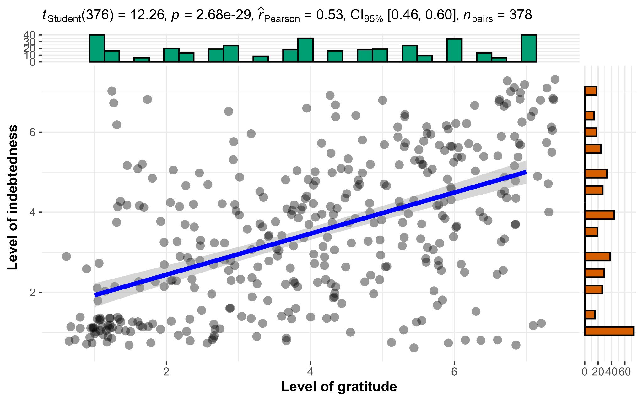

Figure 2  
*Study 2 benevolent condition (H1c null hypothesis): Association between gratitude and indebtedness*

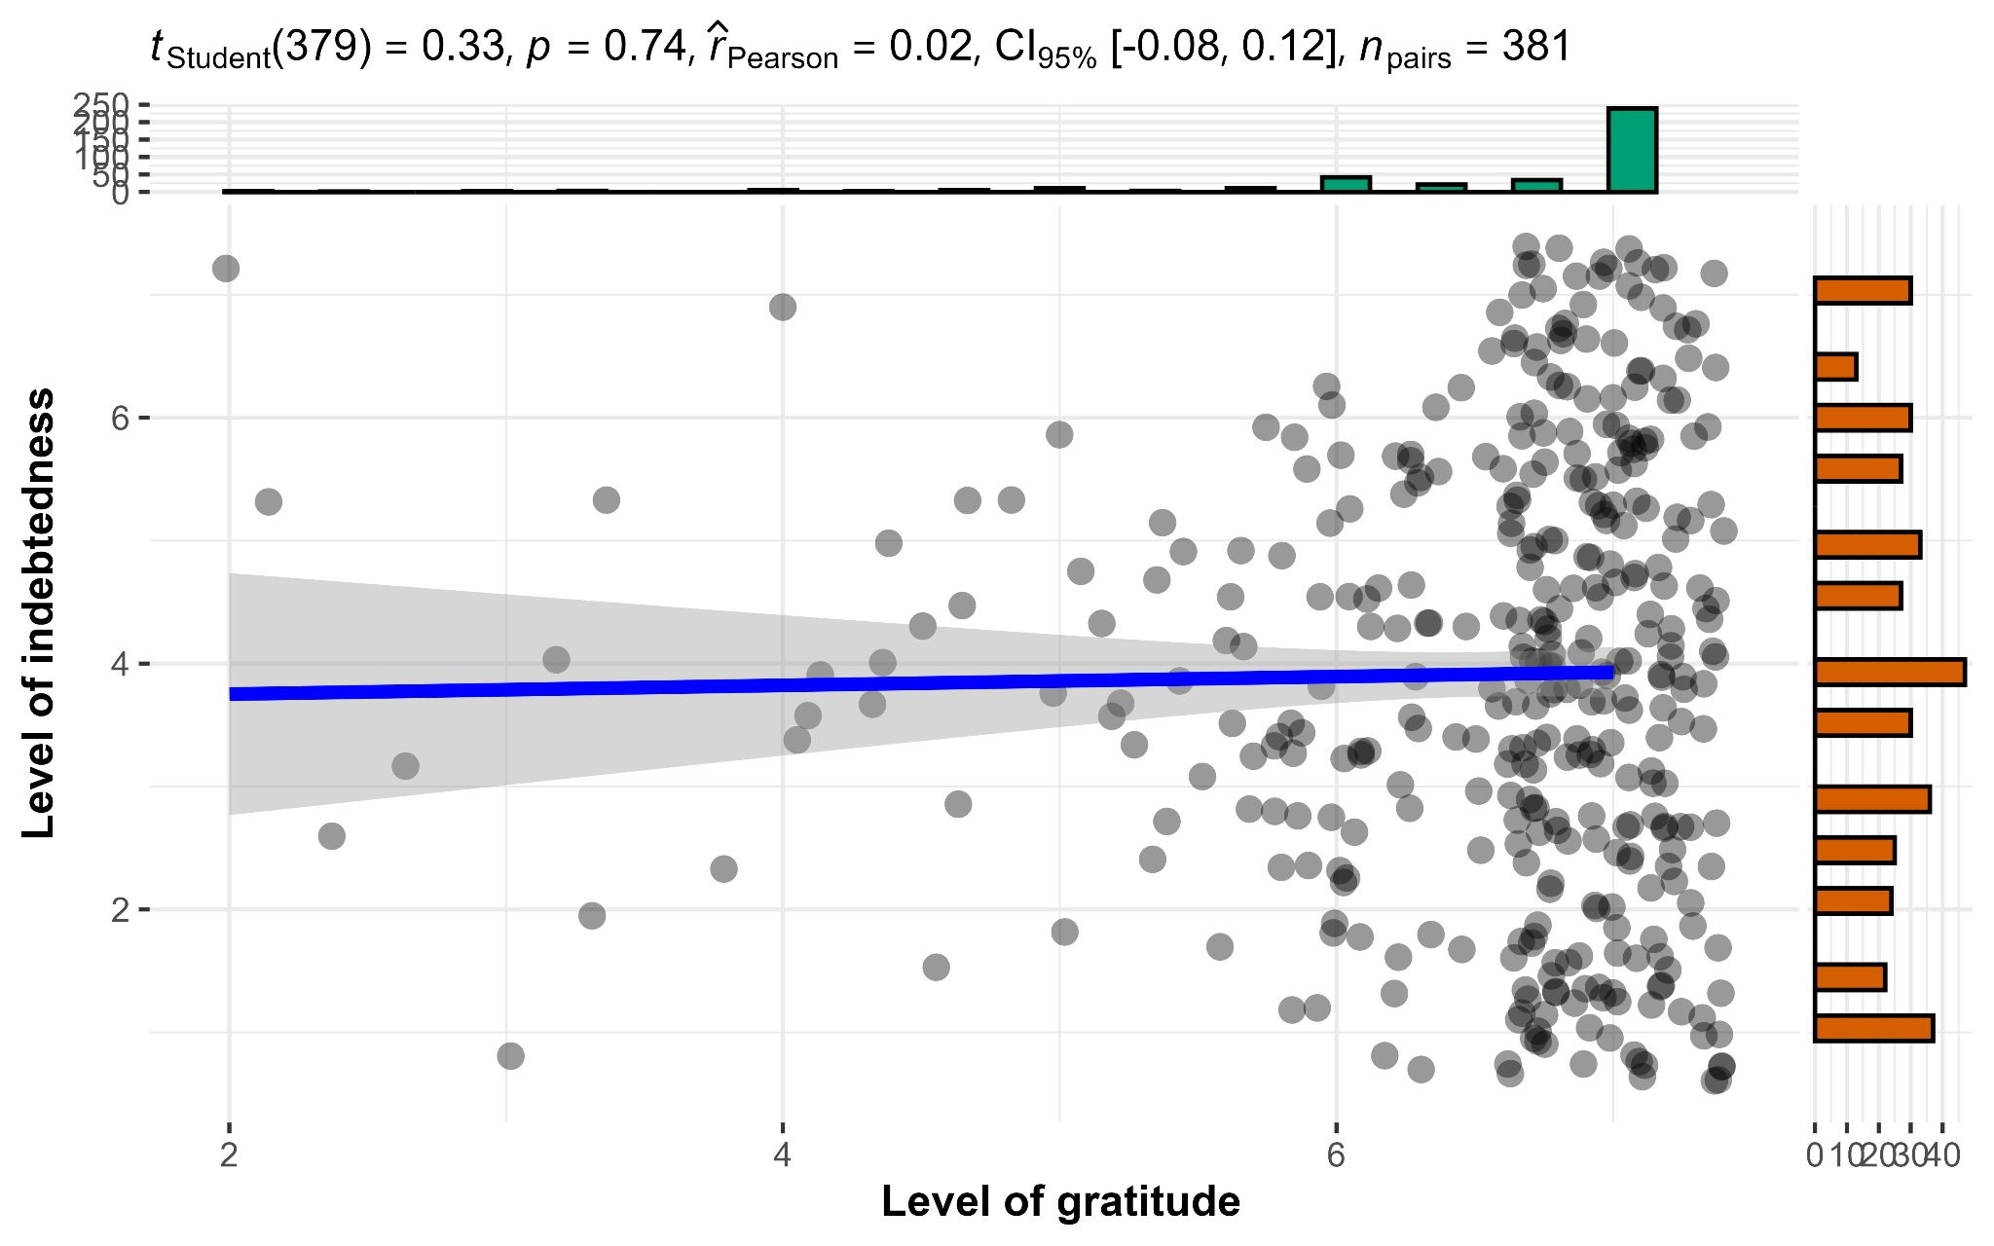

#### Core hypothesis: Impact of intent (benevolent > selfish) on gratitude is stronger than on indebtedness

We conducted ANCOVAs, with the rated magnitude of favor as a covariate, and found support for differences in gratitude between the benevolent condition and the selfish-ulterior condition (H2: *F*(1, 756) = 365, *p* < .001; *η2p* = 0.33, 90% CI [0.28, 0.37]), but not in indebtedness (H3 null hypothesis: *F*(1, 756) = 0.37, *p* = .54; *η2p* < .001, 90% CI [0.00, 0.01]). We, therefore, concluded support for the combination of Hypotheses 2 and 3 for higher gratitude when recalling a benevolent favor compared to a selfish favor, after controlling for the magnitude of the favor, but less so for indebtedness.

#### Complementary regression analyses

We conducted regression analyses with a condition variable contrasting benevolent and selfish helper intent and magnitude of favor predicting gratitude and indebtedness. For gratitude, we found support for both intention conditions (*β* = -0.51, *t*(756) = -19.11, *p* < .001) and magnitude of favor (*β* = 0.37, *t*(756) = 13.84, *p* < .001) as predictors of feelings of gratitude (*R2* = 0.53, 95% CI [0.48, 0.58], *F*(2, 756) = 430.49, *p* < .001).

We found support that magnitude of favor (*β* = 0.38, *t*(756) = 10.46, *p* < .001), but not for intention conditions (*β* = 0.02, *t*(756) = 0.61, *p* = .54), as predictors of feelings of indebtedness (*R2* = 0.14, 95% CI [0.10, 0.19], F(2, 756) = 60.52, *p* < .001).

We concluded support for Hypothesis 4 (2r) that helpers’ motives (benevolent vs. selfish-ulterior) and magnitude of favor predict gratitude, but - as expected - not for Hypothesis 5 (3r null hypothesis) that helpers’ motives and magnitude of favor predict indebtedness.

###### Figure 3 *Study 2: Helper intention impact on gratitude*

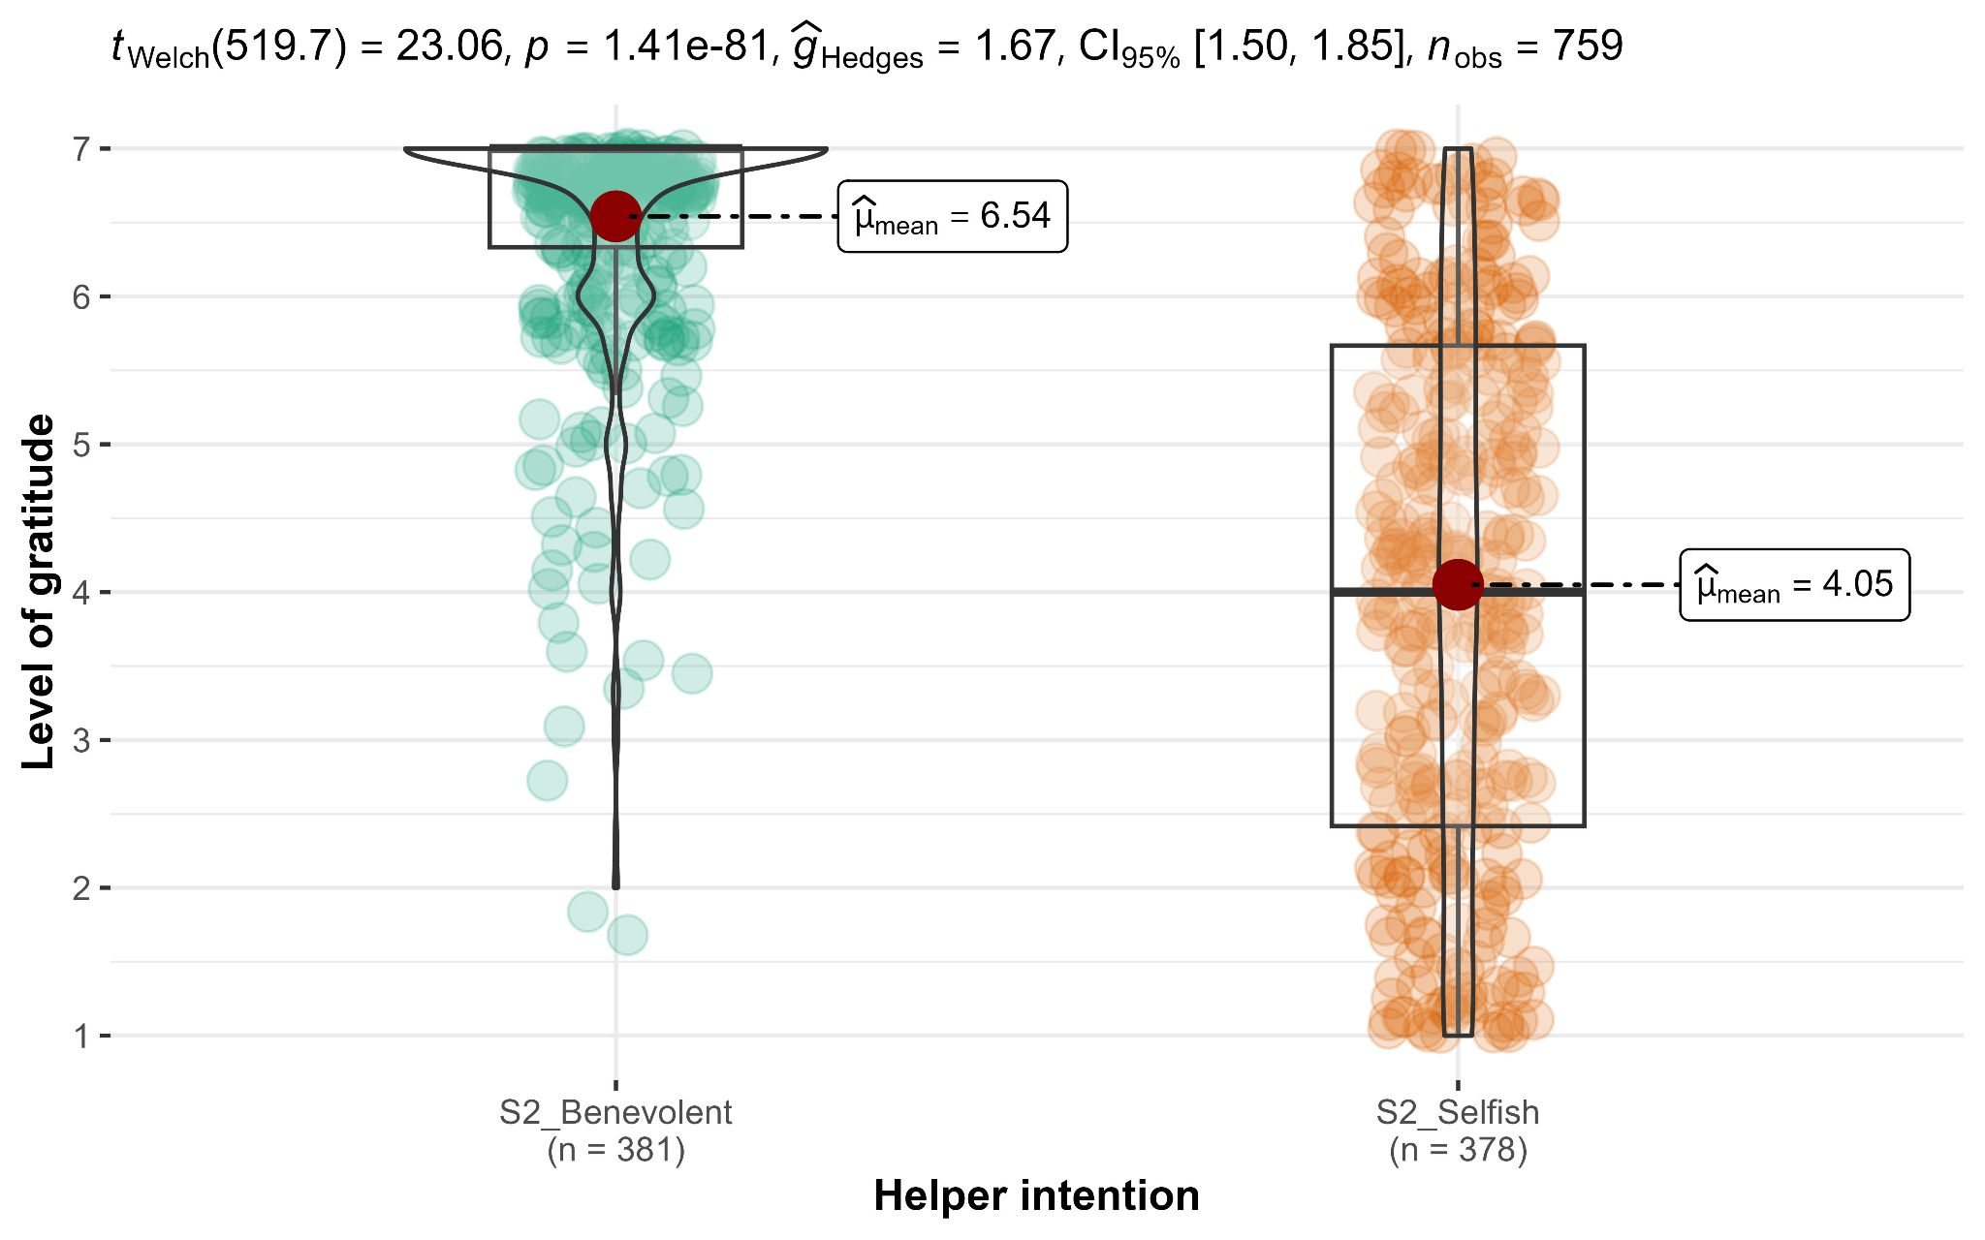  
*Note*. Scale: 1 to 7; higher values indicate stronger feelings of gratitude.

###### Figure 4 *Study 2: Impact of helper intention on indebtedness*

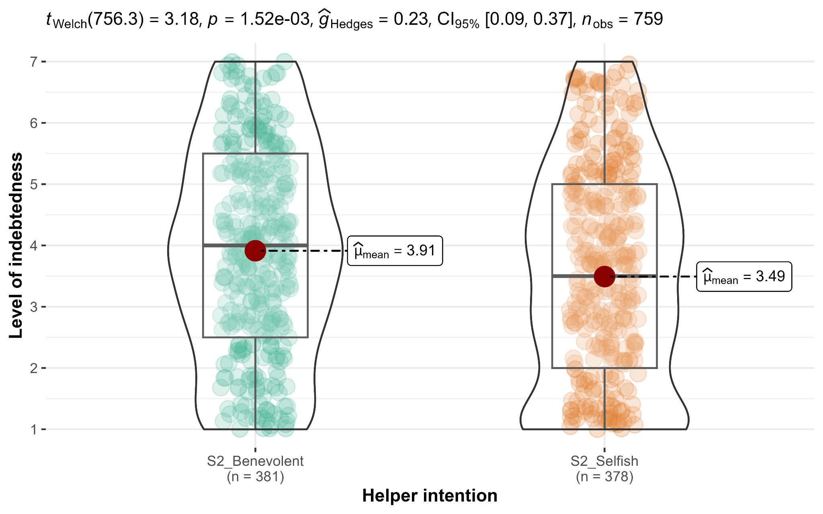

*Note*. Scale: 1 to 7; higher values indicate stronger feelings of indebtedness.

#### Interaction between intent and emotions (gratitude vs. indebtedness): Extension analysis of a direct test to core hypothesis

We conducted a mixed ANOVA examining the interaction between intent (benevolent versus selfish-ulterior; between-subject) and emotion type (gratitude versus indebtedness; repeated) and found evidence of main effect for emotion type, *F*(1, 757) = 532.4, *p* < .001, *η2p* = .41, 95% CI [0.37, 0.46]; evidence of main effect for intent, *F*(1, 757) = 216.6, *p* < .001, *η2p* = .22, 95% CI [0.18, 0.27]; and evidence of interaction between intent and emotion type, *F*(1, 757) = 225.0, *p* < .001, *η2p* = .23, 95% CI [0.19, 0.27]. We plotted the findings in Figure 5.

###### Figure 5 *Study 2: Interaction between helper intention and emotions*

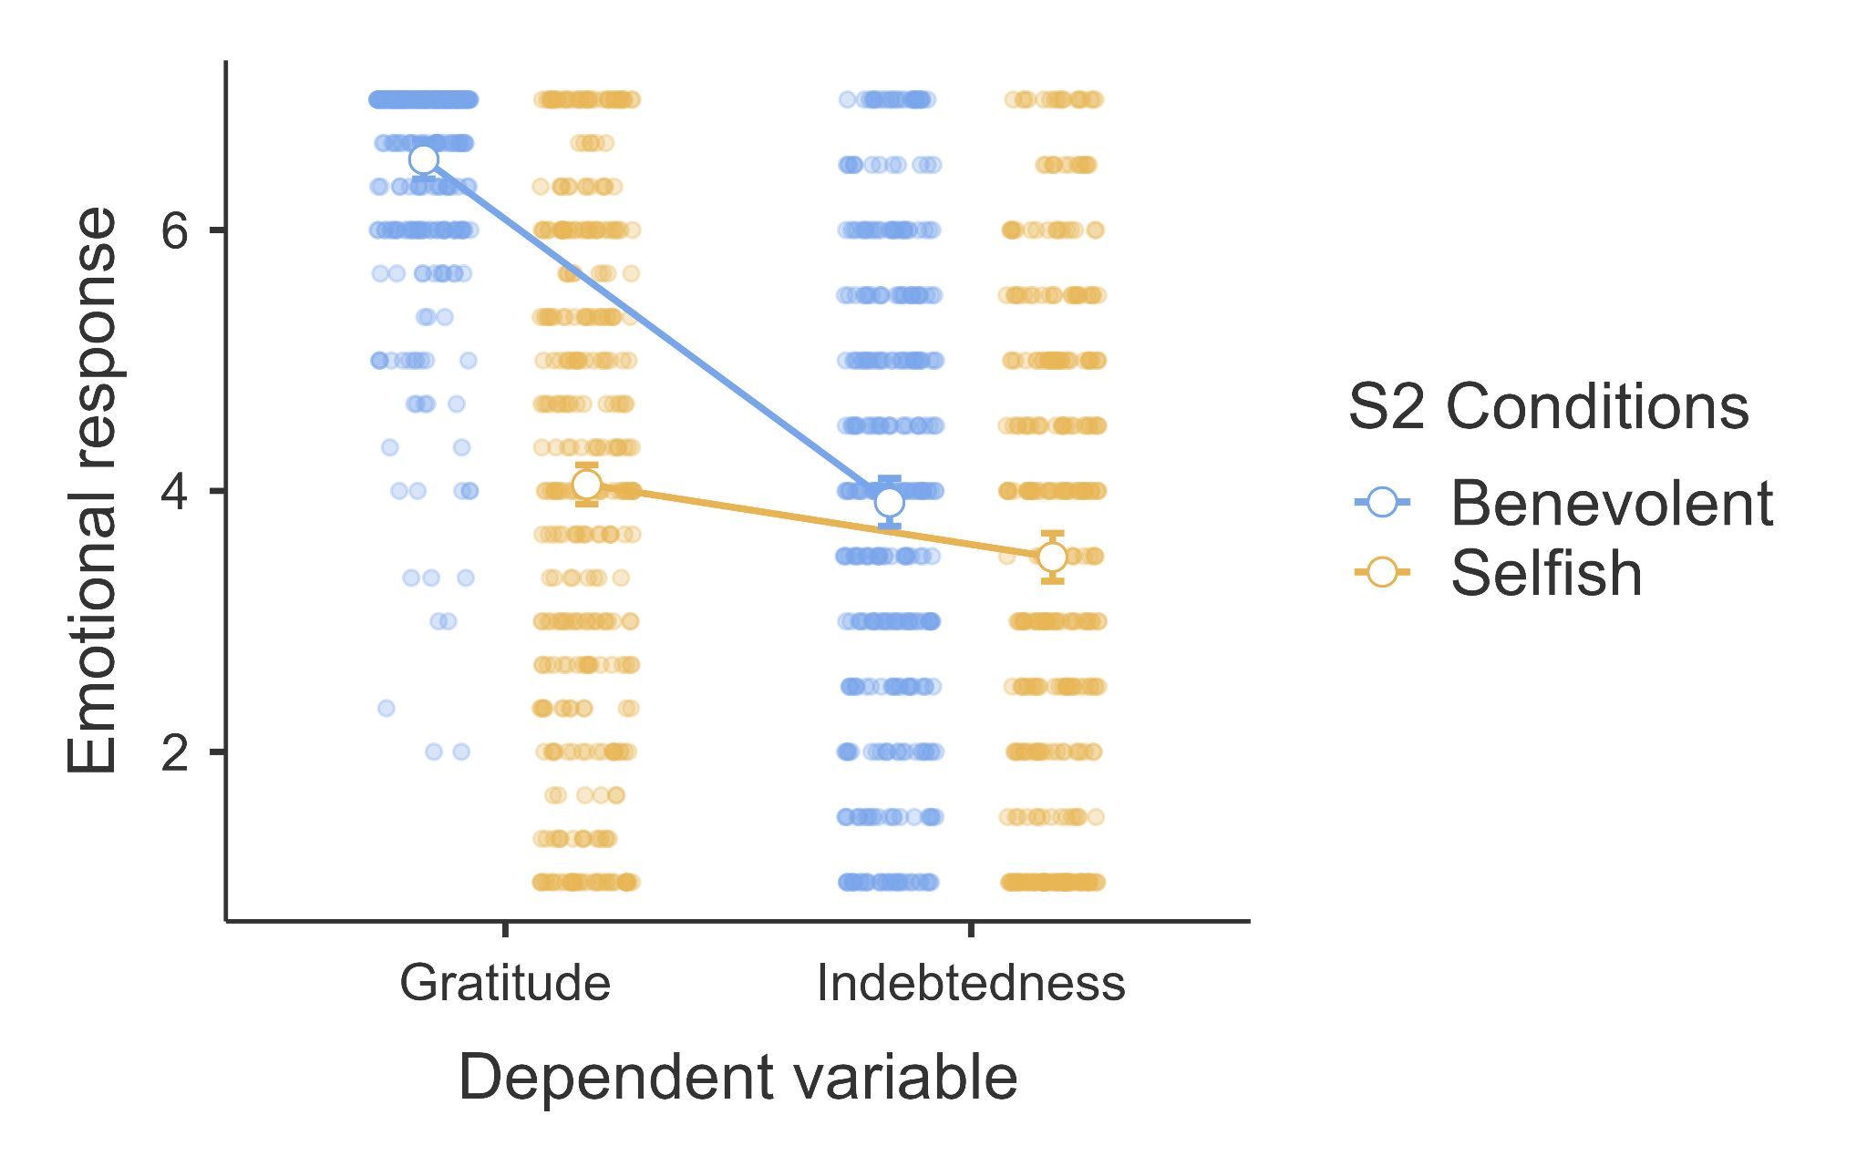

*Note*. Scale is from 1 to 7, higher values indicate stronger feelings of the emotion.

### Study 3

#### Manipulation check: Helper intention

We conducted independent samples *t*-tests (Welch’s;two-tailed) and found that participants rated benefactor as being less selfish in benevolent condition (*n* = 251; *M* = 1.71, *SD* = 1.17) compared to selfish-ulterior condition (*n* = 254; *M* = 4.81, *SD* = 1.36; *Md* = 3.10; *t* (493) = 28, *p* < .001; *d* = 2.49, 95% CI [2.26, 2.72]). We also found that participants rated helper as being more selfish in selfish-ulterior condition compared to Ambiguous condition (*n* =254; *M* = 3.02, *SD* = 1.59; *Md* = 1.79; *t* (494) = 14, *p* < .001; *d* = 1.24, 95% CI [1.05, 1.43]). Participants rated helpers as being less selfish in the benevolent condition compared to the ambiguous condition (*t* (464) = -11, *p* < .001; *d* = -0.98, 95% CI [-1.16, -0.79]).

#### Covariate: Magnitude of favor

We conducted independent samples *t*-tests (Welch’s; two-tailed) and found that the rated in the selfish-ulterior condition (*n* = 254; *M* = 5.67, *SD* = 1.32) was lower than the magnitude in the benevolent condition (*n* = 251; *M* = 6.27, *SD* = 0.99; *Md* = -0.60; *t* (469) = -5.8, *p* < .001; *d* = -0.52, 95% CI [-0.69, -0.34]) and in the ambiguous condition (*n* = 254; *M* = 6.16, *SD* = 1.09; *Md* = -0.49; *t* (489) = -4.5, *p* < .001; *d* = -0.40, 95% CI [-0.58, -0.22]). However, we found no support for the magnitude of favor in the benevolent condition as different from that in the ambiguous condition (*t*(499) = 1.2, *p* = .20; *d* = 0.11, 95% CI [-0.07, 0.28]).

#### Associations between gratitude and indebtedness

We conducted Pearson's correlation tests and found support for a positive association between gratitude and indebtedness in the benevolent condition (*r*(249) = 0.25, 95% CI [0.13, 0.36], *p* < .001), the selfish-ulterior condition (*r*(252) = 0.17, 95% CI [0.05, 0.29], *p* < .01), and the ambiguous condition (*r*(252) = 0.23, 95% CI [0.11, 0.34], *p* < .001). We, therefore, concluded support for Hypothesis 6 that gratitude is positively associated with indebtedness in ambiguous conditions.

#### Core hypothesis: Impact of intent (benevolent > ambiguous > selfish) on gratitude is stronger than on indebtedness.

We conducted one-way ANOVAs and found support for helper intention's impact on gratitude (*F*(2, 756) = 70.9, *p* < .001; *η2p* = 0.16, 90% CI [0.12, 0.20]), but not on indebtedness (*F*(2, 756) = 0, *p* = 1.0; *η2p* = 0.00). Therefore, we concluded support for Hypothesis 7a that gratitude is different across the three conditions (benevolent, selfish-ulterior, and ambiguous), and - as expected - no support for Hypothesis 8a (reframed from null hypothesis) that indebtedness is different across the three conditions.

Following the ANOVAs, we conducted post-hoc contrasts analyses for Hypotheses 7b and 7c, and found support for feelings of gratitude in the ambiguous condition (*n* = 254; *M* = 6.14, *SD* = 1.09) as weaker than in the benevolent condition (*n* = 251; *M* = 6.59, *SD* = 0.79; *Md* = -0.45; *t* (756) = -4.76, *p* < .001; *d* = -0.42, 95% CI [-0.60, -0.25]; H7b), but stronger than in selfish-ulterior condition (H7c: *n* = 254; *M* = 5.48, *SD* = 1.24; *Md* = 0.66; *t* (756) = 7.09, *p* < .001; *d* = 0.63, 95% CI [0.45, 0.81]; between benevolent and selfish-ulterior: *t* (756) = 11.83, *p* < .001; *d* = 1.05, 95% CI [0.87, 1.24]).

Also, we conducted post-hoc contrasts analyses for Hypotheses 8b and 8c (reframed from null hypotheses) and - as expected - found no support for differences in indebtedness comparing the benevolent condition (*M* = 5.09, *SD* = 1.42) to both the ambiguous condition (*M* = 5.09, *SD* = 1.58; *Md* = 0; *t* (756) = 0.01, *p* = .9948; *d* = 0.00, 95% CI [-0.17, 0.18]; H8b) and the selfish-ulterior condition (*M* = 5.09, *SD* = 1.43; *Md* = 0; *t* (756) = -0.05, *p* = .969; *d* = 0.00, 95% CI [-0.18, 0.16]; H8c).

###### Figure 6 *Study 3: Helper intention impact on gratitude*

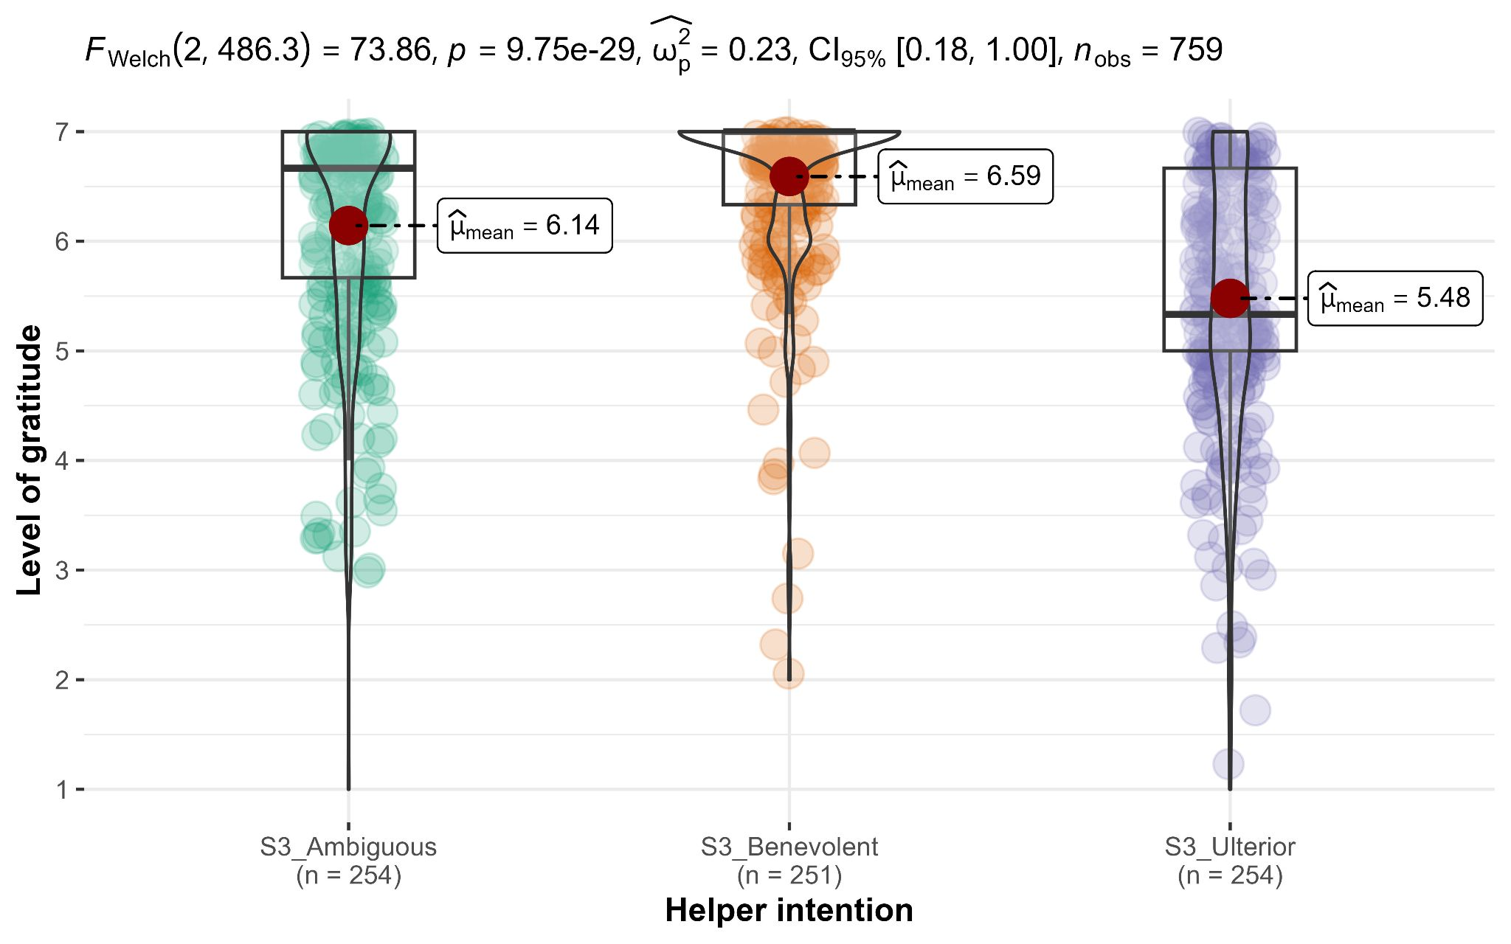

*Note*. Scale: 1 to 7; Higher values indicate stronger feelings of gratitude.

###### Figure 7 *Study 3: Helper intention impact on indebtedness*

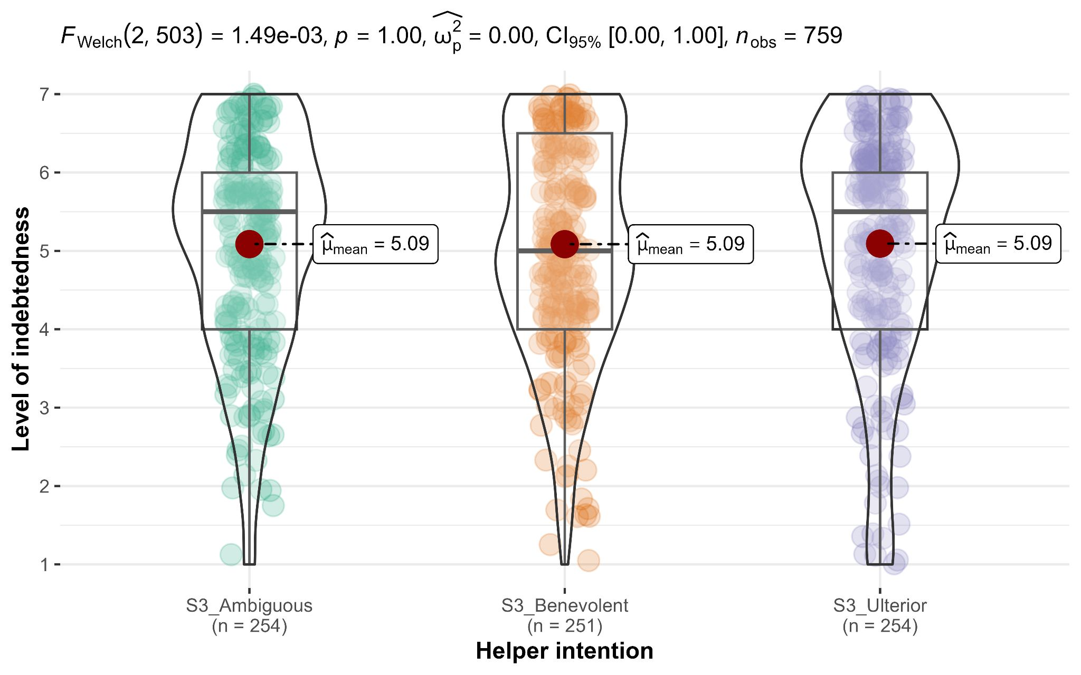

*Note*. Scale: 1 to 7; Higher values indicate stronger feelings of indebtedness.

#### Interaction between intent and emotions (gratitude vs. indebtedness): Extension analysis of a direct test to core hypothesis

We conducted a mixed ANOVA examining the interaction between intent (benevolent versus selfish-ulterior versus ambiguous; between-subject) and emotion type (gratitude versus indebtedness; repeated) and found support for a main effect for emotion type (*F*(1, 756) = 275.57, *p* < .001, *η2p* = .27, 95% CI [0.22, 0.31]), a main effect for intent (*F*(2, 756) = 19.72, *p* < .001, *η2p* = .05, 95% CI [0.03, 0.08]), and an interaction between intent and emotion type (*F*(2, 756) = 30.12, *p* < .001, *η2p* = .07, 95% CI [0.05, 0.10]; H7b/c and H8b/c combined; Figure 8).

###### Figure 8 *Study 3: Interaction between helper intention and emotions (H7b/c+H8b/c)*

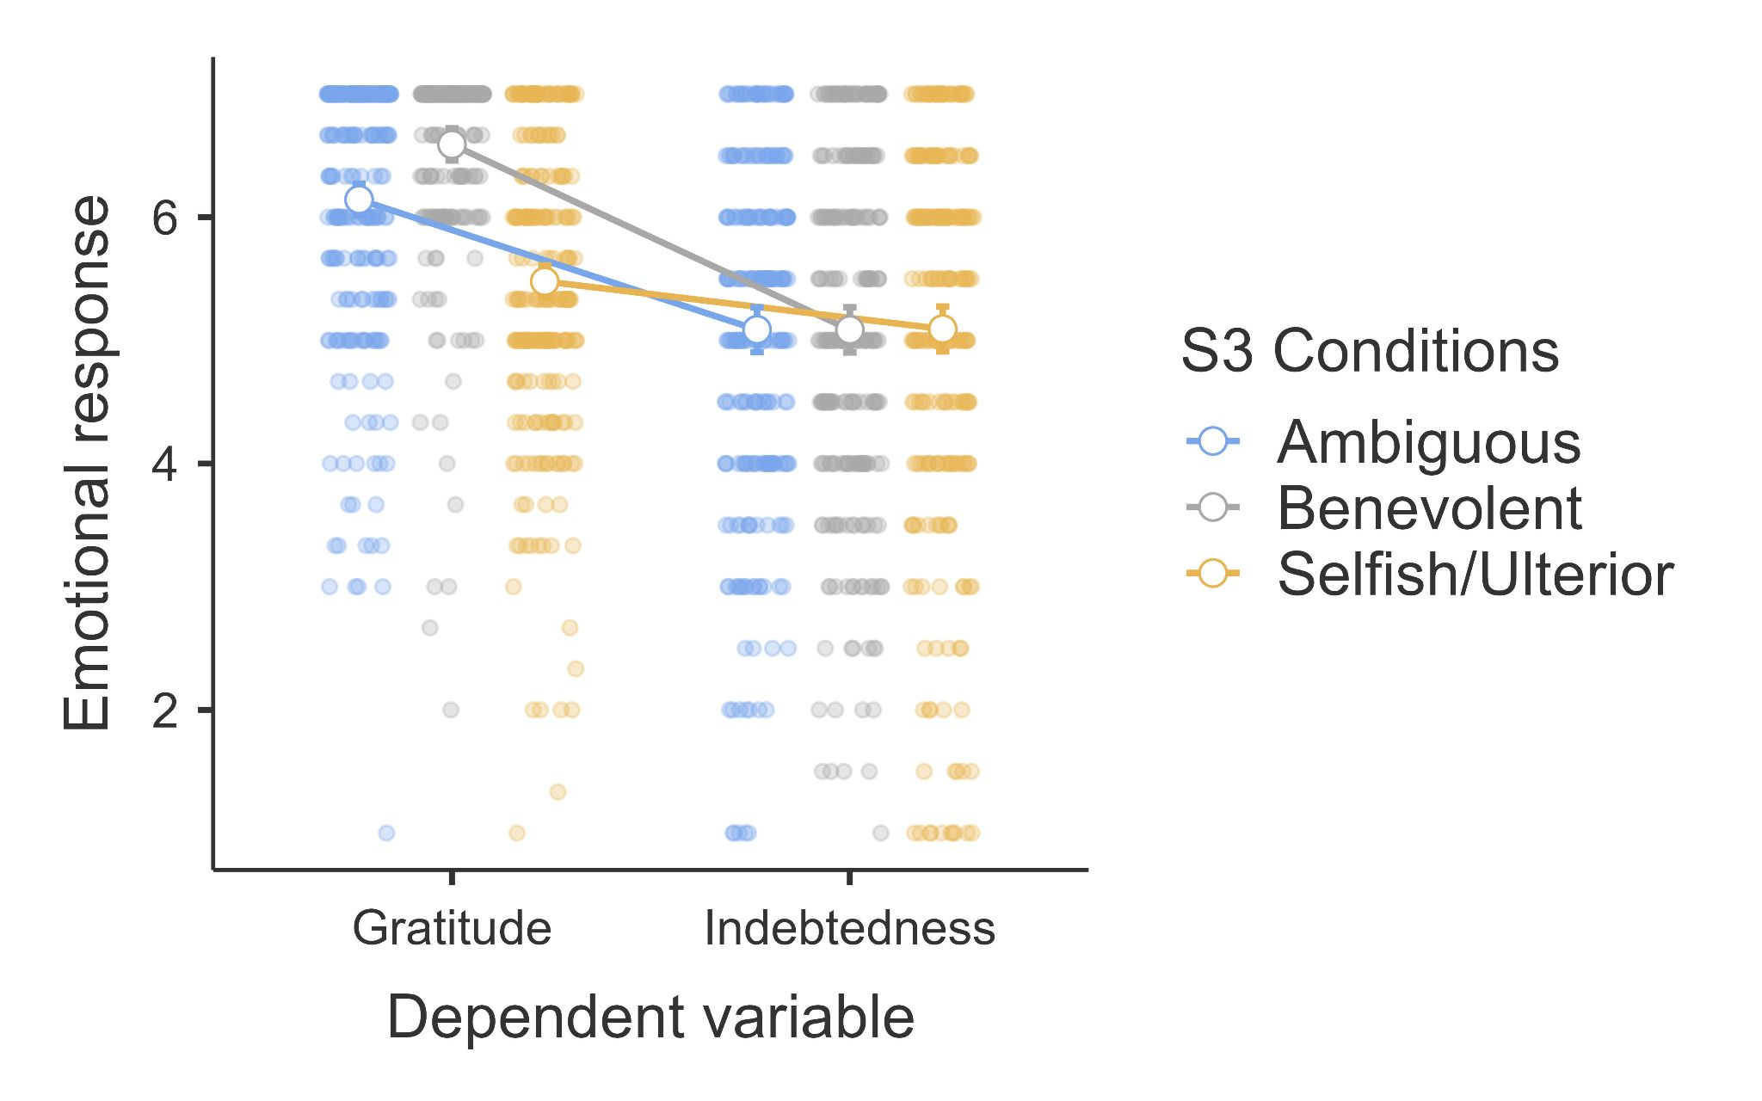

*Note*. Scale: 1 to 7; higher values indicate stronger feelings of the emotion.

###### Table 8 *Summary of statistical tests and results interpretation*

| **Hypothesis** | **Statistical tests** | **Target Article** | | | **Replication** | | | **Interpretation** |
| --- | --- | --- | --- | --- | --- | --- | --- | --- |
|  |  | *p* | Effect size | CI | *p* | Effect size | CI |  |
| 1a | Pearson correlation | <.001* | *r* = .57 | [0.41, 0.69] | < .001 | *r =* .34 | [0.28, 0.40] | Signal - inconsistent, smaller |
| 1b | Pearson correlation | <.001* | *r* = .61 | [0.39, 0.76] | < .001 | *r* = .53 | [0.46, 0.60] | Signal - inconsistent, smaller |
| 1c | Pearson correlation | >.20 | *r* = .20 | [-0.10, 0.47] | = .70 | *r* = .02 | [-0.08, 0.12] | No signal - consistent |
| 2 | ANCOVA | <.001* | *η2p* = 0.2 | [0.08, 0.32] | < .001 | *η2p* = 0.33 | [0.28, 0.37] | Signal - inconsistent, larger |
| 3 | ANCOVA | >.20 | *η2p* = 0.01 | [0.00, 0.08] | = .54 | *η2p* < .001 | [0.00, 0.01] | No signal - consistent |
| 2+3 | Mixed ANOVA (extension) | / | */* | / | < .001 | *η2p* = .23 | [0.19, 0.27] | **Fully supported** |
| 4 | Linear regression | <.001* (a) <.01  (b) <.01 | *R2* = .73  β =.32  β =.62 | [0.61, 0.81] | < .001  (a) < .001  (b) < .001 | *R2* = .53 β = -0.51  β = 0.37 | [0.48, 0.58] | Signal - inconsistent, smaller |
| 5 | Linear regression | <.001* (a) >.20  (b) <.001 | *R2* = .26 β =.13  β =.42 | [0.10, 0.41] | < .001  (a) = .540  (b) < .001 | *R2* = 0.14 β = 0.02  β = 0.38 | [0.10, 0.19] | Signal - inconsistent, smaller |
| 6 | Pearson correlation | <.05* | r = .42 | [0.06, 0.68] | < .001 | *r* = .23 | [0.11, 0.34] | Signal - inconsistent, smaller |
| 7a | One-way ANOVA | <.01* | *η2p* = .14 | [0.03, 0.26] | < .001 | *η2p* = 0.16 | [0.12, 0.20] | Signal - consistent |
| 7b | Independent t-test (two-tailed) | <.05* | *d* = 0.55 | [0.02, 1.08] | < .001 | *d* = 0.42 | [0.25, 0.60] | Signal - consistent |
| 7c | Independent t-test (two-tailed) | .07 | *d* = 0.49 | [-0.04, 1.01] | < .001 | *d* = 0.63 | [0.45, 0.81] | Signal - inconsistent, positive effect |
| 7b/c+ 8b/c | Mixed ANOVA (extension) | / | / | / | < .001 | *η2p* = .07 | [0.05, 0.10] | **Fully supported** |
| 8a | One-way ANOVA | >.20 | η2p = .00 | [0.00, 0.03] | = 1.00 | *η2p* < 0.01 | [0.00, 1.00] | No signal - consistent |
| 8b | Independent t-test (two-tailed) | >.20 | *d* = 0.13 | [-0.39, 0.64] | = .994 | *d* = 0.00 | [-0.17, 0.18] | No signal - consistent |
| 8c | Independent t-test (two-tailed) | >.20 | *d* = 0.03 | [-0.49, 0.55] | = .969 | *d* = 0.00 | [-0.18, 0.16] | No signal - consistent |
| 9 | Pearson correlation | <.05* | *r* = -.40 | [-0.67, -0.04] | < .001 | *r* = -0.50 | [-0.59, -0.40] | Signal - consistent |
| 10 | Pearson correlation | >.20 | *r* = .00 | [-0.37, 0.37] | = .80 | *r =* -.21 | [-0.14, 0.11] | No signal - consistent |

*Note*. See Table 1 for hypotheses. See supplementary for more details. For partial eta-squared, 90% confidence intervals are calculated specifically instead of 95% in order not to include zero with the p-value falling below .05 (Lakens, 2014). The interpretation of outcome is based on LeBel et al. (2019)

#### Associations between helper intentions, gratitude, and indebtedness

We conducted correlation tests (Pearson's Correlation) in the ambiguous condition and found support for more selfish intention as being negatively associated with gratitude (*r*(252) = -0.50, 95% CI [-0.59, -0.40], *p* < .001), yet not associated with indebtedness (*r*(252) = -0.01, 95% CI [-0.14, 0.11], *p* = .80).

## Extensions: Perceived expectations for reciprocity and reciprocity inclination

We added perceived expectations for reciprocity and reciprocity inclination as two extension dependent variables in Study 3 and evaluated how they differ across conditions and are associated with gratitude and indebtedness.

###### Figure 9 *Study 3: Helper intention impact on reciprocity inclination*

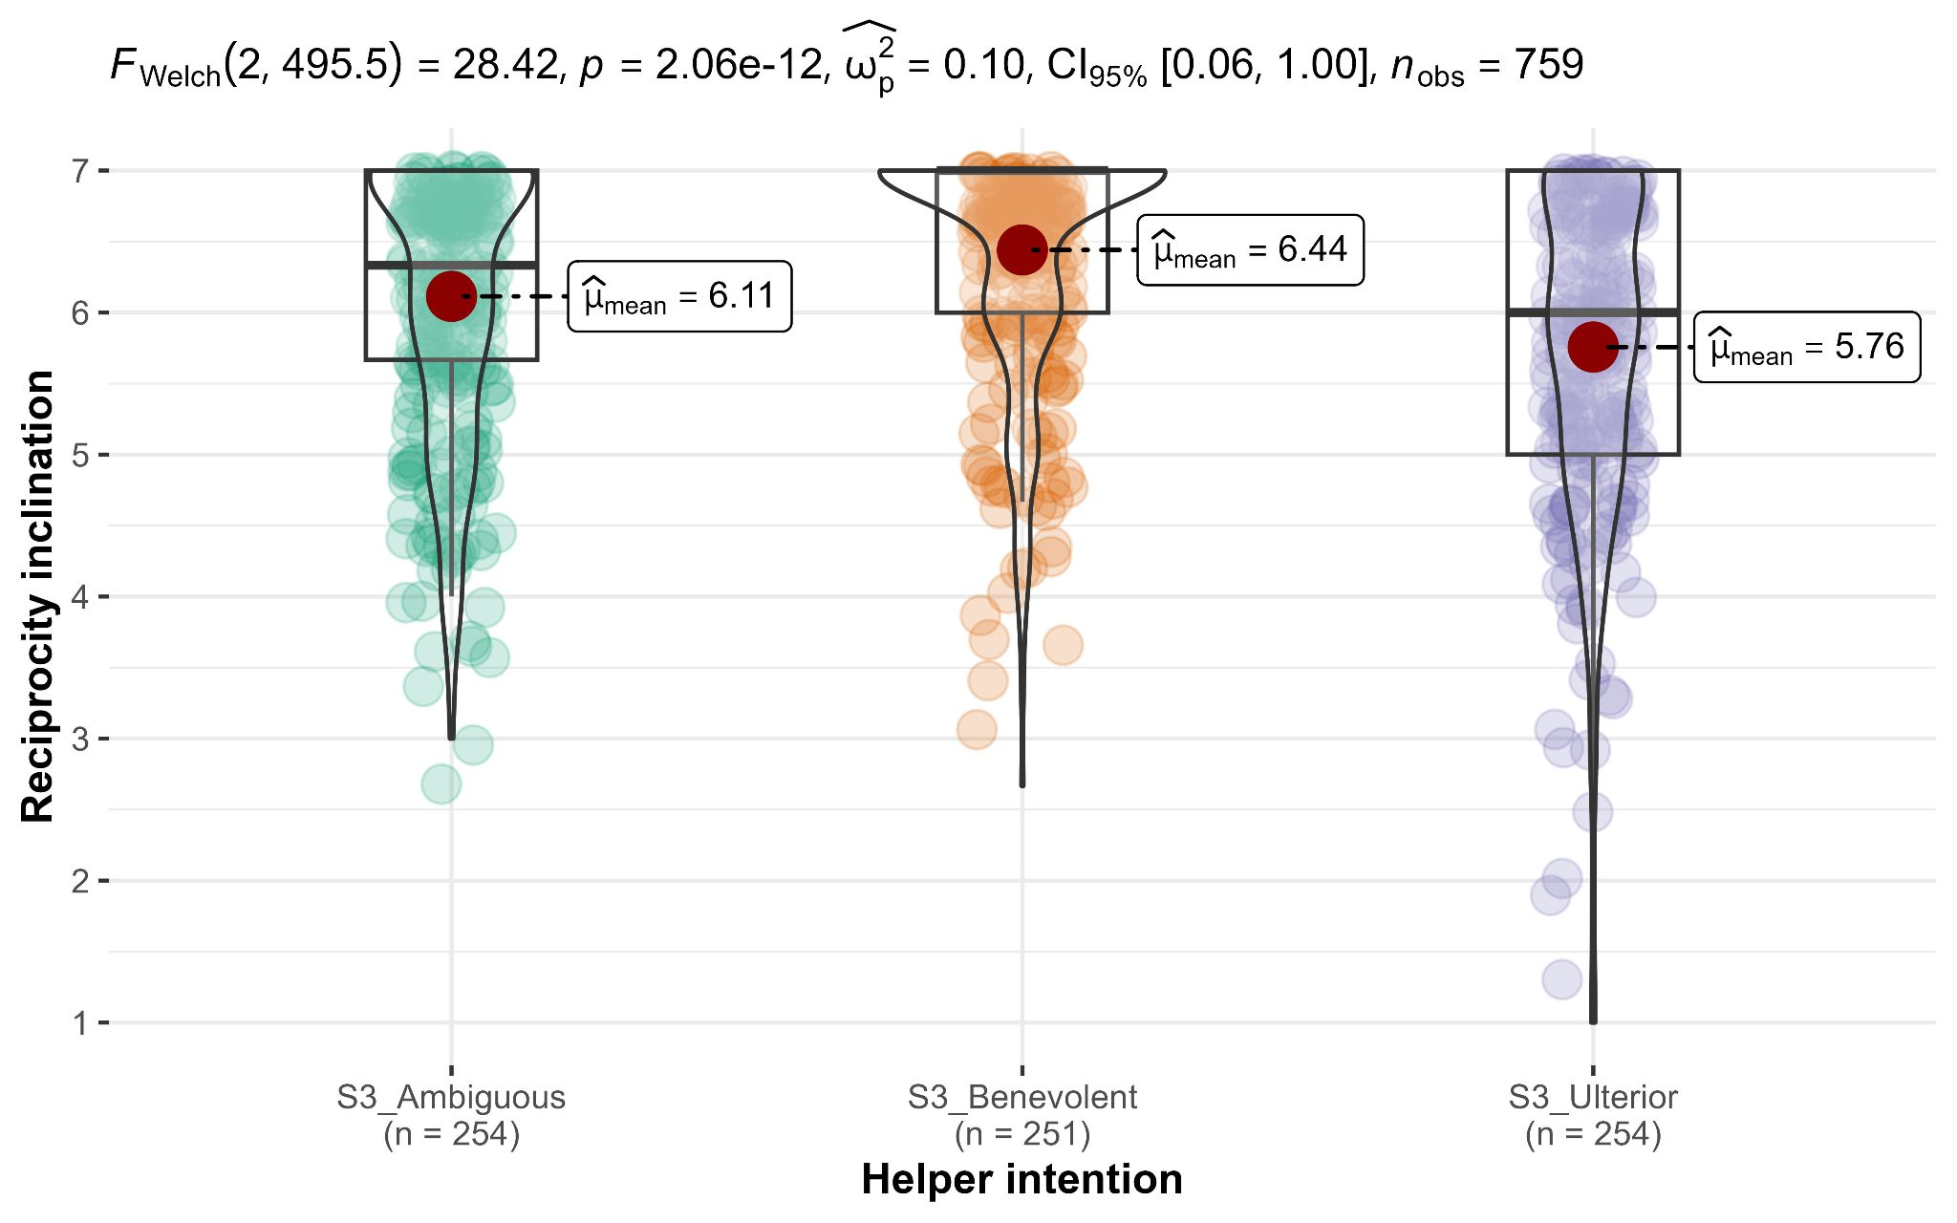  
*Note*. Scale: 1 to 7; Higher values indicate higher expectations for reciprocity.

First, we conducted independent samples *t*-tests (Welch’s;two-tailed) and found support for higher perceived expectations for reciprocity in the selfish-ulterior condition (*n* = 254; *M* = 5.89, *SD* = 1.18) than in the benevolent condition (*n* = 251; *M* = 3.65, *SD* = 1.79; *Md* = -2.24; *t* (433) = -17, *p* < .001; *d* = -1.51, 95% CI [-1.71, -1.31]). We found support for Hypothesis 11a over 11b.

Then, we conducted independent samples *t*-tests (Welch’s; two-tailed) and found support for higher reciprocity inclination in benevolent condition (*n* = 251; *M* = 6.44, *SD* = 0.84) than those in the selfish-ulterior condition (*n* = 254; *M* = 5.76, *SD* = 1.2; *Md* = 0.68; *t* (455) = 7.4, *p* < .001; *d* = 0.66, 95% CI [0.48, 0.84]). We found support for Hypothesis 12b over 12a.

We then conducted correlation tests (Pearson's Correlation) and found no support for a link between reciprocity inclination and perceived reciprocity expectations (*r*(757)= -0.06, 95% CI [-0.13, 0.01], *p* = .08). We failed to find support for Hypothesis 13 that perceived reciprocity expectations is correlated with reciprocity inclination.

We also conducted correlation tests (Pearson's Correlation) and found support for a negative correlation between perceived reciprocity expectations and gratitude (*r*(757) = -0.28, 95% CI [-0.35, -0.22], *p* < .001), and a positive correlation between perceived reciprocity expectations and indebtedness (*r*(757) = 0.17, 95% CI [0.10, 0.24], *p* < .001). We successfully found support for Hypotheses 14 and 15 that gratitude and indebtedness are associated with perceived expectation for reciprocity.

Finally, we added exploratory correlations for the associations with reciprocity inclination. We found support for reciprocity inclination having a positive association with gratitude (*r*(757) = 0.52 [0.46, 0.57], *p* < .001), and a weaker positive association with indebtedness (*r*(757) = 0.29 [0.22, 0.35], *p* < .001; z for differences between correlations = 5.71, *p* < .001).

###### Figure 10 *Study 3: The association between perceived expectations for reciprocity* and *reciprocity inclination*

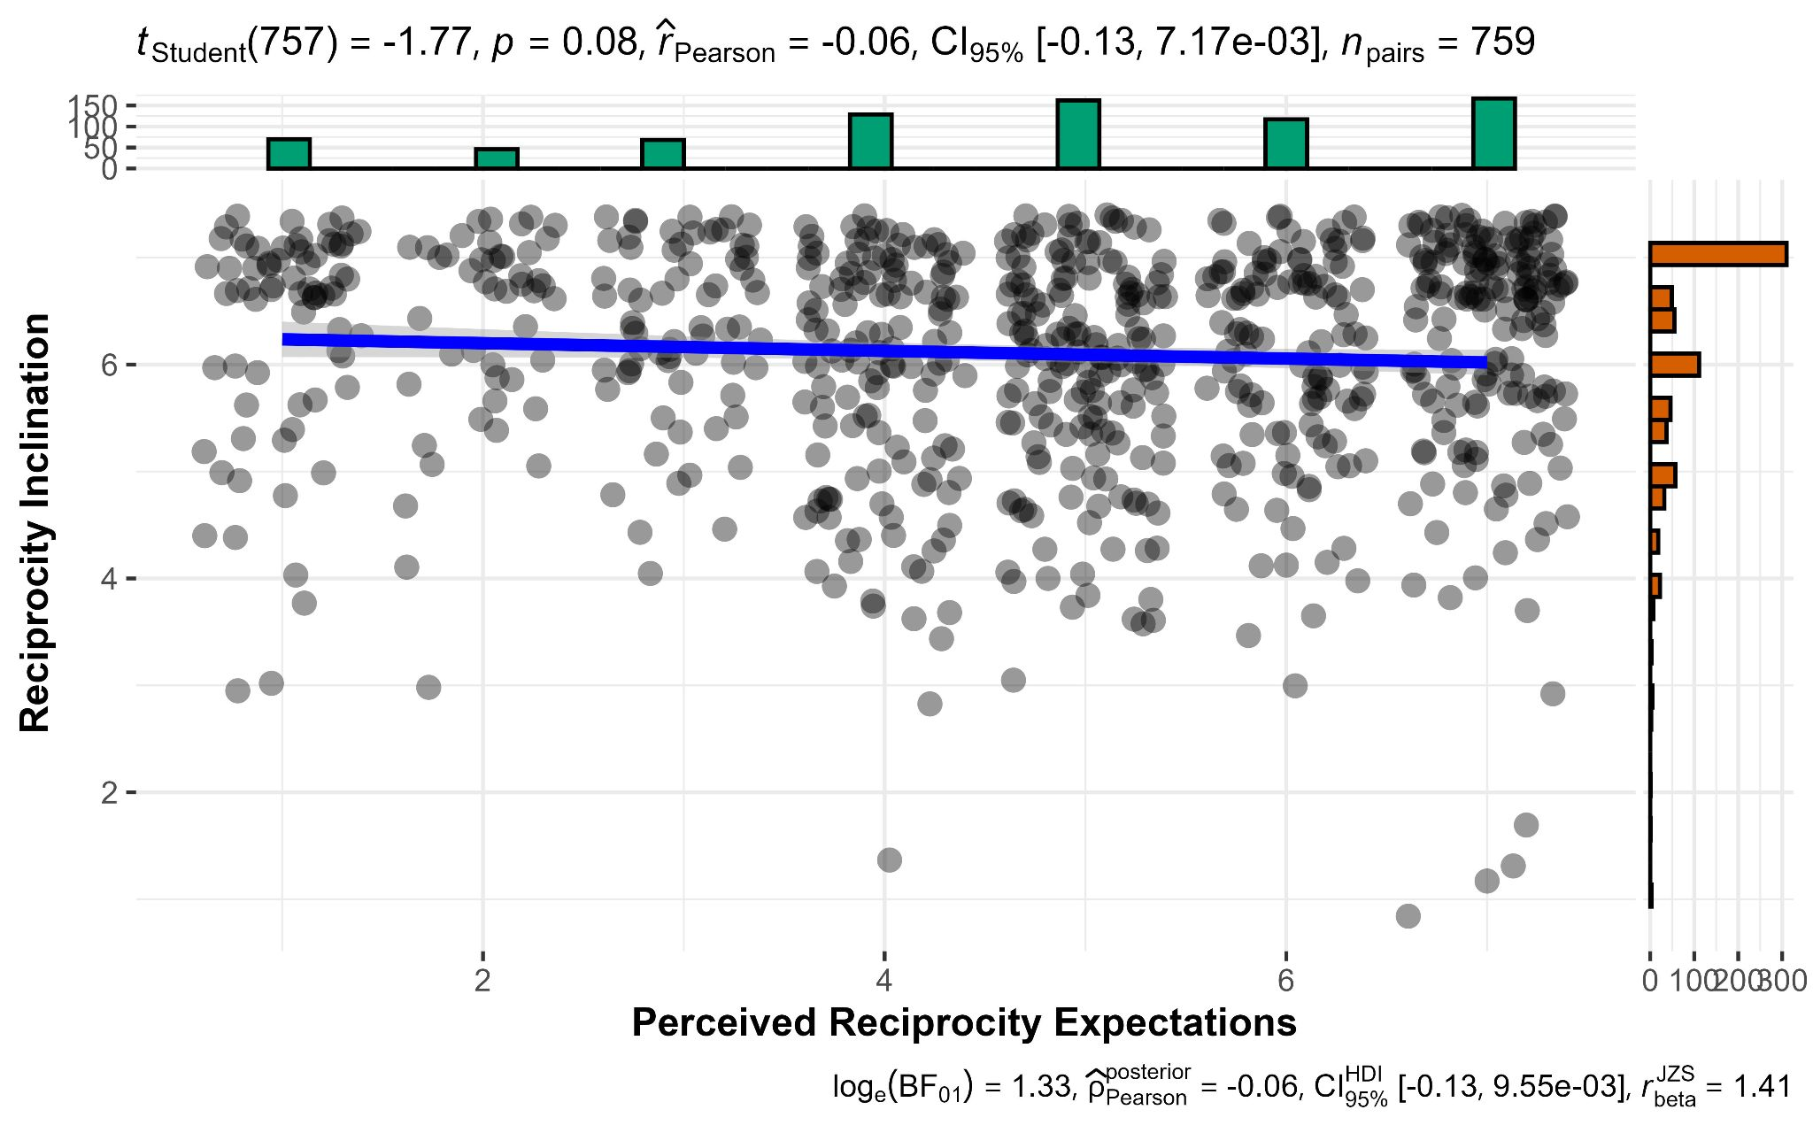

###### Table 9 *Extension: Summary of statistical tests*

|  |  |  |  |  |  |
| --- | --- | --- | --- | --- | --- |
| **Hypothesis** | **Stat. tests** | **df** | ***p*** | **Effect size** | **CI** |
| 11 | Independent t-test (two-tailed) | 433 | < .001 | *d* = 1.51 | [1.31, 1.71] |
| 12 | Independent t-test (two-tailed) | 455 | < .001 | *d* = 0.66 | [0.48, 0.84] |
| 13 | Pearson correlation | 757 | = .08 | *r =* -0.06 | [-0.13, 0.01] |
| 14 | Pearson correlation | 757 | < .001 | *r =* -0.28 | [-0.35, -0.22] |
| 15 | Pearson correlation | 757 | < .001 | *r =* 0.17 | [0.10, 0.24] |

*Note*. See Table 1 for all hypotheses’ contents. CI = 95% confidence intervals.

# Discussion

In our replication and extensions Registered Report for the effects of helper intention on gratitude and indebtedness demonstrated by Tsang (2006), results were mostly consistent with the findings reported in the target article (see Table 8 for a summary).

## Replication

Overall, we found that benevolent (versus selfish) intentions were more strongly associated with gratitude than with indebtedness. Comparison of hypotheses 2 and 3 in Study 2 (H2: *η2p* = 0.33 > H3: *η2p* = 0.001) as well as hypotheses 7b/c and 8b/c in Study 3 (H7b/c: *d* = 0.42 /0.63 > H8b/c: *d* = 0) both revealed that impact of helper intent on gratitude is much stronger than on indebtedness. These results are consistent with Tsang's (2006) conceptualization of gratitude and indebtedness as distinct emotions and with different emotional levels depending on perceived benefactors’ intentions.

Our replication reveals slightly weaker effect sizes for some of the effects compared to those reported in the original article. For example, the association between gratitude and indebtedness is weaker across conditions in study 2 (Hypothesis 1a: Original: *r* = 0.57; Replication: *r* = 0.34) and in the ambiguous condition in study 3 (Hypothesis 6: Original: *r* = 0.42; Replication: *r* = 0.23). However, all is still very consistent with the core hypotheses in the target article about the influence of helper intent on gratitude and indebtedness suggested by Tsang (2006). Overall, 7 out of 9 of the hypotheses in Study 3 were consistent and shared remarkably similar effect sizes with the original article, indicating the robustness and replicability of Tsang's (2006) conceptualization on gratitude and indebtedness after more than one and a half decades.

Some may question the value of replication studies, asserting that highly cited studies are inherently reliable and replicable. We believe these reactions often stem from a hindsight bias (also known as the "knew-it-all-along phenomenon") that many, including researchers, harbor towards replication studies. We previously demonstrated an ironic display of hindsight bias over the replicability of a classic experiment on hindsight bias (Study 3; Chen et al. 2021). To try and address hindsight bias over the replicability of our target article, we conducted a prediction poll on Twitter/X on March 26, 2023 (Feldman, 2023), and found that 24 out of 30 (80%) of the researchers in the community predicted an unsuccessful replication of Tsang’s (2006) Studies 2 and 3, which is one of the lowest predictions among other targets included in the same Twitter/X poll. These predictions stand in strong contrast to the very successful replication we reported here, and further highlights the importance of testing intuitions and the possible misperceptions that some may hold towards the importance of comprehensive independent Registered Reports of direct replication.

## Extensions: Perceived expectations for reciprocity and reciprocity inclination

We ran extensions examining the relationship between gratitude, indebtedness, perceived reciprocity expectations, and reciprocity inclination. Our findings showed that: (1) perceived expectation for reciprocity was lower in benevolent helping intent than in selfish-ulterior helping intent, (2) reciprocity inclination was stronger in receiving a benevolent helping than a selfish-ulterior helping (3) expectation for reciprocity was negatively associated with gratitude and positively associated with indebtedness, and (4) there was no indication that expectation for reciprocity are associated with reciprocity inclination. Overall, we found empirical support for the hypothesis that gratitude and indebtedness are correlated to expectation for reciprocity, yet failed to find support for the association between expectation for reciprocity and reciprocity inclination.

Our findings support Watkins et al.’s (2006) argument that expectation for reciprocity would be associated with higher indebtedness but lower gratitude. Provided that benevolent helping intent is associated with lower expectations for reciprocity, then according to the experimental paradigm of Watkins et al. (2006), it would be associated with decreased indebtedness and increased gratitude. Our extensions help link between Tsang (2006) and Watkins et al. (2006) into a more comprehensive theory that higher benevolent intent is correlated with lower expectations and therefore higher gratitude than indebtedness.

## Implications, limitations, and directions for future research

We concluded a successful replication, yet note several limitations in the way we implemented the replication which we originally in Stage 1 were unsure if might impact results. First, we did not take into account the inflation from 2006 at which the study was first held, to 2023 at which our replication was held. The stimuli used in our $200 in 2006 is fairly equal to $300 in 2023. This was a dilemma that we acknowledged when we conducted our replication, but we decided not to change the stimuli. We considered the target’s claims and theory, but we did not find in the article or in any follow-up literature that indicated it as an important factor, and thus, we decided to conduct a direct replication for our current study without changing the value. Our successful replication with similar effect sizes with the target further supports the conclusion that this was not a critical factor.

Second, we have not performed a systematic review and meta-analysis of the literature pointing to the findings in the literature that built up on the target article. The scope for this direct replication with extensions was rather narrow and purely focused on the empirical effort to reproduce and replicate the original findings, and thus we decided to keep our literature review concise, mostly to explain how the target article was embedded in the broader literature. We believe our successful replication can serve as a cornerstone for future systematic reviews on research of gratitude and indebtedness and provide empirical evidence for a more comprehensive meta-analysis since Tsang's (2006) studies were first conducted.

Third, we added the expectation for reciprocity as an extra dependent variable on top of the original manipulation check of helper intentions, given that the scenario also explicitly mentioned expectations in the benevolent (vs. selfish) condition. This could be a duplication. We decided to keep what we replicated and what we extended discrete for our direct replication, but we see room for regarding the expectation for reciprocity as a manipulation check, combining it with the original dependent variable of perceived helpers’ motivations.

Fourth, we deviated from the target article’s design by having participants take part in both the replication of Study 2 and the replication of Study 3 in random order. This may potentially introduce order effects, where responses to one scenario might influence responses to subsequent scenarios. However, by randomizing the sequence of two studies for each participant, we minimized potential biases. Our exploratory analyses indicated that this had little to no impact on the findings, with results consistent when comparing the full sample (as pre-registered) to studies presented first (exploratory). Given the strong alignment between the effects observed in the original research and our replication results, and the exploratory analyses, we believe order had little to no impact on our findings.

Our replication and extension takes the first step in combining the key relevant experimental paradigm of Tsang (2006) and Watkins et al. (2006) about the influence of helper intent and expectation for reciprocity on gratitude and indebtedness, with a conceptual replication of Bartlett and DeSteno (2006) and Peng et al. (2020) about the relationship between gratitude, indebtedness, and reciprocity. The strong association between helper intentions and expectations for reciprocity in our findings may serve as the empirical foundation to develop a comprehensive framework for explaining the influence of helper intentions on gratitude and indebtedness. In contrast, the absence of an association between expectations for reciprocity and reciprocity inclination in our results may be seen as lending support for Peng et al.'s (2020) findings over that of Bartlett and DeSteno (2006).

Following a successful replication of Tsang (2006) and our extension of studying reciprocity, we recommend more regular replications in the field, to state theoretical factors and predictions that might impact the effects and future replications, and to examine moderators like the amount of money or degree of favor involved. Together with the empirical support for the impact of helper intentions on gratitude and indebtedness found in this replication, we believe it would be ideal to conduct a comprehensive systematic review, two decades after Tsang’s (2006) research was first conducted.

Lastly, although we found an association between reciprocity expectations and gratitude and indebtedness in these studies, the causal effect between these variables remains unclear. Future research could consider trying to manipulate perceived expectations for reciprocity and reciprocity inclination, to further test the causal relationship between helper intent, reciprocity, gratitude, and indebtedness.

# References

Algoe, S. B., Gable, S. L., & Maisel, N. C. (2010). It's the little things: Everyday gratitude as a booster shot for romantic relationships. *Personal Relationships*, 17(2), 217-233. <https://doi.org/10.1111/j.1475-6811.2010.01273.x>

Algoe, S. B., Fredrickson, B. L., & Gable, S. L. (2013). The social functions of the emotion of gratitude via expression. *Emotion*, 13(4), 605.

Ames, D. R., Flynn, F. J., & Weber, E. U. (2004). It’s the thought that counts: On perceiving how helpers decide to lend a hand. *Personality and Social Psychology Bulletin*, 30(4), 461-474. <https://doi.org/10.1177/0146167203261890>

Bar-Tal, D., Bar-Zohar, Y., Greenberg, M. S., & Hermon, M. (1977). Reciprocity behavior in the relationship between donor and recipient and between harm-doer and victim. *Sociometry*, 40(3), 293. <https://doi.org/10.2307/3033537>

Bartlett, M. Y., & DeSteno, D. (2006). Gratitude and Prosocial Behavior: Helping When It Costs You. *Psychological Science*, 17(4), 319–325. https://doi.org/10.1111/j.1467-9280.2006.01705.x

Bartlett, M. Y., Condon, P., Cruz, J., Baumann, J., & Desteno, D. (2012). Gratitude: Prompting behaviours that build relationships. *Cognition & emotion*, 26(1), 2-13.

Brandt, M. J., IJzerman, H., Dijksterhuis, A., Farach, F. J., Geller, J., Giner-Sorolla, R., ... & Van't Veer, A. (2014). The replication recipe: What makes for a convincing replication?. *Journal of Experimental Social Psychology*, 50, 217-224.

Chen, Y., Chee, X., & Feldman, G. (2023). Revisiting the Differential Centrality of Experiential and Material Purchases to the Self: Replication and extension of Carter and Gilovich (2012). *Collabra:Psychology*. Retrieved December 2022, from <https://osf.io/v2w5h/>.

Chen, J., Kwan, L. C., Ma, L. Y., Choi, H. Y., Lo, Y. C., Au, S. Y., ... & Feldman, G. (2021). Retrospective and prospective hindsight bias: Replications and extensions of Fischhoff (1975) and Slovic and Fischhoff (1977). *Journal of Experimental Social Psychology*, 96, 104154.

Coles, N. A., Tiokhin, L., Scheel, A. M., Isager, P. M., & Lakens, D. (2018). The costs and benefits of replication studies. *Behavioral and Brain Sciences*, *41*. <https://doi.org/10.1017/S0140525X18000596>

Delacre, M., Lakens, D., & Leys, C. (2017). Why Psychologists Should by Default Use Welch’s t-test Instead of Student’s t-test. *International Review of Social Psychology*, 30(1), 92–101. DOI: http://doi.org/10.5334/irsp.82

Emmons, R. A., & Crumpler, C. A. (2000). Gratitude as a human strength: Appraising the evidence. *Journal of Social and Clinical Psychology*, 19(1), 56-69. <https://doi.org/10.1521/jscp.2000.19.1.56>

Faul, F., Erdfelder, E., Lang, A.-G., & Buchner, A. (2007). G*Power 3: a flexible statistical power analysis program for the social, behavioral, and biomedical sciences. *Behavior Research Methods*, 39(2), 175–191. <https://doi.org/10.3758/BF03193146>

Feldman, G. (2023). Registered Report Stage 1 manuscript template. <https://doi.org/10.17605/OSF.IO/YQXTP>

Feldman, G. (2023). “Will it replicate? Tsang, 2006 | Studies 2 and 3” poll on Twitter (Mar 26, 2023). Retrieved from <https://x.com/giladfeldman/status/1639889119013752832>

Field, S. M., Hoekstra, R., Bringmann, L., & van Ravenzwaaij, D. (2019). When and Why to Replicate: As Easy as 1, 2, 3?. *Collabra: Psychology, 5*(1).

Fredrickson, B. L. (2004). Gratitude, like other positive emotions, broadens and builds. *The Psychology of Gratitude*, 144-166.

Frijda, N. H. (1988). The laws of emotion. *American psychologist*, 43(5), 349.

Gouldner, A. W. (1960). The norm of reciprocity: A preliminary statement. *American Sociological Review*, 25(2), 161. <https://doi.org/10.2307/2092623>

Goyal, N., Adams, M. M., Wice, M., Sullivan, S., & Miller, J. G. (2022). Gratitude endures while indebtedness persuades: investigating the unique influences of gratitude and indebtedness in helping. *Cognition and Emotion*, 36(7), 1361-1373.

Graham, S. (1988). Children's developing understanding of the motivational role of affect: An attributional analysis. *Cognitive Development*, 3(1), 71-88. <https://doi.org/10.1016/0885-2014(88)90031-7>

Gray, S. A., Emmons, R. A., & Morrison, A. (2001 August). Distinguishing gratitude from indebtedness in affect and action tendencies. Poster presented at the annual meeting of the American Psychological Association, San Francisco, CA.

Greenberg, M. S. (1980). A theory of indebtedness. In K. J. Gergen, M. S. Greenberg, & R. H. Willis (Eds.), *Social exchange: Advances in theory and research* (pp. 3–26). New York: Plenum Press

Heirene, R. (2020, January 7). A call for replications of addiction research: Which studies should we replicate & what constitutes a “successful” replication?. <https://doi.org/10.31234/osf.io/xzmn4>

Isager, P. M. (2019). [Quantifying Replication Value: A formula-based approach to study selection in replication research](https://www.psycharchives.org/handle/20.500.12034/2024). *Open Science 2019, Trier, Germany*.

Isager, P. M., van Aert, R. C. M., Bahník, Š., Brandt, M. J., DeSoto, K. A., Giner-Sorolla, R., … Lakens, D. (2020, September 2). Deciding what to replicate: A formal definition of “replication value” and a decision model for replication study selection. <https://doi.org/10.31222/osf.io/2gurz>

Jané, M., Xiao, Q., Yeung, S., Ben-Shachar, M. S., Caldwell, A., Cousineau, D., Dunleavy, D. J., Elsherif, M., Johnson, B., Moreau, D., Riesthuis, P., Röseler, L., Steele, J., Vieira, F., Zloteanu, M., & Feldman, G. (2024). Guide to Effect Sizes and Confidence Intervals. <http://dx.doi.org/10.17605/OSF.IO/D8C4G>

Klein, R. A., Vianello, M., Hasselman, F., Adams, B. G., Adams Jr, R. B., Alper, S., ... & Batra, R. (2018). Many Labs 2: Investigating variation in replicability across samples and settings. *Advances in Methods and Practices in Psychological Science, 1*(4), 443-490. <https://journals.sagepub.com/doi/full/10.1177/2515245918810225>

Komter, A. E. (2004). Gratitude and gift exchange. *The Psychology of Gratitude*, 194-212. <https://doi.org/10.1093/acprof:oso/9780195150100.003.0010>

Kubacka, K. E., Finkenauer, C., Rusbult, C. E., & Keijsers, L. (2011). Maintaining close relationships: Gratitude as a motivator and a detector of maintenance behavior. *Personality and Social Psychology Bulletin*, 37(10), 1362-1375.

Lane, J., & Anderson, N. H. (1976). Integration of intention and outcome in moral judgment. *Memory & Cognition*, 4(1), 1-5. <https://doi.org/10.3758/bf03213247>

LeBel, E. P., McCarthy, R. J., Earp, B. D., Elson, M., & Vanpaemel, W. (2018). A unified framework to quantify the credibility of scientific findings. *Advances in Methods and Practices in Psychological Science*, *1*, 389-402. <https://doi.org/10.1177/2515245918787489>

LeBel, E. P., Vanpaemel, W., Cheung, I., & Campbell, L. (2019). A brief guide to evaluate replications. *Meta-Psychology*, 3, 1-9. DOI: 10.15626/MP.2018.843

Litman, L., Robinson, J., & Abberbock, T. (2017). TurkPrime. com: A versatile crowdsourcing data acquisition platform for the behavioral sciences. *Behavior research methods*, 49(2), 433-442. <https://doi.org/10.3758/s13428-016-0727-z>

Mathews, M. A., & Green, J. D. (2010). Looking at me, appreciating you: Self-focused attention distinguishes between gratitude and indebtedness. *Cognition & Emotion*, 24(4), 710-718.

McCullough, M. E. (2002). Savoring life, past and present: Explaining what hope and gratitude share in common. *Psychological Inquiry*, 13(4), 302-304. <https://psycnet.apa.org/record/2003-01827-007>

McCullough, M. E., Tsang, J.-A., & Emmons, R. A. (2004). Gratitude in Intermediate Affective Terrain: Links of Grateful Moods to Individual Differences and Daily Emotional Experience. *Journal of Personality and Social Psychology*, 86(2), 295–309. https://doi.org/10.1037/0022-3514.86.2.295

Moshontz, H., Campbell, L., Ebersole, C. R., IJzerman, H., Urry, H. L., Forscher, P. S., ... & Castille, C. M. (2018). The Psychological Science Accelerator: Advancing psychology through a distributed collaborative network. *Advances in Methods and Practices in Psychological Science, 1*(4), 501-515. <https://doi.org/10.1177/2515245918797607>

Naito, T., & Sakata, Y. (2010). Gratitude, indebtedness, and regret on receiving a friend’s favor in Japan. *Psychologia*, 53(3), 179-194.

Nelson, J. M., Hardy, S. A., Tice, D., & Schnitker, S. A. (2023). Returning thanks to God and others: prosocial consequences of transcendent indebtedness. *The Journal of Positive Psychology*, 1-15. <https://doi.org/10.1080/17439760.2023.2190926>

Nosek, B. A., & Errington, T. M. (2020). What is replication?. *PLOS Biology*, 18(3), e3000691. <https://doi.org/10.1371/journal.pbio.3000691>

Nosek, B. A., Hardwicke, T. E., Moshontz, H., Allard, A., Corker, K. S., Dreber, A., ... & Vazire, S. (2022). Replicability, robustness, and reproducibility in psychological science. *Annual Review of Psychology*, 73, 719-748.

Olsson-Collentine, A., van Assen, M. A. L. M., & Wicherts, J. M. (2020). Heterogeneity in direct replications in psychology and its association with effect size. *Psychological Bulletin*. <https://doi.org/10.1037/bul0000294>

Open Science Collaboration. (2015). Estimating the reproducibility of psychological science. *Science*, 349(6251), aac4716.

Ortony, A., Clore, G. L., & Collins, A. (1988). The cognitive structure of emotions. *Cambridge*: Cambridge University Press.

Patil, I. (2021). Visualizations with statistical details: The 'ggstatsplot' approach. *Journal of Open Source Software*, 6(61), 3167, doi:10.21105/joss.03167

Peng, C., Nelissen, R. M., & Zeelenberg, M. (2018). Reconsidering the roles of gratitude and indebtedness in social exchange. *Cognition and Emotion*, 32(4), 760-772.

Peng, C., Malafosse, C., Nelissen, R. M. A., & Zeelenberg, M. (2020). Gratitude, indebtedness, and reciprocity: an extended replication of Bartlett & DeSteno (2006). *Social Influence*, 15(1), 4–16. https://doi.org/10.1080/15534510.2019.1710248

Peng, C., Nelissen, R. M., & Zeelenberg, M. (2018). Reconsidering the roles of gratitude and indebtedness in social exchange. *Cognition and Emotion*, 32(4), 760-772. <https://doi.org/10.1080/02699931.2017.1353484>

R Core Team (2022). R: A Language and environment for statistical computing. (Version 4.1) [Computer software]. Retrieved from https://cran.r-project.org. (R packages retrieved from CRAN snapshot 2023-04-07).

Roberts, R. C. (1991). Virtues and rules. *Philosophy and Phenomenological Research*, 51(2), 325. <https://doi.org/10.2307/2108130>

Tesser, A., Gatewood, R., & Driver, M. (1968). Some determinants of gratitude. *Journal of Personality and Social Psychology*, 9(3), 233-236. <https://doi.org/10.1037/h0025905>

​​The JAMOVI project (2023). JAMOVI. (Version 2.6.17) [Computer Software]. Retrieved from <https://www.jamovi.org>.

Tsang, J. (2006). The effects of helper intention on gratitude and indebtedness. *Motivation and Emotion*, 30(3), 198-204. <https://doi.org/10.1007/s11031-006-9031-z>

Watkins, P., Scheer, J., Ovnicek, M., & Kolts, R. (2006). The debt of gratitude: Dissociating gratitude and indebtedness. *Cognition & Emotion*, 20(2), 217-241. <https://doi.org/10.1080/02699930500172291>

Welsh, D. T., Baer, M. D., Kim, J. K., Thiel, C., & Smith, I. H. (2022). Desirable or deceitful? How social exchange dynamics shape responses to pro‐coworker unethical behavior. *Personnel Psychology*, 75(3), 619-644.

Williams, L. A., & Bartlett, M. Y. (2015). Warm thanks: gratitude expression facilitates social affiliation in new relationships via perceived warmth. *Emotion*, 15(1), 1.

Yeung, S. K., & Feldman, G. (2022). Revisiting the Temporal Pattern of Regret in Action Versus Inaction: Replication of Gilovich and Medvec (1994) With Extensions Examining Responsibility. *Collabra: Psychology*, 8(1). doi: 10.1525/collabra.37122

Zwaan, R. A., Etz, A., Lucas, R. E., & Donnellan, M. B. (2018). Making replication mainstream. *Behavioral and Brain Sciences*, 41, e120.

1. Stage 2 note: We implemented this scale given the scale in the article. For future research, researchers might consider the option of offering participants the option of “no urge”, either as an added 0 value or to replace the lowest value of 1.