Michotte's research on perceptual impressions of causality: a registered replication study

Peter A. White
School of Psychology,
Cardiff University,
Tower Building,
Park Place,
Cardiff CF10 3YG,
Wales,
U. K.

email: whitepa@cardiff.ac.uk
ORCID ID: 0000-0002-9080-6678

Keywords: Phenomenal causality; Launching effect; Perception of causality; Michotte; Causal impression; Causal cognition

Abstract

Michotte (1946/1954/1963) showed that visual impressions of causality can occur in perception of simple animations of moving geometrical objects. In the launching effect, one object is perceived as making another object move by bumping into it. In the entraining effect, the two objects move together after contact and the first moving object is perceived as pushing or carrying the other one. There has been much further research on the launching effect in particular, and citations of Michotte's pioneering work have increased rapidly in recent decades, underlining its importance in contemporary psychology and neuroscience. However, many of the experiments reported Michotte's book, exploring conditions under which launching and entraining do and do not occur, have never been replicated. The methodology, involving mostly a few knowledgeable observers and no statistical analysis, indicates that replication and extension would be desirable, to assess the reliability of the results reported by Michotte and to inspire further research on aspects of these perceptual impressions that have been neglected in more recent research. In this pre-registered replication study, fourteen experiments are planned that replicate and, in some cases, extend experiments reported by Michotte (1946/1954/1963).

Michotte's research on perceptual impressions of causality: a registered replication study

When observing simple animations of moving geometrical shapes, we sometimes have perceptual impressions of causality, of one object making something happen to another object. This was first demonstrated by Michotte (1946/1954/1963). In his stimulus, a black square (object A) and a red square (object B) are visible on a screen, as shown in Figure 1. Figure 1(a) shows the initial locations of the objects. The red square is initially stationary. The black square moves horizontally at constant speed until it contacts the red square, whereupon it stops as shown in Figure 1(b). Without delay the red square moves off at the same speed and in the same direction, as shown in Figure 1(c). The stimulus is deliberately highly abstracted. The objects are simple two-dimensional geometrical forms and there is no visual context. It might be expected that observers would perceive only the objects and their motions. In fact, in Michotte's (1963) words, "observers see object A bump into object B, and send it off (or 'launch' it), shove it forward, set it in motion, give it a push. The impression is clear: it is the blow given by A which makes B go, which produces B's movement" (p. 20). Michotte (1946, 1954, 1963) called this perceptual impression the launching effect (l'effet lancement in the original publication).
In a variation on that stimulus, the black square continues to move after contact with the red square, so that the two objects move together, remaining in contact. The reported impression is that the black square pushes or carries the red square. Michotte called this the entraining effect. Launching and entraining are both causal impressions, but are qualitatively different. The entraining impression shows that there is more to perceptual impressions of causality than just the launching effect, and indeed there may be multiple qualitatively distinct visual causal impressions (Hubbard, 2013a; Michotte, 1946/1954/1963; White, 2017).
The aim of the present research is to replicate, with extensions in some cases, several of the experiments on the launching and entraining effects reported by Michotte (1946/1954/1963).
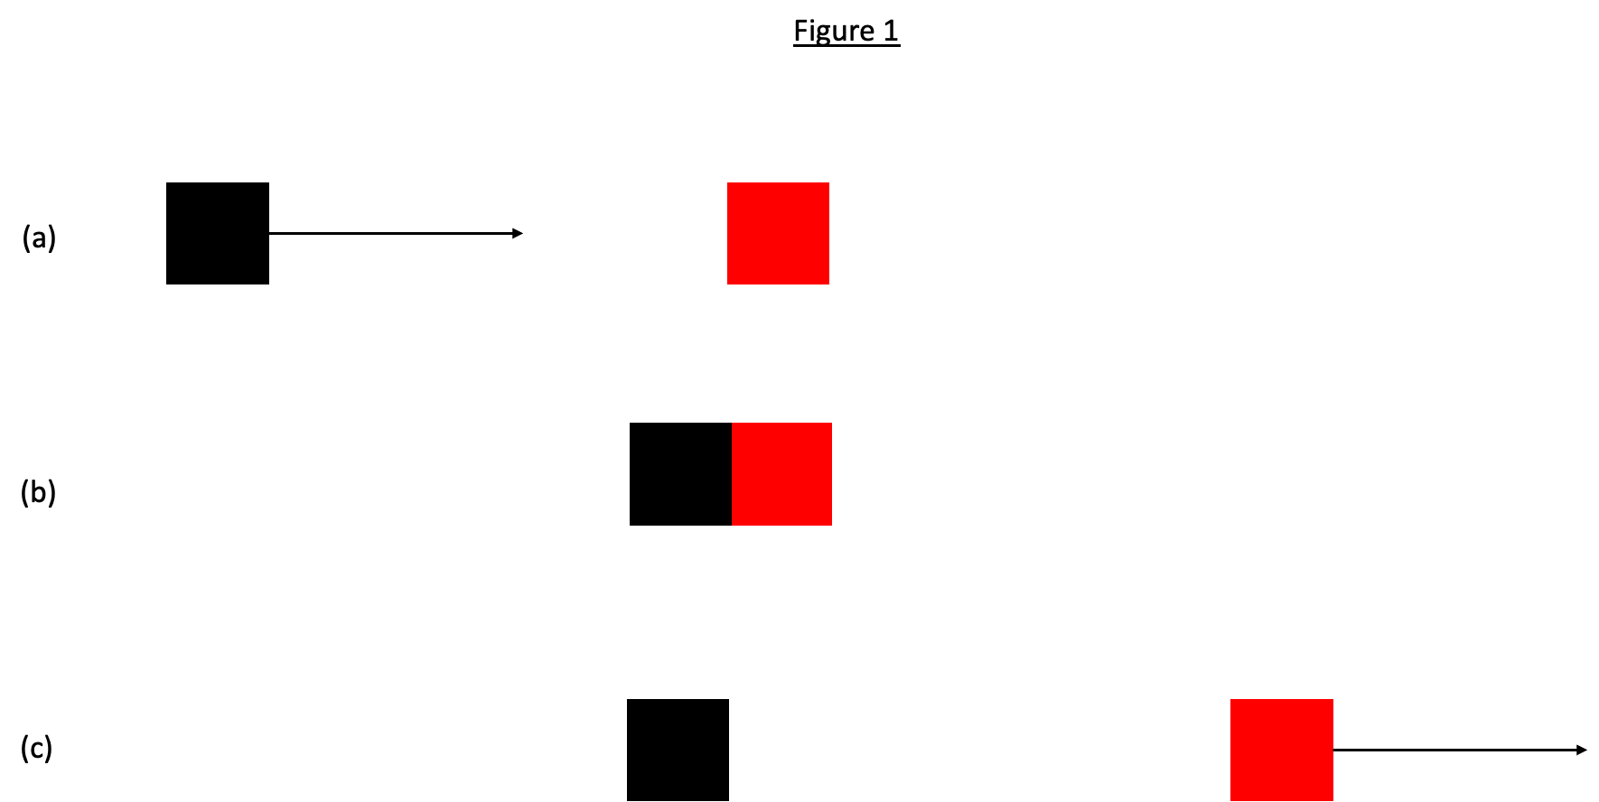
Figure 1. Schematic representation of stimulus for the launching effect used by Michotte (1963): (a) initial locations of objects and motion direction of the black square; (b) contact between the objects, at which point the black square stops moving and the red square moves off as shown in (c).

The launching effect is well established and has been confirmed in numerous subsequent studies (Gordon, Day, & Stecher, 1990; Hubbard, 2013a, 2013b; Schlottmann, Ray, Mitchell, & Demetriou, 2006; Scholl & Tremoulet, 2000). Evidence from neuroscience, perceptual processing, and developmental studies converges on the conclusion that the launching effect is a perceptual phenomenon, generated in automatic perceptual processing, not a product of post-perceptual cognition. In neuroscience it has been found that typical stimuli for the launching effect activate areas in the visual system of the brain, distinctively from non-causal control stimuli (Blakemore, Fonlupt, Pachot-Clouard, Darmon, Boyer, Meltzoff, Segebarth, & Decety, 2001; Blos, Chatterjee, Kircher, & Straube, 2012; Fugelsang, Roser, Corballis, Gazzaniga, & Dunbar, 2005; Roser, Fugelsang, Dunbar, Corballis, & Gazzaniga, 2005). The perceptual nature of the launching effect is shown by evidence that it can influence other contemporaneous perceptual processing. Moors, Wagemans, and de-Wit (2017) used a method called continuous flash suppression, in which a dynamic noise stimulus is presented to one eye and a stimulus of interest is presented to the other eye with gradually increasing contrast, until the participant reports detection of any part of the stimulus. Participants did not have to report a causal impression, just any element of the stimulus. Detection occurred sooner for launching stimuli than for non-causal controls, supporting the hypothesis that causality is constructed at an early stage of perceptual interpretation.¹ Typical stimuli for the launching effect induce retinotopic adaptation, meaning adaptation specific to the retinal location to which the stimuli were presented (Kominsky & Scholl, 2020; Rolfs, Dambacher, & Cavanagh, 2013), also indicative of the causal impression being a product of perceptual processing. If a stimulus is presented in which the black square stops before reaching the red square and the gap between them is filled with a stationary object, the size of the gap is underestimated, as compared to non-causal control stimuli (Buehner & Humphreys, 2010). That illusory spatial contraction is greater at the end of the stationary object contacted by the black square than at the other end, further indicating involvement of perceived causality in generating the illusion (Chen & Yan, 2020). The perceived trajectory of apparent motion varies depending on whether the objects in question are causal objects in a launching display or not (Kim, Feldman, & Singh, 2013), showing that the causal interpretation occurred prior to the construction of apparent motion. Developmental evidence also supports the claim that the launching effect is a perceptual phenomenon: infants aged about six months respond to launching stimuli and non-causal controls as if they have a causal impression with the launching stimulus (Kominsky, Strickland, Wertz, Elsner, Wynn, & Keil, 2017; Leslie & Keeble, 1987; Newman, Choi, Wynn, & Scholl, 2008; Muentener & Bonawitz, 2017).
The causal impression does not correspond to what the laws of physics tell us about interactions between inanimate objects. Newton's third law states that objects at contact exert equal and opposite forces on each other. It is as true to say that the red square makes the black square stop as it is to say that the black square makes the red square move. But participants in experiments do not perceive the red square as making the black square stop, and do not mention that possibility in spontaneous verbal reports of their perceptions (Michotte, 1946/1954/1963; Schlottmann et al., 2006). Causality is perceived as going one way, from the black square to the red square (White, 2006). The black square is incorrectly perceived as exerting more force on the red square than the red square exerts on the black square (White, 2007, 2009). The typical stimulus for the launching effect, in which the red square moves at the same speed as the black square, is not even very realistic. Runeson (1983) showed that it lies at one extreme of the range of possibilities allowed by the laws of mechanics, an extreme that would never be encountered in actual collision events. Normally, the object in the role of the red square would move more slowly than the object in the role of the black square, not at the same speed, and the latter would continue to move forward rather than stopping on contact. The typical stimulus for the entraining effect is also unrealistic because the two objects could only continue to move together without change of speed if the red square had zero mass and the black square adhered to it. Whatever the launching and entraining effects may be, they are not direct or accurate apprehension of what goes on in real inanimate contact events. They are perceptual constructs.
Michotte's research on perceptual impressions of causality has been hugely influential. It has been described as "classic" (e.g. by Guski & Troje, 2003; Hafri & Firestone, 2021; Moors et al., 2017), "seminal" (Choi & Scholl, 2006), it was certainly pioneering, and it continues to influence and inspire research in perception, cognition, developmental psychology, social psychology, cross-cultural psychology, treatment of causality in language, and also in neuroscience (Hubbard, 2013a, 2013b; Scholl & Tremoulet, 2000; Wagemans, van Lier, & Scholl, 2006). Interest in Michotte's research on visual causal impressions is rapidly inceasing. Michotte's book reporting the research was first published in French in 1946, with an extended second edition published in French in 1954, and an English translation of the second edition published in 1963; from this point on only the 1963 edition will be cited because it was the source consulted by the present author. Wagemans et al. (2006) reported that the various editions of the book had, in 2006, been cited 419 times, and they reported data showing a steady increase in citations over the decades. That increase has accelerated since then: at time of writing, consultation of the Web of Science (on April 21st 2023) shows 1389 citations of the book, so the number has more than tripled in just 17 years.
Michotte (1963) reported 95 experiments and numerous additional observations not dignified with experiment numbers. Of the numbered experiments, 44 were concerned with the launching effect, 9 with the entraining effect, and the remainder with various other phenomena such as perception of animal locomotion and qualitative causality (e.g. whether a contact event can be perceived as causing a change in size of an object, without that object moving). Many of the experiments on launching and entraining have never been replicated, and have received little attention in the subsequent research literature. Given the long-standing and ever increasing importance of Michotte's research in general and that on the launching effect in particular (Hubbard, 2013a, 2013b; Thinès, Costall, & Butterworth, 1991; Wagemans et al., 2006), this is an unsatisfactory situation. On the one hand, the reproducibility of many of the results described by Michotte (1963) is not known; on the other hand, there is potentially a rich treasure trove of research there, and re-examination of it holds the promise of expanding the scope of research on perceptual impressions of causality.
It is not feasible to replicate all of the experiments on launching and entraining. It was decided to focus on experiments most directly concerned with the causal impressions themselves. Experiments on matters peripheral to the causal impression, such as those on the radius of action (the span of movement on either side of the contact event that seemed to observers to have something to do with the contact event) were not selected. Fourteen experiments were designed, eight on the launching effect and six on the entraining effect. Most of these were concerned with experiments by Michotte that have never been replicated or extended. Two of them concern variables that have been further investigated but with results that have varied considerably between studies. These are delay between the black square contacting the red square and the red square starting to move, and spatial gap between the red square and the location at which the black square stops. Research on these variables will be summarised in the introductions to the respective experiments.

General features of method

The experiments reported in Michotte's book were not conducted in accordance with present-day understanding of methodological rigour. In many experiments the only participants were Michotte alone or Michotte and two experienced and knowledgeable colleagues. In a few, a sample of naive observers took part, but the reports are short on information about the participants, the instructions given to them, and data recording. There is no statistical analysis. In some experiments (such as the delay experiment) there are reports of percentages of observations falling into one category or another, but that is all. Michotte's preferred approach was experimental phenomenology: the aim was to capture the qualitative features of perception and, in some experiments, how those features varied with stimulus conditions, the ultimate goal being to construct a theoretical account of the perceptual structure of phenomenal causality. Using an experienced observer was considered a more fruitful means of achieving that goal. Without meaning to denigrate experimental phenomenology, replication with a large sample of naive participants would be desirable.
Most of the stimuli were created using an ingenious mechanical apparatus involving paper discs mounted on a rotating spindle. The "objects" were thick lines painted on the discs, and they appeared as rectangles to the observer because a screen was interposed in front of the discs with the lines. A narrow slit revealed to the observer just a short segment of each line, creating the appearance of small rectangular objects. When the disc rotated, the objects appeared to move or stay still depending on how the line was painted on the disc. The slit formed a visible track along which the objects appeared to move. In other experiments a cinematic projection method was used. The present research will use computer technology instead of Michotte's apparatus. Most studies since Michotte have used computer presentation and the launching effect clearly does occur with that technology. It is possible that technological differences could affect the results; this issue will be addressed in the general discussion in light of the results.
In visual appearance the stimuli and manipulations will be as similar as possible to those used by Michotte. The object that moved first in the stimulus for the launching effect was a black square and the other object was a red square and those features will be retained, except where object shape is manipulated. The standard size of object used (with the rotating disc method) was 5 mm square. A larger size of 12.4 mm (40 pixels) will be used in the present research, except where object size itself is a manipulated variable. There will be no visible slit or track: the objects will move in an otherwise plain white frame on the computer screen. The viewing distance reported for the basic launching effect experiment was 1.5 metres and that will be retained. In keeping with Michotte's method, movement of the heads of observers will not be restricted.
Instead of spontaneous reports of perceptual impressions, the present research will use rating scales. Rating scale methods have been used in many studies on perceptual impressions of causality (Hubbard, 2013a) and are an accepted method of collecting data on perceptual impressions. For purposes of replication, the rating scales should capture the forms of words used by Michotte when describing the perceptual impressions. There is inevitably a risk that verbal statements may be interpreted by participants in ways that are different from what they meant to Michotte. However, construct validity requires wording of rating scales to be as similar to Michotte's descriptors (in English translation) as possible. The participants cannot be trained in Michotte's method of experimental phenomenology, and in any case it is important that they should be naive to the research and not influenced by possible bias on the part of the researchers. Asking participants to give free verbal reports of what they perceive (as in Schlottmann et al., 2006) essentially transfers the problem of interpretation from the participant to the researcher. For any kind of statistical analysis to be done, the participants' reports would need to be subjected to content analysis. Defining the content categories in advance so as to ensure validity in categorisation of statements to categories is problematic. And participants cannot be guaranteed to focus on the features of the stimulus that are of interest to the researcher: for example, they might not report a causal impression even if they have one, but might choose just to report the motions of the objects instead. So rating scales will be used that take the form of verbal statements based on Michotte's descriptors, and participants will rate their degree of agreement or disagreement with each statement. Different statements apply in different experiments so further details are given in the method sections of the respective experiments.
Michotte reported that the launching and entraining effects are not always reported by naive observers at first. He claimed that, after a few trials, the causal impressions did start to occur, and that the initial problem was due to the participants not being used to the artificial conditions of the laboratory, probably including the mechanical apparatus used to present the stimuli. Two subsequent studies with naive participants and the same apparatus reported low rates of reporting the launching effect (Beasley, 1968; Boyle, 1960). Effects of experience with the stimuli have also been found (Brown & Miles, 1969; Powesland, 1959; Schlottmann et al., 2006; Woods, Lehet, & Chatterjee, 2012). As Scholl and Tremoulet (2000) argued, those findings can be interpreted as response biases, in other words as effects on how people make overt responses about what they perceive, rather than effects on the perceptual impressions themselves. There may also be effects of fatigue and attention (Choi & Scholl, 2004). Participants may be reluctant to endorse extremes of the rating scale until they have seen a representative sample of the stimuli, to get an idea of the range of variation in them. On the other hand, Bechlivanidis, Schlottmann, and Lagnado (2019) found that gap and delay stimuli shown before participants have observed a typical launching effect stimulus tended to be given high ratings of causality, and those ratings fell significantly after exposure to a typical launching stimulus. More will be said about that study in the introduction to Experiment 4 below. It is, however, important to the replication study that participants should, as far as possible, report what they see, their visual impressions, and not what they think following deliberation. Preliminary experience with the stimuli, and carefully worded instructions are both important to achieving that end. The plan, therefore, is to start by presenting each participant with a sample of six stimuli chosen to illustrate the variety of stimuli that will be encountered. Participants will just view each stimulus, presented in random order, and no response will be elicited from them. Two of the six will be the typical stimuli for the launching and entraining effects.
In experiment 38 Michotte (1963) manipulated the speed of the objects, with both moving at the same speed, from 4 mm/s to 1100 mm/s. He reported: "The most perfect impression of launching is given with speeds between 20 and 40 cm. per sec. [200 to 400 mm/s] and even a little higher" (p. 107). At speeds around 100 - 150 mm/s he reported that "the impact is slight and lacking in vigour" (p. 107), though the launching effect still occurred. With Michotte's apparatus the apparent motion was macroscopically continuous. With computer-generated stimuli that is not the case. The stimulus is a series of static images replaced at the refresh rate (60 Hz in the present study), and at high speeds one image is displaced by several pixels from the one in the previous frame. The very high speeds that supposedly gave rise to the strongest impressions of launching are not practical with computer presentation because the large jumps from one frame to the next can give rise to noticeable blur or jerky motion. That could disrupt not only motion processing but also perception of contact between the objects. A compromise must therefore be found between the desideratum of high speed and the need for smooth motion and absence of blur to be perceived. With the computer to be used for the experiments, that compromise appears optimal at about 124 mm/s. That was therefore adopted as the standard speed for the objects and is used except where indicated otherwise.
Stimulus variables either investigated or mentioned in Michotte's reports of the experiments will be manipulated, resulting in parametric designs that can be analysed with analysis of variance (ANOVA). A large sample of naive observers will take part and the experiments will be run by an experimenter naive to the research topic, as well as to the specific aims and hypotheses being tested.
To conclude this section with a typographical convention, the experiments in the present paper will be identified with upper case "E" and Michotte's experiments will be identified with lower case "e" (except at the start of a sentence).

Participants

The participants will be volunteer first-year undergraduate students of psychology at Cardiff University with normal or corrected to normal vision, participating in return for course credit. Michotte's research is not on the undergraduate curriculum so all should be naive to the research topic. In the cohorts from which the sample will be obtained, approximately 80% are female, most are in the age range 18 - 21 years, and most have British nationality. Informed consent will be obtained from all participants and participants will be given a written debrief at the end of the experiment, as well as having the opportunity to ask questions about the research. Ethical approval has been granted by the Ethics Committee of the Cardiff University School of Psychology.
Each participant will take part in multiple experiments. Exactly how participants will be assigned to experiments cannot be stipulated until piloting has been done to determine how long each experiment takes to run, but it is anticipated that any given participant will take part in approximately one third of the experiments.

Minimum effect size and sample size determination

This is a replication study and the research being replicated was not subject to any kind of statistical analysis. In view of that, the main concern is to establish statistical significance. The minimum effect size of interest is of less concern than finding statistically significant support for the effects claimed by Michotte. Avoiding both Type I and Type II errors is important. These considerations indicate that it is desirable to have a relatively large sample and a conservative alpha level of .01.
In principle any statistically significant effect would be meaningful no matter how small the effect size, but small effect sizes can only be detected by studies with large samples of data. Therefore it is reasonable to consider what sort of effect size can be expected and to determine the sample size in accordance with that. The minimum effect size of interest cannot be defined a priori but effect sizes in previous in previous research can provide a reasonable empirical guide (Lakens, 2022). For this purpose the available research was scrutinised and studies were selected that met the following criteria: (i) effect sizes were reported (not many studies have done this); (ii) the measure used must be a causal judgment measure of the sort used in the proposed research, so, for example, studies of judged speed (Parovel & Casco, 2006) and judged naturalness (Vicovaro & Burigana, 2014) were ruled out; (iii) ANOVA must be used and, since only main effects are predicted in the proposed studies, only effect sizes for main effects were sampled; (iv) only effect sizes for effects where a significant effect was predicted were selected. Effect sizes meeting these criteria were found in the following studies: Mitsumatsu (2013); Ryu and Oh (2018); Vicovaro (2018); Mayrhofer and Waldmann (2016); Hubbard and Ruppel (2018); and I included my own most recent publication that met the selection criteria (White, 2018). This generated a sample of 25 effect sizes with an overall mean of .40 and a range from .04 (Mitsumatsu, 2013) to .73 (Hubbard & Ruppel, 2018). Only three were less than .20 (all from Mitsumatsu, 2013), and two more were less than .25, so 80% of the effect sizes were greater than .25. There is a possibility that the mean is inflated by publication bias (Lakens, 2022) but, if small effect sizes were common, the distribution of effect sizes in published research should be skewed towards the smaller end of the range and there is no evidence of that in the effect sizes sampled here. It is likely, therefore, that true effect sizes for the phenomena studied in this research are often greater than .25.
With that in mind, G*Power was used to determine desired sample sizes for the designs of each of the proposed experiments (except for Experiments 8 and 10 where the chi-square test will be used). For these calculations, alpha was set at .01, power at .90, correlation among measures at 0.1, and nonsphericity correction at 1. With these values and an effect size of .20, the desired sample varied from 36 (for Experiments 7 and 9) to 66 (for Experiment 3). With an effect size of .25, the desired sample varied from 24 (for Experiments 7, 9, 11, and 12) to 42 (for Experiment 3). A sample of 66 would not be possible because of resource limitations. A sample of 50 is feasible. With power at .20, only two experiments (2 and 3) have desired samples in excess of that and, with power at .25, none of them do. A sample of 50 was therefore deemed adequate to give a reasonable chance of finding any effects that are there to be found.
A sample of studies using launching stimuli and published since 2000 revealed considerable variation in numbers of participants. Several studies reported between 8 and 20 participants (Guski & Troje, 2003; Kim et al., 2013; Kominsky et al., 2017; Mitsumatsu, 2013; Parovel & Casco, 2006; Ryu and Oh, 2018; Scholl & Nakayama, 2002; Vicovaro & Burigana, 2014; Vicovaro, Battaglini, & Parovel, 2020; Zhou, Huang, Jin, Liang, Shui, & Shen, 2012). A few ran more than 20 but had different dependent measures as a between-subject variable, with numbers varying from 14 to 16 for each dependent variable (Hubbard & Ruppel, 2013, 2017; Sanborn, Mansinghka, & Griffiths, 2013). Of the remainder, in ascending order of numbers, Umemura (2017) ran 27; Vicovaro (2018) ran 40; Young, Rogers, and Beckmann (2005) ran 44; Wang, Chen, and Yan (2020) ran 57 with 32 on a causal judgment measure and 25 on a force judgment measure; Young and Falmier (2008) ran 58; Falmier and Young ran 67 in a four-way mixed ANOVA design; Schlottmann et al. (2006) ran 72 in a study where the measure was free verbal reports; Mayrhofer and Waldmann (2016) ran 934 in an online study with 233 or 234 participants allocated to each of four between-subject conditions. Two points can be made about this. One is that it seems not to be difficult to obtain statistically significant results with small samples, as used in most of the studies cited above. The other is that the sample size of 50 chosen for the present research is towards the higher end of the range. Reliability is a major issue in a replication study and there are indications of substantial inter-individual variability in responses (e.g. Schlottmann et al., 2006; Straube & Chatterjee, 2010), so a large sample is desirable for those reasons as well.
Data from all participants will be included unless there has been technological failure in data recording or the experimental session was not completed (e.g. because of participant withdrawal). If such events occur, further participants will be run until the target number is reached. There is no clear objective criterion for making decisions about excluding participants on grounds of data quality, so all will be included. In the absence of objective criteria for exclusion of participants there is a danger that some participants might not engage fully with the task and therefore might not differentiate between the rating scales. To check on the frequency with which this occurs, scatterplots depicting relationships between responses on the different rating scales will be included for each experiment.

Apparatus and stimuli

Stimuli will be generated on screen using PsychoPy (Version 3; Peirce, 2007), from instruction files written in Excel. Stimuli will be presented on an iMac desktop computer with a screen resolution of 3.226 pixels per mm, at a frame rate of 60 Hz. The overall size of the screen will be 590 width x 330 mm height. The viewing distance will be that used by Michotte, 1.5 metres. Observers in his studies were free to move so that feature of the method is retained in the present study, and for that reason spatial measurements are given in millimetres rather than degrees of arc.
General features of stimulus presentations are listed in Table 1.

Variations from the standard features above are detailed in the method sections of the corresponding experiments.
It was noted above that, with computer presentations, apparently moving objects actually jump by some number of pixels from one frame to the next. In all cases stimuli were designed so that exact contact between the two objects occurred; that is, the static frame in which contact occurred showed no gap between and no overlap of the objects.

Table 1
Summary of general features of stimulus presentations
_________________________________________________________________________
Stimuli are presented within a frame with a white ground, 1600 width x 800 pixels height, 496 x 248 mm.
Experiments 1 - 8 are based on the typical stimulus for launching as illustrated in Figure 1; Experiments 9 - 14 are based on the typical stimulus for entraining.
Objects are squares except in Experiment 1 where object width is manipulated and in Experiment 8 which follows Michotte's experiment 33 in using circular discs.
Objects are 12.4 mm on each side except in Experiment 1 where object width is manipulated, Experiment 8 where circular discs with 9.3 mm radius are used, and Experiments 3, 11, and 12, where object size is manipulated.
Objects move horizontally from left to right except in Experiment 2 where some objects in some stimuli move from right to left.
The object that moves first is black and the object that moves second is red, except in Experiment 1 where both objects are black.
Speed of motion is 124 mm/s except for some stimuli in Experiments 1, 7, 9, 10, 11, and 12 where object speed or speed ratio is manipulated.
Object motion continues until the red square exits the frame except for two stimuli in Experiment 2 where objects stop within the frame.
Distance moved by each object varies between stimuli and between experiments; the minimum distance used is 124 mm.
_________________________________________________________________________

Table 2 lists the main concern of each experiment and the experiment(s) by Michotte on which each was based. More detailed information is given in Table 3, the design plan, and the method sections of the individual experiments.
Table 2
Summary of replications
_________________________________________________________________________
Experiment Replication
Launching experiments
1 Effect of reduced object width (Michotte experiment 10)
2 Effect of contextual object motions (Michotte experiments 20, 21, 24 - 26)
3 Effect of object size (Michotte anecdotal report, p. 82)
4 Effect of delay when black square contacts red square (Michotte experiment 29)
5 Effect of pause in motion of single object (Michotte experiment 30)
6 Effect of non-contact between the two objects (Michotte experiment 31)
7 Effect of red square being in motion away from black square (Michotte experiment 17)
8 Effect of vertical displacement of black square motion path (Michotte experiment 33)
Entraining experiments
9 Effect of red square being in motion away from black square (Michotte experiments 48, 49, and 55)
10 Effect of relative speed of objects (Michotte experiment 54)
11 & 12 Effect of spatial relations between small object and large screen (Michotte experiment 52)
13 Effect of delay when black square contacts red square (not studied by Michotte)
14 Effect of non-contact between the two objects (not studied by Michotte)
_________________________________________________________________________

Design

Specific experimental designs are described under the individual experiment headings and summarised in Table 3. Because of the large number of experiments, the .01 criterion for statistical significance will be used. This will be further modified within each experiment by use of the Bonferroni correction based on the number of dependent variables in that experiment. Correction for violation of sphericity will be applied if necessary. Where appropriate, post hoc paired comparisons will be carried out using the Tukey test or single contrast testing with the significance level set at .05. Effect sizes will be calculated using the partial eta squared measure. Significant interactions are not predicted for these studies. If any occur, the existing literature will be utilised as a source of possible interpretations; any interpretation proposed would be treated as a way forward for further investigation.
___________________________________________________________________________
Table 3
Experimental designs for all experiments
___________________________________________________________________________
Experiment Design and analysis
___________________________________________________________________________
Experiments 1 - 8: launching stimuli
1 Object width (10 widths in equal increments from 0.62 mm to 6.2 mm).
Speed of both objects (62 mm/s v. 124 mm/s).
Each statement analysed with two-way ANOVA (within-subjects).
2 Five different visual camouflage stimuli. Each will be analysed separately twice:
Each statement analysed with one-way ANOVA comparison with standard launching stimulus (within-subjects, no fixation condition only).
Each statement analysed with one-way ANOVA for presence v. absence of fixation point (between-subjects).
3 Size of black square (2.48 mm v. 12.4 mm v. 93 mm).
Size of red square (2.48 mm v. 12.4 mm v. 93 mm).
Each statement analysed with two-way ANOVA (within-subjects).
4 Delay between black square contacting red square and red square moving (13 delays in equal increments from 0 ms to 200 ms).
Each statement with a Bayesian linear mixed model using the Bayesian ANOVA module in JASP
5 Pause in motion of single object (13 pause durations in equal increments from 0 ms to 200 ms).
Each statement analysed with one-way ANOVA (within-subjects).
4 & 5 Results will be subject to correlation analysis to assess similarity in effects of pause and delay.
6 Gap size (3.1 mm v. 6.2 mm v. 12.4 mm v. 24.8 mm v. 46.5 mm v. 68.2 mm v. 89.9 mm).
Object speed (74.3 mm/s v. 124.0 mm/s v. 186.0 mm/s).
Each statement analysed with two-way ANOVA (within-subjects).
7 Speed ratio of black square before contact to red square after contact (2:1 v. 3:1 v. 4:1 v. 6:1)
Speed of red square after contact (18.6 mm/s v. 37.2 mm/s v. 74.4 mm/s)
Presence v. absence of fixation point (between-subjects).
Each statement analysed with three-way mixed design ANOVA.
8 Stopping location of black disc with five locations.
Each statement for each stimulus analysed with chi-square test.
Experiments 9 - 14: entraining stimuli
9 Speed ratio of black square before contact to red square after contact (2:1 v. 3:1 v. 4:1 v. 6:1).
Speed of both objects after contact (18.6 mm/s v. 37.2 mm/s v. 74.4 mm/s).
Presence v. absence of fixation point (between-subjects).
Each statement analysed with three-way mixed design ANOVA.
10 Speed of black square before contact (62 mm/s v. 124 mm/s v. 186 mm/s).
Speed of both objects after contact (62 mm/s v. 124 mm/s v. 186 mm/s).
Each statement for each stimulus analysed with chi-square test.
11 Speed of small (red) object (62 mm/s v. 124 mm/s v. 186 mm/s).
Spatial relations of objects (see Table 5 for details).
Each statement analysed with two-way ANOVA (within-subjects).
12 Speed of large (red) object (62 mm/s v. 124 mm/s v. 186 mm/s).
Spatial relations of objects (see Table 6 for details).
Each statement analysed with two-way ANOVA (within-subjects).
13 Delay between black square contacting red square and both objects moving (13 delays in equal increments from 0 ms to 200 ms).
Each statement analysed with one-way ANOVA (within-subjects).
14 Gap size (3.1 mm v. 6.2 mm v. 12.4 mm v. 24.8 mm v. 46.5 mm v. 68.2 mm v. 89.9 mm).
Object speed (74.3 mm/s v. 124.0 mm/s v. 186.0 mm/s).
Each statement analysed with two-way ANOVA (within-subjects).
___________________________________________________________________________
Note: All experiments have multiple dependent measures (see method sections of individual experiments). Each will be analysed separately.

___________________________________________________________________________
Table 4
Design plan
___________________________________________________________________________
Michotte did not test hypotheses, nor did he carry out statistical analysis. His reports of results were all consistent with the perceptual structure hypothesis that was developed as the research went on. So the overall plan is to test the general hypothesis that the results and observations reported by Michotte are reliable. Failures to replicate, which would include non-significant results and significant results in the direction opposite to that reported by Michotte, would have disconfirmatory value for his perceptual structure theory. More detail about that, the experimental designs, and the rationale for the designs can be found in the main text under the individual experiment headings. None of the hypotheses predicts a significant interaction so these are not mentioned in the design plan. Desired sample sizes were calculated using G*Power 3.1.

Expt. | Question | Hypothesis | Sampling plan | Analysis plan | Rationale for  deciding the  sensitivity of  the test for  confirming or  disconfirming  the hypothesis | Interpretation  given different  outcomes | Theory that  could be  shown wrong  by the  outcomes
1 | Will  Michotte's  result be  replicated? | H1. Passing  impression  will occur with  narrow objects,  transition to  launching  effect with  wide objects.  Manipulation of  speed is  exploratory,  justified by  findings that  the launching  effect varies  with speed | For n = 50, α =  .01, significant F  ratio for main  effect of object  width. Post hoc  paired  comparisons  tested with  Tukey test with  α = .05. Direct  comparisons  between  statements  tested with  related means  t test. Linear trends  on both measures  tested with Pearson  linear correlation  coefficient. | Two-way  within-subs  ANOVA,  object width  (10 values) x  speed of both  objects (2  values) | Assuming effect  size of .20 or  more, with  Power = .90  and correlation  among  measures = 0.1,  n = 39 is  adequate. With  effect size of .25  or more, n = 26  is adequate. | Transition from high  passing ratings at low  width to high  launching ratings at  high width would be  successful replication.¹  If F ratio is significant  at .01 this will be  tested with post hoc  paired comparisons  (Tukey test). All other  results would be  failure to replicate. If  all launching means  were below scale mid-  point that would be  disconfirmatory for  launching effect. | Michotte's  perceptual  structure  theory.
2 | Will  Michotte's  results be  replicated? | H2. Camouflage  manipulations  will reduce or  eliminate  launching effect.  This will be  qualified by  fixation  manipulation -  see main text  for details. | For n = 50, α =  .01, significant F  ratio for main  effect of  camouflage v.  standard. Ditto  for main effect of  fixation  manipulation. | For each stimulus: (a)  one-way within subs  ANOVA v. standard  launching stimulus,  no-fixation condition  only; (b)  one-way  between-subs  ANOVA for  presence  v. absence of  fixation point.  ANOVA is used for  consistency with the  other experiments. | Assuming effect  size of .20 or  more, with  Power = .90  and correlation  among  measures = 0.1,  n = 62 is  adequate. With  effect size of .25  or more, n = 40  is adequate.  . | Significantly higher  launching ratings for  standard than for  camouflage stimuli  would be successful  replication. All other  results would be  failure to replicate.  Reported effect of  fixation were not  interpreted by  Michotte;  unexpected  interactions will  not be interpreted  but will be  discussed in the  discussion. | Module  hypothesis.
3 | Will  manipulating  object size  affect ratings  of launching? | H3. The  launching effect  will not be  affected by  object size  manipulation  (as claimed by  Michotte). | For n = 50, α =  .01, significant F  ratio for main  effect of delay.  Null hypothesis  tested with  Bayesian linear  mixed model. | Two-way  within-subs  , size  of  black  square (3  values)  x size  of red square  (3 values). | Assuming effect  size of .20 or  more, with  Power = .90  and correlation  among  measures = 0.1,  n = 66 is  adequate. With  effect size of .25  or more, n = 42  is adequate. | Significant effect of  size of either object  on launching ratings  would discnfirm  Michotte's claim.  Non-significant  effect would be  consistent with it. | Significant  effect is not  predicted by  Michotte's  theory but  would not be  disconfirm-  atory for it.
4 | Will  Michotte's  result be  replicated? | H4. Launching  ratings will  decline as delay  increases. | For n = 50, α =  .01, significant F  ratio for main  effect of delay.  Post hoc  single  contrast testing  for linear trend  with  α = .05. | One-way  within-subs  ANOVA,  delay duration,  13 values). | Assuming effect  size of .20 or  more, with  Power = .90  and correlation  among  measures = 0.1,  n = 51 is  adequate. With  effect size of .25  or more, n = 33  is adequate. | Statistically  significant decline of  launching ratings  with increasing  delay would bs  successful replication.  All other results  would be failure to  replicate. If F ratio is  significant at .01 this  will be tested with  post hoc paired  comparions (Tukey). | Michotte's  perceptual  structure  theory and  module  hypothesis.
5 | Will  Michotte's  result be  replicated? | H5. Ratings of  continuous  motion will  decline as pause  duration  increases.  H6. There will  be a high  positive  correlation with  launching  ratings in  Expt. 4. | For n = 50, α =  .01, significant F  ratio for main  effect of pause  duration. Post  hoc  single  contrast testing  for linear trend  with  α = .05. | One-way  within-subs  ANOVA,  pause duration,  13 values). | Assuming effect  size of .20 or  more, with  Power = .90  and correlation  among  measures = 0.1,  n = 51 is  adequate. With  effect size of .25  or more, n = 33  is adequate. | Statistically  significant decline of  continuous motion  ratings with  increasing pause  duration would be  successful replication,  as would significant  and high positive  correlation with  launching ratings in  Expt. 4; low or  negative correlation  would be failure to  replicate. If F ratio is  significant at .01 this  will be tested with  post hoc paired  comparisons (Tukey). | Michotte's  perceptual  structure  theory.
6 | Will  Michotte's  result be  replicated? | H7. Ratings of  launching will  decline as gap  size increases.  H8. Ratings of  launching will  increase as speed  increases. | For n = 50, α =  .01, significant F  ratio for main  effect of gap size.  Post hoc  single  contrast testing  for linear trend  with α = .05.  Main  effect of  speed, post hoc  testing with  Tukey test.. | Two-way  within-subs  ANOVA, gap  size (7 values)  x object speed  (3 values). | Assuming effect  size of .20 or  more, with  Power = .90  and correlation  among  measures = 0.1,  n = 38 is  adequate. With  effect size of .25  or more, n = 26  is adequate. | Decline of launching  ratings with  increasing gap size  would be successful  replication. All other  results for gap size  would be failure  to replicate. Increase  of launching ratings  with increasing  object speed would  be successful  replication. All other  results for object  speed would be  failure to replicate. | Michotte's  perceptual  structure  theory and  module  hypothesis.
7 | Will  Michotte's  result be  replicated? | H9. Ratings of  launching will be  above scale mid-  point for all  stimuli.  H10. That will  be qualified by  fixation  manipulation.  See main text  for details. | For n = 50, α =  .01, significant t tests  for comparison  between ratings and  scale mid-point. | t-tests comparing  ratngs for each  stimulus with scale  mid-point. | Assuming effect  size of .20 or  more, with  Power = .90  and correlation  among  measures = 0.1,  n = 36 is  adequate. With  effect size of .25  or more, n = 24  is adequate.  . | Launching ratings  above scale mid-  point for all stimuli  would be successful  replication.  Significant effects  would not be  disconfirmatory  unless one or more  means was below  scale mid-point.  Reported effects of  fixation were not  interpreted by  Michotte;  interpretation here  will depend on  results. | Michotte's  perceptual  structure  theory.
8 | Will  Michotte's  result be  replicated? | H11. Launching  effect will be  weak or absent  for all stimuli. | Non-significant  chi-  square test  on  comparisons  between  statements for  each stimulus.  or significant  similarity. | Comparisons between  statements for each  stimulus using chi-  square test. | Nonparametric  analysis that  allows possibility  of testing  significant  similarity  will be used. | Non-significant result  with means below  scale mid-point on  launching measure  would be successful  replication.  Significant result  with at least one  mean above scale  mid-point would be  unpredicted;  interpretation would  depend on details of  result. | Michotte's  perceptual  structure  theory.
9 | Will  Michotte's  result be  replicated? | H12. If black  square is fixated,  entraining effect  will occur for all  stimuli. If red  square is  fixated,  entraining effect  will not occur. | For n = 50, α =  .01, significant t tests  for comparison  between ratings and  scale mid-point. | t-tests comparing  ratngs for each  stimulus with scale  mid-point. | Assuming effect  size of .20 or  more, with  Power = .90  and correlation  among  measures = 0.1,  n = 36 is  adequate. With  effect size of .25  or more, n = 24  is adequate. | With fixation on  black square,  entraining ratings  above scale mid-  point for all stimuli  would be successful  replication.  Significant effects  would not be  disconfirmatory  unless one or more  means was below  scale mid-point.  Reported effects of  fixation were not  interpreted by  Michotte;  interpretation here  will depend on  results. | Michotte's  perceptual  structure  theory.
10 | Will  Michotte's  result be  replicated? | H13.  Entraining effect  will occur for all  stimuli. | Non-significant  chi-square test  on  comparisons  between  statements for  each stimulus.  or significant  similarity.  . | Comparisons between  statements for each  stimulus using  chi-square test. | Nonparametric  analysis that  allows possibility  of testing  significant  similarity  will be used.  . | Entraining ratings  above scale mid-  point for all stimuli  would be successful  replication.  Significant effects  would not be  disconfirmatory  unless one or more  means was below  scale mid-point. | Michotte's  perceptual  structure  theory.
11 | Will  qualitative  impression  change  depending on  spatial  relations  between  stimuli? | H14. When both  objects have the  same speed,  there will be  qualitative  differences in  reported  impressions with  launching  favoured for  some stimuli,  entraining for  others, and  pulling for  others. When the  objects have  different speeds,  differences will  be weak or  absent.² | For n = 50, α =  .01, significant F  ratio for main  effects of spatial  relation and  speed of small  object. Post hoc  paired  comparisons  tested with Tukey  test with α = .05. | Two-way  within-subs  ANOVA,  spatial  relation  between  objects when  both are  in  motion (7  values)  x speed  of small  object (3  values).  Comparisons between  statements analysed  with one-way  ANOVA with  repeated measures. | Assuming effect  size of .20 or  more, with  Power = .90  and correlation  among  measures = 0.1,  n = 38 is  adequate. With  effect size of .25  or more, n = 24  is adequate. | Significant  differences between  measures can be  interpreted as  qualitative  differences in  perceptual  impression. For  example, if pulling  ratings are  significantly higher  than launching,  entraining, and  independent motion  ratings for a  particular stimulus,  that would sypport  interpretation that a  pulling impression  occurs. See main  text for more  details. | Michotte's  perceptual  structure  theory.
12 | Will  qualitative  impression  change  depending on  spatial  relations  between  stimuli? | H15. When both  objects have the  same speed,  there will be  qualitative  differences in  reported  impressions with  launching  favoured for  some stimuli,  entraining for  others, and  pulling for  others. When the  objects have  different speeds,  differences will  be weak or  absent.² | For n = 50, α =  .01, significant F  ratio for main  effects of spatial  relation and  speed of large  object. Post hoc  paired  comparisons  tested with Tukey  test with α = .05 | Two-way within-subs  ANOVA, spatial  relation between  objects when both are  in motion (7 values)  x speed of small  object (3 values).  Comparisons between  statements analysed  with one-way  ANOVA with  repeated measures. | Assuming effect  size of .20 or  more, with  Power = .90  and correlation  among  measures = 0.1,  n = 38 is  adequate. With  effect size of .25  or more, n = 24  is adequate. | Significant  differences between  measures can be  interpreted as  qualitative  differences in  perceptual  impression. For  example, if pulling  ratings are  significantly higher  than launching,  entraining, and  independent motion  ratings for a  particular stimulus,  that would sypport  interpretation that a  pulling impression  occurs. See main  text for more  details. | Michotte's  perceptual  structure  theory.
13 | Will effect of  delay for  entraining be  similar to that  for launching? | H16. Entraining  effect will  decline as delay  increases. | For n = 50, α =  .01, significant F  ratio for main  effect of delay.  Post hoc  single  contrast testing  for linear trend  with α = .05. | One-way  within-subs  ANOVA,  delay  duration (13  values). | Assuming effect  size of .20 or  more, with  Power = .90  and correlation  among  measures = 0.1,  n = 51 is  adequate. With  effect size of .25  or more, n = 33  is adequate. | Statistically  significant decline of  entraining ratings  with increasing delay  would support  hypothesis. All other  results would fail to  support hypothesis.  If F ratio is significant  at .01 this will be  tested with post hoc  paired comparisons  (Tukey test with α =  .05. | Michotte's  perceptual  structure  theory.
14 | Will effect of  gap size for  entraining be  similar to that  for launching? | H17. Entraining  effect will decline  as gap size  increases. | For n = 50, α =  .01, significant F  ratio for main  effect of gap size.  Post hoc  single  contrast testing  for linear trend  with α  = .05.  M  ain effect of  speed tested  with Tukey test. | Two-way  within-subs  ANOVA,  gap size (7  values) x  object speed  (3 values). | Assuming effect  size of .20 or  more, with  Power = .90  and correlation  among  measures = 0.1,  n = 38 is  adequate. With  effect size of .25  or more, n = 26  is adequate. | Statistically  significant decline of  entraining ratings  with increasing gap  size would support  hypothesis. All other  results would be  failure to support  hypothesis. If F ratio  is significant at .01  this will be tested  with post hoc paired  comparisons  (Tukey test). | Michotte's  perceptual  structure  theory.

Footnotes.
1. Available evidence (Michotte, 1963, experiment 10) indicates only that the transition from passing to launching should occur somewhere between 1 mm and 5 mm object width.
2. Michotte (1963) tested only a single stimulus with both objects moving at the same speed (experiment 52) and found entraining. Experiments 11 and 12 extend this by manipulating spatial relations between the objects when both are in motion, so occurrence of qualitative differences between them in causal impressions is a novel prediction.
_____________________________________________________________________

Procedure

The experiments will be run in a small windowless laboratory with fluorescent lighting giving a moderate ambient light level. Each experiment will have its own written instructions, including the dependent measures for the respective experiments
(see https://osf.io/kynjw?view_only=103e1dc33cca4464be9d167d929e4c63 for details), and the experimenter will check that the participant has understood the instructions each time. When the participant indicates that they have understood the instructions, the experimenter will show them how to proceed through the stimuli and responses with mouse clicks. Participants will then proceed through the stimuli for each experiment at their own pace, under supervision. Order of experiments will be randomised independently for each participant and order of stimuli within experiments will be similarly randomised. In each experiment, each stimulus will be presented once to each participant. Given the large total number of stimuli, participants will be permitted to take short breaks between experiments.
Initially, a series of six stimuli chosen from the experiments and including typical stimuli for the launching and entraining effects will be presented in random order. Before these are presented, participants will be instructed that the experiments are concerned with their impressions of what they see, not with any thoughts they might have about the stimuli, and that the series of stimuli is to give them an idea of the kinds of stimuli that will be encountered in the experiments. They will be instructed to observe the stimuli and that no response is required, and they will be invited to ask questions if they have any. The experimenter will answer questions, where possible, emphasising if necessary that it is the visual impression they have of the stimuli that is of interest. The experimenter will be naive to aims and hypotheses so will not be able to give information that might bias participant responses.

Experiment 1: object width

Experiment 1 is based on experiment 10 in Michotte (1963, p. 49). A single stimulus was presented in which the width of the objects was reduced from 5 mm to 1 mm. Michotte reported that the launching effect did not occur. Instead there was an impression that he termed the Tunnel Effect, which is an impression of one object passing over or behind another. Impressions of one object passing over another object have been reported in several experiments by Scholl and colleagues (Choi & Scholl, 2004, 2006; Scholl & Nakayama, 2002, 2004). In those experiments, the object that moved first stopped at a point where it partly or completely occluded the other object, and various manipulated factors influenced whether the first object was perceived as launching the other object or as passing over it. Michotte's experiment 10 is different in that the passing impression was reported when there was no overlap of the objects, and it has not previously been replicated.
Effects of object speed on the launching effect have often been reported, as was discussed earlier, so it is possible that the point of transition from passing to launching might vary depending on speed. For that reason, object speed was also manipulated.
H1. There should be linear trends for ratings on the passing scale to decrease and ratings on the launching scale to increase with increasing width. Ratings on the passing scale should be significantly higher than ratings on the launching scale at the narrowest width, and ratings on the launching scale should be higher than ratings on the passing scale at the greatest width. There is no basis for predicting exactly where that transition from passing to launching will occur. No significant interaction with object speed is predicted.

Method

Michotte did not report any variations on the stimulus in experiment 10. Experiment 1 is therefore an extended replication. Stimuli were based on the launching effect stimulus depicted in Figure 1. Object width (of both objects) is varied from 0.62 mm to 6.2 mm in increments of 0.62 mm (2 pixels), resulting in ten different widths. The height of the objects is 12.4 mm in all stimuli. Speed is manipulated with two values, 124 mm/s and 62 mm/s, with both objects moving at the same speed in any given stimulus. Both objects are the same colour (black) so that colour difference could not be used as a cue to interpret what happened.
Written instructions to participants begin as follows: "In this experiment you will see a series of short movies, about one or two seconds in duration, each involving two objects, both black rectangles. Each movie will begin with one rectangle moving towards the other. We are interested in what you see when the moving rectangle reaches the other one, the visual impression you have of the movies, not any thoughts you might have about what you are seeing. For each movie you will be asked to rate the extent to which you agree or disagree with each of three statements as descriptions of your visual impression of what happened. The three statements are as follows:
The initially moving rectangle made the other rectangle move by bumping into it.
The initially moving rectangle passed across the other rectangle, which moved little or not at all.
The initially stationary rectangle moved off when the moving one reached it, but it moved independently and its motion was not caused by the other rectangle.
You should rate your agreement or disagreement with each statement as a description of your visual impression, by entering a number from 0 to 10. The more strongly you agree with a statement, the higher the number you should put, up to a maximum of 10. The more strongly you disagree with a statement, the lower the number you should put, down to a minimum of 0 (zero)."
The statement for passing is based on Michotte's description of the Tunnel Effect. The statement for independent motion is also based on Michotte's preferred form of expression - the term "independent(ly)" was used frequently in Michotte (1963) - in described impressions of stimuli in which the launching effect did not occur.

Experiment 2: camouflage

Experiments 20 - 26 were called camouflage experiments by Michotte (1963). The basic principle was to present a typical stimulus for launching but in a context of other movements, by one or both of the two objects themselves or by additional objects. In experiments 22 and 23 one of the objects changed shape without otherwise moving. Experiment 2 is a replication of the other five experiments (20, 21, 24 - 26).
In experiment 20 the red square was the leftmost of a series of five red squares with gaps of 1.5 mm between them. Figure 2 depicts the sequence of events in this stimulus. When the black square begins to move, the rightmost of the red squares starts moving to the right. Each one in turn starts moving with the same velocity at regular intervals, timed so that the leftmost one starts to move when the black square contacts it. The red squares continue to move until they have exited the frame. Thus, it is a standard launching stimulus, but with a visible context of other moving objects. Michotte (1963) reported that the launching effect did not occur with this stimulus, unless the point of contact between the black square and the leftmost red square was fixated.
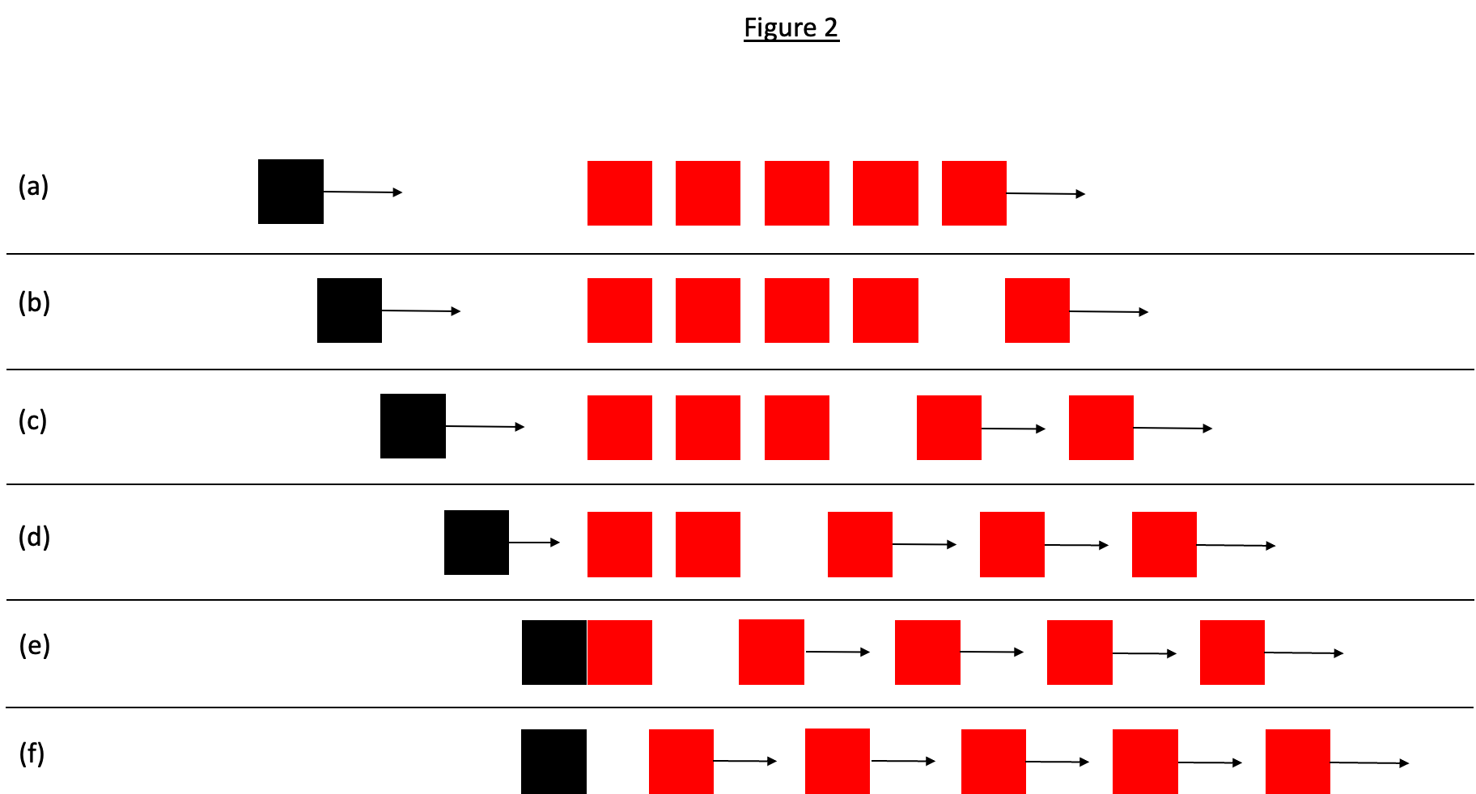
Figure 2. Schematic representation of camouflage stimulus in Experiment 2, based on Michotte (1963, experiment 20). Figure 2(a) shows the first frame of the stimulus: the black square starts to move and the rightmost red square also starts to move with the same velocity. Figure 2 (b) shows these object motions continuing. In Figure 2(c) the next red square has also started to move with the same velocity. Figure 2(d) shows the next red square moving in the same way. Figure 2(e) shows the frame in which the black square contacts the leftmost red square. At that point the fourth red square has also started to move, and the black square stops. Figure 2(f) then shows the leftmost red square moving off as in the standard stimulus for the launching effect (Figure 1). Equal amounts of time elapse between successive onsets of motion in the red squares.

In experiment 21, when the black square started moving, the red square moved to the right then back to its starting position and repeated this, with the motion timed so that it reached its starting position just as the black square arrived there. Apart from that the stimulus was a standard launching stimulus. Michotte reported that the launching effect did not occur "when observers look at the situation as a whole" (1963, p. 74) but that it did occur when the contact point was fixated.
In experiment 24 a third object was added. In the present experiment this object is coloured blue to distinguish it from the other two objects. This object started to the right of the red square and moved toward it, timed so that contact with the red square coincided with contact of the black square with the red square. The third object then continued to move to the left. The motion sequence is schematically depicted in Figure 3.
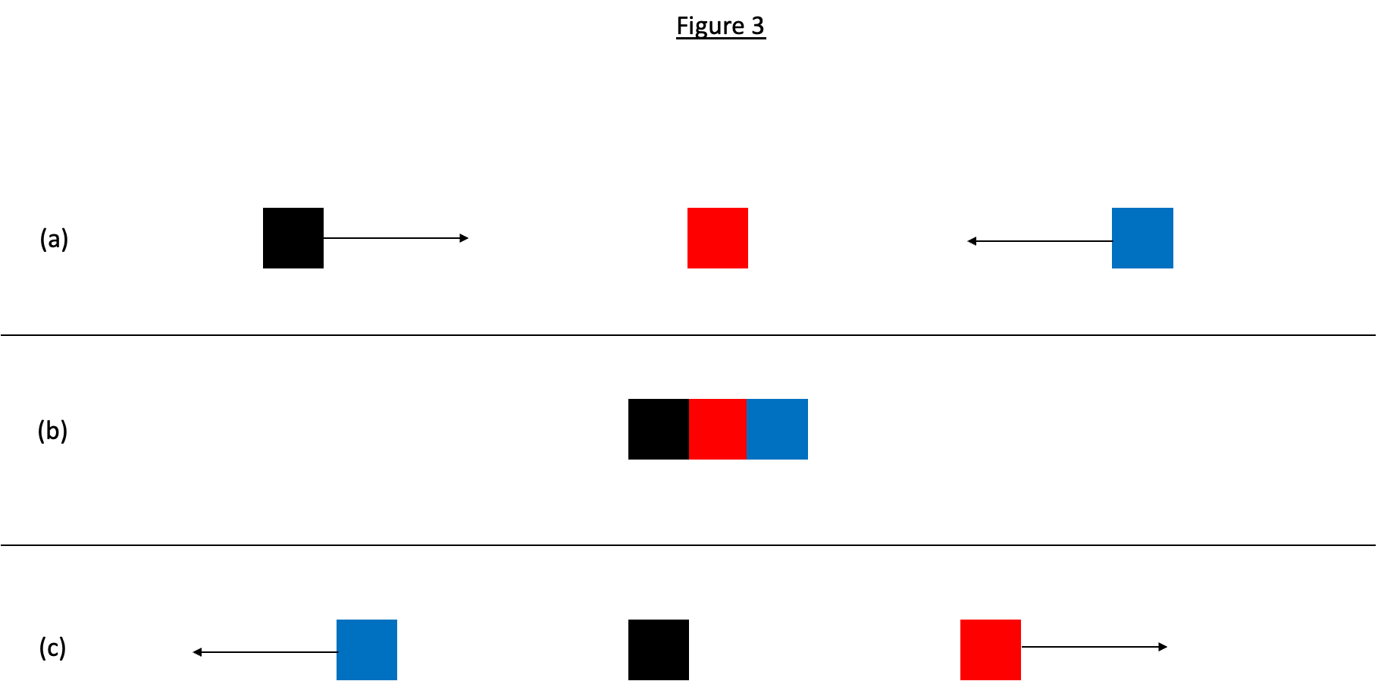

Figure 3. Schematic representation of camouflage stimulus in Experiment 2, based on Michotte (1963, experiment 24). Figure 3(a) shows the first frame of the stimulus with motion directions indicated for the black square and the blue square. Figure 3(b) shows the frame in which the black square and the blue square contact the red square. At that point the black square stops and the red square moves off as in the standard stimulus for the launching effect. The blue square continues to move to the left, passing behind the black and red squares so that the black and red squares were not occluded. Figure 3(c) shows the continuing motion of the red and blue squares.

Experiment 25 was similar to the typical stimulus for launching except that, on contacting the red square, the black square returned to its starting point at the same speed. Michotte reported that the launching effect did not occur.
In experiment 26, the red square was initially located further to the right than usual. Both objects started moving towards each other simultaneously. When they came into contact, the black square stopped and the red square moved to the right as in the typical launching stimulus. Michotte reported a strong launching effect with this stimulus.
These experiments are potentially important to any theoretical account of perceptual impressions of causality because the typical stimulus for launching is there in all of them, but (with the exception of experiment 26) the launching effect does not occur. It is important to understand why the launching effect is eliminated by the presence and movement of other objects, if the replication confirms that result. Experiment 2 is just a replication of Michotte's experiments, but there would seem to be many possible variations that might shed much light on what is perceived.
H2. Camouflage manipulations, with the exception of the stimulus based on experiment 26, will reduce or eliminate the launching effect. This will be qualified by effects of fixation similar to those reported by Michotte (1963).

Method

Stimuli matching the descriptions of those used by Michotte and summarised above were constructed. In experiments 20 and 21 Michotte (1963) commented that the launching effect did occur if the point of contact between the black square and the red square was fixated. For this reason, for all of the stimuli a fixation point, a small black cross, is located adjacent to the point of contact and presence v. absence of the fixation point will be manipulated between-subjects with 25 participants in each condition. Michotte (1963) did not offer any explanation for the effect of fixation. Fixation can be regarded as a manipulation of the focus of attention. Things at the focus of attention tend to be processed more deeply, whereas things outside the focus of attention are processed little or not at all. Therefore, if participants fixate the point of contact, the camouflage components of the stimulus are likely to be neglected in processing, resulting in reduced camouflage effects. The fixation point manipulation tests this reasoning.
It is not easy to prepare instructions for participants in the no-fixation condition that do not carry an implicit demand for them to fixate on the contact point: they are, after all, reporting on their perception of what happens at contact. The instructions for the condition without the fixation point therefore draw on the language used by Michotte, as quoted above: "In this experiment you will see a series of short movies, about one or two seconds in duration, in which two or more moving objects will appear. We are interested in what you see, the visual impression you have of the movies, not any thoughts you might have about what you are seeing. You should look at the movie and the objects in it as a whole. At some point during the movie a black square will contact a red square and the red square will move away. For each movie you will be asked to rate the extent to which you agree or disagree with each of two statements as descriptions of what you saw. The two statements are as follows:
The black square made the red square move by bumping into it.
The red square moved when the black square reached it, but it moved independently and its motion was not caused by the black square."
Instructions for rating agreement or disagreement are as in Experiment 1.
Instructions for the fixation group are similar except that the sentence "You should look at the movie and the objects in it as a whole" was replaced by the following: "You will see a small black cross on the screen. You should look at this cross throughout the duration of the movie and not look anywhere else". These two sentences are underlined to make them salient to the participant. The experimenter will verbally remind participants of this before each movie.
Data for each stimulus will be subject to two analyses. Each will be compared with data from a standard launching stimulus (this will be the 12.4 mm x 12.4 mm size condition from Experiment 3) to assess whether the launching effect is significantly reduced by the camouflage manipulation. And presence v. absence of fixation point for each stimulus will be analysed.

Experiment 3: object size

On pp. 82 - 83 Michotte (1963) discussed variations in object features and reported that variation in colour, size, and shape did not affect the occurrence of the launching effect. In relation to object size he did not number any experiments but reported that "various" experiments were run using the projection method in which the objects were circles ranging from 2 to 28 cm in diameter. He commented, "In the normal conditions for these experiments - in particular when the point of impact is fixated throughout - the Launching Effect is produced consistently. Sometimes, admittedly, there are differences of degree in this impression, and there are also individual variations between subjects" (p. 82). But, he concluded, "no difference in size, within the limits used... is found to be absolutely incompatible with the Launching Effect" (p. 82). This rather inexact account leaves open the possibility that the launching effect might vary depending on object size, so Experiment 3 was designed to test this. The reference to a fixation point also suggests that fixation might make a difference to the perceptual impression so the experiment was designed to test that as well.
This experiment is not an exact replication because Michotte did not report sufficient details of stimuli and method to make that possible. To maximise the likelihood of finding an effect if there is one there to be found, a wide range of object sizes was used.
H3. The launching effect will not be affected by manipulations of object size.

Method

Three sizes are used, squares of 2.48 mm, 12.4 mm, and 93 mm, manipulated independently for each object. As in Experiment 2, presence v. absence of a fixation point is manipulated between subjects with 25 participants in each condition. The design, therefore, is a 2 between (presence v. absence of fixation point) x 3 within (size of black square) x 3 within (size of red square) design.
Instructions to participants in the no-fixation condition are similar to those for Experiment 1 but with two differences. The statement that both rectangles were black was replaced with a statement describing the objects as a black square and a red square and the black and red square terminology is used throughout the instructions. The two statements in Experiment 2, the launching and independent motion statements, are used. Instructions to participants in the fixation condition are similar except that the instructions for fixation from Experiment 2 were added. As in Experiment 2, the experimenter will verbally remind participants of the need to fixate the cross.

Experiment 4: delay

Experiment 4 is a replication of experiment 29, in which delay was introduced between the black square contacting the red square and the red square starting to move. Michotte used 13 delays in increments of 14 ms from 14 ms to 182 ms. This cannot be exactly replicated with the present technology because the time span of a single frame is 16.7 ms, so 13 delays in increments of 16.7 ms are used, from 0 ms to 200.0 ms.
Michotte (1963) reported that, even with a delay of 70 ms, reporting of the launching effect was reduced and, with a delay of 154 ms, it was all but extinguished. He reported that, at intermediate delays, the launching effect occurred but with some time lag: "Object B [the red square] 'sticks' to object A [the black square]; its departure takes place only after some delay" (p. 92). This "delayed launching" impression was the predominant response with delays around 98 ms. After that it declined and perception of independent motion increased. Replication therefore requires inclusion of a statement based on Michotte's description of this delayed launching impression.
Several subsequent studies have manipulated delay. Three studies presenting incremental delays similar to those used by Michotte (1963) found similar rapid declines in reported perceptual causality as delay increased beyond 50 ms to about 200 ms (Deodato & Melcher, 2022; Sanborn et al., 2013; Woods et al., 2012) . Results of other studies suggest that sensitivity to delay might not be as acute as Michotte (1963) reported. Meding, Bruijns, Schölkopf, Berens, & Wichmann (2020) had a delay manipulation with several delays from 0 ms to 400 ms and found a decline in ratings as delay increased, but even with zero delay the mean rating was not much above the mid-point of their scale. Guski and Troje (2003) found a steeper decline from a higher mean at zero delay. Schlottmann et al. (2006) presented a launching stimulus with a delay of 1250 ms and found that 8% of 72 participants gave spontaneous descriptions suggestive of physical causality. However, considering only those who saw the delay stimulus before any of the others, 50% (6/12) gave physical causality responses. Bechlivanidis et al. (2019) used a stimulus with 250 ms delay. If the delay stimulus was the first one presented, mean ratings were above 60 on a 101-point scale. If the delay stimulus was then presented again after a typical launching stimulus with zero delay, mean ratings were significantly lower, and below the scale mid-point. This change in ratings suggests that at least some participants, were, initially, reporting a post-perceptual judgment rather than a perceptual impression: a perceptual impression would not change significantly after only three stimulus presentations. The likelihood of post-perceptual judgment being involved was increased by the wording of the question for the rating task, which was that used by Schlottmann et al. (2006), except for a change in the colour of the second object: "Do you have the impression that red somehow made blue move?" (Bechlivanidis et al., 2019, p. 789). The word "somehow" invites speculation which is perhaps undesirable in a study of perception and "having an impression" can refer to non-perceptual cognitive processes in common parlance - e.g. "I had the impression that he didn't like me". So it is not certain that participants were reporting visual impressions of causality.
Overall, therefore, results for delay manipulations have been variable. It seems likely that wording of the statement or question to be rated is of some importance and merits further investigation. As a first step forward, this study was designed to replicate as closely as possible the stimuli that Michotte used, and with a form of wording in the instructions that emphasised the need to report a visual impression. Comparison of such a form of words with those used in the other studies cited here should be a priority for future research.
H4. The launching effect will weaken as delay increases. At intermediate delays the delayed launching impression will dominate and at longer delays independent motion will be perceived.

Method

There is a single variable, delay at contact, with 13 delays ranging from 0 ms to 200.0 ms in increments of 16.7 ms. Instructions to participants are as in Experiment 3 (non-fixation condition) except that three statements are presented for rating, as follows:
"The black square made the red square move by bumping into it.
The black square made the red square move by bumping into it, but the red square seemed to 'stick' to the black square briefly before moving off.
The red square moved independently and its motion was not caused by the black square."
The second of these was designed to capture Michotte's description of the delayed launching impression.

Experiment 5: pausing of a single object in motion

This was a replication of experiment 30. In that experiment there was just a single object that moved for a distance equal to that of the combined motions of the black and red squares in experiment 29. A pause in the movement occurred halfway through. Pause durations were manipulated in the same way as delay durations in experiment 29. Michotte (1963) reported that short pauses were not perceived; that is, motion was perceived as continuous. At pauses of moderate duration, a percept of discontinuity was reported "which is still compatible with the unity of the whole, i.e. the 'movement in two stages'" (p. 96). That impression peaked with a pause duration of 70 - 87 ms. With longer pause durations there was an impression "of a halt, or definite pause, and together with this the impression of two separate movements" (p. 96). The importance of this experiment is that the effect of the pause was closely correlated with the effect of delay in experiment 29. The launching effect was reported for delay durations that matched pause durations where motion was reported as continuous. At pause durations where motion was perceived as discontinuous (in experiment 30), the percept of delayed launching tended to occur (in experiment 29); and, at durations where motion was perceived as having two components with a halt between them (in experiment 30), the percept of independent motion tended to dominate (in experiment 29). This suggests that the perceptual impression of causality might depend critically on perception of continuity of motion across the two objects, which could have significant theoretical implications. Experiment 5 was therefore designed with a single object in motion and with incremental pause durations matching those used in Experiment 4. Results will be correlated with those of Experiment 4.
H5. The impression of continuous motion will decline as delay increases. At intermediate delays the percept of discontinuous motion will dominate and at longer delays two motions with a halt between them will be perceived.
H6. There will be high positive correlations between launching ratings (Experiment 4) and continuous motion ratings, between delayed launching ratings (Experiment 4) and discontinuous motion ratings, and between independent motion ratings (Experiment 4) and ratings of two motions with a halt between them.

Method

The experiment involves stimuli in which a black square moves across the screen on the same motion path as the combined motions of the black and red squares in the corresponding animations in Experiment 4. Halfway through this motion (equivalent to the point of contact between the objects in the Experiment 4 stimuli) a pause is introduced with 13 durations increasing in increments of 16.7 ms from 0 ms to 200.0 ms. Thus, the pause durations in this experiment matched the delay durations in Experiment 4. Three statements were created for the rating task designed to reflect Michotte's descriptions of the impressions that occurred.
Written instructions to participants read as follows: "In this experiment you will see a series of short movies, about one or two seconds in duration, each involving one moving object, a black square. We are interested in what you see, the visual impression you have of the movies, not any thoughts you might have about what you are seeing. For each movie you will be asked to rate the extent to which you agree or disagree with each of three statements as descriptions of what you saw. The three statements are as follows:
The motion of the black square seems continuous without any break or pause.
The motion of the black square seems like a single movement but in two stages with a brief discontinuity or pause in the middle.
There is an impression of two separate movements with a halt or definite pause in the middle."
Instructions for rating agreement or disagreement were as in the previous experiments.

Experiment 6: gap

This is based on experiment 31 in which the projection method was used. The first moving object (a circle of light 35 mm in diameter) stopped before reaching the initially stationary object (a similar circle of light). Michotte reported that the launching effect could occur despite the presence of a gap between them. The reporting of results is anecdotal but it is clear that speed was a critical factor, and that the launching effect could occur despite the presence of a substantial gap if the speed was sufficiently great: Michotte reported that even a gap of 500 mm "did not necessarily make the causal impression disappear" (p. 100). Yela (1952) ran a study with 250 naive participants and found that the numbers reporting the launching effect fell from 100% with zero gap to 28% with a 90 mm gap. In a further study Yela (1952) included a delay manipulation and found that the effect of delay on the launching effect was similar for all gap sizes, up to a maximum of 50 mm. Yela concluded that "The impression of pushing [launching] is bound to continuity in time, but indifferent to continuity or discontinuity in space" (p. 146). Some studies since then have reported very low causal ratings with even quite small gaps (Fugelsang et al., 2005; Sanborn et al., 2013; Schlottmann & Anderson, 1993; Schlottmann et al., 2006). Perhaps the most extreme result was that reported by Sanborn et al. (2013): with speeds ranging from 60 mm/s to 150 mm/s, ratings in their causal judgment task were low with gaps as small as 2 mm.² There is a striking contrast between these recent results and those reported by Michotte (1963) and Yela (1952).
This brief review indicates that there is some uncertainty about the effect of gaps on the causal impression, and particularly about the role of object speed. Some studies have used gap stimuli as non-causal controls for launching effect stimuli (Cohen & Amsel, 1998; Falmier & Young, 2008; Fugelsang et al., 2005; Leslie, 1982; Roser et al., 2005); the results reported by Michotte (1963) and Yela (1952) suggest that this might be inadvisable unless the gap is large.
Exact replication of experiment 31 is not possible, partly because of technological differences and partly because of the inexactness in the reporting of manipulations and results (Michotte, 1963). Also, the largest gaps used by Michotte (1963) are greater than the size of the screen to be used for the present experiment. It was decided to sample a range of gaps up to the maximum used by Yela (1952), 90 mm. Given the likely importance of object speed, as reported by Michotte (1963), speed (of both objects) was also manipulated.
H7. The launching effect will decline as gap size increases.
H8. For all gap sizes, the launching effect will increase as object speed increases.

Method

There are two independent variables. Gap size is manipulated with seven values, 3.1 mm, 6.2 mm, 12.4 mm, 24.8 mm, 46.5 mm, 68.2 mm, and 89.9 mm. Three speeds are used, 74.3 mm/s, 124.0 mm/s, and 186.0 mm/s, with both objects having the same speed in any given stimulus. This makes a 7 within (gap size) x 3 within (speed) ANOVA design.
The instructions needed to be modified to take account of the fact that the black square does not come into contact with the red square. The first paragraph of the instructions therefore read as follows: "In this experiment you will see a series of short movies, about one or two seconds in duration, each involving two objects, a black square and a red square. Each movie will begin with the black square moving towards the red square. We are interested in what you see when the black square stops moving and the red square starts moving, the visual impression you have of the movies, not any thoughts you might have about what you are seeing. It may still be possible to have a visual impression that the black square made the red square move, even when they do not come into contact. For each movie you will be asked to rate the extent to which you agree or disagree with each of two statements as descriptions of your visual impression of what happened. You should rate your agreement or disagreement with each of the statements based just on your visual impression, not on what you think is possible". The two statements were as follows:
"The black square made the red square move.
The red square moved independently and its motion was not caused by the black square."

Experiment 7: chasing

This is based on experiment 17. In that experiment the two objects started moving at the same time and in the same direction. The black square moved faster than the red square and caught up with it. When the black square contacted the red square the former stopped and the latter continued to move. The stimulus resembles the typical stimulus for launching except for the motion of the red square prior to contact. Michotte (1963) reported that the launching effect occurred with these stimuli but not so much if the black square's speed was only a little faster than that of the red square. Michotte also claimed that the launching effect occurred if the speed of the red square did not change after contact, and even if the red square slowed down after contact. Speeds and distances moved cannot be exactly the same as those used by Michotte (1963), but a range of speed ratios was devised that overlaps with the range used by Michotte. To achieve this, the speed of the red square before contact was held constant at the 37.2 mm/s and the speed of the black square was manipulated.
Michotte's (1963) experiment 49 was an entraining version of experiment 17. He reported that the entraining effect occurred if the black square was fixated but not if the red square was fixated. Experiment 9 below is based on experiment 49 and manipulates fixation. To make this experiment and Experiment 9 as similar as possible, therefore, fixation was also manipulated in this experiment, and it is predicted that the effect of fixation reported by Michotte will be found in this experiment as well.
H9. There will be a main effect of fixation with higher means when the black square is fixated than when the red square is fixated.

Method

In this experiment, the red square moves before contact at 37.2 mm/s and the speeds of the black square are set to bring about speed ratios of 2:1, 3:1, 4:1, and 6:1. After contact the red square moves at either 74.4 mm/s, 37.2 mm/s (the same as the speed before contact), or 18.6 mm/s.
In addition, a fixation manipulation is included as a between-subjects variable with 25 participants in each of two conditions. Participants will be instructed to fixate the black square in one condition and the red square in the other. This was so that the design of this experiment would be similar to that of Experiment 9, described below, where a fixation condition is required because Michotte (1963) commented that what was perceived depended on which object was fixated. Experiment 9 is the same as Experiment 7 but with entraining rather than launching stimuli. Michotte did not mention fixation in connection with experiment 17, but it could be enlightening to see whether launching and entraining are similarly affected by differences in fixation, so in that respect this experiment is an extended replication. This results in a 2 between (fixation, black square v. red square) x 4 within (speed ratio) x 3 within (red square post-contact speed) ANOVA design.
Speeds are at the slow end of the range used by Michotte but the limited size of the computer screen imposes certain constraints on speed: if both objects are in motion at speeds that are not very different, for one to catch up with the other requires a lot of space, especially if the speeds are fast.
Wording of statements for the rating task is problematic in this experiment. It would not be right to have a statement saying that the black square made the red square move because participants might disagree with this on the grounds that the red square was already in motion before contact occurred. Therefore statements referring explicitly to the motion of the red square after contact were constructed. In the black square fixation condition there is a further sentence reading "Please keep your gaze on the black square all through the movie". In the red square fixation the same wording is used except that "red" was substituted for "black". The experimenter will verbally remind participants of this before each movie.
Written instructions are similar to those for the non-fixation condition of Experiment 3, with two exceptions. The instructions for fixation described above were inserted, and two statements are presented for rating, as follows:
"The motion of the red square after contact was brought about by the black square bumping into it".
"The motion of the red square after contact was independent of that of the black square and not caused by the black square".

Experiment 8: vertical displacement of motion path

In the typical stimulus for the launching effect, as depicted in Figure 1, the black square contacts the red square full face on. In experiment 33, Michotte (1963) used the projection method and the objects were circles. The first moving object's path was vertically displaced. In Michotte's words: "Object A sets off and takes up position immediately above or below B and in contact with it. At this moment B starts to move in its turn, and follows a route parallel to the prolongation of the route followed by A" (1963, p. 101). Michotte reported that the launching effect did not occur with this stimulus. This kind of displacement has not been investigated since Michotte's research. Part of the reason for replicating the study is that it is a different type of gap stimulus. Michotte (1963) and Yela (1952) found that the launching effect can occur even with substantial gaps in the horizontal plane. This experiment will show whether the same is the case for gaps in a different plane of motion. This could have relevance to theoretical accounts of the launching effect. This is an extended replication, with five different stopping positions for the black disc, as described in the method section and depicted in Figure 4.
H10. The launching effect will be weak or absent for all stimuli.

Method

Michotte used discs in experiment 33, so in this experiment black and red discs with 9.3 mm radius are used instead of the black and red squares. In one movie the black disc stops at a point where it is vertically aligned and in contact with the red disc. In four other movies the black disc follows the same motion path but stops two diameters before the red square, one diameter before, one diameter after, and two diameters after. This is therefore a one-way ANOVA design with five values. Figure 4(a) shows the starting locations of the objects and the direction of the black disc's motion. Figure 4(b) shows the five locations at which the black disc stops moving. When the black disc stops moving, the red disc moves off horizontally as the red square does in Figure 1.
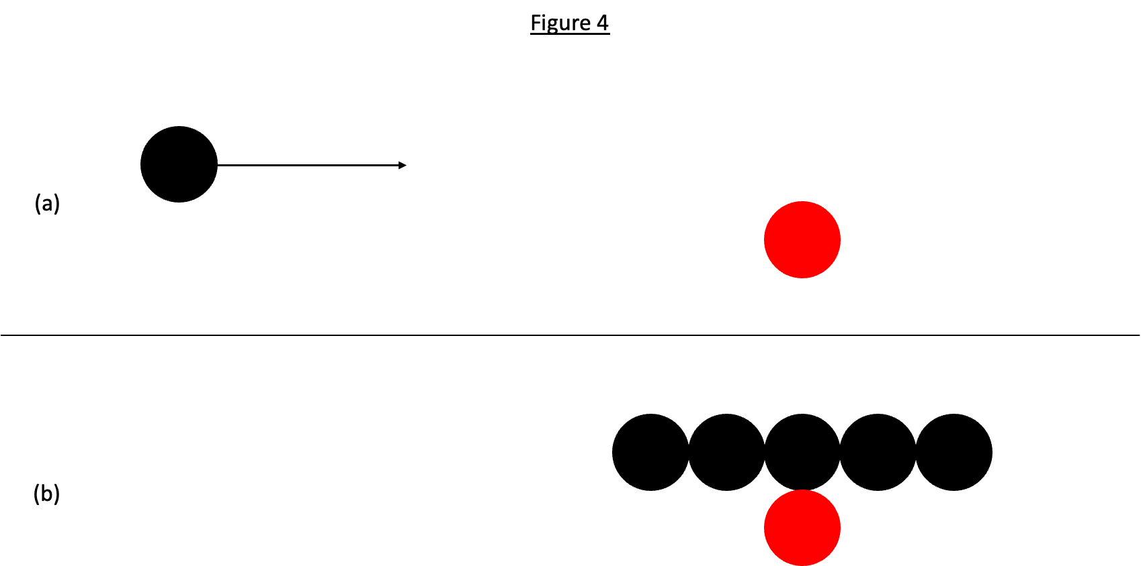
Figure 4. Schematic representation of stimuli used in Experiment 8. Figure 4(a) shows the first frame of the stimulus and the motion direction of the black square. Figure 4(b) shows the five different locations at which the black square stops. In each case the red square starts to move horizontally to the right as soon as the black square stops.

Wording of the statements for the participants is problematic here as well. It cannot be said that the black disc makes the red disc move by bumping into it because, in some movies, the black disc does not contact the red disc. Also, Michotte (1963) reported that an impression called "triggering" occurred with the displacement stimulus. This refers to an impression that one object "touches off' or initiates the motion of the other object, which is nonetheless perceived as moving independently. Three statements were therefore constructed with these considerations in mind. H10 states that the launching effect will be weak or absent for all stimuli. Therefore, instead of using rating scales, participants will be asked to choose the one of three verbal descriptions that best fits with what they perceive. The prediction would be that, for each stimulus, the launching description will be the least chosen.
"In this experiment you will see a series of short movies, about one or two seconds in duration, each involving two objects, a black disc and a red disc. Each movie will begin with the black disc moving towards the red disc. We are interested in what you see when the black disc stops moving and the red disc starts moving, the visual impression you have of the movies, not any thoughts you might have about what you are seeing. For each movie you will be asked to choose the one of the statements listed below that best fits with your visual impression of what happened. It may still be possible to have a visual impression that the black disc made the red disc move, even when they do not come into contact. You should make your choice based just on your visual impression, not on what you think is possible. The three statements are as follows:
The black disc brought about the motion of the red disc.
The black disc triggered or initiated motion in the red disc, which then moved independently.
The red disc moved off when the black disc stopped moving, but it moved independently and its motion was not caused by the black disc."

Experiment 9: entraining with chasing

In experiments 48, 49, and 55, both objects were in motion from the start. The black square moved faster than the red square and caught up with it. When contact was made, the two objects moved together as in the typical stimulus for entraining. In experiment 48 they moved at the red square's original speed. That is, the speed of the red square did not change at contact. Michotte (1963) reported that the entraining effect occurred if the black square was fixated but not if the red square was fixated. In experiment 49, after contact they moved at the black square's original speed. Michotte reported that, when there was a great difference in speed between the two objects before contact, the entraining effect occurred. When the difference in speed was small, the movements of the objects could be perceived as independent of each other. Nothing was reported about fixation. In experiment 55, after contact the two objects moved more slowly than the red square had been moving before contact. Michotte reported that the results were similar to those of experiment 49, in that the entraining effect occurred but its occurrence depended on which object was fixated. In summary, stimuli of this kind give rise to the entraining effect but not if the red square is fixated. This experiment was designed to be similar to Experiment 7 but with entraining stimuli instead of launching stimuli.
H11. There will be a main effect of fixation with higher means when the black square is fixated than when the red square is fixated.

Method

The manipulation of motion in experiments 48 and 49 was similar to that in experiment 17, which was the model for Experiment 7, except that the black square continued to move and remained in contact with the red square after contact. For that reason, Experiment 9 was designed as an entraining version of Experiment 7. The design is therefore a 2 between (fixation, black square v. red square) x 4 within (speed ratio, 2:1 v. 3:1 v. 4:1 v. 6:1) x 3 within (speed of both objects after contact, 74.4 mm/s v. 37.2 mm/s v. 18.6 mm/s). Stimuli are similar to those in Experiment 7 except that the black square continues to move after contact, at the same speed as the red square, so that they remain in contact.
This is an entraining effect experiment so the wording of the statement describing a causal relation reflects Michotte's descriptors for the entraining effect, which refer to the black square carrying or pushing the red square or taking the red square along with it (Michotte, 1963, p. 21). Written instructions are similar to those for the respective black square and red square fixation conditions of Experiment 7 except that two statements are presented for rating, as follows:
"After contact the black square pushed the red square or carried the red square along with it."
"The motion of the red square after contact was not caused by the black square".

Experiment 10: entraining with relative speed manipulation

In experiment 54 the relative speed before and after contact was manipulated. Michotte (1963) described two variations, one in which the speed was four times faster after contact than before, and another in which the opposite was the case. Michotte reported that the entraining effect occurred with both variations: "this character is largely independent of a change in speed at the moment when the objects come into contact" (p. 159). This is different from what happens with the launching stimulus, where relative speed made a considerable difference to the occurrence of the causal impression (Michotte, 1963; Natsoulas, 1961), but there has been no replication of this experiment.
H12. The entraining effect will occur for all stimuli.

Method

The stimuli are variations on the typical stimulus for entraining; i.e., the red square is stationary until the black square contacts it. This is an extended replication of Michotte's experiment 54 in that three speeds are used both for motion of the black square before contact and for motion of the two conjoined objects after contact. The three speeds chosen are 62 mm/s, 124 mm/s, and 186 mm/s. These are manipulated orthogonally for the black square before contact and the two objects after contact, resulting in a 3 x 3 ANOVA design which replicates the speed ratios used by Michotte.
Written instructions are as follows:
"In this experiment you will see a series of short movies, about one or two seconds in duration, each involving two objects, a black square and a red square. Each movie will begin with the black square moving towards the red square. We are interested in what you see when the black square reaches the red square, the visual impression you have of the movies, not any thoughts you might have about what you are seeing. For each movie you will be asked to choose the one of the statements listed below that best fits with your visual impression of what happened. The three statements are as follows:
After contact the black square pushed the red square or carried the red square along with it.
After contact the red square pulled or dragged the black square.
The motion of the red square after contact was not caused by the black square and the red square did not pull or drag the black square."

Experiment 11

Experiments 11 and 12 together constitute an extended replication of experiment 52. Experiment 50 should be described first. In that experiment, a disc 50 mm in diameter was visible in front of a 100 x 150 mm white screen. The screen and the disc started to move horizontally at the same speed and at the same time. Michotte (1963) reported that the stimulus was perceived as a single object with the disc "constituting 'part of' the screen" (p. 152). In experiment 52 the screen moved 10 - 20 mm and then the disc began to move, again with the same velocity as the screen. With this stimulus Michotte reported an entraining effect, with the screen pushing or carrying the disc. Michotte concluded that temporal priority of motion of the screen was essential in determining the occurrence of the entraining effect.
Michotte (1963) did not report any variations on those experiments, except for one in which the disc oscillated a little while moving horizontally (experiment 51). Preliminary investigations by the present author suggested that the spatial relations between the two objects when both are in motion might make substantial and qualitative differences to the perceptual impression: the large object might be perceived as launching, pushing (entraining), or pulling the small one depending on their spatial relations. Similarity in speed of the two objects also appeared to be important to the occurrence of these impressions. Thus, the main purpose of this experiment and Experiment 12 was to replicate the stimulus used by Michotte (with adjustments necessitated by the differences in technology) and to extend the range of stimuli used, to test the possibility that qualitatively different impressions would occur depending on the spatial relations between the objects when in motion.
These two experiments are important for two reasons. One is that there has been no subsequent investigation of this kind of stimulus and Michotte's experiments 50 and 52 have, as far as this author has been able to discover, never been mentioned since their publication. Michotte's account implies that it is not necessary, for entraining to occur, that the black square should approach and contact the red square: in experiment 52 the disc is visibly superimposed on the screen, the entrainer, all the time. So replicating that result alone would add to our understanding of the entraining effect. The other is that the appearance of qualitative differences in perceptual impression depending just on the spatial relations between the objects may be important to a full understanding of perceptual impressions of causality. The research literature since Michotte (1963) has been heavily dominated by the launching effect and qualitatively different causal impressions have been comparatively neglected (Hubbard, 2013a, 2013b). There is a possibility that all of them should be considered together as a single explanandum. These experiments may, therefore, shed more light on that.
H13. When both objects have the same speed, there will be qualitative differences in reported impressions with launching favoured for some stimuli, entraining for others, and pulling for others. When the objects have different speeds, differences in reported impressions will be weak or absent.

Method

The large object in the stimuli for this research is a 186 mm black square and the small object is a 12.4 mm red square. Assuming horizontal motion of objects from left to right, and assuming that the small object starts moving at some time after the large object has started, several combinations of initial spatial relation of the objects and spatial relation when the small object starts moving are possible and will be tested in this experiment. These are listed in Table 5. In addition, the speed of the small object relative to that of the large one is manipulated, being either slower, the same as, or faster. The large object moves at 124 mm/s and the small one moves at 62 mm/s, 124 mm/s, or 186 mm/s. Orthogonal manipulation of this variable with the seven spatial arrangements described in Table 5 yielded a 3 x 7 ANOVA design with a total of 21 stimuli.
___________________________________________________________________________
Table 5
Spatial relations between the large object and the small object in stimuli to be used in Experiment 11
_____________________________________________________________________
1. The small object is initially located to the right of the large object and starts to move when the large object contacts it. (This is the kinematic pattern for the typical launching stimulus.)
2. The small object is initially located to the right of the large object and starts to move when superimposed on the large object and not in contact with any edge of it.
3. The small object is initially located to the right of the large object and starts to move when outside but in contact with the rear of the large object.
4. The small object is initially located to the right of the large object and starts to move when outside and beyond the rear of the large object.
5. The small object is initially located superimposed on the large object and starts to move after a delay but when still superimposed on the large object.
6. The small object is initially located superimposed on the large object and starts to move when outside but in contact with the rear of the large object.
7. The small object is initially located superimposed on the large object and starts to move when outside and beyond the rear of the large object.
___________________________________________________________________________

Figure 5 schematically depicts the seven stimuli where both objects move at the same speed. In that figure, stimuli are numbered in accordance with their numbering in Table 5, so they form a visual complement to the verbal descriptions in Table 5. In Figure 5 the relative sizes of the objects are not proportional to what is in the actual stimuli (because of the small size of the red square), but the spatial relations depicted are accurate. In the actual stimuli, when the red square is within the boundaries of the black square, it is superimposed on the black square so that it remains visible at all times. Figure 5(a) shows the first frame of each stimulus. Figure 5(b) shows the first frame in which the red square starts to move. When both objects then move at the same speed, that spatial relation is maintained for the remainder of the stimulus. The arrows in Figure 5(b) represent motion of both objects, not just the large square.

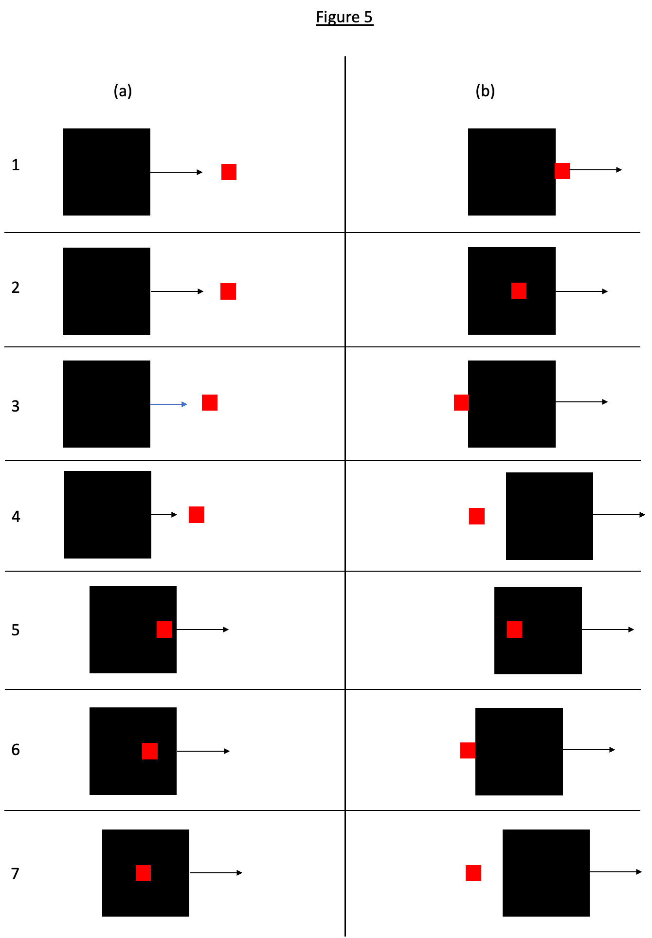
Figure 5. Schematic representation of seven stimuli used in Experiment 11. Stimuli are numbered from 1 to 7 and these correspond to stimulus numbers in Table 5 where verbal descriptions of the stimuli are given. Figure 5(a) shows the first frame of each stimulus with the motion direction of the black square indicated. Figure 5(b) shows the spatial relation between the two squares when both are in motion. When both squares move with the same velocity, the spatial relations depicted in Figure 5(b) persist throughout the duration of motion of both objects.

An example stimulus is schematically depicted in Figure 6. This is for the stimulus in which the small red square is initially located to the right of the large black square and starts to move when outside but in contact with the rear of the large square, with both objects moving at the same speed (no. 3 in Table 5 and Figure 5).
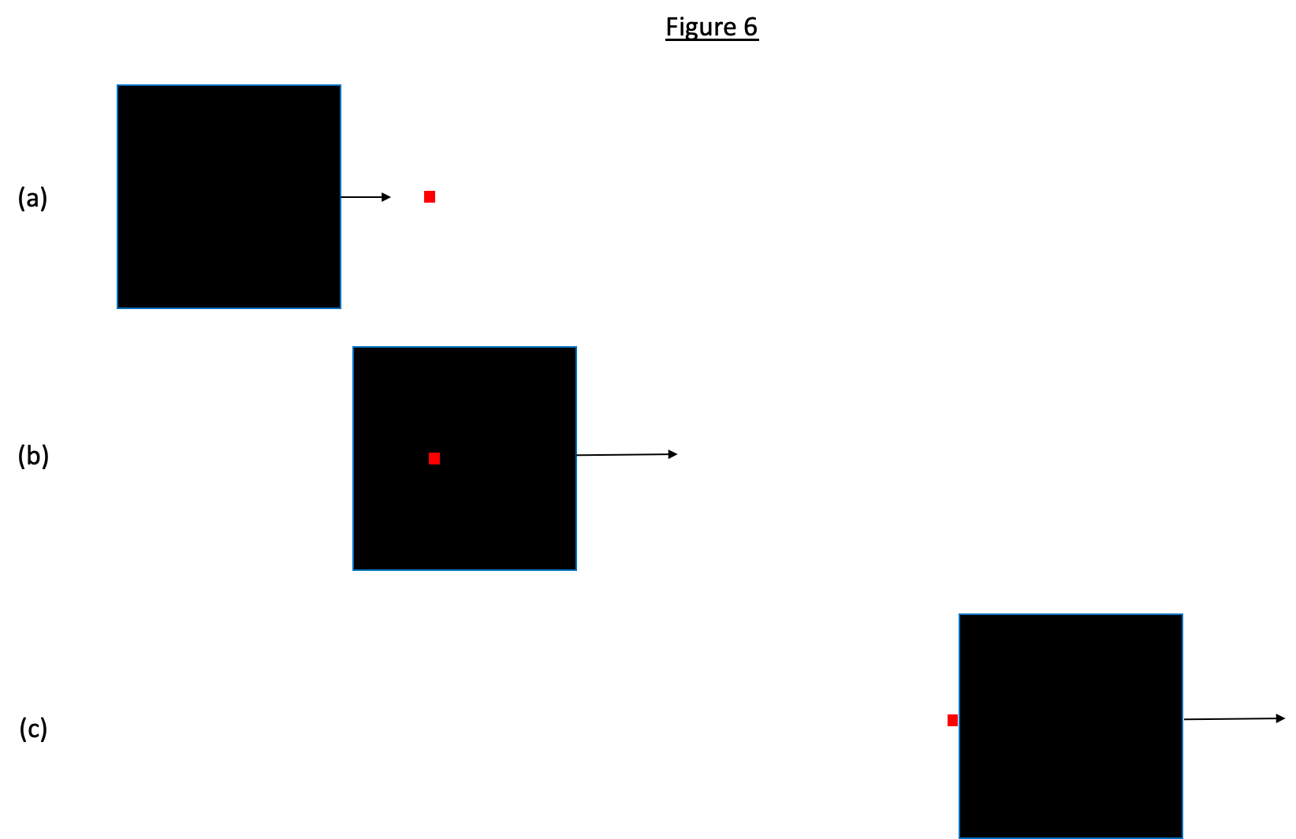
Figure 6. Schematic representation of a stimulus used in Experiment 11. This is number 3 as shown in Figure 5 and Table 5. In this figure, unlike in Figure 5, the objects are shown with the correct proportional difference in size. Figure 6(a) shows the first frame with the motion direction of the black square indicated. Figure 6(b) shows an intermediate point in the motion of the black square; the red square, still motionless at this point, is superimposed on the black square so that it remains visible throughout. Figure 6(c) shows the spatial relation between the objects when both are in motion.

The stimulus depicted in Figure 6 has kinematic features that resemble those of experiment 56, one of three experiments on what Michotte called the traction effect. The stimulus begins like a launching stimulus, and with objects of identical sizes, but the black square passes the red square; as soon as it has done so, the red square starts moving and the two objects continue in contact at the same speed as in the stimulus for the entraining effect. Michotte (1963) reported that "we see object A pass over object B, hook it on behind and tow it" (p. 160). So it is possible that an impression of pulling or towing may occur with this stimulus. Visual impressions of pulling have been investigated further since Michotte's studies (White, 2010; White & Milne, 1997), and for that reason the three experiments on the traction effect were not selected for replication here. However, the stimulus emerges naturally from the manipulation of spatial relations between the objects in this experiment and the next one, so it is included here.
Written instructions are similar to those for Experiment 10 except that four statements are presented for rating, as follows:
"The black square made the red square move by bumping into it." [This is the descriptor for the launching effect, similar to that used in experiments on launching above.]
"The black square pushed the red square or carried the red square along with it." [This is the descriptor for the entraining effect, similar to that used in experiments on entraining above.]
"The black square seemed to pull the red square, as if they were connected in some way." [This is a descriptor for the pulling impression, adapted from wording used in a study of the pulling impression by White and Milne (1997, p. 582).]
"The motion of the red square was independent of that of the black square and was not caused by it in any way." [This is adapted from the independent motion descriptor used in other experiments above.]

Experiment 12

This experiment was designed to be as similar as possible to Experiment 11 but with inversion of object size. That is, the object that moves first would now be the small object. Because of the disparity in sizes, the stimuli are not quite the inverse of those used in Experiment 11. The manipulations of spatial relations are described in Table 6. Schematic depictions of the stimuli are presented in Figure 7.
H14. When both objects have the same speed, there will be qualitative differences in reported impressions with launching favoured for some stimuli, entraining for others, and pulling for others. When the objects have different speeds, differences will be weak or absent.

___________________________________________________________________________
Table 6
Spatial relations between the large object and the small object in stimuli to be used in Experiment 12
_____________________________________________________________________
1. The large object is initially located to the right of the small object and starts to move when the small object contacts it. (This is the kinematic pattern for the typical launching stimulus.)
2. The large object is initially located to the right of the small object and starts to move when the small object is superimposed on it and not in contact with any edge of it.
3. The large object is initially located to the right of the small object and starts to move when the small object is outside but in contact with the front of the large object.
4. The large object is initially located to the right of the small object and starts to move when the small object is outside and beyond the front of it.
5. The large object is initially located with the small object superimposed on it and starts to move when the small object is still superimposed on it.
6. The large object is initially located with the small object superimposed on it and starts to move when the small object is outside but in contact with the front of the large object.
7. The large object is initially located with the small object superimposed on it and starts to move when the small object is outside and beyond the front of it.
___________________________________________________________________________
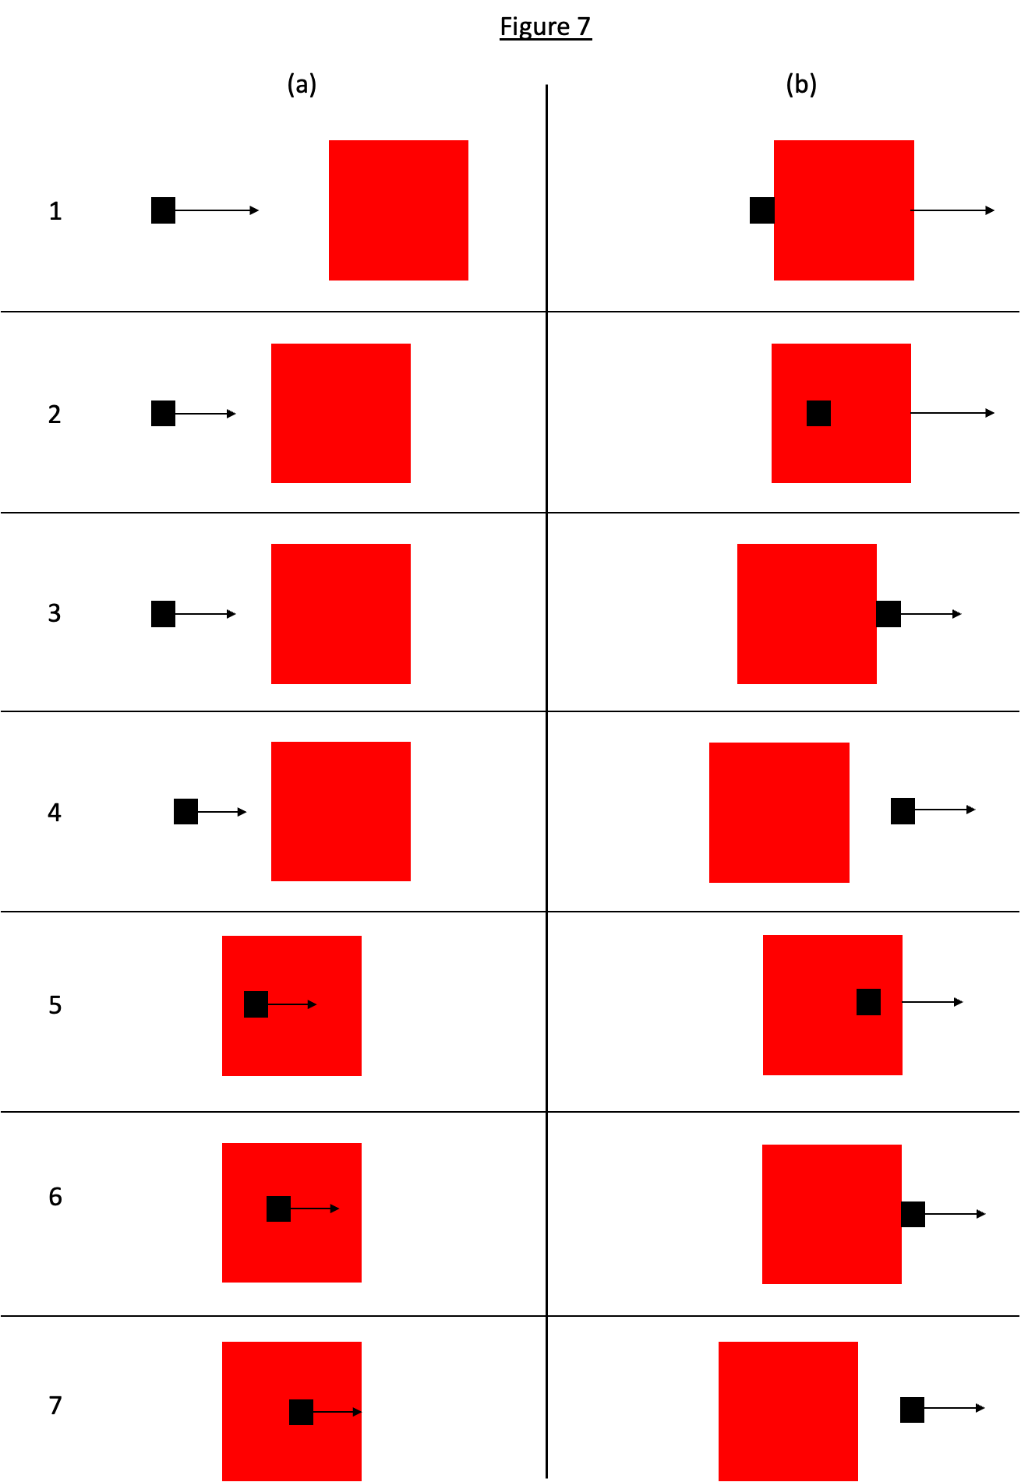
Figure 7. Schematic representation of seven stimuli used in Experiment 12. Stimuli are numbered from 1 to 7 and these correspond to stimulus numbers in Table 6 where verbal descriptions of the stimuli are given. Figure 7(a) shows the first frame of each stimulus with the motion direction of the black square indicated. Figure 7(b) shows the spatial relation between the two squares when both are in motion. When both squares move with the same velocity, the spatial relations depicted in Figure 7(b) persist throughout the duration of motion of both objects.

Method

Speed of the large object relative to that of the small one is manipulated, being either faster, the same as, or slower, with the same speeds as in Experiment 11. This again results in a 3 x 7 ANOVA design with a total of 21 stimuli. As in Experiment 11, when the small object is within the boundaries of the large one it is superimposed on the large one so as to be visible throughout. Written instructions, including the statements to be rated, are the same as in Experiment 11.

Experiment 13: delay with entraining stimuli

Effects of delay and gap manipulations have featured prominently in the history of research on the launching effect but not in studies of the entraining effect (Hubbard, 2013a). Bélanger and Desrochers (2001) presented entraining stimuli with either a gap of 40 mm between the objects or a delay of 1000 ms between the first object contacting the second one and the two objects starting to move together. They reported that a sample of adults perceived the typical entraining stimulus as more causal than the gap and delay stimuli but did not give any statistical information. A sample of infants aged about 6 months did not show significant discrimination between the entraining stimulus and the delay and gap stimuli. That seems to have been the only study to use a delay manipulation with entraining stimuli. Experiment 13 was therefore designed to fill this evident gap in the literature by replicating the delay manipulation used in Experiment 4 but with entraining instead of launching stimuli. It is predicted that the effect of delay found with launching stimuli will generalise to entraining stimuli.
H15. The entraining effect will decline as delay increases; at long delays independent motion will be perceived.

Method

The method is as for Experiment 4 except that entraining stimuli are used instead of launching stimuli, and the following statements are used for the rating task:
"The black square pushed the red square or carried the red square along with it."
"The red square seemed to pull the black square, as if they were connected in some way."
"The motion of the red square was independent of that of the black square and was not caused by it in any way."
Since the two objects remain in contact in entraining stimuli, the statement referring to the red square briefly sticking to the black square before moving off was not appropriate for this experiment.

Experiment 14: gap with entraining stimuli

There has been no published study of effects of gap on the entraining effect, so this study was designed to fill the gap in the literature by replicating the gap manipulation in Experiment 6 but with entraining instead of launching stimuli. It is predicted that the effects found with launching stimuli will generalise to entraining stimuli.
H16. Based on the effect of gap size on the launching effect, the entraining effect will decline as gap size increases.
H17. The entraining effect will increase in strength as speed increases.

Method

The method is as for Experiment 6 in all particulars except that entraining stimuli were used instead of launching stimuli.

Interpretation of results

Since this is a replication study, a key theme in the interpretation of results will be assessing the fit with the findings reported by Michotte (1963) and discussing possible reasons for any failures to replicate. It is anticipated that methodological differences between Michotte's research and the present studies may be a relevant factor, especially the use of computer technology instead of the disc and projection methods. Michotte's use of a small sample of knowledgeable observers in many experiments might also be a relevant consideration. That in turn touches on the issue of whether the results show perceptual impressions, or whether and to what extent post-perceptual processing, expectancies, and other non-perceptual factors might influence reported impressions. Issues raised in the introductions to particular experiments will be discussed in light of the results. This applies particularly to the delay and gap manipulations in Experiments 4 and 6, where the results of the replication studies may help to interpret and understand the variation in results of other studies using similar manipulations. Parametric manipulations of variables may help to define boundary conditions for the occurrence of the launching and entraining effects. Experiments 1 (object width manipulation) and 8 (vertical displacement of motion path) for launching, and experiments 13 (delay) and 14 (gap) for entraining, are examples that could be revealing in that respect. The extended replications in Experiments 11 and 12 may show qualitative changes in perceptual impressions, encompassing launching, entraining, and pulling, and suggest that a full theoretical account of perceptual impressions of causality would need to incorporate those other kinds of impressions, and the factors that govern the shift from one kind to another, into an integrated explanation. Further discussion of what this might involve will depend on the results.
Several theoretical accounts of visual impressions of causality have been published (Hubbard, 2013b; Michotte, 1963; Scholl & Tremoulet, 2000; White, 2017). In a replication study, discriminative testing of hypotheses is not a primary aim. However, some hypotheses make predictions that could be confirmed or disconfirmed in the present studies. These will be briefly discussed here, with anticipation of more thorough treatment in light of the results.
Michotte (1963) argued that, in any case where a visual causal impression occurs, the motion of the target (the red square) is perceived as a continuation of the movement of the first moving object, which is perceptually independent of the spatial displacement of the target. Simplifying somewhat, the key to this is kinematic integration, which occurs when the stimulus has Gestalt properties. With the launching effect, kinematic integration depends on the Gestalt principle of good continuation (Wagemans, Elder, Kubovy, Palmer, Peterson, Singh, & von der Heydt, 2012). This refers to the perpetuation of the motion properties of the first moving object in the target, which means that motion continues without a break in space or time, and without change in its properties. Thus, the launching effect is predicted to occur when the first mover contacts the target and, without delay, the target starts moving with the same speed and direction as the first mover. The launching effect should be weakened or absent if there is substantial delay at contact, gap between the objects, and vertical displacement of motion path, and the present experiments will provide tests of all of those. For entraining, kinematic integration is explained by the Gestalt principle of common fate. This just means that the impression depends on the two objects sharing the same motion properties after coming into contact. This will be tested by Experiments 11 and 12 where entraining would not be predicted to occur when the objects move at different speeds after contact. The delay and gap manipulations (Experiments 13 and 14) should not significantly affect entraining, however, because the objects share the same velocity when the red square starts moving in both cases.
Other authors have argued that there is an innate perceptual module for the launching effect (Leslie & Keeble, 1987; Scholl & Tremoulet, 2000). The module is brought into operation by definable stimulus conditions and the causal impression occurs when it operates. For the launching effect, those conditions are the typical features of the stimulus for launching, as depicted in Figure 1. The module hypothesis predicts that the launching effect should occur whenever those features are present. For this, Experiment 2 may provide critical evidence because the typical features of the stimulus for launching are present in all the stimuli and the module hypothesis therefore predicts that the launching effect should occur for all of them. Michotte (1963) claimed that, in most cases, the launching effect did not occur, though this depended on fixation. Experiment 2 may therefore provide results of importance for evaluating the module hypothesis.
In two more hypotheses, perceptual impressions of causality are derived from experiences of interactions between the body and other objects. In one version, actions on objects yield information about forces and causality, mainly through proprioception (Proske & Gandevia, 2012), and these experiences are stored in long term memory, where they function as a kind of template for interpreting visual information about interactions between objects (White, 2009, 2012a). The causal impression is the proprioceptive impression of acting on an object, activated and applied in interpretation of what is visually perceived. In another version, forces applied to the surface of the body are detected through proprioception; that is, instead of actions on objects, objects acting on the actor are the source of visual impressions of causality (Wolff & Shepard, 2013). Both hypotheses depend for their testability on empirical propositions about the kinds of experience that support acquisition of causal impressions. They do not define precisely what those experiences are, and so it is not easy to generate and test predictions from either account. It has been argued that the entraining effect is the kind of perceptual impression that could only result from experiences of actions on objects because the kinematics of a typical stimulus for entraining are not possible for inanimate objects (Runeson, 1983; White, 2017). The entraining effect, therefore, might be the best available evidence in favour of the actions on objects hypothesis. It is not likely, however, that the present replication study could generate evidence that would be decisive for either of these experience-based hypotheses.

Footnotes

1. Another possible interpretation is that reports result from application of a decision criterion for detection, and the decision criterion might differ between stimuli of different kinds. Moors et al. (2007) did not discuss this possibility, so further research would be necessary to test this.
2. This is probably attributable to the instructions. Participants were told to decide whether the movie "came from a real collision of the blocks or a random combination of the variables. A real collision looks like the blocks actually collide" (p. 421). It is likely, therefore, that participants just judged whether the blocks came into contact or not and judged that a real collision did not occur if they did not perceive contact. This is probably not a study of the launching effect at all.

References

Beasley, N. (1968). The extent of individual differences in the perception of causality. Canadian Journal of Psychology, 22, 399-407.
https://doi.org/10.1037/h0082779
Bechlivanidis, C., Schlottmann, A., & Lagnado, D. A. (2019). Causation without realism. Journal of Experimental Psychology: General, 148, 785-804.
https://doi.org/10.1037/xge0000602
Bélanger, N. D., & Desrochers, S. (2001). Can 6-month-old infants process causality in different types of causal events? British Journal of Developmental Psychology, 19, 11-21.
https://doi.org/10.1348/026151001165930
Blakemore, S.-J., Fonlupt, P., Pachot-Coulard, M., Darmon, C., Boyer, P., Meltzoff, A. N., Segebarth, C., & Decety, J. (2001). How the brain perceives causality: an event-related fMRI study. Neuroreport, 12, 3741-3746.
https://doi.org/10.1097/00001756-200112040-00027
Blos, J., Chatterjee, A., Kircher, T., & Straube, B. (2012). Neural correlates of causality judgment in physical and social context - the reversed effects of space and time. Neuroimage, 63, 882-893.
https://doi.org/10.1016/j.neuroimage.2012.07.028
Boyle, D. G. (1960). A contribution to the study of phenomenal causation. Quarterly Journal of Experimental Psychology, 12, 171-179.
https://doi.org/10.1080/17470216008416721
Brown, H. V., & Miles, T. R. (1969). Prior stimulation and the perception of causality. Quarterly Journal of Experimental Psychology, 21, 134-136.
https://doi.org/10.1080/14640746908400205
Buehner, M. J., & Humphreys, G. R. (2010). Causal contraction: spatial binding in the perception of collision events. Psychological Science, 21, 44-48.
https://doi.org/10.1177/0956797609354735
Chen, Y., & Yan, B. (2020). The space contraction asymmetry in Michotte's launching effect. Attention, Perception, and Psychophysics, 82, 1431-1442.
https://doi.org/10.3758/s13414-019-01912-3
Choi, H., & Scholl, B. J. (2004). Effects of grouping and attention on the perception of causality. Perception and Psychophysics, 66, 926-942.
https://doi.org/10.3758/BF03194985
Choi, H., & Scholl, B. J. (2006). Perceiving causality after the fact: postdiction in the temporal dynamics of causal perception. Perception, 35, 385-399.
https://doi.org/10.1068/p5462
Cohen, L. B., & Amsel, G. (1998). How infants perceive a simple causal event. Developmental Psychology, 29, 421-433.
https://doi.org/10.1037/0012-1649.29.3.421
Deodato, M., & Melcher, D. (2022). The effect of perceptual history on the perception of causality. Journal of Vision, 22, (11), No. 13, 1-8.
https://doi.org/10.1167/jov.22.11.13
Fugelsang, J. A., Roser, M. E., Corballis, P. M., Gazzaniga, M. S., & Dunbar, K. N. (2005). Brain mechanisms underlying perceptual causality. Cognitive Brain Research, 24, 41-47.
https://doi.org/10.1016/j.cogbrainres.2004.12.001
Gordon, I. E., Day, R. H., & Stecher, E. J. (1990). Perceived causality occurs with stroboscopic movement of one or both stimulus elements. Perception, 19, 17-20.
https://doi.org/10.1068/p190017
Guski, R., & Troje, N. F. (2003). Audiovisual phenomenal causality. Perception and Psychophysics, 65, 789-800.
https://doi.org/10.3758/BF03194815
Hafri, A., & Firestone, C. (2021). The perception of relations. Trends in Cognitive Sciences, 25, 475-492.
https://doi.org/10.1016/j.tics.2021.01.006
Hubbard, T. L. (2013a). Phenomenal causality I: varieties and variables. Axiomathes, 23, 1-42.
https://doi.org/10.1007/s10516-012-9198-8
Hubbard, T. L. (2013b). Phenomenal causality II: integration and implication. Axiomathes, 23, 485-524.
https://doi.org/10.1007/s10516-012-9200-5
Hubbard, T. L., & Ruppel, S. E. (2013). Ratings of causality and force in launching and shattering. Visual Cognition, 21, 987-1009.
https://doi.org/10.1080/13506285.2013.847883
Hubbard, T. L., & Ruppel, S. E. (2017). Perceived causality, force, and resistance in the absence of launching. Psychonomic Bulleting and Review, 24, 591-596.
https://doi.org/10.3758/s13423-016-1121-7
Hubbard, T. L., & Ruppel, S. E. (2018). Changes in colour and location as cues of generative transmission in perception of causality. Visual Cognition, 26, 268-284.
https://doi.org/10.1080/13506285.2018.1436628
Kim, S.-H., Feldman, J., & Singh, M. (2013). Perceived causality can alter the perceived trajectory of apparent motion. Psychological Science, 24, 575-582.
https://doi.org/10.1177/0956797612458529
Kominsky, J. F., & Scholl, B. J. (2020). Retinotopic adaptation reveals distinct categories of perception. Cognition, 203, 104339, 1-21.
https://doi.org/10.1016/j.cognition.2020.104339
Kominsky, J. F., Strickland, B., Wertz, A. E., Elsner, C., Wynn, K., & Keil, F. C. (2017). Categories and constraints in causal perception. Psychological Science, 28, 1649-1662.
https://doi.org/10.1177/0956797617719930
Lakens, D. (2022). Sample size justification. Collabra: Psychology, 8, 1-27.
https://doi.org/10.1525/collabra.33267
Leslie, A. M. (1982). The perception of causality in infants. Perception, 11, 173-186.
https://doi.org/10.1068/p110173
Leslie, A. M., and Keeble, S. (1987). Do six-month-old infants perceive causality? Cognition, 25, 265-288.
https://doi.org/10.1016/S0010-0277(87)80006-9
Mayrhofer, R., & Waldmann, M. R. (2016). Causal agency and the perception of force. Psychonomic Bulletin and Review, 23, 789-796.
https://doi.org/10.3758/s13423-015-0960-y
Meding, K., Bruijns, S. A., Schölkopf, B., Berens, P., & Wichmann, F. A. (2020). Phenomenal causality and sensory realism. i-Perception, 11, (3), 1-16.
https://doi.org/10.1177/2041669520927038
Michotte, A (1946). La perception de la causalité. Louvain: Études de Psychologie.
Michotte, A. (1954). La perception de la causalité (2nd éd.). Louvain: Études de Psychologie.
Michotte, A. (1963). The perception of causality (T. R. Miles & E. Miles, trans.). London: Methuen. (English translation of Michotte, 1954).
Mitsumatsu, H. (2013). Stronger discounting of an external cause by action in human adults: evidence for an action-based hypothesis of visual collision perception. Journal of Experimental Psychology: General, 142, 101-118.
https://doi.org/10.1037/a0028570
Moors, P., Wagemans, J., & de-Wit, L. (2017). Causal events enter awareness faster than non-causal events. PeerJ, 5, e2932.
https://doi.org/10.7717/peerj.2932
Muentener, P., & Bonawitz, E. (2017). The development of causal reasoning. In M. R. Waldmann (Ed.), Oxford Handbook of Causal Reasoning (pp. 677-698). Oxford: Oxford University Press.
https://doi.org/10.1093/oxfordhb/9780199399550.013.40
Natsoulas, T. (1961). Principles of momentum and kinetic energy in the perception of causality. American Journal of Psychology, 74, 394-402.
https://doi.org/10.2307/1419745
Newman, G. E., Choi, H., Wynn, K, & Scholl, B. J. (2008). The origins of causal perception: evidence from postdictive processing in infancy. Cognitive Psychology, 57, 262-291.
https://doi.org/10.1016/j.cogpsych.2008.02.003
Parovel, G., & Casco, C. (2006). The psychophysical law of speed estimation in Michotte's causal events. Vision Research, 46, 4134-4142.
https://doi.org/10.1016/j.visres.2006.08.005
Peirce, J. (2007). PsychoPy - Psychophysics software in Python. Journal of Neuroscience Methods, 162, 8-13.
https://doi.org/10.1016/j.jneumeth.2006.11.017
Powesland, P. F. (1959). The effect of practice upon the perception of causality. Canadian Journal of Psychology, 13, 155-168.
https://doi.org/10.1037/h0083773
Proske, U., & Gandevia, S. C. (2012). The proprioceptive senses: their roles in signaling body shape, body position and movement, and muscle force. Physiological Review, 92, 1651-1697.
https://doi.org/10.1152/physrev.00048.2011
Rolfs, M., Dambacher, M., & Cavanagh, P. (2013). Visual adaptation of the perception of causality. Current Biology, 23, 250-254.
https://doi.org/10.1016/j.cub.2012.12.017
Roser, M. E., Fugelsang, J. A., Dunbar, K. N., Corballis, P. M., & Gazzaniga, M. S. (2005). Dissociating processes supporting causal perception and causal inference in the brain. Neuropsychology, 19, 591-602.
https://doi.org/10.1037/0894-4105.19.5.591
Runeson, S. (1983). On visual perception of dynamic events. Acta Universitatis Upsaliensis: Studia Psychologica Upsaliensia. Uppsala, Sweden.
Ryu, D., & Oh, S. (2018). The effect of good continuation on the contact order judgment of causal events. Journal of Vision, 18(11), 5, 1-12.
https://doi.org/10.1167/18.11.5
Sanborn, A. N., Mansinghka, V. K., & Griffiths, T. L. (2013). Reconciling intuitive physics and Newtonian mechanics for colliding objects. Psychological Review, 120, 411-437.
https://doi.org/10.1037/a0031912
Schlottmann, A., & Anderson, N. H. (1993). An information integration approach to phenomenal causality. Memory and Cognition, 21, 785-801.
https://doi.org/10.3758/BF03202746
Schlottmann, A., Ray, E., Mitchell, A., & Demetriou, N. (2006). Perceived social and physical causality in animated motions: spontaneous reports and ratings. Acta Psychologica, 123, 112-143.
https://doi.org/10.1016/j.actpsy.2006.05.006
Scholl, B. J., & Nakayama, K. (2002). Causal capture: contextual effects on the perception of collision events. Psychological Science, 13, 493-498.
https://doi.org/10.1111/1467-9280.00487
Scholl, B. J., & Nakayama, K. (2004). Illusory causal crescents: misperceived spatial relations dut to perceived causality. Perception, 33, 455-469.
https://doi.org/10.1068/p5172
Scholl, B. J., & Tremoulet, P. D. (2000). Perceptual causality and animacy. Trends in Cognitive Science, 4, 299-309.
https://doi.org/10.1016/S1364-6613(00)01506-0
Straube, B., & Chatterjee, A. (2010). Space and time in perceptual causality. Frontiers in Human Neuroscience, 4, No. 28, 1-10.
https://doi.org/10.3389/fnhum.2010.00028
Thinès, G., Costall, A., & Butterworth, G. (Eds.), Michotte's Experimental Phenomenology of Perception. Hove, East Sussex: Lawrence Erlbaum.
Umemura, H. (2017). Causal context presented in subsequent event modifies the perceived timing of cause and effect. Frontiers in Psychology, 8, No. 314, 1-9.
https://doi.org/10.3389/fpsyg.2017.00314
Vicovaro, M. (2018). Causal reports: context-dependent contributions of intuitive physics and visual impressions of launching. Acta Psychologica, 186, 133-144.
https://doi.org/10.1016/j.actpsy.2018.04.015
Vicovaro, M., Battaglini, L., & Parovel, G. (2020). The larger the cause, the larger the effect: evidence of speed judgment biases in causal scenarios. Visual Cognition, 28, 239-255.
https://doi.org/10.1080/13506285.2020.1783041
Vicovaro, M., & Burigana, L. (2014). Intuitive understanding of the relation between velocities and masses in simulated collisions. Visual Cognition, 22, 896-919.
https://doi.org/10.1080/13506285.2014.933940
Wagemans, J., Elder, J. H., Kubovy, M., Palmer, S. E., Peterson, M. A., Singh, M., & von der Heydt, R. (2012). A century of Gestalt psychology in visual perception: I. Perceptual grouping and figure-ground organization. Psychological Bulletin, 138, 1172-1217.
https://doi.org/10.1037/a0029333
Wagemans, J., van Lier, R., & Scholl, B. J. (2006). Introduction to Michotte's heritage in perception and cognition research. Acta Psychologica, 123, 1-19.
https://doi.org/10.1016/j.actpsy.2006.06.003
Wang, Y., Chen, Y., & Yan, B. (2020). The causal and force perception and their perceived asymmetries in flight collisions. Frontiers in Psychology, 11, No. 1942, 1-12.
https://doi.org/10.3389/fpsyg.2020.01942
White, P. A. (2006). The causal asymmetry. Psychological Review, 113, 132-147.
https://doi.org/10.1037/0033-295X.113.1.132
White, P. A. (2007). Impressions of force in visual perception of collision events: a test of the causal asymmetry hypothesis. Psychonomic Bulletin and Review, 14, 647-652.
https://doi.org/10.3758/BF03196815
White, P. A. (2009). Perception of forces exerted by objects in collision events. Psychological Review, 116, 580-601.
https://doi.org/10.1037/a0016337
White, P. A. (2010). The property transmission hypothesis: a possible explanation for visual impressions of pulling and other kinds of phenomenal causality. Perception, 39, 1240-1253.
https://doi.org/10.1068/p6561
White, P. A. (2012a). The experience of force: the role of haptic experience of forces in visual perception of object motion and interactions, mental simulation, and motion-related judgments. Psychological Bulletin, 138, 589-615.
https://doi.org/10.1037/a0025587
White, P. A. (2012b). Visual impressions of causality: effects of manipulating the direction of the target object's motion in a collision event. Visual Cognition, 20, 121-142.
https://doi.org/10.1080/13506285.2011.653418
White, P. A. (2017). Visual impressions of causality. In M. R. Waldmann (Ed.), Oxford Handbook of Causal Reasoning (pp. 245-264). Oxford: Oxford University Press.
https://doi.org/10.1093/oxfordhb/9780199399550.013.17
White, P. A., & Milne, A. (1997). Phenomenal causality: impressions of pulling in the visual perception of objects in motion. American Journal of Psychology, 110, 573-602.
https://doi.org/10.2307/1423411
Wolff, P., & Shepard, J. (2013). Causation, touch, and the perception of force. Psychology of Learning and Motivation, 58, 167-202.
https://doi.org/10.1016/B978-0-12-407237-4.00005-0
Woods, A. J., Lehet, M., & Chatterjee, A. (2012). Context modulates the contribution of time and space in causal inference. Frontiers in Psychology, 3, No. 371, 1-9.
https://doi.org/10.3389/fpsyg.2012.00371
Yela, M. (1952). Phenomenal causation at a distance. Quarterly Journal of Psychology, 4, 139-154.
https://doi.org/10.1080/17470215208416612
Young, M. E., & Falmier, O. (2008). Launching at a distance: the effect of spatial markers. Quarterly Journal of Experimental Psychology, 61, 1356-1370.
https://doi.org/10.1080/17470210701595522
Young, M. E., Rogers, E. T., & Beckmann, J. S. (2005). Causal impressions: predicting when, not just whether. Memory and Cognition, 33, 320-331.
https://doi.org/10.3758/BF03195320
Zhou, J., Huang, X., Jin, X., Liang, J., Shui, R., & Shen, M. (2012). Perceived causalities of events are influenced by social cues. Journal of Experimental Psychology: Human Perception and Performance, 38, 1465-1475.
https://doi.org/10.1037/a0027976

Acknowledgements and funding statement

There was no grant funding for this research. Funding is supplied by Cardiff University School of Psychology. The help of the experimenter will be acknowledged here after data collection.

