Is the past farther than the future?
A registered replication and test of the time-expansion hypothesis based on the filling rate of duration

Qinjing Zhang^{１a*}, Yoshitaka Masuda^{１*}, Kodai Toda^{１}, Kohei Ueda^{１}, and Yuki Yamada^{２}

^{１}Graduate School of Human-Environment Studies, Kyushu University, Fukuoka, Fukuoka, Japan
^{２}Faculty of Arts and Science, Kyushu University, Fukuoka, Fukuoka, Japan

ª Corresponding author:
E-mail: zhang.qinjing.156@s.kyushu-u.ac.jp (QZ)
* These two authors contributed equally to this work
Abstract
Caruso et al. (2013) reported the Temporal Doppler Effect (TDE), in which people feel that the past is farther than the future. In this study, we made two high-power (N = 2244 in total), direct replication studies of Caruso et al., and additionally examined whether illusory temporal expansion, depending on the degree of fulfillment in durations, is related to the TDE. We predicted that the past would be felt farther than the future because the filling rate of duration of the past should be higher than that of the future. The results showed that psychological distance was significantly closer in the past than in the future and was inconsistently correlated with the filling rate of duration or the number and length of events and errands. Further, in some cases, the correlations were significant in the opposite direction of the predictions. Overall, our results did not replicate the previous findings but were reversed, and the filling rate of duration failed to explain the psychological distance. Based on these findings, we highlight the aspects that need to be clarified in future TDE studies. Preregistered Stage 1 protocol: https://osf.io/d9ec3/ (date of in-principle acceptance: 19/04/2022)

Keywords: Temporal Doppler Effect, filling rate of duration, psychological distance, filled-duration illusion

1. Introduction
Our estimation of time is often inaccurate and does not correspond to objective time although the ability to perceive and estimate time is fundamental to daily life (Buhusi & Meck, 2005). For example, on the millisecond timescale, durations were perceived to be longer as the number of dots, stimulus size, luminance, and numbers increased (Xuan, Zhang, He, and Chen, 2007). In addition, various factors such as emotion (Droit-Volet & Meck, 2007; Yamada & Kawabe, 2011), arousal (Schwarz, Winkler, & Sedlmeier, 2013), and temporal frequency (Yuasa & Yotsumoto, 2015) have been reported to affect subjective time.
Even for longer durations, various factors affect the estimation of time, and our subjective time estimation sometimes does not match the physical time. For example, negative events are felt more distant than positive events, such as social success or proud events (Ross & Wilson, 2002). Without deadlines, events that require more effort to achieve are felt more distant in time than those that need less effort (Jiga-Boy, Clark, & Semin, 2010).

1.1. Temporal Doppler Effect
Our estimation of time is not limited to past events. It has also been reported that in temporal estimation of the past and future, our subjective time estimation and physical time are not equivalent. An example is the Temporal Doppler Effect (TDE). Caruso, Van Boven, Chin, and Ward (2013) reported that people tend to feel that the past is farther than the future, even when the objective temporal distance is the same. In Study 1a, they asked participants to either think back 1 month or ahead 1 month, and then report the target day’s psychological distance. In Study 1b, they changed the duration from 1 month to 1 year. In Study 2, they asked participants to report the psychological distance from Valentine’s Day. The results of these studies indicated that the past feels farther than the future.
It has been suggested that the mental representations of time (e.g., past, and future) may be based on metaphors for space and movement in time. Generally, describing time requires spatial analogies and metaphors (Matlock, Ramscar, & Boroditsky, 2005). Temporal cognition relies heavily on spatial concepts as well (Casasanto & Boroditsky, 2008). In fact, while describing a temporal duration, we use words such as “long” or “far away,” which can also describe a physical distance. Additionally, it has been argued that temporal and spatial movement (especially forward and backward) may be closely related to our behavior and temporal cognition. Miles, Nind, and Macrae (2010) reported that our body tends to lean forward while thinking about the future, and backward while thinking about the past. Another finding suggests that our thoughts about the future, or past increase when observing vection stimuli that prompt the sensation of moving forward, or backward, respectively (Miles, Karpinska, Lumsden, & Macrae, 2010).
Based on these studies, Caruso et al. (2013) conducted a third study to prove that the TDE is caused by movement based on spatio-temporal metaphor. Study 3 examined whether participants felt the future was closer than the past because the future approaches, and the past recedes from the present. They used virtual motion to manipulate the direction of participants’ physical movement, which affected their orientation to the past and the future. They predicted that people’s movement would moderate the asymmetry in psychological distance. The results indicated that when the participants perceived moving forward, the past felt more distant than the future. In contrast, the future felt farther than the past when they perceived moving backward, although the effect was not significant. Further, the psychological distance of the future when moving forward was not significantly different from that of the past when moving backward. Similarly, there was no significant difference in the psychological distance of the future when moving backward and the past when moving forward. Consequently, Caruso et al. (2013) proposed that the temporal asymmetry of psychological distance is formed by the perception that people are moving toward the future and moving away from the past; approaching (i.e., future) events are felt psychologically closer while retreating (i.e., past) events are felt farther, despite having the same objective temporal distance. Caruso et al. (2013) named TDE as an analogy of the well-known physical phenomenon of the Doppler Effect. The importance of spatial movement was also examined in a later study (Aksentijevic & Treider, 2016).
However, several studies have attempted to explain the TDE from perspectives other than spatial movement. Gan, Miao, Zheng, and Liu (2017) examined the effects of personal traits and environmental factors on the TDE. They found that higher personality traits of future orientation contribute to stronger TDE. In addition, the TDE was based on interactions between positive emotions and the personality trait of future orientation. Moreover, the TDE may be useful for adaptation to future challenges. From the developmental perspective, McCormack, Burns, O’Connor, Jaroslawska, and Caruso (2019) found that only adults tend to be future-oriented in the mind-wandering task, whereas participants in all groups were much more likely to describe past events in the cue word task. They hold the opinion that the asymmetry between the past and future arises from future-oriented bias and developmental changes that may be task-specific. Mrkva, Travers, and Van Boven (2018) claimed that simulational fluency may be the basis of psychological distance from events. When an event can be simulated fluently (i.e., easier to imagine), the psychological distance from that event tends to be short. This study aimed to test an explanation of this phenomenon that arises from a different perspective of the asymmetry between past and future: the filling rate of duration.

1.2. Filled-duration illusion
The filled-duration illusion (FDI) is a phenomenon in which people perceive a filled duration to be longer than an empty duration, even though both durations are objectively the same (Thomas & Brown, 1974; Wearden, Norton, Martin, & Montford-Bebb, 2007). Previous studies used intervening discrete elements (e.g., a click sound, or flash) as stimuli to fill the duration (Buffardi, 1971; Thomas & Brown, 1974). Some studies used additional tasks, such as mental arithmetic, as the content of the filled duration (Burnside, 1971; Hicks, Miller, & Kinsbourne, 1976).
The FDI has mainly been investigated for very short durations concerning the number of events during the interval, such as milliseconds (e.g., Hasuo, Nakajima, Tomimatsu, Grondin, & Ueda, 2014; Wearden et al., 2007). From another perspective regarding the length of events during the interval, which is also related to time perception, Liverence and Scholl (2012) found that the way in which a continuous event is segmented into discrete units greatly influences duration judgments. However, do these phenomena still exist when the duration is changed to hours, days, months, or longer? Analogous to the stimuli and tasks used in research for short durations, we assumed that for longer durations, the extent of events filling the duration, which we refer to as “the filling rate of duration” in this study, will also influence the psychological distance. The filling rate of duration is a function of not only the number of events but also the length of each event in the past and future. When considering this aspect, there is a qualitative difference between the past and the future, respective of whether they have already been experienced. The past comprises not only expected events but also unexpected events (e.g., a sudden invitation to dinner from a friend). All past events contribute to its filling rate of duration, whereas only scheduled and expected events contribute to the future duration. Therefore, it is assumed that the number of events and the length of each event affecting the filling rate of duration are higher in the past. In summary, we assumed that the filling rate of duration would be higher in the past than in the future. Hence, the past duration is longer than the future duration, although both temporal distances are objectively equivalent.
Contrastingly, Caruso et al. (2013) conducted a study to demonstrate that the TDE is independent of “filling of the time.” To examine whether the “filled in” (i.e. intervening events) could increase the psychological distance in the future, some participants were asked to list multiple plans they would complete, while other participants were not. The results suggested that listing such plans reduced the psychological distance between the present and the future.
However, the filling rate of duration we focus on is different from the “filled in” used by Caruso et al. (2013). They manipulated the extent of how much the interval is “filled in” by listing events. The filling rate of duration in our study is not only the number of intervening events in the duration, but also the length of each event (see Supplementary Information). Moreover, there must be events that we have actually experienced in the past (and will experience in the future), even if they are not listed. What we focus on in our study is each event that we have experienced or will experience in the future, and its length.

1.3. Aims of the present study
Findings that support our hypothesis (i.e., higher the filling rate of duration makes the duration feel longer) have been studied in areas, such as the estimation of the date of past events and how psychologically distant the events feel. We tend to estimate the date of an event in the past to be more recent or older than the actual date. This tendency is called telescoping (e.g., Janssen, Chessa, & Murre, 2006; Thompson, Skowronski, & Lee, 1988). Thompson et al. (1988) proposed that when we are unsure about the date of a specific event, we may use the number of events between that specific event and the present as a cue for date estimation. When the number of events that occurred in this duration was greater, the date was estimated to be older, and vice versa. Additionally, Zauberman, Levav, Diehl, and Bhargave (2010) reported that the more event occurrences we can recollect between the present and the past, the more distant the events feel. These studies suggest that the number of intervening events is related to estimating the date of past events and the psychological distance from them. However, it has not been examined whether psychological distance between both the past, and future can be explained by the filling rate of duration.
The present study aimed to replicate the TDE and test the overarching hypothesis that it arises from the filling rate of duration. We replicated TDE directly using a registered report. To prevent the publication bias of replication research, we chose to do it as a registered report as (non-reviewed) pre-registration is insufficient to prevent such biases (Ikeda, Xu, Fuji, Zhu, & Yamada, 2019). It will contribute to the robustness and transparency of TDE research.
For the time conditions, we used 1 month and 1 year, based on the original study (Caruso et al., 2013). The TDE has previously been replicated in a variety of time conditions. For example, Gan, Miao, Zheng, and Liu (2017) conducted experiments with six durations (1 week, 2 weeks, 1 month, 3 months, 6 months, and 12 months), and the results showed that the TDE was observed under all these conditions. However, our study followed the time conditions of the original study, since we do not investigate the effect of time scale.
We planned to test the following hypotheses. First, we hypothesized that people will feel the past is farther than the future, despite an equivalent objective temporal distance, as in the original study (H1). Second, we expected that people will have a higher filling rate of duration for the past than the future (H2-1), because all past events have been experienced, while only scheduled events can be considered for the future. Furthermore, in analogy to the FDI, we hypothesized that the psychological distance will be farther when the filling rate of duration is higher for a relatively long time, such as 1 month or 1 year (H2-2). If H2-1 and H2-2 are supported, we can provide a novel explanation of the TDE from the perspective of the filling rate of duration. If the TDE is successfully replicated while the filling rate of duration in the past is not higher than that in the future, the filling rate of duration cannot explain the TDE or the scale we used is not valid enough for measuring the filling rate of duration. On the contrary, if the TDE is not replicated but H2-2 (the psychological distance will be farther when the duration is fuller) is supported, only the psychological distance between the past and the future can be explained by the filling rate of duration.

2. Study 1
2.1. Method
2.1.1. Key independent and dependent variable(s).
2.1.1.1. Independent variables.
Temporal direction (past, future). There were two temporal directions in our study: the past, and the future. In our study, the temporal direction followed a between-subject design to replicate Caruso et al.’ (2013) study directly (H1), and a within-subject design to verify our novel explanation (H2-1 and H2-2). In the within-subject design, the temporal direction was counterbalanced.
Filling rate of duration. The filling rate of duration is defined as the perceived fullness of events, relating to the number of events and the length of each event, that people have already experienced, or will experience, during a specific duration. To avoid the possibility that participants do not take both the length and number into consideration when measuring the filling rate of duration, we divided participants into two equal-sized groups and used two different scales for the filling rate of duration, respectively. One scale asked participants about the filling rate of duration, how much they were filled with or will be filled with errands and events in 1 month (1 year in Study 2), using a Likert scale from 1 (not filled at all) to 10 (all filled up). The other one asked participants from the remaining half to report the number and length of errands and events, respectively, that they have already experienced or will experience using similar measurements (see Supplementary Information). The filling rate of duration was the within-subject factor.
2.1.1.2. Dependent variable.
Psychological distance. Psychological distance refers to the distance people feel from the past or the future (Trope & Liberman, 2010; Van Boven & Caruso, 2015). In our studies, psychological distance was measured using a Likert scale from 1 (a really short time from now) to 10 (a really long time from now), using the same methodology as Caruso et al.’s (2013) Study 1a. The participants were asked to evaluate the psychological distance of exactly 1 month, and 1 year ago/later in Studies 1, and 2, respectively.

2.1.2. Participants.
2.1.2.1. Sample size and power analysis.
As we used different analysis designs for each hypothesis, we conducted the power analysis and a priori sensitivity power analysis separately and recruited the maximum number of participants. Based on the power analysis elaborated below, 936 participants were recruited for Study 1, which includes the replication of Study 1a by Caruso et al. (2013). In their study, the effect size was calculated as Cohen’s d = 0.52, and the sample size was 95. Nevertheless, the small sample size might overestimate the effect size. Furthermore, in accordance with previous replication studies (Guo et al., 2020; Nitta, Tomita, Zhang, Zhou, & Yamada, 2018; Yonemitsu et al., 2020), we halved the effect size of Caruso et al.’s (2013) Study 1a and used Cohen’s d = 0.26 to calculate the sample size required for our study. As Cashen and Geiger (2004) suggested the use of a power of .95 to reduce the possibility of Type II error, we conducted a power analysis for H1, at Cohen’s d = 0.26, α = .02, 1−β = .95, using G*Power 3.1 (Faul, Erdfelder, Lang, & Buchner, 2007) and pwr package 1.3-0 (Chamely, 2020) on R 4.0.5 (R Core Team, 2021). The power analysis result indicated that 468 participants per group (936 participants in total) were required to obtain a power of .95. For testing H2-1 and H2-2, as we divided participants into two equal groups to use two different scales, we conducted an a priori sensitivity power analysis on half the sample size (468 participants), reporting that dz = 0.18 for H2-1 and critical r = .11 for H2-2, which are much smaller than dz = 0.4 (r = .2), as advocated by Brysbaert (2019). Considering the results above, we recruited 936 participants to meet the requirement for H1.
Recruitment and screening. All the participants were recruited online via Yahoo! Crowdsourcing Service. All the questions need to be filled for the participants to submit the answer.
Inclusion criteria include:
- Individuals between 18 to 99 years of age.
- Residents of Japan; as means of payment were only available in Japan.
Exclusion criteria include:
- Individuals under 18 or over 99 years of age.
- Individuals who failed the attention check.
Data collection had continued until the minimum sample size (936 participants) indicated by the power analysis has been met, considering the above criteria. We used the data from the 1st timestamp to the 936th for further analysis.

2.1.3. Procedure.
The participants read instructions and gave their informed consent before taking part in the study. They were also informed that they can withdraw their participation at any time. We did not collect any personal information, except for gender and age. The collected data are strictly protected.
Our studies strictly followed the procedures used in Caruso et al.’s (2013) study, except for using crowdsourcing to recruit participants and presenting the instructions and the questionnaire in Japanese. Data were collected using Google Forms. Details of the instructions and translations are provided in the Supplementary Information.
After reading the instructions and giving their informed consent, the participants were instructed to report their gender and age. Then, participants were requested to think back to exactly 1 month ago (past condition), or exactly 1 month later (future condition), from the day of this study and report the target day’s psychological distance. Answers were recorded using a Likert scale from 1 (非常に短い時間である: a really short time from now) to 10 (非常に長い時間である: a really long time from now). Next, regarding the filling rate of duration, half of the participants reported how much the past month (past condition) was filled with errands and events, or how much the coming month (future condition) will be filled with errands and events, using a Likert scale from 1 (まったく埋まっていなかった: not filled at all) to 10 (すべて埋まっていた: all filled up). For the query, we used two Japanese words, “用事” and “出来事” (see Supplementary Information). The first word is similar to the English word “errands,” and includes a nuance of important aspects, such as meetings, rather than everyday routines, such as bathing. The second word is similar to “events,” and it often refers to something that happens accidentally. The rest of the participants were asked to estimate the number of errands and events that happened during the last month (past condition) or will happen in the coming month (future condition) using a Likert scale from 1 (非常に少ない: an extremely small number) to 10 (非常に多い: an extremely large number). Moreover, they were asked to estimate the average length of all the errands and events during the last month (past condition) or will be in the coming month (future condition) from 1 (非常に短い時間である: a really short time) to 10 (非常に長い時間である: a really long time). The order of these two questions in terms of the number and length of intervening events was random.
After this, the participants were requested to think in the opposite condition (i.e., future, or past) and report the psychological distance and filling rate of duration in order. To exclude invalid responses, they completed an attention check test at the end by answering “Which year of Reiwa is it now (2022) ?”. Reiwa is the current regnal era name of Japan, and the year 2022 AD is Reiwa 4. Japanese people are familiar with this era name; hence, we can use the same scale from 1 to 10 in the attention check. The order in which participants were asked about the past and future was counterbalanced between participants, and at which scale the participants were measured on the filling rate was random.

2.1.4. Data analysis.
A two-sample t-test (past vs. future) was conducted to compare the estimated psychological distance in the past and future conditions (H1). Since this study includes a replication of the TDE, we analyzed the data in the same way as Caruso et al. (2013). Subsequently, we compared whether the filling rate of duration differs in the past and future conditions based on a paired t-test (H2-1). In addition, we also conducted a correlation analysis between psychological distance and the filling rate of duration using Spearman’s rank correlation coefficient (H2-2). In this correlation analysis, we did not distinguish between the future and the past in terms of psychological distance, and analyzed both conditions simultaneously.
The criteria for confirming our hypotheses were as follows: For H1, we predicted that psychological distance scores in the past condition will be significantly larger than in the future condition (α = .02). This result would indicate the acceptance of H1 as well as the success of the replication of Caruso et al.’s (2013) Studies 1a and 1b. For H2-1, we predicted that the filling rate of duration scores in the past condition will be significantly higher than in the future condition (α = .02). This result would indicate the acceptance of H2-1. For H2-2, we predicted that the filling rate of duration is related to psychological distance. A correlation analysis between the filling rate of duration and psychological distance was performed, and a significant positive correlation would indicate the acceptance of H2-2.

3. Study 2
3.1. Method
3.1.1. Key independent and dependent variable(s).
The key independent and dependent variables were the same as those in Study 1.

3.1.2. Participants.
In Study 2, similar to Caruso et al.’s (2013) Study 1b, we only changed the duration from 1 month to 1 year. The effect size in Caruso et al.’s Study 1b was calculated as Cohen’s d = 0.45. Hence, we conducted a power analysis in the same way as in Study 1 at Cohen’s d = 0.22, α = .02, 1−β = .95, and recruited 1308 participants in accordance with the results of the power analysis for H1. Consistent with Study 1, we also conducted an a priori sensitivity power analysis on half of the sample size (645 participants), reporting that dz = 0.16 for H2-1 and critical r = .09 for H2-2, which are much smaller than dz = 0.4 (r = .2), advocated by Brysbaert (2019). We recruited 1308 participants to meet the requirement for H1. The participants were limited to those who have not participated in Study 1 by using the blacklist function offered by Yahoo! Crowdsourcing Service.
The inclusion and exclusion criteria were the same as that in Study 1.

3.1.3. Procedure.
Study 2 was conducted in the same way as Study 1, except for the change in the duration from 1 month to 1 year.

3.1.4. Data analysis.
Study 2 conducted the same analysis and definitions for acceptance of our hypotheses as in Study 1, except for the change in the duration from 1 month to 1 year.

4. Ethics
The ethics committee of Kyushu University approved this protocol (number: 2021-007). All the participants will read the instructions before participating in the study, which states that they can withdraw their participation at any time and that we will protect their personal information. This study is being conducted according to the principles expressed in the Declaration of Helsinki.

5. Results and discussion
These and the subsequent parts were created in Stage 2. Since the Stage 1 parts of the manuscript were accepted in principle, no additions or modifications were made to it, except the following: In the text in Stage 1, we used “large” and “great” as adverbs to express the degree of rate, but this was inappropriate as an English expression, so we have retroactively corrected this to “high.” In addition, tense was adjusted as necessary. These changes do not affect any of our hypotheses, predictions, interpretation of results, or logic of the present study.

5.1. Study 1
All analyses conducted corresponded to Stage 1 peer-reviewed pre-registration (https://osf.io/gurxv). We used psychological distance, the filling rate of duration, and the number and length of errands and events as dependent variables. Per the exclusion criteria and stopping rule, 150 participants were excluded from the analyses, and 936 participants (M = 47.68, SD = 11.11, 322 female, 15 other/non-respondent) were analyzed. To avoid the influence of task order, the participants were randomly assigned to one of the four task-order groups (Figure 1). A set (for past/future) of tasks asked participants to answer psychological distance first, followed by either the filling rate of duration, or number and length. Each participant was randomly assigned to answer either the past or future set first and then asked to answer the filling rate of duration, or number and length. Consequently, the number of participants in each group was 254 (A), 231 (B), 224 (C), and 227 (D).

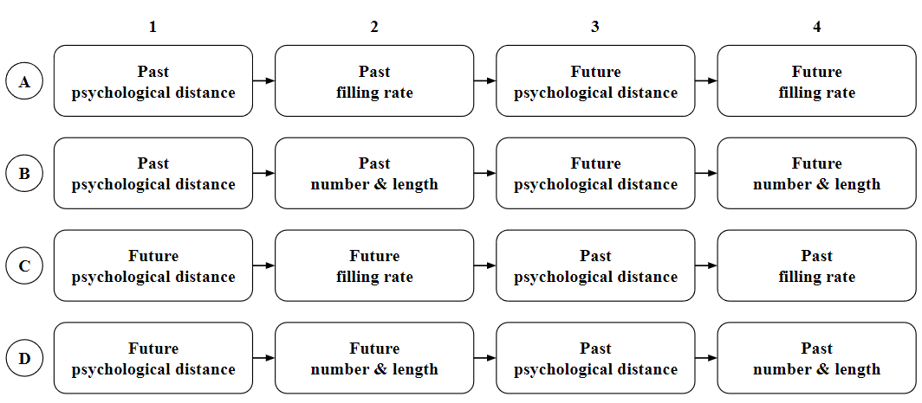
Figure 1. Task-order groups. A, B, C, and D represent the four task sequences to which participants were randomly assigned, while 1, 2, 3, and 4 represent the order of each task.

We used R version 4.0.5 (R Core Team, 2021) for all statistical analyses. Effect size was calculated by effectsize package (Ben-Shachar, Lüdecke, & Makowski, 2020) version 0.6.0.1. We ran a correlation analysis using the rmcorr package (Bakdash & Marusich, 2017) version 0.4.6. All analyses were conducted at a significance level (α) of .02.
Welch’s two-sample t-test was conducted to compare the estimated psychological distance in past and future conditions (H1). As it was a replication of the TDE, to analyze the data as in Caruso et al. (2013), only the first response for each participant was used for analysis. In other words, we used only A1 and B1 as psychological distances for the past condition and C1 and D1 as psychological distances for the future condition (Figure 1). This means that past and future conditions were treated as between-participants variables for this analysis.
Subsequently, we compared whether the filling rate of duration and the number and length of errands and events differed in past and future conditions based on a paired t-test (H2-1). In this analysis, past and future conditions were treated as within-participant variables. The filling rate of duration in the past was calculated by combining the responses of A2 and C4, and the filling rate of duration in the future was combined with the responses of A4 and C2 (Figure 1). The number and length of errands and events were calculated in the same manner as the filling rate of duration.
Furthermore, we conducted a correlation analysis between psychological distance and the filling rate of duration, and the number and length of errands and events using Spearman’s rank correlation coefficient (H2-2). In this correlation analysis, we did not distinguish between the future and the past in terms of psychological distance and analyzed both conditions simultaneously. However, if the rank correlation coefficient is calculated with these data as independent, two measurements, one from the past and one from the future, and obtained from the same participant, the overall correlation may not be estimated correctly because of intra-individual correlation. Therefore, after ranking the data using R’s rank function, and using these data and the rmcorr package (Bakdash & Marusich, 2017), we calculated Spearman's rank correlation coefficients for repeated measures. Note that the ranking method used was the AVERAGE method in R.

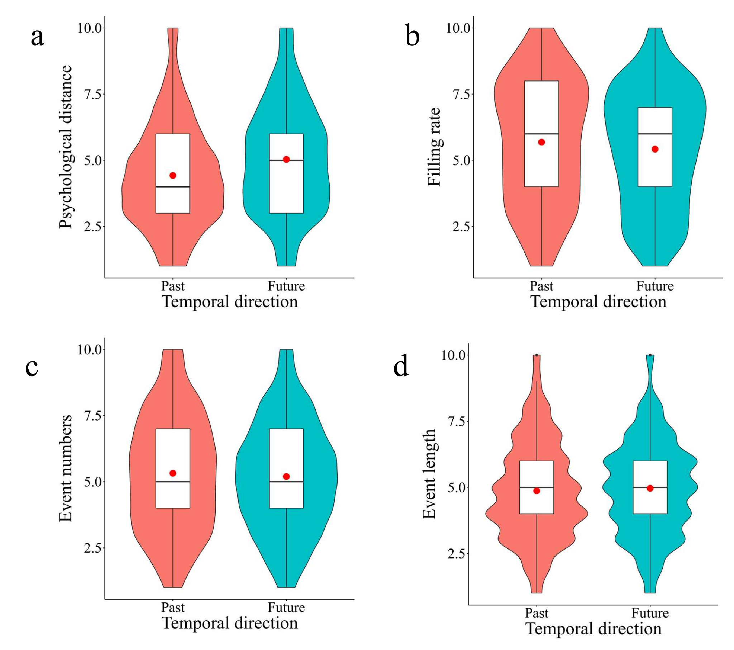
Figure 2. The violin and box-and-whisker plots of the results in Study 1. The red dots show mean scores. (a) The psychological distance to the past and future. (b), (c), and (d) The past and future filling rate of duration, numbers, and lengths of errands and events, respectively. All of these were rated on a 10-point scale. Higher scores indicate more distant (in psychological distance), more filled (in filling rate), more numerous (in number), and longer (in length).

Figure 2 shows the results of Study 1. Welch’s two-sample t-test showed that the psychological distance in the future condition was significantly farther than in the past condition (t(920.18) = -4.57, p < .001, Cohen’s d = -0.30, 95% CI [-0.43, -0.17]). This result does not support H1, which hypothesized that the past is felt to be more distant than the future, even though the objective temporal distance is the same. That is, the results of Caruso et al.’s (2013) Study 1a failed to be replicated, but a reversal was observed.
Then, we conducted paired t-tests for the filling rate of duration, and the number and length of errands and events to compare the past and future conditions (H2-1). The result of the filling rate of duration showed that the past was significantly higher than the future (t(477) = 3.30, p = .001, Cohen's d = 0.15, 95% CI [0.06, 0.24]). There was no significant difference between the past and future with respect to either the number (t(457) = 1.51, p = .132, Cohen's d = 0.07, 95% CI [-0.02, 0.16]) or the length of errands and events (t(457) = -1.33, p = .183, Cohen's d = -0.06, 95% CI [-0.15, 0.03]). Thus, our hypothesis that the filling rate of duration is higher in the past than in the future was supported. It is suggested that the filling rate of duration is composed of both the number and length of errands and events, not just one of them.
We then examined whether there was a correlation between psychological distance and the other variables (the filling rate of duration, number, and length) using the ranked data (H2-2) with the rmcorr package (Bakdash & Marusich, 2017). Psychological distance was not significantly correlated with either the filling rate of duration (ρ = -.05, 95% CI [-.14, .04], p = .255) or the number of errands and events (ρ = -.07, 95% CI [.14, .32], p = .159). However, psychological distance showed a significant correlation with the length of errands and events (ρ = .23, 95% CI [-.16, .03], p < .001). Therefore, our hypothesis was not fully supported.

5.2. Study 2
All analyses conducted corresponded to Stage 1 peer-reviewed pre-registration, and the analysis procedure was the same as in Study 1. Per the exclusion criteria and stopping rule, 180 participants were excluded from the analysis, and 1308 participants (M = 47.94, SD = 11.75, 473 female, 16 other/non-respondent) were analyzed. None of the participants participated in Study 1. To avoid the effect of task order, participants were randomly assigned to four task-order groups, as in Study 1 (Figure 1). The number of participants in each group was 307 (A), 339 (B), 328 (C), and 334 (D).

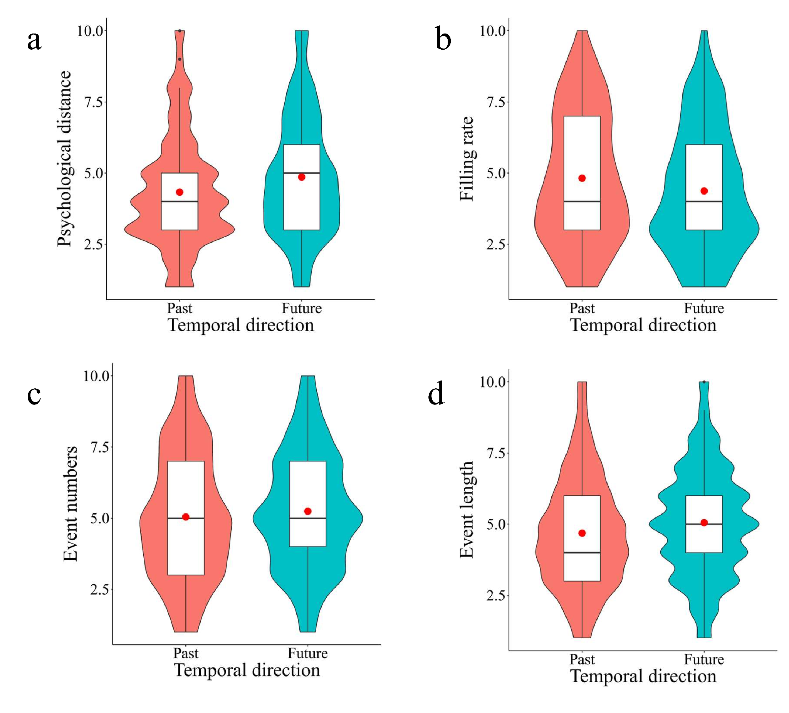Figure 3. The violin and box-and-whisker plots of the results in Study 2. The red dots show mean scores. (a) The psychological distance to the past and future. (b), (c) and (d) The past and future filling rate of duration, numbers, and lengths of errands and events, respectively. All of these were rated on a 10-point scale. Higher scores indicate more distant (in psychological distance), more filled (in filling rate), more numerous (in number), and longer (in length).

Figure 3 shows the results of Study 2. The result of Welch’s two-sample t-test showed that psychological distance in the future condition was significantly farther than in the past condition, similar to Study 1 (t(1304) = -4.66, p < .001, Cohen’s d = -0.26, 95% CI [-0.37, -0.15]). H1, which hypothesized that the past is felt farther than the future, was not supported. This suggests that the present study failed to replicate the results of Caruso et al.’s (2013) Study 1b, but a reversal was observed.
We conducted paired t-tests for the filling rate of duration, and the number and length of errands and events to compare the past and future conditions (H2-1). The result of the filling rate of duration showed that the past was significantly higher than the future (t(634) = 6.15, p < .001, Cohen’s d = 0.24, 95% CI [0.17, 0.32]). The results of both the number (t(672) = -2.63, p < .001, Cohen’s d = -0.10, 95% CI [-0.18, -0.03]) and length (t(672) = -4.97, p < .001, Cohen’s d = -0.19, 95% CI [-0.27, -0.12]) showed that the future one was more numerous or longer than the past one. Thus, our hypothesis that the filling rate of duration is higher in the past than in the future is supported. However, the number and length of errands and events were numerous or longer in the future than in the past, which is contrary to the result of the filling rate of duration.
To examine whether there was a correlation between psychological distance and the other variables (the filling rate of duration, number, and length) using the ranked data (H2-2) with the rmcorr package (Bakdash & Marusich, 2017). A significant negative correlation between psychological distance and the filling rate of duration was observed (ρ = -.12, 95% CI [-.20, -.04], p = .002). Psychological distance showed significant positive correlations with the number of errands and events (ρ = .18, 95% CI [.11, .25], p < .001) and the length of errands and events (ρ = .36, 95% CI [.29, .43], p < .001). Thus, our hypothesis was not supported.

6. General Discussion
This is a registered report per the Caruso et al.’s (2013) Studies 1a and 1b, which aimed to examine differences in psychological distance underlying past and future conditions (TDE) and to investigate the relationship between psychological distance and the filling rate of duration inspired by FDI studies in time perception. In our Study 1, the results showed that the past felt closer than the future, which is the opposite of H1, and suggested a failure to replicate the Caruso et al.’s (2013) Study 1a. We also examined whether the TDE could be explained by the filling rate of duration. The results indicated that the filling rate of duration was higher in the past than in the future, as predicted. The correlation between psychological distance and the length of errands and events was significantly positive, however, no significant correlation between psychological distance and the filling rate of duration, the number of errands and events were observed. In other words, our hypothesis that the filling rate of duration was higher in the past than in the future and had an effect on the TDE was not supported as a whole.
Next, in our Study 2, in which the time scale was changed from 1 month to 1 year, the results also indicated that the past felt closer than the future. It showed an opposite direction from H1 and suggested that the Caruso et al.’s (2013) Study 1b was not replicated. We then examined whether the TDE could be explained by the filling rate of duration. In H2-1, the filling rate of duration was higher in the past than in the future. In H2-2, there was a significant negative correlation between psychological distance and the filling rate of duration. In other words, our hypothesis that the filling rate of duration was higher in the past than in the future and that this had an effect on the TDE was not supported as a whole.
One of the aims of this study was to contribute to the robustness and transparency of the TDE research using the Registered Reports system. Although approximately 1000 people participated in Studies 1 and 2 to increase statistical power of the test, the TDE was not replicated (rather, our results were the opposite of the original research).
Investigating what contributed to these discrepancies in the results between the studies would be beneficial in forming a better understanding of the TDE. Indeed, there are several differences in the research methodology between Caruso et al. (2013) and our study: (i) our experiment used crowdsourcing services rather than face-to-face methods; (ii) the instructions and questionnaires were written in Japanese, and only Japanese people participated in the experiment; and (iii) the experiment was conducted during the COVID-19 pandemic. In the following section, we discuss these differences and how they influence the replication of the TDE.
First, unlike the previous study, we used crowdsourcing to recruit participants. Previous studies show that even for demanding cognitive and perceptual experiments, web experiments do not reduce data quality (Germine et al., 2012). Therefore, it is unlikely that the crowdsourced web experiment, especially with the present less demanding task compared with perceptual experiments, caused any significant deterioration in measurement accuracy or failed to detect any true effects that should have existed. In addition, we excluded data from participants who did not respond properly to the ACQ to ensure the quality of our data. These points led us to consider that the difference in the experimental platform did not play a major role in the present failure to replicate Caruso et al. (2013).
Second, several linguistic and cultural differences exist. In Japanese, the past is sometimes expressed as “mae (前)” which means “before” as an expression of time, while it also means “front” referring to a spatial direction, and the future as “ato (後)” which means both “after” and “back.” This suggests that the spatio-temporal metaphors in Japanese and English may be reversed. This reversal in the spatio-temporal metaphors may have led to the different results on the TDE between the previous and present studies. It should be noted that even if the spatio-temporal metaphors are reversed between Japanese and English speakers, it does not affect the original explanation of the TDE that the future approaches the present and the past moves away from it. This is because the mechanism proposed by Caruso et al. (2013), as an analogy to the Doppler effect in physics, focuses on temporal distance, that is, whether the past or future approaches or moves away from the present on the temporal dimension. In their explanation, the movement on the psychological temporal dimension is critical, regardless of the spatial metaphor unique to Japanese. Therefore, the TDE mechanism proposed by Caruso et al. cannot explain our results from the Japanese sample. Nevertheless, cross-cultural comparative studies focusing more on this point are warranted since the contributions of language and culture to the TDE, or possibly the mental timeline (Starr & Srinivasan, 2021), are important for clarifying its cognitive mechanism and generalizability.
In terms of conducting the experiment during the COVID-19 pandemic, the tendency to think about the past rather than the uncertain future may have strengthened, which may have led to an opposite result to that of Caruso et al. (2013). Previous findings showing that the tendency to think about the past, such as nostalgia, increases when psychological threat and loneliness are high, can suggest this possibility (Routledge et al., 2013; Wildschut et al., 2006, 2010). Indeed, the findings of this study that the filling rate of duration is higher in the past than in the future seem to be part of the tendency that the phenomenon of thinking more about the past rather than the uncertain future was strengthened during the COVID-19. However, since these results are not a direct indicator of the aforementioned time orientation, and this study was the first to report on the TDE during the pandemic, this influence cannot be concluded. It should be discussed from the integrated view of this study and subsequent studies that examine the TDE during the pandemic. It should also be noted that a comparison with previous studies examining the TDE before the pandemic is necessary in such cases.
Thus, more evidence is needed to determine whether the methodological and contextual differences between our study and Caruso et al. (2013) influence the TDE, as well as to understand the underlying mechanism. Moreover, the mechanism of the TDE needs to be discussed according to the differences mentioned above. This study attempts to explain the TDE based on the filling rate of duration. Although the filling rate of duration was higher in the past than in the future, as we predicted, the correlation with psychological distance was extremely weak in Study 1, and contrary to our prediction, a negative correlation was observed in Study 2. These results suggest that it is not appropriate to explain the TDE based on the filling rate of duration. However, this mechanism-oriented approach is crucial in itself, and rather than just examining whether the phenomenon is related to some factors, as in previous TDE studies, future TDE studies should focus more on the underlying cognitive mechanism. Importantly, this requires the TDE to be replicated robustly. Moreover, because there is a possibility that the TDE may not be replicated, as in our study, it is appropriate to conduct the study as a registered report to prevent publication bias.
In the present study, the TDE was not replicated as already known (although there are several possible influences) and the mechanism remains unclear. Given the sample size, the TDE does not appear to be a robust and culturally universal phenomenon, and there still seems to be room for reconsideration of this phenomenon and its mechanism.

Question | Hypothesis | Sampling plan | Analysis Plan | Rationale for deciding the sensitivity of the test for confirming or disconfirming the hypothesis | Interpretation given different outcomes | Theory that could be shown wrong by the outcomes | Results
Q1: Which is psychologically closer, the future or the past? | H1: People will feel the past as farther than the future as in the original study (Caruso et al., 2013). | 936 participants were recruited in Study 1.  Another 1308 participants were recruited in Study 2.  The number of participants is based on power analyses. | Similar to Caruso et al.’s (2013) Study 1a and 1b, we used a two-sample t-test to compare the estimated psychological distance in the past and future conditions in a between-subject design. | Power analysis conducted using G*Power 3.1 (Faul, Erdfelder, Lang, & Buchner, 2007) and pwr package 1.3-0 (Chamely, 2020) on R 4.0.5 (R Core Team, 2021) indicates that this sample size will have 95% statistical power to detect an effect size of d = 0.26 (d = 0.22 in Study 2) of the comparison between past group and future group in Study 1 at a significance level of .02. | In Study 1 (or 2), a significant difference between the past and the future condition (α = .02) indicates the acceptance of H1 in 1 month (or 1 year) condition, and the replication success of Caruso et al.’s (2013) Study 1a (or 1b). If H1 is not supported, there may be two reasons for it.  First, the results of psychological distance may be affected by the recruitment method of participants (i.e., crowdsourcing).  Second, there is a possibility that the TDE does not exist, or only exists under very limited conditions. | Q1 and H1 aim to replicate Caruso et al.’s (2013) study directly. Therefore, no theory could be proved wrong by the outcomes. | H1 was not supported and a reversal was observed.
Q2-1: Which duration is fuller, the future or the past? | H2-1: Duration will be fuller in the past than in the future. | Using two different scales to measure the filling rate of duration (see Independent variables for details), participants were divided into two equal groups, with 468 participants in each group for Study 1 and 645 participants in each group for Study 2. | We used a paired t-test to compare whether the filling rate of duration differs in the past and future conditions in a within- subject design. | For H2-1 and H2-2, we also conducted an a priori sensitivity power analysis and found that the effect size is much smaller than dz = 0.4 (r = .2), which we were determined to use. Further, we also used the full sample size to test these hypotheses.  (see Sample size and power analysis section for further details) | Significant difference between the past and the future condition (α = .02) indicates the acceptance of H2-1.  Significant positive correlation between psychological distance and the filling rate of duration indicates the acceptance of H2-2.  If H2-1 and H2-2 are not supported, it would suggest that the filling rate of duration is not an appropriate explanation for the TDE. If H2-2 is supported but H2-1 is not, we cannot explain TDE by the filling rate of duration. However, there might be some distortion in time estimation, which is based on the FDI-like effect, or the scale we use might not be valid enough for the filling rate of duration. | We are not aiming to contradict Caruso et al.’s (2013) explanations. Our aim is to provide another explanation for it, regardless of spatial-temporal metaphor. | H2-1 was supported (the filling rate of duration was significantly higher in the past than in the future).
Q2-2: Does the filling rate of duration affect the psychological distance in the future and past conditions? | H2-2: When the duration is fuller, the psychological distance will be farther. |  | We conducted a correlation analysis between psychological distance and filling the rate of duration, using Spearman’s rank correlation coefficient. We analyzed both future and past data simultaneously. |  |  |  | H2-2 was not supported (the correlations between the filling rate of duration and psychological distance were negligible in Study 1 or negative in Study 2).

Declaration of Conflicting Interests
The authors of this article declare that they have no financial conflict of interest with the content of this article. YY is a recommender and managing board member at PCI Registered Reports.

Acknowledgements
We would like to thank Editage (www.editage.com) for English language editing.

Authors’ contributions
CRediT Statement
Conceptualization: QZ, YM, KU, KT, YY; Formal Analysis: QZ, YM, KT, YY; Funding acquisition: YY; Investigation: QZ, YM, KT, YY; Methodology: QZ, YM, KU, KT; Project administration: YY; Supervision: YY; Visualization: QZ, YM, KU, KT; Writing - Original Draft: QZ, YM, KU, KT, YY; Writing - Review & Editing: QZ, YM, KU, KT, YY

Funding
This research is supported by JSPS KAKENHI: JP18K12015, JP20H04581, 21H03784, and 22K18263.

Data availability
All data and digital materials of this study are openly available on the Open Science Framework page (https://osf.io/x29k7/).

Supplementary Information
Instructions for the experiments in Japanese and English translation are as follows. Our experiments used exactly the same instructions but divided these questions into several sections to make it easier for participants to answer.

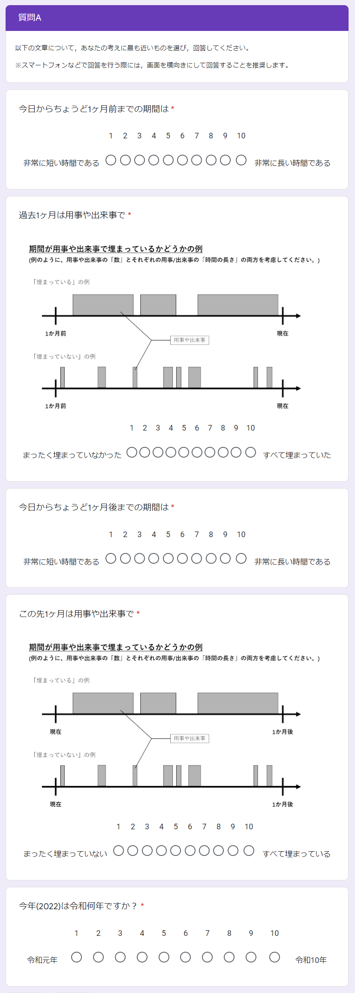
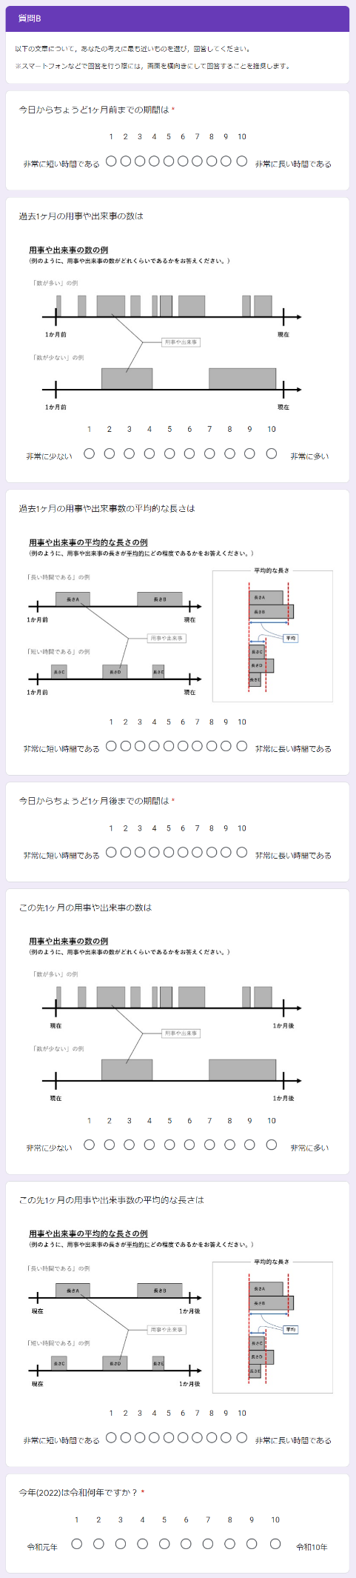
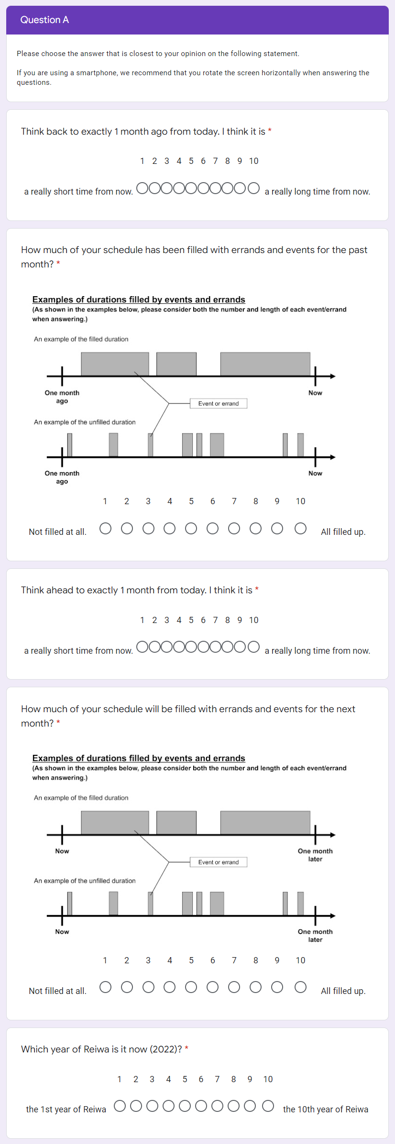
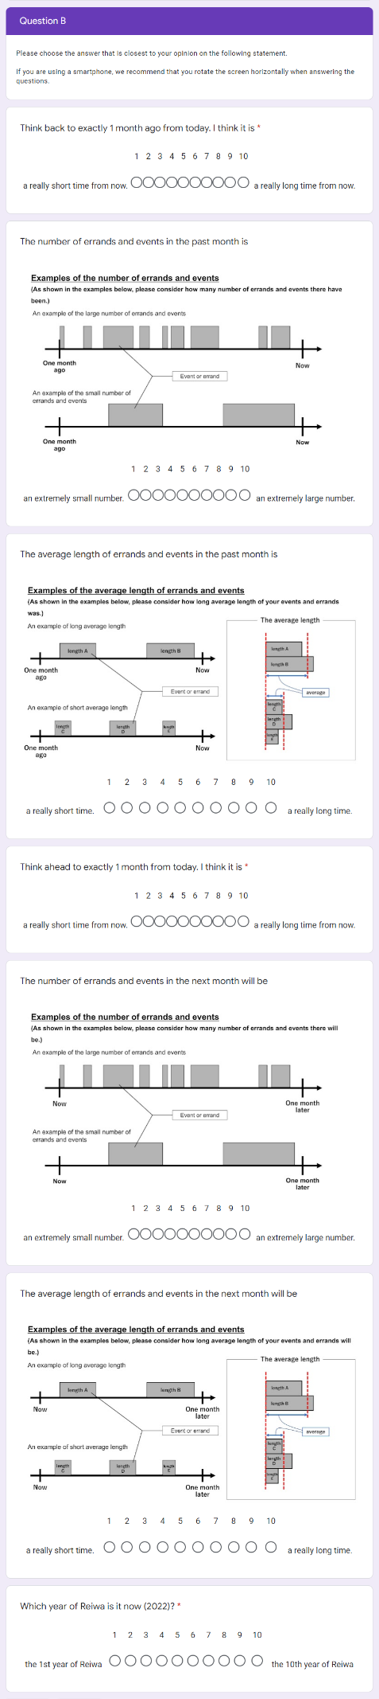
As we divided participants into two groups using two different scales, measuring the filling rate of duration, we would like to provide possible outcomes and explanations for it. This facilitated easier classification, in this case, we just discussed the relationship regardless of whether it is positive or negative. As long as the filling rate of duration is related to psychological distance, regardless of the result of number or length, our hypothesis is supported. However, when the filling rate of duration is not related to psychological distance, our hypothesis is not supported, and there are several possible explanations as listed below.

 |  | Filling rate and psychological distance
 |  | 1a: Filling rate is related to psychological distance | 1b: Filling rate is not related to psychological distance
Length, number, and psychological distance | 2a: Both length and number are related to psychological distance | All the three factors (length, number, and filling rate) affect psychological distance.  The result shows that the filling rate consisted of both the length and the number of the intervening events. This result is in accordance with our hypothesis: when the filling rate of duration is higher, the psychological distance is farther. | Both length and number are related to psychological distance, while the filling rate of duration is not related to psychological distance.  These results show that the scale that we used to measure the filling rate of duration is not valid enough for measuring both the number and the length of intervening events simultaneously.
 | 2b: Only length (or number) is related to psychological distance | The length (or number) and filling rate affect psychological distance. These results show that the filling rate of duration just consisted of length (or number) of intervening events.  Moreover, our hypothesis is partially supported; when the filling rate of duration which consists of length (or number) of intervening events is higher, the psychological distance is farther. | Either length or number is associated with psychological distance, while the filling rate of duration is not related to psychological distance.  These results show that either the concept of filling rate needs to be rediscussed or the way in which we ask participants to answer should be reconsidered.
 | 2c: Neither length nor number is related to psychological distance | Only the filling rate affects psychological distance. These results show that the concept of filling rate should be considered as a complex combination of length and number of events rather than a simple combination.  Our hypothesis is supported: when the filling rate of duration is higher, the psychological distance is farther. | None of the factors are related to psychological distance.  These results show that our hypothesis and the concept of the filling rate of duration is not supported and needs further investigation.

Note that after the in-principle acceptance, we made two small modifications, deleting the “Group 1:” and “Group 2:” from the first row and first column to avoid misunderstanding. It does not influence any of the hypotheses or the interpretation of the results.
References
Aksentijevic, A., & Treider, J. M. G. (2016). It’s all in the past: Deconstructing the temporal Doppler effect. Cognition, 155, 135–145. https://doi.org/10.1016/j.cognition.2016.07.001
Bakdash, J. Z. & Marusich, L. R. (2017). Repeated measures correlation. Frontiers in psychology, 8, 456. https://doi.org/10.3389/fpsyg.2017.00456
Ben-Shachar MS, Lüdecke D, Makowski D (2020). “effectsize: Estimation of Effect Size Indices and Standardized Parameters.” Journal of Open Source Software, 5(56), 2815. https://doi.org/10.21105/joss.02815
Brysbaert, M. (2019). How many participants do we have to include in properly powered experiments? A tutorial of power analysis with reference tables. Journal of Cognition, 2(1), 16. https://doi.org/10.5334/joc.72
Buffardi, L. (1971). Factors affecting the filled-duration illusion in the auditory, tactual, and visual modalities. Perception & Psychophysics, 10(4-B), 292–294. https://doi.org/10.3758/BF03212828
Buhusi, C. V., & Meck, W. H. (2005). What makes us tick? Functional and neural mechanisms of interval timing. Nature Reviews Neuroscience, 6(10), 755–765. https://doi.org/10.1038/nrn1764
Burnside, W. (1971). Judgment of short time intervals while performing mathematical tasks. Perception & Psychophysics, 9(5), 404–406. https://doi.org/10.3758/BF03210238
Caruso, E. M., Van Boven, L., Chin, M., & Ward, A. (2013). The temporal doppler effect: When the future feels closer than the past. Psychological Science, 24(4), 530–536. https://doi.org/10.1177/0956797612458804
Casasanto, D., & Boroditsky, L. (2008). Time in the mind: Using space to think about time. Cognition, 106(2), 579–593. https://doi.org/10.1016/j.cognition.2007.03.004
Cashen, L. H., & Geiger, S. W. (2004). Statistical power and the testing of null hypotheses: A review of contemporary management research and recommendations for future studies. Organizational Research Methods, 7(2), 151–167. https://doi.org/10.1177/1094428104263676
Champely, S. (2020). pwr: Basic functions for power analysis. R package version 1.3-0. https://CRAN.R-project.org/package=pwr
Droit-Volet, S., & Meck, W. H. (2007). How emotions colour our perception of time. Trends in Cognitive Sciences, 11(12), 504–513. https://doi.org/10.1016/j.tics.2007.09.008
Faul, F., Erdfelder, E., Lang, A. G., & Buchner, A. (2007). G* Power 3: A flexible statistical power analysis program for the social, behavioral, and biomedical sciences. Behavior Research Methods, 39(2), 175-191. https://doi.org/10.3758/BF03193146
Gan, Y., Miao, M., Zheng, L., & Liu, H. (2017). Temporal doppler effect and future orientation: Adaptive function and moderating conditions. Journal of Personality, 85(3), 313–325. https://doi.org/10.1111/jopy.12242
Germine, L., Nakayama, K., Duchaine, B. C., Chabris, C. F., Chatterjee, G., & Wilmer, J. B. (2012). Is the Web as good as the lab? Comparable performance from Web and lab in cognitive/perceptual experiments. Psychonomic Bulletin & Review, 19(5), 847–857. https://doi.org/10.3758/s13423-012-0296-9
Guo, W., Liu, H., Yang, J., Mo, Y., Zhong, C., & Yamada, Y. (2020). Stage 2 Registered Report: How subtle linguistic cues prevent unethical behaviors. F1000Research, 9, 996. https://doi.org/10.12688/f1000research.25573.2
Hasuo, E., Nakajima, Y., Tomimatsu, E., Grondin, S., & Ueda, K. (2014). The occurrence of the filled duration illusion: A comparison of the method of adjustment with the method of magnitude estimation. Acta Psychologica, 147, 111–121. https://doi.org/10.1016/j.actpsy.2013.10.003
Hicks, R. E., Miller, G. W., & Kinsbourne, M. (1976). Prospective and retrospective judgments of time as a function of amount of information processed. The American Journal of Psychology, 89(4), 719–730. https://doi.org/10.2307/1421469
Ikeda, A., Xu, H., Fuji, N., Zhu, S., & Yamada, Y. (2019). Questionable research practices following pre-registration. Japanese Psychological Review, 62(3), 281–295. https://doi.org/10.24602/sjpr.62.3_281
Jiga-Boy, G. M., Clark, A. E., & Semin, G. R. (2010). So much to do and so little time: Effort and perceived temporal distance. Psychological Science, 21(12), 1811-1817. https://doi.org/10.1177/0956797610388043
Janssen, S. M. J., Chessa, A. G., & Murre, J. M. J. (2006). Memory for time: How people date events. Memory & Cognition, 34(1), 138–147. https://doi.org/10.3758/BF03193393
Liverence, B. M., & Scholl, B. J. (2012). Discrete events as units of perceived time. Journal of Experimental Psychology: Human Perception and Performance, 38(3), 549–554. https://doi.org/10.1037/a0027228
Matlock, T., Ramscar, M., & Boroditsky, L. (2005). On the experiential link between spatial and temporal language. Cognitive Science, 29(4), 655–664. https://doi.org/10.1207/s15516709cog0000_17
McCormack, T., Burns, P., O’Connor, P., Jaroslawska, A., & Caruso, E. M. (2019). Do children and adolescents have a future-oriented bias? A developmental study of spontaneous and cued past and future thinking. Psychological Research, 83(4), 774–787. https://doi.org/10.1007/s00426-018-1077-5
Miles, L. K., Karpinska, K., Lumsden, J., & Macrae, C. N. (2010). The meandering mind: Vection and mental time travel. PLOS ONE, 5(5), e10825. https://doi.org/10.1371/journal.pone.0010825
Miles, L. K., Nind, L. K., & Macrae, C. N. (2010). Moving through time. Psychological Science, 21(2), 222–223. https://doi.org/10.1177/0956797609359333
Mrkva, K., Travers, M., & Van Boven, L. (2018). Simulational fluency reduces feelings of psychological distance. Journal of Experimental Psychology: General, 147(3), 354–376. https://doi.org/10.1037/xge0000408
Nitta, H., Tomita, H., Zhang, Y., Zhou, X., & Yamada, Y. (2018). Disgust and the rubber hand illusion: A registered replication report of Jalal, Krishnakumar, and Ramachandran (2015). Cognitive Research: Principles and Implications, 3. https://doi.org/10.1186/s41235-018-0101-z
R Core Team (2021). R: A language and environment for statistical computing. R Foundation for Statistical Computing, Vienna, Austria. URL https://www.R-project.org/
Ross, M., & Wilson, A. E. (2002). It feels like yesterday: Self-esteem, valence of personal past experiences, and judgments of subjective distance. Journal of Personality and Social Psychology, 82(5), 792-803. https://doi.org/10.1037/0022-3514.82.5.792
Routledge, C., Wildschut, T., Sedikides, C., & Juhl, J. (2013). Nostalgia as a resource for psychological health and well‐being. Social and Personality Psychology Compass, 7(11), 808-818. https://doi.org/10.1111/spc3.12070
Schwarz, M. A., Winkler, I., & Sedlmeier, P. (2013). The heart beat does not make us tick: The impacts of heart rate and arousal on time perception. Attention, Perception, & Psychophysics, 75(1), 182–193. https://doi.org/10.3758/s13414-012-0387-8
Starr, A., & Srinivasan, M. (2021). The future is in front, to the right, or below: Development of spatial representations of time in three dimensions. Cognition, 210, 104603. https://doi.org/10.1016/j.cognition.2021.104603
Thomas, E. C., & Brown, I. (1974). Time perception and the filled-duration illusion. Perception & Psychophysics, 16(3), 449–458. https://doi.org/10.3758/BF03198571
Thompson, C. P., Skowronski, J. J., & Lee, D. J. (1988). Telescoping in dating naturally occurring events. Memory & Cognition, 16(5), 461–468. https://doi.org/10.3758/BF03214227
Trope, Y., & Liberman, N. (2010). Construal-level theory of psychological distance. Psychological Review, 117(2), 440-463. https://doi.org/10.1037/a0018963
Van Boven, L., & Caruso, E. M. (2015). The tripartite foundations of temporal psychological distance: Metaphors, ecology, and teleology. Social and Personality Psychology Compass, 9(11), 593-605. https://doi.org/10.1111/spc3.12207
Wearden, J. H., Norton, R., Martin, S., & Montford-Bebb, O. (2007). Internal clock processes and the filled-duration illusion. Journal of Experimental Psychology: Human Perception and Performance, 33(3), 716–729. https://doi.org/10.1037/0096-1523.33.3.716
Wildschut, T., Sedikides, C., Arndt, J., & Routledge, C. D. (2006). Nostalgia: Content, triggers, functions. Journal of Personality and Social Psychology, 91, 975–993. https://doi.org/10.1037/0022-3514.91.5.975
Wildschut, T., Sedikides, C., Routledge, C., Arndt, J., & Cordaro, P. (2010). Nostalgia as a repository of social connectedness: The role of attachment-related avoidance. Journal of Personality and Social Psychology, 98, 573–586.​​ https://doi.org/10.1037/a0017597
Xuan, B., Zhang, D., He, S., & Chen, X. (2007). Larger stimuli are judged to last longer. Journal of Vision, 7(10), 2–2. https://doi.org/10.1167/7.10.2
Yamada, Y., & Kawabe, T. (2011). Emotion colors time perception unconsciously. Consciousness and Cognition, 20(4), 1835–1841. https://doi.org/10.1016/j.concog.2011.06.016
Yonemitsu, F., Ikeda, A., Yoshimura, N., Takashima, K., Mori, Y., Sasaki, K., Qian, K., & Yamada, Y. (2020). Warning ‘Don’t spread’ versus ‘Don’t be a spreader’ to prevent the COVID-19 pandemic. Royal Society Open Science, 7(9), 200793. https://doi.org/10.1098/rsos.200793
Yuasa, K., & Yotsumoto, Y. (2015). Opposite distortions in interval timing perception for visual and auditory stimuli with temporal modulations. PLOS ONE, 10(8), e0135646. https://doi.org/10.1371/journal.pone.0135646
Zauberman, G., Levav, J., Diehl, K., & Bhargave, R. (2010). 1995 feels so close yet so far: The effect of event markers on subjective feelings of elapsed time. Psychological Science, 21(1), 133–139. https://doi.org/10.1177/0956797609356420

Values were rounded to the nearest whole number in most cases. However, to use a conservative criterion, values were rounded down for the former and rounded up for the latter in the power analysis and the a priori sensitivity power analysis.

