Stage 2 Registered Report

Does alleviating poverty increase cognitive performance?
Short- and long-term evidence from a randomized controlled trial

Barnabas Szaszi^{1*}, Bence Palfi², Gabor Neszveda³, Aikaterini Taka⁴, Péter Szécsi^{5,1}, Christopher Blattman⁶, Julian C. Jamison⁷, Margaret Sheridan⁸

¹Institute of Psychology, ELTE; Eotvos Lorand University, Budapest, Hungary
²Imperial College London, UK
³John von Neumann University, Hungary
⁴Maastricht University, The Netherlands
⁵Doctoral School of Psychology, Institute of Psychology, Eotvos Lorand University, Hungary,
⁵University of Chicago, US,
⁶University of Exeter, UK
⁷The University of North Carolina at Chapel Hill, US,

*Corresponding author: Barnabas Szaszi (szaszi.barnabas@ppk.elte.hu)

Abstract
In this Registered Report, we investigated the impact of a poverty alleviation program on cognitive performance. We analyzed data from a randomized controlled trial conducted on low-income, high-risk individuals in Liberia where a random half of the participants (n=251) received a $200 lump-sum unconditional cash transfer - equivalent approximately to 300% of their monthly income - while the other half (n= 222) did not. We tested both the short-term (2-5 weeks) and the long-term (12-13 months) impact of the treatment via several executive function measures. The observed effect sizes of cash transfers on cognitive performance (b = 0.13 for the short- and b = 0.08 for the long-term) were roughly four times smaller than suggested by prior non-randomized research. Bayesian analyses revealed that the overall evidence supporting the existence of these effects is inconclusive. A multiverse analysis showed that neither alternative analytical specifications nor alternative processing of the dataset changed the results consistently. However cognitive performance varied between the executive function measures, suggesting that cash transfers may affect the subcomponents of executive function differently.

Keywords: unconditional cash transfer, scarcity, cognitive functioning

Introduction
A variety of studies show that living in financial scarcity has a negative impact on cognitive functioning ^{1–6} and that decreased cognitive functioning limits the economic opportunities of the poor ^{7–9}. If so, impaired cognitive performance is one important pathway through which the self-reinforcing cycles of poverty are perpetuated ¹⁰. This study’s central question concerns to what extent such a pathway of deprived cognition exists, and whether it can be broken in adulthood. To do so, we analyse pre-existing data from a cash transfer-based poverty alleviation program ¹¹. Extending the previous work of Blattman et. al.,¹¹ who showed that a mixed unconditional cash transfer and behavioral therapy program can reduce crime and violence, in the present work we aim to test experimentally whether the cash treatment can improve cognitive performance of the poor in the short- and the long-term.
The idea that unconditional cash transfers could enhance cognitive functioning was considered unlikely even a few years ago. In recent years, however, a growing literature has brought evidence that poverty impacts cognitive performance. In their seminal paper, Mani, Mullainathan, Shafir, and Zhao ³ showed that farmers achieve lower scores on measures of fluid intelligence and cognitive control before the harvest, when poor, compared with after the harvest, when rich. Although Wicherts and Scholten ¹² raised concerns about the robustness of the results, these findings generated interest in the scientific and policy-making community, as they suggest that the poor are not inherently less capable, but rather exhibit such outcomes due to the context of poverty. Carvalho, Meier and Wang ¹³ did not find differences in cognitive performance between randomly assigned participants receiving online surveys before and after payday in a US context. However, reanalyzing the same dataset controlling for the distance of the cognitive measurements from payday, Mani, Mullainathan, Shafir and Zhao ¹⁴ found supporting evidence for the effect. In a more recent study, Kaur, Mullainathan, Schilbach and Oh ¹⁵ randomized the timing of income to test its effect on productivity amongst manufacturing workers in India. They found that on cash-rich days, the average number of mistakes decreased among the poorer workers. Ong, Theseira, and Iyh ¹⁶ also showed that a one-off, unanticipated debt-relief program improved the performance of the recipients on a cognitive control task compared to their performance before the debt relief.
These results suggest that positive financial shocks can enhance the cognitive performance of the poor, at least in the short-term. However none of these studies directly experimentally varied wealth, and they leave open the question of whether poverty alleviation programs could have enduring, long-term impacts. If the effects of extra cash on cognition dissipate quickly, it also raises the policy question regarding whether such programs are a useful means to help the poor break out of poverty. Measuring the short- and long-term effect of cash transfers could also help formulate and distinguish competing theories of change, improving our understanding of the key mechanisms through which cash transfers express themselves ¹⁷.
There are several potential pathways through which poverty can impair cognitive performance in the short-term. The circumstance of poverty may tax cognitive capacity by introducing scarcity-related concerns or increased anxiety and stress ^{3,15,18–20}. Furthermore, individuals living in poverty are often sleep-deprived ^{21,22}, and experience more pain ²³, conflict ¹¹ and acute hunger ^{24,25} which can also diminish their cognitive performance. On the other hand, some effects of poverty may only harm cognitive performance over a longer time frame. Diminished access to inputs and resources, such as education, physical & mental health care ^{20,26} and high quality nutrition ^{27,28}, has the potential to create enduring change in cognitive functioning particularly when experienced during early life.
In the present study, we tested whether alleviating poverty influences cognitive functioning on a poor and vulnerable population: street youth in Monrovia, Liberia. The study participants, all men between the ages of 18 and 35, had weekly cash earnings of around $17 mainly from temporary, low-skilled work. A quarter were homeless in the two weeks preceding the intervention, and they slept hungry on average 1.3 days a week. We used data from a randomized controlled field experiment described in detail in Blattman et al.¹¹, testing the effect of a $200 lump-sum unconditional cash transfer on the cognitive performance of the participants 2-5 weeks and again 12-13 months after the cash transfer intervention. We also aimed to explore the role of potential mechanisms (e.g. worrying, sleep deprivation, mental-health, hunger, recent conflicts) in driving the impact of the cash treatment.
We extend previous findings along several dimensions. First, testing the effect of cash transfers in a randomized study allows us to provide a clearer and less biased estimation of the treatment effects compared to previously published studies using pre-post and related designs ¹². In addition, our study design enabled us to test both the short- and long-term effect of unconditional cash transfers on cognitive performance, as well as to start to examine various potential pathways of impact.
Methods
The Stage 1 protocol for this Registered Report was accepted on 15th February 2022. The protocol, as accepted via PCI Registered Report, can be found at https://osf.io/k56yv. This research was approved by the Institutional Review Board at Yale University (IRB-0912006068) and complies with all relevant ethical regulations.
In the present Registered Report, we re-analyzed the randomized controlled trial also described in Blattman et al.¹¹. The present paper focuses on the effect of the cash intervention on cognitive functioning. At the time of the design (2009) and the original publication of Blattman et al. (2017), the authors specifically did not hypothesize any change in cognitive function, and hence excluded it from their preregistration, focusing their paper instead on how therapy and unconditional cash transfers affected criminal and antisocial behavior. Cognitive functions were assessed to obtain an exhaustive list of baseline measures. The treatment effects on cognitive functioning have not previously been analysed beyond a preliminary summary of a small subset of outcomes (see Blattmann et al., 2017, Appendix D7).
Participants and data collection
The study aimed to recruit 1,000 high-risk, low-income males. The Network for Empowerment and Progressive Initiatives (NEPI) — a Liberian non profit organization with a strong reputation in the local neighborhoods of Monrovia and with connections to local leaders — coordinated the recruitment process. Many recruiters had graduated from previous NEPI programs and had backgrounds similar to the target population: criminal involvement, and/or former membership of armed groups especially during multiple civil conflicts in the country. NEPI staff involved in the interventions did not participate in the recruitment process.
Recruiters identified and visited five residential neighborhoods of Monrovia with especially high levels of criminality and violence, each with a population around 100,000. They looked for vulnerable participants with evident signs of homelessness and substance abuse and approached potential participants directly on the street. To avoid spillover effects within social networks, recruiters were instructed to approach only one in every seven potential participants. That way, roughly10,000 marginalised potential beneficiaries were observed, from which only 1,500 men were invited to participate in the experiment. Next, recruiters explained the psychosocial intervention and study. The cash grants were never mentioned at this stage. From the initial 1,500 recruited men, 501 withdrew from the study due to lack of interest. As a result, the final sample for the four treatment arms (including those not analyzed in the present study) consisted of 999 poor young males with an average age of 25 years (Figure 1).

The process of the study
For purposes of the present research, the study had two mutually exclusive treatment arms: no treatment and treatment with the cash transfers. Note that in the original study¹¹, there were two additional treatment groups (treatment with a cognitive behavior-informed therapy (CBT) and treatment with CBT followed by the cash transfer) which we do not analyze in the present paper. As the data collection of the different arms were interconnected, here we briefly discuss the study process for all treatment arms (Figure 1).

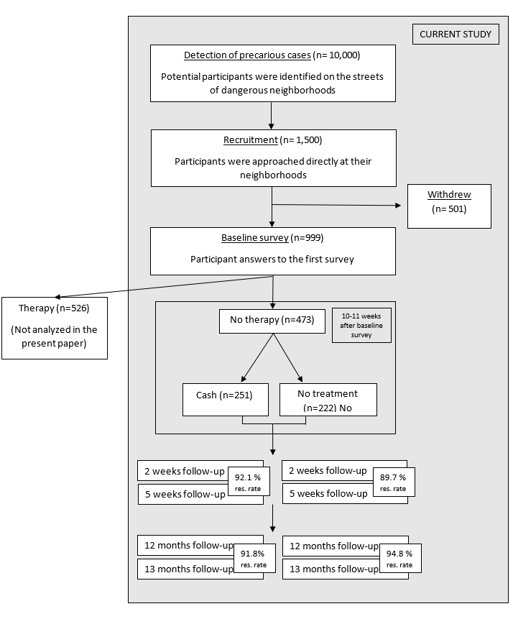
Figure 1. Consort diagram. Survey response rates are calculated as the difference between the total number of respondents at baseline and the number of respondents "unfound" at each endline, all divided by the number of respondents at baseline.

After being recruited and before being assigned to any of the conditions, participants answered a baseline survey. Next, participants were asked to draw chips blindly from a pouch which determined whether they were assigned to participating or not in therapy. Crucially, participants analyzed in the present study (receiving no therapy) were not engaged further until the assignment of cash treatments. 10-11 weeks after the baseline survey, all participants were invited to a public draw in groups of 50 where the lump-sum US$200 grants were randomly drawn by a nonprofit organization (Global Communities). Instead of computerized randomization, personal draws by hand were used in order to maximize trust and transparency among the participants. Four follow-up surveys were conducted 2 and 5 weeks, and then 12 and 13 months after the cash randomization by a nonprofit research organization (Innovations for Poverty Action). As a result of the one-shot physical randomization procedure, 22 percent of the overall participants were assigned to the control arm (n = 222), and 25 percent into the cash only arm (n =251) (as well as 28 percent into therapy only (n = 277), and 25 percent into the joint treatment arm (n = 249). Note that the therapy only and joint treatment arms are not analyzed in the present study. As reported in detail in Blattman et al. ¹¹, the treatment is largely balanced along the covariates reported below.
The phases of implementation
The authors implemented the study in three phases. For safety and procedural reasons, we first conducted a pilot phase with 100 men in a peri-urban part of Monrovia. Data from participants in the pilot phase were later compiled with the participants recruited later. Few changes to the intervention or protocols were required, and so a largely similar second phase of recruitment and treatment started half a year after the pilot study, with a geographical extension of the recruitment in the central areas of Monrovia. During that phase, 398 participants were recruited. The third phase of implementation followed 9 months later, and consisted of a recruitment of 501 men from three different areas of Bushrod Island.
The treatment: unconditional cash transfers
Individuals in the cash transfer treatment condition received US$200 in a single lump-sum - about 300% of monthly income for the target population.
A compensation of US$10 was given for participants in the control condition. The winners were briefly advised on how to keep this money safe. However, the cash transfers were unconditional and the final decision on how they would use the money was at the participants’ discretion.
Baseline and Follow-up surveys
The follow-up surveys were administered verbally by trained enumerators. Each participant was asked to participate in five surveys. Once they agreed with the study terms, participants completed a baseline survey. The remaining four surveys took place 2 and 5 weeks (short-term), and then 12 and 13 months (long-term) after the cash distribution . As the administration of multiple measurements at relatively short intervals has been argued to decrease noise and increase precision for key outcomes ²⁹, the authors collected two data points both for the short-term and the long-term follow-ups. That is, the 2 and 5 weeks, and the 12 and 13 months follow-up surveys intended to measure the same underlying phenomenon. Accordingly, similarly to Blattman et al.¹¹, we merged the responses for the 2 and 5 weeks as well as for the 12 and 13 months surveys in our analyses by taking the average of the corresponding results.
Each survey session included a roughly 90 minutes-long questionnaire, delivered verbally. It included measures such as antisocial behavior, psychological state, time preferences, social identity, and self-control, among others. The survey was followed by a roughly 45-minute session of games and tests including the executive function measures. The response time measures were administered using a stopwatch, as in the context of the study it was not feasible to collect data using computerized means. The questions, games, and tests were always administered in the same order. The average earnings from the survey and games were roughly equivalent to a half-day wage. In the current paper, we only focus on and analyze the results of the cognitive performance tests. As described in detail in Blattman et al. (2017, Appendix A3), the authors collected at least five close contacts and all known addresses of the participants and spent on average three to four days locating respondents per survey to minimize attrition rates. The attrition rate of the overall endline survey was 7.6 percent after one year, which is common in field experiments in developing countries ^{e.g., 30}. Most importantly, the response rates in all treatment arms were within 0.4 percent of the control group, while the joint significance tests including all baseline covariates yielded p = 0.328, suggesting that the attrition was unsystematic acorss treatments.
Cognitive performance assessment
The detailed task materials for each task are available at the Appendix.
The arrow task (attention, inhibition, switching)³¹: Three versions of the arrow task were developed. In each version, participants were visually presented with a series of 32 black or white arrows pointing up or down. Both the number of incorrect answers and the total time of completion were recorded. In the arrows attention task, participants were asked to state verbally the direction of arrows presented to them on a piece of paper. Performance on this task signals a baseline ability to maintain attention, interpret symbols, and follow directions. In the arrows inhibition task, participants were again presented with rows of arrows, and had to report verbally the opposite direction to what they were actually seeing. To complete the task successfully, one needs to inhibit the more common or prepotent response (actual direction) and produce a less common response. In the arrows switching task, participants were told to report verbally the actual direction of the arrow if the arrow was white, and report the opposite direction if the arrow was black. The successful completion of the task requires the maintenance of attention, the ability to switch between goals, and the inhibition of prepotent responses.
Digit span task (forward and backward): Working memory capacity was assessed by an oral digit span task. The instructor read aloud two sequences of digits (one at a time) in random order with a short break between the digits. Participants were asked to repeat verbally the digits either in the same (forward-digits) or the reverse order (backwards-digits). In case at least one of the two sets of digits were correctly repeated by the participant, the instructor continued reading longer sets of digits up to a maximum of nine digits. That is, the total number of repeated digits was dependent on the performance of the participant (minimum 2, maximum 16). In order to avoid learning effects, the digit sequences were different in the surveys conducted close in time (2-weeks versus 5-weeks, and 12-months versus 13-months). The number of correctly repeated digits was recorded separately for the forward and backward digit tasks.
Maze task (response time and accuracy): Participants were asked to complete three mazes with increasing difficulty in the maze task. After completing a pilot trial, they had 2, 2, and 3 minutes to complete each of them. Both the completion time of the three mazes and the number of correctly completed mazes were recorded. Although the maze task is related to cognitive ability, as it is not a standardized measure of a specific cognitive function it was only included in the multiverse analysis section.

Hypotheses and Data Analysis Strategy

Overview
In the primary analyses, we tested the two confirmatory hypotheses outlined below. The data analysis closely followed the steps detailed in the Stage 1 protocol (available at https://osf.io/k56yv). Following the protocol, the conclusions of the paper are based on the outcome of these primary analyses.
Hypothesis 1: We hypothesize that participants receiving unconditional lump-sum cash-transfers show better cognitive performance in the short-term compared to participants in the no treatment group (2-5 weeks)
Hypothesis 2: We hypothesize that participants receiving unconditional lump-sum cash-transfers show better cognitive performance in the long-term compared to participants in the no treatment group (12-13 months).
Furthermore, we also planned to conduct two exploratory analyses: (1) a multiverse analysis to reveal the robustness and sensitivity of the results to different analytical choices (see “Robustness tests: multiverse approach”) and (2) a mediation analysis to understand the driving mechanism behind the observed effects in the primary analysis. The mediation analysis was planned for those cases where the primary analysis revealed strong support (BF >10) for the effect; however we did not end up conducting this analysis because we found no strong support for the effects in the primary analyses.
Only the summary of the results of the multiverse analysis are reported in the main text, discussing which analytical choices and variables lead to which inferences as compared to the main analyses. The detailed results are published in the Appendix.
Statistical framework
The statistical inferences were based on Bayes Factors (BF). BFs indicate the relative evidence for two competing theories on the basis of the collected data ³². We followed the modified recommendations of Lee and Wagenmakers ³³ on the threshold of good enough evidence. BF values above 10 and below 1/10 were regarded as strong evidence for the alternative and the null hypothesis, respectively. If the data did not reach these thresholds, we concluded that we did not have strong evidence for either of the hypotheses, and we interpreted the BF values using their original definition, namely the strength of relative evidence between the hypotheses.

Calculation of Bayes Factors
We modeled the predictions of the hypotheses by using a half-Cauchy distribution with a mode of zero and with the scale factor of 0.34 ³⁴. Previous studies testing the effect of cash transfers applied various designs and cognitive function measures that were different from the measures used in the present paper. Consequently, instead of using one measure from a specific paper to estimate the expected effect size (scale factor) for the BF calculation, we conducted a mini meta-analysis on previously published field studies providing causal evidence on the effect of poverty on cognitive functions, where variance of real money was captured involving significant uncertainty¹⁴. The analysis code of the meta-analysis is available at the OSF page of the project (https://osf.io/qymaz/). The result of the meta-analysis involving five measures from two studies ^{3,16} showed a standardized effect size of b =0.34, after adjusting for the effect of publication bias. Accordingly, when calculating the BF, we used 0.34 as the scale factor of the half-Cauchy distribution modeling the effect of cash transfers on cognitive function measures.
To assess the robustness of our conclusions to the applied scale factors of the models of H1 and H2, we report Robustness Regions for each Bayes factor with two extreme priors (b = 0.09, b = 1.57), using half of the smallest effect size and twice the largest effect size from the mini-meta analysis.
Bayes Factor Design Analysis
We conducted Bayesian Factor Design Analysis (BFDA) which is an alternative to frequentist power analyses enabling researchers to estimate the informativeness of the study in a Bayesian framework.
To do so, we used the BFDA package in R ³⁵. For each model in our primary analyses, we conducted 10,000 simulations. Our calculations were carried out with the assumptions that alternative hypotheses are true. For the simulations, we used the effect sizes and the sample sizes detailed below. In case the sample sizes were not matched between the comparison groups, to provide a conservative estimate we used the sample size of the smaller group to calculate our estimations. The long-term rates of correct evidence were calculated as the proportion of iterations where strong evidence (BF > 10) was found for the existence of the effect. The long-term rates of misleading evidence were computed as the proportion of iterations where the evidence strongly supported the null hypothesis (BF < 10).
We found that, assuming the alternative hypotheses are true and with the parameters detailed above, the model provides correct inference in 82% and inconclusive results in 18% of the simulations for H1 and H2, while it makes incorrect inferences in less than 0.01% of the cases. Although our design is not optimized to reliably detect a null effect, we calculated the rate of misleading evidence under the assumption that the null hypothesis is true for each of our hypotheses. The results showed the rates of misleading evidence were < 1% for both of the hypotheses. The analysis code of BFDA analysis is available at the OSF page of the project (https://osf.io/qymaz/).
Primary analyses
Dependent variable
We used an executive function index as the dependent variable in the primary analysis. The executive function index was calculated for each participant by summing the standardized (z-scored) values of the following measures: accuracy scores (number of correctly repeated digits) in the forward and backward digit span tasks; response time (average logarithmized completion time, reversed scoring) in the arrow switching and arrow inhibition tasks; and accuracy (number of incorrect answers, reversed scoring) in the arrow switching and arrow inhibition tasks. Finally, we standardized the executive function index to make it comparable with other results.
To ensure that we did not include executive function measures with ceiling and floor effects, in the Stage 1 report, we planned to exclude any of the measures from the calculation of the executive function index and hence from the primary analysis where more than 60% of the individuals achieve either a perfect score or zero correct answers in any given test. However we did not find evidence for a ceiling or floor effect, so we kept all the measures.
Specification of the models
To test hypothesis 1 and 2, we focused on the comparison of the cash only (n = 251) and the no treatment arms (n = 222), and conducted an intention-to-treat Bayesian regression analysis in the short-term and in the long-term phases separately.
The parameters of the models are specified below:
Y_{ij} = τ₁Cash_{i} + λX_{i} + γ_{j} + ε_{ij},
where Y is the outcome variable, ‘Cash’ is a dummy for the random assignment to the treatment involving Cash transfer, X is a vector of control characteristics, and γ is the fixed effect for each randomization block. In different specifications of the model, the outcome variable, Y, is the result of the executive function index 2-5 weeks, or 12-13 month after the intervention. The control characteristics, X, included the same variables as Blattman et al.: age, married or partnered, number of children in the household, years of schooling, having any disability, peer being ex-combatant, weekly cash earnings, savings stock, working hours, selling drugs, using marijuana daily, using hard drugs daily, and committing theft in the past two weeks. To control for outliers, we winsorized the continuous variables at the 99th percentile. Furthermore, we excluded eight participants from the control and three individuals from the cash treatment condition who did not achieve at least an 80% success rate in the arrow attention test. Not being able to finish the arrow attention test can signal a general inability or lack of motivation to produce meaningful results in any of the additional cognitive function measures. Missing values were imputed at the median level.

Results of the primary analysis
We did not find strong evidence for or against the hypothesis that cash transfer programs have a positive impact on the cognitive performance of the poor (see Figure 2.). Although the Bayesian regression analyses showed small positive effects, these results were inconclusive both in the short-term (b = 0.130, CI_{95%} = [-0.051, 0.311], S.E. = 0.092, t = 1.412, BF_{planned} = 1.209, BF_{small prior} = 1.951, BF_{large prior} = 0.290) and in the long-term (b = 0.075, CI_{95%} =[-0.102, 0.252], S.E. = 0.090, t = 0.838, BF_{planned} = 0.563, BF_{small prior} = 1.220, BF_{large prior} = 0.128).

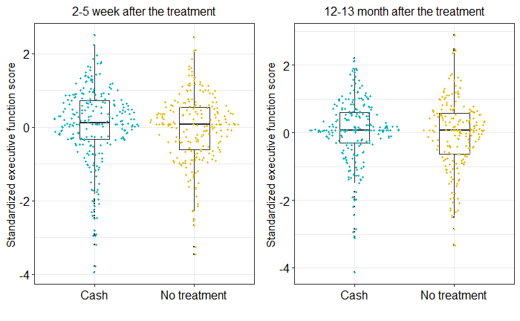
Figure 2. Standardized executive function scores in the Cash and the No treatment group in the short- and the long-term.

Robustness tests: multiverse approach
To assess the robustness of these results, we performed a multiverse analysis which involved “performing all analyses across the whole set of alternatively processed data sets corresponding to a large set of reasonable scenarios” ³⁶. We argue that the addition of a multiverse analysis is useful given that there are several choices (e.g., choosing of the dependent variables, transforming and coding the data and choosing the specific analysis techniques) which can influence the results. The multiverse analysis was exploratory as we did not have specific hypotheses for each analysis. Accordingly, we conducted multiple versions of the intent-to-treat analyses specified in the primary analysis section with six alternative analytical specifications (with and without control variables x three different priors), across 14 alternatively processed datasets (two exclusion criteria x seven imputation methods) predicting 14 different cognitive function measures as follows.
Alternative analytical specifications. We repeated all the analyses with and without the control variables (age, married or partnered, number of children in the household, years of schooling, having any disability, peer ex-combatant, weekly cash earnings, savings stock, working hours, selling drugs, using marijuana daily, using hard drugs daily, and committing theft in the past two weeks) and with three different priors: the effect size used in the primary analysis (b = 0.34), as well as half of the smallest effect size (b =0.09) and twice the largest effect size (b = 1.57) from the mini meta-analysis described above.
Alternatively processed datasets. Exclusion criteria for individuals: We repeated all analyses with two different exclusion criteria. First, we winsorized the continuous variables at the 99th percentile while we also excluded all individuals who did not achieve at least an 80% success rate in the arrow attention test. Second, we applied no exclusion criteria .
Handling of missing data: We repeated all analyses using the following imputation methods for outcome variables: 1) imputing the median value; 2) imputing missing dependent variables for the treatment (control) group as the found treatment (control) mean plus (minus) 0.10, 0.25, or 1 SD of the found treatment (control) distribution ³⁷.
Additional cognitive function measures and indexes. To further test the robustness and specificity of the findings in the primary analysis, we conducted the analyses separately for the six executive function measures which comprised the executive function index and ten alternative measures of cognitive function. As a result, the following dependent variables were included in the multiverse analysis: Executive function index; Arrow switching accuracy; Arrow switching RT; Arrow inhibition accuracy; Arrow inhibition RT; Arrow attention accuracy; Arrow attention RT; Arrow tasks RT index; Arrow tasks accuracy index; Digits Forward accuracy; Backward digits accuracy; Digit span index; Maze accuracy; Maze total completion time. The detailed description of the calculation of these measures can be found in the Appendix.
Summary results of the multiverse analysis
We conducted 2x392 Bayesian intent-to-treat regressions testing the robustness of the short-term and long-term results separately. Our goal was to explore how much the results change due to choices in the data processing and analysis, and furthermore to identify which choices have the strongest effect on the conclusions. The summary statistics for all 784 results can be found in the Appendix. To facilitate comprehension of these findings, we created two types of Figures. Figures 3 and 5 are descriptive specification curves ³⁷ that display the distribution of effect size estimates and 95% confidence intervals for each specification, enabling researchers to identify the most consequential analytical decisions. Figures 4 and 6 depict the robustness of the Bayes Factors to different priors.
Short-term results
Figure 3 implies that 78% of specifications lead to positive estimates, but 94.7% of the specifications yielded 95% confidence intervals that included zero. The bottom panel of the figure shows ^{see 37} that using alternative analytical specifications (with and without control variables) and alternatively processed datasets (applying exclusion criteria or not, and using seven different imputation methods) didn’t yield consistent change in the effect sizes. However, the way the cognitive performance was measured seemed to matter. The effect of cash transfers was always positive when executive functions were assessed with arrow switching accuracy, digits forward accuracy, or digit span index, but was mostly negative when measured by arrow switching RT, backward digits accuracy or maze task accuracy.

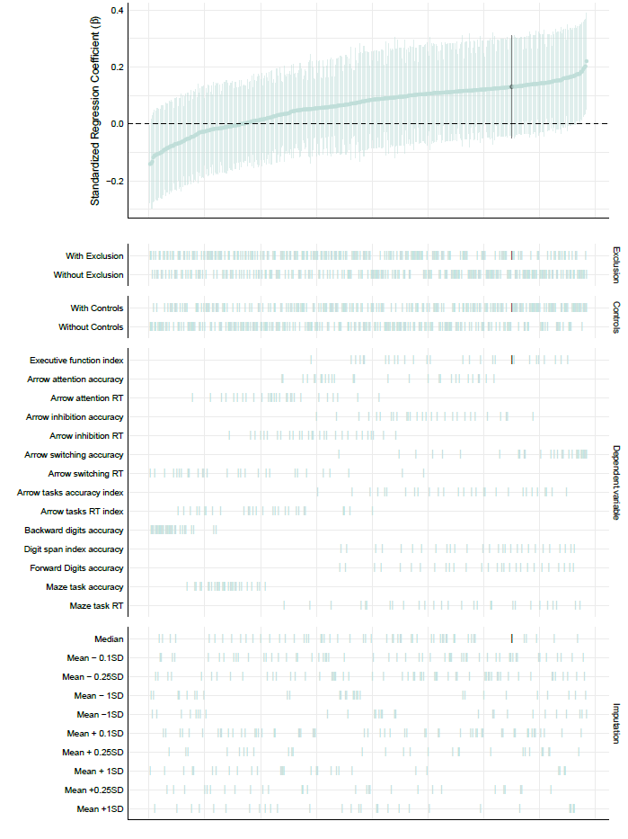
Figure 3. Descriptive specification curve depicting effect size estimates of the treatment (short-term). The dots in the top panel depict standardized effect sizes associated with 392 different specifications, each estimating the effect of cash transfers on cognitive performance 2-5 weeks after the treatment. The regions around the depicted dots show 95% confidence intervals.
Each row in the bottom panel corresponds to one analytical choice. The dots vertically aligned show the observed estimates when applying the given analytical choice, enabling readers to inspect the variance and magnitude of those estimates compared to other analytical choices. The black dot in the upper panel shows the result of primary analysis and the black lines in the bottom panel the corresponding specifications.
Visual inspection of Figure 4 suggests that the priors used in our analysis seem to affect the sign and strength of evidence. Using the small prior 100%, while using the planned prior 98%, of the Bayes Factors are between 10 and 1/10, however using large priors led to strong evidence (BF<1/10) for the null in 40% of the specifications.

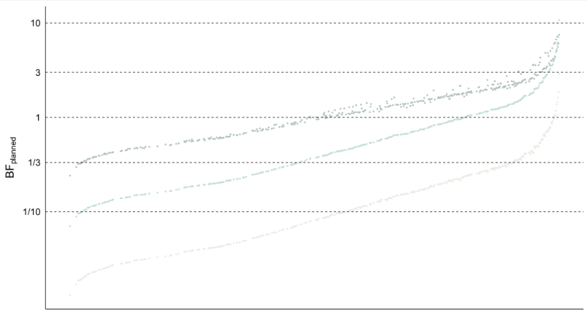
Figure 4. Robustness of the Bayes Factors to different priors (short-term). The figure shows the Bayes Factors associated with each of the 392 alternative specifications using the planned (0.34; middle dots), small (0.09; upper dots), and large (1.57, lower dots) priors.

Long-term results
Figure 5 shows that the estimated standardized effects vary both in the positive (60%) and the negative range (40%), and none of the specifications yielded confidence intervals not including 0. Alternative analytical specifications and alternatively processed datasets do not seem to change the effects consistently. However, similarly to the short-term results, the way the cognitive performance was assessed seems to matter. The impact of the cash transfer program was mostly positive when cognitive performance was assessed with arrow switching accuracy, digits forward accuracy, or digit span index, but was mostly negative when measured by arrow inhibition accuracy, maze task accuracy, and maze task RT.

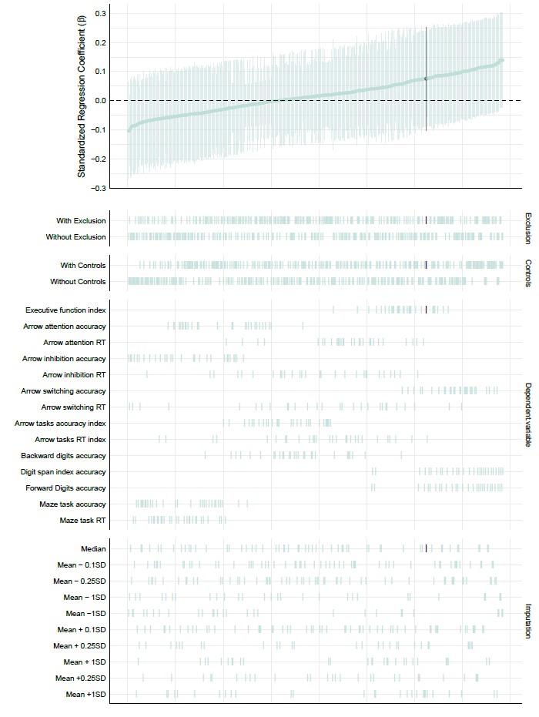
Figure 5. Descriptive specification curve depicting effect size estimates of the treatment (long-term). The dots in the top panel depict standardized effect sizes associated with 392 different specifications, each estimating the effect of cash transfers on the cognitive performance of the poor 12-13 months after the treatment. The regions around the depicted dots show 95% confidence intervals. Each row in the bottom panel corresponds to one analytical choice. The dots vertically aligned show the observed estimates when applying the given analytical choice, enabling readers to inspect the variance and magnitude of those estimates compared to other analytical choices.. The black dot in the upper panel shows the result of the primary analysis and the black lines in the bottom panel the corresponding specifications.
Visual inspection of Figure 6 suggests that the priors used in our analysis seem to affect the sign and strength of evidence. Using the planned prior 97%, while using the small prior 100% of Bayes Factors are between 10 and 1/10, however using large priors led to strong evidence for the null in the majority (72%) of the specifications.

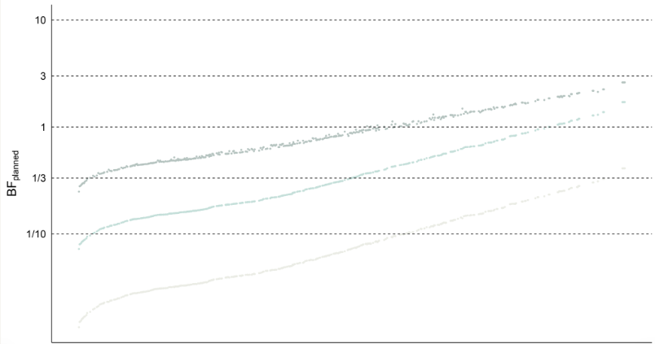
Figure 6. Robustness of the Bayes Factors to different priors (long-term). The figure shows the Bayes Factors associated with each of the 392 alternative specifications using the planned (0.34;middle dots), small (0.09; upper dots) and large (1.57, lower dots) priors.
Discussion
In this paper, we tested the effect of a lump-sum unconditional cash program equivalent to three months of income on the cognitive performance of an extremely poor population using data from a randomized controlled field experiment. We observed a small effect on executive functions both for the short (b = 0.13) and the long term (b = 0.08) toward the hypothesized positive direction, but the data provided inconclusive Bayesian evidence to support or reject the effectiveness of the intervention. Notably, the effects found in this study were roughly four times smaller than effect sizes observed in prior non-experimental research. Given the observed effect size, we would have needed a sample of 4750 participants to find strong Bayesian evidence.
The contrast between our results and those of prior studies could be the consequence of some mix of differences in the research design, sample of participants, administered cognitive function measures, and differences in the treatment. While we cannot conclude with certainty how these differences add up and interact, we can make a few observations which may put our findings into context.
First, while previously published studies used pre-post designs ^{3,13,16}, here the findings are based on a randomized controlled trial. Randomized controlled trials in general provide less biased estimates as the act of randomization balances both observed and unobserved characteristics of participants, allowing attribution of any differences in outcome between groups to be the effect of cash transfers ^{e.g., 38}.
Second, although individuals participating in the study were extremely poor, they were relatively homogeneous and unusual along some of their demographics. This may have influenced the effect in some unknown way: they were all male, from Liberia, between the ages of 18 and 35, and selected to be engaged in high levels of antisocial behavior as well as often homeless.
Third, we used paper and pencil or verbal versions of three different arrow tests, two different digit span tasks and a maze task to assess changes in cognitive functioning, while previous studies predominantly used computerized forms of cognitive control and intelligence tests ^{3,13,16}.
Fourth, in the present study, participants were provided with a lump-sum cash of $200. It is an open question how a larger cash treatment or a monthly installment instead of lump-sum money would have impacted the results. Previous results found that monthly payments vs. lump-sum money may have differential effects on people’s behavior ³⁹, while other studies have suggested that receiving insufficient cash transfers can have negative effects by making individuals needs more salient ⁴⁰.
Improper implementation of the treatment, or spillover effects, could have led to the relatively smaller effects, but we do not think that this was the case. Blattman et al.¹¹ found that the same treatment on the same participants had significant effects on several outcomes including crime, violence, lifestyle changes, and self-investment among others, and they found that these treatments combined with cognitive therapy even had significant effects after 10 years ⁴¹.
As a non-negligible portion of the participants showed signs of substance abuse, it could have also been that these people spent the extra cash on substances that had a deleterious effect on their cognition, diminishing the effect of the treatment. However, again, the data do not support this hypothesis. Information on marijuana and hard drug usage was collected in the 2-5 week and 12-13 month follow-up surveys. As Blattman et al. ¹¹ reports, neither marijuana nor hard drug usage was significantly affected by the cash treatment either in the short or in the long term (for detailed results see Table 6, p. 1190, Blattman et al., 2017). Finally, the fact that the cognitive function measures were administered as part of a 90 minute long questionnaire could have exhausted the participants leading to floor effects. However, our data showed no sign of ceiling or floor effects. In sum, future research should explore and hopefully reveal how different factors impact the efficiency of poverty alleviation interventions.
Finally, the multiverse results suggested that our estimates are robust to alternative analytical specifications, and to processing the dataset in different ways, however the magnitude and even the sign of the investigated effect was influenced by which executive function measure was applied. When measuring the accuracy of the arrow switching task, the digits forward task, or using the digit span index, the cash program showed larger, positive estimates consistently both for the short term and for the long term. Using the accuracy score from the maze task yielded smaller, negative estimates. The results showed a more varying pattern when using the other eight executive function measures. These findings suggest that the impact of cash transfers on cognitive function may vary by the type of cognitive function assessed. In particular, it is possible that cash positively impacts working memory more robustly than inhibitory control as working memory is assessed in the digit span index and is required for effective execution of the complex arrows-switching task. The effect of cash on the backward digit span test was negligible or even negative for the short-term, weakening this argument. However this hypothesis would be consistent with prior theories ⁴² which emphasized the possibility that the impact of increased cash availability on cognitive function is derived from a decrease in the need for individuals to attend to and thus be distracted by monetary concerns while performing cognitive tests. This enhanced need to attend to concerns related to money might be conceptualized as an additional working memory demand.
The question of when, why, and to what extent cash transfers affect cognition is far from being answered, which also reflects the limitations of our study. Future work should further examine how different magnitudes of cash transfers and the way they are distributed (lump sum vs. installments) affect cognitive performance; how different demographic characteristics (such as the level of money scarcity, cultural differences, or the strength of one’s social network) and the mode of task administration (online vs. onsite, computer vs. pencil based, oral vs. written) moderate the effect; whether working memory and inhibitory control are affected differently by cash transfers; and whether some specific forms of cognitive control or working memory respond more robustly to poverty alleviation.

Data and Code Availability
A de-identified and masked dataset and all the code used for data management and analysis will be openly available at the project’s OSF page (https://osf.io/qymaz/).
Deviations from the Stage 1 protocol:
We standardized the executive function index to make its results comparable with other results from prior findings and with the results of the multiverse analysis.
We added the following elements to the analysis code: code that creates a figure showing the results of the primary analysis; code exporting the statistical results to a csv file.
The following elements were part of the Stage 1 protocol, but we have only added them to the analysis code during Stage 2: calculation of the proportion of correct answers for each arrow task separately; the calculation of the Pearson correlation between reaction time and accuracy separately for each arrow task; exclusion criteria of individuals to test for floor and ceiling effect.

Competing interest statement
The authors declare no competing interests.
Acknowledgements
We would like to thank Balazs Aczel for the useful comments on this proposal, and Pal Kolumban for his help. We would like to thank Melinda Szrenka for continuous support in all aspects of the project. For financial support, we thank the National Science Foundation (SES-1317506), the World Bank’s Learning on Gender and Conflict in Africa (LOGiCA) trust fund, the World Bank’s Italian Children and Youth (CHYAO) trust fund, the UK Departmentfor International Development (DFID) via the Institute for the Study of Labor (IZA), a Vanguard Charitable Trust,the American People through the United States Agency for International Developments (USAID) DCHA/CMMoffice, and the Robert Wood Johnson Health and Society Scholars Program at Harvard University (Cohort 5). The funders have/had no role in study design, data collection, and analysis, decision to publish or preparation of the manuscript.
Author contributions
BS developed the first version of the hypotheses, analysis plan and wrote the first version of the manuscript. KT, SP, GN and PB have contributed to the improvement of the analysis plan and provided suggestions to the manuscript. PB wrote the script for the Bayes Factor calculation, SP prepared the mini-metaanalysis, while GN wrote the rest of the analysis script. SP and BS created the figures. CB, JJ, and MS were responsible for the design of the randomized controlled trial, data collection, as well as supervised and provided suggestions on the hypotheses, analyses plan, and the manuscript of the Registered Report.
Data handling prior to the submission of the Registered Report
Prior to the submission of the present manuscript, no confirmatory or exploratory analysis were conducted by BS, AT and GN. BS and AT have gained access to the data in December 2019 while GN downloaded the data in February 2020. CB, JJ, and MS had access to data immediately after it was collected. SP didn’t have access to the raw data. At the time of publishing Blattman et al. ¹¹, CB, JJ, and MS did not hypothesize change in executive functions, thus no analyses had been carried out and published on the topic of the present paper beyond a preliminary analyses discussed in Table D7 in the online Appendix of Blattman et al. ¹¹, which reports the programs’ 12-13 months impact on a narrow set of cognitive measures.

References
1. Feinstein, L. Inequality in the early cognitive development of British children in the 1970 cohort. Economica 70, 73–97 (2003).
2. Hurley, R. L. Poverty and Mental Retardation: A Causal Relationship. (1969).
3. Mani, A., Mullainathan, S., Shafir, E. & Zhao, J. Poverty impedes cognitive function. science 341, 976–980 (2013).
4. Oasis, K.-T. & Remy, B.-L. Poverty and intelligence: Evidence using quantile regression. (2014).
5. Shah, A. K., Mullainathan, S. & Shafir, E. Some consequences of having too little. Science 338, 682–685 (2012).
6. Szaszi, B., Szécsi, P. & Aikaterini, T. The effect of poverty on cognitive performance: a systematic review and meta-analysis of the causal evidence. Manuscript (2022).
7. Bishop, J. The impact of academic competencies on wages, unemployment, and job performance. in Carnegie-Rochester Conference Series on Public Policy vol. 37 127–194 (Elsevier, 1992).
8. Cawley, J., Heckman, J. & Vytlacil, E. Three observations on wages and measured cognitive ability. Labour Econ. 8, 419–442 (2001).
9. McKenna, B. S., Dickinson, D. L., Orff, H. J. & Drummond, S. P. The effects of one night of sleep deprivation on known‐risk and ambiguous‐risk decisions. J. Sleep Res. 16, 245–252 (2007).
10. Dean, E. B., Schilbach, F. & Schofield, H. Poverty and cognitive function. in The economics of poverty traps 57–118 (University of Chicago Press, 2018).
11. Blattman, C., Jamison, J. C. & Sheridan, M. Reducing crime and violence: Experimental evidence from cognitive behavioral therapy in Liberia. Am. Econ. Rev. 107, 1165–1206 (2017).
12. Wicherts, J. M. & Scholten, A. Z. Comment on “Poverty impedes cognitive function”. Science 342, 1169–1169 (2013).
13. Carvalho, L. S., Meier, S. & Wang, S. W. Poverty and economic decision-making: Evidence from changes in financial resources at payday. Am. Econ. Rev. 106, 260–84 (2016).
14. Mani, A., Mullainathan, S., Shafir, E. & Zhao, J. Scarcity and Cognitive Function around Payday: A Conceptual and Empirical Analysis. J. Assoc. Consum. Res. 5, (2020).
15. Kaur, S., Mullainathan, S., Oh, S. & Schilbach, F. Does Financial Strain Lower Productivity? (2019).
16. Ong, Q., Theseira, W. & Ng, I. Y. Reducing debt improves psychological functioning and changes decision-making in the poor. Proc. Natl. Acad. Sci. 116, 7244–7249 (2019).
17. Dean, E. B., Schilbach, F. & Schofield, H. Poverty and cognitive function. in The economics of poverty traps 57–118 (University of Chicago Press, 2017).
18. Haushofer, J. & Fehr, E. On the psychology of poverty. Science 344, 862–867 (2014).
19. Mullainathan, S. & Shafir, E. Scarcity: Why having too little means so much. (Macmillan, 2013).
20. Ridley, M. W., Rao, G., Schilbach, F. & Patel, V. H. Poverty, Depression, and Anxiety: Causal Evidence and Mechanisms. 370, (2020).
21. Bessone, P., Rao, G., Schilbach, F., Schofield, H. & Toma, M. The economic consequences of increasing sleep among the urban poor. (2020).
22. Grandner, M. A. et al. Who gets the best sleep? Ethnic and socioeconomic factors related to sleep complaints. Sleep Med. 11, 470–478 (2010).
23. Chou, E. Y., Parmar, B. L. & Galinsky, A. D. Economic insecurity increases physical pain. Psychol. Sci. 27, 443–454 (2016).
24. Afridi, F., Barooah, B. & Somanathan, R. Hunger and Performance in the Classroom. (2019).
25. Jones, N. & Rogers, P. J. Preoccupation, food, and failure: an investigation of cognitive performance deficits in dieters. Int. J. Eat. Disord. 33, 185–192 (2003).
26. Newman, A. Faith, identity, status and schooling: An ethnography of educational decision-making in northern Senegal. (University of Sussex, 2016).
27. Adeyeye, S. A. O., Adebayo-Oyetoro, A. O. & Tiamiyu, H. K. Poverty and malnutrition in Africa: a conceptual analysis. Nutr. Food Sci. (2017).
28. Leibenstein, H. Economic backwardness and economic growth. (1957).
29. McKenzie, D. Beyond baseline and follow-up: The case for more T in experiments. J. Dev. Econ. 99, 210–221 (2012).
30. Strauss, J., Witoelar, F. & Sikoki, B. The fifth wave of the Indonesia family life survey: overview and field report. vol. 1 (RAND Santa Monica, CA, 2016).
31. Korkman, M., Kirk, U. & Kemp, S. NEPSY II: Clinical and interpretive manual. (Harcourt Assessment, PsychCorp, 2007).
32. Dienes, Z. Bayesian versus orthodox statistics: Which side are you on? Perspect. Psychol. Sci. 6, 274–290 (2011).
33. Lee, M. D. & Wagenmakers, E.-J. Bayesian cognitive modeling: A practical course. (Cambridge University Press, 2014).
34. Dienes, Z. & Mclatchie, N. Four reasons to prefer Bayesian analyses over significance testing.
Psychon. Bull. Rev. 25, 207–218 (2018).
35. Schönbrodt, F. D. & Wagenmakers, E.-J. Bayes factor design analysis: Planning for compelling evidence. Psychon. Bull. Rev. 25, 128–142 (2018).
36. Steegen, S., Tuerlinckx, F., Gelman, A. & Vanpaemel, W. Increasing transparency through a multiverse analysis. Perspect. Psychol. Sci. 11, 702–712 (2016).
37. Karlan, D., Knight, R. & Udry, C. Consulting and capital experiments with microenterprise tailors in Ghana. J. Econ. Behav. Organ. 118, 281–302 (2015).
38. Hariton, E. & Locascio, J. J. Randomised controlled trials—the gold standard for effectiveness research. BJOG Int. J. Obstet. Gynaecol. 125, 1716 (2018).
39. Haushofer, J. & Shapiro, J. The short-term impact of unconditional cash transfers to the poor: experimental evidence from Kenya. Q. J. Econ. 131, 1973–2042 (2016).
40. Jaroszewicz, A., Jachimowicz, J., Hauser, O. & Jamison, J. How Effective Is (More) Money? Randomizing Unconditional Cash Transfer Amounts in the US. Randomizing Unconditional Cash Transf. Amounts US July 5 2022 (2022).
41. Blattman, C., Chaskel, S., Jamison, C. J. & Sheridan, M. Cognitive behavior therapy reduces crime and violenceover 10 years: Experimental evidence. (2022) doi:10.31235/osf.io/q85ux.
42. De Bruijn, E.-J. & Antonides, G. Poverty and economic decision making: a review of scarcity theory. Theory Decis. 1–33 (2021).

Indeed when the present study was originally designed in 2009, the authors did not expect an effect on cognitive performance. Cognitive functioning was assessed to obtain an exhaustive list of baseline measures.
Most individuals in the no treatment group received US$10 as a consolation prize. This was true for the 899 participants in Phases 2 and 3 but not the 100 individuals in Phase 1.
For those in the therapy group the 8-week long therapy started one week after the random assignment. The Sustainable Transformation of Youth in Liberia, a cognitive behavioral therapy informed program, was a psychological treatment and aimed to have a lasting effect on the participants' life in two main domains. First, it tried to encourage future orientation instead of present-biased behavior. Second, it aimed to help participants self-identify as a normal society member by exercising behavioral patterns which are characteristic of mainstream identity.
During the preparation of the project, we interviewed a group of local individuals about the start-up cost of a small enterprise estimating the range between $75 and $125. We also assumed that people have other spending pressures and precautionary saving motives. That, combined with our budget constraints is how the $200 was determined.
Note, that in the pilot phase, instead of the 2 and 5 week surveys, there was only a 3 week survey. The exact average time for conducting the surveys after the grants were 2.2, 5.7, 55.4, and 61.1 weeks.
The sample size was calculated using the BFDA parameters detailed above.

