**Revisiting celebrity contagion and the value of objects:**

**Replication and extensions Registered Report of Newman et al. (2011)**

**[Stage 1]**

Mannix Chan  
ORCID: 0000-0001-9699-9522  
Department of Psychology, University of Hong Kong  
[mannix42@connect.hku.hk](mailto:mannix42@connect.hku.hk) / [mannixchan@proton.me](mailto:mannixchan@proton.me)

*Yaqi Jin  
ORCID: 0000-0001-6745-7599  
 Department of Psychology, University of Amsterdam  
 [yvonne27hku@gmail.com](mailto:yvonne27hku@gmail.com)

*Eva Yiyu Chen  
ORCID: 0000-0003-4675-9445  
University of Chicago Booth School of Business  
[cyy11292018@outlook.com](mailto:cyy11292018@outlook.com)

*Shanshan Peng  
 School of Statistics and Actuarial Science, University of Hong Kong, Hong Kong SAR  
 [dbl3peng@connect.hku.hk](mailto:dbl3peng@connect.hku.hk) / [larissapeng@outlook.com](mailto:larissapeng@outlook.com)

Aaron Charlton  
ORCID: 0000-0001-8384-3852

[aaronbcharlton@gmail.com](mailto:aaronbcharlton@gmail.com)

^Gilad Feldman  
ORCID: 0000-0003-2812-6599  
University of Hong Kong  
gfeldman@hku.hk / giladfel@gmail.com

* Contributed equally, joint second author

^ Corresponding author

**Author bios**

Mannix Chan is a research assistant with the University of Hong Kong Psychology department.

Yaqi Jin, Eva Yiyu Chen, and Shanshan Peng were students at the University of Hong Kong during the academic year 2022.

Aaron Charlton is an independent researcher, science blogger, and entrepreneur.

Gilad Feldman is an assistant professor with the University of Hong Kong Psychology department. His research focuses on judgment and decision-making.

**Declaration of Conflict of Interest**

The authors declare no potential conflicts of interest with respect to the authorship and/orpublication of this article.

**Financial disclosure/funding**

The project was supported by the University of Hong Kong Teaching Development Grant awarded to Gilad Feldman.

**Authorship declaration**

Mannix Chan, Yaqi Jin, Eva Yiyu Chen, and Shanshan Peng designed the initial study, developed the experimental materials for each study respectively and wrote an initial draft of the Registered Report Stage 1. Aaron Charlton did an initial editing of the Registered Report Stage 1 draft.

Mannix Chan took the lead over the project, redid the survey design and analyses, finalized the materials and analysis scripts, wrote the manuscript for submission, and addressed reviewer feedback.

Eva Yiyu Chen and Aaron Charlton provided feedback and reviewed drafts for the current project.

Gilad Feldman supervised and guided each step in the project, ran the data collection, conducted the pre-registration, and edited the manuscript for submission and the reply to reviewer feedback.

**Rights**

CC BY or an equivalent license is applied to the AAM arising from this submission. ([clarification](https://bit.ly/rrs-primer))

**Acknowledgements**

We thank Burak Tunca (ORCID: 0000-0001-6381-2979) for reviewing and providing comments on a previous version of this article’s PCIRR Stage 1 submission.  
We thank Prof. Newman for the support and materials provided.

**Citation of the original article**

Newman, G. E., Diesendruck, G., & Bloom, P. (2011). Celebrity Contagion and the Value of Objects. *Journal of Consumer Research, 38*(2), 215–228. <https://doi.org/10.1086/658999>

# Contributor Roles Taxonomy

|  |  |  |  |  |  |
| --- | --- | --- | --- | --- | --- |
| **Role** | **Mannix Chan** | **Yaqi Jin Shanshan Peng** | **Eva Yiyu Chen** | **Aaron Charlton** | **Gilad Feldman** |
| Conceptualization | X |  |  |  | X |
| Pre-registration | X | X | X |  | X |
| Data curation |  |  |  |  | X |
| Formal analysis | X | X | X |  |  |
| Funding acquisition |  |  |  |  | X |
| Investigation | X | X | X |  |  |
| Pre-registration peer review / verification |  | X | X | X | X |
| Data analysis peer review / verification |  | X | X | X |  |
| Methodology | X |  |  |  |  |
| Project administration |  |  |  |  | X |
| Resources |  |  |  |  | X |
| Software | X | X | X |  |  |
| Supervision |  |  |  |  | X |
| Validation |  |  |  | X | X |
| Visualization | X | X | X |  |  |
| Writing-original draft | X |  |  |  |  |
| Writing-review and editing |  |  | X | X | X |

# 

# PCIRR-Study Design Table

|  |  |  |  |  |  |  |
| --- | --- | --- | --- | --- | --- | --- |
| Question | Hypothesis | Sampling plan | Analysis plan | Rationale for deciding the sensitivity of the test for confirming or disconfirming the hypothesis | Interpretation given different outcomes | Theory that could be shown wrong by the outcomes |
| Experiment 1 replication: Do fame and valence impact item valuation? | H1a/b: There are main effects for valence and fame, but no interaction. | This study aims to recruit at least 1200 participants online via Prolific. | Two-way between-subjects ANOVA | Power analyses indicate that this planned sample size should be well-powered enough  to detect effects  much weaker  than the smallest  effects in the  target article. See the power  analysis section of this manuscript. | We interpreted replication results based on criteria in LeBel et al. (2019) by comparing our replication effect sizes and confidence intervals to the original effect sizes in the target article.  We concluded a successful replication if both studies showed a signal in the same direction as the original study by Newman et al. (2011), a failed replication if none of the studies showed a signal in the same direction as the original, and one out of two to be a mixed results replication. | Contagion theory. That people value objects differently, depending on fame and valence, and associated with desire for physical touch. |
| Experiment 1 replication: Do fame and valence impact desire for physical contact and market demand? | H2b: There is a main effect for valence on desire for physical contact.  H3a: There is a main effect for fame on market demand. | Two-way between-subjects ANOVA. |
| Experiment 2 replication:  Do valence and physical contact impact willingness to purchase celebrity item? | H7c: There is an interaction between valence and physical contact on willingness to purchase.  H8c: There is a main effect of market demand on willingness to purchase (regardless of valence) | Two two-way between-subjects ANOVAs, once for physical contact and once for market demand |
| Experiment 1 Extension: Do fame and valence impact desire for non-physical contact and market demand? | H2b: There is a main effect for valence on desire for non-physical contact. | Two-way between-subjects ANOVAs |

# Abstract

[IMPORTANT: The abstract, method, and results sections were all written using a randomized dataset produced by Qualtrics to simulate what these sections will look like after data collection. These will be updated following the actual data collection. No pre-registration or data collection has actually taken place yet.]

Why are people willing to pay more for items previously owned by famous people? One possible explanation, first examined by Newman et al. (2011), is the contagion effect, the idea that people believe the objects contain “remnants” of their previous owners. In a Registered Report with a US online Prolific sample (*N* = 1200), we conducted a replication and extension of Experiments 1 and 2 from Newman et al. (2011).

[The following section will be updated after data collection.]

Materials, data, and code are available on: <https://osf.io/3kmr9/> .

*Keywords:* contagion effect; judgment and decision making; registered report; replication; proximity effect; consumer behavior; marketing

# 

# Revisiting Celebrity contagion and the value of objects: Replication and extensions Registered Report of Newman et al. (2011) [Stage 1]

[IMPORTANT: Section is written in the past tense to simulate what the manuscript will look like after data collection, yet no pre-registration or data collection took place yet.]

## Background

Objects that were previously owned by famous celebrities tend to fetch high prices at auctions. A pair of sneakers once worn by Kanye West was sold for 1.8 million US dollars in April 2021, making it the most expensive pair of sneakers that have ever been sold (Kennedy, 2021). Objects that seem to have no intrinsic value may also sell for high prices: a broken tennis racket used by Serena Williams during the 2018 US Open final against Osaka Naomi was sold for 20,910 US dollars at auction (Lane, 2019). Curiously, items that were owned by people who are widely reviled can also fetch high prices; the personal items of Ted Kaczynski (known as the Unabomber) were sold for around 190,000 US dollars (NBC News, 2011), and one of Hitler’s Mercedes sold for almost 5 million British pounds (around 7 million US dollars) (Lacitis, 2018). It seems clear that these objects have a high price tag attached to them not just because of their intrinsic properties, but more importantly due to their association with their previous owners and what those objects represented.

Newman et al. (2011) raised three possible explanations for the high valuation of celebrity items. The first is the mere association with celebrities, meaning thatobjects previously owned by celebrities could be more valuable simply because they remind us of their previous owners. Thus, the extrinsic value of the object is that it would serve as a physical reminder to the special memories that the owner of that object has related to that celebrity, which the owner would want to protect (Zauberman et al., 2009). However, the authors also state that if this were to be the case, “objects belonging to individuals who are explicitly disliked should carry no value at all” since the association with the celebrity will then be unwanted, and the reason behind why people will pay money for their possessions will be because they “admire [these] individuals [who are generally explicitly disliked…] for whatever reason”.

The second explanation is the perceived market demand for these objects. People may be willing to pay more for a celebrity possession simply because they believe others will purchase it from them at a higher price due to its previous association with the celebrity. The commodity effect states that anything that can be possessed, and is useful to the person possessing it, will be valued according to several criteria — including scarcity (Brock, 1968; Lynn, 1992). Simply making an item more scarce or increasing its unavailability can cause a corresponding increase in its subjective value (and thus price) for others. Therefore, people may be more likely to pay higher prices for these items simply due to how scarce these items are, with the assumption that other people will pay more for these items later on; simple market forces cause these items to have a value of their own. However, the authors note (and we concur) that there is a circularity to this explanation — people pay more because people pay more. It fails to explain the initial demand, or the reason why others would be willing to pay more. Despite these limitations, it is logical that people will pay more for something that they can resell at a higher price later, and this makes sense as a partial explanation for the phenomenon.

The last explanation is contagion, the belief that an “immaterial essence” of the objects’ previous owner can be transmitted to the object through physical contact, and Newman et al. (2011) argues that this explanation is the critical factor in why people place a higher valuation on objects owned by celebrities. They sought to disambiguate these three potential drivers of higher valuation of celebrity-owned items: mere association measured by liking, contagion measured by desire for physical contact, and market value measured by market demand. They concluded that the desire for physical contact appeared to be the strongest driver of the effect.

We report a close replication and extensions Registered Report of sections of Experiments 1 and 2 in Newman et al. (2011) with the following goals: (1) to conduct an independent replication of the contagion effect on celebrity items, and (2) to build on their work by adding extensions examining the role of proximity in the contagion effect.

We begin by reviewing the literature on contagion theory, then discuss our motivation for the current replication study and the target’s hypotheses and study design, and conclude with our replication and extension design, needed adjustments, and added extensions.

## Contagion theory

Contagion is a form of magical thinking in which people believe that “things that once have been in contact with each other may influence each other through transfer of some of their properties via an immaterial ‘essence’” (Rozin et al., 1986). This concept was first introduced into scientific literature by anthropologists in the late 19th century (Nemeroff and Rozin, 1994), and was used to describe various indigenous peoples’ beliefs about how things that come into physical contact with another object can transfer their properties with each other by means of a transferral of a “soul” or “mana.” This process is analogous to and is thought to have derived from a biological defense system against how germs and pathogens infect the body (Nemeroff and Rozin, 1994).

The contagion effect is manifest in people who seek to avoid previously “neutral” objects after they have come in contact with negative sources, such as a disliked person, and in people who are attracted to items that have come into contact with positive sources, such as a person they are sexually attracted to (Rozin et al., 1986). In consumer contexts, it has been found that shoppers will rate clothing that has previously been touched by other people as less favorable than clothing that has not been touched (Argo et al., 2006), but the reverse effect happens when the person that previously touched the clothing was an attractive salesperson of the opposite sex (Argo et al., 2008). In the case of celebrities, it has also been shown that the degree of physical contact a celebrity has had with an object is positively correlated to the amount of money that people are willing to pay for it in a real-life context (Newman & Bloom, 2014).

In more recent years, a growing body of literature has examined factors that influence contagion. The activation of contagion is related to contextual cues such as product attributes (Di Muro & Noseworthy, 2013), packages (White et al., 2016), spatial orientation (Castro et al., 2013; Savani et al., 2011; Newman & Dhar, 2014; Kim & Kim, 2011), and temporal proximity (Smith et al. 2016). For instance, Castro et al. (2013) discovered that consumers tend to think that fewer people touched well-organized products on shelves than disorganized products. Smith et al. (2016) revealed that products with smaller serial numbers are considered to be “closer” to artists, and consumers have a higher preference for them.

Contagion has also been shown to correlate with an individual’s confidence, dispositional judgments of others, and persuasive power (Kramer & Block 2014; Lee et al., 2011; Hingston et al., 2017; Hasford et al., 2015). For instance, people believe that their own athletic abilities will increase when they use objects that have physical contact with star athletes (Kramer & Block, 2014). Children value celebrity possessions because of contagion and need to substantiate their sense of self through contagion to objects (Diesendruck & Perez, 2015; van Gerven et al., 2018).

## Choice of article for replication: Newman et al. (2011)

We chose to replicate Newman et al. (2011) because of its impact and the potential in improving on its reproducibility, clarity, methods, and reporting.

(2011)’s findings have had substantial impact on scholarly research in consumer behavior, social psychology, and behavioral economics and at the time of writing (July 2024), the article was cited 388 times (according to Google Scholar). Following the recent growing recognition of the importance of reproducibility and replicability in psychological science (Nosek et al., 2022), we aimed to revisit the first two studies of Newman et al. (2011) by conducting a close, independent, and well-powered replication and extensions Registered Report.

Whether and how contagion predicts valuation is still under debate. Some research suggested that the association and contagion accounts are not independent because the latter can be partially explained by the former (Nemeroff & Rozin, 1994; Rozin & Nemeroff, 2002, cited in Fedotova & Rozin, 2018). Specifically, imagining the target objects in contact with a contagion source facilitates the formation of an association between the two entities, and the interaction between the two influences the purchase intention of consumers (Fedotova & Rozin, 2018). Much research documented the value people give to items associated with celebrities (Jaffe & Aaron, 2005; Escalas & Bettman, 2009; Pfarrer et al., 2010), yet Newman et al. (2011) were among the first to contrast possible reasons underlying the phenomenon, trying to reconcile the association account, perceived market demand, and contagion.

Follow-up articles include Newman and Bloom (2012), which extended the concepts of celebrity contagion to artwork, showing that perfect duplicates of art are less valuable than the original due to contagion, and Newman and Bloom (2014), which continued to explore the contagion effect with actual auction data, demonstrating that collectors’ willingness to pay is affected by the perceived physical contacts of a celebrity with an object. To the best of our knowledge, there are no published direct replications of this article thus far.

Going beyond scholarly impact, the findings by Newman et al. (2011) also hold the potential for practical implications. Within the commercial context, luxury brands may increase the valuation of their products by highlighting contagion with artistic creators (Dion & Arnould, 2011), original manufacturing locations (Arora et al., 2018; Newman & Dhar, 2014), and the craftsmen (Fuchs et al., 2015). Outside of mainstream commerce, the value of contagion with black metal musicians also motivates dark tourism (Podoshen, 2013).

## 

## Main hypotheses and analyses in the target article for replication

Newman et al. (2011) consisted of three studies conducted online with questionnaires, and we focused the scope of our replication to sections of Experiments 1 and 2 in Newman et al. (2011) to revisit the core findings in the target article. We felt that Experiment 3 would be best to tackle separately, and only after a successful replication of Experiments 1 and 2, given that it involved an indirect activation priming procedure and resulted in much weaker effects[1].

We summarized all hypotheses in Table 1, with our identified core hypotheses and analyses targeted for replication in bold[2]. Of all tested ideas in the target article, the key findings related to the idea that desire for physical contact and pleasantness of wearing, as representations of contagion, showed a more similar pattern of effects with item valuation and willingness to purchase than measures and manipulations of market demand.

Contrasting the three possible explanations, Experiment 1 concluded that associations “do not appear to play a significant role” in how possessions are valued by participants, whereas both market demand and desire for physical contact were associated with item valuation in different ways depending on the valence or fame of the person. The authors tested the main effects and interaction of moral valence (positive, negative, mixed) and fame (celebrity versus non-celebrity) on item valuation, desire for physical contact, and market demand. Item valuation was the main dependent variable, and they reported finding support for main effects of both the manipulations of valence and fame, with no interaction. They then showed that the valence manipulation also impacted desire for physical contact but not market demand, and that the fame manipulation also impacted market demand but not desire for physical contact.

In Experiment 2, they examined the impact of moral valence (positive versus negative) and degree (highlighted versus decreased) on willingness to purchase and pleasantness of wearing, once for physical contact and once for market demand. They found support for an interaction between valence and degree over willingness to purchase only for physical contact but not for market demand where highlighting demand always led to higher willingness. The pattern they found for pleasantness of wearing seemed closer to willingness to purchase for the manipulation of physical contact than for market demand.

###### **Table 1** *Summary of hypotheses, findings of Newman et al. (2011) and our replication, and comparison interpretation*

| Exp | Variable | H# | Main effect / interaction | Target article  findings | Target article stats | Target article effects (*η2*) | Replication stats | Replication effects (*η2*) | Comparison interpretation |
| --- | --- | --- | --- | --- | --- | --- | --- | --- | --- |
| 1 | Item valuation [main] | **H1a**  **H1b**  H1c | **Main effect for fame**  **Main effect for valence**  No interaction. | **Higher for celebrities**  **Higher for positive**  N/A | ***F*(1, 211) = 11.42**  ***F*(1, 211) = 29.48**  N/A | **0.05 [0.01, 0.11]**  **0.22 [0.14, 0.30]**  N/A | ***F*(X, XXX) = XX.XX *F*(X, XXX) = XX.XX** *F*(X, XXX) = XX.XX | **X.XX [X.XX, X.XX] X.XX [X.XX, X.XX]** X.XX [X.XX, X.XX] | Signal/direction  Signal/direction  Signal/direction |
|  | Desire for physical contact | H2a  **H2b**  H2c | Main effect for fame  **Main effect for valence**  Fame x valence interaction | N/A  **Higher for positive**  Interaction: Positive: celebrity higher Mixed/negative: celebrity lower | N/A  ***F*(1, 211) = 66.55**  *F*(2, 211) = 3.12 | N/A  **0.39 [0.30, 0.47]**  0.03 [0.00, 0.07] | *F*(X, XXX) = XX.XX  ***F*(X, XXX) = XX.XX**  *F*(X, XXX) = XX.XX | X.XX [X.XX, X.XX]  **X.XX [X.XX, X.XX]**  X.XX [X.XX, X.XX] | Signal/direction  Signal/direction  Signal/direction |
|  | Market demand | **H3a**  H3b  H3c | **Main effect for fame**  Main effect for valence  Fame x valence interaction | **Higher for celebrities**  N/A  Interaction:  Only celebrities had valence main effect - higher for positive. | ***F*(1, 211) = 328.06**  N/A  *F*(2, 211) = 5.08 | **0.61 [0.53, 0.67]**  N/A  0.05 [0.01, 0.10] | ***F*(X, XXX) = XX.XX**  *F*(X, XXX) = XX.XX  *F*(X, XXX) = XX.XX | **X.XX [X.XX, X.XX]**  X.XX [X.XX, X.XX]  X.XX [X.XX, X.XX] | Signal/direction  Signal/direction  Signal/direction |
|  |  | H4 | Mediation from fame x valence to item valuation: All variables | Weak to no effects, and correlational, therefore not examined in the replication | N/A | N/A | N/A | N/A |  |
|  | Liking | H5a H5b H5c | Main effect for fame  Main effect for valence  Fame x valence interaction | Higher for celebrities Higher for positive None | N/A | N/A | *F*(X, XXX) = XX.XX  *F*(X, XXX) = XX.XX  *F*(X, XXX) = XX.XX | X.XX [X.XX, X.XX]  X.XX [X.XX, X.XX]  X.XX [X.XX, X.XX] |  |
|  | Historical significance | H6a H6b h6c | Main effect for fame  Main effect for valence  Fame x valence interaction | N/A | N/A | N/A | *F*(X, XXX) = XX.XX  *F*(X, XXX) = XX.XX  *F*(X, XXX) = XX.XX | X.XX [X.XX, X.XX]  X.XX [X.XX, X.XX]  X.XX [X.XX, X.XX] |  |
|  |  |  |  |  |  |  |  |  |  |
| 2 | **Willingness to purchase a celebrity item**  [main] | H7  H7a  H7b **H7c** | Physical contact:  Main effect for valence  Main effect for physical contact  **Valence x physical contact interaction** | N/A  N/A **Interaction.** Positive:  highlight contact->higher willingness; decreased contact->lower willingness. Negative:  highlight contact->lower willingness; decreased contact->higher willingness. | N/A  N/A  ***F*(1, 219) = 16.77**  *F*(1, 111) = 17.43  *F*(1, 118) = 2.69 | N/A  N/A  **0.07 [0.03, 0.13]**  0.13 [0.05, 0.24]  0.02 [0.00, 0.09] | *F*(X, XXX) = XX.XX  *F*(X, XXX) = XX.XX  ***F*(X, XXX) = XX.XX**  *F*(X, XXX) = XX.XX  *F*(X, XXX) = XX.XX | X.XX [X.XX, X.XX]  X.XX [X.XX, X.XX]  **X.XX [X.XX, X.XX]**  X.XX [X.XX, X.XX]  X.XX [X.XX, X.XX] | Signal/direction  Signal/direction  Signal/direction  Signal/direction  Signal/direction |
|  | Willingness to purchase a celebrity item | H8  H8a  H8b H8c | Market demand:  Main effect for valence  Main effect for market demand  Valence x market demand interaction | N/A  N/A Interaction. Positive:  highlight demand->higher willingness; decreased demand->lower willingness. Negative:  highlight demand->higher willingness; decreased demand->lower willingness | N/A  N/A N/A  *F*(1, 118) = 8.35   *F*(1, 108) = 21.24 | N/A  N/A N/A  0.06 [0.01, 0.15]   0.16 [0.07, 0.28] | *F*(X, XXX) = XX.XX  *F*(X, XXX) = XX.XX  *F*(X, XXX) = XX.XX  *F*(X, XXX) = XX.XX  *F*(X, XXX) = XX.XX | X.XX [X.XX, X.XX]  X.XX [X.XX, X.XX]  X.XX [X.XX, X.XX]  X.XX [X.XX, X.XX]  X.XX [X.XX, X.XX] |  |
| 2 | Pleasantness of wearing | H9  H9a  H9b H9c | Physical contact:  Main effect for valence  Main effect for physical contact  Valence x physical contact interaction | N/A  N/A Interaction. Positive:  highlight contact->higher pleasure; decreased contact->lower pleasure. Negative:  highlight contact->lower pleasure; decreased contact->higher pleasure. | N/A  N/A N/A  *F*(1, 111) = 12.46  *F*(1, 108) = 12.26 | N/A  N/A N/A  0.10 [0.03, 0.20]   0.10 [0.03, 0.20] | *F*(X, XXX) = XX.XX  *F*(X, XXX) = XX.XX  *F*(X, XXX) = XX.XX  *F*(X, XXX) = XX.XX  *F*(X, XXX) = XX.XX | X.XX [X.XX, X.XX]  X.XX [X.XX, X.XX]  X.XX [X.XX, X.XX]  X.XX [X.XX, X.XX]  X.XX [X.XX, X.XX] |  |
| 1 | Extension:  Desire for non-physical contact | H8a  H8b  H8c | Main effect for fame  Main effect for valence  Fame x valence interaction | Exploratory extension:  Our expectations mirror H2.  Interaction: Positive: celebrity higher Mixed/negative: celebrity lower | Exploratory extension | Exploratory  extension | *F*(X, XXX) = XX.XX  *F*(X, XXX) = XX.XX  *F*(X, XXX) = XX.XX | X.XX [X.XX, X.XX]  X.XX [X.XX, X.XX]  X.XX [X.XX, X.XX] |  |

Effect sizes were not reported in the target article, and we calculated those from the available statistics. We report 90% CIs for η2 effect sizes throughout this article as these are equivalent to an .05 alpha (Steiger, 2004; Lakens, 2014).   
Comparison interpretation uses a modified version of the criteria in LeBel et al. (2019).   
We bolded the analyses that we identified as being key to the arguments made by the target article.

## Extension: Desire to have non-physical contact

We added an extension to also examine the desire to have non-physical contact. We summarized the extension hypotheses in Table 2.



## 

(2016) found that even the serial number of an object can carry the contagion effect, as earlier serial numbers signal being “temporally closer to the origin (e.g., the designer or artist who produced it)” than later numbers, even when the level of physical contact was controlled for. They referred to the example of original vinyl pressing of the Beatles’ *White Album*; approximately three million were produced, making its scarcity relatively low, but vinyls with earlier serial numbers were sold for higher prices than did those with later ones. Huang et al. (2017) suggested that future research on the concept of contagion can focus on aspects of the process that may drive the contagion effect, such as physical contact, to “broaden and deepen existing models of contagion”.

We therefore aimed to extend the replication by further examining the role of physical contact: whether the desire to have physical contact with the person is needed for the contagion effect to manifest, or whether it can be a desire to have non-physical contact with this person.

The theoretical model that Newman et al. (2011) used to define the contagion effect specified that physical contact is a prerequisite for the effect to occur — the “essence” of a person is imbued into an object through physically touching the item. This model is reflected in the measures for contagion in the original study; they all involve physically touching a person or object (e.g. “How much would you want to give this person a hug or shake their hand?”)

However, more recent studies argued that physical contact is not necessary for the contagion effect to occur (Huang et al., 2017; Morales et al., 2018). They posited that, among other vectors of “contamination”, just being close to an object is enough for a person to “contaminate” it. For example, Kim and Kim (2011) found that an object can become “infected” just by being in the general vicinity of a source of “contamination”, without the source of “contamination” ever having to come into actual physical contact with the object itself. Furthermore, Stavrova et al. (2016) found that contagion can affect objects that do not even physically exist: even a piece of music can be “contaminated” by the intentions of the person who made them.



Therefore, in order to study whether adding a dimension of contagion that does not involve physical contact, we added a measure that does not involve physical contact. We meant this as an exploratory extension, yet our baseline was to compare desire for physical versus non-physical contact, and so our expectations mirrored that of the findings for desire for physical contact.

## 

## Pre-registration and open-science

We provided all materials, data, and code on <https://osf.io/3kmr9/>. [To be updated in Stage 2:] This project received Peer Community in Registered Reports Stage 1 in-principle acceptance ((Enter link); (Enter link)) after which we created a frozen pre-registration version of the entire Stage 1 packet (Enter link) and proceeded to data collection. [To be updated after Stage 2 endorsement:] It has then gone through peer review and officially endorsed by Peer Community in Registered Reports ([Endorsement citation]; [Endorsement link]). All measures, manipulations, exclusions conducted for this investigation are reported, and data collection was completed before analyses. There are no other unreported/unlinked pre-registrations for this project. This Registered Report was written based on the Registered Report template by Feldman (2023).

# Methods

[IMPORTANT: Method and results were written using a randomized dataset produced by Qualtrics to simulate what these sections will look like after data collection. These will be updated following the data collection. For the purpose of the simulation, we wrote things in past tense, but no pre-registration or data collection has taken place yet.]

## Power and sensitivity analyses

We analyzed all the effects reported in target article’s Studies 1 and 2, and calculated effect sizes (*η2*) with the help of a guide by Jané et al. (2024), and power based on the *F*-statistics reported (alpha of 0.05, aiming for power of 0.95). Effect size and confidence intervals were calculated for all main analyses where possible in R 4.4.0 (R Core Team, 2021) with the packages “MOTE” (Buchanan et al., 2019), “effectsize” (Ben-Shachar et al., 2020), and “pwr” (Champion, 2020). We summarized our analyses in Table 1 and Table S1 in the supplementary materials.

The target article’s studies had many hypotheses and many dependent variables, and conducted many analyses. It was not always clear which of the analyses were considered to be the key analyses of interest, and so we flagged what we considered to be the main hypotheses and analyses. In Study 1, for the key dependent variable of item valuation they found support for the fame and valence main effects (our H1a and H1b), and argued that the main effect for valence is related to a main effect for valence in the desire physical contact (our H2b) and that the main effect of valence is related to the main effect of fame (H3a). In Study 2, the key dependent variable was the willingness to purchase a celebrity item, with the main analysis for the purpose of the study was examining the impact of the manipulation of physical contact showing a valence by level of physical contact interaction (our H9c). Our power analysis for these five key hypotheses was that the smallest effect of those required 344 participants in order to detect.

However, to account for the likelihood that the target article’s effects are an overestimation, we used the small telescopes approach as described in Simonsohn (2015) to aim for enough power to detect effects much weaker than those reported by the original study, by using a general rule of thumb of multiplying the target article’s original samples by 2.5 to obtain the required replication sample size. The largest sample size in the original Experiments 1 and 2 was 455 for Experiment 2 (which is an overestimation by around two times, given that the key hypothesis for Experiment 2 only tested on half of the sample looking at physical contact). We therefore multiplied 455 by 2.5 to result in 1137.5, which we rounded up to 1200. We felt that targeting 1200 rather than 344 would give the target article much better chances for a successful replication, if the effect indeed exists.

We ran a sensitivity analysis using GPower and found that a sample of 1200 would allow us to detect (95% power; alpha of 5%) a one-way main effect of *f* = 0.11 with three conditions (for H1a and H2b), a one-way main effect of *f* = 0.10 with two conditions (for H1b and H3a), an interaction effect of *f* = 0.10 with 4 conditions in a 2 by 2 design (H9c), equivalent to *η2* lower than 0.01, considered tiny effects, far smaller than the effects detected by the target article.

## Participants

[To demonstrate what the results would look like after data collection, we simulated a dataset of 1200 participants using Qualtrics and reported our analyses below based on that dataset. Results will later be updated in full to a sample of ~1200 participants and the real data.]

We recruited a total of 1200 US Americans using Prolific (Palan & Schitter, 2018; *Mage* = 50.23, *SD* = 28.38; 278 male, 286 female, 636 other/didn’t disclose)[3]. A total of XXX participants began the survey but did not proceed beyond the consent and verifications.

We targeted the general US American population sample using Prolific’s filters: we restricted the location to the US using “standard sample”, and set the participant filters to “Nationality: United States”, “Country of birth: United States”, “Place of most time spent before turning 18: United States”, “Minimum Approval Rate: 95, Maximum Approval Rate: 100”, “Minimum Submissions: 100, Maximum Submissions: 10000”.

We summarized a comparison of the target article sample and the replication samples in Table 2.

[Stage 1 note: We will first pretest the survey duration and technical feedback with 30 participants to make sure our time run estimate is accurate and to adjust pay as needed. The data of these 30 participants will not be analyzed to test the outlined hypotheses in this paper prior to full data collection, other than to assess survey completion duration, feedback regarding possible technical issues and payment, and needed pay adjustments. Unless serious technical issues that affect data quality and require survey modification, these participants will be included in the overall analyses conducted with the full sample.]

[An example placeholder, to be updated in Stage 2: We first pretested survey duration with 30 participants to test time run estimate and adjusted pay based on the duration. The data of the 30 participants was not analyzed other than to assess technical issues, survey completion duration, and needed pay adjustments, and were included in the final data analysis.]

[The assignment pay is based on the federal wage of 7.25USD/hour, per minute, so for example 5-8 minutes survey would be paid 1 USD per participant.]

###### **Table 2** *Comparison between the original Experiments 1 and 2 and the replication*

|  |  |  |  |
| --- | --- | --- | --- |
|  | Newman et al. (2011) Experiment 1 | Newman et al. (2011) Experiment 2 | US Prolific workers (2024) |
| Sample size | 245  (217 after exclusions) | 455 | 1200 |
| Geographic origin | Not mentioned, recruited from an online database maintained by Yale University | | US Americans |
| Gender | 67% female (164 female, 81 male) | 64% female (291 female, 164 male) | 278 male, 286 female, 636 other/didn’t disclose |
| Median age (years) | Not mentioned | | 51 |
| Average age (years) | 35.2 | 34.1 | 50.23 |
| SD of age (years) | Not mentioned | | 28.38 |
| Range of age (years) | Not mentioned | | 0-99 |
| Medium (location) | Not mentioned, presumably by computer online | | Computer (online) |
| Compensation | Not mentioned | | Nominal payment |
| Year | 2011 | | 2024 |

###### **3** *Experiment 1: Replication and extension experimental design [3x2 between-subject design]*

|  |  |  |  |
| --- | --- | --- | --- |
| **IV1: Moral valence** [between subjects]  **IV2: Fame** [between subjects] | **IV1: Positive valence**  Name an “incredibly moral” celebrity | **IV1: Negative valence**  Name an “incredibly immoral” celebrity | **IV1: Mixed valence**  Name a “moral at times and immoral at other times” celebrity |
| **IV2: Celebrity**  Participant requested to name a celebrity or a public figure  **IV2: Noncelebrity**  Participant requested to name a person whom they know personally who is not a celebrity | *All DVs and checks run three times across three items (sweater, wristwatch, pair of gloves); final DVs averaged across the three items*  **Replication dependent variables**  **Item valuation** (Primary dependent measure) (Frazier et al., 2009) (α = TBD)  “How much would you like to own this item?”  “How likely would you be to purchase this item if it was for sale?”  “Is this item worth keeping?”  1 (*Not at all*) to 9 (*Very much so*)  **Desire to have physical contact** [“contagion” in target article”] (α = TBD)  “How much would you want to give this person a hug or shake their hand?”  “How much would you like to hold this item in your hands?”  1 (*Not at all*) to 9 (*Very much so*)  **Perceived market demand** [“market value” in target article] (α = TBD)  “Are there some people who would pay money for this item?”  “Would other people be impressed if they found out that you owned this item?”  1 (*Not at all*) to 9 (*Very much so*)  **Historical significance**  “Does this item have historical value (i.e. should it be put in a museum?)”  1 (*Not at all*) to 9 (*Very much so*)  **Liking**  “How much do you like this person?”  1 (*Extreme disliking*) to 9 (*Extreme liking*)  **Extension dependent variable**  **Desire to have non-physical contact**:  “How much would you like to meet this person through a video call?”  1 (*Not at all*) to 9 (*Very much so*)  **Checks**  Manipulation check “In your opinion, how famous is this person?” 1 (Not at all famous) to 9 (Extremely famous) Comprehension validation checks “Is the individual that you listed still alive?” (“Yes” or “No”) “Is the individual that you listed someone that the average American has heard of?” 1 (*Definitely not*) to 9 (*Definitely yes*) | | |

###### 

###### **Table 4** *Experiment 2: Replication and extension experimental design [2x2x2 between-subject design]*

|  |  |  |  |  |
| --- | --- | --- | --- | --- |
|  | **IV2: Manipulation of physical contact**  Prompt regarding physical contact with sweater presented | | **IV2: Manipulation of market demand**  Prompt regarding market demand with sweater presented | |
|  | **IV3: Highlighted**  “It was one of their favorite sweaters” | **IV3: Decreased**  “They never […] even opened the box that it came in” | **IV3: Highlighted**  “There is a lot of demand for items owned by [the celebrity]” | **IV3: Decreased**  “There is very little demand for items owned by [the celebrity]” |
| **IV1: Positive celebrity**  Name a celebrity deeply admired | **Dependent variables**  *Measured once before and once after the manipulation*  **Willingness to purchase a celebrity item** [“purchase intentions” in target article]  “(Imagine that you are on eBay and you have the opportunity to bid on a sweater that belonged to [the celebrity].) Please rate how willing you would be to purchase the sweater owned by [the celebrity], compared to an identical used sweater (in the same condition) that was not owned by [the celebrity].”  1 (*Much less likely to purchase*) to 9 (*Much more likely to purchase*)  **Pleasantness of wearing item** [“pleasure of wearing item” in target article]  “Please rate how pleasant you would find the experience of wearing this sweater.”  1 (*Extremely unpleasant*) to 9 (*Extremely pleasant*)  **Comprehension validation checks**  “Is the individual that you listed someone that you know personally (if you have met this person only once and do not talk to them regularly, please mark “no”)  “Is the individual that you listed someone that the average person has heard of?”  “Is the individual that you listed still alive?”  Scale: “Yes” or “No” | | | |
| **IV1: Negative celebrity**  Name a celebrity deeply despised (Nemeroff and  Rozin, 1994) |
| **Covariate: Individual differences contagion sensitivity scale** (Haidt et al., 1994)  “Even if I were hungry, I would not drink a bowl of my favorite soup if it had been stirred by a used but thoroughly washed flyswatter.”  “It would bother me to sleep in a nice hotel room if I knew that a man had died of a heart attack in that room the night before.”  “If a friend offered me a piece of novelty chocolate shaped like dog-doo, I would not eat a bite.”  1 (*Strongly disagree*) to 9 (*Strongly agree*) | | | | |

Design is 2 (valence: positive vs. negative) x 2 (manipulation: physical contact vs. market demand ) x 2 (direction: highlighted vs. decrease) between-subjects design

## Design and procedure

We outlined the experimental design for the replications and extensions of Experiments 1 and 2 in Tables 3 and 4.

In the target article, Experiments 1 and 2 were conducted separately with independent samples. We ran the two studies together in a single unified data collection. The display of scenarios and conditions was counterbalanced using the randomizer “evenly present” function in Qualtrics: participants completed both experiments in a random order. This unified design combining replications of several studies into a singular data collection was previously tested successfully in many of the replications and extensions conducted by our team (e.g., Chan & Feldman, 2024; Jacobs et al., 2024; Wong & Feldman, 2024), and is especially powerful in addressing concerns about the target sample (e.g., naivety and attentiveness) when some studies replicate successfully whereas others do not, as well as in allowing for drawing inferences about links between the different studies and consistency in participants’ responding to similar paradigms.

The display of experiments, conditions, and specific items were counterbalanced by Qualtrics’ randomizer function to display certain questions in a random order, to display the two experiments in a randomized order, and to distribute participants randomly and evenly across the different conditions.







Participants first indicated their consent with four questions confirming their eligibility, understanding, and agreement with the study terms, to which they needed to answer “yes” to proceed to the rest of the study. Three of the four questions also served as attention checks, with the options order being rotated (yes, no, not sure) indicating that the participant confirmed that they would: (1) pay close attention to details and answer subsequent questions carefully, (2) agree to having to answer attention and comprehension checks, and (3) that they are a native English speaker born, raised, and currently located in the US. Failing any of the three attention questions meant that the participants did not indicate consent and therefore could not continue to the rest of the study. These were followed by a question that requested participants to copy and paste a statement indicating that they understood and agreed to the terms of the study, and they were allowed to try that as many times as needed to get it right. The two experiments were then presented in a random order.

### Experiment 1

Experiment 1 had a 3 (celebrity valence: positive, negative, or mixed) × 2 (fame: celebrity or noncelebrity) between-subjects design.

Each participant was randomly assigned to one of three different valence conditions. In the positive condition, participants were asked to generate the name of an individual either “incredibly moral” (positive), “incredibly immoral” (negative), or “of mixed moral valence; i.e., someone who is both moral at times and immoral at other times” (mixed).

Each participant was also randomly assigned to one of two celebrity status (fame) conditions: a celebrity condition, or a non-celebrity condition. In addition to the above valence manipulation when generating the name of an individual, in the celebrity condition, the name of the person generated was also requested to be “the name of a living celebrity or public figure (not someone [they knew] personally)”; in the non-celebrity condition, this was instead “the name of a living person (someone you know personally) who is not a celebrity or public figure”.

Participants were then prompted to answer a few questions related to this generated individual, including a manipulation check. They then answered several questions regarding hypothetical ownership of three objects presented in random order: a sweater, a wristwatch, or a pair of gloves. In the target article the scores of the three objects were averaged for the main analyses.

The main dependent variable of **item valuation** was measured using three items: “How much would you like to own [the] item?”, “How likely would you be to purchase [the item] if it was for sale?”, and “Is this item worth keeping?”

**Desire to have physical contact** (referred to in the target article as “contagion”)

**Perceived market demand**

This entire process (the generation of a name under a given condition, answering questions related to this individual, and then answering questions related to a hypothetically owned item) was repeated for each of the three objects. Participants were prompted to provide the name of a different individual for each of the three objects.

### Experiment 2

Experiment 2 had a 2 (valence: positive vs. negative) x 2 (manipulation: physical contact vs. market demand) x 2 (direction: highlighted vs. decreased) between-subjects design.

Participants were first randomly assigned to one of two different valence conditions: a positive celebrity condition, or a negative celebrity condition. In the positive condition, participants first provided the name of their “favorite living celebrity or public figure. This could be a movie star, a musician, a professional athlete, a politician, etc.”. It was also specified that “this should be someone whom [they] like very much and admire and would be excited to meet personally.” In the negative condition, participants instead provided “the name of a living person, whom [they] consider to be evil, or to personify evil; not someone [they] know personally, but a villain. This could be a mass murderer, or a fanatical leader—someone that [they] have strong negative feelings about.” These prompts were adapted from Nemeroff and Rozin (1994).

The main dependent variable of **willingness to purchase celebrity item** (the sweater) was measured using a single item: “Please rate how willing you would be to purchase the sweater owned by [the celebrity], compared to an identical used sweater (in the same condition) that was not owned by [the celebrity]” (1 = *Much less likely to purchase*; 9 = *Much more likely to purchase*). Also, the **pleasantness of wearing the sweater** was measured using a single item: “Please rate how pleasant you would find the experience of wearing this sweater” (1 = *Extremely unpleasant*; 9 = *Extremely pleasant*).

Participants were then randomly assigned to one of two conditions in two different types of manipulations: physical contact versus market demand. These two different types of manipulation were then further divided into two different directions of manipulation, either highlighted (i.e., increased), or a decrease.

In the “physical contact + highlighted” condition, participants were told that a sweater owned by the celebrity “was given to [the celebrity] as a gift and it was one of their favorite sweaters and they wore it often – i.e., this item has had a lot of physical contact with them”. In the “physical contactIn the “market demand + highlighted” condition, participants were told that “there is a lot of demand for items owned by [the celebrity], so if [they] wanted to, it is highly likely that [they] could resell the sweater to someone else”. In the “market demand + decreased” condition, participants were told that “there is very little demand for items owned by [the celebrity], so even if [they] wanted to, it is highly unlikely that [they] could resell the sweater to someone else”.

After reading the manipulation, the participants were asked to answer the same questions regarding **willingness to purchase celebrity item** and the **pleasantness of wearing** the sweater again. Finally, all participants were then presented with a 3-item sensitivity to contagion individual differences scale modified from Haidt et al. (1994) (exploratory; described below).

After completing both experiments, the participants answered a number of funneling questions, including how serious they were in filling out the questionnaire and what they thought the purpose of the study was, and provided their demographic information and feedback regarding pay.

### Manipulation and comprehension validation checks

In Experiment 1,

mirroring the original Experiment 1, participants responded to a manipulation check regarding the target’s celebrity status: “In your opinion, how famous is this person?” (1 = *Not at all famous*, 9 = *Extremely famous*). We also included two comprehension validation questions: 1) “Is the individual that you listed still alive?” (1 = *Yes*, 0 = *No*), and 2) “Is the individual that you listed someone that the average American has heard of?” (1 = *Definitely not*, 9 = *Definitely yes*)

In the replication of Experiment 2, participants answered three binary comprehension validation questions (1 = *Yes*, 0 = *No*): 1) “Is the individual that you listed someone that the average person has heard of?”, 2) “Is the individual that you listed someone that you know personally (if you have met this person only once and do not talk to them regularly, please mark “no”)”, and one question we added 3) “Is the individual that you listed still alive?”.

### Predictors (individual differences) [Exploratory]

Contagion sensitivity was measured for the replication of Experiment 2 right before the end of the experiment using three items adapted from Haidt et al. (1994, as cited in Newman et al., 2011). Specifically, participants indicated their agreement with the following statements (1 = *Strongly disagree*, 9 = *Strongly agree*): “Even if I were hungry, I would not drink a bowl of my favorite soup if it had been stirred by a used but thoroughly washed flyswatter”, “It would bother me to sleep in a nice hotel room if I knew that a man had died of a heart attack in that room the night before”, and “If a friend offered me a piece of novelty chocolate shaped like dog-doo, I would not eat a bite.”. We felt that the 3-way interaction was already very complex and so meant to collect this measure only as an exploratory measure to mirror what was done in the target article, with no predictions or analyses.

## Extension: Desire to have non-physical contact

We modified the design for Experiment 1 to accommodate an extension. We included the question “How much would you like to meet this person through a video call?” (1 = *Not at all*; 9 = *Very much so*) to be displayed alongside the questions about desire to have physical contact. This question was presented three times, one time for each of the three items (sweater, wristwatch, pair of gloves).

**Deviations from the original studies**

Apart from the addition of the extension questions, we made a few more adjustments to our replication study design with reference to the original; these adjustments are summarized in the “target article versus replication” section of the supplementary.

## 

### 

### 

We, therefore, pre-registered that if we failed to find support for our hypotheses, we would examine for indication of an order effect, and rerun the analyses for the failed study/studies by focusing on the participants that completed the failed study when it is displayed first.

### 

checking manipulation checks or using those to exclude any participants in both of our analyses.

### Evaluation criteria for replication findings

We aimed to compare the replication effects with the original effects in the target article using a modified version of the criteria set by LeBel et al. (2019), which involves comparing our replication effect sizes and confidence intervals to the original effect sizes in the target article. See the “replication versus the original” section of the supplementary materials for a description of the original criteria.

The criteria by LeBel et al. (2019) examines the presence and absence of a signal and whether the target’s effect size is within the replication’s confidence intervals. However, as the tests involved in this replication are *F* tests, it is not possible for the effect size of the tests involved to be negative. For replications involving interaction effects, we will report a consistent signal for each study if support for a disordinal interaction effect is found that is in the same direction as the original (i.e.

We pre-registered our strategy to evaluate our conclusion of whether the target article successfully replicated overall based on the number of studies in which our findings indicated a signal in the same direction as the target article, per the following: a successful replication if both studies replicate, a failed replication if both studies do not replicate, and a mixed findings replication if only one of the studies replicate.

## Replication closeness evaluation

We classified our replication as a close replication using the criteria by LeBel et al. (2018) criteria, summarized in Table 5.

###### **Table 5** *Classification of the replication, based on LeBel et al. (2018)*

|  |  |  |
| --- | --- | --- |
| **Design facet** | **Replication** | **Details of deviation and severity [minor/major]** |
| Effect/hypothesis | Same |  |
| IV construct | Similar | Minor textual differences in the original and the replication; see the target article versus replication section in the supplementary. |
| DV construct | Similar | Extra DVs were added in the form of extensions; original DVs were not modified. |
| IV operationalization | Same |  |
| DV operationalization | Same |  |
| Population (e.g., age) | Presumably similar | Original participants were recruited from an online database maintained by  Yale University; presumably represents a general US adult population. |
| IV stimuli | Same |  |
| DV stimuli | Same |  |
| Procedural details | Different | Procedure before and after the experiments are different from the original |
| Physical settings | Presumably similar | Original study presumed to have been conducted online |
| Replication classification | Close replication |  |

*Note*. Criteria for evaluation of replications by LeBel et al. (2018). The "similar" category was added to the LeBel et al. (2018) typology to refer to minor deviations or extensions aimed to adjust the study to the target sample that are not expected to have major implications on replication success; see Olsson-Collentine et al. (2020) for a meta analysis showing minor to no expected impact due to variations in sample population or setting.

# 

## We summarized descriptives in Tables 6 and 7 and the statistics in Table 1, and plotted findings in Figures 1 to 7. Plots were created using jmv (Selker et al., 2023).

We conducted all analyses in R 4.4.0 (R Core Team, 2021) using Rstudio version 2024.04.1+748 (Posit team, 2024). We wrote our planned analysis code (see the OSF folder) using the packages "effectsize" (Ben-Shachar et al., 2020), "ggstatsplot" (Patil, 2021), "haven" (Wickham et al., 2023), "jmv" (Selker et al., 2023), "labelled" (Larmarange, 2024), "ltm" (Rizopoulos, 2006), "psych" (Revelle, 2024), "reshape2" (Wickham, 2007), and "qacBase" (Robert, 2022). We applied the Holm p-values adjustment to all analyses that include post-hoc comparisons. Confidence intervals reported for ANOVA analyses are 90%.

## Replication - Experiment 1

We summarized the descriptives for Experiment 1 in Table 6.

### Description of the elicited persons

[By recommendation from reviewer Dr. Lachlan Deer: We aim to broadly describe the elicited celebrity and non-celebrity figures.]

### Three items: Reliability, differences, and grouping

To mirror the target article’s analyses, we first ran several Cronbach’s alpha tests for the different items that comprised item valuation, desire to have physical contact, and perceived market demand DVs respectively, to test if these three DVs were internally consistent. Cronbach’s alphas for the items in the item valuation, desire for physical contact, and market demand were -.02, -.03, and -.04 respectively.

We then ran five repeated measures one-way ANOVAs for the item valuation, desire to have physical contact, and perceived market demand, liking, and historical significance DVs respectively per item displayed to the participant (sweater, wristwatch, pair of gloves) to test if the responses between the three types of items for each DV were different.

### We

did not find any indication

for differences between the sweater, wristwatch, and gloves conditions in item valuation (*F*(1.99, 2391) = 0.37, *p* = 0.69, *η2* = 0.00, 90% CI [0.00, 0.00]), desire for physical contact (*F*(2, 2394) = 0.74, *p* = 0.48, *η2* = 0.00, 90% CI [0.00, 0.00]), perceived market demand (*F*(2, 2394) = 1.20, *p* = 0.30, *η2* = 0.00, 90% CI [0.00, 0.00]), liking (*F*(2, 2395) = 0.54, *p* = 0.56, *η2* = 0.00, 90% CI [0.00, 0.00]), and historical significance (*F*(2, 2398) = 0.04, *p* = 0.96, *η2* = 0.00, 90% CI [0.00, 0.00]).

We therefore calculated a combined score for each of these five dependent variables by averaging the scores across the three items.

We then ran an independent samples *t*-test between the reported fame of the individuals by participants in the celebrity conditions and the non-celebrity conditions. We found support for differences in fame between the celebrity (*M* = 4.92, *SD* = 1.48) and the non-celebrity conditions (*M* = 5.11, *SD* = 1.54, *tWelch*(1196) = -2.20, *p* = .03, *gHedges* = -0.13, 95% CI [-0.24, -0.01]).

### Fame and valence interaction

We ran two-way ANOVAs on the main effects of fame and valence as well as their interaction on each of the five dependent measures: item valuation, desire for physical contact, perceived market demand, liking, and historical significance.

###### **Table 6** *Experiment 1: Descriptive statistics*

|  |  |  |  |  |
| --- | --- | --- | --- | --- |
| **Item valuation** | Negative valence | Mixed valence | Positive valence | Overall |
| Celebrity | 4.90 [0.79]  (190) | 5.05 [0.87]  (197) | 4.98 [0.84]  (214) | 4.98 [0.84]  (601) |
| Non-celebrity | 4.84 [0.84]  (209) | 4.96 [0.85]  (203) | 5.10 [0.89]  (187) | 4.96 [0.87]  (599) |
| Overall | 4.87 [0.82]  (399) | 5.00 [0.86]  (400) | 5.04 [0.87]  (401) | 4.97 [0.85]  (1200) |
| **Desire for physical contact** | Negative valence | Mixed valence | Positive valence | Overall |
| Celebrity | 4.99 [1.08]  (190) | 4.98 [1.04]  (197) | 4.96 [1.10]  (214) | 4.97 [1.08]  (601) |
| Non-celebrity | 5.04 [1.01]  (209) | 5.01 [0.93]  (203) | 5.02 [1.09]  (187) | 5.02 [1.01]  (599) |
| Overall | 5.01 [1.04]  (399) | 4.99 [0.99]  (400) | 4.99 [1.09]  (401) | 5.00 [1.04]  (1200) |
| **Perceived market demand** | Negative valence | Mixed valence | Positive valence | Overall |
| Celebrity | 5.05 [1.04]  (190) | 5.06 [1.03]  (197) | 4.99 [0.99]  (214) | 5.03 [1.02]  (601) |
| Non-celebrity | 5.03 [1.00]  (209) | 5.02 [1.02]  (203) | 4.94 [1.10]  (187) | 5.00 [1.04]  (599) |
| Overall | 5.04 [1.04]  (399) | 5.04 [1.03]  (400) | 4.97 [1.04]  (401) | 5.02 [1.03]  (1200) |
| **Historical significance** | Negative valence | Mixed valence | Positive valence | Overall |
| Celebrity | 5.05 [1.54]  (190) | 4.99 [1.68]  (197) | 5.01 [1.59]  (214) | 5.02 [1.60]  (601) |
| Non-celebrity | 4.93 [1.56]  (209) | 5.03 [1.45]  (203) | 5.11 [1.50]  (187) | 5.02 [1.50]  (599) |
| Overall | 4.98 [1.55]  (399) | 5.01 [1.56]  (400) | 5.06 [1.55]  (401) | 5.02 [1.55]  (1200) |
| **Liking** | Negative valence | Mixed valence | Positive valence | Overall |
| Celebrity | 5.04 [1.47]  (190) | 5.06 [1.48]  (197) | 4.87 [1.52]  (214) | 4.99 [1.49]  (601) |
| Non-celebrity | 5.21 [1.46]  (209) | 5.10 [1.51]  (203) | 5.10 [1.45]  (187) | 5.14 [1.48]  (599) |
| Overall | 5.13 [1.46]  (399) | 5.08 [1.49]  (400) | 4.98 [1.49]  (401) | 5.06 [1.48]  (1200) |
| **Desire to have non-physical contact (extension)** | Negative valence | Mixed valence | Positive valence | Overall |
| Celebrity | 4.93 [1.53]  (190) | 5.14 [1.45]  (197) | 4.75 [1.32]  (214) | 4.93 [1.44]  (601) |
| Non-celebrity | 4.91 [1.41]  (209) | 4.89 [1.50]  (203) | 4.90 [1.40]  (187) | 4.90 [1.44]  (599) |
| Overall | 4.92 [1.47]  (399) | 5.01 [1.48]  (400) | 4.82 [1.35]  (401) | 4.92 [1.44]  (1200) |

*Note*. For each cell, the first number is the mean, the number in [square brackets] is the standard deviation, and the number in (round brackets) is the number of participants in that condition.

#### Item valuation

We conducted a two-way ANOVA on item valuation (summarized in Table 1 and plotted in Figure 1). We found no support for a main effect of fame (*η²* = 0.00 [0.00, 0.00]), valence (*η²* = 0.00 [0.00, 0.02]), or an interaction (*η²* = 0.00 [0.00, 0.01]).

###### **Figure 1** *Experiment 1: Fame and valence on item valuation*

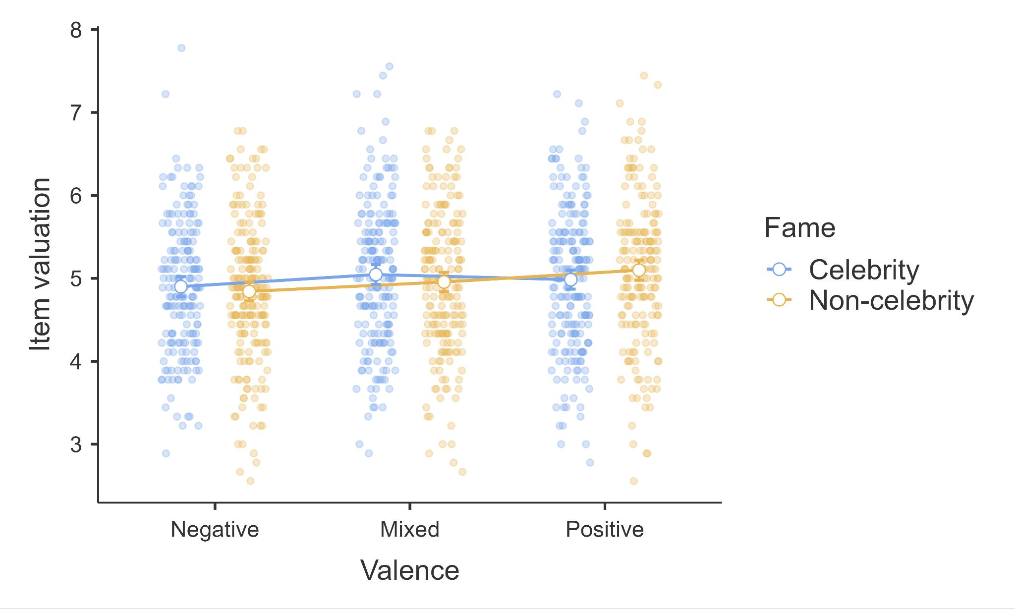

*Note*. Error bars represent 95% CI. Scale: 1 = *Not at all*; 9 = *Very much so*.

#### 

#### Desire for physical contact

We conducted a two-way ANOVA on the desire for physical contact (summarized in Table 1 and plotted in Figure 2). We found no support for a main effect of fame (*η²* = 0.00 [0.00, 0.00]), valence (*η²* = 0.00 [0.00, 0.00]), or an interaction (*η²* = 0.00 [0.00, 0.00]).

###### 

###### Figure 2 *Experiment 1: Fame and valence on desire to have physical contact*

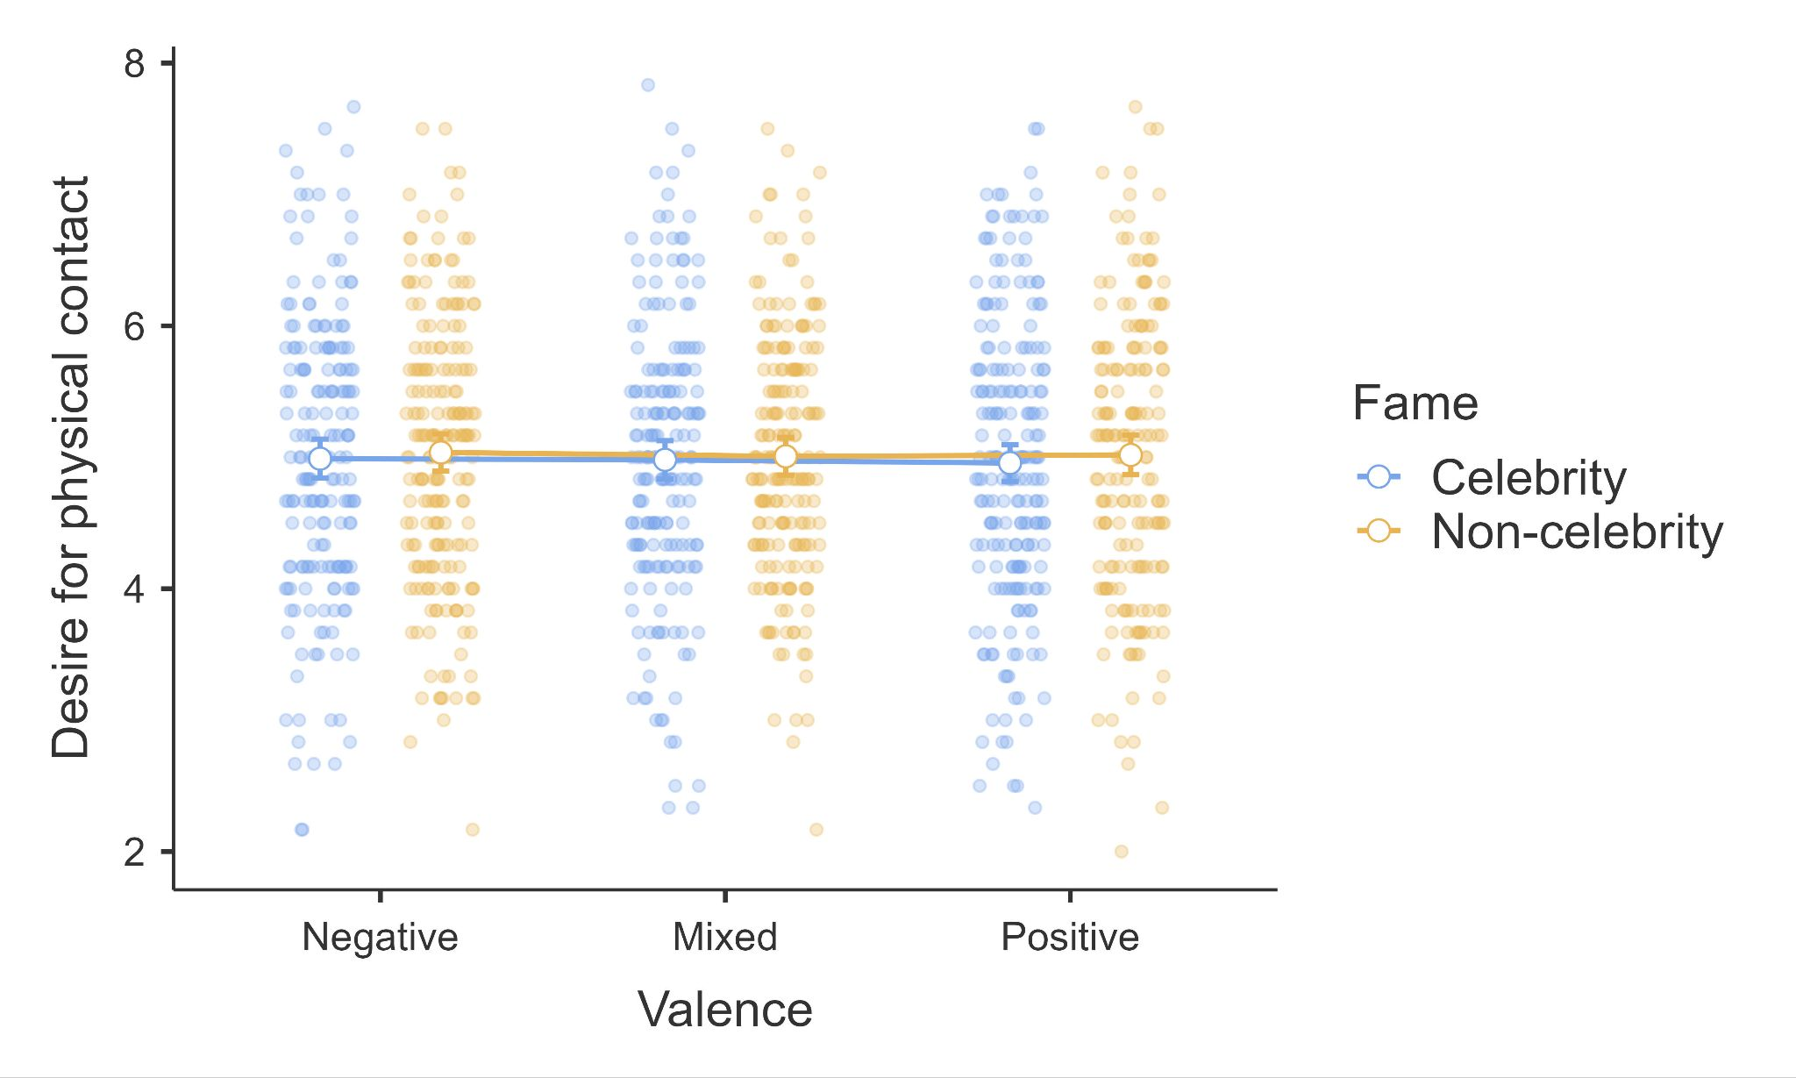

*Note*. Error bars represent 95% CI. Scale: 1 = *Not at all*; 9 = *Very much so*.

#### 

#### Market demand

We conducted a two-way ANOVA on market demand (summarized in Table 1 and plotted in Figure 3). We found no support for a main effect of fame (*η²* = 0.00 [0.00, 0.00]), valence (*η²* = 0.00 [0.00, 0.01]), or an interaction (*η²* = 0.00 [0.00, 0.01]).

###### **Figure 3** *Experiment 1: Fame and valence on market demand*

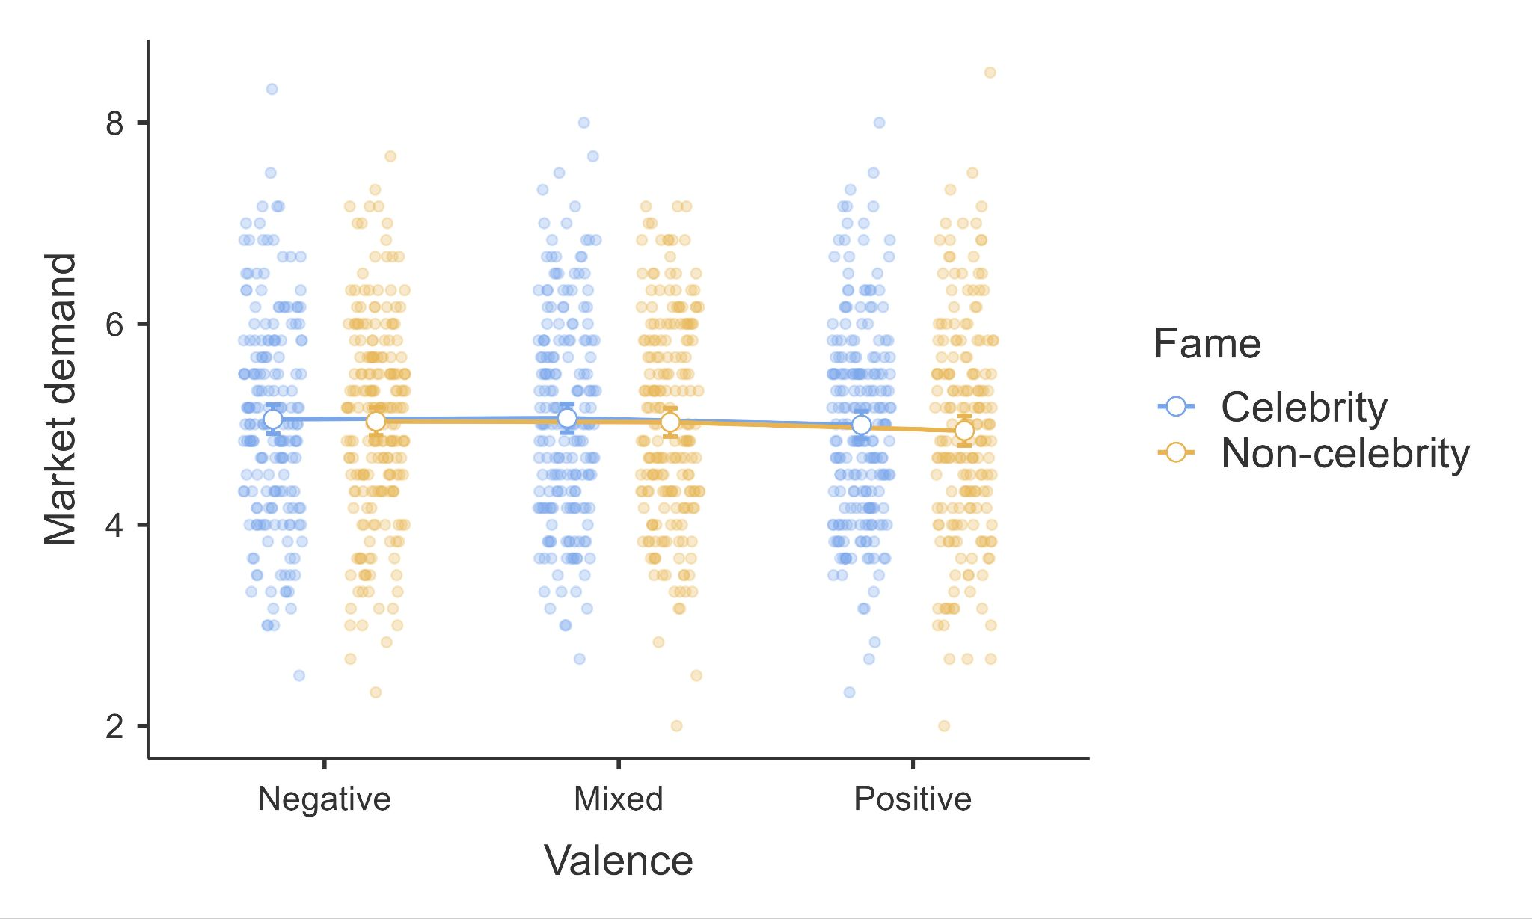

*Note*. Error bars represent 95% CI. Scale: 1 = *Not at all*; 9 = *Very much so*.

### 

#### Liking

We conducted a two-way ANOVA on liking (summarized in Table 1 and plotted in Figure 4). We found no support for a main effect of fame (*η²* = 0.00 [0.00, 0.00]), valence (*η²* = 0.00 [0.00, 0.01]), or an interaction (*η²* = 0.00 [0.00, 0.01]).

###### **Figure 4** *Experiment 1: Fame and valence on liking*

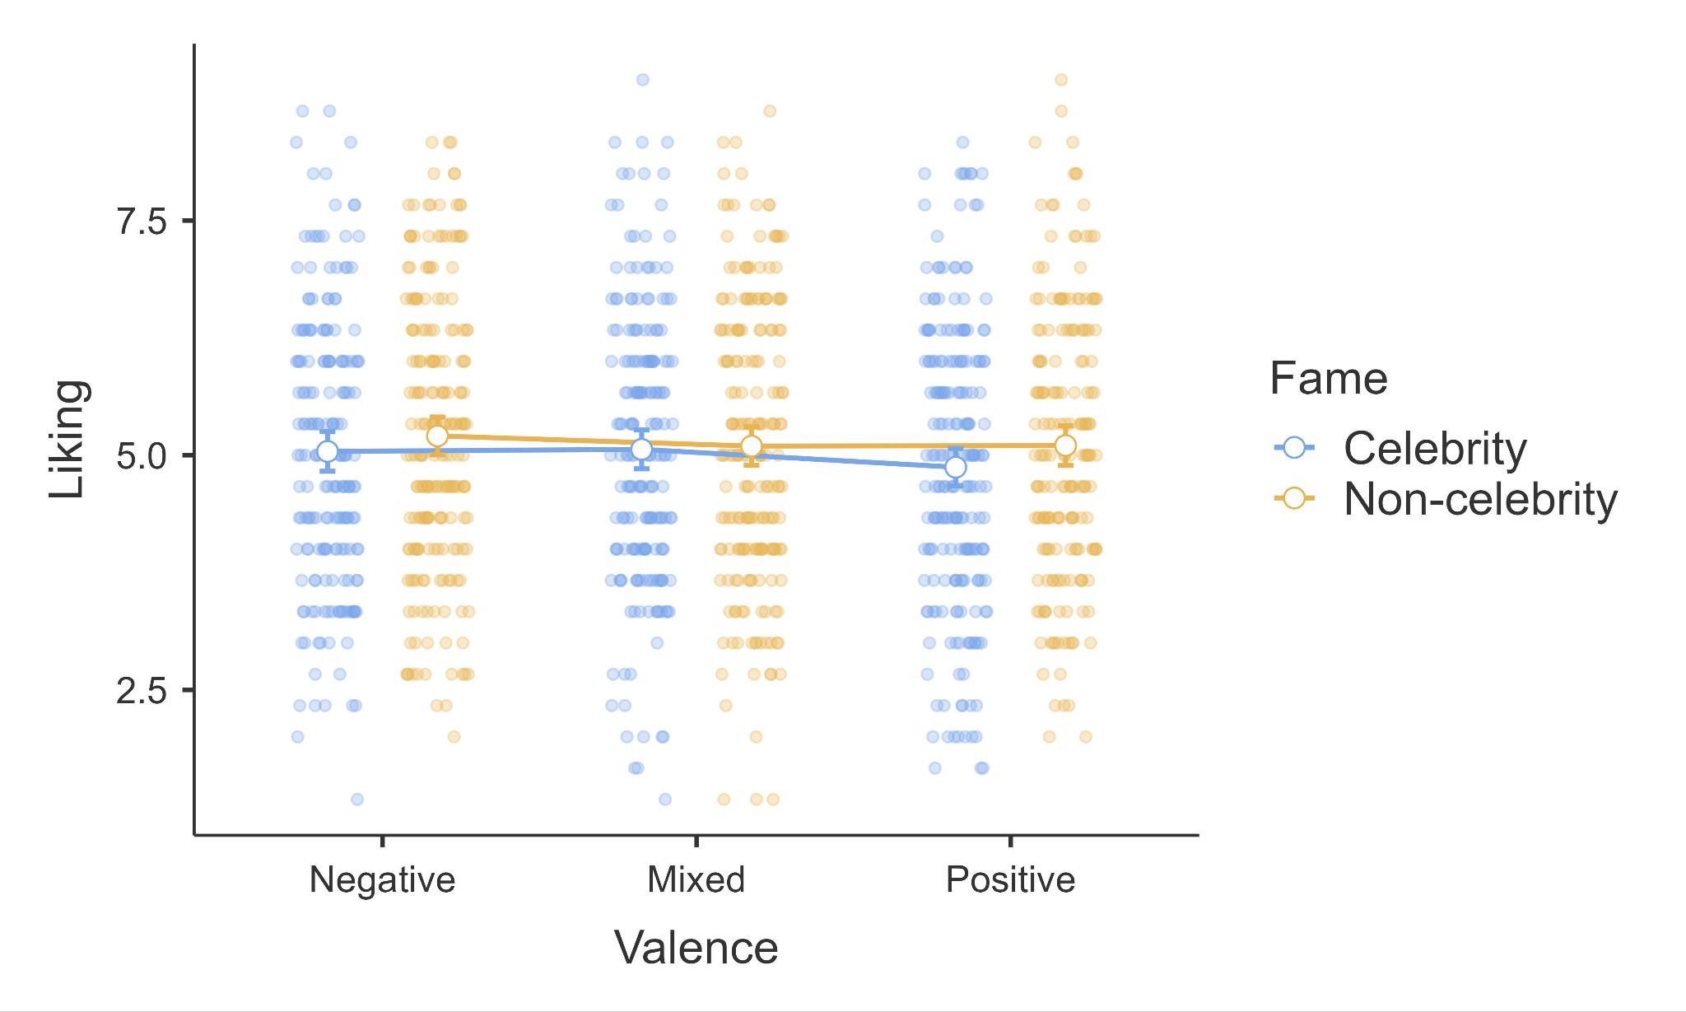

*Note*. Error bars represent 95% CI. Scale: 1 = *Extreme disliking*, 9 = *Extreme liking*.

#### Historical significance

We conducted a two-way ANOVA on historical significance (summarized in Table 1 and plotted in Figure 5). We found no support for a main effect of fame (*η²* = 0.00 [0.00, 0.00]), valence (*η²* = 0.00 [0.00, 0.01]), or an interaction (*η²* = 0.00 [0.00, 0.01]).

###### **Figure 5** *Experiment 1: Fame and valence on historical significance*

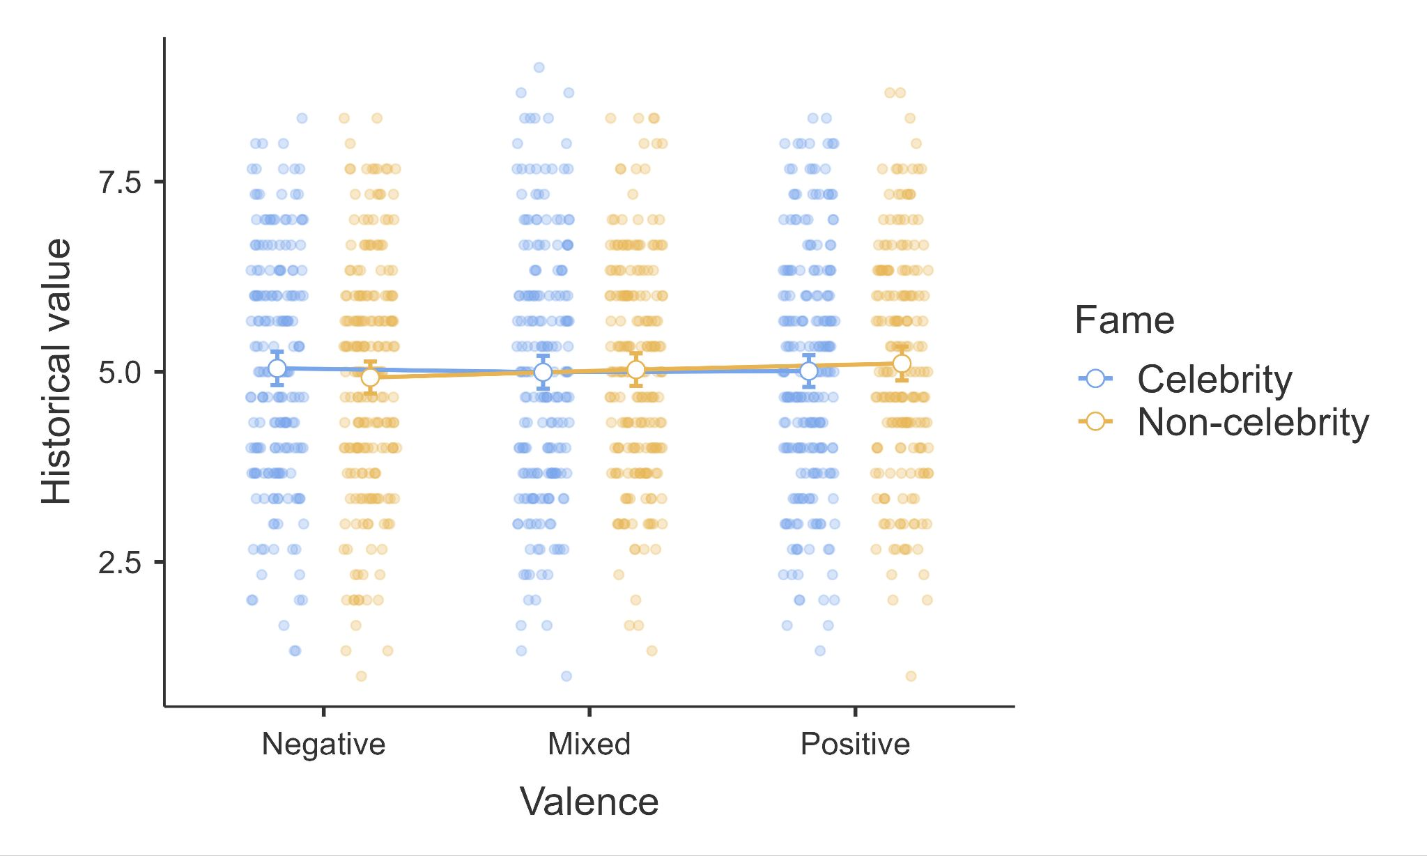

*Note*. Error bars represent 95% CI. Scale: 1 = *Not at all*, 9 = *Very much so*.

## Replication - Experiment 2

We summarized the descriptives for Experiment 2 in Table 7.

###### **Table 7** *Experiment 2: Descriptive statistics*

|  |  |  |  |
| --- | --- | --- | --- |
| Change in *willingness to purchase* –  physical contact manipulation | Highlighted direction | Decreased direction | Overall |
|  |  |  |  |
|  |  |  |  |
|  |  |  |  |
| Change in *willingness to purchase* –  market demand manipulation | Highlighted direction | Decreased direction | Overall |
|  |  |  |  |
|  |  |  |  |
|  |  |  |  |
|  |  |  |  |
| Change in *pleasantness of wearing* –  physical contact manipulation | Highlighted direction | Decreased direction | Overall |
|  |  |  |  |
|  |  |  |  |
|  |  |  |  |
| Change in *pleasantness of wearing* –  market demand manipulation | Highlighted direction | Decreased direction | Overall |
|  |  |  |  |
|  |  |  |  |
|  |  |  |  |

### 

We analyzed the manipulation checks, and found that 53.3% of participants (639 out of 1200) responded that the prompted individual was not someone they knew personally. We did not find any indication for differences between the percentage of participants who responded that the average person had heard of the celebrity in the negative celebrity conditions (52.8%, 316 out of 599) compared to the positive celebrity conditions (50.2%, 302 out of 601; *χ2* = 0.66, *p* = 0.40).

### Valence and manipulation direction interaction

We ran a two way ANOVA for valence and manipulation direction on willingness to purchase and pleasantness of wearing for both physical contact manipulations and market demand.



|  |  |  |  |
| --- | --- | --- | --- |
|  |  |  |  |
|  |  |  |  |
|  |  |  |  |



|  |  |  |  |
| --- | --- | --- | --- |
|  |  |  |  |
|  |  |  |  |
|  |  |  |  |



|  |  |  |  |
| --- | --- | --- | --- |
|  |  |  |  |
|  |  |  |  |
|  |  |  |  |



|  |  |  |  |
| --- | --- | --- | --- |
|  |  |  |  |
|  |  |  |  |
|  |  |  |  |

#### Willingness to purchase

For physical contact, we found no support for a main effect of valence (*η²* = 0.00 [0.00, 0.00]), direction (*η²* = 0.00 [0.00, 0.00]), or an interaction (*η²* = 0.00 [0.00, 0.00]). [We will elaborate on main effects if supported].

For market demand, we found no support for a main effect of valence (*η²* = 0.00 [0.00, 0.00]), direction (*η²* = 0.00 [0.00, 0.00]), or an interaction (*η²* = 0.00 [0.00, 0.00]). [We will elaborate on main effects if supported].

###### Figure 6 *Experiment 2: Willingness to purchase - valence by direction for physical contact and market demand*

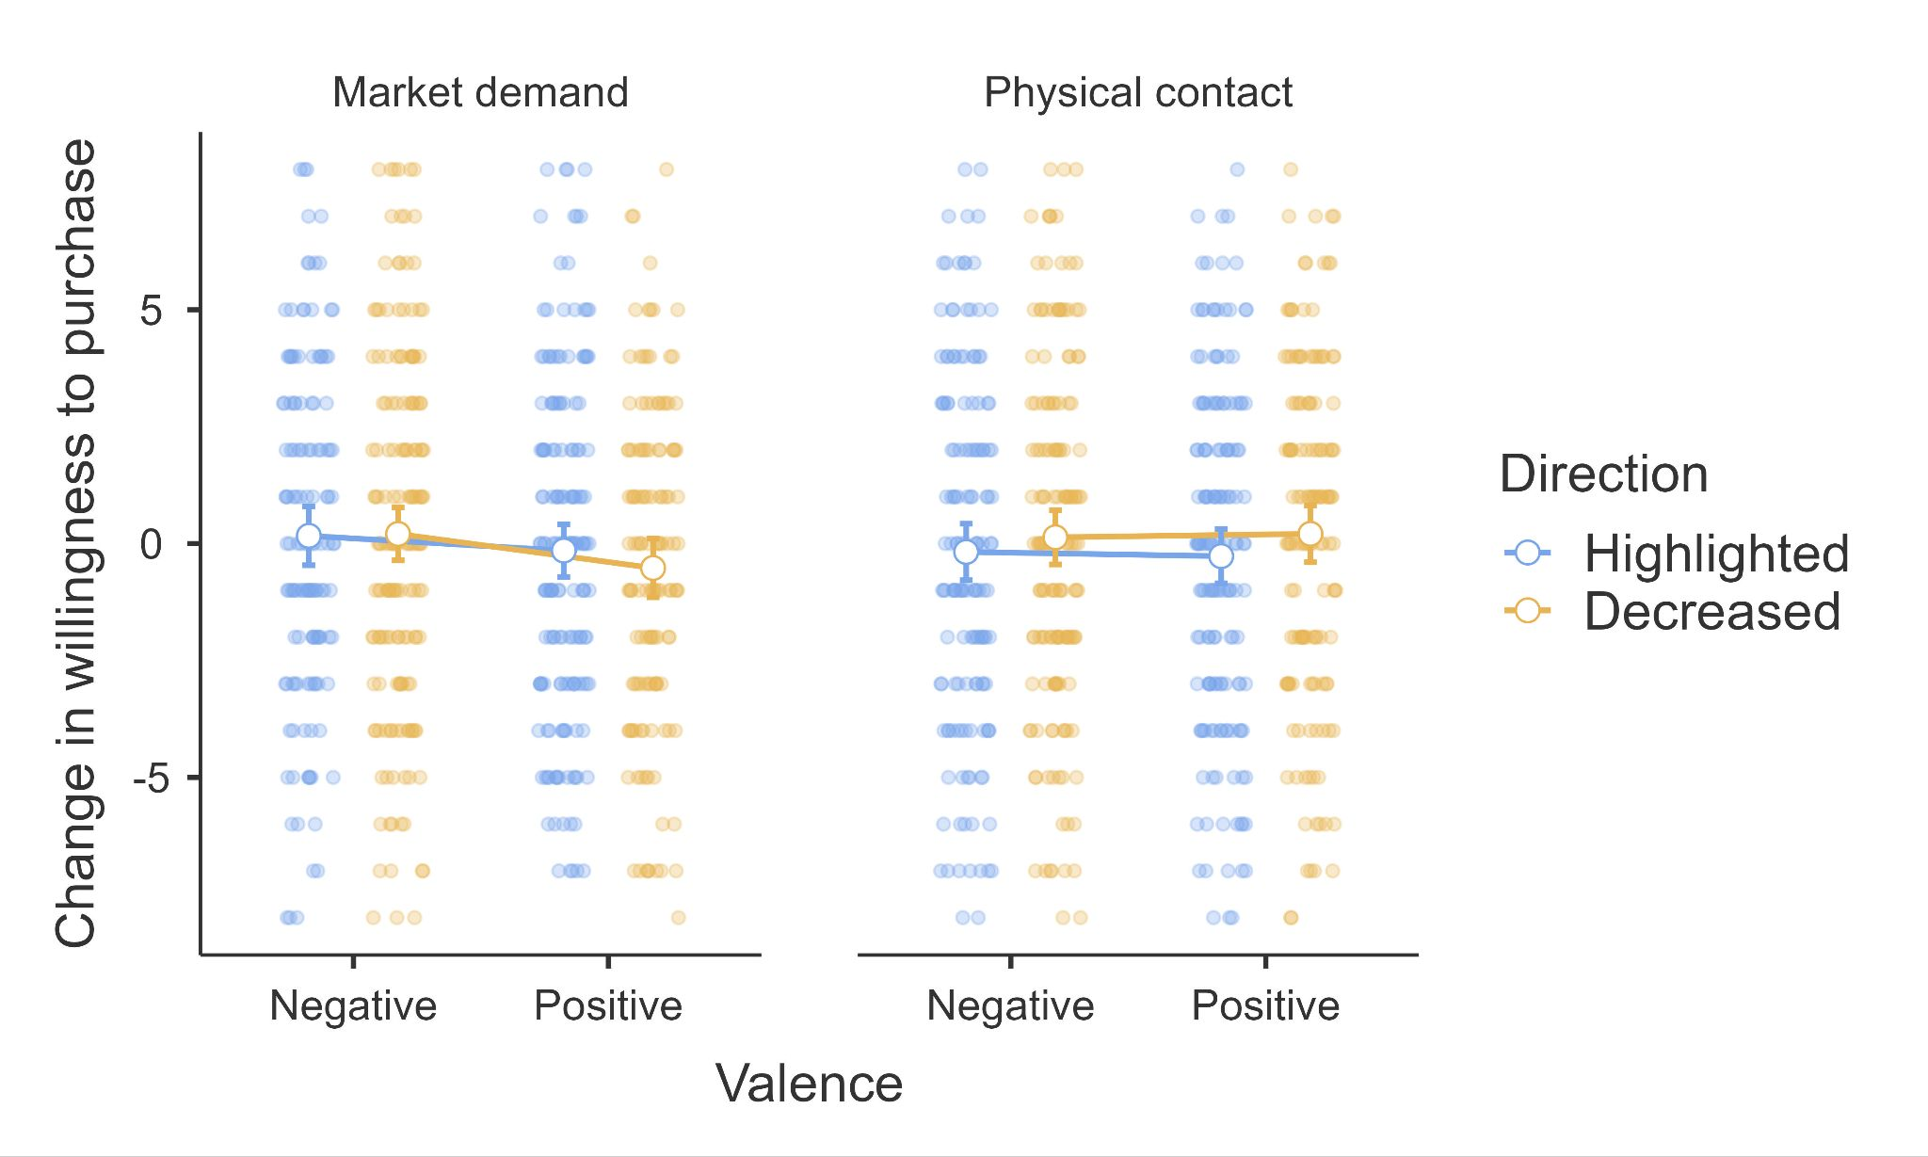

Error bars represent 95% CI. Scale: 1 = *Much less likely to purchase*, 9 = *Much more likely to purchase*.

#### Pleasantness of wearing

For physical contact, we found no support for a main effect of valence (*η²* = 0.00 [0.00, 0.00]), direction (*η²* = 0.00 [0.00, 0.00]), or an interaction (*η²* = 0.00 [0.00, 0.00]). [We will elaborate on main effects if supported].

For market demand, we found no support for a main effect of valence (*η²* = 0.00 [0.00, 0.00]), direction (*η²* = 0.00 [0.00, 0.00]), or an interaction (*η²* = 0.00 [0.00, 0.00]). [We will elaborate on main effects if supported].

###### Figure 7 *Experiment 2: Pleasantness of wearing - valence by direction for physical contact and market demand*

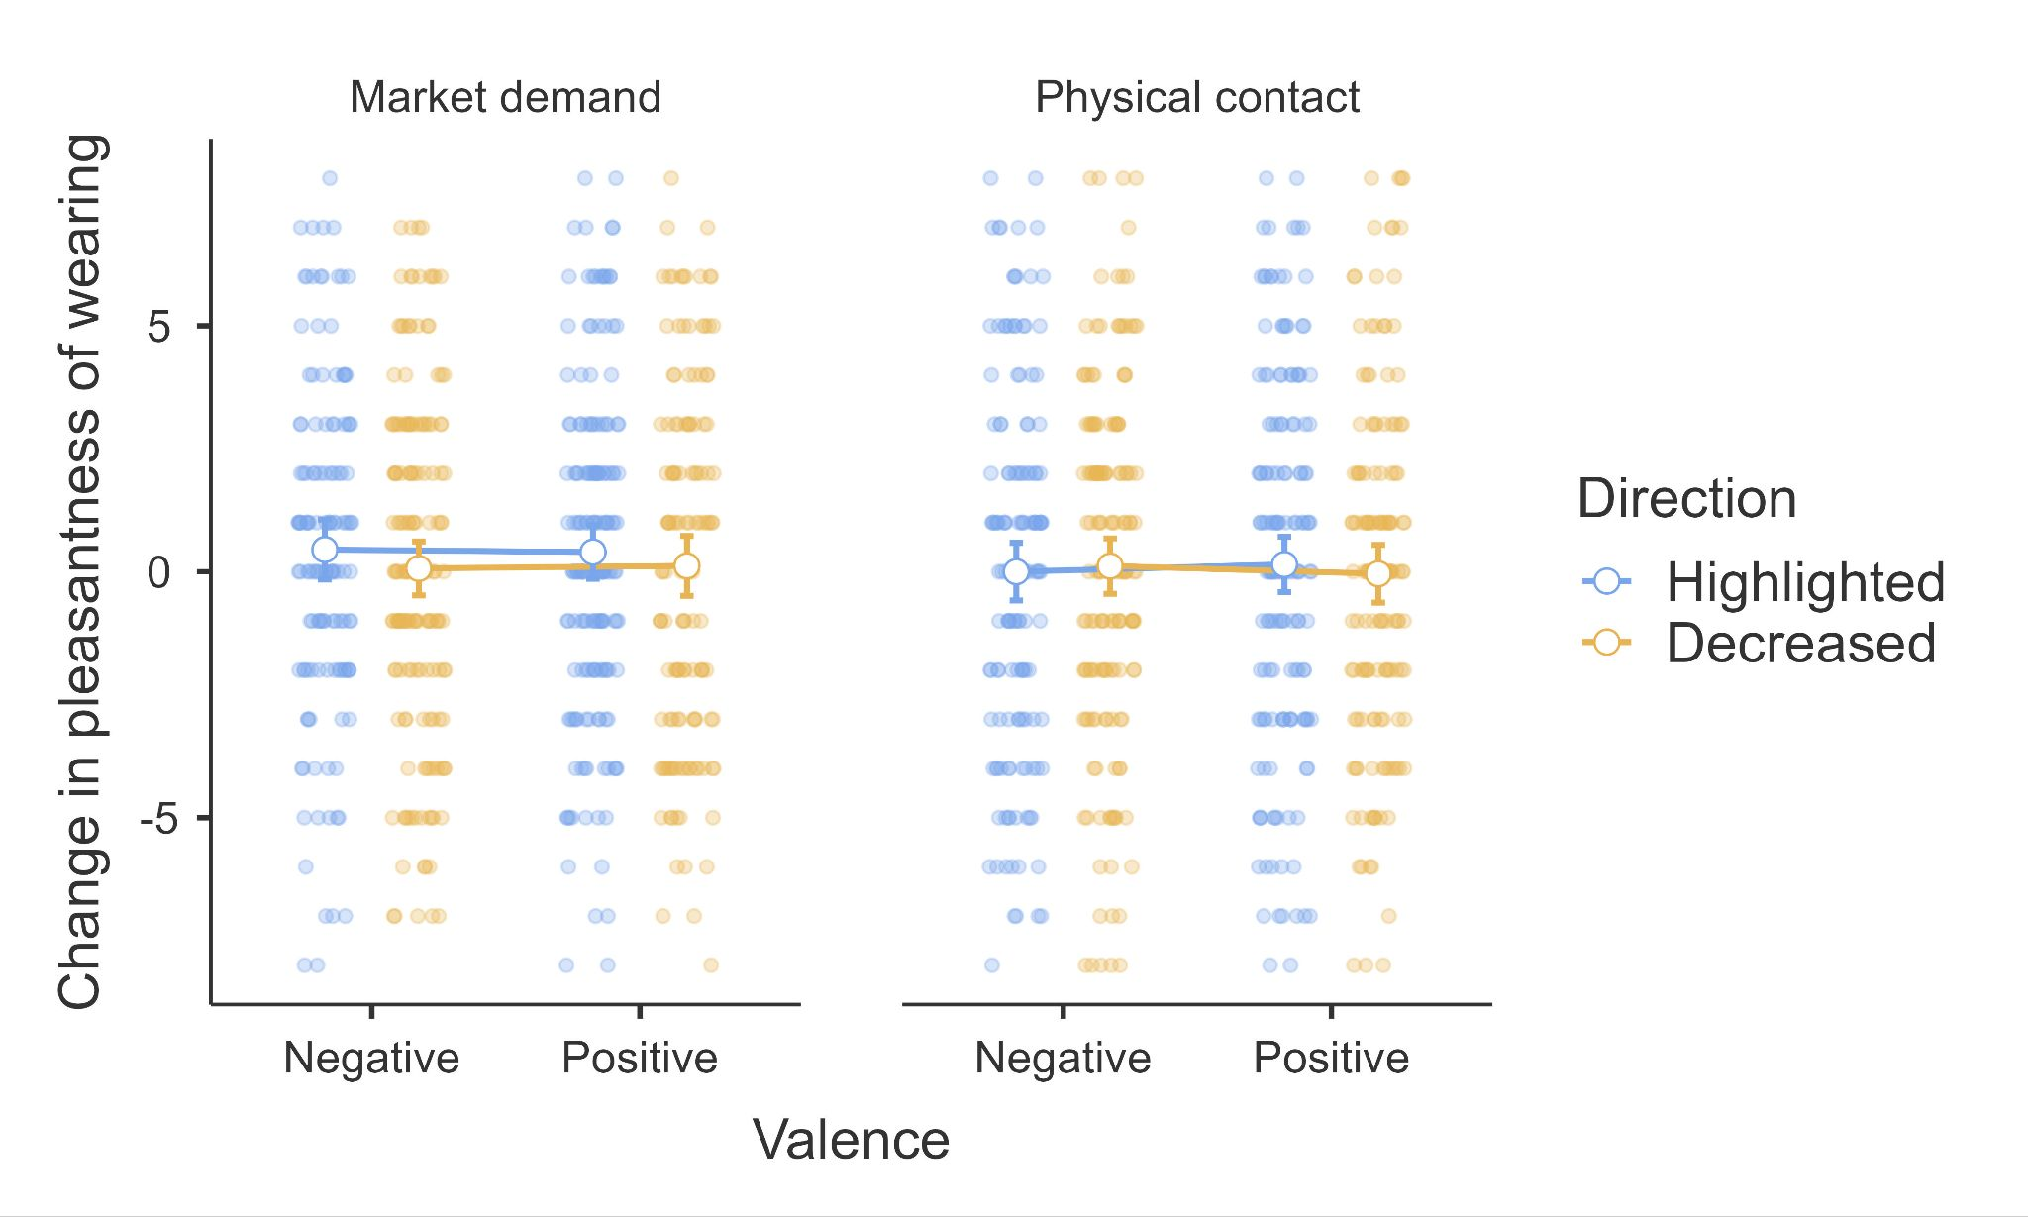

Error bars represent 95% CI. Scale: 1 = *Extremely unpleasant*, 9 = *Extremely pleasant*.

## Comparing replication to target article’s findings

We summarized the replication statistics and effects in Table 1 to allow for easier comparison to the target article’s findings.

[Stage 2 plan: We will expand further once the real data comes in]

## 







We summarized extension descriptives in Table 6. We contrasted the replication’s desire for physical contact with our extension’s desire for non-physical contact, and conducted a 3-way mixed ANOVA, we found that…

Figure 7  
*Experiment 1: Fame and valence contrasting physical vs. non-physical contact*

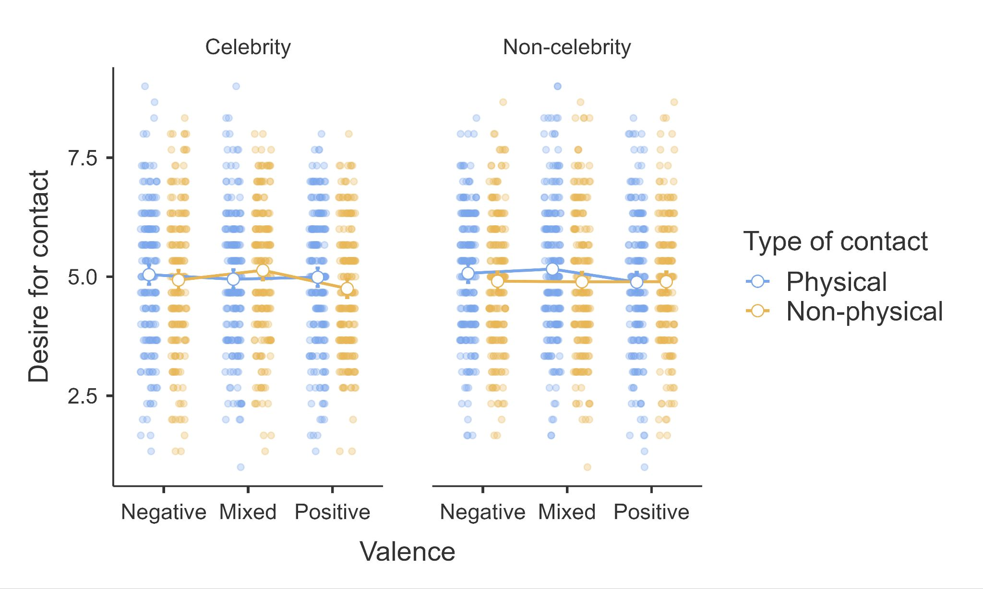

Error bars represent 95% CI. Scale: 1 = *Not at all*, 9 = *Very much so*.

# Discussion

[Please note that the discussion and conclusion sections will only be completed in Stage 2 following data collection.]

[By recommendation from reviewer Dr. Lachlan Deer: Discuss the findings and implications of the findings of our “desire for non-physical contact” extension independent of the results for the “desire for physical contact” (referred to as “contagion” in the target article) replication item. ]

[By recommendation from reviewer Dr. Lachlan Deer: Potentially discuss as limitations and future directions - 1) valence beyond morality, 2) association beyond physical connection [beyond the extension], and 3) advantages and disadvantages of the elicitation procedure as compared to a fixed list of celebrities.]

**Conclusion**

[Please note that the discussion and conclusion sections will only be completed in Stage 2 following data collection.]

# References

Argo, J. J., Dahl, D. W., & Morales, A. C. (2006). Consumer contamination: How consumers react to products touched by others. *Journal of Marketing, 70*(2), 81-94. <https://doi.org/10.1509/jmkg.70.2.081>

Argo, J. J., Dahl, D. W., & Morales, A. C. (2008). Positive consumer contagion: Responses to attractive others in a retail context. *Journal of Marketing Research, 45*(6), 690-701. <https://doi.org/10.1509/jmkr.45.6.690>

Arora, A., Wu, J., Arora, A., Bacouël-Jentjens, S., & McIntyre, J. (2018). Miu Miu Diffuses Prada: Coupling Country-of-Origin versus Country-of-Manufacture Effects with Brand Authenticity and Contagion. *Journal of International Consumer Marketing, 28*(4), 228-250. <https://doi.org/10.1080/21548455.2018.1497218>

Ben-Shachar, M. S., Lüdecke, D., & Makowski, D. (2020). effectsize: Estimation of Effect Size Indices and Standardized Parameters. *Journal of Open Source Software, 5*(56), 2815. <https://doi.org/10.21105/joss.02815>

Brock, T. C. (1968). Implications of commodity theory for value change. In A. G. Greenwald, T. C. Brock, & T.M. Ostrom (Eds.), *Psychological Foundations of Attitudes* (pp. 243-275). Academic Press.

Buchanan, E. M., Gillenwaters, A., Scofield, J. E., & Valentine, K. D. (2019). *MOTE: Measure of the Effect: Package to assist in effect size calculations and their confidence intervals* (R package version 1.0.2) [Computer software]. <http://github.com/doomlab/MOTE>

Castro, I. A., Morales, A. C., & Nowlis, S. M. (2013). The influence of disorganized shelf displays and limited product quantity on consumer purchase. *Journal of Marketing*, *77*(4), 118-133.<https://doi.org/10.1509/jm.11.0495>

Chan, M., & Feldman, G. (2025). Factors impacting effective altruism: Revisiting heuristics and biases in charity in a replication and extensions Registered Report of Baron and Szymanska (2011). Endorsed by *Peer Community in Registered Reports*.<https://doi.org/10.17605/OSF.IO/BEP78> Retrieved from:https://osf.io/saqmg

Diesendruck, G., & Perez, R. (2015). Toys are me: Children’s extension of self to objects. *Cognition, 134*, 11-20.<https://doi.org/10.1016/j.cognition.2014.09.010>

Di Muro, F., & Noseworthy, T. J. (2013). Money isn’t everything, but it helps if it doesn’t look used: How the physical appearance of money influences spending. *Journal of Consumer Research, 39*(6), 1330-1342.<https://doi.org/10.1086/668406>

Dion, D., & Arnould, E. (2011). Retail luxury strategy: assembling charisma through art and magic. *Journal of Retailing, 87*(4), 502-520.<https://doi.org/10.1016/j.jretai.2011.09.001>

Escalas, J. E., & Bettman, J. R. (2009). Connecting with celebrities: Celebrity endorsement, brand meaning, and self-brand connections. *Journal of Marketing Research, 13*(3), 339-348.<https://doi.org/10.1037/e621092012-080>

Fedotova, N. O., & Rozin, P. (2018). Contamination, association, or social communication: An examination of alternative accounts for contagion effects. *Judgment and Decision Making, 13*(2), 150–162. <https://doi.org/10.1017/s1930297500007063>

Feldman, G. (2023). Registered Report Stage 1 manuscript template. <https://doi.org/10.17605/OSF.IO/YQXTP>

Frazier, B. N., Gelman, S. A., Wilson, A., & Hood, B. (2009). Picasso Paintings, Moon Rocks, and Hand-Written Beatles Lyrics: Adults' Evaluations of Authentic Objects. *Journal of Cognition and Culture, 9*(1-2), 1–14. <https://doi.org/10.1163/156853709X414601>

Fuchs, C., Schreier, M., & Van Osselaer, S. (2015). The Handmade Effect: What's Love Got to Do with It? *Journal of Marketing, 79*(2), 98-110.<https://doi.org/10.1509/jm.14.0018>

Haidt, J., McCauley, C., & Rozin, P. (1994). Individual differences in sensitivity to disgust: A scale sampling seven domains of disgust elicitors. *Personality and Individual Differences, 16*(5), 701–713. <https://doi.org/10.1016/0191-8869(94)90212-7>

Hasford, J., Hardesty, D. M., & Kidwell, B. (2015). More than a feeling: Emotional contagion effects in persuasive communication. *Journal of Marketing Research, 52*(6), 836-847.<https://doi.org/10.1509/jmr.13.0081>

Hingston, S. T., McManus, J. F., & Noseworthy, T. J. (2017). How inferred contagion biases dispositional judgments of others. *Journal of Consumer Psychology*, *27*(2), 195-206.<https://doi.org/10.1016/j.jcps.2016.09.005>

Huang, J. Y., Ackerman, J. M., & Newman, G. E. (2017). Catching (Up with) Magical Contagion: A Review of Contagion Effects in Consumer Contexts. *Journal of the Association for Consumer Research, 2*(4), 430–443. <https://doi.org/10.1086/693533>

Jacobs, T. P., Wang, M., Leach, S., Siu, H. L., Khanna, M., Chan, K. W., ... & Feldman, G. (2024). Revisiting the Motivated Denial of Mind to Animals Used for Food: Replication Registered Report of Bastian et al. (2012). *International Review of Social Psychology*, 37(1), 6.<https://doi.org/10.5334/irsp.932>

Jaffe, A., & Aaron, J. (2005). *Modernism and the Culture of Celebrity* (Vol. 13). Cambridge University Press.

Jané, M., Xiao, Q., Yeung, S., Ben-Shachar, M. S., Caldwell, A., Cousineau, D., Dunleavy, D. J., Elsherif, M., Johnson, B., Moreau, D., Riesthuis, P., Röseler, L., Steele, J., Vieira, F., Zloteanu, M., & Feldman, G. (2024). Guide to Effect Sizes and Confidence Intervals. <http://dx.doi.org/10.17605/OSF.IO/D8C4G>

Kennedy, M. (2021, April 26). *Kanye West sneakers fetch record $1.8m at Private Sale*. AP News. Retrieved October 29, 2021, from <https://apnews.com/article/entertainment-music-lifestyle-business-hip-hop-and-rap-f4e3c76ce47c5f6a1806597daaac1e6e>

Kim, L. R., & Kim, N. S. (2011). A proximity effect in adults' contamination intuitions. *Judgment and Decision making*, *6*(3), 222. <https://doi.org/10.1017/S193029750000142X>

Kramer, T., & Block, L. (2014). Like Mike: Ability contagion through touched objects increases confidence and improves performance. *Organizational Behavior and Human Decision Processes, 124*(2), 215-228.<https://doi.org/10.1016/j.obhdp.2014.03.009>

Lacitis, E. (2018, February 26). How ‘Hitler’s car’ ended up parked in Medina. *The Seattle Times.*<https://www.seattletimes.com/seattle-news/how-hitlers-car-ended-up-parked-in-medina/>

Lakens, D. (2014). *Calculating confidence intervals for Cohen’s d and eta-squared using SPSS, R, and Stata*. The 20% Statistician. <https://daniellakens.blogspot.com/2014/06/calculating-confidence-intervals-for.html>

Lane, B. (2019, December 10). *The racket which Serena Williams smashed during her 2018 US Open final defeat to Naomi Osaka just sold at auction for $20,910*. Insider. Retrieved October 29, 2021, from <https://www.insider.com/serena-williams-smashed-racket-us-open-sells-for-20910-2019-12>

Larmarange, J. (2024). *labelled: Manipulating Labelled Data* (R package version 2.13.0) [Computer software]. [https://CRAN.R-project.org/package=labelled](https://cran.r-project.org/package=labelled)

LeBel, E. P., McCarthy, R. J., Earp, B. D., Elson, M., & Vanpaemel, W. (2018). A unified framework to quantify the credibility of scientific findings. *Advances in Methods and Practices in Psychological Science, 1*, 389-402. <https://doi.org/10.1177/2515245918787489>

LeBel, E. P., Vanpaemel, W., Cheung, I., & Campbell, L. (2019). A brief guide to evaluate replications. *Meta-Psychology, 3*, 1-9. <https://doi.org/10.15626/MP.2018.843>

Lee, C., Linkenauger, S. A., Bakdash, J. Z., Joy-Gaba, J. A., & Profitt, D. R. (2011). Putting like a pro: The role of positive contagion in golf performance and perception. *PLoS One*, *6*(10), e26016.<https://doi.org/10.1371/journal.pone.0026016>

Lynn, M. (1992). The Psychology of Unavailability: Explaining Scarcity and Cost Effects on Value. *Basic and Applied Social Psychology, 13*(1), 3–7. <https://doi.org/10.1207/s15324834basp1301_2>

Morales, A. C., & Fitzsimons, G. J. (2007). Product contagion: Changing consumer evaluations through physical contact with "disgusting" products. *Journal of Marketing Research, 44*(2), 272-283.<https://doi.org/10.1509/jmkr.44.2.272>

Morales, A. C., Dahl, D. W., & Argo, J.(2018). Amending the Law of Contagion: A General Theory of Property Transference. *Journal of the Association for Consumer Research*, *3*(4), 555–565. <https://doi.org/10.1086/698907>

NBC News. (2011, June 3). *Unabomber auction nets $190,000*. <https://www.nbcnews.com/id/wbna43257976>

Nemeroff, C., & Rozin, P. (1994). The Contagion Concept in Adult Thinking in the United States: Transmission of Germs and of Interpersonal Influence. *Ethos: Journal of the Society for Psychological Anthropology*, *22*(2), 158–186.<https://psycnet.apa.org/doi/10.1525/eth.1994.22.2.02a00020>

Newman, G. E., & Bloom, P. (2012). Art and authenticity: The importance of originals in judgments of value. *Journal of Experimental Psychology: General, 141*(3), 558–569. <https://doi.org/10.1037/a0026035>

Newman, G. E., & Bloom, P. (2014). Physical contact influences how much people pay at celebrity auctions. *Proceedings of the National Academy of Sciences*, *111*(10), 3705–3708. <https://doi.org/10.1073/pnas.1313637111>

Newman, G. E., Diesendruck, G., & Bloom, P. (2011). Celebrity Contagion and the Value of Objects. *Journal of Consumer Research, 38*(2), 215–228. <https://doi.org/10.1086/658999>

Newman, G. E., & Dhar, R. (2014). Authenticity Is Contagious. *Journal of Marketing Research, 51*(3), 371-386.<https://doi.org/10.1509/jmr.11.0022>

Nosek, B. A., Hardwicke, T. E., Moshontz, H., Allard, A., Corker, K. S., Dreber, A., ... & Vazire, S. (2022). Replicability, robustness, and reproducibility in psychological science. *Annual Review of Psychology, 73*(1), 719-748. <https://doi.org/10.1146/annurev-psych-020821-114157>

Olsson-Collentine, A., Wicherts, J. M., & van Assen, M. A. L. M. (2020). Heterogeneity in direct replications in psychology and its association with effect size. *Psychological Bulletin, 146*(10), 922–940. <https://doi.org/10.1037/bul0000294>

Palan, S., & Schitter, C. (2018). Prolific. ac—A subject pool for online experiments. *Journal of Behavioral and Experimental Finance*, *17*, 22-27. <https://doi.org/10.1016/j.jbef.2017.12.004>

Patil, I. (2021). Visualizations with statistical details: The 'ggstatsplot' approach. *Journal of Open Source Software, 6*(61), 3167. <https://doi.org/10.21105/joss.03167>

Pfarrer, M. D., Pollock, T. G., & Rindova, V. P. (2010). A tale of two assets: The effects of firm reputation and celebrity on earnings surprises and investors' reactions. *Academy of Management Journal, 53*(5), 1131-1152.<https://doi.org/10.5465/amj.2010.54533222>

Podoshen, J. (2013). Dark tourism motivations: Simulation, emotional contagion and topographic comparison. *Tourism Management, 35,* 263-271.<https://doi.org/10.1016/j.tourman.2012.08.002>

R Core Team (2021). *R: A language and environment for statistical computing* (Version 4.4.0) [Computer software]. R Foundation for Statistical Computing. [https://www.R-project.org/](https://www.r-project.org/)

Revelle, W. (2024). *psych: Procedures for Psychological, Psychometric, and Personality Research* (R package version 2.4.3) [Computer software]. [https://CRAN.R-project.org/package=psych](https://cran.r-project.org/package=psych)

Rizopoulos, D. (2006). ltm: An R package for Latent Variable Modelling and Item Response Theory Analyses. *Journal of Statistical Software, 17*(5), 1-25. <https://doi.org/10.18637/jss.v017.i05>

Robert, K. (2022). *qacBase: Functions to Facilitate Exploratory Data Analysis* (R package version 1.0.3) [Computer software]. [https://CRAN.R-project.org/package=qacBase](https://cran.r-project.org/package=qacBase)

Rozin, P., Millman, L., & Nemeroff, C. (1986). Operation of the laws of sympathetic magic in disgust and other domains. *Journal of Personality and Social Psychology*, *50*(4), 703–712.<https://doi.org/10.1037/0022-3514.50.4.703>

Rozin, P., & Nemeroff, C. (2002). Sympathetic Magical Thinking: The Contagion and Similarity “Heuristics”. In T. Gilovich, D. Griffin & D. Kahneman (Eds.), *Heuristics and biases: The psychology of intuitive judgment* (pp. 201-216). Cambridge University Press. <https://doi.org/10.1017/CBO9780511808098.013>

Savani, K., Kumar, S., Naidu, N. V. R., & Dweck, C. S. (2011). Beliefs about emotional residue: The idea that emotions leave a trace in the physical environment. *Journal of Personality and Social Psychology*, *101*(4), 684.<https://doi.org/10.1037/a0024102>

Selker, R., Love, J., & Dropmann, D. (2023). *jmv: The 'jamovi' Analyses* (R package version 2.4.11) [Computer software]. [https://CRAN.R-project.org/package=jmv](https://cran.r-project.org/package=jmv)

Simonsohn, U. (2015). Small Telescopes: Detectability and the Evaluation of Replication Results. *Psychological Science, 26*(5), 559–569. <https://doi.org/10.1177/0956797614567341>

Smith, R. K., Newman, G. E., & Dhar, R. (2016). Closer to the Creator: Temporal Contagion Explains the Preference for Earlier Serial Numbers. *Journal of Consumer Research, 42*(5), 653–668. <https://doi.org/10.1093/jcr/ucv054>

Stavrova, O., Newman, G. E., Kulemann, A., & Fetchenhauer, D. (2016). Contamination without contact: An examination of intention-based contagion. *Judgment and Decision Making, 11*(6), 554–571. <https://doi.org/10.1017/S1930297500004770>

Steiger, J. H. (2004). Beyond the F Test: Effect Size Confidence Intervals and Tests of Close Fit in the Analysis of Variance and Contrast Analysis. *Psychological Methods, 9*(2), 164–182. <https://doi.org/10.1037/1082-989x.9.2.164>

van Gerven, D., Land-Zandstra, A., & Damsma, W. (2018). Authenticity matters: Children look beyond appearances in their appreciation of museum objects. *International Journal of Science Education. Part B. Communication and Public Engagement, 8*(4), 325-339.<https://doi.org/10.1080/21548455.2018.1497218>

White, K., Lin, L., Dahl, D. W., & Ritchie, R. J. (2016). When do consumers avoid imperfections? Superficial packaging damage as a contamination cue. *Journal of Marketing Research*, *53*(1), 110-123.<https://doi.org/10.1509/jmr.12.0388>

Wickham, H. (2007). Reshaping Data with the reshape Package. *Journal of Statistical Software, 21*(12), 1-20. <https://doi.org/10.18637/jss.v021.i12>

Wickham, H., Miller, E., & Smith, D. (2023). *haven: Import and Export 'SPSS', 'Stata' and 'SAS' Files* (R package version 2.5.4) [Computer software]. [https://CRAN.R-project.org/package=haven](https://cran.r-project.org/package=haven)

Wong, C., & Feldman, G. (2024). Choice Bracketing revisited: Replication and extensions Registered Report of seven experiments reviewed in Read et al. (1999). Received Registered Report Stage 1 in-principle acceptance from *Royal Society of Open Science*.<https://doi.org/10.17605/OSF.IO/VDQEK> Retrieved from<https://osf.io/zqnw9>

Zauberman, G., Ratner, R. K., & Kim, B. K. (2009). Memories as Assets: Strategic Memory Protection in Choice over Time. *Journal of Consumer Research, 35*(5), 715–728. <https://doi.org/10.1086/592943>

1. “Social” priming replications have so far had a very poor replication record.
2. We note that we thought the terminology used by the target article did not represent what was manipulated or measured well and lacked consistency, and so we decided to change the terminology to more accurately capture what was done. In Experiment 1, the target article referred to measures of “contagion” and “market value”, which we changed to “desire for physical contact” and “market demand”. In Experiment 2, they had a manipulation of the domains referred to as “contagion” versus “market value”, which we changed to “physical contact” and “market demand”, and dependent measures of “purchase intentions” and “pleasure from wearing”, which we changed to “willingness to purchase” and “pleasantness of wearing”. We noted those changes in the design tables Tables 3 and 4.
3. In some instances, Prolific recruits participants beyond the specified sample size. This is due to the platform sometimes incorrectly classifying valid completed responses as ‘timed out’ or ‘returned’. We will not exclude any complete valid responses from our dataset, and will include any additional completed responses obtained from Prolific.